Science and the media:

From ideas to action

Expert Working Group Report

March 2011

Prepared by the Science and Media Expert Working Group

Chaired by Dr Susannah Eliott

CEO, Australian Science Media Centre as part of Inspiring Australia.

For more information about Inspiring Australia, please contact: Manager

Science Communication and Strategic Partnerships Questacon – The National Science and Technology Centre Department of Innovation, Industry, Science and Research PO Box 5322

Kingston ACT 2604

Telephone: +61 2 6270 2800

Facsimile: +61 2 6270 2808

Email: [**Inspiring.Australia@innovation.gov.au**](mailto:Inspiring.Australia@innovation.gov.au)

You can access this report from the Department’s Internet site at:

[**http://www.innovation.gov.au/**](http://www.innovation.gov.au/)

Copyright

With the exception of material that has been quoted from other sources and is identified by the use of quotation marks “ ”, or other material explicitly identified as being exempt, material presented in this report is provided under a Creative Commons Attribution 3.0 Australia licence.



The details of the relevant licence conditions are available on the Creative Commons website at [http://creativecommons.org/licenses/by/3.0/au/deed.en.](http://creativecommons.org/licenses/by/3.0/au/deed.en)

The document should be attributed as *Inspiring Australia Expert Working Group on Science and the Media: from ideas to action*.

# Contents

Acknowledgments iv

Key findings v

Introduction 1

Why focus on science in the media? 1

The state of science in the media in Australia 1

Changing cultural paradigms 3

Making ideas happen 3

Role and composition of the Expert Working Group 4

Recommendations 6

Theme 1. Overarching recommendations 6

Theme 2. General programming 9

Theme 3. Supporting scientists to engage with the media 12

Theme 4. Supporting journalists who report science 21

Theme 5. Transparency in the release of publicly funded research 34

Theme 6. School students and science in the media 39

Appendix 1 Expert Working Group composition 41

Appendix 2 Contributors 42

Appendix 3 Science Journalism Survey 2010 45

# Acknowledgments

The Science and Media Expert Working Group would like to thank Lucy Andrew for her excellent research and editing support. We would also like to acknowledge the submissions, feedback and contributions from more than 70 journalists, scientists, science communicators and others. We would like especially to thank Dr Will Rifkin (University of NSW) and Dr Peter Pockley (Scicomm) who reviewed the draft report and provided extensive feedback. Full submissions made to the working group are available on the Inspiring Australia website.

A good deal of in‐kind support (and patience!) was also provided by staff at the Australian Science Media Centre.

# Key findings

* Rapid changes in the media landscape brought on by the explosion in new media have created many new avenues for science content. There are now more opportunities for scientists to play a greater role in the creation of popular science content and to collaborate with media outlets in the communication of science.
* There are also opportunities for greater collaboration between scientists, artists, producers and editors to develop new ideas and push the boundaries of traditional media content. Such linkages should be nurtured.
* Science is relatively well represented in the mainstream news media in Australia, with editors of major news outlets indicating they believe science is an important component of the daily news stream.
* However, science is not well represented in general programming, being under‐ represented in factual and documentary programming and missing‐in‐action from most Australian drama, comedy and reality TV.
* Much science news coverage in Australia is framed in a political context, with many important scientific issues only getting major media coverage when they are picked up first by politicians. While this is not necessarily a problem, it does mean that experts can be reluctant to engage with issues that are politically hot. It can also mean that important science issues that have not reached the political agenda remain hidden from public scrutiny and debate.
* The science underlying key issues of public interest could be highlighted by greater transparency and openness in the release of science‐based reports commissioned by government departments.
* The quality of science coverage in the mainstream media could be improved by providing support for scientists to communicate more effectively with the media and for journalists to report on complex science issues, in each case through on the job professional development augmented by well‐supported undergraduate or postgraduate training.
* The quantity, diversity and depth of science coverage in the mainstream media could be extended by the creation of more stimulating science images and interactives suitable for new and traditional media.
* School children could benefit greatly from a program that links breaking news to science learning and teaches critical evaluation of science information from traditional and non‐ traditional (social networking sites etc) news sources.

# Introduction

## Why focus on science in the media?

Science1 influences so much of our daily lives that it’s hard to think of an area of modern social and professional life that is not impacted by it—whether it’s the computer our kids use to access Facebook, the car we drive to work or the food we put on the table at night. Science also has a huge role in informing many of the challenges we face as a society from water resources, climate change and energy to influenza outbreaks, cancer and vaccinations.

The need for greater scientific engagement and an ability to critically assess the credibility of scientific information couldn’t be more compelling. The public needs to ‘own’ science and engage in debate about it—as much as people ‘own’ and engage with sport, music or politics. Science need not be seen as something ‘out there’ that the bulk of the population has no control over—society can and should have a say in the direction that research takes and therefore the type of society we build into the future.

Inspiring the public about scientific issues is also vital for our society since the practicalities of maintaining our current lifestyle require that people not only take an interest in science and technology but that they take up careers in it. The economy is bolstered by science‐ based jobs in areas ranging from health care to brewing.

The role of the media in informing the public and shaping public perceptions has been widely researched and the media are known to have great power in moulding public attitudes on a wide range of issues—science is no exception. Many of the greatest scientific issues of our time are being played out across the bulletins and front pages of the mainstream media and are now being discussed and debated in new media, as well. And yet a recent report on Australian attitudes to science conducted by ANU in December 2010 found that despite strong interest, 44.5% of the population feel not well informed about science.2 This correlates with a Victorian study that showed around half of the Victorian population feel they don’t get enough information about either science or technology from the media.3

## The state of science in the media in Australia

Anecdotal evidence from the Australian Science Media Centre (AusSMC) and interviews with newspaper editors indicates that science is increasingly well represented in news and current affairs and is considered an important strand of the daily news stream. The past four years has seen more than a 50% increase in the use of scientists in the news media with topics like flu, climate change and water resources frequently dominating the news agenda for weeks on end.4 Once science enters the political domain its relevance and interest value for the media go up tremendously and experts are sought out and quoted extensively.

During the Copenhagen climate talks in 2009, the Australian media did relatively well in

reporting the science behind climate change alongside the obvious political dimensions (Painter ‐ 5).

However, the increasing prominence of science in the news media can be a double‐edged sword, sometimes coinciding with increasing public mistrust and confusion, as has been seen in the area of climate change.2,6 As science becomes tied to politics and moves up the news agenda, scientists working in politically sensitive fields (whale research, climate change, stem cell research etc) often feel ill prepared to deal with questions about government policy.7 Journalists also face new challenges, reporting complex issues with little or no training in science to support them.

However, there is very little data and analysis being done on the quality of science coverage in the media and the role of specialist reporters in producing in‐depth science content (see Recommendation 17). The fast changing media landscape and the increasing role of blogging and ‘citizen journalism’ has changed the way topics are covered in new and traditional media. Yet a lack of ongoing monitoring and analysis of science coverage makes it difficult to draw conclusions regarding the impact of these changes on different segments of the reading and viewing public.

In times of crisis such as natural disasters, access to credible and accurate scientific information becomes critical. The nature of the mass media does not always suit this kind of communication since their role is to entertain as much as to inform. Science can often end up a victim of the need to entice an audience with sensational headlines and emotive content.8 This was apparent in the wake of the Black Saturday bushfires in Victoria in 2009 and more recently following the earthquake, tsunami and consequent nuclear reactor incidents in Japan in 2011.

The role of government in distributing rapid, accurate, evidence‐based information to the media is paramount and yet this is frequently not handled well by Australian government agencies in crisis situations. Many government employed scientists are required to go through laborious approval procedures in order to speak to the media, a situation that can mean response times of days, weeks or months rather than the minutes or hours required by the news media.7 The Expert Working Group has devoted an entire section (Theme 5) to transparent communication of science from government sources.

Various initiatives could improve the quality of science coverage in news and current affairs including media skills training for scientists (Recommendations 6–7) and basic skills in analysing research data for journalists (Recommendations 12–14). Greater transparency in the release of scientific reports and the promotion of an independent expert community to comment on the veracity of research findings could also help disentangle research from policy responses (Recommendations 21–25).

Science clearly has much further to go when it comes to the entertainment industry, being rarely portrayed in either a positive or negative light in Australian drama, comedy, feature films and reality TV. We believe that a meeting of minds is needed to change this paradigm and encourage greater use of science in general programming. The recommendations include several incentives to promote this area.

## Changing cultural paradigms

The broad spectrum of general programming is to some extent a reflection of Australian society and thus represents a fresh opportunity for engaging more of the community with science. ‘Inviting’ scientists into people’s home through the medium of television makes them more accessible and less obscure. This is an important part of changing the cultural paradigm away from perceptions of science as geeky, difficult, boring or just plain irrelevant. The group believes that this is best achieved through incentives that encourage and enable producers, researchers and script writers to access science.

The aim is not to introduce facts and figures into general programming but to encourage the use of scientific material as an element of Australian culture. Australia has around 80,0009 people with postgraduate research qualifications employed in areas as diverse as marine biology, neuroscience and mineral exploration. Every facet of our lives is influenced by the work of these people and yet, apart from the notable exceptions of forensic and veterinary scientists, and medical doctors, they do not figure prominently in generic representations of Australian culture.

In this context, the group has made a number of recommendations aimed at bringing science more prominently into the fold of Australian identity through the medium of television and new media. We recommend the establishment of a Science and Entertainment Exchange and a Science‐Media Innovation Fund to encourage the cross fertilisation of ideas between the scientific and entertainment communities, and the introduction of seed funding for science in general programming.

Other recommendations that could help change the cultural paradigm in Australia towards greater inclusion of science include:

* the development of a breaking news graphics service enabling access to scientific data in rich visual formats such as creative data visualisations, animations and mashups etc (Recommendations 20 and 25)
* media skills and presentation training for PhD students to help generate a sea change in the culture of science by equipping young scientists with the skills to engage with the media and make the most of traditional and new media opportunities (Recommendation 7)
* a young science ambassadors program that mentors bright young scientists as spokespeople in the media and provides opportunities for them to engage with the public through the entertainment sector (Recommendation 9).

## Making ideas happen

The working group recognises that new ideas need a variety of champions to flourish. It would be neither beneficial nor productive for the federal government to fully fund all recommendations and that is not the intention of this report. However, many novel ideas need crucial seed funding to get them off the ground. Thus many of the recommendations

are for pilot projects in which seed funding from DIISR or other relevant departments will enable the seed of the idea to germinate. Further sustenance and growth can come from partnerships between government, business, the media industry and the research and education sectors.

Many of the recommendations proposed here have natural linkages—young science ambassadors program with the Science and Entertainment Exchange and the ‘breaking news science images’ with science learning through news in schools program etc. A Science‐Media Coordinator who can oversee the development of the various initiatives and help promote linkages between them would be very beneficial (Recommendation 1). It would also help in linking the Science‐Media initiatives to the rest of the Inspiring Australia strategy. Such a person can be employed through a competitive process and hosted by one of the major collaborating organisations or could be seconded from the Inspiring Australia team.

Some excellent ideas fail to take off through lack of momentum. We recommend that DIISR follow a similar process to the South Australian Government’s Thinkers in Residence Program10, where new ideas are assigned champions from a variety of sectors (business, education, media, research etc) and a coordinator helps maintain momentum by bringing champions together to report on progress and forge further linkages with other programs. This process gave rise to the Australian Science Media Centre and the Royal Institution of Australia, championed by Melbourne businessman, Peter Yates and the Scientists in Schools Program championed by CSIRO Preventative Health Flagship director, Richard Head, amongst others.

Champions can be individuals or organisations and it is expected that they will play a key role in developing and in some cases completely reshaping the recommendations in this report.

It is important that Inspiring Australia and the Science‐Media initiatives have support and engagement at the Ministerial level and we would encourage the Minister for Innovation or his/her representative to attend Champion meetings whenever possible.

## Role and composition of the Expert Working Group

The Expert Working Group on Science and the Media is a diverse group of experts from the research, entertainment, news, magazine, new media, education and science communication sectors. The full list of Expert Working Group members is in Appendix 1.

The role of the group was to review the state of science in the media in Australia and develop a set of recommendations that could help strengthen the media’s role in communicating science and ultimately increase public participation in and engagement with science. Although new media is covered to some extent in this report, a new media expert working group is planned within the Inspiring Australia initiative and so it has not been covered comprehensively here. However, given that traditional media is transitioning into new media forms, often seamlessly, we have attempted to incorporate new media as much as possible throughout the report while bearing in mind that there are numerous issues and

opportunities that need to be explored but which were beyond the resources and scope of the group.

During this review, 72 additional experts were consulted through one‐on‐one interviews by phone, email or in person. They are listed in Appendix 2. Six formal submissions were received and are available on the Inspiring Australia website ([**www.innovation.gov.au/inspiringaustralia**](http://www.innovation.gov.au/inspiringaustralia)).

# Recommendations

## Theme 1. Overarching recommendations

While there are many individual recommendations worthy of consideration in this report, the ones in this section are umbrella recommendations that may encompass or connect with many of the others. For example, a science‐media coordinator has been recommended to ensure that projects deemed important are championed and that linkages between projects are encouraged. Regular science engagement surveys will provide benchmarks that enable better evaluation of the projects recommended in later sections when they come to fruition. And finally, the Science Media Innovation fund could well provide the stimulus needed to make recommendations like the Science and Entertainment Exchange (Recommendation 4), the collaborative content project (Recommendation 8) or ‘science in the news’ schools project (Recommendation 26), go from an idea to a reality.

To help ensure that each recommendation is further developed and nurtured, the Expert Working Group recommends that a champion be identified for each recommendation as the first stage of its implementation.

**Recommendation 1**

**That a science‐media coordinator be employed or seconded for up to three years to oversee the development of the initiatives recommended by the Expert Working Group.**

**REASONING**

The working group would like to see an overarching coordinator engaged to work with various partnering organisations, help identify champions and provide connectivity between different projects. A coordinator could be employed through a competitive process to work with an existing organisation or could be seconded from the Inspiring Australia team.

**IMPLEMENTATION**

Appointment of a science‐media coordinator as early as possible in 2011 would help to oversee the implementation of high priority recommendations that have been funded.

**Recommendation 2**

**That science engagement in the Australian population be measured regularly by repeating science surveys at regular intervals.**

**REASONING**

The working group expressed concern about the lack of data on Australian public understanding of, attitudes to and interest in science, scientific literacy and major avenues of science information (internet, television, radio, print etc). Without access to data from ongoing monitoring, it is difficult to design, target and evaluate strategies to increase public engagement with science through the media.

The National Enabling Technologies Strategy (NETS), formerly the Office of Nanotechnology, has done some excellent work gauging public opinion on specific issues such as climate change, nanotechnology and gene technology, though this tends to be specific and focused on controversial issues. The Federation of Scientific and Technological Societies (FASTS) together with the Australian Academy of Science (AAS) ran a 2010 poll11 that indicated a worrying lack of scientific literacy in the

general population.

A more comprehensive survey should be conducted bi‐annually, with consistent questions that enable benchmarking and comparisons over time.

**IMPLEMENTATION**

Stage 1 (early 2011): Identify champion; Stage 2 (mid 2011): Conduct first survey; Stage 3 (late 2011): Produce report; Stage 4 onwards (2013): Repeat survey every two years.

**Recommendation 3**

**That a Science‐Media Innovation fund be established to encourage and support the bubbling up of new ideas that bring more science to people through the mainstream media.**

**REASONING**

There are few if any funds available that actively encourage scientists and the media industry to work together to come up with novel ideas for providing new content through traditional and new media channels. Such a grant could be similar to the ARC linkage grants and would aim to encourage artists, scientists, producers, editors and perhaps even schools to work together on innovative science media projects. All applications should include an aspect of new media.

Although Science Week grants provide money for new science programs within Science Week, more is needed to seed ongoing projects and to encourage linkages between groups that do not normally work together. The Australian Science and Entertainment Exchange (see Recommendation 4) could be a conduit through which such linkages are formed and ideas sparked prior to applying for a Science Media Innovation grant.

The fund could be administered directly by DIISR or through a secondary granting body such as the Australian Science and Entertainment Exchange (see Recommendation 4) or Screen Australia.

**IMPLEMENTATION**

Stage 1 (mid 2011): Identify and enlist administering organisation; Stage 2 (late 2011): Set up guidelines for pilot program; Stage 3 (early 2012): Launch pilot and administer funds; Stage 4 (early 2014): Review funded programs and if successful seek sponsorship for further rounds.

**Theme 2. General programming**

Some may ask why we have given general programming such prominence in this report. Surely science in the news, the training of scientists and support for science journalism are more important? The truth is that these things are so obviously important that they are frequently explored and debated in discussions about the coverage of science in the media. And while the lack of science in general programming on television or radio is often noted, there is rarely any attempt to rectify the situation. This section resulted from extensive discussion amongst the Expert Working Group and other contributors and proposes several ideas for bridging the divide between the entertainment and science communities. The development of these ideas is just a start and it is hoped that, as they take shape, others will surface.

Some people who reviewed earlier drafts of this report had difficulty with the concept of providing supplementary grants to encourage general program makers to include science content. Some felt strongly that the media should not receive funding for producing programs that are themselves basically profit making ventures. However, interviews with a number of program makers indicate that when faced with a tight budget, including science content is not considered cost effective. And while one might think that they should consider this a ‘public good’, the reality is that incentives are needed.

Although there is no evidence to prove that including more science content in the mainstream media will result in more children taking up careers in science, programs like *Bondi Vet* and *RPA* (filmed at the Royal Prince Alfred Hospital in Sydney) should give us optimism that, when done well, science content can raise awareness of science and provide a more ‘human face’ to expert opinion. It would be good to see this type of programming extended to other sciences beyond veterinary and medical practice.

**Recommendation 4**

**That a centre or program based on the US Science and Entertainment Exchange be established, with the aim of strengthening linkages between scientists and the media and entertainment industry.**

**REASONING**

The group recognises that there are many exciting opportunities for getting more science and scientists into different genres in the media and entertainment spheres, including reality TV, factual and documentary, sitcoms, drama, comedy and feature films. What is lacking in Australia is a ‘meeting place’ where experts in the scientific and entertainment industries can ‘find’ each other, share ideas and explore new ways of working together. This does not happen without facilitation.

This recommendation is based on the Science and Entertainment Exchange that was set up by the US National Academy of Science in 2008. It facilitates a valuable connection between the science and entertainment communities and can quickly and efficiently make introductions, schedule briefings, and arrange for consultations for anyone developing science‐based entertainment content. The advisory board boasts highly influential actors such as Dustin Hoffman, Nobel Prize winning scientist Leon Lederman, as well as writers, directors and producers. The Science and Entertainment Exchange played an integral role in bringing together the producers of the movie *Watchmen* with consultant physicist Dr James Kakalios, who has won an Emmy award for his video *Science of Watchmen*.

An Australian Science and Entertainment Exchange (ASEEx) could have formal or informal links with its US counterpart.

The ASEEx Board should be made up of representatives from the entertainment industry, the scientific community and funding bodies such as Screen Australia. The exchange will benefit from having high profile champions, Nobel Prize or Australian of the Year winners and well known Australians in the entertainment industry.

Such a centre could be established from scratch but would be more cost effective as a program within an existing organisation working in collaboration with other relevant groups. The Royal Institution of Australia has begun to work with scientists, editors and producers and may be able to host the exchange as part of their activities.

**IMPLEMENTATION**

Stage 1 (mid 2011): Identify champion; Stage 2 (late 2011): Development of concept and consultation with relevant groups; Stage 3 (mid 2012): Launch exchange.

**Recommendation 5**

**That a general programming supplementary fund be established to encourage television and film content that includes factual science, fictional science (i.e. superhero science), science concepts or characters.**

**REASONING**

The aim of this grant would be to increase the amount of science in general programming by inspiring program makers as well as helping them to access and utilise the science information and expertise needed. Providing grants for script writers to research and write drama that has a science element would be a positive way of encouraging science content.

Long running programs can include science content. A good example was the inclusion of Dr Norman Swan in series 10 of the Biggest Loser produced by Fremantle Media. Fictional programming can also involve science, eg. American sitcoms like *Big Bang Theory* or a police drama like *Numb3rs*, both of which have science at the core and scientists as major characters. The grant might also, for example, encourage the development and/or introduction of a marine scientist central character in *Home & Away*, or an episode centred on science in *Blue Heelers.*

Such efforts often require support to overcome hurdles such as the cost of consulting or performance fees or the cost of employing a program researcher with expertise in science.

New programming ideas often need seed funding for producers to research ideas and develop programs that can then be sold to television stations or production companies. The program could be expanded to provide funding for other projects such as newspaper or radio series that have a science flavour and also for writers to research or write fiction and non‐fiction books.

**IMPLEMENTATION**

Stage 1 (2011): Identify champion (individual or organisation); Stage 2 (late 2011): Develop pilot program with input from program makers; Stage 3 (mid 2012 to mid 2013): Launch pilot; Stage 4 (early 2014): Evaluate pilot and seek further funding.

## Theme 3. Supporting scientists to engage with the media

The often quoted assumption that scientists are unwilling and unskilled when it comes to communicating their work to a lay audience is a rather simplistic generalisation. A survey of 445 scientists7 conducted by the AusSMC and the Australian Science Communicators in 2007 showed that, of those who had interacted with the media, more than 60% found it to be a positive experience. The Centre now has 2,800 Australian experts on its database who are willing to engage with the media and it is clear from open access databases like Expertguide that many scientists are keen to be contacted by journalists. Indeed the experience of the Centre is that many go out of their way to be helpful, taking calls after hours with little complaint, providing comment from international meetings, airport lounges and just about anywhere else they happen to be.

However, there is no doubt that many scientists would like more help, especially those working within areas of science that have become politicised (35% of survey respondents felt that their area of research had become too political and that this impeded their interactions with the media). Many (42%) also feared that they would be misquoted or that their work would be over‐sensationalised. Of a variety of options for improvement put to scientists, 58% felt that media training and opportunities to meet and network with journalists would make the most difference. Interestingly, the latter idea was echoed in a recent survey with specialist science reporters, with 63% of respondents supporting networking with scientists as a way of improving the craft of science journalism (see Theme 4).

The recommendations in this section are designed to address some of these issues.

Providing better access to media training for working scientists as well as PhD students will help to improve understanding of the media world and build scientists’ confidence in speaking with and approaching journalists. Bringing scientists and journalists together through internships and regular forums will help develop good relationships between the media and researchers and hopefully help scientists see the benefits of reaching the wider public through the media.

Some contributors to this report felt strongly that scientists need incentives to engage with the media and that the ARC and the NHMRC should play a stronger role by introducing ‘carrots’ in the funding process. However, money earmarked for media training or communication activities (not allowed under the current framework for the ARC) might be unpopular with scientists who will see it as less money for research. And clearly a granting process that uses media coverage as a measure in the selection of successful projects could introduce terrible bias into the system and encourage the relentless search for publicity at all costs. Of course, the media is not the only avenue through which scientists communicate with the public and it may be that outreach in general could be a measurable outcome of research (programs run with schools etc). A good example of this is ‘Talking Scientists’ run by the Queensland Government.

Expert Working Group member Ian Frazer remarked that the ARC and the NHMRC could potentially do more to engage with the media themselves by providing more information about the science they fund—“it’s not just the scientist’s prerogative to do this—the funding bodies have the right (perhaps even the obligation) to do this too”. Philanthropic organisations publicise the research they fund in order to demonstrate their relevance and worth to the community and this can act as a ‘carrot’ for scientists to communicate their work more widely in collaboration with those who fund them.

A note of caution raised by a number of science journalists, however, is that the need to communicate science must not translate into excessive spin that promotes unrealistic expectations in the media and the public. Most research institutions have media managers who play a critically important role in the dissemination of science but who are also under constant pressure to promote their organisation in the most positive light possible. This can sometimes result in over‐hyped releases for the sake of attracting attention. The Expert Working Group would like to see scientists take a more active role in ensuring the accuracy of the press releases written about their work and more support for non‐specialist media managers (see Recommendation 19).

There was also much discussion about the need for media ‘science stars’. As veteran science reporter, Peter Pockley put it, “Science needs a cadre of ‘science champions’—scientists who, first, are secure as leaders in their research and, second, are prepared to be seen and heard frequently in the public arena expounding the nature and values of science beyond the boundaries of their own specialisations and without primarily promoting their institutions.”12

Australia has a plethora of talented scientists that are recognised by a range of state and national awards (PM’s Science Prize, the Eureka Awards, the Tall Poppy program etc).

Coordinating the finalists of these awards into an ambassadors program with ongoing support for their role as communicators, could launch them as media spokespeople for the scientific community, not just at the time of their award ceremony, but for the duration of their science careers (see Recommendation 9).

New media and social media are seen by many to offer new and exciting platforms for the communication of science. The explosion of new media opportunities is allowing scientists to link directly with the public in a way that has not been possible before. Science personalities like Dr Karl and Adam Spencer have around 45,000 and 10,000 Twitter followers respectively (as of March 2011).13 In 2009 more than 8 million Australians read blogs.14 In comparison with more ‘formal’ sources of information like news websites, blogs are perceived as more funny, interesting and independent, but far less trustworthy and accurate. However, while attitudes toward blogs have remained fairly stable since 2007, those toward news websites have weakened. These sites are thought to be more biased, less independent, less accurate and less entertaining than they were perceived to be in 2007.

Only 3% of bloggers said they blogged because they were an expert on a particular topic.

Encouraging scientists to have an online presence and engaging in activities such as tweeting and blogging will help them to raise their profile while highlighting evidence based information and contributing to relevant debates taking place in the media.

### Media skills training for scientists

#### Recommendation 6

**That a free online media skills program for scientists and PhD students be developed with input from a variety of bodies with expertise in the area of science media and online training.**

**REASONING**

The group acknowledges the need for media training for scientists to help them engage more effectively with the media. While scientists should be encouraged to do longer hands‐on workshops that give them first‐hand experience and practice doing interviews (a responsibility usually taken on by their employers), this is not possible for all scientists. An online program would help those scientists who are unable to do a longer workshop before an interview and younger scientists for whom training is often not available. A survey conducted by the AusSMC in 2008 indicated that such a module would be beneficial and well utilised by the research community.

The modules must be dynamic and interactive and enable scientists to hone in on the most relevant information needed at the time (eg. tips on doing a live interview on talkback radio etc).

The program would include a module on effective use of new media with background information on engagement through social media and blogging and best practice guidelines for creating online content for public audiences (see Recommendation 8).

Scientists would also receive tips on how to take pictures and footage (on field trips, for example) that is suitable for distribution to a range of media.

The AusSMC has developed a prototype basic media module. Other modules could be developed with input from well‐known science media trainers such as Econnect Communication. This project could involve collaboration with the ARC and NHMRC and feed into the PhD training program (Recommendation 7).

The cost of producing an initial series of modules has been estimated by the AusSMC to cost approximately $60,000. Funding could be sought from a range of sources including the private sector (eg. scientific publishing companies).

**IMPLEMENTATION**

Stage 1 (early 2011): Identify collaborators; Stage 2 (mid 2011): trial AusSMC’s prototype media training module and use prototype to pitch for funding; Stage 3 (late 2011): Develop media modules specific for TV, radio, print, new media and visual communication; Stage 4 (early 2012): Review and incorporate changes; Stage 5 (mid 2012): Launch completed modules.

**Recommendation 7**

**That matched funding be provided to universities to conduct presentation and media training for PhD students commencing a research doctorate.**

**REASONING**

Training to be a good communicator is a necessary but often neglected part of science research training. A good grounding in presentation skills will not only help PhD students interact better with the media as their careers develop but will also increase their employability in a range of sectors. Media training of scientists is currently ad hoc and only available to a few who often don’t do media skills training until after they have had their first bad experience with the media. This recommendation aims to get in early and inspire researchers to engage with the public through the media and help them to feel confident doing media work in the future.

Some universities are offering communications training to their PhD students but this is inconsistent and frequently done only within one department. However, this program should build on and extend existing training efforts such as the program run by the Centre for the Public Awareness of Science at the ANU.

Funding for the program could be administered by organisations who distribute PhD scholarships such as the ARC and NHMRC. Universities should be encouraged to use reputable trainers with expertise in training researchers. A suggested protocol or unit could be designed for adaptation by universities. A coordinating body is needed to ensure quality control.

We recommend that funding from government sources be matched by universities and industry and that media training be incorporated into existing training programs such as industry awareness.

**IMPLEMENTATION**

Research needs to be done to find out how many universities have a program in place already and how many would take up the opportunity. On the basis of this data, a unit should be developed with input from science communication trainers that can then be tailored by individual universities. A guide to minimum content should be agreed to by universities before funds are provided. Stage 1 (mid 2011): Identify champion; Stage 2 (late 2011): Develop program and identify collaborators; Stage 3 (early 2012): Run pilot program with one university; Stage 4 (mid to late 2012): Evaluate pilot program; stage 5 (2013): Roll out national program.

**Recommendation 8**

**That a best practice guide in the use of new media, especially social networking and blogging, be developed for scientists and science communicators**

**REASONING**

The group felt that many attempts by organisations to utilise tools such as Twitter and Facebook recognised the importance of these mediums but were ad hoc and often lacked the understanding required to make best use of them. ‘Social’ on the Internet is not about a destination, but about the ability to discover, share and discuss content on the Web with others. The advent and rapid uptake of smart phones and tablets means that social media will continue to grow in importance and influence, providing a strong case for the development of a best practice “Science Communicator’s Guide to Social Media”.

Most media training workshops do not currently include new media. However, some organisations such as Econnect Communication have begun to incorporate new media in their workshops.

The material developed for a social media guide could also be included in the new media section of the proposed online media skills training course (see Recommendation 6).

This project could be done collaboratively with involvement from organisations like ABC Science online, Google Australia and Facebook. It may also be efficient to engage a digital agency such as the Daemon Group or Hill & Knowlton with broad expertise in social media to research the field and develop the content.

**IMPLEMENTATION**

Stage 1 (mid 2011): Identify champion; Stage 2 (late 2011): Develop package and incorporate into online training (see Recommendation 6); Stage 3 (ongoing): Update on a regular basis.

* 1. **Supporting ongoing relationships between scientists and the media**

**Recommendation 9**

**That a ‘science ambassadors’ program be established, encouraging ongoing contact between the media and the winners of science competitions.**

**REASONING**

There are many science awards presented in Australia each year including; *Fresh Science, Tall Poppies, Young Investigator, CRC Association early career research awards, PM Science Prizes and Eureka Science Awards, state science prizes etc.* Some are associated with media training (Fresh Science, Victoria Science Prize) or include a communications element in the judging criteria (Tall Poppies, Eureka Award for the promotion of science, CRC Association early career award etc) and involve some communications activities in an ongoing capacity (visits to schools etc). All Tall Poppy winners are included in the AusSMC database as a prerequisite to their nomination and each batch of Fresh Scientists are invited to join the AusSMC database of experts

However, ongoing support for these scientists to connect with the media is ad hoc and dependent on the prize and the resources of the organisations awarding them. As a consequence, we are not making the most of the excellent scientific and media talent identified by these awards.

A proactive coordinated ambassadors program would ensure that these award winning Australian ‘science stars’ are mentored in their ongoing communications efforts and supported to become known science spokespeople in the media. Each group of young ambassadors could be matched with mentors (eg. ‘celebrity scientists’ and/or science media personalities). It is assumed that the number of winners will be relatively small (overall winners from the Tall Poppies in each state etc), approximately 20 each year. Although this is a relatively small number, the potential impact is high because, with good mentoring and moral support, many of these young ambassadors could become significant spokespeople and media personalities.

Particular attention could be given to supporting women prize winners, ensuring future female role models in the media.

The cost of setting up an ambassadors program depends on the host institution and the infrastructure they are able to provide.

**IMPLEMENTATION**

Stage 1 (mid 2011): identify champion organisation to lead project and form partnerships with prize/program administrators; Stage 2 (mid to late 2011): Set up mentoring program for winners and hold series of workshops to further advance their skills. Stage 3 (late 2012): Feed names and details of winners into databases run by the AusSMC, the ASEEx (see 2.1) and the Online Directory; Stage 4 (ongoing): Coordinator to identify ongoing opportunities for ambassadors.

**Recommendation 10**

**Develop a program for collaborative content development with working scientists on internships in willing news rooms.**

**REASONING**

The emphasis in this recommendation is on the establishment of ongoing relationships between working scientists and media outlets with collaborative content production a positive spin‐off. While training is a beneficial component, the ability to create popular content, hopefully in an ongoing capacity is important.

There have been effective internship programs for working scientists at the ABC and The Australian. At the ABC the fellows receive one week intensive training in cross media before rotating around to different parts of the ABC over the following five weeks. Scientists gain insight into the culture of radio, TV and online news and take what they learn back to their organisations. Such programs currently involve relatively few scientists but could be expanded to include more scientists in a wider variety of media outlets in their home city.

There is also an opportunity for media organisations to collaborate with scientists on investigating stories and developing authoritative content by leveraging the combinations of expertise. The enormous growth in the ‘blogosphere’ provides media outlets and scientists with new opportunities to create science content collaboratively.

We recommend that participating newsrooms nominate scientific disciplines linked to content areas or topics they would like to investigate for their audiences. In turn suitable scientists could be identified or sought to work with journalists on the issue. This should be seen as a true collaboration, rather than the scientists ‘consulting’ to the newsroom, as the aim is to build awareness of the journalistic process among scientists while creating authoritative content with scientific input.

Involving regional media outlets will help foster positive relationships between local scientists and their local media (with the potential for local media to advertise the ‘boffin in residence’ at the time). For example a Southern Cross University (northern NSW) expert could be matched with *The Northern Star* based in Lismore and/or the local radio station etc. This will also help keep the cost of the program down. The online media training module (see Recommendation 6) could help offset the cost of training scientists in remote areas and could be run with the support of local governments. The selection of scientists could connect with the PhD presentation skills program (Recommendation 7), whereby the best communicators each year are encouraged to apply for internships.

A range of media outlets have already indicated they are interested in participating, including ABC, The Age, The Daily Telegraph, the Herald Sun and the Adelaide Advertiser. Non‐news outlets such as production houses like Shine and Fremantle Media may also be interested in having scientists as collaborators.

The cost of running an internship program depends on the host institution and what level of infrastructure support they can provide. An effective program will require a coordinator that liaises between institutions and media outlets and monitors output. Once a champion is found, it may be possible to seek seed funding from the Science and Entertainment Exchange.

**IMPLEMENTATION**

Stage 1 (mid 2011): Identify champion; Stage 2 (late 2011): Develop internship program with input from science institutions and media industry, including seeking funds or in‐kind support to help run media training; Stage 3 (2012): Run pilot internship program. Stage 4 (late 2012): Evaluate pilot program and based on success, seek further support for 2013.

#### Recommendation 11

**That high profile science forums be staged regularly, inviting a panel of leading scientists and representatives from mainstream media outlets to come together to discuss topical science related issues.**

**REASONING**

An ongoing program could be set up that is run through, or similar to, the National Press Club lunches and that becomes a known brand for science dissemination and dialogue. Though one organisation may take the lead, the series must be done in collaboration with a variety of institutions around the country depending on the topic. ‘On the radar’, ‘lab to lunch’ or ‘the national press club science series’ could become known as agenda setters, helping to trigger debate and inform the public on important issues in science. It is important that the lead organisation maintains editorial control to ensure events are unbiased and not driven by the agenda of one organisation or sector.

The AusSMC does regular physical and online briefings for the media on issues such as climate change, water, rising food prices, energy, swine flu etc. They often lead to extensive media coverage but are not open to the public and do not have a high profile in themselves.

A new series of science events could be set up in a similar way to the TED‐X conferences, with one organisation taking the lead and providing the marketing and template for the events and a variety of organisations nominating to host events in different locations.

The estimated cost of running such a series is $10,000 per event with costs shared between collaborating organisations.

**IMPLEMENTATION**

Stage 1 (mid 2011): Identify champion (must be independent and not seen as agenda driven or lobby‐based) to work with institutions and coordinate events; Stage 2 (late 2011): Develop program in collaboration with institutions; Stage 3 (2012): Begin science series.

**Theme 4. Supporting journalists who report science**

Unlike many developed countries such as the UK, Germany and Japan, much science reporting in Australia is done by general journalists or journalists in other rounds such as politics, business and lifestyle. Of the approximately 700 journalists registered with the AusSMC to receive science alerts and expert comment, only around 10% are specialist science, health or environment journalists. Although there is very little published data on trends in science journalism in Australia, there are indications that the field is in decline globally (see Section 4.2 for a more detailed exploration of this topic).12,15

There is also very little analysis being done on the quality of science coverage in Australia and how this relates to who is reporting science. While many have expressed concern about the way major scientific topics such as climate change, gene technology, energy and water resources are covered in the Australian media, few have researched the reasons why.

Scientists tend to blame the media for being superficial and journalists often blame scientists for not explaining the science better. Given the large influence of the mainstream media on public perception and understanding, there is clearly a need for more evidence‐based analysis in order to better understand the factors at play.

A common observation is that when science becomes political and moves up the media agenda it is often reported by political reporters instead of science reporters. “I covered climate science for years before climate change became a political issue,” said Expert Working Group member, Deborah Smith from the Sydney Morning Herald. “When it became political, it was mostly reported by journalists in a political or current affairs round.” While this is to be expected and is not necessarily bad, one can imagine it has an impact on the way controversial areas of science such as climate change are covered in the Australian media, though there is virtually no published research on this.

In reality, many mainstream issues underpinned by science are no longer wholly the domain of science and so reporting by a variety of different journalists may in fact improve the coverage overall, especially where reporters from different rounds work collaboratively on in‐depth pieces. A topic like ‘responding to climate change’ for example involves consideration of policy, economics, psychology and education as well as climate science.

Nevertheless, the Expert Working Group felt that the large number of general journalists in Australia who frequently report on science need support to cover complex issues. This is one of the major objectives of the AusSMC. A number of the recommendations in this section are geared towards supporting general reporters and those specialised in other rounds who also report on science.

There was also recognition of the important role that public relations and media managers play in what and how science is covered in the mainstream media, a topic covered in more detail in the introduction of Theme 3 and in Section 4.3.

The World Wide Web is clearly having a large impact on the coverage of science and its assimilation by the public. Many journalists covering science express concern about the shorter news cycles and pressure to publish in ever shorter timeframes, the product of an

online news environment that has become highly competitive and needs constant ‘feeding’ (see Appendix 3).

More and more people are sourcing their news online. A 2010 American survey16 shows that 46% of Americans get online news three or more days a week. According to the Nielsen Social Media Report14 19% of Australians using social networks posted a news story or article during 2009 and 25% cite social networking sites as a source of news and information.

Tweeting, which is not simply used for micro‐blogging but is useful for news feeds and alerts, is becoming increasing popular with one in three online Australians having visited Twitter in 2009, compared with one in fourteen at the end of 2008.14

Blogs are also now an important source of information for many Australians and yet only 3% of bloggers in 2009 wrote blogs because they were experts on the topic (down from 8% in 2007).14 The interplay between blogging and ‘citizen journalism’ and articles written by accredited journalists is now a major source of debate and discussion. While blogs are entertaining and provide a valuable platform for dialogue, they can also generate misinformation and confusion when inaccurate figures are highlighted and opinion presented as fact. Many contributors to this report felt strongly that scientists need to embrace social media and that greater engagement with web tools such as blogs will benefit public understanding of science (this is covered more fully in Theme 3).

Perhaps even more than traditional media, new media is also hungry for stimulating images and animated graphics that can help explain difficult concepts in dynamic and interactive ways. There may be an opportunity to increase science coverage dramatically through the development of a breaking news science graphics service (Section 4.4).

### Training for general journalists

#### Recommendation 12

**Develop a unit on reporting research that can be incorporated into undergraduate journalism courses.**

**REASONING**

Major news topics that are under‐pinned by science, such as climate change, water resources, influenza outbreaks and stem cell research are often reported by general journalists or journalists in other specialist rounds such as politics, business or urban affairs. The bulk of journalists entering undergraduate and postgraduate courses in journalism come from an arts and humanities background and can find reporting complex science stories a challenge.

The group felt that the accuracy of reporting on key science issues could be improved if journalists are given some basic training in reporting on research findings during their undergraduate degree. This could include training on how to assess the credibility of experts, understanding the peer review process and making sense of scientific reports and basic statistics. This training is applicable across a wide spectrum of news stories and would be beneficial for all journalists not just those wanting to work on a science round.

A generic unit could be developed by a relevant organisation and then tailored by individual lecturers to suit their students and teaching style. Ideally the unit would be incorporated into a compulsory journalism subject so all journalism students receive some training on how to report research findings.

**IMPLEMENTATION**

Stage 1 (early 2011): Identify champion; Stage 2 (mid 2011): Course development; Stage 3 (2012): Trial new unit in selected undergraduate courses; Stage 4 (2013): Evaluation of trial.

**Recommendation 13**

**Offer in‐depth briefings for working journalists on topical science issues.**

**REASONING**

While basic training in reporting research for undergraduates is desirable, there are many working journalists who could benefit from a better understanding of some of the topics they are covering. Many senior journalists find themselves having to cover science stories like climate change or water resources but don’t necessarily feel well equipped to ask the right questions or assess the credibility of the experts they have to interview. Professional development courses could be held online to attract journalists from around the country and could be run, for example, as a series that concentrates on the topical issues of the day.

The AusSMC regularly hosts online briefing sessions for journalists to listen to and question scientists about topical issues. All online briefings are archived and can be used by journalists as an online resource. The briefing sessions are currently provided on an ad hoc basis by the AusSMC. Other organisations that could contribute to such a series include the Australian Centre for Independent Journalism (UTS), the University of Melbourne’s Centre for Advanced Journalism and the Media Entertainment and Arts Alliance (MEAA).

**IMPLEMENTATION**

Stage 1 (early 2011): Research need and enthusiasm for such a program in the media industry (S‐M coordinator); Stage 2 (mid 2011): Identify and engage champion (individual or organisation) to seek sponsorship and develop program; Stage 3 (late 2011): Run series of three briefings as a pilot; Stage 4 (2012): Run full series of 12 briefings.

**Recommendation 14**

**That a ‘Before the Headlines’ service be provided to help journalists analyse science papers before they are released publicly.**

**REASONING**

This idea is based on a successful UK service called *Behind the Headlines*, which provides an unbiased and evidence‐based analysis of health stories that make the news. The service is intended for both the public and health professionals, and endeavours to explain the facts behind the headlines and give a better understanding of the science that makes the news, provide an authoritative resource for GPs which they can rely on when talking to patients, and become a trusted resource for journalists and others involved in the dissemination of health news.

A similar service—‘Before the Headlines’—could be created in Australia and provided to journalists under embargo as they write their stories. Such a service is currently being trialled in the UK by the London‐based Science Media Centre.

In Australia, the Media Doctor website provides a similar service but is more focused on critiquing the reporting of the health news stories which appear in the Australian media. The AusSMC does provide some pre‐publication services to journalists by collating expert commentary (‘rapid roundups’) on journal articles before they are made public, but does not have the in‐house expertise to analyse data and provide advice on research method etc. Organisations that may be able to offer this expertise include the ARC and NHMRC.

**IMPLEMENTATION**

Stage 1 (early 2011): Assess effectiveness of UK service when trial is complete (S‐M Coordinator); Stage 2 (mid 2011): Based on UK experience, seek champion to work with collaborators and source financial support if required. Stage 3 (2012): Start pilot program.

* 1. **Supporting the role of specialist science reporting**

According to veteran science journalists Robyn Williams and Peter Pockley, specialist science reporting in Australia is seriously under threat.2,15 The ABC, who back in 1960 led the way with science programs such as the science show, has in recent years closed their Natural History Unit, axed Radio National science programs and ‘let go’ science documentary makers and reporters from ABC Science Online. With fewer jobs available, more science journalists are moving into public relations.12

This decline is part of a worldwide trend where falling revenues from traditional media have led to specialist reporters being the first to be ‘let go’ by media organisations. The result is that special interest subjects are increasingly being covered by general reporters.15

So does it matter if science stories are written by non‐specialist reporters?

A recent Australian study17 compared the quality of health and medical stories written by specialist and non‐specialist journalists, and those sourced from major news organisations, in Australia from 2004–08. They found that it does matter who writes news stories that cover the benefits and harms of health care interventions. Stories written by specialist health journalists working for a single media outlet scored more highly than those written by less experienced writers. However, more research is needed before extrapolating this to all areas of science reporting.

**A survey of science journalism in Australia**

A survey was conducted by the Expert Working Group to gauge the state of science journalism in Australia and how the field has changed in recent years. The results are summarised below, with the full survey available in Appendix 3.

The survey was sent out to 80 specialist reporters in the fields of science, health, environment and technology with 32 responses received (a response rate of approximately 40%). The focus of the survey was on trends in specialist reporting in the mainstream news media and so specialist publications such as trade magazines and specialist programs were not included.

Most mainstream media outlets that cover news have at least one specialist science, health or environment reporter and in some cases they have one for each sector.

Of interest for this report is the fact that a majority (80%) of specialist reporters felt secure in their jobs and 77% felt that science was considered important by the media outlet they work for. However 70% reported having increasingly less time and resources to work on complex science stories and 61% felt that if they left they would be replaced by a general reporter rather than a specialist reporter. Interestingly, 63% said the main impediment to strong science coverage was a lack of interest in science from editors (“The problem is the assumption by editors that the public doesn’t care about this stuff” as one journalist put it).

A number of reporters expressed concern over the development of science journalism as a field with 67% supporting the idea of a mentoring system for young specialist reporters and several suggesting a mentored cadetship program as the best way to learn and maintain the craft of science journalism.

While some saw new media as an opportunity (“It means you can get the message out to a wider audience”), others saw it as a threat to quality reporting: “The big question is how science journalism will fare against blogging. Many people prefer blogs because they pander to prejudices. Objective journalism hasn’t established a strong case for itself, not least because there are too many editorial agendas that pander to prejudices too”.

Many felt that the pressure to write for a variety of platforms has left them with less time to focus on complex stories and ensure the information is accurate. There was clearly pressure felt by many journalists to report for the online environment in addition to their usual reporting, creating shorter news cycles and at times almost impossible deadlines: “I’m a print journalist but am increasingly expected to file for online, and film videos—this increases pressure and means less time is spent on the actual story,” and “when stories are wanted online it can be an incredible rush, with greater potential for errors”.

#### Recommendation 15

**That investigative science grants be established for journalists to pursue a science related issue.**

**REASONING**

Journalists are time poor and have few opportunities to do investigative journalism on science related issues that come across their desk. Small grants would enable them to pay for costs such as travel to investigate a specific issue. In some cases they may opt to take up to one month leave without pay from their organisations to undertake research, in which case the fund could help pay their salary during this period. It would also be open to freelancers.

Initially the investigative science grants would be government funded with a plan to seek private funding that would be administered by an organisation such as the Walkley Foundation, the National Press Club or the AusSMC. It is critically important that there be an effective firewall to ensure that such a scheme is independent of funding bodies.

Investigative research funded by such a grant could spawn a number of news and feature stories, all of which would credit the fund. The fund, if branded appropriately, could also help raise the profile of specialist science reporting and would provide opportunities for science journalists to apply for Australian and international prizes on the basis of the investigative pieces they produce.

The impact of this program would be measured in terms of the provision of independent, in‐depth content in the mainstream media, informing the public on key issues and triggering new debates underpinned by evidence‐based science.

It is suggested that between 10 and 15 grants of up to $6,000 each be offered per year for Australian reporters.

Swinburne University’s Public Interest Journalism has recently launched YouCommNews.com that enables members of the public to donate money to help fund in‐depth journalism. If this model proves successful, an investigative research grant may not be needed. However, it is acknowledged that independent investigative journalism that plays a ‘watchdog’ role in the science arena is becoming more rather than less important.

**IMPLEMENTATION**

Stage 1 (mid 2011): Identify champion and funding source to run pilot program; Stage 2 (early 2012): Call for nominations for grants in 2012–13; Stage 3 (mid 2012): Administer grants for 2012; Stage 4 (late 2013): Assess pilot program.

**Recommendation 16**

**That a Walkley Award for Science Journalism or prize of a similar profile be established with funding from a variety of sources.**

**REASONING**

The only awards for science journalism are the Eureka Awards, of which there are two awards specifically for science journalism and environmental journalism. Many specialist reporters feel that the role of science journalism needs to be acknowledged in the general journalism community. Such an award would also act as an incentive to general reporters to pursue science stories.

The award should be for science‐based journalism which has a clear influence on policy or public debate, or brings an important scientific issue to broad public attention. Similar to the Walkley Awards it should be open to Australian journalists from all media outlets. Suggested prize is $10,000.

**IMPLEMENTATION**

Stage 1 (early 2011): Conduct research into the feasibility of including a science journalism prize into the Walkley Awards, National Press Club prizes etc. Stage 2: Provide funding for new prize (first awarded in 2012).

**Recommendation 17**

**That a regular (2–3 yearly) survey of science journalists and ongoing monitoring of science in the media be conducted in order to generate reliable data on which conclusions about the state of science and science journalism in Australian media can be drawn.**

**REASONING**

There has been much debate about the quality and quantity of science news in Australia in recent years, especially in light of the rapidly changing face of journalism globally. Research into the quality of health journalism in the Australian media has recently shown that stories written by specialist health journalists were of higher quality than those written by less experienced writers, yet as the authors of the study point out, “this source of health literacy is currently under pressure as falling revenues threaten the future of the traditional media”.17

As the demands within news rooms increase and budgets decrease, little is known about the impact of these social and economic pressures on science specialist reporting. There is currently insufficient data on the status of and trends in science journalism in Australia to draw any real conclusions.

The working group would like to see a regular survey of newsrooms to quantify the numbers of science specialist reporters—including a clear separation of speciality (i.e. science, medical and health, environment and technology). A regular survey of this kind would generate reliable, comparable figures from which analysis about the state of science journalism in Australia can be generated. The survey should also gather qualitative data on the political, social and economic influences on science journalism including how things like media ownership, business models, resource levels, working routines, and labour practices effect the production of science news.

Ongoing monitoring and analysis of science coverage will also enable a better understanding of how changes in the media landscape are impacting the quantity and quality of science coverage.

**IMPLEMENTATION**

Stage 1 (mid 2011): Identify champion (organisation); Stage 2 (late 2011): Develop and conduct first survey.

### Supporting science public relations

#### Recommendation 18

**That an online portal be developed for Australian science media releases and a directory of Australian scientists and events that can be accessed by journalists.**

**REASONING**

The US, Europe and Asia each have a central online portal for science media releases; EurekAlert, Alpha Galileo and Asia Research News. However there is currently no equivalent web portal in Australia where institutions can post all their releases in one place, in a timely manner, for the public and any interested reporters to see. The site would have embargoed access for journalists as well as searchable archives and images.

Although there are some Australian expert directories available online, they are generally not comprehensive (eg. expert directories from individual institutions) or are not up‐to‐date, generally due to lack of resources. Having a directory of research scientists from the CSIRO, state and federal government departments, private institutions and the education sector, would allow journalists to quickly locate a particular science contact. The password protected directory should include scientists contact details, a short bio and state any conflict of interest.

The AusSMC has a large database of Australian scientists which is currently not available online but could be provided to journalists within a password protected web environment. The Group of Eight (Go8) is also developing a database of experts, though the emphasis is on encouraging research linkages rather than providing a resource for journalists. Expertguide has developed an online directory with experts from paying institutions. Although institutions must pay to have their experts added, it is free for journalists and has become a popular resource due to its accessibility and the provision of after‐hours contact details.

ScienceAlert has a functional website containing breaking news and job advertisements, but currently does not have a password protected site and does not enable organisations to post releases. AusSMC has established advance access relationships with major research journals around the world and shares embargoed science information with Science Media Centres in other countries (UK, Japan, NZ, Canada and Denmark). Embargoed information will soon be available via protected access on the AusSMC website, though there is no facility to enable posting of press releases.

There are many potential players in this project, which ideally should be a collaboration between relevant organisations working in the area, such as Expertguide, ScienceAlert, AusSMC, the Australian Science Communicators and Cosmos Magazine. However, it will probably be necessary for one organisation to take the lead, possibly via a tender process.

**IMPLEMENTATION**

Stage 1 (early 2011): Conduct feasibility to assess need and usefulness of resource (S‐ M coordinator); Stage 2 (mid to late 2011): Identify lead organisation (preferably through a tender process) and funding; Stage 3 (early 2012): Development of webportal, including password protection, building networks, development of database etc; Stage 4 (2013): Web portal to go live.

#### Recommendation 19

**That a ‘best practice guide’ be developed for public relations experts working in science.**

**REASONING**

The group acknowledged the need to support public relations professionals and science communicators who are either new to science or who have not worked with the news media before. Unfortunately Australia does not have an organisation equivalent to STEMPRA (the Science, Technology, Engineering and Medicine Public Relations Association) in the UK. The Australian Science Communicators (ASC) fill this role to some extent but the broad base of their membership means that resources specific to science public relations in the mainstream media arena are minimal. ASC members have triggered useful discussion on issues such as excessive spin in press releases and organised workshops on the communication of climate change etc. But there is potential to make this aspect of ASC more proactive.

Further support for science PR could include tips on writing science press releases, communicating risk and best practice in science communication to the media and information on who’s reporting science. Workshops and online discussion forums dedicated to science public relations would also be useful.

The web portal recommended in Recommendation 18 could provide a hub for some of this material. Also, good practice could be encouraged through the process of uploading press releases (eg. providing a 50‐word summary that gives the key message, fields that require embargo information with Australian time zones included, after‐hours contacts etc). Best practice guides and a discussion forum could be provided in a section of the portal dedicated to public relations and/or on the ASC website. ASC could also collaborate with other relevant organisations to trigger more debates and organise specialised workshops on various aspects of good practice in science PR.

It is recommended that a workshop be organised involving several organisations and from which the content for a ‘best practice guide’ can be drawn. The focus will be on science communicators working to disseminate science to the news media. A series of workshops in different capital cities on good practice for science public relations professionals charged on a cost recovery basis would also be beneficial

**IMPLEMENTATION**

Stage 1 (2011): Identify a champion (organisation); Stage 2 (mid 2011): Champion to organise workshop with key collaborators; Stage 3 (late 2011): Development of best practice guide; Stage 4 (2012): Run a pilot series of best practice workshops (hosted by different institutions in different states), based on the best practice guide. Stage 5 (2013): If pilot is successful, hold further professional development activities with funds coming from institutions and individuals attending workshops.

* 1. **Ushering more science into the media through images**

**Recommendation 20**

**Expand the free ‘breaking news science images’ service piloted by the Australian Science Media Centre to provide more visual science content for new and traditional media.**

**REASONING**

The timely availability of animated graphics, footage, photographic images and digital diagrams when major news stories break has a dramatic impact on the coverage of science in both new and traditional media. New media is hungry for visual content and science has many opportunities but little active production in terms of visual content for breaking news topics. By working with institutions to produce rich visual material to compliment a journal article release or in response to breaking stories such as earthquakes, tsunamis etc, journalists could generate more prominent and effective reporting of science.

During an informal survey of the media conducted by the AusSMC, a common barrier identified by journalists to getting science stories prominent placement in their outlet is the lack of visual content. Stimulating visuals for print, TV and online media, that have been vetted by scientists, could have a dramatic impact on improving the quality and quantity of science content in the media.

This project is estimated to have greatest impact in widening the communication channel between the scientific community and the public by allowing them access to information through the mainstream media which otherwise would not get a run. The success of this project could be measured by such indicators as the number and prominence of stories in the media accompanied by a graphic and through feedback from the media and scientific community.

The AusSMC in collaboration with media outlets, CSIRO, universities and research institutions could build up a publicly accessible (or accessible to the media through a password protected site) library of images, video footage and graphics. The AusSMC would also like to involve university students studying multi‐media to develop static, dynamic and interactive graphics that can be used by media outlets and offers students profile and experience.

**IMPLEMENTATION**

Stage 1 (early 2011): Assess usefulness of resource and identify collaborators (already done by AusSMC to some extent); Stage 2 (mid 2011): Start a 6‐month pilot program that engages students from the multimedia unit at the University of South Australia; Stage 3 (2012 onwards): If pilot successful, seek ongoing support for program from a variety of government and non‐government sources.

**Theme 5. Transparency in the release of publicly funded research**

The gradual conversion of the World Wide Web from a mostly passive platform to a space where sharing of information, collaboration, live discussion and participation are possible (often referred to as Web 2.0) has created new opportunities for the communication of science. This much more dynamic environment has also created new technical capabilities such as mashups, where data from several different websites are merged and often displayed in a visual form. Tools like mashups can enable much greater engagement between the public and institutions that create data.

This was the impetus for the Government 2.0 taskforce18 chaired by Nicholas Gruen in late 2009 which explored the capacity for Web 2.0 tools to improve the engagement between government and the communities they serve. The taskforce recommended that “a declaration of open government should be made at the highest level” to create a more transparent and participatory form of governance. The Science and Media Expert Working Group strongly endorses their recommendations regarding the transparency of publicly funded research.

Web 2.0 and Gov 2.0 have great relevance for science communication because large amounts of scientific data are stored within government agencies. Whether it be statistical data from the Australian Bureau of Statistics, weather data at the Bureau of Meteorology, or hydrological data maintained by the Murray Darling Basin Authority, many would argue that this information should not only be visible on government websites (it often is in a static form) but should be made available in a way that enables the media and the public to access and use the data.

The Expert Working Group is keen to see greater transparency in the release of scientific research reports and assessments that are commissioned by government departments, not just in terms of their presence and accessibility on the internet but also in the way they are released to the media. Journalists are often not given embargoed access to such reports, making it difficult to assimilate the information before interviewing experts and filing stories. Better utilising the scientific authors of such reports during their public release will also help separate scientific advice from the political response.

The role of government in distributing rapid, accurate, evidence‐based information to the public via the media during times of crisis is also incredibly important. Yet rapid communication during such times is often difficult for government employed scientists, who are usually required to go through approval procedures in order to speak to the media. Such bureaucracy can mean response times of days or weeks rather than the minutes or hours required during a crisis. While some government agencies do well and are prepared for rapid response in the wake of a natural disaster or a disease epidemic, many ‘shut down’ when a crisis has occurred and rely on independent scientists working in universities to bear the brunt of the media onslaught. Developing better protocols to ensure fast, accurate response during times of crisis would be beneficial to the media, the public and ultimately the government sector.

#### Recommendation 21

**That the release of government commissioned science reports with relevance to policy be made fully transparent.**

**REASONING**

The release of scientific reports commissioned by governments needs to be made fully transparent, with arms length between scientific bodies that produce government commissioned reports and the government agencies that commission them. Greater transparency is in line with the Minister for Innovation’s Charter on the freedom of speech of Government employed scientists19 and the findings of the Government 2.0 taskforce.18

The group recommends that a protocol be established whereby reports are released to the public within a specified timeframe after the report is received by government and that the expert authors of the report be given the opportunity to speak publicly about their findings. While this type of procedure is followed by some ministers some of the time and is common practice in countries like the UK, it is ad hoc in Australia with some reports released to the public quickly and with the expert authors involved in their release, while others are held back for extended periods, or not released at all, and with the expert authors cut out of the process.

The group believes that tax payers have the right to information in tax‐payer funded reports unless there is a critical reason not to release the findings (such as national security). The group also believes that governments as well as the scientific community would benefit by maintaining arms length between expert advice and commissioning agencies. This is supported by the Government 2.0 taskforce: “public sector information is a national resource … releasing as much of it on as permissive terms as possible will maximise its economic and social value to Australians and reinforce its contribution to a healthy democracy”.

The group would also like to see such protocols include rapid release of important scientific information in times of crisis.

**Recommendation 22**

**That expert authors who have written reports for government be involved in the public release of the final report.**

**REASONING**

Involving expert authors in the release of scientific reports could help keep the focus on the science in the report. Excluding them or resigning them to a largely supportive role makes it more likely that the media will focus solely on the political issues surrounding the report, issues that are best covered in the context of the policy response to expert advice.

**IMPLEMENTATION**

In consultation with government representatives develop a best practice benchmark for the release of government commissioned scientific reports.

**Recommendation 23**

**That Government funded scientific reports be released according to a protocol (to be developed) which provides sufficient embargoed access to enable better understanding by accredited journalists prior to public release.**

**REASONING**

The group believes that poor reporting of some science issues could be improved by providing journalists with time to read and assimilate information in science reports before they are released at a press conference. Expecting journalists to ask intelligent questions when they have not been given the chance to read and understand the report is unrealistic. The failure to prepare journalists before press conferences leads to superficial and sometimes inaccurate coverage. On especially sensitive issues, advance access could be done through a lock‐down similar to the federal budget process.

**IMPLEMENTATION**

Stage 1 (mid 2011): Identify lead department; Stage 2 (late 2011): Develop protocol in collaboration with all relevant government departments.

**Recommendation 24**

**Where necessary, that greater encouragement be given to government employed scientists to engage with the public through the media.**

**REASONING**

Despite attempts to ensure greater transparency of scientific information emanating from public research agencies and substantial effort by groups such as CSIRO, the group felt there was still some way to go before all experts working in government agencies felt encouraged to (or at least not impeded from) talking to the media about their research.

As stated by the Minister for Innovation in his address to FASTS in February 2008, “public research agencies do not, broadly speaking, draw upon a legacy of custom and practice, and policies that support freedom of expression in universities. They lack the centuries of tradition, in terms of a role in public and intellectual debate”.

A Charter was signed by Minister Carr19 and several research agencies in November 2008 which was designed around a set of General Principles:

* + - Encouragement of open communication and dissemination of research findings
    - Encouragement of debate on research issues of public interest
    - Recognition of the role of researchers in such communication and debate
    - The contestability of ideas
    - Independence and integrity of public research agencies in their research activities
    - Government responsibility for policy formulation and implementation.

The working group would like to see the progress of the Minister for Innovation’s Charter monitored to ensure it has impact and that well worn grooves are proactively dismantled by organisations with the support of government. We would also like to see the charter extended to other public agencies that employ scientists.

**IMPLEMENTATION**

Stage 1 (2011): Identify a lead organisation; Stage 2 (late 2011): Conduct surveys to determine current communication practices in government science institutions; Stage 3 (early 2012): Deliver report.

**Recommendation 25**

**That government science institutions make data available to media companies to allow reporting of science stories through new methods such as data visualisation and mashups.**

**REASONING**

New tools for journalists such as mapping technology and other data visualisation techniques allow powerful, finely‐grained reporting of scientific information.

Examples include real‐time bushfire threat mapping and influenza tracking. Other data sets including disease incidence by location, or climate data, when combined with maps or graphic design, have the potential to explain highly complex issues in accessible ways. Government institutions such as the Bureau of Meteorology, the CSIRO or the Department of Health and Ageing have a wealth of scientific data which can now be shared with the public in new and interesting ways.

As the end results would be based on the full data sets, the full integrity of the information is preserved in transmission. Making such data held by government departments available is also in line with the group’s other recommendations on transparency in the scientific process and with taxpayer expectations that information held by Commonwealth agencies be made available within reasonable limits.

This recommendation could potentially involve all scientific institutions producing data. Leadership for this could be provided in the context of the ‘breaking news graphics service’ (Recommendation 20) and the online visual media and new media training for scientists and institutions (Recommendations 6 and 8). A working group made up of IT engineers from media companies and science institutions together with journalists and government scientists could work out the practical steps in making data available. The group could then come up with a set of guidelines for science institutions on what kinds of data to make available and create a set of recommendations or technical framework for data formatting.

**IMPLEMENTATION**

Stage 1 (2011): Identify champion; Stage 2 (late 2011): Identify collaborators and form working group; Stage 3 (mid 2011): prepare recommendations and protocols for use by government departments.

**Theme 6. School students and science in the media**

Connecting science to what is being reported in the news engages students in an interactive way, allowing them to think critically about sources of science information and how the media reports on these issues. With ever increasing amounts of information available on the web it is important that young people have the skills to critically analyse information and discern credible from non‐credible sources. Encouraging scientists to visit schools and providing resources, will help teachers deliver the national curriculum20 that refers to the evaluation of science in the media.

#### Recommendation 26

**Inspire science learning and critical thinking through analysis of the news and encourage evaluation of science in the media and sources of information.**

**REASONING**

An informal program of discussing science in the news has been trialled by the AusSMC in collaboration with the R‐7 Family Unit Primary School in South Australia, communications company ElwinMedia and the Flinders University Centre for Science Education in the 21st Century. Parents with a science background visit the classroom with resources provided by the AusSMC and lead interactive discussions on the science behind current news topics. Breaking stories such as the eruption of the Icelandic volcano, Eyjafjallajoekull, in early 2010 are wonderful opportunities for discussing a range of science topics from geology to aircraft engines. Some topics covered, such as the invention of synthetic life by US researchers, provided rich material for discussing ethical as well as scientific issues. Students are encouraged to question and analyse how the media has covered the topic.

Such a program could be included as part of the CSIRO’s Scientists in Schools program, which develops partnerships between teachers and scientists. Visiting scientists are ideally placed to work with teachers to deliver a multi‐media program within the classroom that focuses on critical evaluation of science reported in the news. The multi‐media program could include news stories and teacher resources from ABC’s educational news program *Behind the News*, Network Ten’s Scope program and Cosmos magazine plus commentary from scientists and animated graphics from the AusSMC. The presentations would be suitable for smart boards and could be downloaded and used to guide an interactive discussion or tailored to suit the needs of teachers or visiting scientists.

Information and links to the science news program for schools could be included in the CSIRO’s Science by Email, which sends a weekly science update to approximately 39,000 teachers nationwide.

The program would be primarily aimed at senior primary with the potential to expand to high schools. The intention is to compliment aspects of the science curriculum*.

Collaborating organisations could include Behind the News (ABC), Royal Institution of Australia, Cosmos magazine, AusSMC, Scope (Network Ten), Scientists in Schools (CSIRO), the Centre for Science Education in the 21st Century (Flinders University), the Australian Science Teachers Association and Science by Email programs together with DIISR and the Department of Education, Employment and Work Place Relations (DEEWR).

**IMPLEMENTATION**

Stage 1 (early 2011): Identify a lead organisation who can provide the infrastructure for a coordinator position; Stage 2 (mid 2011): Assess and develop the pilot program being trialled at the R‐7 Family Unit; Stage 3 (early 2012): Start formal pilot, develop resources and trial in second and third terms in selected schools; Stage 4 (late 2012): Evaluate pilot program; Stage 5 (2013): Apply for further funding if deemed successful.

## Appendix 1 Expert Working Group composition

|  |  |  |  |  |
| --- | --- | --- | --- | --- |
| **Participant** | **Location** | **Role** | **Organisation** | **Sectors represented** |
| Alan Noble | Adelaide | Engineering Director | Google Australia | Online media, new media |
| Cherrie Bottger | Brisbane | Head of Children’s programming | Network Ten | Commercial TV, children’s TV |
| Deb Smith | Sydney | Science Editor | *Sydney Morning Herald* | Newspapers, science journalism, news |
| Grant Cochrane | Rural NSW | CEO—Agricultural Publishing | Rural Press | Rural print and online media, rural reporting |
| Ian Allen | Sydney | ABC Science Online | ABC Radio | Online media, new media, social networking |
| Ian Frazer | Brisbane | Aust of the year 2006, Head of Diamantina Institute for cancer, UQ | University of Queensland | Science, research |
| Jenni Metcalfe | Brisbane | Director (also former President of ASC) | Econnect Communications | Science media training, international science media engagement |
| Lyndal Byford | Adelaide | Media Manager | AusSMC | NGO, science media, news media |
| Michael Gawenda | Melbourne | Director, Centre for Advance Journalism | University of Melbourne | Editorial, academic journalism |
| Niall Byrne | Melbourne | Director | Science in Public | Science communication, science media training |
| Paul Colgan | Sydney | Managing Editor, *The Punch* | News Ltd | Online opinion, news |
| Peter Yates | Melbourne | Chairman | Ri Aus & AusSMC | Business, community, philanthropy |
| Richard Campbell | Sydney | Executive Producer— The Family (formerly The Biggest Loser) | Shine Media | Commercial TV—popular programming |
| Robyn Williams | Sydney | Presenter, Science Show | ABC | Radio, science journalism, features |
| Susannah Eliott (Chair) | Adelaide | CEO | AusSMC | NGO, science media, news media |
| Wilson da Silva | Sydney | Editor (former Pres of the WFSJ) | Cosmos | Magazines, publishers, science journalism |

## Appendix 2 Contributors

The Expert Working Group would like to acknowledge the following people who were consulted through one‐on‐one meetings, phone interviews or by email and who provided feedback on the draft report:

* Dr Kristin Alford—Managing Director, Bridge8 Pty Ltd
* Anna‐Maria Arabia—Chief Executive Officer, Federation of Scientific and Technological Societies (FASTS)
* Professor Wendy Bacon—Director, Australian Centre for Independent Journalism, University of Technology Sydney
* Wendy Barnaby—Editor, *People and Science*, British Science Association
* Patrick Baume—Senior Media Analyst, Media Monitors
* Drew Berry—Animator, Walter and Eliza Hall of Medical Research
* Sophie Black—Editor, Crikey.com
* Dr Catriona Bonfiglioli—Senior Lecturer in Media Studies, University Technology Sydney
* Her Excellency, Ms Quentin Bryce AC—Governor General of Australia
* Martin Callinan—Manager, Science Policy, Australian Academy of Science
* Fiona Cameron—COO, Screen Australia
* Professor Ian Chubb—Vice Chancellor, ANU
* Robert Clark—Executive Producer, Behind the News, ABC
* Linda Cooper—Director, Bragg Initiative, Department of Premier and Cabinet (SA Govt)
* Craig Cormick—Director, National Enabling Technologies Strategy
* Dr Suzanne Cory—President, Australian Academy of Science
* Julian Cribb—Founder, SciNews and Science Alert
* Dr John Curran—General Manager, Communications, CSIRO
* Leigh Dayton—Science Reporter and Health Editor, *The Australian*
* Dr Philip Dooley—Manager of Outreach Programs, School of Physics, The University of Sydney
* Dr Cathy Foley—President, FASTS
  + Fiona Fox—Chair, Expert Working Group on Science and the Media, UK and Director, Science Media Centre (UK)
  + Peter Fray—Editor, *Sydney Morning Herald*
  + Toss Gascoigne—Director Toss Gascoigne and Associates
  + Phil Gardner—Editor, *Herald Sun*
  + Professor Susan Greenfield—Neuroscientist, Oxford University (UK)
  + Yen Heng—Science Communications Manager, National Measurement Institute
  + Sheena Ireland—Director, Stakeholder Relations, Australian Research Council
  + Catriona Jackson—Director, Communications, ANU
  + Andrew Jaspan—Former Editor, *The Age*
  + Daryl Karp—Director, World Congress of Science and Factual Producers
  + Alison Leigh—Editorial Director, World Congress of Science and Factual Producers
  + Garry Linnell—Editor, *The Daily Telegraph*
  + Bill Mackey—Deputy CEO, Aust Academy of Tech Sciences and Engineering
  + Melvin Mansell—Editor, *Adelaide Advertiser*
  + Sandra McEwen—Principal Curator, Biosciences and Built Environment, Powerhouse Museum
  + John McFarlane—Editor of online Documentary, SBS Television
  + Michael McHugh—Editor, *Mindfood* magazine
  + Colin McKinnon—Head of training, *The Age*
  + Jan McClelland—Manager, Australian Centre for Independent Journalism (UTS)
  + Professor Caroline McMillen—Pro Vice‐Chancellor, University of South Australia
  + Sue Meek—Executive Secretary, Australian Academy of Science
  + Graham Mitchell—Chief Scientist of Victoria
  + Bruce Morgan—Regional Media Coordinator, Fairfax
  + Professor Rob Morrison—Deputy President, Australian Science Communicators
  + Mary‐Ellen Mullane—Investment Development Manager, Screen Australia
  + Bindi Newman—Partnership Consultant, SBS Television and Online
* Caroline Norrie—Communications, NHMRC
* Helen O’Neil—Director, Council for the Humanities, Arts and Social Sciences
* Jacqueline Park—Director and Editor, Walkley Magazine at International Federation of Journalists and Walkley Foundation for Journalism
* Sonya Pemberton—Director, Pemberton Productions
* Dr Peter Pockley—Scicomm
* Paul Ramadge—Editor, *The Age*
* Dr Will Rifkin—Director—ALTC New Media for Science Communication Project, Faculty of Science, UNSW
* Jane Roscoe—Network Programmer, SBS Television
* Damian Scanlon—Chief Operating Officer, Royal Institution of Australia
* Mark Scott—Managing Director, ABC
* Professor Margaret Sheil—CEO, Australian Research Council
* Rebecca Skinner—Senior Manager, Communications and Networking, Australian Stem Cell Centre
* Elektra Spathopoulos—Executive Director, Australian Institute of Policy and Science
* Liz Stevens—Manager, Documentary Unit, Screen Australia
* Associate Professor Sue Stocklmayer—Centre for the Public Awareness of Science
* Tim Thwaites—Consultant, Science in Public
* Amanda Tyndall—Head of Programs, Royal Institution of Australia
* Beverley Wang—Producer, ABC Radio Australia
* Chris Warren—National Secretary, Media Entertainment and Arts Alliance (MEAA)
* Professor Chris West—CEO of Zoos SA, Professor of Zoology at Adelaide University and Professor of Biodiversity Conservation at Flinders University
* Professor Martin Westwell—Director, Flinders Centre for Science Education in the 21st Century
* Wendy Williams—Manager, Science and Community, Dept of Innovation, Industry and Regional Development (Vic)
* Dr Bill Young—Director, Water for a Healthy Country, National Research Flagship (CSIRO)
* Wendy Zukermann—Asia Pacific reporter, *New Scientist*

## Appendix 3 Science Journalism Survey 2010

An online survey of science journalists was conducted between December 2010 and January 2011 with the aim of assessing the state of specialist science reporting in Australia. The survey was sent to 80 science journalists working for mainstream Australian media outlets. The group included some freelance reporters but did not include science writers working for trade magazines or other highly specialised programs or publications. The survey was answered by 32 journalists, a response rate of 40%.

### Question 1: What type of media do you work in?

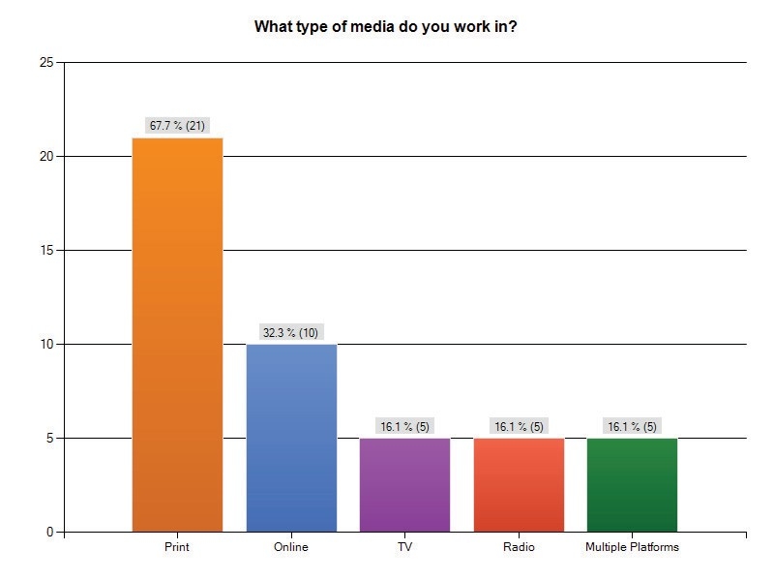

**Question 2: Which media company do you work for?**

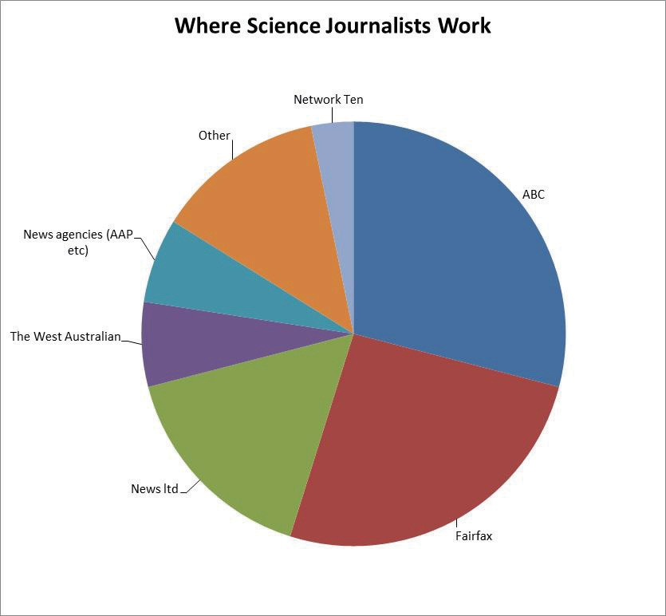

Two respondents identified themselves as freelance writers.

### Question 3: What is your job title?

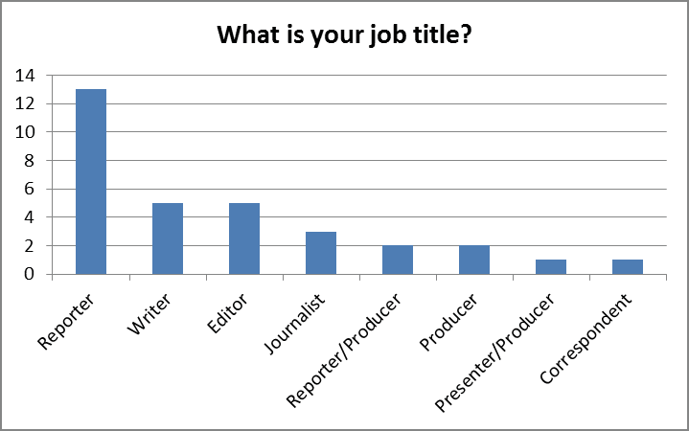

**Question 4: What fields do you cover?**

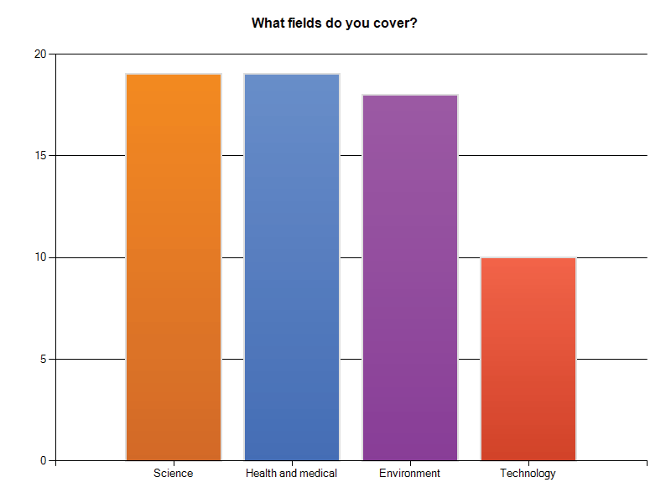

**Question 5: What is your educational background?**

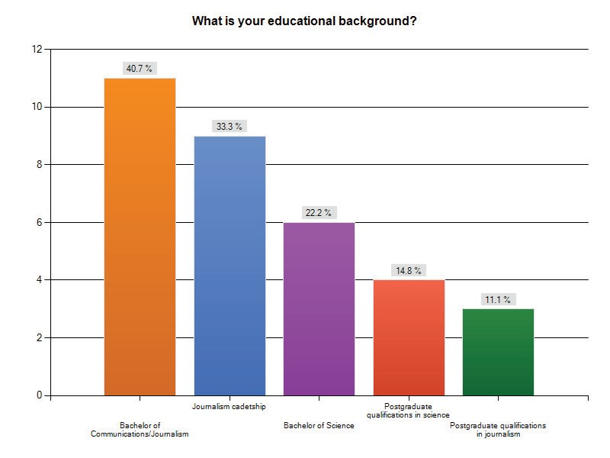

**Question 6: What qualifications did your media outlet look for when hiring for your position as a science journalist?**

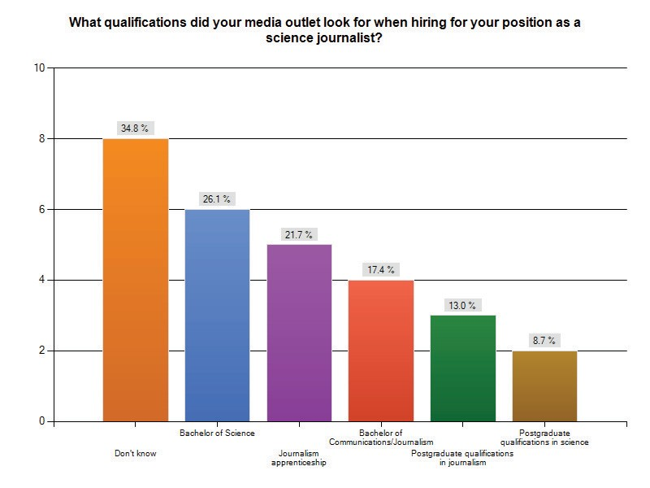

Seven respondents indicated that experience was specifically sought by their media outlet.

### Question 7: How long have you been covering science related topics?

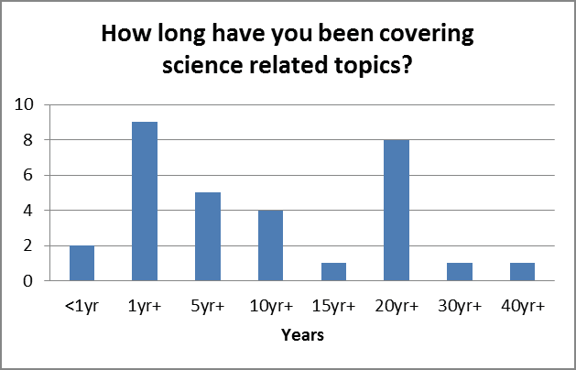

**Question 8: Was your position newly created or did you take over from another science journalist?**

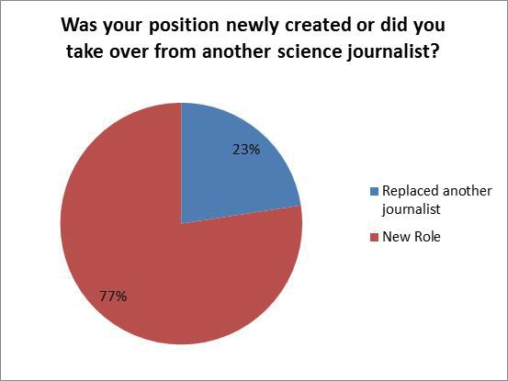

**Question 9: Is your role as a science journalist permanent or will you be moving on to other rounds?**

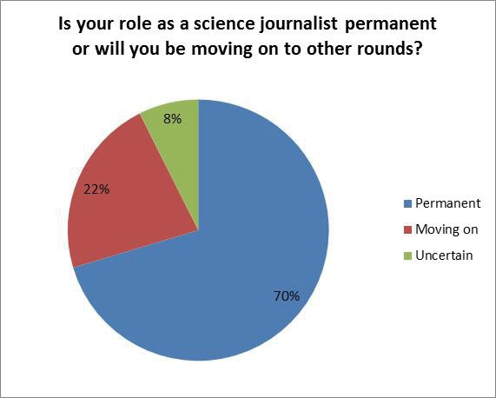

**Question 10: Are you required to produce general stories as well as science stories?**

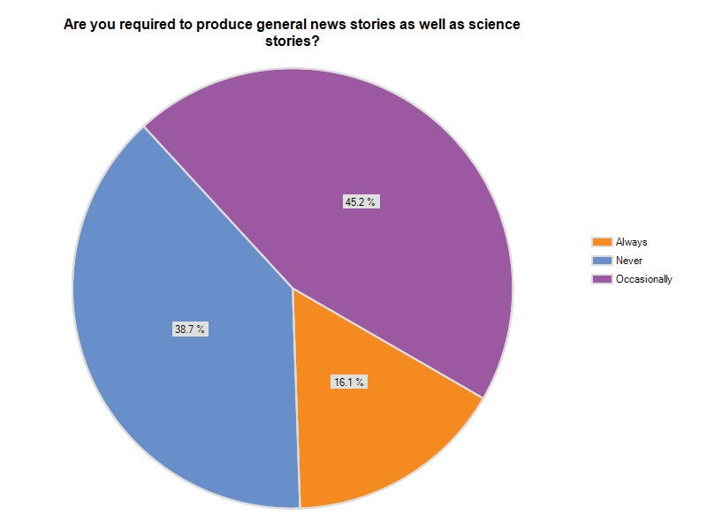

**Question 11: Has your role changed since you started as a science reporter?**

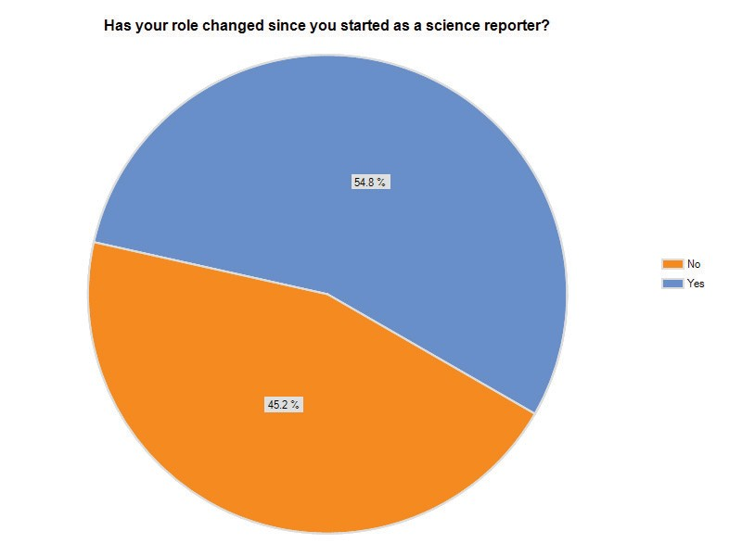

**Question 12: If so, in what ways has this changed?**

The majority of respondents reported that there is an expectation to report stories in more than one medium and immediacy required, especially in online reporting. Additionally the skills expected of some journalists now includes being able to take on the role of a producer and be capable of camera and sound work.

Comments include:

“There is now more consideration of other media platforms and ways of appealing to diverse audiences.”

“More coverage of international science politics/policy expected—less emphasis on ‘local content’.”

“I frequently cover other areas of news, especially when other senior reporters are away.”

### Question 13: How would you rate the following aspects of your work?

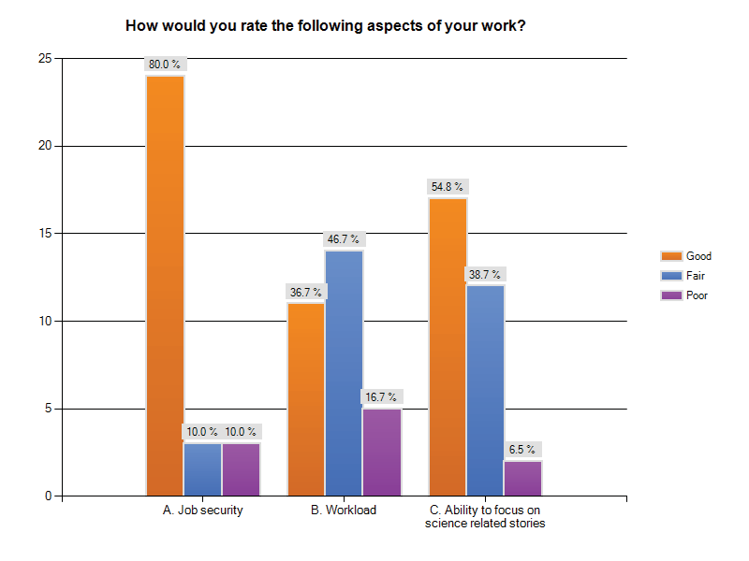

Comments include:

“Workload depends on what you mean by ‘good’. My workload is often demanding, but that can be good.!”

“I am happy in the best job I’ve ever had, but I sometimes wonder if the Editor moved on. His is very supportive of science, and that’s not a universal quality.”

“Continually expected to work produce more with no extra resources thus diluting my ability to do my job properly.”

“Great depth now impossible.”

“Due to a high workload it is very helpful to have organisations like AusSMC who can quickly source expert comment.”

“I frequently cover other areas of news, especially when other senior reporters are away.”

“Politics of the environment are a big factor in my reporting role.”

### Question 14: If you work on a range of media platforms such as online as well as print or radio, how does this influence your reporting?

There were 26 responses to this question. Responses were mixed but there was a common theme of feeling rushed in reporting news for different media.

Comments included:

“I’m a print journalist but am increasingly expected to file for online, and film videos—this increases pressure and means less time is spent on the actual story.”

“When stories are wanted online it can be an incredible rush, with greater potential for errors.”

“Excellent opportunities for cross‐over stories and contacts.”

“It means you can get the message out to a wider audience.”

“I write for online, it doesn’t influence my reporting, simply make two versions of the stories that need to run across the two mediums.”

“Filing online stories allows me report major stories as soon as they break and to update stories as required. Fortunately, it is not a significant component of my workload.”

### Question 15: Do you feel that the role of the science journalist is considered important by your media outlet?

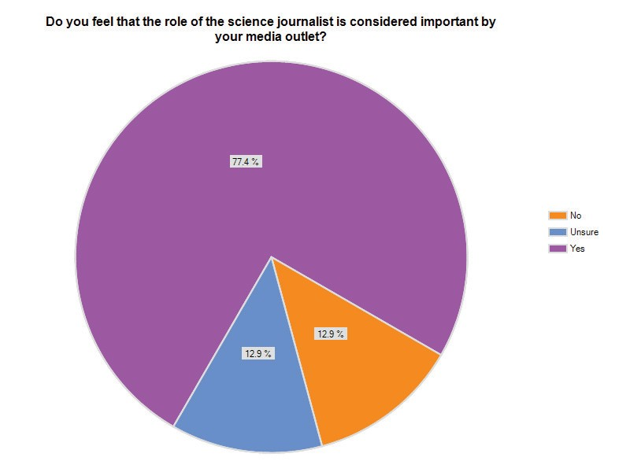

Despite the overwhelming positive response, comments were mixed:

“There are elements of the newsroom who are sceptical of the round.”

“It’s often up to the reporter to make it that way. A dud reporter usually struggles to get published.”

“There’s currently little interest in discovery stories, only current events/politically oriented science stories.”

### Question 16: Has this changed in the past 5 years?

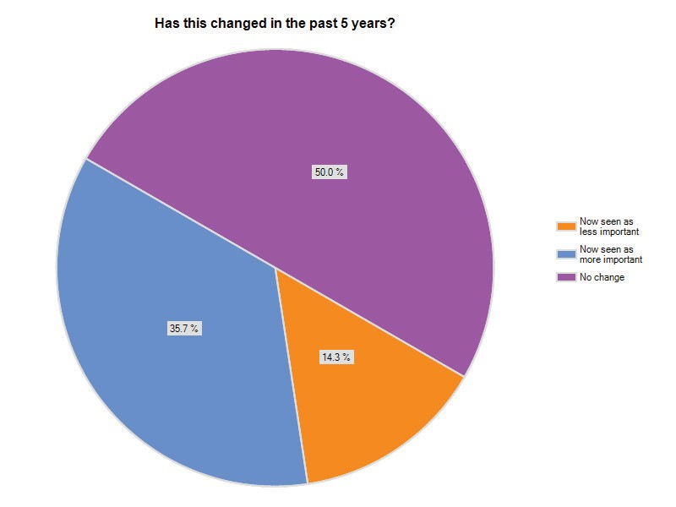

Comments include:

“Climate change and environmental policy has driven much greater interest in science.”

“As the environment has become a bigger political topic so has the importance of the round.”

“There is an increasing demand for ‘uplifting’ medical stories to balance out the negative hard stories of the day, there is more emphasis on study based stories.”

“TV science insecure. No succession in radio.”

### Question 17: Do you have more or less time and resources to research complex stories?

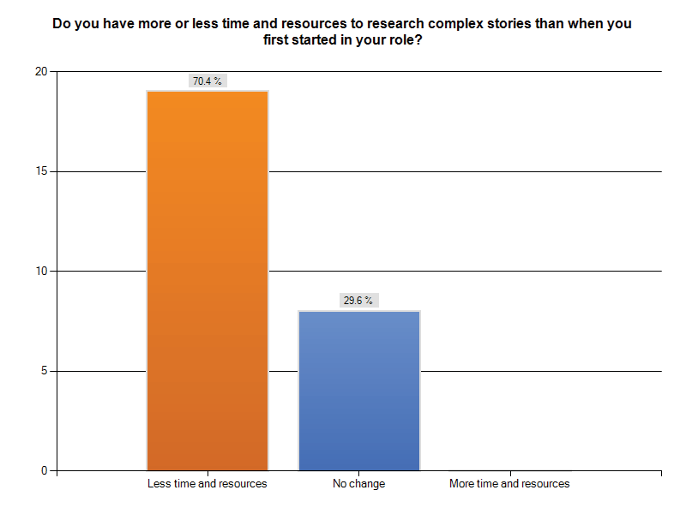

Comments included:

“We no longer have a dedicated researcher in our unit—everyone has to do all aspects of their stories.”

“My job is made easier by the AusSMC.”

“Drinking from the internet firehose can be time‐consuming in itself.” “Resources are about to be boosted. But having enough time is always a battle.”

### Question 18: If you were replaced do you think a general or a specialist journalist would be given your round?

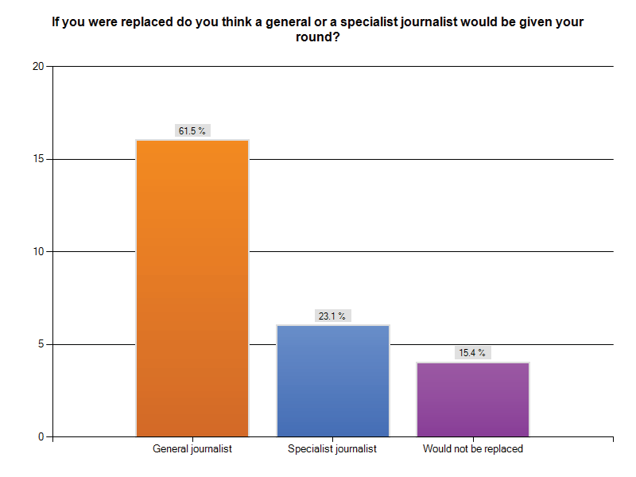

Despite 77.4% of respondents reporting that their employers value science journalists (Q 15), 61.5% of respondents feel that they would be replaced by a general journalist if they left. As one journalist commented “It is possible that someone who was already working as a specialist health reporter at another outlet would replace me but it is more likely the position would be filled internally by a journalist from another round”.

### Question 19: Are there any factors which you feel threaten science journalism in the mainstream media?

There were a wide range of responses to this question. Some key themes include:

* + Time pressure
  + Lack of staff
  + Complexity of science stories—difficult to simplify, audience having poor science literacy limits what is written
  + Online world—more competition, shorter news cycles
* Lack of funding—reduction in budgets, lack of advertising revenue, cost cutting
* Dumbing down of science stories to be appealing to a wide range of audiences
* Lazy reporting of science—breakthrough stories, cheesy news angles Comments included:

“The dumbing down of science to ‘cheesy news angles’ by some institutions—

science communicators have a lot to answer for on this score! It means chiefs of staff etc get a very skewed picture of science, and it perpetuates the schlock/horror view of science as a subject that always needs a joke or a sensational tag to secure a place on the news list.”

“Pressure to attract a wider audience by simplifying stories and avoiding complex science.”

“There is a lot of pressure to dumb down stories to ensure they have wide appeal. Less importance is placed on specialist knowledge in the media.”

“Time pressure (hard to get your head around complex topics in short time frames), lack of advertising support, antagonism towards science on a general basis.”

“Time pressures, less time to work on high quality end.”

### Question 20: Do you see any trends occurring in the media that have an impact on science journalism?

The main trends identified include:

* Dumbing down of news stories
* Chasing ratings
* Online publication
* Reducing budgets Comments included:

“People are more concerned about entertainment than real science news.”

“The dumbing down of the media generally, which I see as the result of the infotainment trend that has made online, print and TV blur.”

“Media moving away from dead trees top online—it should and is changing the way stories are presented.”

“I think there needs to be more effort put into maintaining good high quality science journalism content in the face of the growing pressure to focus on multimedia platforms. Good high quality content should be the top priority.”

“As we do more online, everything has to be reduced down. We have less space to explain complicated issues.”

“I think online media, especially use of graphics videos etc could make science reporting more interactive and exciting.”

“Information is more immediate, we can go straight to the source (reports, papers etc) without the blather of press releases and communication staff.”

“The rise of internet sites for news, more opportunities in specialist news services— people who love science talking to people who love science and leaving other people out of conversation. No support for in‐depth investigative features.”

### Question 21: Do you have any recommendations on how science journalism could be supported further?

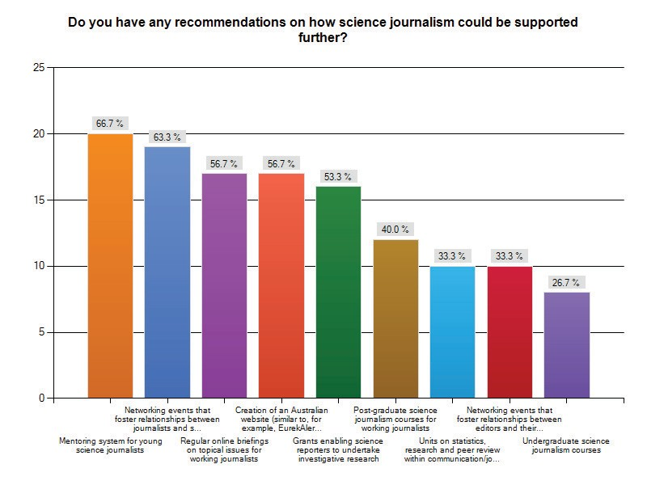

Comments included:

“Cadetships for liberal arts/science graduates with plenty of mentoring support if they get a job. Specialist journalist courses are of little value as journalism is a craft learned on the job. A solid undergraduate degree is the most important pre‐ requisite for Science Journalism.”

“Can I say I think giving science reporters grant money is a BAD IDEA. A journalist undertaking research is no longer an impartial observer. They would have new financial and other ties to a research institute, which would further complicate the task of being a GOOD science reporter. Who writes the story about their research? While I’d love to get a grant to go off and research some issue, it’s important to note that this is the work of a scientist AND NOT A REPORTER. Would a scientist like to come and work for a media company, and deal with the pressures of the news cycle, writing about research institutes they may one day want to work for, or write for the public about research undertaken by their colleagues? I think they would find that horribly compromising—the same applies to journalists!!!”

“The establishment and funding of cross media science cadetships which could operate across the ABC, Newspapers and other media outlets.”

“Better educated readers are the clue, we have the journalists, we have the resources but we don’t have the editors believing that the public want to read about the wonders of the universe. The dumbing down of everything is a social trend reflected and encouraged by mainstream media which is concentrated in fewer and fewer hands. We are in dark times but the trend will swing full circle in a few years when we get a generational change (10 years to go)”

“A difficulty with training and degree programs is then guaranteeing the availability of employment for science skilled journalists in Australia—our market is just too small. Building the science literacy and capacity of all journalists, editors and media workers in pragmatic, practical and respectful ways, is certainly useful. Skilling up without patronising is key.”

### Question 22: What do you think are the main impediments to strong science coverage?

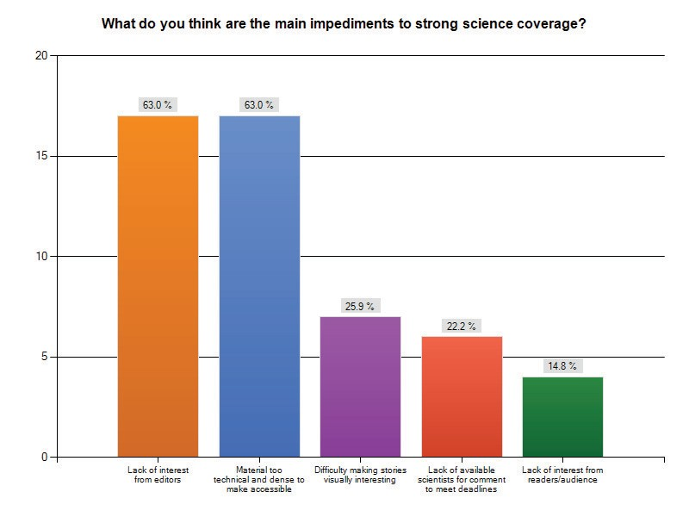

Comment included:

**“**Too many science communicators trying to justify their jobs—I’m serious! Most have no little idea about how the media works, or emerging media trends—many have NEVER been in a news room (Which explains why they ring to inquire if you received their media release at a time when you’re flat out on deadline. I want to deal with scientists directly—not PR people dumbing science down.”

“Scientists must always make themselves available. Sometimes it seems they do not want to deal with journalists even though they want coverage. Understandably, they hate losing control over their work.”

“Often scientists do not understand the process of journalism and what is needed to construct interesting stories”

“More than editors, it is the managers who are not interested.”

“Scientists are generally VERY available to talk about their work. More so than the ‘talent’ involved in any other aspect of reporting I can think of. The problem is an assumption by editors that the public doesn’t care about this stuff. In general, I think the public does care—and the challenge is on presenting the information at a level that explains but does not condescend. (Assuming the journalist even understands it!!!)”

### Question 23: Do you have any other comments on science reporting in Australia?

“Most scientists are fine with the media, but somehow this myth is being perpetuated that they need the intervention of special communicators to make the work accessible. They don’t.”

“I’d like to see more science journalism jobs, paid at decent wages. Until then all this talk of supporting science reporting to a certain extent sounds like empty rhetoric and window dressing to me.”

“Australia does not and has not suffered from widespread inaccurate science reporting. Rather, it’s suffered a lack of editorial/producer interest in the commercial media. What we don’t need are more press releases and efforts to encourage young scientists to see a career. Most incorrectly see Science Journalism as explaining science, whereas the job is to cover the current events angles on advances, as well as the political and social environment in which scientists operate. As noted above I strongly feel a liberal arts degree is the best basic requirement, with a social science or science grad degree the icing on the science journalist cake. Again I argue mentored cadetships are the way to learn the craft. It’s journalism not science education.”

“The big question is how science journalism will fare against blogging. Many people prefer blogs because they pander to prejudices. Objective journalism hasn’t established a strong case for itself, not least because there are too many editorial agendas that pander to prejudices too.”

“We are a tiny community. Building capacity and community amongst science journalists has been attempted in the past through the Australian Science Communicators network, but this is really more focused on communication professionals rather than journalists and journalism per se—I know very few journalists who are members. As community builders in the profession Australian science journalists often pack above our weight on the world stage—mainly because a few individuals have been active in global networks of science journalists over the years—but building capacity and confidence in the profession within Australia, especially in an increasingly constrained media landscape (funding models, staffing, science output) is a challenge worth focus.”

“The AUSMC is a fantastic initiative and is fantastic at flagging interesting news leads to media companies, and then helping reporters turn these into stories. I would shudder to think what would happen to science reporting without them! I guess I also struggle with this notion that some people think we need to ‘make science cool’ so the public will engage. I think that is selling the public short. We need to adopt a more mature position which says ‘the public expects to be kept informed on this’ and then pitch science‐based stories, relevant to breaking news

stories, to news rooms. Scientists and the academic community also need to be less worried about how they are perceived or more intent on getting the message out. They have a valid voice in most news stories and it is waiting to be heard. In general, I think most of these things are occurring (at least I see it on my patch). I also acknowledge some parts of the media appear to live in blissful ignorance of scientific principals or the need for an evidence base!”

“We need an active science community commenting on stories published via letters etc to give the feedback the editors want to hear so they understand the readership isn’t as dumb and uninterested as they believe.”

# Notes

1. Science here is broadly defined as evidence‐based research and includes the natural and physical sciences, technology, engineering and evidence‐based social science research.
2. *Community interest and engagement with science and technology in Victoria, Research Report*

(2007). Victorian Department of Innovation, Industry and Regional Development.

1. Lamberts R, Grant WJ, Martin A, *Public Opinion About Science*, ANU Poll (2010).
2. AusSMC. *A recent snapshot.* [**http://www.aussmc.org/archive‐2/a‐recent‐snapshot/**](http://www.aussmc.org/archive-2/a-recent-snapshot/)
3. Painter J, *Summoned by Science: Reporting climate change at Copenhagen and Beyond* (2010). Reuters Institute for the Study of Journalism.
4. Cormick C, *What Drives Climate Change Drifters?* Conference Proceedings of the Public Communication of Science and Technology, New Delhi, December 2010
5. Australian Science Media Centre, *Free to Speak: A survey of Australian scientists and their interactions with the media* (2007): [**http://www.aussmc.org/about‐us/surveys**](http://www.aussmc.org/about-us/surveys)
6. Cribb J, *Perils of the Junk Information Age*. Issues 87: June 2009; 20‐23
7. Access Economics & The Department of Innovation, Industry, Science and Research. (2010) *Australia’s future research workforce: supply, demand and influence factors*. [prepared by Access Economics] prepared for The Department of Innovation, Industry, Science and Research: [**www.innovation.gov.au/Research/Documents/AustraliasFutureResearchWorkforce‐**](http://www.innovation.gov.au/Research/Documents/AustraliasFutureResearchWorkforce-SupplyDemandandInlfuenceFactorsStudy.pdf)[**SupplyDemandandInlfuenceFactorsStudy.pdf**](http://www.innovation.gov.au/Research/Documents/AustraliasFutureResearchWorkforce-SupplyDemandandInlfuenceFactorsStudy.pdf)
8. SA Thinkers in Residence [**http://www.thinkers.sa.gov.au/**](http://www.thinkers.sa.gov.au/)
9. Auspoll & Federation of Australian Scientific and Technological Societies and Australian Academy of Science (2010) *Science Literacy in Australia*. Prepared by Auspoll for the Federation of Australian Scientific and Technological Societies and the Australian Academy of Science: [**www.fasts.org/images/News2010/science%20literacy%20report%20final%20270710.pdf**](http://www.fasts.org/images/News2010/science%20literacy%20report%20final%20270710.pdf).
10. Pockley P, *Science Journalism Threatened*, Issues 87: June 2009, 8–13.
11. ABC Science Online
12. Nielsen Social Media Report, Wave 3: 2009–2010, *Separating hype from reality*.
13. Williams R, *Facing extinction*, The Walkley Foundation, 19 February 2010:

[**www.walkleys.com/features/617/**](http://www.walkleys.com/features/617/)

1. The Pew Research Centre for the People & the Press, *Americans Spending More Time Following the News,* September 12, 2010: [**http://people‐press.org/report/?pageid=1793**](http://people-press.org/report/?pageid=1793)
2. Wilson A, Robertson J, McElduff P, Jones A, Henry D, (2010) *Does It Matter Who Writes Medical News Stories?* PLoS Med 7(9): e1000323. doi:10.1371/journal.pmed.1
3. Government 2.0 Taskforce, *Engage: Getting on with Government 2.0*:

[**www.finance.gov.au/publications/gov20taskforcereport/index.html**](http://www.finance.gov.au/publications/gov20taskforcereport/index.html)

1. Public Research Agency Charter with the Commonwealth Scientific and Industrial Research Organisation: [**www.innovation.gov.au/Science/Documents/CharterCSIRO.pdf**](http://www.innovation.gov.au/Science/Documents/CharterCSIRO.pdf)
2. Australian Curriculum, Draft Consultation version 1.1.0 (2010) Australian Curriculum Assessment and Reporting Authority

Year 7/8 Content Descriptions: Science as a Human Endeavour, Nature of Science

Science helps individuals and communities to make choices about issues in life and evaluate claims made in a range of media and advertising. Elaboration: evaluating media and product claims about nutrition and exercise in terms of knowledge about the structure and function of relevant body systems; critiquing claims made in a range of media about issues relating to use of energy resources

Achievement standard (Year 7): They begin to evaluate how science is used in society (eg advertising, media, health and environmental promotion, engineering and technology, careers) and begin to reflect on how science is used to inform people’s ideas of the world around them.

Achievement standard (Year 8): They can use their scientific understanding to evaluate scientific claims (eg in media and advertising).