Innovation and Science Australia
Performance Review of the Australian Innovation, Science and Research System
2016

© Commonwealth of Australia 2016
ISBN: 978-1-925092-88-2 (print)
ISBN: 978-1-925092-89-9 (online)
Performance Review of the Australian Innovation, Science and Research System 2016
With the exception of the Commonwealth Coat of Arms, this work is licensed under a Creative Commons Attribution 4.0 International licence (CC BY 4.0)
http://creativecommons.org/licenses/by/4.0/deed.en
Third-party copyright
Wherever a third party holds copyright in this material, the copyright remains with that party. Their permission may be required to use the material. Please contact them directly.
Attribution
Innovation and Science Australia (2016) Performance Review of the Australian Innovation, Science and Research System 2016. Commonwealth of Australia. Canberra.
Use of the Coat of Arms
The terms under which the Coat of Arms can be used are detailed on the following website: http://www.itsanhonour.gov.au/coat-arms

Foreword
Since the dawn of civilisation, innovation has driven human progress. What many take for granted— the elimination of diseases such as polio and smallpox, breakthrough antibiotic treatments such as penicillin, safe and efficient travel courtesy of the jet engine, individual access to computing and communications power within a hand-held device—all of these benefits have been delivered by innovation. Innovation is an essential driver of productivity and economic growth; hence governments around the world are grappling with how best to encourage and support more of it.
In recognition of the importance of innovation to our future prosperity, in December 2015, the Australian Government announced its National Innovation and Science Agenda (NISA). One of the initiatives in the NISA was the formation of Innovation and Science Australia (ISA), an independent statutory body with the remit to provide whole-of-government advice on all science, research and innovation matters. A key deliverable for ISA is to develop a strategic plan for improving and enhancing Australia’s Innovation, Science and Research System that extends to 2030. Our intention is to deliver a plan to government by late 2017.
The ISA Board is also tasked with the oversight of a number of Australian Government innovation support programmes, including the Research and Development Tax Incentive, the Venture Capital Limited Partnerships and Early Stage Venture Capital Limited Partnerships funding, the Entrepreneurs’ Programme elements, the Biomedical Translation Fund, and the Cooperative Research Centres.
ISA’s board is composed of a mix of members drawn from industry and science with extensive experience in innovation and entrepreneurship (Appendix A). The board’s areas of expertise include venture capital funding, start-ups and early-stage innovative businesses, academic research, innovation within large businesses and translating research into commercial opportunities. I am assisted in my role as Chair of this committed group by Dr Alan Finkel, Australia’s Chief Scientist, as the board’s deputy chair.
ISA’s mission is the realisation of an ambitious vision for Australia’s future, one in which science and innovation play a central role in securing our prosperity and addressing the great challenges of our times. Australia must be ambitious in facing these challenges. We are a country with incredibly talented and industrious people and we must aim to optimise our innovation potential. This means creating, transferring and applying knowledge to achieve a sustainable high-growth economy and protect the environment and social fabric of this great nation.
This is an important and exciting challenge. As a nation we currently spend more than $33 billion per annum on research and development and it is essential we optimise the benefits from such investments.
ISA’s important work begins with this Performance Review of the Australian Innovation, Science and Research System (ISR System Review). The ISR System Review does not make specific recommendations for future government decisions, but instead provides a baseline from which to develop the 2030 Strategic Plan and measure future progress. Nonetheless, the findings in the ISR System Review make one thing very clear: we need to significantly lift our game if we want to be a top tier innovation nation. My fellow board members and I hope that the ISR System Review will provide valuable insights and guidance to stakeholders during this critical evaluative period of the process. We look forward to seeking input through broad consultation for our task ahead.
The production of this ISR System Review would not have been possible without contributions from a wide range of stakeholders and experts from across government, business, academia and the public. I would particularly like to acknowledge and thank PricewaterhouseCoopers for its pro bono assistance in developing the performance scorecard, and the Australian Council of Learned Academies for conducting workshops and sharing valuable insights gained through the Securing Australia’s Future work programme. I would also like to thank those staff members from the Department of Industry, Innovation and Science, including the Office of the Chief Economist, the Department of the Prime Minister and Cabinet’s Project Office, and many other stakeholders who contributed throughout the drafting process.
Bill Ferris AC
Chair, ISA Board
December 2016

Contents
Foreword i
Executive summary vi
Introduction 1
Overview 1
What is innovation? 2
What is research? 2
What is science? 2
Why innovate? 2
National Innovation and Science Agenda 4
National and global context 4
Technology and globalisation 5
Society 5
Urbanisation and sustainability 6
Part A | Measuring performance 8
What is the Innovation, Science and Research System? 8
Framework for assessment 9
Part B | Performance assessment 13
Enablers 13
Policy 13
Money 30
Infrastructure 49
Skills 56
The Australian research workforce is world-class in many research fields 63
Networks 73
Collaboration between researchers and businesses appears limited 75
Culture 80
Our short-term-oriented culture may affect innovation in different ways 84
Outputs 86
What are Australia’s innovation outputs? 87
Novelty of innovation introduced by Australian businesses 87
Who produces Australia’s innovation outputs? 88
Strengths 90
Weaknesses 92
Findings: Outputs 92
Outcomes 93
Economic outcomes 93
Social outcomes 96
Environmental outcomes 97
Strengths 98
Weaknesses 98
Findings: Outcomes 99
Part C | Overall findings and next steps 102
Performance of the Australian Innovation, Science and Research System 102
Key findings 102
Knowledge creation 102
Knowledge transfer 103
Knowledge application 103
System-wide 104
Outputs 104
Outcomes 104
Key findings 105
Scorecard 106
Prioritisation and selection of the scorecard indicators 106
The performance scorecard 106
The 2030 Strategic Plan 109
Part D | Appendices 111
A ISA Board Member biographies 111
B Acronyms and glossary 116
Acronyms 116
Glossary 117
C Consultations 122
Stakeholder list 122
D Scorecard performance metrics 127
Knowledge creation 127
Knowledge transfer 129
Knowledge application 130
Outputs 132
Outcomes 132
E Summary of Australian Government programmes 133
F Summary of Australian Government programme assessments 136
G State and territory programmes 138
H Areas for regulatory improvement 139
I Networks of different types in Australia 143
J Initiatives related to innovation in Indigenous communities 145
Notes 147

Note: References through this document are provided in the Notes section.

Executive summary
Whilst Australia enjoys an enviable level of broad-based prosperity, we must invest wisely in order to sustain it. The forces of technological change are increasingly disrupting our economy but at the same time opening new and compelling paths to future wealth. As a nation we must harness these changes to our shared advantage.

The context for the Innovation, Science and Research System Review
Australia has maintained a sustained period of economic growth and high employment for the past 25 years, including through the Global Financial Crisis when many other developed nations fell into recession. For Australians, this growth has increased GDP per capita, delivered jobs and higher standards of living. On average, we enjoy some of the longest lives, best-quality services and most liveable communities in the world.
Australia, like many countries, has seen a recent slump in productivity growth. If productivity growth is not revitalised, Australia risks a prolonged period of stagnation. At the same time, the accelerating pace of technological change is causing structural shifts in key industry sectors and employment patterns. Long-term trends, such as the ageing of the population and changes in the climate, present complex challenges that communities will have to solve together.
Against this backdrop, the Australian Government recognised through the National Innovation and Science Agenda (NISA) that a robust, resilient, and efficiently functioning Innovation, Science and Research System (the ISR System) is critical to the opportunities all Australians will enjoy. The government has therefore asked Innovation and Science Australia (ISA), an independent statutory board, to review the current performance of the ISR System (the ISR System Review). This assessment will inform a long-term strategic plan for the development of the ISR System to 2030.
In the ISR System review, we consider a range of performance metrics that characterise the current ISR System, and, where appropriate, compare them to the performance of systems in other OECD+ countries (the 35 OECD member countries in addition to China, Taiwan and Singapore). We provide a snapshot of a changing Australia and observations about the opportunities we want Australia’s ISR System to enable in the years ahead.

Innovation in Australia

What do we mean by innovation?
Innovation is doing something differently and creating value as a result. It is found in every sector of the economy, in enterprises large and small, and in cities as well as regional areas. The value it creates can be economic, social or environmental. From an economic perspective, innovation is the key long-term driver of productivity growth. More generally, innovation is the key enabler of adaptability and renewal across all sectors of society, and thus is an important determinant of how readily communities can adjust to the realities of different times.

What do we mean by research?
Research is the creation of new knowledge, creating in turn the expanded capabilities that enable the development of novel technologies, skilled jobs and new products. It includes basic research to create new knowledge without a particular use or application in view, applied research directed towards an aim or objective, or a mix of both. A number of actors carry out research, including businesses, higher education institutions, not-for- profits and governments. Research also covers a diversity of disciplines, including arts, humanities and social sciences. It is often a mix of many. In all its forms, it is essential to innovation.

What do we mean by science?
Historically, science was the study of individual natural systems, from which we came to understand the fundamental characteristics of our world such as the nature of light, movement and chemical reactions. Today science is dominated by the need to understand complex systems and to predict their behaviours. Research in science increasingly takes into account interactions with society and the economy. In the light of such complexities and responsibilities, scientists collaborate with the humanities, social sciences and other disciplines. They must communicate to the public the uncertainties, consequences and benefits of their research. Most importantly, scientists have a duty to contribute to teaching science and mathematics to our youth. This will ensure the broader ability of our population to understand the world around them and be equipped with the skills increasingly demanded for the jobs of today and the future.

What do we mean by the “ISR System”?
The Australian ISR System is complex and dynamic. The ISR System is an open network of many diverse actors who interact to produce and spread innovations that have economic, social and environmental value. The people and organisations in the ISR System include businesses (big and small, old and new), not-for-profits (publicly funded and private), education providers, investors, governments (federal, state, territory and local), researchers and end-users (consumers and communities). The composition of the ISR System changes, as actors join and leave, and the intensity of activity also changes as investments and risk appetites rise and fall. The Australian ISR System is highly interconnected with international systems, as knowledge, talent, and competitor organisations move across national and regional boundaries.
Figure 1: Sources, users and activities of R&D funds (ISA estimates), 2014.³
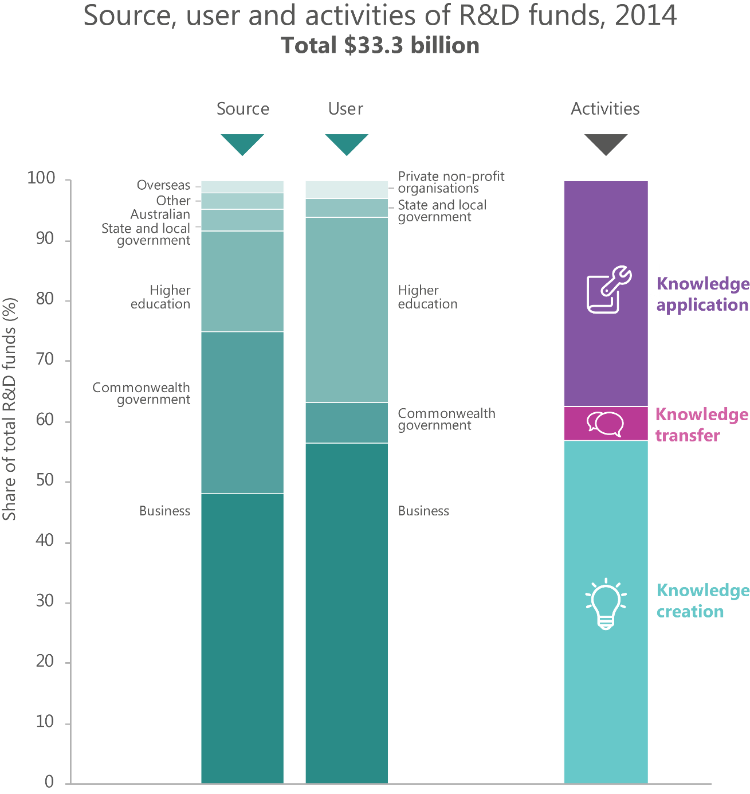

What is the scale of the ISR System?
The complex and dynamic nature of the ISR System makes it difficult to measure with precision or in real time. A recurrent theme in this ISR System Review is the challenge of capturing the activities and the impacts of actors in the ISR System with sufficient clarity to inform a national response.
A sample of metrics, however, demonstrates that the ISR System is significant and underscores the importance of studying its dynamics in depth:
- The national investment in research and development (R&D) currently totals 2.1 per cent of GDP. In absolute terms, the Australian Government invests around $10 billion in this activity, and other participants in the ISR System (primarily the business community) invest twice as much again (Figure 1).
- Surveys suggest that some 58 per cent of small and medium-sized enterprises and 68 per cent of large firms successfully introduced innovations, though only 9 per cent of firms introduced highly novel, new-to-market innovations. ¹
- The level of risk capital investments in emerging businesses and technologies, through mechanisms such as angel investment and venture capital, is difficult to establish, but the best metrics of venture capital investment point to at least 205 new and follow on investment deals totalling $383 million in 2014–15.²

ISA’s approach to assessing the ISR System

This ISR System Review uses a simple framework to guide the performance assessment
ISA’s framework identifies three innovation activities (see Figure 2):
- knowledge creation;
- knowledge transfer; and
- knowledge application.
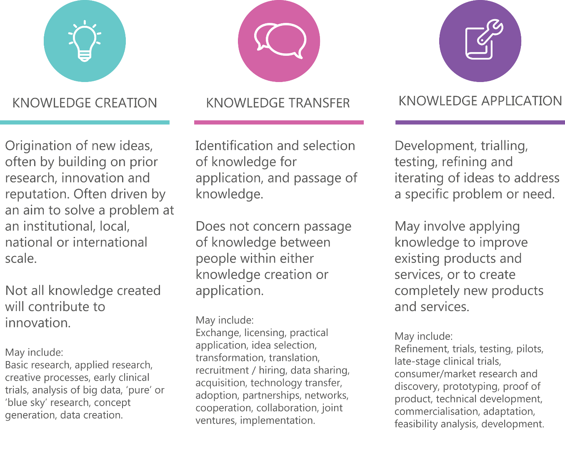
Figure 2: Innovation activities, by type
These activities produce outputs across the ISR System, such as new and improved products or processes.
The adoption of innovation outputs, including those sourced from international systems, delivers outcomes, such as improved productivity, longer life expectancies and a more resilient Australian ISR System.
These activities do not occur in a vacuum. The framework identifies six categories of enablers that facilitate innovation activities:
- policy;
- money;
- infrastructure;
- skills;
- networks; and
- culture.
The linkages across, within and between innovation activities and enablers are of critical importance to eventual outcomes (Figure 3).
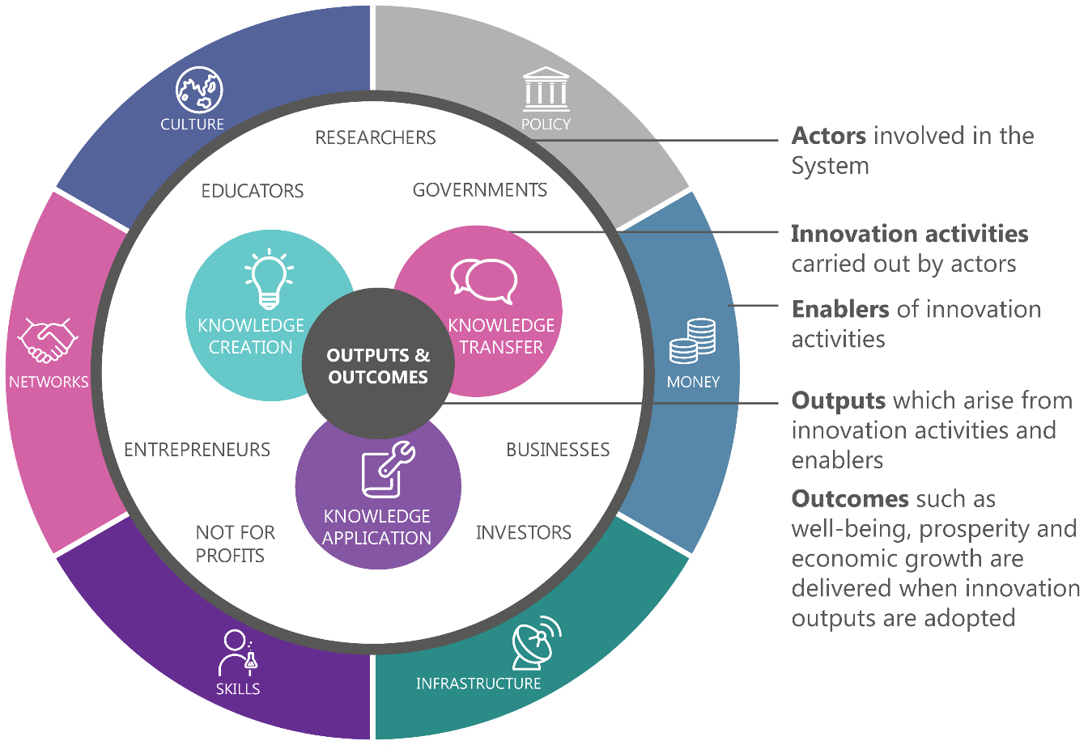
Figure 3: Performance framework to assess the Australian ISR System.

To capture this complexity, this ISR System Review examines the overall strengths and weakness of the ISR System’s activities in knowledge creation, knowledge transfer, and knowledge application through the lens of the six categories of enablers. It also considers indicators for the outputs and outcomes that the ISR System generates from these activities.

An Australian Performance Scorecard
This ISR System Review has been prepared in part to provide a baseline from which to measure future progress through the adoption of suitable metrics, recognising the limitations of existing frameworks as aids to policy. International assessments, in particular, frequently use rankings as an assessment tool, but do so with a focus on only a single aspect of the system, or try to combine disparate dimensions into a single “score” (with all the methodological challenges that might be expected).
The Global Innovation Index is one example of the advantages and limitations of this approach. It ranks the innovation performance of 128 countries and economies around the world based on 82 indicators.⁴ Australia ranked 19th in the 2016 Global Innovation Index, and our overall international position has been relatively stable over the past five years, ranging from 17th to 23rd.⁵ Whilst the Index provides a useful annual pulse check it needs to be interpreted with an understanding of our unique national context and goals.
This ISR System Review introduces a new Australian Scorecard, calibrated to the needs of Australian decision-makers through measures of particular relevance to our ISR System, and informed by the global evidence base. More than 250 available metrics gathered by domestic and international bodies such as the OECD were assessed and prioritised to identify 20 most pertinent and relevant performance indicators performance indicators (Figure 4).
ISA welcomes feedback on this approach, and will finalise these metrics as part of the 2030 Strategic Plan.
Figure 4: Performance scorecard for the Australian ISR System.⁶
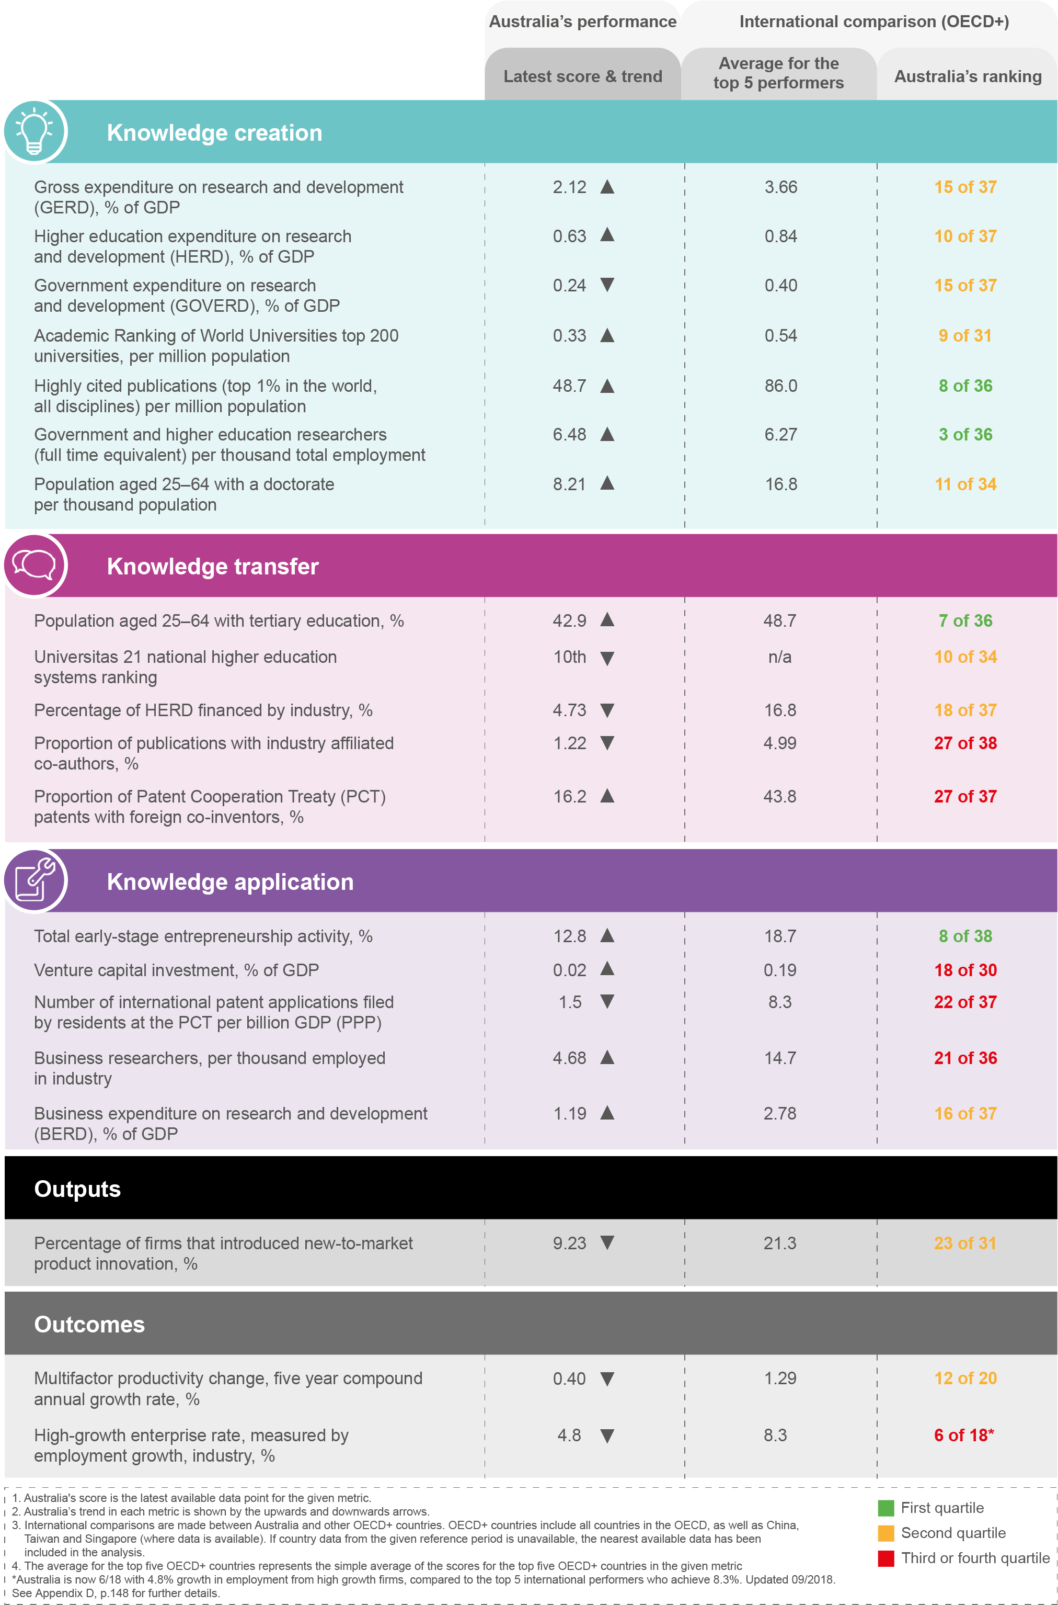

This ISR System Review complements existing Australian data and reports
The ISR System has been analysed and assessed by a number of bodies from both the public and private sectors. Public sector examples included:
- The Office of the Chief Economist in the Department of Industry, Innovation and Science has for several years prepared the annual “Australian Innovation System Report”, which brings together a body of evidence on the structure and performance of Australia’s innovation system.
- The Chief Scientist is leading the development of the 2016 National Research Infrastructure Roadmap, setting out priorities for future investment in line with emerging needs and strengths.
- The Australian Research Council conducts a regular evaluation of Australia’s university research quality under the banner Excellence in Research for Australia.
From the private sector, reports have included:
- The “Crossroads” report by start-up industry group StartupAus, which tracks the rapid development of the start-up ecosystem in Australia over recent years.
- The report “Compete to Prosper: Improving Australia’s global competitiveness”, published by McKinsey in 2014.
- The “Securing Australia’s Future” series of reports by the Australian Council of Learned Academies (ACOLA).
This ISR System Review is intended to complement these and other reports, and provide a baseline perspective to inform ISA’s future work on the 2030 Strategic Plan.

Findings
The findings on the performance of the ISR System cover knowledge creation, knowledge transfer and knowledge application, as well as innovation enablers, outputs and outcomes. Highlights are discussed below, while the full list of 30 findings are available at ‘Part C: Overall findings and next steps’.
Two enablers emerge as common themes in the ISR System as a whole (system-wide):
- Culture: Australia is one of the most multicultural societies in the world, with a quarter of Australians born overseas and a strong tradition of immigration. International studies point consistently to the powerful positive impacts of diversity, and of immigrants in particular, in driving innovation ecosystems. There is good anecdotal evidence that this is true in Australia. Reports have argued that Australia could make better use of its home-based diaspora of skilled immigrants and its international higher-education alumni. It could also draw upon its diaspora of skilled citizens in innovation clusters around the world such as Silicon Valley and Israel. At the same time, women are under-represented in several parts of the ISR System, despite strong evidence of the benefits of gender diversity, with studies pointing to the importance of cultural factors in shaping these trends.
Although there are common references to Australia’s ‘risk-averse’ culture, no strong evidence of this was found. To the contrary, although Australian incentive structures do not consistently encourage risk taking behaviour, in many places there is strong evidence of a vibrant and healthy appetite for risk. There is also evidence suggesting a focus on the short term at the expense of the long game, which could inhibit our progress towards a more dynamic and innovative future.
- Policy: The Australian Government’s support for innovation has included major investments in its research agencies like CSIRO and long-standing programmes including Rural R&D Corporations, Cooperative Research Centres, research block grants and tax incentives for business. Whilst there are evaluations showing the success of several such programmes, there is a need for improved data in this area to ensure the efficiency and effectiveness of all Australian Government interventions.

Knowledge Creation: Australia is above average
Australia’s performance in knowledge creation is generally above average. For example, Australia ranks 8th out of 36 OECD+ countries in its contribution to the top 1 per cent of highly cited publications per million population,⁷ and the nation’s universities have generally been trending upwards in rankings based on research metrics.⁸ This reflects support from several enablers, namely:
- Money: Australia’s relative level of expenditure on R&D activities in higher education and private not-for-profits is above the OECD average (albeit not in the top tier), and is continuing to grow in absolute terms.⁹ Collectively over half of this pool is spent in the fields of medical and health sciences, biological sciences and engineering.
- Infrastructure: Australia has excellent research infrastructure assets, most of which have high levels of use and have supported significant outputs and achievement. However, there is scope for improvement in the overarching governance and ongoing whole-of-life funding for research infrastructure, which the 2016 National Research Infrastructure Roadmap will address.
- Skills: Australia achieves a higher quality and quantity of research outputs than international peers based on the size of its research community, with standout research quality in science and engineering. The Australian population enjoys high rates of graduation from higher degrees by research (MPhil or PhD).¹⁰
- Networks: The Australian research community exhibits high levels of international collaboration, and is well represented in international scientific efforts such as the Square Kilometre Array.
Whilst this is generally a positive result, it points to significant scope to raise the national aspiration from “above average” to “top tier”. For example, despite a strong university system overall, Australia has no university in the global top 20.

Knowledge Transfer: Needs to be improved
Several previous studies have identified knowledge transfer as an area of weakness in Australia. Specific areas in which Australia’s knowledge transfer activities could be improved include:
- Networks: There is substantial evidence that Australia is poor at translating and commercialising its strong research base. International data suggests that collaboration between the research and business community is weak, and mobility of people between academic and business careers is low. Changes are underway, with governments, research organisations and businesses increasingly looking to more formalised models and roles to facilitate relationships and collaboration.
- Skills: The capacity of the population to absorb new technologies and ideas is reflected in the availability of skills gained through tertiary education, as well as the literacy and numeracy of the workforce overall. Australia has a highly educated population: over 40 per cent of working age people have a tertiary education, placing Australia just outside the top five performing OECD+ countries.¹¹ However, the performance trend in international surveys of school science and mathematics suggest that Australia’s education system is significantly underperforming against other countries, many of which are advancing rapidly.
Comparisons with other nations also suggest that Australia could harness the vocational education and training sector more effectively to build skills for innovation.
- Policy: In 2016–17, only 16 per cent of government funding for innovation programmes will specifically encourage knowledge transfer.
- Infrastructure: Recent efforts by several Australian agencies to open government datasets to community use reflect growing recognition of their untapped economic and social value.

Knowledge Application: Not yet matching our strength in knowledge creation
There is strength and vibrancy in the start-up sector, reflected in the growth of accelerators and co-working spaces across the country, and an influx of venture capital, in many cases driven by serial entrepreneurs. These are hallmarks of a start-up movement with growing potential. However, across several categories of enablers there is a mixed picture in the area of knowledge application:
- Policy: Global studies have consistently shown that strong regulatory frameworks and infrastructure, and sound banking, legal and corporate sectors provide an environment conducive to business innovation. Australia compares favourably on many of these enablers, and policy changes in areas such as bankruptcy laws introduced as part of NISA are likely to further enhance the innovation environment. However, while businesses do not cite regulation as a general barrier to innovation, there are regulatory restrictions in some specific areas and there is evidence that the Australian Government’s procurement policies have not encouraged innovation as effectively as approaches in other countries.12 New initiatives such as the Business Research and Innovation Initiative (BRII) and the Australian Government’s Naval Shipbuilding Plan are expected to improve this performance.
- Skills: Whilst the skill level of the Australian workforce is generally high, a number of studies have highlighted concerns about the quality of Australian managers with respect to innovation leadership and management. Separately, Australia’s skilled immigration policies have generally been supportive of the needs of innovative businesses, but there is growing competition for skilled migrants from other countries.
- Networks: Connectivity between Australian and international businesses is weak, and Australian businesses do not sufficiently participate in global value chains.
- Money: Australia shows persistently low levels of business expenditure on R&D compared with leading innovation nations.13 Despite generally sound credit markets for established businesses, access to risk capital is an area where Australia lags other countries14, although ISA notes that several significant new venture capital funds have been raised in the past 12 months, and additional support through NISA has also been put in place.

Innovation Outputs: A question of novelty
Australia has a strong base of businesses that have implemented new and improved goods and services, processes, marketing and organisational practices. This is reflected in the fourth highest proportion of innovative small to medium enterprises (SMEs) in the OECD+.¹⁵ There are some standout sectors, such as mining, manufacturing, financial services, and professional, scientific and technical services, in which businesses are introducing high levels of new-to-the-world innovations. However, the vast majority of innovation introduced by Australian businesses has a low degree of novelty¹⁶ and relies upon the adoption and adaptation of existing technology and knowledge (i.e. following best practices). This suggests that the ISR System is failing to capitalise on its above average performance in knowledge creation. Transferring and applying that knowledge into radical innovation is what generates greater impact and higher rewards to business, the economy, and broader society.

Innovation Outcomes: Watch the trends
Australia’s overall economic performance has been strong compared with other OECD nations over the past few decades. Few other countries have consistently outperformed Australia on GDP per capita and unemployment. Australia has also regularly ranked highly on well-known indices of social outcomes, highlighting relatively high life expectancies, educational attainment and life satisfaction. While there are many factors at play, these are at least in part attributable to Australia’s historic performance in innovation.
At the same time, there are some concerning trends in outcome data. Like many other countries, Australia’s multi-factor productivity performance has been weak over recent years. Additionally, Australia needs to increase the number of high growth firms that will create future jobs, strong productivity growth and, through innovation, higher wages.

An overall perspective
Australia’s ISR System shows uneven performance. There are some sectors where it performs very well and these are central to our international competitiveness.
However, in too many areas, a lack of connectivity across the ISR System means that strong performance in research is not matched by similar performance in commercialisation. The business innovation that we do see can be characterised as incremental rather than new-to-world, and our education system is not equipping young Australians with the skills and entrepreneurial perspectives necessary for achieving a stronger ISR System in the future.
There is an apparent lack of urgency and understanding about this national mission in the broader community. Complacency will endanger the shared prosperity Australians have historically enjoyed.

What ISA will do next

The 2030 Strategic Plan will expand on ISA’s analysis and enable new directions
The Australian Government has asked ISA to develop a 2030 Strategic Plan (the Plan) for innovation, science and research. The Plan will describe what the ISR System should look like in 2030 and the paths by which we can reach it. It will, in effect, set the destination and chart the course that Australia as a nation can choose to take.
Work undertaken to prepare this ISR System Review has highlighted some broader strategic issues that will be considered in developing the Plan. It will be informed by the baseline Performance Scorecard; and it will further evaluate the utility of the performance metrics in informing policy development.

Strategic implications
The process to develop the Plan will commence with consultation. Some of the questions will include:
- What should a fit-for-purpose ISR System look like in 2030? This ISR System Review has painted a picture of Australia as an incremental innovator, with generally low levels of new-to-market innovation. Is this a sustainable strategy to continue into 2030, or is there a need to focus more on disruptive innovation, and move closer to the technological frontier?
- How should Australia regard international peers? Can Australia go beyond simply seeking to “catch up” with more advanced international innovation systems, and instead look to “leapfrog” ahead of them? Can Australia learn from progress in other systems to accelerate its own?
- Which challenges are unique to Australia, and which are global concerns? Where can Australia improve its performance and restart its productivity growth, in the context of a rapidly evolving global market?
- Are there some sectors or projects that could stimulate innovation more broadly? Can Australia take advantage of technological and economic shifts to pursue specific opportunities that would also have broader spill-over benefits for the ISR System?
- How can we ensure better measurement of the ISR System’s performance? Can we improve measurement of the different types of value that innovation adds in order to inform policy development? Are new metrics needed to better understand social aspects of the ISR System such as collaboration and culture? What are the optimal levels of failure or mistakes in the ISR System?
In 2017, ISA will continue the dialogue with the Australian community, as we seek to shape an innovation future that Australia can approach with confidence and courage.

Introduction

Overview
The Australian Government invests around $10 billion each year on R&D related to science and innovation.17 Businesses invest even more.¹⁸ Everyday Australians invest their time, energy and money into developing creative solutions, building new enterprises and integrating new practices and products into their daily lives.
But the questions we have to ask are whether these efforts and investments are achieving as much as they could for all Australians? Is our level of investment in innovation sufficient and appropriately allocated in order to achieve our desired future with improvements to our economic, social and environmental wellbeing?
This Innovation, Science and Research System Review (ISR System Review) provides a broad assessment of the performance of the Australian Innovation, Science and Research System (the ISR System; see Appendix B for a list of acronyms and a glossary of terms used in this ISR System Review). It aims to identify aspects of the ISR System needing greater effort, and to propose metrics that can be used to track the performance of the ISR System over time.
Innovation and Science Australia’s (ISA’s) assessment of the performance of the Australian ISR System:
- gives an overview of the ISR System, including the people, organisations and activities involved
- identifies the key enablers that influence the performance of the ISR System: policy, money, infrastructure, skills, networks and culture
- describes the current performance of the ISR System, including existing interventions and the alignment of activities, priorities and investment
- proposes key performance indicators that could be used to track the performance of the ISA System over time, and
- identifies gaps or barriers that could benefit from change or adjustment, particularly those that can be directly influenced by government.
It does not aim to:
- develop goals or specific recommendations for future government investment, or
- carry out a forensic evaluation or performance audit of specific programmes or initiatives.
This ISR System Review draws on many metrics commonly used to measure innovation.¹⁹ However, ISA recognises that quantitative metrics, on their own, cannot fully reflect the performance of the Australian ISR System. For this reason, ISA’s performance assessment methodology incorporated consultations (see Appendix C), desktop research and previous government reviews to ensure a more robust and insightful picture of the performance of the ISR System.
Importantly, findings from this ISR System Review will provide input to an innovation, science and research strategic plan for Australia, the 2030 Strategic Plan (the Plan).
The Plan will be developed by ISA, in 2017, in consultation with the community, for government consideration.
ISA has been asked to review the performance of the ISR System every five years. To inform this, as well as to track annual progress, a performance scorecard has been developed (see Part C). It includes 20 high-level performance indicators that have been carefully selected, although ISA expects that the scorecard will be adjusted over time as data availability improves and our understanding of the ISR System grows.

What is innovation?
Everyone can be an innovator. Even small improvements in the way we do things are expressions of creativity and innovation, and contribute to an innovative society.²⁰ Such ‘common innovation’ is important because innovation and wealth creation often arise from local-level entrepreneurship and everyday efforts, not just large-scale activities.²¹
At the organisational level, ‘innovation’ can refer to a clearly defined strategy and process, which often involve stages and gates, to guide activity, manage risk and allocate investment.²²
There are many definitions of innovation in use, but the OECD defines innovation as ‘the implementation of a new or significantly improved product (good or service), a process, a new marketing method, or a new organisational method in business practices, workplace organisation or external relations’.²³
Innovations are often measured in terms of economic value; however, other forms of value (such as improved quality of life, environment value or social value) are often the stated objectives of innovation but are less well captured using common performance metrics. ²⁴
This ISR System Review seeks to capture these values with alternative metrics, including qualitative measures.

What is research?
Research is the creation of new knowledge, creating in turn the expanded capabilities that enable the development of novel technologies, skilled jobs and new products. It includes basic research to create new knowledge without a particular use or application in view, applied research directed towards an aim or objective, or a mix of both. A number of actors carry out research, including businesses, higher education institutions, not-for- profits and governments. Research also covers a diversity of disciplines, including arts, humanities and social sciences. It is often a mix of many. In all its forms, it is essential to innovation.

What is science?
Historically, science was the study of individual natural systems, from which we came to understand the fundamental characteristics of our world such as the nature of light, movement and chemical reactions. Today science is dominated by the need to understand complex systems and to predict their behaviours. Research in science increasingly takes into account interactions with society and the economy. In the light of such complexities and responsibilities, scientists collaborate with the humanities, social sciences and other disciplines. They must communicate to the public the uncertainties, consequences and benefits of their research. Most importantly, scientists have a duty to contribute to teaching science and mathematics to our youth. This will ensure the broader ability of our population to understand the world around them and be equipped with the skills increasingly demanded for the jobs of today and the future.

Why innovate?
Australians have some of the highest living standards in the world. We have high life expectancy, access to high-quality education and health services, and some of the most liveable cities in the world.²⁵
This did not come about by accident.
In past times of economic hardship and change, Australians have used their innovative skill, collective effort and creativity to unite and build a better future. In the mid-1980s, Australia faced stubbornly high unemployment, stagnant growth, persistent inflation and declining relative living standards. In response, we embarked on one of the most significant periods of policy reform and change ever seen in an advanced economy.
Australian Governments floated the currency, deregulated the financial system, and swept away unnecessary rules and regulations.²⁶
While the challenges we face today are different from the ones we faced in the 1980s, the economic and social imperative to innovate remains.
Indeed, given the pace of technological change, and the rate at which nations around the world are responding to that change, the risk of not innovating goes beyond simply missing out on opportunities. If the ISR System is not optimised and we as a nation lag in innovation, our economy and national wellbeing will be jeopardised.
The public policy reforms of the 1980s and 1990s set a clear direction and laid the foundations for the economic prosperity we enjoyed in the 1990s and 2000s. Reforms drew on business and community resilience and creativity to build a foundation for new growth and take advantage of opportunities presented by global changes and interconnections.²⁷
During this period many jobs were lost but even more were created.²⁸ GDP per person rose from $18,200 to $20,400 in the five years from 1990 to 1995.²⁹ Productivity growth accounted for most of the increase in real incomes,³⁰ and innovation contributed to productivity growth. Overall, living standards steadily increased.³¹
Australia’s quarter century of economic growth was spurred again during the 2000s by a surge in terms of trade and the mining investment boom.³² More recently, the economy has benefited from a depreciation in our exchange rate.³³ In 2016, Australia entered its 25th year of uninterrupted annual economic growth and our GDP per capita is ranked fourth highest against 37 OECD+ countries.
Looking forward it is clear that Australia cannot just rely on favourable economic conditions or our traditional export base of mining and resources. While we do not want to reduce our resource base, we also need to look towards other areas for growth.
Australia’s productivity growth has weakened since the 1990s.³⁴ In 2015–16, mining investment in Australia fell by approximately 27 per cent. Commodity prices have recently fallen, which has fed into weaker terms of trade and less revenue derived from exports.³⁵
A key part of the problem is that the Australian economy remains undiversified, particularly in terms of exports. Australia has only 19 internationally competitive industry sectors,³⁶ and only two in manufacturing: food and beverages, and basic metals. By contrast, comparator countries, such as New Zealand, Netherlands, and Canada, have at least 35 internationally competitive industry sectors.³⁷ The diversity of exports is seen as a key indicator of a country’s innovation capabilities, and according to Harvard University’s economic complexity index,³⁸ the Australian export base has become less complex over the past decade.
Recent declines in Australia’s terms of trade, and likely declines in labour force participation due to the ageing population, must be offset by improvements in productivity. It is estimated that Australia will need to double its long-term productivity growth for Australians to enjoy the same standard of living as they did under the years of the mining boom.³⁹ Innovation is vital to achieve this. To guarantee our wellbeing and quality of life into the future, we must anticipate and create future opportunities and maximise the benefits of the ISR System.⁴⁰
In 2015, the Australian Government named 24 initiatives in the NISA to address key weaknesses in the ISR System. States and territories are also announcing strategies of their own to improve aspects of the ISR System.

National Innovation and Science Agenda
On 7 December 2015 the Australian Government launched the National Innovation and Science Agenda (NISA) (www.innovation.gov.au). NISA is a long-term plan to secure Australia’s economic prosperity by supporting new areas of economic growth, driving job creation and ensuring that Australians are positioned to take advantage of technological changes affecting the global economy.
NISA focuses on four key areas: strengthening Australia’s culture and capital to encourage entrepreneurship and investment in early stage ventures; increasing collaboration between industry and researchers to commercialise new products and create more internationally competitive businesses; focusing on talent and skills to ensure that Australians are equipped for the jobs of the future and that Australian businesses can attract the world’s best and brightest; and government as an exemplar, ensuring that the Government is leading by example.
The package included a $1.1 billion investment over four years as part of a first wave of measures. NISA also builds on existing programmes and places an emphasis on innovation and science in policy development. Innovation and Science Australia (ISA) was established under NISA as a new independent statutory board to provide whole- of-government advice to Government on all science, research and innovation matters. The measures announced in the package were as follows:
Culture and Capital  Tax incentives for angel investors  New arrangements for venture capital investment  Access to company losses  Intangible asset depreciation  CSIRO Innovation Fund  Incubator Support Programme  Improve bankruptcy and insolvency laws  Employee Share Scheme | Collaboration  Critical research infrastructure  Sharper incentives for engagement  Global Innovation Strategy  Cyber Security Growth Centre  Innovation Connections programme  Advancing quantum computing technology  Measuring impact and engagement of university research  ARC Linkage Projects Scheme
Talent and Skills  Inspiring all Australians in digital literacy and STEM  Supporting innovation through visas | Government as an exemplar  Data61  Business Research and Innovation Initiative  Digital marketplace  Innovation and Science Australia  Public data strategy

National and global context
The world we live in today is not the same as it was the past, and what we do and have today is not necessarily what we will need in the future to maintain our wellbeing and quality of life. While we cannot accurately predict the future, we can be certain that technology, global powers, society, demography and the environment will not remain the same, both nationally and around the world.
There are a number of trends that are already occurring and widely expected to continue into the future. These trends, some national and some global, will inevitably change the nature and performance of the ISR System. Anticipating them can create opportunities for economic growth and development.
In order for any performance assessment to be relevant and inform a plan for the future, it must take these trends into account.

Technology and globalisation
Technology has helped to change the way Australians work, engage socially, buy goods and access services. As technologies have been adopted by a larger proportion of the population, the benefits to Australia have also increased.⁴¹
Technological change will cause further disruption in the future. In some instances it may not be as simple as having to adapt to changing jobs as a result of computerisation and automation. Some experts predict a future where the workforce will change even more significantly.⁴²
Data will be easier to collect, store and transmit and people will be able to engage and collaborate in new ways.
We have seen technology-enabled globalisation lower coordination costs, reducing time required for resources to reach international end users,⁴³ and permitting the development of new products and services. The movement of goods, services, people, data, finances and communication is predicted to expand further in the years ahead.⁴⁴ The ways that boundaries around countries, regions, governments, professional fields and value
chains are being constantly challenged and redrawn will have direct implications for the Australian ISR System.⁴⁵ A strategic, long-term approach to innovation can create opportunity from this period of unprecedented technology-driven change.
Globalisation has other proven advantages for Australia, with our multicultural society and international connections giving us access to a pool of global talent, infrastructure, funding and markets. There are also opportunities to specialise as part of global supply chains rather than try to do everything ourselves. Australia’s trade with the world has been increasingly important to the economy,⁴⁶ but opening ourselves up to competition also brings new economic, social, cultural and regulatory challenges and risks.
Since the 1950s, global economic power has increasingly shifted towards the Asia–Pacific region.⁴⁷ We have capitalised on this in the past decades, with strong exports to the region. With Asia predicted to account for almost half of the world’s economy by 2025,⁴⁸ the Asian region will be a critical partner in Australia’s future growth.⁴⁹
Another important trend is income growth in the Asia–Pacific region, South America and Africa, which will help billions of low income people move into the middle class.⁵⁰ As middle-class consumers have historically fuelled consumption, investment and economic growth,⁵¹ it is often assumed that this is a growing opportunity for Australia. However, with increasing global competition and the pace of technological innovation elsewhere it will also be harder for Australian businesses to be players in this emerging market.
Globalisation will be an opportunity only for competitive and innovative Australian firms and industry sectors.

Society
In the context of globalising markets and economies, many nations around the world are contending with increasing levels of inequality and diminishing social cohesion.
Inequality in a nation reduces its potential for innovation and its innovation success.⁵² Inequality leads to adverse social and economic consequences and negatively affects economic growth and sustainability.⁵³ As technologies increasingly displace existing jobs, the effects of innovation-related inequality can become worse if change is not managed.⁵⁴ Embracing and increasing social diversity, on the other hand, presents unique opportunities for developing new and innovative ways of doing things.
Australia has historically been a relatively equal country. However, wealth has become more unequally distributed since 2004.⁵⁵ Today, Australia’s level of income inequality is above the OECD average; we currently rank 21st out of 35 OECD countries and our performance is worsening.⁵⁶ In 2012, Australia’s GINI coefficient—which measures income inequality on a scale of zero to one—was 0.326, higher than the coefficients of more than half the OECD countries. In 2014, this increased to 0.337.⁵⁷
At the same time, Australia’s demographic profile is anticipated to change significantly in the next decades. By 2054–55, more than one-fifth of the Australian population (22.6 per cent) will be aged 65 years and over.⁵⁸ This presents challenges and opportunities. There will be relatively fewer Australians of the traditional working age (15 to 64 years). At the same time, there will be untapped value in an ageing population, which has unique experience and skills. Challenges such as technical literacy and lifelong learning must be addressed if older Australians are to be fully included as creators of innovation, consumers of innovation and citizens who support the changes associated with innovation.
Health, social and care needs will also change dramatically, with increases in chronic disease and long-term illness predicted, alongside growing antimicrobial resistance.⁵⁹ Many other countries are also experiencing demographic changes, with increasing life expectancies and decreasing birth rates contributing to ageing populations. This can however provide opportunities and markets for Australia to provide human services.

Urbanisation and sustainability
As the world’s economies become increasingly knowledge-based, the importance of place is growing.⁶⁰ The physical and social characteristics of our surroundings can support innovation by attracting workers, encouraging collaboration, diversity and interpersonal exchange.
According to the United Nations, over half (54 per cent) of the world’s population lives in urban areas. This is expected to increase to 66 per cent in 2050, with the majority of the increase in urban populations concentrated in Asia and Africa.⁶¹ In 2014, around 89 per cent of the Australian population lived in urban areas, and this is expected to increase to 93 per cent by 2050.⁶² This will lead to increased pressure on existing infrastructure, including passenger and freight transport networks and housing stocks, and potential reductions in our air quality and quality of life.⁶³
However, there are also great opportunities to supply commodities and present new solutions to issues related to urbanisation.
Regional, rural and remote areas around the world may face population decline as urbanisation increases, yet rural areas will continue to be important for the production of food, energy and resources worldwide.
The wealth generated from rural and regional Australian innovation contributes significantly to our current national quality of life and wellbeing,⁶⁴ with around two-thirds of Australia’s export earnings coming from regional industries including agriculture, tourism, retail, services, manufacturing and mining. It is important to note that these successes have not always translated into proportional levels of prosperity for people living in regional, rural and remote areas of Australia. People in these areas continue to experience lower access to services and infrastructure, and unequal outcomes across a range of social, health and economic indicators.⁶⁵
On top of these changes, we can anticipate that growing populations will contribute to increased pressure on the environment, including water resources and food production.⁶⁶ As we can expect more extreme weather, and greater effects of global warming and greenhouse gas emissions, innovation must also help solve the ecological and environmental challenges that we face.

Part A | Measuring performance

What is the Innovation, Science and Research System?
This Innovation, Science and Research System Review (ISR System Review) focuses on the performance of the Australian Innovation, Science and Research System (the ISR System). The ISR System can be thought of as an open network of actors who interact within a broader environment to produce and diffuse innovations that have economic, social and/ or environmental value.⁶⁷
The ISR System includes individuals and bodies who generate ideas and knowledge; those who fund, develop, commercialise or apply new ideas and knowledge; and citizens and organisations who adopt innovative ways of doing things, purchase new products or support leaders who do things differently. Table 1 outlines the actors in the ISR System.
The ISR System is dynamic and complex. It affects, and is affected by, changes in technology, demography, society, globalisation, culture and economic structures. It is continually changing and evolving in response to changes to which innovation contributes.
Table 1: Snapshot of key actors in the ISR System
Businesses | In June 2015 there were over 2 million actively trading businesses registered with an ABN in Australia.⁶⁸ Of these businesses, 61 per cent had no employees, 28 per cent had 1–4, 9 per cent had 5–19, 2 per cent had 20–199, and less than 1 per cent had 200 or more.⁶⁹ The high level of businesses with no employees likely reflects the number of sole traders and trusts in Australia.
Entrepreneurs and start-ups | Start-ups are defined by the OECD as firms less than two years of age. The proportion of Australian small to medium enterprises that were start-ups declined from 19.2 per cent (~152,000 firms) in 2006 to 16.3 per cent (~132,000 firms) in 2011.⁷⁰ High-growth start-ups are found in all sectors of Australia’s economy.⁷¹
Higher education— universities | There are 43 universities in Australia.⁷² In 2015, Australian universities employed over 118,000 staff, and taught almost 1,400,000 students. The majority of Australia’s basic research is carried out in Australian universities.
Higher education— Vocational education and training institutions | There are over 4,000 registered training providers in Australia and over 4.5 million students.⁷³
Government— policy and delivery agencies | Australia’s federal, state and territory governments contribute over $10 billion to innovation, science and research programmes.⁷⁴  Policymakers and politicians also set the strategic direction and make decisions that affect the entire ISR System.
Government— publicly funded research agencies | Australia’s federal, state and territory governments employ over 16,000 R&D personnel.⁷⁵  There are 16 Australian Government research agencies, which in 2016–17 received $1.9 billion in funding for R&D.⁷⁶ CSIRO, the Defence Science and Technology Group, and the Australian Nuclear Science and Technology Organisation account for over 75 per cent of this funding.⁷⁷  In 2016–17, the top three socioeconomic objectives of Australian Government–funded R&D activities within agencies were defence (23 per cent), followed by exploration and exploitation of the Earth (15 per cent) and agriculture (15 per cent).⁷⁸  The National Survey of Research Commercialisation found that government research agencies received $44 million in gross licences, options and assignments.⁷⁹ They also entered into 2,300 contracts, collaborations and consultancy agreements with other organisations and firms for a value of approximately $384 million.⁸⁰
Investors | Investors provide funding and equity for start-ups, early- and late-stage ventures, and businesses that are undergoing change or need to raise capital.  In 2014–15, there were 121 active venture capital and later stage private equity managers who were managing 210 venture capital and later state private equity investment vehicles.⁸¹
Not-for-profits | Private not-for-profits undertake research for knowledge creation in medicine, science and technology, social science and policy. They include privately funded medical research institutes and other research organisations.
Researchers | Australia’s researchers contribute new knowledge and apply knowledge in new ways to generate value. Often, this value is intangible.  Researchers are found in the higher education, government, business or not-for-profit sector. In the latest figure for 2008–09, there were 91,617 researchers in Australia.

Framework for assessment
Assessing the performance of the ISR System is challenging. There is no agreed framework that describes it and its components. Similar projects undertaken have recognised that it is not feasible to map the ISR System in detail and quantify all of the variables, interactions and feedback loops.
This ISR System Review uses a high-level framework to guide our assessment of the performance of the ISR System (Figure 5). The framework consists of:
- Innovation activities: Innovation results from interactions between actors in the ISR System as they undertake a range of innovation activities. For the purposes of this ISR System Review, we have broadly characterised them as knowledge creation, knowledge transfer and knowledge application. Any actor can be involved in any one of these innovation activities. Innovation is not necessarily a result of all of these steps happening consecutively and linearly; it can involve just one of these steps.
- Enablers: Actors and the innovation activities they undertake are supported by enablers such as policy, money, infrastructure, skills, networks and culture. The enablers used in this ISR System Review are broadly consistent with those identified by other nations in their attempts to measure their national innovation performance.⁸²
- Outputs and outcomes: In a national innovation system, the combination of innovation activities and enablers translates into innovation outputs (such as new products, processes, services and so on) and, ultimately, depending on the rate of adoption, results in outcomes that affect our wellbeing, prosperity and economic growth.
The ISR System Review examines the overall strengths and weakness of mechanisms within each of the six enablers, measuring their input and output indicators, as well as the indicators for the outputs of the ISR System to evaluate the creation, transfer and application of knowledge within it. A number of indicators have also been evaluated for the outcomes of the ISR System, although the link from innovation to outcomes is more difficult to make. Indicators have not been weighted as the modelling required to determine the relative importance of some enablers is complex and beyond the parameters of this ISR System Review. This ISR System Review presents a total of 30 findings on the performance of the ISR System in Part C.
This analysis was complemented by a literature review, user experience research and targeted stakeholder consultation. The ISR System Review summarises the state of play in each of the domains of interest represented in the performance framework and explores what we are doing well and where we can improve.
This ISR System Review also provides a performance scorecard, which includes 20 high-level performance indicators for the Australian ISR System (see Part C, Figure 38). These indicators were collected from a range of authoritative sources and mapped against the ISA performance framework. Indicators were selected in conjunction with PricewaterhouseCoopers and the Office of the Chief Economist based on their relevance to the performance of the ISR System, their quality, and their consistency and comparability. Indicators have been compared, where possible, with the performance of 35 OECD member countries plus China, Taiwan and Singapore (OECD+).
Figure 5: Performance framework for an assessment of the Australian ISR System.
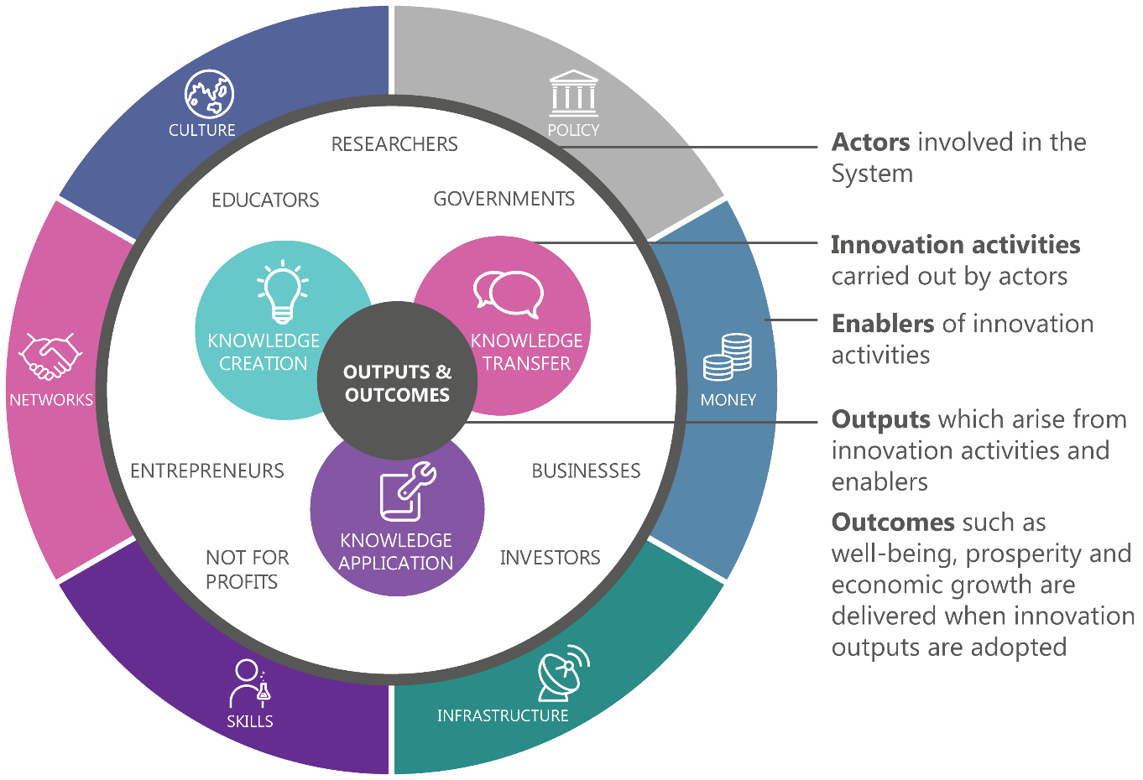
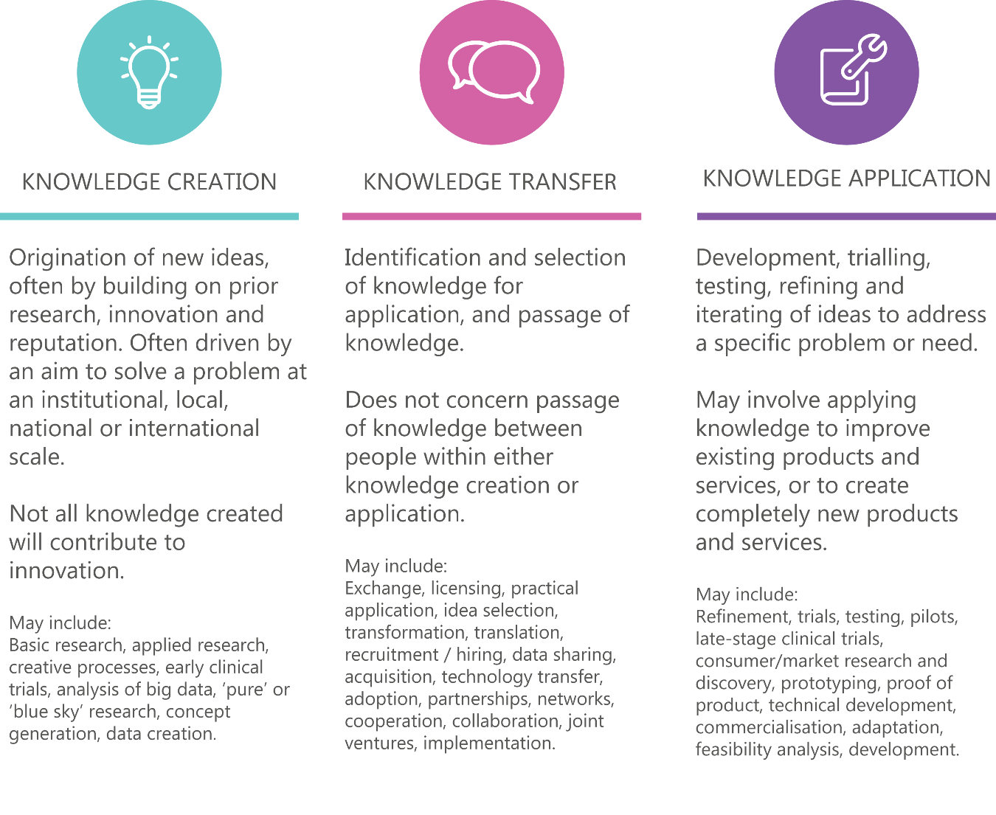

Part B | Performance assessment

Enablers

Policy
In Australia, ‘innovation’ has been on governments’ agendas since at least since the 1980s. Over that time, the various agendas have focused on different aspects of innovation. In practice, however, innovation has been part of Australian policy for at least 100 years; for example, the organisation now called the Commonwealth Scientific and Industrial Research Organisation (CSIRO) was established in 1916. Innovation continues to be a major focus for governments. Most recently, the Australian Government’s National Innovation and Science Agenda (NISA) was announced in 2015, to establish a focus on innovation as the key long-term driver to secure Australia’s economic prosperity.⁸³
The Australian Government has strong influence over innovation in some sectors (such as defence) and shares influence in other areas with states and territories (for example, industry, education and agriculture).⁸⁴ Local governments also contribute to innovation through the delivery of services and support for local businesses and clusters.
Governments can influence the performance of the Innovation, Science and Research System (ISR System) in a number of ways, including by setting a clear strategic direction and leadership; establishing priorities; funding and implementing policies and programmes; funding research agencies; regulating behaviour; procuring, purchasing and commissioning; and educating the public. Government interventions in the ISR System can be either direct or indirect.
- Direct mechanisms include payments to individuals or organisations to undertake specific innovation activities (e.g. employee remuneration, grants or contract payments), generally as part of an overarching government programme and through injecting equity or capital.
- Indirect mechanisms aim to encourage or discourage certain types of behaviour through tax offsets, subsidies or other incentives.

What can governments do to drive innovation?

Strategic direction and leadership
Creating a high-performing ISR System requires very deliberate and strategic government leadership, with an emphasis on taking a long-term view.⁸⁵ Leadership by government means having a vision, setting short-term and long-term goals, implementing and managing change, and leading by example. Developing long-term, national, bipartisan strategies and priorities that can endure through political changes is essential.
Setting strategic priorities in science, technology and innovation is a feature of many leading innovation nations.⁸⁶ A strong national strategic priority framework must also be nimble, with a capacity to adapt to unforeseen developments and opportunities.⁸⁷ Among different nations, determined priorities can vary in their specificity; some priorities are focused on broad areas such as global challenges (climate change, energy security) and others are specifically focused on technologies, industries or research fields.⁸⁸
While the process to set priorities is different in each country, they are commonly determined in consideration of national economic, social and environmental opportunities and threats. Prioritisation develops clear strategies in response to these risks and opportunities.⁸⁹ It involves reaching consensus about our strengths and capitalising on them. Figure 6 shows how prioritisation by the Australian Government influences institutions and programmes.
Figure 6: How priorities guide activities in institutions and programmes.
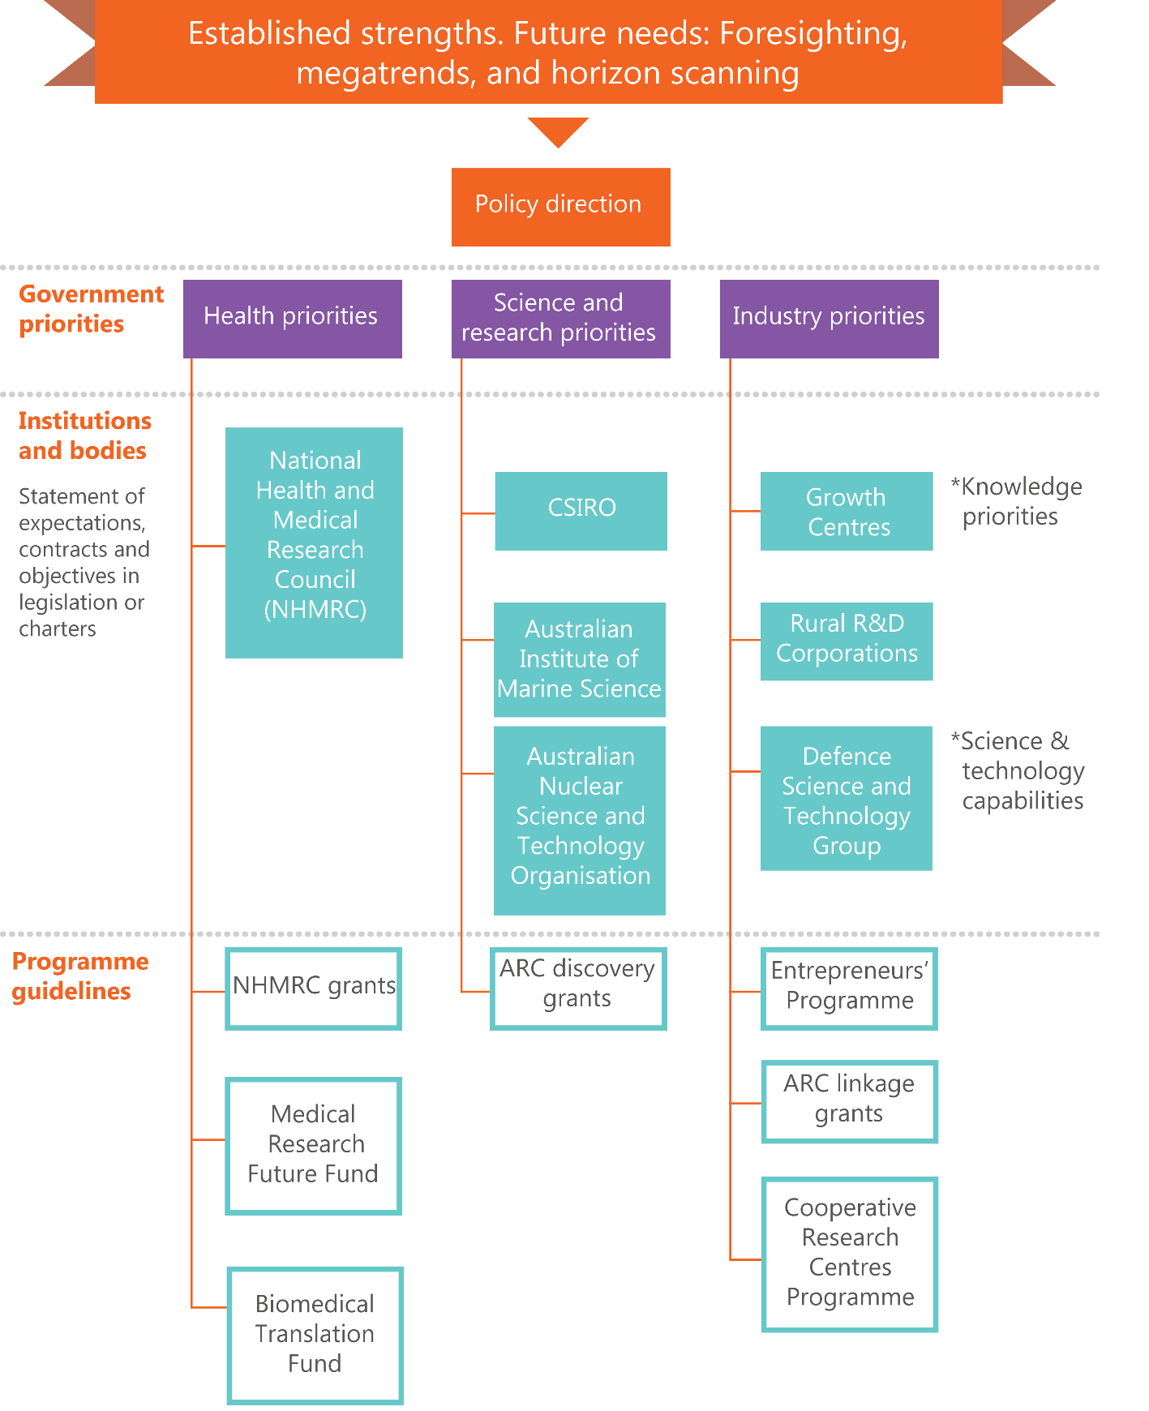
As shown in Figure 6, the Australian Government has developed a number of national priorities to guide innovation, science and research funding.
National science and research priorities announced in 2015 identify nine priority areas: food, soil and water, transport, cybersecurity, energy, resources, advanced manufacturing, environmental change and health.
In the industry portfolio, Industry Growth Centres have been established in six sectors of competitive strength and strategic priority: advanced manufacturing; cybersecurity; food and agribusiness; medical technologies and pharmaceuticals; mining equipment, technology and services; and oil, gas and energy resources.
The health priorities were determined by the National Health and Medical Research Council (NHMRC) and include the priority area of Aboriginal and Torres Strait Islander people’s health, as well as the Australian Government’s national health priority areas: arthritis and osteoporosis, asthma, cancer, cardiovascular disease, dementia, diabetes, injury, mental health and obesity.⁹⁰ Medical Research and Innovation Priorities have also been established to guide decision making around Medical Research Future Fund disbursements.⁹¹
There currently appears to be some alignment of government priorities, institutions and activities (see Table 2). ISA has heard repeated calls for clearer long-term strategic leadership and more effective governance of innovation, science and research in Australia. Few programmes currently operationalise the priorities (such as through eligibility or merit criteria) to a significant extent.
A small country like Australia cannot do everything and can benefit from aligning its resources and efforts. The current and past governments have tended to use a mixed approach—providing broad guidance but minimally operationalizing the specific priorities. In the past, few programmes have reserved funding for priority areas or have specified priority areas as an eligibility requirement for funded projects.

Table 2: Comparison of innovation, science and research priorities by topic area⁹²
 | Priorities |  | Institutions and bodies |  |  | Activities
 | National science and research priorities | Health priority areas | CSIRO business units and focus areas | Industry Growth Centres | Rural R&D Corporations | Sectors receiving the most government expenditure on R&D | Sectors receiving the most R&D tax incentive funds | Sectors receiving the most research income for higher education R&D
Mining | Resources |  | Mineral resources | Mining equipment, technology & services |  |  | Mining
Energy | Energy |  | Energy | Oil, gas & energy resources |  |  | Electricity, gas, waste & water
Agriculture, forestry and fishing | Food |  | Agriculture & food | Food and Agribusiness | 15 R&D corporations | Agriculture & veterinary sciences |  | Agriculture & veterinary sciences
Health | Health | Health | Health & biosecurity | Medical technologies & pharmeceuticals |  | Medical & health sciences |  | Medical & health sciences
Biological & chemical sciences |  |  | National research collections |  |  | Biological sciences |  | Biological sciences
Manufacturing | Advanced manufacturing |  | Manufacturing | Advanced manufacturing |  |  | Manufacturing
Engineering & construction |  |  |  |  |  | Engineering | Construction | Engineering
Services | Transport |  |  |  |  |  | Services
Environmental | Soil & water  Environmental change |  | Land & water  Oceans & atmosphere |  |  |  |  | Environmental sciences
ICT & digital sciences | Cyber security |  | Data 61 | Cyber security |  | Information & computing sciences
Space & exploration |  |  | Astronomy & space science

Australian Government programmes
In 2016–17, the Australian Government expects to provide $10.1 billion in support of R&D through a range of programmes and funding of PFRAs.⁹³ Key programmes are summarised in Appendix E. A number of these programmes have been reviewed or evaluated, and the findings of these reviews are summarised in Appendix F.
Analysis of funding for key programmes (Figure 7) shows that:
- Australian Government programmes largely focus on either knowledge creation (targeting the research sector) or knowledge application (targeting the business sector)
- a number of programmes include a collaboration component (e.g. the ARC Linkage Programme) and around 16 per cent of Australian Government funding in 2016–17 will go towards supporting knowledge transfer between business and the research sector
- a significant proportion of Australian Government funding for business is delivered through indirect mechanisms including the R&D tax incentive
- around two-thirds of Australian Government programmes are small in scale; 91 of the 139 Australian Government programmes in 2016–17 will be less than $10 million in size
- around 90 per cent of Australian Government funding is delivered through programmes that have been operating for over five years.
In the forward estimates, the expenditure will increase due to the Medical Research Future Fund, Defence and the CSIRO.

Figure 7: Australian Government funding by innovation activity and primary objective, 2016-17 estimates.⁹⁴
The size of each circle represents the estimated amount of programme funding ($ million) allocated to knowledge creation, transfer or application for selected initiatives. The allocation of funding across categories was determined through an analysis of programme subcomponents and objectives using the most recently available information from Portfolio Budget Statements; the Science, Research and Innovation budget tables; and programme-specific information such as guidelines and grant outcome reports. Selected initiatives include all major programmes (>$50 million) included in the 2016–17 Science, Research and Innovation budget tables plus a number recently announced. The Automotive Transformation Scheme and the National Institutes Program (Australian National University component) have been excluded from the analysis of selected initiatives but are included in the ‘other programmes’ total.
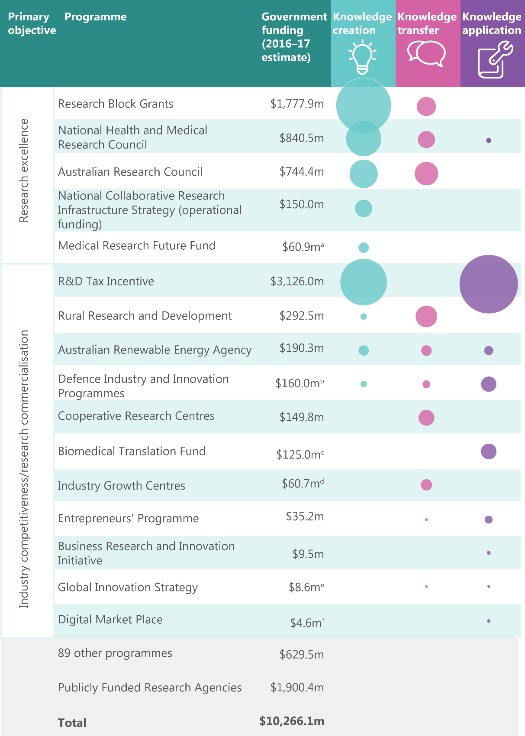
It is outside of the scope of this Innovation, Science and Research System Review (ISR System Review) to assess the effectiveness of individual programmes. However, a number of Australian Government programmes have been reviewed or evaluated in recent years. These reviews are summarised in Appendix F. While not all programmes have been evaluated, findings suggest there are some programmes, or components of them, that are particularly effective at achieving their objectives. These include:
- Cooperative Research Centres (CRCs): Reviews in 2012 and 2015 found the programme is highly effective in linking researchers with domestic and international end users, as well as in delivering significant economic, environmental and social returns.⁹⁵ In 2012, it was estimated that CRCs accounted for $14.5 billion of gross direct economic impacts and community benefits, with a return on investment of 3:1.⁹⁶ By 2015, CRC research had contributed 36,434 journal articles and 42,838 end-user reports.⁹⁷
- National Collaborative Research Infrastructure Strategy (NCRIS): A review conducted by KPMG in 2014 found that research infrastructure funded through NCRIS has significantly underpinned Australia’s scientific research capacity. To 2014, 5,265 publications, 3,391 citations and 1,376 conference papers had been produced as a result of NCRIS, and it had also generated $1.06 of co-investment for every $1 invested by the Australian Government.
- Rural R&D Corporations (RDCs): A 2011 review found that research sponsored by RDCs has been of significant benefit to the rural sector and wider community. The linkages that RDCs facilitate between researchers and producers have led to rapid take-up of research outputs by producers.⁹⁸
There are some programmes that are acknowledged as being supportive by stakeholders but that have not yet been adequately reviewed due to their newness in current form. These include the Industry Growth Centres and the Entrepreneurs Programme.

Australian Government research agencies
There are currently 16 Australian Government research agencies. The Australian Government provides around $2 billion a year to these agencies for R&D activities; however, many agencies supplement this through other funding sources, such as commercial revenue or fee-based research. CSIRO, the Defence Science and Technology Group and the Australian Nuclear Science and Technology Organisation (ANSTO) are the largest Australian Government–funded R&D agencies in 2016–17, accounting for 76 per cent of total Australian Government R&D funding to research agencies.
CSIRO is by far the largest Australian Government research agency. It employs over 5,000 staff nationally, and in 2016–17 received total funding of around $1.5 billion from the Australian Government and other sources. CSIRO is the largest filer of provisional patents in Australia,⁹⁹ and internationally it was ranked 24th in patent cooperation treaty (PCT) patent applications filed amongst government and research institutes worldwide in 2015.¹⁰⁰ The CSIRO ranks 20th in the Reuters top 25 global innovators list for government, ahead of NASA.¹⁰¹ This ranking identifies the most prolific government producers of publications and patents, and ranks these institutions according to a composite indicator. The composite indicator is based on data from the Derwent World Patents Index, the Derwent Innovations Index, the Patent Citation Index and the Web of Science, taking into account patent volume, patent success, global reach, patent citations, patent citations made to publications, publication output and industry connections in research. Despite its ranking, CSIRO ranks below average on measures of the frequency with which patent filings cite CSIRO publications.¹⁰²
R&D objectives vary between agencies (Figure 8). Overall, around 23 per cent of Australian Government–funded R&D activities within agencies were directed toward defence, followed by exploration and exploitation of the Earth (15 per cent) and agriculture (15 per cent).
Figure 8: R&D expenditure by socioeconomic objective, Australian Government agencies, 2016-17.
‘Other’ includes education; culture, recreation, religion and mass media; political and social systems, structures and processes; exploration and exploitation of space; and general advancement of knowledge financed by general university funds or other sources.¹⁰³
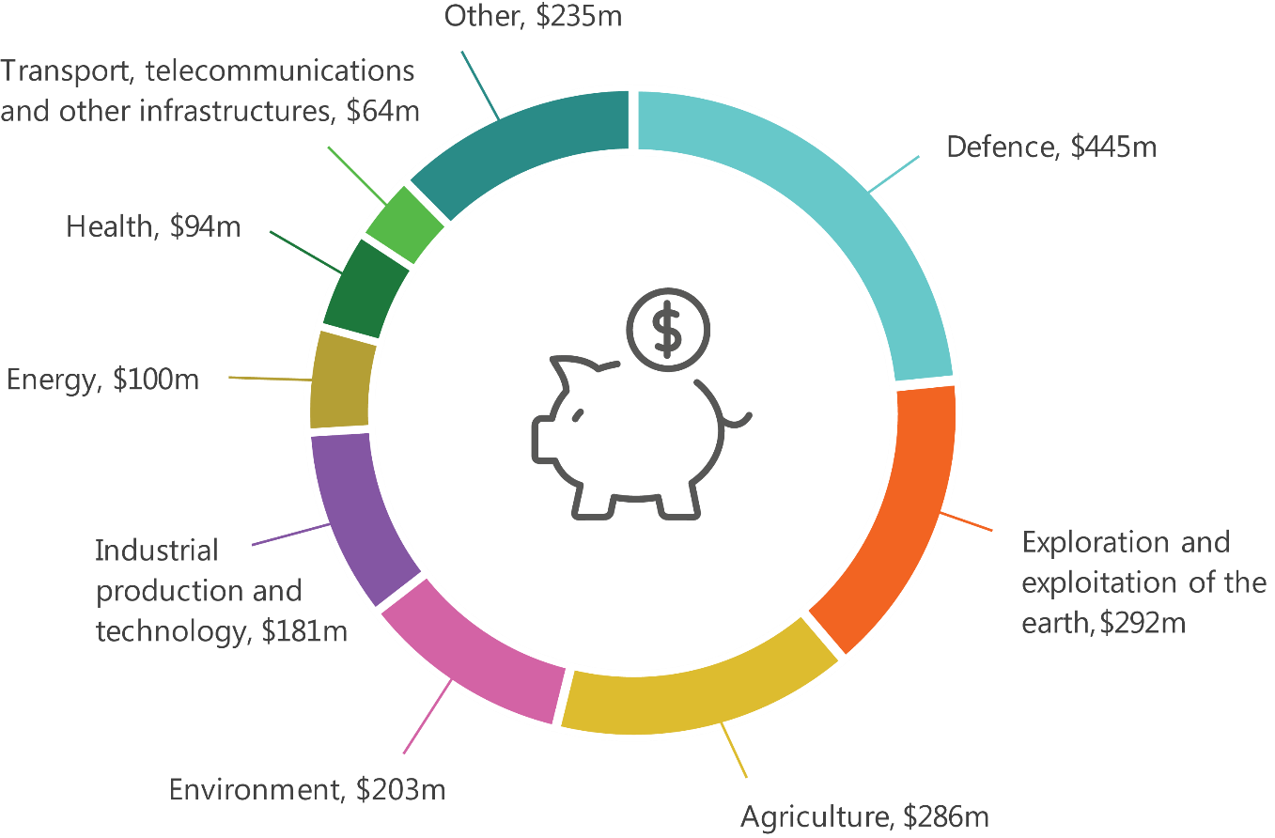

State and territory government programmes
State and territory governments also make important contributions to innovation, science and research in Australia. Estimates provided by state and territory governments to ISA suggest that the cumulative expenditure on R&D by the states and territories in 2016–17 will exceed $1.1 billion.
States and territories provide support for innovation-related activities across a range of areas.¹⁰⁴ This includes:
- investing in a range of collaboration, commercialisation, co-investment, skills and science promotion initiatives
- distributing vouchers, which are widely used to support business-to-business and business-to-research collaboration, skills development and commercialisation, and innovation in SMEs
- offering training, mentorship and scholarship programmes to foster collaboration, commercialisation and skills development
- reviewing regulatory frameworks to ensure a supportive environment for innovation and disruption
- supporting or developing accelerators, incubators or regional innovation clusters.
States and territories also work together through the relevant Ministerial Council and officials groups, such as the Commonwealth State and Territory Advisory Council on Innovation.
There are a number of common features in the approach of the states and territories:
- agriculture, defence, advanced manufacturing (including specific components such as aerospace manufacturing), energy, medical technology and IT are key sectoral priorities (see Appendix G)
- attracting international talent in academia and industry
- social innovation is a key area of focus, reflecting state and territory responsibility for the delivery of many social and health services
- many states and territories provide targeted support to specific regional innovation clusters.

Regulation
Regulation is ‘any rule endorsed by government where there is an expectation of compliance’.¹⁰⁵ It can take many forms. Regulation is put in place by all levels of government in Australia.
There are examples where regulation has been used for:
- ensuring safety and protection of consumers, natural resources or national security
- improving equity and allocation of resources
- addressing monopolies or abuses of market power
- overcoming negative externalities and unintended consequences of economic activities
- reducing information asymmetry
- incentivising new forms of innovation.¹⁰⁶
Regulation can affect innovators in different ways, depending on the sector, the type of activity being performed, the current stage of development, and whether or not innovators are operating in or across our domestic and overseas markets.
Regulation can actively encourage and foster innovation;¹⁰⁷ for example, tighter emission laws were introduced in California to drive the production of cleaner vehicles and energy generation technologies, while energy rating schemes that inform consumer choice can create a demand for more efficient appliances.
However, regulation can also restrict innovation, particularly when it is prescriptive—for example, about which technologies must be used—rather than being outcomes-based. In addition, complying with regulation may require time, money and/or expertise (so-called compliance costs), which can take time away from other activities or delay innovation processes, and significantly affect competitiveness.
Australia’s regulatory environment generally provides transparent rules and penalties for company directors, lenders, investors and borrowers; certainty around the ownership and sale of assets; protections for employers and employees; and clear compliance obligations for entering products and services into the marketplace, all of which can foster innovative business activities. It also generally makes Australia an attractive place to live.

Procurement, purchasing and commissioning
Procurement, purchasing and commissioning involve decisions about where and how government money is spent. This includes expenditure on goods and services in the form of capital expenditure (buildings, structures and equipment) and operating expenditure (business services, leasing and rent, and contracted services).
In 2014–15, the top categories of Australian Government procurement expenditure were from a range of sectors (Table 3). In 2014–15, Australian Government procurement contracts totalled $59 billion. Around 80.5 per cent of this value was spread over a relatively small number of high value contracts. In areas where there are high levels of procurement expenditure, there are potentially greater opportunities to influence incentives for, and behaviours of, providers of goods or services.
Table 3: Top ten Australian Government procurement contracts for goods and services in 2014-15 totalled more than $55 billion. A relatively small proportion of government procurement is directed towards SMEs.¹⁰⁸
Category | Value  ($m) | % of total value | % of SME participation
Politics and civic affairs services | 12,870.2 | 22 | 39
Commercial and military and private vehicles and their accessories and components | 12,249.0 | 21 | 13
Management and business professionals and administrative services | 10,917.4 | 18 | 39
Building and construction and maintenance services | 7,358.5 | 12 | 9
Engineering and research and technology-based services | 3,767.7 | 6 | 32
Information technology broadcasting and telecommunications | 2,836.5 | 5 | 29
Defence and law enforcement and security and safety equipment and supplies | 2,142.1 | 4 | 22
Fuels and fuel additives and lubricants and anti-corrosive materials | 1,219.4 | 2 | 8
Education and training services | 935.7 | 2 | 49
Healthcare services | 755.5 | 1 | 16
Total | 55,052.0

Strengths

The regulatory environment is generally supportive of innovation
Australia performs well above OECD country averages for indicators of federal regulatory policy and governance (stakeholder engagement for developing regulations, regulatory impact assessments and ex-post evaluations).¹⁰⁹ It ranks 5th out of 128 economies for regulatory quality¹¹⁰ and 13th out of 189 economies for ease of doing business.¹¹¹ Australia also ranks highly in terms of the soundness of its banks, legal rights and corporate finance; it has one of the world’s most efficient stock markets, and some of the strongest financial and banking regulations and competition legislation.¹¹² While some businesses might perceive Australia’s regulatory framework as being overly prescriptive, it still compares favourably with international counterparts, and the small size of Australia’s cash economy suggests that regulation is not overly burdensome.¹¹³
Government regulation and compliance are not seen as major barriers to innovation by Australian businesses (Figure 9).¹¹⁴ Instead, Australia’s regulatory frameworks are generally seen as important (for instance, for consumer and environmental protection, and as assurance for exported products) and benign in terms of impacts on innovative capacity, with some specific exceptions that are discussed later in this ISR System Review.
Figure 9: Barriers to innovation identified by businesses.
Government regulation is fifth out of seven barriers identified by innovation-active businesses; this aligns with other findings in this ISR System Review.¹¹⁵
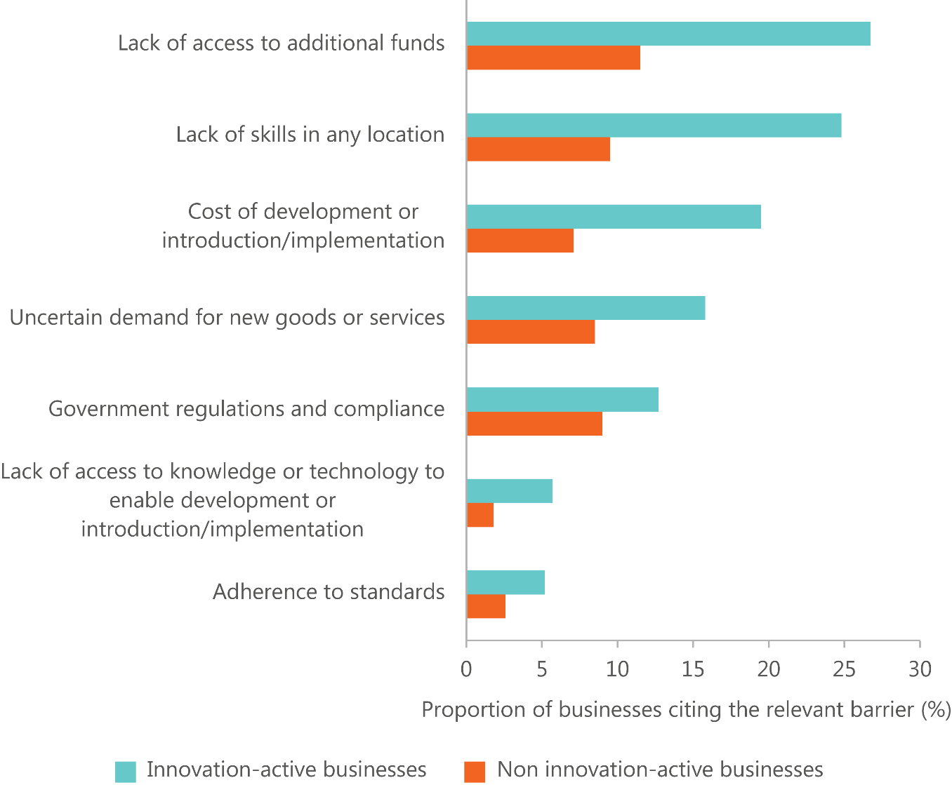

However, while Australia’s regulatory environment is, in general, considered to be either benign or largely supportive of innovation and its broader outcomes, a number of potential areas for improvement have been identified. These include the following (see ‘Skills’ for more detail):
- Intellectual property arrangements have been criticised for overprotecting rights holders.
- Domestic labour mobility is restricted for some occupations as a result of inconsistent recognition of qualifications between states and territories.
- Labour market regulation could do more to support innovative employment conditions, especially in small businesses.

- International labour mobility should support timely entry of skilled workers necessary to drive innovation.
- Insolvency and director liability laws may encourage a fear of failure among Australian businesses.
- Crowd-sourced equity funding and foreign investment are restricted by current regulatory arrangements.
- Clinical trial regulation is inconsistent and makes Australia a less attractive clinical trial location than other nations.
- Industrial chemicals regulation can delay innovation as a result of the cost of pre- approvals and long approval processes.
- Planning and zoning requirements can inadvertently restrict the growth of clusters, reduce liveability or discourage innovative development.
- International regulatory decisions are not sufficiently considered as a basis for Australian decisions, which could reduce domestic approval times in some sectors.
- Existing regulatory frameworks are not always sufficiently flexible and able to accommodate rapid change (e.g. in technology or consumer preferences).
In many of these areas, reform is underway through NISA and other initiatives (see details in Appendix H). In some cases, ISA has heard that this reform is too slow.

New statistical methods will allow proper evaluation of programme impact.
The Australian Government’s approach to innovation has included major investments in its research agencies such as CSIRO and ANSTO, and major long-standing programs like CRCs, block funding for universities, and RDCs. The majority of innovation-related programmes, by number are small in scale.
Ninety per cent of Australian Government funding is delivered through programmes that have been operating for over five years. However, name changes and changes to eligibility and other criteria make it hard for actors across the ISR System to plan for, or rely on, long-term government support across the life of innovation, science and research projects.
Around two thirds of Australian Government programmes are less than $10 million per year each in size, and there are numerous small-scale state and territory government programmes. This significant number of small-scale programmes is not necessarily a problem if these programmes are appropriately evaluated and lessons shared. Past evaluations of Australian Government programmes (Appendix F) have tended to focus on questions of administration and implementation, rather than effectiveness.
The government has a role in collecting and monitoring data critical to understanding how well the ISR System is functioning. Audits and performance assessments, such as this one, are constrained or enabled by the data that are available.
The Australian Bureau of Statistics (ABS) and the Department of Industry, Innovation and Science (DIIS) in particular have developed and maintain a number of datasets and publications to inform innovation, science and research policy. Key initiatives include the following:
- The ABS Business Characteristics Survey¹¹⁶ provides information on the nature of innovation in Australian businesses.
- The ABS Business Longitudinal Analysis Data Environment (BLADE) is a record of the financial and economic performance of businesses in Australia from 2001 onwards, built from the Australian Business Register, patenting data and company tax records.¹¹⁷
- The annual Australian Innovation System Report was initiated in response to the Cutler review of Australia’s innovation system to provide a synthesis of innovation-relevant data to inform policy development. It has been published since 2010, and focuses on different themes each year.¹¹⁸
Through the work of the ABS and DIIS, the government has developed reputable and robust methods of data collection and analysis to inform decision-making. This will help reduce the number of sub-scale programmes by determining what effective pilot programmes are and when necessary deciding to discontinue them or scale them up.

Weaknesses

There are few direct mechanisms to support knowledge transfer
The majority of government funding for innovation in Australian businesses is indirect, which gives recipients a high degree of autonomy over how funds are used. Most OECD countries use tax incentives—an indirect mechanism—to encourage R&D in business to some extent. However, the Netherlands, Australia, Canada, Japan and France are unusual in using tax incentives as the principal form of support for innovation (Figure 10).¹¹⁹
Indirect mechanisms such as tax incentives provide businesses with maximum control on R&D investment decisions with minimal intervention from government. The use of indirect mechanisms limits the ability of government to strategically focus effort but allows the market to decide. In contrast, direct mechanisms can be targeted through eligibility criteria to ensure that public support is provided to the activities which governments judge most likely to contribute to the performance of the overall ISR System.¹²⁰
Government interventions can encourage and facilitate the flow of knowledge across national innovation systems,¹²¹ and governments may assume a broader role as facilitators, connectors and enablers of system-level collaboration.¹²² Many countries recognise this and provide nationwide support for intermediaries, networks and collaboration (Table 4).¹²³ In many cases there are considerable funds provided to support knowledge transfer e.g. Fraunhofer Institutes in Germany: €2 billion per year. However, current Australian Government programmes remain heavily weighted towards knowledge creation and application, with only relatively small investments in support of knowledge transfer (Figure 11).
In recognition of ongoing barriers to collaboration in existing Australian Government programmes, a number of adjustments have been recommended to incentivise greater collaboration, particularly between researchers and business. These include:
- R&D tax incentive: the biggest lever the government has does not currently incentivise collaboration with research organisations. This is in contrast to the R&D tax initiatives in some other countries, such as France, which provide a collaboration taxation offset premium as well as a taxation offset premium for employment of researchers.¹²⁴ The recent review of the R&D tax incentive recommended the introduction of a collaboration premium under the R&D tax incentive to provide additional support for collaboration activity.¹²⁵
- ARC Linkage Programme, Entrepreneurs’ Programme and CRCs: These programmes have historically required matching cash or in-kind contributions from SMEs. This can disincentivise SMEs from participating, because they may have limited cash flow. However, under the new funding rules for the ARC Linkage Projects scheme, which have now been implemented, partner organisations with fewer than twenty full-time employees are exempt from the cash contributions requirements normally associated with partner organisations.
- Research Block Grant funding criteria (a NISA initiative): new university funding arrangements, to commence in 2017, will increase incentives for industry and end user-engagement.
Figure 10: Proportion of direct and indirect government support for business R&D expenditure, by percentage of all government expenditure on business R&D.
2013 or latest year. 2011 data used for Australia, Iceland and Mexico. 2012 data used for Ireland, Belgium, the United States, Spain and Switzerland. Data on tax incentive support is unavailable for Poland.¹²⁶
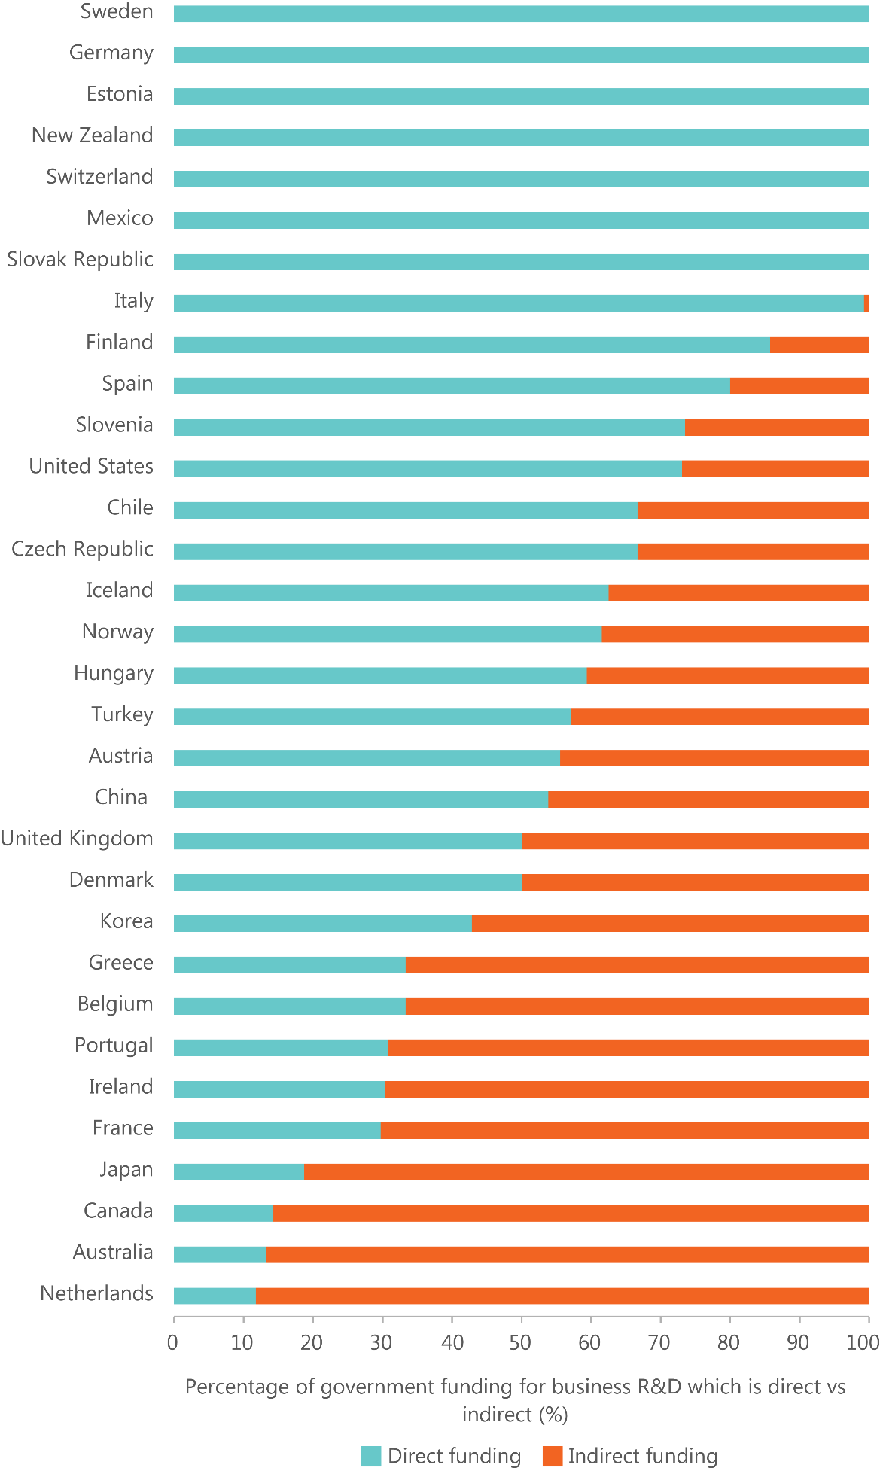
Figure 11: Annual funding* for Australian Government programmes for innovation, according to innovation activity, 2016-17.¹²⁷
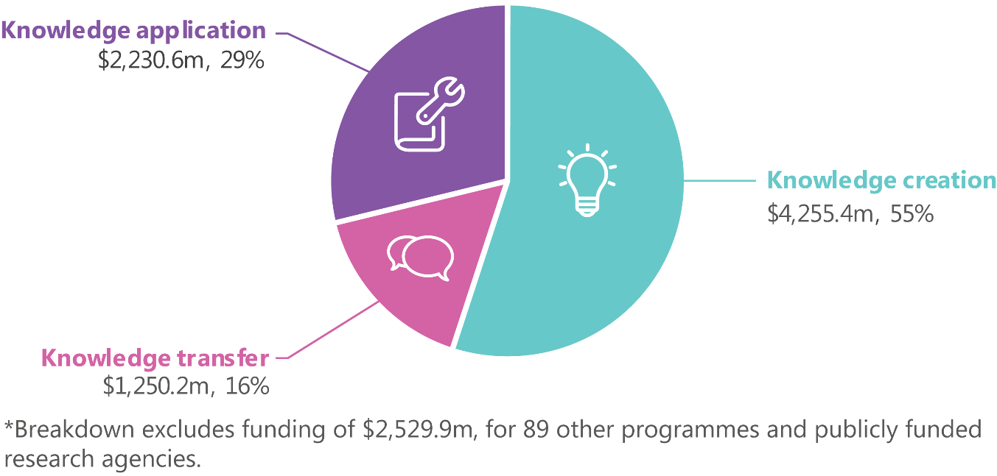

Table 4: International funding to support intermediaries, networks and collaboration.
Country | Programme | Description | Government investment | Total government investment in R&D
Netherlands | Top Sectors | The Top Sectors aim to achieve greater collaboration between knowledge institutes and business. | Over €1 billion¹²⁸ | €5,020 million (2015)
Germany | Leading Edge Cluster Competition | Clusters are being supported to address global challenges that are beyond the capabilities of regional innovation and value-creation chains. | Up to €500 million (2008-2017)¹²⁹ | €25,902 million (2015)
Germany | Fraunhofer-Gesellschaft | Fraunhofer-Gesellschaft was established to close the gap between the latest university insights and industry-specific product and process improvements. | €2 billion per year¹³⁰ | €25,902 million (2015)
United Kingdom | Catapult Centres and Industrial Strategies | Catapult centres were established to close the gap between research findings and their development into commercial propositions. | £200 million over four years¹³¹ | £10,177 million (2014)
United States | National Networks for Manufacturing Innovation | The programme aims to address the technical and financial problems faced by the private sector in translating promising early-stage research into manufacturing capability and new products. | US$500 million for 15 institutes¹³² | US$137,172 million (2015)
United States | Small Business Administration Regional Cluster Initiative | The initiative aims to:  - increase opportunities for small business participation within the clusters  - promote innovation in the selected cluster industries  - enhance regional economic development and growth in the regions where clusters operate. | Up to a total of US$2.5 million per cluster over five years¹³³ | US$137,172 million (2015)
Canada | Business-Led Networks of Centres of Excellence | The initiative aims to:  - strengthen public-private collaborations to meet private sector needs  - position Canadian firms in high-value segments of production chains  - create, grow and retain companies in Canada  - produce business and product innovations that will capture new markets. | C$12 million per year | C$9,655 million (2013)
New Zealand | Callaghan Innovation | The programme aims to bridge the gap between R&D and commercialisation. | NZ$270 million in 2014¹³⁵ | NZ$1,408 million (2015)
Australia | Industry Growth Centres | The Industry Growth Centres Initiative is an industry-led approach which focuses on areas of competitive strength and strategic priority to drive innovation, productivity and competitiveness. Six Growth Centres are tasked with four broad themes, one of which is to improve engagement between research and industry within industry.¹³⁶ | AUD$250 million over four years from 2016-17 | AUD$10,061.8 million in 2016-17
Australia | Cooperative Research Centres Programme | The programme supports industry-led collaborations between industry, researchers and the community. | AUD$149.8 million in 2016-17 | AUD$10,061.8 million in 2016-17

Relative to other countries, government procurement could do more to foster innovation
The majority of OECD countries use procurement approaches ‘not only to foster value for money but also to pursue other policy objectives’.¹³⁷ Australia ranks 63rd out of 138 countries for the extent to which government purchasing decisions foster innovation.¹³⁸
Australia’s relatively poor performance on this measure may be related to the emphasis government procurement guidelines place on value for money.¹³⁹ This could discourage domestic innovation and investment in innovation.¹⁴⁰
Conversely, overseas examples highlight the potential for governments to use procurement as a direct mechanism to increase the incentives for innovation. For example, the government-wide US Small Business Innovation Research programme was established in 1982 to encourage small businesses to participate in US Government R&D and potentially commercialise their outputs. The programme requires government departments spending more than $100 million on extramural R&D to set aside a portion of this spend for small businesses.¹⁴¹ Similarly, the UK Small Business Research Initiative was established in 2001 to improve the number of small R&D-based businesses winning contracts from government.¹⁴²
In a similar way, the NISA includes two initiatives to increase the participation of Australia’s innovative SMEs in government procurement. The Business Research and Innovation Initiative is testing the opportunities for SMEs to develop more innovative solutions to government policy and service delivery problems.¹⁴³ The Digital Marketplace connects government buyers of digital goods and services with suppliers. The website makes it easier for business start-ups and SMEs to compete for the government’s $5 billion per year spend on ICT products and services.¹⁴⁴ These are relatively small initiatives compared to the total size of government procurement spending.

Findings: Policy

Knowledge transfer
- What are our weaknesses?
  - There are few direct mechanisms to support knowledge transfer. Most Australian Government funding for innovation targets knowledge creation and knowledge application, and most funding to businesses is delivered through indirect mechanisms.

Knowledge application
- What are our strengths?
  - The regulatory environment is generally supportive of innovation. However, while businesses do not cite regulation as a general barrier to innovation, there are regulatory restrictions in some specific areas.
- What are our weaknesses?
  - Relative to other countries, government procurement could do more to foster innovation. Australian governments could make better use of procurement to incentivise innovation, particularly in SMEs, though current initiatives are expected to help.

System-wide
- What are our strengths?
  - New statistical methods will allow for the proper evaluation of programme impact. This will allow sub-scale programmes to be discontinued or scaled-up appropriately to reduce the number of ineffective programmes.

Money
Money continually flows through the ISR System, between businesses, governments, researchers and not-for-profits.
In innovation, money flows are measured and described according to how money is used or where it comes from. In general terms:
- Uses of money include investment and expenditure
  - Investment tends to refer to money used to purchase assets. This includes physical assets (e.g. plant and equipment or research infrastructure) and intangible assets (e.g. intellectual property).
  - Expenditure tends to refer to money used to fund the operation of organisations (e.g. paying salaries or purchasing goods and services).
- Sources of money are generally referred to as either finance or funding
  - Finance tends to refer to money provided by businesses or investors, generally with the expectation of getting a return. It can be informal (e.g. loans from family or retained earnings) or formal (e.g. bank loans).
  - Funding tends to refer to money provided, especially by government or philanthropists, for a particular purpose (e.g. government funding delivered through grant programmes, tax offsets and procurement).
The financial system, including banks, equity markets and other financial intermediaries, can play an important role in facilitating the movement of money across the ISR System.
It is difficult to estimate the entire amount of money in the ISR System because it is complex and dynamic. For example, in a knowledge economy, the investment in innovation also includes the labour costs of workers who generate, absorb and analyse information in their everyday work.¹⁴⁵ Attempts to describe the total amount of money in the ISR System often use total expenditure on R&D as a proxy. This measure provides a high-level overview of sources, uses and the flows of money in the ISR System (Figure 12 on the following page).

Uses of money

Gross expenditure on R&D
In 2013–14, Australia’s gross expenditure on R&D (GERD) was $33.5 billion, or 2.12 per cent of GDP. Australia’s GERD as a percentage of GDP has increased significantly since the mid-1990s; it peaked at 2.25 per cent in 2008 and declined slightly to 2.12 per cent in 2013.¹⁴⁷ The increase in Australia’s relative level of investment in R&D since the mid-1990s has allowed us to keep pace with other OECD countries. In 2013, Australia ranked 15th out of 37 OECD+ countries for its relative level of investment in R&D.¹⁴⁸ This is around the OECD+ average but well behind the average for the top five nations in the OECD+ (3.66 per cent of GDP in 2013).
GERD can be broken down into its component parts, which include (Figure 13):
- expenditure by businesses listed on the ABS business register (BERD)
- expenditure by universities and other tertiary education institutions (HERD)¹⁴⁹
- expenditure by Australian federal, state and territory governments (GOVERD)¹⁵⁰
- expenditure by private not-for-profit organisations (PNPERD).¹⁵¹
Businesses account for the largest proportion of R&D expenditure, followed by the higher education sector, then the government sector.¹⁵²
Over the past two decades GERD has shifted significantly towards experimental development and applied research, and away from pure basic research and basic research.^{153,154,155} This could reflect a shift in policy focus towards research commercialisation. Over the same period, higher education has also increased its share of GERD.¹⁵⁶
Figure 12: Sources, user and activities of R&D funds (ISA estimates), 2014.¹⁴⁶
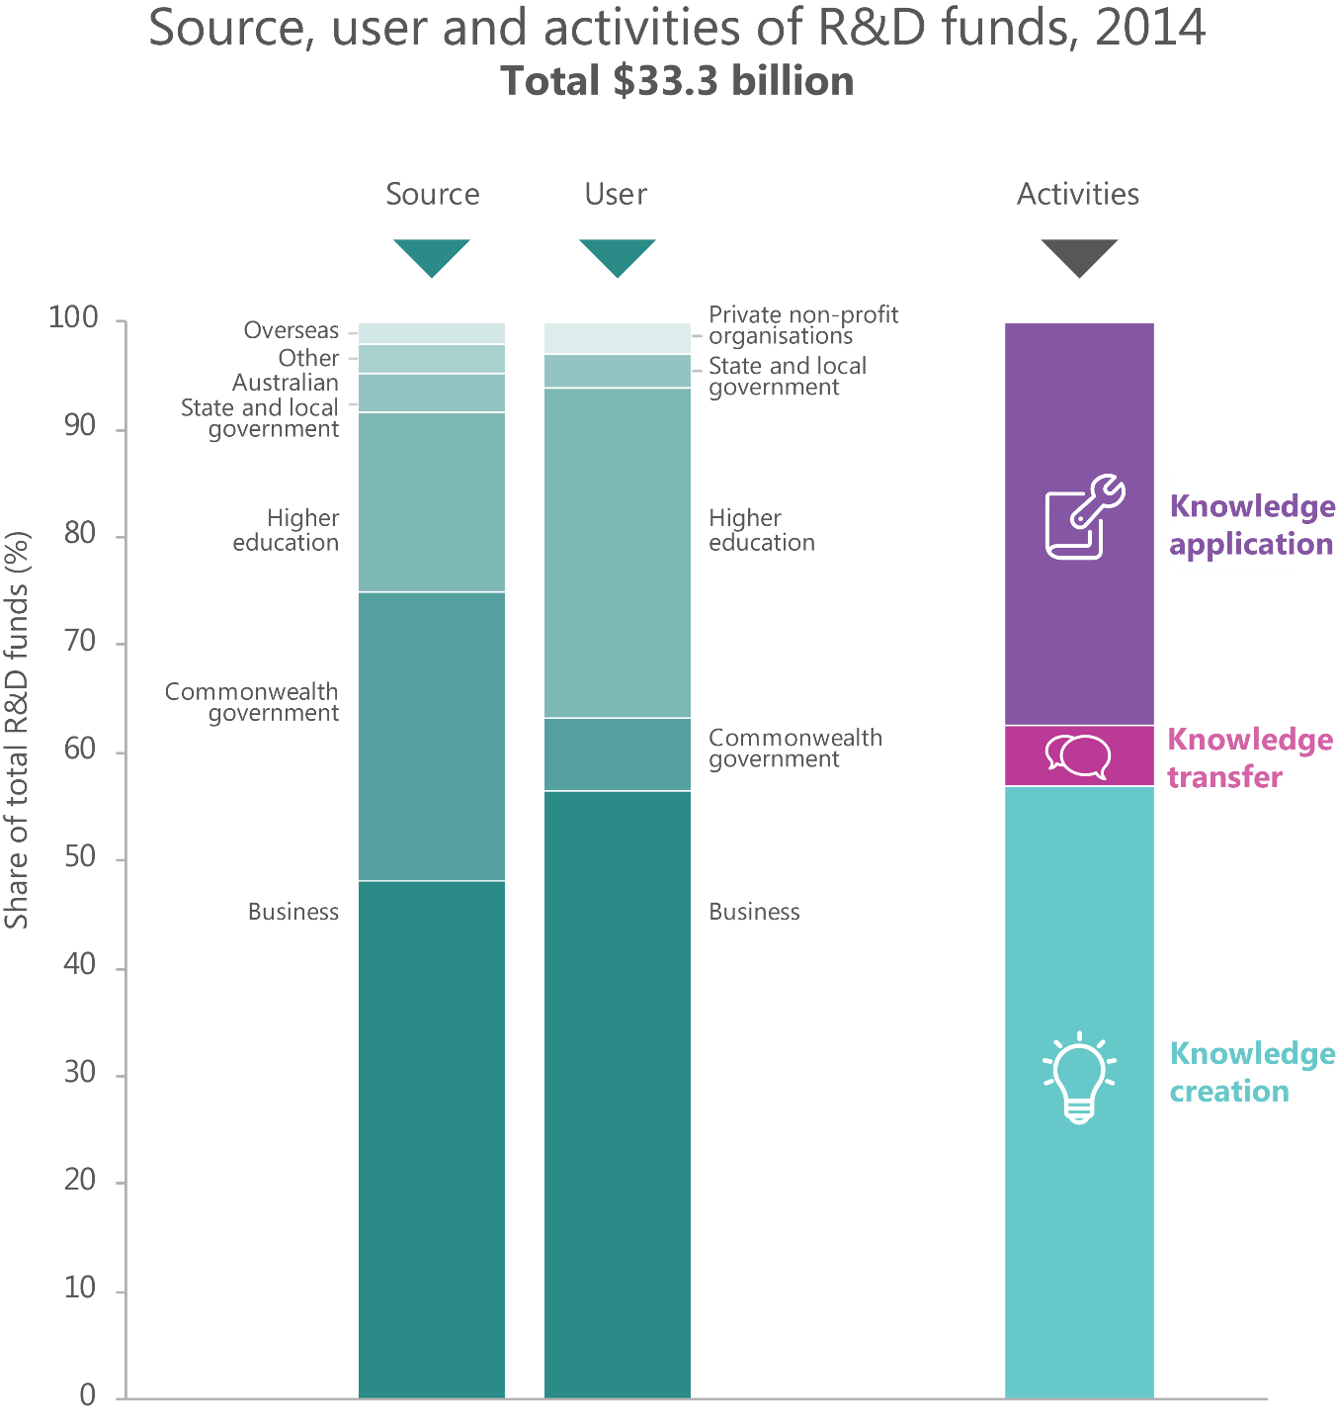
Figure 13: Gross expenditure on R&D (GERD) as a percentage of GDP, by sectoral contributions, 1996-97 to 2013-14.
The charts show GERD as a percentage of GDP and the relative contributions of each sector to R&D performance.¹⁵⁷
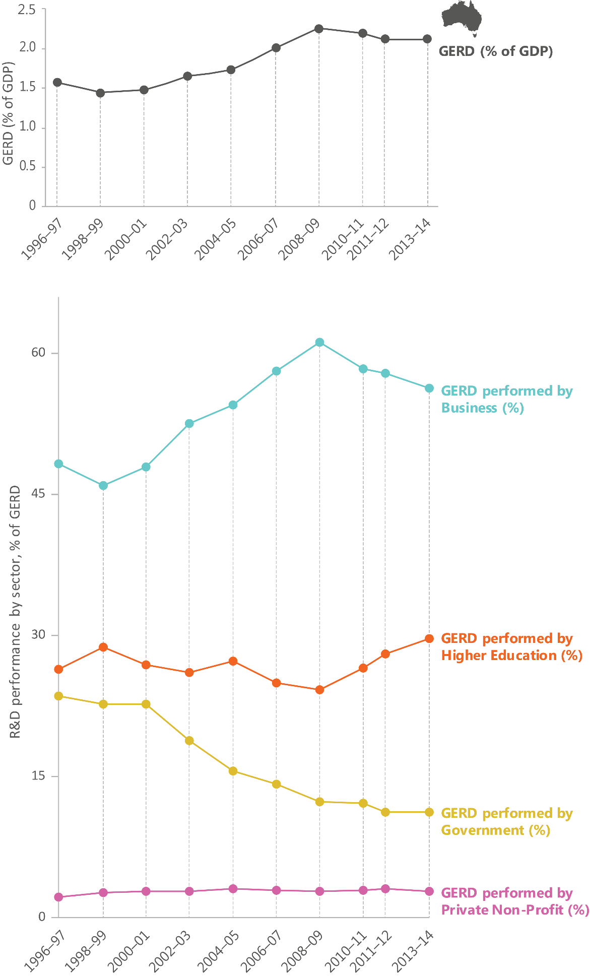

Business expenditure on R&D
Business expenditure on R&D (BERD) in 2013–14 was $18.8 billion, or 1.19 per cent of GDP (Figure 14). Australia ranks 16th of 37 OECD+ countries for BERD. This is behind the OECD+ average and well behind the average for the top five nations in the OECD+ (2.78 per cent of GDP in 2013).¹⁵⁸
Around 60 per cent of BERD is spent on experimental development and 33 per cent on applied research, predominantly in engineering and information and computing sciences. Large businesses incurred most of the R&D expenditure (59 per cent), followed by medium-sized businesses with 24 per cent. The proportion of R&D expenditure by large businesses has declined in recent years.¹⁵⁹

Higher education expenditure on R&D
In 2014, higher education expenditure on R&D (HERD) was $10.1 billion (Figure 15). HERD increased from 0.41 per cent of GDP in 1995 to 0.63 per cent in 2014.^{161,162} This is above the OECD average, but below the average for the top five nations in the OECD+ (0.86 per cent of GDP in 2014).¹⁶³

Government expenditure on R&D
In 2014–15, government expenditure on R&D (GOVERD) was around $3.3 billion (Figure 16). This figure does not include government contributions to business R&D through the R&D tax incentive, which amounted to $2.8 billion in 2014–15.¹⁶⁵ It does, however, include $2.3 billion of the Australian Government’s expenditure on R&D incurred through its research agencies—such as CSIRO and the Defence Science and Technology Group—and other agencies.
GOVERD decreased from 0.42 per cent of GDP in 1994–95 to 0.21 per cent in 2014– 15.^{166,167,168} Australia ranks 20th out of 37 OECD+ countries for the relative level of GOVERD (excluding expenditure on R&D tax incentives). This is around the OECD+ average, but well below the average for the top five nations in the OECD+ (0.33 per cent of GDP in 2014–15).¹⁶⁹
The nature and scale of government funding for innovation activities beyond R&D expenditure are discussed elsewhere in this ISR System Review.

Private non-profit expenditure on R&D
In 2014–15, private non-profit expenditure on R&D (PNPERD) was around $1 billion, or 0.063 per cent of GDP (Figure 17).^{172,173} In 2013–14, PNPERD made up around 2.84 per cent of Australia’s total expenditure on R&D.¹⁷⁴ Of the OECD countries, only Chile, the United States and Italy had a higher proportion of R&D performed by their private non- profit sector.¹⁷⁵
Figure 14: Business expenditure on R&D as a percentage of GDP and relative ranking against other OECD+ countries, 2004-05 to 2014-14¹⁶⁰
Expenditure is mainly directed towards experimental development.
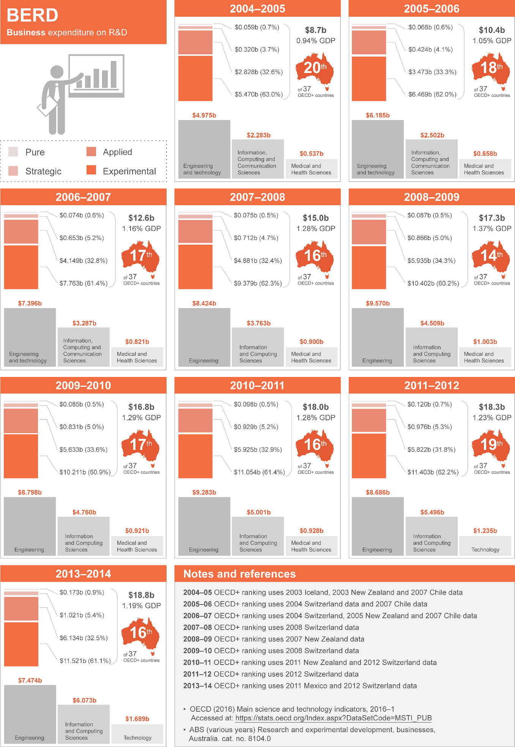
Figure 15: Higher education expenditure on R&D as a percentage of GDP and relative ranking against other OECD+ countries, 2004 to 2014.
Australia’s ranking is relatively high, and the expenditure is mainly directed towards pure basic, strategic basic and applied research.¹⁶⁴
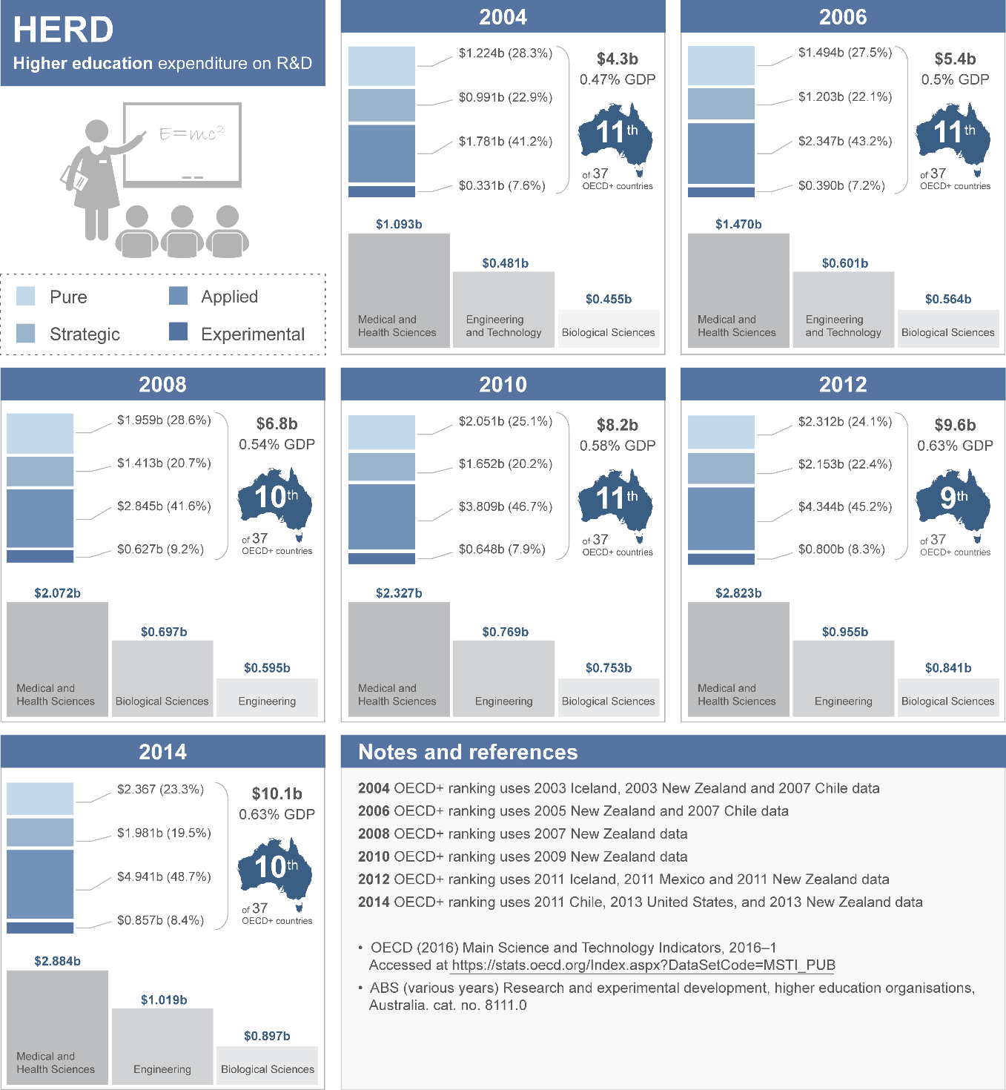
Figure 16: Government expenditure on R&D as a percentage of GDP and relative ranking against other OECD+ countries, 2004-05 to 2014-15.
Australia ranks relatively low, and most of the expenditure is allocated to strategic basic and applied research.^{170, 171}
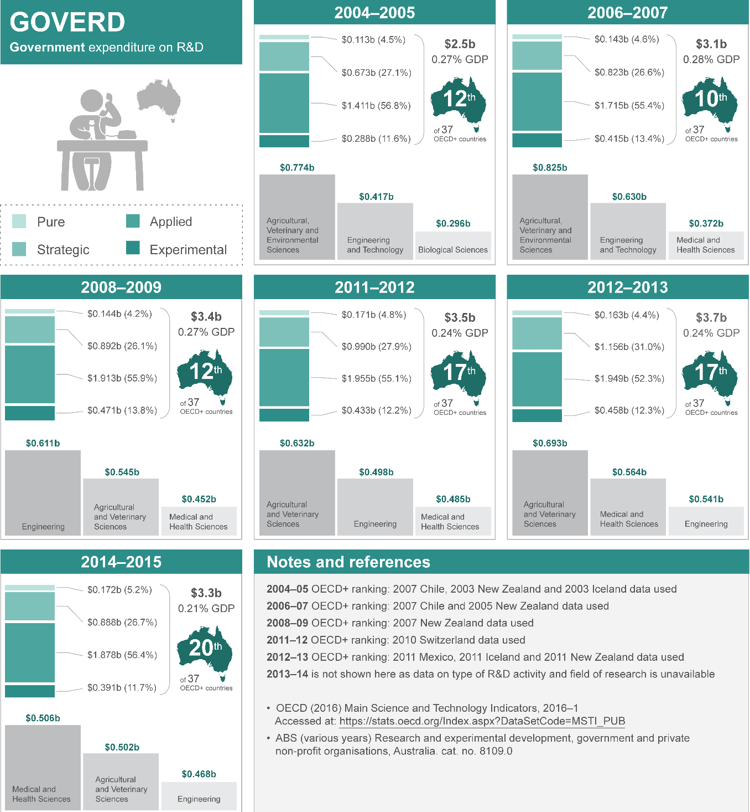
Figure 17: Private non-profit expenditure on R&D as a percentage of GDP, 2004-05 to 2014-15.
Expenditure is mostly directed towards strategic basic and applied research, especially medical research.¹⁷⁶
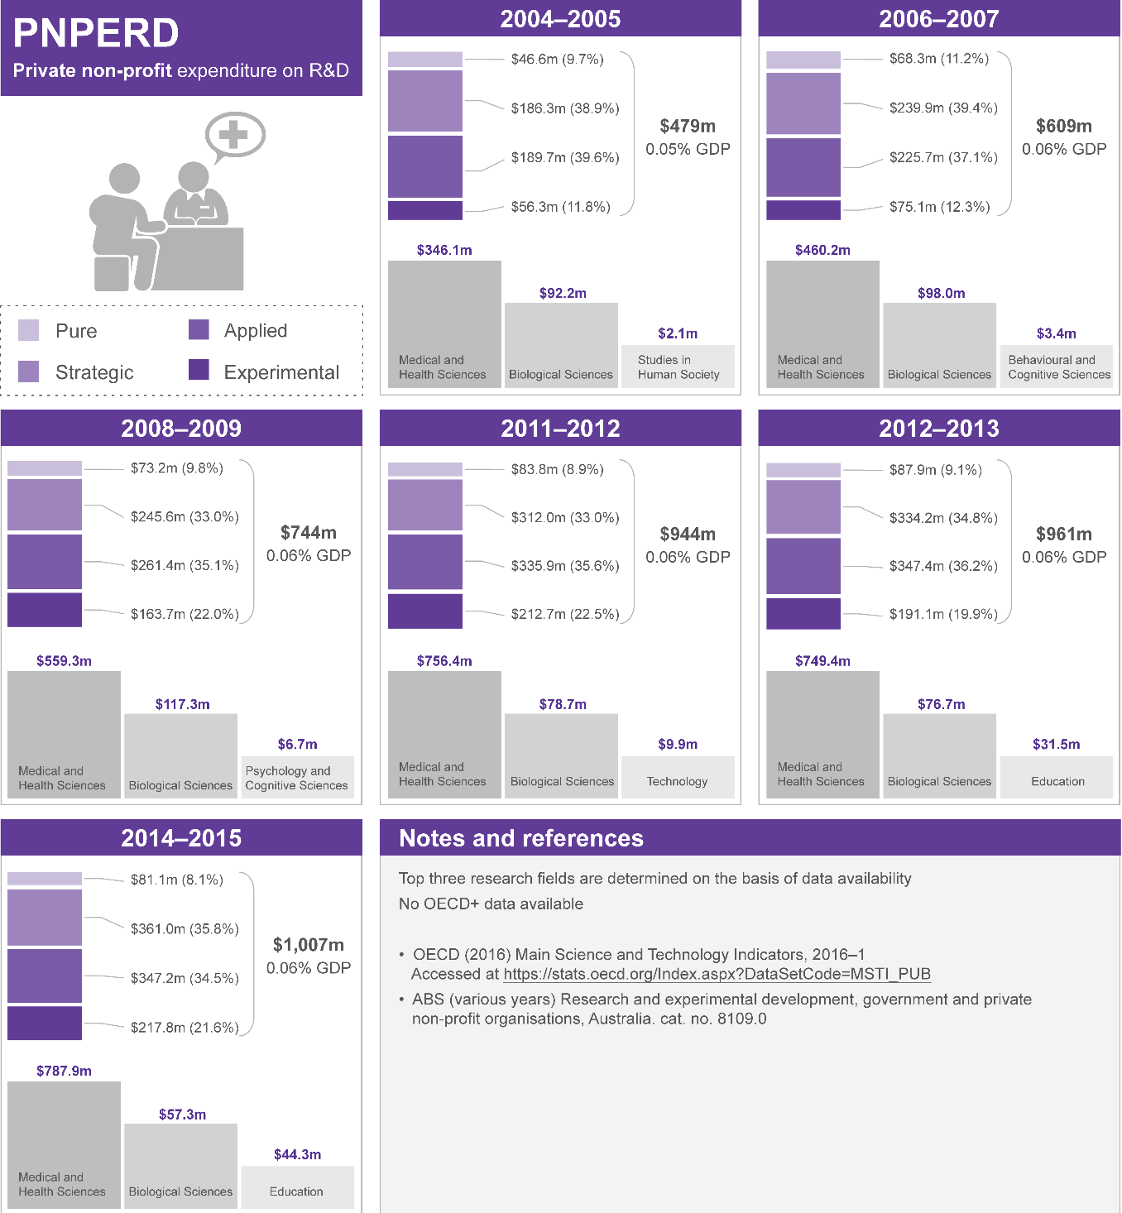

Other uses of money
R&D expenditure does not capture all money spent on innovation. For example, in 2014–15 only 14 per cent of Australia’s innovation-active businesses incurred expenditure on research and experimental development.¹⁷⁷ At the same time, the total amount of money spent on all innovation activities by Australian businesses is estimated to be between $26 billion and $30 billion.¹⁷⁸ In 2014–15, the acquisition of machinery, equipment or technology was the most common type of expenditure for innovation by Australian businesses. Marketing, training, reorganisation and labour-related costs are also common types of expenditure, followed by expenditure on design, planning and testing, and research and experimental development activity.¹⁷⁹ It is unclear whether the lack of information about the total amount of money in the ISR System is of sufficient importance to warrant further data collection.

Sources of money

Venture capital
In some countries, venture capital investment is an important source of funds for higher- risk, early-stage businesses. Investors in venture capital are generally professional individual investors or institutional investors such as superannuation funds.
As at 2014, Australia had a very small venture capital sector relative to some of other developed nations. According to the OECD, Australia’s venture capital investment represented around 0.02 per cent of GDP, which means Australia ranked 18th out of 30 OECD countries (Figure 18).¹⁸⁰
Figure 18: Total venture capital investment as a percentage of GDP, 2015.¹⁸¹
Note: 2014 data used for Israel and Japan
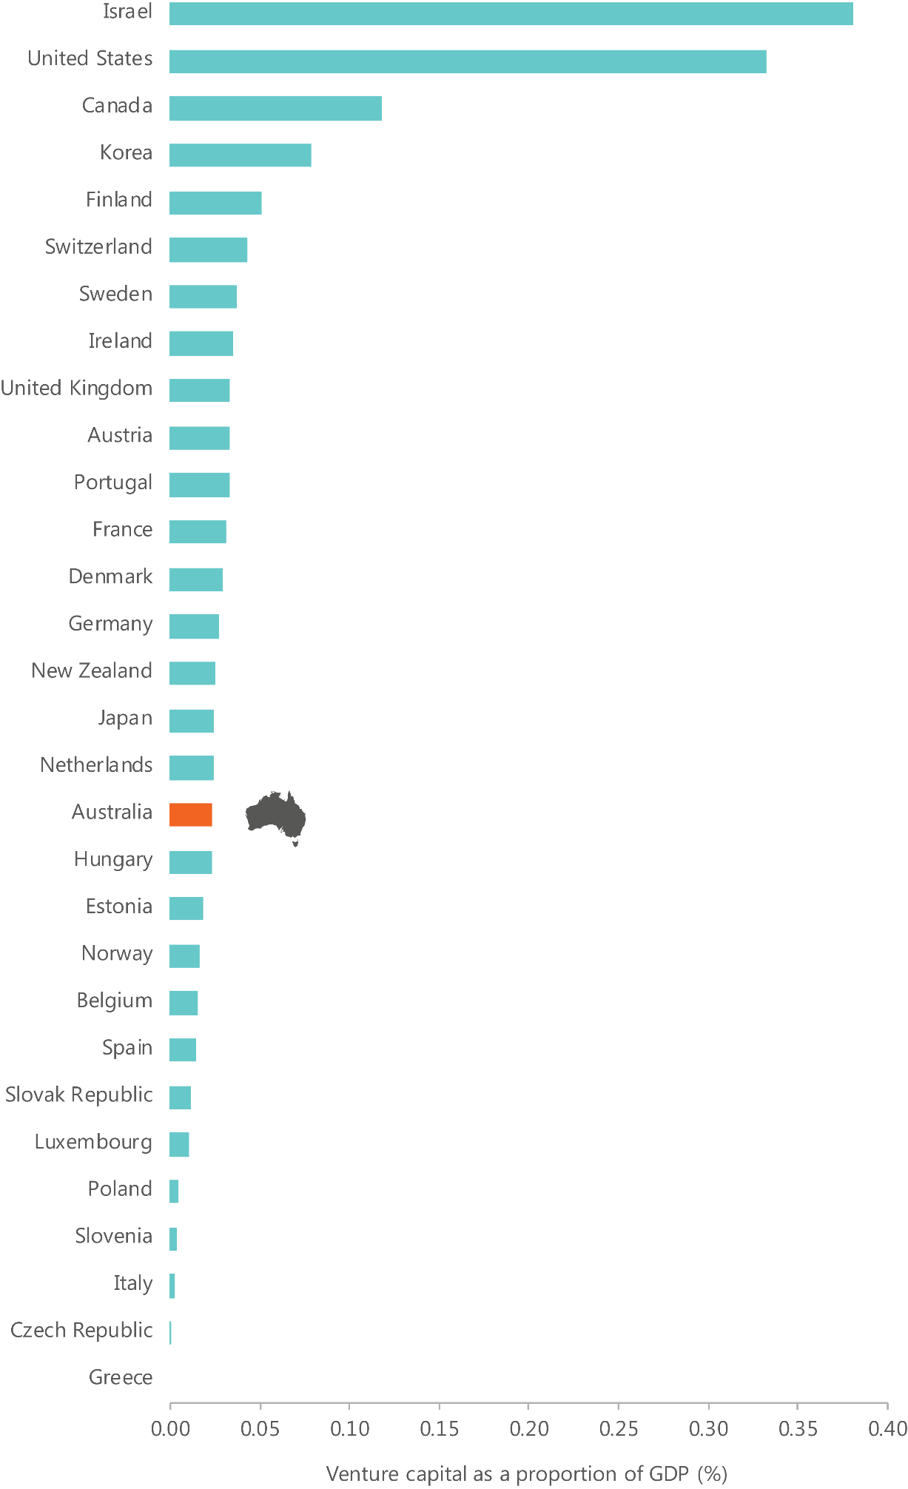
In 2014–15, venture capital investments totalled $1.9 billion, a 14 per cent increase since 2013-14. Over the year, 205 new and follow-on venture capital investment deals totalled $383 million.¹⁸² The number and size of venture capital transactions in Australia are relatively low compared to some other countries, such as the United States. In 2013–14, 35 venture capital transactions per million businesses were undertaken in Australia, with an average investment of around US$1.7 million. In the same year in the United States, 149 transactions per million businesses were undertaken, with an average investment of around US$9.2 million.¹⁸³
While access to finance is not a barrier for most Australian businesses, it is for some, especially those seeking capital for high risk ventures, including the early-stages of business development. Venture capital is meant to provide funding for higher risk, early-stage firms; however, the bulk of Australian investment occurs at later stages of business development (Figure 19).
A number of initiatives are underway to address the lack of early-stage equity finance in Australia. As part of the NISA the CSIRO Innovation Fund supports the commercialisation of technology developed by Australia’s research organisations.¹⁸⁴ Also new tax incentives are available to individuals and organisations investing in innovative companies at the early and growth stages of a start-up.¹⁸⁵
The introduction of tax concessions and the Significant Investor Visa may have contributed to increased activity in the venture capital sector. In 2015–16, Early Stage Venture Capital Limited Partnership (ESVCLP) investments increased by $97 million, the largest dollar value increase in the nine-year history of the ESVCLP, and registrations doubled (Figure 20).¹⁸⁶
Figure 19: Venture capital and later stage private equity investment deal value, by stage of investee company, 2014-15.¹⁸⁷
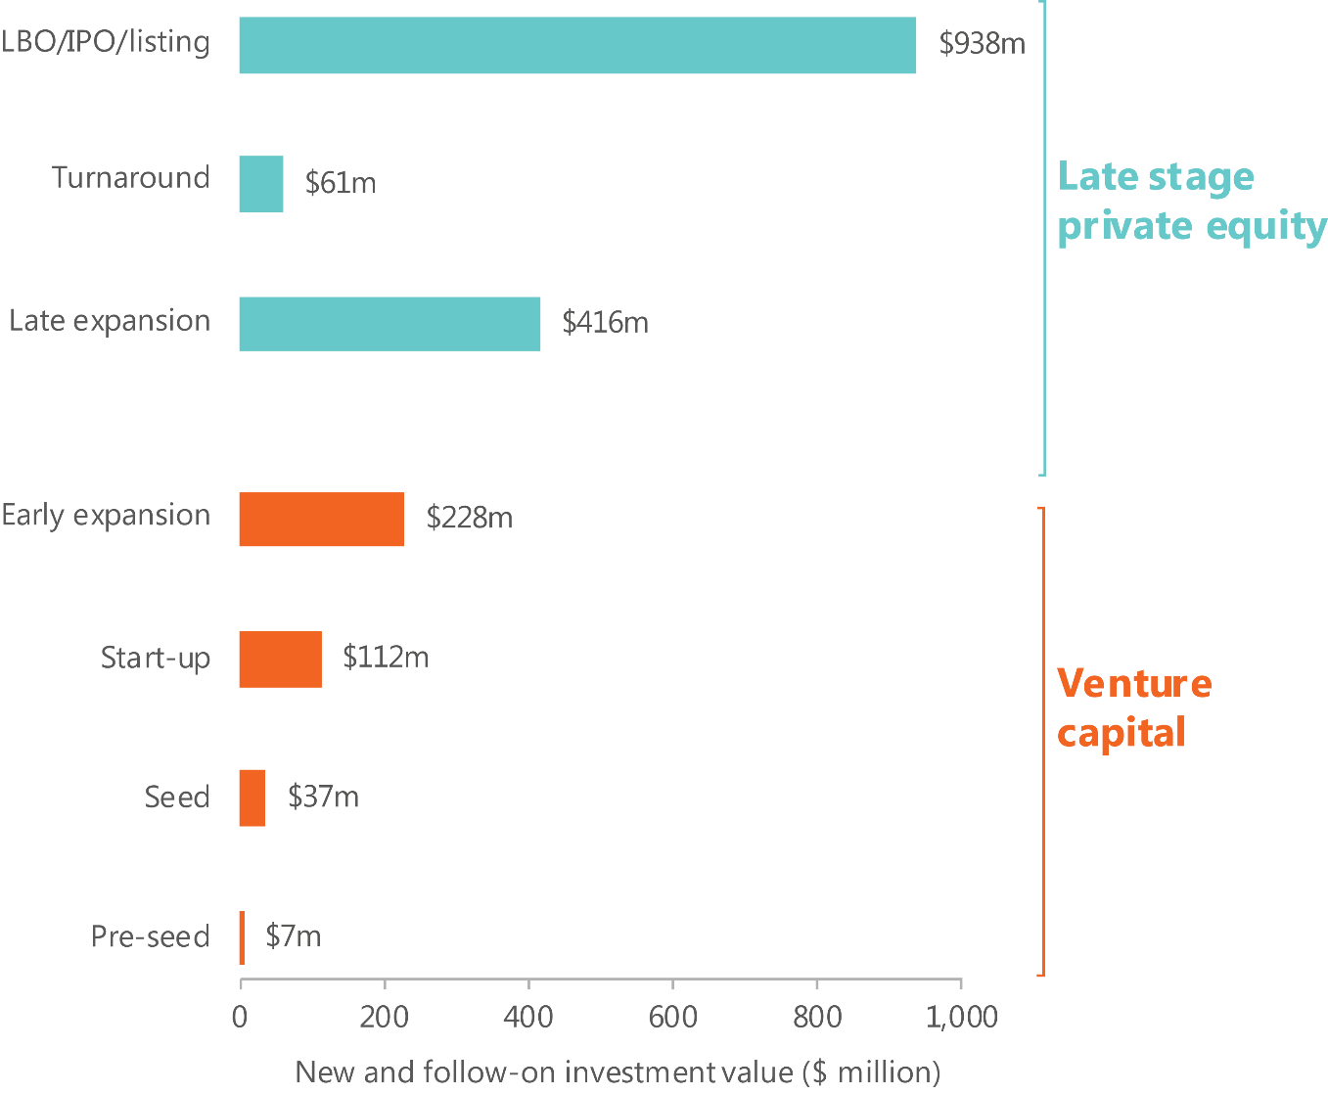
Figure 20: ESVCLP registrations and total amount invested, 2008-09 to 2015-16.¹⁸⁸
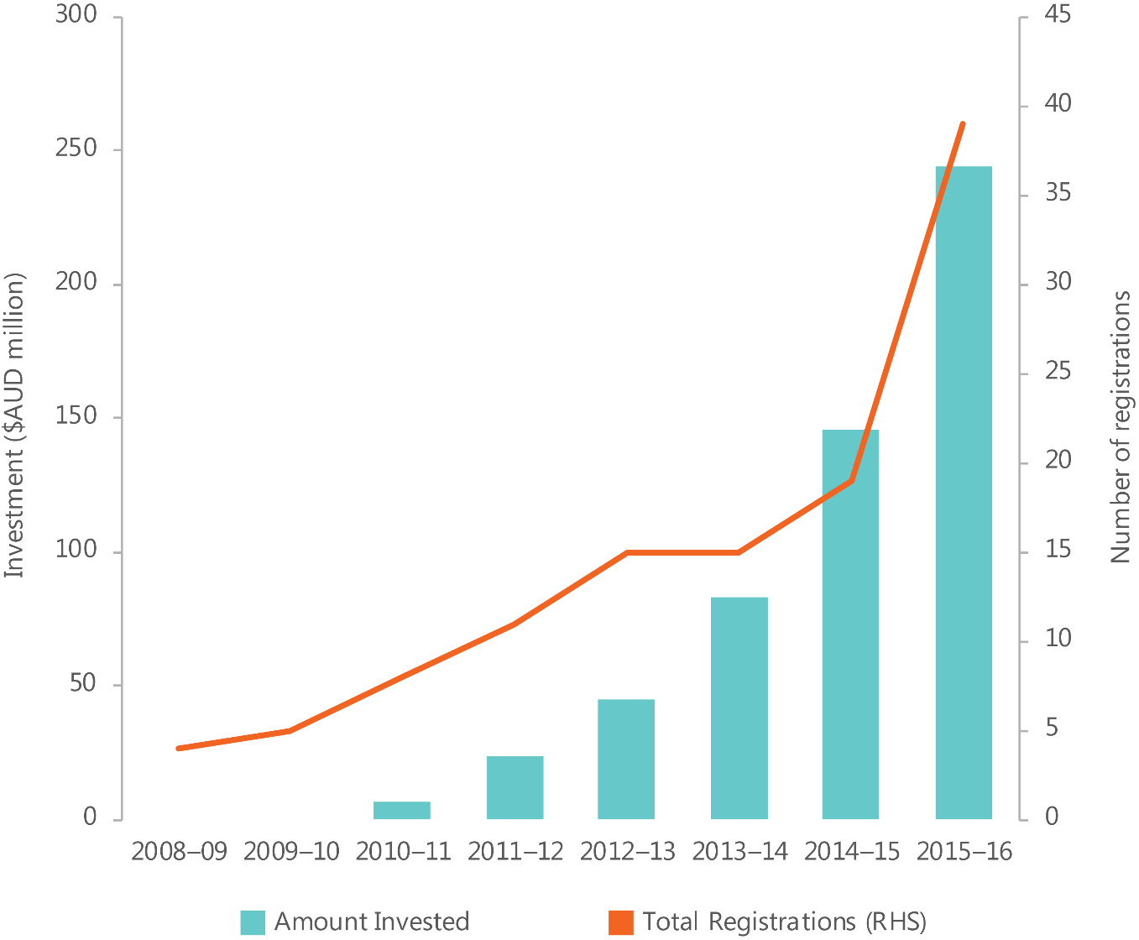

Foreign investors
Foreign investors can be an important source of money and can bring additional benefits in the form of experience, technology transfer and access to important networks.
Australia ranked 6th in the OECD+ in 2014 for foreign direct investment inflow, and 11th in 2015.¹⁸⁹ Foreign investment and ownership in companies are associated with higher degrees of innovation novelty and export orientation.¹⁹⁰

Individuals
Australian business founders rely heavily on their personal savings, with 76 per cent of total required funds coming from founders’ own funds,¹⁹¹ including personal savings and credit cards (Table 5). The funding sources for nascent and young firms reflect the modest nature of most start-ups. The average amount of money required by founders to start a business in Australia is around US$23,000.¹⁹² Over half of young and nascent
firms are founded by people who have had previous experience in starting a business and may have accumulated profits from past successes.¹⁹³ It has also been argued that skilled entrepreneurs are adept at achieving lots with seemingly little money or resources.¹⁹⁴ The similarities between nascent and young firms also suggest that there is usually no large change in the funding source from inception through to early life.¹⁹⁵
Angel investors are high net worth individuals who identify and invest in business start- ups in exchange for equity. ¹⁹⁶ According to the Global Entrepreneurship Monitor, angel investors made up around 5.1 per cent of the Australian population in 2014, above the average for developed nations at 3.3 per cent. ¹⁹⁷ Despite this, previous studies have indicated that few nascent and young firms in Australia access funding through angel investors. Of around 625 nascent firms and 559 young firms that participated in the first wave of the Comprehensive Study of Entrepreneurial Emergence in 2007, 98 per cent of nascent firms and 99 per cent of young firms did not use angel investor equity as a source of funding. ¹⁹⁸ Only 1 per cent of nascent firms reported using angel investor equity as a major source of funding (see Table 5). ¹⁹⁹
Digital technology is facilitating the creation of new platforms to enable individuals to invest in all stages of innovation. Crowdfunding, for example, is a growing but relatively underused source of finance in Australia. Crowdfunding is the practice of using internet platforms, mail-order subscriptions, benefit events and other methods to find supporters and raise funds for a project or venture. There are currently four main types (or models) of crowdfunding: donation-based, reward-based, equity-based and debt-based.²⁰⁰ In 2015, just 5.5 per cent of entrepreneurs in Australia used crowdfunding compared to 14.5 per cent in the United States and 13.4 per cent in Canada.²⁰¹
Table 5: Major sources of funds for Australia's nascent and young firms are the personal savings of their founders followed by personal credit cards and bank loans.
Nascent firms are defined as firms in the process of being created, but not yet established in the market, and young firms are defined as having been operational for up to four years.²⁰²
Major source of funds (representing at least 20 per cent of funding needs) | Nascent firms (percentage using source of funding) | Young firms (percentage using source of funding)
Personal savings | 72 | 51
Personal credit card | 21 | 19
Money from another business that the founders also own | 9 | 2
Government grants | 2 | 1
Delayed payment terms from suppliers | 5 | 9
Advance payment from customers | 5 | 8
Loans from family members | 5 | 2
Loans from friends, employers, or colleagues | 1 | 1
Founders’ personal secured bank loans | 12 | 11
Founders’ other personal loans, overdraft or other credit facilities from a bank. | 6 | 6
Secured bank loans to the business | 5 | 6
Other loans, overdraft or other credit facilities from a bank to the business itself | 1 | 2
Loans from any other organisation to the business itself | 1 | 2
Equity from family members | 1 | 2
Equity from friends, employers or colleagues | 1 | 0
Equity from other private investors (angel investors) | 1 | 0
Equity from venture capital firms or any other organisations | 1 (not designated as a major or minor source)

Industry
In 2012, 4.73 per cent of HERD was financed by industry,²⁰³ putting Australia 18th out of 37 OECD+ countries.²⁰⁴ The contribution of Australian industry to HERD is below the OECD+ average, and well below the average for the top five nations in the OECD+ (16.77 per cent in 2012) (Figure 21).
Australia’s percentage of HERD financed by business has declined consistently since 2006 (when it was 6.76 per cent).²⁰⁵
Figure 21: Percentage of HERD financed by industry, OECD comparison, 2012.²⁰⁶
Note: 2011 data used for New Zealand, Sweden and Mexico.
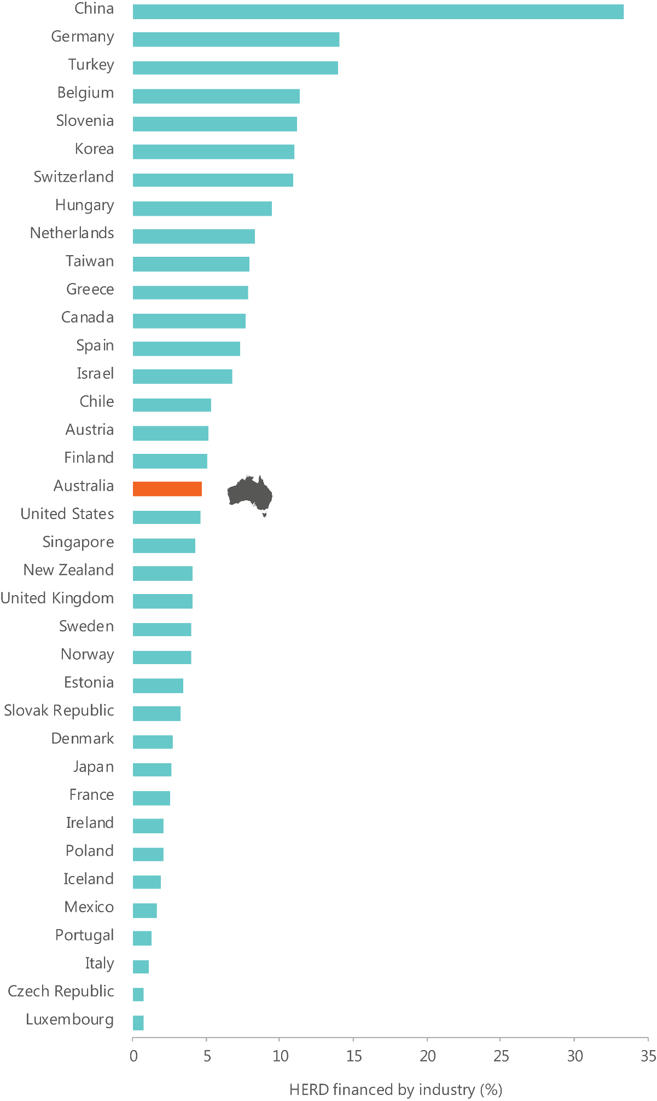

Other sources of money
There are other sources of money, of varying scale. These include government funding (covered in ‘Policy’), philanthropy, foreign venture capital, and university incomes.
An important source of money is income derived from operations and investments, which is then re-distributed into expenditure on innovation. It is unclear what level of income across sectors is re-distributed into expenditure on innovation. However, for R&D expenditure, the level sourced from internal funds varies significantly across sectors.
Around 95 per cent of businesses expenditure on R&D is funded from business’ own funds (internally funded), ²⁰⁷ while around 23 per cent of private not-for-profit expenditure on R&D is internally funded, and 64 per cent of government expenditure on R&D is internally funded.²⁰⁸ Over half of higher education expenditure on R&D is funded from general university funds.²⁰⁹ General university funds include general funding from the Australian Government (including, for example, income related to HECS) and funds earned from student fees and non-research specific donations and bequests. ²¹⁰
The extent to which philanthropy funds innovation in Australia is relatively small. However, it has been playing an increasing role in financially supporting innovation in some areas, particularly social enterprises, since 2010.²¹¹ There are a number of charitable bodies and foundations which are supporting innovation efforts in Australia, especially at the community level.²¹² Charitable donations within Australia were responsible for funding 12 per cent of social enterprises in Australia in 2016, up from 7 per cent in 2010.²¹³
Precise figures on foreign venture capital within Australia are unavailable. However, the Australian Government runs a number of programmes to encourage foreign venture capital to support our early-stage businesses and their innovative efforts. For instance, the Venture Capital Limited Partnership programme provides tax incentives to certain foreign investors.²¹⁴ Similarly, the ESVCLP programme offers tax concessions and was recently amended under NISA to provide further incentives, such as raising the cap on venture capital investments by $100 million for new ESVCLPs.²¹⁵ These policies have helped to attract over $600 million in domestic and foreign venture capital for early-stage start-ups since July 2015.²¹⁶
While the Australian Government provides funding to universities, they also accrue a significant amount of money through other sources. In 2014, Australian higher education providers obtained $6.2 billion from fees and charges, earned $1.2 billion from consultancy and contract projects, and received $1.8 billion through royalties, trademarks and licences.

Strengths

We have higher relative levels of funding for R&D activities in higher education and not-for-profit organisations compared to other nations
There is significant funding available for R&D activities in the higher education and not- for-profit sectors in Australia, relative to other OECD nations (see Table 12 and Table 13). It is difficult to evaluate the extent to which this translates into innovation outputs.
However, a significant proportion of research carried out in Australia is at or above world standard (see ‘Skills’). Long-term funding, combined with consistent incentives to produce research outputs such as papers, may have contributed to our current world-class research capability in many fields.^{218,219}

Financial markets generally function well, though access to risk capital has been a constraint
Only a minority of Australian businesses require external finance intermediated through the financial system in any given year. For example, in 2014–15, only 17 per cent of Australian business sought external finance (either debt or equity) (Figure 20). Australian businesses primarily seek external finance to maintain short-term cash flow, to ensure survival, or to replace machinery or equipment. Only 10.5 per cent of businesses sought finance to fund innovation.²²⁰ Australian businesses are more likely to seek, and successfully obtain, debt financing over equity financing.^{221,222} As mentioned the recent rapid increase in venture capital funds should help with equity financing.
While some businesses do experience difficulty accessing finance, this is not a system- wide problem, and most businesses can access the finance they need in some way (Figure 22).²²³ This does not mean that accessing the funds for innovation is easy for all businesses in all sectors. Innovative businesses are more likely to identify access to finance as a barrier to innovation,²²⁴ particularly when they are pursuing an unproven business model.²²⁵ For these businesses, the difficulties they face in obtaining finance reflect the risks, costs and benefits associated with doing something new.²²⁶
Figure 22: Proportion of Australian businesses seeking external finance and success rates, 2014-15.²²⁷
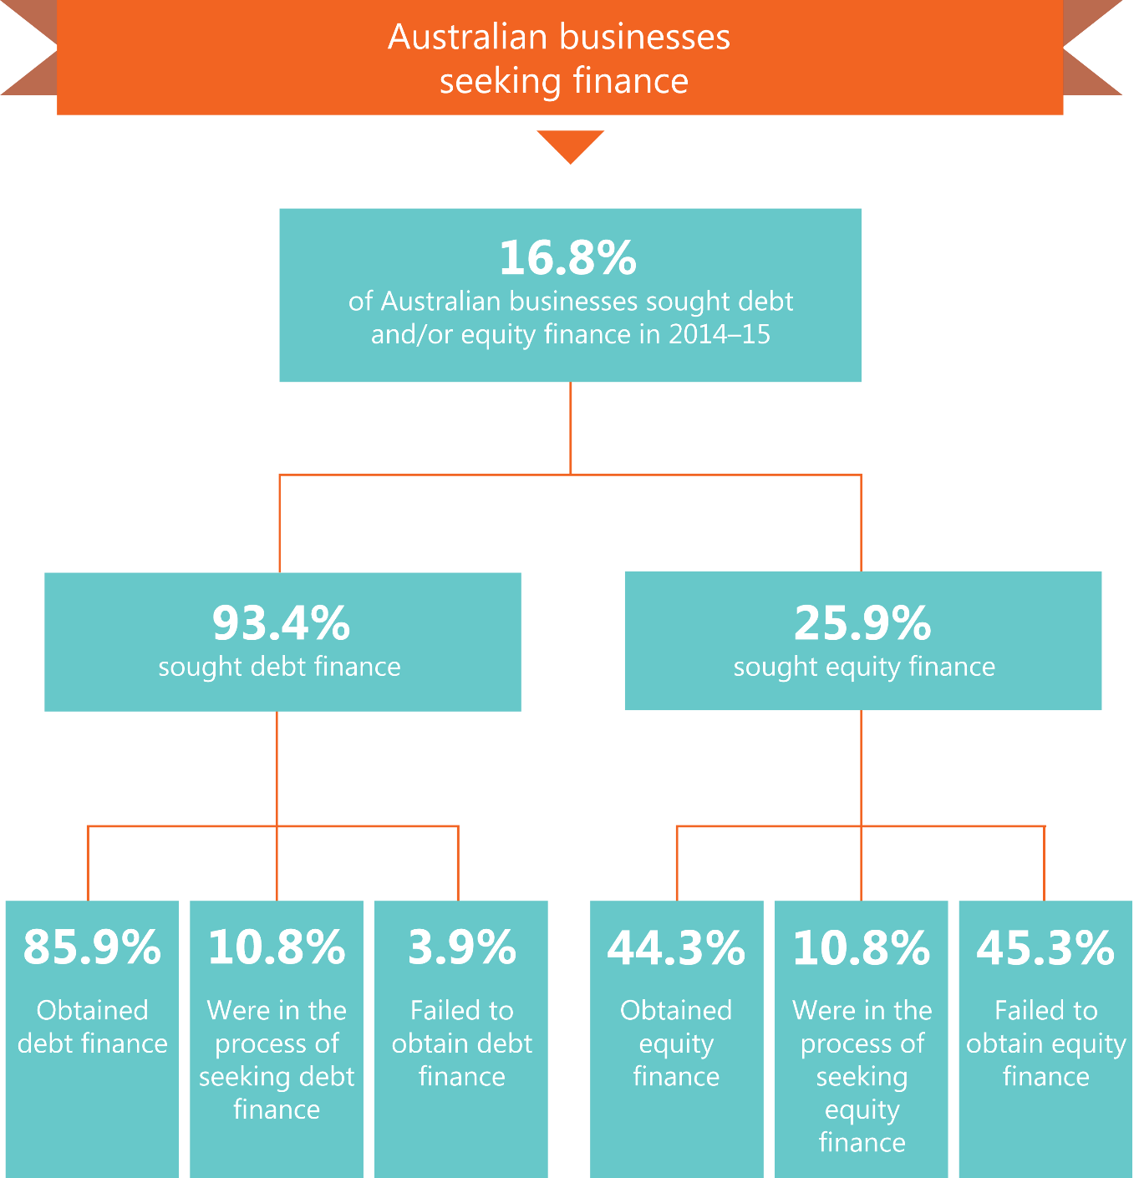

Weaknesses

Australian business expenditure on R&D is low relative to expenditure in other countries
Australia’s BERD is low and has not kept pace with business expenditure in leading innovation nations (Figure 23). Australian business investment in R&D has declined as a percentage of GDP since 2008.²²⁸
There are a number of reasons why Australian business investment in R&D is comparatively low. They include:
- Australia’s industrial structure: Australia’s industrial structure affects R&D intensity.²²⁹ Over time Australia’s industry composition has shifted away from sectors of higher R&D intensity (such as manufacturing) towards sectors of lower R&D intensity (such as services).
- Australian businesses’ focus on innovation with a low degree of novelty (see ‘Outputs’): compared to other countries, Australian firms rank poorly on the proportion of firms that have introduced new-to-market products in manufacturing and services (22nd and 14th out of 28 OECD countries, respectively).²³⁰ New-to-market innovators are much more likely to undertake R&D. On the other hand, the new-to- business innovations undertaken by Australian businesses are usually adaptations or modifications of other innovations and may require little or no R&D.²³¹
- the smaller size of Australia’s SMEs relative to SMEs in other nations: small-scale production may make it more difficult for individual businesses to fund their own R&D and capture its benefits.²³² Like other advanced economies, the Australian economy is dominated by SMEs, with over 99 per cent of all businesses employing less than 200 people.^{233,234} However, compared to SMEs in other nations, Australia’s SMEs are generally smaller with lower turnover and fewer staff. This is reflected in the definitions of SMEs used by different national statistics agencies: in Australia, SMEs are business with up to 200 employees, in the United Kingdom and the European Union, SMEs have up to 250 employees, and in Canada and the United States, SMEs have up to 500 employees.^{235,236,237,238,239,240}
- Australians’ preferences for dividend payments over longer-term investments such as R&D: dividend payments return earnings to shareholders, instead of using them to grow the business, such as through investment in R&D. Australian dividend payout ratios are high compared to the ratios in other countries.²⁴¹ Reasons for Australians’ preferences for dividend payments may include the system of dividend imputation, which ensures that company profits paid to residents are taxed only once;²⁴² shareholders’ preferences for short-term returns;^{243,244} and managers’ and boards’ perceptions of fewer viable investment opportunities in Australia.²⁴⁵
Figure 23: Expenditure on R&D by business as a percentage of GDP, 2013.²⁴⁶
Note: 2012 data used for Switzerland and 2011 data used for Mexico.
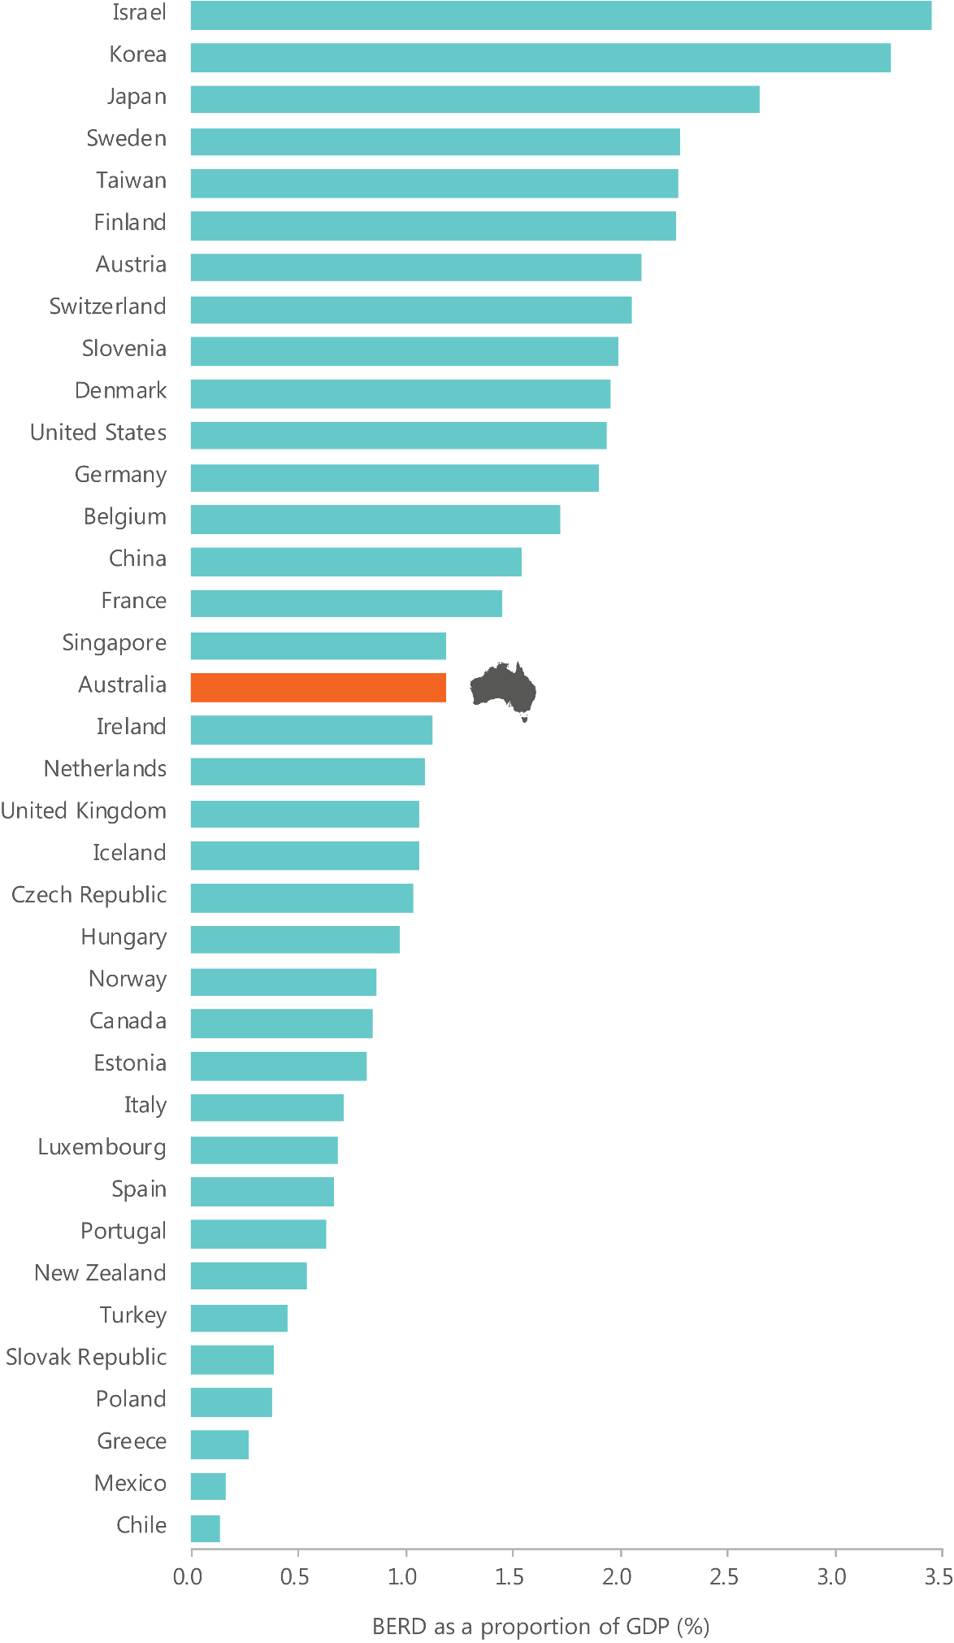

Findings: Money

Knowledge creation
- What are our strengths?
- We have higher relative levels of funding for R&D activities in higher education and
not-for-profit organisations compared to other nations.

Knowledge application
- What are our strengths?
- Financial markets generally function well, though access to risk capital has been a constraint. Recent new funds flowing into the venture capital sector may contribute to overcoming this.
- What are our weaknesses?
- Australian business expenditure on R&D is low relative to expenditure in other countries. Australian business investment in R&D is low, has declined as a percentage of GDP since 2008, and has not kept pace with leading innovation nations.

Infrastructure
Key innovation infrastructure in Australia includes:
- Research infrastructure: underpins research excellence and research collaboration
- Information assets and data infrastructure: enables digital innovation and the creation of new business models
- Intellectual property system: creates incentives for the creation and application of new knowledge.
- Other types of infrastructure, including urban infrastructure (roads, services, housing, etc.), production or commercialisation infrastructure (supply chains, clinical-trial facilities, warehouses, pilot plants, etc.), and research infrastructure owned by the private sector are also important. They are outside of the scope of this ISR System Review; it is difficult to measure and attribute innovation directly to them because they support such a broad range of activities.

Research infrastructure
Research infrastructure comprises the assets, facilities and services which support research across the ISR System.²⁴⁷ Research infrastructure can be characterised into four categories (Table 6). International research infrastructure is often accessed as joint partners providing proportional access (e.g. Square Kilometre Array) or through payment or merit-based access. Some foreign governments have invested in Australian research infrastructure such as New Zealand’s investment in the Synchrotron. Nearly all national infrastructure has merit-based access including that held by the publicly funded research agencies.
Research infrastructure is highly utilised with many being over-subscribed such as the Australian Synchrotron, the Australian Centre for Neutron Scattering and the Centre for Accelerator Science.
Research infrastructure is funded through a range of sources, including the Australian Government, industry, state and territory governments, research organisations and international governments.²⁴⁸ Australian Government programmes and funding sources— including NCRIS, research block grants, the budget appropriations of publicly funded research agencies, and Australian Research Council (ARC) and NHMRC grants—form the foundation of support and help to coordinate contributions from elsewhere.
Since 2004, the Australian government has invested over $2.8 billion to deliver world class research infrastructure. This investment has attracted more than $1 billion in co- investment from universities, research agencies, state and territory governments and industry.
Table 6: A typology of research infrastructure in Australia, with examples.²⁴⁹
 | Characteristics | Examples
Institutional | These facilities are owned and operated by a single institution. Predominantly utilised by internal researchers. Research priorities set by institutions. Funded through institutional budgets. | General laboratories  Specific industry-funded facilities  Coastal research vessels
National | These facilities optimise scarce resources and create scale from a national network of facilities. They are highly collaborative, supported by highly skilled technical workforces and represent national best practice. | For example, the Australian Phenomics Network
Landmark | A category of research infrastructure that is of such scale that the national interest is best served by landmark facilities. These are large-scale. Invested in from time to time by a national government. | Australian Synchrotron  OPAL Research Reactor
Global | Multi-national, collaborative and of a scale where the cost of establishment is beyond the resources or expertise of a single nation. Funded by multiple nations. | Square Kilometre Array  European Molecular Biology Laboratory (EMBL)

Information assets and data infrastructure
Information assets and data infrastructure include infrastructure and capabilities that permit the collection, storage, distribution and analysis of information and data. They also include specific datasets, which, if openly accessible, can form a foundation for knowledge creation, transfer and application.
Assets include ICT equipment, internet infrastructure and the skills required to maintain and use these (the latter of which are discussed further in ‘Skills’). The majority of Australia’s businesses (96.5 per cent in 2014) are connected to broadband internet.^{250,251} However, Australia’s internet speeds have slipped down international rankings. In 2015, Australia had dropped from 46th to 48th of 148 countries in average connection speed (8.2 Mbps) and 60th for average peak connection speed (39.3 Mbps).²⁵² Further, there are still significant differences between internet access in regional, rural and remote areas compared to urban areas. The National Broadband Network is working to improve the quality of digital connections across the nation.
There is increased interest in open data and data-led innovation. High numbers of open datasets—data made available by governments, councils, universities and businesses so that others can use them with little or no restriction—can support innovation in a range of areas, including:
- product innovations (e.g. health data can be used by the makers of pharmaceuticals and medical devices to find patients for trials and identify potential problems once products are in use)²⁵³
- service innovations (e.g. data can be used to develop more efficient access to government services, such as public transport apps)
- process innovations (e.g. weather data can be used to optimise harvesting in agriculture)²⁵⁴
- business model innovations (e.g. GPS data have led to taxis and Uber cars providing improved services to users).
Increasing access to open data can create significant economic benefits. Estimates suggest that benefits could be in the order of $25 billion per year, or 1.5 per cent of Australia’s GDP.²⁵⁵ Open data can also generate significant social and environmental value, such as improved social services, new jobs or more sustainable energy production.
Importantly, while many important datasets are government-owned, important datasets can, and should, be contributed to by researchers and businesses. Work is underway to ensure more research data are open and accessible—for example, through the Australian National Data Service.²⁵⁶ While access to research data is improving, it costs time and money to clean data, securely store it, format it and address ethical issues.

Intellectual property system
Intellectual property (IP) rights give legal protections to the creators of new ideas and provide them with the opportunity to commercialise their ideas. IP rights include patents, trademarks, copyright, design rights, and plant breeder’s rights, all of which can encourage innovation.²⁵⁷ Of the five, patents are most commonly used as a proxy measure for innovation or commercialisation of science.
A patent is an exclusive right granted for an invention, which can be broadly described as a new way of doing something, or as a new technical solution to a problem.²⁵⁸ There are three types of patents available in Australia:
- Standard patents last for up to 20 years from the filing date of the application (or up to 25 years for pharmaceutical substances). The application must be examined prior to granting the patent to establish that the invention is new, that it involves an inventive step and that it can be made or used in an industry.
- Innovation patents last up to eight years. There is no examination before the patent is granted, but the patent cannot be enforced unless examined and certified.
- Provisional patents are described as placeholders. They establish a priority date and are an inexpensive way of signalling an intention to file for a full patent.²⁵⁹
In 2015, there were 28,605 standard patent applications in Australia; this was an increase of 10 per cent from 2014, and reflects an upward trend over the last decade.²⁶⁰ Of these, 2,291 standard patents, or just 8 per cent, were filed by Australian residents. In the same year, 1,828 innovation patents were filed, with Australian residents accounting for 61 per cent of filings.²⁶¹
In 2014, Australians filed over four times as many applications abroad as they filed domestically (Figure 24). This reflects the jurisdictional nature of the IP rights system and the size of the Australian market. IP rights are only enforceable in the jurisdiction in which they are granted. Consequently, if an applicant wants to protect their IP in different markets, they must submit applications across multiple countries for a single invention. This is facilitated by the Patent Cooperation Treaty and the Paris Convention for the Protection of Industrial Property.²⁶² In 2015 1.5 international patent applications were filed by Australians at the PCT per billion $PPP GDP.²⁶³ This ranks Australia 22nd of 37 OECD+ countries, and well below the average for the top five OECD+ performers (8.3 international patents filed at the PCT/bn PPP$ GDP).²⁶⁴
To supplement patent data, trademark data can be used as an indicator for innovation activity. A trademark is a legally protected word, phrase, picture or symbol.²⁶⁵ Trademarks serve to distinguish a firm’s product from others in the market, and help companies differentiate new and innovative products from inferior substitute products.²⁶⁶ Importantly, trademarking is an indicator for innovation in knowledge intensive service companies which tend not to patent.²⁶⁷ Trademarks are thus an important indicator for innovation in heavily services based economies such as the Australian economy.²⁶⁸ In 2014, 65.4 trademark applications were filed by Australians per billion $PPP GDP.²⁶⁹ This ranks Australia 14th out of 20 OECD+ countries, just below the OECD+ average (65.9 trademarks filed per billion PPP$ GDP) and well below the average for the top five OECD+ performers (118.1 trademarks filed per billion PPP$ GDP).²⁷⁰
In practice, the IP system needs to strike an appropriate balance. Too little protection can discourage inventors from disclosing or commercialising their ideas. Too much protection can constrain the application of knowledge to other areas and limit the transfer of knowledge across the ISR System.
A recent review by the Productivity Commission suggests that Australia may have got the balance wrong, suggesting that Australia has relatively strong copyright and patent rights compared to other countries. The Productivity Commission suggests that Australia’s intellectual property system grants patent protection too easily and this has allowed a proliferation of low-quality patents (particularly innovation patents).²⁷¹ The Productivity Commission also notes that Australia’s copyright system has progressively expanded and protects works longer than necessary to encourage creative endeavours.²⁷² As Australian firms tend to ‘adopt and adapt’ innovations, disseminating and building on the knowledge of others is key. Low-value patents and other unnecessary IP protections can impede this type of innovation by frustrating the efforts of follow-on innovators, stymieing competition and raising costs to the community.²⁷³ The Productivity Commission’s inquiry report proposes a number of measures to raise the quality of patents in the Australian system, including increasing the degree of invention required to receive a patent and abolishing the innovation patent system.²⁷⁴ With regard to the former, recent changes brought about by the ‘Raising the Bar’ reforms may have addressed this, although it could be too early to tell.
Too much protection for rights holders is likely to have a negative effect on innovation in Australia. Australia is a currently a net importer of IP-intensive goods and services and the gap between IP imports and exports is growing rapidly.²⁷⁵ In recent years, Australia has also signed up to—or continued negotiations on—a number of international trade agreements. Some of these agreements include restrictions on IP; however, Australia has no overarching IP policy framework to guide changes to IP protection in the context of international trade negotiations.²⁷⁶ The Productivity Commission’s inquiry report suggests that Australia should take a more strategic approach to the negotiation of IP provisions in international agreements, including a more comprehensive consideration of domestic IP interests.²⁷⁷
Figure 24: Patents filed by Australian residents domestically and abroad, 2004 to 2014.²⁷⁸
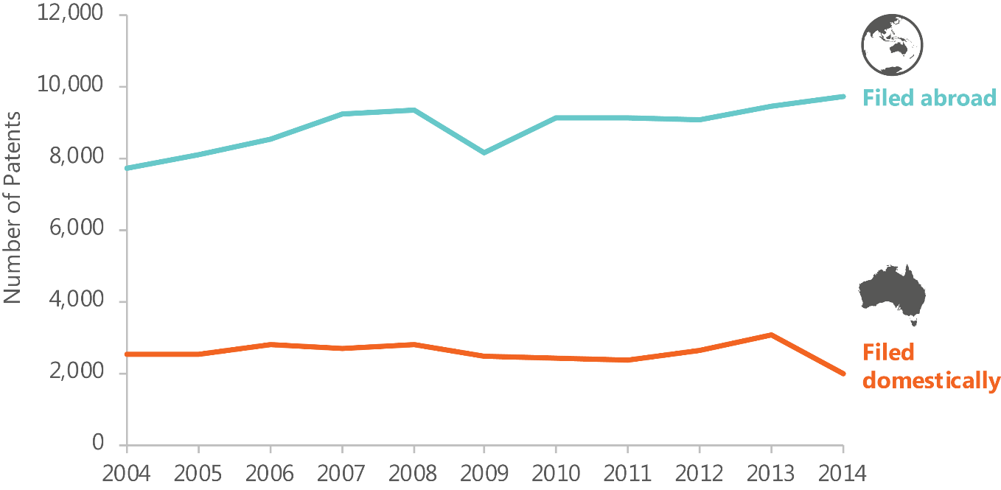

Strengths

Many of Australia’s research infrastructure assets are world-class, although there is a need for overarching governance and ongoing, whole-of-life funding
Many of Australia’s research infrastructure assets have high levels of use and support significant research output and scientific achievement. For example, the Australian Synchrotron, the Australian Centre for Neutron Scattering and the Centre for Accelerator Science are significantly oversubscribed. The Synchrotron has produced a significant number of research publications that have a high or very high level of global citation. NCRIS currently supports 27 projects across Australia.²⁷⁹ The use of the facilities supported by NCRIS by the research community both in academia and in industry is significant. There is also a significant amount of research being published as a result of the facilities supported by NCRIS.²⁸⁰
Evaluations suggest that the research infrastructure funded through NCRIS has generated $1.06 of co-investment for every $1 invested by the Australian Government, and has facilitated high levels of collaboration and integration across disciplines and institutions.²⁸¹ The most recent review of NCRIS noted that the programme had been successful in providing access to facilities and resources (infrastructure) which may have been previously unavailable, and in reducing duplication. It also noted the value of developing a significant skill base and technical capability associated with the infrastructure.²⁸²
ISA has heard that, without exception, NCRIS facilities are led and staffed by highly skilled and professional personnel who ensure the success of the infrastructure and research done within it, often in spite of inconsistent, unpredictable and short-term (one to two years) funding extensions.²⁸³
The Australian Government’s support for national research infrastructure has been historically provided through the funding of PFRAs and departments along with a number of grant programmes. Significant injections have happened through the Major National Research Facility Programme (1996–2005) and NCRIS (2006–2011) with significant additional capital funding ($1 billion) through the Education Investment Fund Super Science Initiative (2009–2013) and separate funding for information and data infrastructure under the Systemic Infrastructure Initiative (2001–2006). A number of projects established under the Super Science Initiative are now funded through NCRIS.
In 2014, the National Commission of Audit recommended that ‘the government take a more strategic, whole of government approach to funding R&D, including by committing to ongoing funding for critical research infrastructure in Australia, informed by a reassessment of existing research infrastructure provision and requirements. This is consistent with feedback received by ISA throughout its consultations.
As part of the NISA, in 2015, the NCRIS was given significant support with a major injection of operational funding ($1.5 billion over ten years). Considerable further funding was also provided for the operational running costs of the Synchrotron ($520 million over ten years) and funds for the operational and capital build of the Australian site of the Square Kilometre Array ($294 million).
The 2016 National Research Infrastructure Roadmap provides an opportunity to improve strategic prioritisation and coordination of all national research infrastructure in Australia. It identifies Australia’s priority research infrastructure needs for the next 10 years to guide future investment decisions, including the allocation of operating funding under NCRIS.²⁸⁴ ISA believes there is a need for overarching and ongoing whole of life funding of national research infrastructure.
The European Union has a comprehensive centralised research infrastructure inventory called Mapping of the European Research Infrastructure Landscape. This database helps scientists to access research equipment and facilities, and assists national policymakers to make informed decisions on the funding of research infrastructure in their region.

We are increasing our open government datasets and improving data sharing
Since 2015, there has been a significant increase in the number of open datasets in Australia (Figure 25). As a result, Australia performs reasonably well on open data compared to other nations. In the OECD’s pilot open data index, which assesses openness, usefulness and reusability of government data assets, Australia ranked 4th, behind Korea, France and the United Kingdom (Figure 26).
This ranking can be attributed to the growing focus on open data in Australia, and a number of initiatives that have been established in recent years to improve access to valuable datasets. In particular:
- the Australian Government Public Data Policy Statement provides a clear mandate for Australian Government entities to optimise the use and reuse of public data, to release non-sensitive data as open by default, and to collaborate with the private and research sectors to extend the value of public data for public benefit285
- the open data platform ‘data.gov.au’ is to be improved as part of the NISA. This will include improving search, publishing, data quality and spatial publishing functions. There are already over 20,000 Australian Government, state and territory government, city council and university data records on the platform
- Australia is working in partnership with The GovLab at New York University to conduct the Open Data 500 Australia project to assess the value open government data adds. This is the first study of Australian companies and NGOs which use open government data to generate new business, develop new products and services, and create social value²⁸⁶
- the Data Skills and Capability Framework aims to enhance data literacy and data skills in government.²⁸⁷
While there has been increased focus on open data in Australia, areas for improvement remain.²⁸⁸ There is known demand for more public sector data by the research and private sectors.²⁸⁹ Other governments’ open data platforms host many more datasets from more contributors. For example, the UK open data website has around 40,000 datasets and they are spread over 1,390 different publishers.²⁹⁰ In the United States, there are 186,426 open datasets from 182 organisations.²⁹¹
While the Productivity Commission’s inquiry into data availability and use is not yet completed, its draft report suggests that fundamental reform is required to ensure data processes become more transparent and establish community trust.²⁹²
Figure 25: Open datasets in Australia, 2013 to 2016 (includes federal, state, territory and local government agencies and universities).²⁹³
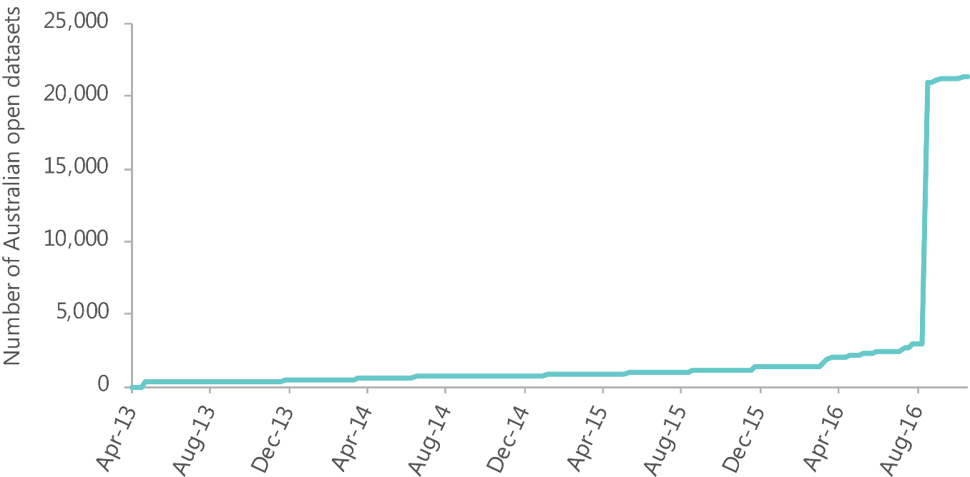
Figure 26: The pilot OURdata index (open, useful, reusable government data) ranked Australia 4th out of 29 OECD countries in 2014, well above the OECD average.²⁹⁴
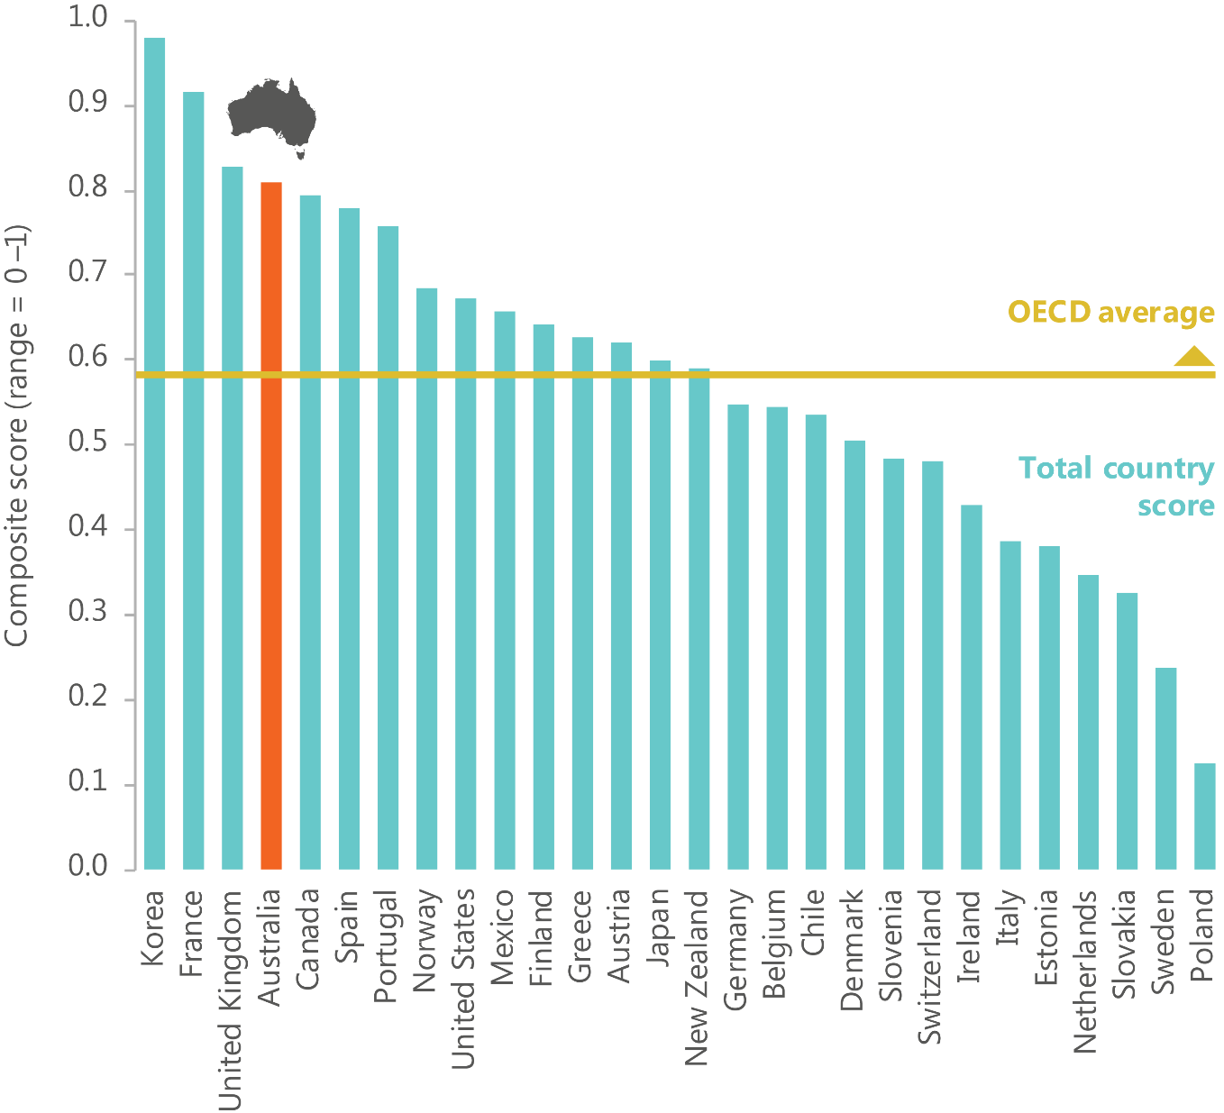

Findings: infrastructure

Knowledge creation
What are our strengths?
- Many of Australia’s research infrastructure assets are world-class, although there is a need for overarching governance and ongoing, whole-of-life funding. Many of Australia’s research infrastructure assets have high levels of use and have supported significant research output and scientific achievement.

Knowledge transfer
What are our strengths?
- We are increasing our open government datasets and improving data sharing. Open government data is improving publicly available datasets and we have new data sharing arrangements within government enabling new data tools.

Skills
The term ‘skills’, in the context of this ISR System Review, refers to the supply and quality of skills, talent, competencies and/or experience for innovation, as well as attitudes towards innovation, science and research. Successful innovation requires a range of different skills, possessed by either an individual or, more commonly, a team. Recent research has proposed a high-level profile of the capabilities required for innovative enterprises (Table 7). The skills most commonly used by innovation-active businesses are financial and marketing skills (Figure 27). In 2014–15, the most commonly reported areas of skills shortage were in trades, marketing and financial skills (Figure 28).
Behaviours such as being adaptable, authentic, business-minded, collaborative, customer- focused, flexible, globally aware, self-aware and resilient are also important for most innovative organisations.²⁹⁵
Successful innovation may also often require access to more specific skill sets, such as legal or venture capital skills. Venture capital and entrepreneurial skills are broader than leadership and management skills, and include critical analysis, intuition and the ability to select people or ideas that have a good chance of being successful.
In addition to the skills required for specific innovation activities, it is important to ensure that the general population has a satisfactory level of basic skills. Basic skills enable people to fully participate in education, the economy and society, and they provide people with the ability to learn and acquire new knowledge over their working life.²⁹⁶ For example, numeracy and literacy enable participation in education, and digital literacy can help people adapt to change and effectively utilise new technologies.²⁹⁷
Table 7: Skills for innovation.²⁹⁸
It is widely recognised that a diverse range of skills and capabilities are needed for successful innovation. How these skills are combined—either by an individual, or in a team—is also critical.²⁹⁹
Category | Description
Basic skills | Covering numeracy, reading and comprehension, written expression (literacy), active learning, oral expression, problem-solving, critical thinking, self-awareness and digital literacy. These basic skills are sometimes referred to in the business community as employability skills.
Knowledge skills | Covering knowledge drawn from science, technology, engineering and mathematics (STEM) and the humanities, arts and social sciences (HASS). Knowledge skills lie at the foundation of ‘knowledge organisations’ (that is, organisations that create, manage, use and transfer knowledge-based products or services).
Technical and technician skills | Covering areas such as equipment maintenance, installation, repair, operation and control, machine programming and software maintenance, quality control, technology and user experience design, troubleshooting.
Creativity, design and cross-cultural skills | Covering idea and opportunity creation (which may or may not be sourced from science and technology), problem-solving, integrative thinking, ingenuity and end user (customer) orientation including cross-cultural understanding within and across multiple global markets.
Entrepreneurial skills | Covering abilities related to starting a business, whether as a start-up company or as a new venture in an established organisation, including an ability to focus on satisfying customer needs and end user wants.
Business skills | Covering implementation and administration of critical business systems and processes, including sales and marketing, accounting and finance, materials procurement and supply, project delivery, recruitment and motivation of employees and contractors, and management of time.
Management and leadership skills | Covering judgement and decision-making, communicating and coordinating with others, emotional intelligence, negotiation, persuasion, organisational culture, training and teaching others.

There is no universal skills mix for innovation.³⁰⁰ Different skills mixes are required for different types of innovation and different innovation activities.³⁰¹
Businesses that use STEM skills are more likely to introduce new-to-the-world innovation,³⁰² and efforts are underway to address STEM skills shortages. At the same time, the most commonly used skills by innovation-active Australian businesses are non-STEM skills,³⁰³ and the greatest shortages are reported in trades.³⁰⁴ HASS skills are particularly important for demand-driven innovation, as these skills include the ability to investigate and understand customer experience, market forces and organisational culture.³⁰⁵ According to Professor Ian Chubb, former Chief Scientist of Australia, ‘the social sciences and the humanities will underpin a creative and innovative Australia; and it is only in this context that STEM can be effective’.³⁰⁶
How skills are combined, either by an individual, or in a team, is also critical to successful innovation. Research with some of Australia’s most innovative organisations has shown that a mix of different skills types is necessary for an optimal contribution to innovation. Deep technical and narrow knowledge skills are an important part of this mix, but they are not sufficient for an optimal contribution to innovation if used alone.³⁰⁷ A key feature of highly innovative enterprises is that they mix both technical and non-technical skills, with research indicating that both STEM and business skills are shown to be critical factors associated with innovation.³⁰⁸
Innovative businesses also place significant value on choosing staff with the right skills as well as those that will culturally fit the organisation; have a good emotional intelligence; can critically think, solve problems and be creative; and have leadership; communication and people skills. 309 Innovative businesses invest in technical and broader skills development in their staff, and rotate their staff through the organisation to gain whole of organisation insight.
Figure 27: Skills used by Australian businesses, by innovation status, 2014-15.³¹⁰
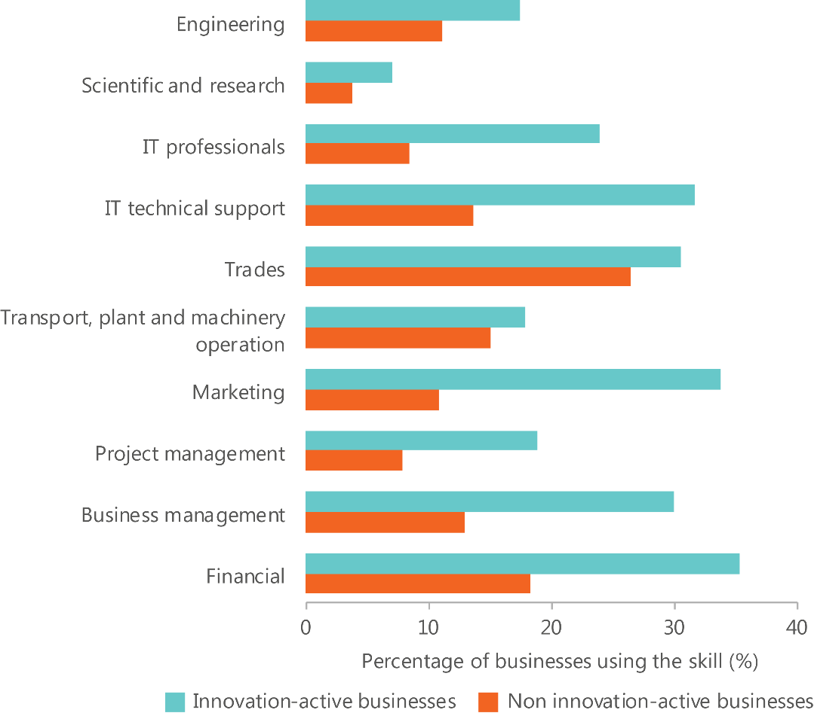
Figure 28: Skills shortages reported by Australian businesses, by innovation status, 2014-15.³¹¹
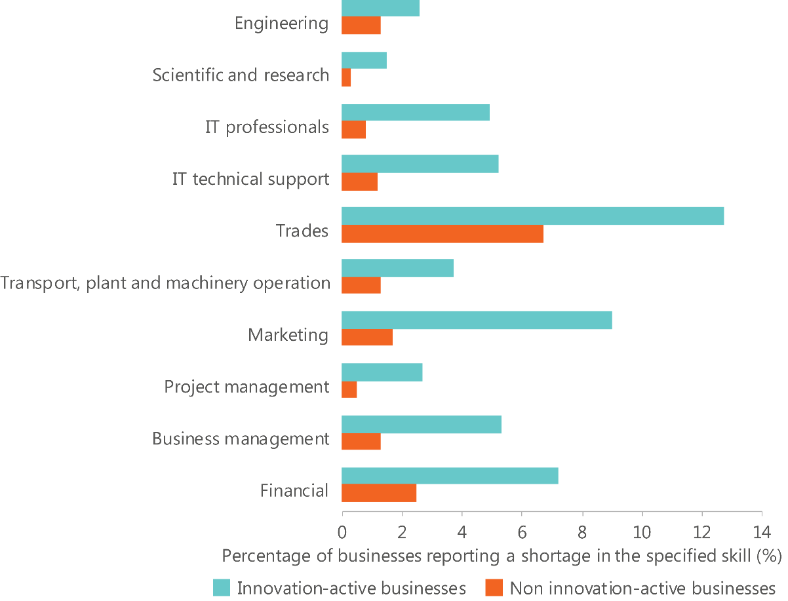

How are the skills for innovation developed?
Skills and attitudes can be learned in formal educational settings, on the job or through formal mentoring or coaching. They may also be learned informally in homes and communities, or brought into the ISR System through migration.
The education system is the main provider of formal skills (Table 8). In general, primary and secondary school systems equip students with the basic skills required for participating in society. They also provide broad coverage of many of the key knowledge skills, such as science, mathematics and social science. The post-school education system (Figure 29) provides students with in-depth knowledge of specific technical, design and business skills.
Many skills are also formally acquired through practical experience, mentoring, collaboration or on-the-job training. Research with some of Australia’s leading innovative organisations has highlighted that these organizations use partnerships, contractors, networks and clusters to access complementary expertise. While firms typically indicate a belief that the workforce has STEM-related skills shortages, leading innovative firms do not expect new recruits to be job-ready. These firms take a long-term approach to skills building and use sophisticated recruitment, training and incentive systems, combined with strong cultures and engagement, to support their innovation strategy.³¹²
Skills and attitudes are also learned in informal settings. For example, skills such as entrepreneurship, leadership, ingenuity and troubleshooting may be more effectively learned through trial and error in a real-world context.
Finally, skills can also be brought relatively quickly into the ISR System through immigration. Immigration is tailored to supplement the Australian labour force with short, medium and long-term skills needs, through both permanent and temporary migration programmes.
Table 8: Stocktake of current skills development in Australia, detailing main source, total numbers of students/graduates and main fields of study (formal education and migration only, informal excluded).
Skill source | Total number | Skill focus/competency
Schools (2014)³¹³ | 3,673,765 full-time school students | Australian students perform above the OECD average in reading, mathematics and science.  In the top-performing country (Singapore), 40 per cent to 50 per cent of Year 4 and Year 8 students reach the Advanced TIMSS benchmark in mathematics and science. It is around one in 10 in Australia.³¹⁴
Vocational education and training (2015)³¹⁵ | 815,905 programme completions  52.4% male  46.9% female  0.7% not known/other | Top five fields:  - Management and commerce  - Engineering and related technologies  - Society and culture  - Mixed field programmes  - Food, hospitality and personal services
Domestic students university course completion (2015)³¹⁶ | 217,928 students  60% female  40% male | Top five fields:  - Society and Culture  - Health  - Management and Commerce  - Education  - Natural and Physical Sciences
International students university course completion (2015)³¹⁷ | 106,908 students  52% female  48% male | Most popular field of study—management and commerce
457 visa entrants (2014-15)³¹⁸ | 51,310 primary 457 visas granted³¹⁹ | Top three sponsor industries:  - Other services  - Information media and telecommunications  - Accommodation and food services
Skilled migration stream (2014-15) | 127,774³²⁰  This comprises:  - general skilled migration—72,840  - employer sponsored—48,250  - business innovation and investment—6,484  - distinguished talent—200 | Top five fields of primary applicants:³²¹  - Accountants  - Software engineers  - Cooks  - Registered nurses  - ICT business analysts
Postgraduate course completion (2015)³²² | 124,018 students³²³ | Top five fields of award course completions:  - Management and commerce  - Society and culture  - Health  - Education  - Engineering and related technologies
Figure 29: The post-school education system is divided into two sectors: higher education, and vocational education and training (VET).
The majority of higher education students go to universities; the majority of VET students attend private training providers.^{324,325,326}
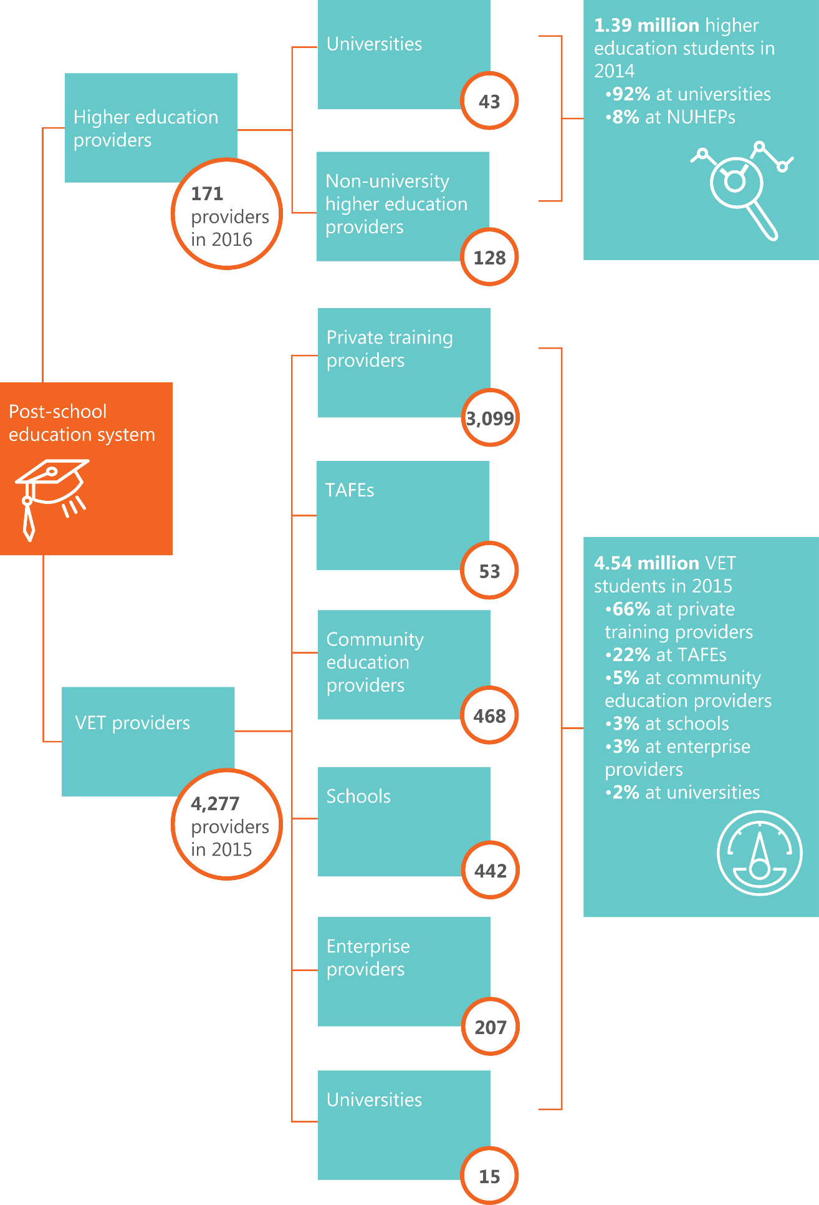

Strengths

The Australian research workforce is world-class in many research fields
Australia achieves much better research outputs than would be expected from the number of people employed in the research workforce.³²⁷ On the latest available data (from 2010), Australia ranked 15th out of 30 OECD countries for the total number of R&D personnel per 1,000 employed.³²⁸ Yet Australia accounts for a larger share of world research outputs relative to our total population. Australia produces 48.7 top 1% highly cited publications per million in the population.^{329,330} This ranks Australia 8th out of 36 OECD+ countries, behind the top five OECD+ performers (86.0 top 1% highly cited publications per million in the population) but well above the OECD+ average (34.3 top 1% highly cited publications per million in the population). ^{331,332}
Between 2005 and 2015, 77 Australian organisations contributed to the top 1 per cent of highly cited publications worldwide. Of these, 40 organisations (just over half) were universities.³³³ The 2015 Excellence in Research for Australia (ERA) process identified 43 areas of national strength across a range of disciplines in basic science, engineering and humanities and these are distributed across Australia’s universities (Table 9).³³⁴ This is up from 20 in 2012. Across the last three rounds of ERA results (2010, 2012 and 2015), the quality of research produced by Australian universities has improved significantly.
Most of Australia’s researchers are engaged in the higher education sector.³³⁵ In 2012, there were 6.5 researchers (as measured on an FTE basis) in the Australian government and higher education sectors per thousand workers.³³⁶ This was the third highest number out of 36 OECD+ countries, and above the average for the top five performers (6.27 researchers on an FTE basis per thousand workers).³³⁷ The number of researchers engaged in R&D by the higher education sector has more than doubled since 1992.³³⁸ Latest data (2008–09) indicate that 58 per cent of all researchers devoted to R&D in Australia are within the higher education sector.³³⁹ Within universities specifically, nearly a quarter of researchers are in the medical and health sciences.³⁴⁰
Australia also has relatively high levels of higher degree by research (HDR) graduates, and this number has been increasing over time. The latest census data shows that Australia has 8.2 doctorate holders per thousand people in the working age population.³⁴¹ This is slightly above the OECD+ average (7.9 doctorate holders per thousand in the working age population) but below the average for the top five performing OECD+ countries (16.8 doctorate holders per thousand in the working age population).³⁴² Of Australia’s doctorates, 14 per cent were educated in engineering, manufacturing and/or construction.³⁴³
In 2015, there were over 65,500 HDR enrolments and over 10,000 HDR completions. Compared with 10 years ago, enrolments have increased by 17,000 students and course completions by around 3,000 students.³⁴⁴ This growth can be largely attributed to the increased number of international students. In addition, Indigenous Australians’ involvement in research and research training has increased markedly over the past decade. Indigenous HDR completions have increased by 33 per cent since 2006. Over the same period, the number of Indigenous academic staff has increased by almost 40 per cent.³⁴⁵
In 2015, 34 per cent of HDR graduates were from overseas and 32 per cent of HDR enrolments were overseas students.³⁴⁶ Many international students want to stay in Australia after graduation. Surveys have indicated that around 45 per cent of international research students believe they will work in Australia in the year following graduation.³⁴⁷
Overall measures of Australian publications indicate that outside of the top-performing publications, Australia has a number of publications that are not cited at all. In 2015, around 43 per cent of Australian publications were not cited, compared to the OECD+ average of 46 per cent.³⁴⁸
It is unclear what an acceptable level of uncited research would be.
Table 9: Research at or above world standard, by institution and field of research, 2015.
5 well above world standard; 4 above world standard; 3 at world standard (scores of 2 below world standard, and 1 well below world standard, are not shown).³⁴⁹ 15 two-digit fields of research (indicated by green) contain 43 national research strengths which are identified at the four-digit field of research.
 | Mathematical Sciences | Physical Sciences | Chemical Sciences | Earth Sciences | Environmental Sciences | Biological Sciences | Agricultural and Veterinary Sciences | Information and Computing Sciences | Engineering | Technology | Medical and Health Sciences | Built Environment and Design | Education | Economics | Commerce, Management, Tourism and Services | Studies In Human Society | Psychology and Cognitive Sciences | Law and Legal Studies | Studies In Creative Arts and Writing | Language, Communication and Culture | History and Archaeology | Philosophy and Religious Studies
National Research Strengths
Institution
The University of Adelaide | 5 | 5 | 4 | 4 | 4 | 4 | 4 | 4 | 4 | 3 | 5 | 3 |  | 3 | 3 | 4 | 3 | 4 | 4 | 3 | 4 | 4
Australian Catholic University |  |  |  |  |  |  |  |  |  |  | 4 |  | 3 |  |  | 3 | 5 | 3 |  |  | 3 | 4
The Australian National University | 5 | 5 | 4 | 4 | 5 | 5 | 4 | 5 | 4 |  | 5 |  |  | 4 | 4 | 5 | 4 | 5 | 3 | 5 | 5 | 5
Bond University |  |  |  |  |  |  |  |  |  |  | 4 |  |  |  | 3 |  |  | 3
The University of Canberra |  |  |  |  | 5 |  |  | 3 |  |  | 3 |  | 3 |  |  | 3 |  | 3 | 3 | 3
Central Queensland University | 5 |  |  |  | 4 |  | 4 |  | 3 |  | 4 |  |  |  |  |  | 5
Charles Darwin University |  |  |  |  | 4 | 3 | 3 | 3 |  |  | 5
Charles Sturt University |  |  |  |  | 3 |  | 3 |  | 3 |  |  |  | 3 |  |  |  |  |  |  |  |  | 3
Curtin University of Technology | 3 | 4 | 4 | 4 | 3 | 3 | 4 | 3 | 4 |  | 3 | 3 | 3 | 3 |  | 3 | 4 |  | 3 | 3 | 3
Deakin University |  |  | 4 |  | 4 | 3 | 4 | 3 | 4 | 4 | 5 |  | 4 | 3 | 3 | 3 | 3 | 3 | 3 | 3 | 4 | 3
Edith Cowan University |  |  |  |  | 4 | 4 |  |  | 3 |  | 4 |  |  |  |  |  | 3
Federation University | 3 |  |  | 3 |  |  |  | 3 |  |  | 3 |  |  |  |  | 3 |  |  |  |  | 3
Flinders University | 3 | 3 | 3 | 3 | 3 | 3 | 3 | 3 | 3 | 4 | 3 |  |  | 3 |  | 3 | 3 | 3 | 3 | 3 | 3 | 3
Griffith University |  | 5 | 5 | 3 | 5 | 3 | 3 | 3 | 4 |  | 4 | 3 | 3 |  | 3 | 4 | 3 | 4 | 4 | 3 | 4
James Cook University |  | 3 | 3 | 4 | 5 | 4 | 3 |  | 3 |  | 3 |  | 3 |  |  | 3 |  | 3 |  | 3 | 4
La Trobe University | 4 | 5 | 4 |  | 3 | 5 | 5 | 3 |  |  | 3 |  | 3 | 3 | 3 | 3 | 3 | 3 |  | 4 | 4 | 3
Macquarie University | 4 | 5 | 3 | 4 | 5 | 4 | 5 | 3 | 3 |  | 4 | 3 | 3 | 3 | 3 | 3 | 4 | 4 | 3 | 4 | 4 | 4
The University of Melbourne | 5 | 5 | 5 | 4 | 5 | 4 | 4 | 5 | 5 | 4 | 5 | 4 | 5 | 5 | 5 | 4 | 4 | 5 | 4 | 5 | 5 | 4
Monash University | 4 | 5 | 5 | 3 | 4 | 4 |  | 4 | 5 | 5 | 5 | 3 | 4 | 4 | 4 | 4 | 4 | 5 | 4 | 4 | 5 | 4
Murdoch University |  |  | 3 |  | 3 | 3 | 3 |  | 3 | 3 | 3 |  | 3 |  |  | 3 |  |  | 3 | 3 | 4 | 3
The University of New England | 4 |  | 3 | 4 | 4 | 4 | 5 |  |  |  | 4 |  | 3 |  |  | 3 | 3 | 3 | 3 | 3 | 3 | 3
The University of New South Wales | 5 | 4 | 4 | 5 | 4 | 4 |  | 5 | 5 | 4 | 4 | 4 | 4 | 5 | 5 | 4 | 5 | 5 | 5 | 4 | 5 | 4
The University of Newcastle | 4 | 3 | 4 | 4 |  | 4 |  | 3 | 4 |  | 4 | 3 | 3 |  | 3 | 3 | 4 | 3 | 3 | 3 | 4 | 3
The University of Notre Dame Australia |  |  |  |  |  |  |  |  |  |  | 4
The University of Queensland | 4 | 5 | 5 | 4 | 5 | 5 | 4 | 4 | 5 | 5 | 5 | 3 | 5 | 4 | 5 | 5 | 5 | 4 | 4 | 5 | 4 | 4
Queensland University of Technology | 4 | 3 | 4 | 3 | 4 | 3 |  | 3 | 4 | 5 | 4 | 3 | 4 | 3 | 3 | 3 |  | 3 | 3 | 4
RMIT University | 3 | 4 | 4 |  | 4 |  |  | 3 | 4 |  | 3 | 4 | 3 |  |  | 3 |  | 3 | 3 | 4
The University of South Australia | 5 |  | 4 |  | 4 | 4 |  | 3 | 5 |  | 4 | 3 | 3 |  | 3 | 3 | 4 | 4 | 3 | 4
Southern Cross University |  |  |  | 4 | 4 | 3 | 5 |  | 3 |  | 4 |  | 3 |  |  | 3
The University of Southern Queensland | 3 | 3 |  |  | 4 |  | 3 |  | 3 |  | 4 |  |  |  |  |  |  |  |  |  | 3
The University of the Sunshine Coast |  |  |  |  | 4 | 4 | 4 |  |  |  | 3 |  |  |  |  |  | 3
Swinburne University of Technology | 3 | 5 | 4 |  |  | 3 |  | 3 | 4 | 4 | 3 | 3 |  |  |  |  | 3 |  |  | 4 | 3
The University of Sydney | 5 | 5 | 4 | 4 | 4 | 4 | 4 | 5 | 4 | 4 | 5 | 3 | 4 | 4 | 4 | 5 | 4 | 5 | 4 | 5 | 5 | 5
The University of Tasmania | 3 | 3 | 4 | 4 | 4 | 4 | 4 |  | 3 |  | 4 |  | 3 | 3 |  | 3 | 3 | 4 | 3 | 3 | 4 | 3
The University of Technology, Sydney | 4 | 4 | 5 |  | 5 | 4 | 5 | 4 | 3 |  | 4 | 3 | 3 | 5 | 4 | 3 |  | 4 |  | 4 | 3
Victoria University | 4 |  |  |  |  |  |  |  | 4 |  |  |  | 3 |  |  |  |  |  |  | 3
The University of Western Australia | 3 | 5 | 3 | 4 | 5 | 5 | 4 | 4 | 4 |  | 4 | 3 | 4 | 3 | 4 | 4 | 5 | 3 | 3 | 3 | 4 | 3
The University of Western Sydney | 4 |  | 3 |  | 4 | 4 | 4 | 3 | 4 |  | 4 | 3 | 3 |  |  | 3 | 3 |  | 3 | 4 | 3 | 3
The University of Wollongong | 4 | 3 | 5 | 4 | 3 | 3 |  | 3 | 4 |  |  |  | 3 | 3 |  | 4 | 3 | 4 | 3 | 4 | 4 | 3

Australians have sufficient levels of basic skills, although some trends are concerning
The Australian education system produces graduates with sufficient levels of basic skills. Australian students perform above the OECD average in reading, mathematics and science on Programme for International Student Assessment (PISA) measures,³⁵⁰ but Australia’s relative performance has declined in reading since 2000, mathematics since 2003 and science from 2006.³⁵¹
Australia’s workforce is becoming progressively more educated and demand for higher- order skills in the workforce is expected to increase.³⁵² Australians complete more years of education than the OECD average,³⁵³ and the number of people completing tertiary education is rising (Figure 30). In Australia, 41.9 per cent of people aged 25 to 64 have attained a tertiary qualification, compared with the OECD+ average of 35.9 per cent.³⁵⁴ In the top five OECD+ performers in this area, an average of 48.2 per cent of people in this age group are university-educated.
Figure 30: The percentage of the Australian population aged 25-64 attaining tertiary education has increased since 2000, and is now over 40 per cent.³⁵⁵
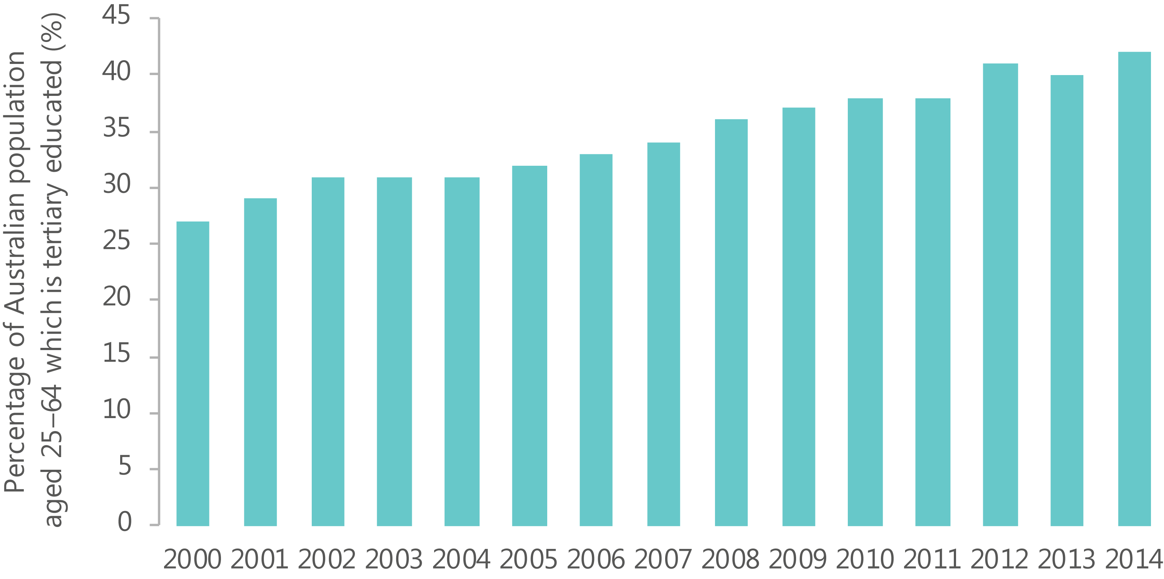
Despite the majority of Australians having sufficient levels of basic skills, Australia’s PISA scores indicate that we have a long tail of educational underachievement, especially among disadvantaged groups such as:³⁵⁶
- students from rural, regional and remote areas
- students from low socioeconomic backgrounds³⁵⁷
- Aboriginal and Torres Strait Islander students, where the difference between Indigenous and non-Indigenous student performance is equivalent to about 2.5 years of schooling.
Australian businesses expect that their requirements for STEM-qualified people will increase over the next five to 10 years. Across all sectors, over 50 per cent of employers are expecting an increase in demand for STEM-trained professionals.³⁵⁸ Australia faces gaps between STEM supply and demand when STEM participation and performance is considered across primary and secondary schools, in higher education and in the workforce (Table 10).
As a result, improving the supply of STEM skills is currently a key priority for the Australian Government and state and territory governments.³⁵⁹ In recent years, governments have implemented a number of policies, strategies and reviews designed to improve Australia’s performance in STEM, through focusing on areas such as teacher quality, curriculum and curriculum resources, school and university education and work-integrated learning (e.g. internships and work placements).³⁶⁰
Australia’s primary and secondary education curriculums are supported by the National STEM School Education Strategy, which aims to increase engagement and teacher capacity. The NISA package also includes an ‘Inspiring all Australians in digital literacy and STEM’ measure to increase the engagement of students in STEM. The VET sector plays an important role in strengthening STEM skills in the workforce (e.g. through apprenticeships).³⁶¹
Table 10: Summary of key issues in STEM skills in Australia.
Of particular note are the shortage of ICT skills reported by start-ups, and the mismatch between IT graduates’ skills and industry needs.
Issue | Description
School student performance | The results from international assessment programmes³⁶² suggest that school student science and mathematics performance is declining. For example, in PISA 2015:  - Australian students’ performance in maths dropped from 17th to 20th ^{363,364}  - Australia’s ranking for science decreased from 8th to 10^{th365,366}
School student participation | Participation in senior secondary science and mathematics has been declining for decades,³⁶⁷ and for science, is the lowest in 20 years.³⁶⁸ In some countries, students are required to study mathematics until the end of school, including Brazil, China, Israel and Finland.³⁶⁹  At the same time, in many other countries STEM participation and performance are improving rapidly, which risks affecting Australia’s future competitiveness.³⁷⁰
Under-representation in participation and achievement | In terms of enrolments and patterns of completions, there are continued disparities between students from different groups. Indigenous students, students with disability, students in remote and very remote locations, and students of low socioeconomic status are all under-represented in STEM.³⁷¹  In PISA 2015, Indigenous students achieved significantly lower scores than non-Indigenous students and there was an under-representation of Indigenous students at the higher end of the proficiency scale and an over-representation of Indigenous students are lower end of the proficiency scale.³⁷²
Current skills gaps among university graduates | From 2002 to 2012, the percentage of Australian graduates with natural sciences and engineering degrees fell from 22 per cent to 18 per cent.³⁷³ While above the OECD average, the proportion of first-degree Australian students enrolled in STEM is low compared to comparator countries like Finland, Korea and Germany.³⁷⁴ Furthermore, approximately three in every five Australian STEM graduates go on to work outside STEM core occupations.³⁷⁵

Skilled migration contributes significantly to Australia’s skills base
Since September 2005, net migration to Australia has exceeded domestic population growth.³⁷⁶ The number of skilled migrants arriving in Australia increased from 77,878 people in 2004–05 to 128,550 people in 2013–14.^{377,378} In 2014–15, the most common skill categories of workers arriving through Australia’s skilled visa stream were accountants, software engineers, cooks, registered nurses and business analysts³⁷⁹.
Changes to Australia’s migration policy in 1996 increased the emphasis on skilled migration and created the 457 visa, a new pathway for temporary skilled migration. Australia is an attractive migrant destination, and our migration policy and programmes facilitate the entry of temporary and permanent migrants to positively contribute to the labour market and support Australian business and the economy.
The NISA includes a number of measures to further attract skills from overseas. It includes an enhanced pathway to permanent residence for postgraduate research graduates with qualifications in STEM or specified ICT fields, and an entrepreneur visa for individuals with third party funding who want to develop or commercialise their innovative ideas in Australia.³⁸⁰
Skills shortages are occurring all over the world, and competition for skilled people will increase. A number of countries already have established visa programmes for entrepreneurs, including Canada’s Start-up Visa Program, the UK’s Tier 1 (Entrepreneur) visa, and Singapore’s Entrepreneur Pass Scheme, the last of which is renewed on the condition that the migrating entrepreneur meets job creation outcomes and business expenditure thresholds.
Australia is well positioned to attract overseas talent. A number of our cities rate among the most livable cities in the world,³⁸¹ and our high quality of life helps us attract and retain entrepreneurs and other skilled workers required for innovation.³⁸² Entrepreneurs, for example, often decide where to live based on quality-of-life factors and personal connections years before they start their firms.³⁸³

Weaknesses

Despite a strong university system overall, Australia has no university in the global top 20
Overall, Australia has a strong university system. However, none of Australia’s universities currently feature in the top 20 of the QS, Times and Shanghai ranking systems.
The Universitas 21 (U21) ranking of national higher education systems holistically evaluates the performance of national higher education systems based on their resources, learning environment, connectedness to society, and outputs as measured by student outcomes and publication performance.⁴¹⁸ Australia’s higher education system currently ranks 10th out of 50 countries assessed in the U21 rankings. ⁴¹⁹ Out of the four areas assessed in the U21 rankings, Australia scored lowest in the area of resources, where it ranked 14th out of 50 countries.⁴²⁰ This area assesses public and private funding provided to institutions and their use of this funding for both teaching and R&D.⁴²¹ In 2013, Australia’s total expenditure on tertiary education institutions was 1.7 per cent of GDP, ranking Australia 14th out of 32 OECD+ countries.⁴²²
A number of other ranking systems evaluate the performance of individual Australian universities. While the Group of Eight universities consistently perform well in these rankings, none of them ranked within the top 20 institutions in the 2016 QS, Times and Shanghai rankings.^{423,424,425}

Compared to other countries, Australia under-utilises vocational education and training
Comparison with other leading innovation nations suggests that Australia’s VET sector is an underused resource in the ISR System.
There are over 4,000 registered VET providers in Australia, each specialising in various disciplines. While there is significant diversity across the sector, in general, VET providers and people with VET qualifications:
- can be innovators in their own right, by developing products or services in collaboration with industry partners. Surveys of innovation-intensive industries show that people with VET occupations are amongst businesses’ principle sources of ideas for technological innovation³⁸⁴
- are well placed to diffuse, share and implement innovation. Through their close connections with industry, VET-trained people and VET providers are able to diffuse new ideas, technology and processes developed elsewhere.³⁸⁵ VET students often combine work experience and work-based learning (e.g. through apprenticeships), giving them a close and long-term connection with business.
- have an important role in retraining and upskilling of existing workers,³⁸⁶ which is increasingly important in the context of digital disruption, economic change and the need for lifelong learning.
At the institutional level, there are a number of challenges that prevent the VET sector from maximising its role in innovation. For example, the long time frames required to make changes to VET training packages can hinder the sector’s ability to respond to current industry needs. There are few resources available to assist teachers to keep up with the latest technologies and innovations, partly due to budget constraints.³⁸⁷ This is in contrast with countries like Canada that have a dedicated applied research budget for VET providers.³⁸⁸

There are ongoing business, management and leadership skills gaps
Well-managed and well-led firms are more innovative, producing more innovations that lead to performance improvements and producing more innovations that disrupt markets or create new markets in terms of both radical and incremental innovation.³⁸⁹
A lack of leadership for innovation has been a longstanding challenge for Australian organisations.³⁹⁰ Leadership occurs at all levels, including at the board level. Boards are an important source of strategic advice and many play an active role in strategic decision making.³⁹¹ However in the majority of cases, the board defers strategic decisions making to senior leaders.³⁹² These strategic decisions are important for innovation, as the extent to which strategic goals are implemented, communicated and understood within the organisation is positively associated with both radical and incremental innovation.³⁹³
Innovation management is critical for corporate competitiveness; it enables businesses to deal with disruption and flourish in a rapidly changing environment.³⁹⁴ The combination of business skills and technological literacy is important for the creation of new business models, new markets and new sources of economic growth.395 Business, management and leadership characteristics common to innovative organisations include attention to user needs, a culture of innovation and collaboration, processes and systems for managing innovation activities, and the capability to draw on skills and knowledge external to the organisation.³⁹⁶
In 2015 13 per cent of Australians aged 18 to 64 were either nascent entrepreneurs or the owner-manager of a new business.³⁹⁷ This is slightly below the average for the top five most entrepreneurial OECD+ countries (19 per cent) and ranks Australia 8th out of 38 OECD+ countries.³⁹⁸ Compared to other countries however, Australians are good at starting businesses but not good at growing them.^{399, 400} For decades, major reports have identified shortcomings in leadership and management capability in Australian enterprises.⁴⁰¹ Highly innovative organisations deliberately develop expertise in leadership and management; however, these skills are less evident in Australian SMEs, including entrepreneurial start-ups.⁴⁰²
Gaps, or shortcomings, have been identified in Australia’s workplace management and leadership performance.⁴⁰³ These include the following:
- Many workplaces do not get the basics of management and leadership right.
- Many leaders are not well trained for the job.
- Many organisations underinvest in leadership development.
- Leadership in Australian organisations does not reflect wider social diversity.
- Managers tend to overrate their own performance relative to international benchmarks.
A lack of attention to user needs is one management and organisation attribute that may explain why some firms are not able to innovate successfully while others are. ⁴⁰⁴
A strong focus on the end users of innovation, or understanding the demand side, includes understanding and responding to growth, shifts in user needs and preferences, and new (often international) market opportunities made possible by advances in technology, international trade, and customer expectations.⁴⁰⁵
Design skills are increasingly being applied to help solve complex community, policy and service design problems, under the banner of ‘design thinking’ or ‘co-design’. Design thinking methods explore possibilities, find solutions to complex problems and create outcomes that benefit end users through a combination of logic, imagination, intuition and systemic reasoning. Design provides the link between creativity and innovation to help ensure ideas become attractive propositions for end users.⁴⁰⁶ Australian start- ups rank design skills as the third most important skill set in their organisation, behind business skills and technical skills,^{407,408} and design skills are unlikely to be made redundant by disruptive technology like automation.⁴⁰⁹

The current supply of ICT graduates is not meeting industry needs
There is a significant gap between the supply of, and demand for, ICT graduates (Figure 31). Australian start-ups report that they are unable to recruit enough skilled Australian ICT workers.⁴¹⁰ In the ICT industry, 79 per cent of employers expect an increase in demand for STEM professionals.⁴¹¹ A large number of non-ICT jobs require a significant degree of digital literacy. The importance of ICT skills across society will increase as digital technology becomes increasingly pervasive in workplaces and society.⁴¹²
However, many recent ICT graduates struggle to find employment in their chosen field following graduation. For example, 67 per cent of recent graduates from bachelor degrees in computer science found work in their chosen field in 2014, compared to 84 per cent in 2008. This apparent contradiction between skills shortage and poorer employment outcomes for ICT graduates has been linked to a mismatch between graduate skills and industry needs. A survey of Australian Information Industry Association members and ICT academics suggests that current ICT graduates have good knowledge of software engineering and information systems, but lack some specific IT skills and broader workplace capabilities (Table 11).
Figure 31: Supply of ICT skills (as measured by ICT university completions and 457 visa holders with Australian Computer Society (ACS) marked occupations), and demand for ICT skills (as measured by ICT job vacanices) in Australia, 2006 to 2014.
There continues to be a large shortfall of ICT skills, and the majority of ICT skills in Australia come from overseas.^{413,414,415,416}
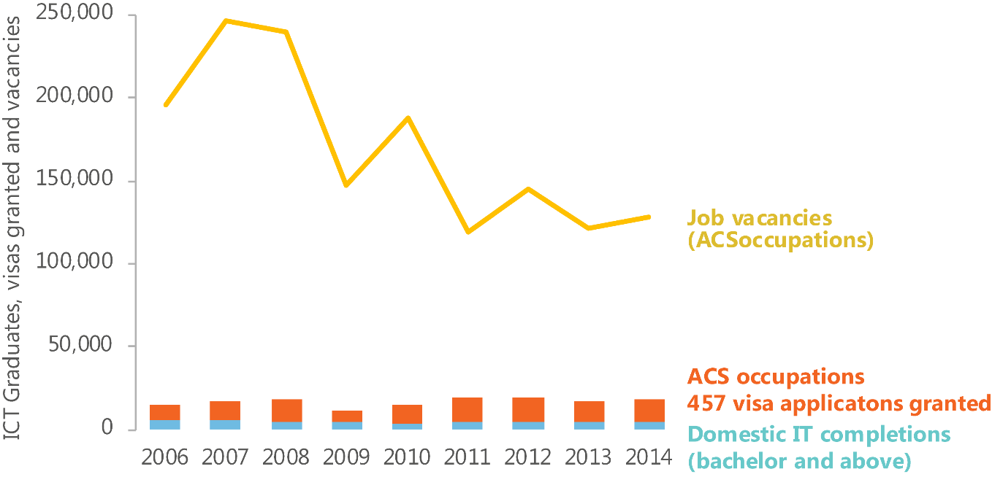
Table 11: Capabilities of current Australian ICT graduates.
In general, people working in the IT industry have a much lower opinion of current ICT graduates’ capabilities compared to academics teaching in the field.⁴¹⁷
Hard ICT skills | Industry view University view  (% of respondents that agree) |  | Difference
Software | 77 | 79 | -2
Systems | 53 | 66 | -13
Security | 39 | 34 | 5
Cloud | 42 | 33 | 9
Industry certifications | 31 | 20 | 11
Data analytics | 39 | 37 | 2
Networks | 62 | 65 | -3
Big data | 19 | 29 | -10
Programming | 71 | 85 | -14

Higher order skills | Industry view University view  (% of respondents that agree) |  | Difference
Communication | 43 | 56 | -13
Initiative | 41 | 51 | -10
Aptitude for learning | 76 | 65 | 11
Complex problem-solving | 53 | 64 | -11
Creative problem-solving | 42 | 48 | -6
Project management | 31 | 58 | -27
Quantitative skills | 60 | 44 | 16
Understanding business and industry | 15 | 24 | -9

Findings: Skills

Knowledge creation
What are our strengths?
- The Australian research workforce is world-class in many research fields. Australia achieves much better research outputs than would be expected from the number of people engaged in the research workforce.
What are our weaknesses?
- Despite a strong university system overall, Australia has no university in the global top 20.

Knowledge transfer
What are our strengths?
- Australians have sufficient levels of basic skills, although some trends are concerning. The Australian education system generally produces graduates with good levels of basic skills. However, emerging data on STEM education in particular is a cause for concern.
What are our weaknesses?
- Compared to other countries, Australia under-utilises vocational education and training (VET). Comparisons with other nations suggest that Australia could better use the VET sector to build skills for innovation.

Networks
Networks, in the context of the ISR System, include a range of structures, roles and mechanisms designed to increase the cost-effectiveness of collaboration, or otherwise facilitate collaboration, to increase innovation. Networks can be broadly classified according to the main strategy which supports their formation and maintenance, noting that networks which fall into one group may secondarily also fall into others:
- Facilitated: networks facilitated by people or organisations with specific roles as intermediaries
- Co-located: networks based on geographical proximity
- Virtual: networks that use digital internet and communications technologies to build and maintain relationships between people and organisations
- Incentivised: networks formed around specific shared problems, strategies or other incentives that facilitate collaboration or reduce barriers to it
- Co-resourced: formalised sharing of staff or co-funding commitments.
Australia currently has a mixture of network types (Appendix I). The availability of detailed information is patchy, reflecting a wider lack of understanding of the current state of networks for innovation in Australia as well as a lack of evidence of the effectiveness of some types of networks.
Collaboration is a mechanism for the sharing and exchange. While it is difficult to definitively link innovation and collaboration, on balance, the ‘case for the benefits of innovation collaboration is plausible,’⁴²⁶ and collaboration is estimated to more than triple the likelihood of business productivity growth.⁴²⁷
Trust underpins effective collaborative relationships; it can take a long time to build but can be broken down quickly.⁴²⁸ Significant investment therefore needs to be made in building relationships—both formally and informally—in order to establish collaborative partnerships that can endure through the setbacks or challenges that inevitably arise in innovation activities.⁴²⁹

Strengths

We have good levels of research–to–research collaboration
Collaboration among researchers can foster innovation by facilitating knowledge transfer both within and across disciplinary boundaries.
Many Australian researchers work closely with international collaborators. This ensures that knowledge created overseas can be transferred to Australia, and new perspectives can be added to our way of thinking. Australia ranks 13th in the world in terms of international academic collaboration.⁴³⁰ Further, between 2011 and 2014, Australia’s leading 24 universities had an average international collaboration rate of 48.9 per cent on all scientific publications, which is higher than the global average of 40.2 per cent.⁴³¹ The number of formal agreements on academic research collaboration between Australian universities and overseas institutions increased by 82 per cent between 2005 and 2014 (from 3,054 to 5,559).⁴³²
Australian research–to–research collaboration is supported by a range of well-established network structures. University campuses, research conferences and national research infrastructure are places where researchers can interact and where knowledge can be shared and developed. Australia has 43 universities⁴³³ and approximately 130 other higher education providers;⁴³⁴ these institutions collectively have over 40,000 research staff.⁴³⁵ Technologies that support virtual networks such as Australia’s Academic and Research Network (a data highway for research institutions and schools) further facilitate the sharing of knowledge. Additionally, government funded research infrastructure, such as those facilities and projects funded through NCRIS and those in PFRAs improve collaboration among 35,000 researchers.⁴³⁶
Shared research incentives are common. Research grant applications, projects and papers typically involve research teams, technicians, advisers, support staff, peer reviewers, presentations of findings, and/or interaction with students. There are often also shared goals, with many researchers focusing on major global or national problems.
There is constant movement of students and academic staff within and between institutions across the world, which creates constant opportunities for forming new collaborations and relationships.⁴³⁷ This movement is supported by a variety of high-quality scholarships, including Endeavour Scholarships, John Monash Awards and Rhodes Scholarships.

We are increasing our focus on networks
There is an increased focus on the importance of networks in the Australian ISR System. Governments, research organisations and businesses are increasingly looking to more formalised models and roles to facilitate relationships and support collaboration. The number of accelerators, incubators, mentoring programmes and technology-transfer programmes to support researchers, entrepreneurs and new businesses has risen since 2000 when Australia’s oldest accelerators were established.⁴³⁸ In 2014, an online assessment of accelerator activity rated Australia as having the largest number of start-ups in accelerators in the Asian region (138 in total).⁴³⁹ Recently through the NISA, the Australian Government is helping more business access incubators. State, territory and local governments also provide assistance to businesses accessing incubators and accelerators.
Clusters are geographical concentrations of interconnected companies, specialised suppliers and service providers, firms in related industries, and associated knowledge institutions such as universities and research institutes.⁴⁴⁰ Clusters are thought to facilitate innovation and economic growth by improving access to inputs, labour, information and knowledge.
Successful clusters in Australia have developed in various ways:
- Some clusters have been largely attributed to the entrepreneurial nature of the local business community and strong local private sector buy-in. For example, marine industry clusters were developed in Far North Queensland during the 1990s.⁴⁴¹
- Some clusters form around local geographical or natural resource strengths. For example, Queensland’s tourism cluster is used by the Harvard Business School as a key case study of cluster development through local community efforts, and the Federal Government’s Industry Growth Centres are establishing collaboration hubs around Australia in specific strengths sectors.⁴⁴²
- Some clusters are supported by governments, Commonwealth, state and local.
- Some clusters form around and through research institutions or infrastructures, including universities and CSIRO. For example, the Carlton Connect Initiative is an innovation precinct being coordinated by the University of Melbourne.⁴⁴³
- Some clusters have been established in response to economic declines. For example, t
- he cluster built around HunterNet Cooperative in Newcastle arose out of bottom–up action and development in response to adversity and the decline of manufacturing.⁴⁴⁴
In comparison to clusters in other countries, Australia’s regional innovation clusters do not play a significant role across the entire ISR System. In terms of the state of cluster development, Australia ranks 39th out of 128 countries on the Global Innovation Index⁴⁴⁵ and 22nd out of 138 countries on the Global Competitiveness Index.⁴⁴⁶
The reasons for the low levels of clustering are not well understood. They may include the following:
- Relatively small investments in support of intermediaries, networks and collaboration (see ‘Policy’).
- Clusters tend to evolve from a sense of urgency;⁴⁴⁷ Australia has had relative economic success over the past decades and has therefore lacked a sense of urgency.
- Australia’s geographical size may also be a contributing factor. However, many studies have found that physical proximity alone does not generate innovation growth.^{448,449,450}
While place-based clustering in Australia is limited, efforts are currently underway to better connect priority industries. In particular, the Industry Growth Centres initiative includes the development of virtual networks which aim to achieve many of the same benefits as regional innovation clusters in other countries; some Industry Growth Centres are also co-locating their head offices with research organisations. In addition, many CRCs are located in or near universities or research organisations.

A number of vibrant start-up ecosystems are flourishing around the country
The current understanding of what contributes to the emergence of high quality, high potential start-ups is based on a holistic view of an ecosystem.⁴⁵¹ This view places emphasis on the diversity of organisations that provide support, the interconnections between them, and the paths by which entrepreneurs navigate them. ⁴⁵² By nature, many ecosystems are geographically bounded.⁴⁵³ However, nation-wide, there are positive signs of growth in supportive organisations which underpin ecosystems. In its 2016 Crossroads report, StartupAUS notes the concerted efforts to grow business incubators, business accelerators and co-working spaces, and greater levels of capital from venture capital funds and business angels.⁴⁵⁴ Serial entrepreneurs are also making important contributions to local ecosystems, investing time and money, and sharing expertise with the next generation of entrepreneurs. ⁴⁵⁵

Weaknesses

Collaboration between researchers and businesses appears limited
Australian universities are producing some of the best research in the world (see ‘Skills’). However, only 4.8 per cent of innovation-active businesses in Australia collaborate with universities or higher education institutions on innovation.⁴⁵⁶ Further, between 2003 and 2012, only 9.8 per cent of Australian patents had international co-inventors.⁴⁵⁷ In 2010–12, Australia ranked last out of 26 OECD countries on the proportion of both SMEs and large businesses collaborating with universities or other non-commercial research institutions on innovation.⁴⁵⁸
The proportion of research publications listing an industry affiliated co-author can give an indication of the level of research-business collaboration in a country. In 2015 1.22 per cent of publications listed both Australian and industry affiliated authors.⁴⁵⁹ This is below the OECD+ average (2.24 per cent) and well below the average for the top five performers in the OECD+ (4.99 per cent).⁴⁶⁰ Figure 32 shows that Australia’s performance in this metric has been consistently poor over the last decade.
Figure 32: Proportion of publications with at least one Australian author and one industry affiliated author, compared to the OECD+ average and the average for the top five performing OECD+ countries.⁴⁶¹
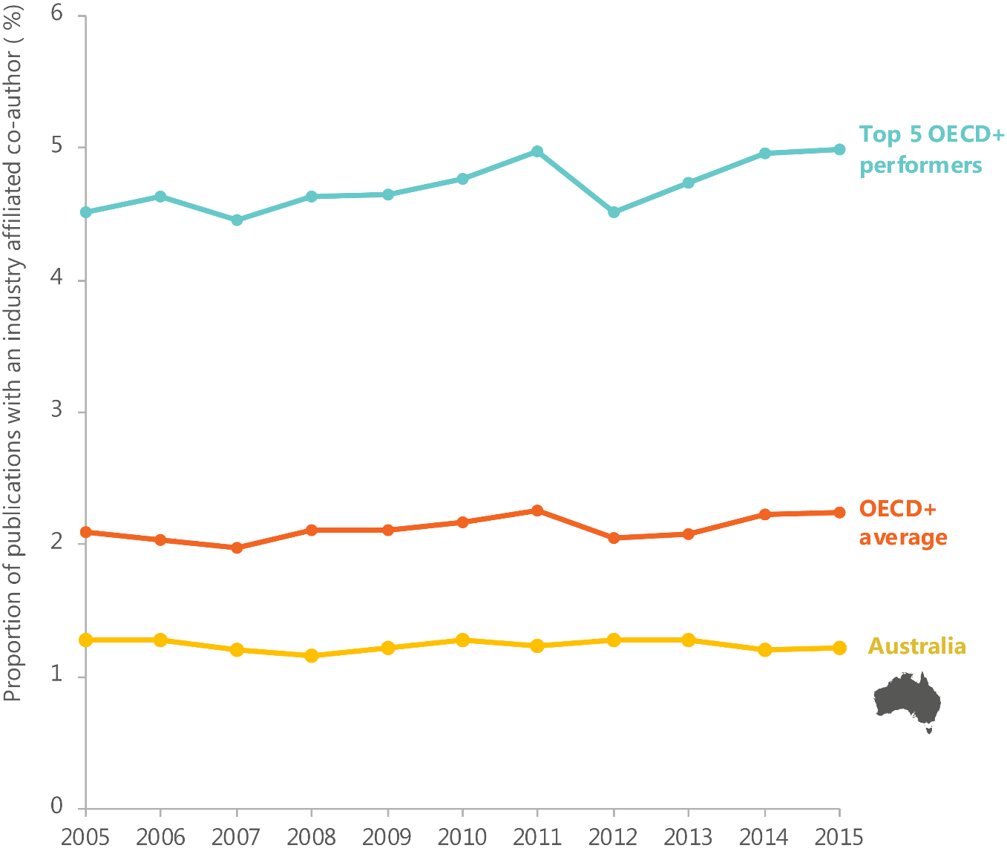
Australia’s progress on improving business–to–research collaboration is mixed. Since 2010, the number and value of research contracts, consultancies and collaborations reported by research organisations has been relatively stable (Table 12).⁴⁶² The percentage of HERD financed by business is 4.73 per cent, which is below the OECD+ average and has declined consistently since 2006.
In the 2016 Global Innovation Index, Australia ranked 20th in the world for university– industry research collaboration.⁴⁶³
ISA has heard there are a number of reasons contributing to the relatively low level of collaboration between businesses and university researchers. For example:
- businesses say they lack the skills or time needed to collaborate with public sector research organisations⁴⁶⁴
- businesses and researchers have historically had different incentives⁴⁶⁵
- businesses struggle to know how to find the right researcher to help them identify, describe and address a problem
- businesses claim there are protracted timelines in negotiating intellectual property agreements, although the Australian Government’s IP Toolkit developed in 2015 is expected to help negotiations
- government funding is heavily weighted away from intermediaries, networks and collaboration (see ‘Policy’)
- some Australian businesses are inward-looking and do not see the need to form new partnerships to be globally competitive⁴⁶⁶.
Some change is occurring. Many Australian universities now provide financial incentives to researchers for working with businesses, some universities are working on freeing up IP,⁴⁶⁷ additional funding has been provided for additional PhD placements in industry,⁴⁶⁸ and recent changes in block grant funding and the development of a new assessment system to evaluate the engagement and impact of university research are intended to incentivise researchers to reach out to businesses (announced in NISA). External engagement by researchers with businesses can have positive effects on researchers’ publication outcomes as well as providing a new source of grant money.^{469,470}
Table 12: Number and value of research contracts, consultancies and collaborations of publicly funded research organisations (2010 to 2014, nominal dollars).
The number and value of research contracts and consultancies have recovered following a dip in 2012 and 2013.⁴⁷¹
 | 2010 | 2011 | 2012 | 2013 | 2014
Number of research contracts, consultancies and collaborations | 15,478 | 15,429 | 11,146 | 12,228 | 15,461
Value of research contracts, consultancies and collaborations ($ billion) | 1.457 | 1.435 | 1.392 | 1.576 | 1.808

The movement of staff between research organisations and businesses is one way to facilitate knowledge transfer. Highly innovative businesses succeed by bringing in external expertise to achieve the skills mix required for a project as and when they need it.⁴⁷²
Australia currently has a low percentage of researchers working in businesses. In 2011, businesses employed around one-third of all researchers in the country, a low rate by OECD standards.⁴⁷³ As a share of total business employment, Australia ranks 21st out of 36 OECD+ countries in the employment of researchers in businesses.⁴⁷⁴ In comparison, over 80 per cent of all researchers in Israel were employed in business enterprises in 2013. In Canada, around 60 per cent of researchers are employed by businesses.⁴⁷⁵ Further, only 18.9 per cent of Australian research students aspire to a career in research-related work outside of a university and 23 per cent intend to follow a non-research work pathway in a professional occupation.⁴⁷⁶ This is distinct from other countries like France, where industry-based PhD positions are highly sought-after.⁴⁷⁷
Past internal university performance incentives have not encouraged research–to– business collaboration.⁴⁷⁸ Promotion processes for academics considered criteria such as grant funding, research performance (primarily publications), teaching, administrative skills and length of service; they have not considered industry linkages or network participation.⁴⁷⁹ Researchers who have left the university sector have found it difficult to return, and researchers based in industry can struggle to compete for research grant funding.
New measures (some as part of NISA) are being introduced to reduce these disincentives. For example:
- funding has been provided for additional PhD placements in industry⁴⁸⁰
- to complement Excellence in Research for Australia (ERA), the Australian Research Council (ARC) will implement a national assessment system for the engagement and impact of university research. It is anticipated that this will lead to greater collaboration between universities and the end users of research, and incentivise improved performance in the translation and commercialisation of research⁴⁸¹
- industry partnership PhD programmes (e.g. expansion of the French CIFRE fellowships model through the Australian Government and held at the Australian National University)⁴⁸²
- in 2014 the ARC committed to ensuring that all eligible researchers have fair and equitable access to competitive funding through the National Competitive Grants Program (NCGP). The Research Opportunity and Performance Evidence (ROPE) policy aims to ensure the assessment processes accurately evaluate a researcher’s career history.⁴⁸³ This ensures that researchers who have spent time outside of academia for family reasons or a stint in industry are not disadvantaged when applying for funding.
In addition, a recent review of the R&D tax incentive has recommended extra incentives for businesses to hire STEM PhD graduates.⁴⁸⁴

Australian businesses rank poorly on international collaboration
Australian businesses rank poorly on their level of collaboration with international partners, which is critical to enter global supply chains. Australia’s large firms rank 24th out of 27 OECD+ countries for international collaboration on innovation, and SMEs rank 19th.⁴⁸⁵
While there are limitations with the OECD metric on levels of collaboration with international partners—as the OECD uses a three-year reference period for most countries’ data, but the Australian data is only a one-year reference period—there are other metrics which demonstrate similarly weak performance. In 2013, only 16.2 per cent of Australian Patent Cooperation Treaty patent applications were filed with a co-inventor located abroad.⁴⁸⁶ This puts Australia 27th out of 37 OECD+ countries for the percentage of Patent Cooperation Treaty patents filed with an international co-inventor. This is lower than the average for the OECD+ (24 per cent) and much lower than the average for the top five OECD+ countries (44 per cent). Cross-border co-invention is lower in Australia than in similar countries such as New Zealand (18 per cent), the United Kingdom (25 per cent) and Canada (29 per cent).⁴⁸⁷ In addition, Australia’s participation in global value chains is below the OECD+ average according to the Global Value Chain Participation Index.⁴⁸⁸
ISA has heard a number of potential reasons why Australian businesses perform relatively poorly on international collaboration. These relate to:
- geographic isolation: Australia’s geographic isolation is a challenge for both Australian businesses and their potential partners
- weak economic incentive: Australia’s relative economic prosperity over the past two decades has reduced the imperative to be globally competitive and seek out partnerships beyond our borders
- lack of cross-cultural skills: we do not necessarily have, or value intermediaries with, cross-cultural communication skills.

Findings: Networks

Knowledge creation
What are our strengths?
- We have good levels of research–to–research collaboration. Australian academic researchers collaborate significantly, particularly internationally. Collaboration between researchers is supported by a range of network types.

Knowledge transfer
What are our strengths?
- We are increasing our focus on networks. Governments, research organisations and businesses are increasingly looking to more formalised models and roles to facilitate relationships and support collaboration.
What are our weaknesses?
- Collaboration between researchers and businesses appears limited. Few businesses in Australia collaborate with universities or higher education institutions, although there are encouraging improvements. A relatively low percentage of researchers working in businesses is associated with limited incentives.

Knowledge application
What are our strengths?
- A number of vibrant start-up ecosystems are flourishing around the country. Grassroots movements, in many cases driven by serial entrepreneurs, are attracting new talent and new money into the establishment and nurturing of high-growth start-ups.
What are our weaknesses?
- Australian businesses rank poorly on international collaboration. Compared to businesses in other countries, Australian businesses are less likely to collaborate with international partners or participate in global value chains.

Culture
The ISR System does not operate within a vacuum. Its social and cultural context influences its performance.
Culture is a shared set of assumptions, beliefs, identity, values and common sense that shapes (often unknowingly) our everyday preferences, choices and habits,⁴⁸⁹ our attitudes towards work and consumption,^{490,491} individual perceptions of opportunity and status,⁴⁹² and levels of trust within groups.⁴⁹³
Our cultural contexts—in businesses, organisations, communities or the national culture—shape what we choose to do and how we choose to do it. Culture influences the sorts of innovation we pursue, the way we carry out innovation activities and society’s receptiveness to the change and adaptation associated with particular innovations. Prevailing cultural tendencies within businesses, institutional and at the societal level can encourage or inhibit innovation in a range of ways.
Widespread culture change requires coordinated action across the ISR System. International examples highlight the importance of unifying different individuals and organisations in the ISR System around a common vision for the future, through high-level strategic leadership.

Diversity
Diversity in all its forms is important for a high-performing ISR System. Much innovation happens at the intersection of different disciplines and different ways of thinking about problems.⁴⁹⁴ Creativity and productivity are enhanced by diversity in groups, networks and teams.⁴⁹⁵ Innovation requires teams of people with a range of skills, and businesses that are ethnically and gender diverse are likely to outperform less diverse businesses.⁴⁹⁶
Diversity and inclusion are important drivers of innovation in cities and regions.⁴⁹⁷ Diversity across the nation is important because if people do things differently, adaptation and change are the cultural norm rather than the exception. Interaction between people with diverse experience, cultures and attitudes increases the productivity of knowledge workers by stimulating creativity and innovation.⁴⁹⁸
Australia’s Indigenous peoples’ knowledge and ways of life can provide unique insights and perspectives. Aboriginal and Torres Strait Islander cultures have the potential to contribute more significantly to the innovation landscape. It is possible that innovation also has the potential to assist with closing the gap and addressing ongoing inequalities that Aboriginal and Torres Strait Islander people experience.⁴⁹⁹ For a list of initiatives that relate to innovation in Indigenous communities, see Appendix J.

Organisational cultures
Building organisational relationships and a culture that supports innovation is key to achieving innovation results.⁵⁰⁰ Analysis of data from 759 firms across 17 major world economies suggests that corporate culture is the strongest driver of innovation that disrupts markets or creates new markets altogether.⁵⁰¹ Key organisational attitudes and practices identified in the study were a willingness to cannibalise and iterate, a future market orientation, a willingness to innovate, and a high tolerance for risk.⁵⁰² An organisational culture that fosters creativity, openness and risk-taking is positively associated with innovation.⁵⁰³ Businesses with hierarchical structures, and organisations with high numbers of formal structures, procedures and policies, are negatively associated with innovation.⁵⁰⁴

National culture
National cultures have been assessed and measured in various ways, perhaps most notably in Hofstede’s National Culture Dimensions—which compares national cultures based on six dimensions; power distance, uncertainty avoidance, competitiveness, individualism, temporal orientation, and indulgence.⁵⁰⁵ While there are limitations to this approach,⁵⁰⁶ cultural characteristics described by Hofstede can be linked to innovation.
According to the Hofstede cultural framework, some Australian cultural traits appear to support innovation, while others are likely to be restricting performance (Table 13). Table 14 shows Australia’s Hofstede cultural traits in comparison to leading innovation nations.
For example, Australia’s score on the uncertainty avoidance scale, which reflects how comfortable citizens are with ambiguity, suggests that Australian culture is not particularly risk-averse. This is supported by evidence elsewhere. Australia has high levels of entrepreneurial activity (see ‘Skills’), indicating that Australian society is not lacking in risk-takers. Further, Australian culture appears to support and encourage entrepreneurship; evidence points to positive attitudes towards entrepreneurship, relatively positive media attention, and portrayal of successful role models for prospective entrepreneurs.⁵⁰⁷ Australia’s risk-taking is also evident in other widespread Australian cultural traits and pastimes.⁵⁰⁸
While evidence suggests that Australia has a relatively average level of risk acceptance compared to other nations, there is a persistent focus on risk aversion. This may be related to negative incentives, for example, directors’ liability provisions in legislation, or reverse incentives such as the relative ease of keeping a well-paying job.
The process of innovation can be significantly inhibited if failed attempts cannot be openly discussed, evaluated, reviewed or dismantled in a supportive environment in order to inform the next attempt.
Table 13: Australian national culture scores according to Hofstede Dimensions (2010), arranged according to whether they are likely to support or restrict innovation in Australia.
Scores are on a scale of 1 to 100, determined relative to other countries. A score of 50 indicates neutrality relative to other countries. A score below 50 indicates the culture scores low relative to other countries, and a score above 50 indicates the culture scores high relative to other countries.⁵⁰⁹ Some traits can be interpreted in a variety of ways (e.g. temporal orientation), all of which are given.
Dimension | Score  (relative scale, out of 100) | Australia’s performance
Power distance | 36 | Australia is not a particularly hierarchical nation. New ideas can emerge from all levels in an organisation.
Uncertainty avoidance | 51 | Australians are not particularly risk-averse. We have learned to deal with the unknown in different ways. Australia’s score here suggests that this is not a major inhibitor of innovation in Australia at present.
Competitiveness | 61 | Australia is a competitive nation. The common motivation to perform in school, work and play is to strive to be the best, and the winner takes all.
Individualism | 90 | Australia is a highly individualistic culture. It is a loosely knit society where individuals look after themselves and their immediate families, and where employees are expected to be self-reliant.  Our national culture emphasises competitiveness and individualism over collective responsibility and collaboration.
Temporal orientation | 21 | Australians have a strong concern with maintaining links with the past (e.g. traditions, norms and existing powers) while dealing with the challenges of the present and future.  Australians value future rewards, thrift, perseverance and adaptation in the long term, less than they value instant gratification, pressure to spend, respecting tradition, protecting one’s ‘face’ and short term results.
Indulgence | 71 | Australians like to realise their impulses and desires to enjoy life. They often favour short- term gratification over long-term life quality. They are generally optimistic, place a high emphasis on leisure time, and spend money as they wish.  This suggests that Australians may be less concerned about future threats than people in other nations, and so may struggle to see urgency in warnings about the future and therefore to seek or support innovative solutions.

Table 14: Australia's scores on the Hofstede Dimensions compared to the scores of leading innovation nations.⁵¹⁰
Hofstede score (0 to 100. 50 indicates neutrality relative to other nations).
 | Australia | Denmark | Finland | Germany | Ireland | Netherlands | Singapore | Sweden | Switzerland | UK | USA
Power distance | 36 | 18 | 33 | 35 | 28 | 38 | 74 | 31 | 34 | 35 | 40
Uncertainty avoidance | 51 | 23 | 59 | 65 | 35 | 53 | 8 | 29 | 58 | 35 | 46
Competitiveness | 61 | 16 | 26 | 66 | 68 | 14 | 48 | 5 | 70 | 66 | 62
Individualism | 90 | 74 | 63 | 67 | 70 | 80 | 20 | 71 | 68 | 89 | 91
Temporal orientation | 21 | 35 | 38 | 83 | 24 | 67 | 72 | 53 | 74 | 51 | 26
Indulgence | 71 | 70 | 57 | 40 | 65 | 68 | 46 | 78 | 66 | 69 | 68

Strengths

Australia’s multicultural society is an important asset, but diasporas could be leveraged more
Australia is one of the most multicultural societies in the world; over one-quarter of our population (28 per cent) migrated to Australia from overseas.⁵¹¹ Multiculturalism is not only significant but also increasing in Australia: between June 1996 and June 2013, Australia’s overseas-born population grew by 51.2 per cent to 6.4 million.⁵¹² The majority of Australians born overseas are from the United Kingdom, New Zealand, China, India and the Philippines (Figure 33).
The largest overseas-born populations in Australia are also some of our largest trading partners such as the United Kingdom, New Zealand, China and Malaysia. This gives us a linguistic and cultural advantage when it comes to connecting and collaborating with Europe and Asia,⁵¹³ and a greater potential to understand user needs from outside Australia and connect to global value chains.
In comparison to other leading innovation nations, the strength of Australia’s multiculturalism is particularly reflected in levels of education. Australia has a higher proportion of foreign-born doctorate holders⁵¹⁴ and a higher percentage of highly educated individuals in immigrant and native-born populations than countries such as Germany, Netherlands, and Switzerland.⁵¹⁵ Interestingly, when it comes to fields of student enrolments, Australia’s international students are skewed towards social sciences, business and law, while those in leading innovation nations (Germany, Switzerland, Sweden and Denmark) are more evenly balanced with engineering, manufacturing and construction.⁵¹⁶
Our diasporas—Australians living abroad or groups of people living in Australia who remain linked by their connection to a common ‘homeland’ or place of family origin—have the potential to help us to understand, and reach into, foreign markets.⁵¹⁷
Australia’s Chinese and Indian diasporas constitute around 1.8 million people.⁵¹⁸ Diasporas use their language skills, cultural knowledge and global networks to develop and maintain trusted people-to-people links that provide information on emerging markets, business opportunities and economic, political and cultural changes.⁵¹⁹
Diasporas are a major source of innovation and entrepreneurialism.⁵²⁰ In Australia, an average of 38 per cent of start-ups are founded by people born overseas.⁵²¹ Interviews with Asian businesspeople by the Australian Council of Learned Academies reveals that they face major impediments in realising their desire to make a greater contribution to the Australian economy.⁵²²
The term ‘bamboo ceiling’ has been used to describe the reasons why Asian Australians are not able to fully participate and contribute to the Australian economy and society.⁵²³ For example, only around 4 per cent of Australia’s top 200 publicly listed companies have board directors of Asian descent.⁵²⁴ Also non-English language skills, cultural competence and connections are not commonly seen as advantageous by Australian businesses, which remain focused on the domestic market and lack knowledge of Asian markets.
Figure 33: Top 10 birthplaces of migrants in Australia according to total number of people, compared to our top 10 trading partners, by dollar value.⁵²⁵
* Includes Channel Islands and Isle of Man.
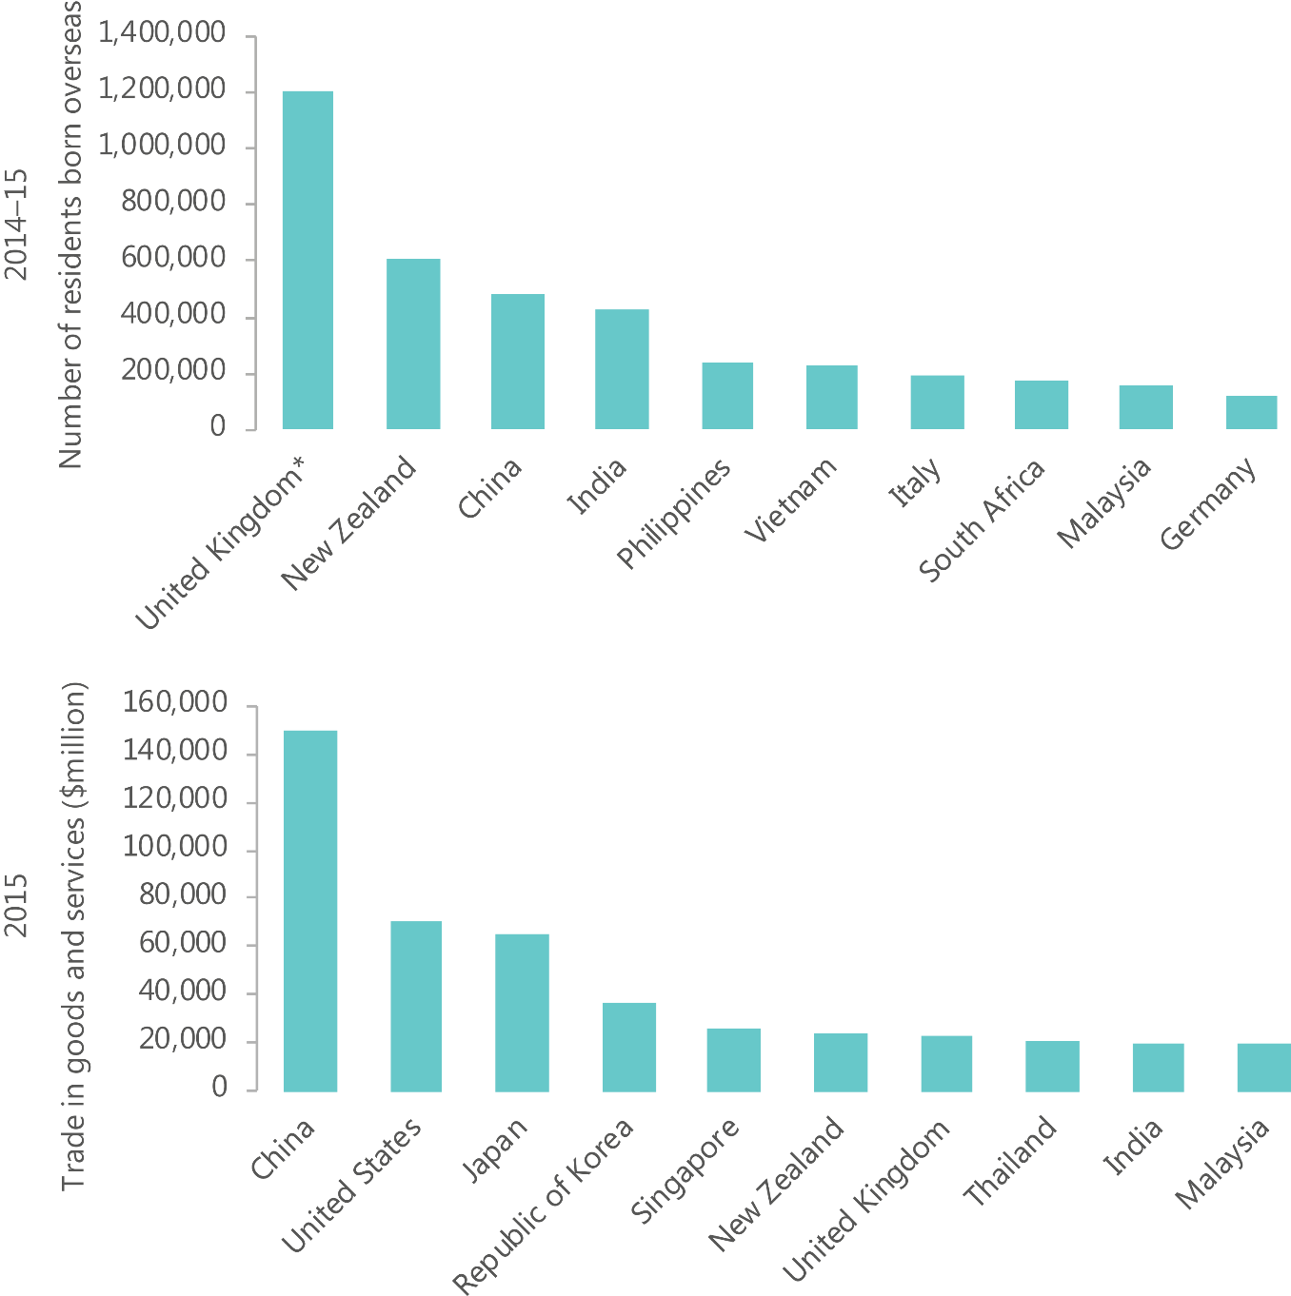

Weaknesses

Our short-term-oriented culture may affect innovation in different ways
Australia ranks low on its long-term orientation, scoring 21 on the Hofstede Dimensions scale for temporal orientation.⁵²⁶This is in contrast to leading innovation nations that score highly on temporal orientation (for example, Switzerland scores 74, Singapore scores 72 and Austria scores 60), which have a longer-term view.
This suggests that Australia has a culture that has a low propensity to save for the future and a high focus on achieving quick results. This cultural trait is likely to be a significant barrier to innovation as it inhibits forward thinking, strategic planning and working towards long-term goals.
A short-term orientation can be observed across Australian culture—for example, in Australia’s three-year federal election cycle,⁵²⁷ Australian shareholders’ preferences for near-term returns,⁵²⁸ and Australians’ preferences for immediate financial reward rather than long-term gains.⁵²⁹ It is also evident in the ISR System (discussed elsewhere in this ISR System Review)—for example, short funding periods, expectations of rapid returns on investment in new businesses, and challenges faced in developing a long-term strategy. Our relative strength in incremental innovation may be related to our cultural emphasis on short-term efficiency, growth and success (see ‘Outputs’). This short-term focus may hamper radical innovation, as this innovation activity takes much longer than the culture, systems and programmes designed to support it.

Australia remains a gender-unequal society
There is a body of literature showing the importance of gender diversity for innovation performance.⁵³⁰ While Australian gender inequality is similar to that in most other developed and leading innovation nations, this area is an opportunity for Australia to improve.⁵³¹
Australia has made some of progress towards gender equity. Female representation in the workplace has been improving—the percentage of women on ASX 200 boards has more than doubled, from 8.3 per cent in 2009 to 23.6 per cent in 2016.⁵³² while 34 per cent of business operators in 2014 were women,⁵³³ and 1 in 4 start-ups are funded by women (up from 1 in 6 five years ago).⁵³⁴ Moreover, in terms of education, more women than men aged 20–64 years have attained a bachelor degree level qualification or above,⁵³⁵ and girls are consistently outperforming boys on reading and writing in both primary school and high school.⁵³⁶
Despite this progress twenty-four companies in the ASX 200 do not have women on their board,⁵³⁷ and only 12 per cent of female STEM graduates earn in the top income bracket, compared to 32 per cent of men.⁵³⁸

Findings: Culture

System-wide
What are our strengths?
- Australia’s multicultural society is an important asset, but diasporas could be leveraged more. Australia’s uniquely multicultural society is a strength, and our diverse population, including our diaspora, has the potential to contribute more to innovation.
What are our weaknesses?
- Our short-term oriented culture may affect innovation in different ways.
- Australia is a culture that has a high focus on achieving quick results. This may be reflected in the prevalence of incremental new to the business only innovation rather than radical new to the world innovation.
- Australia remains a gender-unequal society. Evidence shows that gender diversity is important for innovation performance, and there is room for Australia to better develop and use its female talent in many roles

Outputs
In the context of this ISR System Review ‘innovation outputs’ are the direct result of the innovation activities carried out by actors in the ISR System. This includes the implementation or introduction of innovation, such as a new good or service or a new way to manage business practices. However, while the focus of this chapter is on the implementation or introduction of an innovation, it is important to recognise the importance of actively trying to innovate. Innovation takes time and learning from failure and past attempts is an essential part of the process to achieving results.⁵³⁹
Innovation is often seen as a continuous process and aspects of it can be intangible, which makes it difficult to measure. ⁵⁴⁰ While innovation can occur in any sector of the economy, including the public sector, measures of innovation outputs are typically collected at the firm level. Many actors, including universities, government and not-for-profits, are involved in the innovation activities which successfully lead to innovation outputs.
Innovation outputs are not themselves an outcome. Diffusion is the way innovation outputs spread from their very first implementation to consumers, countries, markets and firms.⁵⁴¹ Without diffusion, an innovation has no impact and leads to no economic, social or environmental outcomes (see Outcomes).
It is also important to recognise that there are a number of intermediates which flow from one part of the ISR System as outputs to form inputs to other parts of the ISR System.
This includes codified knowledge such as academic publications and intellectual property rights. These intermediates provide useful indicators of the ISR System’s potential performance and are discussed where relevant throughout this ISR System Review (see, e.g., ‘Infrastructure’ and ‘Skills’).
Innovation outputs can be characterised according to four innovation types:
- product innovation: the creation of a good or service that is either completely new (e.g. the internet) or an improvement on previous versions (e.g. a self-driving car)
- process innovation: the development of a new method to produce an existing good or service (e.g. use of 3D printing)
- marketing innovation: the implementation of a new marketing method (e.g. changes to product packaging or product placement)
- organisational innovation: the development of new organisational methods within a firm’s business practices, workplace, organisations or external relations.⁵⁴²
Innovation outputs can also be classified according to novelty. All innovations carry a degree of novelty, and at a minimum must at least be new to the business.⁵⁴³ The Australian Bureau of Statistics (ABS) classifies innovation outputs according to four degrees of novelty, arranged from highest to lowest:
- new to the world innovation: an innovation that has never been seen before in the world
- new to the industry innovation: an innovation that has never been seen before among a group of competing firms
- new to Australia innovation: an innovation that is new to the country
- new to the business only innovation: an innovation that is new to a business but not that business’s market.⁵⁴⁴
Related to the degree of novelty is the diffusion of innovation and its resultant impact. Innovations can be characterised according to their impact on the market:
- incremental innovation: an innovation involving minor modifications and improvements in existing products and processes, each of which is of small significance but which, cumulatively, are of major significance⁵⁴⁵
- radical innovation: an innovation which represents a significant departure from existing practice or knowledge that has a significant impact on its market, for example, by changing the market structure, creating a new market, or making a pre-existing market obsolete.⁵⁴⁶
It is extremely difficult to measure the impact of an innovation on its market, as the change may occur some time after the introduction of the innovation and other factors may be involved in market changes.⁵⁴⁷
Being first to market does not ensure commercial success and diffusion.⁵⁴⁸ Highly radical innovations are more likely to experience difficulties diffusing because of a lower rate of market acceptance for radical innovations as compared to incremental innovations.⁵⁴⁹ However, assuming that an innovation diffuses within its market, a firm is more likely to experience the competitive benefits of having introduced a radical innovation if their innovation is first to reach the market.⁵⁵⁰ Conversely, incremental innovations often do not involve a high degree of novelty.⁵⁵¹

What are Australia’s innovation outputs?
In 2014–15, 45 per cent of firms were involved in work that was intended to result in the introduction of an innovation.⁵⁵² Over the year, 38.2 per cent of firms introduced an innovation, 21.2 per cent of firms had an innovation activity still in development, and 7.7 per cent of firms abandoned their innovation activity. ⁵⁵³
Over time, an increase in the proportion of firms trying to innovate (innovation active firms) has been associated with an increase in the proportion of firms introducing innovation (see Figure 34). This reiterates the importance of actively trying to innovate as an essential part of achieving results.
Figure 34: Growth in the proportion of businesses that try to innovate (innovation active) and businesses that introduce innovation (innovating firms).
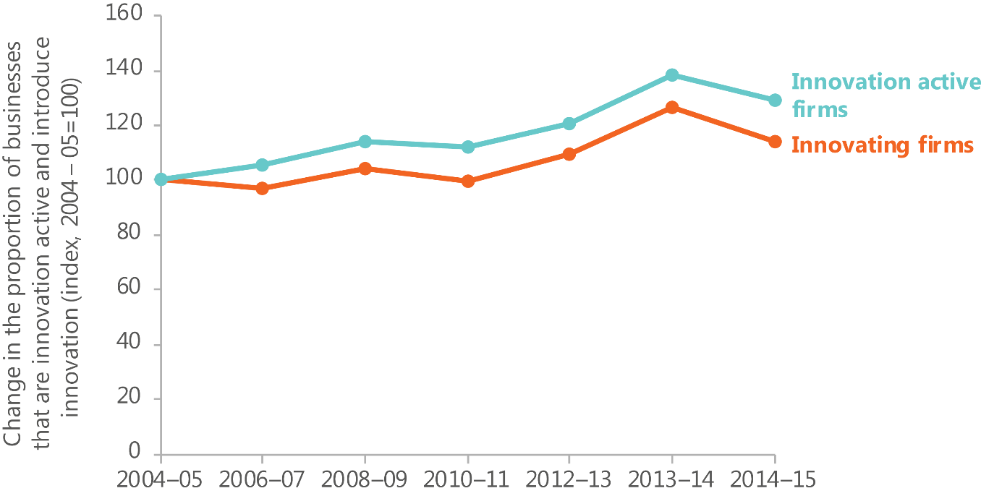

Novelty of innovation introduced by Australian businesses
Very few Australian businesses introduce new to the world innovation. Table 15 shows a breakdown of innovations that were introduced in 2014–15 and 2012–13 by type and novelty. Across all types of innovation in 2014–15, the majority are not that novel, with 74.5 per cent to 92.2 per cent of firms that introduced innovation in the year being new to the business only.⁵⁵⁴ By comparison, just 1.2 per cent to 8.4 per cent of firms introduced highly novel, new to the world innovation.⁵⁵⁵ Similarly, in 2012–13, there is a relatively small proportion of highly novel innovations across all types (1.1 per cent to 11 per cent) and a majority of innovations (75.0 per cent to 91.7 per cent) that are not that novel.⁵⁵⁶ These findings are broadly consistent with national survey of Australian Institute of Management members, which indicated that 70 per cent of their organisations’ innovations were incremental versus 30 per cent that were radical.⁵⁵⁷
The number of Australian businesses introducing highly novel innovations has remained consistently low over time. Over the past ten years, the number of firms introducing new to world goods and services innovations has ranged between 4.5 per cent and 9 per cent.⁵⁵⁸ More broadly, the introduction of new to market innovation—including new to world, new to Australia and new to industry innovation—appears to have declined since 2006–07.⁵⁵⁹
A high level of new to business innovation suggests that Australia is an incremental innovator and adopts innovations from elsewhere rather than creating them. Incremental innovations have a number of benefits, including shorter lead times, greater certainty and predictable development costs and market potential, and require smaller levels of investment.⁵⁶⁰ However, greater impact through economic, social, and environmental outcomes can be generated through radical innovation.⁵⁶¹ Evidence suggests that firms at the leading edge of radical innovation dominate global markets and promote the international competitiveness of their home economies.⁵⁶²
Table 15: Type of innovation introduced by Australia's innovating businesses, 2012-13 and 2014-15.⁵⁶³
Type of innovation | Products (%) |  | Processes (%) |  | Organisational (%) |  | Marketing (%)
 | 2012-13 | 2014-15 | 2012-13 | 2014-15 | 2012-13 | 2014-15 | 2012-13 | 2014-15
New to the world | 11.0 | 8.4 | 4.2 | 2.5 | 1.1 | 2.2 | 1.7 | 1.2
New to Australia but not the world | 8.1 | 7.4 | 3.4 | 3.9 | 1.4 | 3.1 | 1.5 | 1.8
New to the industry | 9.4 | 12.9 | 7.9 | 9.4 | 6.1 | 5.9 | 6.7 | 5.9
New to the business only | 75.0 | 74.5 | 85.4 | 85.8 | 91.6 | 90.5 | 91.7 | 92.2

Who produces Australia’s innovation outputs?
There are a number of actors involved in attempts to innovate. While around 61 per cent of businesses reported that their ideas and information for the development of innovation were sourced from within the business or related company, other sources included clients and customers (38.6 per cent), competitors and other businesses from the same industry (27.9 per cent) and websites, journals, research papers and publications (24.7 per cent).⁵⁶⁴
A broad range of firms introduce innovation, from start-ups to mature businesses, businesses big and small, and business from a number of different industries.

Industry sectors
The innovation outputs of Australian businesses vary by industry sector across innovation types and novelty. Some industry sectors are inherently more innovative.⁵⁶⁵ These sectors rely on R&D and innovation to develop their product and remain competitive within their market.
In 2014–15, the industry sectors with the highest proportion of firms introducing innovations were wholesale trade, manufacturing, health care and social assistance, other services, and accommodation and food services.⁵⁶⁶
Industry sectors differ in the types of innovation they introduce. For the introduction of highly novel new to world goods and services innovation, the industry sectors which had the highest proportion of firms were mining, manufacturing, professional, scientific and technical services, wholesale trade and arts and recreation services (Table 16).⁵⁶⁷
Innovation and competitive strengths rely on and support one another. Innovation is essential for retaining or gaining industry competitiveness. For example, after the collapse of the Finnish forestry industry in the early 1990s, innovation from the ICT sector created companies like Nokia to lead Finland’s transition to a leading knowledge economy.⁵⁶⁸ Australia’s pre-existing sectoral strengths provide a good foundation for innovation because they already have established capabilities through existing skilled workforces, networks, capital equipment and established consumer and revenue bases.
Australia has established competitive strength in a number of areas including mining, agriculture, health, international education, tourism and manufacturing (Table 17). A diversity of industry capabilities supports Australia’s ability to capture opportunities in the global marketplace, and innovate for improved economic, social and environmental outcomes.
Table 16: Top five Australian industry sectors according to novelty of product innovations, 2014-15.⁵⁶⁹
Note: Data refers to the percentage of businesses introducing an innovation of the specified degree of novelty.
Novelty of innovation | High degree of novelty | Medium degree of novelty |  | Low degree of novelty
 | New to the world | New to Australia | New to the industry | New to the business only
Top industry sectors | Mining | Transport, Postal and Warehousing | Administrative and Support Services | Accommodation and Food Services
 | Manufacturing | Manufacturing | Retail Trade | Construction
 | Professional, Scientific and Technical Services | Electricity, Gas, Water and Waste Services | Wholesale Trade | Rental, Hiring and Real Estate Services
 | Wholesale Trade | Wholesale Trade | Transport, Postal and Warehousing | Health Care and Social Assistance
 | Arts and Recreation Services | Arts and Recreation Services | Other Services | Financial and Insurance Services

Table 17: Australia's sectoral strengths as identified by key reports.⁵⁷⁰
2014 Deloitte report
Strength sectors | Gas, tourism, agribusiness, health, international education and wealth management (mining is described as a declining strength)
Report methodology | Deloitte identifies strength where industries have an Australian advantage in capturing a global megatrend.
2014 McKinsey report
Strength sectors | Mining, agriculture, education, tourism, food manufacturing and advanced manufacturing
Report methodology | McKinsey identifies strength where Australia has a competitive edge in the global export market.
2013 PricewaterhouseCoopers report
Strength sectors | Health and medical technology, digital, tropical and transport
Report methodology | PricewaterhouseCoopers identifies strength according to an industry’s growth potential, level of establishment and competitive advantage.

Business size and age
As firms become larger, they are more likely to try to innovate and are more likely to introduce innovation. In 2012–13, 79 per cent of large firms⁵⁷¹ were innovation active compared to 64 per cent of small to medium sized enterprises (SMEs).⁵⁷² Over the same period, 58 per cent of SMEs introduced innovations compared to 68 per cent of large firms.⁵⁷³
Yet on measures of R&D expenditure over the period of 2006–07 to 2011–12, young Australian firms spent $50,000 per employee compared to mature firms, which spent less than $30,000 per employee on R&D.⁵⁷⁴

Strengths

We have innovative SMEs
Australia has the fourth highest proportion of innovating SMEs across all countries in the OECD+ (see Figure 35).⁵⁷⁵ 58 per cent of Australian SMEs introduced an innovation in 2012-13.⁵⁷⁶ This is below the average of the top five performing OECD+ countries (63 per cent) but well above the OECD+ average of 44 per cent.⁵⁷⁷
While larger Australian firms are more likely to innovate, they rank 18th out of 30 OECD+ countries.⁵⁷⁸ The proportion of large firms which have introduced an innovation (68 per cent) is around the OECD+ average for large firms (69 per cent) and falls well behind the average for large firms in the top five performing countries (87 per cent).⁵⁷⁹
Figure 35: Percentage of Australian SMEs and large innovating firms, relative to other OECD+ countries, 2010-12. 2012-13 data used for Australia.
Note: 2011-13 data used for Korea, 2009-11 data used for Japan and 2009-10 data used for Chile.⁵⁸⁰
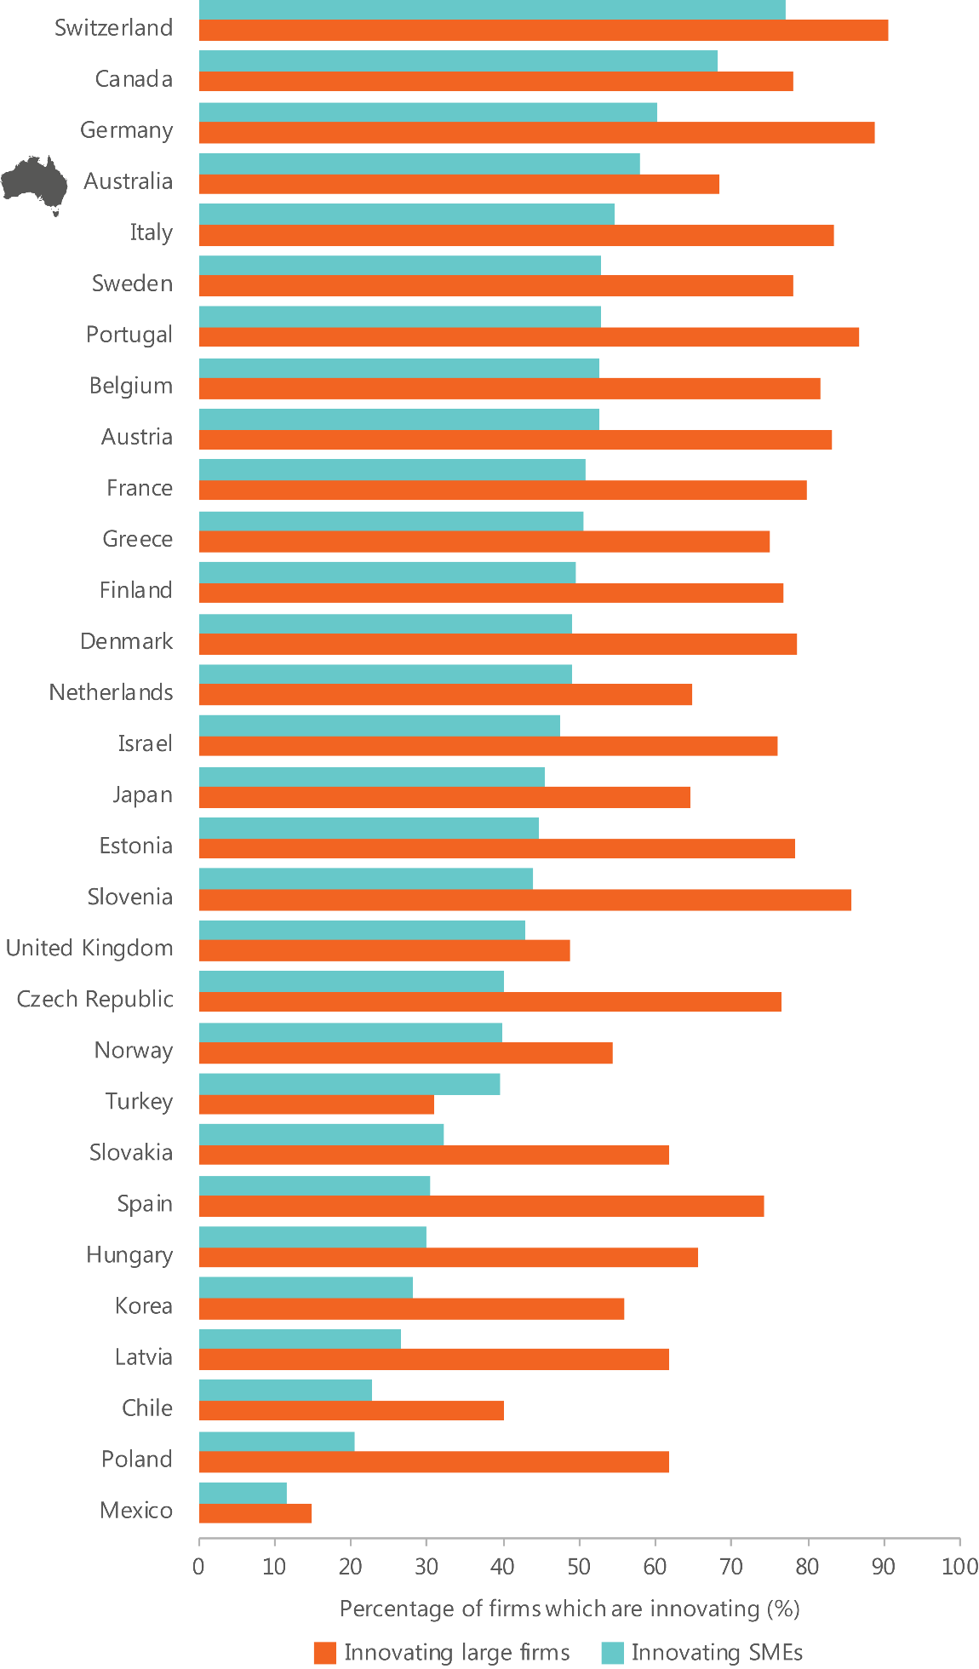

We have some highly innovative sectors
While there are limitations and gaps in the data available on innovation activity across all industry sectors, the best available data from the ABS suggests that three sectors in Australia excel in introducing highly novel, new to the world innovations: mining; manufacturing; and professional, scientific and technical services. These sectors are also R&D-intensive and linked to global value chains.

Weaknesses

Our innovations are not that novel
The vast majority of innovation introduced by Australian businesses is new to the business only and reflects a low degree of novelty. Only 9.2 per cent of Australian firms are engaged in new to market product innovation, which includes the higher novelty new to the world, new to Australia and new to the industry innovations.⁵⁸² The involvement of Australian firms in new to market innovation is below the OECD+ average of 13.3 per cent, and well below the average of the top five performing countries in the OECD+ (21.3 per cent of all firms).⁵⁸³ A low level of new-to-market innovation suggests that Australia is an incremental innovator and adopts innovations from elsewhere rather than creating them. Conversely, we do little highly novel, radical innovation, which generates greater impact despite having higher risk and uncertainty.⁵⁸⁴

Findings: Outputs
What are our strengths?
- We have innovative SMEs. We have the fourth highest proportion of innovative SMEs in the OECD+, with 58 per cent of SMEs introducing new products, processes, organisational or marketing innovations
- We have some highly innovative sectors. We have several sectors introducing good levels of new to the world innovations domestically. These include mining; manufacturing; and professional, scientific and technical services.
What are our weaknesses?
- Our innovations are not that novel. In many sectors the innovations introduced by Australian business are new to the business only and reflect a low degree of novelty.

Outcomes
Innovation helps to maintain Australia’s ongoing wellbeing, prosperity, employment prospects and living standards.⁵⁸⁵
There have been some examples of innovation that have adversely affected people’s lives, such as when improvements in technology and production processes have displaced traditional jobs. Despite these short-term impacts, over the long-term, innovation has overwhelmingly contributed to greater overall wealth and health.⁵⁸⁶
It is difficult to definitively measure the link between innovation and economic, environmental and social outcomes due to the number of other contributing factors and indirect causal relationships.⁵⁸⁷ However, the performance scorecard provides a selection of measures (or proxies) that are most likely to be broadly attributable to innovation and the achievement of these outcomes.

Economic outcomes
Approximately 50 per cent of economic growth in OECD countries can be attributed to innovation, a contribution that is expected to grow.⁵⁸⁸ Compared to other OECD countries, Australia performs well on overall measures of economic growth. In 2015, Australia’s GDP per capita of $45,769 (current US dollars, PPP) was 14 per cent above the OECD average.⁵⁸⁹ Australia’s annual GDP growth rate of 2.26 per cent was also above the OECD average of 2.12 per cent.⁵⁹⁰ Australia’s GDP per capita (current US dollars, PPP) has remained higher than the OECD per capita total since 1970. Only four other OECD countries have consistently performed better over the period: Luxemburg, Norway, the United States and Switzerland.
Businesses make an important contribution to Australia’s economic outcomes, particularly those involved in innovation. Australia’s innovation-active businesses make a disproportionate contribution to business income and employment.⁵⁹¹ They are two to three times more likely to report increased productivity and twice as likely to export compared to non-innovation-active businesses.⁵⁹² Innovation helps business growth, with firm level outcomes in turn contributing to positive economic outcomes.
High growth firms, measured by either employment or turnover, contribute strongly to Australia’s economic outcomes. These firms display more than 20 per cent annualised growth over a three year reference period, and have no fewer than 10 employees at the beginning of the reference period.⁵⁹³ High growth firms can be found across all sectors of the economy and include businesses of all ages, from start-ups to mature businesses.⁵⁹⁴ Despite making up a small fraction of businesses, high growth firms make significant contributions to Australia’s economic growth, employment and exports.⁵⁹⁵ Compared to other nations, Australia has a very low proportion of high growth businesses. In 2013 Australia ranked last out of 27 OECD+ countries for high growth enterprise rate as measured in industry by employment.⁵⁹⁶

Productivity
Productivity is about working smarter, rather than working harder.⁵⁹⁷ Innovation is a key driver of productivity growth.⁵⁹⁸ It contributes to the efficiency of converting inputs, such as labour and capital, into outputs. Multi-factor productivity (MFP) measures improvements in efficiency over and above the use of both labour and capital, such as changes in management practices, organisational changes and changes in general knowledge.⁵⁹⁹ MFP is a widely used proxy for the contribution of innovation to economic growth.⁶⁰⁰ MFP represents improvements in ways of doing things (innovation), which is the primary source of real economic growth and higher living standards over the long term. In the short term, however, MFP also reflects unexplained factors such as cyclical variations in labour and capital utilisation, economies of scale and measurement error.⁶⁰¹ For this reason, MFP is best estimated and reported over the productivity cycle, which is determined by the ABS. However, to enable an international comparison, ISA has also analysed Australia’s MFP on a five year compound annual growth rate.
In both the current incomplete productivity cycle (2007–08 to 2014–15) and the last complete cycle (2003–04 to 2007–08), Australia’s average annual MFP growth has remained flat.⁶⁰²
MFP growth has slowed considerably from levels of growth over the 1990s and early 2000s (see Figure 36). Over the five years to 2014, Australia’s average annual growth in MFP was 0.4 per cent, which ranked Australia 12th out of 20 OECD+ countries.⁶⁰³
Figure 36: Australia's annual growth in multi-factor productivity, 1990 to 2014 (5 year compound annual growth rate).⁶⁰⁴
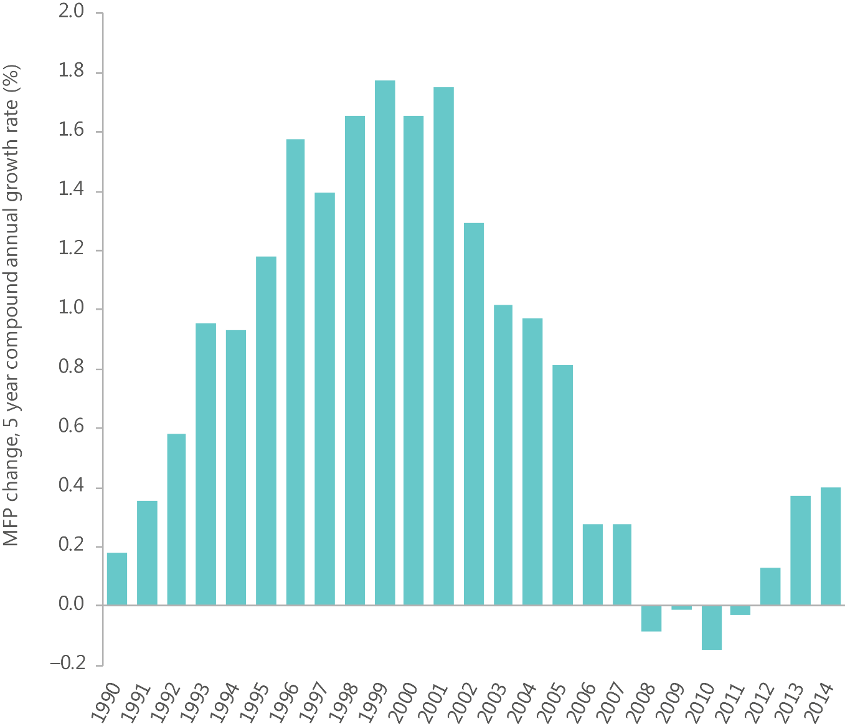

Employment and wages
In 2015, Australia’s unemployment rate was 6.1 per cent, below the OECD total of 6.8 per cent.⁶⁰⁵ Since 2005, Australia’s unemployment rate has remained consistently below the OECD total.⁶⁰⁶ Only four other countries have consistently performed better over the period, Japan, Norway, Korea and Switzerland.⁶⁰⁷
In 2015, approximately 11.8 million people were employed in Australia.⁶⁰⁸ Over the past two decades, 3.6 million jobs have been added to the Australian economy.⁶⁰⁹ Innovations contribute to employment through firms (particularly high growth firms) that introduce them.⁶¹⁰ High growth firms are more likely to innovate and make a significant contribution to overall employment growth.⁶¹¹
Over the seven years to 2010–11, 820,000 new jobs were created by businesses in the Australian economy.⁶¹² High growth firms generated the majority of this growth, creating 2 million jobs over the period.⁶¹³ By comparison, firms which showed nil or negative growth over the period lost around 2.4 million jobs.⁶¹⁴
Start-ups also make a substantial contribution to employment growth, particularly high growth start-ups. ⁶¹⁵ Irrespective of their rate of growth, start-ups contributed 1.2 million new jobs over the seven years to 2010–11.⁶¹⁶ High growth start-ups in particular contributed the majority of this job creation (65 per cent). ⁶¹⁷ Mature business, by comparison, lost 230,000 jobs over the period.
Innovation also contributes to the overall quality of employment. Previous studies have indicated a general increase in the level of skills with technological change.⁶¹⁸ However, associated with these changes have been increasing polarisation in the skills mix, with high skill positions growing at a faster rate than low skill positions in some economies including in Australia.⁶¹⁹ This has contributed to an increase in income inequality.⁶²⁰ Over the 25 years to 2010, real wages increased 14 per cent for those in the bottom 10 per cent compared to 72 per cent for those in the top 10 per cent.⁶²¹

Exports
In 2014, Australia’s exports of goods and services totalled US$341 billion, making Australia the 14th highest exporter by export value in the OECD+.⁶²² Australia’s top five goods and services exports in 2015 were iron ore, coal, education related travel services, natural gas and personal travel services.⁶²³
Australia’s exports aren’t considered high-technology. High-technology exports come from industries of high R&D intensity, such as aerospace, computers, and pharmaceuticals.⁶²⁴ High-technology exports are used as an indicator for how innovative a country’s exports are. Australia exported US$4.69 billion in high-technology products during 2014.⁶²⁵
While Australia’s high-technology exports have been increasing steadily since 1988, they remain low internationally.⁶²⁶ In 2014, Australia ranked 26th out of 37 OECD+ countries by the value of its high-technology exports.⁶²⁷ This is below the OECD+ average of US$52.1 billion and well below the average for the top five performing countries in the OECD+ (US$237 billion).⁶²⁸ Among Australia’s manufacturing exports, 13.6 per cent were high-technology exports in 2014.⁶²⁹ This is below the OECD+ average of 15.1 per cent and well below the average of the top five OECD+ countries (30.4 per cent).⁶³⁰
Australia also exports knowledge. Knowledge assets are intangible assets such as research and technical assistance, patents, designs, trademarks, and licenses (excluding licences licenses to reproduce and distribute computer software and audio-visuals).
Trade in knowledge represents the flow of knowledge between nations. Over the past decade, trade in knowledge assets has grown faster than GDP in most measured OECD countries.⁶³¹ In 2013, Australian exports of knowledge assets totalled US$4.7 billion, ranking Australia 18th out of 31 OECD countries by absolute export value.⁶³² On balance, however, Australia is a net importer of knowledge assets, while most measurable OECD countries are net exporters. Australia’s net imports of knowledge assets totalled US$4.9 billion in 2013, ranking Australia 28th out of 31 OECD countries on its net balance of trade in knowledge assets by absolute monetary value.⁶³³
While Australia may not be considered an exporter of innovative goods and services, innovation remains important to its export growth. Innovation has driven exports through high growth firms. High growth firms make a significant contribution to Australia’s exports. Over the seven years to 2010–11, export sales increased by $0.22 trillion, with high growth firms generating 84 per cent of this export growth.⁶³⁴
Innovation has also driven exports through productivity improvements and embodied advancements in knowledge, technology, and branding within industries. In 2014–15, MFP growth in mining (5.5 per cent)⁶³⁵ has enabled greater production output, also contributing to an increased capacity to export commodities. Many industry sectors where Australia has a comparative advantage, including coal and metal ore mining, also coincide with strengths in R&D intensity, patent applications and trademarks. ⁶³⁶ Embodied knowledge and technology may also be provided by other supporting industries within the supply chain, such as mining service providers and mining equipment manufacturers.⁶³⁷

Social outcomes
As a key driver of productivity growth, innovation has positive impacts on overall living standards.⁶³⁸ It also contributes to broader, non-income based measures of social outcomes through improvements in health care and advancements in infrastructure systems. Compared to other countries, Australia performs well on a number of indicators of social outcomes (Table 18). Australian life expectancy is above average, with life expectancy at birth being 82 years, two years above the OECD average. Australians also have relatively high rates of life satisfaction. When asked to rate their general satisfaction with life on a scale from 0 to 10, Australians gave a 7.3 grade, higher than the OECD average of 6.5.⁶³⁹
Australia performs above the OECD average in almost all 11 areas of the Better Life Index, and in 2016 was 2nd out of 37 OECD+ countries when all 11 areas were equally weighted, behind Norway.^{640,641} Australia has consistently ranked very highly in this index, with a small improvement over the last decade.⁶⁴² Australia also ranks consistently very highly in the United Nations Human Development Index (it is currently 2nd out of 37 OECD+ countries), and has experienced a small improvement over the last decade. In 2016, Australia also scored 4th out of 35 OECD+ countries on the Social Progress Index.⁶⁴³
Table 18: Australia's performance on selected indicators from the 2016 Better Life Index.⁶⁴⁴
Topic | Score (out of 10) | Performance against selected indicators
Jobs and earnings | 8.4 | Seventy-two per cent of working-age Australians (aged 15 to 64 years) have a paid job, higher than the OECD employment average of 66 per cent.
Housing | 7.4 | Australian households on average spend 20 per cent of their gross adjusted disposable income on keeping a roof over their heads, slightly below the OECD average of 21 per cent.
Work–life balance | 5.9 | Australian full-time workers devote 60 per cent of their day on average, or 14.4 hours, to personal care (eating, sleeping, etc.) and leisure (socialising with friends and family, hobbies, games, computer and television use, etc.)—less than the OECD average of 15 hours.
Health status | 9.4 | Life expectancy at birth in Australia stands at 82 years, two years above the OECD average of 80 years.
Education and skills | 8.0 | Australians can expect to go through 19.2 years of education between the ages of 5 and 39, more than the OECD average of 17.5 years.
Community | 8.5 | Ninety-five per cent of Australians believe that they know someone they could rely on in time of need, more than the OECD average of 88 per cent.
Civic engagement and governance | 8.6 | Australia is ranked 8th out of 38 countries for the level of stakeholder engagement in developing regulations with a score of 2.7 (on a scale of 0 to 4), higher than the OECD average of 2.4.

Environmental outcomes
Australia is fortunate to have significant stocks of environmental assets compared to many other countries.⁶⁴⁵ Environmental assets include minerals and energy resources, land, timber resources, fish and water resources. The economic value of Australia’s environmental assets was estimated at $5.8 trillion at 30 June 2015, almost double the 2006 value.⁶⁴⁶
Australia’s recent economic prosperity can be partly attributed to the utilisation or consumption of our environmental assets. Between 1996–97 and 2013–14, Australia’s economic output rose by 73 per cent. Over the same period, measures of the production of waste, energy consumption and greenhouse gas emissions increased. Waste production rose 163 per cent, energy consumption increased 31 per cent and greenhouse gas emissions increased 20 per cent.⁶⁴⁷ While water consumption fell by 16 per cent during this period, higher rainfall in recent years supported an increase in water consumption of 40 per cent between 2010–11 and 2013-14.⁶⁴⁸
In many OECD countries, innovation is helping nations to decouple emissions and other by-products from production processes. Despite the increase in energy consumption and greenhouse gas emissions, Australia is becoming more efficient over time (Figure 37).
A comparison of changes in selected indicators of environmental pressure per unit of economic production between 1996–97 and 2013–14 shows that the Greenhouse Gas (GHG),⁶⁴⁹ energy,⁶⁵⁰ and water intensity⁶⁵¹ of Australia’s economy has declined significantly since 1996–97.
While Australia has experienced improvements in emissions, water and energy intensity over time, compared to other countries, Australia performs poorly on measures of carbon dioxide productivity, energy productivity, material productivity and water productivity.⁶⁵² In 2013, Australia ranked 35th out of 37 OECD+ countries on the measure of GDP produced per unit of energy related carbon dioxide emissions, 26th (out of 15 OECD+ countries) on energy productivity, ⁶⁵³ 13th (out of 15 OECD+ countries) on material productivity and 19th (out of 36 OECD+ countries) on water productivity.⁶⁵⁴
Figure 37: Intensity of selected indicators of environmental pressure per unit of economic production (gross value added), 1996-97 to 2013-14.⁶⁵⁵
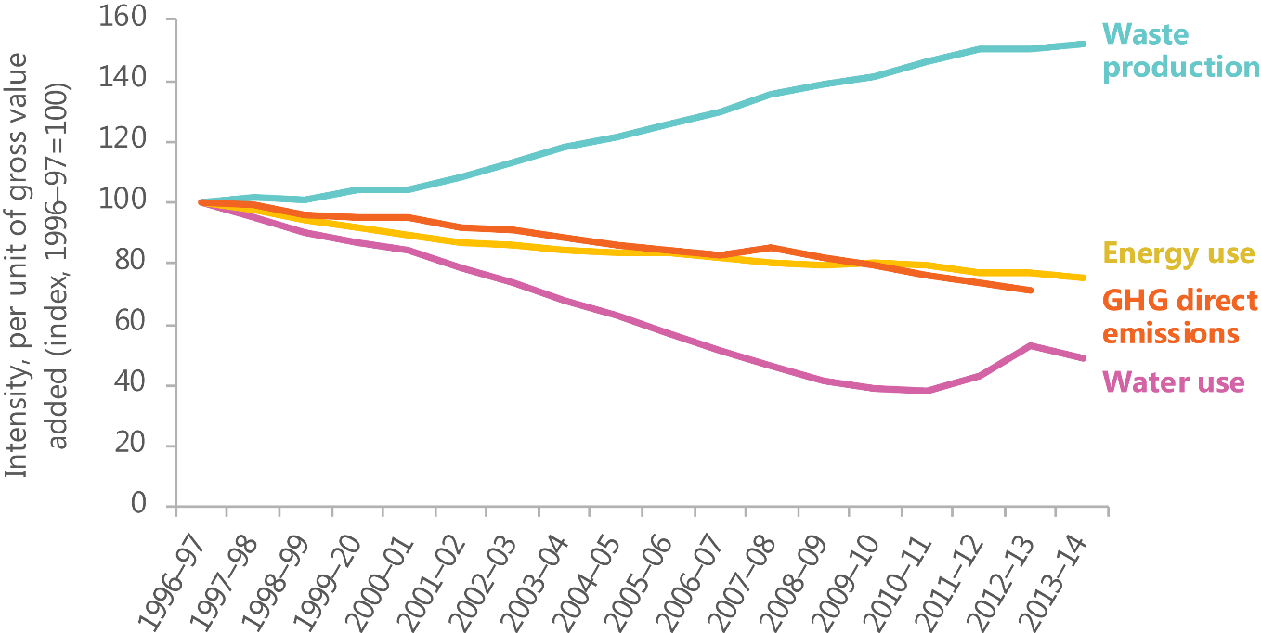

Strengths

Australia has had strong economic performance
In 2015, Australia’s unemployment rate was 6.1 per cent, below the OECD total of 6.8 per cent.⁶⁵⁶ Since 2005, Australia’s unemployment rate has remained consistently below the OECD total.⁶⁵⁷ Only four other countries have consistently performed better over the period, Japan Norway, Korea and Switzerland.⁶⁵⁸
Australia’s GDP per capita (current US dollars, PPP) has remained higher than the OECD total GDP per capita since 1970. Only four other OECD countries have consistently performed better over the period, Luxemburg, Norway, the United States and Switzerland.

Australia is considered a great place to live
Australia performs above the OECD average in almost all 11 areas of the Better Life Index, and in 2016 was 2nd out of 37 OECD+ countries when all 11 areas were equally weighted, behind Norway.^{659,660} Australia has consistently ranked very highly in this index, with a small improvement over the last decade.⁶⁶¹ Australia also ranks consistently very highly in the United Nations Human Development Index (it is currently 2nd out of 37 OECD+ countries), and has experienced a small improvement over the last decade. In 2016, Australia also scored 4th out of 35 OECD+ countries on the Social Progress Index.⁶⁶²

Weaknesses

Like many other countries, we are seeing a slowdown in productivity growth
Over the long-term, productivity growth contributes to improved well-being through the growth of output and income.⁶⁶³ Per capita income growth has declined over three consecutive years since 2012–13 mainly due to the large decline in the terms of trade.⁶⁶⁴ Before this, Australia had not experienced negative income growth since 1960.⁶⁶⁵
In 2015–16, Australia’s terms of trade decreased by 10.2 per cent, its fourth consecutive annual decrease.⁶⁶⁶ If the terms of trade continue its current downward trend, it will exert further pressure on Australia’s level of income in the years to come.⁶⁶⁷ Experts have indicated that productivity growth will need to double from its historical rate of growth to maintain the per capita income growth experienced over the last two decades.⁶⁶⁸
Similar to other OECD countries, Australia’s productivity growth has slowed since the 1990s.⁶⁶⁹ In the context of this environment, innovation has been identified as an imperative to drive new sources of growth; enabling increasing work at the technological frontier to drive the productivity growth required to maintain income and continued prosperity.⁶⁷⁰

Findings: Outcomes
What are our strengths?
- Australia has had strong economic performance. Compared to other nations, Australia’s level of unemployment has remained consistently low over time and Australia has maintained a high level of GDP per capita.
- Australia is considered a great place to live. Australia ranks consistently high in a number of well-known indices of social outcomes, with high levels of life satisfaction and high levels of education.
What are our weaknesses?
- Like many other countries, we are seeing a slowdown in productivity growth. There is broad debate about the possible causes of this.

Part C | Overall findings and next steps

Performance of the Australian Innovation, Science and Research System
It is without doubt that innovation is critical to Australia’s future. However, Australia will struggle to become more innovative without a strategy to guide our efforts over the long term.
This is why the Australian Government has asked Innovation and Science Australia (ISA) to consult with the community to deliver a 2030 Strategic Plan (the Plan) by the end of 2017 for it to consider. The goal of the Plan is to establish what Australia’s Innovation, Science and Research system (the ISR System) should look like in 2030—and determine how we should get there. Having a long-term strategy will ensure Australia can reach its innovation potential and be a world leader in the knowledge economy of the future.
This Innovation, Science and Research System Review (ISR System Review) establishes a baseline for measuring our future performance towards this.
It has drawn on a simple performance framework and has reviewed six areas that are critical for enabling innovation to occur: policy, money, infrastructure, skills, networks and culture. However, ISA is ultimately interested in what this means for Australia’s ability to create, transfer and apply knowledge. This is because these activities will lead to outputs such as new or improved products, processes and services and ultimately achieve greater outcomes for Australian society. These outcomes are the reason why innovation is important.
This section summarises the findings identified against each of the enablers, mapped to Australia’s performance in knowledge creation, transfer and application, and the delivery of innovation outputs and outcomes.

Key findings

Knowledge creation
What are our strengths?
- We have higher relative levels of funding for R&D activities in higher education and not-for-profit organisations compared to other nations.
- Many of Australia’s research infrastructure assets are world-class, although there is a need for overarching governance and ongoing, whole-of-life funding. Many of Australia’s research infrastructure assets have high levels of use and have supported significant research output and scientific achievement.
- The Australian research workforce is world-class in many research fields. Australia achieves much better research outputs than would be expected from the number of people engaged in the research workforce.
- We have good levels of research–to–research collaboration. Australian academic researchers collaborate significantly, particularly internationally. Collaboration between researchers is supported by a range of network types.
What are our weaknesses?
- Despite a strong university system overall, Australia has no university in the global top 20.

Knowledge transfer
What are our strengths?
- We are increasing our open government datasets and improving data sharing. Open government data is improving publicly available datasets and we have new data sharing arrangements within government enabling new data tools.
- Australians have sufficient levels of basic skills, although some trends are concerning. The Australian education system generally produces graduates with good levels of basic skills. However, emerging data on STEM education in particular is a cause for concern.
- We are increasing our focus on networks. Governments, research organisations and businesses are increasingly looking to more formalised models and roles to facilitate relationships and support collaboration.
What are our weaknesses?
- There are few direct mechanisms to support knowledge transfer. Most Australian Government funding for innovation targets knowledge creation and knowledge application, and most funding to businesses is delivered through indirect mechanisms.
- Compared to other countries, Australia under-utilises vocational education and training (VET). Comparisons with other nations suggest that Australia could better use the VET sector to build skills for innovation.
- Collaboration between researchers and businesses appears limited. Few businesses in Australia collaborate with universities or higher education institutions, although there are encouraging improvements. A relatively low percentage of researchers working in businesses is associated with limited incentives.

Knowledge application
What are our strengths?
- The regulatory environment is generally supportive of innovation. However, while businesses do not cite regulation as a general barrier to innovation, there are regulatory restrictions in some specific areas.
- Financial markets generally function well, though access to risk capital has been a constraint. Recent new funds flowing into the venture capital sector may contribute to overcoming this.
- Skilled migration contributes significantly to Australia’s skills base. Skilled migration is an important source of skills and has increased significantly over the past decade.
- A number of vibrant start-up ecosystems are flourishing around the country. Grassroots movements, in many cases driven by serial entrepreneurs, are attracting new talent and new money into the establishment and nurturing of high-growth start-ups.
What are our weaknesses?
- Relative to other countries, government procurement could do more to foster innovation. Australian governments could make better use of procurement to incentivise innovation, particularly in SMEs, though current initiatives are expected to help.
- Australian business expenditure on R&D is low relative to expenditure in other countries. Australian business investment in R&D is low, has declined as a percentage of GDP since 2008, and has not kept pace with leading innovation nations.
- There are ongoing business, management and leadership skills gaps. Well- managed firms are more innovative. However, gaps have been identified in business, management and leadership capabilities and practices in Australian businesses.
- The current supply of ICT graduates is not meeting industry needs. There are gaps between the supply and demand of ICT graduates, who are particularly important in implementing innovation across a range of industry sectors.
- Australian businesses rank poorly on international collaboration. Compared to businesses in other countries, Australian businesses are less likely to collaborate with international partners or participate in global value chains.

System-wide
What are our strengths?
- New statistical methods will allow for the proper evaluation of programme impact. This will allow sub-scale programmes to be discontinued or scaled-up appropriately to reduce the number of ineffective programmes.
- Australia’s multicultural society is an important asset, but diasporas could be leveraged more. Australia’s uniquely multicultural society is a strength, and our diverse population, including our diaspora, has the potential to contribute more to innovation.
What are our weaknesses?
- Our short-term oriented culture may affect innovation in different ways.
- Australia is a culture that has a high focus on achieving quick results. This may
- be reflected in the prevalence of incremental new to the business only innovation rather than radical new to the world innovation.
- Australia remains a gender-unequal society. Evidence shows that gender diversity is important for innovation performance, and there is room for Australia to better develop and use its female talent in many roles.

Outputs
What are our strengths?
- We have innovative SMEs. We have the fourth highest proportion of innovative SMEs in the OECD+, with 58 per cent of SMEs introducing new products, processes, organisational or marketing innovations
- We have some highly innovative sectors. We have several sectors introducing good levels of new to the world innovations domestically. These include mining; manufacturing; and professional, scientific and technical services.
What are our weaknesses?
- Our innovations are not that novel. In many sectors the innovations introduced by Australian business are new to the business only and reflect a low degree of novelty.

Outcomes
What are our strengths?
- Australia has had strong economic performance. Compared to other nations, Australia’s level of unemployment has remained consistently low over time and Australia has maintained a high level of GDP per capita.
- Australia is considered a great place to live. Australia ranks consistently high in a number of well-known indices of social outcomes, with high levels of life satisfaction and high levels of education.
What are our weaknesses?
- Like many other countries, we are seeing a slowdown in productivity growth.
- There is broad debate about the possible causes of this.

Key findings
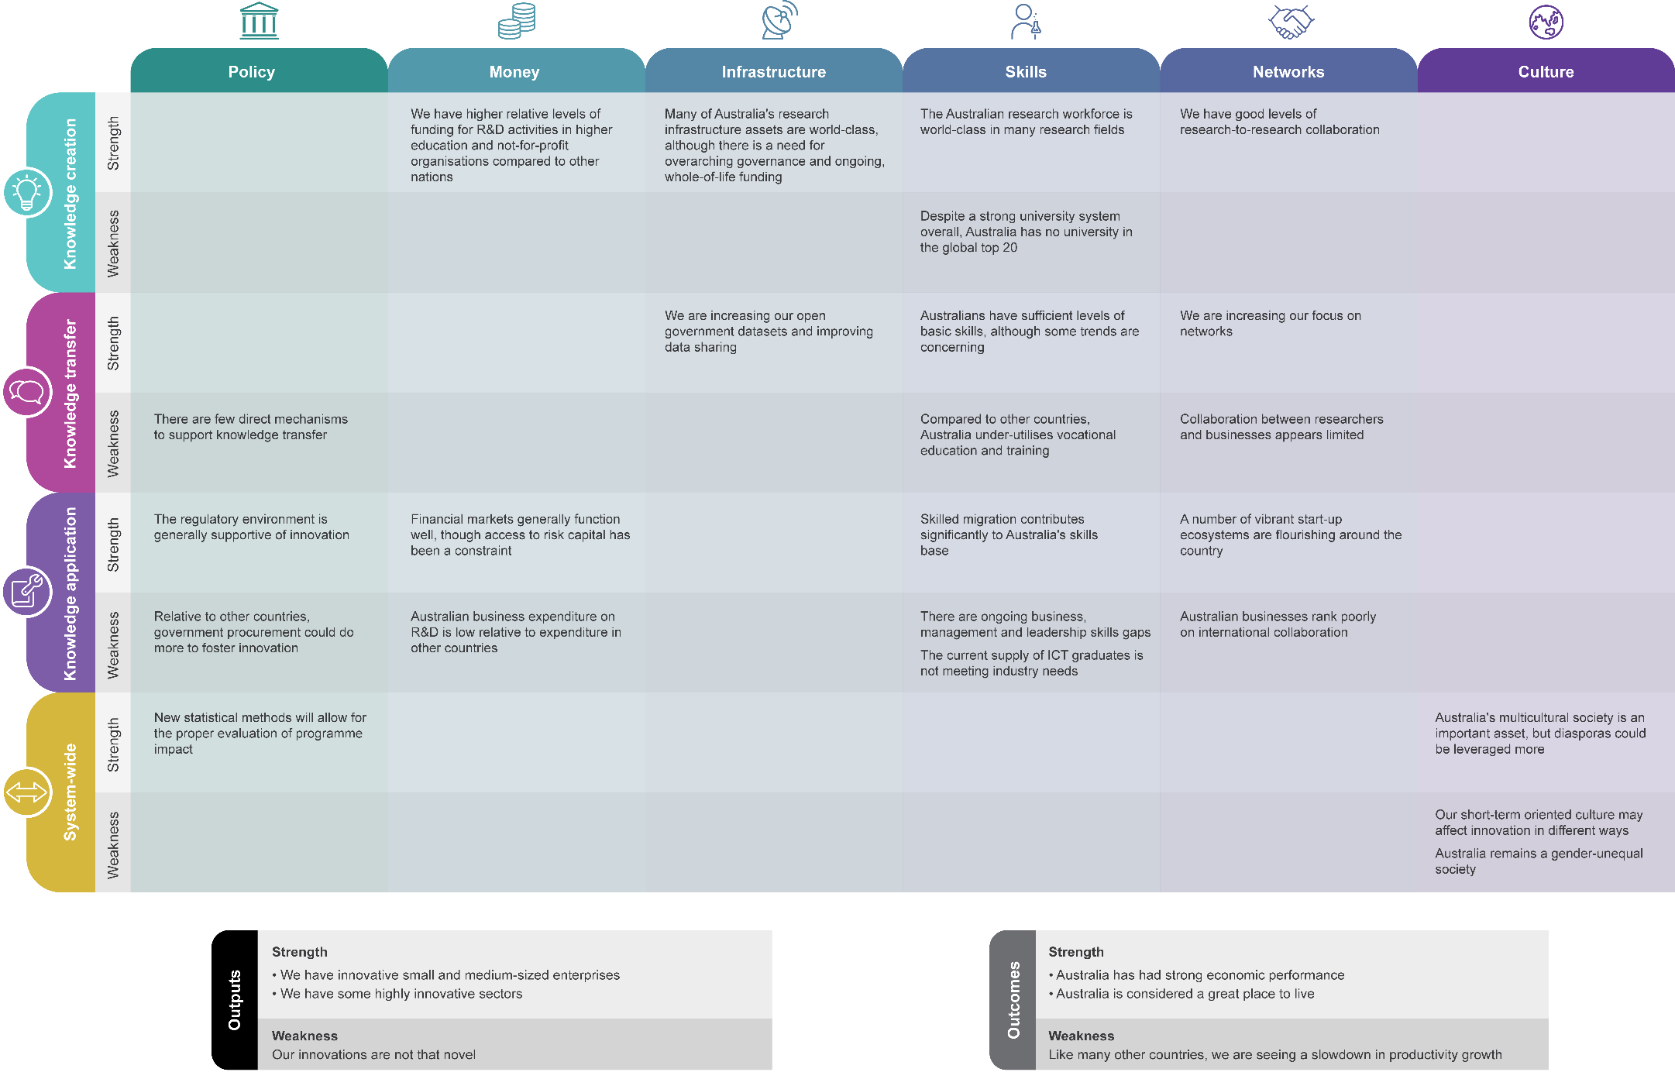

Scorecard
The preceding sections of this ISR System Review discuss the performance of the ISR System drawing on a range of performance metrics. As we move towards 2030, it will be important that there be a consistent approach to measuring the performance of the ISR System. ISA identified 20 performance indicators that it can use to track the performance of the ISR System.
Economic, social and environmental outcomes are central to national wellbeing; however, it is difficult to establish their direct link to innovation as there are other factors that contribute to these outcomes. For this reason, the scorecard includes a limited number of outcome indicators, concentrating on those that are most likely to be broadly attributable to innovation.
As better research and data becomes available and measures of the ISR System improve over time, ISA expects to revise the performance scorecard to ensure it remains accurate, relevant and useful.

Prioritisation and selection of the scorecard indicators
The 20 scorecard indicators were selected from over 250 available metrics related to innovation, science and research. These metrics were collected from a range of authoritative sources and mapped against the ISA performance framework. Scorecard indicators were then selected in conjunction with PricewaterhouseCoopers and the Office of the Chief Economist against the following criteria:
- relevance: does the metric have a strong, evidence-based link to the performance of the ISR System?
- quality: is the metric methodologically robust and from an authoritative source?
- usefulness: are data reported consistently over time and are the data internationally comparable?
Following selection, the latest score, trend, gap to the top performance and relative ranking were calculated for each performance indicator.

The performance scorecard
The 20 indicators in the performance scorecard (Figure 38) provide a high-level snapshot of the current state of the ISR System and will be used to track the performance of the ISR System over time. The scorecard indicators have been mapped against the performance framework categories of outcomes and outputs, and the innovation activities: knowledge creation, knowledge transfer and knowledge application. The scorecard summarises Australia’s performance according to:
- latest score: this column provides the latest available data for Australia on each indicator. The units of measurement are provided in the name of the indicator.
- trend: Upwards and downwards arrows show the overall trend for Australian data on each indicator. An upwards arrow represents improved performance. A downwards arrow represents a decline in performance. This performance is based on domestic data only and does not consider Australia’s performance in relation to international countries.
- average for the top five performers: this column shows the simple average of the scores for the top five OECD+ performers in the relevant metric.
- Australia’s ranking: this column shows Australia’s performance on each indicator relative to the 38 OECD+ countries, using latest available data. Where country data was not available for an indicator, the respective country was excluded from the comparison group. In some cases, where country data was not available for the year of comparison, country data from the closest available year was used for the comparison. The data used for these rankings was adjusted to OECD standards, to ensure that the Australian data is comparable with data for other countries. The colouring of the rankings indicates whether Australia’s comparative performance falls within the first quartile (green), second quartile (yellow), or third or fourth quartile (red).
The performance scorecard indicators are discussed in more detail throughout the ISR System Review. For further information on the indicators, see Appendix D.
Figure 38: Performance scorecard for the Australian ISR System.⁶⁷¹
For explanation of the metrics, see Appendix D.

The 2030 Strategic Plan
The Australian Government has asked ISA to develop a 2030 Strategic Plan (the Plan) for innovation, science and research. ISA will use this performance assessment to inform the development of the Plan in 2017. The Plan will aim to ensure Australia reaches its innovation potential, and contributes to global efforts to develop new technologies, protect the environment, and combat illness and disease. It will aim to maintain and enhance Australia’s wellbeing, prosperity and economic growth by guiding the government’s investment over the medium term.
The Plan will describe what the ISR System should look like in 2030 and determine how Australia can get there. It will identify priority investment, infrastructure and environmental factors for consideration by government and outline how progress can be evaluated over time. It will be delivered to government in late 2017 and be released publicly.
The process to develop the Plan will commence with consultation. Some of the questions will include:
- What should a fit-for-purpose ISR System look like in 2030? This ISR System Review has painted a picture of Australia as an incremental innovator, with generally low levels of new-to-market innovation. Is this a sustainable strategy to continue into 2030, or is there a need to focus more on disruptive innovation, and move closer to the technological frontier?
- How should Australia regard international peers? Can Australia go beyond simply seeking to “catch up” with more advanced international innovation systems, and instead look to “leapfrog” ahead of them? Can Australia learn from progress in other systems to accelerate its own?
- Which challenges are unique to Australia, and which are global concerns? Where can Australia improve its performance and restart its productivity growth, in the context of a rapidly evolving global market?
- Are there some sectors or projects that could stimulate innovation more broadly? Can Australia take advantage of technological and economic shifts to pursue specific opportunities that would also have broader spill-over benefits for the ISR System?
- How can we ensure better measurement of the ISR System’s performance? Can we improve measurement of the different types of value that innovation adds in order to inform policy development? Are new metrics needed to better understand social aspects of the ISR System such as collaboration and culture? What are the optimal levels of failure or mistakes in the ISR System?
In preparing this ISR System Review, ISA has identified a number of data issues and gaps. It will be important that these gaps be considered in the development of the Plan. They may call for conducting new analyses of existing innovation, science and research data; drawing on existing data collected elsewhere; establishing new datasets; or commissioning new research to better understand some parts of the ISR System.
This ISR System Review is just one piece of work which will inform the Plan. The Plan will build on previous work, including this ISR System Review, and give consideration to the outcomes of a number of government-initiated and complementary reviews. Stakeholder consultation during the first half of 2017 will also inform the development of the strategy.

Part D | Appendices

A ISA Board Member biographies
 | Mr Bill Ferris AC (Chair)  Co-Chairman and Co-Founding Partner, CHAMP Private Equity Group  Member, Harvard Business School Asia Pacific Advisory Council  Mr Ferris has played a pioneering and entrepreneurial role in the development of Australia’s venture capital and private equity markets. He has served as Chair of Austrade, the Garvan Institute of Medical Research and the Health and Hospitals Fund Advisory Board. Mr Ferris also joined the expert panel for the Australian Government’s Strategic Review of Health and Medical Research in October 2011.
 | Dr Alan Finkel AO (Deputy Chair)  Chief Scientist of Australia  Chair of the Prime Minister’s Prizes Selection Committee  Dr Finkel commenced as Australia’s Chief Scientist on 25 January 2016. He has an extensive science background as an entrepreneur, engineer, neuroscientist and educator. Prior to becoming Chief Scientist, he was the Chancellor of Monash University and President of the Australian Academy of Technology and Engineering
 | Dr Bronte Adams AM  Managing Director Dandolo Partners International  Dr Adams leads a management consultancy focused on the public sector. She advises a wide range of clients in the innovation, industry, health, technology, science & research, startup, cultural, and education sectors. She previously led the Victorian Government’s technology arm, reforming government through the use of technology, managing major procurements, attracting foreign investment and stimulating the uptake of technology across commercial, public and community sectors.  Dr Adams has chaired and sat on numerous public and private sector entities including the Rhodes Trust in Australia and Victorian Education Research Network (current), Melbourne Symphony Orchestra, Melbourne University Publishing, VICSTART Technology Commercialisation and Victorian Science Technology Innovation Infrastructure Grants Program.
 | Dr Michele Allan  Chancellor, Charles Sturt University  Chair, Grains and Legumes Nutrition Council Chair, Meat and Livestock Australia  Non-Executive Director, Apple and Pear Australia  Dr Allan has held senior executive positions with Amcor Limited, Bonlac Foods, Bioinformatics Centre of Excellence Tasmania, Kraft Foods and ICI. Until September 2008, Dr Allan was Chief Executive Officer and Managing Director of Patties Foods Limited, a manufacturer and marketer of frozen food.
 | Mr Paul Bassat  Co-Founder, Square Peg Capital Non-Executive Director, Wesfarmers  Commissioner, Australian Football League Director, AFL Sportsready Pty Ltd  Prior to founding Square Peg, Mr Bassat co-founded SEEK in 1997 and served as CEO and then as Joint CEO from 1997 to 2011. SEEK is the world’s largest online employment business and in 14 years went from a start-up to one of Australia’s top 100 companies.
 | Dr Rufus Black  Master of Ormond College  Deputy Chancellor of Victoria University President of Museum Victoria  Dr Black brings together extensive private, public and social sectors experience at both management and governance levels. He is the co-founder of the Wade Institute for Entrepreneurship and a Director of the Walter and Eliza Hall Institute and teaches in the University of Melbourne’s new Master of Entrepreneurship degree.  Dr Black’s social sector experience includes Chairing the Teach for Australia Board and he is a Director Emeritus of Teach for All. He continues his commercial interests as a Director of law firm Corrs Chambers Westgarth.  Dr Black’s public policy work has included working with Hospital and Healthcare Reform Commissions in 2009, leading the Accountability and Governance Review of the Department of Defence in 2010 and the Prime Minister’s Independent Review of the Australian Intelligence Community in 2011. He was the Strategic Advisor to the Secretary for Education in Victoria from 2012 to 2014.
 | Ms Maile Carnegie  Group Executive Digital Banking, ANZ  Previously Ms Carnegie was Managing Director of Google Australia and New Zealand for three years. Prior to this she served as Managing Director of Procter & Gamble Aust/NZ, having worked for the company for over 20 years in many capacities. Ms Carnegie has global industry experience and has served on advisory boards of the University of Technology, Sydney, the Australian Securities and Investments Commission, the NSW Treasurer and the B20.
 | Ms Beth Comstock  Vice-Chair, GE  Board Member, Nike  Trustee President, Cooper-Hewitt Smithsonian Design Museum  Ms Comstock previously held the role of Senior Vice-President of GE and President of Integrated Media. She has also served as the Chief Marketing Officer of GE.
 | Mr Scott Farquhar  Co-Founder, Co-CEO, Atlassian Investor, Blackbird Ventures Investor/Mentor, StartMate  Mr Farquhar is experienced with all aspects of the software industry, from developing software, growing a software team, documenting process, software sales, online marketing, growing an online community and writing code. He was named the Australian IT Professional of the Year in 2004, and in 2006 was the youngest person ever to be awarded the Australian Entrepreneur of the Year by Ernst & Young.
 | Professor Bronwyn Harch  Executive Director of the Institute for Future Environments Professor of Applied Statistical Science at QUT  Professor Harch is an applied statistician and research leader with two decades of experience in the agriculture, environment, health, manufacturing and energy sectors. She is passionate about generating knowledge to better the technology and practices that make our world more sustainable, secure and resilient.  Professor Harch was previously the Chief of CSIRO’s Division of Computational Informatics and previously the Deputy Director of CSIRO’s Sustainable Agriculture Flagship. She worked at the CSIRO for 18 years as a researcher and research strategist. Professor Harch is a Fellow of the Academy of Technological Science and Engineering, an Elected Member of the International Statistical Institute, a Graduate of the Australian Institute of Company Directors, an Accredited Member of the Statistical Society of Australia Inc., and Past President of The International Environmetrics Society.
 | Dr Marlene Kanga AM  Chair, Department of Industry, Innovation and Science, R&D Incentives Committee  Director, iOmniscient Pty. Ltd. Director, Sydney Water Corporation Director, Hearing CRC  Director, Asialink  Dr Kanga is an experienced company director and a Fellow of the Australian Institute of Company Directors and the Academy of Technology and Engineering. She has degrees in chemical engineering and has a PhD in Finance from Macquarie University.  Dr Kanga has been a champion for innovation, especially in the engineering sector through her leadership roles as a National President of Engineers Australia and as President Elect of the World Federation of Engineering Organisations. She is a director of a company that has commercialised Australian research to develop a platform for intelligent video analytics technologies.
 | Mr Daniel Petre AO  Partner, Air Tree Ventures Director, McGraths Real Estate  Advisory Board Member, Oneview Limited Director, Garvan Institute of Medical Research Director, Smart Sparrow  Mr Petre is a technology investor, strategic adviser, and board member. He has had a 30-year career in technology-related organisations. This has included time as the local Managing Director for Microsoft, Vice-President in the US headquarters, and Director of Asia–Pacific headquarters. Over the last 15 years, he has founded three major technology investment companies (ecorp, netus and AirTree Ventures) which invested over $100 million in close to 20 technology-related start-ups. Mr Petre has been a board member of a number public companies and not-for-profit organisations over the last 15 years as well as authoring three books.
 | Dr Chris Roberts  Member, NSW Innovation and Productivity Council Non-Executive Director, ResMed Inc  Alliance Professor, University of NSW, King’s College London and Arizona State University  Dr Roberts was a Founding Director of ResMed Inc and also served as the company’s Vice President. He previously also served as Chairman and Director of Research Australia, a non-profit organisation promoting health and medical research.
 | Mr Saul Singer  Journalist and author  Mr Singer is a columnist and former editorial page editor at The Jerusalem Post. He has also been published in The Wall Street Journal, Commentary, Moment, The New Leader and The Washington Post blog ‘PostGlobal’. He has previously served as an adviser in the United States Congress to the House Foreign Affairs and Senate Banking Committees.  Mr Singer co-authored Start-up nation in 2009 and Confronting Jihad: Israel’s struggle and the world after 9/11 in 2003.
 | Ms Glenys Beauchamp PSM (Ex Officio)  Secretary of the Department of Industry, Innovation and Science  Ms Beauchamp was previously Secretary of the Department of Regional Australia, Local Government, Arts and Sport and served as Deputy Secretary in the Department of the Prime Minister and Cabinet and the Department of Families, Housing, Community Services and Indigenous Affairs.  She has held a number of executive positions in the ACT Government including Deputy Chief Executive, Department of Disability, Housing and Community Services and Deputy CEO, Department of Health. She also held senior positions in housing, energy and utilities functions with the ACT Government.

B Acronyms and glossary

Acronyms
ABS | Australian Bureau of Statistics
ACOLA | Australian Council of Learned Academies
ANSTO | Australian Nuclear Science and Technology Organisation
ARC | Australian Research Council
ATO | Australian Taxation Office
BERD | Business expenditure on research and development
BLADE | Business Longitudinal Analysis Data Environment
BTF | Biomedical Translation Fund
CRC | Cooperative Research Centre
CSIRO | Commonwealth Scientific and Industrial Research Organisation
DET | Department of Education and Training
DIIS | Department of Industry, Innovation and Science
DTO | Digital Transformation Office
ERA | Excellence in Research for Australia
ESVCLP | Early Stage Venture Capital Limited Partnership
FDI | Foreign direct investment
GDP | Gross domestic product
GERD | Gross expenditure on research and development
GOVERD | Government expenditure on research and development
HASS | Humanities, arts and social sciences
HDR | Higher degree by research
HERD | Higher education expenditure on research and development
ICT | Information and communication technology
IP | Intellectual property
ISA | Innovation and Science Australia
ISR | Innovation, Science and Research
MFP | Multifactor productivity
NCRIS | National Collaborative Research Infrastructure Strategy
NISA | National Innovation and Science Agenda
NGO | Non-government organisation
NHMRC | National Health and Medical Research Council
OECD | Organisation for Economic Co-operation and Development
OECD+ | Includes all countries in the OECD plus China, Taiwan and Singapore
PCT | Patent Cooperation Treaty
PNPERD | Private non-profit research and development
PPP | Purchasing power parity
R&D | Research and development
SME | Small to medium sized enterprise
STEM | Science, technology, engineering and maths
TAFE | Technical and Further Education
TTO | Technology Transfer Office
VC | Venture capital
VET | Vocational education and training

Glossary
Angel investor | An angel investor is a high net worth individual who identifies and invests in business start-ups in exchange for equity.
Business Expenditure on R&D | Business Expenditure on R&D (BERD) is intramural expenditure on creative and systematic work undertaken in order to increase knowledge or to devise new applications of available knowledge by businesses. This includes all businesses whose primary activity is the production of goods and services for sale to the general public; private non-profit institutions; and government.
Business Longitudinal Analysis Data Environment | Business Longitudinal Analysis Data Environment (BLADE) is an environment that allows the integration of administrative data (for e.g. from the Australian Taxation Office) and firm level data from the ABS. It is designed to support a micro-level analysis macroeconomic outcomes.
Debt financing | The process of raising capital by selling bonds, bills, or notes to investors, who become creditors entitled to the principal and interest on this debt.
Deep technology | Technology that is unique, differentiated, and represents a significant scientific or technical advancement.
Diaspora | Diasporas make a claim to a country of family origin. Individuals identify with this claim and develop an emotional attachment to the country. Diasporas are dispersed, yet remain highly connected with each other. These individuals are also recognised and accepted within their communities as being diaspora members.⁶⁷²
Dividend | A payment from a corporation to its shareholders.
Early-stage entrepreneurship activity | The percentage of the adult population engaged in enterprise creation activities. This covers individuals who are starting a business and those who are running a business which is less than three and a half years old.
Entrepreneur | A person who begins a business, taking upon themselves a financial risk with the hope of a profit.
Equity financing | The process of raising capital by selling shares to investors, who become shareholders entitled to an ownership interest in the business
Foreign direct investment | Foreign direct investment is investment in the form of a controlling ownership in a business enterprise in one country from an entity based in another country.
Gross Expenditure on R&D | Gross Expenditure on R&D (GERD) is constructed by adding together the R&D expenditures of four sectors: Business; Government; Higher Education; and Private non-profit.
Goods or Services Innovation | Any good or service or combination of these that is new to a business (or significantly improved). Its characteristics or intended uses differ significantly from those previously produced/offered.
Government expenditure on R&D | Government expenditure on R&D (GOVERD) is intramural expenditure on creative and systematic work undertaken in order to increase knowledge or to devise new approaches of applying knowledge from all units of the Australian government (excluding local governments, higher education institutions and government entities involved in market production or financial activities) and all organisations that are mainly financed by and operate for those government units.
Hackathon | An event, typically across several days, in which a large number of people meet to collaboratively computer programme, often with the aim of solving a specified problem.
Higher Education expenditure on R&D | Higher Education expenditure on R&D (HERD) is intramural expenditure on creative and systematic work undertaken in order to increase knowledge or to devise new applications of available knowledge by universities and other institutions of post-secondary education regardless of their source of finance or legal status.  Note: ABS data exclude colleges of Technical and Further Education.
High growth enterprise rate | The proportion of firms that grow their employee numbers by at least 20% a year over a three year observation period, and had 10 or more employees at the beginning of the observation period.
Higher degree by research | A higher degree by research is typically a masters or PhD degree with a thesis component.
Higher education | Education provided by public and private universities as well as non-university higher education providers.
Higher-order skills | Skills like critical thinking, that require greater levels of cognitive processing, and which have more generalizable benefits.
Incremental innovation | An innovation that fails to have a significant impact on its market.
Incubator | A place in where start-up companies share their workspaces to benefit from mentorship and peer learning.
Industry | The collective term for all businesses involved in producing goods or services for commercial benefit.
Infrastructure | People, technologies, capabilities and organisations that directly support innovation activities.
Innovation | An innovation is the implementation of a new or significantly improved product (good or service), a process, a new marketing method, or a new organisational method in business practices, workplace organisation or external relations.
Innovation inputs | The skills, infrastructure, networks and investment contributions needed for innovation activities.
Innovation outcomes | Indicators of wellbeing, prosperity and economic growth that result from the benefits of innovation, for example jobs or improved health.
Innovation outputs | The direct outcomes of innovation activities, for example a new or improved product, service, organisational process or marketing approach.
Innovation-active firm | A businesses that has undertaken any innovative activity during the reference period including: introducing an innovation; and/working towards developing or introducing of an innovation (this work can be either still in progress or abandoned). The European Community Innovation Survey defines an innovation active firm as a firm that has developed a new or significantly improved product, service, organisational process or marketing method in the last three years.
Innovating Business | A business that introduced any type of innovation in the given reference period. Note that this does not include still in progress or abandoned innovations.
Intramural expenditure | Intramural Expenditure on R&D is all current expenditure plus gross fixed capital expenditures for R&D performed within a statistical unit during a specific reference period, whatever the source of funds. Expenditure incurred for R&D performed within a sector of the economy (e.g. the government sector) during a specified period.
Inventor | A person who produces a new or significantly improved good, service, process or marketing approach
Investment | Public and private spending on innovation activities or assets in order to realise an appreciation in future value or generate an income.
Intellectual property | Intangible property that is the result of creativity, such as a patent or copyright.
Knowledge application | The development, trialling, testing, refinement and iteration of ideas to address a specific aim.
Knowledge creation | The origination of new ideas, often building on prior knowledge and driven by an aim to solve a problem.
Knowledge spillover | These are externalities occur when an actor is able to absorb knowledge that was created by others without paying for this knowledge through a market transaction.
Knowledge transfer | The identification and selection of knowledge for application and the passage of information specifically between those who generated the knowledge and those who will apply the knowledge.
Landing pad | A short term operational base in an innovation hotspot for market ready start-ups, aimed at increasing their access to international markets.
Later stage private equity | An investment in companies in the late stage of expansion, turnaround and buy-out or sale stage of investment. The risks are still high and investors have a divestment strategy with the intended return on investment mainly in the form of capital gains (rather than long-term investment involving regular income streams).
Marketing innovation | New or significantly improved design, packaging or sales methods aimed to increase the appeal of goods or services of a business or to enter new markets.
Micro venture capital | Money invested into seed stage companies with smaller amounts of money than typical venture capital.
Multi-factor productivity | Change in output per unit of combined inputs (e.g. labour and capital).
Nascent entrepreneur | A person who is actively involved in setting up a business they will own or co-own, and where the business has not yet paid salaries, wages or other payments to the owners for more than three months.
Nascent firm | A firm which is in the process of being created, but which has not yet been established in the market.
Networks | Mechanisms and groupings that support collaboration on innovation.
New-to-business only innovation | An innovation that has been adopted for the first time in a specific business.
New-to-market innovation | A novel innovation that is either: (1) new to the world; (2) new to Australia but not the world; or (3) new to the industry within Australia, but not new to Australia or to the world.
Not-for-profit | A not-for-profit is an organisation which provides good and services to households which are free or at prices that are not economically significant. They may be funded privately (private not-for-profit) or publicly (public not-for-profit).
Operational Process Innovation | New or significantly improved methods of producing or delivering goods or services of a business (including significant change in techniques, equipment and/or software).
Open data | Publicly available information that can be used or republished without restriction from copyright, patents, or other mechanisms of control.
Organisational / managerial process innovation | New or significantly improved strategies, structures or routines of a business which aim to improve performance.
Patent | A government authority or licence conferring the right to exclude others from making, using or selling an invention for a set time period.
Private Non-profit Expenditure on R&D | Private Non-profit Expenditure on R&D (PNPERD) is intramural expenditure on creative and systematic work undertaken in order to increase knowledge or to devise new applications of available knowledge by private non-profit organisations. Private non-profit organisations consist of resident non-market operators providing goods and services to households free or at prices that are not economically significant (excluding private non-profit organisations engaged in market production not included in the NPIs Serving Households sector). Expenditure on activities aimed at increasing knowledge or applying knowledge in new ways from Private Non- Profit Organisations (resident non-market operators providing goods and services to households free or at prices that are not economically significant).
Procurement | The act of identifying and purchasing a good or service from an external source, most often in a tendering or competitive bidding process.
Research and development | Research and development (R&D) is creative work undertaken on a systematic basis in order to increase the stock of knowledge, and subsequently using this stock of knowledge to devise new applications.
R&D personnel | All people involved in R&D activities, including technicians and other support staff.
Radical innovation | An innovation that has a significant impact on its market.
Real GDP | The level of a gross domestic product after changes in inflation have been taken into account.
Research and development | Expenditure aimed towards generating knowledge or applying knowledge in new ways.
Risk capital | Money explicitly available for investment into a high-risk business or security.
Science (Australian definition) | Disciplines within the natural and physical sciences: astronomy and the earth sciences, physics, chemistry, the materials sciences, biology and biomedical science’.
Science (EU definition) | The humanities, social sciences, life sciences, medical sciences, engineering and technical sciences, and physical sciences’.
Seed venture capital | Investment in a company when the idea for the company is in its earliest stage of development, often sourced from the founder’s personal assets.
Serial entrepreneur | An entrepreneur who completes one project before starting on another.
Skills | The theoretical and practical understanding needed for innovation activities.
Small business | A business that is actively trading and employs less than 20 people.
Small and Medium-sized Enterprises (SMEs) | According to the Department of Finance, a small to medium enterprises is defined as a business which employs less than 200 FTEs.  This is different to Europe / UK (0–249 FTEs) and to the US (0–499 FTEs).  Small to micro enterprises is also a term often used in Australia.
Start-up venture capital | Investment in a company at the stage where it is not fully operational but has a developed business plan and a product or service to sell.
Status of innovation:  Introduced | The business successfully introduced an innovation during the reference period (although the innovation does not need to have been commercially successful).
Status of innovation:  Still in Development | The business was in the process of developing or introducing an innovation during the reference period but work on the innovation was still in progress at the end of the period.
Status of innovation:  Abandoned | The business abandoned the development and/or introduction of an innovation during the reference period (i.e. work on the innovation ceased without full introduction occurring).
Terms of trade | The ratio of export prices to import prices.
Tertiary education | Education beyond the secondary (grade 12) level.
Users | People and organisations interacting with the Australian innovation system.
Venture capital | High risk private equity capital for typically new, innovative or fast growing unlisted companies.
Young firm | A firm in the process of having been operational for up to four years.

C Consultations
ISA carried out consultations with a broad range of university, business, industry, research and government stakeholders over a seven month period (April to October 2016). In total, ISA engaged with over 300 representatives from more than 100 different organisations.
Stakeholders included representatives from higher education and vocational training, research organisations, government entities and community sectors (see below). Four main forms of consultation were used to test findings from research and to discover any new and significant contributions: stakeholder meeting and roundtables, one-on-one conversations and digital engagement.

Stakeholder list

A
Academy of the Social Sciences in Australia
ACIL Allen Consulting
Ad Signa Consulting
Advanced Manufacturing Growth Centre
ANU College of Physical & Mathematical Sciences
Asialink Business
Association Nationale Recherche Technologie (ANRT)
Association of Australian Medical Research Institutes
ATPi
Attorney-General’s Department
Austrade
Australian Academy of Science
Australian Academy of Technological Sciences and Engineering
Australian Academy of the Humanities
Australian Bureau of Statistics
Australian Chamber of Commerce and Industry
Australian Computer Society
Australian Council for Private Education and Training
Australian Council of Learned Academies
Australian Council of Social Services
Australian Industry and Skills Committee
Australian Industry Group
Australian Information Industry Association
Australian Institute of Maritime Science
Australian Mathematical Sciences Institute
Australian National University
Australian Nuclear and Science Technology Organisation
Australian Private Equity & Venture Capital Assoc. Limited
Australian Research Council
Australian Technology Network
Automed

B
BIO Pacific Partners
BioMelbourne Network
Boeing
Business Council of Australia
Business/Higher Education Round Table

C
Capital Markets Cooperative Research Centre
Centre for Research & Development Strategy Japan Science & Technology Agency
Chief Scientist of (Government of South Australia)
Cooperative Research Centres Association
Council of Rural Research and Development Corporations
Council of Small Business of Australia
CRC Plant Biosecurity
CSIRO

D
Data61
Deloitte Access Economics
Department of Agriculture and Water Resources
Department of Business (NT)
Department of Chief Minister, Treasury and Economic Development Directorate (Australian Capital Territory Government)
Department of Communications and the Arts
Department of Defence
Department of Economic Development, Jobs, Transport and Resources (VIC)
Department of Education and Training
Department of Employment
Department of Environment and Energy
Department of Finance
Department of Finance (NSW)
Department of Foreign Affairs and Trade
Department of Health
Department of Human Services
Department of Immigration and Border Protection
Department of Industry, Innovation and Science
Department of Industry (NSW)
Department of Infrastructure and Regional Development
Department of Premier and Cabinet (SA)
Department of Premier and Cabinet (TAS)
Department of Premier and Cabinet (VIC)
Department of Premier and Cabinet (WA)
Department of Science, Information Technology and Innovation (QLD)
Department of Social Service
Department of the Prime Minister and Cabinet
Digital Transformation Office

E
Embassy of France
Embassy of Italy
Embassy of Japan
Embassy of the Federal Republic of Germany
EMBL Australia
Energy Policy Institute of Australia
Engineers Australia
Ernst & Young

F
Food Innovation Australia Ltd
Foundation for Young Australians

G
Geoscience Australia
Group of Eight

I
Impact Innovation Group
Innovative Research Universities
Intersective
IP Australia
ISACA

J
James Cook University

K
Kinetic Pressure Control

L
Low Carbon Living CRC

M
Meat and Livestock Australia
Medicines Australia
METS Ignited
Monash Business School
Monash University
MTPConnect

N
National Bank Australia
National Energy Resources Australia
National Health and Medical Research Council
New Zealand High Commission
New Zealand Ministry of Business, Innovation and Employment
NSW Business Chamber

O
One Ventures

P
Policy Cures
PriceWaterhouseCoopers
Pro-Bono Australia
Professionals Australia

Q
Queensland University of Technology

R
Regional Development Australia
Regional Universities Network
Research Australia

S
Science Technology Australia
Scientell
Senator the Hon Arthur Sinodinos AO
Senator the Hon Simon Birmingham
Sendle
StartupAus
Swinburne University
Synergy

T
TAFE Directors Australia
The Australian Cyber Security Growth Network
The CBR Innovation Network
The Friday Collaborative
The Hon Barnaby Joyce MP
The Hon Christopher Pyne MP
The Hon Craig Laundy MP
The Hon Greg Hunt MP
The Hon Julie Bishop MP
The Hon Malcolm Turnbull MP
The Hon Scott Morrison MP
The Hon Steven Ciobo MP
The Hon Sussan Ley MP

U
UK Satellite Applications Catapult
UniQuest (University of Queensland)
Universities Australia
University of Melbourne
University of New South Wales
University of Newcastle
University of Technology Sydney
University of Wollongong

V
Vernx
Victorian TAFE Association

W
White Ribbon Australia
WWF Australia

D Scorecard performance metrics

Knowledge creation
Gross expenditure on research and development (GERD), % of GDP
Definition | Gross expenditure on R&D (GERD) is the total national intramural expenditure on R&D. This represents expenditure devoted to R&D by the business, government, private non-profit and higher education sectors. GERD is measured as a percentage of GDP.
Additional information | GERD is the main aggregate used for international comparisons of R&D expenditures, and the most commonly used proxy to compare spending on innovation. The latest figure provided by the ABS on Australia’s GERD was a 2013–14 estimate. The OECD annually reports on GERD as a percentage of national GDP.
Source | ABS (2015) Research and Experimental Development, Businesses, Australia, 2013–14. cat. no. 8104.0  OECD (2016) Main Science and Technology Indicators, 2016–1. Accessed at https://stats.oecd.org/Index.aspx?DataSetCode=MSTI_PUB

Higher education expenditure on research and development (HERD), % of GDP
Definition | Higher education expenditure on R&D (HERD) is the total intramural expenditure on R&D performed by the higher education sector on R&D. HERD is measured as a percentage of GDP.
Additional information | HERD includes R&D expenditure by all universities and other institutions providing formal post-secondary education (excluding colleges of Technical and Further Education); and expenditure from research entities under the direct control or administration of these post-secondary education providers. The ABS surveys higher education institutions biennially to assess their R&D expenditure over the previous calendar year. The OECD annually reports on HERD as a percentage of national GDP.
Source | ABS (2016) Research and Experimental Development, Higher Education Organizations, Australia, 2014. cat. no. 8111.0  OECD (2016) Main Science and Technology Indicators, 2016-1. Accessed at https://stats.oecd.org/Index.aspx?DataSetCode=MSTI_PUB

Government expenditure on research and development (GOVERD), % of GDP
Definition | Government expenditure on R&D (GOVERD) is the total intramural expenditure on R&D performed by the government sector on R&D. GOVERD is measured as a percentage of GDP.
Additional information | GOVERD includes R&D expenditure by all government units of the Australian Government and state and territory governments (though excludes local governments and higher education institutions) and all organisations controlled and mainly financed by those government units. The ABS surveys government entities biennially to assess their R&D expenditure over the previous financial year. GOVERD does not capture indirect expenditure on R&D such as the R&D tax incentive. The OECD annually reports on GOVERD as a percentage of national GDP.
Source | ABS (2016) Research and Experimental Development, Government and Private Non Profit Organisations, Australia, 2014–15. cat. no. 8109.0  OECD (2016) Main Science and Technology Indicators, 2016-1. Accessed at https://stats.oecd.org/Index.aspx?DataSetCode=MSTI_PUB

Academic Ranking of World Universities top 200 universities, per million population
Definition | The number of national universities within the top 200 of the Academic Ranking of World Universities (also known as the Shanghai rankings) measured per million domestic population.
Additional information | The Academic Ranking of World Universities assesses universities based on their Nobel Prize laureates, Field Medallists, highly cited publications, papers indexed by Science Citation Index-Expanded and Social Science Citation Index, and publications featuring in Nature and Science. Rankings are released annually by the Shanghai Ranking Consultancy.
Sources | ShanghaiRanking Consultancy (2016) Academic Ranking of World Universities 2016. Accessed at http://www.shanghairanking.com/ARWU2016.html  OECD (2016) Main Science and Technology Indicators, 2016-1. Accessed at https://stats.oecd.org/Index.aspx?DataSetCode=MSTI_PUB

Highly cited publications (top 1% in the world, all disciplines) per million population
Definition | This metric shows the number of publications in the world’s top 1% of highly cited publications that have at least one domestic author, measured per million people in the domestic population.
Additional information | Publications include journal articles, review or notes from any discipline. A publication may have a number of international co-authors.
Source | Thomson Reuters (2016) InCites.  Accessed at https://incites.thomsonreuters.com/  OECD (2016) Main Science and Technology Indicators, 2016-1. Accessed at https://stats.oecd.org/Index.aspx?DataSetCode=MSTI_PUB

Government and higher education researchers (full time equivalent) per thousand total employment
Definition | The number of researchers in a nation’s higher education and government sectors (on a full time equivalent basis) measured per thousand total employment (on a headcount basis).
Additional information | Researchers are professionals engaged in the conception or creation of new knowledge. For international comparison purposes, the number of researchers is normalised to total employment. The OECD annually reports on the number of researchers in government and the higher education sector.
Source | OECD (2016) Main Science and Technology Indicators, 2016-1. Accessed at https://stats.oecd.org/Index.aspx?DataSetCode=MSTI_PUB

Population aged 25–64 with a doctorate per thousand population
Definition | The number national residents who have successfully completed a doctorate degree level qualification or equivalent, measured per thousand people aged between 25 and 64 years in the national population.
Additional information | A doctorate degree level or equivalent qualification refers to a second stage tertiary qualification (Level 8- 2011 International Standard Classification of Education (ISCED) or Level 6- 1997 ISCED). The OECD publishes international data for this metric biennially.
Source | OECD (2015) OECD Science, Technology and Industry Scoreboard 2015: Innovation for growth and society. OECD Publishing. Paris. pg. 102  OECD (2013) OECD Science, Technology and Industry Scoreboard 2013: Innovation for growth. OECD Publishing. Paris. pg. 96

Knowledge transfer
Population aged 25–64 with tertiary education, %
Definition | The number national residents who have successfully completed a tertiary qualification measured as a percentage of the national population aged between 25 and 64 years.
Additional information | A tertiary qualification refers to short cycle tertiary education, bachelors, masters, or doctorates and doctorate or equivalents (Level 5 and above- 2011 ISCED or Level 5 or above- 1997 ISCED). The OECD publishes international data for this metric annually.
Source | OECD (2016) Educational attainment and labour-force status. Accessed at http://stats.oecd.org/Index.aspx?datasetcode=EAG_NEAC

Universitas 21 national higher education systems ranking
Definition | The Universitas 21 (U21) ranking system evaluates national higher education systems on the basis of their resources, environment, connectedness to society, and output as measured by student graduation rates and research. National scores are expressed as a percentage of the top ranking country’s score (with the top ranking country being 100 per cent).
Additional information | The U21 ranking is an indicator of the overall quality of a national higher education system by assessing four broad areas:  - Resources (25% weighting). Assesses national investment in higher education, including public and private expenditure on teaching and research.  - Environment (25% weighting). Assesses the governmental policy and regulatory regimes affecting the higher education system and indicators such as gender balance amongst students and staff.  - Connectivity (10% weighting). Assesses the linkages of the higher education system both with other sectors domestically and with countries overseas.  - Output (40% weighting). Assesses the efficacy of the system on the basis of research performance and graduate outcomes.  The metric is reported annually.
Source | Universitas 21 (2016) Data Comparison of the U21 Rankings. Accessed at http://www.universitas21.com/rankingcomparison

Percentage of HERD financed by industry, %
Definition | The percentage of HERD financed by industry is the proportion of the higher education sector’s total intramural expenditure on R&D which is financed by business.
Additional information | Expenditure on R&D can be financed from a number of sources, including other sectors. The OECD reports on this metric annually, with Australian data appearing biennially.
Source | OECD (2016) Main Science and Technology Indicators, 2016-1. Accessed at https://stats.oecd.org/Index.aspx?DataSetCode=MSTI_PUB

Proportion of publications with industry affiliated co-authors, %
Definition | The proportion of publications with a domestic author that have an industry affiliated co-author listed.
Additional information | Publications include journal articles, reviews, notes or proceedings papers from any discipline.
Source | Thomson Reuters (2016) InCites.  Accessed at https://incites.thomsonreuters.com/#/analytics

Proportion of Patent Cooperation Treaty (PCT) patents with foreign co-inventors, %
Definition | This metric shows the percentage of patents filed at the PCT, which have a domestic inventor or inventors and at least one other foreign inventor.
Additional information | A patent is an exclusive right granted for an invention. The PCT is an international patent system administered by the World Intellectual Property Organisation (WIPO).
Source | OECD (2016) International co-operation in patents: patent applications filed under the PCT with foreign co inventors.  Accessed at http://stats.oecd.org/Index.aspx?DatasetCode=PATS_COOP

Knowledge application
Total early-stage entrepreneurship activity, %
Definition | This indicator measures the percentage of the population aged between 18 and 64 who are in the process of starting a venture and those who are running a business less than 3.5 years old.
Additional information | This metric includes business start-ups of any type. The Global Entrepreneurship Monitor reports on this metric annually.
Source | Global Entrepreneurship Research Association (2016) Global Entrepreneurship Monitor—Adult Population Survey Measures, 2015: Total early-stage entrepreneurial activity (TEA).  Accessed at http://www.gemconsortium.org/data/key-indicators

Venture capital investment, % of GDP
Definition | The annual amount of equity investments made to support the pre-seed, seed, start-up and early expansion stages of business development, measured as a percentage of national GDP.
Additional information | The ABS publishes Australian data on venture capital annually. The ABS defines venture capital as high-risk private equity capital for typically new, innovative or fast growing unlisted companies. The OECD reports international data annually. There are no standard international definitions of either venture capital or the breakdown of venture capital investments by stage of development. The OECD groups investments by stage of development to allow for international comparison.
Source | OECD (2016) Entrepreneurship at a Glance 2016. OECD Publishing. Paris
 | OECD (2015) Entrepreneurship at a Glance 2015. OECD Publishing. Paris. pg. 103

Number of international patent applications filed by residents at the PCT per billion GDP (PPP)
Definition | The metric shows the number of patents filed by national residents at the PCT, per billion dollars of GDP adjusted by purchasing power parities (PPP). Here the nationality of the first named applicant on the patent determines the origin of the PCT application.
Additional information | A patent is an exclusive right granted for an invention. The PCT is an international patent system administered by the WIPO. PPPs are the rates of currency conversion that equalise the purchasing power of different currencies by eliminating the differences in price levels between countries.
Source | Cornell, INSEAD and WIPO (2016) Global Innovation Index Analysis: 6.1.2 PCT international applications by origin.  Accessed at https://www.globalinnovationindex.org/analysis-indicator

Business researchers per thousand employed in business
Definition | The metric indicates the number of business enterprise researchers (on a full time equivalent basis) per thousand people employed in business (on a headcount basis).
Additional information | Researchers are professionals engaged in the conception or creation of new knowledge. For international comparison purposes, the number of researchers is normalised to business employment. The OECD annually reports on the number of researchers in government and the higher education sector.
Source | OECD (2016) Main Science and Technology Indicators, 2016-1. Accessed at https://stats.oecd.org/Index.aspx?DataSetCode=MSTI_PUB

Business expenditure on research and development (BERD), % of GDP
Definition | Business expenditure on R&D (BERD) is the total intramural expenditure on R&D performed by businesses measured as a percentage of national GDP.
Additional information | Businesses include entities registered on the ABS Business Register. The ABS publishes data biennially. The OECD reports international data annually.
Source | OECD (2016) Main Science and Technology Indicators, 2016-1. Accessed at https://stats.oecd.org/Index.aspx?DataSetCode=MSTI_PUB

Outputs
Percentage of firms that introduced new to market product innovation, %
Definition | This metric shows the proportion of firms which have introduced a new or significantly improved good or service that is new to their market (new-to- market), where the market is defined as the firm and its competitors.
Additional information | New-to-market is a measure of novelty. The OECD measures novelty as new to the firm, new to the market, or new to the world. The ABS reports different measures of novelty, which include new to the business only, new to the industry within Australia but not new to Australia or new to the world, new to Australia but not the world, and new to the world. New to the world is the highest degree of novelty. New to the market novelty includes either: (1) new to the world; (2) new to Australia but not the world; or (3) new to the industry within Australia, but not new to Australia or to the world. The ABS publishes data on innovation in Australian businesses annually. The OECD reports on this metric biennially. European indicators use a reference period of three years whereas Australia uses a reference period of one year.
Source | OECD (2015) OECD Innovation Indicators 2015: June 2015. Accessed from http://www.oecd.org/sti/inno-stats.htm  OECD (2013) OECD Innovation Indicators 2013: June 2013. Accessed from http://www.oecd.org/sti/inno-stats.htm

Outcomes
Multifactor productivity change, five year compound annual growth rate, %
Definition | Multifactor productivity (MFP) measures the changes in output per unit of combined inputs of labour and capital. The change or growth in MFP is measured as a five year compound annual growth rate.
Additional information | MFP is measured as a residual of the changes in GDP that cannot be attributed to changes in labour and capital. The OECD publishes international data on MFP annually.
Source | OECD (2016) Multifactor productivity (indicator).  Accessed at https://data.oecd.org/lprdty/multifactor-productivity.htm

High growth enterprise rate, measured by employment growth, industry, %
Definition | This metric shows the percentage of firms that meet the criteria for high growth within the industry sector. In this metric, high growth is defined by employment growth. High growth firms have an average annualised growth of over 20 per cent a year over a three-year period, and had 10 or more employees at the beginning of the observation period.
Additional information | High growth can be calculated by either employment or turnover growth. The OECD publishes international data on the high-growth enterprise rate for three sectors, industry, services and construction. This international data is published annually. Australian data is calculated by the ABS using the same methodology as the OECD.  *In the Performance Scorecard published in the Review, there was an error for the following metric in the outcome section. Values for high-growth enterprise rate, measured by employment growth, industry, % for 2014 have been amended to reflect the most recent figures.
Source | Data provided by the ABS; OECD (2016) Entrepreneurship at a Glance 2016. OECD Publishing. Paris

E Summary of Australian Government programmes
The following table provides a summary of selected Australian Government programmes of particular interest to this ISR System Review.
Programmes supporting research excellence
Australian Research Council (ARC) programmes | The Australian Research Council administers the National Competitive Grants Programme, which comprises of two main elements-Discovery and Linkage-under which the ARC funds a range of complementary schemes to support researchers at different stages of their careers, build Australia’s research capability, expand and enhance research networks and collaborations, and develop centres of research excellence.⁶⁷³ Funding proposals through the ARC must be submitted through an eligible organisation, namely Australian universities.  The ARC’s Discovery funding schemes recognise the importance of fundamental research to the ISR System. The ARC’s Linkage funding schemes aim to encourage and extend cooperative approaches and improve the use of research outcomes by strengthening links within Australia’s ISR System and with innovation systems internationally.  The ARC also administers Excellence in Research for Australia (ERA).⁶⁷⁴ ERA is designed to evaluate research quality and to encourage improvements in research produced by Australian universities. In 2018, the ARC will implement a new national evaluation of the engagement and impact of Australian university research, in order to encourage further improvements in this area.
Medical Research Future Fund | The Medical Research Future Fund (MRFF) provides grants to support health and medical research and innovation.⁶⁷⁵ It is designed to complement existing medical research and innovation funding (including NHMRC funding and the Biomedical Translation Fund) to support stronger partnerships between researchers, healthcare professionals, governments and the community.
National Collaborative Research Infrastructure Strategy (NCRIS) | The National Collaborative Research Infrastructure Strategy (NCRIS) supports the development of research infrastructure that is collaborative, national, and nonexclusive. The National Collaborative Research Infrastructure Strategy (NCRIS) currently supports  27 projects across Australia.⁶⁷⁶
National Health and Medical Research Council (NHMRC) programmes | The National Health and Medical Research Council manages the Australian Government’s investment in health and medical research.⁶⁷⁷ This investment is administered through various programmes, which include grants for research, scholarships and fellowships and infrastructure support. In 2015, funding was administered through over 20 different grant schemes.
Research Block Grants | Research Block Grants (RBGs) are provided to higher education providers to fund the indirect costs of research, research infrastructure and research training.⁶⁷⁸ Funding is delivered through a number of different schemes and is allocated based on performance assessed through several metrics.
Programmes supporting industry competitiveness and research commercialisation
Australian Renewable Energy Agency (ARENA) | ARENA was established in 2012 to improve the competitiveness of renewable energy technologies and to increase the supply of renewable energy in Australia.⁶⁷⁹ It achieves this by providing financial assistance (in the form of grants) for research into, and development and deployment of, renewable energy technologies, and engaging in knowledge sharing in relation to the same. The Australian Government announced on 23 March 2016 its intention to create a new Clean Energy Innovation Fund, to be jointly managed by ARENA and the Clean Energy Finance Corporation (CEFC).
Biomedical Translation Fund | The Biomedical Translation Fund (BTF) provides at least $500 million (50 per cent from the Australian Government, 50 per cent co-investment from the private sector) for investment in biomedical discoveries.⁶⁸⁰ Licensed fund managers are able to draw down funds from the BTF over a period of up to seven years. All investments are required to be exited before 15 years. The BTF will provide funding to commercialise late state medical research discoveries and is anticipated to operate as a for-profit venture fund.
Business Research and Innovation Initiative (BRII) | Through the Business Research and Innovation Initiative (BRII), the government has allocated $19 million to support entrepreneurs to create new products and innovations that meet defined government needs, while retaining their intellectual property and the right to commercialise the ideas in Australia or overseas.⁶⁸¹
Cooperative Research Centres | The CRC Programme aims to foster high quality research to solve industry-identified problems through industry-led and outcome-focused collaborative research partnerships between Industry Entities and Research Organisations.682 It was launched in 1990, and since the commencement of the programme in 1991, 211 CRCs have been funded. The programme is a competitive merit based grant programme that requires matched funding.
CSIRO  Innovation Fund | The CSIRO Innovation Fund supports early stage commercialisation of innovations from CSIRO, universities and other publicly funded research bodies.⁶⁸³ The Fund includes an early stage innovation fund, and a $20 million expansion to CSIRO’s Acceleration programme “ON” to include other publicly funded research organisations to more rapidly prepare their research for commercial adoption.⁶⁸⁴
Digital Market Place | The Digital market place is a website which connects government buyers who have digital business problems with suppliers who can provide potential solutions.⁶⁸⁵ The website allows two-way collaboration between government and suppliers and makes it easier for business start-ups and SMEs to compete for government’s $5 billion per year spend on ICT products and services.
Defence innovation programmes | Initiatives include the Defence Innovation Hub (a virtual network that brings together defence innovation programmes and enables the defence industry to undertake collaborative innovative activities), the Next Generation Technologies Fund (which will invest in significant strategic technologies critical to Australia’s defence and national security capabilities), and the Defence Innovation Portal (which will provide a communication bridge between Defence, industry and academia, thereby establishing vital connections between small to medium enterprises and Defence).⁶⁸⁶
Entrepreneurs’ Programme | The Entrepreneurs’ Programme includes four components: Accelerating Commercialisation helps SMEs, entrepreneurs and researchers to commercialise novel products, processes and services, Business Management involves a review of business operations and strategy by experience business advisers and facilitators, Innovation Connections helps businesses identify knowledge gaps preventing business growth, and Incubator Support offers funding support for new incubators and accelerators, existing incubators and funding support for secondments of experienced employees from national and international institutions.⁶⁸⁷
Global Innovation Strategy | The Global Innovation Strategy includes $36 million over four years to establish five overseas ‘Landing Pads’, funding assistance for international collaboration for Australian businesses and researchers and funding for multi-partner activities directed to shared regional challenges.688
Industry Growth Centres Initiative | Six Growth Centres have been established in sectors with perceived competitive strength and strategic priority: food and agribusiness; advanced manufacturing; oil and gas; mining equipment, technology and services; medical technology and pharmaceuticals; and cyber security.689 Each Growth Centre carries out activities to improve the productivity, competitiveness and innovative capacity of their respective sectors.
Industrial Transformation Research Programme | The ARC’s Industrial Transformation Research Programme funds research hubs and research training centres, and supports Higher Degree by Research students and postdoctoral researchers in gaining real-world practical skills and experience through placement in industry.690 The Programme’s priority areas are aligned with those of the Growth Centres.
R&D Tax Incentive | The R&D Tax Incentive is a broad-based, market-driven assistance programme for all industries.691 Support for R&D, through the R&D Tax Incentive, and its predecessor the R&D Tax Concession, has been in place since 1985. The programme provides refundable and non-refundable tax offsets to encourage R&D activities in Australia.
Rural Research and Development Corporations (RDCs) | Rural Research and Development Corporations (RDCs) are industry– government R&D investment partnerships.692 There are 15 RDCs which cover agriculture, forestry and fishing industries. Each RDC is tasked with delivering tangible and practical improvements for their industries in terms of productivity and profitability, sustainability, and the community. They do this through strategic and targeted investments in and partnerships for research, development and adoption, and in some cases, market access, market development and promotion.

F Summary of Australian Government programme assessments
The following table provides a summary of findings from previous reviews and evaluations of selected Australian Government programmes of particular interest to this ISR System Review.
Programmes supporting research excellence
Australian Research Council (ARC) programmes | The ARC has a rolling programme of funding scheme evaluations. The ARC Linkage Projects scheme was reviewed in 2010; this review found the scheme was performing well and fostered collaborative interaction between sectors. The Future Fellowships scheme was also subject to an internal review in 2013; this review found the scheme had been implemented and administered effectively. Additionally, the ARC Centres of Excellence scheme is currently being reviewed.  In 2015 the ARC Linkage Programme was also considered in the Review of Research Policy and Funding Arrangements.⁶⁹³ This review found that current administrative arrangements could be changed to improve collaboration and made a series of recommendations on improvements to the grant process, including running continuous rounds. The review found that every dollar of ARC funding through collaboration- focused schemes (Linkage Projects, Industrial Transformation Research Hubs (ITRH) and Industrial Transformation Training Centres (ITTC))—generate around $1.88 of cash and in-kind contributions from partner organisations. The Australian Government announced the implementation of recommended changes to the ARC Linkage Programme, including a continuous application process from 1 July 2016.  ERA was reviewed for its effectiveness following its second round ERA 2012—the ARC commissioned an independent review of ERA which was conducted by ACIL Allen Consulting, titled Benefits Realisation of Excellence in Research for Australia (published December 2013).
Medical Research Future Fund | The MRFF has not yet been reviewed. MRFF must be reviewed under s62 of the MRFF Act. The scheduled date for review is 2023.
National Collaborative Research Infrastructure Strategy (NCRIS) | The programme was reviewed in 2010,⁶⁹⁴ and more recently in 2014 by KPMG.⁶⁹⁵ Both reviews were positive about the operation of NCRIS.  The evaluations suggest that the research infrastructure funded through NCRIS has supported significant research output and scientific advances, generated $1.06 of co-investment for every $1 invested by the Australian Government, and facilitated high levels of collaboration and integration across disciplines and institutions.
National Health and Medical Research Council (NHMRC) programmes | The Office of NHMRC is currently undertaking a structural review of NHMRC’s grant programmes. The review is expected to be finalised at the end of 2016.  In 2011, the Australian Society for Medical Research commissioned a report by Deloitte Access Economics.⁶⁹⁶ The report estimated that the value of commercialisation from NHMRC R&D conducted since 1970–71 was $6.1 billion, and for nearly all total benefits from NHMRC funded health R&D exceeded its costs. In 2012 the Australian Continuous Improvement Group (ACIG) reviewed the NHMRC Development Grant Scheme.⁶⁹⁷ The review found 80 per cent of the grants had secured a commercial partner, 55 per cent were under possible commercial development and six had a product to market or were awaiting regulatory approval.⁶⁹⁸ In 2015, collaboration focused programmes administered by the NHMRC were considered under the Review of Research Policy and Funding Arrangements.⁶⁹⁹ All three reviews were largely positive, but recommended some adjustments.
Research Block Grants | In 2015 RBGs were reviewed under the Watt Review.⁷⁰⁰ The Watt Review acknowledged that RBGs make an important contribution to supporting the indirect costs of research, end user engagement and research training. However, changes over time had resulted in limited policy coherence, unnecessary complexity in funding allocation and lack of incentives to drive collaboration. In response, the Australian Government announced the implementation of new arrangements for the RBGs from 1 January 2017.⁷⁰¹
Programmes supporting industry competitiveness and research commercialisation
Australian Renewable Energy Agency (ARENA) | ARENA has commissioned evaluations of three of its programmes. The Solar R&D Review evaluates ARENA’s existing and potential solar R&D and demonstration activities.  The Australian Centre for Advanced Photovoltaics (ACAP), a joint solar PV research initiative between CSIRO and a number of Australian universities, is currently undergoing a mid-term evaluation.  Finally, the Australian Solar Thermal Research Initiative (ASTRI), a solar thermal research programme coordinated by CSIRO and involving six Australian universities, is also undergoing a mid-term evaluation by ARENA.
Biomedical Translation Fund | BTF has not been evaluated.
Business Research and Innovation Initiative (BRII) | BRII is in its pilot phase.
Cooperative Research Centres | The CRC programme has been the subject of many reviews. The programme has proven to be highly important to the Australian R&D scene and, by linking researchers with domestic and international end users, has delivered significant economic, environmental and social impacts. Overall, the programme has been estimated to have a 3:1 return on investment.702  Despite these successes, the most recent review, the 2015 Miles Review,703 made a number of recommendations to improve the programme.
CSIRO Innovation Fund | New initiative and has not been evaluated.
Digital Market Place | New initiative and has not been evaluated.

G State and territory programmes
Advanced manufacturing
Aereospace
Agriculture
Automotive
Biomed
Construction, infrastructure and smart cities
Creative industries
Defence
Energy/New energy
Environmental and marine science
Financial and professional services
Food and fibre
Goods exports to Asia
ICT and digital innovation
International education
Life science and Biofutures
MedTech
Mining
Mining equipment/technology services
Regional headquarters and multinationals
Resources
Tourism
Transport technology

H Areas for regulatory improvement
Regulatory area | Contribution to innovation underperformance | Current status
Intellectual property | While our Intellectual property (IP) arrangements offer incentives for investment in IP, they have been criticised by stakeholders for providing too much emphasis on protecting rights holders, and encouraging filing strategies that frustrate subsequent attempts by follow-on innovators.⁷¹⁶ This is addressed in more detail in Infrastructure. | The Productivity Commission commented on this issue in its final report on IP arrangements, published on 20 December 2016.⁷¹⁷ The Australian Government is seeking feedback on that report, prior to its plans to release a government response in mid-2017.
Domestic labour mobility | Mutual recognition arrangements between all states and territories and New Zealand have been in place since 1992 and are governed by legislation and agreements. These arrangements entitle people holding an occupational licence in one state or territory to an equivalent licence in another state or territory provided the work being regulated is substantially the same in both. However, not all qualifications and occupations are recognised consistently across different states and territories, and in 2015, the Productivity Commission found that while existing mutual recognition arrangements worked well, overall objectives were at risk of being eroded if state and territory regulators imposed extra conditions when determining equivalency.⁷¹⁸ This restricts domestic labour mobility and has detrimental effects on innovative businesses wanting to expand their workforce in areas to where opportunities have shifted.⁷¹⁹ | In December 2013, COAG decided to work through the Council for the Australian Federation (CAF) to investigate approaches that would increase labour mobility and deliver net benefits for businesses and governments. CAF has since pursued a concept called ‘automatic mutual recognition’ (AMR), targeted at licensees who work intermittently or temporarily across borders. While some progress has been made in areas of electrical worker and veterinarian licenses, CAF does not have a current work programme to increase take-up of AMR, despite industry representatives calling on governments to re-start the process for all trades and professions in the construction industry.⁷²⁰  The Cross Jurisdictional Review Forum is to present to Australian Heads of Government and the New Zealand Prime Minister a Review Report in 2016 responding to the Productivity Commission 2015 report’s findings.
Labour market regulation | Australia ranks 28th out of 138 economies in terms of labour market efficiency,⁷²¹ and opportunities for reform exist in areas of minimum wage, hiring and firing, collective bargaining, working hours, and the mandated cost of worker dismissal.⁷²² | In 2015, the Productivity Commission recommended a new type of innovative arrangement spanning individual and enterprise agreements.⁷²³ This would allow employers, particularly small business, to provide innovative employment conditions that are attractive to employees but which are not currently possible under industrial awards.
Regulatory area | Contribution to innovation underperformance | Current status
International labour mobility | Stakeholders have identified that visa pathways need to support the timely entry of skilled migrants necessary to drive innovation. This is particularly the case for start-ups who are rapidly expanding their business, for whom timing of recruitment is critical. Some stakeholders indicated Australia’s 457 Visa programme can add time and costs for innovative employers wanting to recruit quickly. The 457 Integrity Review considered a broad range of views and recommended giving consideration to a streamlined approach that would reduce processing times without reducing programme integrity.⁷²⁴ | On 10 September 2016, the Australian Government implemented a new Entrepreneur visa stream and amended the points test for the skilled migration programme. These changes support the NISA.  The Government is implementing reforms, including those recommended by the 457 Integrity Review to improve business access to the subclass 457 programme whilst strengthening integrity, including the introduction on 1 July 2016 of streamlined processing of lower- risk nominations for accredited sponsors.⁷²⁵
Insolvency laws | Our current insolvency laws place unnecessary emphasis on penalties, generating a fear of failure amongst Australian businesses. | Planned reforms under the NISA recognise how successful business ventures often come from lessons learnt through making mistakes, Consultation on the proposed regulatory changes is underway.
Director liability | If a company has been responsibly managed, the debts of the company usually remain with the company.  Occasionally things go wrong, and company directors can become personally liable for company debt and/or be subject to other penalties. Provisions in tax law make company directors personally liable for unpaid superannuation guarantee amounts and PAYG withholding amounts, even if they were not a director of the company at the time.⁷²⁶ While this is designed to deter fraudulent activities, it may stifle innovation and competitive behaviours in innovative companies undergoing rapid restructure.
Crowd- sourced funding | Australia’s current regulatory requirements create a barrier to widespread use of Crowd-sourced Equity Funding (CSEF). This means small innovative companies are missing out on funding that could help them develop their ideas. | Introducing laws to provide access to CSEF in Australia will provide a diverse range of funding options for businesses and will remove the competitive disadvantage compared to their international counterparts.  Passage of the Corporations Amendment (Crowd-sourced Funding) 2015 Bill (the CSEF bill) will allow unlisted public companies with less than $5 million in assets or turnover to raise up to $5 million from crowd-sourced equity funding.
Regulatory area | Contribution to innovation underperformance | Current status
Foreign investment | Australia’s foreign investment framework places additional approval obligations on foreign government investors when they acquire a direct interest in an Australian entity, start a new business, or acquire an interest in Australian land, regardless of the value of the investment. This may have unintended consequences for private equity and venture capital investment in Australia, as foreign investment into private equity and venture capital funds can, in certain circumstances, make those funds a foreign government investor subsequently captured by our foreign investment framework. | Australia’s peak body for private equity and venture capital funding has recommended the Government review recent changes to the foreign investment framework to ensure they do not unintentionally deter these routine and passive investments into Australian private equity and venture capital.727
Clinical trials | There is a need to strengthen Australia as an attractive clinical trial research destination for investment. The clinical trial industry is facing increasing international competition, accordingly increased harmonisation of clinical trials standards is needed across the states and territories to retain and attract higher value pharmaceutical trials.728 | The clinical trials landscape in Australia is multi-layered. Activities undertaken or initiated by the Department of Health, Department of Industry Innovation and Science, and/or the National Health and Medical Research Council (NHMRC) in response to recommendations from the 2011 Clinical Trials Action Group (CTAG) Report729 has boosted Australia’s profile as a preferred destination for conduct of clinical trials. However, issues of fragmentation and inefficiency remain. While these problems are also found in comparable countries, improvements would drive further investment. In April 2016 the Council of Australian Governments (COAG) Health Council agreed to look at new approaches to organising sites to improve administrative efficiencies, better engage sponsors and improve trial start up times and outcomes.730
Industrial chemicals regulation | The chemicals and plastics industry experiences delays as a result of long approval times and complex processes. 731 | The current National Industrial Chemicals Notification and Assessment Scheme (NICNAS) reform process aims to reduce regulatory burden on the industrial chemicals sector by streamlining assessment processes and refocusing assessment effort on higher risk industrial chemicals. The reforms are due to implemented by 1 September 2018.732 There has been an extensive consultation process with stakeholders to develop the implementation detail for the reforms.733 The revised regulatory framework will need to be monitored during implementation to ensure appropriate outcomes are achieved.
Regulatory area | Contribution to innovation underperformance | Current status
Planning and zoning | Different state and territory planning and zoning requirements can impose unnecessary costs on businesses, and can inadvertently act as a barrier to innovation by entrenching existing development patterns, restricting the natural growth of clusters and networks, and reducing liveability. The Productivity Commission has previously recommended Australian governments improve planning and zoning flexibility so as to allow innovative businesses to be able to find suitable land (for example, without the need for rezoning) in order to enter and compete in the marketplace.734 | The Competition Policy Review (‘the Harper Review’) recommended state and territory governments test planning and zoning rules to determine if the benefits of any restrictions on competition outweighed the costs to the community as a whole. The Australian Government response supported this recommendation735 noting that it was an area of state responsibility and indicating a willingness to consider payments for reforms that improve productivity and lead to economic growth.
International regulatory decisions | Regulation in Australia has not always developed with a view to the global context. Regulatory efficiencies are available for certain products that have already been approved by trusted overseas regulators. The 2015 Competition Policy Review identified the adoption of international standards as a priority area for regulation reform.736 Additionally, COAG agreed in 2014 to adopt international standards for regulating systems, products and processes as a default principle unless it can be demonstrated there is a good case not to.737 | In the agriculture sector, the AVPMA is currently considering ways to reduce time to market for new products, using overseas decisions as a basis for registration. In the health sector, while the TGA outperforms some overseas regulators (including the EU) in terms of its median approval time for new medicines for the Australian market, timeliness of approvals for medical devices is comparatively slower. This has prompted the Australian Government to accept recommendations that the TGA make better use of available and comparable overseas regulatory decisions in order to facilitate more rapid access to new medicines and medical devices. This decision will increase efficiencies and reduce the duplication of effort for sponsors of new and innovative medicines and medical devices without eroding consumer protections for Australians. In addition, domestic approval processes for medical devices could be accelerated through more adequate resourcing.
Pace of regulatory change | Regulation must be responsive to the market signals that can quickly shape and change business and consumer behaviours. During a period of rapid technological innovation, increasing competition will test the flexibility and utility of existing regulatory frameworks, revealing the need for more forward-thinking regulation that can comfortably accommodate innovation. | In the Finance sector, Australia is already adopting more forward looking and innovation-friendly regulatory practices. In 2016, both the UK Financial Conduct Authority and the Monetary Authority of Singapore signed agreements with the Australian Securities and Investments Commission (ASIC) in order to reduce regulatory uncertainty and time frames for innovative businesses entering the other’s market.738

I Networks of different types in Australia
Note that some information is not available, reflecting a wider lack of understanding of the state of networks for innovation in Australia at present.
Facilitated networks | Description | Examples and numbers
Technology transfer offices (TTOs), business liaison offices, technology transfer units, commercialisation arms | Offices based in research institutions which identify and protect potentially valuable IP, license the IP to external parties, establish spin off companies and generate social value from research.739 | Most Australian research organisations have one.
Knowledge brokers, boundary spanners and knowledge exchange specialists | Two main types: people who have a dedicated role and mandate for working in multi-organisational/multi-sector settings (of whom there are relatively few) and people who naturally undertake these activities in their work. | There are few dedicated knowledge brokerage roles, but it is an emerging area of specialization.  In sectors where knowledge brokerage is acknowledged as a role, ISA has heard that many organisations employ people who do this, but there are few dedicated roles.
International network of counsellors | Assists the Australian Government’s engagement with other nations through offices based around the world. | There are 15 counsellors across the world.740
Mentors | Formal or informal relationships where a more experienced person helps to guide and advise a less-experienced person. | A wide range of mentoring programmes and organisations exist.
Government programmes | Many government programmes are designed to facilitate networks in different ways, such as providing matched funding to support collaborative projects or acting as intermediaries, fostering regional supply hubs and coordinating with relevant state and territory industries. | Industry Growth Centres, CRCs, ARC linkage and Rural Research Development Corporations (RRDCs), Entrepreneurs Programme (Innovation Connections).
Industry associations | Associations which act on behalf of multiple businesses and facilitate interaction; some are specific to a sector or product; others are broader. | The Australian Industry Group, for example, represents more than 60,000 Australian businesses.741
Local networks | Local governments will often support a local network of people with common interests. Sometimes they become self-sustaining.
Co-located networks
Accelerators | Places that provide or facilitate seed funding, intensive training in cohorts, a structured development programme and business development mentoring to researchers.742  Many are supported by governments (typically Australian, state and territory). | Estimates vary from 22 accelerators in Australia743 to 95 accelerators in Sydney alone744, mainly for tech- based innovation. Definition problems, combined functions and lack of centralised data mean this number is not clear.745
Incubators | Physical spaces designed to support new firms until they are self-sustainable. They also offer additional services such as referrals to professional services firms, potential investors, customers and others. Many are supported by governments (typically Australian, state and territory). | There is lack of information about the number of incubators and one reports identifies 100 in Sydney alone.746
Clusters and technology parks | Regional innovation clusters often aim to grow a network of SMEs, large businesses and researchers (sometimes based around a university or research organisation) and may provide mentoring, matchmaking, training and facilitation of collective action on priority issues. | Nine science and technology parks in Australia.747
Research infrastructure | Assets, facilities and services, which support researchers. Generally managed by research organisations or government agencies. | 27 NCRIS projects, plus a range of other landmark and national infrastructure facilities.
Landing pads | Overseas locations that act as start-up accelerators for Australian businesses. | Five Australian Landing Pads around the world.
Virtual networks
Australia’s Academic and Research Network (AARNet) | An ICT platform for Australian education and research institutions to collaborate with each other and their international peer communities. | Connects over one million users across Australia.748
Networks based on incentives
Issue-specific networks | Networks based on specific issues, which underpin conferences, events, grant applications and other collaborative activities.
Government funding | A number of government programmes require collaboration as a condition for funding. | ARC Linkage Grants.
Co-investment | Projects and initiatives where different organisations contribute funding to a shared project or initiative.
Networks based on shared staff
Secondments, placements, exchanges, internships | Programmes designed to move staff for specific periods of time to work in a different organisation or sector. | Numerous programmes exist but they are not frequently evaluated.
Joint PhD programmes | Researcher training that involves working on an industry-specific problem, in collaboration with an industry partner.  This model is common in Europe but in Australia programmes are much smaller- scale.

J Initiatives related to innovation in Indigenous communities
The Australian Government is creating a supportive environment for innovation in Indigenous communities. A number of initiatives are specifically focused on supporting the growth of Indigenous business innovation.⁷⁴⁹ Examples of these initiatives include:
- Establishing a $115 million Indigenous Entrepreneurs package including:
  - $90 million for an Indigenous Entrepreneurs Fund to provide grants to new and growing businesses for infrastructure
  - Refocusing the $23.1 million Indigenous Business Development and Assistance Programme delivered by Indigenous Business Australia (IBA), to support businesses to become sustainable and link them to IBA and commercial finance
  - $1.9 million for an Indigenous Business Sector Strategy (IBSS) developed in partnership with the Indigenous business sector, to assist Indigenous businesses access programs and emerging opportunities and markets.
- Building upon partnerships with major employers through the Employment Parity Initiative to require companies to purchase more goods and services from Indigenous businesses.
- Building upon the Indigenous Procurement Policy to ensure 3 per cent of all government contracts are with Indigenous businesses by 2020.⁷⁵⁰

These measures are complementary to the Australian Government’s broader commitment to improving Indigenous health and welfare, education and employment outcomes.
Other initiatives related to innovation in Indigenous communities include the following:
- The IDX Initiative is a partnership between the National Centre of Indigenous Excellence and the Telstra Foundation that supports digital innovation, experimentation and learning with Aboriginal and Torres Strait Islander digital makers, organisations and communities. Importantly, the initiative also supports people to choose not to use digital technologies, for personal or cultural reasons.
- The Entrepreneurs for Innovation and Change summit brings together more than 20 innovators, educators, thought leaders and members of the entrepreneurial, business and Aboriginal community, offering the best cutting-edge business ideas and global community-driven practical solutions.

Notes
1 | OECD (2015) Science Technology and Industry Scoreboard—OECD innovation indicators June 2015. Accessed from http://www.oecd.org/sti/inno-stats.htm
2 | ABS (2016) Venture Capital and Later Stage Private Equity, Australia, 2014–15. cat. no. 5678.0
3 | Note: a) Business funded R&D has been adjusted down by the amount of the R&D tax incentive reported in the 2016–17 Science, Research and Innovation Budget tables ($2,765 million). This amount has been added to Australian Government funded R&D as an indirect source of funds for R&D; b) Higher education includes General University Funds, which includes general funding from the Australian Government (including, for example, income related to HECS), and funds earned from student fees and non-research specific donations and bequests; c) Other Australian funding includes research specific donations and bequests; joint government/business funding; funding from private non-profit organisations; funding from the higher education sector for R&D performed by business which cannot be further disaggregated; non-Australian Government competitive grant funding for R&D performed by higher education and any other Australian sources of funds not included in the other categories; d) Estimated amounts spent by R&D performers on knowledge creation is based on basic and applied research performed; knowledge application is based on experimental development performed; and knowledge transfer is based on R&D financed by other selected sources; and e) Please note that estimates are based on different, overlapping reference periods due to the unavailability of data over a common reference period. Estimates are based on R&D expenditure and sources of funds for R&D.  Reference: ABS (2015) Research and Experimental Development, Businesses, Australia, 2013–14. cat. no. 8104.0; ABS (2016) Research and Experimental Development, Government and Private Non Profit Organisations, Australia, 2014– 15. cat. no. 8109.0 ; ABS (2016) Research and Experimental Development, Higher Education Organisations, Australia, 2014. cat no. 8111.0; Department of Industry, Innovation and Science (2016) 2016–17 Science Research and Innovation Budget Tables. Accessed at http://www.industry.gov.au/innovation/reportsandstudies/Pages/SRIBudget.aspx
4 | Dutta S, Lanvin B and Wunsch-Vincent S (eds) (2016) The Global Innovation Index 2016: Winning with Global Innovation. Cornell, INSEAD and WIPO. Ithaca, Fontainebleau, and Geneva
5 | Dutta S (ed) (2016) Analysis. Accessed at https://www.globalinnovationindex.org/analysis-indicator; Cornell, INSEAD, and WIPO (2012) The Global Innovation Index 2012. INSEAD. France
6 | Note: a) Data relates to 2013. 2012 Switzerland data used; b) Data relates to 2013. 2012 Switzerland and 2011 Mexico data used; c) Data relates to 2013. 2012 Switzerland and 2011 Mexico data used; d) Data relates to 2016; e) Data relates to 2015; f) Data relates to 2012. 2011 Iceland, New Zealand and Mexico data used; Data relates to 2012. 2013 Switzerland, Germany, Greece, Netherlands data, 2011 Australia, Canada, New Zealand and Chile data, and 2009 Turkey data used; Data relates to 2015. 2014 France data, 2013 Chile data and 2010 China data used; i) Data relates to 2016; j) Data relates to 2012. 2011 Mexico, Iceland, Sweden, Norway, New Zealand and Austria data used; k) Data relates to 2015; l) Data relates to 2013; m) Data relates to 2015. 2014 Singapore, Austria, Denmark, France and Japan data, 2013 Czech Republic and Turkey data, 2010 Iceland data and 2005New Zealand data used; n) Data relates to 2015. 2014 Israel and Japan data used; o) Data relates to 2014; p) Data relates to 2013. 2012 Switzerland data used; q) Data relates to 2013. 2012 Switzerland and 2011 Mexico data used; r) Data relates to 2010–12. 2012–13 Australia, 2009–10 for Chile, 2009–11 Japan and 2011–13 Republic of Korea data used; s) Data relates to 2009–14. 2008–13 Ireland and Spain data used; t) Data relates to 2013. 2012 Germany, France, Canada and United States of America data and 2013–14 Australia data used. Reference: a) ABS (2015) Research and Experimental Development, Businesses, Australia, 2013–14. cat. no. 8104.0; OECD (2016) Main Science and Technology Indicators, 2016-1. Accessed at https://stats.oecd.org/Index.aspx?DataSetCode=MSTI_PUB; b) OECD (2016) Main Science and Technology Indicators, 2016-1. Accessed at https://stats.oecd.org/Index.aspx?DataSetCode=MSTI_PUB; c) OECD (2016) Main Science and Technology Indicators, 2016-1. Accessed at https://stats.oecd.org/Index.aspx?DataSetCode=MSTI_PUB; d) OECD (2016) Main Science and Technology Indicators, 2016-1. Accessed at https://stats.oecd.org/Index.aspx?DataSetCode=MSTI_PUB; ShanghaiRanking Consultancy (2016) Academic Ranking of World Universities 2016. Accessed at http://www.shanghairanking.com/ARWU2016.html; e) OECD (2016) Main Science and Technology Indicators, 2016-1. Accessed at https://stats.oecd.org/Index.aspx?DataSetCode=MSTI_PUB; Thomson Reuters (2016) InCites. Accessed at https://incites.thomsonreuters.com/; f) OECD (2016) Main Science and Technology Indicators, 2016-1. Accessed at https://stats.oecd.org/Index.aspx?DataSetCode=MSTI_PUB; g) OECD (2013) OECD Science, Technology and Industry Scoreboard 2013: Innovation for growth. OECD Publishing. Paris. pg. 96; OECD (2015) OECD Science, Technology and Industry Scoreboard 2015: Innovation for growth and society. OECD Publishing. Paris. pg. 102; h) OECD (2016) Educational attainment and labour-force status. Accessed at http://stats.oecd.org/Index.aspx?datasetcode=EAG_NEAC; i) Universitas 21 (2016) Data Comparison of the U21 Rankings. Accessed at http://www.universitas21.com/rankingcomparison; j) OECD (2016) Main Science and Technology Indicators, 2016-1. Accessed at https://stats.oecd.org/Index.aspx?DataSetCode=MSTI_PUB; k) Thomson Reuters (2016) InCites. Accessed at https://incites.thomsonreuters.com/; l) OECD (2016) International co-operation in patents: patent applications filed under the PCT with foreign co inventors. Accessed at http://stats.oecd.org/Index.aspx?DatasetCode=PATS_COOP; m) Global Entrepreneurship Research Association (2016) Global Entrepreneurship Monitor—Adult Population Survey Measures, 2015: Total early-stage entrepreneurial activity (TEA). Accessed at http://www.gemconsortium.org/data/key-indicators; n) OECD (2015) Entrepreneurship at a Glance 2015. OECD Publishing. Paris. pg. 103; OECD (2016) Entrepreneurship at a Glance 2016. OECD Publishing. Paris; o) Cornell, INSEAD and WIPO (2016) Global Innovation Index Analysis: 6.1.2 PCT international applications by origin. Accessed at https://www.globalinnovationindex.org/analysis-indicator; p) OECD (2016) Main Science and Technology Indicators, 2016-1. Accessed at https://stats.oecd.org/Index.aspx?DataSetCode=MSTI_PUB; q) OECD (2016) Main Science and Technology Indicators, 2016-1. Accessed at https://stats.oecd.org/Index.aspx?DataSetCode=MSTI_PUB; r) OECD (2013) OECD Innovation Indicators 2013: June 2013. Accessed from http://www.oecd.org/sti/inno-stats.htm; OECD (2015) OECD Innovation Indicators 2015: June 2015. Accessed from http://www.oecd.org/sti/inno-stats.htm; s) OECD (2016) Multifactor productivity (indicator). Accessed at https://data.oecd.org/lprdty/multifactor-productivity.htm; t) Data provided by the ABS; OECD (2016) Entrepreneurship at a Glance 2016. OECD Publishing. Paris. Pg.100.
7 | Thomson Reuters (2016) InCites. Accessed at https://incites.thomsonreuters.com/; OECD (2016) Main Science and Technology Indicators, 2016-1. Accessed at https://stats.oecd.org/Index.aspx?DataSetCode=MSTI_PUB
8 | Department of Industry, Innovation and Science (2016) Australian Innovation System Report 2016. Australian Government. Canberra. pg. 42
9 | OECD (2016) Main Science and Technology Indicators, 2016-1. Accessed at https://stats.oecd.org/Index.aspx?DataSetCode=MSTI_PUB
10 | OECD (2015) OECD Science, Technology and Industry Scoreboard 2015: Innovation for growth and society. OECD Publishing. Paris. pg. 102; OECD (2016) Educational attainment and labour-force status. Accessed at http://stats.oecd.org/Index.aspx?datasetcode=EAG_NEAC
11 | OECD (2016) Educational attainment and labour-force status. Accessed at http://stats.oecd.org/Index.aspx?datasetcode=EAG_NEAC
12 | World Economic Forum (2016) The Global Competitiveness Report 2016–2017. World Economic Forum. Geneva. pg. 103
13 | OECD (2016) Main Science and Technology Indicators, 2016-1. Accessed at https://stats.oecd.org/Index.aspx?DataSetCode=MSTI_PUB
14 | OECD (2016) Main Science and Technology Indicators, 2016-1. Accessed at https://stats.oecd.org/Index.aspx?DataSetCode=MSTI_PUB
15 | OECD (2015) Science, Technology and Industry Scoreboard 2015: Innovation for growth and society. OECD Publishing. Paris
16 | ABS (2016) Innovation in Australian Business, 2014–15. cat. no. 8158.0
17 | Department of Industry, Innovation and Science (2016) The Australian Government’s 2016–17 science, research and innovation budget tables. pg. 3. Table 1.  Accessed at http://www.industry.gov.au/innovation/reportsandstudies/Pages/SRIBudget.aspx
18 | ABS (2015) Research and experimental development, businesses, Australia, 2013– 14. cat. no. 8104.0
19 | Department of Industry, Innovation and Science (2010–16). Australian innovation system report (2010–201b) Australian Government. Canberra
20 | Swann GP (2014) Common innovation: how we create the wealth of nations. Edward Elgar Publishing Limited. Cheltenham
21 | Swann GP (2014) Common innovation: how we create the wealth of nations. Edward Elgar Publishing Limited. Cheltenham
22 | Vanstone C (2016) What can the social and public sector learn about effective innovation from science, business and biscuits? The Australian Centre for Social Innovation. Adelaide
23 | OECD and Eurostat (2005) Oslo manual: guidelines for collecting and interpreting innovation data (third edition). OECD Publishing. Paris. pg. 46
24 | Department for Business, Innovation and Skills (2014). BIS analysis paper number 03: Insights from international benchmarking of the UK science and innovation system. UK Government. London
25 | The Economist (2015) Global liveability ranking 2015. Accessed at http://www.eiu.com/liveability2015; OECD (2016) OECD better life index. Accessed at http://www.oecdbetterlifeindex.org/countries/australia/
26 | Parkinson M (2015) The lucky country: Has it run out of luck?  Accessed at https://www.princeton.edu/ceps/workingpapers/247parkinson.pdf
27 | Parkinson M (2015) The lucky country: Has it run out of luck?  Accessed at https://www.princeton.edu/ceps/workingpapers/247parkinson.pdf
28 | Robert Tanton R, Phillips B, Corliss M, Vidyattama Y and Hansnata E (2014) We can work it out: Australia’s changing workforce. AMP. Canberra. pg. 25.
29 | World Bank (2016) Australia: GDP per capita (current US$). Accessed at http://data. worldbank.org/indicator/NY.GDP.PCAP.CD?locations=AU&page=5
30 | The Treasury (2009) Raising the level of productivity growth in the Australian economy. Australian Government. Canberra
31 | UN (2015) Human development index ranking. Accessed at http://hdr.undp.org/ sites/default/files/ranking.pdf
32 | The Treasury (2015) The intergenerational report: Australia in 2055. pg.95. Accessed at http://www.treasury.gov.au/PublicationsAndMedia/ Publications/2015/2015-Intergenerational-Report
33 | RBA (2016) Statement on monetary policy August 2016. pg.34. Accessed at http://www.rba.gov.au/publications/smp/2016/aug/
34 | Parkinson M (2015) The lucky country: Has it run out of luck?  Accessed at https://www.princeton.edu/ceps/workingpapers/247parkinson.pdf
35 | Australian Government (2016) Budget paper no. 1. Australian Government. Canberra. pg. 1–7
36 | Department of Industry (2014) Australian innovation system report 2014. Australian Government. Canberra pg. 84
37 | Department of Industry (2014) Australian innovation system report 2014. Australian Government. Canberra. pg. 107
38 | Centre for International Development (2014) The atlas of economic complexity: Country rankings (2014). Accessed at http://atlas.cid.harvard.edu/rankings/
39 | Australian Government (2016) Budget paper no. 1. Australian Government. Canberra. pg. 1–10
40 | Parkinson M (2015) The lucky country: Has it run out of luck?  Accessed at https://www.princeton.edu/ceps/workingpapers/247parkinson.pdf
41 | Gretton P, Gali J and Parham D (2004) The Effects of ICTs and Complementary Innovations on Australian Productivity Growth.  Accessed at http://www.pc.gov.au/research/supporting/ict-innovations/eictci.pdf
42 | CEDA (2015) Australia’s future workforce? Accessed at http://www.ceda.com.au/ research-and-policy/policy-priorities/workforce
43 | World Trade Organisation (2014) World trade report 2014. World Trade Organisation. Switzerland. pg. 78. Accessed at https://www.wto.org/english/res_e/publications_e/wtr14_e.htm
44 | Bughin J, Lund S and Manyika J (2015) Harnessing the power of shifting global flows. Accessed at http://www.mckinsey.com/business-functions/digital-mckinsey/ our-insights/harnessing-the-power-of-shifting-global-flows
45 | CSRIO (2016) Australia 2030: Navigating our uncertain future. CSIRO. Australia. pg. 11. Accessed at http://www.csiro.au/en/Do-business/Futures/Reports/ Australia-2030
46 | Department of Foreign Affairs and Trade (2014) Fifty years of Australia’s trade. Accessed at https://dfat.gov.au/about-us/publications/Documents/fifty-years-of-Australias-trade.pdf
47 | Dobbs R, Remes J, Manyika J, Roxburg C, Smit S and Schaer F (2012) Urban world: cities and the rise of the consuming class. McKinsey Global Institute. New York. Accessed at http://www.mckinsey.com/global-themes/urbanization/urban- world-cities-and-the-rise-of-the-consuming-class; Kharas H (2010) The emerging middle class in developing countries. Accessed at http://www.oecd-ilibrary.org/development/the-emerging-middle-class-in-developing-countries_5kmmp8lncrns-en; Quah D (2011) The global economy’s shifting centre of gravity. Global Policy. vol. 2. no. 1. pg. 3–9
48 | Australian Government (2012) Australia in the asian century. pg. 53. Accessed at http://www.murdoch.edu.au/ALTC-Fellowship/_document/Resources/australia-in- the-asian-century-white-paper.pdf
49 | CEDA (2015) Australian trade volumes to Asia expected to surge: HSBC global trade research. Accessed at http://www.about.hsbc.com.au/news-and-media/australian- trade-volumes-to-asia-expected-to-surge; HSBC Global Connections (2015) Trade forecast reports: Australia. Accessed at https://globalconnections.hsbc.com/global/ en/tools-data/trade-forecasts/au
50 | Hajkowicz SA, Cook H, and Littleboy A (2012) Our future world: Global megatrends that will change the way we live (2012 revision). OECD. Australia. pg. 12. Accessed at http://apo.org.au/files/Resource/our_future_world_-_mega_trends_that_will_ shape_the_way_we_live.pdf; Kharas H and Gertz G (2010) The New Global Middle Class: A Cross-Over from West to East. In Cheng L (ed) (2010) China’s emerging middle class: Beyond economic transformation. Brookings Institution Press. Washington
51 | Kharas H and Gertz G (2010) The New Global Middle Class: A Cross-Over from West to East. In Cheng L (ed)’s China’s emerging middle class: Beyond economic transformation. Brookings Institution Press. Washington; Pezzini M (2012) An emerging middle class. In OECD (2012) OECD Yearbook 2012. OECD Publishing. Paris
52 | OECD (2015) In it together: Why less inequality benefits all. OECD Publishing. Paris. Accessed at http://dx.doi.org/10.1787/9789264235120-en
53 | Dabla-Norris E, Kochhar K, Suphaphiphat N, Ricka F and Tsounta E (2015) Causes and consequences of income inequality: A global perspective. International Monetary Fund. Unknown place of publication.
54 | OECD (2015) Income inequality: The gap between rich and poor. OECD Publishing. Paris. Accessed at http://dx.doi.org/10.1787/9789264246010-en
55 | Australian Council of Social Service (2015) Inequality in Australia 2015. Australian Council of Social Service. Strawberry Hills. pg.37
56 | OECD (2015) In it together: Why less inequality benefits us all. OECD publishing. Paris
57 | OECD (2016) Income inequality.  Accessed at https://data.oecd.org/inequality/income-inequality.htm
58 | The Treasury (2015) The intergenerational report: Australia in 2055. pg.12. Accessed at http://www.treasury.gov.au/PublicationsAndMedia/Publications/2015/2015-Intergenerational-Report
59 | CSRIO (2016) Australia 2030: Navigating our uncertain future. CSIRO. Australia. Accessed at http://www.csiro.au/en/Do-business/Futures/Reports/Australia-2030
60 | Deloitte (2015) The purpose of place reconsidered. Accessed at http://www2.deloitte.com/au/en/pages/building-lucky-country/articles/purpose-of-place-reconsidered.html
61 | UN (2014) World urbanization prospects (2014 revision). United Nations. Accessed at https://esa.un.org/unpd/wup/Publications/Files/WUP2014-Report.pdf
62 | UN (2014) World Urbanization Prospects (2014 revision). United Nations. Accessed at https://esa.un.org/unpd/wup/Publications/Files/WUP2014-Report.pdf
63 | Department of Infrastructure and Regional Development (2015) State of Australian cities 2014–15. Australian Government. Canberra
64 | Kinnear S, Charters K and Vitartas P (eds) Regional Advantage and Innovation: Achieving Australia’s National Outcomes. Springer Heidelberg. Unknown place of publication.
65 | Australian Institute of Health and Welfare (2008) Rural, regional and remote health: indicators of health status and determinants of health. Australian Institute of Health and Welfare. Canberra
66 | CSRIO (2016) Australia 2030: Navigating our uncertain future. CSIRO. Australia. Accessed at http://www.csiro.au/en/Do-business/Futures/Reports/Australia-2030
67 | Department of Innovation, Industry, Science and Research (2011) Australian innovation system report 2011. Australian Government. Canberra.
68 | ABS (2016) Counts of Australian businesses, including entries and exits, Jun 2011 to Jun 2015. cat. no. 8165.0
69 | ABS (2016) Counts of Australian businesses, including entries and exits, Jun 2011 to Jun 2015. cat. no. 8165.0
70 | Department of Industry and Science (2015) The employment dynamics of Australian entrepreneurship. Australian Government. Canberra. pg. 5. Accessed at http://www.industry.gov.au/Office-of-the-Chief-Economist/Research-Papers/Documents/2015-Research-Paper-4-The-employment-dynamics-of-Australian-entrepreneurship.pdf
71 | Department of Industry and Science (2015) The employment dynamics of Australian entrepreneurship. Australian Government. Canberra. pg. 20. Accessed at http://www.industry.gov.au/Office-of-the-Chief-Economist/Research-Papers/Documents/2015-Research-Paper-4-The-employment-dynamics-of-Australian-entrepreneurship.pdf
72 | TEQSA (2016a) National register of higher education providers. Accessed at http://www.teqsa.gov.au/national-register
73 | NCVER (2016) Total VET students and courses. Accessed at https://www.ncver.edu.au/data/assets/pdf_file/0031/59584/Total-VET-students-and-courses-2015.pdf
74 | Department of Industry, Innovation and Science (2016) 2016–17 Science Research and Innovation Budget Tables. Accessed at http://www.industry.gov.au/innovation/reportsandstudies/Pages/SRIBudget.aspx
75 | ABS (2016) Research and experimental development, government and private non-profit organisations, Australia, 2013–14. cat. no. 8109.0
76 | Department of Industry, Innovation and Science (2016) 2016–17 Science Research and Innovation Budget Tables. Accessed at http://www.industry.gov.au/innovation/reportsandstudies/Pages/SRIBudget.aspx
77 | Department of Industry, Innovation and Science (2016) 2016–17 Science Research and Innovation Budget Tables. Accessed at http://www.industry.gov.au/innovation/reportsandstudies/Pages/SRIBudget.aspx
78 | Department of Industry, Innovation and Science (2016) 2016–17 Science Research and Innovation Budget Tables. Accessed at http://www.industry.gov.au/innovation/reportsandstudies/Pages/SRIBudget.aspx
79 | Department of Industry, Innovation and Science, (2015). Summary of selected NSRC survey metrics for 2012, 2013 and 2014. pg. 4. Accessed at https://www.industry.gov.au/innovation/NSRC/Data/2014/Pages/Table-1.aspx
80 | Department of Industry, Innovation and Science, (2015). ‘Summary of selected NSRC survey metrics for 2012, 2013 and 2014’. pg. 4. Accessed at https://www. industry.gov.au/innovation/NSRC/Data/2014/Pages/Table-1.aspx
81 | ABS (2016) Venture Capital and Later Stage Private Equity, Australia, 2014–15, cat. no. 5678.0
82 | Department for Business, Innovation & Skills (2014) Insights from international benchmarking of the UK science & innovation system. British Government. UK.
83 | Australian Government (2015) National Innovation and Science Agenda. pg.  7. Accessed at http://innovation.gov.au/system/files/case-study/National%20Innovation%20and%20Science%20Agenda%20-%20Report.pdf
84 | National Commission of Audit (2014) Towards Responsible Government. The Report of the National Commission of Audit—Phase One. Australian Government. Canberra. pg. 19,30
85 | The Senate (2015) Economics Reference Committee: Australia’s Innovation System. Australian Government. Canberra
86 | OECD (unknown date) National strategies for science, technology and innovation. Accessed at https://www.oecd.org/sti/outlook/e-outlook/stipolicyprofiles/stipolicygovernance/nationalstrategiesforsciencetechnologyandinnovation.htm
87 | Department for Business, Innovation and Skills (2014). BIS analysis paper number 03: Insights from international benchmarking of the UK science and innovation system. UK Government. London
88 | OECD (unknown date) National strategies for science, technology and innovation. Accessed at https://www.oecd.org/sti/outlook/e-outlook/stipolicyprofiles/stipolicygovernance/nationalstrategiesforsciencetechnologyandinnovation.htm
89 | Mazzucato M (2011) The Entrepreneurial State. Demos. London. pg. 18–19
90 | NHMRC (2016) Research funding statistics and data. Accessed at https://www.nhmrc.gov.au/grants-funding/research-funding-statistics-and-data
91 | Department of Health (2016) Medical Research and Innovation Priorities 2016– 2018. Accessed at https://health.gov.au/internet/main/publishing.nsf/Content/mrff/$FILE/Australian%20Medical%20Research%20and%20Innovation%20Priorities%202016.pdf
92 | Note: a) Australian Government (2016) Science and research priorities. Accessed at http://science.gov.au/scienceGov/ScienceAndResearchPriorities/Pages/default.aspx; b) Australian Institute of Health and Welfare (2016) National Health Priority Areas. Accessed at http://www.aihw.gov.au/national-health-priority-areas/;  Department of Health (2016) Medical Research and Innovation Priorities. Accessed at https://health.gov.au/internet/main/publishing.nsf/Content/mrff; NHMRC (2016) Research funding statistics and data. Accessed at https://www.nhmrc.gov.au/grants-funding/research-funding-statistics-and-data; c) CSIRO (2015) Australia’s  innovation catalyst: CSIRO strategy 2020. Accessed at http://www.csiro.au/strategy/;  d) Department of Industry, Innovation and Science (2016) Industry Growth Centres. Accessed at http://industry.gov.au/industry/Industry-Growth-Centres/Pages/ default.aspx; e) Rural R&D Corporations (2016) The Rural RDCs. Accessed at http:// www.ruralrdc.com.au/about-the-rrdcs/#ruralrrdcs; f) ABS (2016) Research and experimental development, government and private non-profit organisations,  Australia, 2013–14. cat. no. 8109.0; g) Australian Government (2016) Review of the R&D tax incentive. Australian Government. Canberra; and h) ERA (2016) State of Australian University Research 2015–16. Accessed at http://www.arc.gov.au/ sites/default/files/filedepot/Public/ERA/ERA%202015/ERA_2015_National_Report/ ERA2015_Section2.pdf
93 | Note: This figure includes activities beyond R&D expenditure and transfers of funding provided to the business and higher education sectors. Reference: Department of Industry, Innovation and Science (2016) The Australian Government’s 2016–17 science, research and innovation budget tables. pg. 1. Accessed at http://www.industry.gov.au/innovation/reportsandstudies/Pages/ SRIBudget.aspx
94 | Notes: a) Funding figures are sourced from the 2016–17 Science, Research and Innovation Budget Tables unless otherwise noted; b) Programme objectives are yet to be outlined, though are likely to include some funding within knowledge transfer and application yet to be determined; c) Average annual funding based on figures announced in the 2016 Defence Industry Policy Statement. Announced funding over the decade to 2025–26 includes $230 million for the Centre for Defence Industry Capability (which includes the Defence Innovation Portal), $640 million for the Defence Innovation Hub, and $730 million for the Next Generation Technologies Fund. Programme objectives are yet to be outlined in detail; d) Announced Australian Government funding is delivered over the single 2016–17 financial year and is to be matched by private sector funding; e) Funding for the Industry Growth Centres initiative from the Department of Industry, Innovation and Science 2016–17 Portfolio Budget Statements; f) Figures for the Global Innovation Strategy includes $5.036 million from the Department of Industry, Innovation and Science 2016–17 Portfolio Budget Statements and $3.538 million for the landing pads (sourced from the Department of Foreign Affairs and Trade); g) Funding amount for the Digital Marketplace is based on figures provided by the Digital Transformation Office.
95 | The Allen Consulting Group (2012) The Economic, Social and Environmental Impacts of the Cooperative Research Centres Program. Australian Canberra; Miles DA (2015) Growth through innovation and collaboration: A review of the cooperative research centres programme. Australian Government. Canberra. pg. 43
96 | Allen Consulting Group (2012) Economic, Social and Environmental Impacts of the Cooperative Research Centres Program. Australian Government. Canberra
97 | Miles DA (2015) Growth through innovation and collaboration: A review of the cooperative research centres programme. Australian Government. Canberra. pg. 43
98 | Productivity Commission (2011) Rural Research and Development Corporations: Inquiry Report no. 52. Australian Government. Canberra
99 | Wells XE, Finch A, Johnston A and Emmanuel C. (2015) CSIRO Science Health and Excellence Report 2014–15. Summary Version. CSIRO, Australia.
100 | WIPO (2016) Patent Cooperation Treaty Yearly Review. WIPO. Geneva; WIPO (2016) PatentScope. Accessed at http://www.wipo.int/patentscope/en/
101 | Reuters (2016) The World’s Most Innovative Research Institutions. Accessed at http://www.reuters.com/article/us-innovation-rankings-idUSKCN0WA2A5
102 | Note: While a number of its international peers are significantly larger in scale, there are some notable examples of similarly sized peers who rank highly, including the Japan Science and Technology Agency (3rd), Japan’s National Institute of Advanced Industrial Science and Technology (7th), and Singapore’s Agency for Science, Technology and Research (9th). Reference: Reuters (2016) The World’s Most Innovative Research Institutions. Accessed at http://www.reuters.com/article/ us-innovation-rankings-idUSKCN0WA2A5
103 | Department of Industry, Innovation and Science (2016) Science, Research and Innovation Budget Tables 2016–17. Accessed at http://www.industry.gov.au/innovation/reportsandstudies/Pages/SRIBudget.aspx
104 | Australian Government (2015) Senate Economics References Committee: Australia’s Innovation System. Australian Gvoernment. Canberra
105 | Department of the Prime Minister and Cabinet (2014) The Australian Government guide to regulation. Australian Gvoernment. Canberra. pg. 3.
106 | Mazzucato M (2011) The Entrepreneurial State. Demos. London. pg. 193
107 | Mazzucato M (2011) The Entrepreneurial State. Demos. London. pg. 193
108 | Department of Finance (2015) Statistics on Australian Government procurement contracts. Australian Government. Canberra.
109 | OECD (2015) OECD Regulatory Policy Outlook 2015: Country Profile, Australia. Accessed at http://www.oecd.org/gov/regulatory-policy/Australia-web.pdf
110 | Dutta S, Lanvin B and Wunsch-Vincent S (eds) (2016) The Global Innovation Index 2016. Cornell, INSEAD and WIPO. Ithaca, Fontainebleau, and Geneva. pg. 311
111 | The World Bank (2015) Doing Business 2016: Measuring Regulatory Quality and Efficiency. The World Bank. Washington DC. pg. 5
112 | Austrade (2016) Why Australia: Benchmark report 2016. pg. 52. Accessed at http://www.austrade.gov.au/International/Invest/Resources/Benchmark-Report
113 | Department of Industry, Innovation and Science (2015) Australian Industry Report 2015. Australian Government. Canberra
114 | Note: This is supported by findings from ISA consultations and user research. This is also consistent with the preliminary findings of the work by the Industry Growth Centres to identify and address main barriers to innovation in their sectors (consultations still being finalised). Reference: ABS (2016) Innovation in Australian Business, 2014–15. cat. no. 8158.0
115 | ABS (2016) Innovation in Australian Business, 2014–15. cat. no. 8158.0
116 | ABS (2014) Business Characteristics Survey. Accessed at http://www.abs.gov.au/ausstats/abs@.nsf/products/8DF4417273266B0ACA25707C0078D6C4
117 | Department of Industry, Innovation and Science (2016) Business Longitudinal Analytical Data Environment (BLADE). Accessed at https://industry.gov.au/Office- of-the-Chief-Economist/Data/Pages/Business-Longitudinal-Analytical-Data- Environment.aspx
118 | Department of Industry, Innovation and Science (2016) Australian Innovation System Report. Accessed at https://www.industry.gov.au/Office-of-the-Chief- Economist/Publications/Pages/Australian-Innovation-System.aspx
119 | Bell J, Dodgson M, Field L, Gough P and Spurling T (2015) Translating research for economic and social benefit: country comparisons. ACOLA. Melbourne. pg. 66.
120 | Bell J, Dodgson M, Field L, Gough P and Spurling T (2015) Translating research for economic and social benefit: country comparisons. ACOLA. Melbourne. pg. 66.
121 | OECD (2007) Innovation and Growth: Rationale for an Innovation Strategy. pg. 20. Accessed at http://www.oecd.org/science/inno/39374789.pdf
122 | Cunningham S, Theilacker M, Gahan P, Callan V and Rainnie A (2016) Skills and capabilities for Australian enterprise innovation. ACOLA. Melbourne. pg. 8.
123 | Bell J, Frater B, Butterfield L, Cunningham S, Dodgson M, Fox K, Spurling T and Webster E (2014). The role of science, research and technology in lifting Australian productivity. ACOLA. Melbourne. pg. 66.
124 | Ferris B, Finkel A, and Fraser J (2016) Review of the R&D Tax Incentive. Australian Government. Canberra. pg. 32.
125 | Ferris B, Finkel A, and Fraser J (2016) Review of the R&D Tax Incentive. Australian Government. Canberra. pg. 35.
126 | OECD (2015) R&D Tax Incentive Indicators. Accessed at http://www.oecd.org/sti/rd-tax-incentive-indicators.htm
127 | Note: a) The allocation of funding across categories was determined through an analysis of programme subcomponents and objectives using the most recently available information from Portfolio Budget Statements; the Science, Research and Innovation budget tables; and programme-specific information such as guidelines and grant outcome reports. Selected initiatives include all major programmes (>$50 million) included in the 2016–17 Science, Research and Innovation budget tables plus a number recently announced. The Automotive Transformation Scheme and the National Institutes Program (Australian National University component) have been excluded from the analysis of selected initiatives but are included in the ‘other programmes’ total. Funding figures are sourced from the 2016–17 Science, Research and Innovation Budget Tables unless otherwise noted; b) Programme objectives are yet to be outlined, though are likely to include some funding within knowledge transfer and application yet to be determined; c) Average annual funding based on figures announced in the 2016 Defence Industry Policy Statement. Announced funding over the decade to 2025–26 includes $230 million for the Centre for Defence Industry Capability (which includes the Defence Innovation Portal), $640 million for the Defence Innovation Hub, and $730 million for the Next Generation Technologies Fund. Programme objectives are yet to be outlined in detail; d) Announced Australian Government funding is delivered over the single 2016–17 financial year and is to be matched by private sector funding; e) Funding for the Industry Growth Centres initiative from the Department of Industry, Innovation and Science 2016-17 Portfolio Budget Statements; f) Figures for the Global Innovation Strategy includes $5.036 million from the Department of Industry, Innovation and Science 2016–17 Portfolio Budget Statements and $3.538 million for the landing pads (sourced from the Department of Foreign Affairs and Trade); and g) Funding amount for the Digital Marketplace is based on figures provided by the Digital Transformation Office.
128 | OECD (2014) OECD Reviews of Innovation Policy: Netherlands. pg. 12. Accessed at http://www.oecd.org/sti/inno/netherlands-innovation-review-recommendations.pdf
129 | Note: Leading Edge Cluster Competition: Each leading-edge cluster receives up to 40 million euros in funding over a period of five years. Up to 600 million euros of Federal Government funding and at least 600 million euros from participating companies over the entire project period (until 2017). Reference: Federal Ministry of Education and Research (2015) The Germany Research Landscape: Who Does Research in Germany? Accessed at http://dwih.com.br/sites/default/files/the_ german_research_landscape_-_who_does_research_in_germany.pdf
130 | Note: Fraunhofer-Gesellschaft: Almost 30 per cent is contributed by the German federal and Länder governments in the form of base funding. Reference: Federal Ministry of Education and Research (2015) The Germany Research Landscape: Who Does Research in Germany? Accessed at http://dwih.com.br/sites/default/files/the_german_research_landscape_-_who_does_research_in_germany.pdf
131 | Note: As at 2014 an additional $239 million to grow the capabilities of the first seven Catapult centres and to establish two more, and an additional £50 million up to 2020–21 to establish a new Compound Semiconductor Applications Catapult in Wales. Reference: Hauser H (2014) Review of the Catapult Network. UK Government. London
132 | Note: This investment generated over over $1 billion in matching commitments of non-federal funds. Reference: Pritzker P (2016) Keeping America on the cutting edge of innovation: the NMI’s explosive progress. Accessed at https://www.commerce.gov/news/blog/2016/02/keeping-america-cutting-edge-innovation-nnmis-explosive-progress
133 | U.S. Small Business Administration (2016) 2016 State of the Union Address. Accessed at https://www.sba.gov/about-sba/sba-initiatives/sotu
134 | Note: In 2007 the Canadian Government invested $46 million over four years for the creation of the BL-NCE programme. The programme was made permanent in the 2012 federal budget, with annual funding of $12 million. The BL-NCE programme requires networks to generate revenue and secure partner contributions. The BL-NCE programme through government funding provides up to 50 per cent of the eligible direct costs of research, and up to 75 per cent of the eligible operating (administration, networking, commercialization, and outreach) costs of the BL-Network.  Reference: Government of Canada (2015) Business-led networks of centres of excellence program. Accessed at http://www.nce-rce.gc.ca/Programs-Programmes/ BLNCE-RCEE/Index_eng.asp
135 | Note: New Zealand’s 2016 budget provided $8 million in additional funding over four years for the Regional Business Partners Programme, operated by NZTE and Callaghan Innovation.  Reference: Government of New Zealand (2014) Callaghan Innovation: Annual Report 2014. Accessed at https://www.callaghaninnovation.govt.nz/sites/all/files/ annual-report-2014-web_0.pdf
136 | Department of Industry, Innovation and Science (2016) Industry Growth Centres. Accessed at http://www.industry.gov.au/industry/Industry-Growth-Centres/Pages/ default.aspx
137 | OECD (2013) Government at a Glance. OECD publishing. Paris. pg. 129
138 | World Economic Forum (2016) The Global Competitiveness Report 2016–2017. World Economic Forum. Geneva. pg. 103
139 | National Commission of Audit (2014) Toward Responsible Government: The Report of the National Commission of Audit (phase one) Australian Government. Canberra. pg. 228
140 | ASC Pty Ltd (2014) Submission to the Senate Standing Committee on Economics: Inquiry into Australia’s innovation system. Unknown publisher. Unknown place of publication. pg. 1
141 | GAO (2014) Small Business Research Programs: Report to Congressional Committees. Accessed at http://gao.gov/assets/660/657489.pdf
142 | Coad D (2015) The Shaky Start of the UK Small Business Research Initiative in Comparison to the US Small Business Innovation Research Program. Birkbeck University of London. London. Accessed at http://www.bbk.ac.uk/management/docs/workingpapers/WP10.pdf
143 | Department of Industry, Innovation and Science (2016) Business Research and Innovation Initiative (BRII) Pilot. Accessed at: www.innovation.gov.au/page/ business-research-and-innovation-initiative
144 | Australian Government (2016) Digital Marketplace.  Accessed at http://www.innovation.gov.au/page/digital-marketplace
145 | Mazzucato M (2011) The Entrepreneurial State. Demos. London. pg. 35–36
146 | Note: a) Business funded R&D has been adjusted down by the amount of the R&D tax incentive reported in the 2016–17 Science, Research and Innovation Budget tables ($2,765 million). This amount has been added to Australian Government funded R&D as an indirect source of funds for R&D; b) Higher education includes General University Funds, which includes general funding from the Australian Government (including, for example, income related to HECS), and funds earned from student fees and non-research specific donations and bequests; c) Other Australian funding includes research specific donations and bequests; joint government/business funding; funding from private non-profit organisations; funding from the higher education sector for R&D performed by business which cannot be further disaggregated; non-Australian Government competitive grant funding for R&D performed by higher education and any other Australian sources of funds not included in the other categories; d) Estimated amounts spent by R&D performers on knowledge creation is based on basic and applied research performed; knowledge application is based on experimental development performed; and knowledge transfer is based on R&D financed by other selected sources; and e) Please note that estimates are based on different, overlapping reference periods due to the unavailability of data over a common reference period. Estimates are based on R&D expenditure and sources of funds for R&D. Reference: ISA calculations are based on ABS (2015) Research and Experimental Development, Businesses, Australia, 2013–14. cat. no. 8104.0; ABS (2016) Research and Experimental Development, Government and Private Non Profit Organisations, Australia, 2014–15. cat. no. 8109.0; ABS (2016) Research and Experimental Development, Higher Education Organisations, Australia, 2014. cat no. 8111.0; Department of Industry, Innovation and Science (2016) 2016–17 Science Research and Innovation Budget Tables. Accessed at http://www.industry.gov.au/innovation/reportsandstudies/Pages/SRIBudget.aspx
147 | Note: 2012 Switzerland data used. Reference: OECD (2016) Main Science and Technology Indicators. Accessed at http://stats.oecd.org/Index.aspx?DataSetCode=MSTI_PUB#; ABS (2015) Research and Experimental Development, Businesses, Australia, 2013–14. cat. no. 8104.0
148 | Note: 2012 Switzerland data used. Reference: OECD (2016) Main Science and Technology Indicators. Accessed at http://stats.oecd.org/Index.aspx?DataSetCode=MSTI_PUB#
149 | Note: This includes expenditure on R&D by all universities and other institutions providing formal post-secondary education (excluding colleges of Technical and Further Education); and expenditure from research entities under the direct control or administration of these post-secondary education providers.
150 | Note: This includes expenditure on R&D by all units of the Australian government (excluding local governments and higher education institutions) and all organisations controlled and mainly financed by those government units.
151 | Note: This includes expenditure on R&D by non-profit institutions serving households such as charities, learned societies, political parties, trade unions and religious institutions etc.
152 | OECD (2016) Main Science and Technology Indicators, 2016-1. Accessed at https://stats.oecd.org/Index.aspx?DataSetCode=MSTI_PUB
153 | ABS (1994 to 2015) Research and Experimental Development, Businesses, Australia, 1992–93 to 2013–14. cat. no. 8104.0
154 | ABS (1994 to 2015) Research and Experimental Development, Government and Private Non-Profit Organisations, Australia, 1992–93 to 2013–14. cat. no. 8109.0
155 | ABS (1998–2016) Research and Experimental Development, Higher Education Organisations, Australia, 1996–2014. cat. no. 8111.0
156 | ABS (2015) Research and Experimental Development, Businesses, Australia, 2013– 14. cat. no. 8104.0. Accessed at http://www.abs.gov.au/ausstats/abs@.nsf/mf/8104.0
157 | OECD (2016) Main Science and Technology Indicators, 2016-1. Accessed at https://stats.oecd.org/Index.aspx?DataSetCode=MSTI_PUB
158 | OECD (2016) Main Science and Technology Indicators, 2016-1. Accessed at https://stats.oecd.org/Index.aspx?DataSetCode=MSTI_PUB
159 | ABS (2015) Research and Experimental Development, Businesses, Australia, 2013–14. cat. no. 8104.0
160 | ABS (2006–2015) Research and Experimental Development, Businesses, Australia, 2004–2005 to 2013–14. cat. no. 8104.0; OECD (2016) Main Science and Technology Indicators, 2016-1. Accessed at https://stats.oecd.org/Index. aspx?DataSetCode=MSTI_PUB
161 | ABS (2016) Research and Experimental Development, Higher Education Organisations, Australia, 2014. cat. no. 8111.0
162 | ABS (1998) Research and Experimental Development, Higher Education Organisations, Australia, 1996. cat. no. 8111.0
163 | OECD (2016) Main Science and Technology Indicators, 2016-1. Accessed at https://stats.oecd.org/Index.aspx?DataSetCode=MSTI_PUB
164 | ABS (2006–2016) Research and Experimental Development, Higher Education Organisations, Australia, 20042014. cat. no. 8111.0; OECD (2016) Main Science and Technology Indicators, 2016-1. Accessed at https://stats.oecd.org/Index.aspx?DataSetCode=MSTI_PUB
165 | Department of Industry, Innovation and Science (2016) 2016–17 Science, Research and Innovation Budget Tables. Accessed at http://www.industry.gov.au/innovation/ reportsandstudies/Pages/SRIBudget.aspx
166 | OECD (2016) Main Science and Technology Indicators, 2016-1. Accessed at https://stats.oecd.org/Index.aspx?DataSetCode=MSTI_PUB
167 | ABS (2016) Research and Experimental Development, Government and Private NonProfit Organisations, Australia, 2014–15. cat. No. 8109.0
168 | ABS (2004) Research and Experimental Development, Government and Private Non-Profit Organisations, Australia, 2002–03. cat. no. 8109.0
169 | OECD (2016) Main Science and Technology Indicators, 2016-1. Accessed at https://stats.oecd.org/Index.aspx?DataSetCode=MSTI_PUB
170 | ABS (2006–2016) Research and Experimental Development, Government and Private Non-Profit Organisations, Australia, (2004–2005 to 2014–15). cat. no. 8109.0
171 | OECD (2016) Main Science and Technology Indicators, 2016-1. Accessed at https://stats.oecd.org/Index.aspx?DataSetCode=MSTI_PUB
172 | ABS (2016) Research and Experimental Development, Government and Private Non-Profit Organisations, Australia, 2014–15. cat. no. 8109.0
173 | OECD (2016) Main Science and Technology Indicators, 2016-1. Accessed at https://stats.oecd.org/Index.aspx?DataSetCode=MSTI_PUB
174 | OECD (2016) Main Science and Technology Indicators, 2016-1. Accessed at https://stats.oecd.org/Index.aspx?DataSetCode=MSTI_PUB
175 | OECD (2016) Main Science and Technology Indicators, 2016-1. Accessed at https://stats.oecd.org/Index.aspx?DataSetCode=MSTI_PUB
176 | ABS (2006–2016) Research and Experimental Development, Government and Private Non-Profit Organisations, Australia, (2004–2005 to 2014–15). cat. no. 8109.0
177 | ABS (2016) Innovation in Australian Business, 2014–15. cat no. 8158.0
178 | ABS (2016) Innovation in Australian Business, 2014–15. cat no. 8158.0
179 | ABS (2016) Innovation in Australian Business, 2014–15. cat no. 8158.0
180 | OECD (2016) Entrepreneurship at a Glance 2016. OECD Publishing. Paris. pg. 137. Accessed at http://dx.doi.org/10.1787/entrepreneur_aag-2016-en
181 | OECD (2016) Entrepreneurship at a Glance 2016. OECD Publishing. Paris. pg. 137. Accessed at http://dx.doi.org/10.1787/entrepreneur_aag-2016-en
182 | ABS (2016) Venture Capital and Later Stage Private Equity, Australia, 2014–15. cat. no. 5678.0
183 | Productivity Commission (2015) Business Set-Up, Transfer and Closure: Report no.  75. Commonwealth of Australia. Canberra. pg. 20
184 | Australian Government (2016) CSIRO Innovation Fund to commercialise early stage innovations. Accessed at http://www.innovation.gov.au/page/csiro-innovation-fund
185 | Australian Government (2016) Tax incentives for investors.  Accessed at http://www.innovation.gov.au/page/tax-incentives-investors
186 | Data provided by AusIndustry in the Department of Industry, Innovation and Science
187 | ABS (2016) Venture Capital and Later Stage Private Equity, Australia, 2014–15. cat. no. 5678.0
188 | Data provided by AusIndustry in the Department of Industry, Innovation and Science
189 | OECD (2016) FDI flows. Accessed at https://data.oecd.org/fdi/fdi-flows.htm
190 | Department of Industry (2014) Australian Innovation System Report 2014. Australian Government. Canberra. pg. 142–143
191 | Daniels C, Herrington M and Kew P (2016) Global Entrepreneurship Monitor 2015/2016: Special topic report 2015–16: Entrepreneurial Finance. Global Entrepreneurship Research Association. Unknown place of publication.
192 | Daniels C, Herrington M and Kew P (2016) Global Entrepreneurship Monitor 2015/2016: Special topic report 2015–16: Entrepreneurial Finance. Global Entrepreneurship Research Association. Unknown place of publication.
193 | Department of Industry Innovation, Science, Research and Tertiary Education (2012) Australian Small Business: Key statistics and analysis. Australian Government. Canberra
194 | Department of Industry Innovation, Science, Research and Tertiary Education (2012) Australian Small Business: Key statistics and analysis. Australian Government. Canberra
195 | Department of Industry Innovation, Science, Research and Tertiary Education (2012) Australian Small Business: Key statistics and analysis. Australian Government. Canberra
196 | Daniels C, Herrington M and Kew P (2016) Global Entrepreneurship Monitor 2015/2016: Special topic report 2015–16: Entrepreneurial Finance. Global Entrepreneurship Research Association. Unknown place of publication.
197 | Australian Centre for Entrepreneurship Research (2014) GEM Australia 2014 national report. Global Entrepreneurship Monitor. London
198 | Department of Industry Innovation, Science, Research and Tertiary Education (2012) Australian Small Business: Key statistics and analysis. Australian Government. Canberra
199 | Department of Industry Innovation, Science, Research and Tertiary Education (2012) Australian Small Business: Key statistics and analysis. Australian Government. Canberra
200 | Australian Taxation Office (2016). Crowdfunding. Accessed at www.ato.gov.au/Individuals/Income-and-deductions/Income-you-must-declare/Crowdfunding/
201 | Daniels C, Herrington M and Kew P (2016) Global Entrepreneurship Monitor 2015/2016: Special topic report 2015–16: Entrepreneurial Finance. Global Entrepreneurship Research Association. Unknown place of publication.
202 | Department of Industry Innovation, Science, Research and Tertiary Education (2012) Australian Small Business: Key statistics and analysis. Australian Government. Canberra
203 | OECD (2016) Main Science and Technology Indicators, 2016-1. Accessed at https://stats.oecd.org/Index.aspx?DataSetCode=MSTI_PUB
204 | Note: 2011 Austria, New Zealand, Sweden, Norway, Iceland and Mexico data used.
205 | OECD (2016) Main Science and Technology Indicators, 2016-1. Accessed at https://stats.oecd.org/Index.aspx?DataSetCode=MSTI_PUB
206 | OECD (2016) Main Science and Technology Indicators, 2016-1. Accessed at https://stats.oecd.org/Index.aspx?DataSetCode=MSTI_PUB
207 | Note: This includes amounts which are eligible for the R&D tax incentive.
208 | ABS (2015) Research and Experimental Development, Businesses, Australia, 2013–14. cat. no. 8104.0; ABS (2016) Research and Experimental Development, Government and Private Non Profit Organisations, Australia, 2014–15. cat. no. 8109.0
209 | ABS (2016) Research and Experimental Development, Higher Education Organisations, Australia, 2014. cat no. 8111.0
210 | ABS (2016) Research and Experimental Development, Higher Education Organisations, Australia, 2014. cat no. 8111.0
211 | Barraket J, Mason C and Blain B (2016) Finding Australia’s Social Enterprise Sector. Swinburne University of Technology. Unknown place of publication. pg. 32. Accessed at http://cdn.socialtraders.com.au/app/uploads/2016/07/FASES-2016-full-report-final.pdf
212 | Note: For example, the Foundation for Rural and Regional Renewal is running the Innovation for Community Impact programme to provide grants to support innovation and sustainable social change in areas including family and domestic violence, education disengagement, and unemployment. This programme has been sponsored by seven philanthropic donors as well as the NSW Government.  Similarly, eight philanthropic donors are working with the Adelaide City Council to create a Social Ventures Incubator Program to promote innovation among early- stage social ventures that improve community life.
213 | Barraket J, Mason C and Blain B (2016) Finding Australia’s Social Enterprise Sector. Swinburne University of Technology. Unknown place of publication. pg. 23. Accessed at http://cdn.socialtraders.com.au/app/uploads/2016/07/FASES-2016-full- report-final.pdf
214 | PWC (2011) Establishing a New Venture Capital of Private Equity Fund. Accessed at https://www.pwc.com.au/legal/assets/establishing-a-new-vc-or-pe-fund.pdf
215 | Australian Government (2015) National Innovation and Science Agenda. pg. 7. Accessed at http://innovation.gov.au/system/files/case-study/National%20Innovation%20and%20Science%20Agenda%20-%20Report.pdf
216 | Australian Government (2015) National Innovation and Science Agenda. pg. 6. Accessed at http://innovation.gov.au/system/files/case-study/National%20Innovation%20and%20Science%20Agenda%20-%20Report.pdf
217 | Department of Education and Training (2015) Finance 2014: Financial Reports of Higher Education Providers. Australian Government. Canberra. pg. 3
218 | Norton A (2016) Mapping Australian higher education 2016. Grattan Institute. Unknown place of publication. pg. 72. Accessed at http://grattan.edu.au/wp-content/uploads/2016/08/875-Mapping-Australian-Higher-Education-2016.pdf
219 | Norton A (2016) Mapping Australian higher education 2016. Grattan Institute. Unknown place of publication. pg. 50. Accessed at http://grattan.edu.au/wp-content/uploads/2016/08/875-Mapping-Australian-Higher-Education-2016.pdf
220 | ABS (2016) Selected Characteristics of Australian Business, 2014–15. cat. no. 8167.0
221 | ABS (2016) Selected Characteristics of Australian Business, 2014–15. cat. no. 8167.0
222 | Productivity Commission (2015) Business Set-Up, Transfer and Closure: Report no.  75. Commonwealth of Australia. Canberra. pg. 127
223 | Productivity Commission (2015) Business Set-Up, Transfer and Closure. report no.  75. Australian Government. Canberra. pg. 119
224 | (2016) Selected Characteristics of Australian Business, 2014–15. cat. no. 8167.0.
225 | Productivity Commission (2015) Business Set-Up, Transfer and Closure. report no.  75. Australian Government. Canberra. pg. 119
226 | Productivity Commission (2015) Business Set-Up, Transfer and Closure. report no.  75. Australian Government. Canberra. pg. 136
227 | ABS (2016) Selected Characteristics of Australian Business, 2014–15. cat. no. 8167.0
228 | OECD (2016) Main Science and Technology Indicators, 2016-1. Accessed at https://stats.oecd.org/Index.aspx?DataSetCode=MSTI_PUB
229 | Davis G and Tunny G (2005) International comparisons of research and development. Accessed at http://archive.treasury.gov.au/documents/1042/PDF/07_ International_RD.pdf
230 | Note: Data for Australia is 2012–13. Reference: OECD (2015) Science, Technology and Industry Scoreboard 2015. Accessed at www.oecd-ilibrary.org/science-and-technology/oecd-science-technology-and-industry-scoreboard-2015_sti_scoreboard-2015-en.
231 | ABS (2016) Selected Characteristics of Australian Business, 2014–15. cat. no. 8167.0
232 | Gregory RG (1993) The Australian Innovation System. In Nelson R (ed) (1993) National Innovation Systems: a comparative analysis. Oxford University Press. Oxford
233 | OECD (2015) Entrepreneurship at a Glance 2015. OECD Publishing. Paris.
234 | ABS (2016) Counts of Australian Businesses, including Entries and Exits, Jun 2011 to Jun 2015. cat. no. 8165.0
235 | About Inc (2016) SME (Small to Medium Enterprise) Definition. Accessed at https://www.thebalance.com/sme-small-to-medium-enterprise-definition-2947962
236 | ABS (2009) Small Business in Australia, 2001. cat. no. 1321.0
237 | Connolly E, Norman D and West T (2012) Small Business:  An economic overview. Accessed at http://www.abs.gov.au/websitedbs/D3310114.nsf/4a256353001af3ed4b2562bb00121564/d291d673c4c5aab4ca257a330014dda2/$FILE/RBA%20Small%20Business%20An%20economic%20Overview%202012.pdf
238 | The FSE Group (2016) Definition of an SME. Accessed at http://www.thefsegroup.com/definition-of-an-sme/
239 | Government of Canada (2013) SME research and statistics. Accessed at http://www.ic.gc.ca/eic/site/061.nsf/eng/Home
240 | OECD (2005) Small and medium-sized enterprises (SMES): Definition. Accessed at https://stats.oecd.org/glossary/detail.asp?ID=3123
241 | Bergmann M (2016) ‘The rise in dividend payments’ in RBA (2016) Bulletin: March Quarter 2016. pg. 47–56. Accessed at http://www.rba.gov.au/publications/bulletin/2016/mar/pdf/bu-0316.pdf
242 | Note: The system of dividend imputation allows companies to attach franking credits to the dividend, which are drawn from a franking credit balance based on past company taxes paid by the company. Shareholders pay tax on the franked component of a dividend if their marginal income tax rate is above the company tax rate, or alternatively receive a tax refund if their marginal tax rate is below the company tax rate. Reference: Bergmann M (2016) The rise in dividend payments. In RBA (2016) Bulletin: March Quarter 2016. Accessed at http://www.rba.gov.au/publications/bulletin/2016/mar/pdf/bu-0316.pdf. pg. 47–56
243 | Bergmann M (2016) ‘The rise in dividend payments’ in RBA (2016) Bulletin: March Quarter 2016. pg. 47–56. Accessed at http://www.rba.gov.au/publications/bulletin/2016/mar/pdf/bu-0316.pdf
244 | OECD (2015) OECD Business and Finance Outlook 2015. OECD Publishing. Paris. pg. 29–75.
245 | Bergmann M (2016) ‘The rise in dividend payments’ in RBA (2016) Bulletin: March Quarter 2016. pg. 47–56. Accessed at http://www.rba.gov.au/publications/bulletin/2016/mar/pdf/bu-0316.pdf
246 | OECD (2016) Main Science and Technology Indicators, 2016-1. Accessed at https://stats.oecd.org/Index.aspx?DataSetCode=MSTI_PUB
247 | Department of Industry, Innovation and Science (2010) Strategic Framework for Research Infrastructure Investment: Discussion Paper. Australian Government. Canberra. pg. 14
248 | Note: Some assets also receive funding from other nations. For example, Taiwan funds an ANSTO research beamline, and New Zealand contributed capital for the initial suite of beamlines and continues to contribute funding to support the operation of the facility, in return for access to the Synchrotron by New Zealand researchers.
249 | Australian Government (2016) Draft 2016 national research infrastructure roadmap. Accessed at https://docs.education.gov.au/system/files/doc/other/draft_2016_national_research_infrastructure_roadmap_2.pdf
250 | OECD (2016) Key ICT Indicators. Accessed at http://www.oecd.org/internet/ieconomy/oecdkeyictindicators.htm
251 | OECD (2015) OECD Digital Economy Outlook 2015. OECD Publishing. Paris. Accessed at http://www.oecd.org/sti/oecd-digital-economy-outlook-2015- 9789264232440-en.htm
252 | Akamai (2016) Akamai’s State of the Internet: Q4 2015 report. Akamai Technologies Inc. Cambridge. pg. 29–32. Accessed at https://www.akamai.com/cn/zh/multimedia/ documents/content/state-of-the-internet/q4-2015-state-of-the-internet- connectivity-report-us.pdf
253 | McKinsey Global Institute (2013) Open data: Unlocking innovation and performance with liquid information. McKinsey and Company. Unknown place of publication. pg. 80.
254 | PwC (2014) Deciding with data: How data-driven innovation is fuelling Australia’s economic growth. PricewaterHourse Coopers. Sydney. pg. 1. Accessed at http://www.pwc.com.au/consulting/assets/publications/data-drive-innovation-sep14.pdf
255 | Department of Communication and the Arts (2016) Open government data and why it matters now. Accessed at https://www.communications.gov.au/ departmental-news/open-government-data-and-why-it-matters-now
256 | Australian National Data Service (unknown date) Australian National Data Service. Accessed at http://www.ands.org.au/
257 | IP Australia (2016) IP Australia. Accessed at https://www.ipaustralia.gov.au/
258 | IP Australia (2016) Australian Intellectual Property Report 2016. Australian  Government. Canberra. pg. 7. Accessed at https://www.ipaustralia.gov.au/sites/g/  files/net856/f/ip_report_2016.pdf
259 | IP Australia (2016) Types of patents. Accessed at https://www.ipaustralia.gov.au/ patents/understanding-patents/types-patents
260 | IP Australia (2016) Australian Intellectual Property Report 2016. Australian Government. Canberra
261 | IP Australia (2016) Australian Intellectual Property Report 2016. Australian Government. Canberra
262 | IP Australia (2015) Submission to the Productivity Commission Inquiry into Australia’s Intellectual Property Arrangements. Australian Government. Canberra. pg. 26. Accessed at www.pc.gov.au/data/assets/pdf_file/0006/194469/sub023-intellectual-property.pdf
263 | IP Australia (2015) Submission to the Productivity Commission Inquiry into Australia’s Intellectual Property Arrangements. Australian Government. Canberra. pg. 26. Accessed at www.pc.gov.au/data/assets/pdf_file/0006/194469/sub023-intellectual-property.pdf
264 | IP Australia (2015) Submission to the Productivity Commission Inquiry into Australia’s Intellectual Property Arrangements. Australian Government. Canberra. pg. 26. Accessed at www.pc.gov.au/data/assets/pdf_file/0006/194469/sub023-intellectual-property.pdf
265 | IP Australia (2016) Types of trademark. Accessed at https://www.ipaustralia.gov.au/trade-marks/understanding-trade-marks/types-of-trade-marks/types-of-trade- marks
266 | Gotsch M and Hipp C (2014) Using Trademarks to measure Innovation in knowledge-intensive Business Services. Technology Innovation Management Review. vol. 4. no. 5. pg. 18
267 | Schautschick P and Greenhalgh C (2013) Empirical studies of trademarks—the existing economic literature. Accessed at http://www.economics.ox.ac.uk/materials/papers/12770/paper659.pdf
268 | Department of Foreign Affairs and Trade (2016) The importance of services trade to Australia. Accessed at http://dfat.gov.au/international-relations/international-organisations/wto/Pages/the-importance-of-services-trade-to-australia.aspx
269 | Cornell, INSEAD and WIPO (2016) Analysis: 7.1.1 Trademark application class count by origin. Accessed at https://www.globalinnovationindex.org/analysis-indicator
270 | Cornell, INSEAD and WIPO (2016) Analysis: 7.1.1 Trademark application class count by origin. Accessed at https://www.globalinnovationindex.org/analysis-indicator
271 | Productivity Commission (2016) Intellectual Property Arrangements, Inquiry Report No. 78. Australian Government. Canberra. pg. 2
272 | Productivity Commission (2016) Intellectual Property Arrangements, Inquiry Report No. 78. Australian Government. Canberra. pg. 8
273 | Productivity Commission (2016) Intellectual Property Arrangements, Inquiry Report No. 78. Australian Government. Canberra. pg. 2
274 | Productivity Commission (2016 Intellectual Property Arrangements, Inquiry Report No. 78. Australian Government. Canberra. pg. 2
275 | Productivity Commission (2016) Intellectual Property Arrangements, Inquiry Report No. 78. Australian Government. Canberra. pg. 4
276 | Harper I, Anderson P, McCluskey S and O’Bryan M (2015). Competition Policy Review: Final Report. Australian Government. Canberra. pg. 98
277 | Productivity Commission (2016) Intellectual Property Arrangements, Inquiry Report No. 78. Australian Government. Canberra. pg. 26
278 | WIPO (2016) Statistical Country Profiles: Australia. Accessed at http://www.wipo.int/ipstats/en/statistics/country_profile/profile.jsp?code=AU
279 | Department of Education and Training (2016) National Collaborative Research Infrastructure Strategy (NCRIS). Accessed at www.education.gov.au/national-collaborative-research-infrastructure-strategy-ncris
280 | KPMG (2014) National Collaborative Research Infrastructure Strategy Project Reviews—Overarching Report. Australian Government. Canberra. pg. 23
281 | KPMG (2014) National Collaborative Research Infrastructure Strategy Project Reviews—Overarching Report. Australian Government. Canberra. pg. 3
282 | KPMG (2014) National Collaborative Research Infrastructure Strategy Project Reviews—Overarching Report. Australian Government. Canberra. pg. 3
283 | Note: This clear feedback from numerous ISA consultations and is echoed in submissions to the Government. Reference: Universities Australia (2015) Open letter to the Prime Minister of Australia: Australia’s national public research infrastructure preparing for shutdown. Accessed at https://www.universitiesaustralia.edu.au/news/media-releases/Open-letter-to-the-Prime-Minister-of-Australia--Australia-s-National-public-research-infrastructure-preparing-for-shutdown#.V4cGPU3r06Z
284 | Department of Education and Training (2016) 2016 National Research Infrastructure Roadmap: Terms of Reference. Australian Government. Canberra
285 | Australian Government (2015) Australian Government Public Data Policy Statement. Accessed at https://www.dpmc.gov.au/sites/default/files/publications/aust_govt_public_data_policy_statement_1.pdf
286 | Department of the Prime Minister and Cabinet (2015) Public sector data management. Australian Government. Canberra. pg. 22,27
287 | Department of the Prime Minister and Cabinet (2016) Data Skills and Capability in the Australian Public Service. Australian Government. Canberra. pg. 3
288 | PwC (2014) Deciding with data: How data-driven innovation is fuelling Australia’s economic growth. PricewaterHourse Coopers. Sydney. Accessed at http://www.pwc.com.au/consulting/assets/publications/data-drive-innovation-sep14.pdf
289 | Department of the Prime Minister and Cabinet (2015) Public sector data management. Australian Government. Canberra.
290 | UK Government (2016) Browse data by theme. Accessed at https://www.data.gov.uk/
291 | US Government (2016) The home of the U.S. Government’s open data. Accessed at https://www.data.gov/
292 | Productivity Commission (2016) Data Availability and Use (Draft Report). Australian Government. Australia
293 | Australian Government (2016) Total number of datasets. Accessed at https://data.gov.au/stats#total-datasets
294 | OECD (2015) Government at a glance 2015. OECD Publishing. Paris
295 | Business Council of Australia (2016) Being Work Ready: a Guide to What Employers Want. Business Council of Australia. Melbourne.
296 | Bell J, Frater B, Butterfield L, Cunningham S, Dodgson M, Fox K, Spurling T and Webster E (2014) The role of science, research and technology in lifting Australian productivity. ACOLA. Melbourne. pg. 107
297 | Bell J, Frater B, Butterfield L, Cunningham S, Dodgson M, Fox K, Spurling T and Webster E (2014) The role of science, research and technology in lifting Australian productivity. ACOLA. Melbourne. pg. 107
298 | Howard J (2016) The role of government, industry and education and research institutions in developing innovation capabilities: Issues arising from key informant interviews and matters for policy consideration. pg. 10. Accessed at http://www.acola.org.au/PDF/SAF10/Howard.pdf
299 | Cunningham S, Theilacker M, Gahan P, Callan V and Rainnie A (2016) Skills and capabilities for Australian enterprise innovation. ACOLA. Melbourne. pg. 50
300 | Cunningham S, Theilacker M, Gahan P, Callan V and Rainnie A (2016) Skills and capabilities for Australian enterprise innovation. ACOLA. Melbourne. pg. 59
301 | Cunningham S, Theilacker M, Gahan P, Callan V and Rainnie A (2016) Skills and capabilities for Australian enterprise innovation. ACOLA. Melbourne. pg. 6
302 | Department of Industry, Innovation and Science (2016) Submission to the Standing Committee on Education and Employment—Parliamentary Inquiry into Innovation and Creativity: Workforce for the New Economy. pg. 4. Accessed at http://www.aph.gov.au/Parliamentary_Business/Committees/House/Education_and_Employment/Innovation_and_Creativity/Submissions
303 | ABS (2016) Selected Characteristics of Australian Business, 2014–15. cat. no. 8167.0
304 | ABS (2016) Selected Characteristics of Australian Business, 2014–15. cat. no. 8167.0
305 | Bell J, Frater B, Butterfield L, Cunningham S, Dodgson M, Fox K, Spurling T and Webster E (2014). The role of science, research and technology in lifting Australian productivity. ACOLA. Melbourne.
306 | Cunningham S, Theilacker M, Gahan P, Callan V and Rainnie A (2016) Skills and capabilities for Australian enterprise innovation. ACOLA. Melbourne. pg. 104
307 | ACOLA (2016) Securing Australia’s future program: Summary report. ACOLA. Melbourne. pg. 45
308 | Cunningham S, Theilacker M, Gahan P, Callan V and Rainnie A (2016) Skills and capabilities for Australian enterprise innovation. ACOLA. Melbourne. pg. 35
309 | Cunningham S, Theilacker M, Gahan P, Callan V and Rainnie A (2016) Skills and capabilities for Australian enterprise innovation. ACOLA. Melbourne. pg. 65
310 | ABS (2016) Selected Characteristics of Australian Business, 2014–15. cat. no. 8167.0 ABS (2016) Selected Characteristics of Australian Business, 2014–15. cat. no. 8167.0
311 | Cunningham S, Theilacker M, Gahan P, Callan V and Rainnie A (2016) Skills and capabilities for Australian enterprise innovation. ACOLA. Melbourne. pg. 7
312 | ABS (2016) Schools, Australia, 2015. cat. no. 4221.0.
313 | Thomson S, Wernert N, O’Grady E and Rodrigues S (2016) TIMSS 2015: a first look at Australia’s results. ACER. Melbourne.
314 | Cunningham S, Theilacker M, Gahan P, Callan V and Rainnie A (2016) Skills and capabilities for Australian enterprise innovation. ACOLA. Melbourne. pg. 35. Accessed at http://apo.org.au/resource/timss-2015-first-look-australias-results.
315 | NCVER (2016) Total VET students and courses 2015: data slicer. Accessed at https://www.ncver.edu.au/data/data/all-data/total-vet-students-and-courses-data-slicer
316 | Department of Education and Training (2016) Award course completions, 2015. Accessed at https://docs.education.gov.au/node/41786
317 | Department of Education and Training (2016) Award course completions, 2015. Accessed at https://docs.education.gov.au/node/41786
318 | Department of Immigration and Border Protection (2015) Subclass 457 Quarterly Report: Quarter ending at 30 June 2015. Australian Government. Canberra. pg. 1.
319 | Department of Immigration and Border Protection (2015) Subclass 457 Quarterly Report: Quarter ending at 30 June 2015. Australian Government. Canberra. pg. 5.
320 | Department of Immigration and Border Protection (2015) 2014–15 Migration Programme Report. Australian Government. Canberra. pg. 4
321 | Department of Immigration and Border Protection (2015) 2014–15 Migration Programme Report. Australian Government. Canberra. pg. 16.
322 | Department of Education and Training (2016) Award course completions, 2015. Accessed at https://docs.education.gov.au/node/41786
323 | Department of Education and Training (2016) Award course completions, 2015. Accessed at https://docs.education.gov.au/node/41786
324 | TEQSA (2016) National register of higher education providers. Accessed at http://www.teqsa.gov.au/national-register
325 | TEQSA (2016) Statistics report on TEQSA registered higher education providers. Accessed at http://www.teqsa.gov.au/sites/default/files/publication-documents/HEStatisticsReport2016_190416.pdf
326 | NCVER (2016) Total VET students and courses. Accessed at https://www.ncver.edu. au/data/assets/pdf_file/0031/59584/Total-VET-students-and-courses-2015.pdf
327 | Note: Australia’s research workforce includes R&D personnel such as researchers and research support staff employed in higher education institutions, not-for-profit organisations, government and businesses.
328 | OECD (2016) Main Science and Technology Indicators, 2016-1. Accessed at https://stats.oecd.org/Index.aspx?DataSetCode=MSTI_PUB
329 | OECD (2016) Main Science and Technology Indicators, 2016-1. Accessed at https://stats.oecd.org/Index.aspx?DataSetCode=MSTI_PUB
330 | Thomson Reuters (2016) InCites. Accessed at https://incites.thomsonreuters.com/
331 | OECD (2016) Main Science and Technology Indicators, 2016-1. Accessed at https://stats.oecd.org/Index.aspx?DataSetCode=MSTI_PUB
332 | Thomson Reuters (2016) InCites. Accessed at https://incites.thomsonreuters.com/
333 | Thomson Reuters (2016) InCites. Accessed at https://incites.thomsonreuters.com/#/analytics
334 | ERA (2015) Quick Facts—ERA 2015 Outcomes.  Accessed at http://www.arc.gov.au/quick-facts-era-2015-outcomes
335 | ABS (2010) Research and Experimental Development, All Sector Summary, Australia, 2008–09. cat. no. 8112.0
336 | OECD (2016) Main Science and Technology Indicators, 2016-1. Accessed at https://stats.oecd.org/Index.aspx?DataSetCode=MSTI_PUB
337 | OECD (2016) Main Science and Technology Indicators, 2016-1. Accessed at https://stats.oecd.org/Index.aspx?DataSetCode=MSTI_PUB
338 | ABS (2016) Research and Experimental Development, Higher Education Organisations, Australia, 2014. cat. no. 8111.0
339 | Note: On a person year effort basis. Reference: ABS (2010) Research and Experimental Development, All Sector Summary, Australia, 2008–09. cat. no. 8112.0; Department of Industry, Innovation and Science (2016) Australian Innovation System Report 2014. Australian Government. Canberra. pg. 128
340 | ARC (2015) ERA 2015 National Overview. Accessed at www.arc.gov.au/sites/default/files/filedepot/Public/ERA/ERA%202015/ERA_2015_National_Report/ERA2015_Section1.pdf
341 | OECD (2015) Science, Technology and Industry Scoreboard 2015. OECD Publishing. Paris. pg. 102
342 | OECD (2013) Science, Technology and Industry Scoreboard 2013. OECD Publishing. Paris. pg. 96; OECD (2015) Science, Technology and Industry Scoreboard 2015. OECD Publishing. Paris. pg. 102
343 | OECD (2015) Science, Technology and Industry Scoreboard 2015. OECD Publishing. Paris. pg. 103
344 | Department of Education and Training (2016) Selected higher education statistics, 2015 and 2005 student data. Accessed at https://www.education.gov.au/student-data
345 | Department of Education and Training (2016) 2015 Award course completions. Accessed at https://docs.education.gov.au/node/41786
346 | Department of Education and Training (2016) Selected higher education statistics, 2015 student data. Accessed at https://www.education.gov.au/student-data
347 | Edwards D, Bexley E and Richardson S (2011) Regenerating the academic workforce: the careers, intentions and motivations of higher degree research students in Australia. pg. 28
348 | Thomson Reuters (2016) InCites. Accessed at https://incites.thomsonreuters.com/#/analytics
349 | Note: Courtesy of Universities Australia, based on two-digit ratings from the ARC 2015 ERA report.
350 | ACER (2016) PISA 2015: A first look at Australia’s results. ACER. Victoria
351 | ACER (2016) PISA 2015: A first look at Australia’s results. ACER. Victoria
352 | Department of Employment (2016) Employment outlook to November 2020. Accessed at http://lmip.gov.au/default.aspx?LMIP/EmploymentProjections
353 | OECD (2016) Education. Accessed at: http://www.oecdbetterlifeindex.org/countries/australia/
354 | OECD (2016) Educational attainment and labour-force status: ELS—Population who attained tertiary education, by sex and age group. Accessed at https://stats.oecd.org/Index.aspx?DataSetCode=MSTI_PUB#
355 | OECD (2016) Educational attainment and labour-force status.  Accessed at http://stats.oecd.org/Index.aspx?datasetcode=EAG_NEAC
356 | OECD (2015) Education Policy Outlook Snapshot: Australia. Accessed at http://www.oecd.org/australia/highlightsaustralia.htm
357 | Office of the Chief Scientist (2016) Science and maths in Australian Secondary Schools. Accessed at http://www.chiefscientist.gov.au/wp-content/uploads/OCS-Datasheet-secondary-schools_WEB-VERSION.pdf
358 | Office of the Chief Scientist (2015) STEM skills in the workforce: What do employers want? Accessed at http://www.chiefscientist.gov.au/wp-content/uploads/OPS09_02Mar2015_Web.pdf
359 | Ministerial Council on Education, Employment, Training and Youth Affairs (2008) Melbourne Declaration on Educational Goals for Young Australians. pg. 14. Accessed at www.curriculum.edu.au/verve/_resources/National_Declaration_on_the_Educational_Goals_for_Young_Australians.pdf
360 | Marginson S, Tytler R, Freeman B and Roberts K (2013) STEM: Country Comparisons, International comparisons of science, technology, engineering and mathematics (STEM) education. ACOLA. Melbourne. pg. 51
361 | Office of the Chief Scientist (2016), Australia’s STEM Workforce: Science, Technology, Engineering and Mathematics, Australian Government, Canberra.
362 | Note: Assessment programmes include PISA and TIMMS
363 | Office of the Chief Scientist (2016) Datasheet 1: Science and maths in Australian secondary schools. Accessed at http://www.chiefscientist.gov.au/wp-content/uploads/OCS-Datasheet-secondary-schools_WEB-VERSION.pdf;
364 | ACER (2016) Latest PISA results: Australia at the crossroad. Accessed at https://www.acer.edu.au/about-us/media/media-releases/latest-pisa-results-australia-at-the-crossroad
365 | Office of the Chief Scientist (2016) Datasheet 1: Science and maths in Australian secondary schools. Accessed at http://www.chiefscientist.gov.au/wp-content/uploads/OCS-Datasheet-secondary-schools_WEB-VERSION.pdf;
366 | ACER (2016) Latest PISA results: Australia at the crossroad. Accessed at https://www.acer.edu.au/about-us/media/media-releases/latest-pisa-results-australia-at-the-crossroad
367 | Marginson S, Tytler R, Freeman B and Roberts K (2013) STEM: Country Comparisons, International comparisons of science, technology, engineering and mathematics (STEM) education. ACOLA. Melbourne. pg. 41
368 | Office of the Chief Scientist (2016) Datasheet 1: Science and maths in Australian secondary schools. Accessed at http://www.chiefscientist.gov.au/wp-content/uploads/OCS-Datasheet-secondary-schools_WEB-VERSION.pdf
369 | Marginson S, Tytler R, Freeman B and Roberts K (2013) STEM: Country Comparisons, International comparisons of science, technology, engineering and mathematics (STEM) education. ACOLA. Melbourne. pg. 16–41
370 | Marginson S, Tytler R, Freeman B and Roberts K (2013) STEM: Country Comparisons, International comparisons of science, technology, engineering and mathematics (STEM) education. ACOLA. Melbourne.
371 | Marginson S, Tytler R, Freeman B and Roberts K (2013) STEM: Country Comparisons, International comparisons of science, technology, engineering and mathematics (STEM) education. ACOLA. Melbourne. pg. 48
372 | Thomson S, De Bortoli L and Underwood C (2016) PISA 2015: a first look at Australia’s results, Australian Council for Educational Research Ltd. Victoria
373 | OECD (2015) Science Technology and Industry Scoreboard 2015. OECD Publishing. Paris. pg. 100
374 | Marginson S, Tytler R, Freeman B and Roberts K (2013) STEM: Country Comparisons, International comparisons of science, technology, engineering and mathematics (STEM) education. ACOLA. Melbourne. pg. 14
375 | Office of the Chief Scientist (2012) STEM education and the workplace. Australian Government. Canberra. pg. 2. Accessed at http://www.chiefscientist.gov.au/wp-content/uploads/OPS4-STEMEducationAndTheWorkplace-web.pdf
376 | Department of Immigration and Border Protection (2014) Australia’s Migration Trends 2013–14 at a glance. Accessed at https://www.border.gov.au/ReportsandPublications/Documents/statistics/migration-trends13-14-glance.pdf
377 | Department of Immigration and Border Protection (2014) Australia’s Migration Trends 2013–14 at a glance. Accessed at https://www.border.gov.au/ReportsandPublications/Documents/statistics/migration-trends13-14-glance.pdf
378 | Colic-Peisker V (2010) Australian immigration and settlement in the 21st century: who comes in and how do they fare in the employment market? Accessed at https://www.tasa.org.au/wp-content/uploads/2008/12/Colic-Peisker-Val.pdf
379 | Department of Immigration and Border Protection (2015) 2014–15 Migration Programme Report. Australian Government. Canberra. pg. 16
380 | Australian Government (2016) Supporting innovation through visas. Accessed at http://www.innovation.gov.au/page/supporting-innovation-through-visas
381 | The Economist. (2015) Global Liveability Index. Accessed at http://www.economist.com/blogs/graphicdetail/2015/08/daily-chart-5
382 | Withers G, Gupta N, Curtis L and Larkins N (2015) Securing Australia’s Future Program: Australia’s Comparative Advantage. ACOLA. Melbourne. pg. 18
383 | Endeavour Insight (2014) What do the best entrepreneurs want in a city?: Lessons from the founders of America’s fastest-growing companies. pg. 3. Accessed from http://www.ilga.gov/house/committees/98Documents/RevenueAndFinance/SupplementalData/What%20Do%20the%20Best%20Entrepreneurs%20Want%20in%20a%20City_%20-%20FINAL.pdf
384 | NCVER (2004) Innovation agents: Vocation education and training skills and innovation in Australian industries and firms (volume 1). NCVER. Adelaide
385 | NCVER (2004) Innovation agents: Vocation education and training skills and innovation in Australian industries and firms (volume 1). NCVER. Adelaide
386 | Reeson A, Mason C, Sanderson T, Bratanova A and Hajkowicz S (2016) The VET Era: Equipping Australia’s workforce for the future digital economy. Accessed at http://tafeqld.edu.au/resources/pdf/about-us/research-papers/vet-era.pdf
387 | NCVER (2011) VET and the diffusion and implementation of innovation in the mining, solar energy and computer games sectors. NCVER. Adelaide
388 | Research Council of Canada (2015) College and Community Innovation Program. Accessed at http://www.nserc-crsng.gc.ca/Professors-Professeurs/RPP-PP/Info-Info_eng.asp
389 | Gahan P, Adamovic M, Bevitt A, Harley B, Healy J, Olsen JE and Theilacker M (2016) Leadership at Work: Do Australian leaders have what it takes? University of Melbourne. Melbourne. Accessed at workplaceleadership.com.au/sal
390 | Gahan P, Adamovic M, Bevitt A, Harley B, Healy J, Olsen JE and Theilacker M (2016) Leadership at Work: Do Australian leaders have what it takes? University of Melbourne. Melbourne. Accessed at workplaceleadership.com.au/sal
391 | Gahan P, Adamovic M, Bevitt A, Harley B, Healy J, Olsen JE and Theilacker M (2016) Leadership at Work: Do Australian leaders have what it takes? University of Melbourne. Melbourne. Accessed at workplaceleadership.com.au/sal
392 | Gahan P, Adamovic M, Bevitt A, Harley B, Healy J, Olsen JE and Theilacker M (2016) Leadership at Work: Do Australian leaders have what it takes? University of Melbourne. Melbourne. Accessed at workplaceleadership.com.au/sal
393 | Gahan P, Adamovic M, Bevitt A, Harley B, Healy J, Olsen JE and Theilacker M (2016) Leadership at Work: Do Australian leaders have what it takes? University of Melbourne. Melbourne. Accessed at workplaceleadership.com.au/sal
394 | Bell J, Frater B, Butterfield L, Cunningham S, Dodgson M, Fox K, Spurling T and Webster E (2014). The role of science, research and technology in lifting Australian productivity. ACOLA. Melbourne. pg. 29
395 | Productivity Commission (2016) Digital disruption: What do governments need to do? Australian Government. Canberra. pg. 82
396 | Cunningham S, Theilacker M, Gahan P, Callan V and Rainnie A (2016) Skills and capabilities for Australian enterprise innovation. ACOLA. Melbourne.. pg. 32
397 | Global Entrepreneurship Research Association (2016) Global Entrepreneurship Monitor—Adult Population Survey Measures, 2015: Total early-stage entrepreneurial activity (TEA).  Accessed at http://www.gemconsortium.org/data/key-indicators
398 | Global Entrepreneurship Research Association (2016) Global Entrepreneurship Monitor—Adult Population Survey Measures, 2015: Total early-stage entrepreneurial activity (TEA).  Accessed at http://www.gemconsortium.org/data/key-indicators
399 | OECD (2016) Entrepreneurship at a Glance 2016. OECD Publishing. Paris
400 | Global Entrepreneurship Research Association (2016) Global Entrepreneurship Monitor—Adult Population Survey Measures, 2015: Total early-stage entrepreneurial activity (TEA). Accessed at http://www.gemconsortium.org/data/key-indicators
401 | Cunningham S, Theilacker M, Gahan P, Callan V and Rainnie A (2016) Skills and capabilities for Australian enterprise innovation. ACOLA. Melbourne. pg. 6
402 | Cunningham S, Theilacker M, Gahan P, Callan V and Rainnie A (2016) Skills and capabilities for Australian enterprise innovation. ACOLA. Melbourne. pg. 6
403 | Gahan P, Adamovic M, Bevitt A, Harley B, Healy J, Olsen JE and Theilacker M (2016) Leadership at Work: Do Australian leaders have what it takes? University of Melbourne. Melbourne. pg. 5. Accessed at workplaceleadership.com.au/sal
404 | Cunningham S, Theilacker M, Gahan P, Callan V and Rainnie A (2016) Skills and capabilities for Australian enterprise innovation. ACOLA. Melbourne. pg. 32
405 | Howard J (2016) The role of government, industry and education and research institutions in developing innovation capabilities: Issues arising from key informant interviews and matters for policy consideration. pg. 7. Accessed at http://www.acola.org.au/PDF/SAF10/Howard.pdf
406 | Howard J (2016) The role of government, industry and education and research institutions in developing innovation capabilities: Issues arising from key informant interviews and matters for policy consideration. pg. 18. Accessed at http://www.acola.org.au/PDF/SAF10/Howard.pdf
407 | Productivity Commission (2016) Digital disruption: What do governments need to do? pg. 81. Accessed at http://www.pc.gov.au/research/completed/digital- disruption/digital-disruption-research-paper.pdf
408 | Startup Muster (2015) Startup Muster 2015 Report. pg. 10. Accessed at https://www.startupmuster.com/Startup-Muster-2015-Report.pdf
409 | Productivity Commission (2016) Digital disruption: What do governments need to do? pg. 81. Accessed at http://www.pc.gov.au/research/completed/digital- disruption/digital-disruption-research-paper.pdf
410 | Startup Muster (2015) Startup Muster 2015 Report. pg. 16. Accessed at www.startupmuster.com/Startup-Muster-2015-Report.pdf
411 | Prinsley R and Baranyai K (2015) STEM Skills in the Workforce: what do employers want? Australian Government. Canberra.
412 | Deloitte Access Economics (2015), Australia’s Digital Pulse: Key challenges for our nation—digital skills, jobs and education. Australian Computer Society. Australia
413 | Data provided by the Department of Employment
414 | Department of Education (2016) uCube.  Accessed at http://highereducationstatistics.education.gov.au/
415 | Department of Immigration and Border Protection (2016) Temporary Work (Skilled) visa (subclass 457) Programme.  Accessed at https://data.gov.au/dataset/visa-temporary-work-skilled
416 | Note: An ICT job was defined according to the list of occupations used by the Australian Computer Society in defining ICT jobs (excluding ICT Sales Assistants). Reference: Deloitte Access Economics (2015), Australia’s Digital Pulse: Key challenges for our nation—digital skills, jobs and education. Australian Computer Society. Australia
417 | Note: This information relates to a national survey conducted by the Australian Information Industry Association (AIIA) of its members and ICT academics in Australia by the Australian Council of Deans of ICT. Reference: Data provided by the Office of the Chief Scientist in the Department of Industry, Innovation and Science
418 | Williams R, de Rassenfosse G, Jensen P and Marginson S (2013) The determinants of quality national higher education systems. Journal of Higher Education Policy and Management. vol. 35. no. 6. pg. 599–611
419 | Universitas 21 (2016) Data Comparison of the U21 Rankings. Accessed at http://www.universitas21.com/rankingcomparison
420 | Williams R, Leahy A, de Rassenfosse G and Jensen P (2016) U21 ranking of national higher education systems. Universitas 21. Melbourne
421 | Williams R, Leahy A, de Rassenfosse G and Jensen P (2016) U21 ranking of national higher education systems. Universitas 21. Melbourne
422 | OECD (2016) Education at a Glance 2016. OECD Publishing. Paris
423 | Baty P (ed) (2016) Times Higher Education World University Rankings. Accessed at http://digital.timeshighereducation.com/WORLDUNIVERSITYRANKINGS16-17/offline/download.pdf
424 | Quacquarelli Symonds Limited (2016) QS World University Rankings. Accessed at http://www.topuniversities.com/university-rankings/world-university-rankings/2016
425 | Shanghai Ranking Consultancy (2016) Academic Ranking of World Universities 2016. Accessed at http://www.shanghairanking.com/ARWU2016.html
426 | AiGroup (2016) Joining forces: innovation success through partnerships. Australian Industry Group. Canberra. pg. 8
427 | Department of Education (2015) Review of research policy funding arrangements. Australian Government. Canberra. pg. iii
428 | Mayer RC, Davis JH and Schoorman FD (1995) An integrative model of organisational trust. The Academy of Management Review. vol. 20. no. 3. pg. 709–734
429 | AiGroup (2016) Joining forces: innovation success through partnerships. Australian Industry Group. Canberra. pg. 32
430 | Universities Australia (2014) University Research: Policy Considerations to Drive Australia’s Competitiveness. Universities Australia. Canberra. pg. 22
431 | Leiden University (2016) CWTS Leiden Ranking 2016. Accessed at http://www.leidenranking.com/downloads
432 | Department of Industry, Innovation and Science (2015) Australian Innovation System Report 2015. Australian Government. Canberra. pg. 129
433 | Department of Education and Training (2015) 2015 Staff full-time equivalence. Accessed at https://docs.education.gov.au/documents/2015-staff-full-time- equivalence
434 | Norton A (2014) Mapping Australian Higher Education 2014–15. Grattan Institute. Victoria. pg. 10
435 | Department of Education and Training (2015) 2015 Staff full-time equivalence. Accessed at https://docs.education.gov.au/documents/2015-staff-full-time- equivalence
436 | For more information see: Department of Education and Training (2016) National Collaborative Research Infrastructure Strategy (NCRIS). Accessed at https://www. education.gov.au/national-collaborative-research-infrastructure-strategy-ncris
437 | Note: Data on Australian students and researchers working or studying internationally are not available.
438 | Bliemel MJ, Flores RG, de Klerk S, Miles MP, Costas B and Monterio P (2016) The role and performance of accelerators in the Australian Startup Ecosystem. UNSW. Sydney. pg. 22
439 | Fundacity (2014) Asian and Oceanian Accelerator Report.  Accessed at http://www.fundacity.com/asian-accelerator-report-2014
440 | Porter ME (1998) On Competition. Harvard Business Publishing. Boston. pg. 197
441 | Roberts BH and Enright MJ (2004) Industry clusters in Australia: recent trends and prospects. European Planning Studies. vol. 12. no. 1. pg. 99–121.
442 | Department of Industry, Innovation and Science (2016) Industry Growth Centres. Accessed at https://industry.gov.au/industry/Industry-Growth-Centres/Pages/ default.aspx
443 | Carlton Connect Initiative (unknown date) About us. Accessed at https://www.carltonconnect.com.au/about/
444 | HunterNet (2010) HunterNet history. Accessed at http://www.hunternet.com.au/ page31999/HUNTERNET-HISTORY.aspx
445 | Dutta S, Lanvin B and Wunsch-Vincent S (eds) (2016) The Global Innovation Index 2016. Cornell, INSEAD and WIPO. Ithaca, Fontainebleau, and Geneva.
446 | World Economic Forum (2016) The Global Competitiveness Report 2016–2017. World Economic Forum. Geneva. Pg xiii
447 | Food Innovation Australia Ltd (2016) European Clusters Tour Report. Accessed at https://fial.com.au/system/files/knowledge_repository/European%20Clusters%20 Tour%20Report%202016.pdf
448 | Boschma R (2005) Proximity and Innovation: A critical assessment. Regional Studies. vol. 39. no. 1. pg. 61–74
449 | Fagerberg J (1987) A technology gap approach to why growth rates differ. Research Policy. vol. 16. no. 2–4. pg. 87–99
450 | Doloreaux D. and Parto S (2005) Regional innovation systems: Current discourse and unresolved issues. Technology in Society. vol. 27. no. 2. pg. 133–153
451 | Bliemel M, Flores R, de Klerk S, Miles M, Costas B and Monteiro P (2016) The role and performance of accelerators in the Australian startup ecosystem. Accessed at https://www.industry.gov.au/industry/OtherReportsandStudies/Documents/The- role-and-performance-of-accelerators-in-the-Australian-startup-ecosystem.pdf
452 | Bliemel M, Flores R, de Klerk S, Miles M, Costas B and Monteiro P (2016) The role and performance of accelerators in the Australian startup ecosystem. Accessed at https://www.industry.gov.au/industry/OtherReportsandStudies/Documents/The- role-and-performance-of-accelerators-in-the-Australian-startup-ecosystem.pdf
453 | Mason C and Brown R (2014) Entrepreneurial ecosystems and growth oriented entrepreneurship. Accessed at http://www.oecd.org/cfe/leed/Entrepreneurial-ecosystems.pdf
454 | StartupAUS (2016) Crossroads: an action plan to develop a vibrant tech startup ecosystem in Australia. StartupAus. Australia
455 | StartupAUS (2016) Crossroads: an action plan to develop a vibrant tech startup ecosystem in Australia. StartupAus. Australia
456 | ISA analysis based on ABS (2016) Innovation in Australian Business, 2014–15. cat. no. 8158.0
457 | OECD (2015) OECD Science, Technology and Industry Scoreboard: Innovation for growth and society. OECD Publications. Paris
458 | Note: The denominator is 349,200 businesses who are considered to be innovation active. This is worked out from the ABS Business Characteristics Survey which surveys around 7,000–8,000 firms of all sizes and sectors in Australia. The sample is selected to represent 776,000 in scope businesses in 2014–15. From this number there are estimated to be 349,200 innovation-active businesses. Of these 4.8 per cent of business in Australia collaborated on innovation with higher education  institutions. There are limitations with this metric. The OECD data uses a three-year reference period for most countries, but the Australian data are only based on a one-year reference period. The data only refer to the existence of a collaboration, not frequency, intensity or financial value of such collaborations. Moreover, this indicator does not account for forms of collaboration. However, given that the degree of under-coverage is likely to be consistent across countries, it is unclear whether this would have a meaningful impact on Australia’s relative ranking.  Reference: Department of Industry, Innovation and Science (2016) Australian Innovation System Report 2016. Australian Government. Canberra. pg. 60
459 | Thomson Reuters (2016) InCites. Accessed at https://incites.thomsonreuters.com/
460 | Thomson Reuters (2016) InCites. Accessed at https://incites.thomsonreuters.com/
461 | Thomson Reuters (2016) InCites. Accessed at https://incites.thomsonreuters.com/
462 | Department of Industry, Innovation and Science (2016) Latest NSRC data: 2000– 2014 NSRC unit record data. Accessed at https://industry.gov.au/innovation/NSRC/ Data/Pages/default.aspx
463 | Dutta S, Lanvin B and Wunsch-Vincent S (eds) (2016) The Global Innovation Index 2016. Cornell, INSEAD and WIPO. Ithaca, Fontainebleau, and Geneva.
464 | AiGroup (2016) Joining forces: innovation success through partnerships. Australian Industry Group. Canberra
465 | AiGroup (2016) Joining forces: innovation success through partnerships. Australian Industry Group. Canberra
466 | AiGroup (2016) Joining forces: innovation success through partnerships. Australian Industry Group. Canberra
467 | Easy Access IP (2016) Easy Access IP partner institutions. Accessed at http://easyaccessip.com/?page_id=11
468 | Note: This is through the expansion of Australian Mathematical Science Institute intern programme.
469 | Perkmann M, Fini R, Ross J-M, Salter A, Silvestri C and Tartari V (2015), Accounting for Impact at Imperial College London. Imperial College Business School. London. pg. 12
470 | Mamun SAK and Rahman MM (2015) Is there any feedback effect between academic research publication and research collaboration? Evidence from an Australian university. Scientometrics. vol. 105. no. 3. pg. 2179–2196.
471 | Department of Industry, Innovation and Science (2016) Latest NSRC data: 2000– 2014 NSRC unit record data. Accessed at https://industry.gov.au/innovation/NSRC/Data/Pages/default.aspx
472 | Cunningham S, Theilacker M, Gahan P, Callan V and Rainnie A (2016) Skills and capabilities for Australian enterprise innovation. ACOLA. Melbourne. pg. 8
473 | Department of Industry (2014) Australian Innovation System Report 2014. Australian Government. Canberra
474 | OECD (2016) Main Science and Technology Indicators, 2016-1. Accessed at https://stats.oecd.org/Index.aspx?DataSetCode=MSTI_PUB
475 | OECD (2015) Science, Technology and Industry Scoreboard. OECD Publishing. Paris. pg. 105
476 | Edwards D, Bexley E and Richardson S (2011) Regenerating the Academic Workforce: Findings for the National Research Student Survey. ACER. Melbourne. pg. 22
477 | Note: Information supplied by CIFRE and ANU
478 | AiGroup (2016) Joining forces: innovation success through partnerships. Australian Industry Group. Canberra.
479 | Bexley E, James R and Arkoudis S (2011) The Australian academic profession in transition. The University of Melbourne. Melbourne. pg. 24
480 | Note: Through the expansion of the Australian Mathematical Science Institute intern programme.
481 | Department of Education and Training (2016). Personal communication
482 | Department of Industry, Innovation and Science (2016) French research and innovation players open their doors to Australian PhDs. Accessed at http://minister. industry.gov.au/ministers/hunt/media-releases/french-research-and-innovation- players-open-their-doors-australian
483 | ARC (2014) ARC Research Opportunity and Performance Evidence (ROPE) Statement. Accessed at http://www.arc.gov.au/sites/default/files/filedepot/Public/Policy%20&%20Strategy/ARC%20ROPE%20statement/ROPE_Statement_V2014.1_17Aug15.pdf
484 | Ferris B, Finkel A and Fraser J (2016) Review of the R&D Tax Incentive. Australian Government. Canberra. pg. 34
485 | OECD (2015) Science, Technology and Industry Scoreboard 2015. OECD Publishing. Paris. pg. 145
486 | OECD (2016) International co-operation in patents: Patents with foreign co- inventors. Accessed at http://stats.oecd.org/Index.aspx?DataSetCode=PATS_COOP
487 | OECD (2016) International co-operation in patents: patents with foreign co- inventors. Accessed at http://stats.oecd.org/Index.aspx?DatasetCode=PATS_COOP
488 | Austrade (2016) Australia’s participation in Global Value Chains. Accessed at: http://www.austrade.gov.au/news/economic-analysis/australia-s-participation-in-global- value-chains
489 | Hayton JC, George G and Zahra SA (2002) National culture and entrepreneurship: a review of behavioural research. Entrepreneurship Theory and Practice. vol. 26. no. 4. pg. 33–52.
490 | Kingsolver AE (2003) Work. In Barnard A and Spencer J (eds) Encyclopedia of social and cultural anthropology. Routledge. London. Pg. 564–566
491 | Miller D (1987) Material culture and mass consumption. Basil Blackwell Ltd. Oxford
492 | Chibnik M (2011) Anthropology, economics and choice. University of Texas Press. Austin
493 | Rao V and Walton M (eds) (2004) Culture and public action: understanding the role of culture and development policy in an unequal world. Stanford University Press. Stanford. Accessed at http://documents.worldbank.org/curated/en/243991468762305188/pdf/298160018047141re0and0Public0Action.pdf
494 | Cunningham S, Theilacker M, Gahan P, Callan V and Rainnie A (2016) Skills and capabilities for Australian enterprise innovation. ACOLA. Melbourne; Rizvi F, Louie K and Evans J (2016) Securing Australia’s future: Australia’s diaspora advantage: realising the potential for building transnational business networks with Asia. ACOLA. Melbourne
495 | Barker L, Mancha C and Ashcraft C (2014) What is the impact of gender diversity on technology business performance: Research summary. National Center for Women and Information Technology. Boulder; Turner L (2009) Gender diversity and innovation performance. International Journal of Innovation and Sustainable Development. vol. 4. no. 2–3. pg. 123–134
496 | Hunt V, Layton D and Prince S (2015) Diversity matters. McKinsey and Company. London. pg.
497 | Deloitte (2015) Building the lucky country: The purpose of place reconsidered. Deloitte. Sydney
498 | Deloitte (2015) Building the lucky country: The purpose of place reconsidered. Deloitte. Sydney
499 | Department of the Prime Minister and Cabinet (2016) Closing the Gap: Prime Minister’s report 2016. Australian Government. Canberra.
500 | Jaruzelski B, Loehr J and Holman R (2011) The Global Innovation 1000: why culture is key. Booz and Company. New York
501 | Tellis GJ, Prabhu JC and Chandy RK (2009) Radical innovation across nations: the pre-eminence of corporate culture. Journal of Marketing. vol. 73. no. 1. pg. 3–73
502 | Tellis GJ, Prabhu JC and Chandy RK (2009) Radical innovation across nations: the pre-eminence of corporate culture. Journal of Marketing. vol. 73. no. 1. pg. 3–73
503 | Valencia JCN, Valle RS & Jiménez (2010) Organisational culture as determinant of product innovation. European Journal of Innovation Management. vol. 13 no. 4. pg. 466–480
504 | Valencia JCN, Valle RS & Jiménez (2010) Organisational culture as determinant of product innovation. European Journal of Innovation Management. vol. 13 no. 4. pg. 466–480
505 | Hofstede G (2001) Culture’s consequences: comparing values, behaviors, institutions, and organizations across nations (second edition). Sage Publications. Thousand Oaks
506 | Baskerville RF (2003) Hofstede never studied culture. Accounting, Organisations and Society. vol. 28. no. 1. pg. 1–14
507 | Australian Centre for Entrepreneurship Research (2014) GEM Australia 2014 national report. Global Entrepreneurship Monitor. London
508 | Productivity Commission (2010) Gambling. Report no. 50. Australian Government. Canberra
509 | itim International (2016) Geert Hofstede. Accessed at https://geert-hofstede.com/australia.html
510 | itim International (2016) Geert Hofstede. Accessed at https://geert-hofstede.com/australia.html
511 | Department of Economics and Social Affairs (2016) International migration report 2015. United Nations. New York. pg. 32
512 | ABS (2016) Migration, Australia, 2014–15. cat. no. 3412.0
513 | Ang I, Tambiah Y and Mar P (2015) Securing Australia’s Future: Smart engagement with Asia—Leveraging language, research and culture. ACOLA. Melbourne.
514 | OECD (2015) Science, Technology and Industry Scoreboard 2015: Innovation for growth and society. OECD Publishing. Paris pg. 127
515 | OECD (2015) Science, Technology and Industry Scoreboard 2015: Innovation for growth and society. OECD Publishing. Paris pg. 127
516 | OECD (2015) Science, Technology and Industry Scoreboard 2015: Innovation for growth and society. OECD Publishing. Paris pg. 126
517 | Rizvi F, Louie K and Evans J (2016) Securing Australia’s future: Australia’s diaspora advantage: realising the potential for building transnational business networks with Asia. ACOLA. Melbourne. pg 4
518 | Rizvi F, Louie K and Evans J (2016) Securing Australia’s future: Australia’s diaspora advantage: realising the potential for building transnational business networks with Asia. ACOLA. Melbourne. pg 3
519 | Rizvi F, Louie K and Evans J (2016) Securing Australia’s future: Australia’s diaspora advantage: realising the potential for building transnational business networks with Asia. ACOLA. Melbourne. pg 9
520 | Rizvi F, Louie K and Evans J (2016) Securing Australia’s future: Australia’s diaspora advantage: realising the potential for building transnational business networks with Asia. ACOLA. Melbourne. pg 11
521 | StartupAUS (2015) Startup Muster 2015 Report. Accessed at https://www. startupmuster.com/Startup-Muster-2015-Report.pdf
522 | Rizvi F, Louie K and Evans J (2016) Securing Australia’s future: Australia’s diaspora advantage: realising the potential for building transnational business networks with Asia. ACOLA. Melbourne. pg 6
523 | Rizvi F, Louie K and Evans J (2016) Securing Australia’s future: Australia’s diaspora advantage: realising the potential for building transnational business networks with Asia. ACOLA. Melbourne. pg 87
524 | Rizvi F, Louie K and Evans J (2016) Securing Australia’s future: Australia’s diaspora advantage: realising the potential for building transnational business networks with Asia. ACOLA. Melbourne. pg 36
525 | ABS (2016) Migration, Australia, 2014–15. cat. no. 3412.0; DFAT (2016) Australia’s trade in goods and services 2015. Accessed at http://dfat.gov.au/about-us/ publications/trade-investment/australias-trade-in-goods-and-services/Pages/ australias-trade-in-goods-and-services-2015.aspx#partners2015.aspx#partners
526 | Note: Hofstede dimensions are scored on an arbitrary scale from 1 to 100, relative to other countries; if a score is under 50 then a culture scores low on a particular scale, and if a score is over 50 then the culture is considered to be high relative to other countries. Reference: itim (unknown date) Geert Hofstede: Australia. Accessed at https://geert-hofstede.com/australia.html
527 | Note: Three years is short compared to most other nations, including France (five or six years), the UK (five years), or Germany Canada, the US and Denmark (four years).
528 | AVCAL (2016) VC and PE funding in Australia. PowerPoint presented in Canberra.
529 | Wang M, Rieger MO and Hens T (2011) How time preferences differ: evidence from 45 countries. Norwegian School of Economics. Oslo. Accessed at https://brage.bibsys.no/xmlui//bitstream/handle/11250/164165/1/dpfor2011-18.pdf
530 | Diaz-Garcia C, Gonzalez-Moreno A and Saez-Martinez FJ (2013) Gender diversity within teams: Its impact on radicalness of innovation. Innovation: Management, policy and practice. vol. 15. no. 2. pg. 149–160;McKinsey & Company (2016) Women matter. Accessed at http://www.mckinsey.com/global-themes/women-matter; Ruiz-Jimenez JM and Furentes-Fuentes MdM (2016) Knowledge combination capability and innovation: the effects of gender diversity on top management teams in technology-based firms. Journal of Business Ethics. vol. 135. no. 1. pg. 503–515;Ruiz-Jimenez JM and Furentes-Fuentes MdM (2015) Management capabilities, innovation, and gender diversity in the top management team: an empirical analysis in technology-based SMEs. Business Research Quarterly. vol. 19. no. 1. pg. 107–121
531 | Kelley D, Brush C, Greene P, Herrington M, Ali A and Kew P (2014) Special report: women’s entrepreneurship. Global Entrepreneurship Monitor. London; Singer S, Amorós JE and Moska D (2014) Global entrepreneurship monitor: 2014 global report. Global Entrepreneurship Monitor. London.
532 | ACID (2016) Number of women on ASX 200 boards rising steadily. Accessed at http://aicd.companydirectors.com.au/media/media-releases/number-of-women-on-asx-200-boards-rising-steadily
533 | NSW Department of Industry (2016) Key Statistics about Women Entrepreneurs in Australia. Accessed at https://www.industry.nsw.gov.au/data/assets/pdf_file/0005/81968/fact-sheet-women-in-business.pdf
534 | Startup Muster (2015) Start-up Muster 2015 Report. pg. 14. Accessed at https://www.startupmuster.com/Startup-Muster-2015-Report.pdf
535 | Department of Prime Minister and Cabinet (2016) COAG Advisory Panel on Reducing Violence against Women and their Children—Final report. Australian Government. Canberra. pg. 26
536 | For further information on Naplan results see: NAP (2016) Results. Accessed at http://reports.acara.edu.au/Home/Results#results
537 | Department of Prime Minister and Cabinet (2016) COAG Advisory Panel on Reducing Violence against Women and their Children—Final report. Australian Government. Canberra. pg. 26
538 | Office of the Chief Scientist (2016) Australia’s STEM workforce. Australian Government. Canberra. pg. vi
539 | Maslach D (2015) Change and persistence with failed technological innovation. Strategic Management Journal. vol. 37. no. 4. pg. 714–723.
540 | ABS (2016) Innovation in Australian Business, 2014–15. cat no. 8158.0
541 | OECD and Eurostat (2005) Oslo manual: guidelines for collecting and interpreting innovation data (third edition). OECD Publishing. Paris. pg. 17
542 | OECD and Eurostat (2005) Oslo manual: guidelines for collecting and interpreting innovation data (third edition). OECD Publishing. Paris. pg. 48
543 | OECD and Eurostat (2005) Oslo manual: guidelines for collecting and interpreting innovation data (third edition). OECD Publishing. Paris. pg. 17
544 | ABS (2016) Innovation in Australian Business, 2014–15. cat no. 8158.0
545 | Popadiuk S and Choo CW (2006) Innovation and knowledge creation: how are these concepts related? International Journal of Information Management. vol. 26. no. 2006. pg. 302–312; Rosenberg N (1994) Exploring the black box: Technology and economics. Cambridge University Press. Cambridge. pg. 14–15
546 | OECD and Eurostat (2005) Oslo manual: guidelines for collecting and interpreting innovation data (third edition). OECD Publishing. Paris. pg. 58
547 | OECD and Eurostat (2005) Oslo manual: guidelines for collecting and interpreting innovation data (third edition). OECD Publishing. Paris. pg. 17
548 | Pierre T (2011) Innovation novelty and (commercial) performance in the service sector: A Canadian firm-level analysis. Technovation. vol. 31. no. 12. pg. 655–665.
549 | Pierre T (2011) Innovation novelty and (commercial) performance in the service sector: A Canadian firm-level analysis. Technovation. vol. 31. no. 12. pg. 655–665.
550 | Pierre T (2011) Innovation novelty and (commercial) performance in the service sector: A Canadian firm-level analysis. Technovation. vol. 31. no. 12. pg. 655–665.
551 | Popadiuk S and Choo CW (2006) Innovation and knowledge creation: how are these concepts related? International Journal of Information Management. vol. 26. no. 2006. pg. 302–312
552 | ABS (2016) Innovation in Australian Business, 2014–15. cat no. 8158.0
553 | ABS (2016) Innovation in Australian Business, 2014–15. cat no. 8158.0
554 | ABS (2016) Innovation in Australian Business, 2014–15. cat no. 8158.0
555 | ABS (2016) Innovation in Australian Business, 2014–15. cat no. 8158.0
556 | ABS (2016) Innovation in Australian Business, 2014–15. cat no. 8158.0
557 | Samson D and Gloet M (2013) Innovation: the new imperative. Accessed at https://aim.com.au/sites/default/files/downloads/AIM-Research-Innovation-The-New-Imperative.pdf
558 | Data provided by the Office of the Chief Scientist in the Department of Industry, Innovation and Science
559 | Department of Industry, Innovation and Science (2016) Australian Innovation System Report 2016. Australian Government. Canberra. pg. 42
560 | Toner P (2011) Workforce skills and innovation: an overview of major themes in the literature. Accessed at http://www.oecd.org/sti/inno/46970941.pdf
561 | American Marketing Association (2009) Radical Innovation Across Nations: The Preeminence of Corporate Culture, Journal of Marketing. vol. 73. no. 3–23. pg. 3
562 | American Marketing Association (2009) Radical Innovation Across Nations: The Preeminence of Corporate Culture, Journal of Marketing. vol. 73. no. 3–23. pg. 3
563 | ABS (2016) Innovation in Australian Business, 2014–15. cat no. 8158.0
564 | ABS (2016) Innovation in Australian Business, 2014–15. cat no. 8158.0
565 | Davis G and Tunny G (2005) International comparisons of research and development. Accessed at http://archive.treasury.gov.au/documents/1042/PDF/07_ International_RD.pdf
566 | ABS (2016) Innovation in Australian Business, 2014–15. cat. no. 8158.0
567 | ABS (2016) Innovation in Australian Business, 2014–15. cat. no. 8158.0
568 | Jaana W. and Päivi E. (2014). How innovation systems in Finland and Alberta work: Lessons for policy and practice. Innovation: Management, Policy and Practice. vol. 16. no. 1. pg. 21
569 | ABS (2016) Innovation in Australian Business, 2014–15. cat no. 8158.0
570 | Deloitte (2014) Positioning for prosperity? Catching the next wave. Deloitte Australia. Australia; McKinsey Australia (2014) Compete to prosper: Improving Australia’s global competitiveness. McKinsey and Company. Australia; PricewaterhouseCoopers (2013) Industry sectors: Analysis and forecasting. PricewaterhouseCoopers. Australia
571 | Note: The OECD defines large firms as firms with over 249 employees
572 | Note: The OECD defines SME firms as firms with 10–249 employees. Reference: OECD (2015) Science Technology and Industry Scoreboard—OECD innovation indicators June 2015. Accessed from http://www.oecd.org/sti/inno-stats.htm
573 | OECD (2015) Science Technology and Industry Scoreboard—OECD innovation indicators June 2015. Accessed from http://www.oecd.org/sti/inno-stats.htm
574 | Hendrickson L, Bucifal S, Balaguer A and Hansell D (2015) The employment dynamics of Australian entrepreneurship. Accessed at https://www.industry.gov.au/ Office-of-the-Chief-Economist/Research-Papers/Pages/default.aspx
575 | OECD (2015) Science Technology and Industry Scoreboard—OECD innovation indicators June 2015. Accessed from http://www.oecd.org/sti/inno-stats.htm
576 | OECD (2015) Science Technology and Industry Scoreboard—OECD innovation indicators June 2015. Accessed from http://www.oecd.org/sti/inno-stats.htm
577 | OECD (2015) Science Technology and Industry Scoreboard—OECD innovation indicators June 2015. Accessed from http://www.oecd.org/sti/inno-stats.htm
578 | OECD (2015) Science Technology and Industry Scoreboard—OECD innovation indicators June 2015. Accessed from http://www.oecd.org/sti/inno-stats.htm
579 | OECD (2015) Science Technology and Industry Scoreboard—OECD innovation indicators June 2015. Accessed from http://www.oecd.org/sti/inno-stats.htm
580 | OECD (2015) Science Technology and Industry Scoreboard—OECD innovation indicators June 2015. Accessed from http://www.oecd.org/sti/inno-stats.htm
581 | ABS (2016) Innovation in Australian Business, 2014–15. cat no. 8158.0
582 | Note: This measure differs to the ABS data presented above due to adjustments made by the OECD to make data internationally comparable. Reference: OECD (2015) Science Technology and Industry Scoreboard—OECD innovation indicators June 2015. Accessed from http://www.oecd.org/sti/inno-stats.htm
583 | OECD (2015) Science Technology and Industry Scoreboard—OECD innovation indicators June 2015. Accessed from http://www.oecd.org/sti/inno-stats.htm
584 | American Marketing Association (2009) Radical Innovation Across Nations: The Preeminence of Corporate Culture, Journal of Marketing. vol. 73. No. 3–23. pg. 3; Webster E, Buddelmeyer H and Jensen PH (2006) Innovation and the determinants of firm survival. Accessed at http://ftp.iza.org/dp2386.pdf
585 | OECD (2010) The OECD Innovation Strategy: Getting a head start on tomorrow. OECD Publishing. Paris. pg. 2
586 | Department of Industry, Innovation and Science (2016) Australian Innovation System Report 2016. Australian Government. Canberra
587 | Department for Business, Innovation and Skills (2014). BIS analysis paper number 03: Insights from international benchmarking of the UK science and innovation system. UK Government. London
588 | Department of Industry, Innovation and Science (2016) Australian Innovation System Report 2016. Australian Government. Canberra
589 | OECD (2016) Gross domestic product.  Accessed at https://data.oecd.org/gdp/gross-domestic-product-gdp.htm
590 | OECD (2016) GDP growth (annual %).  Accessed at http://data.worldbank.org/indicator/NY.GDP.MKTP.KD.ZG
591 | Department of Industry, Innovation and Science (2016) Australian Innovation System Report 2016. Australian Government. Canberra
592 | Department of Industry, Innovation and Science (2016) Australian Innovation System Report 2016. Australian Government. Canberra
593 | Eurostat (2007) Eurostat—OECD manual on business demography statistics. European Communities. Luxemburg.
594 | Department of Industry, Innovation and Science (2016) Australian Innovation System Report 2016. Australian Government. Canberra
595 | Department of Industry, Innovation and Science (2016) Australian Innovation System Report 2016. Australian Government. Canberra
596 | Data provided by the ABS; OECD (2016) Entrepreneurship at a Glance 2016. OECD Publishing. Paris
597 | OECD (2015) The Future of Productivity. OECD Publishing. Paris
598 | OECD (2015) The OECD Innovation Strategy 2015. OECD Publishing. Paris
599 | OECD (2016) Multifactor productivity (indicator).  Accessed at https://data.oecd.org/lprdty/multifactor-productivity.htm
600 | Hall BH (2011) Using productivity growth as an innovation indicator. Accessed at https://eml.berkeley.edu/~bhhall/papers/BHH11_EC_DGR_prod_innov_Oct.pdf
601 | ABS (2102) Measures of Australia’s Progress: Summary Indicators, 2012. cat. no. 1370.0.55.001
602 | Productivity Commission (2016) PC Productivity Update 2016. Commonwealth Government. Canberra
603 | OECD (2016) Multifactor productivity. Accessed at https://data.oecd.org/lprdty/multifactor-productivity.htm
604 | OECD (2016) Multifactor productivity. Accessed at https://data.oecd.org/lprdty/multifactor-productivity.htm
605 | OECD (2016) Unemployment rate. Accessed at https://data.oecd.org/unemp/unemployment-rate.htm
606 | OECD (2016) Unemployment rate. Accessed at https://data.oecd.org/unemp/unemployment-rate.htm
607 | OECD (2016) Unemployment rate. Accessed at https://data.oecd.org/unemp/unemployment-rate.htm
608 | OECD (2016) Employment rate. Accessed at https://data.oecd.org/emp/employment-rate.htm
609 | OECD (2016) Employment rate. Accessed at https://data.oecd.org/emp/employment-rate.htm
610 | Pianta M (2004) The impact of innovation on jobs, skills and wages. Economia e Lavoro. vol. 38. no. 1. pg. 27–46
611 | Department of Industry, Innovation and Science (2016) Australian Innovation System Report 2016. Australian Government. Canberra.
612 | Department of Industry, Innovation and Science (2016) Australian Innovation System Report 2016. Australian Government. Canberra. pg 27
613 | Department of Industry, Innovation and Science (2016) Australian Innovation System Report 2016. Australian Government. Canberra. pg 27
614 | Department of Industry, Innovation and Science (2016) Australian Innovation System Report 2016. Australian Government. Canberra. pg 27
615 | Department of Industry, Innovation and Science (2016) Australian Innovation System Report 2016. Australian Government. Canberra. pg 27
616 | Department of Industry, Innovation and Science (2016) Australian Innovation System Report 2016. Australian Government. Canberra. pg 27
617 | Department of Industry, Innovation and Science (2016) Australian Innovation System Report 2016. Australian Government. Canberra. pg 27
618 | Pianta M (2004) The Impact of Innovation on Jobs, Skills and Wages. Economia e Lavor. vol. 38. no. 1. pg. 27–46
619 | ABS (2011) Australian Social Trends, Dec 2011. cat. no. 4102.0 ; Pianta M (2004) The Impact of Innovation on Jobs, Skills and Wages. Economia e Lavor. vol. 38. no. 1. pg. 27–46
620 | Australian Council of Social Service (2015) Inequality in Australia: A nation divided. Australian Council of Social Service. NSW; Pianta M (2004) The Impact of Innovation on Jobs, Skills and Wages. Economia e Lavor. vol. 38. no. 1. pg. 27–46
621 | Australian Council of Social Service (2015) Inequality in Australia: A nation divided. Australian Council of Social Service. NSW
622 | OECD (2016) Trade in goods and services (indicator).  Accessed https://data.oecd.org/trade/trade-in-goods-and-services.htm
623 | Department of Foreign Affairs and Trade (2016) Australia’s trade in goods and services 2015, Accessed at http://dfat.gov.au/about-us/publications/trade- investment/australias-trade-in-goods-and-services/Pages/australias-trade-in- goods-and-services-2014-15.aspx
624 | OECD (2015) High, medium and low technology exports.  Accessed at http://stats.oecd.org/oecdstat_metadata/ShowMetadata. ashx?Dataset=CSP6&Coords=%5BSUB%5D.%5BHTEXPORT%5D&Lang=en
625 | World Bank (2016) World Development Indicators: High Technology Exports Details. Accessed at: http://data.worldbank.org/indicator/TX.VAL.TECH.CD
626 | World Bank (2016) World Development Indicators: High Technology Exports Details. Accessed at: http://data.worldbank.org/indicator/TX.VAL.TECH.CD
627 | World Bank (2016) World Development Indicators: High Technology Exports Details. Accessed at: http://data.worldbank.org/indicator/TX.VAL.TECH.CD
628 | World Bank (2016) World Development Indicators: High Technology Exports Details. Accessed at: http://data.worldbank.org/indicator/TX.VAL.TECH.CD
629 | World Bank (2016) World Development Indicators: High Technology Exports Details. Accessed at: http://data.worldbank.org/indicator/TX.VAL.TECH.CD
630 | World Bank (2016) World Development Indicators: High Technology Exports Details. Accessed at: http://data.worldbank.org/indicator/TX.VAL.TECH.CD
631 | OECD (2015) Science Technology and Industry Scoreboard 2015. OECD Publishing. Paris
632 | OECD (2015) Science Technology and Industry Scoreboard 2015. OECD Publishing. Paris
633 | OECD (2015) Science Technology and Industry Scoreboard 2015. OECD Publishing. Paris
634 | Department of Industry, Innovation and Science (2016) Australian Innovation System Report 2016. Australian Government. Canberra
635 | Productivity Commission (2016) PC Productivity Update: April 2016. Australian Government. Melbourne
636 | Department of Industry (2014) Australian innovation system report 2014. pg. 93–94. Australian Government. Canberra
637 | Department of Industry (2014) Australian innovation system report 2014. pg. 94. Australian Government. Canberra
638 | OECD (2015) The Innovation Imperative: Contributing to productivity, growth and well-being. OECD Publishing. Paris
639 | OECD (2016) Better Life Index—Edition 2016. Accessed at http://stats.oecd.org/Index.aspx?DataSetCode=BLI
640 | Note: The Human Development Index is a measure of the average achievement in key dimensions of human development: a long and healthy life, being knowledgeable and having a decent standard of living. Reference: UNDP (2015) Human Development Reports: Human Development Index. Accessed at: http://hdr.undp.org/en/content/human-development-index-hdi
641 | Note: Australia ranking was determined by using equal weighting for all 11 topics on the OECD’s Better Life Index. 2016. Reference: OECD (2016) How’s life? Accessed at http://www.oecdbetterlifeindex.org/#11111111111
642 | For more information on Australia’s performance against all indicators under the 11 topics of the Better Life Index see: OECD (2016) Australia. Accessed at http://www.oecdbetterlifeindex.org/countries/australia/
643 | The Social Progress Imperative (2016) 2016 Social Progress Index. Accessed at http://www.socialprogressimperative.org/global-index/#data_table/countries/spi/ dim1,dim2,dim3
644 | OECD (2016) Better Life Index—Edition 2016. Accessed at http://stats.oecd.org/Index.aspx?DataSetCode=BLI
645 | Note; The term environmental assets (also known as natural capital) is defined as “the naturally occurring living and non-living components of the Earth, together comprising the bio-physical environment that may provide benefits to humanity”. Reference: ABS (2016) Australian Environmental-Economic Accounts, 2016. cat. no. 4655.0
646 | ABS (2016) Australian Environmental-Economic Accounts, 2016. cat. no. 4655.0
647 | ABS (2016) Australian Environmental-Economic Accounts, 2016. cat. no. 4655.0
648 | ABS (2016) Australian Environmental-Economic Accounts, 2016. cat. no. 4655.0
649 | Note: Greenhouse gas (GHG) emissions intensity is a measure of GHG emissions arising from economic production. In these tables, GHG emissions are measured in tonnes emitted per million dollars of gross value added (GVA) in chain volume terms.
650 | Note: Energy intensity is a measure of the energy consumed to produce one unit of economic output, measured here in gigajoules of energy per million dollars of Industry Gross Value Added (GJ/$m IGVA).
651 | Note: Water intensity is a measure of water consumption arising from economic production. In this publication it is measured as water (GL) consumed per million dollars of gross value added (GVA) in chain volume terms.
652 | Data provided by the Office of the Chief Economist in the Department of Industry, Innovation and Science
653 | Data provided by the Office of the Chief Economist in the Department of Industry, Innovation and Science
654 | Department of Industry, Innovation and Science (2016) Australian Innovation System Report 2016. Australian Government. Canberra. pg 87
655 | ABS (2016) Australian Environmental-Economic Accounts, 2016. cat. no. 4655.0
656 | OECD (2016) Unemployment rate. Accessed at https://data.oecd.org/unemp/unemployment-rate.htm
657 | OECD (2016) Unemployment rate. Accessed at https://data.oecd.org/unemp/unemployment-rate.htm
658 | OECD (2016) Unemployment rate. Accessed at https://data.oecd.org/unemp/unemployment-rate.htm
659 | Note: The Human Development Index is a measure of the average achievement in key dimensions of human development: a long and healthy life, being knowledgeable and having a decent standard of living. Reference: UNDP (2015) Human Development Reports: Human Development Index. Accessed at: http://hdr.undp.org/en/content/human-development-index-hdi
660 | Note: Australia ranking was determined by using equal weighting for all 11 topics on the OECD’s Better Life Index. 2016. Reference: OECD (2016) How’s life? Accessed at http://www.oecdbetterlifeindex.org/#11111111111
661 | For more information on Australia’s performance against all indicators under the 11 topics of the Better Life Index see: OECD (2016) Australia. Accessed at http://www.oecdbetterlifeindex.org/countries/australia/
662 | Department of Industry, Innovation and Science (2016) Australian Innovation System Report 2016. Australian Government. Canberra
663 | Productivity Commission (2016) PC Productivity Update 2016, Commonwealth Government. Australia
664 | Productivity Commission (2016) PC Productivity Update 2016, Commonwealth Government. Australia
665 | Productivity Commission (2016) PC Productivity Update 2016, Commonwealth Government. Australia
666 | ABS (2016) Australian System of National Accounts, 2015–16, cat. no. 5204.0
667 | Productivity Commission (2016) PC Productivity Update 2016, Commonwealth Government. Australia
668 | Parkinson M (2015) The lucky country: Has it run out of luck? Accessed at https://www.princeton.edu/ceps/workingpapers/247parkinson.pdf
669 | OECD (2015) The Future of Productivity. OECD Publishing. Paris
670 | OECD (2015) The Innovation Imperative. OECD Publishing. Paris
671 | Note: a) Data relates to 2013. 2012 Switzerland data used; b) Data relates to 2013. 2012 Switzerland and 2011 Mexico data used; c) Data relates to 2013. 2012 Switzerland and 2011 Mexico data used; d) Data relates to 2016; e) Data relates to 2015; f) Data relates to 2012. 2011 Iceland, New Zealand and Mexico data used; Data relates to 2012. 2013 Switzerland, Germany, Greece, Netherlands data, 2011 Australia, Canada, New Zealand and Chile data, and 2009 Turkey data used; Data relates to 2015. 2014 France data, 2013 Chile data and 2010 China data used; i) Data relates to 2016; j) Data relates to 2012. 2011 Mexico, Iceland, Sweden, Norway, New Zealand and Austria data used; k) Data relates to 2015; l) Data relates to 2013; m) Data relates to 2015. 2014 Singapore, Austria, Denmark, France and Japan data, 2013 Czech Republic and Turkey data, 2010 Iceland data and 2005 New Zealand data used; n) Data relates to 2015. 2014 Israel and Japan data used; o) Data relates to 2014; p) Data relates to 2013. 2012 Switzerland data used; q) Data relates to 2013. 2012 Switzerland and 2011 Mexico data used; r) Data relates to 2010–12. 2012–13 Australia, 2009–10 for Chile, 2009–11 Japan and 2011–13 Republic of Korea data used; s) Data relates to 2009–14. 2008–13 Ireland and Spain data used; t) Data relates to 2013. 2012 Germany, France, Canada and United States of America data and 2013–14 Australia data used.  Reference: a) ABS (2015) Research and Experimental Development, Businesses, Australia, 2013–14. cat. no. 8104.0; OECD (2016) Main Science and Technology Indicators, 2016-1. Accessed at https://stats.oecd.org/Index.aspx?DataSetCode=MSTI_PUB; b) OECD (2016) Main Science and Technology Indicators, 2016-1. Accessed at https://stats.oecd.org/Index.aspx?DataSetCode=MSTI_PUB; c) OECD (2016) Main Science and Technology Indicators, 2016-1. Accessed at https://stats.oecd.org/Index.aspx?DataSetCode=MSTI_PUB; d) OECD (2016) Main Science and Technology Indicators, 2016-1. Accessed at https://stats.oecd.org/Index.aspx?DataSetCode=MSTI_PUB; ShanghaiRanking Consultancy (2016) Academic Ranking of World Universities 2016. Accessed at http://www.shanghairanking.com/ARWU2016.html; e) OECD (2016) Main Science and Technology Indicators, 2016-1. Accessed at https://stats.oecd.org/Index.aspx?DataSetCode=MSTI_PUB; Thomson Reuters (2016) InCites. Accessed at https://incites.thomsonreuters.com/; f) OECD (2016) Main Science and Technology Indicators, 2016-1. Accessed at https://stats.oecd.org/Index.aspx?DataSetCode=MSTI_PUB; g) OECD (2013) OECD Science, Technology and Industry Scoreboard 2013: Innovation for growth. OECD Publishing. Paris. pg. 96; OECD (2015) OECD Science, Technology and Industry Scoreboard 2015: Innovation for growth and society. OECD Publishing. Paris. pg. 102; h) OECD (2016) Educational attainment and labour-force status. Accessed at http://stats.oecd.org/Index.aspx?datasetcode=EAG_NEAC; i) Universitas 21 (2016) Data Comparison of the U21 Rankings. Accessed at http://www.universitas21.com/rankingcomparison; j) OECD (2016) Main Science and Technology Indicators, 2016-1. Accessed at https://stats.oecd.org/Index.aspx?DataSetCode=MSTI_PUB; k) Thomson Reuters (2016) InCites. Accessed at https://incites.thomsonreuters.com/; l) OECD (2016) International co-operation in patents: patent applications filed under the PCT with foreign co-inventors. Accessed at http://stats.oecd.org/Index.aspx?DatasetCode=PATS_COOP; m) Global Entrepreneurship Research Association (2016) Global Entrepreneurship Monitor—Adult Population Survey Measures, 2015: Total early-stage entrepreneurial activity (TEA). Accessed at http://www.gemconsortium.org/data/key-indicators; n) OECD (2015) Entrepreneurship at a Glance 2015. OECD Publishing. Paris. pg. 103; OECD (2016) Entrepreneurship at a Glance 2016. OECD Publishing. Paris; o) Cornell, INSEAD and WIPO (2016) Global Innovation Index Analysis: 6.1.2 PCT international applications by origin. Accessed at https://www.globalinnovationindex.org/analysis-indicator; p) OECD (2016) Main Science and Technology Indicators, 2016-1. Accessed at https://stats.oecd.org/Index.aspx?DataSetCode=MSTI_PUB; q) OECD (2016) Main Science and Technology Indicators, 2016-1. Accessed at https://stats.oecd.org/Index.aspx?DataSetCode=MSTI_PUB; r) OECD (2013) OECD Innovation Indicators 2013: June 2013. Accessed from http://www.oecd.org/sti/inno-stats.htm; OECD (2015) OECD Innovation Indicators 2015: June 2015. Accessed from http://www.oecd.org/sti/inno-stats.htm; s) OECD (2016) Multifactor productivity (indicator). Accessed at https://data.oecd.org/lprdty/multifactor-productivity.htm; t) Data provided by the ABS; OECD (2016) Entrepreneurship at a Glance 2016. OECD Publishing. Paris. pg. 100
672 | Rizvi F, Louie K and Evans J (2016) Securing Australia’s future: Australia’s diaspora advantage: realising the potential for building transnational business networks with Asia. ACOLA. Melbourne
673 | ARC (2016) Grants. Accessed at http://www.arc.gov.au/grants
674 | ARC (2016) Excellence in Research for Australia. Accessed at http://www.arc.gov.au/excellence-research-australia
675 | Department of Health (2016) Further information on the Medical Research Future Fund. Accessed at http://health.gov.au/internet/main/publishing.nsf/Content/mrff-more
676 | Department of Education and Training (2016) National Collaborative Research Infrastructure Strategy (NCRIS). Accessed at http://www.education.gov.au/national- collaborative-research-infrastructure-strategy-ncris
677 | NHMRC (2016) National Health and Medical Research Council Annual Report 2015– 2016. Accessed at https://www.nhmrc.gov.au/_files_nhmrc/file/publications/16243_nhmrc_annual_report_2015-16_web_2.pdf
678 | Department of Education and Training (2016) Research Block Grants. Accessed at http://education.gov.au/research-block-grants
679 | Australian Renewable Energy Agency (2016) ARENA. Accessed at http://www.arena.gov.au
680 | Australian Government (2016) Biomedical Translation Fund to commercialise promising discoveries. Accessed at http://www.innovation.gov.au/page/biomedical-translation-fund
681 | Australian Government (2016) Business Research and Innovation Initiative. Accessed at http://www.innovation.gov.au/page/business-research-and-innovation-initiative
682 | Department of Industry, Innovation and Science (2016) Cooperative Research Centres Programme . Accessed at https://www.business.gov.au/assistance/ cooperative-research-centres-programme
683 | Australian Government (2016) CSIRO Innovation Fund to commercialise early stage innovations. Accessed at http://www.innovation.gov.au/page/csiro-innovation-fund
684 | CSIRO (2016) ON: accelerating innovation. Accessed at http://oninnovation.com.au/
685 | Australian Government (2016) Digital Marketplace.  Accessed at https://marketplace.service.gov.au/
686 | DST Group (2016) A New Approach to Defence Innovation. Accessed at http://www. dst.defence.gov.au/sites/default/files/publications/documents/A-New-Approach- to-Defence-Innovation.pdf
687 | Australian Government (2016) Factsheet—Entrepreneurs’ Programme: Overview. Accessed at https://www.business.gov.au/assistance/entrepreneurs-programme- summary/factsheet-entrepreneurs-programme-overview
688 | Australian Government (2016) Global Innovation Strategy. Accessed at http://www.innovation.gov.au/page/global-innovation-strategy
689 | Department of Industry, Innovation and Science (2016) Industry Growth Centres. Accessed at http://www.industry.gov.au/industry/Industry-Growth-Centres/Pages/ default.aspx
690 | ARC (2015) Industrial Transformation Research Program. Accessed at http://www.arc.gov.au/industrial-transformation-research-program
691 | ATO (2016) Research and development tax incentive. Accessed at https://www.ato. gov.au/business/research-and-development-tax-incentive/
692 | Department of Agriculture and Water Resources (2016) Rural Research and Development Corporations. Accessed at http://www.agriculture.gov.au/ag-farm- food/innovation/research_and_development_corporations_and_companies
693 | Watt I (2015) Review of Research Policy and Funding Arrangements. Australian Government. Canberra
694 | Department of Innovation, Industry, Science and Research (2010) National Collaborative Research Infrastructure Strategy: Evaluation Report. Australian Government. Canberra
695 | KPMG (2014) National Collaborative Research Infrastructure Strategy Project Reviews—Overarching Report. Australian Government. Canberra
696 | Deloitte Access Economics (2011) Returns on NHMRC funded Research and Development. Accessed at http://www.asmr.org.au/NHMRCReturns.pdf
697 | NHMRC (2012) Evaluation of Development Grants Scheme: Final report. Australian Government. Canberra. pg. 2
698 | NHMRC (2012) Evaluation of Development Grants Scheme: Final report. Australian Government. Canberra. pg. 2
699 | Watt I (2015) Review of Research Policy and Funding Arrangements. Australian Government. Canberra. pg. 40
700 | Watt I (2015) Review of Research Policy and Funding Arrangements. Australian Government. Canberra. pg. ii
701 | Department of Education and Training (2016) ‘Research Block Grants. Available at https://education.gov.au/research-block-grants
702 | Allen Consulting Group (2012) Economic, Social and Environmental Impacts of the Cooperative Research Centres Program. Australian Government. Canberra. pg. xii
703 | Miles D (2015) Growth through Innovation and Collaboration: A Review of the Cooperative Research Centres Programme. Australian Government. Canberra
704 | Department of Defence (2016) 2016 Defence White Paper. Australian Government. Canberra
705 | Department of Defence (2016) 2016 Defence Industry Policy Statement. Australian Government. Canberra
706 | Australian Government (2016) Innovation Connections. Accessed at https://www.business.gov.au/assistance/innovation-connections
707 | Australian Government (2016) Accelerating Commercialisation funding offers. Accessed at https://www.business.gov.au/Assistance/Accelerating-Commercialisation/Accelerating-Commercialisation-funding-offers
708 | Department of Industry, Innovation and Science (2016) Grants reporting. Accessed at https://industry.gov.au/AboutUs/LegalandLegislativeReporting/Grants/Pages/default.aspx
709 | Department of Industry, Innovation and Science (2016) Budget 2016–17: Portfolio Budget Statements 2016–17 Budget Related Paper No. 122. pg. 41. Accessed at https://industry.gov.au/AboutUs/Budget/Documents/PBS-2016-17.pdf
710 | National Commission of Audit (2014) Appendix to the Report of the National Commission of Audit (volume 2). Australian Government. Canberra. pg. 35
711 | Department of Industry, Innovation and Science Australia (unknown date) Research and Development Tax Concession. Accessed at https://www.industry.gov.au/innovation/InnovationPolicy/Pages/ResearchandDevelopmentTaxConcession.aspx
712 | Department of Industry, Innovation and Science Australia (unknown date) Research and Development Tax Concession. Accessed at https://www.industry.gov.au/ innovation/InnovationPolicy/Pages/ResearchandDevelopmentTaxConcession.aspx
713 | Ferris B, Finkel A, and Fraser J (2016) Review of the R&D Tax Incentive. Australian Government. Canberra
714 | Productivity Commission (2011) Rural Research and Development Corporations: Inquiry Report No. 52. Australian Government. Canberra
715 | ABARES (2010) Public Investment in R&D and extension in Productivity in Australian Broadacre Agriculture. Accessed at http://data.daff.gov.au/data/warehouse/pe_ abares99001761/CP10.16a_productivity_PAPER.pdf
716 | Productivity Commission (2016) Intellectual Property Arrangements: Draft Report. Australian Government. Canberra
717 | Productivity Commission (2016) Intellectual Property Arrangements, Inquiry Report No. 78. Australian Government. Canberra.
718 | Productivity Commission (2015) Mutual Recognition Schemes: Research Report. Australian Government. Canberra
719 | Deloitte Access Economics (2014) Australian innovation imperative: Business Council of Australia. Deloitte Access Economics. Sydney
720 | Council for the Australian Federation (unknown date) Council of the Australian Federation (CAF) Occupational Licensing Reform. Accessed at https://www.caf.gov. au/OccupationalLicensing.aspx
721 | World Economic Forum (2016) The Global Competitiveness Report 2016–2017. World Economic Forum. Geneva. pg. 102
722 | Withers G, Gupta N, Curtis L and Larkins N (2015) Securing Australia’s Future Program: Australia’s Comparative Advantage. ACOLA. Melbourne. pg. 104
723 | Productivity Commission (2015) Workplace Relations Framework: Final report. Australian Government. Canberra. pg. 41
724 | Azarias J, Lambert J, McDonald P and Malyon K (2014) Robust New Foundations: A Streamlined, Transparent and Responsive System for the 457 Programme: An Independent Review into Integrity in the Subclass 457 Programme. Australian Government. Canberra
725 | Department of Immigration and Border Protection (2016) Temporary Work (Skilled) (subclass 457) visa. Accessed at https://www.border.gov.au/Forms/ Documents/1154.pdf
726 | Tax Laws Amendment (2012 Measures No. 2) Act 2012 (Cth). Accessed at https://www.legislation.gov.au/Details/C2012A00099
727 | Australian Private Equity & Venture Capital Association Limited (2016) Funding the new economy: A ‘scale-up’ policy blueprint. Accessed at http://www.avcal.com.au/documents/item/1265
728 | Medicines Australia (2016) Promise to reduce barriers to Clinical Trials will benefit patients. Accessed at https://medicinesaustralia.com.au/media-release/promise-to-reduce-barriers-to-clinical-trials-will-benefit-patients/
729 | Australian Government (2011) Clinical Trials Action Group Report—Clinically competitive: Boosting the business of clinical trials in Australia. Australian Government. Canberra.
730 | COAG Health Council (2016) Communique 8 April 2016. Accessed at http://www.coaghealthcouncil.gov.au/Announcements/ArtMID/527/ArticleID/92/CHC-Communique-8-April-2016
731 | Productivity Comission (2008) Chemicals and plastics regulation: Productivity commission research report. Australian Government. Canberra
732 | Department of Health (2016) Reforms implementation plan. Accessed at https://www.nicnas.gov.au/have-your-say/nicnas-reforms/About-the-Reforms/Reforms-implementation-plan
733 | Department of Health (2016) National Industrial Chemicals Notification and Assessment Scheme Reforms: Consultation Paper 4. Accessed https://www.nicnas.gov.au/data/assets/pdf_file/0017/43703/NICNAS-Reforms-Consultation-Paper-4.pdf
734 | Productivity Commission (2011) Performance Benchmarking of Australian Business Regulation: Planning, Zoning and Development Assessment: Research Report. Australian Government. Canberra
735 | The Treasury (2016) Australian Government response to the Competition Policy Review. Australian Government. Canberra. pg. 10
736 | Harper I, Anderson P, McCluskey S and O’Bryan M (2015) Competition Policy Review: Final Report. Australian Government. Canberra. pg. 46
737 | COAG (2014) COAG Communique—10 October 2014. Accessed at https://www.coag.gov.au/sites/default/files/communique/coag_communique_10_october_2014.pdf
738 | ASIC (2016) 16-088MR British and Australian financial regulators sign agreement to support innovative businesses. Accessed at http://www.asic.gov.au/about-asic/media-centre/find-a-media-release/2016-releases/16-088mr-british-and-australian-financial-regulators-sign-agreement-to-support-innovative-businesses/
739 | Australian Law Reform Comission (2004) 17: Technology Transfer. Accessed at http://www.alrc.gov.au/publications/17-technology-transfer/technology-transfer-offices
740 | Department of Education and Training (2016) International network. Accessed at https://internationaleducation.gov.au/international-network/pages/ default.aspx
741 | Ai Group (unknown date) About Ai Group. Accessed at https://www.aigroup.com.au/about/
742 | Bliemel M, Flores R, de Klerk S, Miles M, Costas B and Monteiro P (2016) The role and performance of accelerators in the Australian startup ecosystem. Accessed at https://www.industry.gov.au/industry/OtherReportsandStudies/Documents/The-role-and-performance-of-accelerators-in-the-Australian-startup-ecosystem.pdf
743 | Bliemel M, Flores R, de Klerk S, Miles M, Costas B and Monteiro P (2016) The role and performance of accelerators in the Australian startup ecosystem. Accessed at https://www.industry.gov.au/industry/OtherReportsandStudies/Documents/The-role-and-performance-of-accelerators-in-the-Australian-startup-ecosystem.pdf
744 | Ducere Business School (2016) A Study on innovation activity across Sydney. Unpublished report.
745 | PWC (2013) The startup economy: how to support tech startups and accelerate Australian innovation. Accessed at https://www.digitalpulse.pwc.com.au/wp-content/uploads/2013/04/PwC-Google-The-startup-economy-2013.pdf
746 | Ducere Business School (2016) A Study on innovation activity across Sydney. Unpublished report.
747 | UNESCO (2016) Science Parks in Australia and New Zealand. Accessed at http://www.unesco.org/new/en/natural-sciences/science-technology/ university-industry-partnerships/science-parks-around-the-world/science-parks-in-australia-and-new-zealand/
748 | AARNET (2016) AARNet provides critical infrastructure for driving innovation in today’s knowledge-based economy. Accessed at https://www.aarnet.edu.au/about-us
749 | Department of the Prime Minister and Cabinet (2016) Closing the Gap: Prime Minister’s report 2016. Australian Government. Canberra.
750 | Australian Government (2015) Commonwealth Indigenous Procurement Policy.

