Offshore South East Australia Future Gas Supply Study

November 2017

Contents
Abbreviations and acronyms 3
Background 4
Why the study was conducted 4
Objectives 5
Who undertook the study 5
Key findings 6
Gas resources 6
Short term prospects 6
Gas supply 6
Infrastructure limitations 7
Commercial and market issues 7
Outcomes of the study 8
Basin backgrounds 8
Onshore infrastructure 10
South east Australian gas market 12
Gas Resources 13
Background 13
Reserves and contingent resources 14
Prospective undiscovered resources 15
Production performance 15
Exploration and remaining potential 15
Future production and forecasts 17
Appendix A - Geological and technical summary 19
Overview 19
Offshore Gippsland Basin 19
Bass Basin 25
Offshore Otway Basin 28
Sorell Basin 32
Appendix B – Offshore petroleum titles 36
Overview 36
Gippsland Basin 38
Bass Basin 39
Otway Basin 40
Sorell Basin 42
Appendix C – Onshore infrastructure 43
Overview 43
Longford Gas Plant 46
Iona Gas Plant 47
Otway Gas Plant 47
Minerva Gas Plant 47
Lang Lang Plant (BassGas Project) 47
Orbost Gas Plant 47
Gas Storage Facilities 48
Appendix D – Commercial and market issues 49
The south east gas market 49
Recent Changes 50
Gas Prices 50
Gas Consumption 51
Barriers to Entry 52
High capital and sunk costs 52
Declining quality of gas resources 52
Low oil prices 54
Third party access to infrastructure and the south east 54
Purpose of third party access regulation 54
Rules governing third party access in gas markets 54
Barriers to third party access to infrastructure 55

Abbreviations and acronyms
2C | Best estimate contingent resource
2P | Proved plus probable reserves
AEMO | Australian Energy Market Operator
BSCF | Billion standard cubic feet
CO₂ | Carbon dioxide
DWGM | Declared Wholesale Gas Market
GJ | Gigajoules
H₂S | Hydrogen sulphide
Hg | Mercury
IRR | Internal rate of return
LNG | Liquefied natural gas
Ma | Million years
MMscf/d | Million standard cubic feet per day
N2 | Nitrogen
NCC | National Competition Council
NGL | National Gas Law
NOPTA | National Offshore Petroleum Titles Administrator
PJ | Petajoules
POS | Probability of success
RF | Recovery factor
STTM | Short-term Trading Market
TJ | Terajoule
TSCF | Trillion standard cubic feet

Background

Why the study was conducted
The Offshore South East Australia Future Gas Supply Study was undertaken by the Australian Government as part of a A$90 million investment in the domestic gas supply.
The eastern Australia gas market is undergoing significant structural change. Australia is on track to being one of the world’s largest liquefied natural gas (LNG) exporters, having seen investment of more than A$200 billion in the past decade.
The accessibility and price of gas has been identified as key risks for Australian business competitiveness and cost of living pressures. Predicted supply shortfalls by the end of the decade, combined with other factors including linking pricing to international export markets, aging infrastructure, and bans on onshore exploration and development are resulting in a higher new ‘normal’ gas price and constrained availability.
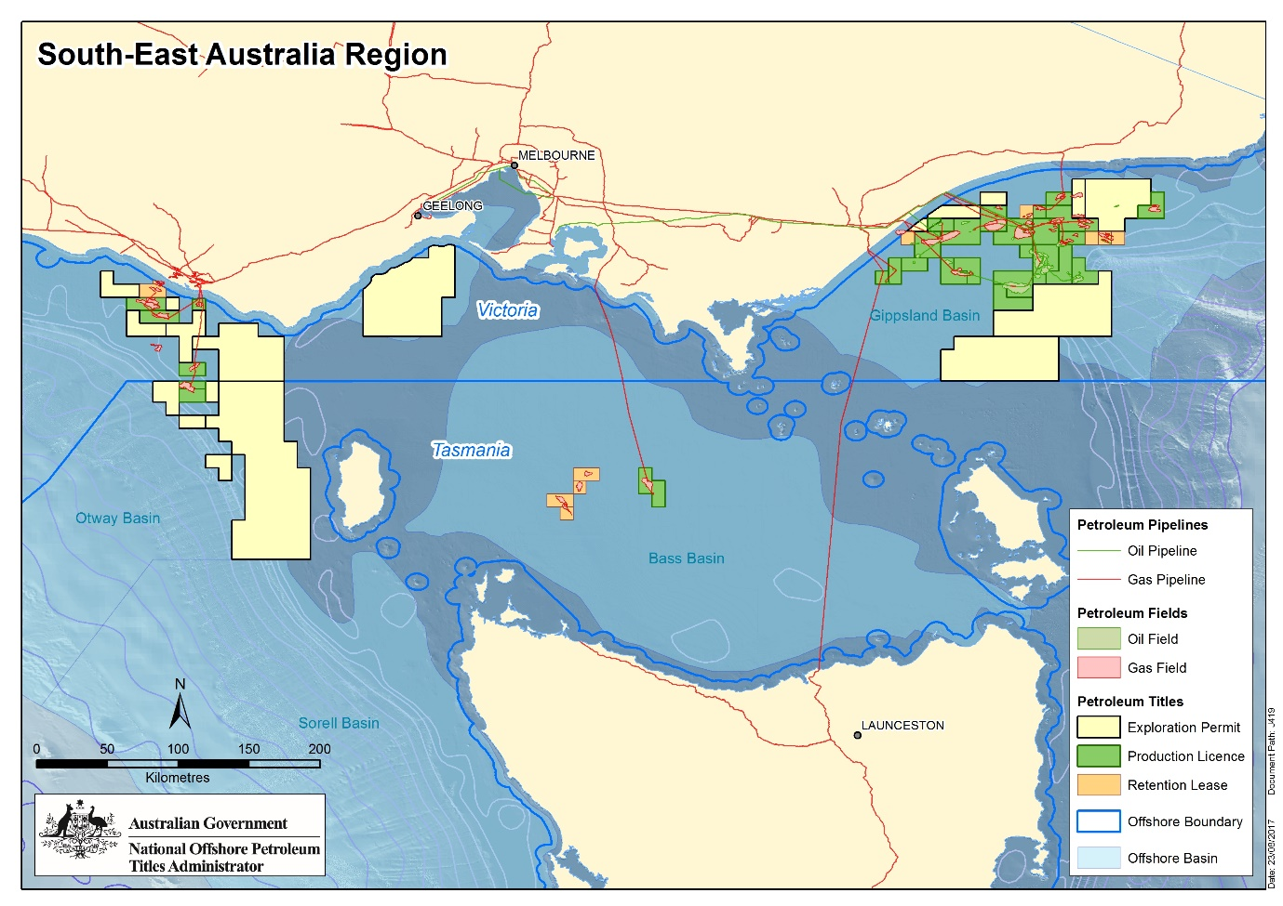
Figure 1. Regional map showing current petroleum titles in south east Australia.

Objectives
The study has two objectives:
- To provide an understanding of the volumes of gas available within the offshore south east Australian basins for potential future input into the east coast domestic gas market.
- To identify short and long term opportunities to maximise sustainable gas recovery from the offshore south east Australian basins.

Who undertook the study
The study was overseen by the Department of Industry, Innovation and Science with data and analysis provided by the National Offshore Petroleum Titles Administrator, Geoscience Australia and contributions from the South Australian and Victorian Governments. Tasmania were advised of the review.

Key findings

Gas resources
- The Study found that at best estimate there are:
- 3.8 trillion standard cubic feet (Tscf) of known gas reserves (2P) and 3.7 Tscf of contingent resources (2C), which remain to be produced from offshore south east Australia.
- 4.3 Tscf of undiscovered volumes (yet to be drilled) have been identified within prospects and leads that could provide additional gas supply in the future0F.
- There are ten retention leases over eight gas fields with total mid-case recoverable resources estimated at 715 petajoules (PJ).

Short term prospects
- There are two gas projects currently under development in offshore Victoria and Tasmania —Cooper Energy’s Sole Project (Gippsland Basin) and Lattice Energy’s Black Watch development (Otway Basin). Both of these are relatively small by historical standards.
- The major known gas fields of south east Australia, have been developed and are significantly depleted. Future production sources will continue to shift from the high volume, shallow depth, high-quality gas fields to low volume, deeper, low-quality gas fields, and most will effectively backfill existing capacity rather than create net new gas volumes for the market.
- There are two other potential projects which could be taken to the market in the short to medium term, but both have limitations around infrastructure and commerciality.
- The Greater Dory prospect on the outer eastern edge of the Gippsland Basin represents a potential exploration prospect which may defer the inevitable transition into smaller, deeper gas deposits, but it would still take between 7-10 years to bring to market if successful.

Gas supply
- Opportunities for increased gas supply from offshore south east Australia in the short term are limited. Infrastructure and technical constraints are likely to lead to these resources being developed over longer timeframes.
- Based on titleholder forecasts:
- Gas supply from offshore south east Australia is expected to continue at close to current levels over the short term (1-5 years) before declining over the medium term (5-10 years), and there may be a reduced capacity to rapidly respond to unanticipated increases in peak winter demand.
- Long term (10-20 years) offshore gas supply is likely to be underpinned by the known and prospective resources within the Gippsland Basin but the unit cost of developing new low volume, deep resources will increase, reflecting geotechnical complexity and distance from existing infrastructure.
- Based on a simplistic projection of recent output, current production levels could be maintained for 8-9 years based on remaining reserves or 15-20 years including contingent resources. However, infrastructure and technical constraints are likely to lead to these resources being developed over longer timeframes.
- Any increase in gas supply from existing projects in the short term will result in a faster erosion of reserves and will have implications for long term security of supply.

Infrastructure limitations
- The Gippsland Basin is the dominant source of offshore gas supply to south east Australia, with approximately 50 per cent of the gas required to meet domestic demand coming from the Longford Gas Plant with the other five gas plants in Victoria providing approximately 10 per cent of domestic demand. This is expected to continue to be the case for the foreseeable future.
- The Longford Gas Plant only supplies the market at levels approaching its full capacity during periods of high seasonal demand (May to August). While there is capacity at other times of the year, increased production at this time would be subject to plant maintenance requirements, prudent management of offshore production assets and commercial arrangements and gas storage capability.
- The supply from the Longford Gas Plant may also be constrained by the capacity within the recently completed gas conditioning plant to process increasingly higher CO₂ gas streams.
- Four of the other five gas plants process gas from outside the Gippsland Basin and have spare capacity, but there is no significant gas supply on the horizon which would allow utilisation of this capacity.
- Resources held under petroleum retention lease and petroleum exploration permits are expected to be developed through existing onshore infrastructure. In the Gippsland Basin, timing of this development will depend on capacity becoming available within nearby infrastructure and securing off-take agreements at prices that support the required investment.

Commercial and market issues
- There are a number of potential market impediments to the development of south east Australia’s offshore gas resources including structural and strategic barriers to entry and third party access to infrastructure.
- Low oil prices and declining quality of gas resources are also adversely affecting the development of new gas resources.

Outcomes of the study

Basin backgrounds
There are four offshore basins in south east Australia that are covered by this study. These are: the Gippsland Basin off eastern Victoria; the Otway Basin off south western Victorian and South Australia; the Bass Basin in between Victoria and Tasmania; and the Sorell Basin off the west coast of Tasmania.
Production from the offshore Gippsland Basin (Figure 2) commenced in the late 1960s and is at a mature stage of development. There is an extensive amount of data available, including from the approximately 200 exploration wells, more than 500 development wells and extensive 3D seismic data coverage.
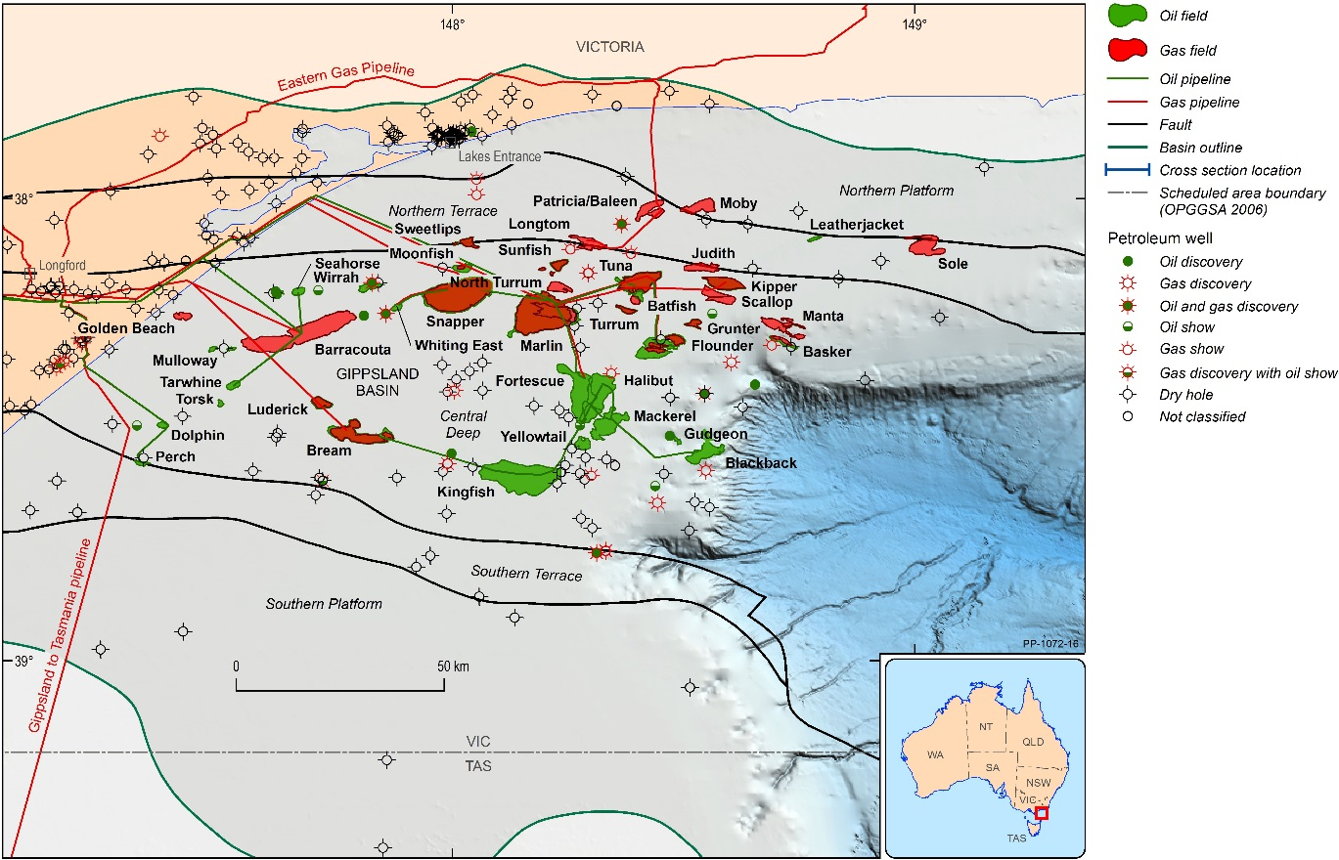
Figure 2. The Gippsland Basin.
The first gas was discovered in the Bass Basin in 1970 and, while there have been a number of gas studies since, only one field, Yolla, has been developed and the eastern part of the basin remains lightly explored. There have been over 20 wells drilled in the basin most of which have been predominantly dry. Seismic data coverage across the basin varies in density and quality.
In the offshore Otway Basin, most exploration has been focused on the inner Otway Basin and the deeper water Nelson Sub basin, to the west of Cape Otway. These areas have comprehensive 3D seismic coverage and around 50 wells have been drilled to date. All development activities have been in the Shipwreck Trough off Port Campbell, and this area is considered to be mature. Exploration in other areas of the basin has been largely unsuccessful and the areas along the continental slope and deeper water regions are underexplored.
The Sorell Basin is located off the west coast of Tasmania and King Island, with water depths ranging from 50-4,000 m. Only three wells have been drilled and there have been no significant discoveries. Seismic data coverage is sparse. More detailed geological and technical information is at Appendix A of this report.
Under the Commonwealth Offshore Petroleum and Greenhouse Gas Storage Act 2006 (the Act), there are currently 53 petroleum titles in south east Australia, with 34 of these located within the Gippsland Basin. There are 22 companies operating in offshore south east Australia, with Esso Australia, on behalf of the Gippsland Basin Joint Venture between Esso Australia Resources Pty Ltd (Esso Australia) and BHP Billiton Petroleum (Bass Strait) Pty Ltd (BHP (Gippsland JV), Lattice Energy and Cooper Energy the most active.
Commonwealth Petroleum titles offshore south east Australia include:
- Thirty one petroleum production licences, of which 24 are located in the Gippsland Basin.
- Eleven petroleum retention leases, of which ten contain gas resources.
- Eleven petroleum exploration permits, of which five are in the Gippsland Basin and six in the Otway Basin.
There are also one production licence, one retention lease and three exploration permits in Victorian coastal waters. Table 1 details the ownership of petroleum titles in offshore south east Australia.
More detailed information on offshore petroleum titles in south east Australia is at Appendix B of this report.

Table 1. Distribution of offshore petroleum titles by Operator. Operators who only operate in state coastal waters are shown in italics.
Operator | Exploration  Permit | Retention  Lease | Production  Licence
3D Oil | 1 | 0 | 0
Bass Strait Oil | 1 | 0 | 0
BHP Billiton | 0 | 0 | 1
Cape Energy Pty Ltd | 0 | 1 | 0
Carnarvon Hibiscus Pty Ltd | 1 | 0 | 1
Cooper Energy | 1 | 5 | 4
Esso Australia Resources Pty Ltd | 1 | 2 | 20
Llanberis Energy Pty Ltd | 1 | 0 | 0
Loyz Oil Australia Pty Ltd | 1 | 0 | 0
Oil Basins Limited | 1 | 0 | 0
Lattice Energy Limited | 4 | 4 | 5
Petro Tech Pty Ltd | 2 | 0 | 0
SGH Energy | 0 | 0 | 1
Total | 14 | 12 | 32

Onshore infrastructure
There are six onshore gas infrastructure plants in Victoria that process gas from offshore south east Australia gas fields, with a combined capacity to process 657 PJ of offshore gas per annum.
The Gippsland Basin Joint Venture (JV) is currently responsible for in excess of 80 per cent of gas production from offshore south east Australia and the Longford Gas Plant represents 67 per cent of installed gas processing capacity. The plant has an annual processing capacity of approximately 429 PJ per annum and has been operating for more than forty years.
Over the longer term, the foundation fields that have underpinned gas supply through the Longford Gas Plant will continue to decline and the Gippsland JV will become increasingly dependent on the development of smaller volume and deeper resources. These resources generally contain higher levels of impurities and will likely require pre-treatment through the Longford Gas Conditioning Plant. The recently completed plant enables the development of additional resources with gas compositions that would not otherwise be suitable for processing through existing infrastructure. It is expected that the overall level of production from the Gippsland JV and the Longford Gas Plant will gradually decline over the long term without further investment in onshore facilities or the discovery of new gas resources.
The Longford gas plant represents the single largest contributor to east coast gas supply currently meeting approximately 50 per cent of total market demand for domestic gas1F (Figure 3). The remaining five gas plants, four of which are currently operating, provide approximately 10 per cent of the gas required to meet demand. The balance of demand, approximately 40 per cent, is currently met from onshore gas production, such as from the Moomba Production Zone (in South Australia). It is expected that the Orbost gas plant will restart production in 2019, processing gas from the Sole Field.

Figure 3. Offshore south east Australia contribution to east coast domestic gas supply.
The five other gas plants that process gas from offshore south east Australia currently supply less than 20 per cent of the total gas produced offshore:
- The Orbost Gas Plant has capacity to process 33 PJ of gas per annum and is not currently in operation, however a substantial proportion of this capacity will be utilised when the Sole gas project comes on line in 2019.
- The Lang Lang Plant processes gas from the Yolla Gas Field in the Bass Basin. It has capacity to process 25 PJ of gas per annum.
- The Iona Gas Plant in western Victoria primarily provides gas storage on behalf of customers during periods of low gas demand and supplies gas during periods of high demand. The facility can store a maximum of 26 PJ of gas.
- The Otway Gas Plant processes gas from the Thylacine, Geographe and Halladale-Speculant fields and has capacity to process 75 PJ of gas per annum.
- The Minerva Gas Plant in western Victoria had an original capacity to process 55 PJ per annum of gas. The Minerva Field is expected to cease production during 2017.
Production levels are likely to remain relatively stable over the short to medium term, with known resources within existing retention leases expected to be developed through these facilities as capacity becomes available. The long term potential for these smaller facilities faces significant uncertainty as no large resources are currently identified for development. Successful exploration and appraisal will be required to maintain current production levels from these facilities over the longer term.
More detailed information on onshore infrastructure is at Appendix C of this report.

South east Australian gas market
In 2016, around two-thirds of total east coast gas supply (onshore and offshore) was used to produce Liquefied Natural Gas (LNG) for export (see figure 4), while the industrial sector consumes the majority of domestic gas, followed by the residential and commercial sector, and the gas power generation sector.
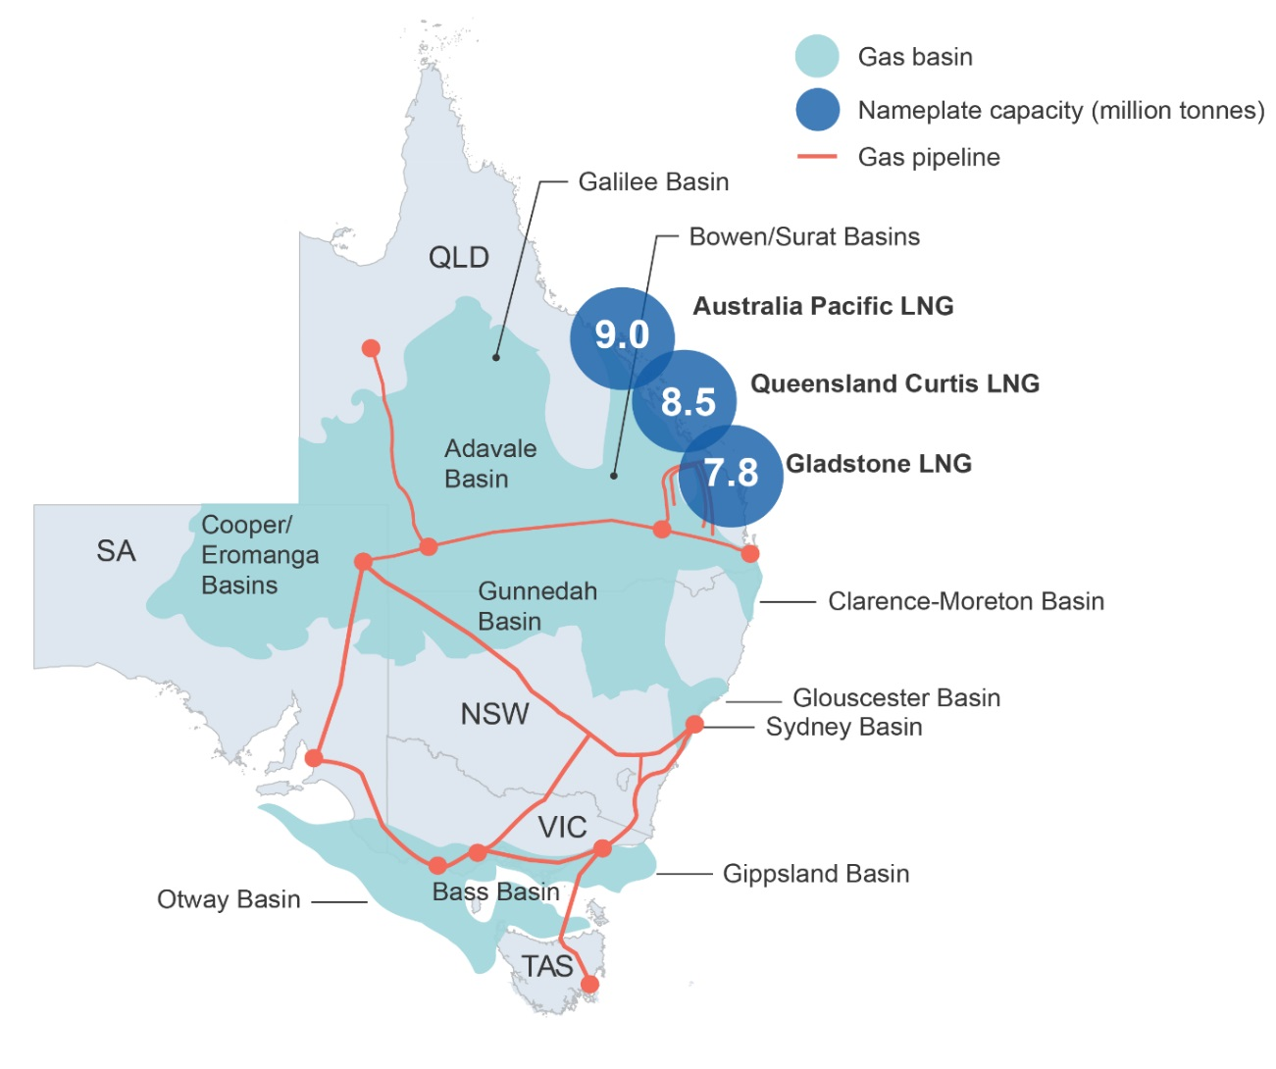 Figure 4: The east coast gas market.
The southern market has become increasingly reliant on production from Bass Strait, partly due to the establishment of the three LNG export projects and the failure to develop more onshore gas resources.
There are a number of potential market impediments to the development of south east Australia’s offshore gas resources.
- Barriers to entry: factors that make it difficult for a firm to enter the market. A distinction can be drawn between structural and strategic barriers2F.
- Structural barriers to entry: features of the industry that can make it difficult for a firm to enter the market. They include the large upfront cost required to develop new offshore gas projects, particularly for deeper, smaller, lower quality fields.
- Strategic barriers to entry: those created or enhanced by incumbent firms for the purpose of deterring the entry of new firms into the market. The extent to which such practices may or may not be apparent is beyond the scope of this study.
- Low oil prices: have reduced the revenue of oil and gas companies, which in turn has affected the level of exploration. Low oil prices have also decreased the expected returns on gas projects where gas is co-produced with oil products.
- Third party access to infrastructure: while rules around third party access to infrastructure do not appear to have been a significant constraint on the development of resources offshore south east Australia to date it may become a more significant issue in the future, should smaller firms seek to enter the market.
Onshore gas pipelines are subject to third party access regulation under the National Gas Law and National Gas Rules where they transport natural gas from gas processing facilities to demand centres. The National Gas Law defines ‘natural gas’ as gas suitable for consumption whereas the offshore pipelines in the Bass Strait transport unprocessed gas to processing plants to be made ready for consumption. As such, rules for third party access would not apply to offshore pipelines in the Bass Strait. Third party access regulation does not apply to gas processing facilities.

Gas Resources

Background
Hydrocarbon volumes are classified based on the relative understanding and degree of certainty associated with their recovery, as well as by the commercial maturity of the associated projects. Resources are categorised as:
- Reserves - where they are discovered and commercial
- Contingent resources - where they are discovered but sub-commercial
- Prospective – where they are undiscovered.
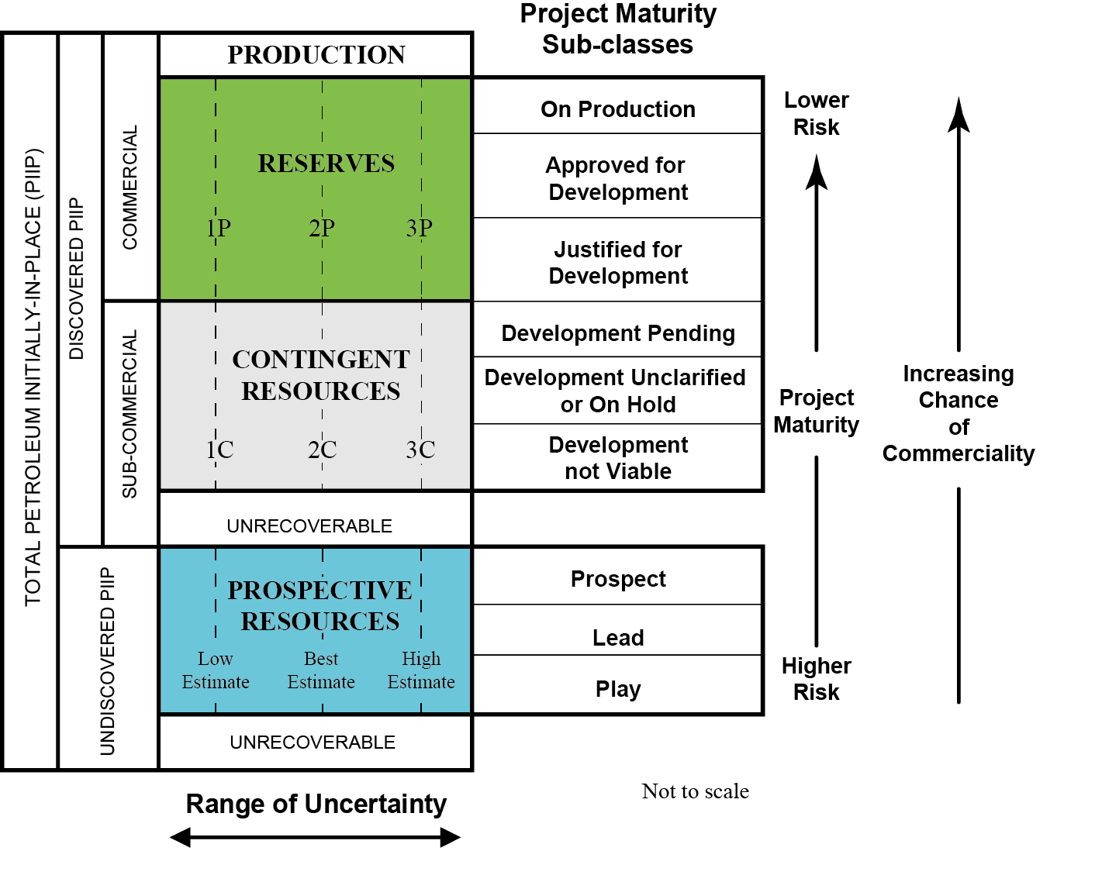
Figure 5. Hydrocarbon resource classification. The uncertainty range associated with hydrocarbon volumes decreases upwards, concurrent with the technical and commercial maturity of projects. Modified from SPE, AAPG, WPC, SPEE, SEG: Guidelines for Application of the Petroleum Resources Management System, November 2011.
Due to the physical properties of petroleum systems, it is impossible to recover 100 per cent of the estimated petroleum initially in-place. The technical ultimate recovery associated with gas projects ranges between 50-80 per cent of the total gas initially in-place.

Reserves and contingent resources
Discovered fields in offshore south east Australia have produced a total of approximately 10.6 Tscf of gas to date, approximately 40 per cent of the total gas initially in-place (approximately 26.1 Tscf).
Of the remaining gas a total of 3.8 Tscf (2P) of gas is classified as reserves with the majority of this gas related to fields that are currently in production. A further 3.7 Tscf (2C) of gas is classified as contingent resources and thus considered recoverable but without an identified commercially viable development pathway. These include resources held within production licences, retention leases and some discoveries within exploration permits.
The Gippsland Basin contains the majority of discovered gas, with between 80-90 per cent of reserves, contingent resources, annual production and cumulative gas production to date from offshore southeast Australia.
Remaining gas reserves across south east Australia are located within production licences. In the Gippsland Basin, there are estimated remaining 2P reserves of 3.2 Tscf. The total gas reserves (2P) within the Bass and Otway basins are estimated to be 554 Bscf.
Of the 3.7 Tscf of contingent (2C) resources across south east Australia some 80 per cent is located within the Gippsland Basin. The proportion of resources held under production licence is 54 per cent, with 25 per cent held under exploration permit, while 21 per cent are under retention leases.

Prospective undiscovered resources
Prospective undiscovered resources are usually mapped using seismic data and do not normally have a well penetration associated with them (although there may be nearby wells used as analogues). Consequently, the range of uncertainty associated with their volumetric estimates is broad and will usually only significantly narrow once exploration drilling is conducted. Reported prospective resource volumes usually represent recoverable volumes, rather than initially in-place.
The largest potential volumes in the Gippsland Basin are located within titles that are operated by Esso Australia, both as part of the Gippsland JV and as operator of the recently acquired exploration permit VIC/P70 in the eastern, deeper part of the basin. In the Otway Basin, there are highly uncertain prospective resources derived from exploration permits with a broad range of volumes. There are no reported leads or prospects in the Bass or Sorell Basins.

Production performance
Total annual raw gas production for south east Australia during the 2016 calendar year was equivalent to 474 billion standard cubic feet (Bscf), with production over any given 12-month period since 2012 ranging between 415-474 Bscf. In a simplistic scenario, which assumes demand at current levels and no further efforts to progress contingent resources into production (reserves), sufficient gas reserves are available (2P) for the next 8 to 9 years. If this simplistic scenario is further extended to incorporate the estimated 2C contingent resources available, it indicates sufficient gas volumes are available for 15 to 20 years.
Any forced increases to upstream gas production from producing fields for input into onshore markets will result in a faster erosion of reserves, which, when combined with the mature nature of hydrocarbon exploration and production in the Gippsland Basin and south east Australia in general, will have implications for long-term security of supply.

Exploration and remaining potential
Most of the prospective regions of the Gippsland Basin are already under petroleum title. (Figure 6) Remaining exploration potential lies along the northern and eastern (deeper water) margins of the basin, including the Greater Dory prospect.
Committed exploration activity in the Gippsland Basin is limited with two exploration wells planned in May 2019 and the acquisition of new 3D seismic data in October 2019. There is one exploration well in the Otway Basin planned to be drilled by Lattice Energy Limited by August 2018. There are a number of operational activities proposed for the next five years including three secondary term exploration wells, and the acquisition of 750 km² of new 3D seismic data.
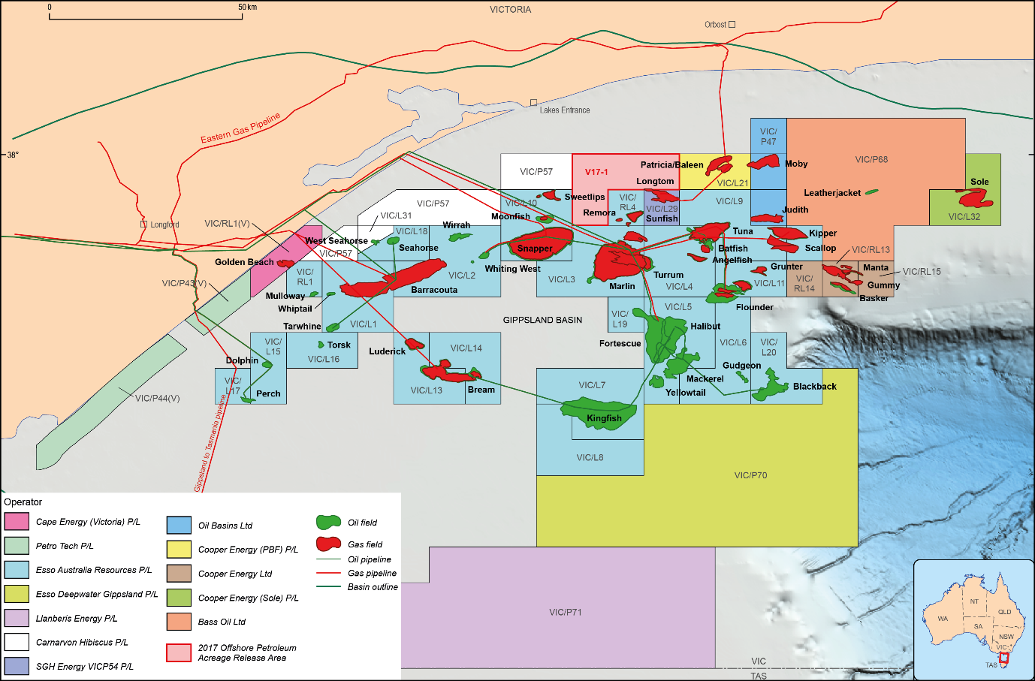
Figure 6. Titles map of the Gippsland Basin.
Five areas were released in offshore south east Australia as part of the 2017 Offshore Petroleum Exploration Acreage Release. These consist of one area in the Gippsland Basin, two in the Otway Basin and two large areas in the Bass Basin. Bids closed on
19 October 2017 and are currently under assessment by NOPTA.
It is generally considered that no new large volumes of gas (i.e. Tscf-scale) are likely to be discovered in the producing region of the Otway Basin. Potential remains in the vacant acreage area around the undeveloped La Bella Gas Field.
Quantitative assessments of undiscovered resources are derived from an understanding of the geology of a basin or region. Resource assessments have been conducted for the coastal waters of the Otway Basin by the Geological Survey of Victoria in 2007, and in the Gippsland Basin by the United States Geological Survey in 2012.3F These assessments were undertaken using the caveat of what is likely to be discovered within a 30 year time frame and estimate the total undiscovered gas potential across south east Australia as being approximately 4.6 Tscf. The Bass and Sorell Basins have not been assessed in a similar manner for undiscovered resources.

Future production and forecasts
Production and forecast information used in this report generally represent upstream gas production and as such the volumes are higher than will be made available to the downstream domestic gas market after processing. The reduced volume available downstream is due to a number of factors, including: the separation of liquid products (condensate and LPG); the removal of inerts and contaminants, such as carbon dioxide, hydrogen sulphide and mercury; and energy (fuel) consumption during production and processing.
Production forecasts should be considered as being indicative of overall trends in future gas supply, rather than representing the volume of gas that will be made available to the market, and should be considered with caution.
The Gippsland Basin is forecast to continue to provide the majority of gas produced from offshore south east Australia. In the period through to 2022, the pattern of upstream production remains similar to recent trends with the Gippsland Basin continuing to provide increased gas supplies during periods of peak seasonal demand. From 2019, the anticipated commencement of production from the Sole project marginally (but briefly) increases total forecast production.
The potential contribution from offshore gas in the Otway Basin is expected to continue a gradual decline from current production levels while the potential production forecast from the Bass Basin, suggests a continued stable decline until approximately 2025.
Over the next six years titleholders forecast that sales gas availability from offshore south east Australia will remain relatively stable, at rates in an approximate range of 290-340 Bscf/a (the equivalent of approximately 319-374 PJ/a ). This is slightly below recent historic production levels for offshore south east Australia by approximately 50 Bscf/a (55 PJ/a) (Figure 7).

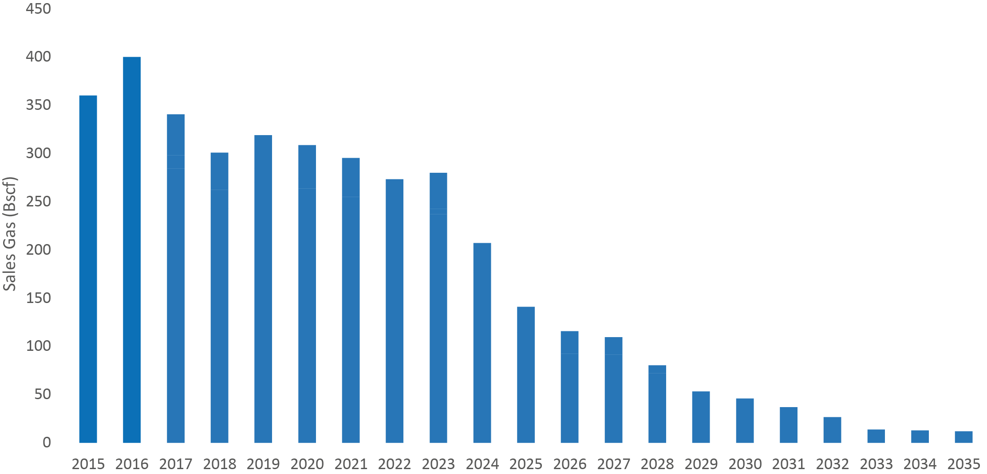
Figure 7. Sales gas forecast from offshore south east Australia. Data is mostly reported as ‘sales gas’ into the gas network after processing at each relevant plant. Note that the data may not include additional gas volumes to be derived from some projects yet to begin production or from some 2C contingent resources.
Beyond 2023, existing titleholders are forecasting a decline in upstream production from existing assets. This projection reflects current contracted supply of sales gas and does not necessarily reflect the potential gas supply that could be made available from existing reserves and contingent resources. Achieving higher levels of supply is likely to require further investment and development.

Appendix A - Geological and technical summary

Overview
Petroleum activity in offshore south east Australia (Figure A1) began in 1892 with early exploration efforts in the Otway Basin. Oil production from the onshore Gippsland Basin commenced in 1924 and over 60 wells were drilled in ensuing years. Significant offshore exploration began during the 1960’s and resulted in major oil and gas discoveries in the Gippsland Basin.
The level of exploration and development activity that has been undertaken in offshore south east Australia varies significantly from basin to basin and as such the understanding and data supporting it also varies. Despite the long history of exploration and petroleum production in the region, areas remain that have only been lightly explored and could benefit from further investigation.
Figure A1. Regional map showing the location of major geological basins across south East Australia.

Offshore Gippsland Basin
The Gippsland Basin is located on the southeast margin of Victoria, with both onshore and offshore components, extending into Tasmania’s coastal waters to the east of Flinders Island
(Figures A2 and A3). The offshore Gippsland Basin is one of Australia’s premier hydrocarbon provinces, with significant volumes of oil, condensate, LPG and natural gas produced since the 1960s.
The history of hydrocarbon production in the Gippsland Basin dates back to 1924 and began with oil encountered onshore by the Lake Bunga 1 well. Over 60 wells were drilled in the ensuing years, and by 1941, the Lakes Entrance area had produced more than 8,000 barrels (bbl) of heavy oil. Significant offshore exploration in the Gippsland Basin did not begin until the mid-1960s and the early Barracouta and Marlin gas condensate field discoveries suggested the basin was primarily gas prone, until the discovery of the Kingfish oil field in 1967. By the end of 1969, eleven fields had been discovered and the first five (Barracouta, Marlin, Snapper, Kingfish and Halibut) were in production. In the 1970s to 1990s discoveries continued to be made including the giant Fortescue (1978) and West Tuna (1984) oil fields, as well as the Kipper (1986) gas field, with many more discoveries being non-commercial. In the 1990s no new discoveries were made, although the drilling of Longtom 1 laid the groundwork for the later Longtom gas field development. The West Tuna, Kipper and Blackback oil and gas fields were the last discoveries of significant size.
Historically, Victoria’s domestic gas consumption has largely been met via production from offshore Gippsland, with a current renewed focus on gas (and condensate) rather than the traditional focus on oil (as the majority of these reserves have been produced). Most significant discoveries are in water depths of 150 m or less, however depths can exceed 3,000 m in the Bass Canyon to the east.
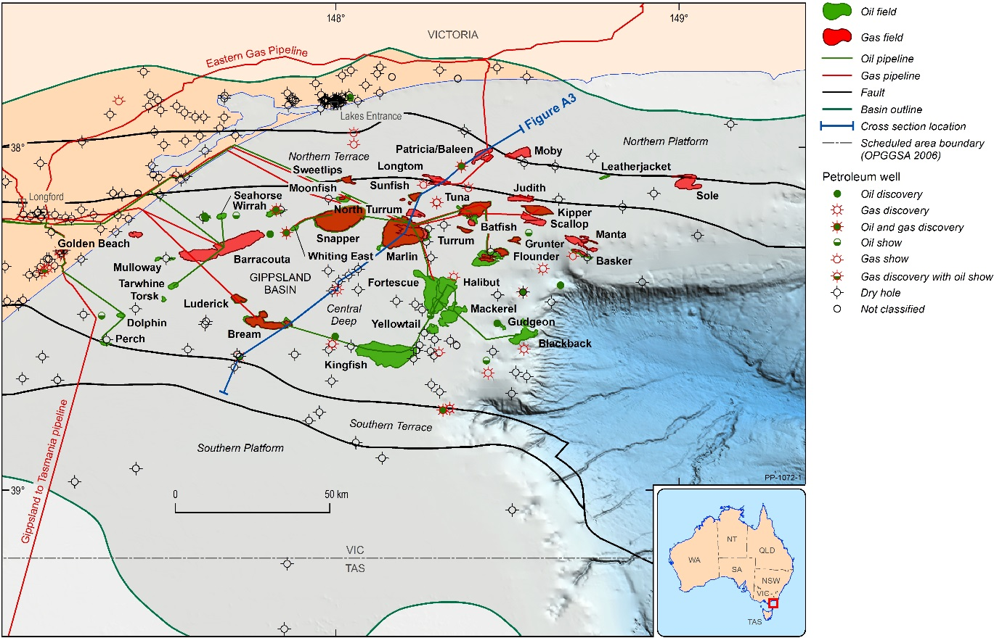
Figure A2. Location of the Gippsland Basin in south-east Australia. The cross-section is shown in Figure A3 below.
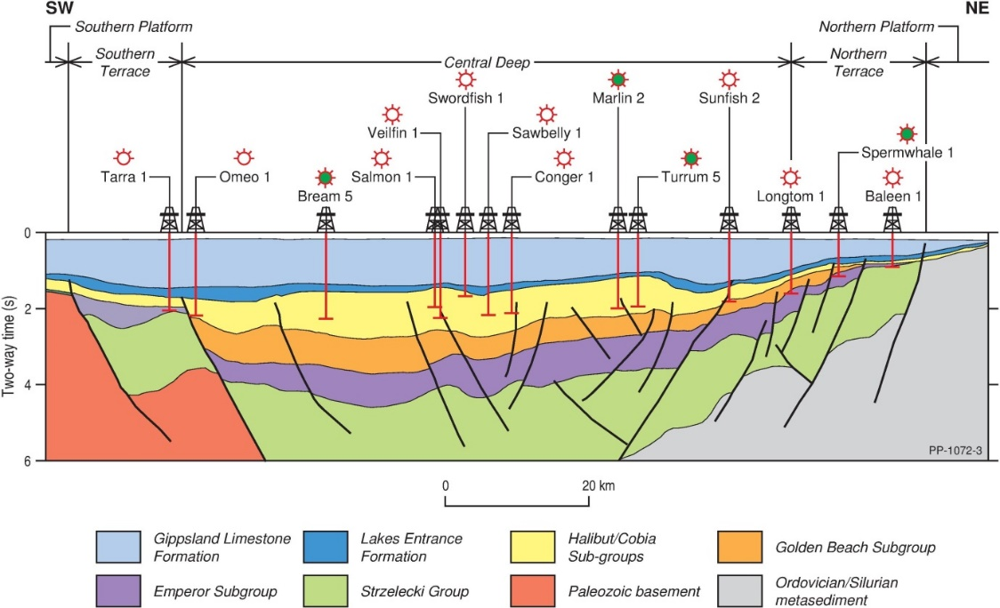
Figure A3: Cross-section through the central parts of the Gippsland Basin. Key exploration targets are present in the Latrobe Group, particularly the Cobia and Halibut subgroups. Location is shown on Figure A2 above.
The Gippsland Basin formed during the breakup between Australia and Antarctica, and has a similar sedimentary sequence to the Otway Basin to the west. The Early Cretaceous (145 million years (Ma)) rifting was followed by a second phase (in the Late Cretaceous; 100 Ma), associated with the separation of New Zealand and the formation of the Tasman Sea. The two phases of rifting resulted in the formation of a series of east-west trending fault systems (regional fractures that split rock sequences into segmented blocks) that separate the basin into the Southern Platform, Southern Terrace, Central Deep, Northern Terrace and Northern Platform (Figure A4).

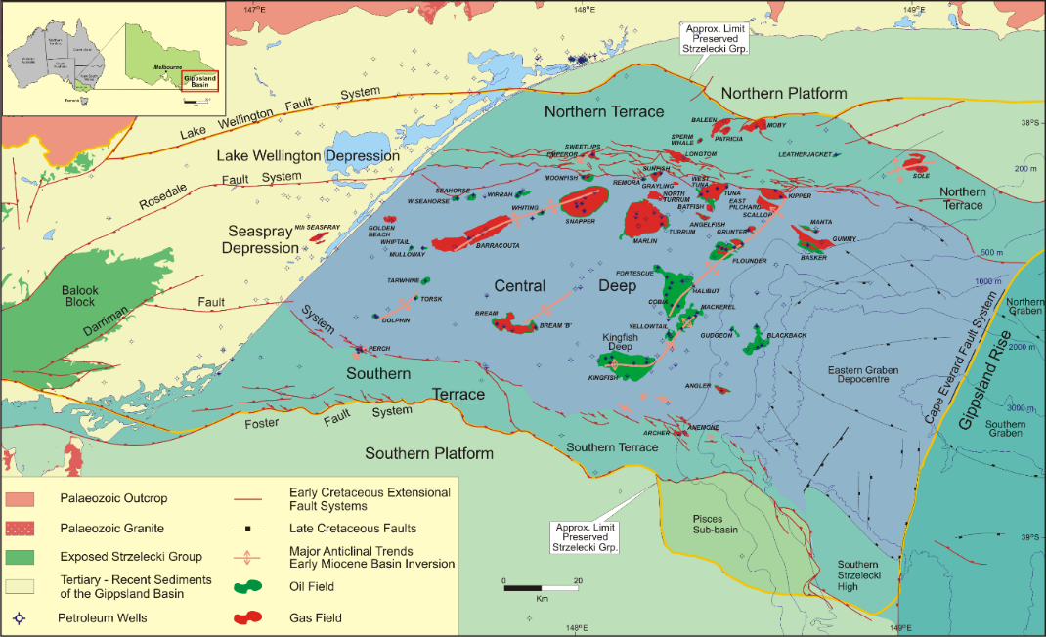
Figure A4. Structural elements map of the Gippsland Basin4F.
The large majority of hydrocarbons within the Gippsland Basin are reservoired in sediments of the Latrobe Group (Late Cretaceous to Paleogene (100-66 Ma), which represent the main regional reservoirs at shallow depths (referred to as ‘top Latrobe’), as well as the source of significant volumes of both oil and gas deeper down. The Lakes Entrance Formation (Oligocene to Early Miocene (34-21 Ma)) forms the regional seal beneath which hydrocarbons have accumulated.
The Latrobe Group is a very thick, heterogeneous sequence, with excellent quality, extensive and well connected reservoirs in the younger units, and lower quality, more discontinuous reservoirs in the older section. Hydrocarbon composition and quality also varies vertically and laterally across the basin, with gas accumulations in the deeper, older reservoirs, usually containing significantly higher levels of carbon dioxide (CO₂), as well as other impurities including mercury (Hg) (especially along the northern margin of the Central Deep).
The regional petroleum systems of the Gippsland Basin are dominated by two interconnected flow pathways emanating from the Central Deep–a northern (gas-dominated) and a southern (oil-dominated) fill-spill chain–which converge (from east to west at the Barracouta (gas) Field) and culminate at shallow depths in the near-shore area (near Golden Beach). The only hydrocarbon sources outside of the Central Deep are located in the Northern Terrace, where migrating hydrocarbons are thought to be transmitted across the Rosedale Fault System. However, top seal containment within the Northern Platform is compromised due to a combination of thinning of the Lakes Entrance Formation regional seal and its truncation by the Lake Wellington Fault System.
All currently producing offshore fields are located within the Central Deep, with only five discoveries (Archer/Anemone, Angler, Blackback, Dory and Gudgeon) made in the eastern, deeper water area. More recent exploration has discovered a number of smaller fields, some of which have commenced production i.e. Patricia/Baleen, Longtom, Basker and Manta. Exploration potential remains within the acreage held by the Gippsland JV, especially along the northern margin of the Central Deep.
There is an extensive amount of exploration data available in the offshore part of the Gippsland Basin, with approximately 200 exploration wells and more than 500 development wells drilled. (Figure A5). The Central Deep region is almost completely covered by 3D seismic data, mostly acquired from 2000-10. The remainder of the basin has a good coverage of 2D seismic data of varying vintages, the most recent surveys being the Gippsland Infill 2D Marine Seismic Survey acquired by Geoscience Australia in 2015 and the Gippsland Basin Southern Flanks 2D Marine Seismic Survey acquired by Geoscience Victoria in 2010, both on the southern margin of the basin.
Even though the Gippsland Basin is considered to be a mature basin, the southern and eastern margins have received only sporadic exploration interest to date. There are identified exploration risks relating to lack of seal i.e. an absence of suitable rocks to trap and contain hydrocarbons, along the southern margin, and whilst the northern margin has more prospectively, accumulations discovered have tended to be more compartmentalised, higher in contaminants and generally smaller. Recent analysis of data in the eastern, deeper water regions, has identified potentially large, previously overlooked volumes of gas (through improvements to seismic imaging) which will be tested by exploration drilling in the near future.
Significant exploration risks in this basin relate to the difficulty in interpreting seismic data due to complex channelling and associated significant seismic velocity heterogeneity in the sediments overlying the main reservoir units. Presence of seal, especially along the southern margin, and timing of trap formation relative to generation and migration are also important factors.
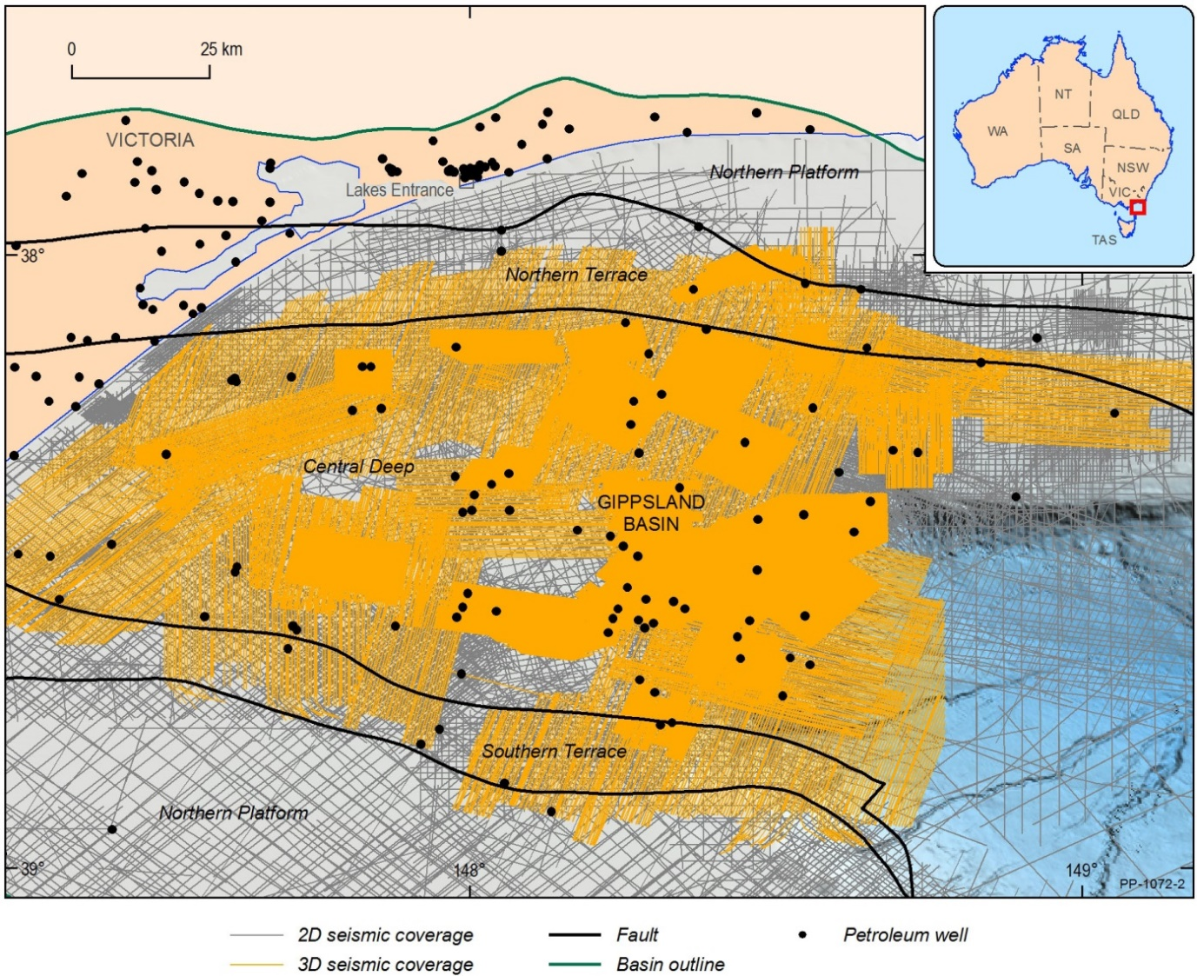
Figure A5: Data coverage in the Gippsland Basin, including wells and seismic.

Large scale oil and gas production over the last five decades has been derived predominantly from the top Latrobe sequence i.e. large, relatively shallow, low inert accumulations (including sweet gas). In recent years hydrocarbon production has remained stable due to infill drilling in the developed fields and work-overs undertaken to renew down-hole equipment and to open new reservoir zones. Ongoing production decline has begun to shift focus from shallow towards deeper reservoirs. Critically, due to the geological characteristics of the Latrobe Group, this equates to a general shift from:
- high to low volumes (porosity)
- high to low connectivity (permeability)
- low to high inert content (i.e. nitrogen, CO2)
- low to high contaminants (i.e. Hg and potentially H2S)
- high to low recovery factors i.e. lower gas production per unit volume of gas initially in-place.
Consequently, barring any new major discoveries of sweet gas, the relative cost of extracting and processing gas from the Gippsland Basin is expected to continue to increase with time.

Bass Basin
The Bass Basin is located under Bass Strait, between the coasts of Victoria and Tasmania. It is separated from the Otway and Sorell basins (to the west) by the King Island High and from the Gippsland Basin (to the northeast) by the Bassian Rise and Flinders Island (Figure A6). It shares similar basin architecture and sedimentary sequences (Lower Cretaceous to Holocene in age; 145.0-0.1 Ma) with the eastern Otway and Sorell basins, associated with breakup between Australia and Antarctica, however rifting failed in the Bass Basin.
The Bass Basin comprises two sub-basins: the Western Cape Wickham Sub-basin which contains the producing Yolla gas and condensate field that is operated by Lattice Energy and a number of other gas and oil discoveries; and the eastern under-explored and as yet unsuccessful Durroon Sub-basin. Water depths across both sub-basins are quite shallow, approximately 80m at their deepest.
Exploration in the Bass Basin began in the 1960s, with the first significant gas discovery in 1970 with the drilling of Pelican 1. Since then a number of gas and condensate discoveries have been made in the Cape Wickham Sub-basin. This includes Yolla 1 (1985), Yolla 2 (1998), White Ibis 1 (1998), Trefoil 1 (2004) and Rockhopper 1 (2009). There have been no hydrocarbon discoveries in the Durroon Sub-basin and, despite several phases of industry activity, the area remains a lightly explored exploration frontier. The area contains only two exploration wells; Durroon 1 and Chat 1. Durroon 1 recorded minor gas indications and Chat 1 was dry. These results are insufficient to prove or preclude an active and effective petroleum system operating in the region.
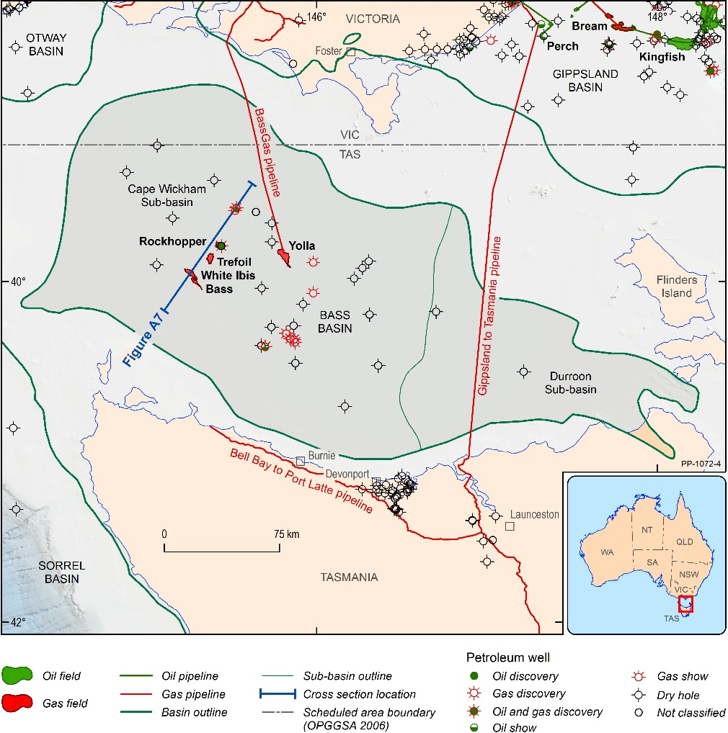
Figure A6. Location of the Bass Basin. The cross-section is shown in Figure A7 below.
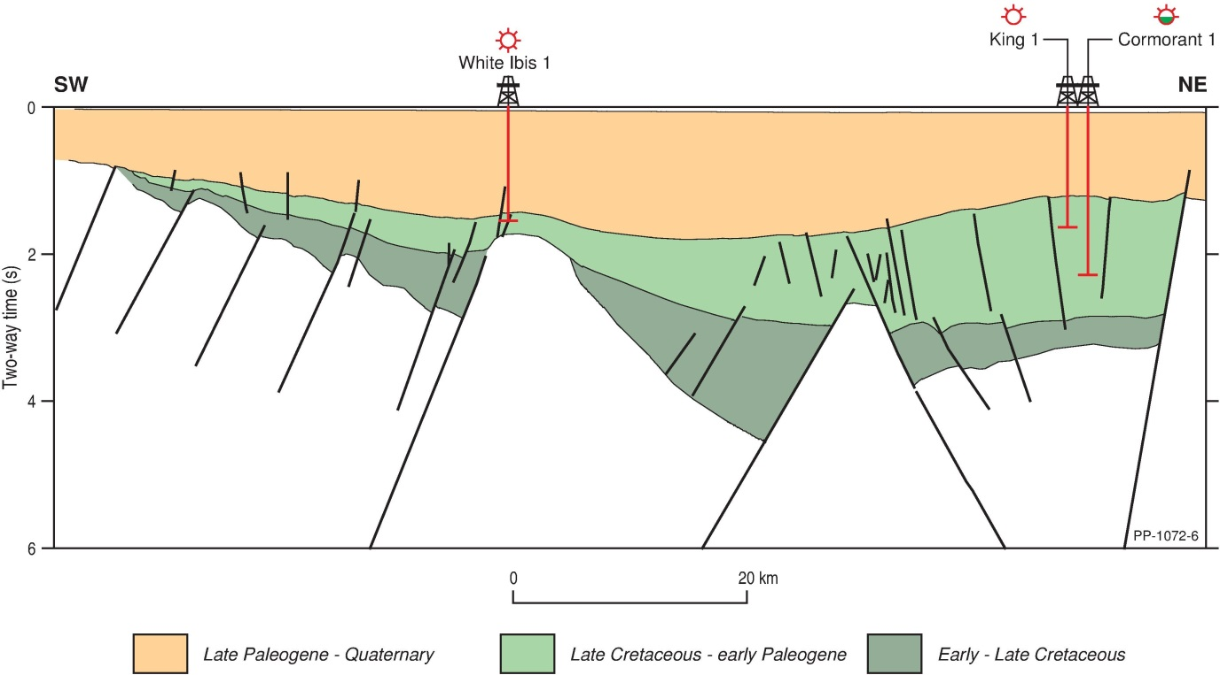
Figure A7: Bass Basin cross-section. Key exploration targets are present in the Late Cretaceous to early Paleogene (Bass and Aroo sequences). Location is shown in Figure A6 above.
Seismic data coverage varies in density and quality, the central Cape Wickham Sub-basin has good seismic coverage with a combination of 3D and closely spaced 2D seismic data, whilst the remainder is more sparsely covered (Figure A8). The oldest 3D survey is the Yolla 3D MSS (1994), with several surveys acquired in 2005 (Peejay 2D/3D MSS and Shearwater 2D/3D MSS); 2008 (Silvereye 3D MSS), and the most recent in 2011 (Dalrymple 3D MSS and Chappell 3D MSS). No 3D seismic data are available for the Durroon Sub-basin and the most recent 2D dataset was acquired in 2008.
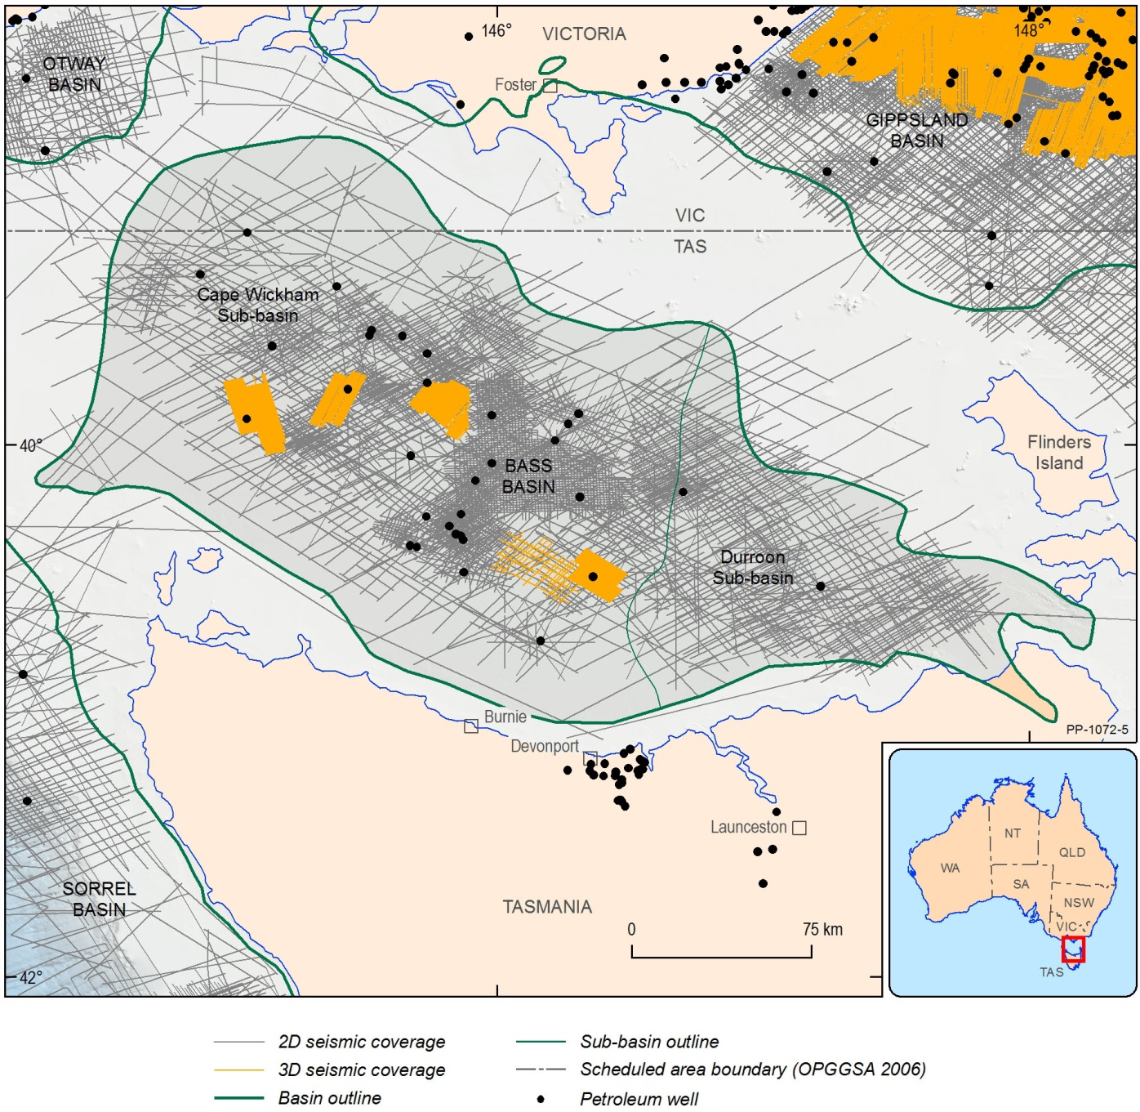
Figure A8. Data coverage in the Bass Basin, including wells and seismic.
The central Cape Wickham Sub-basin has been the most successful region of the Bass Basin, with the producing Yolla gas and condensate field, as well as the Rockhopper, Trefoil, White Ibis and Bass gas and condensate fields. The Pelican gas and condensate discovery to the south of Yolla had good hydrocarbon shows but poor reservoir quality. Approximately 20 other wells have been drilled in the basin, which have been predominantly dry, with the exception of Cormorant-1, Pipipa-1 (oil and gas shows) and King-1, Nangkero-1 and Tilana-1 (gas shows) in the Cape Wickham Sub-basin. The western Bass Basin has proven potential, comprising a number of troughs that have produced significant hydrocarbons. These hydrocarbons have migrated into and been trapped in the Bass and Aroo reservoir sequences (Late Cretaceous to early Paleogene).
Most discoveries are in the Middle and Upper Eastern View Group (Palaeocene-Eocene), sealed by the Demons Bluff Formation and sourced from intra-Eastern View Group and underlying Otway Group coals. Gas and condensate are the predominant hydrocarbons discovered so far, with minor volumes of oil present at Rockhopper-1 and Yolla. Reservoir quality, hydrocarbon charge, presence of volcanics and associated reservoir altering hydrothermal fluids and seal quality are all risks in this region. The discovered fields are complex, with multiple stacked reservoirs in different pressure systems.
Apart from Origin’s success in the vicinity of the Yolla Field, recent exploration has not proved favourable, with a number of titleholders either choosing to not renew exploration permits upon expiry or surrendering, prior to entering permit years with operational activities. There are currently no exploration permits within the basin, but industry nominations were received for the inclusion of T17-1 and T17-2 in the 2017 Offshore Petroleum Exploration Acreage Release.
The Yolla Field (BassGas Project) is the only producing asset within the basin, producing gas, condensate and LPG, via the Yolla-A platform since 2005, which piped to the Lang gas plant in Victoria for distribution. The BassGas Project has recently gone through a Mid-life Enhancement project to extend field life into the 2020s. This has included tie-in of two additional development wells (Yolla-5 and Yolla-6) and installation of compression and condensate pumping modules on the Yolla-A Platform.

Offshore Otway Basin
The Otway Basin has both onshore and offshore components, with water depths extending to >4,000 m (Figure A9). Delivery of gas to the south-east Australian gas market from the offshore fields began during 2005. The basin is contiguous with the Sorell Basin to the southeast, with both basins developed during the breakup between Australia and Antarctica, and contain a sedimentary sequence from the Late Jurassic to Holocene (164.0-0.1 Ma) in age.
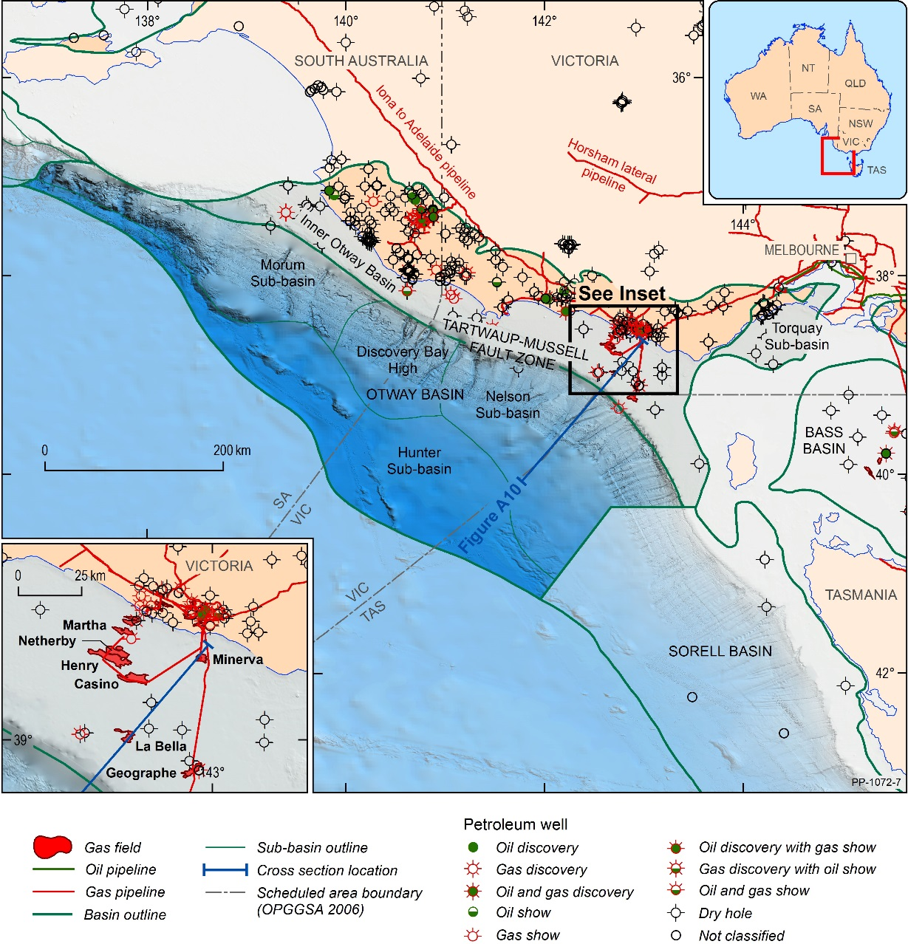
Figure A9. Location of the Otway Basin. The cross-section is shown in Figure A10 below.
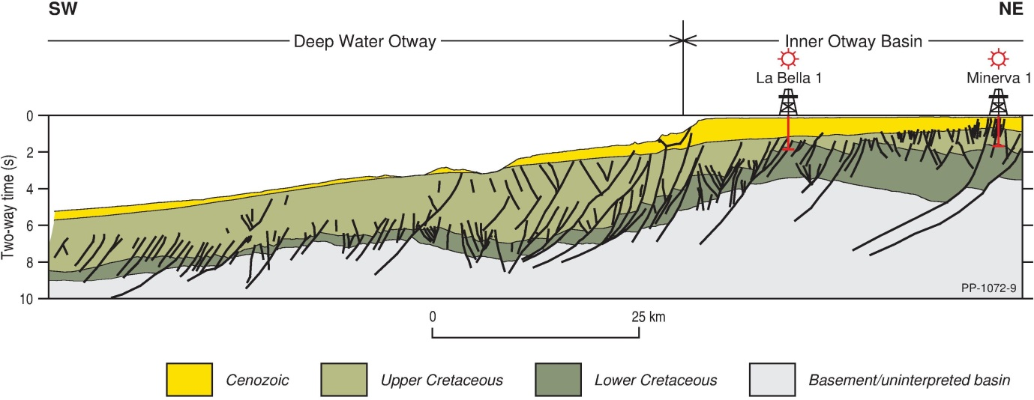
Figure A10. Cross-section of the Otway Basin. Key exploration targets are present in the Lower Cretaceous (Pretty Hill Formation), the Upper Cretaceous (Flaxman, Paaratte and Waarre Formations and the Thylacine Member) and the Palaeocene (Pebble Point Formation). Location is shown in Figure A9.
The offshore Otway Basin contains a number of sub-basins, with exploration being focused on the Inner Otway Basin (including the prospective Shipwreck Trough) and the deeper-water Nelson Sub-basin to the west of Cape Otway, and the Torquay Sub-basin to the east of Cape Otway. A number of discoveries have been made onshore in both Victoria and South Australia, and significant discoveries have been made in offshore Victoria, predominantly gas and condensate in the Inner Otway Basin (Shipwreck Trough).
The sedimentary sequence within the basin is largely siliciclastic (quartz-rich sands with the ability to contain fluid) reflecting fluvial to marine environments during continental break-up, and includes organic rich coals, deltaic and marine sediments that have generated predominantly gas and condensate. Oil-prone source rocks have been identified in the Upper Cretaceous but have not been extensively evaluated in this region.
Extensive 2D seismic data have been acquired across the shallower water Inner Otway Basin, with data coverage becoming very sparse in the deeper water regions, especially below 1,000 m (Figure A11). The Shipwreck Trough region is completely covered by 3D seismic data, and reasonable 3D coverage exists along the continental margin in the eastern Nelson Sub-basin, although steep topography and multiple submarine canyons along the shelf break significantly degrade the quality of the seismic data. Three small 3D seismic surveys have also been acquired to the west of the Shipwreck Trough.
Approximately 50 exploration and development wells have been drilled in the Otway Basin to date. Hydrocarbon exploration has an extensive history, dating back to 1892, with a lack of early success in the region attributed to poor quality exploration data and a poor understanding of the area. After a farm-in agreement in 1966 involving Esso, Shell and Frome-Broken Hill, 22 wells were drilled in both onshore and offshore Victoria and South Australia, hoping to find an analogue for the nearby and successful Gippsland Basin exploration targets, but only minor gas shows were found. Discouraged, major companies abandoned the Otway Basin by 1976. The first commercial discoveries in the basin were made in the onshore Otway Basin with North Paaratte 1 (1979), Grumby 1 (1981) and Wallaby Creek 1 (1981).
All significant offshore discoveries to date are located in the vicinity of the Shipwreck Trough and are all primarily gas and condensate. Reservoirs include the Late Cretaceous Flaxman and Waarre formations, and the Thylacine Member of the Belfast Formation. Regional seal is provided by the mudstones of the Belfast Formation, with several intra-formational seals present within the latest Cretaceous and Tertiary sequences.
A strong resurgence in exploration activity in the Otway Basin from 1999 to 2005 was driven by a combination of changes in the gas market and technological advances and resulted in a number of gas discoveries including Minerva, Geographe and Thylacine, Henry, Netherby, Casino, Halladale, Speculant and Blackwatch.
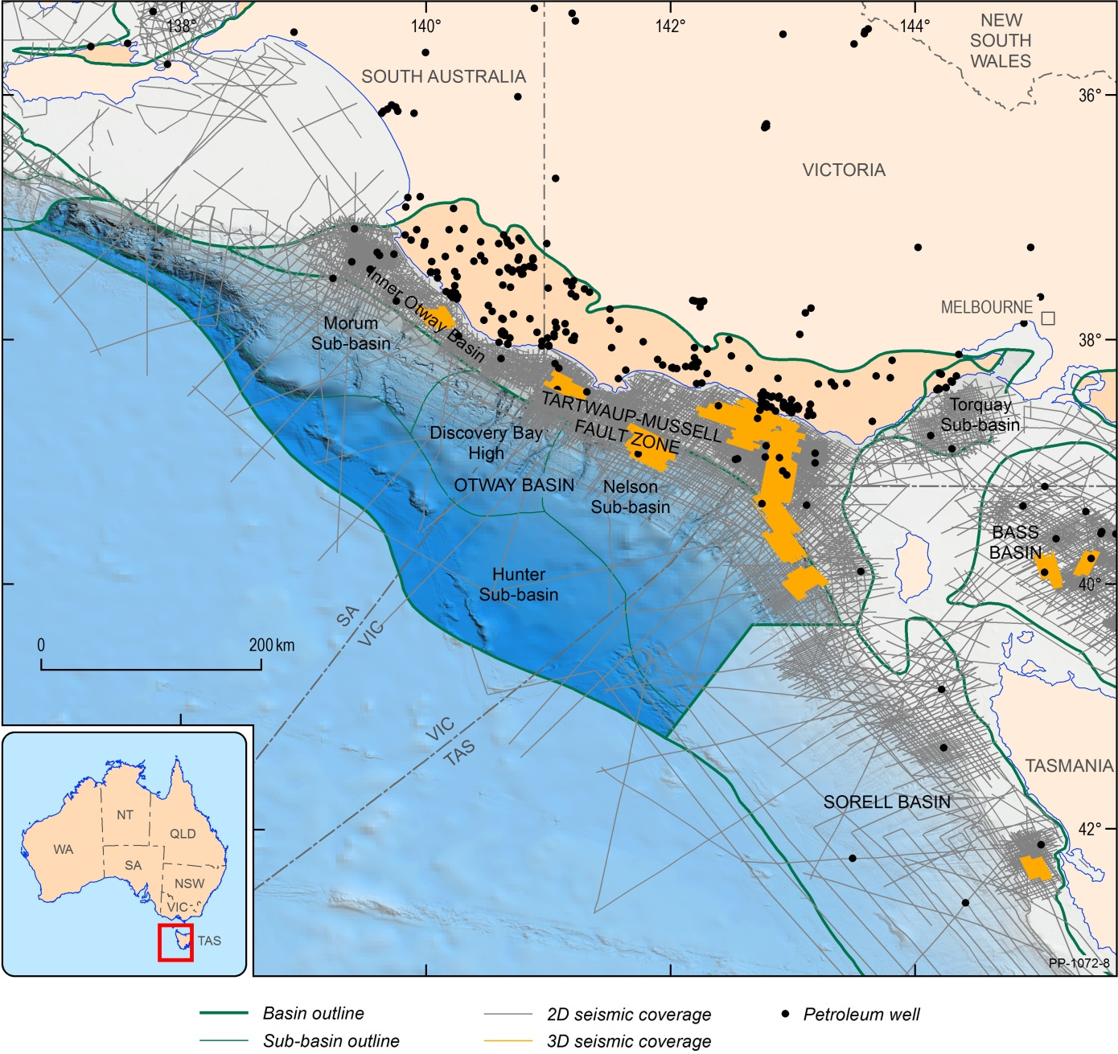
Figure A11: Data coverage in the Otway Basin, including wells and seismic.
Exploration targets in the Otway Basin differ regionally. In onshore South Australia the primary target is the Pretty Hill Formation (Early Cretaceous) that is the producing unit in the Katnook, Ladbroke Grove, Haselgrove and Haselgrove South gas fields. This unit is also present offshore. In Victoria, the Waarre Formation (Late Cretaceous) has produced gas in sixteen onshore fields in the Port Campbell area, as well as the offshore Minerva, La Bella, Geographe and Thylacine fields in the Shipwreck Trough. The Flaxman Formation and the Thylacine Sandstone Member (Late Cretaceous) also host additional gas for the Minerva and La Bella fields. Other potential reservoirs for hydrocarbons include the Paaratte Formation (Late Cretaceous) and the Pebble Point Formation (Palaeocene). All of these reservoirs require effective trapping mechanisms for exploration success and hydrocarbon leakage is a significant risk in the basin.

Exploration within the Shipwreck Trough is considered to be at a relatively mature stage and though a number of smaller accumulations have been discovered i.e. La Bella and Martha, these have been perceived as unfavourable for development. Martha is close to shore but relatively small and while La Bella is larger, it is approximately 50 km from shore and contains higher CO₂.
The areas along the continental slope and deeper water regions of this basin are underexplored. Very few wells have been drilled in the deeper parts of the basin, and whilst Amrit-1 and Hill-1 had hydrocarbon shows, they were not drilled very far into the sedimentary section.
Exploration outside the Shipwreck Trough has largely been unsuccessful, with most wells not encountering any hydrocarbons, or only minor indications of gas. Significant exploration risks in this basin include:
- a high degree of faulting and its associated likelihood of trap-breach
- presence of an adequate seal, especially fault-seal
- the need for traps in close proximity to mature source rocks.
The presence of volcanics and very deep faults also increase the risk of significant volumes of CO₂, as found in the La Bella gas field. Production from fields in this basin is also complicated by compartmentalisation, with some fields not performing as well as initially expected.
The earliest offshore commercial success was the discovery of the Minerva gas field close to Port Campbell in 1993 by BHP Petroleum. This field has been in production since 2005 and is nearing end of field life. The Geographe and Thylacine gas fields were discovered in 2001 by Origin, followed in 2004 and 2005 by the discovery of the Casino, Henry and Netherby gas fields by Santos. All of these fields are currently in production through either the onshore Iona Gas Plant (Casino, Henry & Netherby) or the Otway Gas Plant (Geographe and Thylacine). The Halladale and Speculant project also began gas production in 2016 (Origin), producing gas from Victorian coastal waters via an onshore drill site and delivering gas into the Otway Gas Plant.

Sorell Basin
The Sorell Basin is located off the western coast of Tasmania and King Island, with water depths ranging from 50-4,000 m, and remains under-explored, with a total of three wells drilled and no significant discoveries (Figure A12). Consequently there is no petroleum infrastructure within it or on the nearby Tasmanian coast.
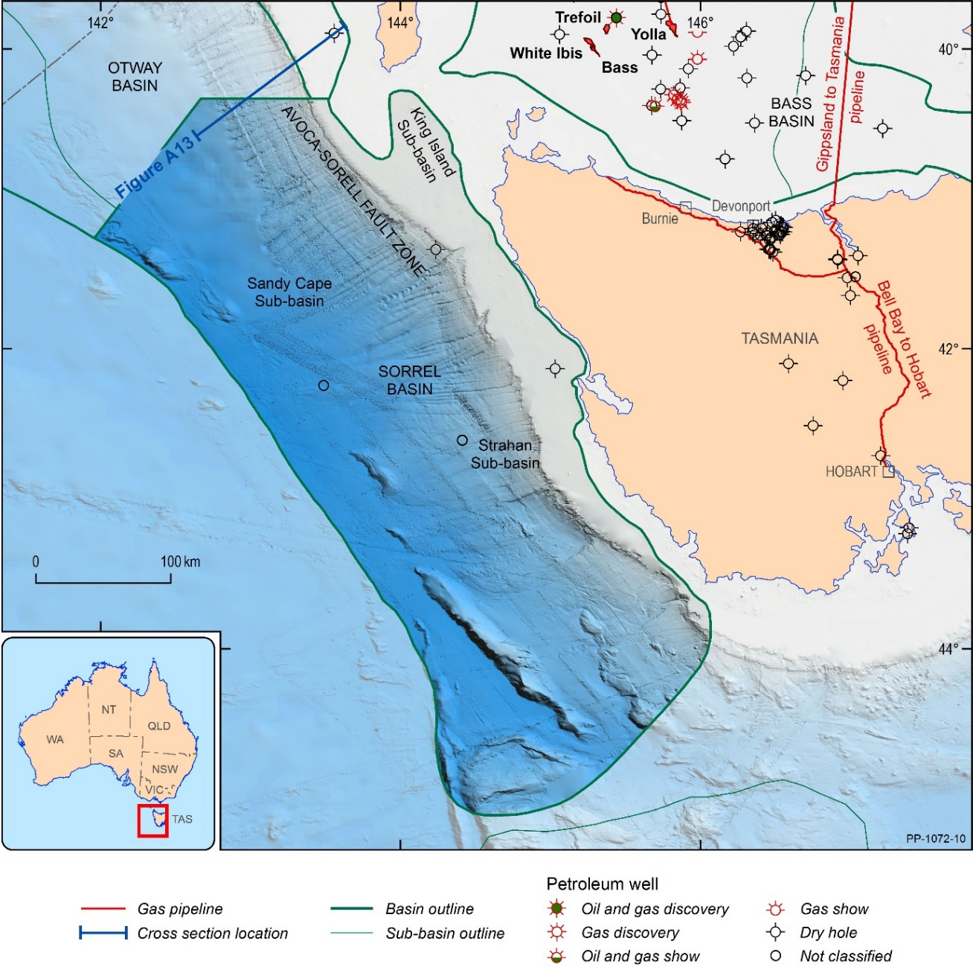
Figure A12. Location of the Sorell Basin. The cross-section is shown in Figure A13.
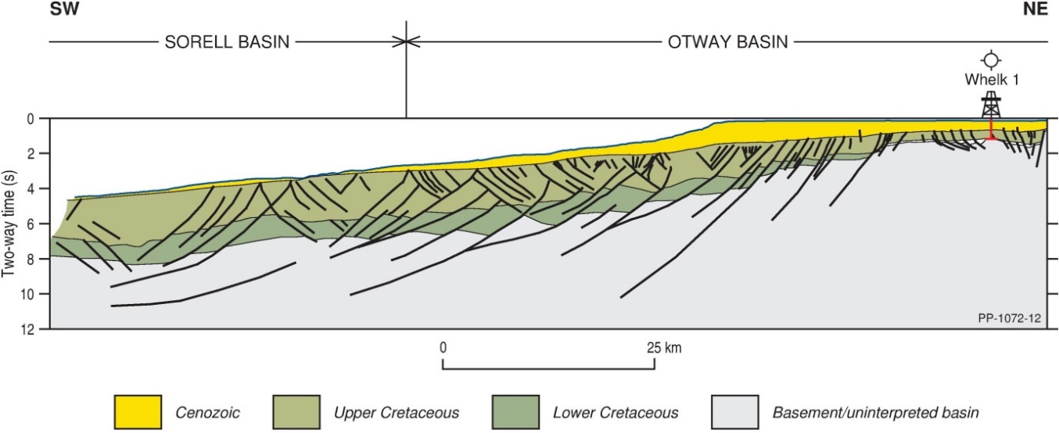
Figure A13: Cross-section of the Sorell Sub-basin which shows the transition from the Sorell Basin to the Otway Basin. Exploration targets in the Sorell Basin include the Shipwreck and Sherbrook supersequences (Upper Cretaceous) and the Wangerrip Supersequence (Cenozoic). Location is shown in Figure A12.
The Sorell Basin is contiguous with the better known Otway Basin to the north and west, and shares similar basin architecture and sedimentary sequences, which developed during the breakup between Australia and Antarctica. The Sorell Basin hosts sediments of Lower Cretaceous to Holocene age across several sub-basins: the King Island, Sandy Cape and Strahan sub-basins in the north and the Port Davey and Toogee sub-basins in the south.
Exploration has been sporadic since the 1960s and has been largely focused on the Strahan, Sandy Cape and King Island sub-basins with single wells drilled in each: Cape Sorell-1 (1982; Amoco Australia Petroleum Company), Jarver-1 (2008; Santos Limited) and Clam-1 (1969; Esso Exploration and Production Australia Ltd). Although dry, they proved the presence of a thick sequence of Cretaceous and Cenozoic sediments with good reservoir (Clam-1 and Cape Sorell-1) and seal (Jarver-1) units in these sub-basins. The sedimentary sequence is largely siliciclastic, reflecting fluvial to marine deposition, with thicknesses ranging from approximately 6,000-3,000 m (north to south) and interpreted to include organic-rich coals, deltaic and marine sediments, which could have potential for generating both oil and gas. Cape Sorell intersected (in the latest Cretaceous sequence) an oil-prone source rock with trace amounts of free oil and gas shows. The deep-water, western region of the basin and the two southern sub-basins are virtually unexplored, and the geology is very poorly understood, with some information available from several Deep Sea Drilling Project and Ocean Drilling Program stratigraphic wells.
Data coverage is generally sparse and largely limited to 2D seismic data (Figure A14). A higher density of 2D seismic lines have been acquired in the Strahan Sub-basin, and the inboard areas of the eastern Sandy Cape Sub-basin along the continental shelf. Only two small 3D seismic surveys have been acquired: the Strahan 3D MSS (2008; Santos) in the Strahan Sub-basin and the Wolseley 3D MSS (2011; Perenco) in the deep water outboard Sandy Cape Sub-basin. Regional magnetic and gravity data has also been acquired (largely by Geoscience Australia and its predecessor entities) to constrain broad-scale basin architecture.
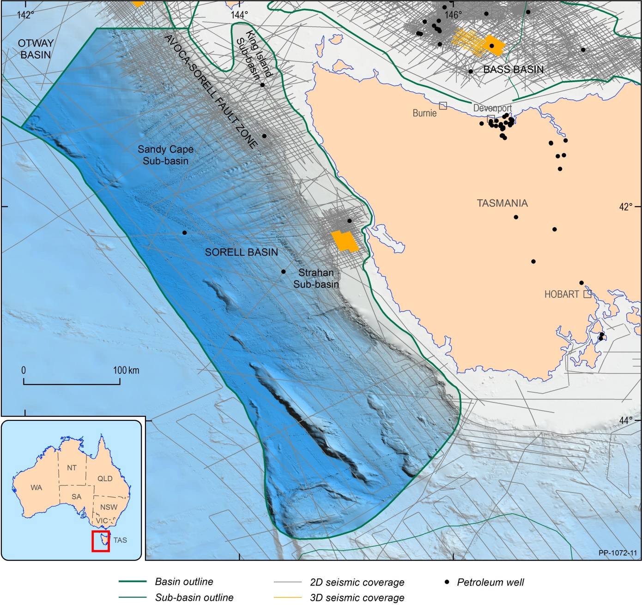
Figure A14: Data coverage in the Sorell Basin, including wells and seismic.
Petroleum systems modelling supports sufficient depth of burial for hydrocarbon generation in much of the basin, with the presence of a working petroleum system suggested by reports of hydrocarbons from sea-floor sampling and by oil shows in Cape Sorell-1. However, peak generation (Albian to Palaeocene) is considered to have occurred prior to uplift and erosion (Palaeocene to Eocene), indicating hydrocarbon retention remains a significant exploration risk.
As a very lightly explored and relatively remote area, key factors affecting exploration and development in the Sorell Basin include:
- limited exploration data
- high uncertainty relating to the presence of an active petroleum system (source, reservoir and seal facies are poorly constrained)
- a lack of infrastructure.

Appendix B – Offshore petroleum titles

Overview
As at November 2017, there are a total of 53 Commonwealth offshore petroleum titles across south east Australia with over half located in the Gippsland Basin (Table B1). An additional five state titles exist within Victorian coastal waters (Table B2). The relative maturity of petroleum activity is reflected in the larger proportion of production licences to retention leases and exploration permits i.e. the most discernible, high volume discoveries have already been made and associated titles have progressed through to production, with exploration activity mostly focused on more subtle, lower volume targets in the periphery.
There are currently eleven retention leases in Commonwealth waters, ten of which contain gas resources. All of these are planned for development through existing infrastructure, as capacity becomes available, effectively providing backfill as gas supply from existing projects decline.
Table B1. Distribution of offshore Commonwealth petroleum titles across south east Australia.
Basin | Exploration Permit | Retention Lease | Production Licence
Gippsland | 5 | 5 | 24
Otway | 6 | 2 | 6
Bass | 0 | 4 | 1
Sorell | 0 | 0 | 0
Total | 11 | 11 | 31
Table B2. Distribution of offshore coastal water petroleum titles across south east Australia.
Basin | Exploration Permit | Retention Lease | Production Licence
Gippsland | 2 | 1 | 0
Otway | 1 | 0 | 1
Bass | 0 | 0 | 0
Sorell | 0 | 0 | 0
Total | 3 | 1 | 1
There are currently 22 companies participating in petroleum activities in offshore south east Australia, with 11 companies responsible as operator for activities within the 53 Commonwealth titles. In addition three companies hold titles in Victoria’s coastal waters, with Lattice Energy participating in titles within both Commonwealth and Victoria coastal waters. Table B3 (below) shows the distribution of titles by operator and the concentration of ownership in producing fields.

Table B3. Distribution of offshore petroleum titles by operator. Coastal water only operators are shown in italics.
Operator | Exploration  Permit | Retention  Lease | Production  Licence
3D Oil | 1 | 0 | 0
Bass Strait Oil | 1 | 0 | 0
BHP Billiton | 0 | 0 | 1
Cape Energy Pty Ltd | 0 | 1 | 0
Carnarvon Hibiscus Pty Ltd | 1 | 0 | 1
Cooper Energy | 1 | 5 | 4
Esso Australia Resources Pty Ltd | 1 | 2 | 20
Llanberis Energy Pty Ltd | 1 | 0 | 0
Loyz Oil Australia Pty Ltd | 1 | 0 | 0
Oil Basins Limited | 1 | 0 | 0
Lattice Energy | 4 | 4 | 5
Petro Tech Pty Ltd | 2 | 0 | 0
SGH Energy | 0 | 0 | 1
Total | 14 | 12 | 32
The majority of the area currently under production licences (granted between 1967 and 1990) is concentrated in the Gippsland basin. Production activities in the Otway and Bass Basins have commenced since the early 2000’s (Figure B1).
Outside of the fields operated by Esso Australia on behalf of the Gippsland JV), Lattice Energy and Cooper Energy are the most active companies in the region and hold the majority of current retention leases. Exploration permits are held by a much more diverse range of titleholders. Notably Esso Australia has had little presence in exploration activity with the exception of one exploration permit that it recently acquired to test the Greater Dory prospect in Petroleum Exploration Permit VIC/P70.
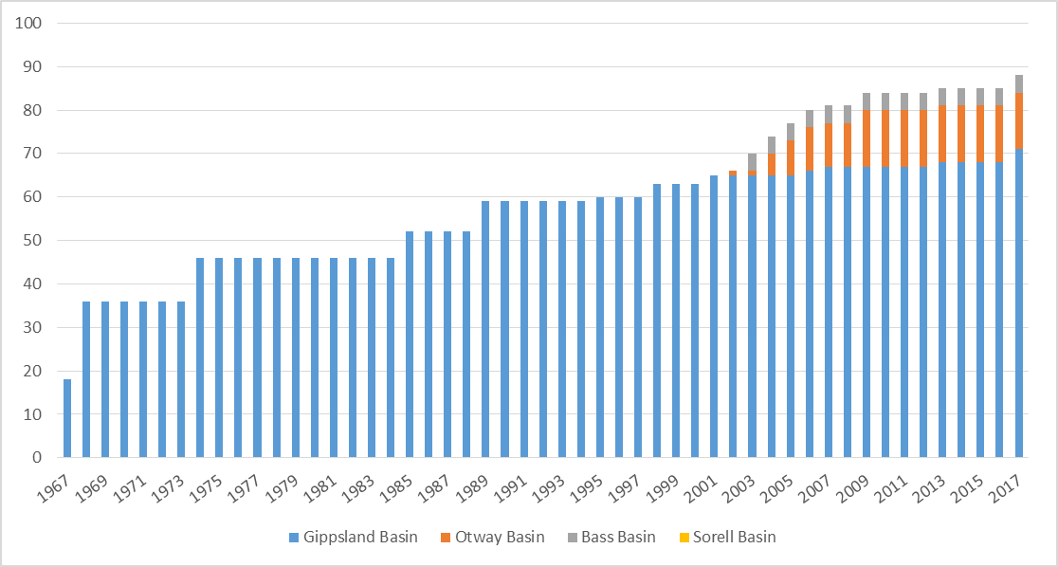
Figure B1: Graticular blocks under Commonwealth Production Licences by basin.

Gippsland Basin
The maturity of petroleum activity in the Gippsland Basin is clearly evident by the 24 production licences of which 13 contain gas resources. The Gippsland JV holds 20 of the 24 production licences in the Gippsland Basin with the first four being granted in 1967 and a further four in 1968. Additional production licences were granted to the Gippsland JV in 1974 (3), 1985 (2), 1989 (4), 1995 (1), 1998 (1) and 2000 (1).
The four production licences held by other titleholders have been granted since 2001 but are not currently in production. These include the Longtom gas field (SGH Energy), Sole and Patricia/Baleen gas fields (Cooper Energy) and the West Seahorse oil field (Carnarvon Hibiscus Pty Ltd). The number of graticular blocks held under Production Licence is shown in Figure B2.

Figure B2: Graticular blocks under Commonwealth production licence per titleholder in the Gippsland Basin
Almost all production licences are located over the prospective Central Deep, with only four licences extending onto the margins i.e. the northern terrace. Activity regarding gas resources within existing licences has largely focused on maximising production from existing reserves and ensuring the smooth transition of discovered resources into production.
The five existing retention leases each cover a single Graticular Block and are located at the margins of the Central Deep (Figure B3). Two of these are held by the Gippsland JV (VIC/RL1 and VIC/RL4) over Mulloway (oil), part of Golden Beach (gas–mostly in Victorian coastal waters), as well as Sunfish and Remora fields (gas). The Golden Beach gas field, under VIC/RL1(V), is the only retention lease in Victoria’s coastal waters within the offshore Gippsland Basin. Applications for the renewal of VIC/RL1 and VIC/RL4 are currently being considered by the Commonwealth-Victoria Offshore Petroleum Joint Authority.
Cooper Energy Ltd holds the remaining three retention leases (VIC/RL13, VIC/RL14 and VIC/RL15) over the Manta, Basker and Gummy fields. These fields were previously held under production licences and developed as an oil project. At the end of commercial oil production applications were received for retention leases over the remaining gas resources. The retention leases were granted in April 2017.
The five exploration permits in Commonwealth waters are located primarily in the northern and southern portions of the basin. The eastern, outboard extension of the Central Deep contains potentially overlooked volumes of gas which will be tested by two exploration wells within exploration permit VIC/P70 due to be drilled by May 2019.
Figure B3. Titles map of the Gippsland Basin.

Bass Basin
The Bass Basin has five existing titles, with a single production licence (T/L1) and four retention leases (T/RL2, T/RL3, T/RL4 and T/RL5). All titles are operated by Lattice Energy and alternatives are being considered for the development of the four retention leases as backfill to the existing production at the Yolla Field, with backfill potential sources including White Ibis, Bass, Trefoil and Rockhopper fields (Figure B4).
Recent exploration has not proved favourable, as reflected by the lack of any current exploration permits. Previous titleholders have either elected not to renew permits upon expiry or surrendering, prior to entering permit years with operational activities. However, industry nominations were received for the release of T17-1 and T17-2 as part of the 2017 Offshore Petroleum Exploration Acreage Release. Bids closed on 19 October 2017 and are currently under assessment by NOPTA.
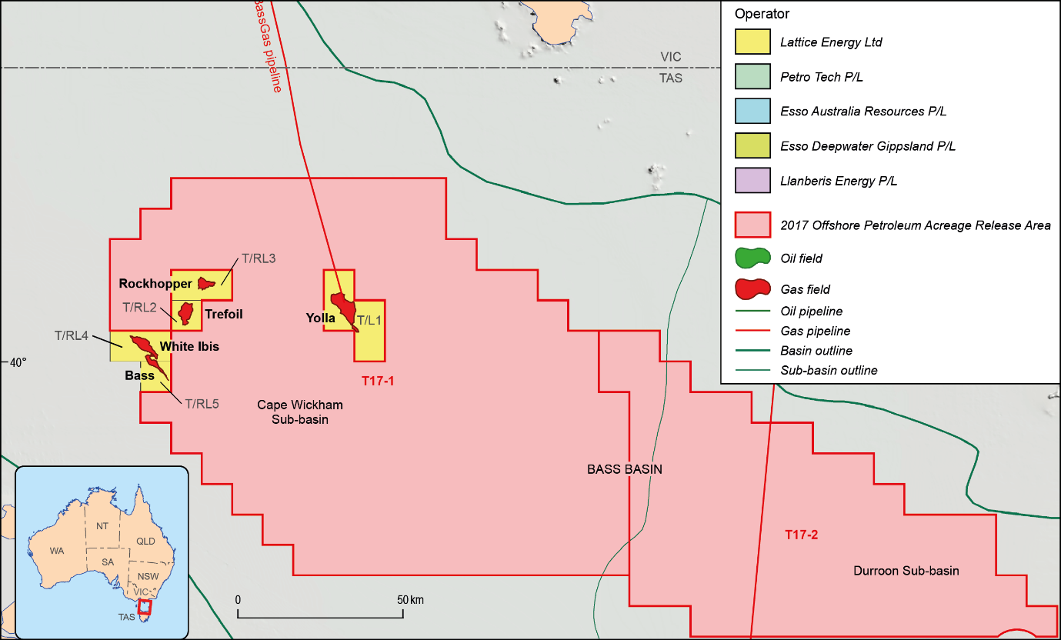
Figure B4. Titles map of the Bass Basin.

Otway Basin
There are currently 14 titles within Commonwealth waters of the Otway Basin: six exploration permits; two retention leases; and six production licences (Figure B5; Table B4). A further two titles are located within Victorian coastal waters: one exploration permit and one production licence.
There are five different companies responsible for operating exploration permits in the Otway Basin, Lattice Energy is the most active explorer in the region with four exploration permits across Commonwealth and Victorian coastal waters. Cooper Energy has recently acquired assets previously held by Santos and now holds a single exploration permit (as well as two existing production licences and the only two retention leases in the region).
The six production licences in Commonwealth waters are being operated as three independent projects covering the Thylacine, Geographe, Minerva, Casino, Henry and Netherby fields (Figure B5). The single offshore production licence in Victorian coastal waters, VIC/L1(V), produces gas from the offshore Halladale and Speculant fields at an onshore location for delivery to the Otway Gas Plant.
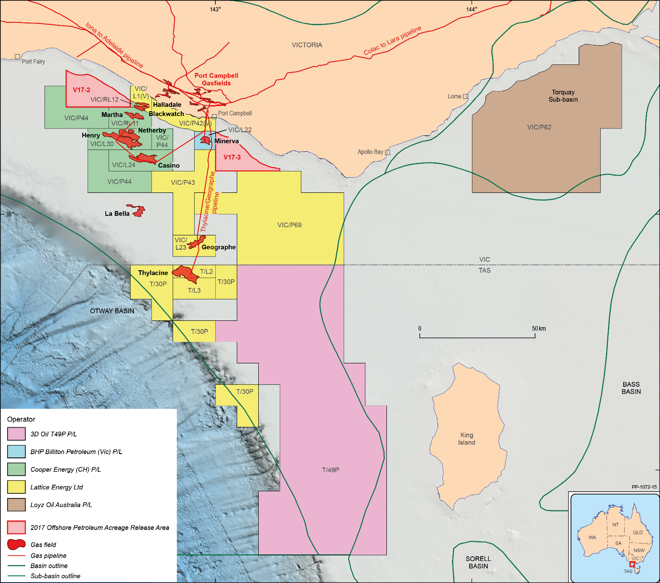
Figure B5. Titles map of the Otway Basin.
Table B4. Distribution of offshore Commonwealth and Victorian petroleum titles by operator in the Otway Basin.
Operator | Exploration  Permit | Retention  Lease | Production  Licence
3D Oil | 1 | 0 | 0
BHP Billiton | 0 | 0 | 1
Cooper Energy | 1 | 2 | 2
Loyz Oil Australia Pty Ltd | 1 | 0 | 0
Lattice Energy | 4 | 0 | 4
Total | 7 | 2 | 7
Two offshore retention leases (VIC/RL11 and VIC/RL12) exist in the nearshore area over the Black Watch and Martha fields, with the former also straddling Victorian coastal waters. These retention leases were subject to renewal applications at November 2017 that are currently under consideration by the Commonwealth-Victoria Offshore Petroleum Joint Authority.

The Halladale and Speculant fields are entirely located in Victorian coastal waters within the VIC/L1(V) production licence (Halladale-Speculant) operated by Origin (Lattice) Energy. Offshore production from Halladale and Speculant is transported from an onshore site onto the Otway Gas Plant.
There are five Otway Basin exploration permits in Commonwealth waters, with a single exploration permit in Victorian coastal waters (VIC/P42(V)). The most recent exploration permit awarded in Commonwealth waters was granted in 2014 and the oldest currently active permit was granted in 1997.

Sorell Basin
There has been no active exploration in the Sorell Basin since the surrender of exploration permit T/32P in 2014. Areas were last released in 2015 as part of the annual acreage release and while bids were received, the areas did not convert to exploration permits. The Sorell Basin differs in some critical elements of its subsurface architecture to other south east Australia basins and the presence of the required petroleum system elements to produce hydrocarbon accumulations remains to be confirmed.

Appendix C – Onshore infrastructure

Overview
Gas produced from offshore petroleum fields is processed through onshore gas plants prior to being distributed to the domestic gas market. There are currently six gas plants in Victoria that process gas from offshore fields (Table C1). The combined production from these gas plants currently meet around 60 per cent of the demand for domestic gas within the east coast market.
Table C1: Processing capacity from onshore south east Australia gas plants5F.
Gas Plant | Daily Processing Capacity^ (TJ/d) | Annual Processing Capacity^ (PJ/a)
Longford Gas Plant | 1,175 | 429
Iona Gas Plant | 109 | 40
Otway Gas Plant | 205 | 75
Minerva Gas Plant | 150* | 55
Lang Lang Gas Plant | 67 | 25
Orbost Gas Plant | 90 | 33
Total | 1,796 | 657
^Adjusted to represent capacity specific to offshore gas supply *Represents initial capacity.
The Longford and Orbost gas plants process gas derived from the Gippsland Basin, while the Lang Lang Plant processes gas from the Bass Basin (Figure C1).
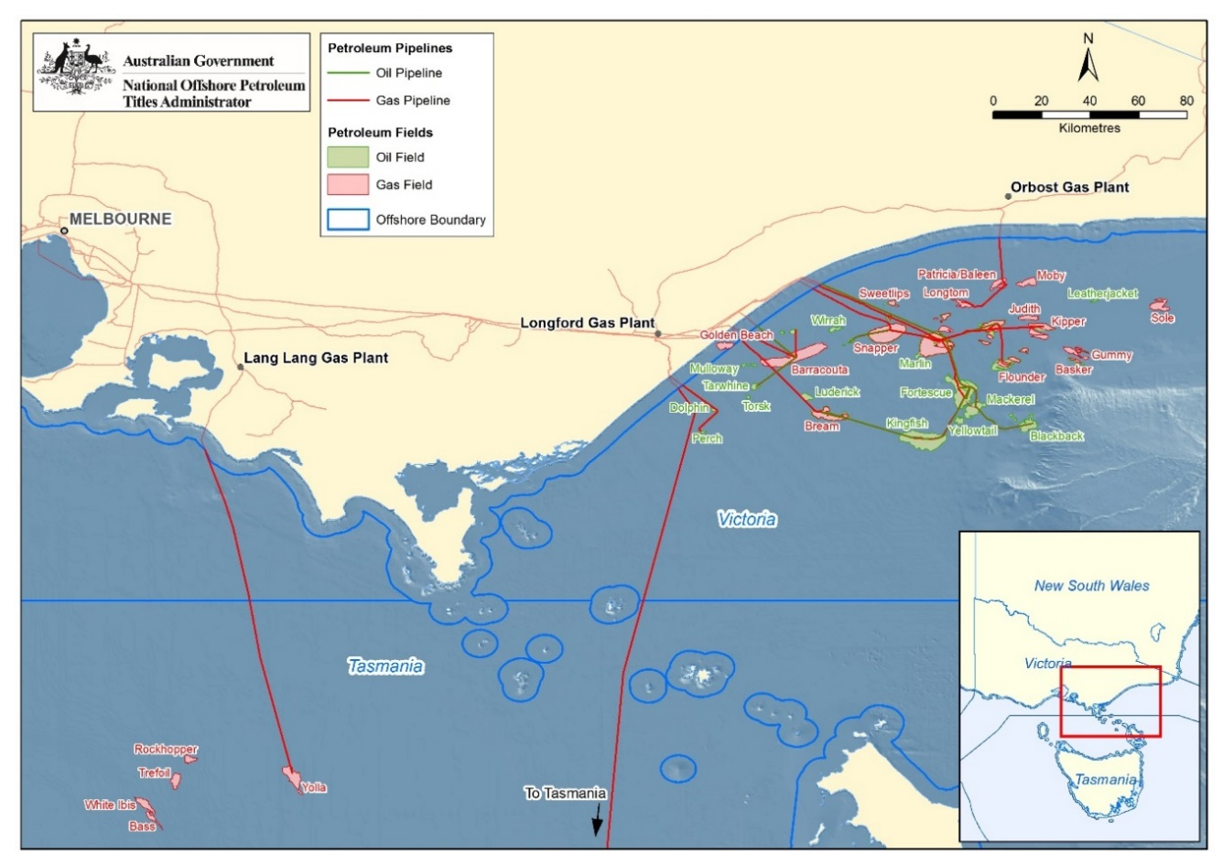
Figure C1. Location of the eastern Victorian gas plants: Lang Lang, Longford and Orbost.
Three other facilities west of Melbourne process gas derived from the Otway Basin, with the Iona, Minerva and Otway gas plants close to each other near Port Campbell (Figure C2).
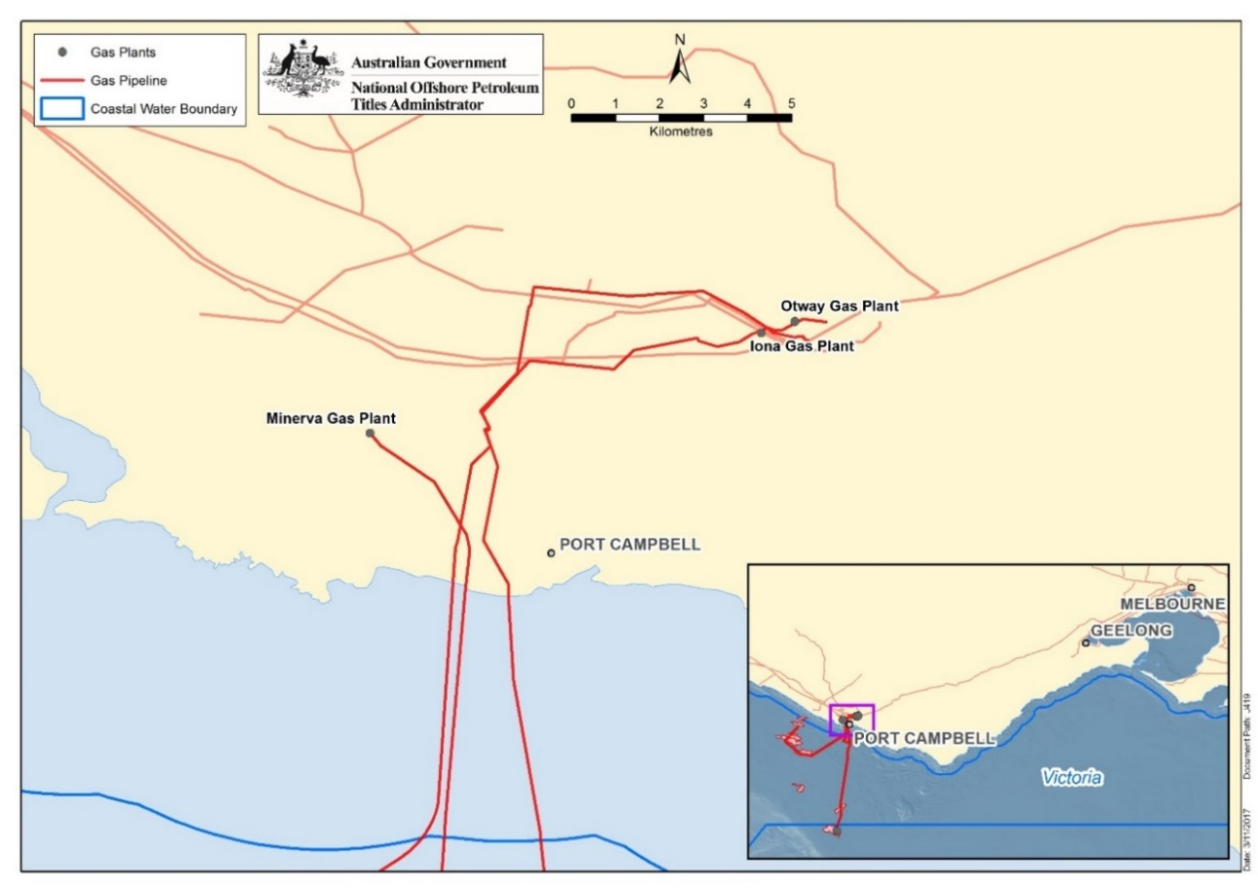
Figure C2. Location of the Iona, Minerva & Otway Gas Plants.
The six facilities have the combined capacity to process approximately 657 PJ6F of offshore gas per annum (PJ/a) (1796 TJ/d) with the capacity of individual plants varying significantly (Figure C3). The Longford Gas Plant provides more than half of installed processing capacity (429 PJ/a; 1175 TJ/d)) and currently supplies in excess of 80 per cent of the gas produced from offshore fields. None of the gas plants currently produce at their full capacity. In the case of the Longford gas plant, spare capacity is used to provide gas at times of peak demand and there is significant seasonal variation in gas production. The Iona gas plant is operated primarily as a gas storage facility and only provides limited capacity for the processing of gas from offshore.
The development of the Iona infrastructure followed closely from events of 25 September 1998 when an explosion at the Longford Gas Plant disrupted supply in Victoria and resulted in severe shortages across the state for approximately two weeks. Consequently, while the total Iona, Otway, Orbost, Minerva and Lang Lang infrastructure is significantly smaller than Longford Gas Plant they are critical infrastructure in ensuring gas supply from offshore south east Australia.
*
Figure C3. Processing capacity from onshore south east Australia gas plants7F. *Represents initial capacity.
The Longford gas plant represents the single largest contributor to east coast gas supply, currently meeting approximately 50 per cent of total market demand for domestic gas8F (Figure C3). The remaining five gas plants, four of which are currently operating, provide approximately 10 per cent of the gas required to meet demand. The balance of demand, approximately 40 per cent, is currently met from onshore gas production, such as from the Moomba Production Zone (in South Australia). It is expected that the Orbost gas plant will restart production in 2019 processing gas from the Sole Field.

Figure C4. Offshore south east Australia contribution to east coast domestic gas supply.
The availability of existing infrastructure and varying levels of available capacity may provide opportunities for the development of additional gas resources under tolling arrangements rather than requiring additional investment in new infrastructure.

Longford Gas Plant
The Longford Gas Plant has operated for more than 40 years as part of the Gippsland JV project. The plant is supplied from a number of offshore fields in the Gippsland Basin and supplies the majority (80 per cent) of the gas produced from offshore fields in south east Australia. On an annual basis the plant currently receives around two thirds of the total offshore production (as available to the Gippsland JV). However, production is seasonal, with the plant managed to operate at levels approaching its full capacity during periods of high demand (winter).
In May 2017, the Gippsland JV completed construction of the Longford Gas Conditioning Plant, which will enable the processing of additional gas resources. The plant is able to process and reduce impurity levels (primarily CO₂ and Hg) so that gas can be delivered through the inlet to the Longford Gas Plant for final processing. The construction of the plant was part of the A$5.5 billion Kipper-Tuna-Turrum project.
The Longford Gas Conditioning Plant itself is designed to deliver ‘conditioned’ upstream gas to the Longford Gas Plant for further processing into sales gas specifications. As existing fields continue to decline, the plant will become increasingly reliant upon this gas for supply. As such, without additional new gas supplies becoming available i.e. via new gas discoveries, it is expected that production of sales gas from the Longford Gas Plant could eventually decline from current levels to be in line with the delivery capacity of the Longford Gas Conditioning Plant.

Iona Gas Plant
The Iona Gas Plant is owned by Lochard Energy, its primary purpose is to provide gas storage on behalf of customers during periods of low gas demand and supply gas during periods of high demand. The facility makes use of the depleted Iona, North Paaratte and Wallaby Creek gas fields to store a maximum of 26 PJ of gas (storage injection rates of 153 TJ/d, with plans to increase this to 250 TJ/d).
The Iona facility can currently provide a maximum daily withdrawal rate of 142 PJ/a (390 TJ/d) of gas to the domestic market from its storage facility, with plans to increase this capacity to 208 PJ/a (570 TJ/d). The plant also provides processing facilities for gas from the offshore Casino gas field in the Otway Basin. Processing capacity available for offshore gas is limited to 40 PJ/a (109 TJ/d).

Otway Gas Plant
The Otway Gas Plant is part of the Otway Gas Project operated by Origin Energy and processes gas from the Thylacine Geographe and Halladale-Speculant fields located in the Otway Basin. The Otway Gas Plant has capacity to process 75 PJ of gas per annum.

Minerva Gas Plant
The Minerva Gas Plant is operated by BHP Billiton Petroleum Pty Ltd (BHP Billiton) and processes gas from the Minerva gas field in Petroleum Production Licence VIC/L22. The Minerva Gas Plant had an initial capacity to process 55 PJ/ of gas per annum. The Minerva Field is expected to cease production during 2017 and no announcements have been made in relation to new gas sources to extend the life of the Minerva Gas Plant.

Lang Lang Plant (BassGas Project)
The Lang Lang Plant is operated by Origin Energy and processes gas from the Yolla gas field in petroleum production licence T/L1. The Lang Lang Plant has capacity to process 25 PJ of gas per annum. A number of fields (White Ibis, Rockhopper, and Trefoil) may provide future gas for processing through the Lang Lang Plant.

Orbost Gas Plant
The Orbost Gas Plant was recently acquired by Cooper Energy which in turn has reached agreement with the APA Group to acquire, upgrade and operate the gas plant. The facility was originally developed to process gas from the Patricia/Baleen gas field and is in the process of being upgraded to enable the development of the Sole gas field.
The Orbost Gas Plant has capacity to process 33 PJ of gas per annum and is not currently in operation. Production is expected to recommence in 2019 with the development of the Sole gas field. Production from the Sole Field is forecast to plateau at approximately 25 PJ per annum which would represent approximately 4.4 per cent of the forecast demand for domestic gas in eastern Australia.
Potential exists for production from the Longtom Field to restart at some point in the future through existing offshore infrastructure. Cooper Energy is also considering the development of the Manta gas field through the Orbost Gas Plant as sufficient capacity becomes available.

Gas Storage Facilities
In addition to the Iona Gas plant there are a number of gas storage facilities within the east coast domestic gas network that assist in managing available gas supply to meet demand as required. There is currently capacity to store approximately 260 PJ of gas within existing facilities (Table C2).
Table C2: Eastern Australia Gas Storage Facilities.9F
Facility | State | Withdrawal Capacity  (TJ/day) | Storage Capacity  (PJ)
Adelaide Energy Otway Basin | SA | 20 | 50
Ballera Underground Storage | QLD | 40 | 11
Iona Underground Gas Storage | VIC | 390 | 26
LNG Storage Dandenong | VIC | 237 | 0.68
Moomba Underground Gas Storage | SA | 120 | 70
Newcastle Gas Storage Facility | NSW | 120 | 1.5
Newstead Underground Storage | NSW | 8 | 2
Roma Underground Storage | QLD | 75 | 65
Silver Springs Gas Storage | QLD | 30 | 35

Appendix D – Commercial and market issues

The south east gas market
The east coast gas market can be thought of as consisting of a northern market and a southern market. Queensland constitutes the northern market (Figure D1). The southern market includes Victoria, New South Wales, South Australia, Tasmania and the Australian Capital Territory. The Cooper Basin, located in southwest Queensland and north eastern South Australia, straddles the two markets.
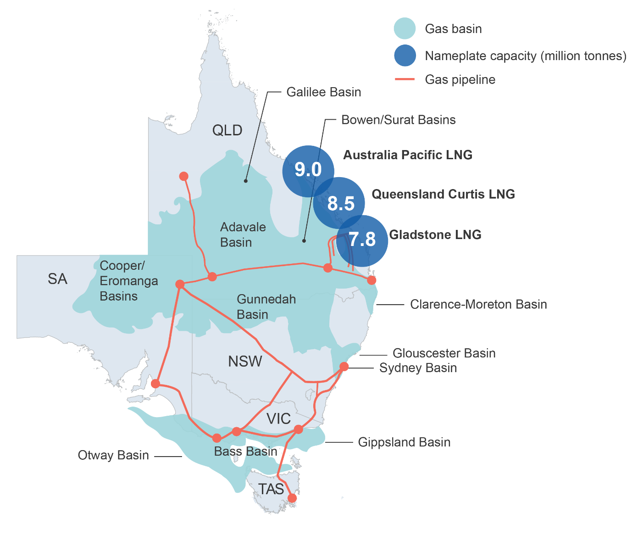
Figure D1: The east coast gas market.
Transportation costs between the southern market and the northern market are relatively high. The market structure in the south is more concentrated than in the north, where there are a larger number of producers. Joint venture and marketing arrangements in the south further increase market concentration. Most of the gas produced in the southern market comes from the Gippsland Basin, which is dominated by production from the Esso-BHP Billiton Gippsland JV.

Recent Changes
The establishment of three LNG export projects on Australia’s east coast has significantly changed the pricing dynamics in the east coast gas market. In the north, international LNG prices appear to have exerted a strong pull over domestic gas prices, with domestic producers now having the option to sell their gas to overseas markets.
Meanwhile, the southern market has become increasingly reliant on production from Bass Strait. The southern market has historically been supplied from Victorian offshore gas, with additional supplies from the onshore Cooper Basin and Queensland. However, the establishment of LNG projects has seen gas from the Cooper Basin and Queensland directed for export, leaving buyers in the south increasingly dependent on production from Bass Straight, which is dominated by the Esso-BHP Billiton Gippsland JV. In its 2016 Inquiry into the east coast gas market, the ACCC argued that an absence of competition in the south was likely to increase the price of gas in the south to the price level in the north plus the costs of transportation10F.

Gas Prices
Wholesale gas prices across the eastern gas market have risen quickly over the past few years. While there is broad agreement that gas prices have increased, it is difficult to say by how much they have risen as most gas is traded on confidential bilateral contracts.
Figure D2 shows movements in wholesale gas spot prices at the various gas trading markets on the east coast. Only a small proportion of gas is sold at these spot prices. For example, the gas traded on the Declared Wholesale Gas Market (DWGM) in Victoria and Short-term Trading Markets (STTMs) only accounts for 10-15 per cent of the gas sold in the regions served by those mechanisms. Nevertheless, higher spot prices are indicative of the general upward trend in gas prices over past few years.
Figure D2. Monthly Australian east coast wholesale gas spot prices. Notes: Wallumbilla is a gas supply hub. STTM stands for Short Term Trading Market. DWGM stands for Declared Wholesale Gas Market. Source: AEMO

Gas Consumption
In 2016, around two-thirds of east coast gas supply was used to produce LNG for export (Figure D3). The majority of domestic gas consumption takes place in the industrial sector, followed by the residential and commercial sector, and the gas power generation sector. The Australian Energy Market Operator (AEMO) expects the long-term contracts of many domestic users to come to an end in 2018, with new contracts expected to be negotiated in an environment of higher prices.
Figure D3. Australian gas use. Notes: AEMO estimates for 2016. Source: AEMO (December 2016) National Gas Forecasting Report.

Barriers to Entry
Barriers to entry can be defined in several ways.11F. For the purposes of this report, barriers to entry are considered to be factors that make it difficult for a firm to enter the market. A distinction can be drawn between structural and strategic barriers.12F Structural barriers relate to features of the industry which are outside the control of market participants. In contrast, strategic barriers are those which are intentionally created or enhanced by incumbent firms for the purpose of deterring the entry of new firms into the market. While an in depth analysis of structural and strategic barriers to entry is beyond the scope of this study, some of the major factors affecting the ability of firms to enter the south east gas supply market are canvassed below.

High capital and sunk costs
Capital costs are one-time expenses required to bring a project into commercial operation. Sunk costs are investments that cannot be recovered once they are made. In industries where capital and sunk costs are high, firms may face greater financial risks associated with entry and may also have greater difficulty raising the capital required to finance a new operation.
Compared to many other industries, capital and sunk costs are relatively high in the offshore gas industry. Drilling rigs, pipelines and potentially gas processing facilities are amongst the infrastructure required for a new gas project. The investment in the Gippsland JV’s Kipper-Tuna-Turrum project, which was completed in full in early 2017, totalled $5.5 billion, including around $1 billion in upgrades to the Longford Gas Processing facility. The cost of Cooper Energy’s Sole project in the Gippsland Basin is expected to be $355 million, with an additional $250 million required to fund upgrades to the Orbost gas processing plant. Exploration expenditure is also a sunk cost with uncertain payoffs.
There are a range of other potential factors which may make it difficult for new firms to compete with incumbents in the offshore south east gas market including absolute cost advantages, economies of scale and vertical integration. As noted, an assessment of these factors is beyond the scope of this study.

Declining quality of gas resources
While gas prices have risen, so has the cost of new gas developments. In the oil-gas industry, the lowest-cost fields are targeted first and development then moves to higher-cost fields if commercially viable. Mirroring an Australia-wide trend, rising costs for new developments in the Bass Strait could have played some role in discouraging the development of new resources.
According to an EnergyQuest report commissioned by the Australian Petroleum Production and Exploration Association (APPEA), finding and development costs (F&DC)13F for offshore domestic gas projects—many of which are located in the Bass Strait—were around A$3.00 a gigajoule in 2014, up from less than A$1.00 a gigajoule a decade earlier.
One of the reasons for this rise in costs is declining field size. The basins in Bass Strait, particularly Gippsland, are regarded as mature, with the prospects for large new discoveries remaining limited. Another reason for rising costs is the quality of remaining gas deposits. As discussed previously, new gas developments in the Gippsland Basin are prone to high levels of contaminants such as hydrogen sulphide (H₂S), mercury (Hg) and carbon dioxide. Gas which contains these impurities requires additional treatment, adding to development costs.
Available data14F suggests that offshore contingent resources in Bass Strait — those which are potentially recoverable but face technological and business hurdles to commercial development — sit around the middle of the cost curve for the east coast (Figure D4).
Figure D4. Production costs in the east coast gas market by basin and resource type. Source: AEMO (2017)
Notes: Production costs are the marginal cost of producing a GJ of sales gas to the point of sale into a transmission pipeline and thus exclude transport cost. They are not intended to reflect gas sale prices, only the marginal cost of actually supplying the gas. Contingent resources are potentially recoverable but face technological or business hurdles to commercial development. Proved and probable (2P) reserves are those which are considered commercially recoverable. 2P developed reserves refer to those with existing wells. 2P undeveloped reserves are those reserves with wells yet to be drilled. For developed 2P reserves, production costs include largely marginal operating costs, royalties and tax. For undeveloped reserves, marginal costs also include the cost of drilling and completion and marginal gas processing plant costs. Where a gas plant does not exist the marginal cost will include an estimate of per unit cost of capital and operating cost for that plant.

Low oil prices
Oil prices have declined sharply since late 2014. The price of Brent crude averaged around US$50 a barrel over the first half of 2017 - well down on its peak of US$119 a barrel in February 2013.
Low oil prices can affect the development of new gas resources in a number of ways. First, since many companies that develop gas resources are also oil producers, low oil prices affect the revenues of gas producers and thus their ability to fund exploration and development activity. Second, given that oil is often co-produced with gas, low oil prices can affect the expected returns from new oil-gas developments, potentially rendering them uneconomic.
The activity of junior companies and explorers, with smaller revenue bases, is particularly likely to be affected by low oil prices. However, some of their larger peers, such as Santos (which previously owned assets in the Bass Strait) and Origin (currently active in Bass Strait but seeking to exit as part of a broader change in corporate strategy), have also been heavily impacted by the downturn in oil prices. In 2015, for example, Origin announced a $337 million write-down to the value of its oil and gas assets in the Cooper, Bass and Otway Basin. Both Santos and Origin are also exposed to oil price movements through their participation in LNG projects where the price of LNG is linked to oil prices.

Third party access to infrastructure and the south east

Purpose of third party access regulation
In some markets, competition can be hampered by natural monopolies on infrastructure services. Access regulations allow third parties to seek access to infrastructure owned and operated by others and, in doing so, aim to promote competition15F. However, access regulation can also have costs, adversely affecting investment incentives and imposing costs on infrastructure service providers.
For this reason, the use of access regulation needs to be carefully considered. It is also only one of several policy instruments available to address competition issues in markets for infrastructure services.

Rules governing third party access in gas markets

Gas pipelines
Gas pipelines are subject to third party access regulation under the National Gas Law (NGL) and National Gas Rules. Pipelines transporting gas can be either uncovered or covered by regulation. Uncovered pipelines are not subject to access regulations. Pipelines which are ‘covered’ are subject to one of two forms of regulation, full regulation or light regulation. Full regulation requires the pipeline service provider to have an access arrangement approved by the regulator (the Australian Energy Regulator in the eastern and northern gas markets, and the Economic Regulation Authority in the western gas market). Light regulation imposes a negotiate/arbitrate model for access, with arbitration by the regulator in the event of a dispute.
Any person or organisation can apply to have pipelines made subject to ‘coverage’. Applications are considered by the National Competition Council (NCC), which provides recommendations to responsible Ministers. The NCC considers applications against a number of criteria specified in the NGL, such as whether the pipeline would be uneconomic to duplicate, and whether access to the pipeline is required to promote a material increase in competition in upstream and downstream markets.
This legal framework for third party access applies to onshore pipelines in Victoria that transport natural gas from gas processing facilities to demand centres such as Melbourne. The NGL defines ‘natural gas’ as gas suitable for consumption. In contrast, the offshore pipelines in the Bass Strait transport unprocessed gas to processing plants to be made ready for consumption. As such, rules for third party access would not apply to offshore pipelines in the Bass Strait.

Gas Processing Facilities
Third party access regulation does not apply to gas processing facilities.

Barriers to third party access to infrastructure

Gas Processing Facilities
There have been calls for policy makers to extend third party regulation to gas processing facilities. The extent to which difficulties gaining access to gas processing facilities currently represents a barrier for new offshore gas projects remains unclear. However, a general point is that difficulties accessing a third party’s gas processing facility are more likely to be a barrier to entry for more marginal projects, where the costs associated with constructing a new gas processing facility would otherwise affect the viability of these projects. With the size and quality of undeveloped gas resources in south east Australia likely to be lower than in the past, new potential projects are more likely to be marginal.
However, it is worth noting that several projects in Bass Strait have developed their own gas processing facilities. For example, as part of Cooper Energy’s Sole and Manta gas projects, Cooper Energy and APA Group agreed that APA would acquire, upgrade and operate the Orbost Gas Plant to process gas from the two projects. Origin’s BassGas project involved the construction of the Lang Lang gas plant.
There are also a number of potential costs to regulating third party access to gas processing facilities16F. First, third party access regulation has the potential to reduce investment by third parties in new gas processing capacity, with third parties likely to use access regulation to access existing facilities.
Second, third party access regulation could reduce new investment by gas processing facility owners, as facility owners may face costs associated with processing third party gas. For example, sharing a gas processing facility with other parties may require plant modifications to ensure that the facility is compatible with the particular chemical composition of a third party’s gas. Further, providing access to third parties can impose costs on the owners of processing facilities of having to coordinate multiple users.

Gas Pipelines
The 2016 ACCC Inquiry into the East Coast Gas Market raised concerns about monopoly pricing by pipeline operators and found issues of restricted access or denial of access to pipeline services in a small number of cases.17F The majority of natural gas pipelines are vertically separated that is, they tend not to be owned by gas producers or retailers and therefore, have no incentive to discourage access. The issue of the third party access regulations not applying to offshore gas pipelines is not raised as an issue in the literature. The Inquiry also made a number of recommendations in regard to gas pipelines. It concluded that while the pipeline sector is responding to the changing market dynamics and offering new services, pricing based on significant pipeline market power was prevalent. It also noted that the regime regulating gas pipelines was not fit for purpose and pipeline pricing is largely unconstrained by either the threat of regulation or effective competition.
In December 2016, Dr Michael Vertigan AC, in his examination of the current test for the regulation of gas pipelines considered that one of the key problems under the gas pipeline regulatory regime was that it afforded pipeline operators and gas shippers unequal levels of bargaining power and access to information when entering into gas transportation agreements.
To address these issues, significant reforms to the east coast gas market have been implemented or are being implemented through the Council of Australian Governments (COAG) Energy Council Gas Market Reform Group.

These reforms include but are not limited to:
- Changes that have recently been made to the National Gas Law (NGL) and National Gas Regulation (NGR) to introduce an information disclosure and arbitration framework that applies to uncovered pipelines.
- The maintenance of the negotiate-arbitrate form of regulation for scheme pipelines (full and light regulation) and potential changes made to the NGL/NGR following the Australian Energy Market Commission’s (AEMC) review into Parts 8-12 of the NGR.
- The capacity trading reforms that are currently being developed (which include the introduction of a day-ahead auction for contracted but un-nominated capacity with a zero reserve price, a capacity trading platform and a range of standardisation measures), which are intended to improve the efficiency with which contract carriage pipelines are used and pose a constraint on the price that pipeline operators charge for short-term capacity.
- The reforms to the Victorian Declared Wholesale Gas Market (DWGM) that the AEMC has recently recommended, which amongst other things are designed to provide appropriate signals and incentives for efficient investment in the Declared Transmission System and improve the allocation of pipeline capacity rights.
- The Australian Energy Market Commission are currently examining the efficacy of parts 8-12 of the National Gas Law pertaining to the access to gas pipelines. The Interim Report was released on 13 October 2017 with the final report to be published in June 2018 - http://www.aemc.gov.au/getattachment/2fa0cfe1-f467-4eb9-ad29-7b2d38f9996e/Interim-report.aspx.

Raw gas is represented as a pre-processed volume (i.e. Tscf) because it includes non-petroleum components (e.g. CO₂); sales gas is reported by its energy content (PJ) after processing.
AEMO 2017 Gas Statement of Opportunities – 2017 gas supply less LNG plants.
Organisation for Economic Co-operation and Development (2005), Policy round tables: barriers to entry, p17.
O'Brien et al 2007 & Pollastro et al 2012
O’Brien, G.W., Tingate, P.R., Goldie Divko, L.M., Harrison, M.L., Boreham, C.J., Liu, K., Arian, N. AND Skladzien, P., 2008: First order sealing and hydrocarbon migration processes, Gippsland Basin, Australia: implications for CO2 geosequestration. In: Blevin, J.E., Bradshaw, B.E. and Uruski, C. (eds), Eastern Australasian Basins Symposium III. Petroleum Exploration Society of Australia, Special Publication, 1–28.
Data has been derived from standing capacities as reported in AEMO’s Natural Gas Services Bulletin Board (http://www.gasbb.com.au/Reports/Standing%20Capacities.aspx) and adjusted to represent processing capacity specific to offshore gas supply.
The processing capacity for natural gas is reported as petajoules (PJ: 1.0 x 10¹⁵ joules) of energy (i.e. energy content in the International System of Units; SI), which converts to equivalent volumes of Victorian natural gas of approximately: 1.0 petajoule (PJ) = 0.91 billion standard cubic feet (Bscf) of gas (Source: Geoscience Australia and BREE, 2014, Australian Energy Resource Assessment. 2nd Ed. Canberra: Appendix D). Note that PJ of gas cannot be directly converted to raw gas volumes because PJ represent post-processing (downstream) gas while raw gas represents pre-processed (upstream) volumes.
Data has been derived from standing capacities as reported in AEMO’s Natural Gas Services Bulletin Board (http://www.gasbb.com.au/Reports/Standing%t20Capacities.aspx) and adjusted to represent processing capacity specific to offshore gas supply.
AEMO 2017 Gas Statement of Opportunities – 2017 gas supply less LNG plants.
AEMO 2017 Gas Statement of Opportunities input data files.
Australian Competition and Consumer Commission (2016), Inquiry into the east coast gas market, p6-7.
There is a large literature on how best to define barriers to entry but no approach has been agreed.
Organisation for Economic Co-operation and Development (2005), Policy round tables: barriers to entry, p10; Organisation for Economic Co-operation and Development (2007), Policy brief: competition and barriers to entry, p3.
F&DC are measured as the total of exploration costs in a year plus expenditure on developing discovered fields, divided by gross additions of reserves in that year. F&DC are not the same as average production costs.
Data on the costs of future developments is, to some degree, speculative.
Productivity Commission (2013), National Access Regime, p 11.
Productivity Commission (2015), Examining barriers to more efficient gas markets, p24.
Dr Michael Vertigan AC, Examination of the current rest for the regulation of gas pipelines, Report, 14 December 2016, p12.

