

**“ISA’s 2030 Strategic Plan: What will it take for Australia to be counted as a top tier innovative nation?”**

**Bill Ferris AC, Chair of Innovation and Science Australia**

**CEDA Address**

**Thursday 15 March 2018**

***Check against delivery***

Thank you for the invitation to speak here today; CEDA’s long interest in the development of economic policy in this country is widely respected and I am very pleased to have this opportunity.

In my view, innovation will be critical to the economic and social outcomes that produce the Australia of 2030; accordingly government innovation policy should occupy a prominent role in our politics and our broader public discourse.

ISA is an independent statutory board tasked with advising Government how to lift Australia’s innovation performance out to 2030. This board of 13 primarily private innovative practitioners has recently delivered a national strategic report to Government entitled: “*Australia 2030 Prosperity through Innovation”*. So what would success look like in 2030? We want Australia to be a top tier innovation nation by 2030, known and respected for the excellence of its research, science and commercialisation, with plentiful and meaningful jobs in a fair, inclusive and healthy economy and society.

To get there by 2030 our strategic plan calls out 5 imperatives to be tackled if Australia is to close the present considerable gap in innovation performance between it and key competitor nations. We make 30 recommendations to deal with these imperatives, some of which I will describe in the time available today.

**Slide 1: Five imperatives for action**

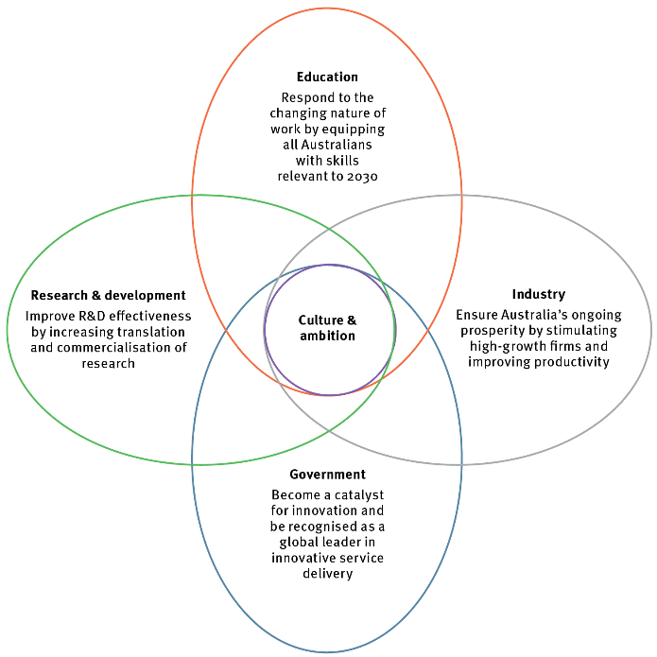

**IMPERATIVE 1: EDUCATION**

**We need to equip our kids with skills relevant to the jobs of 2030.**

In our conversations around the ISA board table we sometimes refer to education as setting the “speed limit” for our economy.

Yet just at the time when Australia needs to accelerate its innovation performance, and raise its economic speed limit, we are falling behind our global peers, particularly in student performance in science, mathematics and literacy.

**Slide 2: Imperative 1: Education**

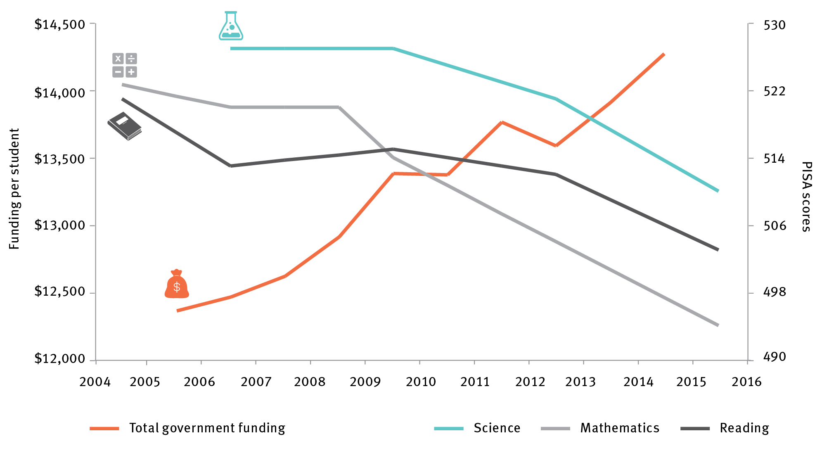

The data shows that while Australia has pockets of excellence in our education system, overall results in science, maths and literacy have declined in the last decade, despite increases in funding. **This must be reversed.**

Therefore ISA’s recommendations focus on changes necessary in secondary school curricula, quality of teaching, and student performance.

We focus on increasing teacher quality and training, noting for example that 40 percent of maths teachers are teaching “out of field” i.e. without any formal maths knowledge or training.

And given that digital literacy will be just as important in future work as basic literacy and numeracy, we support increased emphasis on STEM subjects with an expanding role for the STEM Partnerships Forum, bringing industry and education leaders together to lift student understanding and awareness of the relevance of STEM skills to a wide range of careers.

The changing nature of work in the future means that reskilling and life-long training and learning will be essential to establish a competitive workforce and to maintain a fair and inclusive society out to 2030 and beyond. The Plan therefore recognises and recommends the urgent need to restore and enhance the reputation and capability of the vocational education training (VET) sector.

We’ve seen recent announcements from the Opposition around a review of higher education including VET and we take that as a promising sign that this vital issue is being seriously considered by all sides of politics… **as it should be.**

**IMPERATIVE 2: INDUSTRY**

**We need to ensure Australia’s ongoing prosperity by stimulating high-growth firms and improving productivity.**

Australian business simply isn’t investing in innovation at the rate seen in the business communities of our competitor nations. And, more alarmingly, the trend in this investment has been falling since the GFC. BERD – the acronym for Business Expenditure on Research & Development – reached a highpoint of 1.3 percent of GDP in 2008, but fell to 1 percent in 2015-16. In the same year, BERD was at 3.6 percent of GDP in Israel, and around 2 percent of GDP in both Germany and the USA and at higher rates in other leading innovation countries. The reversal of this downward trend in R&D spending by our business is a top priority in the Plan. We need BERD to expand significantly, with something closer to 1.7% of GDP being a reasonable aim by 2030.

To achieve this goal, our Plan includes a number of recommendations aimed at encouraging start-ups and scale-ups. This includes improved design of existing research and development incentives (tax based, grants based and co-investments) …… incentives to drive a greater bang for the government’s buck and to make sure they are readily accessible to growth oriented companies, big and small.

For example, how do we get more companies like TEXTOR Melbourne based TEXTOR TECHNOLOGIES, which we feature as a case study in our plan. This company has been described as an “An overnight success after its first 10 years”, by a CSIRO colleague recently. Once a struggling small manufacturer, it is now supplying its clever moisture absorption fabrics for many hundreds of millions of nappies produced by Kimberley Clark in facilities here and worldwide. Textor worked with CSIRO to develop novel fabrics, and upgraded its Tullamarine factory to a state-of-the-art, automated facility. In doing so, all staff were retrained to perform higher value roles. These innovations have transformed Textor into a healthcare and hygiene leader, exporting across the Asia Pacific. The business has grown by 300 percent, and has opened up a multinational textile value chain.

As a Board we have noted that Australia’s reliance on indirect tax based incentives is out of step with other more innovative nations. (e.g.) Australia has only 13 percent of its business incentives in direct measures compared to Sweden, Germany and Israel at 100 percent, US 73 percent and the UK at 50 percent.

**Slide 3: Imperative 2: Industry**

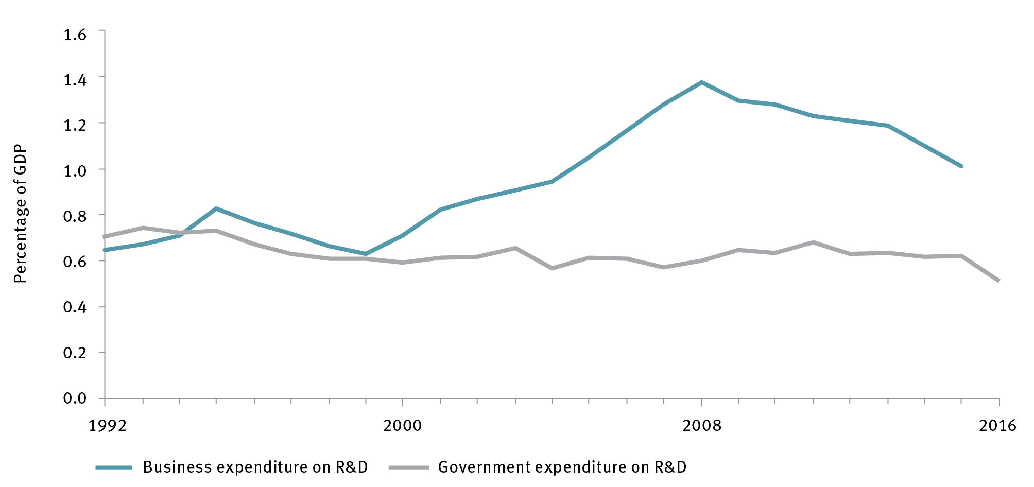

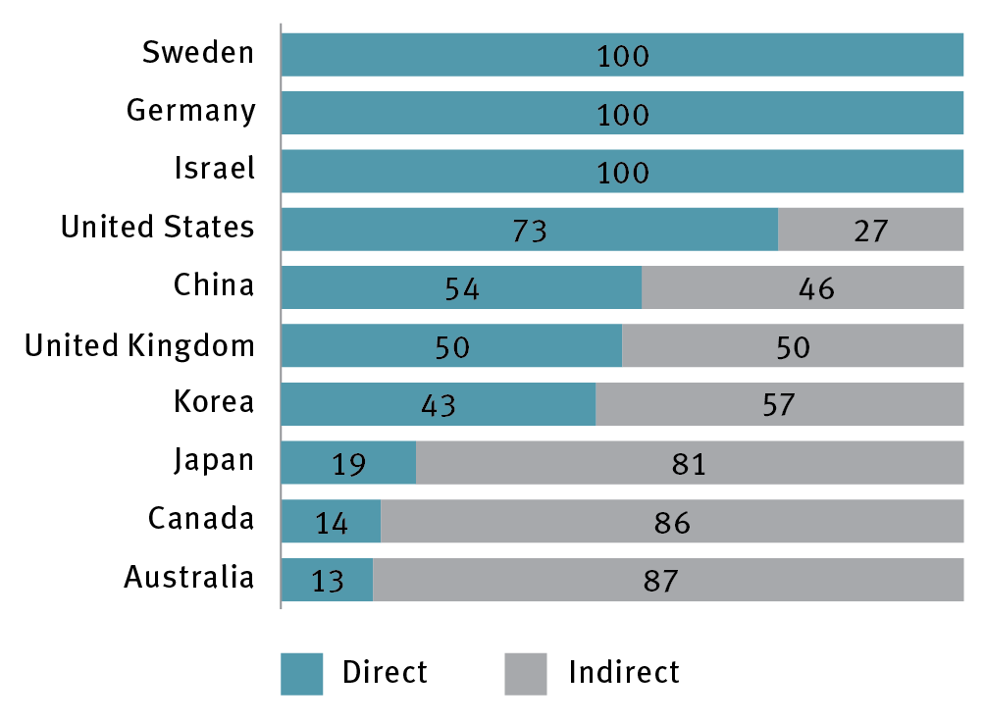

Our report calls for changes in the RDTI aimed at improving the additionality and sustainability of this indirect tax program. These changes build on and refine the recommendations from the previously-published 3F’s review, (commissioned by NISA and fondly referred to as the 3F’s being Fraser, Finkel and Ferris).

We also need to ensure long-term sustainability of the R&D Tax Incentive, given its role in supporting Australian firms’ R&D activities. To do this we’ve recommended a $4m cap on the refundable component of the RDTI. The original 3F report recommended a $2m cap and in reformulating this figure we’ve listened carefully to industry concerns, particularly in the expanding biotech and medtech sectors.

We’ve also recommended providing a stronger incentive for larger firms to invest more than 1% of their annual expenditure in R&D. We’ve recommended a 1 per cent trigger meaning that firms investing more than 1% of their total business expenses in R&D can claim all of their eligible R&D expenditure.

At the same time as improving the indirect RDTI program, we have made recommendations for where direct support should be expanded.

Such direct support includes some of the government’s most effective support activities including the CRC and CRC P program, Industry Growth Centres, challenge grants, EP and the Export Market Development Grants.

Exports are a strong proxy for innovative and competitive performance and our plan therefore calls for an expansion of Austrade’s EMDG program. Indeed approximately 50 percent of the SME’s in the EMDG program are achieving better than 20 percent per annum growth in employees and sales. With consumer households in Asia expected to double from 600 million today to 1.2 billion by 2030, we believe there is a large multiplier opportunity to be supported by this recommendation.

An example of an EMDG recipient is Quickstep. Quickstep’s advanced process technologies provide its customers with lower cost manufacturing solutions for niche volume production. EMDG has encouraged them to attend key international tradeshows. In addition to manufacturing parts for the JSF program, Quickstep is now also supplying parts for the C-130J Super Hercules aircraft program. Quickstep partners with some of the world’s largest aerospace and defence organisations, including the U.S. Department of Defense, Lockheed Martin, Northrop Grumman, BAE Systems and Thales. They have won the National Defence Innovation Award and the Premier's NSW Export Award for Manufacturing.

A further key recommendation relates to the fact that competing in the global innovation economy also requires access to the best talent available. As a small part of the global community, Australia can’t expect to find all of this talent within its own shores. It is therefore vital we have an immigration policy that can attract and retain world class talent for our innovation system. We continue to recommend that government strengthens its capacity and commitment to attracting international talent, which is critical to Australian firms competing on the world stage.

**IMPERATIVE 3: GOVERNMENT**

**Government must become a catalyst for innovation and be recognised as a global leader in innovative service delivery.**

ISA believes Australian governments can and should make greater strategic use of their role in the economy to stimulate innovation amongst SMEs and high growth firms.

**Slide 4: Imperative 3: Government**

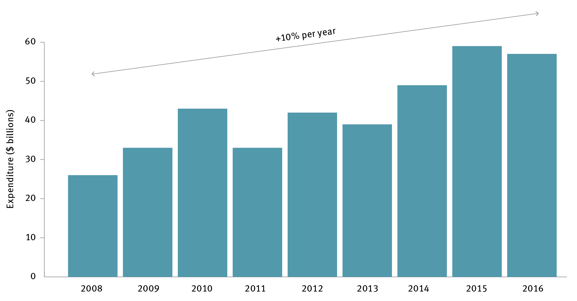

The plan recommends that 33 percent of government procurement contracts should be awarded to SMEs by 2022 (measured in dollar value) and it recommends Governments should accelerate the trial of innovative new approaches to supporting SMEs and high growth firms, such as a “government as a first customer” program.

Australian governments are also sitting on a stockpile of rich data assets. We need to get better and faster at making high value data available, so that third party users can harness it to create new insights and services.

High quality curated data is also an essential ingredient for AI and the efficiency of its algorithms. This carries implications and opportunities for almost all industries, from transport to healthcare and education.

All too often the focus in the public debate on innovation is only on how Governments **invest** in supporting innovation, rather than how they themselves **innovate**.

We need a public service with contemporary skills, broad experience and an open culture. We also need to rethink the way the public service is organised, so public servants can work more effectively in cross-agency teams, rather than the current default model of policy and service silos. Such a public service could then be fit for purpose to drive greater innovation in a transformed digital economy.

Therefore, the Plan calls for a review of the Australian Government Public Service to enable a greater role and capability for innovation in policy development, implementation and service delivery.

**IMPERATIVE 4: RESEARCH AND DEVELOPMENT**

**We must improve R&D effectiveness by increasing translation and commercialisation of research**

Australian researchers produce world class knowledge and ideas. But we badly lag our competitor nations in commercialising this intellectual property. The level of collaboration between business and researchers is also lagging our competitors, e.g. the contribution of Australian industry to higher education R&D is just 5%, and below the OECD average.

**Slide 5: Imperative 4: Research and development**

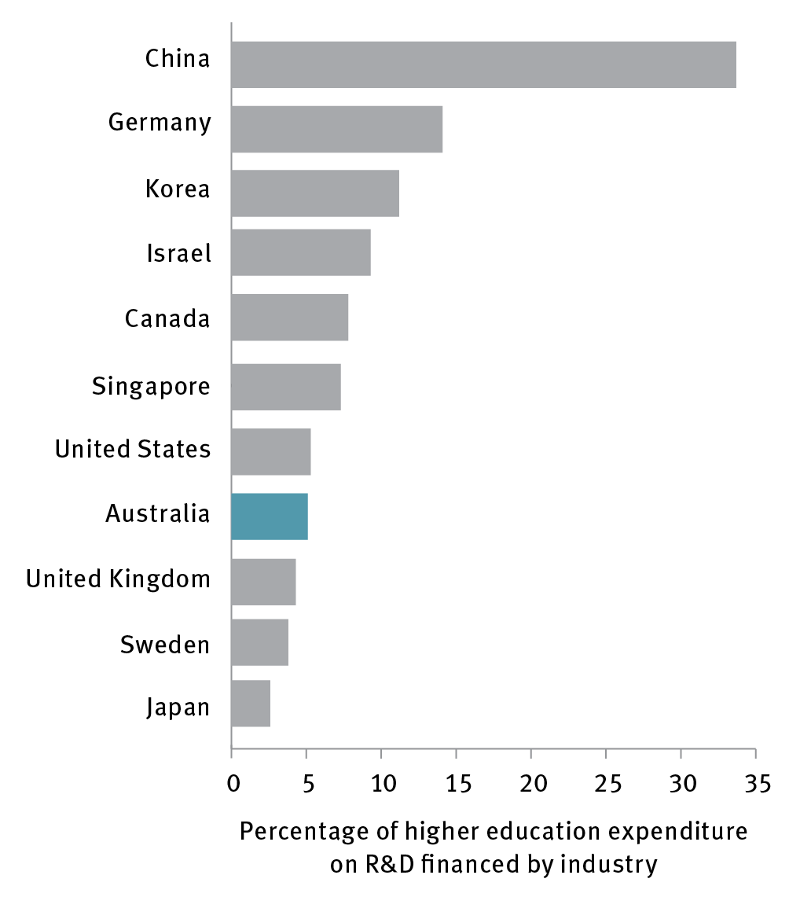

The fantastic talent we have in PhD students is not being taken up by Australian business to the extent that is seen in our competitor nations. For example, recent data shows that for business researchers per thousand employed by industry we sit 21st out of 36 comparable nations. Changing this dynamic, and unlocking the economic and social value of our best ideas both at home and through our exports to the world, is critical to lifting our innovation potential.

Our Plan recommends incentivising collaboration between researchers and businesses by adding a collaboration premium to the RDTI, encouraging more movement of researchers between industry and institutions and more businesses to reach out to our universities and other publicly funded research organisations including CSIRO and the MRI’s. What we need is a ramp up in the exchange among universities and businesses and we believe a collaboration premium will provide an additional boost to this. These joint initiatives produce great outcomes for businesses and their bottom lines, for universities and their researchers, and most importantly for the nation and our innovation system as a whole.

A great example of an initiative that supports industry-research collaboration is the **CRC Programme**; which is a merit-based grants programme that brings together industry, universities and research organisations to conduct and commercialise leading-edge research.

An example is helpful: the **Wound Management CRC** was set up in 2010 to conduct leading-edge collaborative research with the aim of improving the lives of people suffering from wounds. Chronic wounds are estimated to affect more than 433,000 Australians and cost the health system over $2.85 billion a year. Patients can suffer for years, even decades, and this costly chronic health problem leads to many avoidable amputations. One of the many causes of this silent epidemic is that patients must navigate a complicated, fragmented system where not all health professionals use routine best practice to get their patient’s wounds treated. The Wound Innovation CRC research has led to the development of The Wound Innovations clinic, which is applying technology developed by the CRC to transform the lives of Australian wound patients. The Wound Innovations clinic in Brisbane draws together a pool of specialist wound healing talent, now accessible to all Australians through videoconferencing facilities.

Participants in the Wound Management CRC include the University of Western Australia, Curtin University of Technology, Queensland University of Technology, 3M Australia and Ego Pharmaceutics.

In addition, we have reaffirmed the need for Government to establish secure, long-term funding for national research infrastructure, which is a key foundation for our innovation system. This is in accordance with the recommendations of the 2016 National Research Infrastructure Roadmap, which was developed under the expert guidance of my colleague and ISA Deputy Chair, Chief Scientist Dr Alan Finkel.

We have also recommended that the government release an Australian Innovation Precincts Statement to help shape their involvement in the emergence of local clusters of innovation around the country. One of the case studies highlighted in the report shows a glimpse of where we need to head. It tells the story of the Geelong Future Economy Precinct. In five years since the shut-down of the auto industry, the precinct has created well over 1000 jobs in advanced manufacturing, with a particular specialisation in carbon fibre technology. It brings together pioneering companies including Carbon Nexus, CleanTeq, LeMond Composites and Carbon Revolution, and is anchored by Deakin University. Carbon Revolution supplies Ford USA with all of its carbon fibre wheels for the Mustang range. It is also developing products for the aviation sector where strength with lower weight is the holy-grail.

I’d like to take this opportunity to put a spotlight on Universities Australia’s recently launched Clever Collaborations report, which makes the case for introducing greater incentivisation for Australian businesses to collaborate with our world-leading universities, is a practical step in the right direction to facilitate collaboration through providing businesses with a listing of the best pathways to approach every Australian university.

Drawing on analysis by Cadence Economics, the report highlights the potential payoffs for the nation in greater collaboration. The Universities Australia analysis found a “strong direct return on investment to companies of $4.50 for every $1 invested in collaborative university research in Australia.” Like our 2030 Plan, this report sees real value in Australia’s R&D sector maintaining the excellence that has become its hallmark through increasing the incentives for collaboration and commercialisation.

**So to the final but very important IMPERATIVE 5: CULTURE AND AMBITION**

Where I see a big gap between Australia and the world’s leading innovation nations is in the level of our aspiration, and our willingness to tackle very big problems, at a global scale.

To help build a culture that inspires Australians to take on some of the really big challenges and to proudly celebrate their own outstanding science and innovation, the Plan recommends a program of National Missions.

Large scale initiatives, catalysed by governments that address audacious challenges; Australia has a grand tradition of such visionary projects, for example the Snowy Mountains Scheme and SKA telescope and more recently the pursuit of quantum computing led by our Australian of the Year Professor Michelle Simmons.

Such a program would invigorate the public’s excitement and imagination for science and innovation, and inspire our best thinkers and entrepreneurs to solve our greatest challenges.

ISA is recommending that the first such National Mission should be to use genomics and precision medicine to assist Australia becoming the healthiest nation on Earth. This will entail the expansion and integration of genomics and precision medicine capability into our national health and medical system. It is a grand project.

**Slide 6: Imperative 5: Culture and Ambition**

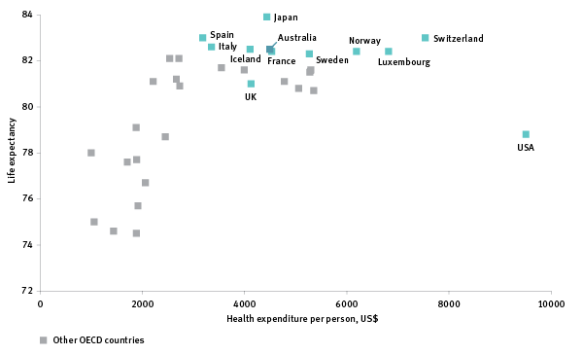

Integrating an expanded capability in genomics and precision medicine into our national healthcare system will ultimately deliver earlier diagnosis and prevention as well as novel therapies and cures. This will assist Australia in becoming the healthiest nation on earth.

**IN SUMMARY:**

Our Report is a report to Government; but its recommendations address all sectors of the economy and all of our citizenry. Ultimately it is about what sort of country we want by 2030 and beyond. We believe that the big challenge is not a shortage of jobs but a shortage of workers appropriately skilled to fill the jobs required by 2030.

Of course we cannot, and do not, leave this heavy lifting to Government alone. Indeed the thrust of our recommendations is to stimulate significant increases in business investment in innovation via leveraging strategic Government actions.

The Report lays out a roadmap for Government action, for implementation of all 30 recommendations by 2022 and for periodic 4 yearly assessments of progress. We have selected 17 domestic and international metrics against which to measure our innovation performance in this journey out to 2030. In only 5 of these 17 measures do we presently rank in the top quartile of nations. So we do have a long way to go.

Innovation is the key to a sustainable prosperity less dependent upon the performance of our commodities exports and historically favourable terms of trade, and more widely driven by the development and commercialisation of our own ideas and inventiveness.

I have described our mediocre performance in innovation as more than just a canary chirp in our economic mineshaft – but more a national clarion call for action.

Now that our report is with government, ISA’s hope is that the 2030 Plan will be realised in full.

**Thank you.**