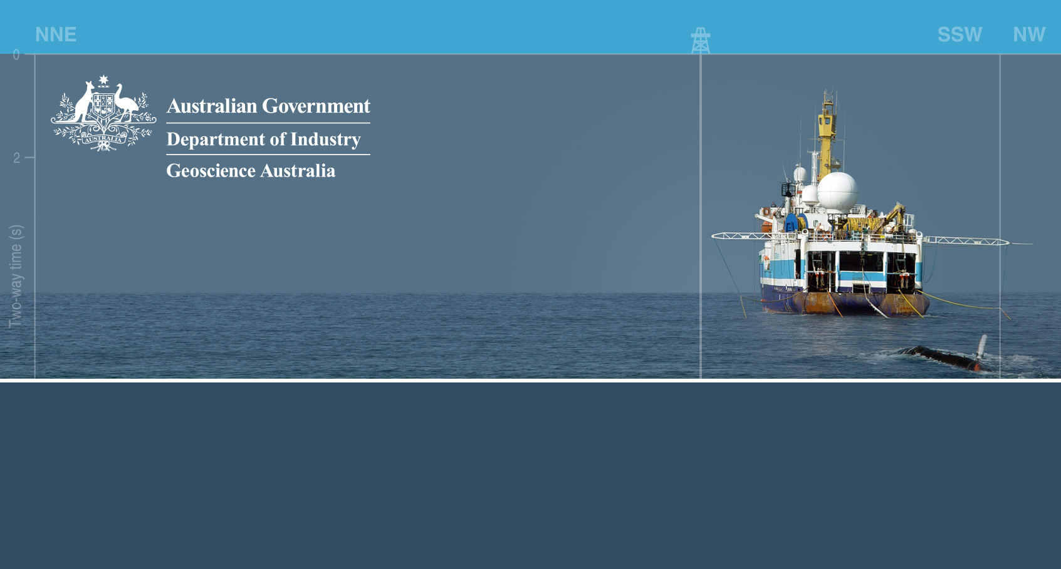OFFSHORE GREENHOUSE GAS STORAGE  
ACREAGE RELEASE | AUSTRALIA 2014

# Release Areas Graticular Block Listing and Diagram— Gippsland Basin, Victoria

## VIC14­-GHG-1

Map Sheet SJ 55 (Melbourne)

|  |  |  |  |  |
| --- | --- | --- | --- | --- |
| 1914 Part | 1915 Part | 1985 Part | 1986 Part | 1987 |

Assessed to contain 5 blocks (1 full block and 4 part blocks)

## VIC14­-GHG-2

Map Sheet SJ 55 (Melbourne)

|  |  |  |
| --- | --- | --- |
| 2197 Part | 2198 Part | 2199 |

Assessed to contain 3 blocks (1 full block and 2 part blocks)

## VIC14­-GHG-3

Map Sheet SJ 55 (Melbourne)

|  |  |
| --- | --- |
| 2200 | 2201 |

Assessed to contain 2 full blocks

2014 Block Diagram–Release Areas: VIC14-GHG-1,   
VIC14-GHG-2 and VIC14-GHG-3

VIC14-GHG-1 consists of 5 blocks, 2 full blocks and 3 part blocks and covers an area of approximately 225 km2. All block numbers representing the Release Area are listed in the Block List matrix for Release Area 1 and belong to Map Sheet SJ55 (Melbourne).

VIC14-GHG-2 consists of 3 blocks, 1 full blocks and 2 part blocks and covers an area of approximately 135 km2. All block numbers representing the Release Area are listed in the Block List matrix for Release Area 2 and belong to Map Sheet SJ55 (Melbourne).

VIC14-GHG-3 consists of 2 full blocks and covers an area of approximately 140 km2. All block numbers representing the Release Area are listed in the Block List matrix for Release Area 1 and belong to Map Sheet SJ55 (Melbourne).
For convenience, geographical coordinates shown on this map are expressed in terms of the Geocentric Datum of Australia 1994 (GDA94). Permit areas are defined by the 5 minute graticular block system set out under section 33 of the Offshore Petroleum and Greenhouse Gas Storage Act 2006; under Sections 37 and 38 of the Act, the position of those blocks is determined by reference to the Australian Geodetic Datum (AGD66).
