

NMI M 4

Pattern Approval Specifications for
Milk Tanks
First edition — June 1981 (Document 114)
Second edition — January 1992 (Document 114)
Second edition, first revision — August 2001 (renamed NSC M 4)
Second edition, second revision — July 2004 (renamed NMI M 4)
Second edition, third revision — February 2006 (added clause 3.14(e))
Bradfield Road, Lindfield, NSW 2070
PO Box 264, Lindfield, NSW 2070
Telephone: (61 2) 8467 3600
Facsimile: (61 2) 8467 3610
Web page: http://www.measurement.gov.au
© Commonwealth of Australia 1981
CONTENTS
1. General 1
1.1 Scope 1
1.2 Terminology 1
2. Metrological Requirements 2
2.1 Maximum Permissible Errors 2
2.2 Units of Measurement 2
2.3 Maximum Scale Interval 2
2.4 Tank Rigidity 2
2.5 Sensitivity of Level Indicator 2
2.6 Verification Standards 2
3. Technical Requirements 2
3.1 Types of Tank 2
3.2 Suitability for Purpose 2
3.3 Suitability for Verification 2
3.4 Fraudulent Use 3
3.5 Operational Controls 3
3.6 Maximum Capacity Indication 3
3.7 Tank Supports 3
3.8 Levelling Requirements 3
3.9 Stamping Plug 4
3.10 Covers, Bridges and Brackets 4
3.11 Inlet 4
3.12 Outlet 4
3.13 Measuring Equipment 5
3.14 Marking 7
Appendix A. Method of Verifying the Accuracy of a Milk Tank 8
Appendix B. Application of a Roman Level used to Inspect Milk Tanks 8
Appendix C. Examples of Recommended Scale Marks 10

1. General

1.1 Scope
This document specifies the metrological and technical requirements for the pattern approval of fixed milk tanks used to measure the volume of milk contained in the tank by means of a linear measuring device. The tanks may also be used to measure other food products.
For other design and construction requirements refer to the appropriate documents issued by Standards Australia, e.g. AS 1187–1988. Refrigerated Bulk Milk Tanks and consult the relevant authorities, e.g. the Department of Agriculture, to ensure that the tank is suitable for its intended purpose. The tank shall also comply with the relevant safety requirements before being submitted for pattern approval.

1.2 Terminology

1.2.1 Milk Tank
A covered, insulated container consisting of an inner stainless steel vessel and an outer casing used to contain milk.

1.2.2 Dipstick
A vertical rigid bar which is graduated and can be dipped into the liquid to measure its level in the tank

1.2.3 Dipstick Socket
A rigid seating fixed to the tank into which the dipstick fits when a measurement is made. The dipstick seats in the socket in one position, i.e. the position at which it is verified and used.

1.2.4 Level Indicator
A device for indicating that the tank is in a level position. The linear measuring device is calibrated to be correct when the tank is in a level position

1.2.5 Level Marks
Fixed marks on the linear measuring device and the tank which are all in the same horizontal plane when the tank is in a level position.

1.2.6 Linear Measuring Device
A device which measures the level of the liquid contained in the tank and is calibrated to indicate the volume contained in the tank at that level.

1.2.7 Maximum Capacity
Value of the volume represented by the highest scale mark.

1.2.8 Maximum Permissible Error
The extreme values of error permitted for the measuring instrument.

1.2.9 Minimum Capacity
Value of the volume represented by the lowest scale mark.

1.2.10 Scale
An ordered set of scale marks together with associated numbering forming part of the liner measuring device.

1.2.11 Scale Interval
The difference between the scale values corresponding to two successive scale marks expressed in the units marked on the scale.

1.2.12 Scale Mark
A line on the linear measuring device corresponding to a defined value of the volume measured.

1.2.13 Sight Gauge
Comprises a sight tube and a scale fixed externally to the tank and connected to the contents of the tank so that the level of liquid in the tube corresponds to the level in the tank and can be measured on the scale.

2. Metrological Requirements

2.1 Maximum Permissible Errors
The maximum permissible error for (re)verification and (re)certification shall be ± 1 scale interval for all scale intervals on the linear measuring device.

2.2 Units of Measurement
The unit of measurement shall be the litre (L).

2.3 Maximum Scale Interval
The maximum scale interval of the linear measuring device for a range of maximum capacities is given in Table 1. Tanks may have a linear measuring device with a scale interval less than that given in Table 1, but the maximum permissible error will apply to the scale interval used and not to the maximum scale interval specified in Table 1.
Table 1. The maximum scale interval for a range of maximum capacities
Maximum capacities | Maximum scale interval
Up to 1000 L inclusive | 2 L
Over 1000 L and up to 2 500 L inclusive | 5 L
Over 2 500 L and up to 5 000 L inclusive | 10 L
Over 5 000 L and up to 10 000 L inclusive | 20 L
Over 10 000 L and up to 25 000 L inclusive | 50 L

2.4 Tank Rigidity
The tank shall be designed to be rigid so that when a static load of 100 kg is applied to any position on the structure supporting the linear measuring device any change in the reading of the volume of contents shall not be more than an amount equal to half the scale interval.

2.5 Sensitivity of Level Indicator
If a level indicator is fitted, when the tank is tilted the movement of the indicator shall be at least equal to the corresponding change in liquid level on any part of the linear measuring device.

2.6 Verification Standards
The accuracy of standards used to verify tanks and their linear measuring devices shall have an overall uncertainty (99% confidence level) of not more than one-third of the maximum permissible error specified

3. Technical Requirements

3.1 Types of Tank
Tanks may be either open-top with a cover(s) or closed-top with an access hole. Open-top tanks may be either rectangular or circular in plan.
Closed-top tanks may be either rectangular (e.g. horizontal/cylindrical) or circular (e.g. vertical/cylindrical) in plan.

3.2 Suitability for Purpose
The tank shall be designed and constructed so that:
(a) it is suitable for the purpose for which it is intended to be used;
(b) it is rigid and free from deformation under normal conditions of transport and use;
(c) it shall not corrode; and
(d) it shall be easy to clean and inspect.

3.3 Suitability for Verification
A tank shall be designed to enable the performance requirements of this document to be applied. Where necessary, a fixed ladder shall be provided to enable measurements to be carried out. A method for verifying the accuracy of the linear measuring device is set out in Appendix A.

3.4 Fraudulent Use
Instruments shall not facilitate fraudulent use.

3.5 Operational Controls
Mechanisms, e.g. plug-rods and valves, shall be designed so that they can only be set to the intended position. Any removable part which can affect the measurement shall be identified with the tank, e.g. by the same serial number.

3.6 Maximum Capacity Indication
The scale mark indicating the maximum capacity shall be 35 mm or more below the point of overflow of the tank.

3.7 Tank Supports
A tank which is not designed to be mounted on a solid plinth or fixed to the floor in accordance with clause 3.8.2(b) shall he fitted with adjustable supports or feet to permit it to be placed in its reference position when installed on a floor with a gradient 1 in 50 or less in any direction provided that the fall of the floor between the supports is 50 mm or less.

3.8 Levelling Requirements

3.8.1 Level Marks
Tanks shall have level marks clearly and permanently indicated in accordance with (a) or (b) and (c), (d) or (e):
(a) Tanks circular in plan — three level marks approximately evenly spaced.
(b) Tanks rectangular in plan — four level marks, one at each corner.
(c) Open-top tanks — level marks on the internal surface of the tank at a level which corresponds with the maximum capacity of the tank.
(d) Closed-top tanks — level marks on the external surface of the tank. Such marks may represent any liquid level provided that it corresponds with a line marked ‘level mark’ engraved on the linear measuring device (see clause 3.13) in a manner that will not interfere with reading the scale marks.
(e) Horizontal cylindrical tanks — level marks on the external surface of the tank at the widest horizontal cross-section. The liquid level represented by the marks shall correspond with a line marked ‘level mark’ engraved on the linear measuring device (see clause 3.13) in a manner that will not interfere with reading the scale marks.
External marks shall be accessible for checking with a Roman level (see Appendix B).

3.8.2 Method of Levelling
Tanks shall be maintained in a level position by either:
(a) using an indicating level fitted to the tank in accordance with clause 3.8.3; or
(b) fixing each support of the tank to a foundation which is designed so that any adjustment or movement of the support will deface a verification seal.
The level shall be set by reference to the level marks specified in clause 3.8.1.

3.8.3 Means of Indicating Level
Any tank not fixed as described in clause 3.8.2(b) shall be fitted with one of the following ways to determine the level position:
(a) A spirit level or plumb-bob of the required sensitivity (see clause 2.5), provided that a tank with vertical sides is not required to have a level indicator if the dipstick is mounted within 5 mm of the vertical axis of symmetry.
The material for fixing the glass vial of a spirit level in its metal container and the means of fixing the container to the tank shall be resistant to hot and cold water, milk, cleaning and sanitising agents. Plaster of Paris shall not be used to fix the vial and aluminium rivets shall not be used to fix the container.
(b) Two dipstick sockets located equidistantly on each side of the axis of symmetry in a plane containing that axis, and at least 1 m apart.
(c) A Roman level of the required sensitivity (see clause 2.5) permanently fixed to the tank in a position where its indication corresponds with external level marks.
One end of the Roman-level device and the level marks shall be at a height which can be easily read and shall be in proximity to the linear measuring device.
Tubing in Roman levels shall be rigid and have an internal diameter of 6 mm or more.
The vertical plane of the Roman level shall be 50 mm or less from the vertical plane containing the linear measure device and the axis of symmetry of the tank.

3.9 Stamping Plug
A stamping plug shall be provided for an inspector’s mark or a servicing licensee’s mark. A stamping plug shall consist of a lead plug (or other approved material) securely set below the surface of an undercut hole and secured so that it cannot be removed from the instrument without defacing the mark. The lead plug shall have a circular face of at least 12 mm diameter or a rectangular face of at least 8 mm × 25 mm, and shall be readily accessible for stamping by means of a 50 mm long stamping tool (see clause 3.13.1.4(b)).

3.10 Covers, Bridges and Brackets
Covers shall allow easy inspection and sampling of the liquid. Bridges, brackets and spirit level mountings shall be sufficiently rigid so they are neither distorted nor deflected under the action of the agitator or the weight of the cover when it is latched open.

3.11 Inlet
The tank shall have at least one inlet pipe or inlet aperture. It may have both.
Where an inlet pipe is part of the tank it shall be designed to minimise froth formation. For example vertical tanks of large capacity may need a bottom inlet. If the inlet is at the bottom it shall also be used as the outlet (see clause 3.12).

3.12 Outlet
The tank shall be provided with only one outlet which complies with the following requirements:
(a) the outlet orifice and the bottom of the tank shall be designed so that the liquid drains to the outlet;
(b) the highest point of the inside of the outer end of the outlet pipe, including the outlet valve, shall be lower than the lowest part of the bottom of the inner tank (see Figure 1);
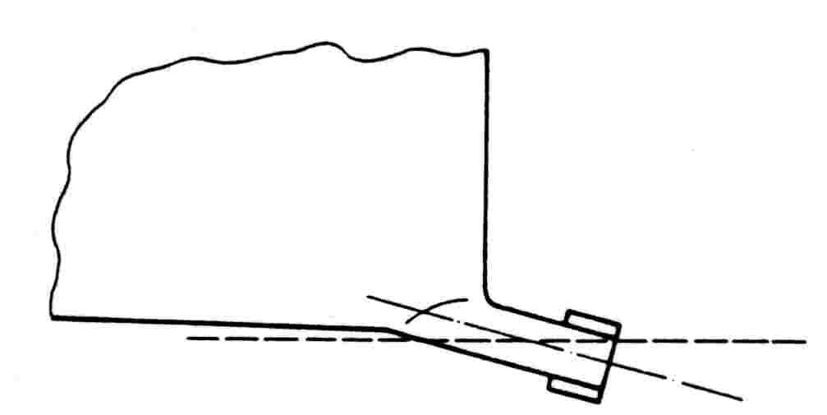
Figure 1. Outlet position (the dashed line represents the horizontal position)
(c) if an outlet valve is fitted it shall be free draining;
(d) the total length of the outlet pipe shall be as short as practicable;
(e) when a plug and rod device is used in place of an outlet valve, it shall be designed so that the plug seals without the rod having to be clamped in position; the plug and rod device shall remain clear of the agitator in the open position and shall not interfere with the draining of liquid; and
(f) with the tank in its reference position and containing 40 L of liquid, at least 39.8 L shall run out by gravity in 1 min.

3.13 Measuring Equipment
Tanks shall be fitted with a linear measuring device such as a dipstick or sight-gauge to determine the volume of liquid contained in the tank.

3.13.1 Dipsticks

3.13.1.1 General
Dipsticks shall give correct, reproducible readings. They shall have a matt finish and provision shall be made for the dipstick to be observed in the liquid before it is withdrawn for reading.

3.13.1.2 Graduation
Dipsticks shall be graduated from the maximum capacity of the tank down to at least 10% of the maximum capacity.
The graduated part of the dipstick shall be rectangular in section, between 25 mm and 30 mm wide and at least 5 mm thick.
Dipsticks shall have a graduated scale legibly engraved, etched or otherwise permanently marked, as described below:
(a) the dipstick shall be graduated in litres;
(b) the distance between the centre lines of any two adjacent scale marks shall be at least 1.5 mm;
(c) the numerical value of the scale interval shall be 1 × l0^{n}, 2 × l0^{n} or
5 × l0^{n}, where n is any positive or negative whole number or zero; and
(d) the arrangement of the scale marks shall comply with NMI P 105. Graduation of Analogue Scales; for examples see Appendix C.

3.13.1.3 Seating
A dipstick shall always seat in the position in which it was calibrated and shall clear the bottom of the tank by at least 5 mm.

3.13.1.4 Identification Markings
The dipstick shall have the following means of identification:
(a) the maker’s name and a serial number which corresponds with the serial number of its tank;
(b) a stamping plug to imprint an inspector’s mark or a servicing licensee’s mark (see clause 3.9); and
(c) a statement of the volume of liquid which corresponds to the interval between adjacent scale marks, e.g. 10 litre GRADS, 10 L GRADS or 10 litre GRADUATIONS, near the top of the dipstick on its graduated face.

3.13.1.5 Dipstick Reading
Before a reading is taken the dipstick shall be clean and dry, the surface of the liquid shall be settled and any froth near the point of entry of the dipstick shall have been hygienically moved aside.
The following procedure shall then be followed:
(a) the dipstick shall be inserted vertically and gently into its lowest position, taking special care during the last 10 mm to prevent ripples;
(b) the dipstick shall be withdrawn vertically, gently and promptly;
(c) the line of demarcation between the wet and dry parts of the dipstick shall be read to the nearest scale mark.

3.13.2 Sight-gauges

3.13.2.1 General
A sight-gauge, which is comprised of a sight-tube and a graduated scale, shall be:
(a) located near the outlet valve;
(b) mounted vertically;
(c) clearly visible and readily accessible so the entire scale may be read; a fixed ladder shall be provided when the maximum capacity datum on the sight-gauge is higher than 1.8 m; and
(d) incorporated in the automatic cleaning system of the tank; the connection of the sight tube to the automatic cleaning system shall not inhibit the venting of the sight tube to the atmosphere.

3.13.2.2 Design
A sight-gauge shall be designed and constructed so that:
(a) the sight-tube is maintained rigid and adjacent to the base line of the scale along its entire length to avoid parallax error;
(b) the sight-tube shall be fitted with a valve (or valves) at its base which:
(i) connects the sight-tube with the tank to fill the tube to the level of liquid in the tank so that the contents of the tank can be measured; and
(ii) drains the sight-tube without the liquid in the sight-tube flowing back into the tank or without draining the contents of the tank;
(c) the drain outlet for the sight-tube shall have a nominal internal diameter which is 26 mm or less;
(d) an optional liquid-sampling valve may be fitted to the sight-gauge provided the contents in the sight-tube can be isolated and the sample of liquid is taken directly from the tank;
(e) any valves which may be dismantled for cleaning, e.g. liquid-sampling valves and isolating valves, shall only be capable of being reassembled in the prescribed manner.
Note: The isolation valve in (b) and the liquid-sampling valve in (d) shall be as close to the tank as practical to reduce the amount of liquid exposed to ambient temperature.

3.13.2.3 Scale
The scale shall be:
(a) manufactured from a non-corrosive material of adequate strength, stability and rigidity;
(b) straight, smooth and free from any flaws;
(c) at least 25 mm wide and 3 mm thick;
(d) fixed in the calibrated position so that adjustment or movement of the scale will result in defacement of an inspector’s mark or servicing licensee’s mark;
(e) graduated in litres from 100% to at least 10% of the maximum capacity and the spacing between adjacent scale marks shall be at least 3 mm; and
(f) arranged so the scale marks comply with NMI P 105. Graduation of Analogue Scales, for examples see Appendix C.

3.13.2.4 Sight-tube
The sight-tube shall:
(a) be transparent and approved by the relevant health authorities;
(b) have a smooth bore of internal diameter of at least 15 mm and a wall thickness of at least 3 mm;
(c) be capable of being dismantled for cleaning or replacement without disturbing the position of the scale; and
(d) be made of material that is resistant to abrasives used for cleaning.

3.13.2.5 Level Marks
As an alternative to the requirements of clause 3.8.1(d) the volume equal to a scale mark represented by level marks on tanks fitted with a sight-gauge may be marked on the nameplate.

3.13.2.6 Sight-gauge Reading
With the tank in its level position the contents in the tank are determined as follows:
(a) open the valve to allow the liquid to enter the sight-gauge;
(b) ensure that the level of the liquid in the sight-gauge has reached equilibrium;
(c) with the eye at the same level as the datum line, read the nearest scale mark; the liquid level in contact with the sight-tube shall be taken as the datum line;
(d) close the valve to isolate the contents of the tank from the sight-gauge; and
(e) drain the sight-gauge.

3.14 Marking
The following information shall be marked on the tank:
(a) manufacturer’s name or registered mark;
(b) designation of model and serial number;
(c) capacity of the tank, i.e. the value of the highest scale mark on the linear measuring device;
(d) the number of the certificate of approval in the form ‘NMI no ….’; and
(e) year of manufacture.
If the tank is fitted with a level indicator there should also be a prominent statement in the vicinity of the measuring device to the effect that the level indicator should be checked before taking the reading on the linear measuring device.

Appendix A. Method of Verifying the Accuracy of a Milk Tank
The method of verifying the accuracy of a milk tank consists of delivering measured quantities of water into the tank to correspond with selected scale marks on the linear measuring device and reading it in the prescribed manger but without rounding.
The tank shall fast be set up in a level position by reference to the level marks specified in clause 3.8.1.
Using a verified standard (see clause 2.6), accurately measure a quantity of water into the tank to correspond with the following volumes on the linear measuring device:
(a) the lowest scale mark;
(b) at least three intermediate scale marks which are approximately evenly spaced; one of the marks should coincide with the level mark on the linear measuring device; and
(c) the highest scale mark.
After each measured addition read, in the prescribed manner but without rounding, the volume indicated on the linear measuring device. The difference between this volume and the volume of water measured into the tank shall not exceed the maximum permissible error (see
clause 2.1).

Appendix B. Application of a Roman Level used to Inspect Milk Tanks
Roman levels apply the hydrostatic principle that the surface of a liquid is level. A Roman level suitable for checking tanks is comprised of 3 to 5 m of flexible tubing of 10 to 15 mm bore with a plain glass tube approximately 15 cm long inserted in each end. Clear plastic tubing is preferable and should not be of smaller bore because of difficulty with air bubbles. The glass tube enables a good meniscus to be obtained.
When filled with water, a Roman level can compare levels inside or outside a tank without filling the tank with water. Before carrying out such a measurement the levels in the tubes should be compared as shown to ensure that the tubing is completely filled. A difference in levels indicates the presence of air bubbles or a blockage.
Figure 2 shows how a Roman level may be used to check the level of a tank with external level marks. Similarly it may be used to check the level of a tank with internal marks without filling the tank with water, or to check the capacity mark on the linear measuring device of a tank with either internal or external level marks. It may also be used to check for bridge distortion or wear in a dipstick socket.
Figure 3 shows how a Roman level is used to check the capacity mark on the dipstick of a tank with external level marks when the tank is full of water. In this case the tube is completely filled by first overfilling the tank by a few litres and then siphoning back to the capacity mark through the Roman level.

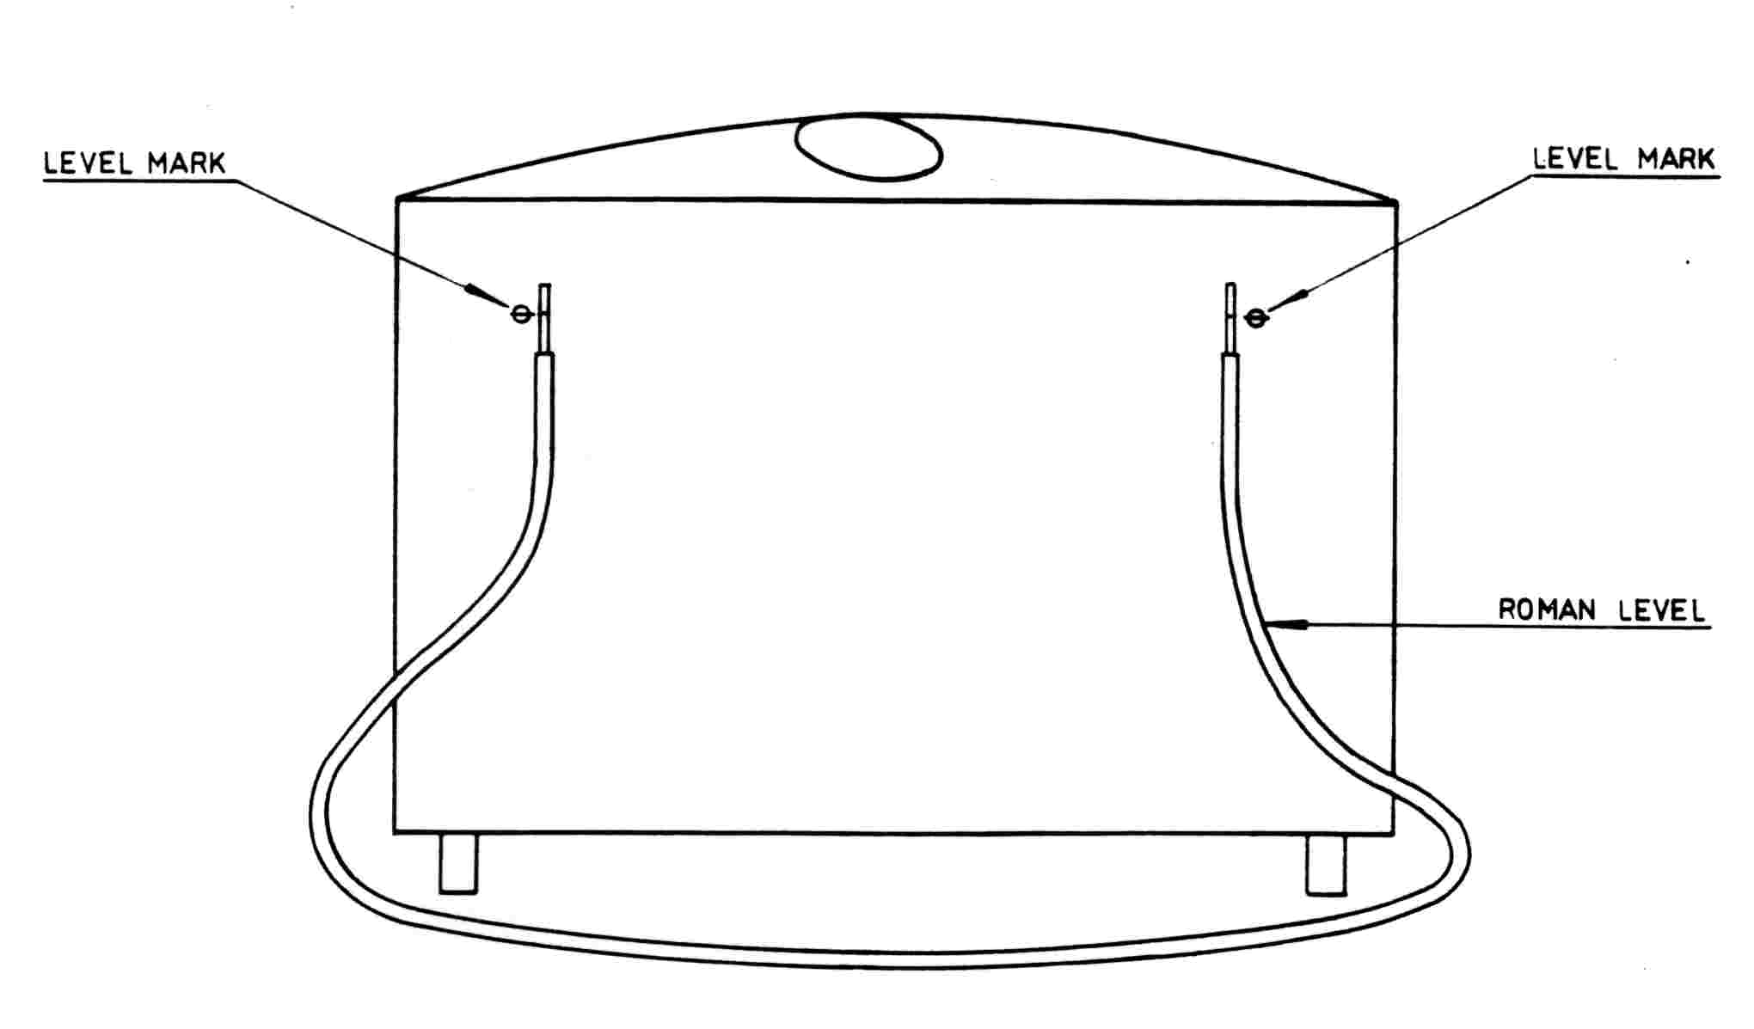Figure 2. A Roman level being used to check the level of a tank with external level marks
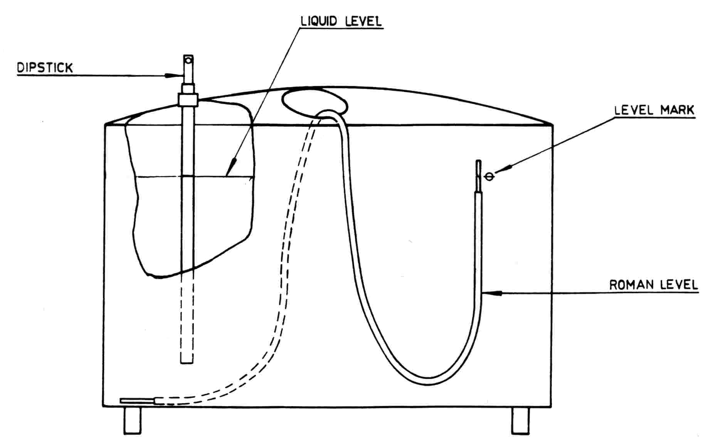
Figure 3. A Roman level being used to check the capacity mark on the dipstick of a tank with external level marks

Appendix C. Examples of Recommended Scale Marks
