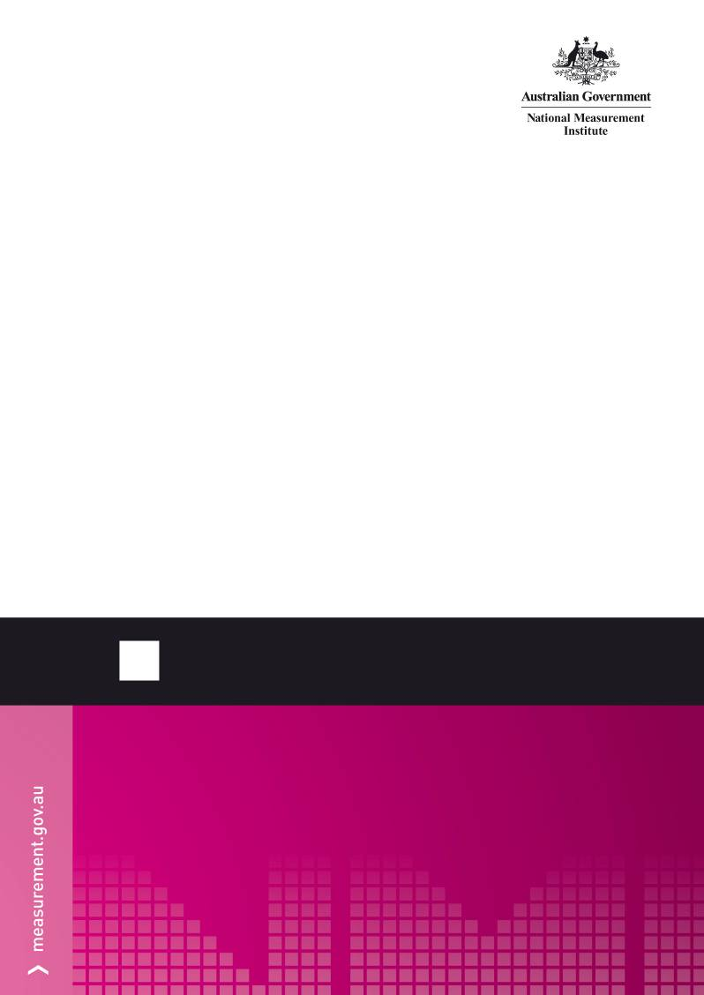
NMI M 7
Pattern Approval Specifications for Point of Sale Systems
© Commonwealth of Australia 2011
First edition — July 2011
First edition, first revision — June 2012
National Measurement Institute
Bradfield Road, Lindfield, NSW 2070
PO Box 264, Lindfield, NSW 2070
T (61 2) 8467 3600
F (61 2) 8467 3610
W www.measurement.gov.au

Amendments
Erratum | Date | Page | Location | Details of change
1 | 26/06/2012 | 2 | clause 5.4 | Amended to allow stored tare for packaging to be any value
2 | 26/06/2012 | 3 | clause 5.6 | Clarified NET and tare indication
3 | 26/06/2012 | 3 | clause 6.1.2 | Clarified required information for electronic indication
4 | 26/06/2012 | 3 | clause 6.1.3 | Reduced height requirement for operator display
5 | 26/06/2012 | 3 | clause 6.2 | Clarified requirement to make a receipt available
6 | 26/06/2012 | 4 | clause 6.2.3.3 | Allowed additional lines on printed tickets

CONTENTS
Amendments ii
Preface iv
1. Scope 1
2. Exclusions 1
3. Terminology 1
4. Terminology and Units of Measurement 2
5. General Requirements 2
5.1 Denomination of Indications 2
5.2 Measuring Instrument Approval 2
5.3 Arrangement of Digits 2
5.4 Scale Interval and Units of Measurement 2
5.5 Computation and Rounding 2
5.6 Indication of NET and Tare Values 3
5.7 Fraudulent Use 3
5.8 Markings 3
5.9 Sealing 3
5.10 Verification Mark 3
5.11 Supplementary Information 3
6. Specific Requirements 3
6.1 Electronic Indication 3
6.2 Printed Information 3
6.3 Software 4
Appendix Acceptable Formats for Labels and Tickets/Receipts 6

Preface
In 1983 the National Measurement Institute (then the National Standards Commission) introduced general supplementary certificate of approval S1/0 for Auxiliary Indicating Devices and later S1/0/A for Electronic Indicating and Printing Devices.
Since then technology has evolved and auxiliary devices have become more sophisticated. Software configurable systems are now the norm and functionality is in many instances moving from the measuring instrument into the auxiliary device. These devices now have functions which are defined in the pattern approval requirements documents for the measuring instruments to which they are connected, and form point of sale (POS) systems.
In order to control these types of devices and software systems more effectively, they have been re-incorporated into the current certificate system.
In July 2011, general supplementary certificate S1/0/A was replaced with S1/0B for simple auxiliary indicating, summing and printing devices. From this date, POS instruments were required to be assessed against document NMI M 7 and have their own pattern approval certificate.
NMI M 7 is based on the requirements of general supplementary certificate S1/0B and the appropriate NMI recommendations for measuring instruments to which the POS systems are to be connected.
NMI M 7 is also used to define label and transaction record requirements for measuring instruments approved against other requirements documents.

Scope
This document specifies the metrological and technical requirements for the pattern approval and verification of point of sale (POS) systems. These are systems which connect to approved measuring instruments and do more than just replicate the measurement data. These systems may perform functions such as price calculation based on measurement data or may have a stored or preset tare functionality.
Such systems typically consist of a controller, display and associated control software and are external to the measuring instrument but connected digitally.

Exclusions
Auxiliary devices or systems which have the following functions must be submitted to NMI for pattern approval against the relevant requirements document (e.g. NMI R 76,
NMI R 117, NMI M 7 etc) of the instrument to which they are to be connected. Devices to be submitted are those which:
- control a function on the measuring instrument; or
- modify the indication of the measured quantity on the primary indicator; or
- store calibration or other measurement related data for use by the measuring instrument; or
- control self-service arrangements for fuel dispensers.
Simple printers and indicators must meet the requirements of the general supplementary certificate S1/0B.
Auxiliary devices which process payment or invoicing information only, e.g. electronic cash registers which capture total price only, do not require pattern approval.

Terminology
Where terminology is not defined here, definitions may be taken from the relevant requirements document for the measuring instrument to which the POS is connected.

Approved Measuring Instrument
An instrument which has been pattern approved under the National Measurement Act, and whose certificate of approval:
- is currently in force under that provision; or
- has expired or been cancelled (but not withdrawn) under the National Measurement Act and was in force when the instrument was manufactured.

Auxiliary Device
A device associated with a measuring instrument which is intended to perform a particular function, directly involved in elaborating, transmitting or displaying measurement results, e.g. electronic indicating, summing or printing devices.

Controller
A data processing device, usually a computer with programmable/loadable software.

Denominations
The words or symbols which indicate the units of measurement, e.g. litre, kg.

Descriptors
Alphanumeric characters which describe the article being measured e.g. T-bone steak, unleaded petrol.

Family of Devices
A family of devices will cover a single model or series of models, or single software version or series of software versions, provided they are not substantially different in their operation.

Label
A statement intended to be attached to a package, usually self-adhesive.

Legally Relevant Software
Any software which participates in the system meeting the requirements of this document.

Measuring Instrument
A thing by means of which a measurement of a physical quantity may be made; or a component of such a thing.

Point of Sale (POS)
A component of a measuring instrument that is:
- approved for use for trade; and
- used for creating labels, receipts or documents; and
- able to convert the result of a measurement made by the measuring instrument; and
- not able to control the measuring instrument or to affect its metrological performance.

Primary Indicator
The indicator that forms a part/component of an approved measuring instrument and provides the first/initial source of information from the measuring instrument.

Simple Printers, Simple Indicators and Summing Indicators
A simple electronic indicating, summing or printing device which is interfaced to an approved measuring instrument in use for trade, to duplicate (but not calculate) price, unit price and/or measurement data.

Transaction Records
Permanent record of a transaction, e.g. ticket, receipt etc.

Terminology and Units of Measurement
The following are acceptable terms for units of measurement and price.
Mass | kg; kilogram; tonne; t; gram; g; metric carat; CM; ct.
Volume | litre; kilolitre; megalitre; millilitre; cubic metre; L; kL; ML; mL; m³.
Length | metre; centimetre, millimetre; m; cm; mm
Quantity | quantity; number; piece(s); item(s); count; qty; no.; pc; PCS; cnt.
Unit price | dollars/mv; $/mv; cents/mv; c/mv,  where ‘mv’ is any of the denominations for mass or volume above.  NOTE: pricing in cents, other than c/L, is prohibited for POS applications.
Price per item | price/piece(s); price/item(s); price/count; price each; price ea; price/pc(s); price/quantity; price/number; $/piece(s); $/pc(s); $/item(s); $/ea; $ each; $ ea.
Price | total price $; price $; dollars $; total $; $.
In the cases above, the word per is an acceptable alternative to ‘/’.
In all cases, the use of lower case denominations (other than for L for litres, M for mega and CM for metric carat) is preferred, however upper case may be used on an instrument with a limited character set.

General Requirements
All devices must comply with the following requirements:

Denomination of Indications
Indications of measured quantity (mass, volume, length etc.) shall be accompanied by the unit of measurement (or its symbol). A list of acceptable units of measurement and symbols are shown in clause 4.
Where a measured quantity is used to determine price, the measured quantity must be shown and be in the same units as the measuring instrument from which the data was derived.
Indications of price and unit price shall include the appropriate units of indication, e.g. $ or $/kg.

Measuring Instrument Approval
The system shall not alter the measuring instrument as approved. This includes removal or accessibility of the primary indication.

Arrangement of Digits
Indications shall be clear and arranged to permit reading easily and without the need for calculation.
Digits shall be horizontally aligned and oriented in the normal viewing position. The decimal marker on numbers less than unity shall be preceded by one zero digit (e.g. 0.5 kg).
Non-significant digits (i.e. additional leading zeros) shall not be shown, e.g. 050 kg. This does not apply to price indications.

Scale Interval and Units of Measurement
All auxiliary devices shall have the same scale interval as the measuring instrument and shall indicate or print values in the same units as the measuring instrument.
Preset tare values are not required to have the same scale interval as the measuring instrument.

Computation and Rounding
Where the device is used to calculate a value such as price, total price, net value of measured quantity, etc. the device shall compute the value correctly.
The result of a calculation of price shall be rounded to the nearest cent.
Further rounding is only permitted on total price and is NOT permitted with payment methods other than cash. Such rounding shall:
- be to the nearest 5 cents or be down to the next lowest 5 or 0;
- show the subtotal before the rounding calculation (unless there is only one line item on the transaction record); and
- show the total price after the rounding calculation.

Indication of NET and Tare Values
Measured quantities which have been automatically adjusted (e.g. to take into account the mass of packaging) must be accompanied by an indication of NET or N.
Note: It is not mandatory for the word ‘net’ to appear on labels for pre-packaged items.
Where indicated, preset tare values shall be accompanied by an indication of tare or preset tare e.g. PT.
For information relating to measurements made by a weighbridge, the measurements should always be associated with the word gross, tare or net as appropriate.

Fraudulent Use
Devices shall have no characteristics likely to facilitate fraudulent use.

Markings
Devices purporting to comply with this approval shall be marked in a clear and permanent manner, in one location, with the following information:
- submittor’s name or mark;
- serial number or other unique identifier; and
- NMI approval number.

Sealing
Provision may be required for sealing in accordance with the relevant sections of the requirements document(s) for the measuring instrument to which the POS is attached
(e.g. NMI R 76, NMI R 117 etc).

Verification Mark
Provision must be made for the application of a verification mark in the same field of vision as the data plate for markings (refer to clause 5.8).

Supplementary Information
Additional information, such as management data, which is outside the scope of these requirements, may be provided on the indicator or on the printed record of the transaction.
This information must not confuse, be inconsistent with, or qualify the meaning or accuracy of measurement data (including quantity, unit price or price).
This information shall not infringe upon the display area designed for the measurement data.

Specific Requirements
In addition to the general requirements set out in clause 5 instruments must meet all of the applicable specific requirements set out below for:
- electronic indication;
- printed information; and
- software.

Electronic Indication
    - Clarity of Indication
Indications shall be clearly visible to the party for whom the indication is intended. They shall be clear, unambiguous and stable, to allow easy reading of the values displayed. Where the device sums a number of transactions, the current line transaction shall be shown.
    - Required Measurement Information
The information below is required to be shown once for each transaction (as applicable):
- measured quantity;
- unit price or price per item; and
- price.
    - Height of Measurement Information
The height of digits, capital letters, symbols etc. related to measurement information listed in clause 6.1.2 shall be at least 4 mm.
On displays for the customer the height shall be the greater of:
- 3 × L mm, (where L is the reading distance in metres); and
- 9.5 mm.

Printed Information
Where the device has the capability to totalise transactions or operate with several customers at the same time, a transaction record shall be available to the customer, unless a label is produced for each transaction.
    - General
Printed information shall be clear, indelible and unambiguous.
The decimal marker shall be printed by the printer, not pre-printed on the label or transaction record. A period or comma can be used as the decimal marker.
Printing whilst the measurement data is changing must not be possible.
Printed label and transaction record examples are shown in the Appendix.
Note: Printing may also be required to satisfy other statutory legislation, e.g. for date, ABN (Australian Business Number), GST (Goods and Services Tax), use-by/best before dates etc.
    - Labels
      - Clarity of Indication
The height of all characters relating to measurement and price shall be not less than 3 mm for labels.
Labels shall be marked (as applicable) with the statements of:
- measured quantity;
- unit price or price per item; and
- price.
If the price and unit price are not applicable, the space where these values are normally printed shall be blank.
    - Transaction Records
      - Clarity of Indication
The height of all characters relating to measurement and price shall be not less than 2 mm for transaction records.
      - Required Information
Transaction records shall have the following information:
- unique transaction indentifier;
- location of the transaction;
- identity of the vendor (in the form of a company name or logo);
- date; and
- time.
Transaction records shall also list the items and include the following for each item:
- a clear descriptor;
- measured quantity or quantity;
- unit price or price per item; and
- price.
When applicable, the application of any credit amount shall be shown, e.g. fuel vouchers.
Any incorrect transactions which appear on the transaction record shall be easily detected, e.g. by repeating the transaction with a symbol indicating a cancellation, or by drawing a line through the transaction.
Pre-determined measurement data which has been entered manually shall be indicated as such.
      - Formatting
The descriptor field shall be at least eight characters long.
Price shall be in its own column and columns shall be separated by at least one space.
Information shall preferably be on a single line or in two lines. If the information is on more than one line then the layout must be consistent throughout the transaction record. The item descriptor shall be on the first line and the price shall be on either the first or last line.
The price column shall:
- be aligned right;
- not contain any other characters;
- be at least six digits wide; and
- not interfere with other printed characters.
Values of measured quantity, unit price and price shall be associated with its denomination, either:
- directly next to the value (e.g. 100 kg, $1.00); or
- by heading the column for these values by the denomination.
The total price shall always be preceded by the symbol ‘$’. The total price shall be highlighted, e.g. by increased font size or bolding.

Software
      - Version Control
Appropriate software version identification shall be assigned to any software that is legally relevant.
Legally relevant software may be identified as separate from non-legally relevant software through:
- the use of appropriate wildcards in a common version number; or
- via separate version numbers of legally and non-legally relevant components.
A method shall be provided to identify the legally relevant software version number.
    - Non-legally Relevant Software
Where legally relevant software has been separated from the non-legally relevant software and frequent changes to non-legally relevant software are anticipated (i.e. minor bug fixes, etc), an appropriate wildcard field in this software version number may also be identified. Changes to the software within this scope are not required to be assessed by NMI.
The non-legally relevant software must not be able to influence the legally relevant software in a manner that causes non-compliance with this document.
This software may operate simultaneously and on the same device as the legally relevant software, e.g. retail store management or inventory control database applications.
    - Configuration and Security
If the legally relevant software includes user configurable settings, these settings must be clearly documented, including the range of any adjustments possible where applicable.
It must not be possible to adjust any user configurable parameters in a manner which would result in the system becoming non-compliant with this requirements document.
Access to user configurable parameters must be protected by a secure method that allows only authorised changes to be made, e.g. password control to settings menu only.

Acceptable Formats for Labels and Tickets/Receipts
Labels
The formats shown are some examples of acceptable labels – other formats may be acceptable.
Tickets/Receipts

Note: Non-metrological printed information such as ABN and GST are not covered here – see the appropriate legislation.

