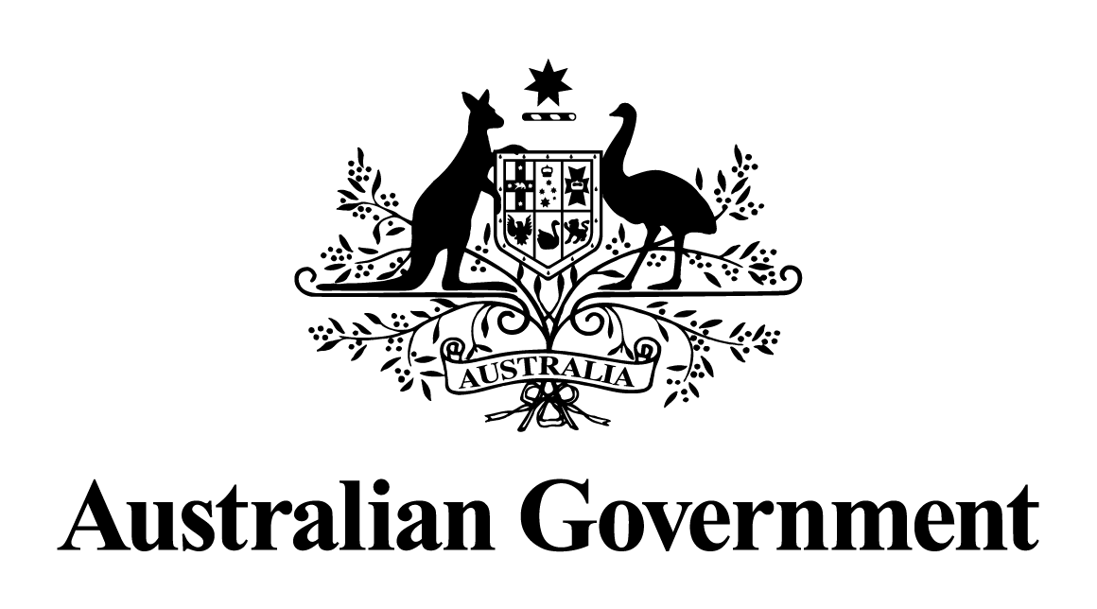

Australian Government response to the   
Senate Economics References Committee report:

Governance and operation of the Northern Australia Infrastructure Facility

October 2019

**Introduction**

The Australian Government recognises the report by the Senate Economics References Committee following their inquiry into the governance and operation of the Northern Australia Infrastructure Facility (NAIF), and thanks the individuals and organisations who contributed.

The Government is committed to making the most of the unique opportunities provided by the north, the NAIF is a key element to achieve this outcome. The NAIF continues to partner with other investors to develop the infrastructure required to support economic growth and larger, more resilient communities for northern Australia.

The NAIF is subject to the rigorous governance, operation and reporting requirements, established for all Commonwealth entities through the *Public Governance, Performance and Accountability Act 2013* (the PGPA Act), and under its purpose made legislation. It is also subject to a number of reviews, audits and a robust evaluation framework.

**Governance and operation of the Northern Australia Infrastructure Facility recommendations**

The Government notes the report includes twelve majority recommendations, with two additional recommendations provided in the Australian Greens Additional Comments. The Government’s response to each recommendation is provided below. The Government also notes the Coalition Senators Dissenting Report.

**Majority Recommendations**

**Recommendation 1:** The committee recommends that the *Northern Australia Infrastructure Facility Act 2016* be amended to require two responsible Ministers (the Minister for Resources and Northern Australia and the Minister for Finance) to provide oversight of the Northern Australia Infrastructure Facility.

The Government **does not accept** this recommendation.

The Government does not consider that the addition of a second responsible Minister would have the practical effect of strengthening oversight of the NAIF.

The NAIF Act establishes the NAIF as a separate Corporate Commonwealth Entity, with influence of the responsible Minister limited to:

* Issuing the NAIF’s Investment Mandate, which outlines the Government’s broad expectations of how the NAIF invests
* Appointing the members of the Board
* An ability to reject an Investment Proposal, within a certain timeframe and upon limited grounds.

These responsibilities are executed by the Minister, but all subject to whole-of-government processes and/or consultation.

The Investment Mandate, while issued by the Responsible Minister, must be consistent with the policy objectives in the NAIF Act, and is a product of extensive consultation. Similarly, NAIF Board member appointments are subject to Cabinet consideration consistent with the approach taken to all significant appointments.

In deciding whether to reject a NAIF investment proposal, the responsible Minister must consider whether the proposal is inconsistent with government policy, poses a national or domestic security risk or could damage Australia’s international reputation or foreign relations. This consideration is informed by the outcomes of cross-Commonwealth consultation undertaken for each project that reaches this point. This provides Ministers with an opportunity to express any concerns they may have with a project.

**Recommendation 2:** The committee recommends that the Northern Australia Infrastructure Facility should establish a Memorandum of Understanding with the Clean Energy Finance Corporation to allow information and processes to be shared on projects that have applied to both agencies, ensuring work is not duplicated.

The Government **supports** this recommendation.

The Government agrees that it is beneficial if the NAIF and Clean Energy Finance Corporation (CEFC), and other investment/funding entities including the Export Finance and Insurance Corporation, Regional Investment Corporation and Australian Renewable Energy Agency, do not duplicate effort and look to collaborate and partner where appropriate. Given their different mandates and objectives, it may often be the case that each entity’s processes and activities are unique.

The NAIF and CEFC are currently in discussion regarding development of protocols to govern their engagement with each other. This will minimise duplication of effort without risk of imposing an unnecessary operative burden.

**Recommendation 3:** The committee recommends that subsection 17(2) of the *Northern Australia Infrastructure Facility Investment Mandate Direction 2018* be amended to include a requirement that within 30 days of an Investment Decision, the Northern Australia Infrastructure Facility publish detailed Indigenous Engagement Strategies from applicants when an investment decision is taken, including detailed Indigenous procurement and employment plans demonstrating a commitment to Indigenous Communities on its website.

The Government **supports-in-principle** this recommendation.

The Government will consider whether there is scope to increase the level of available information on Indigenous Engagement Strategies (IESs) through amendment of subsection 17(2) of the Investment Mandate in the context of the scheduled review of the NAIF Act in 2019. In the interim, the Government will work with the NAIF to encourage project proponents to promote their commitments to indigenous participation, employment and procurement by publishing their IESs, where commercial confidentiality will not be breached.

Further, the Government will work with the NAIF on options to improve engagement and contribution to individual IES’s, including the inclusion of more ambitious objectives. The Government considers that Indigenous engagement undertaken by the NAIF can be better promoted to support public confidence, accountability and evaluation of Indigenous outcomes.

Consistent with the publication of other information regarding NAIF Investment Decisions, it is important that any publication of IESs would be subject to commercial confidentiality.

The NAIF’s IES guideline supports proponents to make commitments to viable and sustainable employment and procurement targets and each IES is therefore tailored to the project, the regional community and context. The Government continues to work with the NAIF to ensure that its IES guideline is as effective as possible.

**Recommendation 4:** The committee recommends that the *Northern Australia Infrastructure Facility Act 2016* be amended to require at least one Board member of Aboriginal or Torres Strait Islander heritage and expand the eligibility criteria for Board appointments to include skills or expertise representative of the Northern Australian economy, like experience in Indigenous development, the sciences and the tourism industry.

The Government **supports-in-principle** this recommendation and will endeavour to appoint an Indigenous Board member provided that Board requirements established by the Act are observed.

The existing eligibility requirements for NAIF Board members ensure the Board has the skills and experience most critical to the NAIF’s key functions as a financier of infrastructure investment in northern Australia. Additional skills and experience in prospective Board members such as Indigenous development, science and tourism are also considered and valued as part of the appointment process.

The Government recognises Indigenous peoples as key stakeholders in northern Australia development, and supports Indigenous engagement with the NAIF at all levels. The Government acknowledges the importance of supporting Indigenous communities and the Indigenous business sector to take advantage of and benefit from the significant opportunities across the north.

As such, the NAIF engages with Indigenous leaders, businesses, potential proponents and organisations on an ongoing basis. This includes multiple meetings since inception, with Traditional Owners, the Indigenous Reference Group (Northern Australia Ministerial Forum), land councils (Native Title Representative Bodies), Prescribed Body Corporates, Indigenous land trusts, businesses and service providers, landholders and others, on matters including project opportunities and Indigenous Engagement Strategies. The NAIF’s Indigenous Engagement Strategy guidelines make it clear that proponents are expected to engage with relevant Indigenous Traditional Owners, organisations and communities, to provide opportunity for Indigenous participation, procurement and employment outcomes and to understand and protect local cultural heritage.

**Recommendation 5:** The committee recommends that subsection 17(2) of the *Northern Australia Infrastructure Facility Investment Mandate Direction 2018* be amended to include a requirement that within 30 days of an Investment Decision, the Northern Australia Infrastructure Facility publish information on its website regarding any conflicts of interest that were disclosed by Northern Australia Infrastructure Facility board members in relation to the relevant project and how they were managed.

The Government **does not accept** this recommendation.

The NAIF Board members are subject to the *Public Governance, Performance and Accountability Act 2013* (the PGPA Act), which requires that Board members disclose material personal interest that relates to the affairs of the NAIF. The NAIF Board members are further subject to the NAIF’s Conflict of Interest Policy, which establishes the framework for managing conflicts of interest. Publishing detailed Board member’s recusals for conflicts is not appropriate due to considerations associated with the *Privacy Act* *1988* and also because it would likely disclose confidential project information.

The NAIF’s governance policies (including NAIF’s Confidentiality Policy and Conflicts of Interest Policy) have been found to reflect current Australian best practice government governance principles and corporate governance for Commercial Financiers by Allens Linklaters and the Australian Government Solicitor.

In addition, the NAIF’s policy of not disclosing conflicts of interest is broadly consistent with the approach taken by the Export Finance Insurance Corporation and the Clean Energy Finance Corporation, as well as publicly listed companies.

The Government notes that the Inquiry did not identify any instances where Board member conflicts of interest were inappropriately managed.

**Recommendation 6:** The Committee recommends that subsection 17(2) of the *Northern Australia Infrastructure Facility Investment Mandate Direction 2018* be amended to include a requirement that within 30 days of an Investment Decision, the Northern Australia Infrastructure Facility publish the following information on its website:  
- A statement addressing how the project proponent has met the mandatory criteria set out in Schedule 1 of the Investment Mandate;  
- Information about the loan conditions between the Northern Australia Infrastructure Facility and the project proponent. i.e. expected repayment rates, rate of return and length of investment; and  
- What approvals need to be completed before a project can commence (e.g. environmental and Native Title approvals).

The Government **does not accept** this recommendation.

The NAIF must already publish the following details on its website within 30 days of an Investment Decision (subject to commercial confidentiality):

(a) the name of the Project Proponent; and

(b) the goods/services involved; and

(c) the location; and

(d) the type of Financing Mechanism; and

(e) the amount of the Financing Mechanism.

This strikes an appropriate balance between transparency and maintaining a level of confidentiality for proponents, to ensure the NAIF can operate effectively in financial markets and achieve the best outcomes for northern Australia.

In addition, the NAIF is subject to both the *Administrative Decisions (Judicial Review) Act 1977,* which provides a mechanism for review of NAIF decisions; and the *Freedom of Information Act 1982*, which provides a right of access to documents held by government (including NAIF), subject to limited exemptions.

**Recommendation 7:** The committee recommends that the Northern Australia Infrastructure Facility prioritise projects that have high local content, procurement and employment plans, to deliver a higher benefit to the regions.

The Government **notes** this recommendation.

The Government notes that the requirement in the Investment Mandate that a project must be of public benefit ensures the economy and community benefit from NAIF investments.

In addition, any projects with NAIF investment must comply with the Government’s Australian Industry Participation Plan policy. This provides opportunities for capable and competitive Australian suppliers to participate in major Northern Australia infrastructure projects.

**Recommendation 8:** The committee recommends that a portion of the Northern Australia Infrastructure Facility's total funds should be allocated to directly supporting Northern Australia's vital tourism industry.

The Government **does not accept** this recommendation.

The NAIF is designed to support construction of northern Australia economic infrastructure. The Act and the Investment Mandate establish a definition of northern Australia economic infrastructure that is sufficiently broad to capture infrastructure projects enabling the tourism industry in northern Australia. Under existing settings and subject to the requirement to give preference to a diversified portfolio, any amount of lending to infrastructure projects that service the tourism industry can occur. The recommended action is therefore unnecessary.

The broader and more flexible Investment Mandate released in April 2018 has improved the ability of the NAIF to contribute to projects that are likely to be of benefit to the tourism industry in northern Australia. As of the end of July 2018 the NAIF had been actively engaged on at least 14 tourism projects, displaying the NAIF’s positive engagement with the tourism sector.

**Recommendation 9:** The committee recommends that the Office of the Australian Information Commissioner undertake a review of the Northern Australia Infrastructure Facility's transparency and freedom of information procedures, with a view to removing the veil of secrecy the Northern Australia Infrastructure Facility operates behind.

The Government **does not accept** this recommendation.

The Government rejects the notion that NAIF is operating behind a veil of secrecy. The Government is committed to ensuring that appropriate information is available to inform the community about the use of public resources, however the NAIF Board must balance public transparency with the need to protect commercially sensitive information. The NAIF operates within a robust framework for information provision and reporting established by the NAIF Act, the Investment Mandate, the PGPA Act, the *Administrative Decisions (Judicial Review) Act 1977* and the *Freedom of Information Act 1982*. This framework ensures that the NAIF is subject to rigorous public oversight in regards to its activities.

The Government notes that the Inquiry did not identify any instances where the NAIF had failed to meet these rigorous information provision obligations.

**Recommendation 10:** The committee recommends that the government work closely with industry and consumer groups to develop and implement a more transparent transaction pipeline to assist building momentum in projects that the Northern Australia Infrastructure Facility is evaluating.

The Government **notes** this recommendation.

The NAIF, as an arm of the Government, already works with project owners to identify what, if any, information can be made publicly available without causing commercial damage to the project or proponent.

**Recommendation 11:** The committee recommends moving more staff to Northern Australia and basing at least one full-time staff member in Darwin to assist with stakeholder management and investment pipeline development in the Northern Territory and northwest Western Australia.

The Government **supports-in-principle** this recommendation.

The Government’s decentralisation agenda recognises that there is value in connecting public servants with the communities and citizens that they serve.

NAIF executive staff are flexible in their approach to engagement with stakeholders. An expert covering Western Australia is in place, providing a permanent NAIF presence in Perth to cover north-western Western Australia and key urban stakeholders.

**Recommendation 12:** The committee recommends expanding the Northern Australia Infrastructure Facility annual report to include more details on the Northern Australia Infrastructure Facility's board and senior staff remuneration in line with executive remuneration reporting undertaken by agencies such as the Export Finance and Insurance Corporation. This would include details such as gross payments, reportable fringe benefits, reportable employer superannuation and bonuses. The Northern Australia Infrastructure Facility should also report more details relating to procurement and other operating costs generally.

The Government **notes** this recommendation.

The PGPA Act and the NAIF Act establish rigorous annual reporting requirements for the NAIF. The Government is confident that the NAIF is, and will continue to meet these obligations.

Like other Commonwealth agencies, remuneration for the NAIF Board and CEO is established by the Remuneration Tribunal, and is a matter of public record through the annual production of an Executive Remuneration Report.

**Recommendations from Australian Greens Additional Comments**

**Additional Recommendation 1:** That the Environment and Infrastructure Legislation Amendment (Stop Adani) Bill 2017 be passed by the Parliament so that a suitable person test is added to the NAIF consideration of a project.

The Government **does not accept** this recommendation.

The Government supports the finding of the Senate Standing Committee on Environment and Communications that the Environment and Infrastructure Legislation Amendment (Stop Adani) Bill 2017 should not be passed for the reasons expressed by that Committee.

**Additional Recommendation 2:** That the *Northern Australia Infrastructure Facility Act 2016* be amended to require NAIF to consider the Australian government’s policy commitment to the Paris Agreement, the climate impacts of a project and to prohibit the NAIF from financing infrastructure which would facilitate the extraction, refinement, transportation or burning of thermal coal or gas.

The Government **does not accept** this recommendation.

Subsection 11(5) of the NAIF Act establishes that the Minister has the power to reject an Investment Decision of the NAIF Board, including on the basis that it would be inconsistent with the objectives and policies of the Commonwealth Government. This provides sufficient avenue for consideration of the policy consistency of potential NAIF investments.

The Government supports an industry-neutral approach to NAIF investment as this will lead to the broadest possible range of projects approaching the NAIF, providing the best opportunity for NAIF to achieve its objectives.

NAIF’s Environmental and Social Review of Transactions Policy provides guidance to the Board regarding assessment of environmental, social and related project governance risks. As guided by the Policy, in assessing climate related risks, the NAIF will consider the likelihood and impacts of key climate risks as well as opportunities, on physical, transitional and liability impacts.