Venture Capital Dashboard FY 2023/24
This report provides key statistics on Australian venture capital funds and investments registered under the Venture Capital Act 2002. It is an important resource for program and policy representatives, venture capitalists, the academic community and those seeking to enhance their understanding of venture capital.
If you would like assistance with this document please email mailto:venturecapital@industry.gov.au.

Notes
* Data is from FY10/11 onwards from submitted quarterly and annual returns for ESVCLP and VCLP partnerships as at the date of publishing up to and including the end of the financial year unless otherwise stated. Figures may vary from previously published data for the same time period
* All currency figures stated are in Australian dollars
* Data bars in tables represent the proportional value in a cell, making it visually easier to compare values in the table
* Dry powder includes cash reserves and unpaid management fees
* For number of registrations, a partnership is counted at each registration point and may thus be represented more than once
* A revocation may occur under either s17.1, s17.5, s17.10 or s17.25 of the Venture Capital Act 2002
* For number of revocations and lapses, years are only shown where a revocation or lapse event occurred
* For number of businesses, an entity may be counted more than once if the name is not reported consistently
* Investments with blank reported sectors have been removed
* More detailed data for sectors and limited partner types was collected from FY 18/19 onwards
* For number of limited partners, an entity may be counted more than once if it has contributed to more than one fund or if the name is not reported consistently. "Super fund" represents non-self managed super funds, "Other entity" includes universities, foundations and uncategorised entities
* Limited partner data was not collected prior to FY 09/10

Glossary
* ESVCLP refers to Early Stage Venture Capital Limited Partnerships, VCLP refers to Venture Capital Limited Partnerships
* Conditional registration and (full) registration requirements for ESVCLPs and VCLPs are defined in the Venture Capital Act 2002
* Sectors are based on ANZSIC divisions sourced from www.abs.gov.au
* Invested amount means the amount invested into businesses, includes initial and follow on investments
* Regions categories are sourced from https://restcountries.com

More Information/Feedback
* For more information refer to www.business.gov.au
* To provide feedback or receive assistance with this document email venturecapital@industry.gov.au

Benefits at a Glance
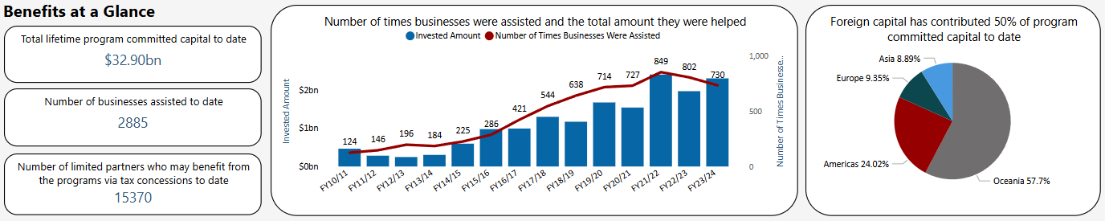

Committed Capital and Investment – ESVCLP and VCLP
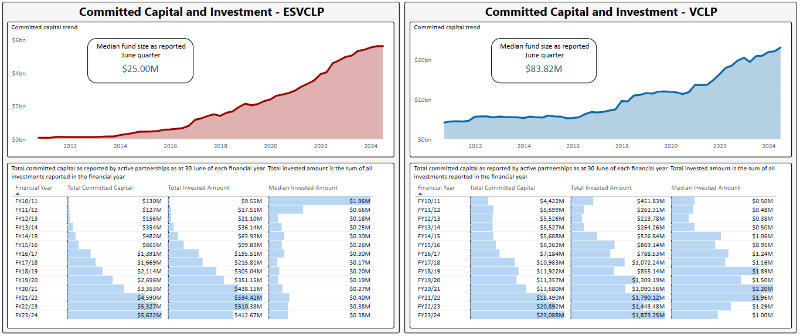

Dry Powder – ESVCLP and VCLP
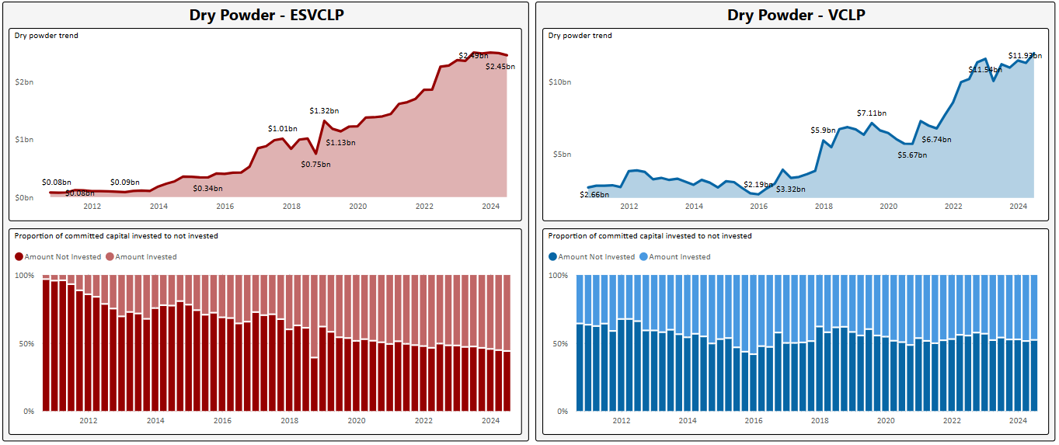

Registrations – ESVCLP and VCLP
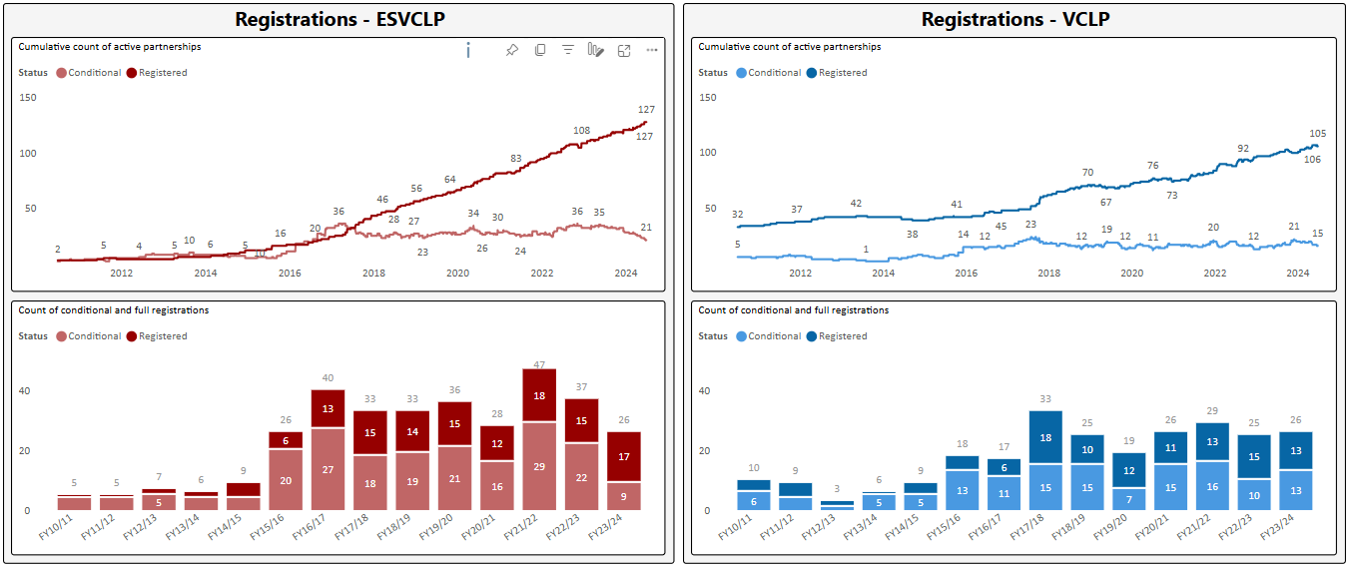

Lapses and revocations – ESVCLP and VCLP
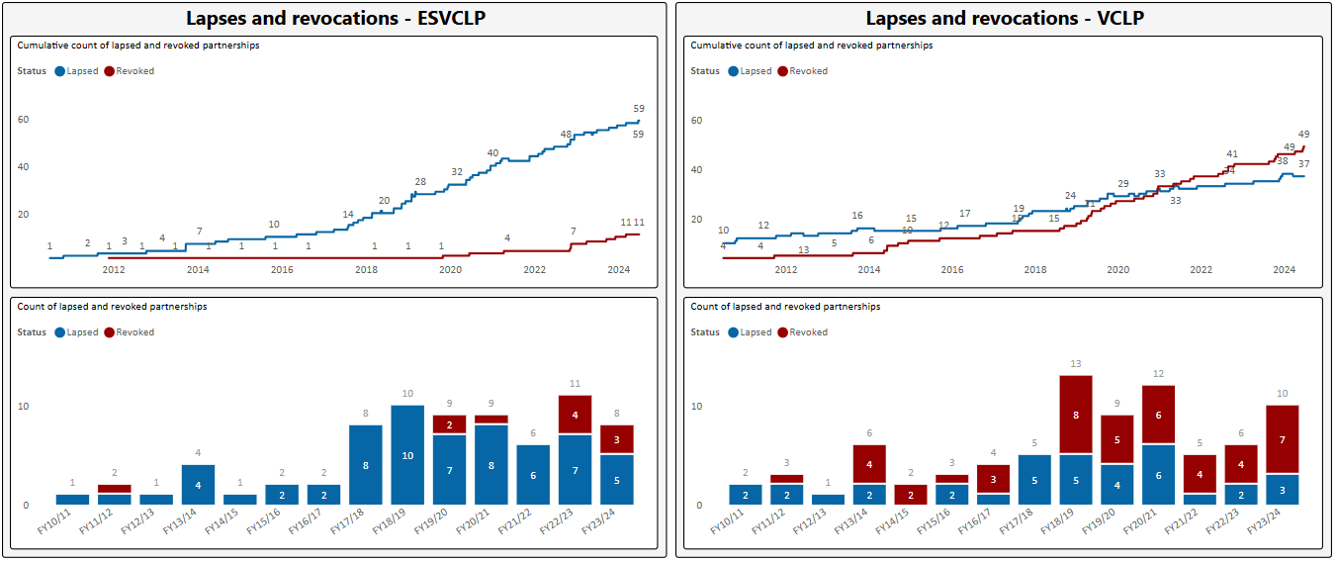

Investment Data Table – Region and Sector
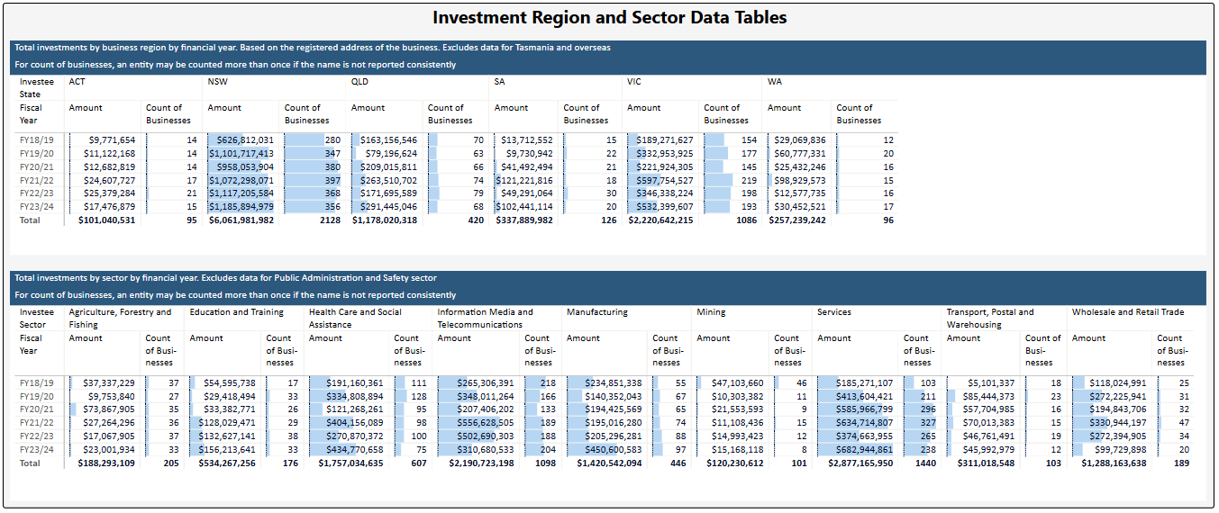

Investment Data Table – Investment Stage – ESVCLP and VCLP
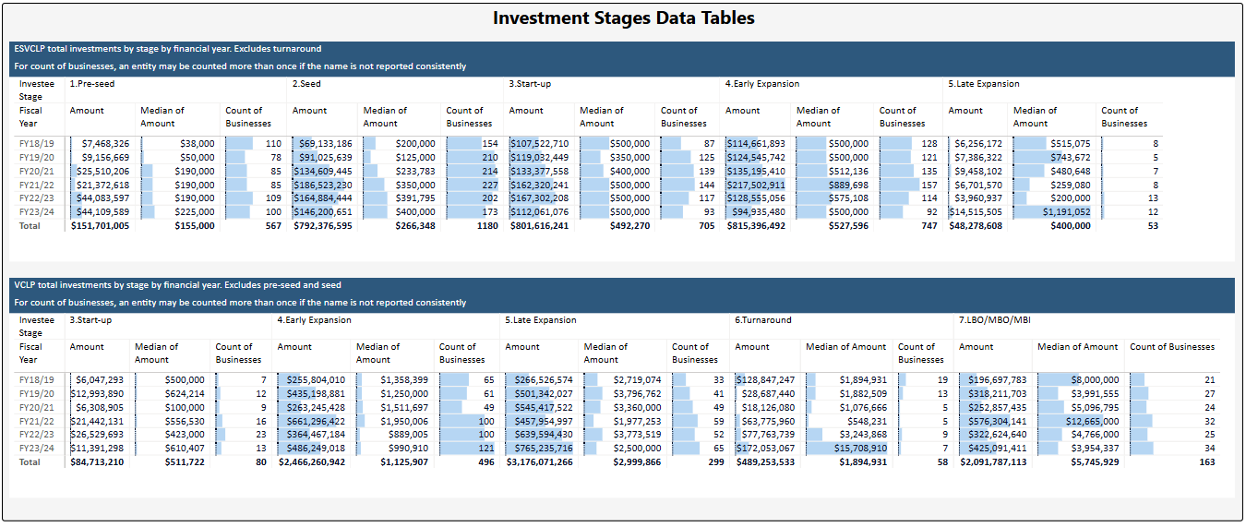

Investments by Sector - ESVCLP
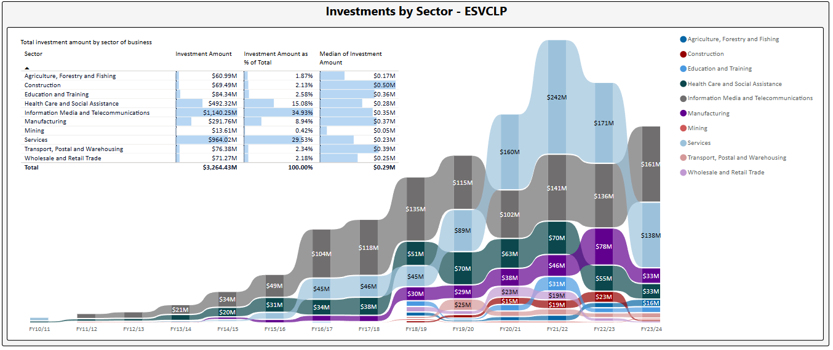

Investments by Sector – VCLP
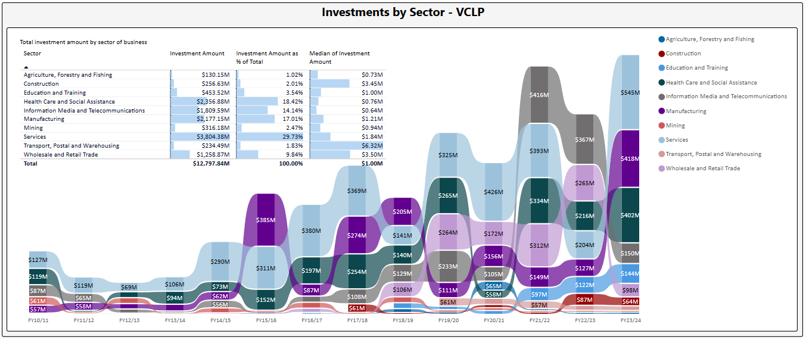

Investments by Stage – ESVCLP
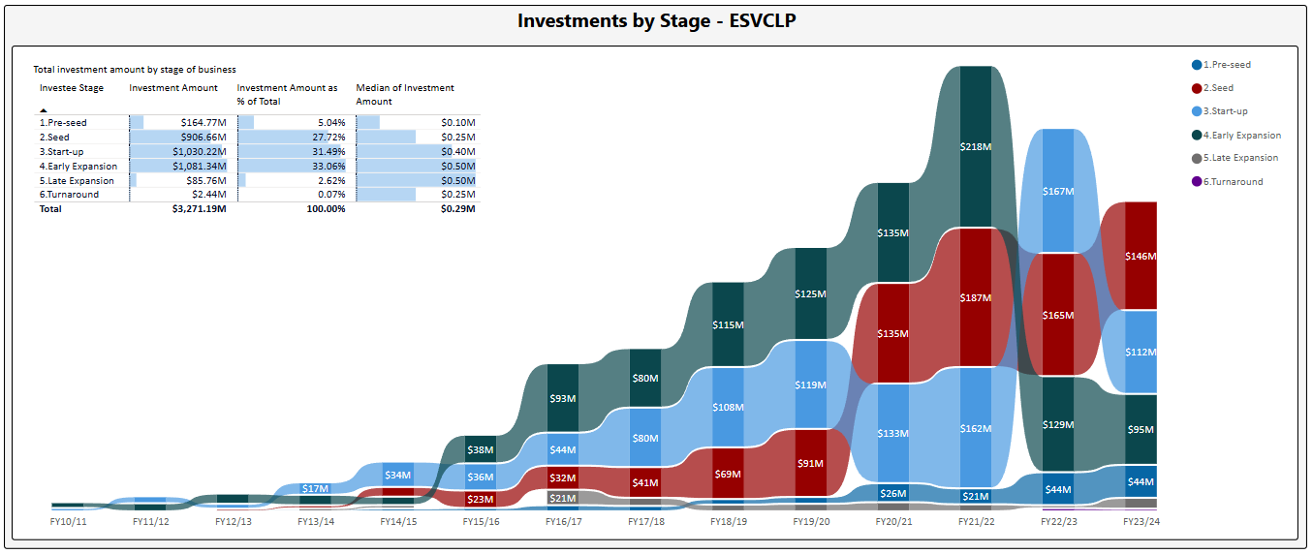

Investments by Stage – VCLP
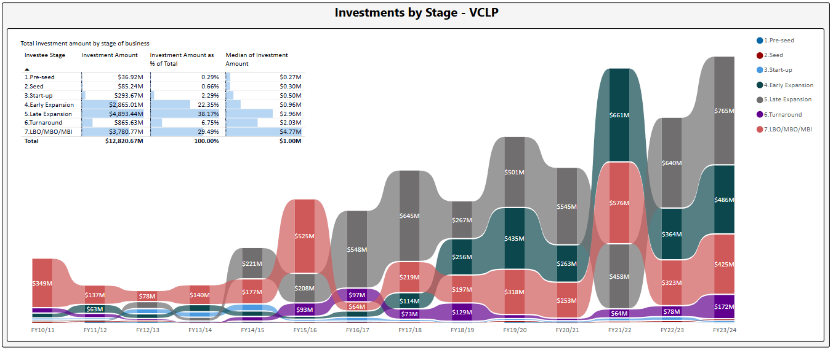

Investments by Region – ESVCLP
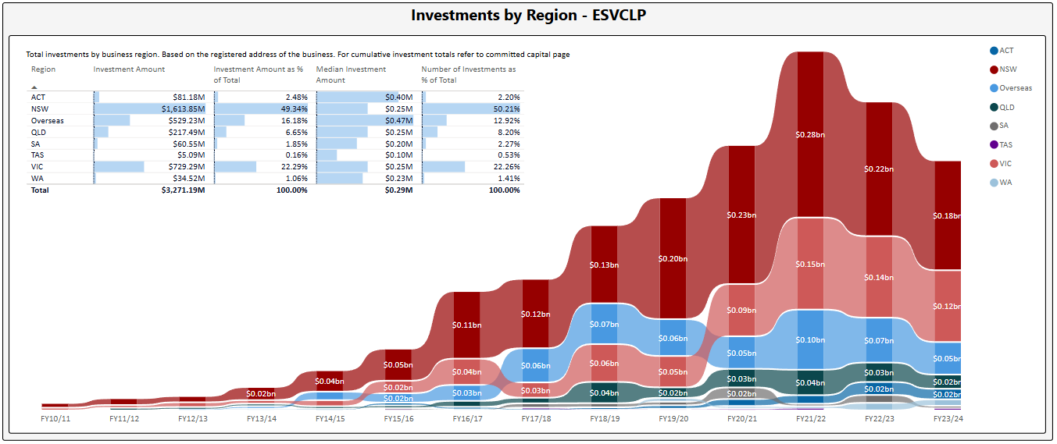

Investments by Region – VCLP
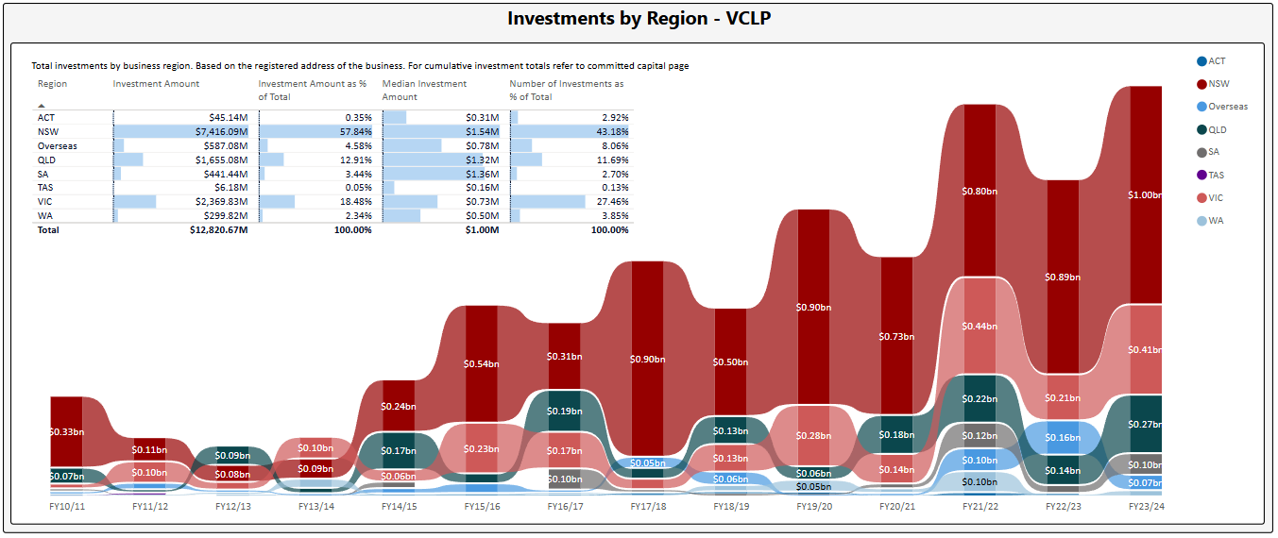

Initial and Follow-on Investments
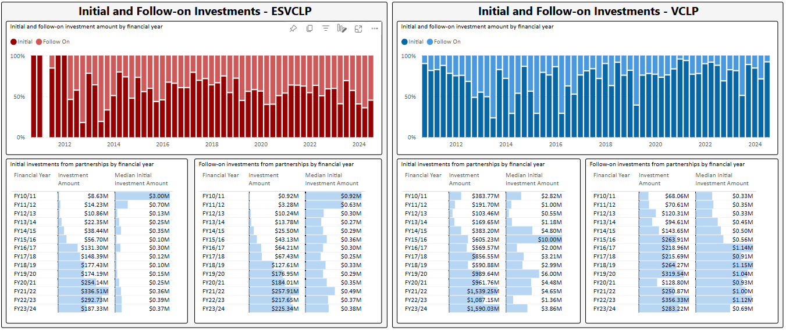

Sources of Funding
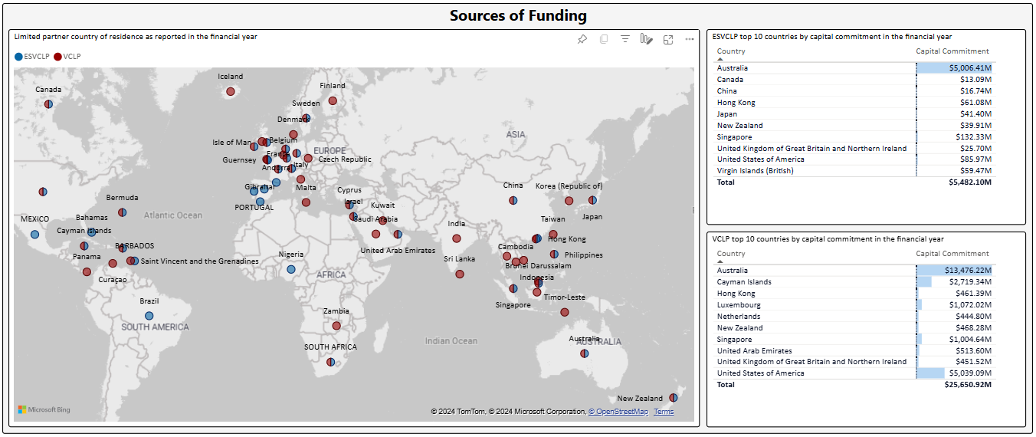

Limited Partners by Type
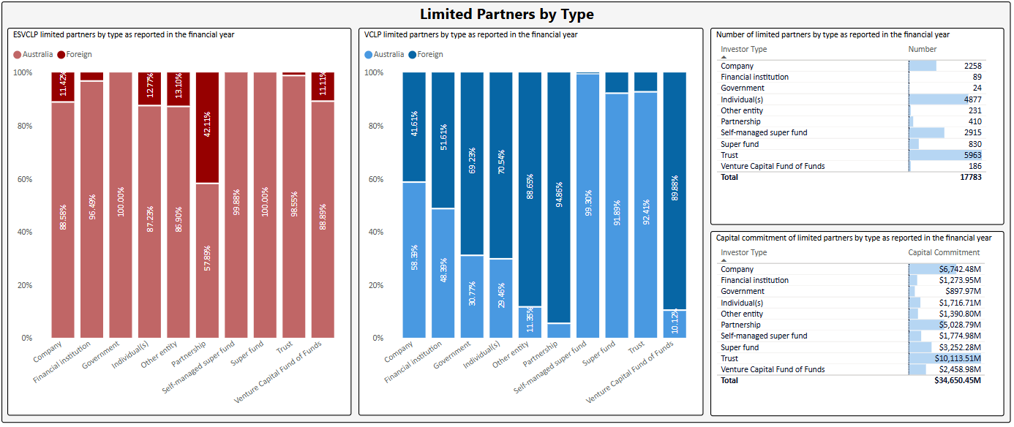

Limited Partner Committed Capital by Region
