Bushfire Earth Observation Taskforce

*Report on the role of space based Earth observations to support planning, response and recovery for bushfires*

31 May 2020

space.gov.au







Contents

Executive Summary 3

Context 5

An overview of Earth observation 8

Australian bushfire EO capabilities 11

Applying EO to bushfire decision making 15

Successes and limitations 17

Opportunities 18

Annexure A – Summary of feedback from stakeholders 24

Annexure B – Bushfire and Natural Hazards CRC EO projects 29

Annexure C – Stakeholders engaged 31

References 32

Acknowledgements

The Australian Space Agency would like to thank its co-members of the Taskforce, consisting of Geoscience Australia, the Bureau of Meteorology and Commonwealth Scientific and Industrial Research Organisation (CSIRO) for its support and commitment. The Taskforce would also like to acknowledge the assistance of the Australasian Fire and Emergency Service Authorities Council and all of the stakeholders included in Figure 2 and outlined in Annexure C.

# Executive Summary

Satellite based Earth observation (‘satellite imagery’) systems are used to support a range of emergency management activities including fire, flood, and severe weather. Responding to fire management, satellite imagery is mostly used to support risk assessment in the lead-up to a fire season weather forecasting and warnings during a fire, and monitoring the recovery in the aftermath of a fire. A range of other platforms are available to support bushfire activities (such as land and air-based platforms), however with the advances in technology in satellite imagery and data analysis, there is opportunity to further consider the use of space based platforms.

In response to the devastating bushfires in 2019-2020, the Minister for Industry, Science and Technology, the Hon Karen Andrews MP, tasked the Australian Space Agency (the Agency) to consider the role of space-based Earth observation (EO) to support planning, response and recovery efforts related to bushfires. The capabilities of NovaSAR-1, accessed through CSIRO, were also asked to be explored as part of this activity.

The Agency, in partnership with the CSIRO, Geoscience Australia (GA) and the Bureau of Meteorology (the Bureau), established the Bushfire Earth Observation Taskforce (the Taskforce) which has engaged with emergency management agencies, State and Territory governments, and the research community to understand this issue and consider opportunities for the future.

The Taskforce examined the decisions required to manage bushfire risk management in the pre-fire, during-fire, and post-fire phases. It then analysed the satellite imagery data needed to support those decisions. This analysis identified that while Australia is good at fusing and integrating existing data there are opportunities for improvement within five broad themes: resolution; revisit time; ICT infrastructure, analysis and validation; and data provision. To address these limitations, it was identified that a key requirement was for satellite imagery and its derived products and services are provided on a regular and assured basis.

The Taskforce identified four pathways to provide regular, assured satellite imagery and its derived products and services:

* **Partnerships:** Ensuring access to satellite EO data by building on existing partnerships with international satellite operators and reviewing Australia’s use of the International Charter on Space and Major Disasters;
* **Data Systems:** Guaranteeing satellite data is reliably and consistently provided to users by streamlining data systems;
* **Tools:** Helping the private sector and community to easily access and tailor products and services; and
* **New satellite imagery:** Exploring opportunities to leverage and develop Australia’s space industry to provide new satellite imagery capabilities, including collaboration on future platforms and the role of private industry, to secure access to key data, address data gaps (revisit and resolution) and support the global observing system.

The Taskforce also observed that while NovaSAR-1 can see through smoke and cloud, by day and night, it cannot provide regular operational support to bushfires. However, it would be useful for Australian research agencies and fire services to develop the use of synthetic aperture radar (SAR) for this purpose.

Within these four pathways, the Taskforce identified several actions that could be achieved by the 2020-2021 summer fire season (pending any impacts because of COVID-19) and opportunities for future investigation.

### Actions for Next Fire Season

GA, CSIRO, the Bureau and the Agency will continue to work closely with peak fire and emergency management groups, research institutions, academia and industry to understand requirements and priorities, and coordinate the rollout of new capabilities for operational use.

For the 2020-2021 summer fire season, Commonwealth agencies including GA, CSIRO, the Bureau and the Agency have reviewed their products and services and are planning capability improvements within existing funding, including:

* The Agency will consider developing an easy-to-use directory of satellite imagery (and related products and services) for use by all stakeholders.
* The Bureau will continue to increase and improve the use of satellite imagery in its weather and environmental prediction models to improve forecast accuracy and provide operational weather intelligence. This will be achieved by adding new satellite data sources such as winds from the European METOP satellite and ingesting higher resolution data from existing sources such as the Japanese Himawari-8 meteorological satellite.
* CSIRO will consider streamlining tasking and delivery of data from the United Kingdom’s NovaSAR-1 satellite to develop the use of SAR for fire burnt area mapping during smoky and cloudy conditions.
* GA will:
  + enhance the Digital Earth Australia (DEA) system, including:
    - working with governments to provide a national burn scar product to deliver consistent, national information of the area burnt with the associated burn severity, for post-fire impact analysis. Early demonstrator products will be available for expert user review by the 2020-2021 summer fire season;
    - enhanced access to its Waterbodies product, which shows the water last observed by satellite in water bodies greater than half a hectare in area.
  + update the DEA Hotspots system to:
    - Add Himawari-8 derived hotspots to the public view;
    - Harden the DEA Hotspots ICT infrastructure; and
    - Test Sentinel-3 (European Union EO satellites) inputs and make them available to trial users.
  + in partnership with the Agency, liaise with the International Charter on Space and Major Disasters to identify opportunities to better use their data for Australian purposes.

### Future Opportunities

The Taskforce also considered future opportunities to enhance Australia’s capability to manage bushfire risk through satellite imagery. Four areas of opportunity were identified:

1. New satellite imagery missions specific to bushfire risk management can deliver more data bands, improved resolution, and revisit times.

As part of this, Australia could consider the development of its own capability and/or contribute to international missions focused on supporting bushfire activities. Consideration could also include the feasibility of Synthetic Aperture Radar (SAR) for bushfire support (drawing on the experience with NovaSAR-1).

This opportunity would require the development of a detailed feasibility study/business case outlining the options and opportunities available, and ultimately be the subject to consideration by government and availability of funding.

1. Assure current satellite imagery data supply through making meaningful contributions to other, non-bushfire specific mission with international partners. These might include, for example, the ‘Landsat Next’ Earth science mission with the United States and the Himawari-10 future meteorological satellite with Japan.
2. Explore the utility of highly responsive satellite imagery systems to support Commonwealth, State and Territory bushfire risk management through engagement with the Department of Defence’s DEF-799 Phase 1 system.
3. Building the capability and capacity of Australia’s workforce to support future EO missions and activities in partnership with national coordination bodies, state and territory agencies, universities, and industry.

# Context

In response to the devastating bushfires, the Hon Karen Andrews MP, Minister for Industry, Science and Technology directed the Agency to coordinate analysis of the use of Earth observation (EO) from space systems for bushfire risk management. The Agency established a Bushfire Earth Observation Taskforce (Taskforce) to examine the issue in conjunction with CSIRO, the Bureau of Meteorology (the Bureau) and Geoscience Australia (GA).

This report is only a small part of a broader examination of science that supports bushfire preparation, prevention, response and recovery capabilities in Australia, led by CSIRO. Its purpose is to identify the opportunities for improved use of space-based EO capabilities in both the short and long term, including where there may be value in Australian satellite missions that assist with decision making for bushfire risk management.

The Taskforce’s work is positioned within the context of all EO capabilities used to support bushfire risk management. This includes reference to aerial, ground and maritime based collection systems but focuses on satellite imagery and the systems that support it.

Disclaimer: The Taskforce did not examine the causes or contributing factors of any particular fire event.

## Framing the problem

The Taskforce focused its considerations on understanding the decision-making needs of fire and emergency management operational decision makers at the three stages relative to fire occurrence including:

* pre-fire (fuel hazard measures, time since last burn) to assist fire prevention or minimisation activities,
* during-fire (near real-time detection and location of active fire areas); and
* post-fire (mapping and assessment of burned areas)[1].

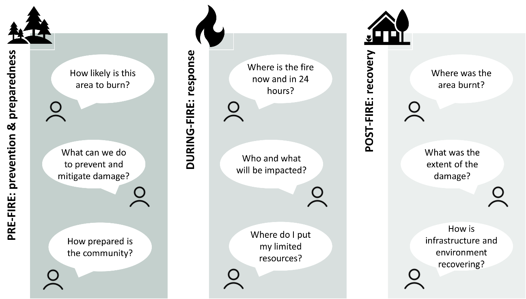

Figure 1 – Components during each stage of fire occurance.

### Pre-fire: prevention and preparedness

EO systems help decision makers understand the land and the climate before fire season begins. Decision making pre-fire is about determining the ‘exposure’ of a given locality to fire risk and the preparations needed. These include placement of emergency response personnel and resources; fire risk reduction activities such as fuel reduction burning, clearing and grazing; community messaging and reducing potential sources of ignition by issuing total fire bans; and closing national parks. In the longer term, it includes influencing building standards and land management practices.

### During-fire: response

During a fire, EO systems that are responsive to tasking, facilitate rapid data delivery, have broad coverage, rapid revisit and high resolution are favoured.

Decision making during-fire encompasses all the factors relevant during the pre-fire and post-fire periods, albeit with the urgency and uncertainty associated with a bushfire. Exploiting the data preparation and services developed pre-season, decisions need to be made quickly with as much confidence as possible.

### Post-fire: recovery

After a fire is controlled or extinguished, EO systems help determine the burn extent and support assessment of the severity of the fire event.

The cost of the fire to flora, fauna, infrastructure, housing and lives needs to be counted and plans for recovery developed. Permanent changes to the environment need to be understood, and much of this information then becomes input into the prevention and preparedness activities for the next fire season.

## Stakeholders

The Taskforce included fire and emergency management agencies from all levels of government, non-government organisations and research institutions across Australia, and sought international input.

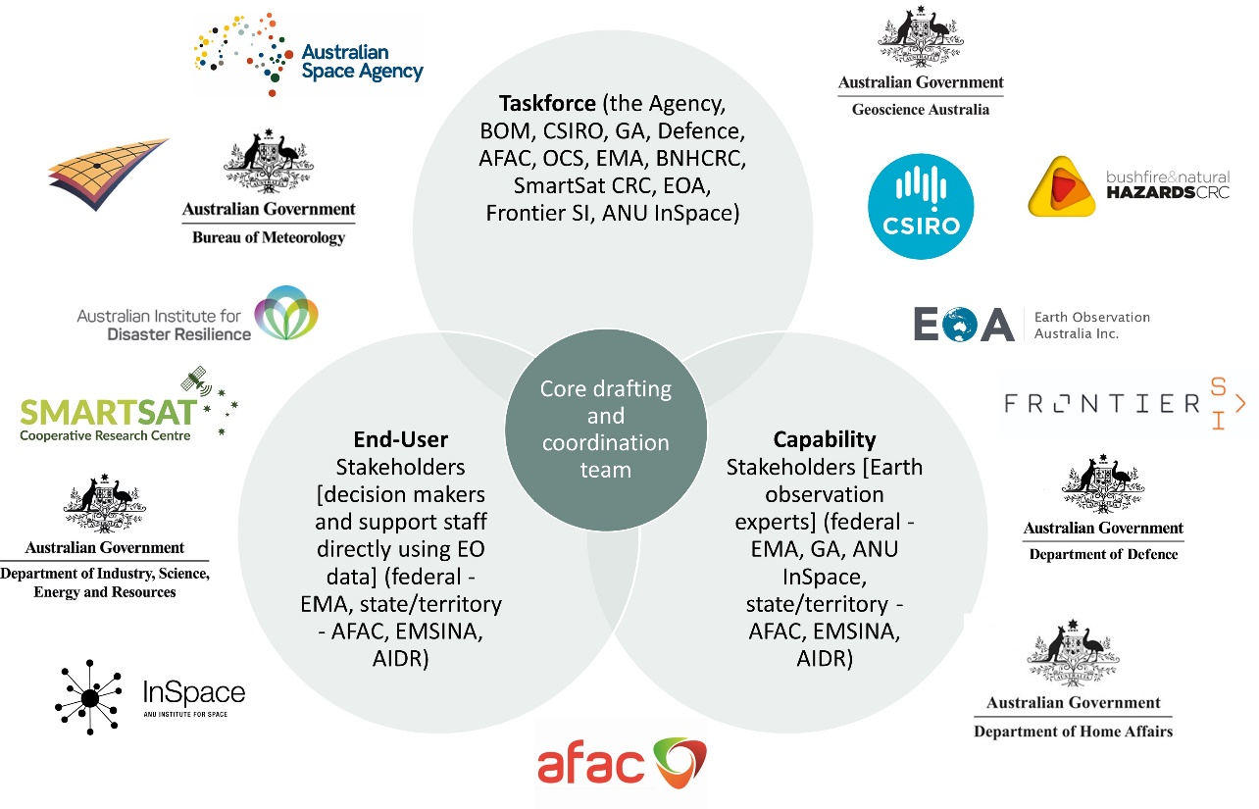

Figure 2 – Stakeholders and their connectivity

## Engagement

The Taskforce held a series of targeted workshops to meet with emergency management decision makers and then agencies, organisations and research agencies to understand how they provide support. This approach assisted the development of a hypothesis that was tested and validated with stakeholders as part of the consultation process.

The Taskforce also held discussions with international space agencies to understand the bushfire expertise resident in their countries that could be available for future bushfire efforts and opportunities for collaboration.

This Taskforce Report is also the result of deep engagement with key national and international stakeholders from the United Kingdom, Canada, United States, Italy and South Korea over a concentrated four-week period.

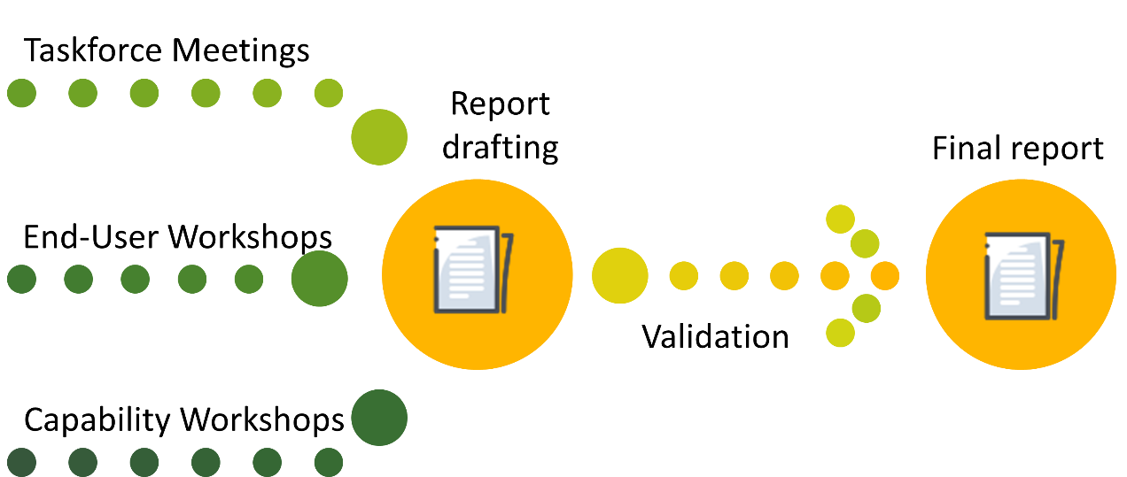

Figure 3 – How the engagement was conducted

# An overview of Earth observation

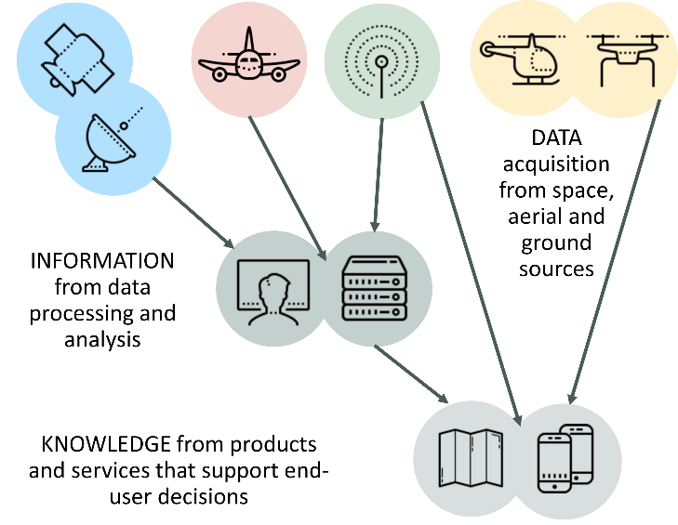EO encompasses a broad suite of activities that gathers observations and produce measurements and spatial data to monitor and examine our planet, its environments, human activities and infrastructure. EO data is collected at a range of scales from centimetres to kilometres, throughout all environments - built, natural, and managed. Some EO data has been collected regularly for decades (e.g. Landsat) through ongoing satellite programs, while other data may be collected at specific times and places to respond to needs such as natural disasters or emergency situations (e.g. a ‘Disaster Charter’)[2].

Figure 4 – The basics of how Earth observation and data collection work

Spatial data users receive data from sensors that are mounted on platforms. The sensor and platform are selected to achieve a given task. Spatial data experts in the various agencies are required to task the sensors and platforms, then process, interpret and publish the data to make it available to end-users.

### Sensors: What to look for?

Sensors are used to ‘remotely sense’ the land, water and atmosphere. A broad categorisation of the sensors currently used is provided below.

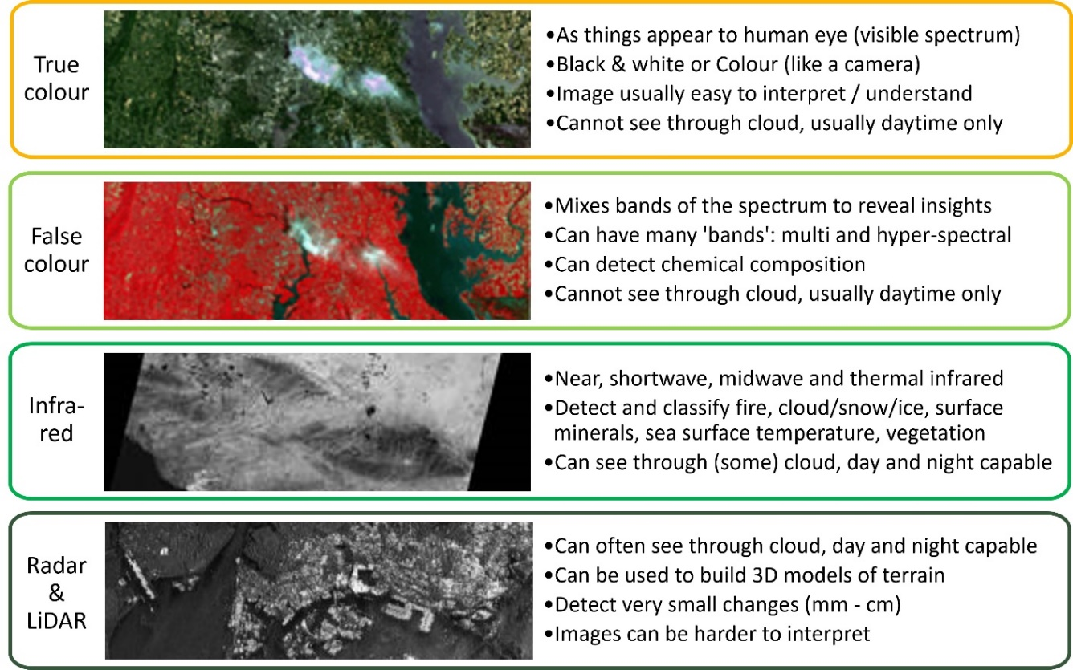

Figure 5 – Categorisation of sensors

### Platforms: Where to look from?

Sensors can be mounted on a range of platforms depending on the particular purpose. They range from hand-held to satellites and give different levels of coverage, response time, ease of use, cost, persistence, revisit (how often a location is observed), and complexity.

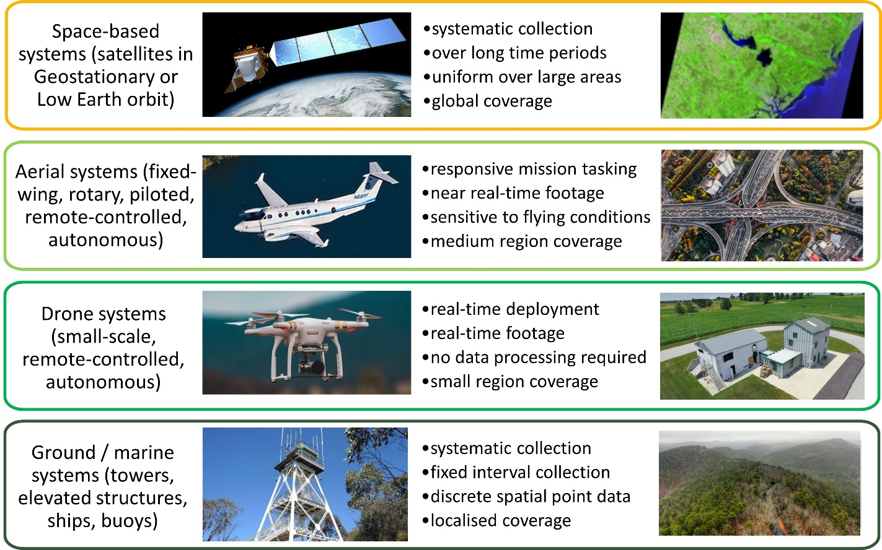

Figure 6 – Platforms for sensors

### Experts: Making it all work

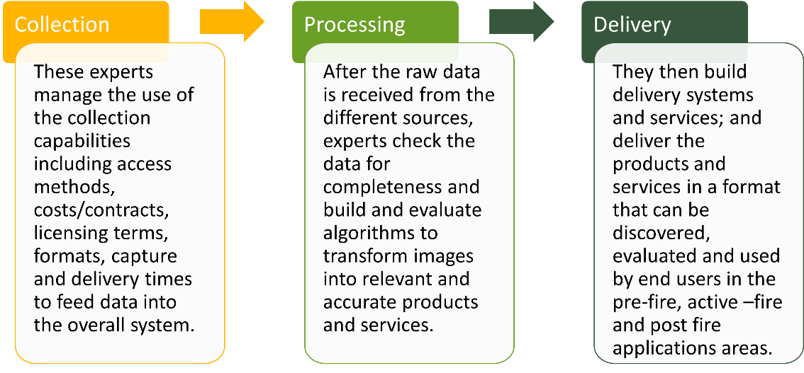EO data is usually not able to be immediately used by decision makers. Therefore, it is incumbent upon EO professionals across the various agencies at Commonwealth, state, territory and local levels to manage the collection activity, process the data, and deliver the outputs to customers. Commercial entities also use the same expertise to process and provide data for a fee.

Figure 7 – Process of using EO data by experts

The latest satellite and airborne systems may offer on-board processing and be able to broadcast some information to users in a more ready-to-use form. However, the information still needs to be overlaid against background data on decision support systems; often it will need to be interpreted by analysts. The design and delivery of these systems and the analysis requires these same EO expert skillsets.

**Fusion and Integration:** The processing and delivery stages usually includes ‘fusion’ (of similar data from different sources) and ‘integration’ (of different kinds of data) to extract more meaning than is otherwise possible. This is a key role of EO experts. A simple example is overlaying burn extent data with infrastructure data to indicate likely losses. To ensure the situation is correctly represented to decision makers, this process requires data to be referenced to the same foundation or datum, with regard for precision and accuracy; it can involve many complex transformations.

**Calibration and Validation:** One of the key activities performed by these EO professionals is the development of methods to transform images to information (calibration) and then the verification of their products against reference data (validation). These activities require extensive and long-term investment in field infrastructure, data collection programs and highly trained personnel, into which Australia’s research institutions, state and Commonwealth agencies have invested significantly over the last 30 years.

# Australian bushfire EO capabilities

EO data to support bushfire risk management can be collected from different platforms, ranging from just above the ground, to varying atmospheric altitudes, to space. Sensors are commonly mounted on terrestrial infrastructure such as towers, drones and aircraft, balloons at high and low altitudes, and satellites in orbit. This EO data is used across all jurisdictions and all levels of government to support bushfire risk management decision making.

There is no neat demarcation between the types of EO capabilities employed by the Commonwealth, state and territory agencies. Commonwealth agencies are the conduit for some satellite data and some states have bespoke access. States and territories use commercially provided satellite data and make use of aerial photography for their highest resolution imagery needs.

The States and Territories also have their own access to aerial-based mapping systems to determine fire fronts and burn extents, including commercial services.

### Data processing, integration and interpretation

The expertise and network of spatial professionals in land management, science, research and emergency management agencies at all levels of government, as well as industry, is Australia’s most important bushfire-related EO capability. Their role is to take data from diverse collection systems and make it available, useable and relevant for end-users.

This work is often facilitated by the work of organisations such as the Australasian Fire and Emergency Services Authorities Council (AFAC), Bushfire and Natural Hazards CRC (BNHCRC), SmartSat CRC, FrontierSI and Earth Observation Australia. Examples of the projects undertaken by BNHCRC are provided in Annex B.

## Satellite data delivery systems

Satellites and ground stations are used for broad scale observation of bushfire-relevant factors such as weather, vegetation condition mapping and identification of thermal hotspots.

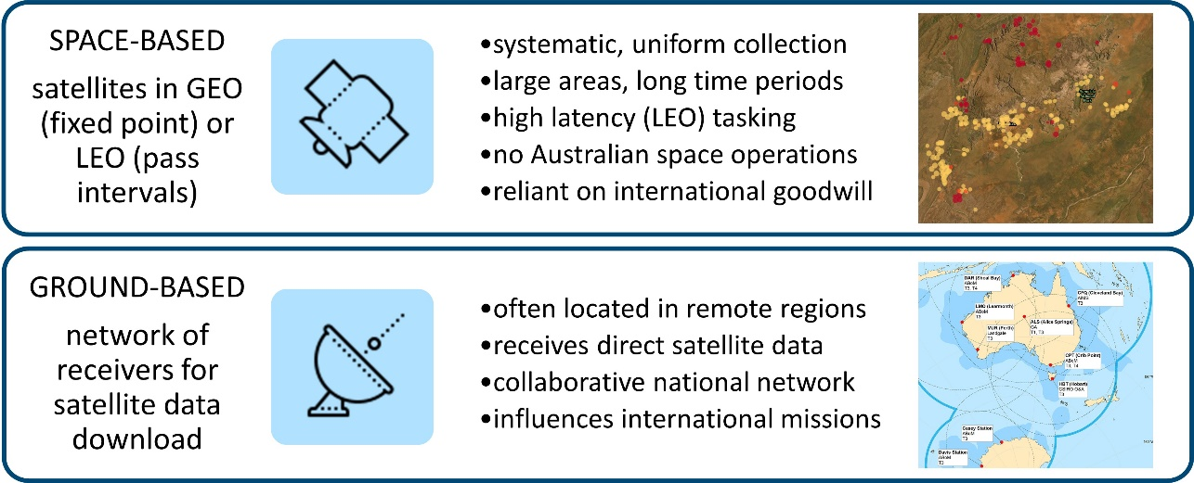

Figure 8 – space based and ground based data delivery systems

Australia does not own any EO satellite systems but has an extensive system of ground station infrastructure that receives satellite data made available through a variety of mechanisms:

* Legal or technical partnerships (Landsat, Copernicus Hub for Sentinel)
* International obligations / treaties (WMO for weather)
* Ad-hoc arrangements (including commercial purchases, research and development)
* Direct acquisition (NovaSAR-1 by CSIRO, MAXAR by Defence)
* Direct broadcast – no agreements (MODIS, AVHRR, VIIRS).

Since Australia is totally reliant on international satellite operators for data, the maintenance and development of these relationships is paramount. Increasingly, due to our technical expertise in spatial data analysis, Australian contributions to other nations’ satellite programs (e.g. United States land observation; Canadian fire satellite; and Japanese meteorological satellites) is being sought.

## Aerial and ground-based fire monitoring systems

The capability of aerial and ground systems is critical for operational support of bushfires in progress, and often the first source of information for emergency services. Reviewing aerial and ground-based fire monitoring services is out of scope of this report and not analysed by the Taskforce.

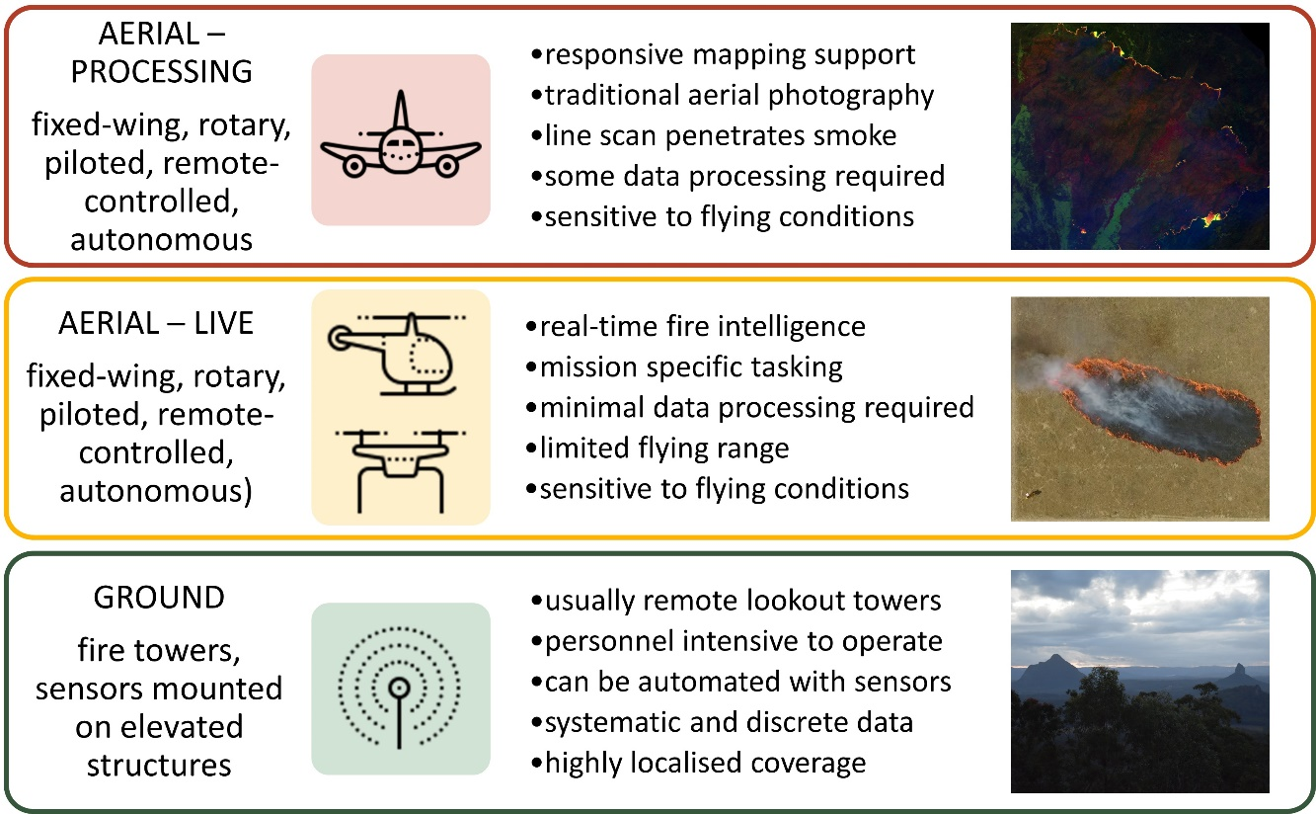

Figure 9 – Aerial and ground based fire monitoring

## Existing and planned EO satellite capabilities

At the Commonwealth agency level, only GA and the Bureau have operational capability for the use of satellite-based systems to support bushfire activities. Most capabilities (e.g. through CSIRO) are research-based, however this R&D provides an important input to improve functionality and capability of the systems in the future.

States and territory agencies, including local government, comprise the most significant satellite data application capabilities in Australia, by using satellite data directly, and/or transforming it to decision critical information used by multiple agencies, industries, and the public.  Parts of these activities are delivered directly and indirectly through the relationships they establish with industry. Their responsibilities for operational response to fires give them insight into the EO information demands of bushfire risk management from planning, to active fire management to post fire impact and recovery assessment.

Industry, both large and small, that transforms satellite data to use-able information optimised for specific environments and applications, plays an essential, but not fully realised role  for the provision and transformation of satellite imagery (from multiple commercial and government sources), data storage, processing, analysis and dissemination systems.

The diagram below provides an overview of the various satellite imagery and related capabilities available or in development in Australia. Those that are operational or readily able to be made operational are toward the top; those more for R&D or in earlier stages of development are toward the bottom.

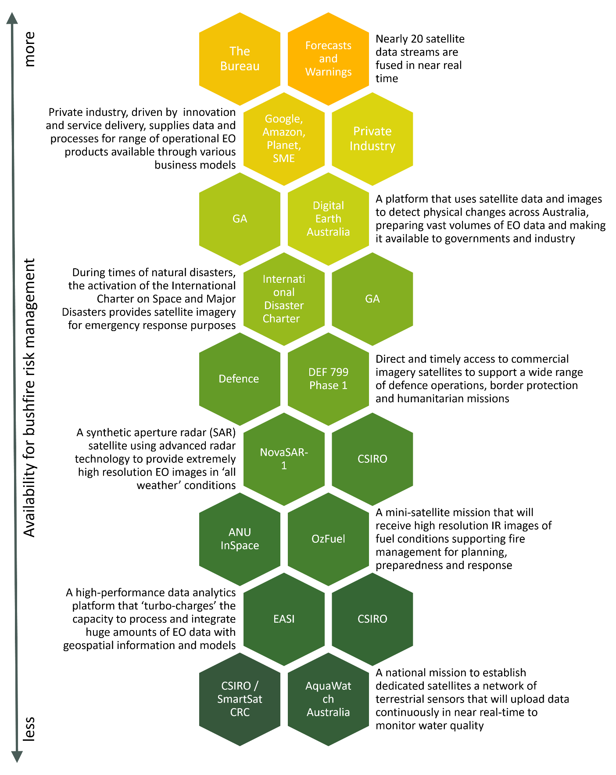

Figure 10 – Australian capabilities that support EO for bushfires

## NovaSAR-1

The NovaSAR-1 satellite, developed by Surrey Satellite Technology Limited (SSTL) in the United Kingdom, utilises synthetic aperture radar (or SAR) which is an advanced form of radar technology providing extremely high-resolution images of Earth from space. CSIRO has purchased a 10 per cent share of time on one of the world's most sophisticated new satellites, called NovaSAR-1.

The key advantage of SAR technology is that it operates effectively in 'all-weather' conditions. This overcomes the main drawback of traditional optical imaging satellites as it can take images of Earth through clouds, and even at night.

With regard to NovaSAR-1 and bushfire activities:

* CSIRO operates NovaSAR-1 as a national facility
* NovaSAR-1 can observe through smoke and cloud, day and night
* SAR is not routinely used for bushfire, but the application has been demonstrated with other SAR satellites
* NovaSAR-1 cannot provide regular operational support to bushfires but would be useful for Australian fire services to develop their use of SAR.

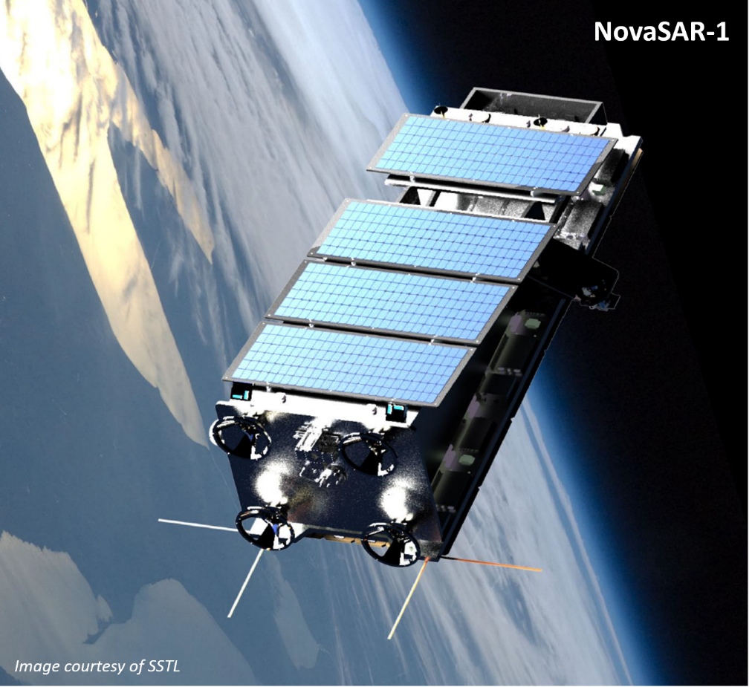

Figure 11 – NovaSAR-1

# Applying EO to bushfire decision making

In the earlier sections of this report, the Taskforce framed the subject into pre-fire, during-fire and post-fire epochs and the nature of the decisions being supported. Subsequent sections included a description of EO systems in general and what EO capabilities Australia has for bushfire support.

The info-graphic below brings those previous sections together: it describes the information required to support decision making for each epoch and the types of EO system types currently used to observe it in Australia. Decision making during-fire encompasses all the factors relevant during the pre-fire and post-fire periods, albeit with the urgency and uncertainty associated with a bushfire.

The colour of each box in Figure 12 links the information needed to the EO system type used to collect the information.

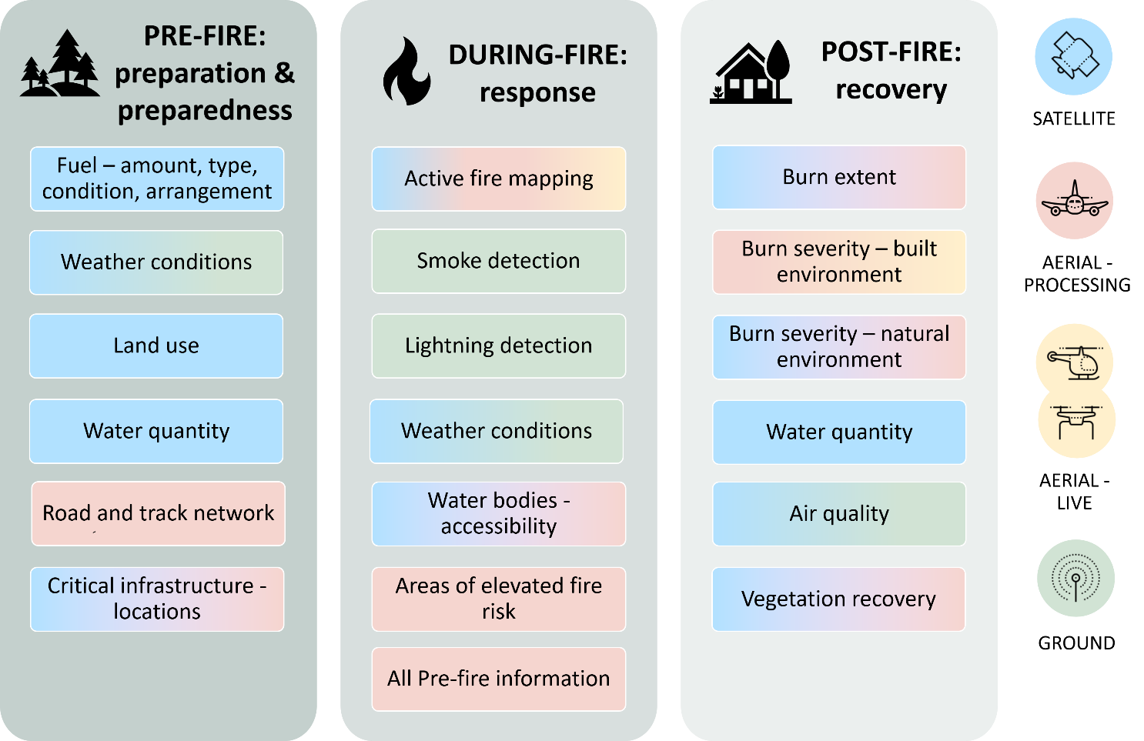

Figure 12 – Applying EO capabilities to the three stages of bushfire decision making

## Satellite-based sensors used by Australia for bushfire management

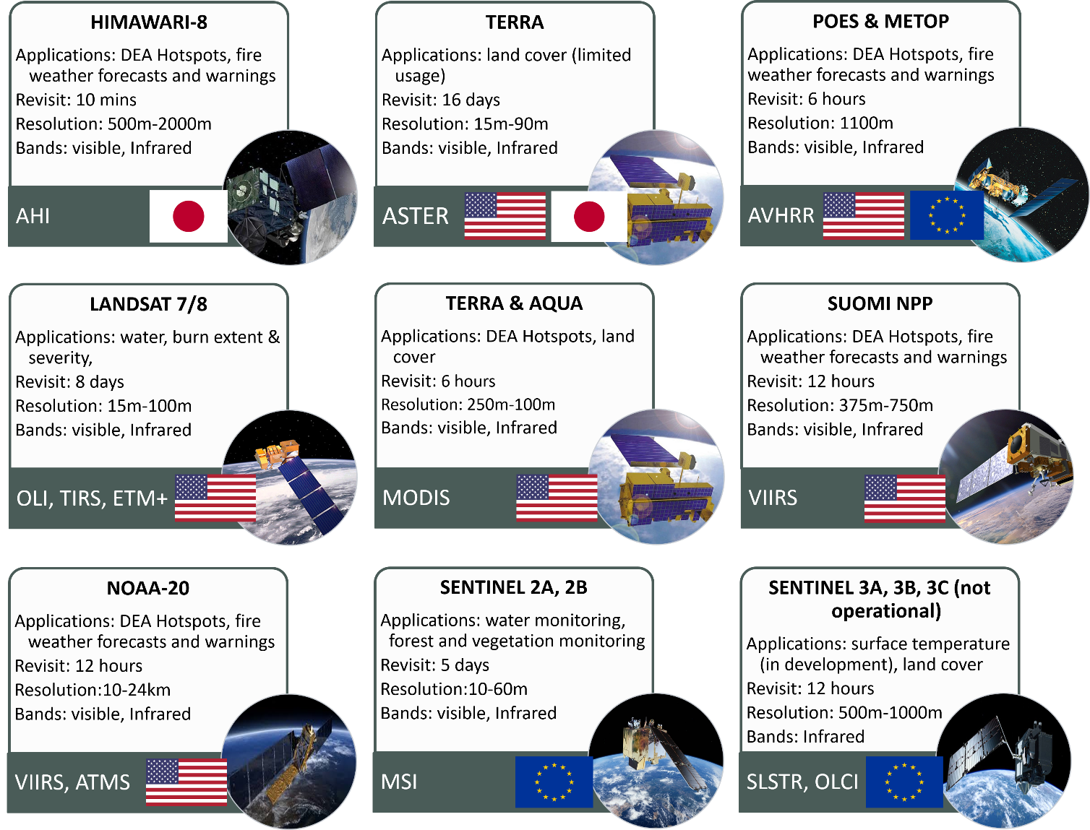

Figure 13 – Satellite based sensors used by Australia for bushfire management

## Expanding Australia’s satellite imagery sources during times of crisis

During a crisis it is common to assist by providing more information to decision makers. One option is to activate further international support from the International Charter for Space and Major Disasters and the Copernicus Emergency Management Service. They can provide Australia with access to a range of additional imagery and data products during a disaster.

However, to make use of this data, significant research, development and investment would be required to ensure that national systems can translate supplied data into reliable, predictable services for the emergency management community; they also need the time to integrate the data into their data services and products.

During the recent bushfire crisis, additional international satellite imagery support was also delivered by the Japan and Korean meteorological agencies by providing Australia with temporary access to expanded capabilities of their satellites, including rapid-scanning imagery that provides much improved ability to detect fires over selected areas and improved forecasting capabilities.

# Successes and limitations

Australia makes good use of available EO systems for bushfire risk management. However, in preparation for an upcoming fire season, during a fire and during recovery, there are limitations. *Annexure A – Summary of feedback from stakeholders* explores key decision points and provides capability suggestions to remedy the limitations. They cover five broad themes:

* resolution;
* revisit time,
* ICT Infrastructure;
* analysis and validation; and
* data provision.

When addressing these limitations, a key finding of the Taskforce is that new EO sources *are useful only when provided on a regular and assured basis*.

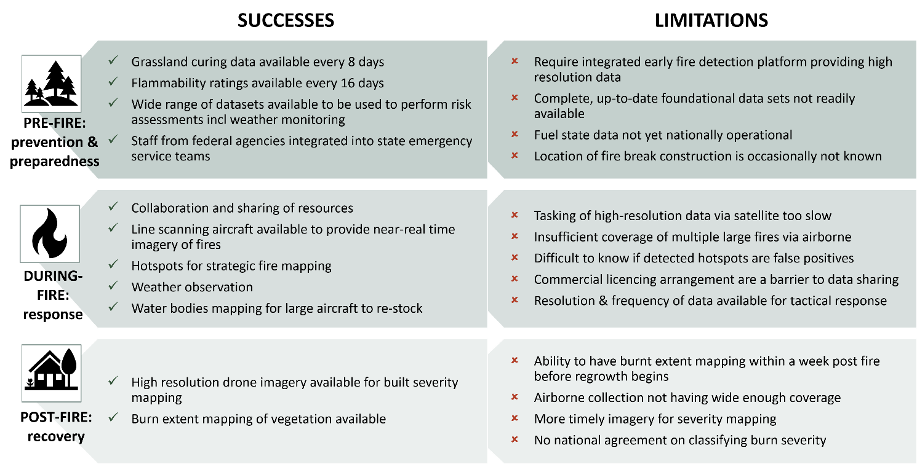

Figure 14 – Summary of the successes and limitations

# Opportunities

Improvements in the five themes (resolution; revisit time; ICT infrastructure; analysis and validation; and data provision) will benefit decision making for bushfire risk management. The Taskforce identified four pathways to provide regular, assured satellite imagery and its derived products and services:

* **Partnerships:** Ensuring access to satellite EO data by building on existing partnerships with international satellite operators and reviewing Australia’s use of the International Charter on Space and Major Disasters;
* **Data Systems:** Guaranteeing satellite data is reliably and consistently provided to users by streamlining data systems;
* **Tools:** Helping the private sector and community to easily access and tailor products and services; and
* **New satellite imagery:** Exploring opportunities to leverage and develop Australia’s space industry to provide new satellite imagery capabilities, including collaboration on future platforms and the role of private industry, to secure access to key data, address data gaps (revisit and resolution) and support the global observing system.

Within these pathways, the Taskforce proposes immediate actions for next fire season and future opportunities. Key actions are highlighted below, with detailed actions outlined in Table 1 and Table 2 respectively.

It is also noted that research institutions, academia and emergency management agencies also have an extensive suite of projects that are addressing many issues, focussed on the exploitation and integration of currently available data sources. *Annexure B – Bushfire and Natural Hazards CRC EO projects* outlines further examples.

## Actions for next fire season

GA, CSIRO, the Bureau and the Agency will continue to work closely with peak fire and emergency management groups and research institutions to understand requirements and priorities, and coordinate rollout of new capabilities for operational emergency management uses.

For the 2020-2021 summer fire season, Commonwealth agencies including GA, CSIRO, the Bureau and the Agency have reviewed their products and services and are planning significant increases in capability within existing funding (subject to the impacts of COVID-19), including:

* The Agency will consider developing an easy-to-use directory of the satellite imagery (and related products and services) for use by all stakeholders.
* The Bureau will continue to increase and improve the use of satellite imagery in its weather and environmental prediction models to improve forecast accuracy and provide operational weather intelligence. This will be achieved by adding new satellite data sources such as winds from the European METOP satellite and ingesting higher resolution data from existing sources such as the Japanese Himawari-8 meteorological satellite.
* CSIRO will consider streamlining tasking and delivery of data from the United Kingdom’s NovaSAR-1 satellite to develop the use of SAR for fire burnt area mapping during smoky and cloudy conditions.
* GA will:
  + enhance the Digital Earth Australia (DEA) system, including:
    - working with governments to provide a national burn scar product to deliver consistent, national information of the area burnt with the associated burn severity, for post-fire impact analysis. Early demonstrator products will be available for expert user review by the 2020-2021 summer fire season;
    - enhanced access to its Waterbodies product, which shows the water last observed by satellite in water bodies greater than half a hectare in area.
  + update the DEA Hotspots system to:
    - Add Himawari-8 derived hotspots to the public view;
    - Harden the DEA Hotspots ICT infrastructure; and
    - Test Sentinel-3 (European Union EO satellites) inputs, make them available to trial users.
  + in partnership with the Agency, liaise with the International Charter on Space and Major Disasters to identify opportunities to better use their data for Australian purposes.

## Future opportunities

Longer-term opportunities are identified across the four pathways to inform future thinking. Four specific areas from across the four pathways are identified below, based on having the greatest impact:

1. New satellite imagery missions specific to bushfire risk management can deliver more data bands, improved resolution, and revisit times.

As part of this, Australia could consider the development of its own capability and/or contribute to international missions focused on supporting bushfire activities. Consideration could also include the feasibility of Synthetic Aperture Radar (SAR) for bushfire support (drawing on the experience with NovaSAR-1).

This opportunity would require the development of a detailed feasibility study/business case outlining the options and opportunities available, and ultimately be the subject to consideration by government and availability of funding.

1. Assure current satellite imagery data supply through making meaningful contributions to other, non-bushfire specific mission with international partners. These might include, for example, Landsat Next with the United States and Himawari-10 with Japan.
2. Explore the utility of highly responsive satellite imagery systems to support Commonwealth, State and Territory bushfire risk management through engagement with the Department of Defence’s DEF-799 Phase 1 system.
3. Building the capability and capacity of Australia’s workforce to support future EO missions and activities in partnership with national coordination bodies, state and territory agencies, universities and industry.

Table 1 – Immediate capability development options

|  |  |  |
| --- | --- | --- |
| **Pathway to opportunities** | Immediate Capability Development Actions for 2020-2021 Summer Bushfire Season | Lead Agency |
| Partnerships | 1. Strengthen relationships between agencies and emergency services through AFAC collaboration model. 2. Further streamline CSIRO tasking and delivery of data from the United Kingdom’s NovaSAR-1 satellite for use in fire burnt area mapping during smoky and cloudy conditions.  NovaSAR-1 has limited coverage but informs satellite systems design thinking for bushfire support. 3. GA, in partnership with the Agency, will liaise with the International Charter on Space and Major Disasters to identify opportunities to better use their data for Australian purposes. 4. Engage with the Japan Meteorological Agency (JMA) to progress opportunities for Australia to contribute to the Himawari-10 (future Japanese meteorological satellite) geostationary meteorological satellite program, with attention to capabilities that would support Australia’s unique needs while also contributing to JMA’s program. 5. Engage with NASA and the United States Geological Survey to progress opportunities for Australia to contribute to the LandsatNext program, supporting Australia’s future access to medium-resolution optical imagery. 6. Develop and publish a roadmap of new satellite EO sensors and capabilities being operationalised, and the bushfire risk management applications they could support. This work should contribute to the Agency’s broader satellite EO roadmap (under development). 7. Release Sentinel 5P data through the Copernicus Australasia Regional Hub for air quality mapping. | 1. All 2. CSIRO 3. GA 4. Bureau 5. GA 6. Agency 7. GA |
| Data systems | 1. Enhance national data storage and sharing capabilities for emergency services, including through the National Bushfire Intelligence Capability project (EMA). 2. Increase and improve the use of satellite imagery in the Bureau’s Numeral Weather Prediction systems and weather forecasts, including:  * testing an updated version of the Numerical Weather Prediction model, which includes some new satellite data sources including higher resolution sea surface winds from METOP/ASCAT. * operationalising high resolution deterministic and ensemble weather models for capital city areas that directly assimilate satellite data. Making better use of Himawari-8 data (radiances and cloud information) to have significant impact on improving forecast accuracy. | 1. GA 2. Bureau |
| Tools | 1. GA will enhance the Digital Earth Australia (DEA) system, including:  * working with Australian governments to provide a national burn scar product to deliver consistent, national information of the area burnt with the associated burn severity, for post-fire impact analysis.  Early demonstrator products will be available for expert user review by the 2020-2021 summer fire season; * enhanced access to its Waterbodies product, which shows the water last observed by satellite in water bodies greater than half a hectare in area.  1. GA will also update the DEA Hotspots system to:  * Add Himawari-8 (current Japanese meteorological satellite) derived hotspots to the public view; * Harden the DEA Hotspots ICT infrastructure; and * Test Sentinel-3 (European Union EO satellites) inputs and make them available to trial users.  1. Improve private sector and community access to systems such as DEA and CSIRO’s Earth Analytics Science and Innovation platform (EASI) Hub that make satellite imagery easier to use, including through increased use of commercial cloud providers, and training tools created by Frontier SI. | 1. GA 2. GA 3. CSIRO |
| New satellite imagery | 1. Streamline tasking and data distribution from the NovaSAR-1 satellite in support of bushfire impact assessment, and conduct research to integrate new satellite data such as synthetic aperture data into more routine fire impact map products. | 1. CSIRO |

Table 2 – Future capability development options

|  |  |
| --- | --- |
| **Pathway to opportunities** | Future Capability Development Opportunities |
| Partnerships | * Consider opportunities for collaboration on the implementation of AquaWatch Australia. * Undertake joint research and development with the European Union’s Copernicus Emergency Management Services, supporting them to tailor their products and services to better meet Australia’s unique needs. * Engage with the Korean Meteorological Agency to identify opportunities for collaboration, including further developing the capabilities established during the recent fire season. |
| Data systems | * Develop and implement processing systems that operationally generate maps of burnt and fire affected areas, including using data from SAR sensors. Australia has increasing access to data from several SAR satellites, including CSIRO’s part ownership of NovaSAR-1, but their capability to see through cloud and smoke for bushfire support is still to be developed. * Review currently available algorithms for bushfire risk management products (particularly around fuel condition, and ecological impact/recovery) and issue ‘best practice’ guidance documents. The Earth Observation For Government Network could coordinate this activity. * Streamline use of EO data by fire-spread models and in biodiversity impact and recovery assessments. * Consider developing and maintaining a catalogue of the calibration/ validation sites and programs needed to ensure bushfire risk management based products can be made (and verified as) fit for purpose for Australian conditions. AusCalVal, once established, could progress this in collaboration with Terrestrial Ecosystem Research Network and the Integrated Marine Observing System. * Explore the utility of highly responsive satellite imagery systems to support Commonwealth, State and Territory bushfire risk management through engagement with the Department of Defence’s DEF-799 Phase 1 system. * Develop a roadmap of the research and development necessary to ensure that data that becomes available from new satellites is used in operational processing systems, reducing the risk of service disruption for users. This work will ensure continuity of service as individual satellite missions cease operation and are replaced with new ones. * Update licencing terms and resources to further facilitate data sharing across agencies and jurisdictions. * Develop an easy-to-use directory of the satellite imagery (and related products and services) available to the emergency management community. * Develop operational capability to deliver fuel moisture product. |
| Tools | * Encourage industry support programs such as DEA Labs and CSIRO’s EASI Hub to stimulate private sector businesses to develop products and services that can support bushfire risk management, particularly products and services that may be of interest to industry sectors such as financial services, agriculture and resources. |
| New satellite imagery | * Consider opportunities to leverage existing projects underway in Australia. * Encourage research agencies and organisations to undertake calibration/validation projects, and product development for future missions, to ensure they benefit bushfire risk management. Support them to engage internationally to promote their work and capabilities to other jurisdictions. * Support the development of the AquaWatch Australia program, noting the global need for information to monitor inland and coastal water quality, including the impacts of fires. * Work with international space agencies to consider opportunities for joint missions and virtual constellations (between nations). * Work with Australian fire and emergency management agencies to examine and advise on commercial fire risk management satellite mission proposals. * Increasing Australia’s access to international satellite data during times of crisis. * Scope opportunities for Australian-built and operated missions to support bushfire risk management.   + Mission Needs for such systems may include:     - Collect key EO specific to Australian conditions, with increases in resolution and revisit as identified in Annex A;     - Reduce dependence on international data;     - Make a valued contribution and address gaps in the global observing system, helping to maintain access to other nations’ data; and     - Leverage and develop Australian industry, particularly those capabilities with opportunities for export and to support international partnerships.   + Mission Goals may include:     - Early fire detection;     - High revisit, high resolution fire location monitoring;     - Measurement of fuel moisture before, during and after a fire event;     - Determination of fire impacts on the built environment, ecosystems, and water resources.   + Missions could range in size, from hosted payloads to cubesats, to joint-missions with international partners to larger missions. |

# Annexure A – Summary of feedback from stakeholders

These tables outline the summary of feedback from stakeholders on which key decisions and supporting datasets are required.

### Pre-Fire risk assessment

Table 3 – Pre fire assessment summary

|  |  |  |  |  |  |  |
| --- | --- | --- | --- | --- | --- | --- |
| **Decision Required** | Data needed to support decisions | Existing use | Existing limitations | Capability needs to address limitations | EO platform  Space | Aerial |Drone | Ground | What useful assistance can EO from space achieve? |
| Impact (on people, infrastructure) | Nationally agreed foundational datasets   * Powerline Location * Telecommunication services Location * Road & Trails Network * Water Supply and River Systems | Used to form risk assessments for emergency services and influences the type of risk mitigation measures that should be used | **Ability to release of datasets**: licensing and effort/resources to make it available.  Data already exists – but is not readily available, and in a format that can be easily consumed.  **Resolution of data**: Need higher resolution across a greater extent to be able to make decisions (E.g. small enough to see small farm dams and debris on trails).  **Currency of data**: The older the data, the less confidence emergency managers will have when assessing risk during an emergency. | Create a catalogue of foundational datasets and release them as easy to access services  Licensing terms and resourcing to allow sharing data between agencies and jurisdictions.  Higher resolution imagery: required for fire trail access mapping (10 - 50cm). | Space, Aerial, Drone | Mixed feedback from emergency services on whether having higher resolution imagery would be beneficial for fire trail access mapping as this is currently being provided using LIDAR data.  If high resolution satellite imagery was available, it would assist in determining where they can open new fire trails. |
| * Land Use * Water Bodies * Canopies above Water Bodies | Higher resolution imagery would enable monitoring of small water bodies.  Higher frequency of acquisition: required for land use, water bodies (Daily) | Space | Higher resolution and frequency will improve the strategic decision making relating to land and water usage.  Canopy mapping could be provided via LIDAR data. |
| Likelihood (of a fire – grade by fire intensity and extent?) | Fuel   * Amount * Type * Condition * Arrangement   Weather   * Forecasting & modelling | RFS currently using this to determine flammability rating using MODIS 16 day composite, with Sentinel 2 imagery coming shortly.  Also using grassland curing product to determine the rate of green to brown using MODIS 8 day composite data (Sentinel 2 coming)  Help determine ‘exposure’ of a given locality to fire risk and the preparations needed.  These include placement of emergency management personnel and resources and fire risk reduction activities such as fuel reduction burning, clearing and grazing. | Suitable fuel state data is not nationally operational at this stage (R&D only).  Fuel state data is not tuned for Australian vegetation.  While we can back calculate forest fire danger nationally for decades, we cannot back calculate grassland fire danger past a few recent years in some locations. Thus, climate change science applies forest fire danger to the whole continent.  Severity for burns appears to be overestimated during modelling. | Broad capture of data to support fuel state modelling at required frequency.   Forested areas – doesn’t change that often - every 5 days  Grassed areas – sub-daily would be useful due to rapid change better mapping of vegetation types, more understanding of fuel structure, better understanding of fire severity, and better understanding of fuel re-accumulation for a given severity of burn.  Collection systems tuned to Australian needs (eucalypt)  Processing and delivery pipeline for fuel moisture transitioned into operational capability | Space (aircraft cannot cover whole area efficiently) | Use satellite weather observation imagery to estimate curing nationally.  Operationalise fuel moisture product for Sentinel using current MODIS based methodology.  Increased frequency of data for grassed areas is highly desirable |
| What mitigation measures are in place? | Imagery to support:   * Where has fire break construction happened * Where has hazard reduction burning occurred | Keeping the community informed of the risks assists them to make adequate preparations. | Location of fire break construction is not known (contractors not mapping areas that have been bulldozed)  Extent and results of hazard reduction burning unknown. Available satellite imagery not always suitable (resolution or frequency). | Higher frequency collection across broader coverage. | Space (aircraft expensive pre-fire) | High resolution commercial satellite imagery could be tasked over fire-break areas to capture the data required. |

### During-Fire determinations

Table 4 – During fire determinations

|  |  |  |  |  |  |  |
| --- | --- | --- | --- | --- | --- | --- |
| **Decision Required** | Data needed to support decisions | Existing use | Existing limitations | Capability needs to address limitations | EO platform  Space | Aerial |Drone | Ground | What useful assistance can EO from space achieve? |
| Determine where the fire is and where it will be in the future | Fire front mapping | Emergency Services use Hotspots to determine where fires are happening across the country due to the wide coverage. Used for detection and early warning.  Emergency Services fly line scanning aircraft to get a higher resolution fire location overview of the fires across large burning areas (20km swaths).  They fly helicopters for smaller area fires (1km swaths).  And use small drones to acquire imagery for a specific area in near real time (100m swaths) for tactical fire-fighting monitoring and response. | **Resolution of data**: current satellite resolution of data does not detect very small fires. To put out early fires need higher resolution for detection, and to know specifically where the fire is.  Frequency of acquisition:   * To get high resolution imagery of the fire front, need to task the satellite. By the time the imagery arrives the fire front has significantly changed. Need near-real time mapping of fire front (which currently can only be done via drone and line scanning aircraft). * Emergency Charter relies on single locations and collecting imagery against those; fires move too rapidly for useful response times. * Slow tasking and imagery receipt for satellite imagery means it is only useful for planning purposes (one-three days ahead), not updates to current situation.   Accuracy of acquisition:   * Difficult to know which hotspots are false positives and which are new fires in early detection, which impacts decisions to re-deploy resources to fight new fires when existing fires are burning. * Hard to determine which areas have not picked up fires due to cloud cover.   **Access to data**: some state emergency departments do not have access to aircraft for high resolution fire front mapping. | Resolution of data:  **Smallest extent required needs to be determined by emergency services)  **Frequency of acquisition**: new fires detected within 10 minutes  **Accuracy of acquisition**: have algorithms designed and optimised for certain areas e.g. different states have different algorithms to optimise detection.  Also have two feeds of data, near-real time hotspot detection, which is less accurate, and a higher accuracy detection which is delivered later due to the time required for processing. | Space, Aerial, Drone | Enhance current capability:   * Inclusion of Himawari-8 using Landgate algorithm to reduce frequency of acquisition * Cloud masking for areas of acquisition blocked by clouds * National validation of hotspots algorithms * Inclusion of Sentinel 3 hotspots * Addition of METOP series of metrological satellites for AVHRR instruments * Explore utility of Defence DEF799 Phase 1 for utility of direct access to commercial high-resolution imagery satellites.   Create new capability:   * Explore new satellite/hosted Thermal Infrared payload system to detect fires from space at increased resolution and frequency (may include High altitude drones). * Merge the Bureau’s radar data with hotspots to monitor fire evolution in real-time.   **Note**: increasing the frequency of hotspot detection would not make a tangible difference on the fire front, as the time to mobilise resources on the ground is very large compared to the current hotspot acquisition frequency. Delivery time of data to users also needs to factor in processing and delivery latency. |
| Smoke detection | Using ground towers with change detection and satellite Imagery to determine smoke plumes.  BoM’s AQFx are used. | Meteorologists do not know the injection height of smoke that is occurring. If you get this wrong then wind directions and vorticity are likely to be wrong, and community impact estimates may be incorrect. | Need to determine the type of chemicals in the smoke? | Space. Ground | Estimate plume cloud top temperatures using Himawari-8 Infrared bands, and this may be relatable in near real-time to smoke injection heights.  Longer term R&D required to explore this further |
| Lightning detection | Being monitored through weatherzone and detected through ground towers. Accurate to 0.5km with 90% reliability. | Large area to cover and lighting can move horizontally which makes it difficult to map. | To Be Determined. | Space. Ground | Longer term R&D required to explore this further |
| Data for fire prediction models: Includes digital elevation models, weather observations and forecasts, fuel condition. | Provides predictions e.g. Mapping bushfire hazard and impacts (Australian Flammability Monitoring System (AFMS) | Quality of data, more than the models being run on the data, can be improved (higher resolution?) to generate better results.  **Note**: feeding input data with large uncertainties amplifies the uncertainties for the outcomes of the fire prediction models | Ability to more regularly update base data used in modelling software (done pre-fire; perhaps updateable during-fire). | Space, Aerial, Drone | Ability to update significant amounts of base data through ability to collect broad scale data. Ability to have standing collection plan ensures regular update. |
| Determine areas of greatest vulnerability in next 24-48 hours | * Cyclone (and other disaster) affected areas * Vegetation health and recovery since last fire * Georeferenced, directly measured critical infrastructure e.g. schools, hospitals * Georeferenced, directly measured health hazards e.g. buildings with asbestos or battery systems/solar panels * Air Quality | Emergency services use these data sources currently.  Aerial Imagery is obtained via aircraft 10-50cm accuracy. | Critical infrastructure and health hazard datasets do exist, but they are not easily accessible, up to date, or available for emergency services. | Air quality readings could be obtained using satellite imagery. Sentinel- 5P.  High resolution imagery could be tasked and obtained through commercial satellites. | Space, Aerial, Drone | Higher resolution data capture over likely fire-threatened areas with usefully short delivery timeframes. |
| Determine weather conditions | * Wind direction * Wind speed * Humidity * Temperature * Pressure * Rainfall | Collected using ground instruments and satellite imagery at 250m+ resolution and 500km swaths | Fire can create its own weather events that can be hard to pick up E.g. convection  Frequency of update could be improved. | Availability of Himawari – 8 satellite data. | Ground, Space, Aerial, Drone | Requires dedicated design process to determine. Potential for involvement in Himawari-10; microwave sounder in geostationary orbit; and/or LiDAR for atmospheric wind. |
| Determine areas of available water bodies | * Water bodies including water depth * Canopies above Water Bodies | Provides insights into the locations of water (or lack thereof) using the observed locations of water from satellite imagery to identify Australia's natural and man-made water bodies. Used to assist aerial firefighting to find the closest water bodies to the firefighting effort. | Resolution of imagery makes finding individual farm dam levels difficult  Frequency of data makes it difficult to use during fire events – cannot determine water levels during fire event if data is more than a couple days old.  Depth of water body requires bathymetry/ground level to determine.  Canopy above water bodies limit access for a helicopter. | Higher resolution imagery would enable monitoring of small water bodies. | Space | Ability to reliably determine water sources to fight fire through updating water surface levels with useful resolution and revisit – if system designed to achieve this. |

### Post-Fire review

Table 5 – Post fire review summary

|  |  |  |  |  |  |  |
| --- | --- | --- | --- | --- | --- | --- |
| **Decision Required** | Data needed to support decisions | Existing use | Existing limitations | Capability needs to address limitations | EO Platform  Space | Aerial |Drone | Ground | What useful assistance can EO from space achieve? |
| Determine the impact of the fire | Burn extent | Landsat and Sentinel 2 satellites are used to generate burn scar mapping of vegetation. | Collection needs to occur soon after fire before regrowth begins | Automation of extent and feature mapping (Machine Learning algorithms)  Ability to quickly collect entire burn area within a week after fire | Space | Common understanding of burn extent across jurisdictions. This includes understanding fire history, especially for forested environments in southern Australia where no consistent large scale burn mapping is available.  Burnt area mapping supports impact estimates for recent fire events. |
| Severity: Built environment and infrastructure damage extent | Aircraft and drones are used to fly over areas to acquire high resolution imagery of building damage.  On the ground inspections are also used to determine building damage. | Freely available satellite imagery is not of a high enough resolution to capture building damage post fire events.  Aerial Imagery does not cover sufficient area in extreme fire events | Artificial Intelligence tools using drone imagery for damage assessments (need 10cm resolution).  Imagery needs to be acquired post fire event and then in 3 months’ time. | Aerial, Drone | Provide more timely imagery if high resolution imagery can be acquired. |
| Severity: Natural environment | Understand likely environmental and ecological recovery time and any support measures for specific areas. | **Note**: Users had mixed views on resolution requirements. For some users the current resolution met their requirements. | Lower spatial resolution with wide coverage able to be used e.g. extensive vegetated areas | Space | There is potential for highly-responsive (tasking and response time) satellite systems to meet this need. Can be examined through cooperation with Defence around the DEF799 Phase 1 capability. |
| Determine any remaining residual risk | Air quality | Air quality ground monitors and Sentinel Imagery | Air quality ratings only available at monitored sites | Sentinel 5P that can monitor air quality. | Space, Ground | Add Sentinel 5P to Copernicus Australasia – to be able to monitor air quality |
| Water quality | Water quality monitors at dams | Water quality ratings only available at monitored sites | Sediments in water? No ready for anything at this stage | Space, Ground (no space-borne platforms currently exist) | Further research and development required |
| Determine the quantity of carbon released | No emergency management decisions, but gives an idea of greenhouse gas emissions e.g. environmental reporting | Further research and development required to understand how carbon can be mapped | | | | |

# Annexure B – Bushfire and Natural Hazards CRC EO projects

### Mapping bushfire hazard and impacts: The Australian Flammability Monitoring System (AFMS).

The CRC/Australian National University (Dr. Marta Yebra), has developed an experimental, operational, near-real-time flammability service (AFMS), to provide decision support information for fire risk management and fire behaviour during operational activities such as hazard reduction burning and pre-positioning of resources, and, in the longer term, the National Fire Danger Rating System. The AFMS provides web based information on fuel moisture and flammability across Australia at 500m resolution (MODIS), along with soil moisture at surface and near surface. The AFMS is being further developed using imagery from several spectral satellites from the GA DEA, to provide higher spatial less than 30m. Long term sustainability of the AFMS is addressed via future hosting at GA.

### JULES based Australian Soil Moisture Information (JASMIN) system

The CRC and Bureau (Dr. Imtiaz Dharssi), have been developing the JASMIN system to estimate national soil moisture in four soil layers over the top three metres of soil. The analysis system has a one hour time-step with daily updating. JASMIN currently has a spatial resolution of about 5km using observations from the Geostationary Meteorological Satellite (GMS), to derive a complex set of meteorological inputs along with soil and vegetation ancillary data. To provide a greater level of operational support it will be necessary for the JASMIN product to be operationalised within the Bureau along with further development to downscale the resolution towards 1km.

### Savanna monitoring and evaluation reporting framework (SMERF).

The CRC/Charles Darwin University (Dr Andrew Edwards), is developing the SMERF product. SMERF aims to develop a standardised, automated, user friendly reporting tool for fire managers in the tropical savannas and rangelands (this area covers approximately 87 per cent of the geographic extent of Australia). This project will value add to many years of existing research that has created sophisticated mapping and modelling tools to support planning and operations through the provision of a ‘dashboard’ of environmental health based of historic burning characteristics. SMERF relies on the ongoing mapping of burnt areas from MODIS satellite imagery.

### Hot spots

The CRC/RMIT (Dr. Karin Reinke), have been undertaking the development of hot-spot detection using the Himawari-8 satellite. Current hot-spot detection uses the MODIS which provides 1-2 passes a day and has no night data provision. Himawari-8 will provide data on a 10 minute interval, 500m resolution, night and day, with 2 minute processing time. Utilisation is currently focused on developing algorithms that will enable better switching between night and day, some geographical issues and cloud masking, along with continued trials to enhance validation. Currently 80 per cent of reports to NSWRFS are ahead of (faster than), incident reports. All jurisdictions support the hot-spots project and are involved in the in-kind development and trailing of the tool. Long term, the capability will be hosted on the GA Sentinel program.

### Fuels3D

CRC/RMIT (Dr. Karin Reinke), provides a sampling, scaling and imaging solution to capture images of vegetation/fuel. An online web app is used to handle the transfer of images and processed data. Input images collected by end-users are processed using a series of scripts in conjunction with third party software to create a 3D representation of the imaged landscape. To transform the 3D point clouds into measurements of fuel hazard, the 3D point clouds are processed into ground, surface and near surface fuel layers. Fuel measures are then calculated to provide an overall fuel hazard assessment.

# Annexure C – Stakeholders engaged

The Taskforce would like to acknowledge and thank many of the stakeholders that engaged, supported and provided pertinent information and time to ensure the quality of the outcomes. Also in recognition of the many State and Territory Government departments that participated in this process.

• ACT Government- Spatial Services

• ACT Rural Fire Service

• Australian Institute for Disaster Resilience

• Australian National Facility for Earth Observation Satellite Calibration & Validation

• Australasian Fire and Emergency Service Authorities Council

• Bureau of Meteorology

• Bushfire and Natural Hazards Co-operative Research Centre

• Charles Deakin University

• Commonwealth Science and Industrial Research Organisation Geoscience Australia

• Department of Defence

• Department of Home Affairs

• Department of Industry, Science, Energy and Resources

• Earth Observation Australia

• Emergency Management Australia

• Emergency Management Spatial Information Network Australia

• Frontier SI

• InSpace (Australian National University)

• Japanese Meteorology Agency

• National Oceanic and Atmospheric Administration

• New South Wales Department of Customer Service - Spatial Services; Emergency Information Coordination Unit

• New South Wales Rural Fire Service

• Northern Territory - Department of Environment and Natural Resources

• Office of the Chief Scientist

• Queensland Dept of Natural Resources, Mines and Energy - Land & Spatial Information

• Queensland Fire and Emergency Services

• Queensland Department of Environment and Science

• Queensland Office of the Inspector-General Emergency Management

• Royal Melbourne Institute of Technology

• SmartSat Co-operative Research Centre

• South Australian Country Fire Service

• South Australian Department for Environment and Water - Predictive Services & Incident Mapping

• Tasmania Parks and Wildlife Service

• University of Queensland

• Victoria - Department of Environment, Land, Water and Planning

• Victoria - Country Fire Authority

• West Australian Department of Fire and Emergency Services

• West Australian Dept of Biodiversity, Conservation and Attractions

# References

## Citations

Australian Earth Observation Community Coordinating Group. (2016). *‘Australian Earth Observation Community Plan 2026: Delivering essential information and services for.* Australian Earth Observation Community Coordinating Group.

S Jones, K. R. (2017). *Remote sensing of active fires: a review – detection, mapping and monitoring v1.0.* Melbourne: Bushfire and Natural Hazards CRC.

## List of Figures

Figure 1 – Components during each stage of fire occurance. 5

Figure 2 – Stakeholders and their connectivity 6

Figure 3 – How the engagement was conducted 7

[Figure 4 – The basics of how Earth observation and data collection work 8](https://dochub/div/australianspaceagency/programmesprojectstaskforces/capability/docs/Bushfire%20Earth%20Observation%20Taskforce%20Report.docx#_Toc42193360)

Figure 5 – Categorisation of sensors 8

Figure 6 – Platforms for sensors 9

[Figure 7 – Process of using EO data by experts 9](https://dochub/div/australianspaceagency/programmesprojectstaskforces/capability/docs/Bushfire%20Earth%20Observation%20Taskforce%20Report.docx#_Toc42193363)

Figure 8 – space based and ground based data delivery systems 11

Figure 9 – Aerial and ground based fire monitoring 12

Figure 10 – Australian capabilities that support EO for bushfires 13

Figure 11 – NovaSAR-1 14

Figure 12 – Applying EO capabilities to the three stages of bushfire decision making 15

Figure 13 – Satellite based sensors used by Australia for bushfire management 16

Figure 14 – Summary of the successes and limitations 17

## List of Tables

Table 1 – Immediate capability development options 20

Table 2 – Future capability development options 21

Table 3 – Pre fire assessment summary 24

Table 4 – During fire determinations 25

Table 5 – Post fire review summary 27

## Acronyms

AFAC Australasian Fire and Emergency Service Authorities Council

AFMS Australian Flammability Monitoring System

ASCAT Advanced SCATterometer

AHI Advanced Himawari Imager

AIDR Australian Institute Disaster Resilience

Agency Australian Space Agency

ASTER Advanced Spaceborne Thermal Emission and Reflection Radiometer

AusCalVal Australian National Facility for Earth Observation Satellite Calibration & Validation

AVHRR Advanced Very High Resolution Radiometer

BNHCRC Bushfire and Natural Hazards Collaborative Research Council

Bureau Bureau of Meteorology

CRC Cooperative Research Centre

CSIRO Commonwealth Scientific and Industrial Research Organisation

DEA Digital Earth Australia

DEF-799 Defence project providing direct and timelier access to commercial imaging satellites

EASI Earth Analytics and Science Innovation

EMSINA Emergency Management Spatial Information Network Australia

EO Earth observation

EOA Earth Observation Australia

EMA Emergency Management Australia

ETM Enhanced Thematic Mapper

EUMETSAT European Organisation for the Exploitation of Meteorological Satellites

GA Geoscience Australia

GEO Geosynchronous/Geostationary Equatorial Orbit

GMS Global monitoring systems

ICT Information and Communication Technology

JMA Japanese Meteorology Agency

LEO Low Earth Orbit

METOP Meteorological satellites operated by EUMETSAT

MODIS Moderate Resolution Imaging Spectroradiometer

MSI Multi-Spectral Instrument

NOAA National Oceanic and Atmospheric Administration

NSWRFS New South Wales Rural Fire Service

OCS Office of the Chief Scientist

POES Polar Operational Environmental Satellites

R&D Research and development

RMIT Royal Melbourne Institute of Technology

SAR Synthetic Aperture Radar

SLSTR Sea and Land Surface Temperature Radiometer

SME Small and Medium Enterprise

SUOMI NPP Suomi National Polar-orbiting Partnership

TIRS Thermal Infrared Sensor on Landsat 8

VIIRS Visible Infrared Imaging Radiometer Suite

WMO World Meteorological Organisation

1. (S Jones, 2017)
2. Australian Earth Observation Community Coordinating Group, 2016)