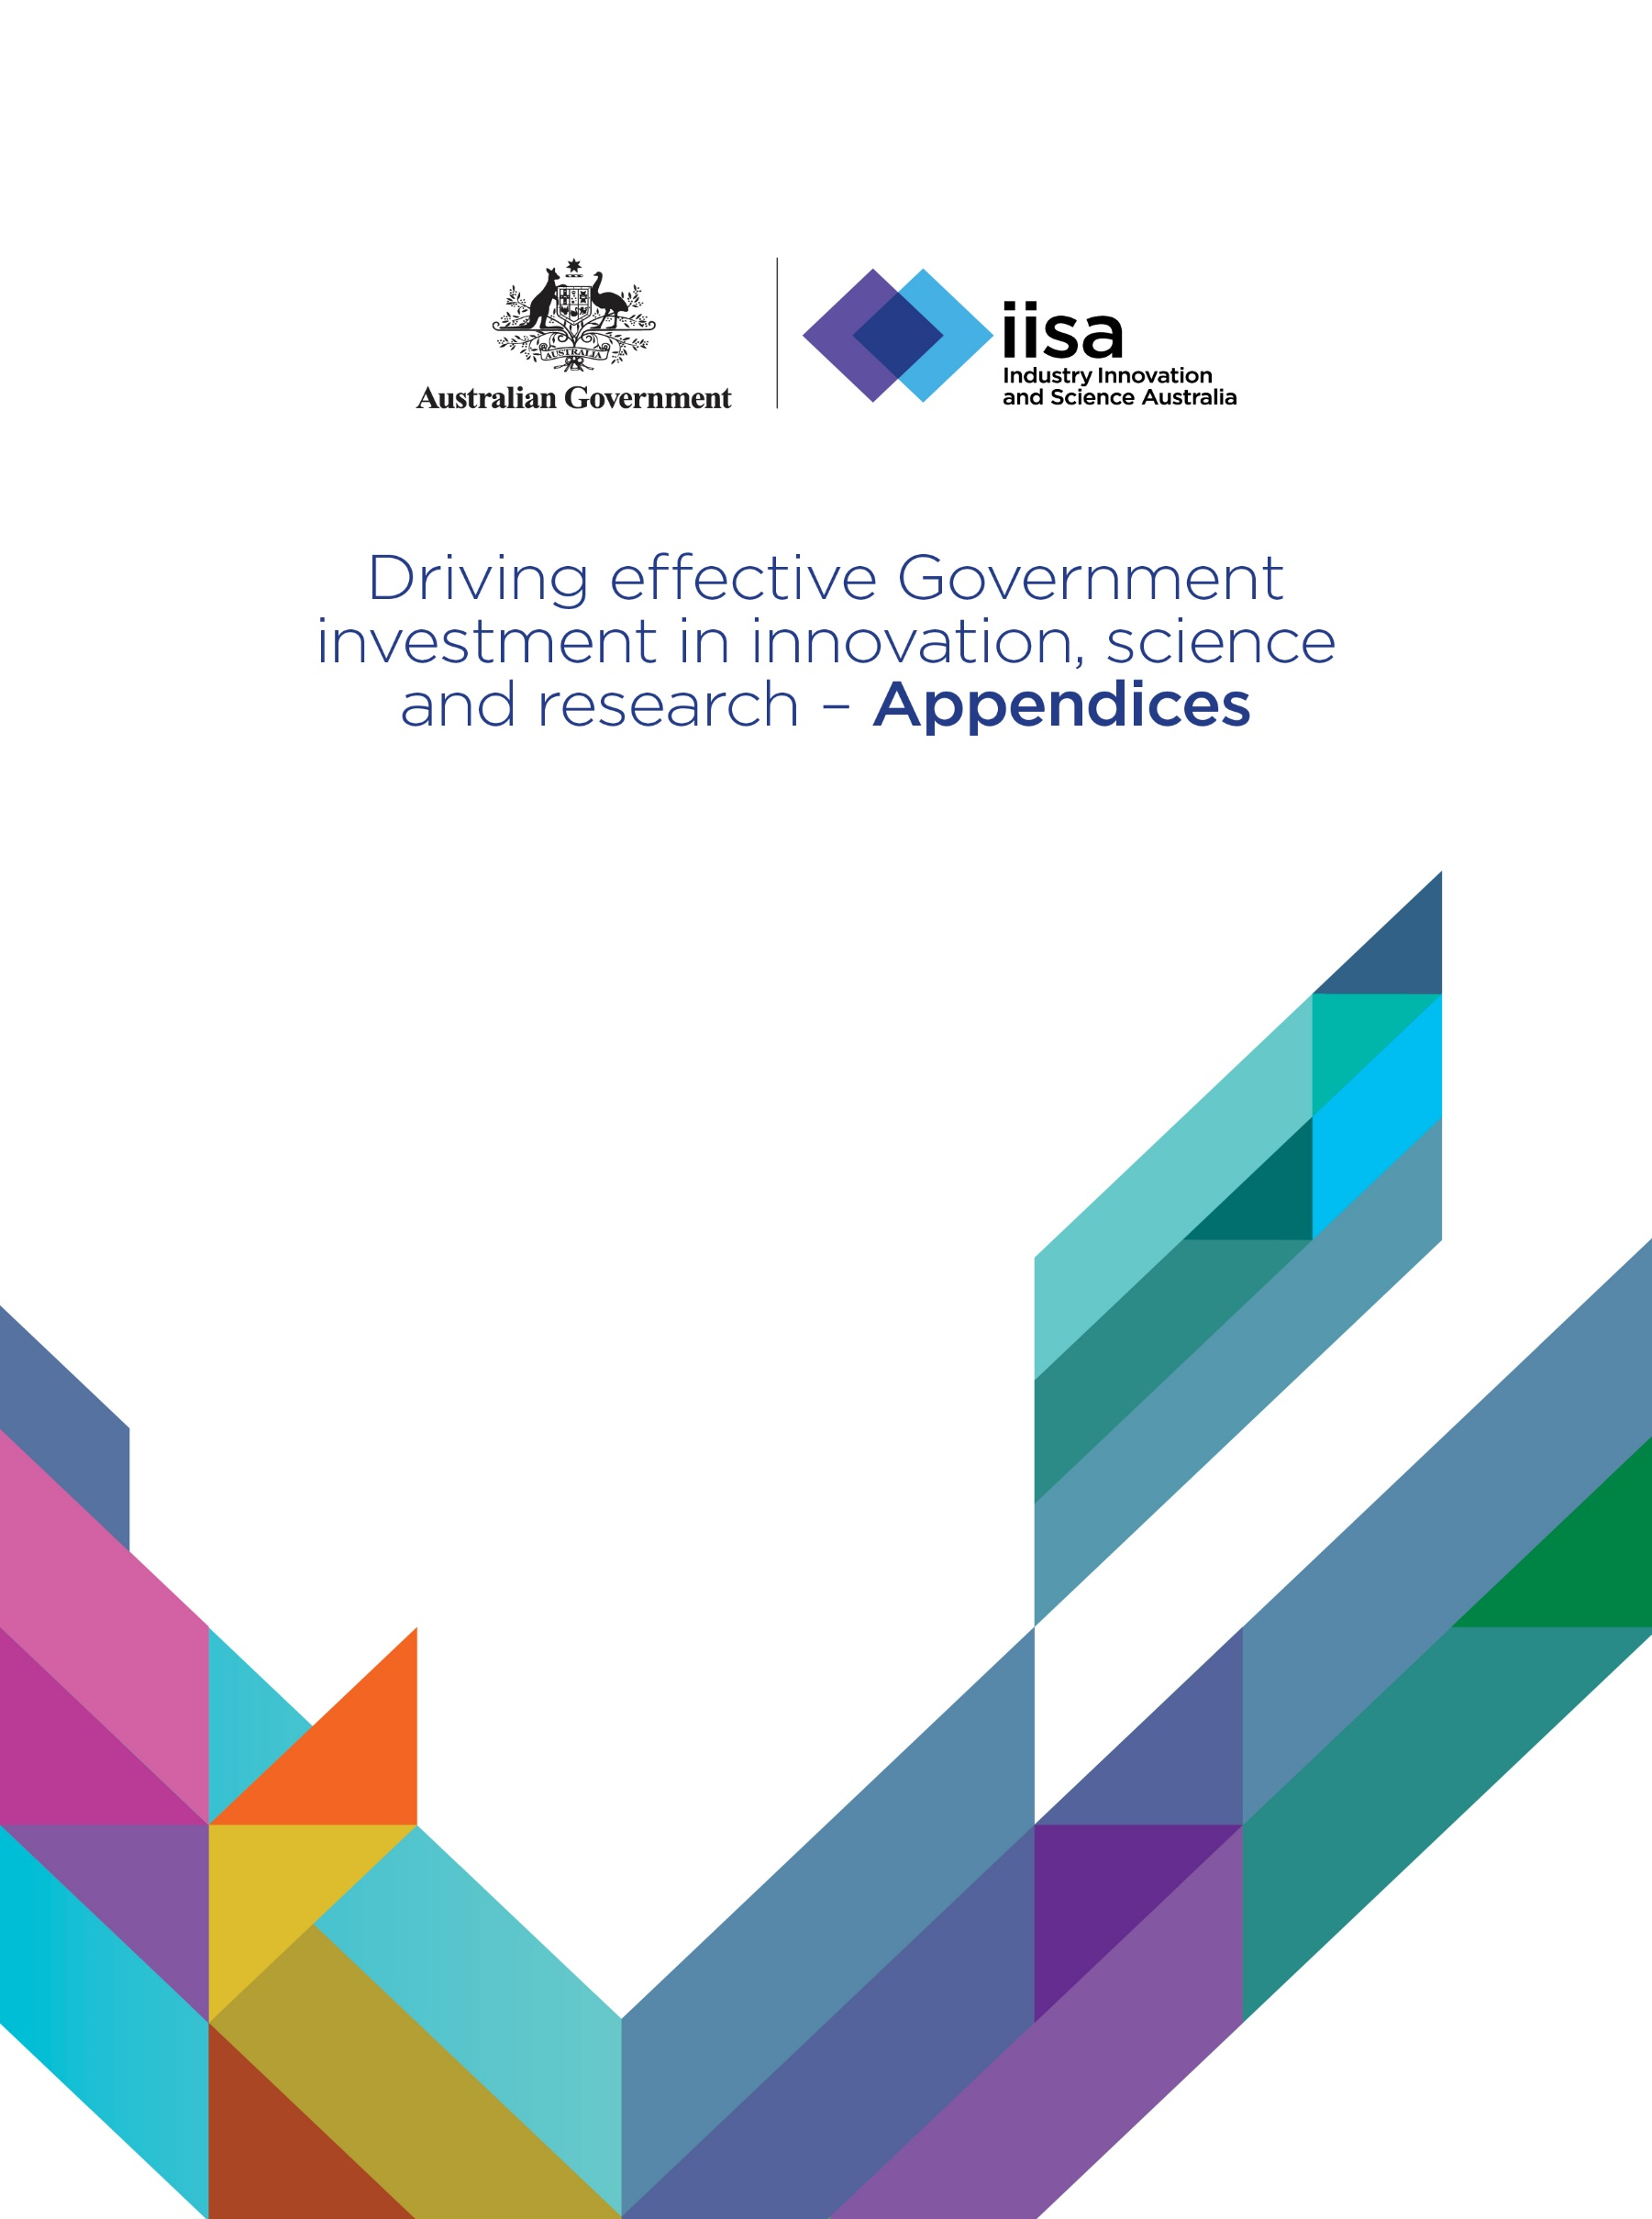

Driving effective Government investment in innovation, science and research

Appendices

Industry Innovation and Science Australia

**Online version**

The online version of this report can be accessed:

<https://www.industry.gov.au/iisa>

**Contact**

Industry Innovation and Science Australia,

GPO Box 2013,

Canberra ACT 2601

Email [office@isa.gov.au](mailto:office@isa.gov.au)

© Commonwealth of Australia 2021

This work is copyright. Apart from any use as permitted under the Copyright Act 1968, no part may be reproduced by any process without prior written permission from the Commonwealth.

Requests and enquiries concerning reproduction and rights should be addressed to the Department of Industry, Science, Energy and Resources GPO Box 9839, Canberra ACT 2601.

Disclaimer

The Australian Government as represented by the Department of Industry, Science, Energy and Resources has exercised due care and skill in the preparation and compilation of the information and data in this publication. Notwithstanding, the Commonwealth of Australia, its officers, employees, or agents disclaim any liability, including liability for negligence, loss howsoever caused, damage, injury, expense or cost incurred by any person as a result of accessing, using or relying upon any of the information or data in this publication to the maximum extent permitted by law. No representation expressed or implied is made as to the currency, accuracy, reliability or completeness of the information contained in this publication. The reader should rely on their own inquiries to independently confirm the information and comment on which they intend to act. This publication does not indicate commitment by the Australian Government to a particular course of action.

Contents

Appendix A: Introduction 5

Appendix B: Aligned to priorities 15

Appendix C: Delivering impact 18

Appendix D: Sustainable 20

Appendix E: Coordinated 21

Appendix F: Strategically balanced 23

Appendix G: Data limitations 31

Appendix H: Australia's ISR system performance Scorecard 34

Appendix I: Glossary 50

# Appendix A: Introduction

The following chapters present additional analyses and information to support the findings presented in the main body of the *Driving effective Government investment in innovation, science and research* report.[1]

### Why governments invest in innovation, science and research

Public investment in science and research is widely recognised as an essential feature of a national innovation system, playing a key role in providing new knowledge and pushing the knowledge frontier.[2] Before considering the issue of why the Commonwealth Government invests in innovation, science and research (ISR), it is worth considering how international jurisdictions are approaching their investments, and how these investments have evolved over time.

#### An international perspective

In 2011, the European Union (EU) Heads of State or Government called for all of the EU's research and innovation funding to be united under a common strategic framework. Wide‑ranging consultation involving all key stakeholders led to Horizon 2020, the financial instrument that implements the Innovation Union to promote employment, competitiveness and growth for the current decade. Horizon 2020’s goal is to ensure Europe achieves scientific and technological excellence in order to stimulate smart, sustainable and inclusive growth. Industrial leadership is one of its three organisational pillars, intended to bolster the competitiveness of European firms, optimising their growth potential and helping EU small and medium-sized enterprises (SMEs) become major actors in the international market.[3]

In the United Kingdom (UK), the 2014 Nurse Review of Research Councils[4] led to major reform of the UK’s research architecture and funding landscape. The findings of this review were subsequently incorporated into an Industrial Strategy,[5] and UK Research and Innovation (UKRI) was launched in 2018 as the national funding agency investing in science and research.[6] UKRI’s main objective is to increase the UK’s Gross Expenditure on Research & Development (GERD) to 2.4 per cent of gross domestic product (GDP) by 2027. It also enables improved coordination across disciplines and direct dialogue over funding between government and researchers.

#### An Australian perspective

The role of the Commonwealth Government and its investment in the Australian ISR system has been the subject of numerous reviews over several decades, including Government‑commissioned reviews, parliamentary inquiries, and independent assessments. Major strategic reviews have included the innovation and science mapping activities that led to *Backing Australia’s Ability* *(1 & 2)[7]* and independent reviews such as *Venturous Australia,[8]* and Innovation and Science Australia’s (ISA’s) *Australia 2030: Prosperity through Innovation*.[9] More recent reviews were commissioned to focus on particular components of the system including higher education research funding (Watt Review), health and medical research funding (the structural review of the National Health and Medical Research Council’s (NHMRC) grant programs), the Cooperative Research Centres (CRC) program and the Research and Development Tax Incentive (R&DTI). Each of these reviews has been considered by Government.

The 2017 Organisation for Economic Cooperation and Development (OECD) review of the Australian economy noted the complexity of Australia’s ISR system, with the involvement of several federal government departments and numerous councils, committees and boards. The report recommends a more integrated ‘whole-of-government’ approach to science, research and innovation, and consolidation of innovation support programs.[10]

Other studies of the Australian ISR system have contemplated broader reforms to the overarching research investment coordination framework and whole‑of‑government evaluation processes. A 2018 House of Representatives Inquiry called for greater oversight and coordination of Australia’s research investment, including a strategic review of investments to identify research priorities, better coordination of national and international research efforts, and ensuring there is adequate research across the research pipeline.[11]

Australian ISR system investigations have also focused on the degree and type of Government support, and the delivery method best suited to stimulating additional business ISR. Among a range of support measures, more recent investigations have focused on the R&DTI, which is the Government’s largest single investment to support businesses undertaking Research and Development (R&D). A 2016 Review of the R&DTI made a number of recommendations to improve the effectiveness, integrity and collaboration impact of the incentive,[12] which were further refined in ISA’s 2030 Plan recommendations.[13]

Notwithstanding the many reviews and investigations into the Commonwealth Government’s support of the ISR system, in 2017 the Productivity Commission observed that there were widespread and important economic, social and environmental benefits generated by Australia’s publicly funded science and innovation.[14] The Commission noted that, on the basis of multiple strands of evidence, the benefits of public spending are likely to exceed the costs. The Commission was, however, not able to give a rigorous quantitative estimate of the returns noting that, given a host of measurement and methodological issues, it is not possible to provide anything other than broad estimates of the overall return on government contributions to ISR.[15]

### Who invests and performs R&D in Australia

Based on Australian Bureau of Statistics (ABS) data, IISA estimates that R&D expenditure in Australia was $32.6 billion in 2016–17[16]. Figure 1 shows the breakdown of this $32.6 billion by performer and funder across key Australian R&D entities. Note that this estimate solely includes R&D, and does not include non-R&D innovation expenditure, which was estimated to be $15–19 billion in business alone in 2016–17.[17] From these estimates, it can be seen that the business and higher education sectors perform most of the R&D within Australia, while business are the primary funder, followed by the Commonwealth and general university funds.[18] Overlaying these data shows the majority of R&D performed by business, the Commonwealth (i.e. publicly‑funded research agencies; PFRAs) and the states and territories is funded by those respective sectors, with the Commonwealth also a substantial funder of higher education R&D. While the Commonwealth is a substantial funder of R&D in Australia (19 per cent), it is not a significant performer (7 per cent).

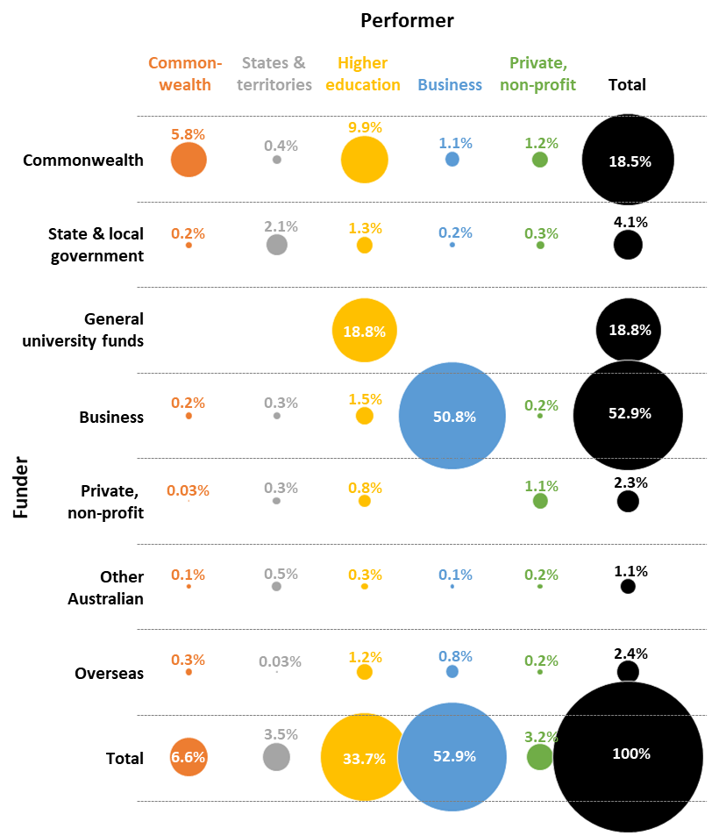

Figure 1 R&D expenditure in Australia by performer and funder across sectors, 2016–17[19]

State and territory governments control a number of R&D policy levers to which the Commonwealth has limited access. State and territory governments can provide valuable testing grounds for innovations in policy and practice that can be piloted in one jurisdiction and subsequently rolled out more broadly, if successful. They can also generate healthy competitive tensions that push strong performers to aim even higher.

Figure 2 shows the proportion of total R&D expenditure in each jurisdiction (states and territories, and overseas) by various sectors. New South Wales and Victoria have the highest overall R&D expenditure, followed by Queensland and Western Australia. The business sector is driving a significant proportion of this R&D, followed by the higher education sector. Most private not‑for‑profit R&D expenditure occurs in Victoria and New South Wales.

Figure 2 shows the proportion of total R&D expenditure in each jurisdiction (states and territories, and overseas) by various sectors. New South Wales and Victoria have the highest overall R&D expenditure, followed by Queensland and Western Australia. The business sector is driving a significant proportion of R&D across all states and territories, followed by the higher education sector. 
The most R&D expenditure occurs in NSW and Victoria, followed by Queensland and Western Australia.
Most private not for profit R&D expenditure occurs in Victoria and New South Wales.

Figure 2 R&D expenditure by location and sector, 2016–17[20]

Figure 2 provides insight into total government R&D expenditure (Commonwealth and state and territory governments combined) by jurisdiction. Victoria, New South Wales and Queensland recorded the largest total government R&D expenditure. Total government R&D expenditure in Tasmania, Australian Capital Territory and South Australia is primarily through the Commonwealth Government (98 per cent, 96 per cent and 75 per cent, respectively), while Queensland, Western Australia and the Northern Territory have the lowest proportions of Commonwealth Government funding (all approximately 45 per cent).

Figure 3 shows the total R&D expenditure in Australia, with respect to field of research (FOR)[21] and performing sector. The fields of research which received the greatest proportion of the $32.6 billion in R&D expenditure in 2016–17 were information and computing sciences (23 per cent), engineering (19 per cent), medical and health sciences (10 per cent), mathematical sciences (10 per cent) and technology (six per cent).

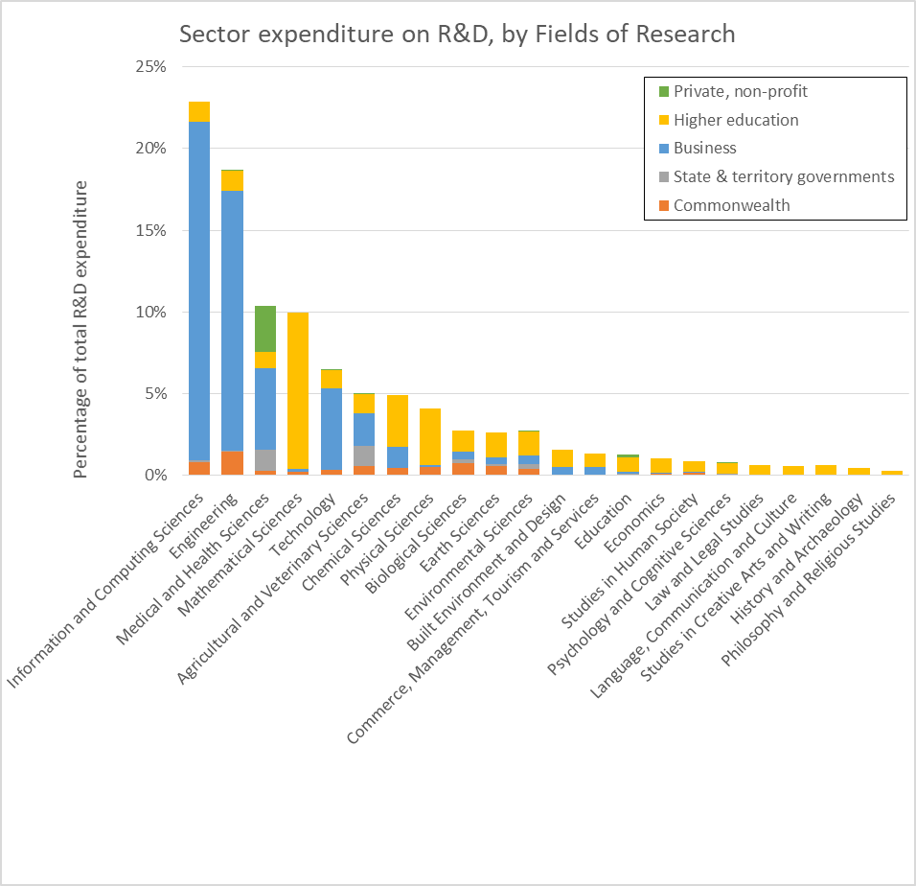

Figure 3 Total R&D expenditure: by field of research and performing sector[22]

Figure 3 illustrates how sectors vary in their FOR focus with respect to their priorities, with higher education being the only sector performing significant R&D across all FORs. The business sector focused primarily on information and computing sciences (performing 91 per cent of all R&D in this field), engineering (84 per cent), technology (79 per cent) and medical and health sciences (53 per cent). Conversely, the higher education sector was the dominant (95 per cent) R&D performer in mathematical sciences. A range of sectors contribute to medical and health sciences R&D expenditure, with this area attracting the most private non-profit R&D expenditure.

The FORs that attract the most Commonwealth R&D expenditure are engineering (22 per cent of total Commonwealth expenditure), information and computing sciences (12 per cent), biological sciences (11 per cent), earth sciences (nine per cent), and agricultural and veterinary sciences (eight per cent).

### What is the Commonwealth Government’s investment in the ISR system?

The Science, Research and Innovation (SRI) Budget Tables report the Government’s investment in R&D, science and innovation. They provide time series data on the government’s investment in ISR and information on R&D, science and innovation activities for government organisations. In 2019–20, the Government’s total investment in R&D and innovation programs and activities is estimated to be $10.1 billion.[23]

Figure 4 provides a high‑level snapshot of the Commonwealth Government’s total ISR investment by program and the socioeconomic objective(s) each program delivers against.[24] The Department of Industry, Science, Energy and Resources (DISER) administers the largest proportion (40 per cent) of the Government’s total ISR investment. This portfolio includes investment in programs relating to the R&DTI (refundable and non-refundable components), the CRC Program, and activities in the Commonwealth Scientific and Industrial Research Organisation (CSIRO), Australian Nuclear Science and Technology Organisation (ANSTO), Geoscience Australia (GA) and Australian Renewable Energy Agency (ARENA).

The Department of Education, Skills and Employment (DESE) portfolio administers the next largest proportion of the total ISR investment (31 per cent). DESE’s portfolio investment includes the Research Training Program, Research Support Program, and the National Collaborative Research Infrastructure Strategy (NCRIS).

The remaining ISR investments are spread across a number of portfolios such as the Department of Health (14 per cent), Department of Defence (six per cent), Department of Agriculture, Water and the Environment (six per cent), Department of Social Services (one per cent) and Department of Foreign Affairs and Trade (one per cent).

Figure 4 also illustrates the relative size of ISR investment programs in the context of the overall ISR investment. The R&DTI is the largest ISR investment activity funded by the Government, representing almost 20 per cent of the total ISR investment. The R&DTI also accounts for the majority (90 per cent) of the Government’s total ISR investment directed towards business. The NHMRC and Medical Research Future Fund (MRFF) are the two primary Government ISR investment programs supporting health and medical research, and together represent approximately 13 per cent of the total 2019–20 Government ISR investment.

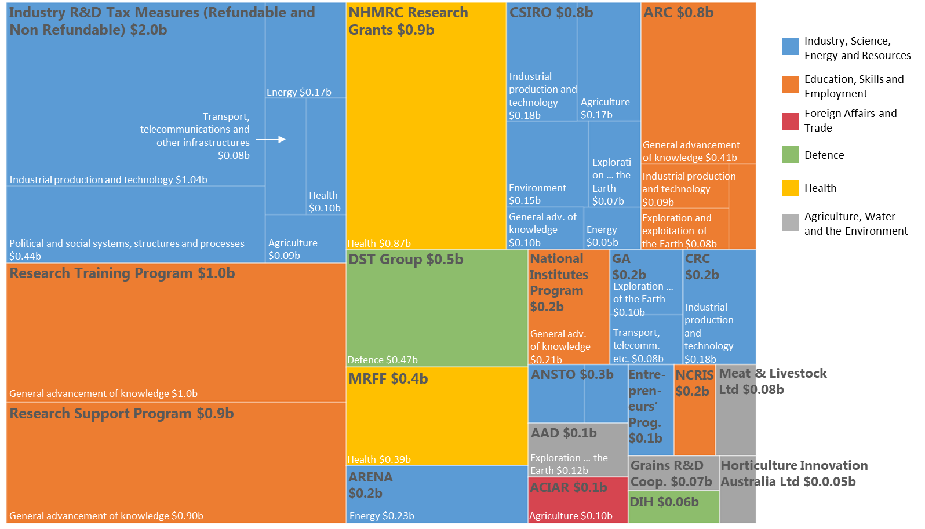

Figure 4 Commonwealth Government investment in ISR (2019–20 SRI Budget Tables)[25]

### Report approach

In light of findings from previous international and Australian reviews, IISA has taken a whole‑of‑system analytical approach to assessing the effectiveness of Government investment in ISR. IISA has:

1. Focused on the Commonwealth Government’s *investment* in ISR programs and activities, which are resourced through a budgetary appropriation and deliver an ISR policy outcome. This includes indirect support to businesses provided through measures such as the R&DTI.
2. Examined the overall effectiveness of the Government’s investment in ISR by conducting a system-level analysis. This is based on a qualitative assessment of previous Australian ISR system reviews (each typically only covering aspects of the ISR system), international literature, and the perspectives gained through consultations with key stakeholders. In addition, data including the SRI Budget Tables, and ABS and OECD data were used to inform quantitative analyses. The lack of consistent, granular and contemporary ISR investment and performance data to underpin these analyses are discussed in Appendix G. While this examination has highlighted many strategies which could increase the effectiveness of the Australian ISR system, IISA has focused on bringing forward recommended actions which it believes will achieve the greatest impact.
3. Not included intramural investments in innovative practices within the public sector in this analysis. Intramural investments, targeted at delivering the Government’s own ISR needs and activities, are often resourced from within general departmental funding. As such, they are not itemised in the Commonwealth Government’s Portfolio Budget Statements, and are difficult to comprehensively capture for analysis.[26]
4. Focused on the Commonwealth Government’s investment in ISR. While IISA recognises that state and territory governments are important contributors to the Australian ISR system, given the relative scale of their investment, as well as the significant complexity of cataloguing investment at the state and territory level, they are not a focus of this analysis. State and territory activities and investments will be touched on, as appropriate, for comparative purposes.
5. Undertaken an in-depth analysis of a thematic sub‑sector of the government ISR system to obtain detailed insights representative of the broader system. The ‘space’ sector was chosen for this purpose as it is an exemplar of an emergent government priority. The collection of government space ISR investment data has informed qualitative and quantitative analyses of the scale, distribution and nature of the government’s space investments. Consultations with Government space funders and performers, including granting bodies, PFRAs, policy makers, program owners, and businesses provided further input to the qualitative analysis.
6. Used five IISA‑developed best-practice principles to frame our analyses and findings. The Australian and international literature broadly agree that these principles underpin effective ISR investment design.[27] The principles are:
   1. aligned to priorities;
   2. delivers impact;
   3. sustainable;
   4. coordinated; and,
   5. strategically balanced (specifically, across phases and pipeline, scale, risk, investment mechanisms, and resourcing).
7. Drawn on metrics considered important to measure Australia’s ISR system performance. These scorecard metrics and a narrative are presented in Appendix H.

IISA’s findings indicate that there is no definitive source of ‘what good looks like’ for the balance and mix of government ISR investments—national innovation systems are simply too diverse. For example, the UK House of Commonsrecentlyfound that “the appropriate balance will depend on the goals and objectives of research policy. The complexity and uncertainty of the research system may mean that the optimal balance is unknowable.” They also noted that there are many possible ‘balances’ or policy mixes, investment decisions are largely based on political choice, and that government ISR investment decisions should be transparent and informed by best‑practice approaches.[28]

# Appendix B: Aligned to priorities

ISR investments, at the system level, should closely align with government priorities to ensure the effectiveness of Government’s investment. These priorities must be flexible enough to remain relevant and responsive to Government priorities, but stable enough to support long-term planning.

### Approaches to investment prioritisation

Top-down approaches to ISR investment prioritisation and coordination identify priority sectors, outcomes, or technologies; address less well-established areas of interest with long‑term horizons; and are more likely to lead to societal change. ISR investments are more likely to succeed if they are vertically aligned with national priorities early in the design process. Large‑scale priority ISR investments can serve as a focus for collaborative research and innovation, support universities or provide supporting ISR infrastructure.[29] Top‑down ISR prioritisation can take many forms, but often includes a variety of nested structural or governance approaches aligned with temporal or sectoral priorities.

Bottom-up approaches to ISR investment prioritisation and coordination, where peer review forms the basis for assessing funded research, are effective in constructing strategic innovation agendas and programs that are focused on the needs of ISR stakeholders. However, bottom‑up approaches are often conservative in scope (being typically limited to an individual research community, program or institution), and usually prioritise shorter-term outcomes.

In many cases, governments are well placed to identify current and emerging national‑scale challenges, and researchers and industry need to consider how their ISR activities can help meet those challenges. Increasingly, the literature has focused on combining bottom‑up and top‑down approaches when implementing ISR investment priorities in order to benefit from the strengths of, and interactions between, both approaches.[30]

### International best-practice

The majority of OECD countries employ a combination of both top‑down and bottom‑up approaches to ISR investment prioritisation and coordination.[31] Linking national ISR priorities with whole-of-government priorities (or even international goals e.g. the United Nations’ (UN) Sustainable Development Goals[32]) enable the ISR system to contribute effectively to solving large‑scale issues such as economic growth, sustainable cities or good health and well‑being. In some instances, dedicated mechanisms are implemented to provide this link, such as the UN’s Nations’ [Technology Facilitation Mechanism](https://sustainabledevelopment.un.org/tfm) which seeks to harness ‘science, technology and innovation to achieve the Sustainable Development Goals’. [33] The EU’s €100 billion research and innovation program, Horizon Europe, has 16 proposed objectives that span strengthening excellent basic research, strengthening gender equality, accelerating industrial transformation and improving access to risk finance.[34]

#### Design of ISR strategies

A recent OECD review of the national ISR initiatives of 12 different countries found many successful long‑term or enduring ISR strategies are organised under overarching priorities, pillars or goals.[35] They combine traditional approaches (for example sectoral-, technology- or national competitiveness‑based priorities) with cross-cutting ‘challenge-based’ approaches aimed at resolving longer-term societal challenges. IISA observed three broad themes in the science and technology priorities specific to government-funded research:

* Scientific excellence and developing research communities of excellence.
* The development of key technologies to support competitiveness.
* Addressing societal challenges.

Challenge-based approaches are increasingly used to complement more traditional national priorities. This helps governments achieve economic growth that is inclusive and sustainable in the context of major societal challenges. As multidisciplinary challenge-based approaches centre on broad and often societal issues such as climate change, they need to be designed in collaboration with a broad range of stakeholders. Articulating national challenges can enhance national innovation culture, accelerate innovation and encourage greater collaboration. They are viewed as a powerful means to inspire innovators, develop solutions to big problems, and generate national passion and pride in innovation and science achievements.[36]

Region or state-specific ISR priorities are a common cross-cutting adjunct to national ISR priorities. Seventy-two per cent of OECD countries have ISR strategies that address priorities for specific states or regions, and seek better coordination between different levels of government.[37]

#### National and subsidiary ISR priorities to provide stability and flexibility

To ensure national ISR priorities are stable enough to foster long‑term planning but flexible enough to remain relevant, many countries have enduring national ISR priorities supported by more specific, flexible, subsidiary priorities. The national ISR priorities provide a clear ISR strategy with well-defined long-term goals that are periodically revised, such as with each new government.[38] In contrast, subsidiary priorities enable Government’s ISR investments to be flexible and remain relevant in the context of an ever-increasing rate of technological and societal advancement. To ensure governments can react quickly to contextual situations and the subsidiary priorities remain relevant, most countries revise these subsidiary priorities more frequently, such as annually or mid-term.[39]

International examples of flexibility in ISR priority setting include:

* The United States’ National Science and Technology Council (NSTC), which can create working groups in crises.
* Singapore’s Research, Innovation and Enterprise Plan, which allows the Singaporean Government to flexibly reorient its sectoral priorities.
* Ireland’s Research Prioritisation process which has an in‑built review process to amend subsidiary priorities while maintaining its overarching key themes.

Conversely, a criticism of the European Horizon 2020 program is its lack of flexibility, which has resulted in considerable policy lag with regard to some emerging technologies. Its successor, Horizon Europe, which commences in 2021, is designed to address these limitations.

#### ISR priorities should include a clear financial commitment

International best-practice has shown that both the national and subsidiary ISR priorities should include a specific financial commitment.[40] The UK’s Industrial Strategy includes a series of cross‑cutting Grand Challenges designed to put the UK at the forefront of the industries of the future. Smaller‑scale activities contribute to each Grand Challenge, supported by a significant Industrial Strategy Challenge Fund.[41] The first two waves of funding secured £986 million in government investment in addition to almost £488 million of underpinning investment. In contrast, Norway’s Long-Term Plan has been criticised for its failure to provide clear financial commitment across all of its ISR priorities.[42]

# Appendix C: Delivering impact

Effective ISR investments demonstrably achieve their intended outcomes. ISR investments should be designed with transparency, have clarity of purpose, expected outcomes, key performance indicators, evaluation processes, returns on investment (financial, economic or social), and user/target. They should also be subject to regular and rigorous monitoring and evaluation at all levels of the system by an independent evaluator.

### Performance of publicly-funded ISR

The Government’s investment in ISR has led to numerous high-impact innovations and outcomes, including the Jameson flotation cell,[43] sliver cell technology,[44] Hexima’s ag‑biotech,[45] and the cervical cancer vaccine Gardasil. Australia’s research system performs well globally. With just 0.3 per cent of the world’s population, Australia contributed over four per cent of world research publications in 2017. Our individual scientists and researchers also perform well, with the Australian ISR system producing 16 Nobel Prize recipients since 1915.[46] Today, Australia ranks tenth, globally, in terms of the overall quality and quantity of its scientific publications.[47]

Despite some high-impact ISR system outcomes, the 2015 Watt Review observed there has been little focus on the performance of Australia’s publicly‑funded ISR system as a whole, given there is no single Minister with overall responsibility for the research sector.[48] Additionally, recent parliamentary inquiries on aspects of the ISR system observe that evaluations, when they have been conducted, are often performed under political or fiscal threat of termination.[49]

Models for whole-of-government investment performance monitoring and evaluation are valuable reference points when designing optimal evaluation frameworks in the ISR domain. In the Republic of Korea, a national institute performs a centralised and legislated ISR performance evaluation function.[50] While some elements of this approach may not directly translate to the Australian context, the breadth of the institute’s function, from collecting internationally comparable national ISR data and evaluating national R&D programs and science agencies, through to diffusing best‑practice performance measurement, could inform Australia’s approach. The Canadian Policy and Directive on Results legislation, administered by the Treasury, implements consistent evaluation processes across government. The Treasury also publicly reports evaluation results, enabling system-wide investment optimisation and ensuring accountability.[51] In Australia, the New South Wales (NSW) Government has moved to a legislated approach to Outcome Budgeting.[52] This approach facilitates performance-focused investment decision-making and promotes transparency in reporting on the performance of NSW Government agencies. The NSW Government has progressively refined the framework, and has observed challenges in achieving the shift, which requires a long-term cross-government cultural change towards an outcomes‑focus, from policy design through to evaluation.[53]

### Challenges of measuring return on public investment

Over the past decade, many important innovations have had their roots in public research, for example, the internet and genomic technologies. However, the OECD[54] noted that the immediate economic returns from academic research investment have been difficult to demonstrate. A detailed review of this field could occupy a report all on its own. As one European commentator observed:

*“The many economic measurements of returns on investment to publicly funded [research and innovation] R&I vary wildly in range, but seem to cluster at around a 20 per cent annual return on investment. This can be compared to 6.8 per cent for the past 10 years of the United States stock market (S&P 500) or the 3.1 per cent for 10‑year Euro Area (19 countries) Government Bonds. In short, publicly funded R&I is a good investment.”[55]*

Importantly, the quantum of Government investment is not the only determinant of success. The UK’s innovation think-tank Nesta has highlighted that while the level of Government ISR investment is important, a well-functioning, efficient and effective innovation system is also needed to maximise the return on investment. Nesta noted that:

*“Government must also remember that fuel alone is not enough. It needs to be pumped into a working engine that performs efficiently and effectively. R&D investment will only fuel economic and societal benefits if the engine—the broader innovation system—is fully functioning. Only that way can we bring bold ideas to life.”*[56]

# Appendix D: Sustainable

ISR investments should be ongoing and predictable, unless rigorous evaluation proves they are ineffective, or when short‑term programs are demonstrably required (e.g. pilot programs). The system should be funded and stable enough to develop long-term ISR strengths and outcomes.

Australia’s system features few long-term and truly transformative ISR programs. The high turnover of Government investment measures has led to uncertainty in the business and research community.[57] Lengthy funding approval processes, disproportionate funding of short‑term measures and funding uncertainty can lead to suboptimal outcomes such as missed opportunities, wasted resources, reduced ability to attract and retain talent, and obstructed career pathways for early and mid‑career scientists.[58]

Internationally, sustainable ISR investment is driven through stable and sustainable ISR strategies.[59] Countries, such as Germany, Japan, Korea, Norway, Singapore and Sweden have long-term, rolling ISR strategies in place, ranging up to 20 years in duration, which are periodically revised.[60] Korea for example, revises its Basic Plan annually while Norway evaluates and revises its Long‑Term Plan every four years. These strategies often put forward quantitative targets primarily linked to total expenditure on R&D, such as a target of 3.5 per cent of GDP for Germany’s High-Tech Strategy.

These rolling ISR strategies provide continuity to business and research sectors, and support coordination and efficiency within government through a consistent structure. They also limit the turnover of investment measures unless rigorous evaluation proves they are ineffective. Within this construct, shorter-term investments are often pilot initiatives that may be transitioned into longer-term programs if effective, or, if evaluation proves they are ineffective, they are ceased.[61]

Internationally, long‑term funding is supporting breakthrough innovation which addresses societal challenges, allowing countries to perform ambitious and complex research agendas.[62] The OECD[63] noted that universities and public research institutions often undertake longer‑term, higher‑risk research that complements private sector research activities.

# Appendix E: Coordinated

Government’s ISR investments, including Defence and National Security, should be coordinated at the whole-of-government level. This coordination should not impose undue administrative burdens, but should improve system efficiency and effectiveness. It should also improve program effectiveness through greater alignment of ISR investments with Government priorities, ensuring Government’s ISR investments maintain their strategic direction.

Both the Australian and international literature observe Australia’s enduring ISR coordination challenges, and the requirement for greater coordination of investments across government, including across state and territory investments.

Australia’s ISR programs operate in a complex system that includes multiple government agencies and numerous councils, committees and boards.[64],[65] In Australia, there is no central body or agency responsible for ensuring coordinated ISR policy development and implementation, or tasked with regularly reviewing ISR investments to ensure that unintentional gaps, overlaps and duplications are minimised.

Numerous reviews have observed the negative impacts resulting from fragmentation,[66],[67] compounded by the lack of an overarching investment strategy. The result is reduced‑scale, individual investments and uncoordinated investments across agencies and funding sources. This fragmentation is inefficient, costly and time consuming for Australian researchers and businesses.[68] Consolidation of these ISR programs would better focus the Government’s investment, and avoid investment gaps and duplication, build areas of expertise and critical mass,[69] and help avoid program failures.[70],[71]

In Australia, several ISR governance and coordination mechanisms have been trialled in the past. In 2015, the Government announced the Innovation and Science Committee (ISC) of Cabinet as part of the National Innovation and Science Agenda (NISA) to place innovation and science at the centre of policymaking. Chaired by the Prime Minister, the ISC included 11 other senior government and ministerial members.[72] In 1997, the Prime Minister’s Science Engineering and Innovation Council was created to serve as the Government's principal source of independent advice on issues in science, engineering and innovation and relevant aspects of education and training.[73]

Internationally, the OECD has found that whole-of-government coordination of national ISR investment, including broad ministerial involvement and interdepartmental monitoring, was a key success factor for ISR governance.[74] ISR commitment at the highest level of government was found to drive inter‑agency coordination of priorities and programs.[75]

The OECD also found that policy action was coordinated through research and innovation councils, national research and innovation strategies or plans, or inter-agency joint programing.[76] Of the 35 OECD countries reviewed, independent ISR advisory councils are mandated to provide policy advice (90 per cent), develop strategic priorities (74 per cent), evaluate policy reforms (48 per cent), coordinate with both government and non-public stakeholders (48 per cent), or allocate research and innovation budgets (23 per cent).[77] In the UK for example, UKRI plays a key coordination role bringing together seven research councils and delivering the majority of government funding for research and innovation (excluding funding for national security or defence purposes).

The OECD also considers the involvement of advisory bodies who represent key ISR system stakeholders as a critical element in the success of ISR governance initiatives.[78] One motive for launching the UKRI strategy was to enable direct dialogue between politicians and scientists over funding by providing science and innovation a unique voice, and ensuring a greater role of science in society.[79]

# Appendix F: Strategically balanced

Australian literature is dominated by discussions around the importance of balancing the ISR investment portfolio and the absence of a framework to guide the process of balancing investments.[80] IISA’s best-practice ISR investment framework recommends a balanced mix of investments across phases and pipeline, scale, risks, investment mechanism, and the types of resourcing, to drive greater efficiencies and more effectively focus outcomes in priority areas.

### Phases and pipeline

A strategic balance between ISR phases (basic, applied and commercialised) will ensure Australia performs the basic research which underpins future commercial opportunities and enables seamless movement between phases of the innovation pipeline. Greater research-industry collaboration encourages a smoother transition of knowledge for commercial application.[81]

The metaphor of a ‘pipeline’ of research and the consequent identification of ‘phases’ is a common (and useful) abstraction. However, in practice, the progression of ideas and technologies from conception to application is rarely smooth and unidirectional. To reflect these complexities, strategies to encourage the successful transition of ISR from basic research through to commercialised (or operationalised) outcomes need to be flexible.

The Australian literature recognises that balancing investments optimally across the phases of the pipeline is a challenge,[82] with a recent call for a strategic review to ensure Australia’s investment across the research pipeline is adequate.[83] Recent reviews have noted that Commonwealth Government investment in blue‑sky and basic research is under pressure and being overlooked for more commercially attractive research. However, government funding of basic research is required to ensure Australia develops both the foundations of technological innovation and the ability to ensure successful applied and commercialised research.[84]

Figure 5 shows the type of Australian R&D activity performed by various sectors.[85] Current R&D expenditure is balanced towards applied research and experimental development, with only 22.3 per cent of total R&D performed being basic research (pure basic research at nine per cent and strategic basic research at 14 per cent).[86] The higher education sector performs 89 per cent of all pure basic research and 62 per cent of all basic research.[87]

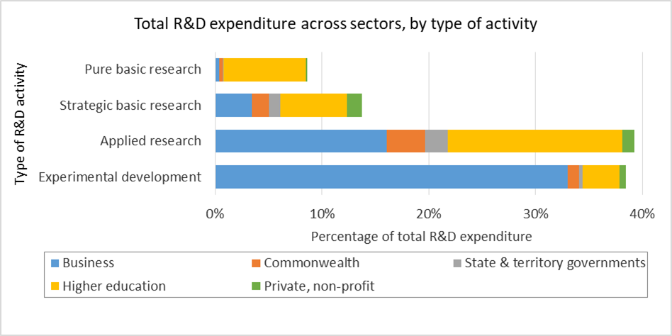

Figure 5 Type of R&D activity across performing sectors

While being the primary performer of pure basic research, the higher education sector participates in all four types of research activity. In contrast, the Commonwealth, state and territory, and business sectors focus on applied research and experimental development, comprising 71 per cent, 68 per cent and 92 per cent of their total performed R&D respectively (Figure 6).

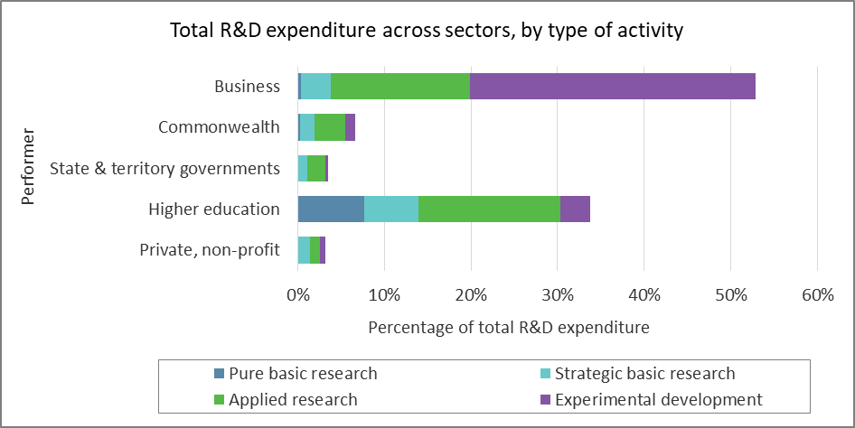

Figure 6 Type of R&D activity, illustrating the contribution of each performing sector

Several reviews have noted that, while Australia performs above the average globally in knowledge creation, there is room to improve the effectiveness of Australia’s knowledge translation and commercialisation.[88] Establishing a dedicated stream of funding for non‑medical research translational activities, comparable to elements of the MRFF, has been recommended previously.[89] The MRFF will nearly double the government’s investment in medical research, and with a strong focus on translational activity, it will encourage Australian researchers to achieve greater impact and require them to work in multidisciplinary teams. The limited experience of Australian businesses engaging with researchers has prompted calls for additional business-side incentives, for example a collaboration premium, which IISA has previously supported.[90]

In 2019, the OECD listed strong industry-research collaboration in R&D as critical to the success of ISR governance policies.[91] Internationally, government initiatives to promote industry–research collaboration often focus on the creation of research centres. These specialise in specific technological domains and connect industry with research to drive innovation and the development of new commercial products and services. Examples include the UK’s Catapult Centres, and innovation superclusters in Canada, where projects are co‑funded by government and industry at a one‑to‑one ratio. Germany’s High-Tech Strategy is recognised for its high‑level of industry‑science connectivity.

Other international initiatives require intermediary organisations such as technology transfer offices to be a primary program partner, or allocate funding to a single consortium rather than a group of actors to ‘democratise’ the generation and diffusion of knowledge. ‘Challenge-based’ innovation policies have also been effective, by setting bold strategic directions and causing different sectors and stakeholders to interact.[92]

Collaborative networks of multidisciplinary and cross-sector actors, who are all actively involved in ISR, has been found to be an effective method of knowledge transfer.[93] These networks are based on transparency and trust; encourage mutual benefit and an understanding of each other’s interests (such as competing demands); have flexible funding programs that support a cooperation culture; reduce barriers to cooperation through clear contracts or binding agreements, particularly around intellectual property (IP); and encourage industry‑research staff mobility.[94],[95]

Initiatives aiming to progress ISR commercialisation have focused on driving market interactions and IP management, including grace periods for patents. To improve the proportion of technology transfer projects with substantial economic impact, strategic support should be provided. For example ensuring technology transfer projects can attract resources and scale up if necessary, and exit swiftly and smoothly if unsuccessful.[96] These have been found to be more effective at increasing commercialisation than those based on traditional indicators such as increasing the total number of patents or start‑ups.[97] This shift away from traditional indicators is particularly relevant in regards to evaluation and measuring the success of industry-research collaboration initiatives.

### Risk

Incorporation of high‑risk and high‑reward ISR in a strategically balanced portfolio of investments ensures sufficient support of ambitious or bold approaches with the potential to lead to breakthrough ISR. The technical and commercial risks of ISR investments need to be assessed, accepted and incorporated into the initial design, and strategically balanced across the investment portfolio.

IISA found that the Government already invests in some higher‑risk ISR. For example, ARENA actively pursues higher‑risk project investments in order to reduce future investment risks and support technology commercialisation.[98] The MRFF’s Frontier Health and Medical Research initiative, NHMRC Ideas grants and CSIRO’s [Main Sequence Ventures](https://mseq.vc/) are investment programs largely focussed on supporting higher‑risk, often early‑stage, innovative ISR. MRFF’s Frontier Health and Medical Research program uses a two‑stage investment structure, with initial support of up to $1 million, followed by $10–$20 million over five years for the best proposals. However, IISA could not find evidence of a more system‑wide approach to risk within the government’s ISR investments, potentially limiting access to high‑risk funding in some ISR areas.

While risk is not explicitly considered in all government ISR investments, risk management processes have been established in some Government‑funded ISR initiatives. This includes the Defence Science and Technology (DST) Group’s Technical Risk Assessment Handbook,[99] which provides Defence personnel and stakeholders with a process and best‑practice guide to the assessment of technical risks for major Defence capital acquisition programs, including projects that require R&D. The Accelerating Commercialisation stream of the Entrepreneurs’ Programme[100] deals at the program level with aspects of the technical risk of projects considered, as well as requiring applicants to provide an execution plan to capture the commercial opportunity and manage risk.

There is increasing international recognition of situations in which governments have played key ‘entrepreneurial’ roles, envisioning and financing the creation of entirely new fields of ISR, from information technology to biotech, nanotech and green tech. In Silicon Valley, for example, the United States government acted as a strategic investor through a decentralised network of public institutions such as the Defence Advanced Research Projects Agency (DARPA), National Aeronautics and Space Administration (NASA) and the Small Business Innovation Research (SBIR) program.[101] As the UK economist Mariana Mazzucato has pointed out, governments have developed nearly all of the technologies that made the iPhone possible: the internet, global positioning systems (GPS), touchscreens and the advances in voice recognition technology which underlie Siri.[102]

The EU, UK, Canada, Germany, Japan, Singapore, Sweden and Israel have implemented specific mechanisms to support breakthrough innovation such as supporting researchers, start-ups and SMEs.[103] These include UKRI’s Smart Grants, Canada’s ‘Challenge Programs’, Japan’s ImPACT (Impulsing Paradigm Change through Disruptive Technologies) program, Sweden’s Bio‑innovation program, and Singapore’s National Research Foundation Investigatorships. A key aspect of many of these international mechanisms is that the funding for this potentially breakthrough innovation is unavailable from other sources, primarily due to its high risk.

### Scale

Appropriately scaled investments are key to achieving meaningful impact, precise targeting and delivery efficiency. There is a recurring theme in the Australian literature that Australia’s science and research investments lack scale, both at the program and the system level. According to one review, low success rates for research grants have been attributed to a limited funding pool, not a limited pool of quality applications.[104] In part, this small ISR investment scale reflects the smaller Australian economy as compared to peer economies such as the United States, UK and Canada.

A high‑level analysis found that half of the ISR programs funded in 2019–20 collectively account for under one per cent of the Government’s ISR investment. This long tail of small investments in ISR is being driven by several types of programs: pilot programs, small‑scale ongoing programs that do not contribute to a larger program, and small-scale ongoing programs that do contribute to a larger program of work.

Some small ISR investments are ongoing, low-cost programs with merit, which do not contribute to any larger program of work. For example, the Australian Biological Resources Study (ABRS), funded since 1978–79 with an average annual budget of $1.8 million, coordinates research in taxonomy and documentation of Australia’s flora and fauna. ABRS provides fundamental information underpinning Australia’s biodiversity research and agricultural industries.[105],[106]

It is important that the scale of ISR programs is appropriate, relative to their intent. For example, the Government’s $20 billion commitment to the MRFF is appropriately scaled to the Fund’s objective to transform health and medical research and innovation to improve lives, build the economy and contribute to health system sustainability.[107] Figure 7 shows the Government’s investment divided into major and minor programs, and the number of programs over time.[108]

Figure 7 shows the Government’s investment divided into major and minor programs (based on size of investment), and the number of programs per year since the 1997-98 financial year.
The proportion of programs by count less than $100 million has risen sharply since 1997-98, but has fallen slightly since 2017-18.

Figure 7 Long-term distribution of ISR investment by program size, according to total investment (*left*) and number of programs (*right*).

Other similarly‑sized economies are also grappling with the issue of scale. For example, New Zealand has set itself a target of becoming a global innovation hub by raising national research expenditure to two per cent of GDP by 2027. New Zealand is concentrating its efforts to build scale and depth in areas of emerging opportunity, disruption and critical need.[109] Similarly, the UK’s research architecture and funding landscape has seen major reform in recent years, including an Industrial Strategy R&D target of 2.4 per cent of GDP, and prioritised investments in national Grand Challenges. Their Industrial Strategy has used smaller‑scale activities under each Grand Challenge and is directly supported by a significant Industrial Strategy Challenge Fund to improve investment scale, and reduce program fragmentation.[110]

### Investment mechanisms

Balancing the use of targeted and broad‑based ISR investment mechanisms should maximise the benefits of both investment mechanisms, while minimising limitations. To understand the Government’s balance of investment mechanisms, IISA assessed each program or activity’s[111] funding‑allocation method and categorised it as either targeted, broad‑based, or multi-method.[112] Overall, the Government’s 2019–20 ISR investments are approximately evenly split between broad‑based (53 per cent; such as R&DTI) and targeted funding allocation methods (46 per cent) such as grants, subsidies, loans, equity funding, and public procurement for R&D). One per cent of funding was allocated through multi‑method approaches.

However, further analysis of funding mechanisms indicated that while investments are almost equally balanced between broad-based and targeted mechanisms overall, there is significant variation across each of the ISR sectors.[113] Figure 8 shows the breakdown of programs within the dominant funding allocation method (broad‑based or targeted) within each sector. This illustrates that many programs are funded by targeted mechanisms within the government and multisector sectors. In contrast, the broad-based mechanisms used in the business and higher education sectors were dominated by a few very large programs: the R&DTI program within business and Australian Research Council (ARC) and block funding within the higher education sector.

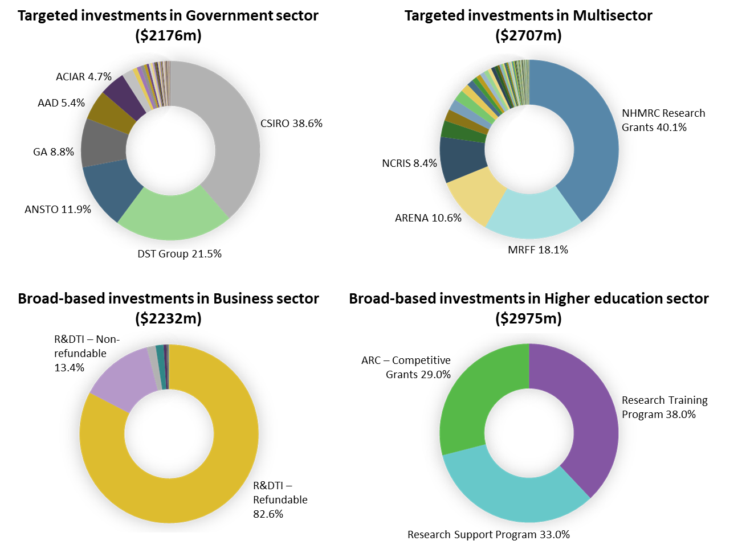

Figure 8 Targeted and broad‑based investment for 2019–20 by individual program investment within each research sector[114]

Australia’s targeted funding mechanisms have been refined over time, such that granting processes in agencies such as the ARC and the NHMRC are mature and effectively supported by a sophisticated review and evaluation infrastructure. However, some stakeholders have suggested that the typically disciplinary area-focussed structure of these processes may be inhibiting the progression of interdisciplinary ISR.

# Appendix G: Data limitations

IISA found that each of the datasets used in this analysis had limitations. The OECD Main Science and Technology Indicators data[115] provided valuable global comparison insights, however, Australian data were not available for many of the comparisons of interest for this analysis.[116] The SRI Budget Tables were found to be a valuable source of surveyed time series data for Commonwealth Government R&D investments, particularly for the system-level analysis of investments within Government departments. However, the SRI Budget Tables were not suitable for more detailed government ISR investment analyses due to some insufficiencies in data detail, accuracy and/or fidelity.

For example, the data for the Government’s investment in ISR, particularly innovation,[117] is incomplete. The 2019–20 SRI Budget Tables define innovation investment as programs and activities explicitly intended to support science, research and/or innovation. More than 80 per cent of the 42 programs funded through the Public Sector Modernisation Fund (PSMF), a $500 million initiative to modernise and enhance the productivity of the public sector,[118] would meet the definition of innovation (such as the Data Integration Partnership of Australia and Business and Community Grants Hub initiatives).[119] Yet only around 40 per cent of these programs are captured within the SRI Budget Tables. This issue is not limited to the PSMF, with other Government innovation investments also unrepresented in the SRI Budget Tables.[120]

Insufficiencies in detail generally relate to program-level data, which leads to issues in assessing investment fragmentation and scale. Many of the smaller programs listed in the SRI Budget Tables contribute to a larger program of work already identified in the tables, but these programs have not been grouped together.[121] Furthermore, many individual line items do not provide sufficient fidelity for this analysis.[122] Program‑level detail would be better organised and more accurately represented as two levels of information; the overarching program or agency (e.g. CSIRO) and the specific program or initiative, as shown in Canada’s InfoBase.[123]

IISA also examined ABS data[124] and found that they provided system‑level survey data for business, Commonwealth, state and territory governments, higher education and private not‑for‑profit R&D expenditure. These data can be used to assess the source of funding, the type and location of the expenditure, and the classification of this expenditure according to socioeconomic objectives and fields of research.[125] However, ABS data can only be used for a system‑level analysis as it does not have enough depth of detail, such as the recipient of funds, to examine gaps and overlaps in the system.

It should be noted that comparisons between the SRI Budget Tables data and the ABS data are limited given they use different (but complementary) approaches to measuring government investment in R&D. The SRI Budget Tables use the funder-based approach[126] and the ABS use the performer‑based approach.[127] Further to this, they use different definitions of socioeconomic objectives, with the 2019–20 SRI Budget Tables using 14 socioeconomic objectives[128] as described in the OECD’s Frascati Manual 2015,[129] while the ABS use 17 divisions (organised under five sectors) as described by the Australian and New Zealand Standard Research Classification (ANZSRC). [130],[131] Of note, the ANZSRC is currently under review to ensure, in part, that it reflects current practice and is sufficiently robust to allow for long-term data analysis.[132] Developed to meet the need for a comprehensive description of Australia’s and New Zealand’s research environment, as well as to enable the international comparison of research statistics, the ANZSRC review will take into account its alignment with international standards such as the Frascati Manual.

The above issues relate in part to a lack of agreement on data sharing across the Australian Public Service (APS). Data Availability and Transparency legislation is currently being drafted[133] by the Government to provide a framework for how public‑sector data in Australia is used and reused. Its goal is to maximise the value of public‑sector data, support a modern data‑based society, drive innovation and stimulate economic growth. A key outcome of this legislation should be enhanced data sharing and improved data governance across the APS. Similar efforts are underway in state governments. For example the NSW Data Analytics Centre[134] operates a whole‑of‑government data analytics infrastructure and data science capability through a single data platform, to facilitate data-sharing and inter-departmental collaboration, combat operational silos, and focus on state-wide outcomes that are greater than the sum of their parts.

To gain more holistic, numerically‑supported, evidence to describe the current balance of government ISR investments (and to effectively adjust this balance over time), more detailed and consistent government investment data is required. Improving ISR investment data presents a significant opportunity for Government to improve the effectiveness of its investments. This could be achieved through new or revised whole‑of‑government ISR investment quantitative evaluation, survey and data collation processes.

Ongoing collection of these data could then be used to inform discussions about whether the current strategic balance of ISR investments remains appropriate, and if not, where adjustments could improve its effectiveness. A consensus definition of which investments are considered ‘within’ the domain, and the careful delineation of which data are to be acquired is required before new data acquisition can commence to ensure data are of sufficient fidelity and accuracy to be meaningfully used to inform discussions of balancing the investment portfolio over time.

# Appendix H: Australia's ISR system performance Scorecard

The COVID‑19 pandemic together with the catastrophic 2019 bushfires, are testing the resilience of Australia’s economy. However, well before these crises, Australia’s productivity growth had slowed significantly and the drivers of economic growth had begun to re‑balance, with mining investment and export growth continuing to slow since the peak of the resources boom in 2011.[135] How we respond in the wake of these crises and address the consequences of our changing economic drivers, will ultimately influence how we adapt to future challenges.

In times of economic uncertainty, innovation is the key to bolstering resilience and adaptability in government and industry. There is an ongoing need for the Australian economy to develop new and more diverse sources of growth to ensure our nation’s prosperity.

Industry Innovation and Science Australia's (IISA) report responds to a request from the Honourable Karen Andrews, MP, the Minister for Industry, Science and Technology, for a report on the effectiveness of the Commonwealth Government's investment in, and system performance of, ISR (including a Scorecard on the ISR system).

To do this, IISA leveraged a Scorecard based on work undertaken by the Department of Industry Science, Energy and Resources (DISER) Analysis and Insights Division and the Office of Australia’s Chief Scientist. This Scorecard (the Scorecard) identifies (based on available, collected and internationally comparable data) metrics considered important for monitoring innovation‑driven productivity gains in the economy.

The information in the Scorecard, and the narrative that follows, is based on data available as at 30 June 2020. While the Scorecard provides a broad overview of Australia’s innovation performance, the data does not reflect the impacts of the recent global pandemic and bushfire events. The data represents a baseline of our performance before the impact of a global shock event, for which the full economic impact domestically and globally is still uncertain. These effects may also not appear in the data for some time.

The following narrative outlines IISA’s views on how Australia’s innovation system has performed pre‑pandemic.

The Scorecard assesses the performance of Australia’s innovation system under each of the drivers of productivity growth: business activities, business environment, national environment and impacts. For ease of reference, the metrics relating to each driver are included at the top of each section, and the Scorecard in its entirety is displayed on page 44.

Based on the metrics identified in the Scorecard, it is important to highlight that no single country performs in the top quartile in every single metric. The Scorecard contains 19 metrics, and of these, Australia has four metrics that rank us in the top quartile, alongside countries such as Iceland, Japan, Norway and the United Kingdom. Our strengths appear to lie in our low levels of regulation, investment in our educational institutions, the quality of our labour and our uptake of digital technologies (inferred from the proxy of adoption of cloud computing technology). Denmark has the most metrics in the top quartile (ten), followed by Sweden (nine) and Switzerland and Korea with eight each. Other nations in the top quartile with five or more metrics, include Austria, Belgium, Estonia, Germany, the Netherlands, the United States and Finland.

### Data limitations

The Analysis and Insights Division within DISER and the Office of Australia’s Chief Scientist undertook a comprehensive review of currently available innovation metrics. Nineteen metrics were identified as key indicators based on available data. A detailed description of each metric is available at Table 1.

In making our observations, we also note the following limitations with the domestic and international data.

* ***Data reporting lags:*** Across the 19 metrics, latest available data ranges from 2016 to 2019. Metric comparisons are made over differing years, with each year potentially having different environmental factors for a particular country that influence the metric result. However, the global environment has remained relatively stable over the period from 2016 to 2019, void of global shock events such as the Global Financial Crisis and the COVID‑19 pandemic.
* ***Consistency of data availability:*** Internationally, data for each metric is not consistently captured each year. In some years, countries will report on certain metrics and in others, they will not (for a variety of reasons). As a result, availability of international data can affect Australia’s ranking, as well as our ranking in the top five, as this is highly dependent on which countries release their data for a particular metric in a given year.
* ***Metric rankings vary in terms of number of countries included in the comparison pool:*** Each metric varies in terms of the number of countries that report on it, and this can change year on year. Therefore, Australia is not ranked consistently against the same cohort of countries. Some metrics include only OECD countries, while others include nations such as China, Malta, Brazil, Bulgaria and South Africa. Comparisons that include non‑OECD countries may skew Australia’s ranking and quartile, as inclusion of developing countries may artificially push Australia’s rank into higher quartiles. Similarly, Australia may be pushed into lower quartiles if only advanced countries are included.

### Business activities

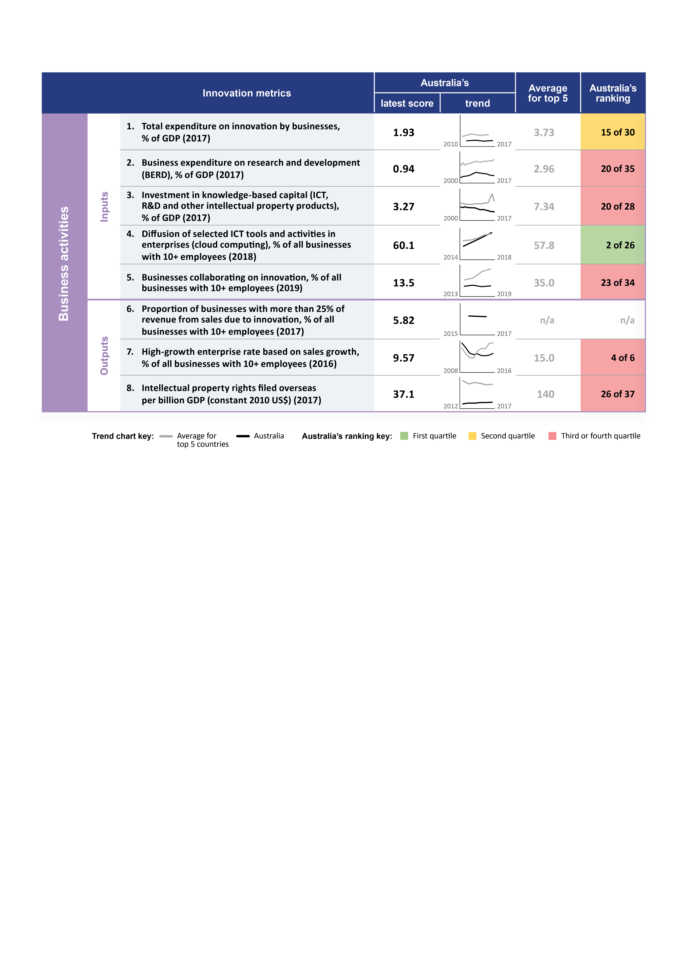

Figure 9 Business activities innovation metrics

The COVID-19 outbreak has had a severe effect on the Australian economy. Australian GDP fell by 7 per cent in the June quarter, and unemployment reached 7.4 per cent in the month of June, the highest rate in more than two decades.[136]

Beyond 2020, the outlook depends on future outbreaks of COVID-19 cases, and the speed at which a viable vaccine can be developed and distributed. Uncertainty and diminished confidence weigh on households and businesses’ spending, hiring and investment plans. The current economic disruption is likely to have long-lasting effects, and it will take time to restore workforces and re-establish businesses.

Despite the uncertainty, if ever there was a time for our businesses to invest in innovation it is now. Innovative economies are more productive, resilient, adaptable, and better able to support higher living standards.[137]

Australian businesses still lag behind peer economies in our total expenditure on innovation by businesses (metric 1; Figure 9). Innovation investment by business in Australia has remained stable since 2010, hovering between 1.7 per cent and 2.1 per cent, to settle in 2017 at 1.9 per cent of GDP. Australia ranks 15 out of 30 countries (behind Portugal, the United Kingdom and France).[138] We are even further behind the average of the top five countries, whose business sectors invest almost twice as much in innovation (investing 3.7 per cent of GDP). If we are to be a top tier innovation nation, there is still much room to improve.

Historically, Business Expenditure on Research and Development (BERD) (metric 2) has been used as a proxy for business innovation investment. While BERD remains important, businesses are increasingly recognising the importance of investment in innovation beyond R&D. Businesses are investing in non-R&D innovation activities including investment in productivity‑enhancing digital technologies (including software and systems), reconfiguring business models, branding and marketing, and development of new firm-specific staff capabilities.[139]

Nevertheless, BERD remains an important measure that should continue to be closely monitored. Australia’s industry mix and macroeconomic factors explain over 90 per cent of the decline in BERD (as a share of GDP) in the last decade.[140] The changes in Australia’s industry mix over the last decade, mainly caused by the decline in manufacturing and an increase in services, account for 21 per cent of the BERD decline. The macro-economic factors (contributing to 71 per cent of Australia’s BERD decline) relate to the shift in our mining sector from exploration and development to operations since the late 2000s. Internationally, R&D intensive manufacturing and Information, Media and Technology (IMT) sectors drive BERD. In Australia, these two sectors form a small part of the Australian economy, and are less R&D intensive.[141]

While Australia’s IMT sector forms a small share of our economy, it appears that generally Australian businesses are willing to use and implement cloud technologies. We rank second of 26 countries on the diffusion of cloud computing within enterprises (metric 4). While adoption of cloud computing goes some way to achieving the Prime Minister’s objectives of Australia being a leading digital economy by 2030, there is still a need to encourage ongoing investment by our businesses in a wider array of technology and digital solutions.

The shift to non-R&D innovation investments also provides the opportunity to grow a wider set of firms and industries. How we support more of our businesses to innovate will be critical to Australia diversifying its sources of economic growth, and crucial to how our industries recover from the impact of the COVID‑19 pandemic.

Often the best ideas and fresh perspectives on a problem are borne from strategic collaborations.[142] Australia’s rate of business collaboration has remained relatively stable (metric 5), in contrast to rapid growth among the top five nations (Belgium, Great Britain, Austria, China, and Japan). Many European nations have increased their collaboration through policy interventions such as Horizon 2020. IISA considers one key step to increasing collaboration is for businesses to instil an innovation mindset.[143] There is also an opportunity to focus not only on the supply of innovation but demand for it. This can be achieved through catalysing levers such as government procurement and challenge-based programs such as the Business Research and Innovation Initiative (BRII). Businesses also have a role to play, and larger businesses need to consider how best they can support and grow the smaller businesses within their supply chain and ecosystems.

One key output measure of great interest in recent years is the percentage of businesses that are high growth firms (HGFs) – metric 7. Australia’s HGF rate fell significantly in the period from 2008 to 2012, as did the top five countries over the same period. However the average of the top five, have subsequently bounced back.

Globally, Australia places fourth out of six countries (behind Czechia, Portugal and Italy).[144] While the sample size of countries where data on HGFs is available is small, continued monitoring of this group of businesses is needed, as they provide a useful indicator of the innovation system health.

Australia’s decline in HGFs appears to coincide with our decrease in GDP growth rate over the same period. A decline in HGFs may be contributing to the declining in GDP growth rate, but at the same time, declining GDP growth rate may affect the growth prospects of HGFs.[145] Another factor that may also influence HGFs rates is Australian firm survival rate which has been decreasing since 2003. As new firms grow, they encounter more hazards to survival.[146] Notwithstanding the Global Financial Crisis (GFC), research has suggested that businesses confront a permanent increase in hazard level driven by sector-specific shifts in entrepreneurships.[147] The current failure rate of business may also dissuade potential entrepreneurs from entering the market.[148]

Intellectual property rights (metric 8) are an important indicator of innovation activity in the system. However, there are only a limited number of Australian businesses developing new‑to‑world products and services, which is reflected in our low rate of international patent numbers. Recent analysis highlights that our businesses are also investing more heavily in innovation activities beyond R&D, including investment in existing technology rather than inventing and patenting new to world technologies.[149]

Improving Australia’s performance against business activities metrics is required if we are to reach the top tier of innovation nations. Australia is falling behind or trending against our global competitors in key inputs. Government support for businesses in this domain needs to be accelerated.[150]

### Business environment

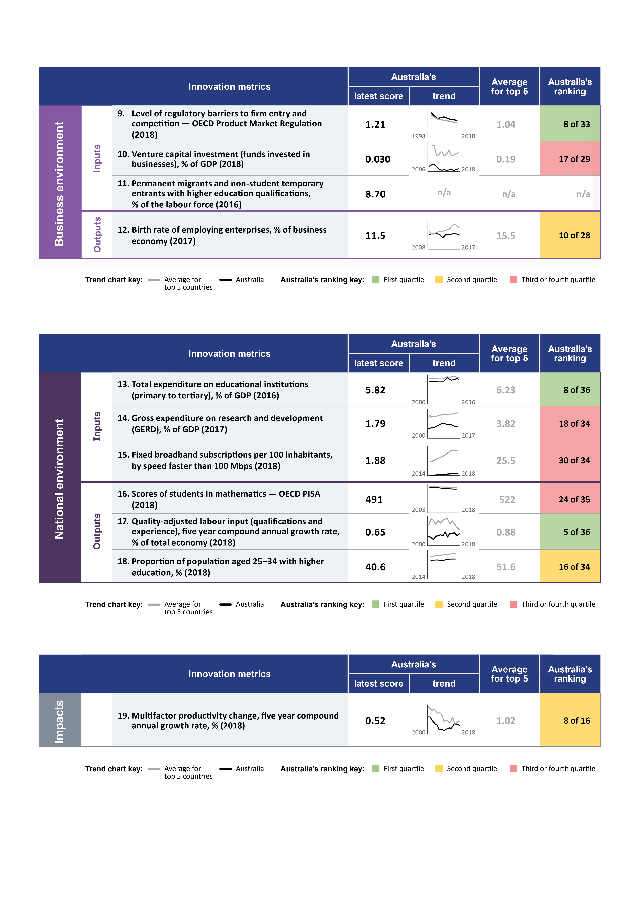

Figure 10 Business environment innovation metrics

The current and future business environment is uncertain, particularly due to the effects of COVID‑19, the bushfires and other recent climate-related events.[151] Against this backdrop, we comment on how the business environment supports innovation investment and productivity growth.

Australia continues to perform well in respect of low levels of regulatory barriers to firm entry and competition (metric 9; Figure 10). We retain our ranking in the top quartile and perform close to the average top five OECD comparators. Access to capital, especially for small and medium‑sized enterprises (SMEs) in Australia, has been challenging. However, for those businesses interested in accessing venture capital (VC), we have seen a steady increase in VC funding investment (metric 10) and availability, over the last five years, albeit from a very low base. However, the total size of the sector as a share of GDP is still well below global leaders. IISA notes that VC investment is highly concentrated in Sydney and Melbourne. These cities account for 95 per cent of VC raised.[152] There is an opportunity to provide VC access to businesses located outside of Melbourne and Sydney, including by providing Commonwealth level support to state-based initiatives where possible.

IISA also notes the importance of ensuring that Australian businesses have access to the right skills and talent. Permanent migrants and non-student temporary entrants with higher education qualifications (metric 11) is a helpful indicator of skills access. While there is no international data to make comparisons (as this was a newly introduced measure in the 2016 census), monitoring these levels, together with industry input on demand, is helpful to identify where there is a talent gap in the domestic workforce.

Based on the metrics in the Scorecard, the business environment is relatively healthy, with reduced regulatory barriers for entry, a buoyed VC market, and an increasing level of skilled migrants in the workforce.[153] However, the birth rate of our employing enterprises (metric 12) has remained stable since 2008. This is a concern given internationally the average top five countries have steadily improved post the GFC. The increase in VC availability may help improve enterprise birth rate, however this will take time to make its way through the system. Business also have a role to play in developing a growth through innovation mindset, which will also help to train the next generation of entrepreneurs.

### National environment



Figure 11 National environment innovation metrics

Our investment in human capital and education infrastructure, highlighted through Australia’s investment in educational institutions (metric 13; Figure 11), lays a good foundation to support innovation‑led productivity.

Australia’s GERD expenditure as a per cent of GDP (metric 14) has been declining since 2008, driven primarily by falling business and Commonwealth expenditure on R&D. Higher education expenditure on R&D has increased slightly during this time.[154] In 2017, BERD accounted for just over 50 per cent of GERD. Further stimulus to business expenditure on R&D, particularly through encouraging business collaboration with government researchers, may see GERD increase in future.

Despite investment in our education infrastructure at all levels, we are not seeing improvements at the primary and high school levels. Our Programme for International Student Assessment (PISA) maths scores are starting to diverge from average OECD nations (metric 16) – a worrying trend.

Investment in our educational institutions has helped Australia to increase the proportion of our population aged 25–34 with higher education (metric 18), which rose from 38.3 per cent in 2014 to 40.6 per cent in 2018. Since higher educational attainment increases the likelihood of employment, increasing this proportion should have flow on effects through the economy.[155] Ensuring that any increase in the proportion of the population with higher education also coincides with an increase in the number of high-value jobs is also a key focus of this Government.

While Australia’s number of tertiary educated individuals has not increased dramatically since 2014, Australia does score in the top quartile on the quality adjusted labour input (metric 17). This metric measures the growth of skills in our workforce, using the educational attainment of workers as a proxy for the quality of labour.[156] This suggests that Australians are able to gain the skills needed (perhaps through other means such as on the job training, or vocational education), positioning Australia well to transition our workforce to new industries, when and if needed.

When transitioning to new knowledge-based economies, access to information becomes increasingly important. Reliable high-speed internet infrastructure has many benefits and spillovers across a number of different industries. Currently Australia’s broadband subscriptions rates per 100 habitants, by speed faster than 100 Mbps (metric 15) ranks us 30 out of 34 countries, only marginally ahead of Turkey, Colombia, Mexico, and Greece. COVID-19 has demonstrated the criticality of high-speed internet for both educational outcomes and business.[157] It is clear there is an opportunity for improvement to ensure we do not slip further behind.

### Impacts



Figure 12 Impact innovation metrics

This report has adopted multi-factor productivity (MFP)[158] growth rate (metric 19; Figure 12) as the ultimate measure of the impact on productivity due to innovation.

Since 2000, Australia and the top comparator countries have experienced nearly a decade of slowed productivity growth, as measured through MFP change. Although Australia has been able to arrest that decline, MFP growth rates are well below those achieved prior to 2000. Innovation‑led productivity improvements will be key to ensuring continued long-term economic and income growth.

### Conclusion

Australia is at a crossroads.[159] Asia’s continued rise is shifting both the geopolitical and economic landscape, and Australia needs to more rapidly adapt to these changes. Australia contends with significant environmental impacts and biodiversity loss, which draws continued scrutiny across the globe. The pandemic has only added to Australia’s economic and environmental challenges, with support measures increasing government debt and shrinking resources available in the future. If we are to continue to prosper, we must carefully consider how we utilise our limited resources in the most efficient and effective way.

Improvements to business investment in innovation are required to propel Australia into the top tier of innovation nations. Australia appears to be falling behind or trending against our global competitors in key inputs of business activities. These include total innovation investment, BERD, investment in knowledge-based capital and business collaboration. Our uptake of cloud computing is indicative that businesses are willing to invest in technology. There is a greater opportunity for productivity uplift if more of our businesses invested, and government support for businesses in this domain is accelerated.[160]

While Australia has come a long way, if we are to recover and accelerate out of this pandemic, become a leading digital economy with an industrial base that is at scale, resilient and competitive, we still have a lot of work ahead of us.

Based on the metrics within this Scorecard, Australia appears to maintain its comparative position in prior areas of strength; Australia has entered into the ranks of the top quartile for only onemetric in the last three years.

Based on the metrics outlined in the Scorecard, Australia’s strengths lie in investment in our educational institutions, reduced regulatory barriers to firm entry, the quality of our labour input and the diffusion of cloud computing technology. These strengths place Australia in the top quartile globally and will place us in good stead on the road to recovery. However, we have consistently been in the top quartile for these metrics in the past, and have not risen into the top quartile in any other Scorecard metrics.

Most worrying is that despite consistent past economic growth, Australia appears to be significantly behind or trending against our global competitors in key metrics of business activities. These include total innovation investment, BERD, investment in knowledge-based capital and business collaboration on innovation.

In a world where the pace of change continues to accelerate, and our economy is hit with increasingly severe shock events such as the bushfires and COVID-19, we need to ensure we build resilience, in both our economy and our people. This requires investment in policies that effectively support our businesses to invest in innovation, and continued investment in our educational institutions. IISA believes these policies need to focus on support for both non-R&D innovation and R&D, including encouraging business to foster and instil a “growth through innovation mindset”.

We all have a role to play, and both Government and businesses need to act now to capitalise on the opportunities that arise from this crisis. This requires the coordinated and collaborative efforts of all the actors in the innovation system.

## Innovation Metrics Scorecard

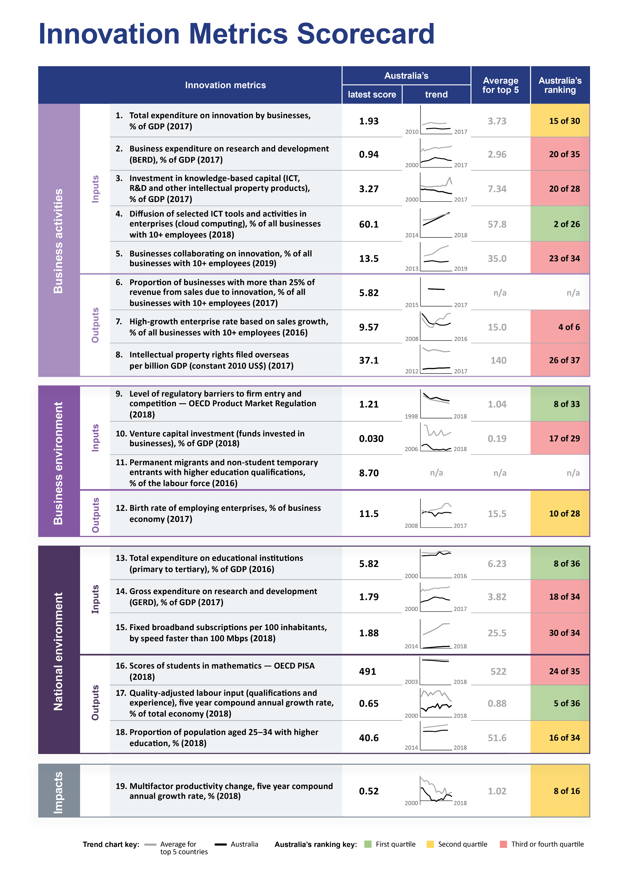

### Key Scorecard features and metric descriptions

The framework used for the Scorecard is based on the Productivity Commission’s Productivity Growth Framework, which conceptualises the main drivers of productivity growth.[161] The Productivity Growth Framework outlines the drivers or determinants of productivity growth, which comprise a mix of factors at the microeconomic level (business or individual), as well as broader macroeconomic conditions that reflect policy settings that government affects.

Key Scorecard elements are explained in Figure 13 below. Detailed definitions and sources for each metric are available in Table 1.

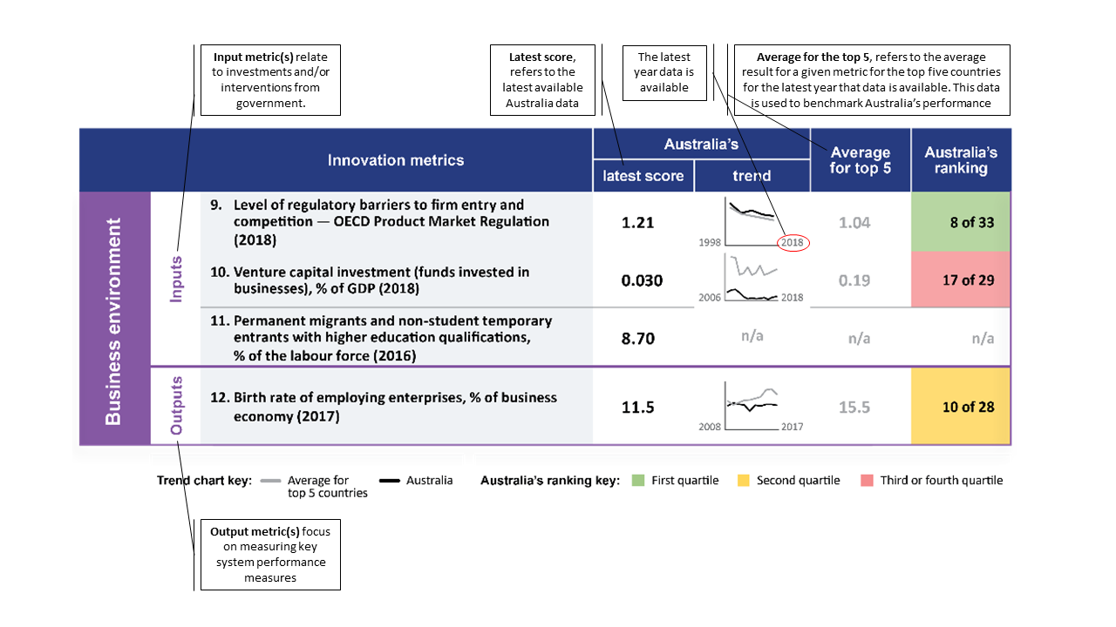

Figure 13 Key elements of the Scorecard

Table 1 Scorecard metric descriptions

|  |  | **Innovation metrics** | **Definition** | **Source** |
| --- | --- | --- | --- | --- |
| **Business activities** | **Inputs** | 1. Total expenditure on innovation by businesses, % of GDP  (this measure is a proxy for business investment in knowledge-based capital and physical capital as an input) | Total innovation expenditure incurred by Australian businesses includes both research and development (R&D) and non-R&D innovation.  This is a calculation based on the total innovation expenditure incurred by Australian businesses, published by the ABS. It is sourced from the BCS. For the purposes of this scorecard, this value was then converted to a percentage of GDP.  An estimated total for innovation expenditure was derived by assigning a random value to each innovation-active business that reported expenditure within the bounded ranges. These data, and the values of those businesses that reported actual dollar values, were then weighted to derive an innovation expenditure total. This simulation was run multiple times and an average of these simulations provides an approximate value of innovation expenditure.  Australian data are presented as the median value of the upper and lower ranges for the innovation expenditure value published by the ABS. | ABS BCS – Cat. No. 8158.0 – Innovation in Australian Business (further ABS calculation); Gross Domestic Product: Current prices;  ABS Cat No. 5206.0 – Australian System of National Accounts. International comparison data are available via Eurostat: Innovation activities and expenditures, Community Innovation Survey (CIS), Eurostat: Gross domestic product at current market prices. |
| 2. Business expenditure on research and development (BERD), % of GDP  (this measure is a proxy for business investment in knowledge-based capital as an input) | Business expenditure on R&D (BERD) includes all expenditure on R&D performed by business enterprises, irrespective of funding sources. | ABS Cat. No. 8104.0 – Research and Experimental Development, Businesses, Australia. International comparison data are available via OECD MSTI. |
| 3. Investment in knowledge-based capital (ICT, R&D and other intellectual property products), % of GDP  (this measure is a proxy for business investment in knowledge-based capital as an input) | ICT investment in the System of National Accounts includes the following key areas: investment in computer hardware, telecommunication equipment, computer software and databases, R&D and other IP products. | ABS Cat. No. 5204.0 – Australian System of National Accounts.  International comparison data are available from the [Measuring the](https://doi.org/10.1787/888933930193) [Digital Transformation (OECD 2019).](https://doi.org/10.1787/888933930193) |
| 4. Diffusion of selected ICT tools and activities in enterprises (cloud computing), % of all businesses with 10+ employees  (this measure is a proxy for the diffusion of digital technologies in business as an input) | Diffusion of selected ICT tools and activities in enterprises provides the percentage of businesses that reported using selected ICT tools, in this case, the metric specifies the use of paid cloud computing.  Data on cloud computing services are gathered through direct surveys of ICT usage by businesses through the BCS. The reported data specifies the percentage of businesses that reported they used paid cloud computing. This is being used as a proxy for the diffusion of ICT tools.  Cloud computing is the only advanced metric that Australia currently has a time series available to measure ICT diffusion. However, it is expected this indicator will be revised after mid 2022 if improvements are made to capture the diffusion of other ICT tools, such as Big Data, the Internet of Things, and other items in accordance with international practices, as recommended in Chapter 4.  This metric looks at businesses with 10 or more employees, as do a number of others below, because the Community Innovation Surveys used internationally collect data on businesses with 10 or more employees. International comparison data on businesses with 9 or fewer employees are generally not available. | ABS BCS – Cat. No. 8129.0 – Business Use of Information Technology and 8167.0 – Selected Characteristics of Australian Businesses. Australian data are sourced from ABS customised data and are for businesses with 10+ employees. International comparison data are available via the OECD, ICT Access and Usage by Businesses Database, 2018. |
| 5. Businesses collaborating on innovation, % of all businesses with 10+ employees (this measure is a proxy for inputs into business investment in management practices and business organisation) | This reports on the proportion of businesses with 10 or more employees that collaborated for the purposes of innovation as a percentage of all businesses.  This annual figure on the scorecard is calculated based on the proportion of all businesses that are innovative (55.9% – OECD table 1). This proportion is multiplied with the proportion of innovative businesses that have collaborated for the purposes of innovation (22.5% – OECD table 15) = (12.6% of all businesses with 10+ employees). | ABS Cat. No.8158.0 (superceded by 8167.0) – Australian data are sourced from ABS customised data and are for businesses with 10+ employees. International comparison data are available via OECD innovation indicators ([www.oecd.org/sti/inno-stats.htm).](http://www.oecd.org/sti/inno-stats.htm).) |
| **Business activities** | **Outputs** | 6. Proportion of businesses with more than 25% of income from sales due to innovation, % of all businesses with 10+ employees  (this measure is a proxy for multiple productivity drivers including physical, human and knowledge-based capital as outputs) | This reports the proportion of businesses with 10 or more employees that have reported more than 25% income from sales from innovative products introduced by the company in the previous year.  While the data is based on self-assessment, it is the best that is currently available. The OECD will be investigating similar intensity-based metrics in their forthcoming release (Q4 2019) and this may provide an internationally comparable data source for future Scorecards. The metric will be reviewed when further international data is available. | ABS Cat. No.8158.0 (superseded by 8167.0) – Australian data are sourced from ABS customised data and are for businesses with 10+ employees. (Goods and Services Innovation Cube, table 6, further ABS calculation) |
| 7. High-growth enterprise rate  based on sales growth, % of all  businesses with 10+ employees  (this measure is a proxy for economies of scale and scope) | High-growth enterprises have an average annualised sales revenue growth of over 20% per year over a 3-year period, and had 10 or more employees at the beginning of the observation period. | Australian data are sourced from ABS BLADE customised data. A summary of these data is available on the [AIS](https://dochub/prod.protected.ind/dochub/DocHubShare/EAS/Business%20Functions/Data%20and%20Analytical%20Services/Innovation%20Research/AIS-Beta/entrepreneurship/firm-growth/index.html) Monitor. International comparison data are available at the OECD Structural and Demographic Business Statistics (SDBS) database on high growth enterprise rates. |
| 8. Intellectual property rights filed overseas per billion GDP (constant 2010 US$)  (this measure is a proxy for business investment in knowledge-based capital as an output) | The sum of the number of patent, trade mark (by class), industrial design (by class) and plant breeders’ rights applications filed at another country’s IP office by a country’s residents in a given year, divided by the country’s GDP (constant 2010 US$).  The filing of IP rights abroad signals export intentions, which in turn suggests the production of globally competitive products and services. Counting all IP rights includes innovative ideas across the economy, enabling comparison of a country’s performance in generating innovation  For trade mark and industrial design applications, some offices allow single-class filing only, meaning that applicants have to file a separate application for each class. Others permit multi-class filings, enabling applicants to file a single application in which a number of classes can be specified. To improve international comparisons of the numbers of applications received, each trade mark and industrial design application will be counted for each class they relate to.  Applicants that file IP rights into the corresponding European IP office are counted once, despite the right being applicable for each member country signatory to that IP arrangement. | WIPO IP Statistics Data Center. Total foreign oriented patent applications (direct and PCT) by applicant origin. Total foreign oriented trade mark applications by class (direct and Madrid) by applicant origin. Total foreign oriented industrial design applications by class (direct and the Hague) by applicant origin. Total foreign oriented plant breeders rights applications (UPOV). GDP (constant 2010 US$) from the World Bank. |
| **Business environment** | **Inputs** | 9. Level of regulatory barriers to firm entry and competition – OECD Product Market Regulation  (this measure is a proxy for the inputs into regulation and competition of businesses) | The OECD Product Market Regulation (PMR) measures the degree to which policies promote or inhibit competition in areas of the product market where competition is viable.  The PMR score is constructed from 18 base indicators that are grouped into two main components; Distortions induced by state involvement, and Barriers to domestic and Foreign Entry.  A lower value indicates a better Product Market Regulation environment. | OECD Product Market Regulation database |
| 10. Venture capital investment (funds invested in businesses), % of GDP  (this measure is a proxy for inputs into trade and investment for business) | The ABS defines VC as investment at the pre-seed, seed, start-up, and early expansion stages of business development. This is a measure of new investment by funds into businesses during the financial year.  Capital investment is vital to help innovative start-ups and young businesses commercialise technologies and turn research into new products. This measures the annual amount of equity investments made to support the pre-seed, seed, start-up and early expansion stages of business development, measured as a percentage of national GDP. | ABS Cat. No, 5678.0 – VC&LSPE. International comparison data are from OECD Entrepreneurship at a Glance. |
| 11. Permanent migrants and non-student temporary entrants with higher education qualifications, % of the labour force  (this measure is a proxy for inputs into demand and supply conditions for labour resources) | The proportion of entrants into Australia, either non-student temporary or permanent, with higher education qualifications. Higher education attainment includes bachelors, masters, doctorates, or equivalent (does not include short- cycle tertiary).  Relates to temporary entrants who were present in Australia on 9 August, 2016 (Census night) and held a temporary visa that was not a student visa.  Relates to migrants who have migrated to Australia under a permanent Skilled, Family, Humanitarian or Other Permanent visa stream and arrived in Australia between 1 January, 2000 and 9 August 2016. | ABS: Cat. No. 3419.0 – Insights from the Australian Census and Temporary Entrants Integrated Dataset, 2016 & ABS Cat. No. 3417.0 – Understanding Migrant Outcomes – Insights from the Australian Census and Migrants Integrated Dataset, Australia, 2016. |
| **Business environment** | **Outputs** | 12. Birth rate of employing enterprises, % of business economy  (this measure is a proxy for outputs of competition and regulation) | The OECD’s definition of an employing enterprise birth is the establishment of an enterprise with at least one employee (headcount). This population consists of new enterprises that have at least one employee in the birth year. Enterprises that existed before the year in consideration that did not have one employee but then subsequently established themselves as an employee enterprise are included in the population for the year that they became an employee enterprise (the birth year). Employment excludes non-salaried directors, volunteers, persons paid by commission only, and self-employed persons, such as consultants and contractors.  OECD’s Entrepreneurship at a Glance 2017 indicates that for Australia and the Republic of Korea, enterprise births do not take into account the transition of enterprises from zero employees to one or more employees.  For Australian data, employing enterprise entries into the population do not include entries due to: mergers, break-ups, split-offs or restructuring of a set of enterprises. The scope is limited to only include businesses that are actively trading in the market sector. Business entities with a turnover below $75,000 do not have to register for GST and hence those who have not registered will not be included in these counts. Businesses that have not submitted a Business Activity Statement or have reported zero dollar amounts over five consecutive quarters (or three consecutive years for annual remitters) are treated as 'long-term non-remitters'. These businesses are not considered to be actively trading and are excluded from the counts, as they are not remitting GST (see [ABS explanatory notes](https://www.abs.gov.au/AUSSTATS/abs@.nsf/Latestproducts/8165.0Main%20Features2June%202014%20to%20June%202018?opendocument&tabname=Summary&prodno=8165.0&issue=June%202014%20to%20June%202018&num=&view=) for more information).  The employing enterprise birth rate corresponds to the number of births of employing enterprises as a percentage of the population of active enterprises with at least one employee (see [OECD Manual on Business Demography](http://www.oecd.org/sdd/39974599.pdf) [Statistics)](http://www.oecd.org/sdd/39974599.pdf). The SDBS category is the total industry, construction and market services, except holding companies. | ABS Cat No. 8165.0 – Counts of Australian Businesses, International comparison data are from OECD Structural and Demographic Business Statistics (SDBS). OECD Entrepreneurship at a Glance (2017). |
| **National environment** | **Inputs** | 13. Total expenditure on educational institutions (primary to tertiary), % of GDP (this measure is a proxy for economy level investment inputs into education) | Financial resources invested in education includes primary, secondary, post- secondary non-tertiary and tertiary sectors. This data includes both general government and private sector expenditure. | Data are sourced from national statistics and harmonised by the OECD for international comparison. OECD Education at a Glance. |
| 14. Gross expenditure on research and development (GERD), % of GDP  (this measure is a proxy for economy level investment inputs into education and infrastructure) | Gross expenditure on R&D (GERD) represents the total expenditure devoted to R&D by the business, government, higher education and private non-profit sectors. | ABS Cat. No. 8104.0 – Research and Experimental Development, Businesses, Australia. International comparison data at OECD MSTI. |
| 15. Fixed broadband  subscriptions per 100 inhabitants, by speed faster than 100 Mbps  (this measure is a proxy for inputs into the development of innovation infrastructure) | The data cover quality of broadband infrastructure as measured by the number of subscriptions for fixed broadband service based on speed of connection expressed in megabits per second (Mbps). This measure is a proxy for network capability but it does not provide the actual performance of broadband connections experienced by subscribers.  This metric uses fixed broadband because a technology neutral broadband | ABS Cat. No. 8153.0 Internet Activity; Table 2 – Internet Subscribers by advertised download speed; ABS Cat. No. 3101.0 – Australian Demographic Statistics: Table 1 – Population Change summary: ERP Change Over Previous Year. International comparison data are sourced from the OECD broadband portal, ‘Fixed |
| **Outputs** | 16. Scores of students in mathematics – OECD PISA  (this measure is a proxy for the output of investment into education at an economy level) | PISA is a triennial international survey that aims to evaluate education systems worldwide by testing the skills and knowledge of 15-year-old students in the subjects of reading, mathematics and science.  The results for science and mathematics at country level are highly correlated. Mathematics has been tracked as Australia’s current educational challenges with regard to mathematics were deemed to be more acute than those for science. | [OECD PISA database](http://www.oecd.org/pisa/data/):  www.oecd.org/pisa/data/ |
| **National environment** | **Outputs** | 17. Quality-adjusted labour input (qualifications and experience), five-year compound annual growth rate, % of total economy (this measure is a proxy for the output of investment into  education and skills at an economy level) | Quality-adjusted labour input is a measure of the skill composition of workers, usually based on the level of educational attainment and labour market experience. Changes in the quality of labour are calculated using data on employment (number of hours actually worked) and compensation of workers (hourly income) by educational attainment, to determine the annual growth rate.  Changes in labour quality (the quality-adjusted labour input) therefore reflects the changing labour market conditions, which impacts labour input contribution to productivity and growth. For example, an increase in the share of workers with tertiary education and those in their prime age – typically defined as those aged 25 to 54 years (which reflect experience of workers) would result in increased labour productivity. | Conference Board Total Economy Database showing the growth rate of labour input, adjusted for quality (labour quality). The data can be accessed from the Growth Accounting and Total Factor Productivity, 1990–2018, series. The data source provides the level of growth in labour quality in the total economy only, not by sector. |
| 18. Proportion of population aged 25–34 with higher education, %  (this measure is a proxy for investment outputs into education at an economy level) | Higher education attainment includes bachelors, masters, doctorates, or equivalent (not short-cycle tertiary) | ABS Cat. No. 6227.0 – Education and Work, Australia, May 2018, Table 14. International comparison data at OECD Education at a Glance. |
| **Impacts** |  | 19. Multifactor productivity change, five year compound annual growth rate, % | MFP measures the changes in output per unit of combined inputs of labour and capital. The change or growth in MFP is measured as a 5-year compound annual growth rate. | OECD Multifactor Productivity  <https://data.oecd.org/lprdty/multifactor-productivity.htm> |

# Appendix I: Glossary

The table below provides definitions of key terms as used by IISA in this report. Additional useful definitions can be found in ISA’s 2016 Performance review of the Australian Innovation, Science and Research System.[162]

| **Term** | **Definition** |
| --- | --- |
| **Applied research** | Applied research is original work undertaken primarily to acquire new knowledge with a specific application in view. It is undertaken either to determine possible uses for the findings of basic research or to determine new ways of achieving some specific and predetermined objectives. [163] |
| **Broad-based allocation** | For this analysis, broad-based investment allocations were taken from SRI Budget Tables categorisations and included entitlement funding (where an organisation undertaking eligible activities receives pre-specified levels of financial assistance from the Commonwealth Government, such as the R&D Tax Measures) and formula funding (where organisations receive an allocation calculated according to a formula based upon their performance against specified metrics, such as performance-based block funding to universities). |
| **Business Expenditure on R&D** | Business Expenditure on R&D (BERD) is intramural expenditure on creative and systematic work undertaken in order to increase knowledge or to devise new applications of available knowledge by businesses. This includes all businesses whose primary activity is the production of goods and services for sale to the general public; private non-profit institutions; and government.[164] For a full technical definition and explanatory notes please defer to the Australian Bureau of Statistics. |
| **Effectiveness** | For this assessment, effectiveness is defined as the ability of public resources to achieve a given set of objectives, as defined by the European Commission.[165] |
| **Experimental development** | Systematic work, using existing knowledge gained from research or practical experience, which is directed to producing new materials, products, devices, policies, behaviours or outlooks; to installing new processes, systems and services; or to improving substantially those already produced or installed.[166] |
| **Field of research** | Field of Research (FOR) is a hierarchical classification system that allows for the categorisation of research activity within Australia and New Zealand. The FOR allows for R&D activity to be categorised according to the methodology used in the R&D, rather than the activity of the unit performing the R&D or the purpose of the R&D.[167] |
| **Government expenditure on R&D** | Government expenditure on R&D (GOVERD) is intramural expenditure on creative and systematic work undertaken in order to increase knowledge or to devise new approaches of applying knowledge from all units of the Australian government (excluding local governments, higher education institutions and government entities involved in market production or financial activities) and all organisations that are mainly financed by and operate for those government units.[168] For a full technical definition and explanatory notes please defer to the Australian Bureau of Statistics. |
| **Government ISR investment** | For the purposes of this report, IISA has focused on the Commonwealth Government’s *investment* in ISR programs and activities in the ISR system which are resourced through a budgetary appropriation and targeted at delivering an ISR policy outcome. This investment also includes indirect support provided to businesses through measures which forgo revenues by the Government, for example, the R&D Tax Incentive. Government investment in ISR includes allocation of public monies to support both R&D and non-R&D innovation. Non-R&D innovation are innovation activities that do not stem from a scientific method or involve R&D. Examples of non‑R&D innovation cited in a recently released IISA report[169] include the development of new or improved business models as well as organisation or marketing practices. The report notes that non-R&D innovation is less well measured than R&D and is a less well-established target for public policy interventions. Further, the focus of this report is the *Commonwealth Government’s* investment in ISR. While state and territory governments are important contributors to the Australia ISR, a detailed examination of these issues is beyond the scope of this report. Reference to state and territory activities and investments are for comparative or illustrative purposes only or to highlight a potential strategic opportunity that the Government may wish to consider. Within the Government’s investment activities, there are ISR investments that are targeted at delivering a particular policy outcome for the ISR system but also intramural ISR investments that the Government makes for its own ISR needs. These intramural investments are not always funded by a specific appropriation outlined in the Government’s Portfolio Budget Statements,[170] but instead resourced from within general departmental funding making them less visible for analysis purposes. While we have observed many investments of this type within the Government during the course of this project, given the challenge of comprehensively capturing all investments of this nature, this review does not include investment in innovative practices within the public sector or innovative government processes. |
| **Gross expenditure in R&D** | Gross expenditure on R&D (GERD) represents the total expenditure devoted to R&D by the Business, Government, Higher Education and Private Non-Profit sectors.[171] For a full technical definition and explanatory notes please defer to the Australian Bureau of Statistics. |
| **Higher Education Expenditure on R&D** | Higher Education expenditure on R&D (HERD) is intramural expenditure on creative and systematic work undertaken in order to increase knowledge or to devise new applications of available knowledge by universities and other institutions of post-secondary education regardless of their source of finance or legal status. Note: ABS data exclude colleges of Technical and Further Education.[172] For a full technical definition and explanatory notes please defer to the Australian Bureau of Statistics. |
| **Innovation** | Innovation is doing something differently and creating value as a result. The value it creates can be economic, social or environmental. At the organisational level, innovation can refer to a clearly defined strategy and process, which often involve stages and gates, to guide activity, manage risk and allocate investment.[173] The OECD defines innovation as four types of innovation: Product innovation, process, innovation, marketing innovation and organisational innovation (see separate entries).[174] |
| **ISR system** | The ISR system is an open network of many diverse individuals and bodies who interact with the broader environment to produce and diffuse innovations that have economic, social and/or environmental value. These individuals and bodies generate ideas and knowledge; fund, develop and commercialise or apply new ideas and knowledge; and adopt innovative ways of doing things, purchase new products or support doing things differently. The ISR system is complex and constantly changing and includes businesses; entrepreneurs and start-ups; universities and vocational education and training institutions; government policy and delivery agencies, along with publicly funded research agencies; investors; not for profit bodies and researchers.[175] |
| **Marketing innovation** | A new marketing method involving significant changes in product design or packaging, product placement, product promotion or pricing. [176] |
| **Non-R&D innovation** | Non-R&D innovation as defined in this analysis is investment in new or significantly improved product, process, marketing and organisational practices that are broader than R&D alone. More information about the economic benefits of non-R&D innovation can be found in Innovation and Science Australia. (2020).[177] |
| **Organisational innovation** | A new organisational method in business practices, workplace organisation or external relations. [178] |
| **Process innovation** | A new or significantly improved production or delivery method. This includes significant changes in techniques, equipment and/or software.[179] |
| **Product innovation** | A good or service that is new or significantly improved. This includes significant improvements in technical specifications, components and materials, software in the product, user friendliness or other functional characteristics.[180] |
| **Pure basic research** | Experimental and theoretical work undertaken to acquire new knowledge without looking for long-term benefits other than the advancement of knowledge.[181] |
| **Research** | Research is the creation of new knowledge, creating in turn the expanded capabilities that enable the development of novel technologies, skilled jobs and new products. Research in all disciplines, produces knowledge that enhances our culture and civilisation and can be used for the public good. It is aimed at generating knowledge of the natural world and of ourselves, and also at developing that knowledge into useful applications, including driving innovation for sustainable productive economic growth and better public services, improving health, prosperity and the quality of life, and protecting the environment.[182] |
| **Science** | Historically, science was the study of individual natural systems, from which we came to understand the fundamental characteristics of our world such as the nature of light, movement and chemical reactions. Today, science is dominated by the need to understand complex systems and to predict their behaviours. Research in science increasingly takes into account interactions with society and the economy. In the light of such complexities and responsibilities, scientists collaborate with the humanities, social sciences and other disciplines. They must communicate to the public the uncertainties, consequences and benefits of their research. Most importantly, scientists have a duty to contribute to teaching science and mathematics to our youth. This will ensure the broader ability of our population to understand the world around them and be equipped with the skills increasingly demanded for the jobs of today and the future.[183] |
| **Socioeconomic objective: Animal Production and Animal Primary Products** | Animal Production and Animal Primary Products covers R&D directed towards breeding and farming livestock and the production of associated primary livestock products; growing pasture, browse and fodder crops; commercial (incl. aquaculture) and recreational fishing; the preparation, transportation and storage of primary livestock products and developing sustainable animal production systems. |
| **Socioeconomic objective: Commercial Services and Tourism** | Commercial Services and Tourism covers R&D directed towards the provision of commercial services to all areas of economic and social development. This subdivision includes R&D directed towards the provision of electricity and gas services to consumers, provision of water, sewerage and drainage services; management and recycling of wastes or waste products as a discrete process or as a service to consumers; wholesale and retail trade services, finance, property and business services; tourism; recreational and personal services and other commercial services not elsewhere classified. It includes R&D directed towards 'clean production' to minimise emissions to the environment from commercial services or tourism or towards protection of the production site. |
| **Socioeconomic objective: Construction** | Construction covers R&D directed towards improving the use and performance of building materials, the processes for which they are used and the functions of engineering, planning, design, management and building services in the construction industry; testing on construction sites the performance, durability and life cycle of materials used in the construction industry; the planning component of the construction up to the stage of developing sketch plans; design component, specifically turning sketch plans into working drawings and specifications; the development and supply of components and materials which are assembled and placed on site to form buildings, but manufactured off‑site; and the design, supply and installation of building services; safety in construction projects; and 'clean production' to minimise emissions from these activities. |
| **Socioeconomic objective: Defence** | Defence covers R&D directed towards the development of defence or national security, including R&D undertaken for military reasons regardless of their content or whether they have secondary civil applications; and towards the development and testing of military or defence related equipment and materials. |
| **Socioeconomic objective: Economic Framework** | Economic Framework covers R&D directed towards the understanding of the economic framework of development or the application of economic theory to assist development; understanding macroeconomic, microeconomic, international trade, management and productivity issues; and developing measurement standards and calibrations services which make a contribution to economic framework. |
| **Socioeconomic objective: Education and Training** | Education and Training covers R&D directed towards general education and training. |
| **Socioeconomic objective: Energy** | Energy covers R&D directed towards energy resources and energy supply. Energy resources covers R&D directed towards the exploration, mining, extraction, preparation and supply of energy mineral resources. Energy Supply covers R&D directed towards renewable energy, energy production and supply, energy transformation, energy distribution and the conservation or efficient use of energy in the form of derived fuels such as petroleum products, electricity, town gas, coke and briquettes and in the form of heat energy. It includes R&D directed towards 'clean production' to minimise emissions from these activities or towards protection of the production site. |
| **Socioeconomic objective: Environment** | Environment covers R&D directed towards assessing and sustaining the quality of the environment and its natural resources; the study of the environment conducted in the context of developing management strategies to sustain the quality of environmental attributes; and studies of the environmental impact of socio-economic activities as well as R&D for the development of social and economic environmental policies. |
| **Socioeconomic objective: Expanding Knowledge** | Expanding Knowledge is the categorisation of R&D which does not have an identifiable socio-economic objective. This is usually the case for pure basic research or strategic basic research. |
| **Socioeconomic objective: Health** | Health covers R&D directed towards human health, including the understanding and treatment of clinical diseases and conditions and the provision of public health and associated support services. |
| **Socioeconomic objective: Information and Communication Services** | Information and Communication Services covers R&D directed towards the support and provision of information and communication services, computer programming or software services, library and library database services, presentations of educational displays for museums, art galleries or other such institutions; printing and publishing newspapers and the provision, processing, presentation or dissemination of information not classified elsewhere; and the prevention and treatment of pollution by information and communication services. |
| **Socioeconomic objective: Manufacturing** | Manufacturing covers R&D directed towards refining and developing processes or strategies for transforming processed or unprocessed materials or components into new products; the manufacture of safe products; and 'clean production' to minimise emissions to the environment from manufacturing processes or towards protection of the production site. |
| **Socioeconomic objective: Mineral Resources** | Mineral Resources (excluding Energy) covers R&D which primarily benefits or has application to the exploration, mining, extraction and processing of mineral resources; and includes 'clean production' to minimise emissions to the environment from these activities or towards protection of the production site. |
| **Socioeconomic objective: Plant Production and Plant Primary Products** | Plant Production and Plant Primary Products covers R&D directed towards improving the characteristics, propagation and growing of field and horticultural crops, native forest, hardwood and softwood plantations, and the production of associated primary plant products; improving the post‑harvest processing, preparation, handling, storage and marketing of primary plant products; and developing sustainable plant production systems. |
| **Socioeconomic objective: Social Development and Community Services** | Social Development and Community Services covers R&D directed towards community and social services (incl. welfare) to individuals or community groups (e.g. disabled, unemployed) and towards social justice and general equity. This subdivision includes R&D directed towards arts and leisure, justice and the law, government and politics, international relations, heritage, communication, religion and the understanding of past societies and ethical issues relating to social development. |
| **Socioeconomic objective: Transport** | Transport covers R&D directed towards improving the efficiency and safety of transport systems for moving freight, passengers or livestock by ground, water, air or any combinations of these or by any other means; oceanic currents and processes that impinge on sea safety or navigation; and minimising emissions from transport. |
| **Socioeconomic objectives** | There are many different definitions of socioeconomic objectives. The 14 used herein through the 2019-20 SRI Budget Tables as described in Frascati Manual 2015. The definitions following have been taken from the ABS.[184] |
| **Space** | For this report and its analysis on the Government’s ISR investment in the space sector, ‘space’ was defined as including earth observation, precision navigation and timing, satellite communications, space situational awareness and debris monitoring, access to space, robotics and automation, leapfrog R&D, and relevant fundamental research. |
| **Strategic basic research** | Experimental and theoretical work undertaken to acquire new knowledge directed into specified broad areas in the expectation of practical discoveries. It provides the broad base of knowledge necessary for the solution of recognised practical problems.[185] |
| **Targeted allocation** | For this analysis, targeted investment allocations were taken from SRI Budget Tables categorisations and included competitive funding (where applications for funding or entries to a competition are judged by a panel against selection criteria), targeted funding (where funding is allocated in order to address particular challenges or to accomplish particular objectives), and competitive/targeted funding (a combination of the previous) competitive and targeted funding). Additionally, programs classified as annual, restricted non-competitive, or other or were uncategorised in the SRI Budget Tables were assessed as targeted investments.  There were a few exceptions for some competitive funding investments, which were assessed as being broad-based measures. These included: CRC, ARC National Competitive Grants Program, Innovation Investment Fund, Inspiring Australia, Public Sector Modernisation Fund, Global Innovation Strategy, and Oversight of Significant Digital and ICT Initiatives programs. |

1. Industry Innovation and Science Australia. (2020). Driving effective Government investment in innovation, science and research.
2. OECD. (2015). The Innovation Imperative: Contributing to Productivity, Growth and well-being. <https://read.oecd-ilibrary.org/science-and-technology/the-innovation-imperative_9789264239814-en#page92>
3. OECD. (2019). Governance of Science and Technology Policies—Case Studies. OECD Science, Technology and Industry Policy Papers. <https://community.oecd.org/docs/DOC-161275>
4. Nurse, P. (2014). Ensuring a successful research endeavour: review of the UK research councils. [www.gov.uk/government/‌collections/nurse-review-of-research-councils](http://www.gov.uk/government/‌collections/nurse-review-of-research-councils); UK House of Commons., (2019). Report on the review of Balance and Effectiveness of Research and Innovation Spending. <https://publications.parliament.uk/pa/cm201719/cmselect/cmsctech/1453/1453.pdf>
5. UK Government. (2017). Industrial Strategy: building a Britain fit for the future. [www.gov.uk/government/publications/industrial-strategy-building-a-britain-fit-for-the-future](http://www.gov.uk/government/publications/industrial-strategy-building-a-britain-fit-for-the-future)
6. OECD. (2019). Governance of Science and Technology Policies—Case Studies. OECD Science, Technology and Industry Policy Papers. <https://community.oecd.org/docs/DOC-161275>
7. Department of Industry, Science and Resources. (2001). Backing Australia’s ability: and innovation action plan for the future. [www.voced.edu.au/content/ngv%3A6459](https://dochub/div/officeinnovationscienceaustralia/programmesprojectstaskforces/gisp/docs/www.voced.edu.au/content/ngv%3A6459); Department of Education, Science and Training. (2004). Backing Australia’s ability: building our future through science and innovation. <https://catalogue.nla.gov.au/Record/3257753>
8. Department of Industry, Innovation, Science, Research and Tertiary Education. (2008). Venturous Australia: building strength in innovation. [www.voced.edu.au/content/ngv%3A12472](https://dochub/div/officeinnovationscienceaustralia/programmesprojectstaskforces/gisp/docs/www.voced.edu.au/content/ngv%3A12472)
9. Innovation and Science Australia. (2017). Australia 2030: Prosperity through Innovation. [www.industry.gov.au/sites/‌g/files/net3906/f/May%202018/document/pdf/australia-2030-prosperity-through-innovation-full-report.pdf](http://www.industry.gov.au/sites/‌g/files/net3906/f/May%202018/document/pdf/australia-2030-prosperity-through-innovation-full-report.pdf)
10. Innovation and Science Australia. (2017). Australia 2030: Prosperity through Innovation. [www.industry.gov.au/sites/‌g/files/net3906/f/May%202018/document/pdf/australia-2030-prosperity-through-innovation-full-report.pdf](http://www.industry.gov.au/sites/‌g/files/net3906/f/May%202018/document/pdf/australia-2030-prosperity-through-innovation-full-report.pdf)
11. House of Representatives Standing Committee on Employment, Education and Training. (2018). Inquiry into funding Australia's research report: Australian Government Funding Arrangements for non-NHMRC Research. <https://parlinfo.aph.gov.au/parlInfo/download/committees/reportrep/024212/toc_pdf/AustralianGovernmentFundingArrangementsfornon-NHMRCResearch.pdf;fileType=application%2Fpdf>
12. Ferris, Finkel, & Fraser (2016). Review of the R&D Tax Incentive. [www.industry.gov.au/data-and-publications/review-of-the-rd-tax-incentive](https://dochub/div/officeinnovationscienceaustralia/programmesprojectstaskforces/gisp/docs/www.industry.gov.au/data-and-publications/review-of-the-rd-tax-incentive)
13. Innovation and Science Australia. (2017). Australia 2030: Prosperity through Innovation. [www.industry.gov.au/sites/‌g/files/net3906/f/May%202018/document/pdf/australia-2030-prosperity-through-innovation-full-report.pdf](http://www.industry.gov.au/sites/‌g/files/net3906/f/May%202018/document/pdf/australia-2030-prosperity-through-innovation-full-report.pdf)
14. Productivity Commission. (2017). 5 Year Productivity Review, Supporting Paper No.12: An overview of innovation policy. [www.pc.gov.au/inquiries/completed/productivity-review/report/productivity-review-supporting12.pdf](http://www.pc.gov.au/inquiries/completed/productivity-review/report/productivity-review-supporting12.pdf)
15. Productivity Commission. (2017). 5 Year Productivity Review, Supporting Paper No.12: An overview of innovation policy. [www.pc.gov.au/inquiries/completed/productivity-review/report/productivity-review-supporting12.pdf](http://www.pc.gov.au/inquiries/completed/productivity-review/report/productivity-review-supporting12.pdf)
16. Refer footnote 18 for IISA’s R&D expenditure analysis details.
17. Innovation and Science Australia. (2020). Stimulating business investment in innovation. [www.industry.gov.au/sites/default/files/2020-02/stimulating-business-investment-in-innovation.pdf](http://www.industry.gov.au/sites/default/files/2020-02/stimulating-business-investment-in-innovation.pdf)
18. ‘General university funds’ represents university funds that are used for R&D, sourced from both Commonwealth Government funding (other than competitive grants, targeted research funding, or funding identified as 'Other commonwealth government') and non-Commonwealth funding (such as fees and charges, income relating to Higher Education Contribution Scheme liabilities, income from non‑research specific donations, bequests and foundations, investment income, reversions from provisions accounts, loans drawn down, income from the institutions commercial operations and from sale of products or assets).
19. In this analysis ‘Commonwealth’ funding includes ‘Commonwealth competitive funds’ and ‘Other Commonwealth government’ (defined as targeted research funding from Commonwealth agencies (e.g. CRC grants) and funding for the Research Training and Support Programs. ‘General university funds’ represents university funds that are used for R&D, sourced from both Commonwealth Government funding (other than competitive grants, targeted research funding, or funding identified as 'Other commonwealth government') and non-Commonwealth funding (such as fees and charges, income relating to Higher Education Contribution Scheme liabilities, income from non‑research specific donations, bequests and foundations, investment income, reversions from provisions accounts, loans drawn down, income from the institutions commercial operations and from sale of products or assets). ‘Other Australian’ funding includes any Australian sources not captured by other descriptors as well as funds from joint business/government, donations and bequests. ABS, 8104.0 – Research and Experimental Development, Businesses, Australia, 2017–18; 8109.0 – Research and Experimental Development, Government and Private Non-Profit Organisations, Australia, 2016–17; 8111.0 – Research and Experimental Development, Higher Education Organisations, Australia, 2016. Note the ABS surveys those entities that perform R&D (businesses, institutes, universities, etc.) in order to identify the amount they spend on R&D activities that they perform in a given year. BERD data was estimated from an average of 2015–16 and 2017–18 BERD data.
20. ABS. 8104.0 – Research and Experimental Development, Businesses, Australia, 2017–18; 8109.0 – Research and Experimental Development, Government and Private Non-Profit Organisations, Australia, 2016–17; 8111.0 – Research and Experimental Development, Higher Education Organisations, Australia, 2016.
21. FOR is a hierarchical classification system that allows for the categorisation of research activity within Australia and New Zealand. The FOR allows for R&D activity to be categorised according to the methodology used in the R&D, rather than the activity of the unit performing the R&D or the purpose of the R&D.
22. ABS. 8104.0 – Research and Experimental Development, Businesses, Australia, 2017–18; 8109.0 – Research and Experimental Development, Government and Private Non-Profit Organisations, Australia, 2016–17; 8111.0 – Research and Experimental Development, Higher Education Organisations, Australia, 2016. Note the ABS surveys those entities that perform R&D (businesses, institutes, universities, etc.) in order to identify the amount they spend on R&D activities that they perform in a given year.
23. These figures have been taken from the SRI budget tables which can be found at [www.industry.gov.au/data-and-publications/science-research-and-innovation-sri-budget-tables](https://dochub/div/officeinnovationscienceaustralia/programmesprojectstaskforces/gisp/docs/www.industry.gov.au/data-and-publications/science-research-and-innovation-sri-budget-tables). Note: this figure is based on budget estimates only.
24. The 2019–20 SRI Budget Tables use the 14 socioeconomic objectives described in Frascati Manual 2015: Exploration and exploitation of the Earth; Environment; Exploration and exploitation of space; Transport, telecommunications and other infrastructures; Energy; Industrial production and technology; Health; Agriculture; Education; Culture, recreation, religion and mass media; Political and social systems, structures and processes; General advancement of knowledge: R&D financed from General University Funds (GUF); General advancement of knowledge: R&D financed from other sources than GUF; and Defence. In our analysis we grouped the two General advancement of knowledge socioeconomic objectives. Source: OECD. (2015). Frascati Manual 2015: Guidelines for Collecting and Reporting Data on Research and Experimental Development, The Measurement of Scientific, Technological and Innovation Activities. OECD Publishing, Paris. <https://doi.org/10.1787/9789264239012-en>
25. AAD, Australian Antarctic Division; ACIAR, Australian Centre for International Agricultural Research; ANSTO, Australian Nuclear Science and Technology Organisation; ARC, Australian Research Council; ARENA, Australian Renewable Energy Agency; CRC, Cooperative Research Centre Program; CSIRO, Commonwealth Scientific and Industrial Research Organisation; DIH, Defence Innovation Hub; DST Group, Defence, Science and Technology Group; GA, Geoscience Australia; MRFF, Medical Research Future Fund; NCRIS, National Collaborative Research Infrastructure Strategy; NHMRC, National Health and Medical Research Council.
26. The Australian Government’s Portfolio Budget statements provide information, explanation and justification to enable an understanding of proposed annual appropriations for Australian Government departments and agencies.
27. These principles have been drawn from a range of sources, including Investing in Canada’s Future review (2017) and Australian sources including the National Science Statement (2017); The National Research Investment Plan (2012); Venturous Australia (Cutler Review, 2008); ISA’s 2030 Strategic Plan; recent major ISR reviews (including Parliamentary Inquiries) and senior Australian Government statements. For completeness, the UK’s 2014 Nurse review did not draw out specific investment principles. In some cases, principles derive from multiple sources. The principles here have been selected as they directly relate to investment in the ISR system and are applicable to the Australian context. While other principles could also apply to the system more broadly, these were not considered to be within the scope of this report.
28. UK House of Commons. (2019). Report on the review of Balance and Effectiveness of Research and Innovation Spending. <https://publications.parliament.uk/pa/cm201719/cmselect/cmsctech/1453/1453.pdf>
29. OECD. (2011). Opportunities, Challenges and Good Practices in International Research Cooperation between Developed and Developing Countries. OECD Global Science Forum. [www.oecd.org/sti/inno/47737209.pdf](http://www.oecd.org/sti/inno/47737209.pdf)
30. Černá, L. (2014). The Nature of Policy Change and Implementation: A Review of Different Theoretical Approaches. OECD report. [www.oecd.org/education/ceri/The%20Nature%20of%20Policy%20Change%20and%20Implementation.pdf](https://dochub/div/officeinnovationscienceaustralia/programmesprojectstaskforces/gisp/docs/www.oecd.org/education/ceri/The%20Nature%20of%20Policy%20Change%20and%20Implementation.pdf)
31. OECD. (2019). Governance of Science and Technology Policies—Case Studies. OECD Science, Technology and Industry Policy Papers. <https://community.oecd.org/docs/DOC-161275>
32. United Nations’ Sustainable Development Goals. [www.un.org/sustainabledevelopment/sustainable-development-goals/](https://dochub/div/officeinnovationscienceaustralia/programmesprojectstaskforces/gisp/docs/www.un.org/sustainabledevelopment/sustainable-development-goals/)
33. United Nations’ Technology Facilitation Mechanism. <https://sustainabledevelopment.un.org/tfm>
34. This information has been sourced from [www.europarl.europa.eu/doceo/document/TA-8-2019-0396_EN.pdf](https://dochub/div/officeinnovationscienceaustralia/programmesprojectstaskforces/gisp/docs/www.europarl.europa.eu/doceo/document/TA-8-2019-0396_EN.pdf). Note that non‑sequential labelling reflects variations introduced as the objectives were refined.
35. Paic, A. and C. Viros (2019). Governance of science and technology policies. OECD Science, Technology and Industry Policy Papers, No. 84, OECD Publishing, Paris. <https://doi.org/10.1787/2b3bc558-en>
36. Innovation and Science Australia. (2017). Australia 2030: Prosperity through Innovation. [www.industry.gov.au/sites/‌g/files/net3906/f/May%202018/document/pdf/australia-2030-prosperity-through-innovation-full-report.pdf](http://www.industry.gov.au/sites/‌g/files/net3906/f/May%202018/document/pdf/australia-2030-prosperity-through-innovation-full-report.pdf)
37. Borowiecki & Paunov. (2018). How is research policy across the OECD organised? Insights from a new policy database, OECD Science, Technology and Industry Policy Papers, No. 55, OECD Publishing, Paris. <https://doi.org/10.1787/235c9806-en>
38. OECD. (2019). Governance of Science and Technology Policies—Case Studies. OECD Science, Technology and Industry Policy Papers. <https://community.oecd.org/docs/DOC-161275>
39. OECD. (2019). Governance of Science and Technology Policies—Case Studies. OECD Science, Technology and Industry Policy Papers. <https://community.oecd.org/docs/DOC-161275>
40. Paic, A. and C. Viros (2019). Governance of science and technology policies. OECD Science, Technology and Industry Policy Papers, No. 84, OECD Publishing, Paris. <https://doi.org/10.1787/2b3bc558-en>
41. UKRI. (2019). Industrial Strategy Challenge Fund. [www.ukri.org/innovation/industrial-strategy-challenge-fund](http://www.ukri.org/innovation/industrial-strategy-challenge-fund)
42. OECD. (2017). OECD Reviews of Innovation Policy: Norway 2017. OECD Reviews of Innovation Policy, OECD Publishing, Paris. <https://doi.org/10.1787/9789264277960-en>
43. Jameson Cell for flotation of minerals and coal. [www.newcastle.edu.au/research-and-innovation/innovation/archived/‌newcastle-innovation/engagement-with-partners/the-jameson-cell-for-flotation-of-minerals-and-coal](https://dochub/div/officeinnovationscienceaustralia/programmesprojectstaskforces/gisp/docs/www.newcastle.edu.au/research-and-innovation/innovation/archived/‌newcastle-innovation/engagement-with-partners/the-jameson-cell-for-flotation-of-minerals-and-coal)
44. Sliver Solar Cells. <http://pv.cecs.anu.edu.au/sliver>
45. Hexima opens glasshouse at La Trobe. [www.latrobe.edu.au/news/articles/2010/article/hexima-cutting-edge-glasshouse-opens](https://dochub/div/officeinnovationscienceaustralia/programmesprojectstaskforces/gisp/docs/www.latrobe.edu.au/news/articles/2010/article/hexima-cutting-edge-glasshouse-opens)
46. Australian Academy of Science. Nobel Australians. [www.science.org.au/education/history-australian-science/nobel-australians](http://www.science.org.au/education/history-australian-science/nobel-australians)
47. Global benchmarking shows innovation & skills power Australian prosperity. [www.austrade.‌gov.au/news/economic-analysis/global-benchmarking-shows-innovation-skills-power-australian-prosperity](https://dochub/div/officeinnovationscienceaustralia/programmesprojectstaskforces/gisp/docs/www.austrade.‌gov.au/news/economic-analysis/global-benchmarking-shows-innovation-skills-power-australian-prosperity)
48. Watt. (2015). Review of research policy and funding arrangements—report. <https://docs.education.gov.au/node/38976>
49. Senate Economic References Committee. (2015). Australia’s innovation system. [www.aph.gov.au/Parliamentary_Business/Committees/Senate/Economics/Innovation_System/Report](https://www.aph.gov.au/Parliamentary_Business/Committees/Senate/Economics/Innovation_System/Report)
50. Korea Institute of S&T Evaluation and Planning, Evaluation of national R&D program performance. [www.kistep.re.kr/en/c2/sub1_4.jsp](https://dochub/div/officeinnovationscienceaustralia/programmesprojectstaskforces/gisp/docs/www.kistep.re.kr/en/c2/sub1_4.jsp)
51. Government of Canada. (2020). Policy on Results. [www.tbs-sct.gc.ca/pol/doc-eng.aspx?id=31300](http://www.tbs-sct.gc.ca/pol/doc-eng.aspx?id=31300) and Government of Canada. (2010). About the Centre of Excellence for Evaluation (archived). [www.canada.ca/en/treasury-board-secretariat/services/audit-evaluation/centre-excellence-evaluation/about-centre-excellence-evaluation.html](http://www.canada.ca/en/treasury-board-secretariat/services/audit-evaluation/centre-excellence-evaluation/about-centre-excellence-evaluation.html)
52. NSW Treasury. Outcome Budgeting. [www.treasury.nsw.gov.au/budget-financial-management/reform/outcome-budgeting](https://www.treasury.nsw.gov.au/budget-financial-management/reform/outcome-budgeting)
53. Shannon Jenkins (2020), the Mandarin, Outcome budgeting calls for cultural and behavioural shift, NSW Treasury says. [www.themandarin.com.au/127142-outcome-budgeting-calls-for-cultural-and-behavioural-shift-nsw-treasury-says/?utm_source=TheJuice&utm_medium=email&utm_source=newsletter&utm_type=mandarin](https://dochub/div/officeinnovationscienceaustralia/programmesprojectstaskforces/gisp/docs/www.themandarin.com.au/127142-outcome-budgeting-calls-for-cultural-and-behavioural-shift-nsw-treasury-says/?utm_source=TheJuice&utm_medium=email&utm_source=newsletter&utm_type=mandarin)
54. OECD. (2015). The Innovation Imperative: Contributing to Productivity, Growth and well-being. [www.oecd.org/publications/the-innovation-imperative-9789264239814-en.htm](http://www.oecd.org/publications/the-innovation-imperative-9789264239814-en.htm)
55. Philip Hines. (2017). Science Business, Why fund research? A guide to why EU-funded research and innovation matter. <https://sciencebusiness.net/system/files/reports/Why-fund-research_.pdf>
56. Nesta. (2019). Fuelling the future of UK innovation. [www.nesta.org.uk/blog/fuelling-future-uk-innovation/?utm_source=Nesta+Weekly+Newsletter&utm_campaign=668072b0f0-EMAIL_CAMPAIGN_2019_09_24_07_58&utm_medium=email&utm_term=0_d17364114d-668072b0f0-181938045](https://dochub/div/officeinnovationscienceaustralia/programmesprojectstaskforces/gisp/docs/www.nesta.org.uk/blog/fuelling-future-uk-innovation/?utm_source=Nesta+Weekly+Newsletter&utm_campaign=668072b0f0-EMAIL_CAMPAIGN_2019_09_24_07_58&utm_medium=email&utm_term=0_d17364114d-668072b0f0-181938045)
57. Senate Economic References Committee. (2015). Australia’s innovation system. [www.aph.gov.au/Parliamentary_Business/Committees/Senate/Economics/Innovation_System/Report](https://www.aph.gov.au/Parliamentary_Business/Committees/Senate/Economics/Innovation_System/Report)
58. Australian Government. (2017). Australia’s National Science Statement. <https://publications.industry.gov.au/publications/nationalsciencestatement/index.html>
59. Paic, A. and C. Viros (2019). Governance of science and technology policies. OECD Science, Technology and Industry Policy Papers, No. 84, OECD Publishing, Paris. <https://doi.org/10.1787/2b3bc558-en>
60. Paic, A. and C. Viros (2019). Governance of science and technology policies. OECD Science, Technology and Industry Policy Papers, No. 84, OECD Publishing, Paris. <https://doi.org/10.1787/2b3bc558-en>
61. Paic, A. and C. Viros (2019). Governance of science and technology policies. OECD Science, Technology and Industry Policy Papers, No. 84, OECD Publishing, Paris. <https://doi.org/10.1787/2b3bc558-en>
62. Nurse. (2014). Ensuring a successful research endeavour: review of the UK research councils: A Review of the UK Research Councils. [www.gov.uk/government/‌collections/nurse-review-of-research-councils](http://www.gov.uk/government/‌collections/nurse-review-of-research-councils)
63. Paic, A. and C. Viros (2019). Governance of science and technology policies. OECD Science, Technology and Industry Policy Papers, No. 84, OECD Publishing, Paris. <https://doi.org/10.1787/2b3bc558-en>
64. OECD. (2017). OECD Economic Surveys: Australia 2017. OECD Publishing, Paris. [www.oecd-ilibrary.org/economics/oecd-economic-surveys-australia-2017_eco_surveys-aus-2017-en](http://www.oecd-ilibrary.org/economics/oecd-economic-surveys-australia-2017_eco_surveys-aus-2017-en)
65. Senate Economic References Committee. (2015). Australia’s innovation system. [www.aph.gov.au/Parliamentary_Business/Committees/Senate/Economics/Innovation_System/Report](https://www.aph.gov.au/Parliamentary_Business/Committees/Senate/Economics/Innovation_System/Report)
66. Senate Economic References Committee. (2015). Australia’s innovation system. [www.aph.gov.au/Parliamentary_Business/Committees/Senate/Economics/Innovation_System/Report](https://www.aph.gov.au/Parliamentary_Business/Committees/Senate/Economics/Innovation_System/Report)
67. Innovation and Science Australia. (2017). Australia 2030: Prosperity through Innovation. [www.industry.gov.au/sites/‌g/files/net3906/f/May%202018/document/pdf/australia-2030-prosperity-through-innovation-full-report.pdf](http://www.industry.gov.au/sites/‌g/files/net3906/f/May%202018/document/pdf/australia-2030-prosperity-through-innovation-full-report.pdf)
68. House of Representatives Standing Committee on Employment, Education and Training. (2018). Inquiry into funding Australia’s research report: Australian Government Funding Arrangements for non-NHMRC Research. <https://parlinfo.aph.gov.au/parlInfo/download/committees/reportrep/024212/toc_pdf/AustralianGovernmentFundingArrangementsfornon-NHMRCResearch.pdf;fileType=application%2Fpdf>
69. Productivity Commission. (2017). 5 Year Productivity Review, Supporting Paper No.12: An overview of innovation policy. [www.pc.gov.au/inquiries/completed/productivity-review/report/productivity-review-supporting12.pdf](http://www.pc.gov.au/inquiries/completed/productivity-review/report/productivity-review-supporting12.pdf)
70. OECD. (2017). OECD Economic Surveys: Australia. [www.oecd-ilibrary.org/economics/oecd-economic-surveys-australia-2017_eco_surveys-aus-2017-en](http://www.oecd-ilibrary.org/economics/oecd-economic-surveys-australia-2017_eco_surveys-aus-2017-en)
71. Productivity Commission. (2017). 5 Year Productivity Review, Supporting Paper No.12: An overview of innovation policy. [www.pc.gov.au/inquiries/completed/productivity-review/report/productivity-review-supporting12.pdf](http://www.pc.gov.au/inquiries/completed/productivity-review/report/productivity-review-supporting12.pdf)
72. Department of Industry, Innovation and Science. (2015). National Innovation and Science Agenda Report. [www.industry.gov.au/data-and-publications/national-innovation-and-science-agenda-report; Innovation and Science at the centre of Government](https://dochub/div/officeinnovationscienceaustralia/programmesprojectstaskforces/gisp/docs/www.industry.gov.au/data-and-publications/national-innovation-and-science-agenda-report;%20Innovation%20and%20Science%20at%20the%20centre%20of%20Government)
73. Prime Minister’s Science, Engineering and Innovation Council. <https://trove.nla.gov.au/people/1444624?c=people>
74. Paic, A. and C. Viros (2019). Governance of science and technology policies. OECD Science, Technology and Industry Policy Papers, No. 84, OECD Publishing, Paris. <https://doi.org/10.1787/2b3bc558-en>
75. Paic, A. and C. Viros (2019). Governance of science and technology policies. OECD Science, Technology and Industry Policy Papers, No. 84, OECD Publishing, Paris. <https://doi.org/10.1787/2b3bc558-en>
76. OECD. (2018). OECD Science, Technology and Innovation Outlook 2018: Adapting to Technological and Societal Disruption, OECD Publishing, Paris. <https://doi.org/10.1787/sti_in_outlook-2018-en>
77. OECD. (2018). OECD Science, Technology and Innovation Outlook 2018: Adapting to Technological and Societal Disruption, OECD Publishing, Paris. <https://doi.org/10.1787/sti_in_outlook-2018-en>
78. Paic, A. and C. Viros (2019). Governance of science and technology policies. OECD Science, Technology and Industry Policy Papers, No. 84, OECD Publishing, Paris. <https://doi.org/10.1787/2b3bc558-en>
79. OECD. (2019). Governance of Science and Technology Policies—Case Studies. OECD Science, Technology and Industry Policy Papers. <https://community.oecd.org/docs/DOC-161275>
80. House of Representatives Standing Committee on Employment, Education and Training. (2018). Inquiry into funding Australia's research report: Australian Government Funding Arrangements for non-NHMRC Research. <https://parlinfo.aph.gov.au/parlInfo/download/committees/reportrep/024212/toc_pdf/AustralianGovernmentFundingArrangementsfornon-NHMRCResearch.pdf;fileType=application%2Fpdf>
81. Paic, A. and C. Viros (2019). Governance of science and technology policies. OECD Science, Technology and Industry Policy Papers, No. 84, OECD Publishing, Paris. <https://doi.org/10.1787/2b3bc558-en>
82. Productivity Commission. (2017). 5 Year Productivity Review, Supporting Paper No.12: An overview of innovation policy. [www.pc.gov.au/inquiries/completed/productivity-review/report/productivity-review-supporting12.pdf](http://www.pc.gov.au/inquiries/completed/productivity-review/report/productivity-review-supporting12.pdf)
83. House of Representatives Standing Committee on Employment, Education and Training. (2018). Inquiry into funding Australia's research report: Australian Government Funding Arrangements for non-NHMRC Research. <https://parlinfo.aph.gov.au/parlInfo/download/committees/reportrep/024212/toc_pdf/AustralianGovernmentFundingArrangementsfornon-NHMRCResearch.pdf;fileType=application%2Fpdf>
84. House of Representatives Standing Committee on Employment, Education and Training. (2018). Inquiry into funding Australia's research report: Australian Government Funding Arrangements for non-NHMRC Research. <https://parlinfo.aph.gov.au/parlInfo/download/committees/reportrep/024212/toc_pdf/AustralianGovernmentFundingArrangementsfornon-NHMRCResearch.pdf;fileType=application%2Fpdf>
85. ABS. 8104.0 – Research and Experimental Development, Businesses, Australia, 2017–18; 8109.0 – Research and Experimental Development, Government and Private Non-Profit Organisations, Australia, 2016–17; 8111.0 – Research and Experimental Development, Higher Education Organisations, Australia, 2016.
86. Definitions are provided in the glossary; original source: [www.abs.gov.au/ausstats/abs@.nsf/66f306f503e529a5ca25‌697e0017661f/22E4C184CA111129CA25697E0018FD78?opendocument](https://dochub/div/officeinnovationscienceaustralia/programmesprojectstaskforces/gisp/docs/www.abs.gov.au/ausstats/abs@.nsf/66f306f503e529a5ca25‌697e0017661f/22E4C184CA111129CA25697E0018FD78?opendocument)
87. Where basic research is the sum of pure basic and strategic basic research.
88. Innovation and Science Australia. (2017). Australia 2030: Prosperity through Innovation. [www.industry.gov.au/sites/‌g/files/net3906/f/May%202018/document/pdf/australia-2030-prosperity-through-innovation-full-report.pdf](http://www.industry.gov.au/sites/‌g/files/net3906/f/May%202018/document/pdf/australia-2030-prosperity-through-innovation-full-report.pdf)
89. Innovation and Science Australia. (2017). Australia 2030: Prosperity through Innovation. [www.industry.gov.au/sites/‌g/files/net3906/f/May%202018/document/pdf/australia-2030-prosperity-through-innovation-full-report.pdf](http://www.industry.gov.au/sites/‌g/files/net3906/f/May%202018/document/pdf/australia-2030-prosperity-through-innovation-full-report.pdf)
90. House of Representatives Standing Committee on Employment, Education and Training. (2018). Inquiry into funding Australia's research report: Australian Government Funding Arrangements for non-NHMRC Research. <https://parlinfo.aph.gov.au/parlInfo/download/committees/reportrep/024212/toc_pdf/AustralianGovernmentFundingArrangementsfornon-NHMRCResearch.pdf;fileType=application%2Fpdf>
91. Paic, A. and C. Viros (2019). Governance of science and technology policies. OECD Science, Technology and Industry Policy Papers, No. 84, OECD Publishing, Paris. <https://doi.org/10.1787/2b3bc558-en>
92. Paic, A. and C. Viros (2019). Governance of science and technology policies. OECD Science, Technology and Industry Policy Papers, No. 84, OECD Publishing, Paris. <https://doi.org/10.1787/2b3bc558-en>
93. Paic, A. and C. Viros (2019). Governance of science and technology policies. OECD Science, Technology and Industry Policy Papers, No. 84, OECD Publishing, Paris. <https://doi.org/10.1787/2b3bc558-en>
94. Guimón, J. (2019). Policy initiatives to enhance the impact of public research: Promoting excellence, transfer and co-creation, OECD Science, Technology and Industry Policy Papers, No. 81, OECD Publishing, Paris. <https://doi.org/10.1787/a4c9197a-en>
95. Paic, A. and C. Viros (2019). Governance of science and technology policies. OECD Science, Technology and Industry Policy Papers, No. 84, OECD Publishing, Paris. <https://doi.org/10.1787/2b3bc558-en>
96. OECD. (2018). OECD Science, Technology and Innovation Outlook 2018: Adapting to Technological and Societal Disruption, OECD Publishing, Paris. <https://doi.org/10.1787/sti_in_outlook-2018-en>
97. Guimón, J. (2019). Policy initiatives to enhance the impact of public research: Promoting excellence, transfer and co-creation, OECD Science, Technology and Industry Policy Papers, No. 81, OECD Publishing, Paris. <https://doi.org/10.1787/a4c9197a-en>
98. ARENA. (2019). ARENA general funding strategy 2019/20–2021/2022. <https://arena.gov.au/assets/2019/09/2019-22-arena-general-funding-strategy.pdf>
99. Defence Science and Technology Group publishes its Technical Risk Assessment Handbook which provides Defence personnel and relevant stakeholders with a process and best-practice guide to the assessment of technical risks for major capital acquisition programs. It provides the framework in which DSTG Project Science and Technology Advisers report the technical risks identified and assessed in major capital acquisitions. DST Group. (2010). Technical Risk Assessment Handbook. [www.dst.defence.gov.au/sites/default/files/basic_pages/documents/Technical-Risk-Assessment-Handbook_2.pdf](https://www.dst.defence.gov.au/sites/default/files/basic_pages/documents/Technical-Risk-Assessment-Handbook_2.pdf)
100. Department of Industry, Innovation and Science, 2019, Entrepreneurs' Programme - Programme guidelines, 2019. [www.business.gov.au/Grants-and-Programs/Entrepreneurs-Programme](https://dochub/div/officeinnovationscienceaustralia/programmesprojectstaskforces/gisp/docs/www.business.gov.au/Grants-and-Programs/Entrepreneurs-Programme)
101. Mazzucato. (2015). What is government’s role in sparking innovation? [www.weforum.org/agenda/2015/04/what-is-governments-role-in-sparking-innovation](https://www.weforum.org/agenda/2015/04/what-is-governments-role-in-sparking-innovation)
102. Mazzucato. (2015). What is government’s role in sparking innovation? [www.weforum.org/agenda/2015/04/what-is-governments-role-in-sparking-innovation](https://www.weforum.org/agenda/2015/04/what-is-governments-role-in-sparking-innovation)
103. Paic, A. and C. Viros (2019). Governance of science and technology policies. OECD Science, Technology and Industry Policy Papers, No. 84, OECD Publishing, Paris. <https://doi.org/10.1787/2b3bc558-en>
104. House of Representatives Standing Committee on Employment, Education and Training. (2018). Inquiry into funding Australia's research report: Australian Government Funding Arrangements for non-NHMRC Research. <https://parlinfo.aph.gov.au/parlInfo/download/committees/reportrep/024212/toc_pdf/AustralianGovernmentFundingArrangementsfornon-NHMRCResearch.pdf;fileType=application%2Fpdf>
105. Australian Department of Industry, Innovation and Science. (2019). Science, Research and Innovation Budget Tables 2019–20. [www.industry.gov.au/sites/default/files/2019-09/2019-20-sri-budget-tables.xlsx](https://www.industry.gov.au/sites/default/files/2019-09/2019-20-sri-budget-tables.xlsx)
106. Australian Biological Resources Study. [www.ala.org.au/who-we-are-3/atlas-background/atlas-partners/ala-community/australian-biological-resources-study-abrs/](https://dochub/div/officeinnovationscienceaustralia/programmesprojectstaskforces/gisp/docs/www.ala.org.au/who-we-are-3/atlas-background/atlas-partners/ala-community/australian-biological-resources-study-abrs/)
107. Department of Health and Ageing, Australian Government. (2020). Medical Research Future Fund. [www.health.gov.au/initiatives-and-programs/medical-research-future-fund](https://dochub/div/officeinnovationscienceaustralia/programmesprojectstaskforces/gisp/docs/www.health.gov.au/initiatives-and-programs/medical-research-future-fund)
108. Australian Department of Industry, Innovation and Science. (2019). Science, Research and Innovation Budget Tables 2019–20. [www.industry.gov.au/sites/default/files/2019-09/2019-20-sri-budget-tables.xlsx](https://www.industry.gov.au/sites/default/files/2019-09/2019-20-sri-budget-tables.xlsx)
109. Ministry of Business, Innovation and Employment. (2019). New Zealand’s Research, Science and Innovation Strategy: draft for consultation. [www.mbie.govt.nz/dmsdocument/6935-new-zealands-research-science-and-innovation-strategydraft-for-consultation](https://dochub/div/officeinnovationscienceaustralia/programmesprojectstaskforces/gisp/docs/www.mbie.govt.nz/dmsdocument/6935-new-zealands-research-science-and-innovation-strategydraft-for-consultation)
110. UKRI. (2019). Industrial Strategy Challenge Fund. [www.ukri.org/innovation/industrial-strategy-challenge-fund](http://www.ukri.org/innovation/industrial-strategy-challenge-fund)
111. Australian Department of Industry, Innovation and Science. (2019). Science, Research and Innovation Budget Tables 2019–20. [www.industry.gov.au/sites/default/files/2019-09/2019-20-sri-budget-tables.xlsx](https://www.industry.gov.au/sites/default/files/2019-09/2019-20-sri-budget-tables.xlsx)
112. For this analysis we have assumed that the SRI categorisations of competitive funding (where applications for funding or entries to a competition are judged by a panel against selection criteria), targeted funding (where funding is allocated in order to address particular challenges or to accomplish particular objectives) and competitive/targeted funding (a combination of the previous two categories) are considered to be targeted investments. There were a few exceptions for some competitive funding investments, which were assessed as being broad-based measures. These exceptions included: CRC, ARC National Competitive Grants Program, Innovation Investment Fund, Inspiring Australia, Public Sector Modernisation Fund, Global Innovation Strategy, and Oversight of Significant Digital and ICT Initiatives programs. Assessment of programs classified as annual, restricted non‑competitive, other or were uncategorised in the 2019–20 SRI Budget Tables were assessed as targeted investments. Broad‑based investments included entitlement funding (where an organisation undertaking eligible activities receives pre‑specified levels of financial assistance from the Australian Government, such as the R&D Tax Measures) and formula funding (where organisations receive an allocation calculated according to a formula based upon their performance against specified metrics, such as performance-based block funding to universities).
113. ISR sector definitions are Government: CSIRO, Defence Science and Technology (DST) Group and other Australian Government ISR; Business: Industry R&D tax measures and other business ISR; Higher education: ARC, NHMRC – (University), Research block grants, other higher education ISR; and Multisector: NHMRC (Government, Medical Research Institutes (MRI), Hospital, Other), other health, CRCs, Rural Research and Development Corporations (RRDCs), other rural ISR, energy and the environment, other ISR. Australian Department of Industry, Innovation and Science. (2019). Science, Research and Innovation Budget Tables 2019–20. [www.industry.gov.au/sites/default/files/2019-09/2019-20-sri-budget-tables.xlsx](https://www.industry.gov.au/sites/default/files/2019-09/2019-20-sri-budget-tables.xlsx)
114. AAD, Australian Antarctic Division; ACIAR, Australian Centre for International Agricultural Research; ANSTO, Australian Nuclear Science and Technology Organisation; ARC, Australian Research Council; ARENA, Australian Renewable Energy Agency; CSIRO, Commonwealth Scientific and Industrial Research Organisation; DST Group, Defence, Science and Technology Group; GA, Geoscience Australia; MRFF, Medical Research Future Fund; NCRIS, National Collaborative Research Infrastructure Strategy; NHMRC, National Health and Medical Research Council; R&DTI, R&D Tax Incentive Program.
115. These data can be found at [www.oecd.org/sti/msti.htm](https://dochub/div/officeinnovationscienceaustralia/programmesprojectstaskforces/gisp/docs/www.oecd.org/sti/msti.htm)
116. For example, Australian data are not available for international comparisons of basic research expenditure.
117. For example, the R&D investment for CSIRO is presented as a single line item.
118. Australian Government. (2017). Agency resourcing: budget paper no. 4: 2017–18. <https://archive.budget.gov.au/2017-18/bp4/Budget2017-18_BP4.pdf>
119. Parliamentary Library. (2017–18). The Public Service Modernisation Fund: a quick guide. <https://parlinfo.aph.gov.au/parlInfo/download/library/prspub/5347385/upload_binary/5347385.pdf;fileType=application%2Fpdf#search=%22library/prspub/5347385%22>
120. For example, Diggerworks ([www.army.gov.au/our-work/strategic-partnerships/diggerworks](https://dochub/div/officeinnovationscienceaustralia/programmesprojectstaskforces/gisp/docs/www.army.gov.au/our-work/strategic-partnerships/diggerworks)) and the Supersonic Deposition 3D printer pilot ([www.minister.defence.gov.au/minister/melissa-price/media-releases/world-first-deployable-3d-printers-defence](https://dochub/div/officeinnovationscienceaustralia/programmesprojectstaskforces/gisp/docs/www.minister.defence.gov.au/minister/melissa-price/media-releases/world-first-deployable-3d-printers-defence)) are not represented in the SRI Budget Tables.
121. For example, there are two DST Group programs each worth $150,000 that are not grouped with the main DST Group line item, and the Australian Institute of Criminology program is broken up over three line items.
122. For example, the R&D investment for CSIRO is presented as a single line item.
123. GC InfoBase, Find the latest information on all government finances, people and results. [www.tbs-sct.gc.ca/ems-sgd/edb-bdd/index-eng.html#start](https://dochub/div/officeinnovationscienceaustralia/programmesprojectstaskforces/gisp/docs/www.tbs-sct.gc.ca/ems-sgd/edb-bdd/index-eng.html#start)
124. Specifically: ABS, 8104.0 – Research and Experimental Development, Businesses, Australia, 2017–18; 8109.0 – Research and Experimental Development, Government and Private Non-Profit Organisations, Australia, 2016–17; 8111.0 – Research and Experimental Development, Higher Education Organisations, Australia, 2016 were used for this analysis.
125. Such as expenditure on labour or expenditure on land, buildings and other structures.
126. The funder-based approach used in the 2019–20 SRI Budget Tables identifies all Australian Government R&D-related programs and activities whose immediate sources of funding is a budgetary appropriation.
127. The performer-based approach used by the ABS surveys entities that perform R&D to identify their R&D expenditure.
128. Socioeconomic objectives: Exploration and exploitation of the Earth; Environment; Exploration and exploitation of space; Transport, telecommunications and other infrastructures; Energy; Industrial production and technology; Health; Agriculture; Education; Culture, recreation, religion and mass media; Political and social systems, structures and processes; General advancement of knowledge: R&D financed from General University Funds (GUF); General advancement of knowledge: R&D financed from other sources than GUF; and Defence. In our analysis we grouped the two General advancement of knowledge socioeconomic objectives.
129. OECD. (2015). Frascati Manual 2015: Guidelines for Collecting and Reporting Data on Research and Experimental Development; The Measurement of Scientific, Technological and Innovation Activities. OECD Publishing, Paris. <https://doi.org/10.1787/9789264239012-en>
130. Socioeconomic objectives: Sector A: Defence (Defence); Sector B: Economic Development (Plant Production and Plant Primary Products; Animal Production and Animal Primary Products; Mineral Resources (excl. Energy Resources); Energy; Manufacturing; Construction; Transport; Information and Communication Services; Commercial Services and Tourism; Economic Framework); Sector C: Society (Health; Education and Training; Law, Politics and Community Services; Cultural Understanding); Sector D: Environment (Environment); Sector E: Expanding Knowledge (Expanding Knowledge).
131. 1297.0 - ANZSRC, 2008, (cat. no.1297.0). [www.abs.gov.au/Ausstats/abs@.nsf/Latestproducts/1297.0Main%20Features32008](https://dochub/div/officeinnovationscienceaustralia/programmesprojectstaskforces/gisp/docs/www.abs.gov.au/Ausstats/abs@.nsf/Latestproducts/1297.0Main%20Features32008)
132. Commonwealth of Australia and New Zealand. (2019). Discussion Paper: Australian and New Zealand Standard Research Classification Review. [www.arc.gov.au/sites/default/files/media-assets/anzsrc_review_discussion_paper.pdf](https://dochub/div/officeinnovationscienceaustralia/programmesprojectstaskforces/gisp/docs/www.arc.gov.au/sites/default/files/media-assets/anzsrc_review_discussion_paper.pdf)
133. In 2016, the Government commissioned the Productivity Commission to undertake a review of data availability and use across the Australian economy. The Productivity Commission’s report, *Data Availability and Use Inquiry,* found Australia was lagging behind our international counterparts, with inconsistent practices and no single approach to public‑sector data sharing. Government’s response to the recommendations made by the Productivity Commission’s. In response, the Office of the National Data Commissioner (ONDC) was formed to oversee a reform of public sector data use.
134. NSW Data Analytics Centre. <https://data.nsw.gov.au/nsw-data-analytics-centre>
135. Reserve Bank of Australia. (2020). The Australian Economy and Financial Markets. Mining and non-mining activity. p. 4. [www.rba.gov.au/chart-pack/pdf/chart-pack.pdf](http://www.rba.gov.au/chart-pack/pdf/chart-pack.pdf)
136. Reserve Bank of Australia. (2020). Statement on Monetary Policy, August 2020. p. 50. www.rba.gov.au/publications/smp/2020/aug/pdf/statement-on-monetary-policy-2020-08.pdf
137. OECD. (2015). The innovation imperative – contributing to productivity growth and well-being. p 11. [www.oecd.org/publications/the-innovation-imperative-9789264239814-en.htm](http://www.oecd.org/publications/the-innovation-imperative-9789264239814-en.htm)
138. Analysis from multiple data sources used to produce the scorecard data, including the EU Community Innovation Survey and ABS Business Characteristics Survey.
139. Innovation and Science Australia. (2016). Performance review of the Australian Innovation, Science and Research System. [www.industry.gov.au/sites/g/files/net3906/f/2018-10/performance-review-of-the-australian-innovation-science-and-research-system-isa.pdf](http://www.industry.gov.au/sites/g/files/net3906/f/2018-10/performance-review-of-the-australian-innovation-science-and-research-system-isa.pdf)

     Innovation and Science Australia. (2020). Stimulating business investment in innovation. [www.industry.gov.au/sites/default/files/2020-02/stimulating-business-investment-in-innovation.pdf](http://www.industry.gov.au/sites/default/files/2020-02/stimulating-business-investment-in-innovation.pdf)
140. AlphaBeta Advisors, for Innovation and Science Australia. (2020). Australian Business Investment in Innovation: Levels, Trends and Drivers. [www.industry.gov.au/sites/default/files/2020-02/australian-business-investment-in-innovation-levels-trends-and-drivers.pdf](http://www.industry.gov.au/sites/default/files/2020-02/australian-business-investment-in-innovation-levels-trends-and-drivers.pdf)
141. AlphaBeta Advisors, for Innovation and Science Australia. (2020). Australian Business Investment in Innovation: Levels, Trends and Drivers. p. 21. [www.industry.gov.au/sites/default/files/2020-02/australian-business-investment-in-innovation-levels-trends-and-drivers.pdf](http://www.industry.gov.au/sites/default/files/2020-02/australian-business-investment-in-innovation-levels-trends-and-drivers.pdf)
142. Soriano, F. and Abello, R. (2015). Modelling the relationships between the use of STEM* skills, collaboration, R&D and Innovation among Australian Businesses. Australian Journal of Labour Economics*,* 18, issue 3, p. 345–374. <https://econpapers.repec.org/RePEc:ozl:journl:v:18:y:2015:i:3:p:345-374>
143. AlphaBeta Advisors, for Innovation and Science Australia. (2020). Australian Business Investment in Innovation: Levels, Trends and Drivers. p. 21. [www.industry.gov.au/sites/default/files/2020-02/australian-business-investment-in-innovation-levels-trends-and-drivers.pdf](http://www.industry.gov.au/sites/default/files/2020-02/australian-business-investment-in-innovation-levels-trends-and-drivers.pdf)
144. A closer observation of the data source highlights issues with the data as demonstrated in the scorecard. The sample size of six countries in 2016 means that Australia’s ranking could change significantly if just a few countries are added. Many countries drop in and out of the data, and these often fall in the top five, which affects the shape of the top five line.
145. Majeed, O., Balaguer, A., Hansell, D., Hendrickson, L., Latcham, A. and Satherley, T. (2018). What drives high-growth? Characteristics of Australian firms. p.5. [www.industry.gov.au/sites/default/files/2018-12/oce-what-drives-high-growth-characteristics-of-australian-firms.pdf](http://www.industry.gov.au/sites/default/files/2018-12/oce-what-drives-high-growth-characteristics-of-australian-firms.pdf)
146. Bakhtiari, S. (2017). Entrepeneurship Dynamics in Australia: Lessons from Micro-data. p. 20–24. [www.industry.gov.au/data-and-publications/staff-research-papers/entrepreneurship-dynamics-in-australia-lessons-from-micro-data](http://www.industry.gov.au/data-and-publications/staff-research-papers/entrepreneurship-dynamics-in-australia-lessons-from-micro-data)
147. The ‘hazard level’ for firms has increased by 5–10 percentage points in 2005 and has not reverted to levels observed prior to 2005. The ‘hazard level’ peaked in 2011 with a 50 percentage point rise in the hazard level of exit relative to 2003.
148. Bakhtiari, S. (2017). Entrepeneurship Dynamics in Australia: Lessons from Micro-data. p. 10. [www.industry.gov.au/data-and-publications/staff-research-papers/entrepreneurship-dynamics-in-australia-lessons-from-micro-data](http://www.industry.gov.au/data-and-publications/staff-research-papers/entrepreneurship-dynamics-in-australia-lessons-from-micro-data)
149. AlphaBeta Advisors, for Innovation and Science Australia. (2020). Australian Business Investment in Innovation: Levels, Trends and Drivers. [www.industry.gov.au/sites/default/files/2020-02/australian-business-investment-in-innovation-levels-trends-and-drivers.pdf](http://www.industry.gov.au/sites/default/files/2020-02/australian-business-investment-in-innovation-levels-trends-and-drivers.pdf)
150. Innovation and Science Australia. (2020). Stimulating business investment in innovation. [www.industry.gov.au/sites/default/files/2020-02/stimulating-business-investment-in-innovation.pdf](http://www.industry.gov.au/sites/default/files/2020-02/stimulating-business-investment-in-innovation.pdf)
151. Reserve Bank of Australia. (2020). Statement on monetary policy – February 2020. p. 71. [www.rba.gov.au/publications/smp/2020/feb/](http://www.rba.gov.au/publications/smp/2020/feb/)
152. IISA analysis was conducted using publically available data from the Australian Investment Council, Pitchbook and the ABS.
153. Phillips, J. and Simon-Davies, J. (2016). Migration—Australian migration flows and population, Parliamentary Library Briefing Book - 45th Parliament, Canberra. [www.aph.gov.au/About_Parliament/Parliamentary_Departments/‌Parliamentary_Library/pubs/BriefingBook45p/MigrationFlows](http://www.aph.gov.au/About_Parliament/Parliamentary_Departments/‌Parliamentary_Library/pubs/BriefingBook45p/MigrationFlows)
154. ABS. (2017–18). 8104.0 - Research and Experimental Development, Businesses, Australia, 2017–18. [www.abs.gov.au/AUSSTATS/abs@.nsf/Latestproducts/8104.0Main%20Features22017-18?opendocument&tabname=Summary&prodno=8104.0&issue=2017-18&num=&view](http://www.abs.gov.au/AUSSTATS/abs@.nsf/Latestproducts/8104.0Main%20Features22017-18?opendocument&tabname=Summary&prodno=8104.0&issue=2017-18&num=&view)
155. OECD. (2020). Education at a Glance 2020, ISSN: 19991487 (online). <https://doi.org/10.1787/19991487>
156. This metric uses growth, as opposed to the total number of skilled workers, and averages the growth across the last five years (as we see fluctuations in each year, so using the average smooths out the line). The higher this number, the more the amount of skills in our workforce is growing, and therefore, the higher the quality of labour [www.conference-board.org/data/economydatabase/index.cfm?id=27770](http://www.conference-board.org/data/economydatabase/index.cfm?id=27770)
157. OECD. (2016). Innovating Education and Educating for Innovation: The Power of Digital Technologies and Skills, OECD Publishing, Paris. <http://dx.doi.org/10.1787/9789264265097-en>
158. MFP reflects pure productivity improvements, where changes in outputs cannot be explained by changes in inputs (labour and capital). It captures all other factors that influence outputs, including the efficiency in which the key inputs of labour and capital are used to produce goods and services. It also captures other factors that influence outputs, including the efficiency in which the key inputs of labour and capital are used to produce goods and services.
159. CSIRO. (2019). Australian National Outlook 2019. [www.csiro.au/en/Showcase/ANO](http://www.csiro.au/en/Showcase/ANO)
160. Innovation and Science Australia. (2020). Stimulating business investment in innovation. [www.industry.gov.au/sites/default/files/2020-02/stimulating-business-investment-in-innovation.pdf](http://www.industry.gov.au/sites/default/files/2020-02/stimulating-business-investment-in-innovation.pdf)
161. Productivity Commission. (2009). Australia’s Productivity Performance: Submission to the House of Representatives Standing Committee on Economics. Productivity Commission. [www.pc.gov.au/research/supporting/productivity-growth/productivity-growth.pdf](http://www.pc.gov.au/research/supporting/productivity-growth/productivity-growth.pdf)
162. Innovation and Science Australia. (2016). Performance review of the Australian Innovation, Science and Research System. [www.industry.gov.au/sites/g/files/net3906/f/2018-10/performance-review-of-the-australian-innovation-science-and-research-system-isa.pdf](https://dochub/div/officeinnovationscienceaustralia/programmesprojectstaskforces/gisp/docs/www.industry.gov.au/sites/g/files/net3906/f/2018-10/performance-review-of-the-australian-innovation-science-and-research-system-isa.pdf)
163. ABS. (1998). 1297.0 - Australian Standard Research Classification (ASRC). [www.abs.gov.au/ausstats/abs@.nsf/66f306f503e5‌29a5ca25697e0017661f/22E4C184CA111129CA25697E0018FD78?opendocument](https://dochub/div/officeinnovationscienceaustralia/programmesprojectstaskforces/gisp/docs/www.abs.gov.au/ausstats/abs@.nsf/66f306f503e529a5ca25697e0017661f/22E4C184CA111129CA25697E0018FD78?opendocument)
164. Innovation and Science Australia. (2016). Performance review of the Australian Innovation, Science and Research System. [www.industry.gov.au/sites/g/files/net3906/f/2018-10/performance-review-of-the-australian-innovation-science-and-research-system-isa.pdf](https://dochub/div/officeinnovationscienceaustralia/programmesprojectstaskforces/gisp/docs/www.industry.gov.au/sites/g/files/net3906/f/2018-10/performance-review-of-the-australian-innovation-science-and-research-system-isa.pdf)
165. European Commission. (2009). An analysis of the efficiency of public spending and national policies in the area of R&D, Directorate-General for Economic and Financial Affairs. <https://ec.europa.eu/economy_finance/publications/pages/publication15847_en.pdf>
166. ABS. (1998). 1297.0 - Australian Standard Research Classification (ASRC). [www.abs.gov.au/ausstats/abs@.nsf/‌66f306f503e529a5ca25697e0017661f/22E4C184CA111129CA25697E0018FD78?opendocument](https://dochub/div/officeinnovationscienceaustralia/programmesprojectstaskforces/gisp/docs/www.abs.gov.au/ausstats/abs@.nsf/‌66f306f503e529a5ca25697e0017661f/22E4C184CA111129CA25697E0018FD78?opendocument)
167. ABS. (1998). 1297.0 - Australian Standard Research Classification (ASRC). [www.abs.gov.au/ausstats/abs@‌.nsf/66f306f503e529a5ca25697e0017661f/22E4C184CA111129CA25697E0018FD78?opendocument](https://dochub/div/officeinnovationscienceaustralia/programmesprojectstaskforces/gisp/docs/www.abs.gov.au/ausstats/abs@‌.nsf/66f306f503e529a5ca25697e0017661f/22E4C184CA111129CA25697E0018FD78?opendocument)
168. Innovation and Science Australia. (2016). Performance review of the Australian Innovation, Science and Research System. [www.industry.gov.au/sites/g/files/net3906/f/2018-10/performance-review-of-the-australian-innovation-science-and-research-system-isa.pdf](https://dochub/div/officeinnovationscienceaustralia/programmesprojectstaskforces/gisp/docs/www.industry.gov.au/sites/g/files/net3906/f/2018-10/performance-review-of-the-australian-innovation-science-and-research-system-isa.pdf)
169. Innovation and Science Australia (2020). Stimulating business investment in innovation. [www.industry.gov.au/sites/default/files/2020-02/stimulating-business-investment-in-innovation.pdf](http://www.industry.gov.au/sites/default/files/2020-02/stimulating-business-investment-in-innovation.pdf)
170. The Australian Government’s Portfolio Budget statements provide information, explanation and justification to enable an understanding of proposed annual appropriations for Australian Government departments and agencies.
171. Innovation and Science Australia. (2016). Performance review of the Australian Innovation, Science and Research System. [www.industry.gov.au/sites/g/files/net3906/f/2018-10/performance-review-of-the-australian-innovation-science-and-research-system-isa.pdf](https://dochub/div/officeinnovationscienceaustralia/programmesprojectstaskforces/gisp/docs/www.industry.gov.au/sites/g/files/net3906/f/2018-10/performance-review-of-the-australian-innovation-science-and-research-system-isa.pdf)
172. Innovation and Science Australia. (2016). Performance review of the Australian Innovation, Science and Research System. [www.industry.gov.au/sites/g/files/net3906/f/2018-10/performance-review-of-the-australian-innovation-science-and-research-system-isa.pdf](https://dochub/div/officeinnovationscienceaustralia/programmesprojectstaskforces/gisp/docs/www.industry.gov.au/sites/g/files/net3906/f/2018-10/performance-review-of-the-australian-innovation-science-and-research-system-isa.pdf)
173. Vanstone, C. (2016). What can the social and public sector learn about effective innovation from science, business and biscuits. The Australian Centre for Social Innovation, Adelaide. <https://publicpurpose.com.au/wp-content/uploads/2016/05/160405-8-Practices-for-Chris-Vanstone.pdf>
174. OECD and Eurostat. (2005). Oslo Manual: Guidelines for Collecting and Interpreting Innovation Data (3rd Edition). OECD Publishing Paris. <https://doi.org/10.1787/9789264013100-en>
175. Innovation and Science Australia. (2016). Performance review of the Australian Innovation, Science and Research System. [www.industry.gov.au/sites/g/files/net3906/f/2018-10/performance-review-of-the-australian-innovation-science-and-research-system-isa.pdf](http://www.industry.gov.au/sites/g/files/net3906/f/2018-10/performance-review-of-the-australian-innovation-science-and-research-system-isa.pdf)
176. OECD and Eurostat. (2005). Oslo Manual: Guidelines for Collecting and Interpreting Innovation Data (3rd Edition). OECD Publishing Paris. <https://doi.org/10.1787/9789264013100-en>
177. Innovation and Science Australia. (2020). Stimulating business investment in innovation. [www.industry.gov.au/sites/default/files/2020-02/stimulating-business-investment-in-innovation.pdf](http://www.industry.gov.au/sites/default/files/2020-02/stimulating-business-investment-in-innovation.pdf)
178. OECD and Eurostat. (2005). Oslo Manual: Guidelines for Collecting and Interpreting Innovation Data (3rd Edition). OECD Publishing Paris. <https://doi.org/10.1787/9789264013100-en>
179. OECD and Eurostat. (2005). Oslo Manual: Guidelines for Collecting and Interpreting Innovation Data (3rd Edition). OECD Publishing Paris. <https://doi.org/10.1787/9789264013100-en>
180. OECD and Eurostat. (2005). Oslo Manual: Guidelines for Collecting and Interpreting Innovation Data (3rd Edition). OECD Publishing Paris. <https://doi.org/10.1787/9789264013100-en>
181. ABS. (1998). 1297.0 - Australian Standard Research Classification (ASRC). [www.abs.gov.au/ausstats/abs@‌.nsf/66f306f503e529a5ca25697e0017661f/22E4C184CA111129CA25697E0018FD78?opendocument](https://dochub/div/officeinnovationscienceaustralia/programmesprojectstaskforces/gisp/docs/www.abs.gov.au/ausstats/abs@‌.nsf/66f306f503e529a5ca25697e0017661f/22E4C184CA111129CA25697E0018FD78?opendocument)
182. Innovation and Science Australia. (2016). Performance Review of the Australian Innovation, Science and Research System. [www.industry.gov.au/sites/default/files/2018-10/performance-review-of-the-australian-innovation-science-and-research-system-isa.pdf](https://dochub/div/officeinnovationscienceaustralia/programmesprojectstaskforces/gisp/docs/www.industry.gov.au/sites/default/files/2018-10/performance-review-of-the-australian-innovation-science-and-research-system-isa.pdf)
183. Innovation and Science Australia. (2016). Performance Review of the Australian Innovation, Science and Research System. [www.industry.gov.au/sites/default/files/2018-10/performance-review-of-the-australian-innovation-science-and-research-system-isa.pdf](https://dochub/div/officeinnovationscienceaustralia/programmesprojectstaskforces/gisp/docs/www.industry.gov.au/sites/default/files/2018-10/performance-review-of-the-australian-innovation-science-and-research-system-isa.pdf)
184. Definitions used in the SRI Budget tables can be found at [www.industry.gov.au/data-and-publications/science-research-and-innovation-sri-budget-tables](https://dochub/div/officeinnovationscienceaustralia/programmesprojectstaskforces/gisp/docs/www.industry.gov.au/data-and-publications/science-research-and-innovation-sri-budget-tables)
185. ABS. (1998). 1297.0 - Australian Standard Research Classification (ASRC). [www.abs.gov.au/ausstats/abs@‌.nsf/66f306f503e529a5ca25697e0017661f/22E4C184CA111129CA25697E0018FD78?opendocument](http://www.abs.gov.au/ausstats/abs@‌.nsf/66f306f503e529a5ca25697e0017661f/22E4C184CA111129CA25697E0018FD78?opendocument)