

**Australian Industry Participation Plans and Implementation Reports for Australian Government Projects**

**SmartForm User Guide for Organisations**

**November 2022**

**E-mail:** [Commonwealthaip@industry.gov.au](mailto:commonwealthaip@industry.gov.au)

**Website:** [www.industry.gov.au/aip](http://www.industry.gov.au/aip)

**Phone:** +61 2 6213 6404

**Contents**

**1.** **Introduction** 3

**2.** **Application of Commonwealth Government AIP Policy** 3

**2.1 Australian Government Procurements** 4

**2.2 Australian Government Grants** 4

**2.3 Australian Government Payments to States and Territories** 4

**2.4 Clean Energy Finance Corporation (CEFC) Investments** 4

**2.5 Northern Australia Infrastructure Facility (NAIF) Loans** 4

**3.** **Using the SmartForm** 5

**3.1 AIP plan SmartForm** 5

**Section A: Completion of AIP plan by the Organisation** 6

**Section B: Review and Approval of AIP plan by the Department** 11

**3.2 Implementation Report SmartForm** 13

**Section C: Completion of Implementation Report by the Organisation** 13

**Section D: Review and Approval of Implementation Report by the Commonwealth Entity** 27

## **Introduction**

The key objective of the Australian Industry Participation (AIP) policy is that Australian industry, especially small and medium enterprises (SMEs), should have full, fair and reasonable opportunity to supply goods and services to eligible[1] Commonwealth projects. This is achieved through the development and implementation of an AIP plan.

An AIP plan outlines the actions an organisation[2] will undertake to familiarise themselves with the capabilities of Australian industry and provide them with **full, fair and reasonable opportunity** to supply goods and services to the project. AIP plans do not mandate the use of Australian industry, but rather aim to provide Australian industry with the opportunity to demonstrate their capabilities so they can be considered in purchasing decisions.

The concept of providing full, fair and reasonable opportunity to Australian industry[3]:

* Full—Australian industry has the same opportunity afforded to other global supply chain partners to participate in all aspects of a project (e.g. design, engineering, project management, professional services and IT architecture).
* Fair—Australian industry is provided the same opportunity as global suppliers to compete on projects on an equal and transparent basis, including given reasonable time in which to tender.
* Reasonable—tenders are free from non-market burdens that might rule out Australian industry and are structured in such a way as to provide Australian industries the opportunity to participate in projects.

## **Application of Commonwealth Government AIP Policy**

The Commonwealth Government AIP policy applies to:

* Australian Government procurements of $20 million or more
* Australian Government grants of $20 million or more
* Australian Government payments of $20 million or more to state and territory governments for large infrastructure projects
* investments from the Clean Energy Finance Corporation and Northern Australia Infrastructure Facility of $20 million or more.

AIP plan requirements under the *Australian Jobs Act 2013* (the Jobs Act) may apply to eligible projects if the estimated capital expenditure of the project is $500 million or more, regardless of the value of Australian Government funding.

### **2****.1** **Australian Government Procurements**

The AIP plan requirement is strategically applied to large Commonwealth tenders (of $20 million or more), by requiring successful tenderers or panellists to prepare and implement AIP plans. This policy has applied from 1 January 2010.

This policy applies to Australian Government agencies that are defined as ‘non-corporate’ Commonwealth entities under the *Public Governance, Performance and Accountability Act 2013* (PGPA Act).

While this policy does not cover ‘corporate’ Commonwealth entities under the PGPA Act, these entities may apply the policy to procurements valued at $20 million or more.

### **2.2 Australian Government Grants**

The AIP plan requirement is applied to large Commonwealth grants of $20 million or more where there are opportunities for Australian industry to supply goods and services. This policy has applied from 1 July 2012.

This policy applies to Australian Government agencies that are defined as ‘non‑corporate’ Commonwealth entities under the PGPA Act.

While this policy does not cover ‘corporate’ Commonwealth entities under the PGPA Act, these corporate Commonwealth entities may apply the policy to grants valued at $20 million or more.

### **2.3 Australian Government Payments to States and Territories**

The AIP plan requirement is applied to large infrastructure projects where funding of $20 million or

more is provided by the Commonwealth through state and territory governments. This policy has applied from 1 July 2012.

To avoid duplication, the Australian Government will not require AIP plans for projects funded by the

Commonwealth, through payments to states and territories, if they are already subject to state or

territory Local Industry Participation Plan.

### **2.4 Clean Energy Finance Corporation (CEFC) Investments**

Section 11 of the CEFC Investment Mandate Direction requires application of AIP plans to projects that CEFC invests in. This will help to increase opportunities for capable and competitive Australian suppliers to participate in CEFC-funded projects. The CEFC commenced operations on 1 July 2013.

### **2.5 Northern Australia Infrastructure Facility (NAIF) Loans**

Section 18 of the NAIF Investment Mandate Direction requires projects to comply with the Commonwealth’s AIP plan policy, before the NAIF Board can make an investment decision on a project proposal. This will help to increase opportunities for capable and competitive Australian suppliers to participate in major Northern Australia infrastructure projects. The NAIF commenced operations on 1 July 2016.

## **Using the SmartForm**

You have received this user guide as your organisation is required to prepare and implement an AIP plan as a requirement to receiving Commonwealth funding of $20 million or more.

### **3.1 AIP plan SmartForm**

The Commonwealth entity[4] will initiate an AIP plan SmartForm then forward it through the SmartForm workflow for you to complete for your eligible project.

Organisations should note the Department of Industry, Science and Resources (the Department) requires at least 10 working days to assess and approve an AIP plan in the SmartForm. The process may involve feedback and revision of draft AIP plans. Where feedback is provided, the timeframe for the approval process is dependent on how long organisations take to incorporate the feedback. It is the sole responsibility of the organisation to manage the timeframes around the approval of the AIP plan and ensure the minimum 10 working days is provided. Organisations must take this timing into account when preparing their AIP plan.

In addition, once a Commonwealth entity has initiated the SmartForm, the organisation has 60 days to complete the form. The form will be permanently deleted if the form is not saved or submitted during this time.

### **Section A: Completion of AIP plan by the Organisation**

The Commonwealth entity will initiate the AIP plan SmartForm and partially complete the ‘Organisation and project details’ tab before sending it to you. You will then receive an email that contains the SmartForm link, expiry date and tracking code for the AIP plan, as well as any specific instructions from the Commonwealth entity.

**IMPORTANT**: The SmartForm has a 60 day life cycle, this means if the form is not saved or submitted in 60 days it will be permanently deleted from the system.

1. **Opening an AIP plan**

When you receive an AIP plan via the SmartForm, similar to the example shown below, click on the link in the email and enter the Reference/Tracking Code.

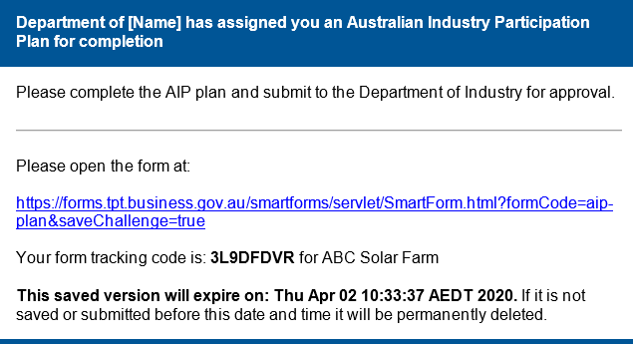

It is important to note the AIP plan Reference/Tracking Code. The Reference/Tracking Code will be used throughout the life of the AIP plan and is required to re-enter the form. This code is also located at the top right corner of the AIP plan once the form is downloaded.

**IMPORTANT:** Please do not share the Reference/Tracking Code outside your organisation or beyond those responsible for preparing the AIP plan as it is specific to your project.

If you forget or lose your Reference/Tracking Code, please contact the AIP team at [aip@industry.gov.au](mailto:aip@industry.gov.au) or 02 6213 6404.

You will need to complete eight tabs in the AIP plan:

Organisation and project details 🡪 Opportunities to supply goods and services 🡪 Publication of opportunities 🡪 Communicating and providing opportunities 🡪 Facilitating future opportunities 🡪 Implementation resources 🡪 Authorised person declaration 🡪 Send to agency

**NOTE:** When reading pre-filled entries from the Commonwealth entity in ‘Organisation and project details’, click in the text box and press the down arrow to expand the text box completely.

1. **Completing the AIP plan**

As the organisation, you will complete the remaining parts of the AIP plan and then send it to the Department for review and approval.

You will need to address the following criteria in the AIP plan. Each criterion is covered in a specific tab in the SmartForm.

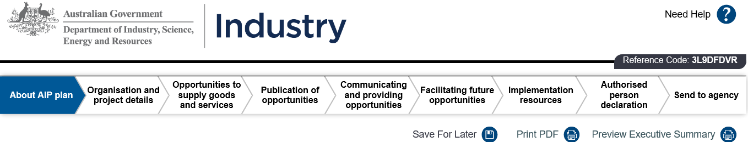

**Criterion 1: Organisation and project details**

This criterion contains information about the Commonwealth entity, your organisation and the project.

**Criterion 2: Opportunities to supply goods and services**

This criterion addresses the opportunities for Australian and/or overseas industry to supply goods and services to the project, details actions the organisation will take to actively seek information about Australian industry capability and specifies the standards used in the project. In addition, organisations are required to provide the estimated value of Australian and international purchased goods and services expected for the project.

**Criterion 3: Publication of opportunities**

**This criterion details where the organisation will publish information on the project, where Australian suppliers will find up-to-date information about opportunities and who to contact for enquiries.**

**Criterion 4: Communicating and providing opportunities**

This criterion requires a communication strategy that will provide for the early identification of opportunities for Australian industry and effective transfer of information on opportunities for Australian industry, through all tiers of supply (e.g. along subcontracting chains).

A communication strategy is essential in showing how an organisation will provide *full, fair and reasonable opportunity* for Australian industry to participate in the project. The strategy details actions the organisation will take to communicate opportunities to Australian industry. The strategy should be implemented as early as possible in the project.

**NOTE:** This criterion will not be deemed to be ‘met’ if an organisation states it will only rely on pre‑existing, closed supply chains and subcontractors and does not intend to communicate opportunities more broadly. Organisations need to describe how they will identify and encourage new suppliers to participate in their project.

This criterion also details how the organisation will provide equal opportunity to Australian industry to respond to tenders and promote AIP plan obligations to contractors and subcontractors.

**Criterion 5: Facilitating future opportunities**

**This criterion details actions the organisation will take to assist Australian industry to participate in future projects in Australia and overseas;** the actions to encourage capability development and integration into global supply chains.

**Criterion 6: Implementation resources**

**This criterion details the resources and procedures the organisation will put in place to implement the AIP plan actions effectively.**

**NOTE**: Completion of each field in the SmartForm should be straightforward as field titles are self‑explanatory. Extra guidance is provided for certain fields in this user guide. If you are unsure, please contact the AIP team.

**Criterion 1: Organisation and project details**

**The Commonwealth entity would have completed the ‘Procurement/grant/loan/investment details’ section** prior to sending you the AIP plan.

For the ‘Description of the project’ field, please ensure the project name, the nature of the project, key characteristics, procurement strategy, anticipated project start and end date, anticipated procurement start date, anticipated construction start and end date (for construction type projects only) are included and correct. Edit if required.

Check the ‘Estimated capital expenditure/total value of the project” field. Edit if required.

**NOTE:** If the estimated capital expenditure of the project is $500 million or more, please contact the AIP Authority (via email at aip@industry.gov.au or call 02 6213 6404) to discuss possible obligations under the *Australian Jobs Act 2013*.

For the **‘Company or organisation's details’ section**, please complete:

* ‘Details of person responsible for implementing the AIP plan’ information

When entering the email address, where possible, please ensure a generic email   
(e.g. [procurement@company.au](mailto:procurement@company.au)) is used instead of an individual email address   
(e.g. [John.Doe@company.au](mailto:John.Doe@company.au)). All AIP plan feedback, the approval notification and attachments will be sent to this email address. A generic email reduces the risk that the SmartForm is sent but not actioned (e.g staff movement).

**IMPORTANT**: Please ensure the email address is typed in correctly as **no bounce back emails** will be sent for incorrect email addresses.

* ‘Contact person (procurement) for company/organisation’ information

**This will be the details of the person responsible for procurement for the project. This information will be published in the AIP plan executive summary to enable contact by interested parties.**

**Criterion 2: Opportunities to supply goods and services**

**‘Expected opportunities for supply of key goods and services (including project management)’ section**

**You will need to list the key goods and services for the project (to be procured, being procured or already procured), indicate if there were/are opportunities for Australian and/or international suppliers and provide the estimated opportunity value.**

You can add a new opportunity line by clicking the “**Add opportunity**” button (see snapshot below) to list the goods and services separately (e.g. Trenching, Earthworks, Fencing, Modules, Trackers etc).



Each key good and service should be listed, together with an indication of whether it offers opportunities for Australian and/or international suppliers. Where you indicate that a good or service cannot be procured in Australia, or via an Australian supplier (**NOTE:** An Australian supplier means an entity that has an ABN or an ACN), an explanation as to why you have made this assessment must be included in the associated text box.

Note that there is a maximum limit of 20 opportunities in the AIP plan. If exceeding the 20 opportunities limit, please group items that will be delivered together that have the same opportunity for Australian and/or international suppliers.

**All Criteria**

**Complete the rest of the AIP plan by reading the questions and selecting your intended actions and providing further information in the response boxes. You should select and describe any actions you have already undertaken on the project. Once you have completed the AIP plan, send the form to the Department by clicking the ‘Send to agency’ button.**

**NOTE:** The Department requires at least 10 working days to assess and approve an AIP plan. Where feedback is provided and revision of the AIP plan is required, you must take this into account to manage the timeframes.

**Print PDF and Preview Executive Summary**

**You can preview the AIP plan and the executive summary of the AIP plan while completing the form. The content of the executive summary is automatically generated from the AIP plan.**



**As the** executive summary of the approved AIP plan (Word and PDF versions) will be published on the AIP website once the Commonwealth entity advises the Department that the contract/agreement has been executed (and if applicable, publicly announced) or financial close for the project has been achieved, please exclude any confidential information that you do not want published.

### **Section B: Review and Approval of AIP plan by the Department**

1. **Review and feedback**

**The Department staff will review your AIP plan and provide feedback, if required. Where feedback is provided, you will receive an email notification.**

**Once you have addressed all the feedback by updating the AIP plan, please re-send the AIP plan to the Department by clicking on the ‘Send to agency’ button.**

1. **AIP plan approval**

When the AIP plan is approved by the Department, the SmartForm system will send an approval email to the Commonwealth entity and your organisation that includes:

* a PDF version of the AIP plan and executive summary
* an HTML file containing the link to complete the Implementation Report
* a calendar reminder for the Implementation Report.

The Department will also receive a copy of the above documents and files.

The Commonwealth entity and organisation should agree on the date of Implementation Report submission and save the date (e.g. one or two months before the due date) in the calendar reminder. The Commonwealth entity will inform the Department of the agreed date for Implementation Report submission.

1. **Implementation reporting requirements**

The type of project (multiyear, non-multiyear or panel procurement) will determine the implementation reporting requirements. The requirements will be specified in the approval email as follows:

* **For non-multiyear projects (less than 24 months)**: an Implementation Report is due 14 months from execution of the contract/agreement or on completion of the contract (for contracts less than 24 months). See **Example A** below.
* **For multiyear projects (24 months or more)**: in addition to the first Implementation Report at 14 months, reports are also required to be submitted annually until completion of the project. See **Example B** below.
* **For panel procurement**: please contact the Department for guidance.

Where applicable, the Department will specify any ad hoc or additional reporting requirements when approving the AIP plan.

**Example A: Approval email for non-multiyear project**

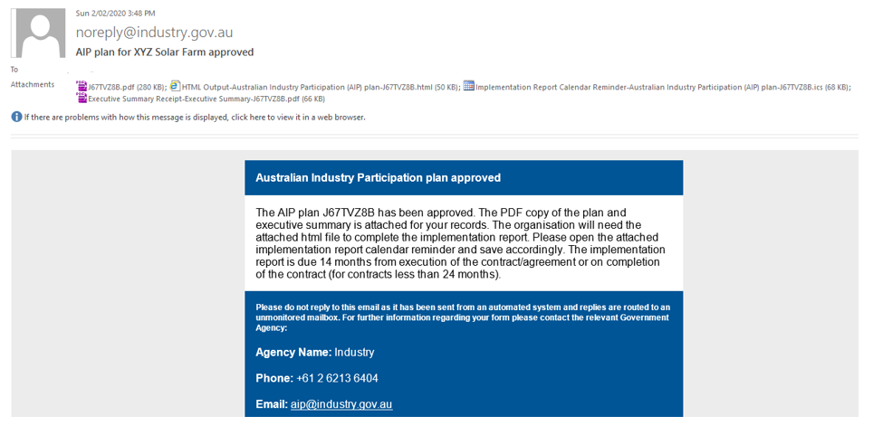

**Example B: Approval email for multiyear project**

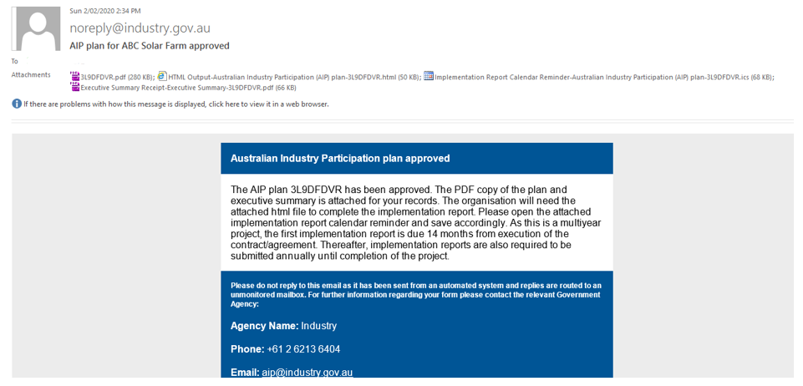

1. **Publication of AIP plan executive summary**

The executive summary of the approved AIP plan (Word and PDF versions) will be published on the AIP website (<https://www.industry.gov.au/regulation-and-standards/australian-industry-participation/comm-government-procurement>) once the Commonwealth entity advises the Department that the contract/agreement has been executed (and if applicable, publicly announced) or financial close for the project has been achieved.

### **3.2 Implementation Report SmartForm**

### **Section C: Completion of Implementation Report by the Organisation**

The organisation will be contractually required to implement its approved AIP plan and report on its implementation.

The organisation will complete the Implementation Report and send it through the SmartForm workflow to the Commonwealth entity for review and approval.

**NOTE:** If you have queries while completing the Implementation Report, please contact the Department for further guidance.

1. **Initiating the implementation report**
2. From the AIP plan approval email attachments, the Implementation Report can be initiated by clicking on the HTML Output which is available as an attachment or within the calendar reminder.

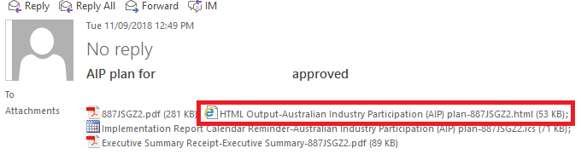

1. Click the ‘Complete Implementation Report’ button.

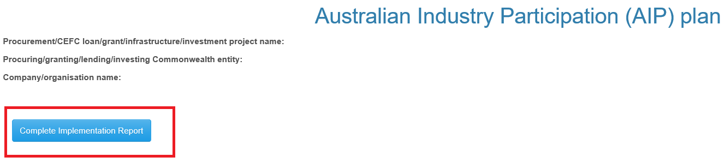

1. A new Reference/Tracking Code will be generated for the Implementation Report (indicated on the top right hand corner of the form).

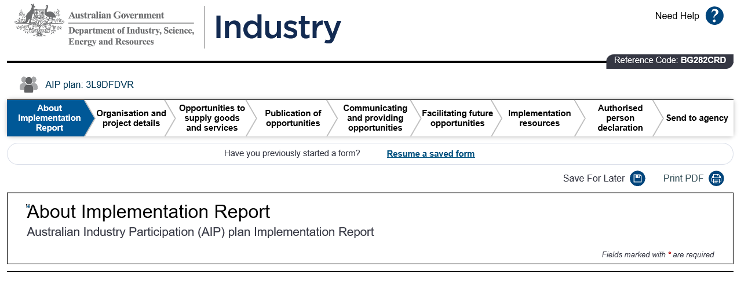

**IMPORTANT:**

* Please do not share the Reference/Tracking Code outside your organisation or beyond those responsible for completing the Implementation Report as it is specific to your project.
* The SmartForm has a 60 day life cycle, this means if the form is not saved or submitted in 60 days it will be permanently deleted from the system.

The SmartForm will transfer responses from the approved AIP plan to the Implementation Report so that you can report against each criterion easily.

When reading pre-filled responses from the AIP plan, click in the text box and press the down arrow to expand the text box completely.

You will complete the Implementation Report and then send it to the Commonwealth entity for review and approval.

1. **General guidance**
2. Yes/No

You must report against the Yes/No responses selected in your AIP plan and explain any variations in the open text fields.

For example: If there were variations to the AIP plan question ‘Do you intend to publicly advertise tender packages or EOIs for all listed goods and services?’, select ‘Yes’ and provide a response in the ‘Detail what changed during implementation’ field.

Alternatively, if the answer is ‘No’ there is no requirement to respond further.

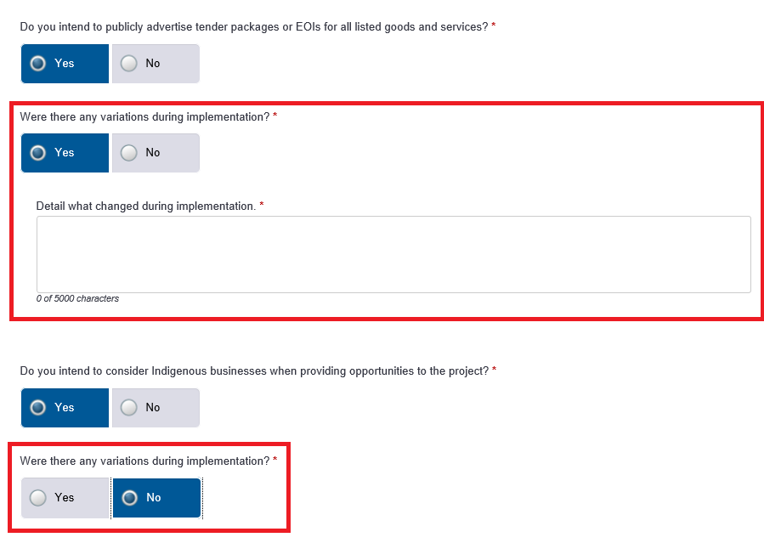

1. Open text field and attachment(s)

You must also report against checked box actions committed in the AIP plan in a mandatory text field and attach any relevant document(s) in the upload field, as demonstrated in the example below:

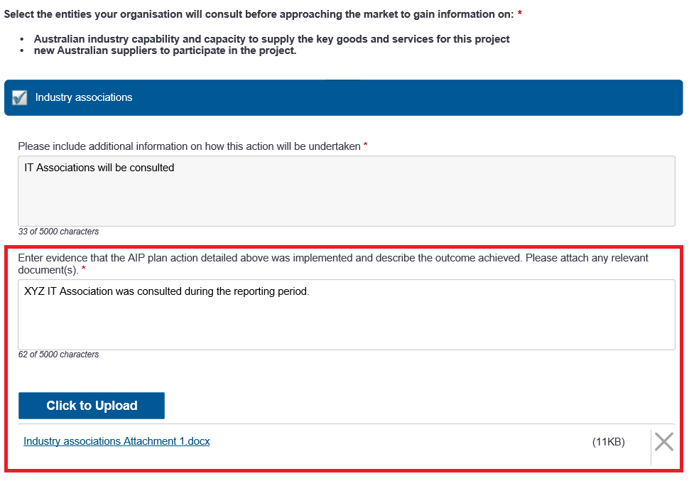

1. Uploading supporting documents

Throughout the Implementation Report you will be asked to report on the outcomes of actions/strategies committed to in the approved AIP plan. As shown in the example below, the text fields are mandatory. If you would like to upload supporting documents note there is a total **20MB upload limit** to the SmartForm. If you have more than 20MB of documentation to upload, please consider zip-locking individual files before uploading. As the form only allows for one document to be attached at a time, you will need to click upload again if you have more than one document to attach for a particular response. Attachments should be named with reference to the question.

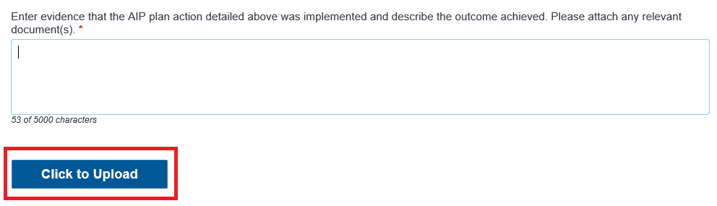

1. **Reporting sections and example responses**

You will need to report against the following criteria in the Implementation Report. Some examples and general guidance have been provided below in this user guide.



**Criterion 1: Organisation and project details**

*‘Email address for procuring/granting/lending/investing Commonwealth entity’ field*

This field is editable and may be updated if necessary (i.e. if advised by the Commonwealth entity).

**IMPORTANT:** Please ensure the email address is typed correctly as **no bounce back emails** are sent for incorrectly typed email addresses.

*‘Provide an update on the project for the reporting period’ field*

Provide an update on the status of your project. For example, an update on construction, the number of contracts awarded or any delays experienced. If your project is multiyear, provide an indication of the expected progress over the next reporting period.

*‘Details of person responsible for implementing the AIP plan’*

This field is editable and may be updated if necessary (e.g. change of personnel responsible for AIP plan implementation). The implementation report feedback, approval notification and attachments will be sent to this email address.

When entering the email address, where possible, please ensure a generic email   
(e.g. [procurement@company.au](mailto:procurement@company.au)) is used instead of an individual email address   
(e.g. [John.Doe@company.au](mailto:John.Doe@company.au)). A generic email reduces the risk that the SmartForm is sent but not actioned (e.g staff movement).

**IMPORTANT:** Please ensure the email address is typed correctly as **no bounce back emails** are sent for incorrectly typed email addresses.

*‘Contact person (procurement) for company/organisation’*

This field is editable and may be updated if necessary (e.g. change of personnel responsible for project procurement).

*‘Postal address’*

These fields are editable and may be updated if necessary (e.g. change of personnel responsible for AIP plan implementation or change of company address).

**Criterion 2: Opportunities to supply goods and services**

* **For multiyear and non-multiyear projects**

*‘Expected opportunities for supply of key goods and services (including project management)’ section*

As shown below, you will need to report the actual value of key goods and services against the estimated values recorded in the approved AIP plan for the list of project goods and services.

**NOTE:** Organisations should provide their best estimate at the time the Implementation Report is submitted.

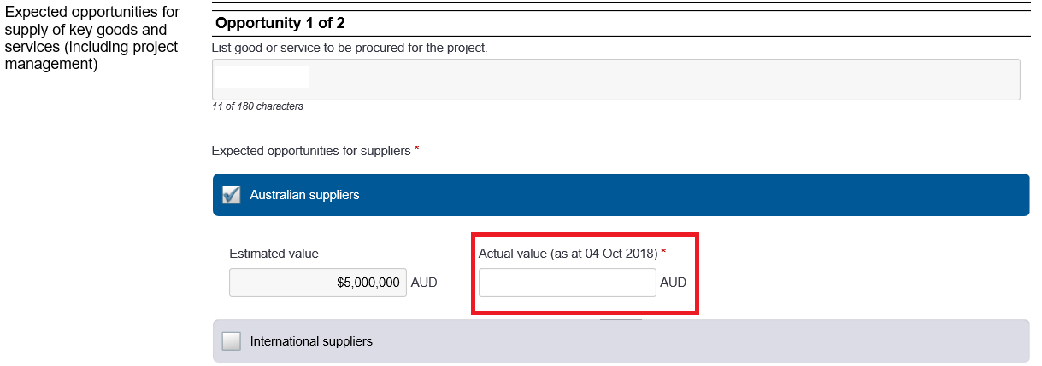

* **For panel procurement**

Please contact the Department for guidance.

***‘Do you intend to consider Indigenous businesses when providing opportunities to the project?’ field***

**Where your organisation indicated it will consider Indigenous businesses when providing opportunities to the project, you may provide observations about the capability and/or capacity of Indigenous businesses engaged in the project, as shown below.**

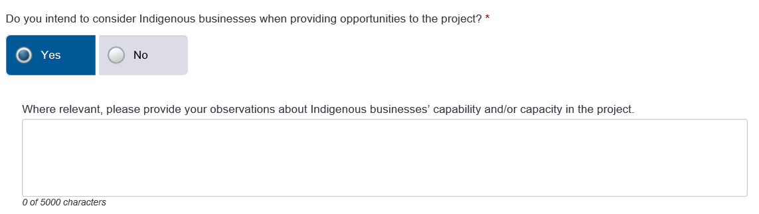

**Industry capability and standards section**

***Select the entities your organisation will consult before approaching the market to gain information on:***

* ***Australian industry capability and capacity to supply the key goods and services for this project***
* ***new Australian suppliers to participate in the project.***

**Example Implementation Report responses are provided below:**

| **Stage** | **Example Implementation Report evidence and outcome** |
| --- | --- |
| **AIP plan action** (transferred from AIP plan) | Vendor identification agencies |
| **AIP plan text box response** *(transferred from AIP plan)* | Engaging with the [name of vendor identification agency].  [Organisation] will engage with the [vendor identification agency] to nominate potential suppliers of goods and services relevant to the contract.  [Organisation] will provide the [vendor identification agency] with a list of goods and services which will be required to complete the contract. These will be listed on the [vendor identification agency] website.  [Organisation] will use the [vendor identification agency] service/website to nominate suppliers to supplement our existing supplier database and these will be invited to respond for the provision of goods and services required to undertake the contract. |
| **Enter evidence that the AIP plan action was implemented and the outcome achieved.** | A list of 12 companies were provided by the [vendor identification agency], from which nine new Australian companies were added to our supplier database.  25 relevant companies from our supplier database (depending on the good or service required) were approached and invited to provide a quotation, including all identified by the [vendor identification agency].  10 current suppliers were awarded contracts valued at $15 million.  Five new companies awarded contracts valued at $2 million. |
| **Please attach any relevant document(s).** | Letter confirming engagement with the [vendor identification agency].  List of project goods and services provided to the [vendor identification agency].  Screenshot from [vendor identification agency] service/website showing the list of goods and services required for the project.  List of potential Australian suppliers provided by [vendor identification agency].  Copy of a request for a quote sent to one of the new Australian suppliers.  List of successful new Australian suppliers of goods and services and value of contracts. |

***‘What standards and certifications will be required for the key goods and services in this project?’ field***

**You must detail how you have implemented standards and certifications requirements for the project. You should provide sample copies of procurement documents which include the standards used for these procurements. If the standards used have changed, you must detail the impact that these changes had on the ability of Australian industry to participate in the project, as shown below:**

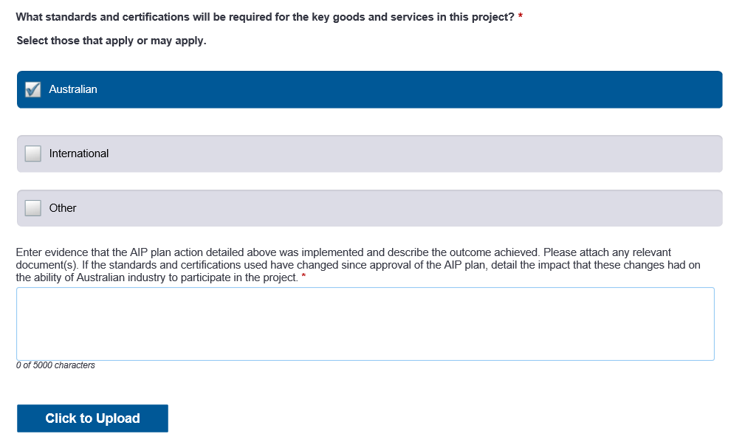

***‘Please provide your observations about strengths and weaknesses of Australian industry capability and/or capacity and general competitiveness throughout this project. This information will help the Department and the Commonwealth Government to work with Australian industry to improve competitiveness and capability in the future.’ field.***

**You must provide observations about strengths and weaknesses of Australian industry capability and/or capacity and general competitiveness relevant to this reporting period, as shown below:**

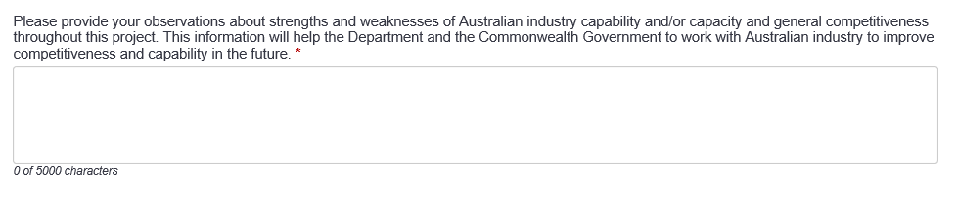

**Criterion 3: Publication of opportunities**

**You must enter evidence that a functioning web address for your organisation or project has been published. Attach a snapshot of the website as evidence.**

**You must enter evidence that a functioning web address for project opportunities has been published. Attach a snapshot of the website showing publication of project opportunities as evidence.**

**Criterion 4: Communicating and providing opportunities**

***Please select the methods your organisation will use to communicate to Australian industry:***

* ***opportunities for supplying key goods or services to the project***
* ***how to register interest in the project and respond to project opportunities***
* ***prequalification requirements for the project***

**Example Implementation Report responses are provided below:**

| **Stage** | **Example Implementation Report evidence and outcome** |
| --- | --- |
| **AIP plan action** (transferred from AIP plan) | Project website OR Project supplier portal |
| **AIP plan text box response** (transferred from AIP plan) | Will develop and utilise a supplier portal to distribute project information, including details for tenders for goods and services and expressions of interest from potential suppliers. |
| **Enter evidence that the AIP plan action was implemented and the outcome achieved.** | * Number of new Australian suppliers registered. * Number of successful new Australian organisations engaged to supply goods and services. |
| **Please attach any relevant document(s).** | Screenshots and/or web address of the supplier portal developed and utilised to find potential Australian organisations. |

| **Stage** | **Example Implementation Report evidence and outcome** |
| --- | --- |
| **AIP plan action** (transferred from AIP plan) | Liaison with industry associations |
| **AIP plan text box response** (transferred from AIP plan) | Will consult with [name] and [name] industry associations to disseminate project and supply information to capable Australian organisations. |
| **Enter evidence that the AIP plan action was implemented and the outcome achieved.** | * Number of new Australian suppliers identified. * Number of new Australian suppliers added to supplier database. * Number of successful new Australian organisations engaged to supply goods and services. |
| **Please attach any relevant document(s).** | Details of any arrangements with [name] and [name] industry associations to identify potential Australian organisations with the capability to supply the project. |

| **Stage** | **Example Implementation Report evidence and outcome** |
| --- | --- |
| **AIP plan action**  ***(transferred from AIP plan)*** | Public announcements |
| **AIP plan text box response** (transferred from AIP plan) | Will make local media announcement(s) about the project, its supply opportunities and opportunities to integrate Australian organisations with global companies. |
| **Enter evidence that the AIP plan action was implemented and the outcome achieved.** | Number of approaches generated from public announcement(s). |
| **Please attach any relevant document(s).** | Copies of any media announcement(s) about the project and supply opportunities e.g. press releases at project milestones on a website. |

| **Stage** | **Example Implementation Report evidence and outcome** |
| --- | --- |
| **AIP plan action**  ***(transferred from AIP plan)*** | Workshops/industry briefings |
| **AIP plan text box response** (transferred from AIP plan) | [Number] of workshops to be held on [dates] at [locations] that will provide sector specific information on how to prepare bids against tenders. |
| **Enter evidence that the AIP plan action was implemented and the outcome achieved.** | * Number and locations of workshops/seminars held. * Number of Australian organisations attending and any follow up enquiries. |
| **Please attach any relevant document(s).** | Copies of any briefings provided at workshops/seminars to potential suppliers. |

| **Stage** | **Example Implementation Report evidence and outcome** |
| --- | --- |
| **AIP plan action**  ***(transferred from AIP plan)*** | Development of supplier information guide |
| **AIP plan text box response** (transferred from AIP plan) | Will develop and distribute to Australian organisations a supplier information guide detailing expectations of suppliers. |
| **Enter evidence that the AIP plan action was implemented and the outcome achieved.** | Number of copies distributed or downloaded. |
| **Please attach any relevant document(s).** | Copy of supplier information guide developed. |

***Please select the methods by which your organisation will provide equal opportunity to Australian industry to respond to requests for the supply of key goods or services.***

**Example Implementation Report responses are provided below:**

| **Stage** | **Example Implementation Report evidence and outcome** |
| --- | --- |
| **AIP plan action**  ***(transferred from AIP plan)*** | Allow reasonable and equal time for submissions/responses |
| **AIP plan text box response** (transferred from AIP plan) | Will provide tender documentation or expressions of interest to all possible suppliers at the same time and with reasonable and equal timeframes for a response. |
| **Enter evidence that the AIP plan action was implemented and the outcome achieved.** | * Number of tenders or expressions of interest released. * Number of generated responses/queries from Australian organisations. * Number of Australian organisations that provided goods and services. |
| **Please attach any relevant document(s).** | Copies of requests for tenders or expressions of interest published in the media, trade publications etc. indicating the same closing time. |

***Please select the methods by which your organisation will promote AIP plan obligations to contractors and subcontractors.***

**Example Implementation Report responses are provided below:**

| **Stage** | **Example Implementation Report evidence and outcome** |
| --- | --- |
| **AIP plan action**  ***(transferred from AIP plan)*** | Include contractual arrangements with suppliers to outline AIP arrangements |
| **AIP plan text box response** (transferred from AIP plan) | Will require contractors and subcontractors to commit to the AIP plan through contractual arrangements. |
| **Enter evidence that the AIP plan action was implemented and the outcome achieved.** | * Number of contractors and subcontractors required to implement AIP policies. * Outcomes identified for Australian industry through contractual arrangement. |
| **Please attach any relevant document(s).** | Copies of contracts requiring contractors and subcontractors to implement AIP actions. |

**Criterion 5: Facilitating future opportunities**

***Please select the methods by which your organisation will encourage capability development for Australian entities.***

**Example Implementation Report responses are provided below:**

| **Stage** | **Example Implementation Report evidence and outcome** |
| --- | --- |
| **AIP plan action**  ***(transferred from AIP plan*)** | Support and assist project suppliers to adopt specific standards and accreditations |
| **AIP plan text box response** (transferred from AIP plan) | Will identify project suppliers that require specific standards and accreditations training and provide recommendation on how and where they can get the appropriate information or training. |
| **Enter evidence that the AIP plan action was implemented and the outcome achieved.** | * Number of Australian companies identified. * Number of Australian companies who sought more information and undertook training to get accredited or adopt specific standards. |
| **Please attach any relevant document(s).** | * List of companies identified that required training. * List of companies that sought more information and/or undertook training. |

| **Stage** | **Example Implementation Report evidence and outcome** |
| --- | --- |
| **AIP plan action**  ***(transferred from AIP plan*)** | Arrange seminars to raise awareness of the benefits of strategic alliances to Australian industry |
| **AIP plan text box response** (transferred from AIP plan) | Will organise seminars to raise awareness of the benefits to Australian industry of entering into strategic alliances and how to enter into and manage such arrangements. |
| **Enter evidence that the AIP plan action was implemented and the outcome achieved.** | * Number of overseas suppliers and Australian suppliers participating in the seminars. * Number of Australian suppliers entering strategic alliances with overseas suppliers. |
| **Please attach any relevant document(s).** | Copies of advertisements, attendance details, presentations at any workshops, seminars or other initiatives to raise awareness of the benefits to Australian industry of entering into strategic alliances and how to enter into and manage such arrangements. |

***Please select the methods by which your organisation will encourage the integration of Australian entities into global supply chains.***

**Example Implementation Report responses are provided below:**

| **Stage** | **Example Implementation Report evidence and outcome** |
| --- | --- |
| **AIP plan action**  ***(transferred from AIP plan*)** | Introduce project suppliers to global companies or suppliers |
| **AIP plan text box response** (transferred from AIP plan) | Will facilitate the introduction of project suppliers to global companies or suppliers and encourage a working relationship. |
| **Enter evidence that the AIP plan action was implemented and the outcome achieved.** | Number of personal and direct introductions held. |
| **Please attach any relevant document(s).** | Details or summaries of introductions made (where, when and who) including any representations from and to major overseas suppliers. |

| **Stage** | **Example Implementation Report evidence and outcome** |
| --- | --- |
| **AIP plan action**  ***(transferred from AIP plan ‘add another’)*** | Build strategic partnerships |
| **AIP plan text box response** (transferred from AIP plan) | Will encourage and facilitate strategic partnerships, consortia building, and joint ventures to build critical mass. |
| **Enter evidence that the AIP plan action was implemented and the outcome achieved.** | * Number of consortia, joint ventures or strategic partnerships developed. * Number of partnerships developed between the supplier and Australian organisations. * Number of identified companies that facilitated partnerships. |
| **Please attach any relevant document(s).** | * Details of any consortia, joint ventures or strategic partnerships established or expected to be established among Australian industry to build critical mass. * Identified Australian companies or agencies that introduced or facilitated partnerships between the supplier and Australian organisations such as the Industry Capability Network or the Entrepreneurs’ Programme. |

**Criterion 6: Implementation resources**

***Please select the procedures and resources that will be utilised to ensure the AIP plan actions are implemented.***

**Example Implementation Report responses are provided below:**

| **Stage** | **Example Implementation Report evidence and outcome** |
| --- | --- |
| **AIP plan action** (transferred from AIP plan) | Develop systems to identify inappropriate actions under the AIP plan and to monitor/record the corrective action taken |
| **AIP plan text box response** (transferred from AIP plan) | Will implement systems [names and/or describe the systems/approaches] to identify inappropriate action under the AIP plan and to monitor/record the corrective action. |
| **Enter evidence that the AIP plan action was implemented and the outcome achieved.** | * Details of the type of system implemented and how it was used to monitor/record corrective action. * Number of corrective actions undertaken. |
| **Please attach any relevant document(s).** | Screenshot of the system used to identify inappropriate action under the AIP plan and to monitor/record the corrective action. |

| **Stage** | **Example Implementation Report evidence and outcome** |
| --- | --- |
| **AIP plan action** (transferred from AIP plan) | Develop systems to identify and report any variations in AIP plan activities |
| **AIP plan text box response** (transferred from AIP plan) | A system [name and/or describe the system/approach] will be implemented for monitoring AIP actions and the extent of Australian industry participation, including a system to report variations. |
| **Enter evidence that the AIP plan action was implemented and the outcome achieved.** | Details of the system implemented to monitor the extent of Australian industry participation and how it was used to monitor variations of AIP plan activities. |
| **Please attach any relevant document(s).** | Screenshot of the system implemented to monitor the extent of Australian industry participation in the project. |

**Send to agency**

**Once you have completed the Implementation Report and attached all relevant evidence, you are ready to submit the form to the Commonwealth entity for review and approval.**

**Ensure the name of the person implementing the AIP plan and the Commonwealth entity email address match those entered in ‘Organisation and project details’.**

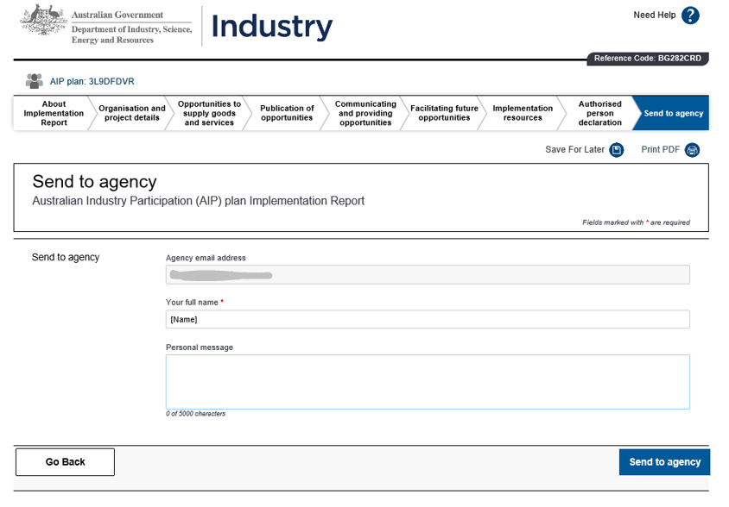

**You may use the ‘Personal message’ field to communicate with the Commonwealth entity before clicking the ‘Send to agency’ button. This communication will not form part of the Implementation Report.**

### **Section D: Review and Approval of Implementation Report by the Commonwealth Entity**

The Commonwealth entity will receive an email notification, through the SmartForm workflow, that you have submitted the Implementation Report. The Commonwealth entity will review and approve the report. If required, the Commonwealth entity will request additional information, evidence or revision. In this case, you will receive an email notification from the Commonwealth entity to address these requests. Once these are addressed, you will then send the report back to the Commonwealth entity for review/approval.

When the Commonwealth entity approves the report, the SmartForm system will send an approval email (see examples below) to the Commonwealth entity and the organisation that includes:

* a PDF version of the Implementation Report
* an HTML file for the organisation to complete the next Implementation Report, if applicable
* a calendar reminder for the next Implementation Report, if applicable.

The Department will also receive a copy of the above documents and files.

For multiyear projects, **if subsequent Implementations Reports are required, the Commonwealth entity and organisation should agree on the date of the next Implementation Report submission and save the date (e.g. one or two months before the due date) in the calendar reminder.** The Commonwealth entity will inform the Department of the agreed date for the next report submission.

**Non-multiyear project implementation report approval email example**

Once the report for a non-multiyear project has been approved, the Commonwealth entity and organisation will receive a notification email similar to that shown below. As there are no further reporting requirements, this is the final email in the SmartForm process.

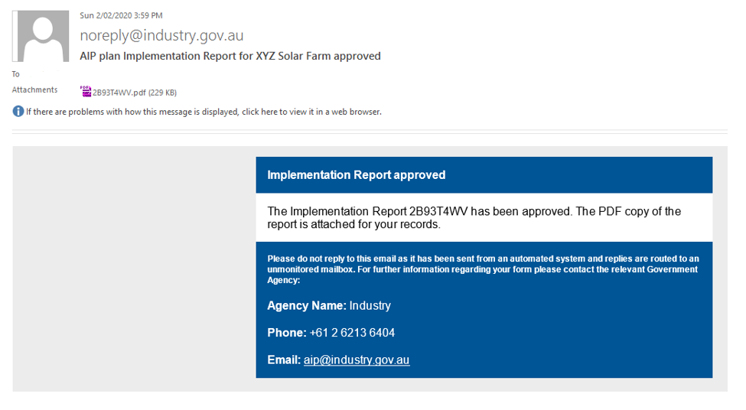

**Multiyear project implementation report approval email example**

Once the report for a multiyear project has been approved, the Commonwealth entity and organisation will receive a notification email similar to that shown below. The email specifies the multiyear reporting requirements.

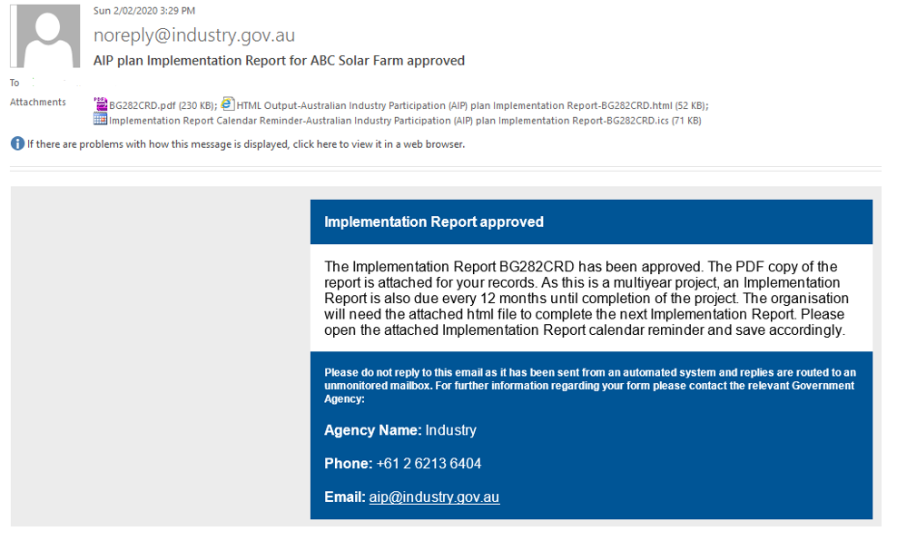

1. An eligible project is a Commonwealth procurement, grant, loan or investment of $20 million or more.
2. ‘Organisation’ in this user guide refers to the successful tenderer/panellist or grant/funding recipient who has a requirement to develop an AIP plan.
3. These are outlined in the [Australian Industry Participation National Framework](https://www.industry.gov.au/sites/default/files/australian-industry-participation-national-framework.pdf) signed by Commonwealth, State and Territory Industry Ministers in April 2001.
4. ‘Commonwealth entities’ refer to the Australian Government agencies captured under sections 2.1 to 2.5 in this user guide.