Name Australia’s Lunar Rover
School Presentation Supporting Material

Title – Slide 1

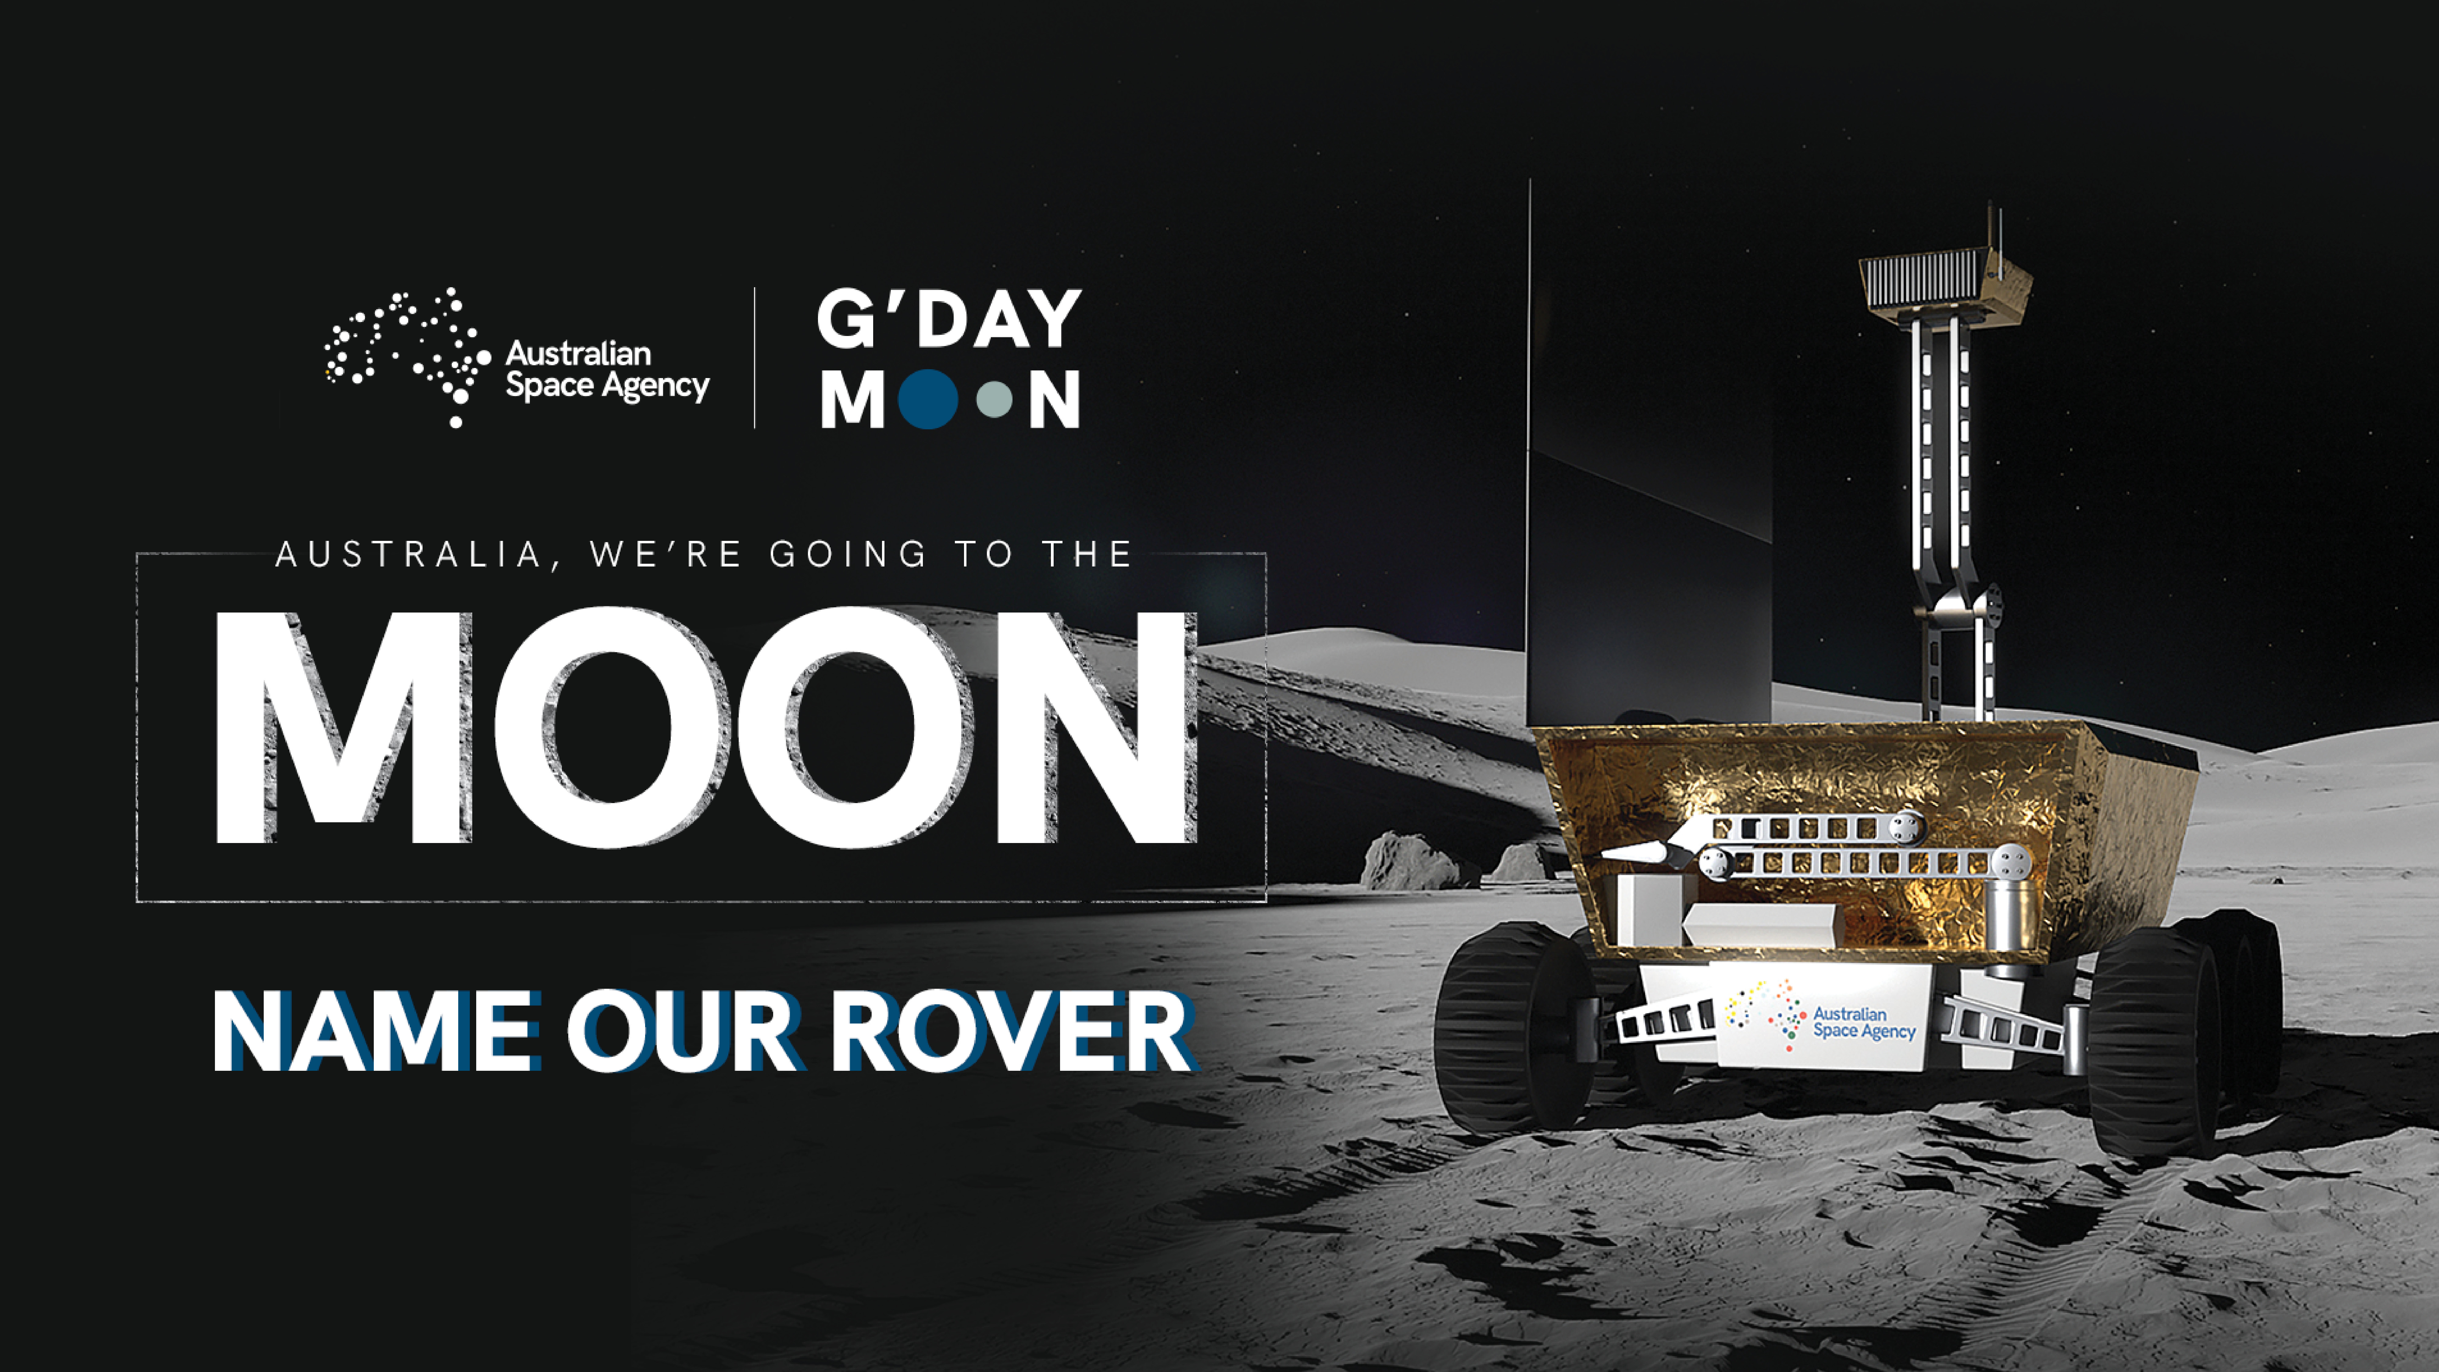

History of Space in Australia – Slide 2
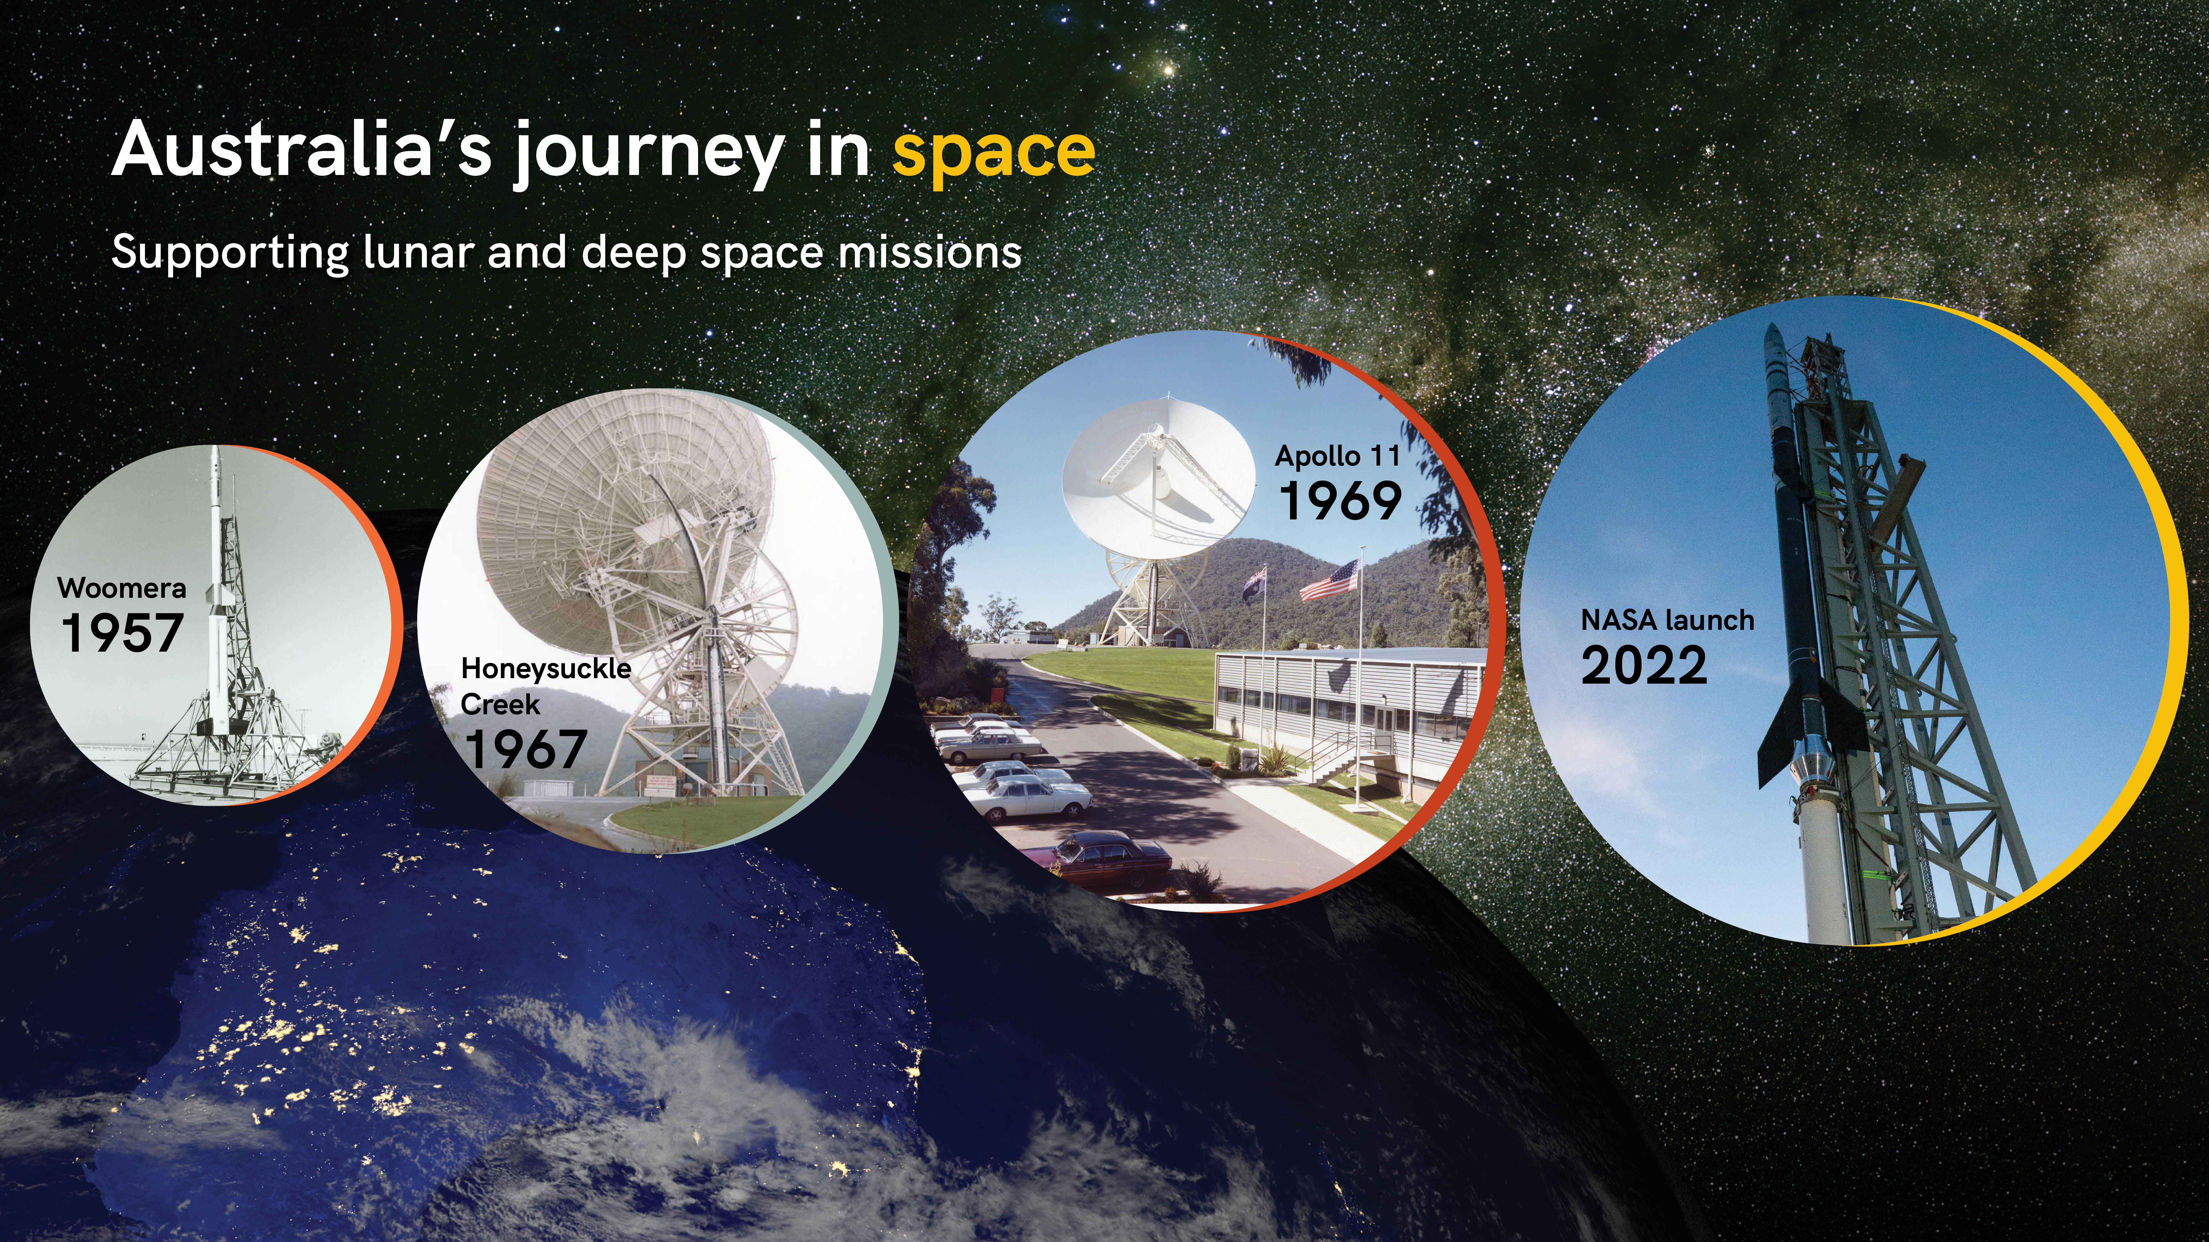
- Australia’s journey into space began in South Australia at the Woomera Rocket Range, with space tracking and sounding rocket programs in 1957.
- Ten years after that – Australia launched its first satellite from Woomera.
- In 1969 Australia played a pivotal role in NASA’s famous Apollo 11 moon landing:
  - Our Parkes Radio Telescope supported Apollo 11, and other lunar and deep space missions.
  - Plus, the Honeysuckle Creek Tracking Station, near Canberra, transmitted the famous first moon steps of Neil Armstrong all around the world.
  - Honeysuckle Creek Tracking Station was built by NASA 1967 to support their Apollo mission to the Moon.
- Since then, we’ve had a lot of Australian experiments and scientific instruments go to space on satellites and NASA Space Shuttles.
- Australia has a very close relationship with NASA and in 2022, NASA chose to launch rockets from the Northern Territory – its first time launching from a commercial space port outside of the USA.

About the Australian Space Agency – Slide 3
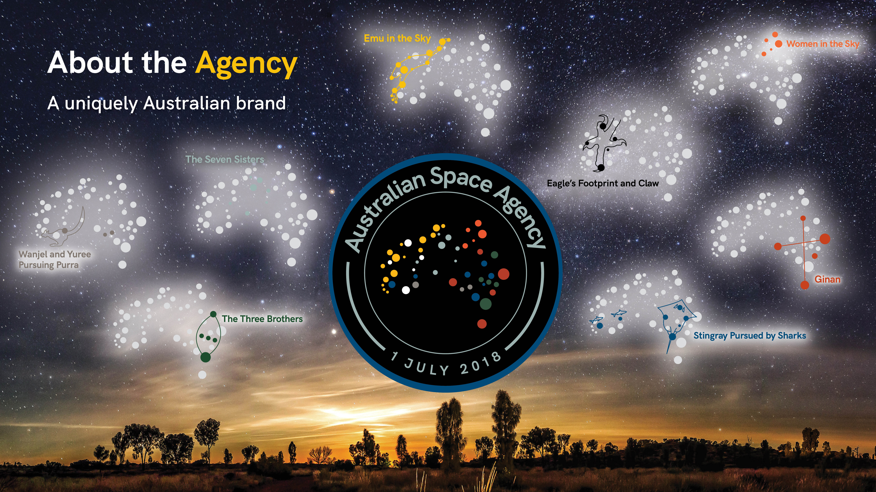
- The Agency began operating on 1 July 2018.
- The Agency is quite different to NASA – it doesn’t launch rockets itself, but instead helps Australian space businesses to do it.
- The Agency looks after the safety around launching rockets and builds and maintains relationships with other space nations.
- And it gives advice to the Australian Government on things such as policy and strategy, and how to best support business.
- Its headquarters are in Adelaide, but many agents work from all parts of Australia.
Our Logo
- About the Australian Space Agency’s logo (or identity):
  - It captures the past, present and future of the Australian space sector by highlighting our unique geographical position here in the Southern Hemisphere, and the strong link between space and our Indigenous people, who are considered the world’s oldest astronomers.
  - It conjures up images of Australia as seen from space: the dots allude to the light provided by industry and technological advances such as GPS and global monitoring.
  - But the abstract view is also what Australians can see when they look to space. The image of the continent is made up of eight Aboriginal constellations or star maps.

Going to the Moon: Team Artemis Australia – Slide 4
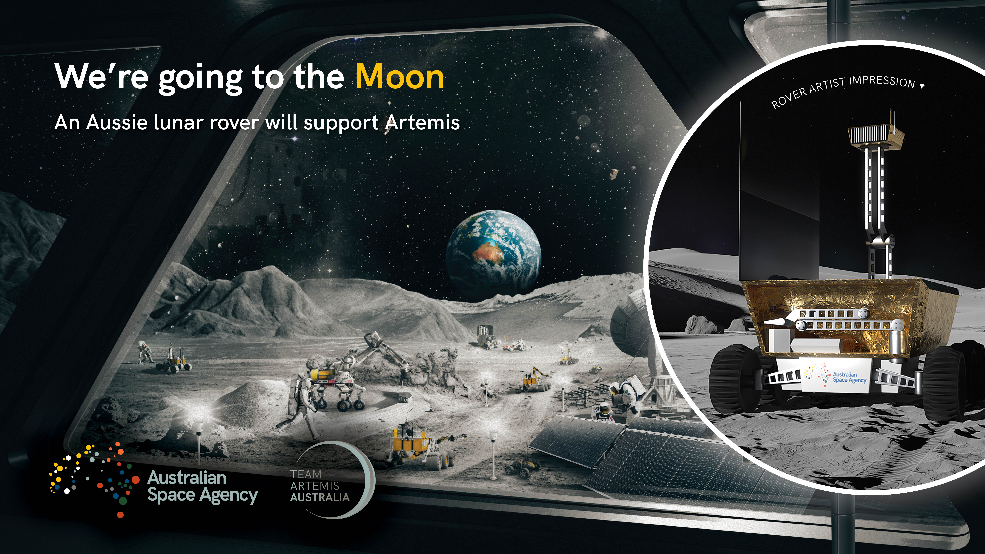
- There are plans to build a long-term presence on the Moon – for people to live there.
- The Artemis Mission is being led by NASA in the USA, but Australia will be an active participant in this feat via the Australian Space Agency-led Team Artemis Australia platform.
  - An Australian designed and built rover will be included in a future mission to the Moon, where it will be used to collect lunar soil.
  - Australia has been chosen to partner with NASA on this technology because we are a leader in the field of robotics, remote operation and automation.
  - For example, certain mining operations in the Pilbara region of Western Australia are controlled by teams thousands of kilometres away in Perth.
  - By translating that expertise into space, we can support those foundational services needed to establish the Moon as a launching point for further human exploration.
- The soil collected by the Aussie-built rover will be used in many different ways to help sustain humans living on the Moon:
  - Scientists will work to extract oxygen from the soil, which could then be used in human life support systems and to create rocket fuel for further exploration of the Moon or Mars.
- Australian expertise in remote sensing, geological surveying, radar mapping and mineral exploration are all vital domains for knowledge in which we can contribute.
- If you could make something to go to the Moon to help humans live there, what would it be?

The Rover – Slide 4 (see above)
- The Australian Government has an agreement with NASA for a small Australian made rover to be sent to the Moon as part of its Artemis Mission.
- The rover, which aims to launch by 2026, is part of the NASA Moon to Mars mission.
- The semi-autonomous rover will be used to collect lunar soil (regolith), which contains oxides.
  - Using separate equipment that will be sent to the Moon with the rover, NASA will aim to extract oxygen from the regolith – a key step towards establishing a sustainable human presence on the Moon, as well as supporting future missions to Mars.
- Two Australian consortiums are currently working on early-stage concepts for the rover.

Why Space Matters – Slide 5
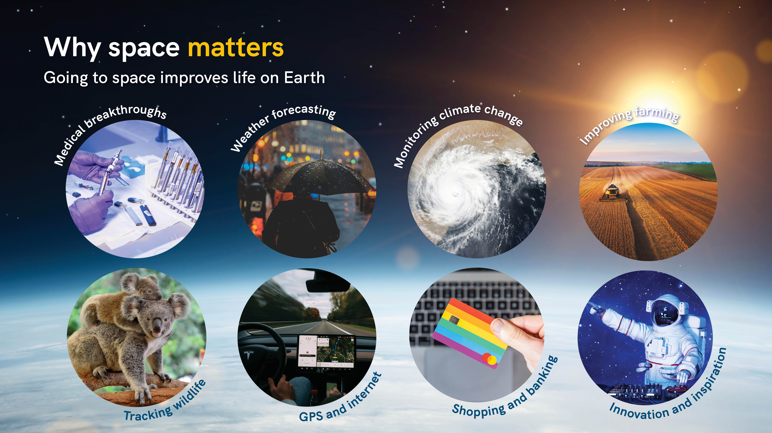
- Have you ever heard someone ask: Why are we spending millions of dollars on space projects, when we need to fix things here on Earth? Perhaps you’ve wondered that yourself.
- The fact is – there is so much we can learn about improving life on Earth by going to Space – especially when it comes to sustainability and helping to mitigate climate change.
- The special requirements of the space environment have led to many innovations that are useful, or help us to solve problems here on Earth:
  - Keeping astronauts healthy has led to medical breakthroughs for treatment for cancer, asthma and heart disease.
  - Plus, it’s helped develop innovations such as pacemakers, artificial limbs and dialysis.
  - Satellites can monitor pollution, as well as weather conditions to help us understand and lessen the effects of climate change.
  - Farmers use satellites to remotely control their equipment, monitor livestock and assess their soil conditions to improve productivity.
  - We can also track wildlife – including endangered native animals like koalas, and certain species of possums and birds.
  - Plus, satellites in space help us in everyday life – including navigation by using GPS, online shopping, and staying connected via the internet and video calls.
- Research conducted on the International Space Station (ISS) provides insight into how materials, plants and even fire behave in space. This can increase safety and lead to many valuable spinoffs on Earth.
- The ISS is a space laboratory that provides new ways to study serious health conditions such as cancer, asthma and heart disease.
- Space also helps us push the boundaries of what is possible: innovating new technology, expanding our problem solving, and inspiring pop culture.

Careers in Space – Slide 6
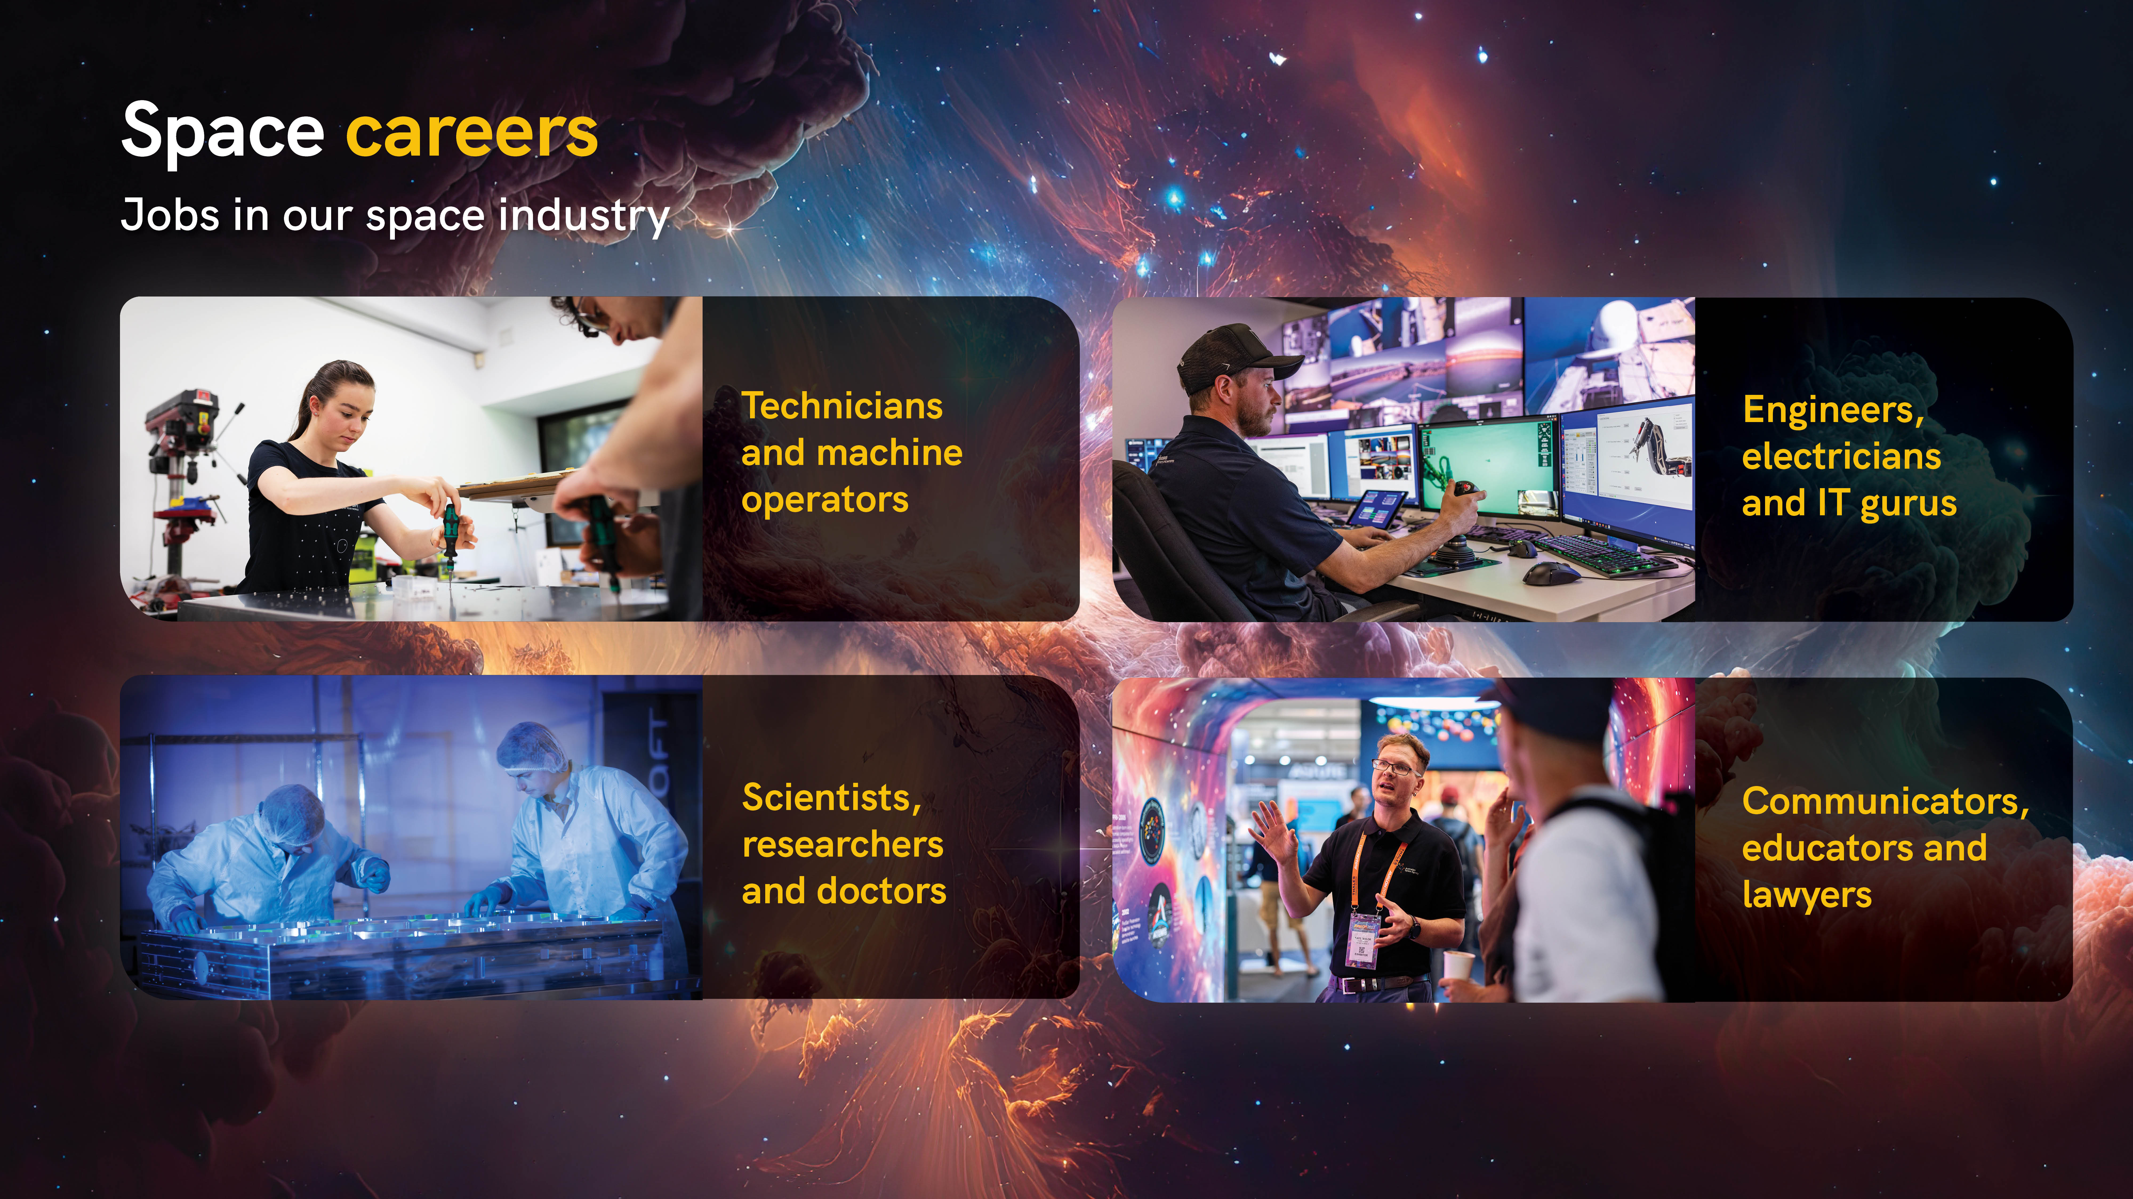
- Who enjoys:
  - building things?
  - solving problems – in maths or science?
  - drawing and designing things?
  - fixing things or helping people?
  - researching and telling stories?
- For all of these interests, there is a job in the space industry in Australia.
- Now, and in the future – when you leave school – we’re going to need:
  - Engineers and Electricians
  - Doctors and Scientists
  - Cyber Security Specialists and Game Developers
  - Technicians and Machine Operators
  - Lawyers and Communicators
- So, it’s important you keep doing what you enjoy, what you’re good at, and who knows – you could end up with a career working in space.
- Or, even living on the Moon…
- Or, being part of the Mission to Mars…!

The Competition – Slide 7
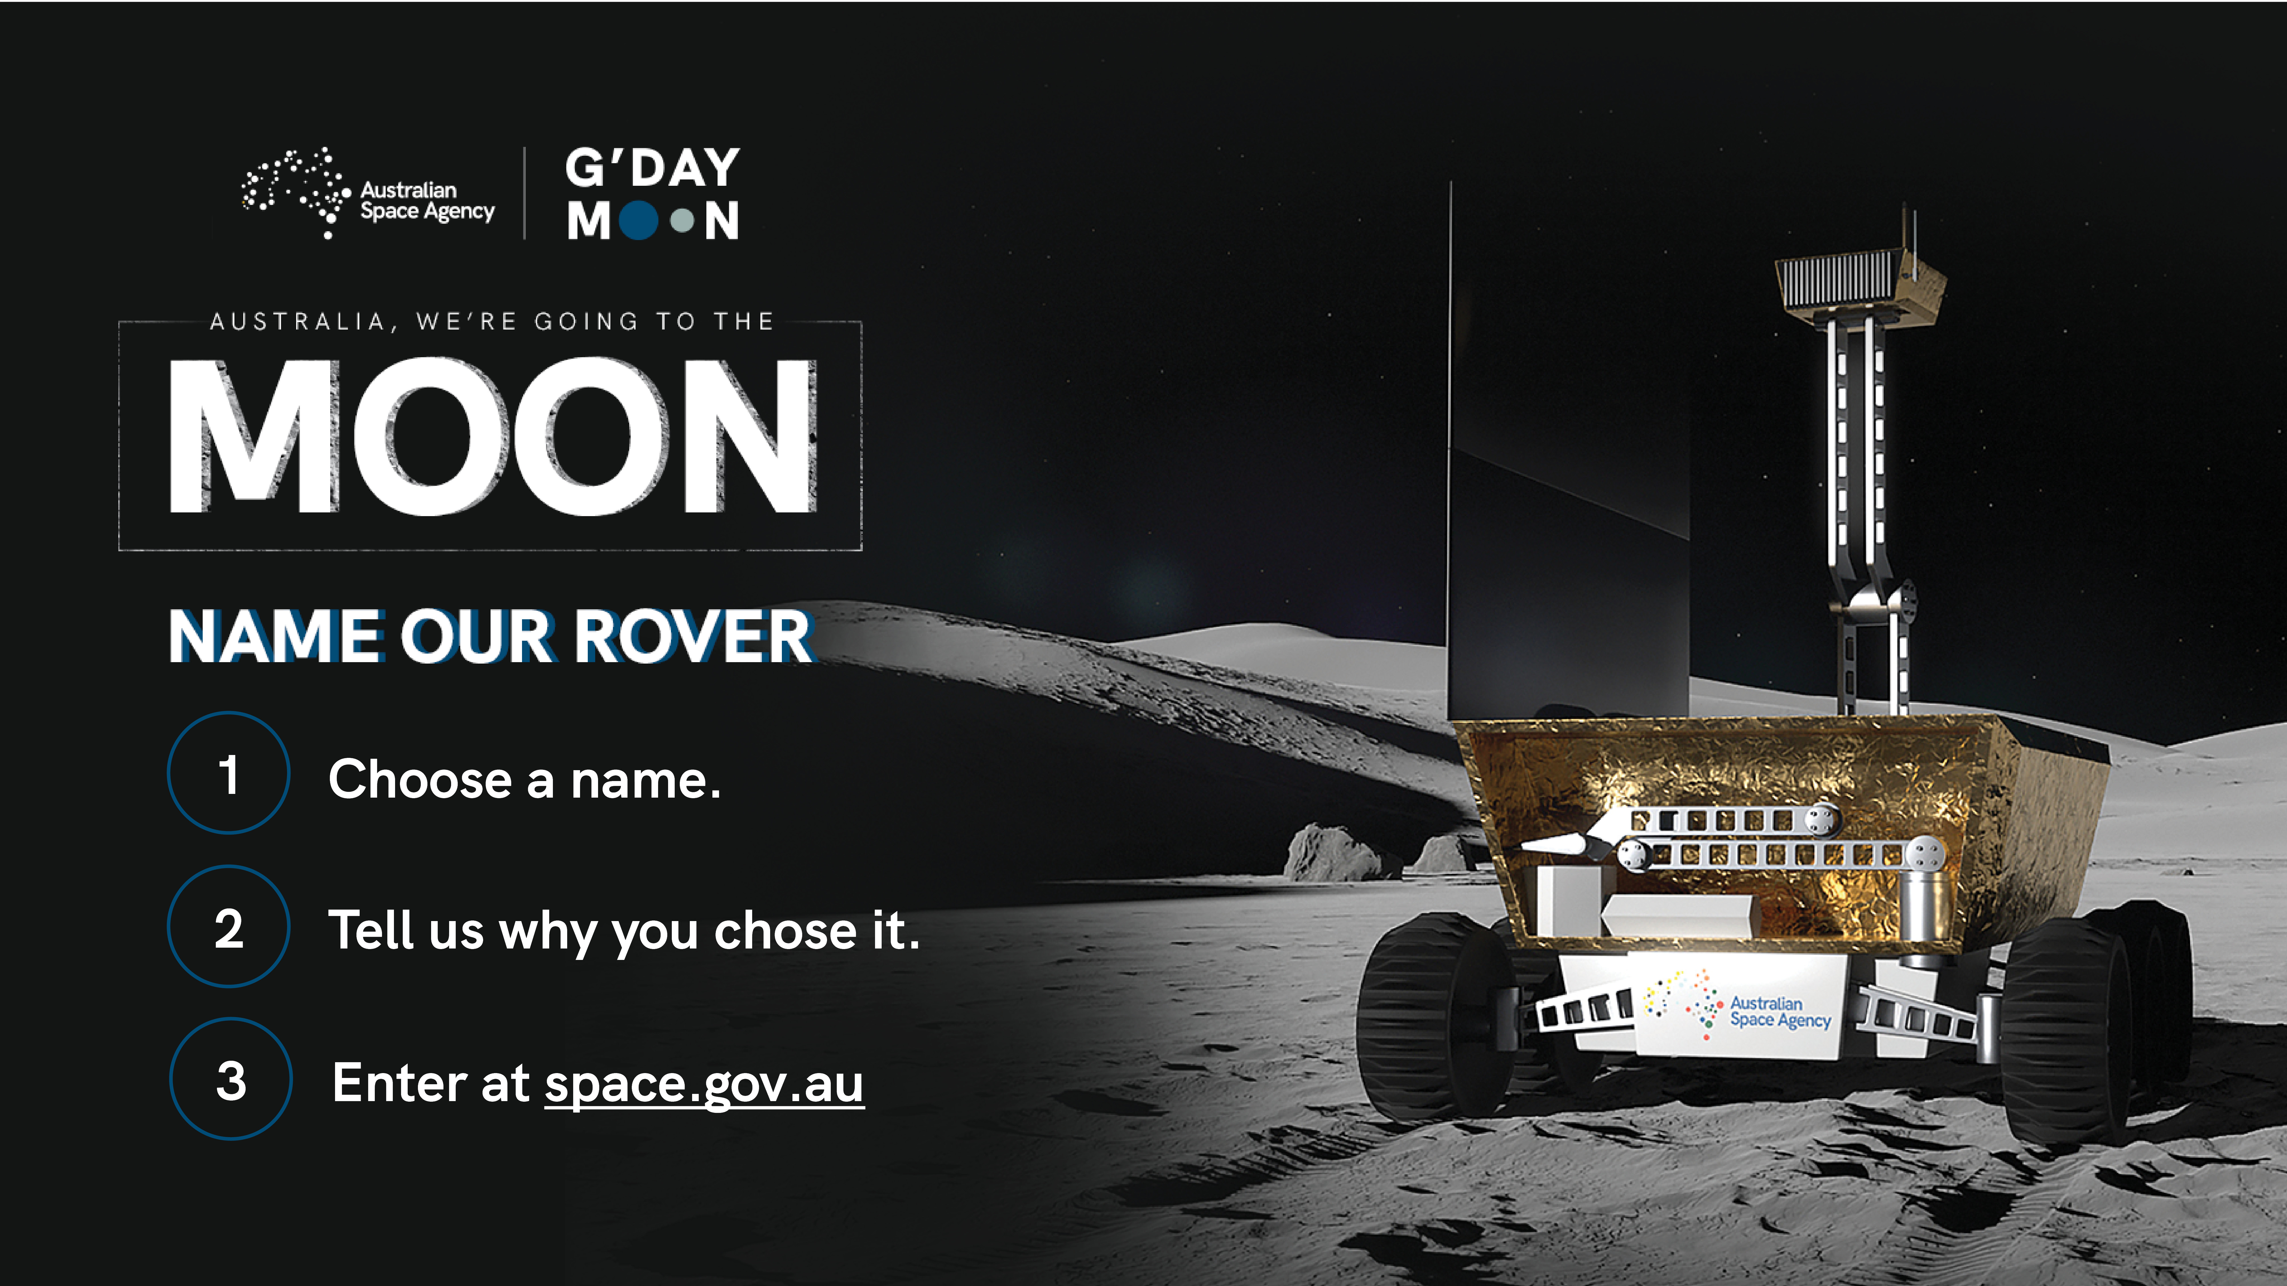

- The Australian Space Agency has launched a competition to name the rover.
- We want this rover name to be uniquely Australian and to reflect our Aussie spirit, our Aussie ingenuity and the excitement of this historic occasion.
- What you need to do is:
  - Come up with a great name for the rover
  - Explain why you think it’s a good name for the rover
  - Enter these details at www.space.gov.au
- The Australian Space Agency will create a shortlist from these submissions, which we will then put to a public vote later in the year.
- This is a milestone moment in our nation’s space history and we want all Australians to have their say in what our rover is called.

Dates to remember
Closing date for initial entries: Friday 20 October 2023 (11.59pm ADST)
Shortlist voting period: Monday 20 November – Friday 1 December 2023
Announcement: Wednesday 6 December 2023

Outro – Slide 8
