

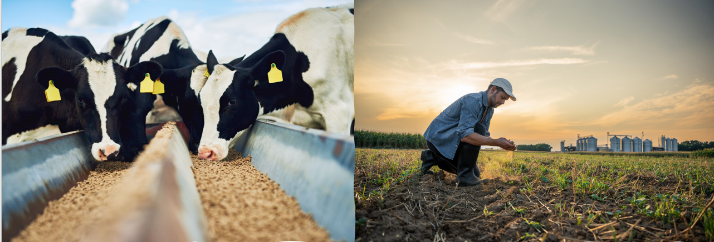

# Agrichemical and Veterinary

## Catalogue

**December 2023**

*Quality reference materials for identification and calibration are essential to making accurate chemical measurements in food and environmental testing.*

| Category | Description | **NMI reference** | **Unit of issue (mg)** | Domestic Cost (A$) (excl GST) | International  Cost (A$) |
| --- | --- | --- | --- | --- | --- |
| Agrichemicals, key metabolites and surrogates | Albendazole sulfoxide | P1792 | 25 | 275 | 385 |
| Agrichemicals, key metabolites and surrogates | Albendazole sulfone | P1793 | 25 | 275 | 385 |
| Agrichemicals, key metabolites and surrogates | Bifenthrin | P1804 | 20 | 121 | 169 |
| Agrichemicals, key metabolites and surrogates | d5-Bifenthrin | P1806 | 1 | 121 | 169 |
| Agrichemicals, key metabolites and surrogates | Carbophenothion sulfoxide | P1726 | 25 | 275 | 385 |
| Agrichemicals, key metabolites and surrogates | Carbophenothion sulfone | P1727 | 25 | 275 | 385 |
| Agrichemicals, key metabolites and surrogates | *cis*-Chlordane | P1624 | 25 | 188 | 264 |
| Agrichemicals, key metabolites and surrogates | *trans*-Chlordane | P1625 | 25 | 188 | 264 |
| Agrichemicals, key metabolites and surrogates | Chlorfluazuron | P1489 | 100 | 188 | 264 |
| Agrichemicals, key metabolites and surrogates | Chlorpyrifos | P1666a | 250 | 188 | 264 |
| Agrichemicals, key metabolites and surrogates | *p*,*p’*-DDD | P1311 | 50 | 155 | 218 |
| Agrichemicals, key metabolites and surrogates | *p*,*p’*-DDT | P1309 | 50 | 155 | 218 |
| Agrichemicals, key metabolites and surrogates | Dieldrin | P1747 | 50 | 155 | 218 |
| Agrichemicals, key metabolites and surrogates | Dibromo-DDE | P1373c | 50 | 228 | 319 |
| Agrichemicals, key metabolites and surrogates | Difluoro-DDE | P1310b | 50 | 228 | 319 |
| Agrichemicals, key metabolites and surrogates | Dimethoate | P1642 | 50 | 155 | 218 |
| Agrichemicals, key metabolites and surrogates | α-Endosulfan | P1368 | 50 | 155 | 218 |
| Agrichemicals, key metabolites and surrogates | β-Endosulfan | P1369 | 50 | 155 | 218 |
| Agrichemicals, key metabolites and surrogates | Endosulfan diol | P1370 | 50 | 228 | 319 |
| Agrichemicals, key metabolites and surrogates | Endosulfan ether | P1371 | 25 | 275 | 385 |
| Agrichemicals, key metabolites and surrogates | Endosulfan sulfate | P1372 | 50 | 275 | 385 |
| Agrichemicals, key metabolites and surrogates | d4-Endosulfan sulfate | P1803 | 1 | 188 | 264 |
| Agrichemicals, key metabolites and surrogates | Fenbendazole sulfone | P1791 | 25 | 275 | 385 |
| Agrichemicals, key metabolites and surrogates | Fipronil | P1668 | 50 | 188 | 264 |
| Agrichemicals, key metabolites and surrogates | Fipronil sulfone | P1731 | 25 | 275 | 385 |
| Agrichemicals, key metabolites and surrogates | Fluazuron | P1490 | 100 | 155 | 218 |
| Agrichemicals, key metabolites and surrogates | Heptachlor | P1394 | 50 | 155 | 218 |
| Agrichemicals, key metabolites and surrogates | Heptachlor epoxide (exo) | P1395 | 20 | 188 | 264 |
| Agrichemicals, key metabolites and surrogates | HMMNI (nitroimidazole metabolite) | P1296 | 50 | 275 | 385 |
| Agrichemicals, key metabolites and surrogates | Iprodione | P1805 | 20 | 155 | 218 |
| Agrichemicals, key metabolites and surrogates | Ketotriclabendazole | P1725b | 5 | 309 | 433 |
| Agrichemicals, key metabolites and surrogates | Lindane (γ-BHC) | P1332 | 50 | 155 | 218 |
| Agrichemicals, key metabolites and surrogates | d6-Methamidophos | P1712 | 1 | 188 | 264 |
| Agrichemicals, key metabolites and surrogates | Methoxychlor | P1305 | 100 | 155 | 218 |
| Agrichemicals, key metabolites and surrogates | *trans*-Nonachlor | P1623 | 10 | 228 | 319 |
| Agrichemicals, key metabolites and surrogates | Oxychlordane | P1622 | 1 (ampoule) | 228 | 319 |
| Agrichemicals, key metabolites and surrogates | Sulfadiazine | M317 | 25 | 121 | 169 |
| Agrichemicals, key metabolites and surrogates | 2,4,6-Trichlorophenoxyacetic acid | P1375 | 50 | 188 | 264 |
| Agrichemicals, key metabolites and surrogates | Trifluralin | P1408 | 50 | 155 | 218 |
| Agrichemicals, key metabolites and surrogates | Triclabendazole | P1788 | 10 | 275 | 385 |
| Agrichemicals, key metabolites and surrogates | Triclabendazole sulfoxide | P1685 | 25 | 275 | 385 |
| Agrichemicals, key metabolites and surrogates | Triclabendazole sulfone | P1684 | 25 | 275 | 385 |
| Agrichemicals, key metabolites and surrogates | Vamidothion | P1728 | 25 | 188 | 264 |
| Agrichemicals, key metabolites and surrogates | Vamidothion sulfoxide (withdrawn from sales) | P1729 | 25 | N/A | N/A |
| Agrichemicals, key metabolites and surrogates | Vamidothion sulfone | P1730 | 25 | 275 | 385 |
| Veterinary steroids, growth promotants, antibiotics and key metabolites* | Acepromazine maleate | M259 | 20 | 121 | 169 |
| Veterinary steroids, growth promotants, antibiotics and key metabolites* | 17α-Boldenone (Epiboldenone) | D582b | 1 | 121 | 169 |
| Veterinary steroids, growth promotants, antibiotics and key metabolites* | 17β-Boldenone glucuronide (K+ salt) | D862 | 1 | 228 | 319 |
| Veterinary steroids, growth promotants, antibiotics and key metabolites* | Chloramphenicol glucuronic acid | P1808 | 1 | 121 | 169 |
| Veterinary steroids, growth promotants, antibiotics and key metabolites* | d9-Clenbuterol hydrochloride | M954 | 1 | N/A | N/A |
| Veterinary steroids, growth promotants, antibiotics and key metabolites* | Fluorogestone (Flugestone) | D652 | 5 | 188 | 264 |
| Veterinary steroids, growth promotants, antibiotics and key metabolites* | Megesterol | D651 | 5 | 171 | 240 |
| Veterinary steroids, growth promotants, antibiotics and key metabolites* | Melengestrol | D655 | 5 | N/A | N/A |
| Veterinary steroids, growth promotants, antibiotics and key metabolites* | Melengestrol acetate | D632 | 50 | N/A | N/A |
| Veterinary steroids, growth promotants, antibiotics and key metabolites* | 17α-Nandrolone (Epinandrolone) | D722e | 1 | 121 | 169 |
| Veterinary steroids, growth promotants, antibiotics and key metabolites* | 17β-Nandrolone glucuronide (K+ salt) | D861 | 1 | 228 | 319 |
| Veterinary steroids, growth promotants, antibiotics and key metabolites* | Sulfatroxazole | M890d | 20 | 121 | 169 |
| Veterinary steroids, growth promotants, antibiotics and key metabolites* | 17α-Trenbolone (Epitrenbolone) | D708 | 5 | 228 | 319 |
| Veterinary steroids, growth promotants, antibiotics and key metabolites* | α-Zearalanol | P1801 | 5 | 121 | 169 |
| Veterinary steroids, growth promotants, antibiotics and key metabolites* | β-Zearalanol | P1802 | 5 | 121 | 169 |
| Veterinary steroids, growth promotants, antibiotics and key metabolites* | α-Zearalenol | P1795 | 5 | 275 | 385 |
| Veterinary steroids, growth promotants, antibiotics and key metabolites* | β-Zearalenol | P1796 | 5 | 275 | 385 |
| Veterinary steroids, growth promotants, antibiotics and key metabolites* | Zearalenone | P1787b | 10 | 188 | 264 |

*Refer to NMI’s sports doping control reference material catalogues for a full listing of available steroids.

### NMI Reference Materials

Reference Materials (RMs) produced by NMI are NATA accredited to ISO 17034:2016(E) and prepared in accordance with our accreditation.

RMs have demonstrated homogeneity and stability and are supplied with:

* Product information sheet
* Safety Data Sheet (SDS)

### NMI Certified Reference Materials

Certified Reference Materials (CRMs) produced by NMI have established metrological traceability to the SI unit for mass (kg).

CRMs have certified purity values, stated as a mass fraction with associated uncertainty and are supplied with:

* Certificate of Analysis (CoA)

### Candidate materials

All care is taken in the storage and handling of these materials however they are not independently certified by NMI.

Individual unit issue size varies depending on the amount available and the difficulty of obtaining the replacement compound. They can be provided with the analytical information available.

### Ampouled Materials

For each ampouled reference material the product information sheet / certificate of analysis will state the mass of analyte dispensed into each ampoule.

### GST charges (Australian customers only)

The prices quoted are EXCLUSIVE of Goods and Services Tax (GST). The current GST rate is 10%. Upon delivery of the requested reference materials NMI will issue valid tax invoices and, if required, adjustment notes as per the requirements of the GST legislation.

### Delivery Fee

Delivery and handling fees apply for all orders and vary with destination. Please check the applicable rates when ordering.

### For further information

 + (612) 9449 0191

 [chemref@measurement.gov.au](mailto:chemref@measurement.gov.au)

[www.measurement.gov.au/chemref](http://www.measurement.gov.au/chemref)

NMI reference materials available globally through our international partner:

LGC Standards

Web: [www.lgcstandards.com](http://www.lgcstandards.com)



**NATA logo notice**: Accredited for compliance with ISO 17034. Accreditation No. 198 / Corporate Site No. 14214.