# 

### **Further information**

For more information on data or government initiatives please access the report from the Department’s website at: [www.industry.gov.au/oce](http://www.industry.gov.au/oce)

### **Project team**

Colin Clark, Mark Gibbons, Kaycee Handley, Andy Lee, Chris Mornement, Andrew Nash, Ranjini Palle, Charlie Qin, Sufyan Saleem and Justin Tang

### **Acknowledgements**

The authors would like to acknowledge the contributions of:

Alfonso Martínez Arranz, Ken Colbert, Silvia Gong, Brett Graham, James Hutson, Crystal Ossolinski and David Thurtell

Cover image source: Shutterstock, Aussie Family Living

ISSN 1839-5007

© Commonwealth of Australia 2023

### **Ownership of intellectual property rights**

Unless otherwise noted, copyright (and any other intellectual property rights, if any) in this publication is owned by the Commonwealth of Australia.

### **Disclaimer**

The views expressed in this report are those of the author(s) and do not necessarily reflect those of the Australian Government or the Department of Industry, Science and Resources.

This publication is not legal or professional advice. The Commonwealth of Australia does not guarantee the accuracy or reliability of the information and data in the publication. Third parties rely upon this publication entirely at their own risk.

### **Creative Commons licence**

| Image shows Creative Commons licence logo | **Attribution 4.0 International Licence  CC BY 4.0** |
| --- | --- |

All material in this publication is licensed under a Creative Commons Attribution 4.0 International Licence, with the exception of:

* the Commonwealth Coat of Arms;
* content supplied by third parties;
* logos; and
* any material protected by trademark or otherwise noted in this publication.

Creative Commons Attribution 4.0 International Licence is a standard form licence agreement that allows you to copy, distribute, transmit and adapt this publication provided you attribute the work. A summary of the licence terms is available from <https://creativecommons.org/licenses/by/4.0/>.

Wherever a third party holds copyright in material contained in this publication, the copyright remains with that party. Their permission may be required to use the material. Please contact them directly.

### **Attribution**

Content contained herein should be attributed as follows:

Department of Industry, Science and Resources, Commonwealth of Australia Resources and Energy Major Projects 2023. The Commonwealth of Australia does not necessarily endorse the content of this publication. Requests and inquiries concerning reproduction and rights should be addressed to [REQ@industry.gov.au](mailto:REQ@industry.gov.au).

Contents

Summary 4

1. Overview 4

2. Critical minerals 11

3. Hydrogen 17

4. Committed and completed projects 19

5. Publicly announced and advanced feasibility projects 22

6. Exploration 25

7. Methodology 26

8. Further information and resources 28

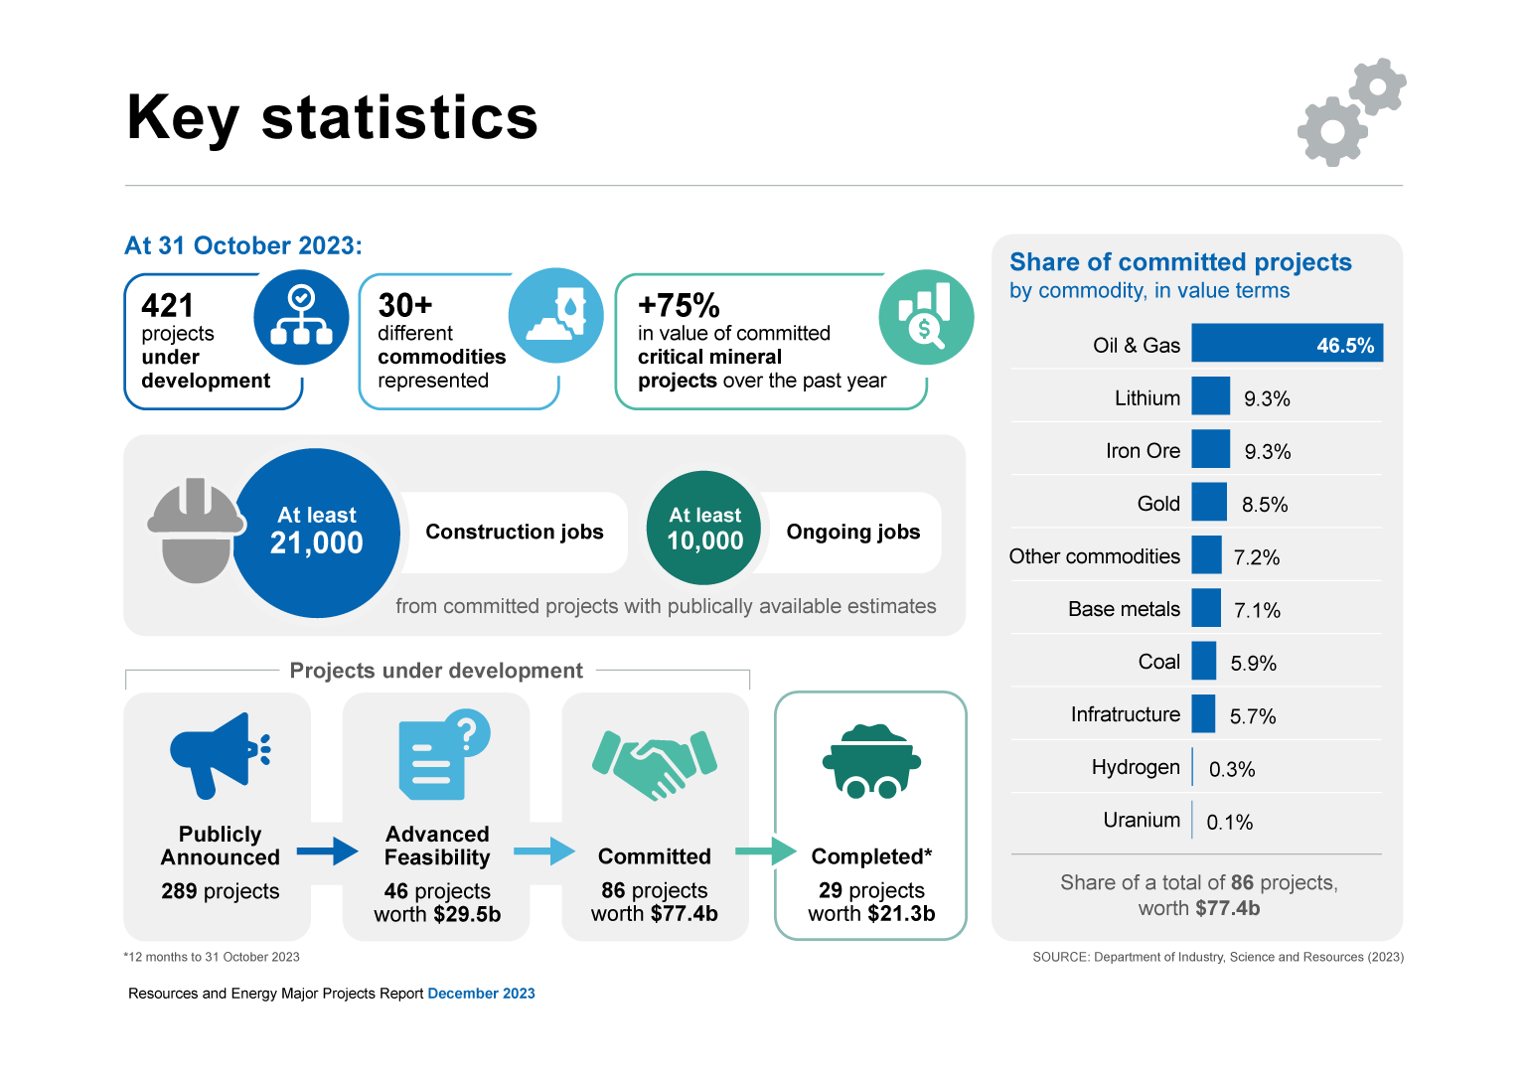

# Summary

* The investment outlook for Australia’s resources and energy sector remains healthy, underpinned by a mix of new energy and traditional commodities.
* There were 421 major resource and energy projects in Australia under development as at 31 October 2023, up from 393 projects a year earlier. This includes 86 committed projects — where a final investment decision (FID) has been taken — and 46 projects at the advanced feasibility stage.
* The value of committed projects fell slightly to $77 billion as some projects progressed to completion. Oil and gas projects continue to make up the largest share of committed projects.
* The value of project completions rose for the third consecutive year, with 29 projects valued at $21 billion achieving commercial production over the year to October 2023.
* There has been a strong advancement of critical minerals projects over the past year, including new commitments for 11 projects (valued at $5 billion), 8 projects (valued at $4.1 billion) completed, and 6 projects (valued at $1.8 billion) publishing advanced feasibility studies.
* Infrastructure projects continue to facilitate Australia's resource and energy industries totalling $4.4 billion of committed projects in 2023. These projects cover new and expanded gas pipelines, electrification of resource processing, productivity enhancing port and rail upgrades, and projects that facilitate the energy transition.
* Public proponents of committed projects estimate, in aggregate, the creation of least 21,000 construction and 10,000 ongoing jobs (about 50% of committed projects have estimates published by project proponents).
* Changes have been made to the methodology this year to reflect the recent change in composition of projects, in particular an increase in the number of projects in emerging new energy and resource commodities where data is limited (see Box 1.1).

# Overview

### Value of committed projects stabilises as completions rise

This report highlights developments among resource and energy projects over the past year and changes in the scope of future investment. Our review suggests that mining investment is stabilising following several years of growing commitments. The value of ‘committed’ resources and energy projects fell 9.3% over the past year to $77 billion, down from $83 billion in 2022 (Figure 1.1), while the number of committed projects rose from 83 to 86 (Figure 1.2).

The fall reflects an increase in the value of project completions over the past year which has led to a faster outflow of projects from the committed stage. This includes a number of high-profile lithium refining projects moving to commercial production over the past year along with several large iron ore and oil and gas projects.

Figure 1.1: Value of committed and completed projects

Source: Department of Industry, Science and Resources (2023)

### Critical minerals and hydrogen: momentum continues to build

New project commitments remain healthy, underpinned by a mix of new energy and traditional commodities. Critical minerals projects comprise a substantial proportion of new commitments across all projects, with $5 billion committed to investment in critical minerals projects over the past year (Figure 1.3). Lithium projects continue to be strongly represented amongst the projects committed this year. A number of critical minerals projects have also progressed to the advanced feasibility stage, including some rare earths projects, suggesting that critical minerals production is set to rise.

Over the past year, many new critical mineral and hydrogen projects have entered the early ‘publicly announced’ stage. In the critical minerals space, the growth in early-stage projects includes announcements for facilities to produce active materials for batteries, and projects to produce titanium and process mineral sands.

This year, 34 new hydrogen projects have been added to the project list, raising the number of hydrogen projects to 76. However, most of these projects remain in the early stages of development, and only 2 projects — with a combined capital expenditure of $0.1 billion — were committed this year. Globally, the hydrogen industry remains immature, and to date a low proportion of announced hydrogen projects have had final investment decisions.

### Traditional commodities are also contributing at all stages

Much of the value of new commitments and completions this year comes from large iron ore projects located in the Pilbara region of Western Australia (WA), including Fortescue’s $5.9 billion Iron Bridge magnetite mine, which reached commercial production in the June quarter. Oil and gas projects are also progressing, with additional wells successfully added at Gorgon Stage 2, providing backfill for the facility.

Iron ore investment remains relatively solid, and more than half of early-stage iron ore projects are magnetite mines, which produce fewer emissions than traditional hematite iron ore mines.

Figure 1.2: Number of projects by stage, 2016-2023

Notes: The 2023 edition replaced the ‘feasibility’ stage with the ‘advanced feasibility’ stage. Projects in the ‘feasibility’ stage are reclassified to either ‘publicly announced’ or ‘advanced feasibility’ stages. Hydrogen was added as a new commodity in the 2021 edition.

Source: Department of Industry, Science and Resources (2023)

Figure 1.3: Value of new commitments by commodity

Source: Department of Industry, Science and Resources (2023)

|  |
| --- |
| Box 1.1: Changes in methodology from the 2022 report  To improve the quality of the data in this report, several changes have been made to how projects are classified into the different stages and how we report capital expenditure for early-stage projects.  These changes largely reflect the recent change in composition of projects in recent years, in particular the growth of emerging new energy and resource commodities including hydrogen, rare earths, high purity alumina, vanadium, battery active materials and electrolytes and graphite. The nascent character of these commodities means available benchmark data on project costs and other variables is limited or of variable quality.  To improve data quality and accommodate gaps in available public information, and hence provide a more solid basis for analysis, the following changes have been made:   * Capital expenditure figures related to projects in the publicly announced stage are no longer aggregated within the main report (Figure 1.4). * When information on capital expenditure or employment is not publicly available, DISR estimates and cost bands are no longer used. This affects the accompanying spreadsheet, with an N/A inserted where public data is not available. * The ‘feasibility’ category has been replaced with an ‘advanced feasibility’ category containing projects that have released a definitive, detailed or bankable feasibility study. Projects that have released such studies will have been subject to a more rigorous costing process. * Aggregated likelihood profiles for projects in the list are no longer provided in this report.   The *2022 Resources and Energy Major Projects* report had an estimated total value of projects under development of $572-705 billion. This figure included DISR estimates for projects with no published capital costs as well as projects that achieved commercial production during 2022.  Excluding DISR estimates and cost bands in the 2022 report and projects that achieved commercial production in that year yields a total capital value of $522 billion across all projects in 2022 and 63 projects without a cost estimate. On a like-for-like basis, this compares to a total capital value of $547 billion across all projects in this year’s report, which includes 95 projects without a cost estimate.  Figure 1.4: Changes to project classification  This graph compares the way the different stages of project development are categorised in 2022 with the new categorisation in the 2023 report |

The addition of new critical minerals projects, and the completion of several older traditional commodity projects has meant that Australia’s three largest export commodities — iron ore, coal and gas — now make up a smaller percentage of total projects at the committed stage. The three accounted for 62% of committed value in 2023, down from 82% in 2022.

Progression of coal projects recorded this year is largely for metallurgical coal. A number of early-stage coal projects have been removed from the list, either due to formal cancellation, applications lapsing or being withdrawn, or other considerations.

Some infrastructure projects have progressed to the next stage, including several LNG import terminals. The Port Kembla LNG import terminal in New South Wales is close to completion, and the Outer Harbor LNG import terminal in South Australia is moving closer to a potential FID.

Gold has consistently attracted the highest level of exploration expenditure amongst commodities over the past 8 years, and many projects are now proceeding through the stages. Five gold projects were completed in 2023, while 3 projects became committed.

Geographically, most of Australia’s resources and energy major projects are located in Western Australia, which now holds more than 70% of project value at the committed stage (Figure 1.3, Figure 1.6).

Figure 1.5: Projects by State/Territory

Source: Department of Industry, Science and Resources (2023)

Table 1.1: Summary of projects as at 31 October 2023

|  | Publicly Announced | Advanced Feasibility | | Committed | |
| --- | --- | --- | --- | --- | --- |
|  | No. of projects | No. of projects | Value A$b | No. of projects | Value A$b |
| Aluminium, Alumina, Bauxite | 2 | 1 | 0.3 | 4 | 0.8 |
| Coal | 42 | 1 | 1.0 | 10 | 4.6 |
| Copper | 12 | 6 | 3.6 | 2 | 2.3 |
| Gold | 11 | 4 | 3.0 | 12 | 6.6 |
| Hydrogen | 72 | 1 | 0.2 | 3 | 0.2 |
| Infrastructure a | 30 | 1 | 5.6 | 15 | 4.4 |
| Iron ore | 26 | 3 | 1.6 | 4 | 7.2 |
| Lead, Zinc, Silver | 5 | 2 | 0.5 |  |  |
| Lithium | 4 |  |  | 9 | 7.2 |
| Nickel, Cobalt | 10 | 3 | 3.7 | 2 | 2.4 |
| Oil & Gas | 27 |  |  | 12 | 36.0 |
| Other Commodities b | 43 | 23 | 9.6 | 12 | 5.6 |
| Uranium | 5 | 1 | 0.4 | 1 | 0.1 |
| **Total** c | **289** | **46** | **29.5** | **86** | **77.4** |

Notes: **a** Infrastructure is limited to resource, energy infrastructure projects including CCS. **b** Other Commodities is limited to resources and energy commodities not elsewhere identified. **c** Totals may not add due to rounding at commodity level.  
Source: Department of Industry, Science and Resources (2023)

Table 1.2: New advanced feasibility studies, commitments to projects and projects completed, between 1 Nov 2022 and 31 Oct 2023

|  | New advanced feasibility studies | | New commitments | | Completed | |
| --- | --- | --- | --- | --- | --- | --- |
|  | No. of projects | Value A$b | No. of projects | Value A$b | No. of projects | Value A$b |
| Aluminium, Alumina, Bauxite | 2 | 0.6 | 4 | 0.8 | 1 | 0.1 |
| Coal | 1 | 1.0 | 3 | 1.3 | 3 | 0.9 |
| Copper | 2 | 0.4 |  |  |  |  |
| Gold | 4 | 3.2 | 3 | 1.8 | 5 | 1.2 |
| Hydrogen |  |  | 2 | 0.1 |  |  |
| Infrastructure a |  |  | 1 | 0.2 | 2 | 0.6 |
| Iron ore | 1 | 0.2 | 2 | 4.1 | 2 | 7.3 |
| Lead, Zinc, Silver | 1 | 0.2 |  |  | 2 | 0.7 |
| Lithium |  |  | 3 | 2.5 | 4 | 3.2 |
| Oil & gas |  |  | 1 | 0.5 | 5 | 6.4 |
| Nickel, Cobalt |  |  |  |  | 1 | 0.1 |
| Other Commodities b | 6 | 1.5 | 6 | 1.9 | 4 | 0.9 |
| Uranium |  |  |  |  |  |  |
| **Total** c | **17** | **6.9** | **25** | **13.2** | **29** | **21.3** |

Notes: **a** Infrastructure is limited to resource, energy infrastructure projects including CCS. Several gas pipelines span across more than one state but have been allocated to one state for reporting purposes. **b** Other Commodities is limited to resources and energy commodities not elsewhere identified. **c** Totals may not add due to rounding at commodity level.

Source: Department of Industry, Science and Resources (2023)

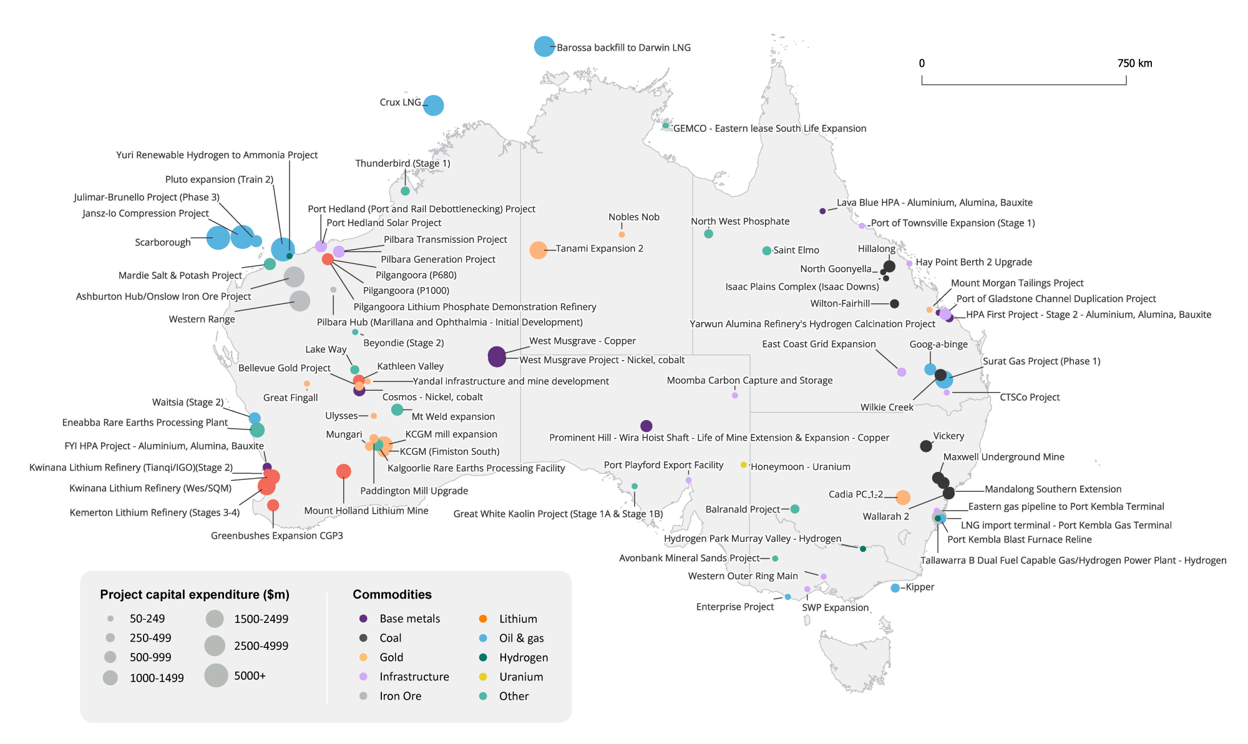

Figure 1.6: Location of projects at the committed stage, as at 31 October 2023

Source: Department of Industry, Science and Resources (2023)

|  |
| --- |

# Critical minerals

### Australian critical minerals sector expanding and diversifying

Australia’s critical minerals major project list now includes 100 projects, with an estimated $24 billion in proposed investment for projects at later stages of development as at 31 October 2023 (Table 2.2). This includes $11.8 billion in committed investments, a 75% increase from last year’s report.

This year’s report sees rare earths emerge as Australia’s largest category of critical minerals at later stages of development (by value), with $7.3 billion in proposed investment. This is closely followed by lithium, with $7.2 billion in proposed investment. Other major categories of later stage projects include nickel-cobalt ($3.6 billion), vanadium ($1.6 billion), and titanium & mineral sands ($1.4 billion). This year’s report also reflects the sector’s ongoing efforts to build downstream processing capabilities, with $11.8 billion in proposed investments for later-stage projects.

More than half of all critical minerals projects (52 projects) are located in Western Australia. Remaining projects were distributed across most Australian States and Territories, including Queensland (12), Northern Territory (10), New South Wales and South Australia (9 each), Victoria (6) and Tasmania (2).

By status, around half of all projects were in the early stages of development (publicly announced). For later-stage projects, around 20% of projects had delivered an advanced feasibility study and a further 20% had been committed. Finally, 8 projects were completed in the last 12 months.

This year’s results highlight the ongoing and rapid development of the critical minerals sector in Australia. Around half of all projects (51) on this year’s list either progressed in their development stage in the last 12 months or are new additions to the report. New projects are concentrated in titanium and minerals sands (5 projects), active materials (4 projects), as well as nickel-cobalt, magnesium, and high purity alumina (HPA) (3 projects each) as well as several other minerals.

**Figure 2.1: Critical minerals project count by stage**

Source: Department of Industry, Science and Resources (2023)

**Figure 2.2: Critical minerals project count by state or territory**

Source: Department of Industry, Science and Resources (2023)

**Figure 2.3: Investment in later stage critical mineral projects ($bn)**

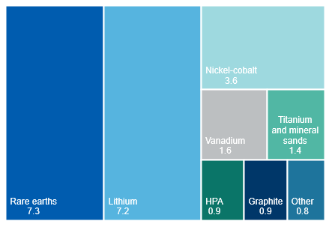

Notes: Later stage projects includes those that have delivered a Definitive Feasibility Study (or equivalent), and/or have reached a Final Investment Decision (i.e Committed stage)

Source: Department of Industry, Science and Resources (2023)

### Rare earths the new leader for investment in later-stage projects

This year’s report reflects rare earths’ emergence as Australia’s largest critical mineral major project category, with 15 projects recorded (from publicly announced through to committed) and proposed investment for later stage projects of $7.3 billion.

In the last 12 months, there has been continued growth in greenfield rare earth mining projects, with the addition of Australian Rare Earths Limited’s Koppamurra project in South Australia. Existing projects have also advanced: such as the delivery of a definitive feasibility study for the Donald Project in Victoria, and early work underway on Lynas Rare Earths’ $500 million expansion of its Mount Weld operation — with first production expected from 2024.

A key trend for rare earths major projects is the continued expansion into downstream processing, with three refining-focused projects on this year’s list. As of late 2023, Lynas Rare Earths’ new $780 million Kalgoorlie processing plant has final commissioning underway, with an estimated start for commercial production of 2024. Iluka Resources’ $1.25 billion Eneabba rare earths refinery expects early site works to be completed in coming months, with first production from 2025. This year’s report also includes a new project: Hastings Technology Metals’ Onslow plant, expected to produce mixed rare earth carbonate from 2028.

### Significant ongoing investment in both lithium mining and refining

Australia’s lithium sector has continued to grow in the last 12 months, with total committed investments increasing by $2.5 billion (from 3 projects). The largest of these projects is the Stage 3-4 expansion of the Kemerton lithium hydroxide refinery. With an announced investment of $1.9 billion, this expansion is expected to boost lithium hydroxide production at this facility by 50,000 tonnes per year. The $560 million Pilgangoora P1000 project also reached committed stage, and is expected to lift spodumene production capacity at the existing facility by 320,000 tonnes annually. Finally, the $105 million Pilgangoora lithium phosphate demonstration refinery reached committed stage in 2023. This plant is expected to produce 3,000 tonnes of lithium phosphate salt per year. In doing so, it will demonstrate a patented, emerging low emissions refining technology.

The full lithium project list consists of 17 projects with total proposed investment at later development stages of around $7.2 billion. Of the full cohort of projects, 9 are in the committed stage and are expected to reach completion in coming years to 2025. A further 4 projects reached completion this year, including Stages 1-2 of the Kemerton hydroxide refinery ($2.3 billion), Stage 1 of the Kwinana (Tianqi/IGO) hydroxide refinery ($770 million), Stage 2 of the Mt Marion mine ($120 million), and Stage 1 of the Finniss lithium project ($84 million).

The current array of Australian lithium projects is expected to support continued growth in mine production, alongside the development of domestic refining capacity. By 2030, Australia’s mined production is projected to be close to double the level in 2022 (based on market estimates, including projects not committed). For refining, Australia currently has three refineries completed or under construction, with a combined capacity of 198,000 tonnes, implying Australia could refine around 20% of domestically mined spodumene by 2030.

### New investment in other downstream battery materials processing

This year’s report highlights another key trend in the critical minerals sector: a number of significant projects are targeting the production of refined and active materials (the next stage of processing) for different battery technologies. Excluding lithium, this year’s report includes 15 projects, with total proposed investment for later stage projects of around $12 billion.

For active materials, the last 12 months has seen four new projects announced. These projects are aiming to produce precursor active materials for cathodes and anodes used in electric vehicle battery manufacturing. This includes Avenira Limited’s proposed manufacturing plant based in Darwin, expected to produce Lithium Iron Phosphate (LFP) cathode active material from 2026; and IGO Ltd and Wyloo Metals’ Kwinana Integrated Battery Material Facility, expected to produce a nickel, manganese, cobalt precursor cathode active material (PCAM).

Behind lithium, nickel-cobalt continues to be the largest category of later stage projects with refining capability. This includes the $1.75 billion Townsville Energy Chemical Hub Stage 2 expansion, for which a scoping study was completed in late 2022. The other new project this year is Nico Resource Limited’s Wingellina, expected to produce 3,000 tonnes per year of cobalt concentrate from 2027.

This year’s report includes three projects targeting downstream processing for vanadium. This includes the Australian Vanadium Project and the Murchison Technology Metals Project — both based in Western Australia — and aiming to produce vanadium electrolyte (a product with applications including in vanadium redox flow batteries).

### High Purity Alumina sector continuing to see new projects

High Purity Alumina or ‘HPA’ was added to Australia’s critical minerals list in 2022. HPA has broad-ranging economic and strategic uses in the automotive and aerospace sectors, particular high-performance electronics and optics. As the world’s second-largest producer of smelting grade alumina, Australia remains well placed to build capacity in HPA in the coming years.

The full HPA project list consists of 6 projects. This year’s report sees a further three HPA projects added to the list. In April 2023, Alpha HPA announced it would go ahead with a $300 million Stage 2 of its HPA First Project. This comes after Stage 1 of the project reached commercial production in late 2022. Queensland Pacific Metals’ $82 million Lava Blue HPA Project is a further addition to this year’s report, and is expected to start commercial production in 2024. The third new HPA project included in this year’s report is Lake Hope’s $65 million HPA Project in Western Australia.

### Projects completed this year concentrated in lithium and mineral sands

A total of 8 projects were completed in the year to 31 October 2023, with a total capital investment of close to $4.1 billion. Completed projects were concentrated in the lithium sector, and also included titanium and minerals sands, tungsten and HPA.

For lithium, a total of 4 projects were completed in the last 12 months. This includes Albemarle’s $2.25 billion Kemerton lithium hydroxide facility and Tianqui and IGO’s $770 million Kwinana refinery. Collectively, these facilities are expected to add around 74,000 tonnes per year in new lithium hydroxide production capacity, the equivalent of around 16% of global production of this product in 2022. This year’s report also shows further expansion of lithium mining capacity in Australia, including completion of Finniss’s 175,000 tonne per year spodumene concentrate project, which reached commercial production in February this year, and a 300,000 tonne per year expansion of MRL and Jiangxi Ganfeng’s joint venture Mt Marion operation.

### Comparing critical minerals projects to last year’s report

The list of included critical minerals projects (which includes both mined materials and immediate downstream processed products) included in this year’s report is consistent with the Australian Government’s Critical Minerals list as at 31 October 2023. Further information on the current list of Australia’s Critical Minerals can be found on the Department of Industry, Science and Resources’ website.

This year’s report has also excluded a small number of nickel-only projects that were included last year. These nickel-specific projects were included due to the extremely common co-location of both minerals, and expectation of the production of some cobalt by these projects. However, further analysis undertaken this year has found these projects will no longer be targeting the commercial production of cobalt.

To provide a comparison to the previous year, the methodology and critical minerals list used in this year’s report have been applied to last year’s eligible projects. For proposed investment, the table below includes projects that have either: (i) delivered a definitive, detailed or bankable feasibility study (ii) reached FID, or (iii) reached completion in the past 12 months.

Table 2.1: Comparing major critical minerals projects to last year

|  |  |  |
| --- | --- | --- |
|  | **2022 report** | **2023 report** |
| **Estimated value ($b)** | 26 | 28 |
| **Total number of projects** | 77 | 100 |

Table 2.2: Summary of critical mineral projects as at 31 October 2023

|  | Publicly Announced | Advanced Feasibility | | Committed | |
| --- | --- | --- | --- | --- | --- |
|  | No. of projects | No. of projects | Value A$b | No. of projects | Value A$b |
| Active materials & electrolytes | 5 | 1 | 0.4 |  |  |
| Nickel-cobalt | 9 | 2 | 3.6 |  |  |
| Graphite | 2 | 4 | 0.9 |  |  |
| High Purity Alumina | 1 | 1 | 0.3 | 3 | 0.7 |
| Lithium | 4 |  |  | 9 | 7.2 |
| Manganese | 2 |  |  | 1 | 0.1 |
| Rare earths | 6 | 6 | 4.8 | 3 | 2.5 |
| Silica/Silicon | 1 | 1 | 0.2 |  |  |
| Titanium & mineral sands | 7 | 3 | 0.5 | 2 | 1.0 |
| Vanadium | 3 | 3 | 1.3 | 1 | 0.3 |
| *Other* | *8* |  |  |  |  |
| **Total** | **52** | **21** | **12.0** | **19** | **11.8** |

Notes: A number of projects included in the total are mixed operations, such as nickel-cobalt mines, where a substantial proportion of the investment is expected to be directed to nickel extraction and refining. Other category includes manganese, magnesium and platinum group metals. Vanadium includes vanadium oxide projects, with outputs including ilmenite, titanium oxide, ferro-vanadium and iron oxides. Tungsten includes tungsten trioxide, molybdenum, tin and other metals. Heavy mineral sands include zircon, ilmenite, niobium, leucoxene, hafnium, leucoxene, rutile and other heavy mineral concentrates.

Source: Department of Industry, Science and Resources (2023)

Table 2.3: New advanced feasibility studies, commitments to projects and projects completed, between 1 November 2022 and 31 Oct 2023, for critical minerals

|  | New advanced feasibility studies | | New commitments | | Completed | |
| --- | --- | --- | --- | --- | --- | --- |
|  | No. of projects | Value A$b | No. of projects | Value A$b | No. of projects | Value A$b |
| High Purity Alumina | 2 | 0.6 | 3 | 0.7 | 1 | 0.1 |
| Lithium |  |  | 3 | 2.5 | 4 | 3.2 |
| Rare earths | 1 | 0.4 | 1 | 0.5 |  |  |
| Titanium & mineral sands | 1 | 0.3 | 2 | 1.0 | 2 | 0.6 |
| Vanadium |  |  | 1 | 0.3 |  |  |
| *Other* | 2 | 0.6 | 1 | 0.1 | *1* | *0.3* |
| **Total** | **6** | **1.8** | **11** | **5.0** | **8** | **4.1** |

Notes: A number of projects included in the total are mixed operations, such as nickel-cobalt mines, where a substantial proportion of the investment is expected to be directed to nickel extraction and refining. Other category includes manganese, magnesium and platinum group metals. Vanadium includes vanadium oxide projects, with outputs including ilmenite, titanium oxide, ferro-vanadium and iron oxides. Tungsten includes tungsten trioxide, molybdenum, tin and other metals. Heavy mineral sands include zircon, ilmenite, niobium, hafnium, leucoxene, rutile and other heavy mineral concentrates.

Source: Department of Industry, Science and Resources (2023)

# Hydrogen

### The hydrogen project list continues to grow

The number of hydrogen major projects continues to grow, with 34 new projects being added over the past year for a total of 76 hydrogen projects for 2023. This compares with 48 hydrogen projects in the 2022 hydrogen list (accounting for additions and removals).

The hydrogen list does not include regional hubs, which are recorded as infrastructure projects for this report. Hubs do not include any production or consumption capacity as they facilitate hydrogen projects. Hydrogen hubs represent a significant portion of investment and will serve as an important springboard for further development.

### More hydrogen projects have reached the committed stage

Three out of 76 hydrogen projects reached the committed phase in 2023, compared to one project in 2022. The estimated capital expenditure for these 3 projects is $234 million. The ratio of ‘committed’ projects to the rest of the project list is similar to that of the rest of the world. In September 2023, the International Energy Agency reported that 4% of all announced hydrogen projects globally had reached FID stage.

One of the three committed Australian projects, ‘Hydrogen Park Murray Valley’, will produce hydrogen to blend into the existing gas system. The aim of the project is to decrease gas consumption in Albury-Wodonga and surrounding areas, with hydrogen expected to displace up to 10% of the natural gas in the power system. The project is scheduled for completion in 2025.

The other newly committed hydrogen project is the ‘Tallawarra B Dual Fuel Capable Gas/Hydrogen Power Plant’. This power plant would have the capability to burn both gas and hydrogen. Energy Australia has agreed to buy 200 tonnes of hydrogen per year as part of the project’s funding agreement.

### **Figure 3.1 Hydrogen project count by stage**

Source: Department of Industry, Science and Resources (2023)

### Australian hydrogen powered by electrolysers

Green hydrogen is hydrogen derived from water and renewable energy via electrolysis. Green hydrogen contrasts with grey hydrogen which is derived from natural gas via steam methane reforming, and black hydrogen, which is derived from coal gasification. Most hydrogen projects in Australia (92.1% by count) will use either the existing power grid or their own renewable generation capacity to generate output (Figure 3.1). A further 4.7% of projects will use coal gasification to produce hydrogen and its derivatives, and 3.1% of projects will use natural gas via steam methane reforming. All projects listed on the 2023 list that use gas or coal to produce hydrogen — or its derivatives — have indicated they will incorporate some form of carbon capture into their process.

### Natural hydrogen is yet to become mainstream

Natural (white) hydrogen is hydrogen formed in underground deposits through natural processes. Australia’s natural hydrogen potential has been receiving increasing attention. Early exploration is occurring and, as of November 2023, a demonstration project is underway. Despite this, there are no hydrogen extraction projects large enough in scale to be identified as ‘major’ projects by this report’s criteria. Further exploration and technical developments could change this in the future.

### Hydrogen as a path to decarbonisation of industry

Hydrogen is seen as a commodity that could aid the decarbonisation of industry. This year, there are 3 new hydrogen projects that aim to reduce emissions from industrial processes. The 3 projects are the ‘Yarwun Hydrogen Calcination Pilot Demonstration Program’ ‘Green Cement Decarbonisation Project’, and ‘Zero Emissions Steel Technology Study’.

The ‘Zero Emissions Steel Technology Study’ is included in the iron ore projects list. The project is trialling technology that uses hydrogen as a reducing agent rather than coal. The ‘Yarwun Hydrogen Calcination Pilot Demonstration Program’, which is included in the aluminium project list, plans to use hydrogen calcination in the production of alumina. The ‘Green Cement Decarbonisation Project’ includes hydrogen production capacity to reduce the plant’s reliance on LPG for heating and drying processes.

### Western Australia and Queensland to host a significant number of projects

### Western Australia continues to host the highest number of hydrogen projects, with 17 of 64 (excluding expansion stages) projects being based in the state, second is Queensland with 13 projects. These states are characterised by the high availability of land and high solar energy potential, making them prime candidates for renewables-based (green) hydrogen.

To maintain consistency across information sources in this rapidly changing space, the Department of Industry, Science and Resources (DISR) coordinates closely with HyResource (a joint initiative between Australian industry and government organisations), which lists currently active projects.

### **Figure 3.2 Hydrogen source by project**

Source: Department of Industry, Science and Resources (2023)

### **Figure 3.3 Number of major hydrogen projects by State/Territory**

Source: Department of Industry, Science and Resources (2023)

# Committed and completed projects

More critical minerals projects are reaching the committed stage

Over the year to October 2023, 29 projects with a total value of $21 billion were completed, broadly comparable with the 30 projects valued at $14 billion in the previous report (Figure 4.1). Most projects currently committed are expected to reach completion by the end of 2026.

The projects completed this year largely comprise iron ore and oil and gas projects in Western Australia. The value of projects at the committed stage moderated over the year to October 2023, easing from $83 to $77 billion (Figure 4.2). Critical mineral projects are an increasingly large part of the committed list, with projects valued at $5 billion in new commitments this year, bringing the value of all committed critical minerals projects to $12 billion (See *Critical Minerals* section). Lithium surpassed iron ore to become the secondlargest commodity in committed capital expenditure (Figure 4.3).

For committed projects, estimates for the number of construction jobs is available for 51% of projects, while estimates for the number of ongoing jobs is available for 44% of projects. Proponents expect at least 21,000 construction and 10,000 ongoing jobs from these projects.

### Projects are progressing for a range of commodities

Consistent with previous editions of the REMP, **oil and gas** projects comprise the largest single group of committed projects by value. There are 12 oil and gas projects that are in the committed stage, with a value of $36 billion. This compares with $46 billion for the 2022 REMP, with the fall attributed to 5 projects progressing to the completed stage — including the $5.7 billion Gorgon Stage 2 development. New commitments in 2023 includes a single project, the third phase of the Julimar-Brunello Project in Western Australia.

Figure 4.1: Expected completion year of projects, from advanced feasibility

Notes: Expected completion year of projects are based on either company announcement or estimated by DISR if the proponent did not publish an expected completion year.

Source: Department of Industry, Science and Resources (2023)

Figure 4.2: Number and value of committed projects

Source: Department of Industry, Science and Resources (2023)

The characteristics of these oil and gas projects vary widely. Some projects involve the production of oil and gas, while others include the building of LNG trains which liquify natural gas for export. Finally, there are LNG import terminals in committed projects which will enable Australia to receive LNG for the first time.

Several large **iron ore** projects progressed to the committed stage or achieved completion over the past year (Figure 4.4). In June 2023, Rio Tinto announced it had awarded $1 billion in construction contracts for its $3 billion Western Range joint venture with Baowu Steel Group. In August 2023, BlueScope Steel approved a $1 billion blast furnace relining. Alinta Energy’s Port Hedland Solar Project also announced battery and solar installation contracts for its $180 million Port Hedland Solar Battery Hybrid project. The project will power BHP’s Port Hedland iron ore port facilities. First production of Fortescue’s 22 million tonnes per annum Iron Bridge Magnetite project was achieved during the June quarter 2023. The net impact of these changes saw the total estimated value of iron ore projects in the committed stage in this year’s report fall from $10 billion to $7 billion.

There are 12 **gold** projects at the committed stage, with a total value estimated at $6.6 billion. Notable projects at the committed stage include Northern Star Resources’ $1.5 billion KCGM mill expansion — which is expected to double output at the Super Pit by 2029 — and Newmont Mining Corporation’s $1.9 billion Tanami expansion phase 2.

There are currently 10 **coal** projects at the committed stage, with a total value estimated at $4.6 billion. Most of these (including various port and channel upgrades, and the Wilton-Fairhill, Vickery, and Mandalong mines) are expected to be completed within the next three years. One project (worth just under $1 billion) is at the advanced feasibility stage. The coal project list points to a reasonably solid investment profile in the short-term but with a tail-off from 2026.

Committed **infrastructure** projects totalled $4.4 billion in 2023, and include new and expanded gas pipelines, productivity enhancing port and rail upgrades, and projects that facilitate the energy transition.

Figure 4.3: Value of committed projects by commodity

Notes: Infrastructure is limited to resource, energy infrastructure projects including CCS. Other Commodities is limited to resource and energy commodities not elsewhere identified.

Source: Department of Industry, Science and Resources (2023)

Figure 4.4: Value of completions and new commitments

Notes: Infrastructure is limited to resource, energy infrastructure projects including CCS. Other Commodities is limited to resource and energy commodities not elsewhere identified.

Source: Department of Industry, Science and Resources (2023)

Table 4.1: Summary of projects at the committed stage, as at 31 October 2023

|  | NSW | | Vic | | Qld | | SA | | WA | | Tas | | NT | | Total | |
| --- | --- | --- | --- | --- | --- | --- | --- | --- | --- | --- | --- | --- | --- | --- | --- | --- |
|  | No. of projects | Value A$b | No. of projects | Value A$b | No. of projects | Value A$b | No. of projects | Value A$b | No. of projects | Value A$b | No. of projects | Value A$b | No. of projects | Value A$b | No. of projects | Value  A$b |
| Aluminium, Alumina, Bauxite |  |  |  |  | 3 | 0.5 |  |  | 1 | 0.3 |  |  |  |  | 4 | 0.8 |
| Coal | 5 | 2.8 |  |  | 5 | 1.7 |  |  |  |  |  |  |  |  | 10 | 4.6 |
| Copper |  |  |  |  |  |  | 1 | 0.6 | 1 | 1.7 |  |  |  |  | 2 | 2.3 |
| Gold | 1 | 1.4 |  |  | 1 | 0.1 |  |  | 8 | 3.1 |  |  | 2 | 2.0 | 12 | 6.6 |
| Hydrogen | 1 | 0.1 | 1 | 0.1 |  |  |  |  | 1 | 0.1 |  |  |  |  | 3 | 0.2 |
| Infrastructure a | 1 | 0.1 | 2 | 0.2 | 5 | 1.6 | 2 | 0.3 | 5 | 2.2 |  |  |  |  | 15 | 4.4 |
| Iron ore | 1 | 1.2 |  |  |  |  |  |  | 3 | 6.0 |  |  |  |  | 4 | 7.2 |
| Lead, Zinc, Silver |  |  |  |  |  |  |  |  |  |  |  |  |  |  |  |  |
| Lithium |  |  |  |  |  |  |  |  | 9 | 7.2 |  |  |  |  | 9 | 7.2 |
| Nickel, Cobalt |  |  |  |  |  |  |  |  | 2 | 2.4 |  |  |  |  | 2 | 2.4 |
| Oil & Gas | 1 | 0.3 | 2 | 0.5 | 2 | 2.5 |  |  | 6 | 28.5 |  |  | 1 | 4.3 | 12 | 36.0 |
| Other Commodities **b** | 1 | 0.5 |  |  | 2 | 0.6 | 1 | 0.1 | 7 | 4.3 |  |  | 1 | 0.1 | 12 | 5.6 |
| Uranium |  |  |  |  |  |  | 1 | 0.1 |  |  |  |  |  |  | 1 | 0.1 |
| **Total** c | 11 | 6.3 | 5 | 0.7 | 18 | 7.0 | 5 | 1.2 | 43 | 55.9 |  |  | 4 | 6.3 | 86 | 77.4 |

Notes: **a** Infrastructure is limited to resource, energy infrastructure projects including CCS. Several gas pipelines span across more than one state but have been allocated to one state for reporting purposes. **b** Other Commodities is limited to resource and energy commodities not elsewhere identified. **c** Totals may not add due to rounding at commodity level.

Source: Department of Industry, Science and Resources (2023)

# Publicly announced and advanced feasibility projects

Critical minerals drive increase in early-stage projects

This year’s report has identified 335 publicly announced and advanced feasibility projects. Of these projects, a total of 46 have published an advanced feasibility study, with an estimated value of $30 billion. The publication of an advanced study is an indicator that the project may be close to reaching the committed stage, with 17 projects (with an estimated value of $6.9 billion) progressing to the advanced feasibility stage this year.

Among the commodities, hydrogen projects make up the largest category (Figure 5.1, see *Hydrogen* section). Critical mineral projects make up 46% of projects in the advanced feasibility stage, (see *Critical Mineral* section). Western Australia accounted for 43% of capital expenditure for projects in the advanced feasibility stage (Figure 5.2).

There are 29 **iron ore** projects which have yet to reach the committed stage, including 3 projects which have published an advanced feasibility study. New projects include the Rio Tinto’s capacity expansion to its newest iron ore mine, Gudai-Darri, which will see production increase by 7 million tonnes a year. Another new project is the Collie green steel recycling mill which will convert scrap steel into rebar for local, domestic and international consumption. Over 50% of the early-stage iron ore projects in this report are magnetite mines at various stages of development. Increased magnetite production will contribute to the global energy transition. Magnetite can be converted into high quality products for use in processes such as Direct Reduced Iron.

More than 15 early-stage **coal** projects were removed from the list in this report. The removals are mostly for thermal coal projects and reflect a combination of applications being withdrawn or allowed to lapse, land being sold by leaseholders, and formal cancellations.

Figure 5.1: Projects yet to reach the committed stage

Notes: Infrastructure is limited to resource, energy infrastructure projects including CCS. Other Commodities is limited to resource and energy commodities not elsewhere identified. Oil and gas projects are not separated between publicly announced and advanced feasibility stages.

Source: Department of Industry, Science and Resources (2023)

Figure 5.2: Value of projects at the advanced feasibility stage

Source: Department of Industry, Science and Resources (2023)

Many coal projects have not progressed beyond early stages for 10 years or more. This has been driven by deteriorating market conditions for coal, as firms faced reduced access to finance and insurance, issues with social licence, and the rapid drop-off in proposed coal plant constructions across Asia. Metallurgical coal projects have progressed further than thermal coal projects, with several (including Tahmoor South, Aquila, Stratford and Olive Downs) progressing to the completed stage. Among thermal coal mines, New Acland progressed to completed in 2023.

|  |
| --- |
| Box 5.1: Impacts of methodology changes on categorisation of oil and gas projects  Oil and gas projects are split into three stages — publicly announced, committed, and completed. This is different from the rest of the REMP methodology which includes a fourth ‘advanced feasibility’ stage that occurs between publicly announced and committed.  The advanced feasibility stage for non-oil/gas projects is based on projects having completed a ‘definitive feasibility study’ or ‘bankable feasibility study’. These studies are not typically conducted in the oil and gas sector, so this stage has been removed from the oil and gas projects list. All projects before the committed stage have a status of publicly announced.  While oil and gas projects carry a degree of uncertainty and project progression cannot be confirmed, some of these projects have the potential to move to the committed stage soon. Examples include:   * The Narrabri coal seam gas project in NSW * The Outer Harbor LNG import terminal in SA * West Erregulla (Phase 1) in WA |

### Oil and gas projects remain a big part of Australia’s investment landscape

There are 27 projects in the **oil and gas** space (excluding infrastructure projects) that have been publicly announced. This is broadly equivalent to the 29 projects in the 2022 REMP. Most of these projects are ongoing since the 2022 REMP, however there are four additions including:

* Tubridgi Stage 2 — includes drilling production wells and expanding capacity to produce native gas.
* Northern Territory LNG — includes the construction of a 6.6 million tonne per annum (MTPA) LNG facility which includes three 2.2 MTPA trains.
* Ichthys expansion (Train 3) — includes building a third LNG train by 2030.
* Atlas (Stage 3) — includes the construction, decommissioning and rehabilitation of coal seam gas wells.

There are 7 oil and gas related infrastructure projects in the publicly announced phase, with all of these being new pipelines or expansions to existing pipelines to facilitate the movement of gas. This compares to 11 projects in the 2022 REMP.

### Robust early-stage activity in smaller commodities

There are 18 **copper** projects which have yet to be committed to, including 6 which have published a definitive or bankable feasibility study. One notable project that progressed this year was Rex Minerals’ Hillside project in South Australia, which completed optimised feasibility and engineering studies in December 2022. The project is expected to produce 42,000 tonnes of copper and 30,000 ounces of gold annually, following capital investment of $854 million.

There were several new additions to the list of copper projects at the publicly announced or advanced feasibility stage this year. In June 2023, Evolution Mining released a pre-feasibility study and commenced feasibility work to extend the mine life of the Ernest Henry copper-gold mine. For a capital investment of $475 million, this extension would allow the Ernest Henry mine to operate for an additional 17 years to 2040. In March 2023, Coda Minerals released a scoping study for the Elizabeth Creek project, which comprises an initial phase ($277 million) to produce copper-cobalt concentrate and a subsequent phase ($320 million) to construct a hydrometallurgical plant to produce copper cathode and battery-grade cobalt sulphate.

There are 15 **gold** projects which have yet to reach the committed stage, including 4 which have published an advanced feasibility study. An addition to the publicly announced stage this year is the Capricorn Metals’ Mt Gibson Gold Project, which confirmed a maiden probable ore reserve of 1.45 million ounces and proposed annual gold production of 152,000 ounces in a pre-feasibility study released in April 2023. Castile Resources is working towards the release of a bankable feasibility study in 2024 for their $280 million Rover 1 project, following a pre-feasibility study release in December 2022. De Grey Mining released a definitive feasibility study for their $1.3 billion Hemi Gold Project in September 2023, with the study confirming the project could become one of Australia’s 5 largest gold mines in terms of production capacity. A definitive feasibility study is now expected for Newmont and Greatland Gold’s $529 million Havieron gold project in WA in H2 2024.

# Exploration

### Exploration expenditure remained stable in 2022–23

Australian exploration expenditure was largely stable over 2022-23, increasing by 0.1% compared to 2021–22 (Figure 6.1). A fall in petroleum exploration expenditure offset an increase in expenditure for other commodities. Petroleum exploration expenditure fell by 21% to $0.9 billion. Non-energy mineral exploration expenditure increased by 4.7% to $3.8 billion, while energy mineral exploration expenditure rose by 32% to $0.3 billion.

### Gold continues to draw the largest interest in mineral exploration

For the last eight years, gold has attracted the most mineral exploration expenditure, overtaking iron ore in 2015–16. In 2022–23, gold exploration expenditure fell by 17% to $1.3 billion, but still accounted for 27% of Australia exploration expenditure (Figure 6.2).

Growth in exploration expenditure for iron ore, base metals and other minerals remained robust, following strong growth in 2021–22. Iron ore exploration expenditure rose by 8.7% to $702 million in 2022–23 but remained below the peak of $1.2 billion attained in 2011–12. Base metals exploration expenditure increased by 11% to $1.1 billion in 2022–23. Exploration of other minerals, including lithium, mineral sands and uranium, rose by 66% to $739 million in 2022–23. Coal exploration expenditure rebounded from 2 years of decline, rising by 24% in 2022–23.

Figure 6.1: Mineral and petroleum exploration expenditure

Source: ABS (2023) Mineral and Petroleum Exploration, Australia, 8412.0

Figure 6.2: Annual mineral exploration expenditure by commodity

Notes: Base metals also include silver and cobalt.

Source: ABS (2023) Mineral and Petroleum Exploration, Australia, 8412.0

# Methodology

Each year, we collect information about the investment outlook for major resources and energy projects. Information is gathered from a range of sources, including company websites and media releases, government departments and agencies, industry associations, and Australian Stock Exchange reports.

Although there is substantial investment by mining and energy companies in replenishing equipment, plant and other property, the focus of this report is on ‘major’ investments — those that can be confidently valued at over $50 million based on publicly available sources. Smaller scale operations are also an important contributor to the sector and the broader Australian economy. But public information, particularly on early-stage projects, can be scarce or difficult to find, and includes projects undertaken by private companies who have fewer obligations to report project progress. This report therefore may omit some projects for which we could not identify key parameters. Each year we seek to improve the coverage and data quality of the report, including through incorporating relevant project information that may not have been identified in previous years.

Developers of resources and energy projects often use different planning processes and assessment methods to support their FID. Thus, there is no standard project development model with clearly defined stages and terminology that can be applied to every resource and energy project.

Projects are grouped into four categories which represent their stage of progression. Earlier stages of developing mining and energy projects, such as identifying deposits and exploration activities, are not included in the list. While these activities are important, it is beyond the scope of this report to assess exploration activities on a project-by-project basis. Instead, a summary and analysis of aggregate exploration expenditure is provided.

For changes in the methodology from the 2022 edition, see Box 1.1.

The four stages we classify projects into are:

1. Projects publicly announced and under consideration
2. Projects that have completed an advanced feasibility study
3. Committed projects — which have taken FID
4. Completed projects — which have commenced production

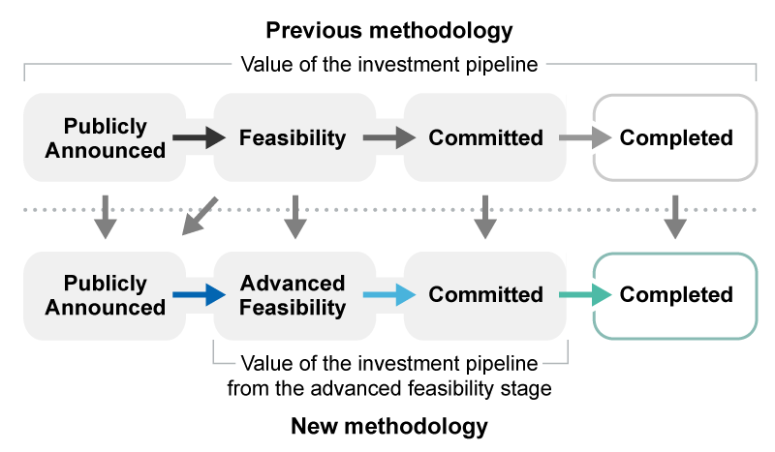

**(1) Publicly announced and under consideration**

Projects at the publicly announced stage are usually early in their development and are typically undergoing feasibility studies to assess the commercial aspects of developing an identified resource. For a project to be listed at this stage, there must be publicly available information on the preliminary project schedule, planned output or cost. As they are still in the early planning stage, projects at the publicly announced stage may not have finalised any engineering designs or construction cost estimates.

Projects at this stage may have provisional or outdated cost estimates and will not have received any formal commitment from companies to proceed. Such projects may have been announced 10 or more years ago with no subsequent progress nor any further studies or updates. The available public information on these projects is collected and presented for use as a reference guide, but data is not modified, aggregated or treated as a formal data source for the purposes of the report. Only the total number of projects at this stage is included.

**(2) Advanced feasibility study completed**

Projects at this stage have completed a definitive, detailed or bankable feasibility study and are considered to have a strong business case for further progression. Definitive feasibility studies will have occurred following detailed Front-End Engineering Design (FEED) studies and full development of the final project scope.

Projects that have progressed through the advanced feasibility stage are likely to proceed to the committed stage. Figures and data on these projects are considered sound enough to use as a leading indicator for future capital investment by the resources sector. However, capital cost estimates on these projects differ from capital costs for projects at the committed stage, since the latter represents fully committed capital investment.

**(3) Committed stage**

Projects at the committed stage have finished all commercial, engineering and environmental studies, received all necessary government regulatory approvals, and finalised the financing of the project to allow construction. Such projects are considered to have received a positive FID from the owner(s). In most cases, projects at this stage of development have already started construction, as there are typically pre-works undertaken as part of exploration and design activities.

Projects at the committed stage typically have cost estimates, schedules, and mine outputs that are well defined and often publicly released. Most projects that progress to the committed stage will eventually commence production. Nevertheless, post-FID, there are still technical and financial risks that, if realised, can result in delays, scope echanges and cost overruns, or even affect the commercial viability of a project and possibly lead to its cancellation.

Data on projects at the committed stage is considered of high quality, and is aggregated, compared, and monitored within the report. Newly committed projects (those which have commenced since the prior report) are included as a distinct category.

**(4) Completed stage**

As many projects include multiple stages and scope elements that can be independent of each other, the timing around when a project reaches the completed stage can be difficult to assess. Under our framework, we consider a project reaches the completed stage when all construction and commissioning activities are completed, and the operation has reached commercial production.   
  
**New projects, expansions and reactivations**

Our framework classifies projects as “new”, “expansion” or “reactivation”. New projects are those that were not active at the same location before the first announcement recorded in our research. Expansions correspond to those that are already existing and are taking their operations to neighbouring fields. In many cases, the goal of the “expansion” is merely to maintain output. There is no implication that output is increasing. Reactivation indicates mines that are returning from care and maintenance, or projects that were announced, then officially abandoned, but have since been returned to the drawing board.

# Further information and resources

Department of Industry, Science and Resources

### **Resources and Energy Quarterly**

The *Resources and Energy Quarterly* report contains the latest data, analysis and forecasts for the value, volume and price of Australia’s major resources and energy commodity exports.

<https://www.industry.gov.au/data-and-publications/resources-and-energy-quarterly-all>

### **Critical Minerals Strategy 2023-2030**

<https://www.industry.gov.au/sites/default/files/2023-06/critical-minerals-strategy-2023-2030.pdf>

Australian Trade and Investment Commission

### **Australian Critical Minerals Prospectus 2022**

The prospectus includes technical, commercial and geological data to help facilitate investment in Australian critical minerals projects and greenfield opportunities. The 2022 prospectus highlights 55 projects seeking investment or offtake agreements and present an opportunity for partners.

<https://www.globalaustralia.gov.au/sites/default/files/2022-12/ATIC_Australian_Critical_Minerals_2022_9DEC22.pdf>

Geoscience Australia

### **Australia’s Identified Mineral Resources**

Australia’s Identified Mineral Resources is an annual assessment of Australia’s mineral reserves and resources for all major, and some minor, commodities. It provides useful indicators of potential resource life and future supply capability, Australia’s global commodity rankings, and insights into the distribution of Australia's resources and industry developments.

<https://www.ga.gov.au/scientific-topics/minerals/mineral-resources-and-advice/aimr>

### **Geoscience Australia Portal**

This provides users with a single point to access Australia’s geoscience data, including a range of assessment tools such as Economic Fairways. <https://portal.ga.gov.au/>

### **Minerals and Mines Maps**

Each year, Geoscience Australia produces a number of maps on resources and industry activity across the country. They include the operating status of the different mines and deposits, along with major infrastructure. The most recent versions of these maps can be accessed via the following links:

Australian Operating Mines Map 2022: <https://d28rz98at9flks.cloudfront.net/147694/147694_00_1.pdf>

Australian Critical Minerals Map 2022: <https://d28rz98at9flks.cloudfront.net/147741/147741_00_1.pdf>

Australian Mineral Exploration Review 2022: <https://d28rz98at9flks.cloudfront.net/147970/147970_00_0.pdf>

### **Australia’s Energy and Mineral Resources Investor Guide 2020**

Australia’s Energy and Mineral Resources Investor Guide 2020 is a guide for investors interested in Australian resources opportunities.

<http://d28rz98at9flks.cloudfront.net/133857/133857_00_0.pdf>

### **Australia’s Energy Commodity Resources 2023**

<https://www.ga.gov.au/digital-publication/aecr2023>

About this report

The *Resources and Energy Major Projects* publication is an annual review of projects which seek to extend, increase, or improve the quality of mineral commodity output in Australia. These investment projects include greenfield projects, expansions, reactivations, processing facilities, and related infrastructure. Since 1997, the publication has reported the value of current and potential investment in the sector and provided commentary on key development trends.

From 2017 to 2019, *Resources and Energy Major Projects* was published as a chapter in the *Resources and Energy Quarterly*. The 2020, 2021 and 2022 editions, as well as pre-2017 updates, are standalone publications.

This edition of the report presents an update on project developments over the twelve months from the start of November 2022 to the end of October 2023, and is accompanied by a [detailed project listing](https://www.industry.gov.au/publications/resources-and-energy-major-projects-2022).

Each year, we seek to improve the coverage and quality of the report. Much of the analysis in this edition is directed at projects that have progressed significantly and which have a higher quality of data associated with them. More details on this change are included in Box 1.1.

Terminology

The methodology used in the report is detailed in the *Methodology* section.

This report and project list is the result of our research on major resources and energy projects under development in Australia. For the purposes of this report, ‘major’ projects are those costed at over $50 million and which have the potential to reach a final investment decision (FID) within the next five years.

Projects are classified into four stages: publicly announced, advanced feasibility, committed and completed. Earlier stages of developing mineral projects, such as identifying deposits and exploration activities, are not included in our lists.