Industry Innovation and Science Australia Annual Report 2022–23

Acknowledgement of Country
Industry Innovation and Science Australia recognises the First Nations people and their ongoing cultural and spiritual connections to the lands, waters, seas, skies and communities.
We acknowledge First Nations people as the Traditional Custodians and Lore Keepers of the oldest living culture and pay respects to their Elders past and present. We extend that respect to all First Nations people.

Letter of Transmittal
The Hon Ed Husic MP
Minister for Industry and Science
Parliament House
CANBERRA ACT 2600
Dear Minister,
I am pleased to present the 2022–23 Annual Report for Industry Innovation and Science Australia (IISA), for the reporting period ending 30 June 2023.
This report has been prepared in accordance with section 46 of the Industry Research and Development Act 1986, which requires that I prepare and provide an annual report to you for presentation to the Parliament.
This report covers the IISA Board’s operations during the 2022–23 financial year and the operations of its committees.
Yours sincerely,
Andrew Stevens
30/10/23

Contents

Acknowledgement of Country 2
Letter of Transmittal 3
Message from the Chair 8
About IISA 10
IISA functions 11
Financial responsibilities 11
Board meetings 11
IISA committees 12
IISA Committee Structure 13
Program performance 14
Research and Development Incentives Committee (RDIC) – Message from the Chair 15
Research and Development Tax Incentives program performance 16
R&DTI case study 17
Lithium Battery Storage PTY LTD (LBS) 17
Project objectives 17
Project description 17
Support received 18
Impact 18
Innovation Investment Committee (IIC) – Message from the Chair 19
Venture Capital programs’ performance 20
VC programs case study 21
SwarmFarm Robotics 21
Project objectives 21
Project description 21
Support received 22
Impact 22
Entrepreneurs’ Programme Committee (EPC) –Message from the Chair 23
Accelerating Commercialisation (AC) program performance 24
EP case study 1 25
Battery Graphene Corp Pty Ltd (trading as Vaulta) 25
Project objectives 25
Project description 25
Support received 26
Impact 26
EP case study 2 27
Real Thing Entertainment Pty Ltd 27
Project objectives 27
Project description 27
Support received 28
Impact 28
Business Research and Innovation Investment program performance 29
Business Research and Innovation Initiative (BRII) case study 30
Wildfire Energy Pty Ltd 30
Project objectives 30
Project description 30
Assistance received 31
Impact 31
Cooperative Research Centres Advisory Committee (CRCAC) – Message from the Chair 32
The Cooperative Research Centres (CRC) Program 33
The CRC Program has 2 streams: 33
Cooperative Research Centres (CRC) program performance 34
CRC Grants case study 35
Innovative Manufacturing CRC (IMCRC): futuremap® 35
The project: futuremap® 35
Support received 35
Testimonial 35
Success story 35
The future for futuremap® 37
CRC Projects case study 38
Project lead partner: Pure Battery Technologies (PBT) 38
Project objectives/description 38
Support received 38
Impact 39
Biomedical Translation Fund (BTF) 40
Biomedical Translation Fund program performance 41
BTF case study 42
OncoRes Medical 42
Project objectives 42
Project description 42
Support received 43
Impact 43
Advice to Government 44
Statement of Expectations 44
National Reconstruction Fund (NRF) 44
Statement of Expectations 44
Progress at 30 June 2023 44
Commercialisation and collaboration 45
Statement of Expectations 45
Progress at 30 June 2023 45
Driving innovation in business through intangible investment/innovation metrics 45
Statement of Expectations 45
Progress at 30 June 2023 46
Industry innovation for business decarbonisation 46
Statement of Expectations 46
Progress at 30 June 2023 46
Oversight of innovation programs 47
Statement of Expectations 47
Progress at 30 June 2023 47
From May 2023 and ongoing 47
Other advice to government 48
Advice on National Reconstruction Fund (NRF) design 48
Private hearing with Standing Committee on Industry, Science and Resources 48
Paper – Building Australia’s Sovereign Capabilities: When Industrial Advantage Meets Sovereign Need 48
Further advice on NRF 48
Engagement activities 49
Industry conferences and forums Universities Australia Conference 2022 49
Australia New Zealand Leadership Forum (ANZLF) 49
National Innovation Policy Forum (NIPF) 49
Government consultations 50
Startup Year Program 50
Minister Husic’s Science and Commercialisation Roundtable 50
Universities Accord Review 50
House of Representatives Standing Committee on Industry, Science and Resources 50
Workshop – Revitalising Australia’s National Science and Research Priorities and National Science Statement 50
Industry Growth Program workshop 51
Site visits 51
Goterra 51
QuintessenceLabs 51
Vow Foods 51
Phyllome 52
AMSL Aero 52
ARIA Research 52
Advanced Navigation 53
State Asphalts 53
About the Office of Industry Innovation and Science Australia (OIISA) 54
How OIISA supports the Board 54
Governance 55
Governance structure 55
Evaluations and reviews 55
Innovation Metrics Review 55
Research and Development Tax Incentive (R&DTI) survey and actions on previous feedback 55
Venture capital tax concessions review 56
Business Research and Innovation Initiative (BRII) impact evaluation 56
Legal matters and litigation 57
Research and Development Tax Incentive 57
Venture Capital Program 58
Board and committee membership 59
IISA Board 59
IISA Board member terms 61
IISA Research and Development Incentives Committee (RDIC) members and terms 62
Innovation Investment Committee (IIC) members and terms 63
Entrepreneurs’ Programme Committee (EPC) members and terms 64
Cooperative Research Centres Advisory Committee (CRAC) members and terms 65
Acronym and Abbreviations List 66

Message from the Chair

I am delighted to present this report outlining the work of the Industry Innovation and Science Australia (IISA) Board over the 2022–23 financial year.
This year has seen the Government increase support for innovation, with major new programs announced and continued investment for the most successful initiatives. Whether you are a fund manager wishing to establish a venture capital partnership; a company seeking to innovate and grow by offsetting some of the costs of eligible research and development (R&D); or a startup or small to medium-sized enterprise (SME) who requires support to develop innovative solutions for government policy, the suite of innovation programs overseen by IISA provides opportunity to drive innovation. The Program Performance section of this report gives an overview of the year’s achievements and showcases a sample of remarkable Australian innovations that IISA is proud to support.
I would like to thank the members of the IISA Board for the passion they bring to their roles. I would particularly like to thank Dr Scott Farrell, Dr Alexander Grant and Ms Sarah Nolet whose terms on the Board ended during the financial year. All three members brought a wide range of expertise and a commitment to our work on the board. Ms Sarah Nolet’s experience in the agriculture industry and entrepreneurship was invaluable and Dr Alexander Grant brought insights from experience across university research, early stage commercialisation and the space sector. Dr Scott Farrell was instrumental in his input to the Venture Capital Tax Concessions Review tabled in the House of Representatives in October 2022.
In December 2022, we welcomed the Statement of Expectations (SOE) from the Hon Ed Husic MP, Minister for Industry and Science (the minister). The SOE affirms the government’s commitment to ensure that Australia’s industry innovation contributes to national wellbeing and strengthens the economy, including through commercialisation of ideas.
Crucial to Australia’s future prosperity will be greater self-reliance on a range of priority areas, such as renewables and low emissions technologies, medical science and enabling capabilities. The government has established the National Reconstruction Fund (NRF) to diversify and transform Australia’s industry and economy to help secure Australia’s future and drive sustainable economic growth. Innovation and productivity are key to these objectives.

To realise Australia’s potential, manufacturers must recognise the importance of intangible investment into pre-production and post-production activities. Australia’s success will depend on how well we perform in these areas of intangible services, including design, logistics, sales and after-sales support. To be globally competitive, we do not want to be the cheapest, we want to be the best. Manufacturing is a horizontal capability that cuts across all sectors. This has underpinned IISA’s advice throughout the year, notably by way of input into the design of the NRF and the development of the Industry Growth Program.
This year, IISA – with its connections to businesses across the economy and guided by the SOE – has investigated the complexity of the challenges faced by businesses to collaborate and commercialise. These not only include practical challenges businesses face when engaging with research entities, but also – importantly – the barriers created by industry structure, market dynamics and business size and composition. In the second half of 2023, we will provide advice to government on practical options to address these barriers based on this analysis.
Also, in context of the SOE, IISA has commenced work to advise government on how Australian businesses, particularly SMEs, can best harness opportunities presented by national and global emission reduction efforts. I am confident that our advice will assist the Government’s overarching policy objectives of industrial and economic transformation, sustainable value creation and economic diversification.
Another area that presents challenges and opportunities for businesses is the transition to a digital economy. Greater collaboration between businesses will increase their ability to capitalise on the availability of data and emerging technologies. Through its advice to government and industry, IISA will continue to encourage adoption of these critical technologies.
I am proud of the work we have achieved in 2022–23. It sets a solid foundation to keep shaping policy for a more diversified and resilient economy, to meet the country’s sovereign needs and our collective responsibility to reduce our environmental footprint on our way to net zero.
I would also like to thank the Chairs of the Research and Development Tax Incentives Committee, the Innovation Investment Committee, the Entrepreneurs’ Programme Committee and the Cooperative Research Centres Advisory Committee, as well as committee members, for the hard work they put in to keep their respective programs running and fund so many fantastic Australian innovations – examples of which are showcased later in this report.
My sincere thanks also go to the Executive Director, Tanya Blight, and staff at the Office of Industry Innovation and Science Australia for their support.
Andrew Stevens
Chair
Industry Innovation and Science Australia

About IISA
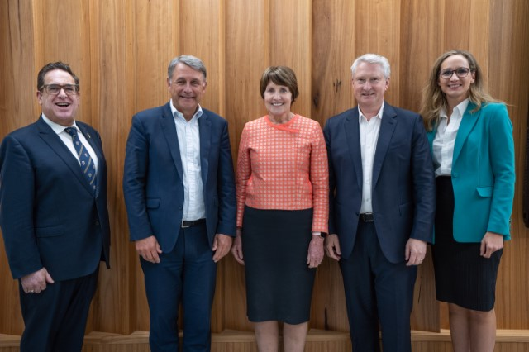
From left to right: Dr Doron Samuell, Andrew Stevens (Chair), Glenys Beauchamp AO PSM,
Patrick Houlihan, Lauren Stafford. Not pictured: Dr Cathy Foley AO (Deputy Chair) and Meghan Quinn PSM (ex-officio member). Image supplied by Department of Industry, Science and Resources.

The Industry Innovation and Science Australia (IISA) Board (the Board) is an independent board established under the Commonwealth Industry Research and Development Act 1986 (the IR&D Act) (section 6). Its functions, detailed at section 7 of the IR&D Act, fall under
3 streams:
- oversee innovation programs delivered by the Department of Industry, Science and Resources (DISR, or the department). This includes strategic governance, technical assessments, audits, plans, evaluations and sharing relevant information with policy and delivery partners
- provide independent strategic advice to government in relation to industry, innovation, science and research matters, and undertake or commission any necessary research for that purpose
- promote investment in industry, innovation, science and research (may include publication of research).
The innovation programs that come under the Board’s remit are named in the IR&D Act, or assigned to the Board under ministerial directions. The Board generally delegates program oversight, including technical assessments, to committees also established under the IR&D Act.
Activities under the 3 streams of work during the 2022–23 financial year are covered in the following sections of this report:
- program performance
- advice to government
- engagement activities.

IISA functions
IISA operates under the authority of the IR&D Act. The object of the IR&D Act is to position Australia as a leading innovation nation by:
- facilitating the provision of independent strategic advice about investment in industry, innovation, science and research
- supporting and encouraging collaboration in the development and delivery of programs relating to industry, innovation, science and research
- authorising spending on programs relating to industry, innovation, science and research
- promoting the development of, and improving the efficiency and international competitiveness of, Australian industry by encouraging R&D activities, innovation and science activities and venture capital activities.
The IR&D Act assigns IISA functions relating to the Research and Development Tax Incentive (R&DTI) and a suite of venture capital (VC) programs. In addition, ministerial directions give IISA responsibility for the Entrepreneurs’ Programme (EP), Cooperative Research Centres (CRC), Biomedical Translation Fund (BTF) and the Business Research and Innovation Initiative (BRII).
In 2022–23, the IISA Board reported to the Hon Ed Husic MP, Minister for Industry and Science,.

Financial responsibilities
IISA has no financial responsibility for program-related grants, or loan or licence agreements entered after 10 September 2004. This follows amendments to the IR&D Act, which came into effect on 11 September 2004, and removed powers of Innovation Australia (now IISA) to commit, approve or recommend expenditure of government funds and further safeguarded members from any personal liability stemming from Board membership.

Board meetings
The Board met face-to-face 3 times this financial year to report on progress and outcomes on its projects and engagements, and for the Board, committee chairs and departmental executives to discuss key issues relating to the work of IISA.
The Board held formal meetings on the following dates:
- 29 September 2022 (Canberra)
- 8 December 2022 (Sydney)
- 23 February 2023 (Sydney).
Each Board meeting was preceded by a day of site visits to innovative businesses that receive assistance from programs overseen by IISA. More information about the site visits can be found in the Engagement Activities section.
In addition, Board members held out-of-session in-person and virtual targeted discussions on key policy areas, including deep dives, workshops and roundtables. More details can be found in the Engagement Activities section.

IISA committees
IISA uses a committee structure to support administration and provide expert advice on innovation and venture capital programs. Functions are delegated to committees under section 21 of the IR&D Act. As of 30 June 2023, there were 4 active committees under IISA delegation:
Research and Development Incentives Committee (RDIC) – The IR&D Act assigns IISA specific functions in the administration of the R&DTI. Other aspects of the program are administered by the Australian Taxation Office (ATO). IISA delegates its functions relating to the R&DTI to the RDIC. The committee, in turn, delegates functions to departmental officials. The committee advises IISA about program operations and operational policy, and it provides certificates to the Commissioner for Taxation about the eligibility of activities registered under the program. The RDIC met 6 times in 2022–23. The committee also held several discussions out of session.
Innovation Investment Committee (IIC) – This committee administers venture capital programs and provides guidance to the department throughout the programs’ lifecycles. This includes decisions on registration and decisions relating to compliance and interpretation. Programs under IIC oversight are co-administered with the ATO, and currently include:
- Early Stage Venture Capital Limited Partnerships (ESVCLPs)
- Venture Capital Limited Partnerships (VCLPs)
- Australian Venture Capital Fund of Funds (AFOF).
The IIC met 10 times in 2022–23.
Entrepreneurs’ Programme Committee (EPC) – In 2022–23, this committee provided merit assessments and merit ranking recommendations on applications under the accelerating commercialisation (AC) component of the EP. The EP (including AC) closed on 9 May 2023. Applications received before this date were assessed following the grant guidelines. Funding agreements in place prior to closure will continue to be honoured.
When the Australian Government announced the closure of the EP, it also announced a new $392.4 million Industry Growth Program for small and medium-sized enterprises (SMEs) and startups. This new initiative will launch in late 2023, in recognition that the needs of SMEs have evolved since the EP started in 2014. The new program builds on the successful elements of the AC component of the EP.
The EPC also provides merit assessments for the BRII, which supports Australian businesses to develop innovative solutions that address persistent government challenges. In 2022–23, the EPC met 6 times to assess AC applications and 2 times to assess BRII applications.

Cooperative Research Centres Advisory Committee (CRCAC) – This committee has an ongoing role to provide advice and recommendations on applications for funding, the progress and performance of individual CRCs, and the operation of the CRC Program, including the CRC and CRC Projects streams. The CRCAC met 4 times in 2022–23.
Biomedical Translation Fund (BTF) (former committee) – The BTF provides companies with venture capital to develop biomedical discoveries into tangible products, services and outcomes. Full details are available online. In May 2016, IISA delegated oversight of the BTF to the Biomedical Translation Fund Committee. Committee members’ terms expired on
3 April 2022. As the substantive work of the committee had been concluded (with fund managers established), appointments were not renewed. On 29 September 2022, IISA made a resolution to revoke the committee’s delegations. IISA retains direct oversight of the program.

IISA Committee Structure
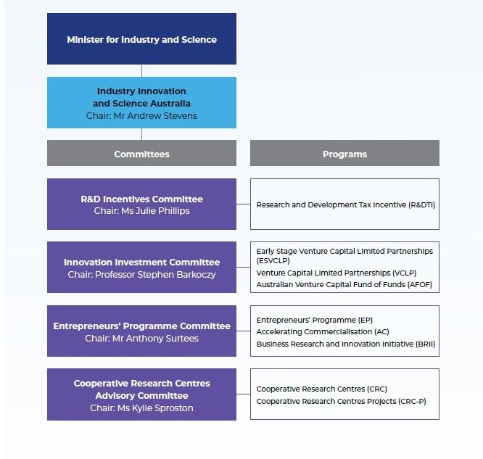

Program performance
IISA oversees a suite of innovation programs to confirm effectiveness and efficiency of delivery and to ensure the collective advancement of the government’s commitment to support businesses to develop and commercialise new ideas and contribute to Australia’s wellbeing. The success of the industry innovation programs that IISA supports is crucial to achieving the government’s commitment to strengthen existing industries by embracing and driving innovation. These industry innovation programs include:
- the Research and Development Tax Incentive
- Early Stage Venture Capital Limited Partnerships
- Venture Capital Limited Partnerships
- Australian Venture Capital Fund of Funds
- Accelerating Commercialisation
- Business Research and Innovation Initiative
- the Cooperative Research Centres (CRC) Program, including the CRC and
CRC Projects streams.
IISA has no financial responsibility for program-related grants, or loan or licence agreements undertaken in 2022–23. The DISR annual report outlines the financial performance for each program.

Research and Development Incentives Committee (RDIC) – Message from the Chair
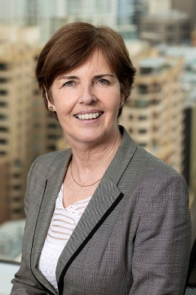
The R&DTI is one of the Government’s most important industry innovation policies. The benefits of research and development (R&D) spill over into the broader economy through ideas, skills and knowledge transfer, and play an important role in Australia’s technological progress and economic growth.
Through the R&DTI, the Government encourages companies to invest in R&D activities that are less likely to be undertaken without government support and most likely to deliver benefits to the broader Australian economy.
Since the inception of the R&DTI in 2011–12, the number of registered businesses and the subsequent value of tax benefits delivered has grown. More than 30,000 companies have registered for the program with benefits delivered to approximately 12,000 businesses each year. For R&D activities in the 2021–22 income year, 2,607 companies registering were new to the program.
In the 2021–22 financial year, registrations were highest from the professional, scientific, and technical services sector, accounting for 33.5% of all applications. This was closely followed by manufacturing at 26.9%.
The RDIC provides advice to IISA on the R&DTI’s operations. The RDIC was pleased to welcome new members in May 2023. These members bring a wealth of relevant knowledge and experience.
A deep dive meeting held in 2023 allowed the RDIC to explore opportunities to leverage the R&DTI to facilitate collaboration between small and medium-sized enterprises (SMEs) and research service providers (RSPs), in line with a key objective of the program to link SMEs with RSPs. Research and examples from around the world demonstrate that collaborative research can deliver more breakthrough innovation, ideas and invention.
Julie Phillips
Chair
RDIC

Research and Development Tax Incentives program performance
Key outcomes in relation to the R&DTI program for the 2021–22 income year, as at end of June 2023:
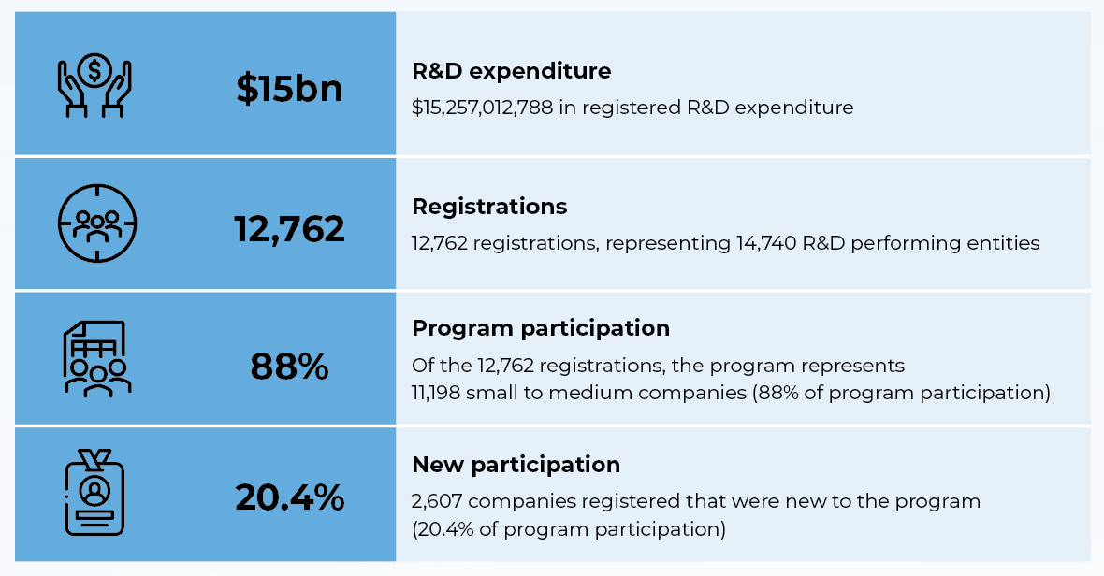
Importantly, the target performance standards for the 2021–22 income year applications were met, with more than 95% of applications being processed within the target time frames. By processing registrations within these time frames, the flow-on effects for companies from this incentive can enter the economy sooner.
In April 2022, IISA made its first determination that certain clinical trials met the requirements for being ‘core R&D activities’. Determinations provide greater certainty and streamline the program’s application process for companies. Since its launch, over 270 companies have relied on this determination when registering for the program.
An Advance Finding pilot for software-related companies was also developed by the department in consultation with the Tech Council of Australia to address software and technology companies’ requests for enhanced certainty and guidance when applying for the program. The aim of this pilot was to both demonstrate the benefits of Advance Findings for software companies and identify the effectiveness of small group consultation sessions for companies looking to apply for an Advanced Finding. Thirty companies participated in the pilot from February to June 2023. This process allowed participants to attend a small group consultation session, where they had direct access to an R&DTI case manager. Feedback from the pilot is currently being reviewed by the department and opportunities will be identified to make further improvements to the Advance Findings process.

R&DTI case study
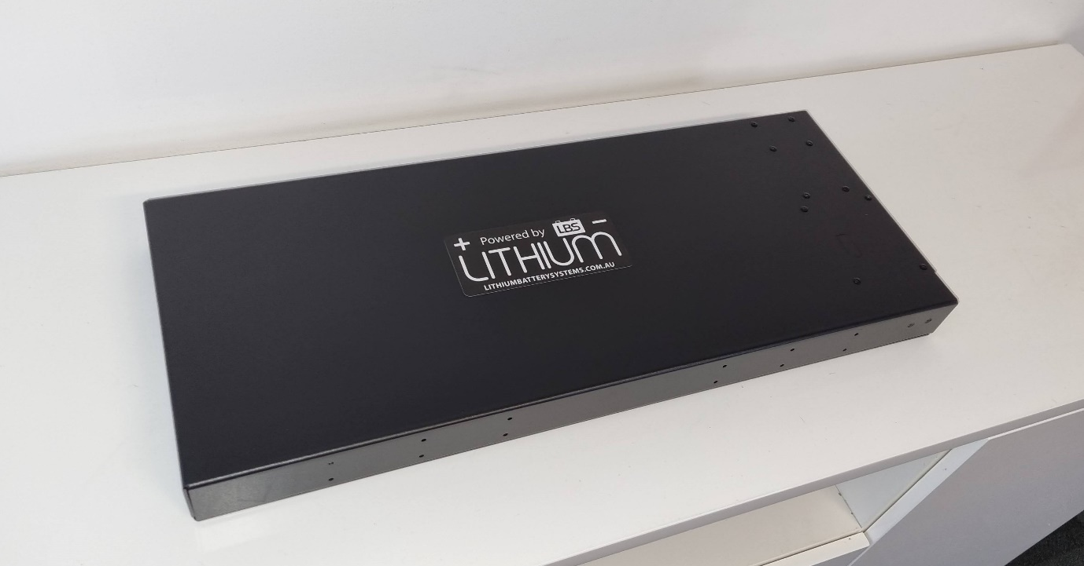
A lithium ion battery produced by Lithium Battery Systems. Image supplied by Lithium Battery Storage Pty Ltd.

Lithium Battery Storage PTY LTD (LBS)
Years in business: 8
Employees: 26
Industry sector: Energy/Manufacturing
Representative: Spencer Smith, Operations Director

Project objectives
Lithium Battery Systems (LBS) aimed to develop a battery and battery management technology that was more powerful, advanced and safer than imported substitutes. The company believed a more sophisticated product could be developed here in Australia, improving product capabilities and onshoring the manufacturing process. Having the battery systems manufactured domestically would also allow LBS to offer an element of customisation to their customers. Achieving this vision meant redesigning several components of a conventional battery management system.

Project description
Extensive research and development was required to establish a new battery management system (BMS) circuit board for the technology. This work took approximately 2.5 years.
Spencer Smith, Operations Director at LBS elaborates on the work undertaken to arrive at a commercially viable technology:
‘We did a lot of design work – electronics design, prototyping, redesigning, going through that loop several times until we reached something that was commercially viable,’ Mr Smith says.
‘Our BMS board handles more power and has more functions than you get overseas, which allowed us to make more powerful batteries, giving us a market differentiation.’
LBS has also added several user-friendly features to its products. These include temperature monitoring systems, short-circuit protection and a digital display to indicate the percentage of power left in the battery. Produced with varying voltages, LBS technology has found traction in the recreational and commercial vehicle market, offering energy storage solutions catered to golf carts, boats, four-wheel drives and utility carts.

Support received
R&DTI.

Impact
Mr Smith says the company’s early success could not have been achieved without the help of the R&DTI.
Not only did LBS develop a range of new lithium-based battery systems manufactured here in Australia, but in the 18 months from August 2020 to January 2022, the company’s revenue grew from $100,000 a month to $500,000. Staff numbers also increased from 6 to 23 in the same period. In 2021, the Australian Financial Review ranked LBS thirteenth in the top 100 fastest growing start-ups in Australia.
The company’s success has been demonstrated in more than sales and growth figures. LBS was a finalist in the 2021 Logan Business Distinction Awards. It was also a finalist in the Australian Small Business Champion Awards in the manufacturing class.
‘When you’re doing R&D, a lot of it turns out to be wasted effort. Funds are limited in a startup. If it weren’t for the R&DTI [which] we had over 3 years, we wouldn’t have been able to self-fund it.’ Spencer Smith, Operations Director, LBS

Innovation Investment Committee (IIC) – Message from the Chair
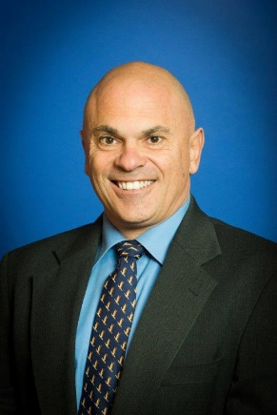
The Australian Government’s Venture Capital Program has continued to encourage venture capital investment in Australian entrepreneurial startup and early-stage companies to stimulate innovation throughout the 2022–23 financial year. The program has registered partnerships from 6 states and territories, which reflects the increasing geographical diversity of Australia’s venture capital ecosystem. Additionally, venture capital investment and the number of businesses receiving investment continues to grow.
As partnership activity and investments increase, program integrity will continue to be a key focus in the new financial year. The department will build on its connection with stakeholders through various engagements and compliance activities.
Professor Stephen Barkoczy
Chair
IIC

Venture Capital programs’ performance
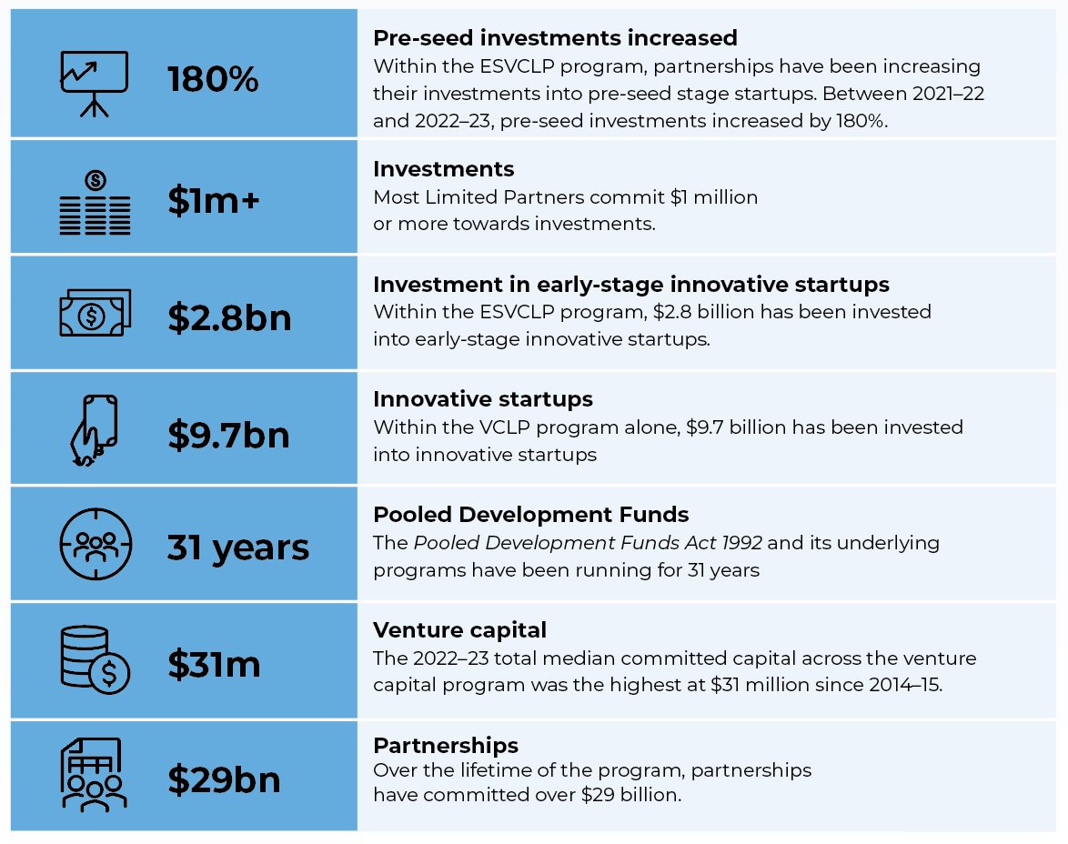

VC programs case study
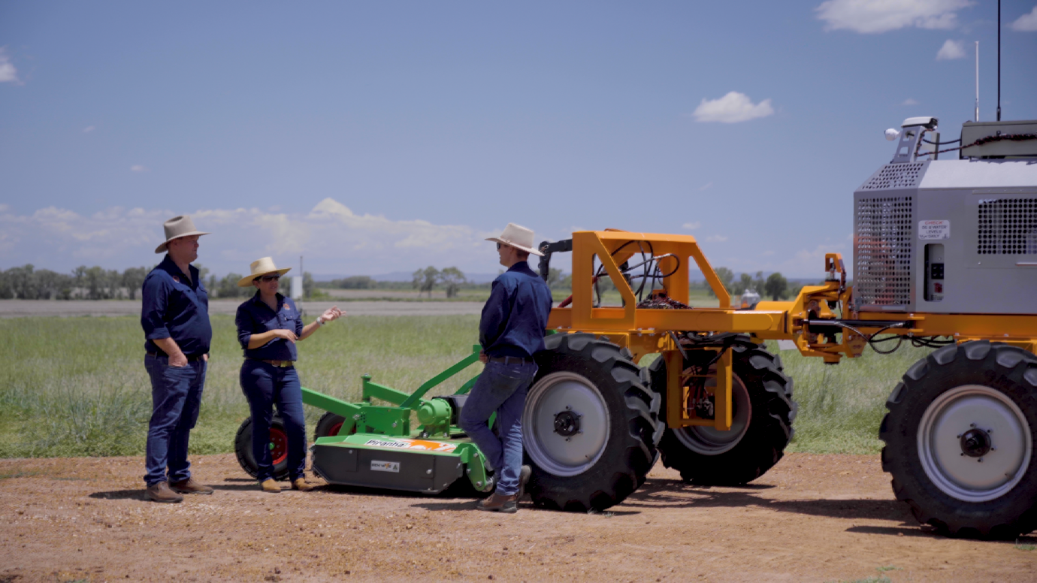
Intelligent robots in agriculture. Image supplied by SwarmFarm Robotics.

SwarmFarm Robotics
Years in business: 11
Employees: Over 25
Industry sector: Agriculture Technology
Founders: Andrew Bate, CEO
Jocie Bate, CFO

Project objectives
SwarmFarm Robotics (SwarmFarm) began in 2012 with a clear vision to create better farming systems using autonomous agriculture. The company was founded by Andrew and Jocie Bate, 2 Australian farmers based on a cattle and crop farm in Emerald, Central Queensland.
SwarmFarm grew from their desire to build more sustainable, effective and efficient ways of farming. Instead of looking to simply automate existing farming methods, SwarmFarm is using innovative farming techniques to shift current agricultural approaches.

Project description
SwarmFarm’s business model is made up of 2 components: the SwarmBot platform and the SwarmConnect ecosystem. SwarmBots are autonomous vehicles or ‘robots’ that are lighter and more nimble than traditional farming equipment. They are designed to undertake various tasks including spraying, weeding and thinning. SwarmConnect is an application ecosystem that allows third-party developers to build applications that integrate with SwarmBot.

Similar to the iPhone and the app store, SwarmBot and SwarmConnect present an ecosystem approach that brings local agricultural methods and local technology to the global agriculture community. Innovators around the world can develop new farming methods in SwarmConnect that suit their region, climate and cropping system. These can then be released onto SwarmBots within their region and globally.
The SwarmBot is therefore constantly evolving and adapting to various agricultural needs.

Support received
Early Stage Venture Capital Limited Partnerships (ESVCLP) program.
SwarmFarm received early-stage venture capital investment from Tenacious Ventures, who are an early-stage agriculture venture capital firm with a partnership registered with the ESVCLP program.
The ESVCLP program encourages investment into innovative early-stage startups and companies by providing tax concessions to eligible venture capital partnerships. This program has assisted Tenacious Ventures to attract investment, which in turn has unlocked more capital for startups such as SwarmFarm.

Impact
SwarmFarm’s approach seeks to create a future where achieving a good harvest is based on better farming techniques. Together, SwarmBots and the SwarmConnect ecosystem enables farmers to develop new farming techniques that are customised to their region. This innovative agriculture approach is grounded on achieving tailored solutions that are customisable, do more with less, and respond to a farm’s unique and changing environment.
‘We’re now starting to get noticed at the global level; global investors are starting to see opportunities within Australia because of the ecosystem we’ve built. Government incentives such as the ESVCLP program have helped get the first ag tech companies running here in Australia.’ Andrew Bate, Co-founder and CEO, SwarmFarm

Entrepreneurs’ Programme Committee (EPC) –Message from the Chair

The EPC is responsible for providing merit assessments of applications in relation to the BRII and, until 30 June 2023, the AC component of the EP.
AC opened for applications on 1 November 2014 and closed to new applications on
9 May 2023. AC was a merit-based competitive program to support small and medium-sized enterprises (SMEs), entrepreneurs and researchers to commercialise novel products, processes and services. Industries supported with AC grants included advanced manufacturing, medical and biotechnology, agritechnology, mining, financial technology, resources and energy.
Starting in 2016, BRII is a demand-side innovation policy lever for Government agencies to help stimulate SME research and development and deliver novel solutions to government challenges. It also stimulates innovation within Australian small and medium businesses. The BRII program provides critical early-stage support for testing new ideas and developing new pathways to market for these innovative initiatives.
BRII has supported the development of solutions to 23 challenges across 16 government agencies and continues to gain interest from other federal government agencies across different portfolios.
Anthony Surtees
Chair
EPC

Accelerating Commercialisation (AC) program performance
In 2022–23, under the AC program, guidance services were provided to 916 eligible businesses, $45,666,226 in matched grant funding was approved, and $28,989,355 was paid in grant funds.
Since inception of AC in October 2014 to closure in the 2022–23 financial year:
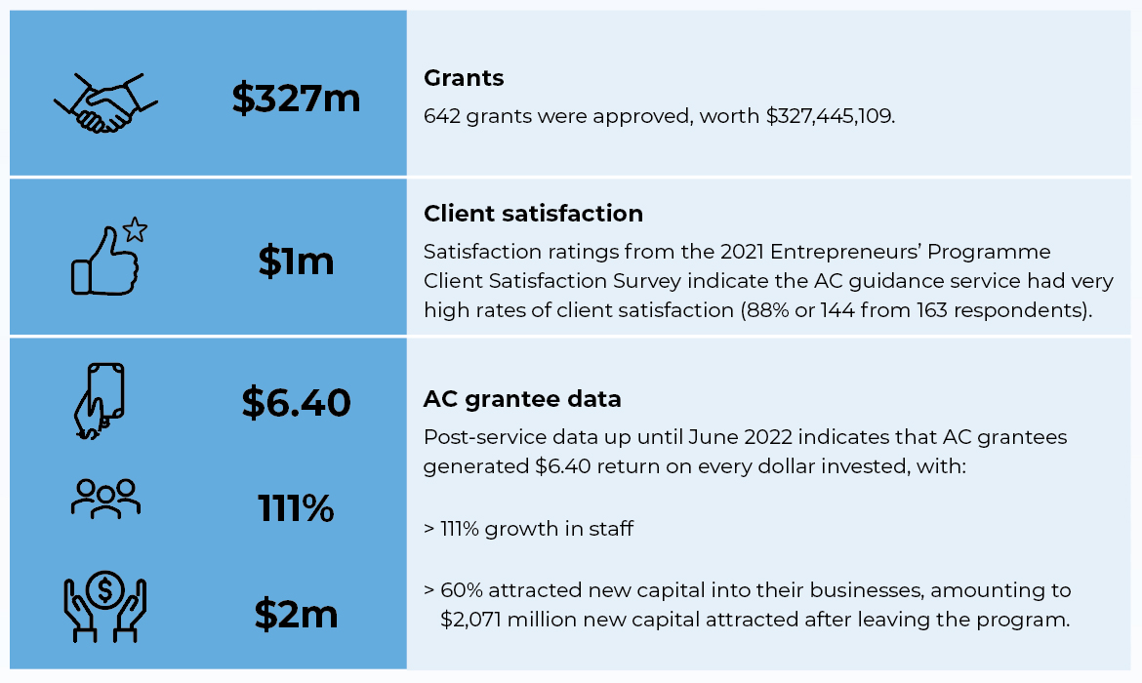

EP case study 1
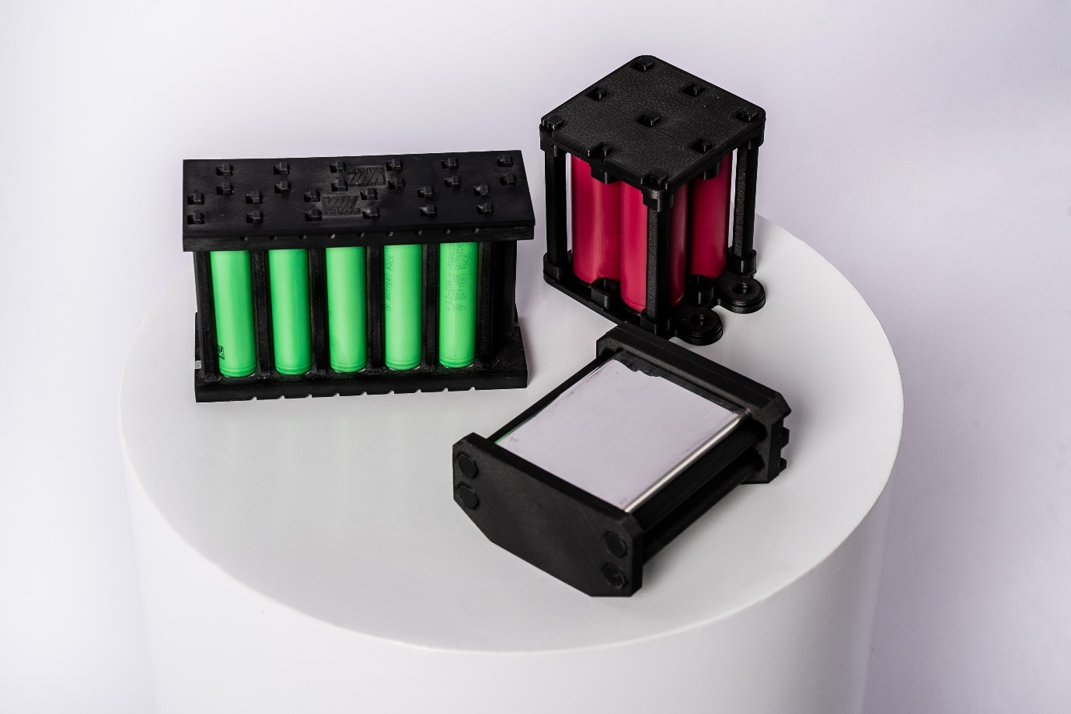
Vaulta weld, screw and glue-free recyclable battery module prototypes developed during the AC grant.
Image supplied by Vaulta.

Battery Graphene Corp Pty Ltd (trading as Vaulta)
Years in business: 4
Employees: 7
Industry sector: Advanced manufacturing
Representative: Dominic Spooner, Founder and CEO

Project objectives
To scale up from prototype to commercial product and to put in place a business management structure.

Project description
Battery Graphene Corp Pty Ltd (Vaulta) has developed patented low-cost and lightweight battery modules for the stationary storage market, which has enabled the company to expand to include the electric vehicle market.
Dominic Spooner had developed a small proof-of-concept battery that was powering a skateboard. He scaled up first to a battery with enough cells for stationary applications and then larger again for moving applications such as an electric vehicle. AC support allowed Vaulta to address the additional requirements for the electric vehicle market and perform the required certifications for market entry in 2021–22.

Support received
Vaulta received a $297,500 EP – AC grant. The project ran from 16 April 2021 to 11 November 2022.

Impact
Vaulta has developed more sustainable batteries that are low cost, lighter and easier to recycle or repair. The objective of the company is to see a global increase in battery recycling from the current range of 3% to 5%.
Over the course of the EP – AC support, Vaulta won the National Circular Economy Award at the Australian Technology Company Awards 2022 and the National Sustainability Awards at the Good Design Awards 2022; delivered batteries to clients, and signed memorandums of understanding (MOUs) with Braille Energy Systems Inc, Quickstep and a global manufacturer of lithium batteries used in the fastest cars in the world, including NASCAR, IndyCar and Aussie V8 Supercars.
In January 2023, ReNu Energy (ASX: RNE) completed the first $250,000 tranche of an investment worth up to $1 million in Vaulta, and $145,000 from international investor Niocycle.
‘The Accelerating Commercialisation funding and support was the critical conduit in taking Vaulta from a proof-of-concept to a paying customer. Vaulta continues to utilise the learnings and outcomes of the grant daily and leverages the use of the approved Australian Government logos on all of its promotional material. Building trust with customers is significantly easier to do when you can show you have the backing of the Australian Government.’
Dominic Spooner, founder and CEO, Vaulta

EP case study 2
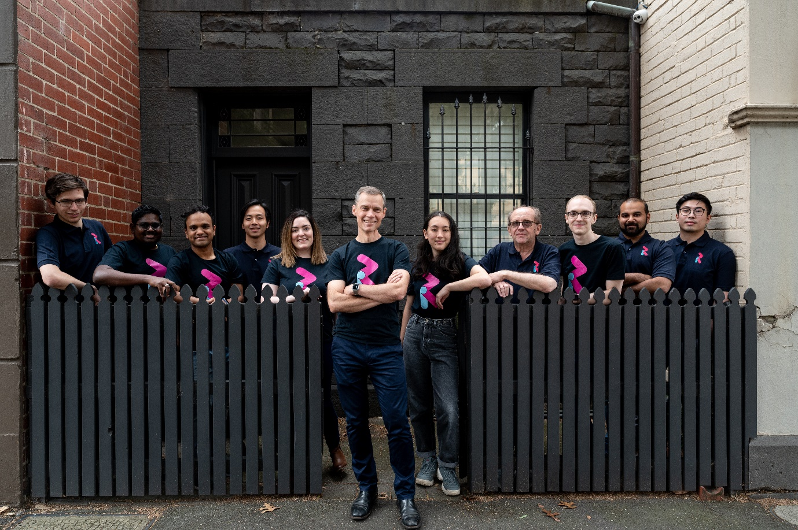
RealThing Ai’s Melbourne team–the engineers behind the innovative speech technology helping people who are vision impaired to access services and information. Image supplied by RealThing Ai.

Real Thing Entertainment Pty Ltd
Years in business: 15
Employees: 30
Industry sector: Software
Representative: Nick Howden, CEO

Project objectives
EP – AC support was used to help commercialise RealThing Ai, develop a new version of the intellectual property and attract investors.

Project description
For people with low vision, daily tasks most people take for granted can seem insurmountable. The dialogue software platform developed by RealThing Ai is an intelligent dialogue engine that can be adapted to a wide variety of applications, enabling third parties to make their product and service offerings more inclusive. RealThing Ai’s platform can generate conversational dialogue that guides users through everyday tasks such as cooking, shopping, finding information and entertainment.
RealThing Ai was able to fast-track its product development and firm up its business case to support its expansion into a new product offering and target market. The updated version of the RealSAM product, which was developed with the support of the program, utilises the latest in smartphone technology to run the intelligent dialogue engine on the device itself, rather than in the Cloud, creating the potential for broader applications beyond being an assisted living device.

Support received
Real Thing Entertainment Pty Ltd received a $1 million EP – AC grant. The project ran from
11 January 2021 to 6 January 2023.

Impact
One key application of RealThing Ai is to assist people with visual impairment – approximately 2.3% of the population in Western countries. The company hopes leading brands will integrate its interactive dialogue software into a range of smart interfaces beyond handheld devices.
RealThing Ai was approached by the US Government through the US Library of Congress as its technology is seen as a ‘best of breed solution for voice tech’. Its National Library Service for the Blind and Print Disabled services hundreds of thousands of Americans living with sight loss and the library has now awarded multiple contracts to RealThing Ai’s new US office.
‘With the Australian Government backing you, it gives investors the peace of mind to say, “OK this is obviously good tech, things are going in the right direction”.’
Nick Howden, CEO, RealThing Ai

Business Research and Innovation Investment program performance
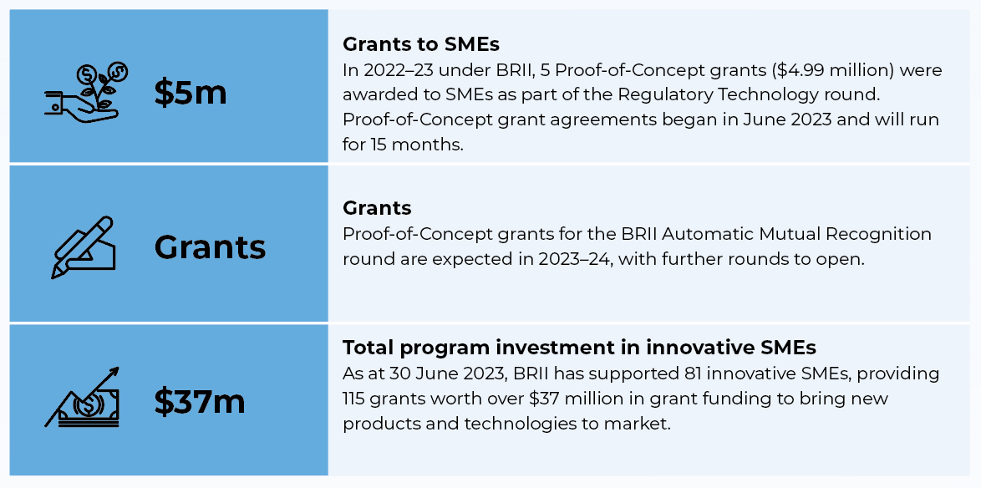

Business Research and Innovation Initiative (BRII) case study
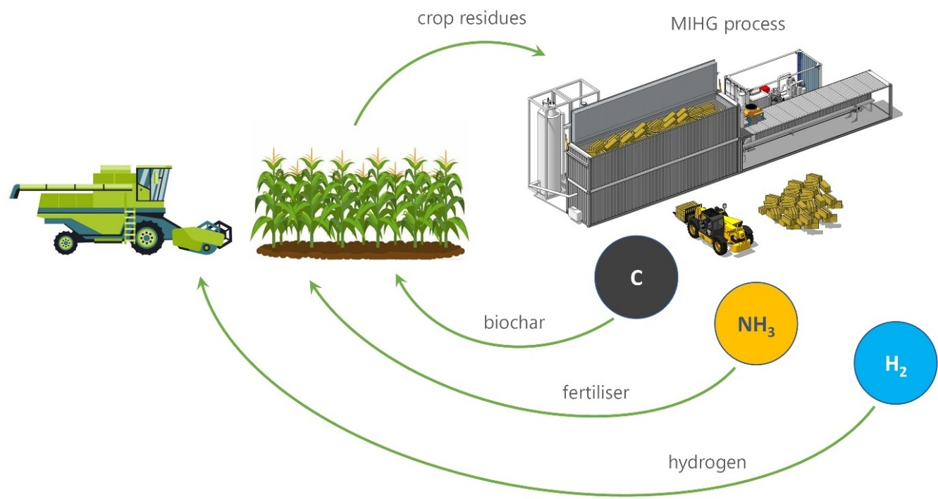
Image supplied by Wildfire Energy

Wildfire Energy Pty Ltd
Years in business: 7
Employees: 6
Industry sector: Renewable Energy, Waste Management, Hydrogen
Representative: Dr Greg Perkins

Project objectives
With assistance from the BRII program, Wildfire Energy’s objective was to develop an innovative technology solution to turn waste into a renewable hydrogen resource to support the production of renewable ammonia for the agriculture industry.
Australia’s agriculture industry depends on 4.9 million tonnes of fertiliser per year and ammonia is the building block of most of these fertilisers. Producing renewable ammonia at a low pressure (less energy intensive processing conditions) requires a source of renewable hydrogen as a feedstock.

Project description
In commencing the project, Wildfire Energy recognised that its Moving Injection Horizontal Gasification (MIHG) technology was a simple, reliable and low-cost solution for producing a renewable hydrogen source. MIHG technology uses residues from growing grain crops and wastes destined for landfill as an untapped resource for processing into hydrogen.
Prior to the BRII program, Wildfire Energy had developed the MIHG pilot plant, converting waste feedstocks such as grain crop residues, municipal solid waste and construction and demolition waste into syngas, a gaseous mixture consisting of hydrogen, methane and carbon monoxide.
The BRII program enabled the company to engineer, procure and construct equipment to concentrate and separate renewable hydrogen from the syngas produced by the MIHG reactors. This equipment delivers purified hydrogen suitable for production of ammonia and for use in vehicle fuel cells.

Assistance received
Through BRII, Wildfire Energy received a $100,000 Feasibility grant to verify the technical and commercial feasibility of its solution over 3 months. Following this, Wildfire Energy was successful in proceeding to BRII’s second stage and received a $1 million Proof-of-Concept grant to produce a prototype of the solution over 18 months. This funding was used to develop and install equipment to concentrate and separate renewable hydrogen in the MIHG pilot plant.

Impact
Wildfire Energy’s MIHG technology will create a more sustainable source of hydrogen to produce ammonia for use as fertiliser in food production. The company is developing the first commercial MIHG project in Brisbane that will divert 40,000 tonnes per year of waste destined for landfill and reduce CO₂ equivalent emissions by 1 million tonnes.
‘The BRII program has been instrumental in helping us refine our MIHG technology, demonstrate hydrogen production and secure industrial customers and investors. Since we undertook the BRII program, we’ve completed paid pilots with several multinational corporations, raised a seed round of financing and secured Calix (ASX: CXL) as a co-funding partner for our first commercial project.’
Dr Greg Perkins, CEO, Wildfire Energy

Cooperative Research Centres Advisory Committee (CRCAC) – Message from the Chair

The CRCAC was delighted to see the release of the latest independent impact evaluation of the CRC Program earlier this year. The evaluation has again shown the value the program delivers for Australia, finding it is delivering on its objectives and making a significant contribution to the Australian economy.
The evaluation found CRCs will generate an estimated $32.5 billion of economic impacts by 2025, and that Australia’s gross domestic product (GDP) is estimated to increase by $5.61 for every dollar of government funding for CRCs since 2005. While it is relatively early in the life of the CRC Projects (CRC-Ps) stream to provide a full appraisal, indications to date are very promising, with completed CRC-Ps estimated to return $7.73 in economic benefit for every dollar of government funding since 2016.
The evaluation also found the program has solid support from stakeholders and partners who consider the program to be contributing to industry competitiveness, sustainability and productivity, increasing the quality and strength of industry-research collaboration, and enhancing the capability of the research workforce.
The CRCAC was also pleased to see a routine schedule for future program rounds has now been published online. These timelines will provide assurance to stakeholders across the industry-research collaboration community and allow applicants to more easily develop collaborative relationships and projects.
The program continued to see strong demand over this past year. The CRC stream saw the announcement of Round 24 with 6 applications selected to progress to Stage 2 of the round, with funding outcomes expected to be announced in December 2023. The CRCAC has also been pleased to support the funding of 43 CRC- Ps over Rounds 13 and 14 with grant funding totalling $94 million in sectors including the circular economy and the National Reconstruction Fund (NRF) priority areas.
The CRCAC was pleased to again see applications from a wide range of industry sectors, demonstrating the program’s ability to bring together industry, research, government and community partners to harness collaborative research and innovation for the benefit of Australia.
Kylie Sproston
Chair
CRCAC

The Cooperative Research Centres (CRC) Program
The CRC Program is a competitive, merit- based grant program that provides funding to support industry-led collaborative research partnerships solving industry-identified problems. The program aims to improve the competitiveness of Australian industries by fostering high quality research and encouraging small and medium enterprises (SMEs) to participate in collaborative research.

The CRC Program has 2 streams:
- CRCs undertake medium-term to long-term, industry-led collaborative research for up to 10 years. There is no set limit on grant funding, but it must at least be matched by cash and in-kind contributions from CRC partners. CRCs must have at least one Australian industry entity and one Australian research organisation as partners.
- CRC-Ps undertake short-term, industry-led collaborative research for up to 3 years. Grants have a minimum funding limit of $100,000, are capped at $3 million and must have at least 2 Australian industry entities (one must be an SME) and one Australian research organisation as partners.
Over the life of the program (since 1990), $5.6 billion of Australian Government funding has supported the establishment of 236 CRCs and 232 CRC-Ps. Partners have committed a further $17 billion in cash and in-kind contributions.
During 2022–23, CRCs and CRC-Ps operated across a variety of sectors, including manufacturing, mining, health care, agriculture, space and the environment.
CRC Round 24 (Stage 1) opened on 13 January 2023 and closed 7 March 2023. In June 2023, the Hon Ed Husic MP, Minister for Industry and Science, invited 6 applications to progress to Stage 2. Stage 2 interviews are scheduled to be held in late October 2023, with funding outcomes expected to be announced in December 2023.
Round 13 and Round 14 CRC-P funding outcomes were announced on 19 January 2023 and 30 June 2023 respectively. Forty- three projects were supported across both rounds, with grant funding totalling $93.6 million. Round 14 encouraged applications that focused on the circular economy.
The CRC Program is well placed to support the Government’s National Reconstruction Fund (NRF) priority areas helping Australian industry scale up and become more competitive. Across the 43 CRC-Ps supported in 2022–23, all aligned with one or more of the NRF priority areas. These will lead to a pipeline of potential investment opportunities for the NRF in coming years. Round 23 of the CRC Grants stream, which opened in June 2021, also encourages applications that contribute to government priorities.
Looking ahead, the CRC Program will continue to develop important, real-world solutions to improve the competitiveness, productivity and sustainability of Australian industries, strengthen the economy and create jobs. The CRC Program will continue to support businesses to innovate, collaborate and capture new market opportunities.

Cooperative Research Centres (CRC) program performance
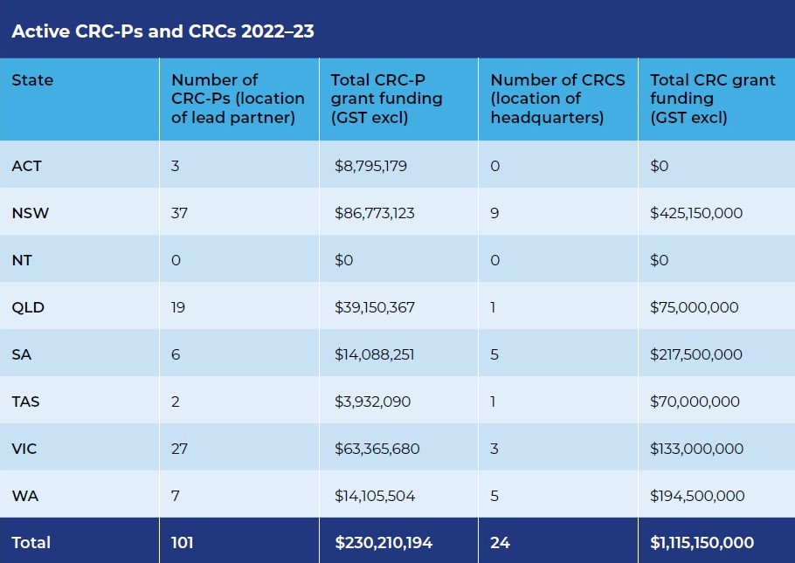.
Over the life of the program (since 1990), $5.6 billion of Australian Government funding has supported the establishment of 236 CRCs and 232 CRC-Ps. Partners have committed a further $17 billion in cash and in-kind contributions.

CRC Grants case study
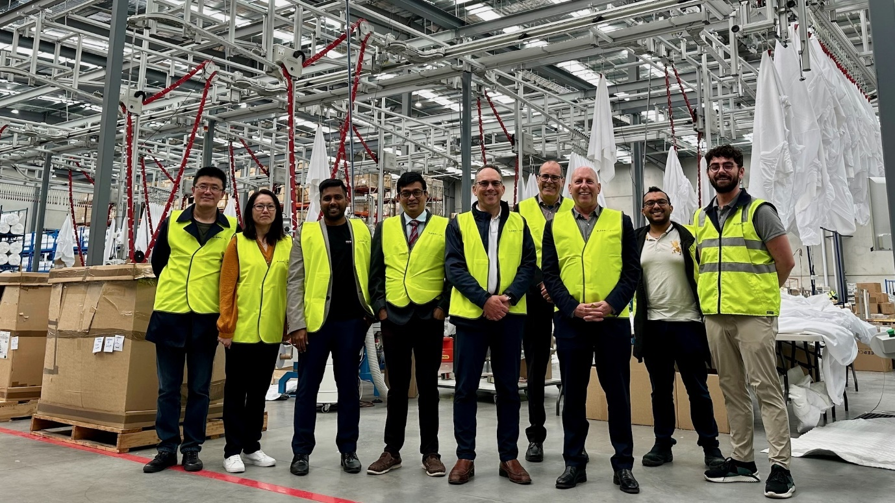
The Innovative Manufacturing Cooperative Research Centre (IMCRC) team at Sleep Corp’s new facility. Image supplied by Sleep Corp.

Innovative Manufacturing CRC (IMCRC): futuremap®
Website: www.imcrc.org
Industry sector: Manufacturing
Representative: David Chuter, CEO

The project: futuremap®
Industry 4.0 is the name used for the emerging fourth industrial revolution and refers to the digitalisation of manufacturing industry technologies and processes.
futuremap® enables participating manufacturers, through either one-on- one structured discussions or as part of interactive group workshops, to map the current state of their business and identify where they can lift their awareness, competitiveness and build resilience against key areas of industrial and advanced manufacturing competitiveness.

Support received
The IMCRC received a $40 million CRC grant over a period of 7.5 years (July 2015 – December 2022).

Testimonial
‘While completing IMCRC’s business assessment, I realised that if we want to go into the future, we have to align and incorporate Industry 4.0 in every aspect of our business,’ – David Kaplan, Managing Director and CEO, Sleep Corp.

Success story
Since 2019, Melbourne-based textile and top-of-bed manufacturer Sleep Corp has been working with IMCRC to overhaul its production processes and develop a sustainable vision for the future. Valuing resilience, wholeheartedness and interdependence, the business has been on a 3-year long transformative journey that commenced with the IMCRC’s futuremap® business assessment, setting out the strategic priorities for the company.
‘We knew we needed to think long term and to put Industry 4.0 and continuous improvement at the core of the next phase of our business journey,’ said Sleep Corp’s managing director David Kaplan. ‘As a business we wanted to be more self-reliant, while looking for ways to bring down costs and improve efficiencies, but it was difficult to know where to start.’
According to Mr Kaplan, it was at this stage that Sleep Corp was introduced to IMCRC. ‘futuremap® was a critical first step in identifying how we would achieve our vision, and better reflect Industry 4.0 in our business throughout the value chain.’
With the Industry 4.0 strategy outlined, the Sleep Corp team partnered with Swinburne University of Technology (Swinburne) to design and set up a novel Virtual Manufacturing System (VMS).
‘The VMS connects robotics-based machinery to a digital twin, allowing for a faster and more flexible manufacturing approach to address changing customer requirements while maintaining cost competitiveness for its range of products,’ said Mr Kaplan.
Originally looking to retrofit this innovative capability within its existing facility, it quickly became evident to Sleep Corp that more space was required, and the company moved its operations to a greenfield site in November 2021.
Ryland Joyce, Sleep Corp’s Operations Manager who oversaw the delivery of the project and the set-up of the new factory, pointed out that IMCRC and futuremap® helped shape Sleep Corp’s manufacturing future in more ways than one. ‘futuremap® made us aware of other technologies and how they could be implemented to benefit the organisation. Warehousing is a classic example. As a result we also implemented an AMR – Autonomous Mobile Robot – system to complement the new manufacturing operation.
‘Together with the consciousness of Industry 4.0, futuremap® helped us recognise the possibility of doing things differently,’ Mr Joyce added.
Mr Kaplan added that they were very deliberate and careful in their transformation and building a manufacturing future versus becoming a net importer of product. ‘We now have space to house current and future manufacturing and wholesaling needs, which has not just modernised our processes, but also our culture.’

In July 2022, IMCRC commissioned the Centre for Transformative Innovation at Swinburne [University] to evaluate the impact and effectiveness of futuremap®. The evaluation revealed that manufacturing businesses that engaged in a futuremap® workshop or one-on-one assessment were found to be growing faster and innovating more than their closest peers, reporting an average increase of 15.5% in sales, 21.5% in wages and 6.6% in staff.
The project has had numerous other business benefits, including firming up Sleep Corp’s supply chain stability and helping improve its environmental footprint.
Hampered by a series of ongoing COVID-19 lockdowns that led to delays, the team is thankful for the support and counsel provided by IMCRC throughout the project.
‘Following our transformation, we’re proud to be considered as a business at the cutting edge of Australian manufacturing and we couldn’t have felt more supported by IMCRC,’ said Mr Kaplan. ‘The team was there for us throughout the entire process, which was invaluable to the project’s success.’

The future for futuremap®
Now that the IMCRC has completed its operations, the Australian Industry Group has been selected as the ongoing custodian of futuremap® to guarantee the long-term success of the platform.
In collaboration with our deployment partners, we have helped over 1,000 manufacturers, particularly SMEs, on their digital transformation journey by demonstrating how Industry 4.0 can improve productivity and create opportunities.
David Chuter, CEO, IMCRC

CRC Projects case study

Refining the future. Image supplied by Pure Battery Technologies.

Project lead partner: Pure Battery Technologies (PBT)
Partners: The University of Queensland, Intdesign Pty Ltd, Cronimet Holding GmbH (international)
Industry sector: Advanced Manufacturing
Grant awarded: $2.2 million

Project objectives/description
A $2.2 million CRC-P grant over 2.5 years has assisted PBT and its partners develop a viable and sustainable process for refining a cobalt concentrate containing nickel and manganese into a high-purity, mixed-metal hydroxide precursor material for lithium ion batteries.
Cobalt is a critical element that plays an important role in advanced manufacturing. Simplifying processing methods for refining cobalt concentrate and increasing the efficiency of recovery will lead to a lower-cost cobalt and mixed-metal battery precursor material. The project will also consider how recycled battery feedstock can be integrated into the process, which will benefit the environment and provide security of supply.
The project has additionally provided professional development opportunities for researchers, engineers and technicians who have contributed to the project and will be employed in the refineries of PBT or other Australian mineral processing companies building Australian capabilities.

Support received
Cooperative Research Centres Projects (CRC-P) funding: $2.2 million
Funding period: 2.5 years

Impact
Environmental and cost-saving benefits:
The CRC-P demonstrated the feasibility of integrating recycled material feedstock into the refining process, proving both technical and economic viability. This integration provides massive environmental benefits by promoting a circular economy approach and reducing the reliance on primary materials. Additionally, cost-saving benefits were achieved by utilising recycled materials as feedstock in the refining process.
International engagement and economic opportunities:
The CRC-P’s successful outcomes has enabled PBT to expand its connection with the global supply chain and international industry partners. It has established links with raw material suppliers, end-use customers and global metal recycling corporations, expanding its economic opportunities and positioning itself for future growth and funding for projects such as building Australia’s first battery material hub.
Advancement of research capabilities:
The advancement in capabilities for all partners through the CRC-P has contributed to positioning Australia as a hub for advanced manufacturing opportunities in the critical minerals and clean energy markets. The project’s achievements have also supported the growth of PBT’s business and established it as a leader in its field.
‘The CRC-P grant funding had a huge impact on PBT’s growth and technology development. It gave us the resources to fuel development of our technologies and enabled local and international cross-disciplinary partnerships that cultivated breakthrough solutions in areas such as feedstock variability and engineering scale-up risks. The success of this project laid the foundation for building a resilient and forward-looking business.’
Dr William Hawker, Chief Technology Officer, PBT

Biomedical Translation Fund (BTF)
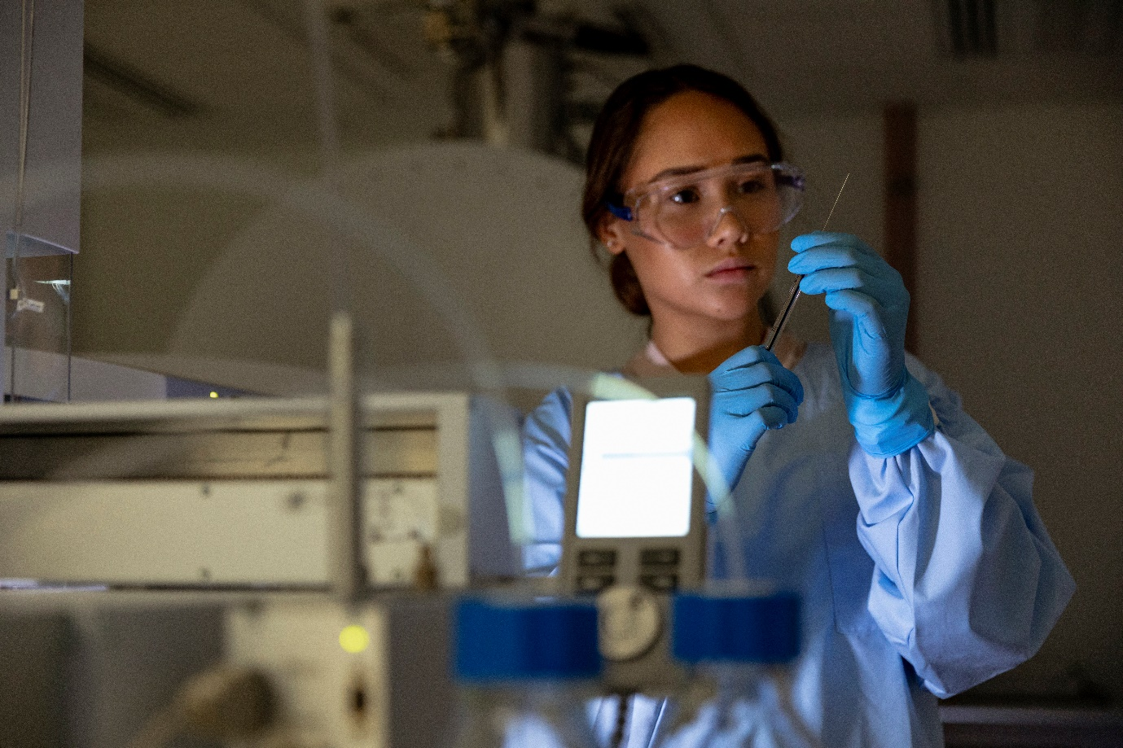
Image: Solstock/Getty Images.
The BTF is an equity co-investment venture capital program. It combines public and private funds to invest in high-growth-potential companies working on medical innovations and support the commercialisation of innovative biomedical research. The Department of Health and Aged Care has policy oversight of the program, while the Department of Industry, Science and Resources is managing ongoing compliance.
Three fund managers partner with the Commonwealth and private investors to foster game-changing breakthroughs: Brandon Capital Partners, OneVentures Management and BioScience Managers. Their highlights for the 2022–23 financial year demonstrate their respective priorities for the upcoming year:
- In May 2023, OneVentures Healthcare Fund III made an initial investment into ImmVirX, a company focused on developing enhanced, bioselected oncolytic virus therapies to treat cancer. This brings the total number of investments to 8 and OneVentures Management will focus on the best performing companies and work collaboratively to help them
achieve success.
- In 2022–23, Brandon Capital Partners’ MRCF-BTF Fund has made follow- on investments into several investee companies to support ongoing trials.
In the coming year, investee companies Aravax Pty Ltd, Axelia Oncology Pty Ltd, George Medicines Pty Ltd, OncoRes Medical Pty Ltd and PolyActiva Pty Ltd will reach critical clinical trial milestones. In addition, several companies in the portfolio will be fundraising to progress their products to the next stage of clinical development.
- Bioscience Managers outlined that the BioScience Managers Translation Fund I is demonstrating high performance at the internal rate of return of 20% in an otherwise challenging market. Saluda Medical Pty Ltd is redomiciling to Delaware, United States to expand in sales and market, business development and partnerships.
In the upcoming 12 to 24 months, Cynata Therapeutics Ltd, a portfolio company, anticipates producing significant clinical data across at least 3 key indications: graft versus host disease, diabetic foot ulcers and osteoarthritis.

Biomedical Translation Fund program performance
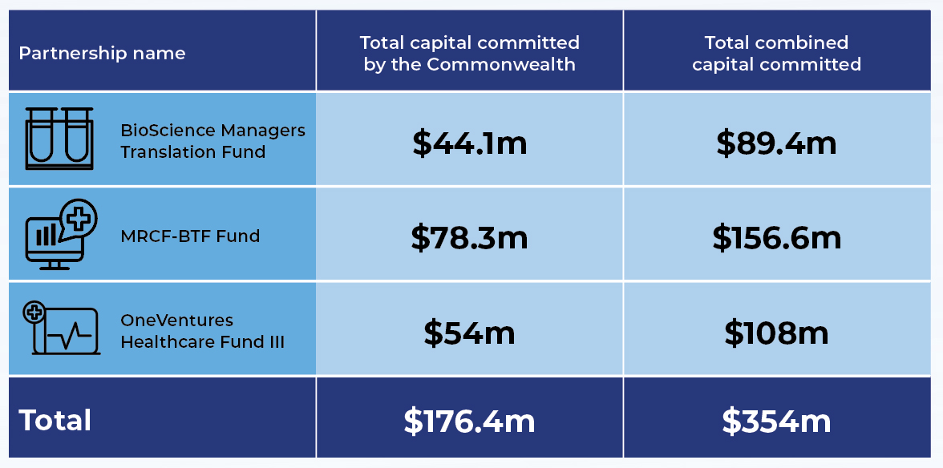

BTF case study
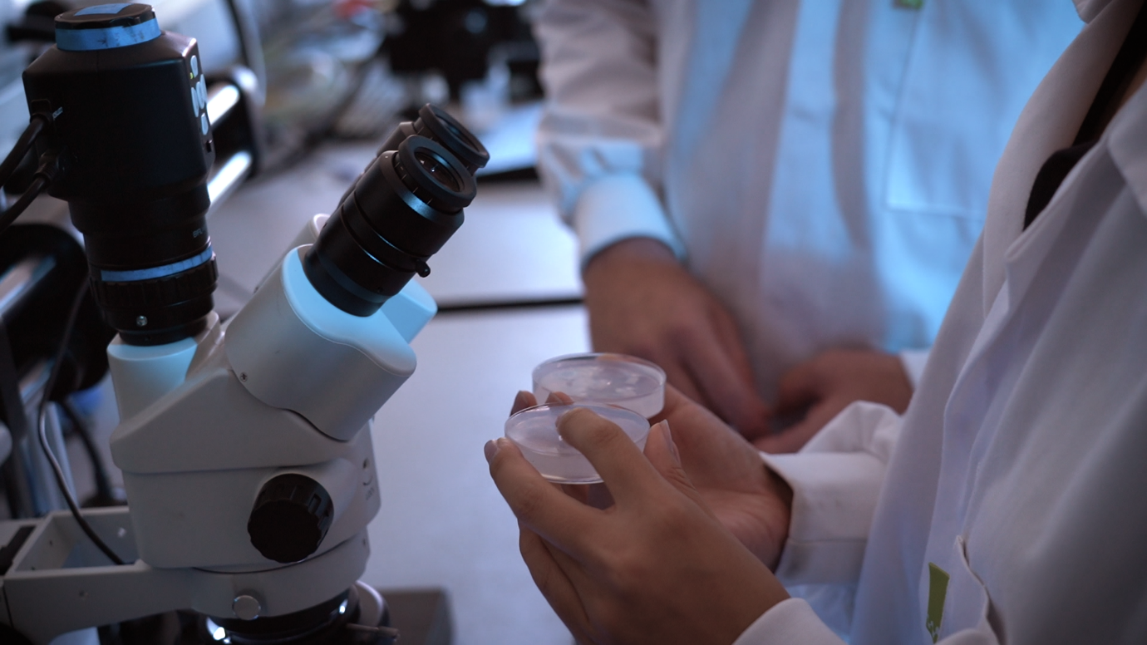
Imaging device improves cancer surgery outcomes. Image supplied by OncoRes Medical

OncoRes Medical
Years in business: 7
Employees: 37
Industry sector: Biomedical Technology
Representative: Dr Katharine Giles, CEO

Project objectives
The team at OncoRes Medical (OncoRes) is developing a new imaging device that supercharges a surgeon’s sense of touch through providing images that detail the microscale map of tissue stiffness. Surgeons currently rely on their sense of touch to ensure all cancerous tumours have been removed. This can lead to incomplete removal of cancerous tissue during surgery, which worsens patient outcomes and costs billions of dollars in unnecessary expenditure through repeat surgeries.

Project description
The innovation behind OncoRes began in a laboratory 10 to 15 years before the company was even founded. A group of researchers at the University of Western Australia made a groundbreaking discovery with funding from the WA Department of Health. Unfortunately, the researchers were unable to progress the discovery into clinical trials due to a lack of subsequent funding.
Brandon Capital discovered the research and identified its potential to revolutionise cancer-related surgeries and, in turn, outcomes. This led to the founding of OncoRes in 2016.
Since then, the team at OncoRes has been working to develop the intraoperative imaging device, which translates a surgeon’s sense of touch into a microscale image to improve surgical accuracy and reduce complication rates. As cancerous tissue is 60% to 70% stiffer than normal tissue, the imaging device enables them to more accurately determine if all cancerous tissue has been successfully removed.

Support received
Biomedical Translation Fund (BTF).
The BTF program provides crucial early translation stage investing to support the transition of biomedical innovation from the laboratory to commercialisation.
OncoRes has received support through one of the program fund managers, Brandon Capital, who has continued to make crucial follow-on investments. The most recent investment was their Series A2 Extension round.

Impact
OncoRes’s device is about giving surgeons more information to enable better decision-making and better surgical outcomes. In cases such as breast cancer, it has the potential to significantly improve patient outcomes. Breast cancer is the most common cancer affecting women, with one in 7 Australian women having breast cancer in their lifetime. With over 20,000 cases of breast cancer in Australia during 2022 and over 2 million per year globally, improvements in breast cancer treatment have the potential to provide huge benefits for women globally.
OncoRes’s device shortens the treatment pathway, reducing mental and financial stress for patients while also reducing the load on the wider health system.

‘Funds like the Biomedical Translation Fund are essential for us to be able to retain incredible Australian innovations in Australia and realise the benefits in terms of both economic and health outcomes for Australia.’ Dr Katherine Giles, CEO, OncoRes Medical

Advice to Government

Statement of Expectations
The work of the Board is guided by the IR&D Act and a Statement of Expectations (SOE).
The SOE issued by the Hon Ed Husic MP, Minister for Industry and Science, in December 2022 outlined the minister’s priorities and Industry Innovation and Science Australia’s (IISA’s) program of work for the year ahead (2023).
The SOE emphasised an expectation for IISA to advise on opportunities to drive stronger outcomes aligned to the Government’s priorities. In May 2023, IISA provided a Statement of Intent (SOI) to the Minister, outlining how it plans to deliver on the SOE. To support the SOI, an annual work plan and stakeholder engagement plan have been developed to manage IISA’s priority activities.
This year, the Board implemented a sponsorship model to progress and deliver projects identified in the SOE. This model gives Board members the opportunity to take ownership of a specific project that aligns with their areas of expertise, and results in operational efficiencies.
Below is a summary outlining the main elements of the work program, and progress as at
30 June 2023.

National Reconstruction Fund (NRF)

Statement of Expectations
IISA to work with the Department of Industry, Science and Resources to support the development of the NRF, including:
- supporting the development of the Industry Co-investment Plans, including by providing advice on non-financial investment needs in the NRF priority areas
- providing ongoing advice, as needed, on the design of the NRF and related issues.

Progress at 30 June 2023
During 2022–23, IISA worked closely with the department to support the development of the NRF. This included providing written advice on the NRF design and intended outcomes of the NRF.
July to December 2022
IISA met with department officials at 2 Board meetings to discuss early design options and intended outcomes for the NRF initiative.
February 2023
IISA submitted advice on NRF design to the department as part of its consultation process.
May 2023
IISA provided further advice on guiding principles to help identify NRF projects that align with the Australian Government’s overarching policy objectives of industrial and economic transformation, sustainable value creation and economic diversification.

Commercialisation and collaboration

Statement of Expectations
IISA to engage with industry and across government to:
- highlight key barriers faced by industry to collaboration with the research sector and commercialisation of research, building from previous IISA work where appropriate
- identify practical options to stimulate industry engagement and improve linkages between industry and research sectors, including to enhance research translation and commercialisation outcomes.
This advice should complement other relevant work across government.

Progress at 30 June 2023
IISA has used its connections to businesses across the economy to analyse barriers faced by businesses to collaboration with the research sector and research commercialisation in Australia, and provide advice on practical options to address these barriers. Project sponsors Lauren Stafford and Dr Doron Samuell have been leading this work.
January to April 2023
Building on previous work, IISA built on ongoing analysis of the current state of play of commercialisation and collaboration to identify barriers from a business perspective.
May to June 2023
IISA ran an industry-wide survey of over 400 participants to better understand the barriers and when they appear. A series of interviews with targeted businesses and leading experts in the field explored why participants think these barriers occur and their top options to overcome them.
From June 2023 and ongoing
Quantifying the return on investment to support research commercialisation through collaboration between the research and business sectors is key to demonstrating the extent to which this type of investment is having an impact. Findings to date suggest significant gaps in the way commercial outcomes are measured. Industry-led, market-driven innovation has greater impact and return on investment than research-led initiatives.
IISA is using this research to provide interim ad-hoc advice while working towards providing a report, including recommendations, to the Minister in the next financial year.

Driving innovation in business through intangible investment/innovation metrics

Statement of Expectations
In line with IISA’s previous work looking at the role intangible assets play in enabling firms to innovate and commercialise, Government welcomes IISA’s advice on specific opportunities to improve understanding and investment by Australian businesses in intangible assets, and on which sectors present the strongest opportunities and should be prioritised.
IISA supports improved innovation metrics by working in close collaboration with the department to identify opportunities to improve innovation metrics and data.

Progress at 30 June 2023
IISA supports the department in its work to identify opportunities to improve the way in which we measure industry innovation through better metrics and data. This will include opportunities to better align innovation metrics to the Government’s current priority areas of the economy.
From January 2023 and ongoing
IISA has continued to distil the findings and insights from previous work on intangible assets to iteratively advise government, department officials and stakeholders on practical options and guidance to improve business understanding and investment in intangibles. This will include which sectors present the strongest opportunities to align with Government’s current priorities, strategies and programs – particularly the NRF.
March to June 2023
A cross-APS working group was established to identify opportunities to improve innovation metrics and data. A stocktake of approaches to measuring innovation was conducted to inform the development of recommendations.
From June 2023 and ongoing
IISA is developing recommendations for the Minister to improve how innovation is measured and to promote business investment in intangible assets. IISA will identify implementation options with the department.

Industry innovation for business decarbonisation

Statement of Expectations
IISA to provide advice on how Australian businesses, particularly small and medium-sized enterprises (SMEs), can best harness opportunities presented by national and global emissions reductions efforts. This includes consideration of the roles of technology and business capability.
This advice should complement and be informed by the work happening across government.

Progress at 30 June 2023
IISA will provide advice on how governments can support the decarbonisation efforts of businesses, particularly SMEs, by identifying the unique barriers these businesses face, and the opportunities for both government and business.
February to May 2023
The project scope was set and the project sponsor Dr Catherine Foley worked with the Office of Industry Innovation and Science Australia (OIISA) to start identifying barriers and opportunities. The project draws on work across government and globally, to advise how SMEs can best harness opportunities presented by decarbonisation efforts.

From May 2023 and ongoing
Through data analysis, IISA is generating insights into SME efforts, and identifying barriers and opportunities to both government and business, in particular, those provided through technology and business capability innovation.
IISA is engaging key collaborative stakeholders including industry bodies and SMEs, to better understand SMEs’ mindset and motivation to take action towards achieving net zero.
IISA will deliver its findings, including recommendations, by November 2023.

Oversight of innovation programs

Statement of Expectations
IISA to continue to carry out its responsibilities in accordance with current legislation to ensure the effective delivery of relevant innovation programs.
The Minister welcomes IISA’s views on whether the current program oversight arrangements are optimal, and any proposed actions for improvements.

Progress at 30 June 2023
IISA will continue to perform its functions as delegated by legislation and ministerial direction, including oversight of relevant innovation programs.
Under the guidance of project sponsor Glenys Beauchamp, IISA will review current governance across the portfolio program suite with a view to ensuring arrangements remain fit for purpose and adequate.
Accountability and compliance obligations will be confirmed and reporting on innovation program outcomes and impact will be provided to the Minister.

From May 2023 and ongoing
IISA started to develop a map of the user journey experience, to then identify opportunities to optimise oversight arrangements.
Mapping of the relevant legislations, instruments, directions and delegations for each innovation program under IISA’s oversight is well progressed.
In the next financial year, IISA will engage in consultation with IISA committee chairs. IISA plans to deliver assurance to Government by December 2023.

Other advice to government

Advice on National Reconstruction Fund (NRF) design
IISA provided advice to government and departmental officials on NRF design. The paper addressed the outcomes expected from the NRF in terms of transformation, diversification, meeting sovereign needs and strengthening supply chains.

Private hearing with Standing Committee on Industry, Science and Resources
At the request of the Standing Committee, the IISA Chair, on behalf of the Board, provided his insights to inform the inquiry into developing advanced manufacturing in Australia.

Paper – Building Australia’s Sovereign Capabilities: When Industrial Advantage Meets Sovereign Need
The Board provided an internal paper to departmental officials. The paper leveraged previous work of IISA and explored sovereign capability beyond the defence context. Using a matrix of sovereign need and industry advantage, the paper mapped out where policy attention could be targeted – where sovereign needs are high and industry advantage is low.

Further advice on NRF
The Board presented a short paper that complemented earlier advice provided in
February 2023. It focused on guiding principles to help identify NRF projects that align with the Australian Government’s overarching policy objectives of industrial and economic transformation, sustainable value creation and economic diversification. It included ‘use cases’ that demonstrated the application of the guiding principles.

Engagement activities
Throughout the year, the Board engaged with multiple stakeholders in government, industry, science and research. These included public speaking engagements, consultations and site visits to companies that receive support from programs IISA has oversight of.
In addition to the engagements listed below, IISA members held numerous out-of-session meetings to progress work addressing the Statement of Expectations (SOE).

Industry conferences and forums
Universities Australia Conference 2022
The annual Universities Australia Conference was the signature event on the Australian higher education calendar. Participants included vice-chancellors, chancellors, senior university representatives, government representatives, industry representatives, members of the research community, international education specialists and media.
The IISA Chair attended on behalf of the Board. He was a panellist in a session on research commercialisation. The session built on the previous year’s session on university industry engagement, which focused on research commercialisation and the outcomes from the University Research Commercialisation Scheme Taskforce. The session explored the complex landscape within which research commercialisation occurs in Australia, including the roles of government, industry and universities. Drawing on the experience of panel members, the session discussed ‘what’s working, what might need to change’ to maintain and grow research commercialisation.

Australia New Zealand Leadership Forum (ANZLF)
The ANZLF was established in 2004 with a desire to strengthen the trans-Tasman relationship, and is now known as a key contributor to creating a seamless business environment between the 2 countries. The ANZLF is the only high-level and broad-based bilateral Australia–New Zealand business forum that engages closely on policy issues with governments on both sides of the Tasman.
The 2022 forum focused on trans-Tasman innovation opportunities, how to strengthen trade and investment, digital connections, the future of health and opportunities to collaborate on climate change and foreign policy challenges, as well as recommendations from ANZLF Sector Groups in the areas of innovation, indigenous business, infrastructure, health technology and tourism. The IISA Chair attended on behalf of the Board as a Lead Discussant, and spoke about the opportunity for trans-Tasman collaboration on decarbonisation and climate resilience.

National Innovation Policy Forum (NIPF)
The NIPF, facilitated by Cooperative Research Australia, brings together those who lead industry-research collaboration and translation in Australia with policymakers and parliamentarians to tackle common challenges. This was an event to facilitate a dialogue about creating greater efficiency, collaboration and impact across the innovation system. The forum brought together almost 200 leaders from across the innovation system at the CEO, chair, deputy vice-chancellor and secretary level.
The IISA Chair, on behalf of the Board, participated as a panellist in a moderated panel discussion on the topic ‘Deconflicting the innovation system and joining the dots’. This was followed by a further table discussion with forum participants.

Government consultations

Startup Year Program
The Startup Year was an election commitment intended to address a ‘lack of support (that) has perpetuated a culture that pushes aspiring and gifted Australian innovators offshore – depriving Australia of jobs and increased sovereign capability’.
The IISA Chair, on behalf of the Board, attended a meeting with the department
of Education as part of a consultation process to develop the Startup Year Program.

Minister Husic’s Science and Commercialisation Roundtable
The purpose of the roundtable was to allow the Hon Ed Husic MP, Minister for Industry and Science, to hear from experts on workforce challenges and opportunities facing science and commercialisation, as well as providing a forum to discuss other issues, such as mega trends impacting our future labour markets and demand for skills. The attendance was dominated by skills, education and training organisations.
The IISA Chair attended on behalf of the Board. He took the opportunity to broaden the discussion away from focusing solely on the commercial activity in universities to a wider system approach. This included more attention on the demand side to drive business dynamism and entrepreneurialism and act as a catalyst for innovation. The IISA Chair’s attendance helped inform the Minister on key issues ahead of the Jobs and Skills Summit, on 1–2 September 2022.

Universities Accord Review
The Australian Government is working to establish an Australian Universities Accord to drive lasting alignment between Australia’s high-quality higher education system and national needs.
The IISA Chair and Deputy Chair met with Mary O’Kane, Universities Accord Panel Chair,
to discuss shared interests in research translation, commercialisation and business investment in research and development (R&D). These issues are relevant to both the Universities Accord and IISA’s current work around barriers to business collaboration with researchers and research commercialisation.

House of Representatives Standing Committee on Industry, Science and Resources
On 22 March 2023, the IISA Chair and the Executive Director of OIISA appeared before the House of Representatives Standing Committee on Industry, Science and Resources inquiry into advanced manufacturing. In line with recent IISA advice on the NRF, the Chair emphasised that firms needed to compete on value-adding for the customer and not only cost. Firms need to consider the whole manufacturing value chain, with a focus in pre-production and post-production.

Workshop – Revitalising Australia’s National Science and Research Priorities and National Science Statement
The Australian Government seeks to revitalise Australia’s science and research priorities and National Science Statement, as the current policy frameworks date from 2015 and 2017 respectively. A taskforce has been set up to achieve this, led by Australia’s Chief Scientist, Dr Catherine Foley (who also holds the role of IISA Deputy Chair).
The IISA members participated in a workshop to develop potential priorities and discuss key points for the National Science Statement.

Industry Growth Program workshop
The IISA members attended a workshop with departmental executives to provide input into the development of the Industry Growth Program, a new program announced by the Government at the 9 May 2023 Budget. The Industry Growth Program will support innovative small and medium-sized enterprises (SMEs) to commercialise their ideas and grow their operations. The program will provide advice and matched grant funding to projects in NRF priority areas.

Site visits

Goterra
Goterra is a Canberra-based waste management company that delivers Modular Infrastructure for Biological Services. They supply hotels, restaurants, farms, SMEs, supermarkets and hospitals with robot-managed capsules, containing shelves of black soldier fly larvae that turn food waste into fertiliser. Once the insects have consumed the waste, they in turn are harvested and sold to farms for high-protein animal feed.
IISA members were able to see the 3 core elements of the business: waste, production (the fly farm) and engineering. They observed the process from food waste being received onsite, how they process it and where they breed the flies. They also visited the engineering workshop. The staff member hosting the visit discussed how their process works and its benefits, the lifecycle of the flies, and provided an outline of the company’s engineering process.

QuintessenceLabs
QuintessenceLabs is a global leader in quantum cybersecurity, addressing the most difficult security challenges facing organisations, using the power of quantum mechanics. Quantum computing poses risks to the security of encrypted data held by organisations. QuintessenceLabs has developed quantum random number generation. This creates truly random numbers that can be used to encrypt data with no factors that can be guessed. It also offers quantum enabled key management and distribution solutions so third-party interception cannot occur during the exchange of data. QuintessenceLabs are Australia’s first quantum technology company.
IISA members attended a short presentation summarising the market drivers behind one of their products under development, followed by a run-through of the evolution of Quantum Random Number Generation produced by QuintessenceLabs and a general tour of the facility. IISA members had the opportunity to observe a chip undergoing evaluation testing at the Quantum Laboratory, where the Quantum Key Distribution technology was being developed.

Vow Foods
Vow Foods, a company made up of innovators, engineers, scientists, artists and foodies, is a company that cultivates cells to make food, particularly meat substitutes. They use advanced biotechnological techniques to ‘cultivate the perfect combination of cells for their ability to self-renew, and for ideal flavour, texture, and aromas.’ They then create the meat substitutes by placing the cells inside climate-controlled cultivators, which creates an environment where the natural course of forming muscle, fat and connective tissue occurs. Rather than working to replicate meats such as chicken, beef and lamb, Vow is creating entirely new animal proteins. Vow is working with regulators to become Australia’s first approved cultured meat product.
Vow Foods uses a combination of cell biology, robotics and software engineering to decipher information contained at the cellular level, which allows the company to identify the keys to new and better flavour, texture and nutrition combinations.

Phyllome
Phyllome is an advanced agriculture company. It uses robots and artificial intelligence to create fully automated plant factories that are protected from the elements, allowing harvesting of produce throughout the year. Phyllome integrates into an existing procurement system to supply produce on demand with the aim of reducing supply chain volatility. Phyllome also has a biomedical team that works on advanced medicinal properties of foods.

AMSL Aero
AMSL Aero aims to design and build the world’s most efficient electric Vertical Take Off and Landing aircraft, Vertiia. Vertiia is an autonomous aircraft that takes off and lands like a helicopter, without the need for a runway. Vertiia will cruise at 300 km/hour, and will travel 250 km powered purely by electric batteries before needing a recharge. Vertiia is designed to travel non-stop up to 1,000 km using hydrogen. Purpose-built for the aeromedical, emergency services and passenger markets, Vertiia will provide a new mode of safe and affordable transport to perform medical evacuations.

ARIA Research
Board members visited ARIA Research, a Cooperative Research Centres Projects (CRC-P) recipient that has partnered with the University of Technology, Sydney and the University of Sydney to develop a bionic device that uses sound for echolocation. The device enables users with vision impairment to perceive their surroundings in precise detail. Unlike other solutions, this technology is non-invasive and does not require surgery. This product will empower people who are blind to navigate their environment independently, without an assistance support worker, saving the health system $10,000 a year per person with vision impairment.

Advanced Navigation
Advanced Navigation is an innovator in AI, robotics and navigation technologies, and prides itself in developing and manufacturing all its solutions in Australian facilities. This gives the company control of the production process and contributes to supply chain resilience. The solutions it builds are applied to land, air, sea and space problems. The majority of the company’s staff (85%) are employed in R&D. Board members discussed the company’s experience with the CRC-P program and its partnerships with Australian National University (ANU) and Royal Melbourne Institute of Technology (RMIT).

State Asphalts
State Asphalts is researching a range of innovative methods to incorporate recyclable materials in asphalt manufacturing, and bringing innovation to the process of asphalt production. The company is partnering with the University of New South Wales (UNSW), and has received funding under the CRC-P program. Board members were given a presentation outlining State Asphalt’s project, and heard directly from the UNSW PhD candidates involved in the research.

About the Office of Industry Innovation and Science Australia (OIISA)
OIISA is the central point of communication between the Board and the department. It provides secretariat, stakeholder engagement and communications support, as well as policy and research teams who conduct project work to deliver on the Statement of Expectations (SOE) and Statement of Intent (SOI).
OIISA has been established under the IR&D Act (subsection 25(1)) to assist the Board and committees in the performance of their functions.
OIISA staff, including the Executive Director, are employed under the Commonwealth Public Service Act 1999.

How OIISA supports the Board
The project teams work closely with Board members to ensure IISA can deliver timely and high-quality outcomes under the SOE.
The policy team takes responsibility for strategy and nominations for new Board members. It also facilitates connections between IISA and the department.
The Engagement and Governance team is responsible for stakeholder and industry engagement, communications, secretariat and administrative support – including secretariat functions for IISA’s committees.
As of 30 June 2023, OIISA has a 3-team structure:
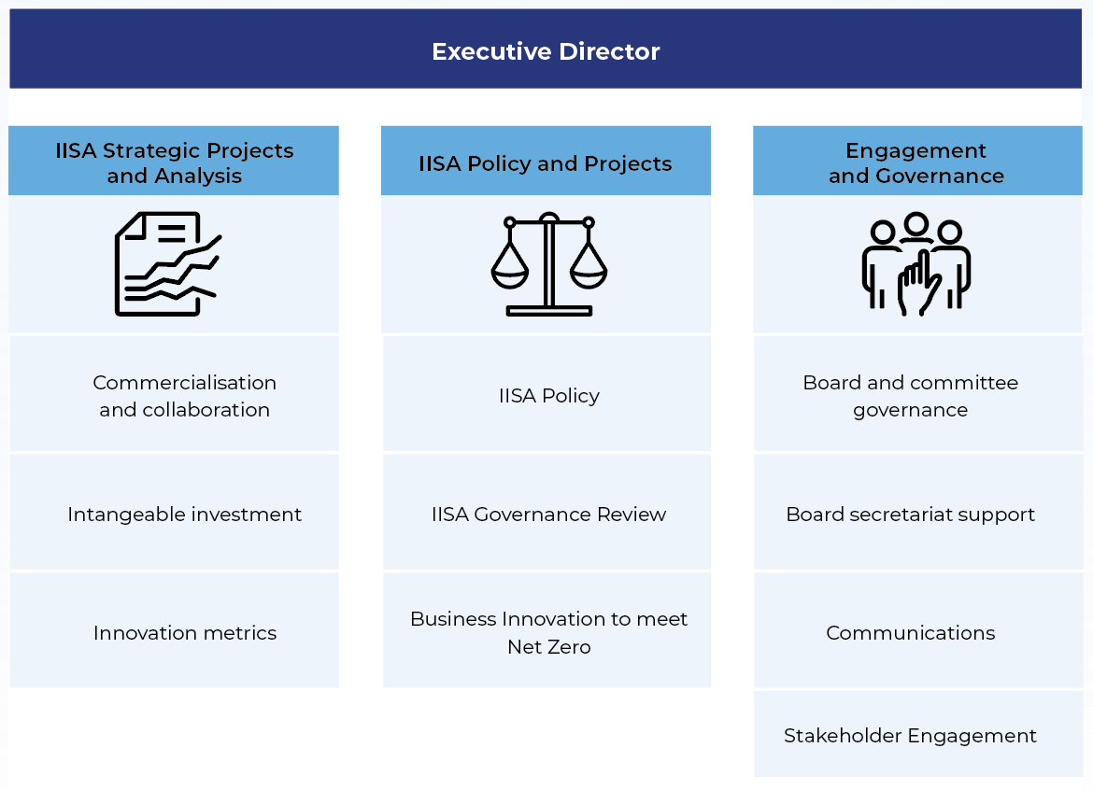

Governance

Governance structure

Evaluations and reviews

Innovation Metrics Review
The November 2017 report Australia 2030: Prosperity through Innovation (the 2030 Plan), developed by (the then) Innovation and Science Australia, highlighted the importance of accurate measurement of the performance of the Australian innovation system. The 2030 Plan recommended (via Recommendation 30) supporting the development of a suite of innovation metrics and methodologies to fully capture innovation and link it to economic, social and environmental benefits.
The Government of the day supported Recommendation 30, which led to the development of the 2018–19 Budget measure – Better Data to Track Innovation in Australia, later becoming known as the Innovation Metrics Review (IMR).
The review sought to:
- improve data sources and metrics around innovation so they are fit-for-purpose and allow, for example, direct international comparisons
- identify and fill measurement gaps and capture hidden innovation
- deliver a list of suitable metrics – the scorecard – that would have policy relevance to government and be useful to guide evidence-based decision-making.
On 30 September 2022, the Government published the outcomes of the review in a report titled Improving Innovation Indicators – Better Data to Track Innovation in Australia.
For more information on the IMR, refer to the Innovation Metrics Review on the Department of Industry and Science website.

Research and Development Tax Incentive (R&DTI) survey and actions on previous feedback
The department surveyed almost 1,000 program registrants to seek their feedback on the program’s accessibility, their understanding of program requirements and perceived program benefits. Respondents highlighted the benefits of the program to their companies and the positive impact the program has on innovation within Australia more broadly. The survey also found that most respondents (94%) are likely to apply to the program again.
In response to stakeholder feedback and recommendations made by the Australian National Audit Office and Board of Taxation in their recent reviews, the department undertook a project to streamline the process of Advance and Overseas Finding applications. These findings provide companies with valuable assurance in the context of an otherwise self-assessment program. As a result of this project, average completion time from application lodgement to decision has decreased to 90 days.

Venture capital tax concessions review
On 27 October 2022, the review of the venture capital tax concession programs (Review) was tabled in the House of Representatives. The Review incorporated the requirements of an impact assessment imposed by legislation (Commonwealth Income Tax Assessment Act 1997; section 118 455). The Treasury and IISA undertook the Review.
The Review found that:
- overall the tax concessions have been well received by stakeholders and are working as intended
- these programs have likely supported the growth of the Australian venture capital sector, which has experienced increased levels of investment and the development of fund managers. These are the primary objectives of the programs
- stakeholders recognised that the programs are just one factor contributing to the growth of the venture capital sector; however, expressed that removal of the programs would be detrimental to the sector.
No policy or reform recommendations were made as specified in the Terms of Reference.

Business Research and Innovation Initiative (BRII) impact evaluation
The department engaged Nous Group (Nous) to conduct an impact evaluation of the BRII program. The impact evaluation was released publicly on 30 May 2023.
The evaluation focused on the outcomes, impact, delivery and design of the BRII. The evaluation was directed towards a set of key evaluation questions relating to the effectiveness and efficiency of the program’s design, the outcomes the program generated for small and medium-sized enterprises (SMEs) and challenge agencies, and the costs and benefits of the BRII. The evaluation looked at the first 3 rounds of the BRII and examined each of the phases of a BRII round, from challenge design through to proof-of-concept.
The impact evaluation found that BRII has achieved its goals by:
- fostering innovation among small and medium businesses
- helping Australian Government agencies solve difficult policy and service delivery problems.
BRII not only achieved both its policy goals but also delivered a substantial net economic benefit to Australia, with early findings from the first round indicating a $1.64 return for every dollar of government investment, a benefit-cost ratio comparable to similar international programs. The evaluation recommended the Government consider scaling up BRII to increase reach and impact.
For more information on the BRII impact evaluation, refer to the Innovation Metrics Review on the Department of Industry and Science website.

Legal matters and litigation

Research and Development Tax Incentive
IISA, through its delegates, makes decisions under the Industry Research and Development Act 1986 (IR&D Act) and the Pooled Development Funds Act 1992 (PDF Act). These are reviewable decisions, and applicants dissatisfied with a decision may ask for an internal review.
When a decision is confirmed or varied at internal review, the applicant may seek external review by the Administrative Appeals Tribunal (AAT). In some cases, applicants may seek a further review by the Federal Court of Australia (FCA).
This section of the report gives a summary of external review matters that IISA has been a party to during the 2022-23 financial year. They relate to the R&D Tax Incentive and venture capital programs.
In 2022–23, one new application was made in the Administrative Appeals Tribunal (AAT) seeking review of IISA’s internal review decision. There were no new applications to the Federal Court of Australia.
There were 4 AAT decisions on R&DTI matters involving IISA during the 2022–23 period. There were a further 6 AAT matters resolved prior to AAT decision (3 withdrawn by the applicants, 3 resolved by consent orders after agreement was reached between the parties).
There was 1 AAT matter that proceeded to final hearing in the 2022–23 year – this was the matter of Active Sports Management Pty Ltd v Innovation and Science Australia (final hearing held on 1–3 May 2023 and 21 July 2023). This matter is now reserved for AAT judgement.
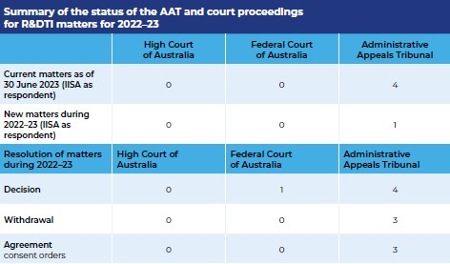

Venture Capital Program
In 2020–21, MEC Resources Ltd (Applicant) made an application to AAT for review of IISA’s internal review decision. The internal review affirmed the initial decision to revoke the Applicant’s pooled development fund (PDF) registration declaration under paragraph 47(1)(a) of the Commonwealth Pooled Development Funds Act 1992 (PDF Act). The matter was heard before the AAT on 9 June 2022.
The AAT handed down its decision on 15 March 2023. The AAT set aside the decision under review to revoke the Applicant’s PDF registration declaration and substituted it with a decision not to revoke the Applicant’s PDF registration under section 47 of the PDF Act.

Board and committee membership

IISA Board
The Board is appointed by and reports to the Minister for Industry and Science. Board members are selected because of their experience and networks in the industry, science and research sectors, and the diversity in their areas of expertise.
Current Board members as of 30 June 2023 are:
Mr Andrew Stevens
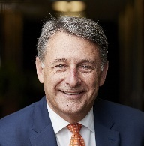
Location: New South Wales
Mr Stevens has chaired the IISA Board since December 2018. He has expertise in change management, business and information and communications technology (ICT) program design, risk evaluation, governance and delivery, business transformation and regional and global expansion. He is also currently a member of the Stockland Group and Ooh! Media board.
Dr Catherine Foley AO PSM

Location: New South Wales
Dr Foley has been Deputy Chair of the IISA Board since 2021. She was appointed as Australia’s Chief Scientist in January 2021. Dr Foley has an extensive career with the Commonwealth Scientific and Industrial Research Organisation (CSIRO), appointed as CSIRO’s Chief Scientist in July 2018. She has expertise in scientific research, quantum physics, sensors, devices and systems, research translation, leadership, advisory and advocating for the role of women in STEM, and she led the development of the Quantum Technology Roadmap for Australia in 2020.
Mr Patrick Houlihan
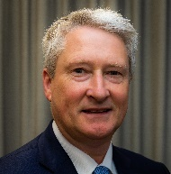
Location: Victoria
Mr Houlihan has been a member of the IISA Board since 2020. He has extensive experience in science, manufacturing and business during 32 years with DuluxGroup, including 9 years in research and development (polymer chemistry) and 14 years as CEO. He is the chairman of the Murdoch Children’s Research Council and has been a member since 2010.
Dr Doron Samuell
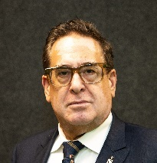
Location: New South Wales
Dr Samuell has been a member of the IISA Board since 2022. He is a medical and behavioural economics specialist with a nous for innovation, expertise and experience in using data to identify and solve complex behavioural problems. He is the Chief Medical Advisor at Clanwilliam Health (Asia-Pacific), the Chief Medical Officer of Allianz Life and the founder, owner and practice lead at Behaviour.
Ms Lauren Stafford

Location: Western Australia
Ms Stafford has been a member of the IISA Board since 2020. She has extensive background in technology development and commercialisation in global resources market. She has expertise in portfolio strategy, technology and business development, corporate structure, governance and operating models and intellectual property and data strategies. Ms Stafford is also a member of the Industry Advisory Board of Quantum Technology Exchange.
Ms Glenys Beauchamp AO PSM

Location: Australian Capital Territory
Ms Beauchamp has been a member of the IISA Board since 2021. She has served in secretary and deputy secretary positions across multiple government departments for 18 years. She has expertise in policy, program management, high-level stakeholder engagement skills, experience interacting with APS leaders, organisational stewardship and governance skills.

Ms Meghan Quinn PSM

Location: Australian Capital Territory
Ms Quinn is the Secretary of the Department of Industry, Science and Resources. Throughout her career she has provided advice on a wide range of economic policy areas including financial markets, superannuation, corporate governance, international relations, structural reform, industry policy, macroeconomics, climate change mitigation, forecasting and modelling.

IISA Board member terms
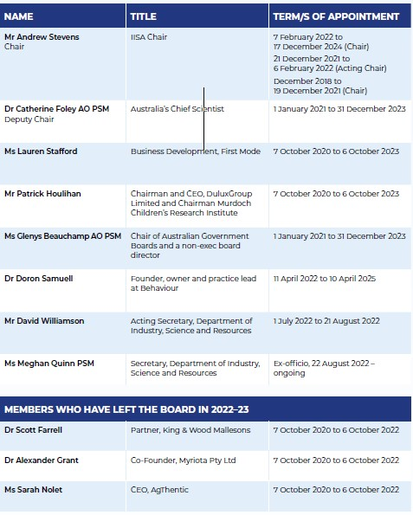

IISA Research and Development Incentives Committee (RDIC) members and terms
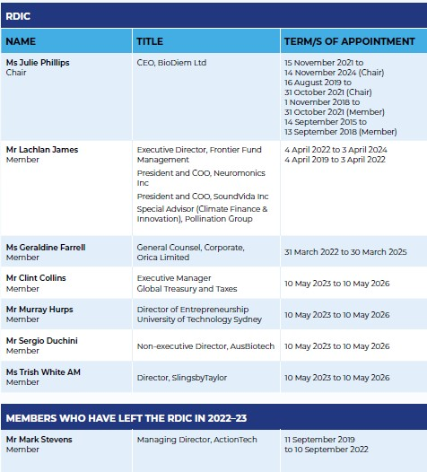

Innovation Investment Committee (IIC) members and terms
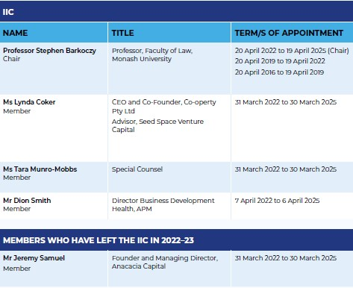

Entrepreneurs’ Programme Committee (EPC) members and terms
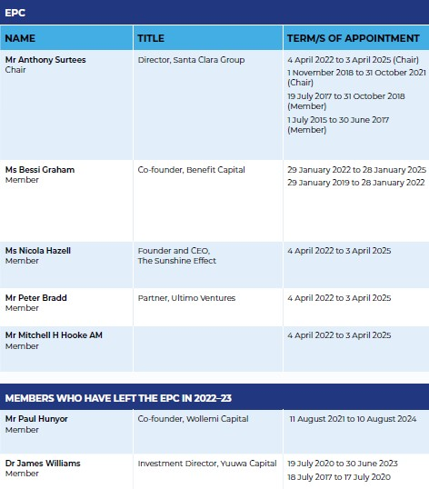

Cooperative Research Centres Advisory Committee (CRAC) members and terms
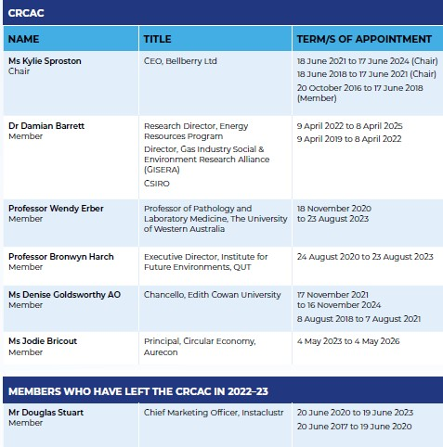

Acronym and Abbreviations List
A
AAT Administrative Appeals Tribunal
AC Accelerating Commercialisation
AFOF Australian Venture Capital Fund of Funds
AI Artificial Intelligence
AM Member of the Order of Australia
AMR Autonomous Mobile Robot
ANZLF Australian New Zealand Leadership Forum
AO Officer of the Order of Australia
APS Australian Public Service
ASX Australian Stock Exchange
ATO Australian Taxation Office
B
BMS Battery Management System
Board Industry Innovation and Science Australia Board
BRII Business Research and Innovation Initiative
BTF Biomedical Translation Fund
C
CEO Chief Executive Officer
CFO Chief Financial Officer
CO₂ Carbon dioxide
CRCs Cooperative Research Centres
CRCAC Cooperative Research Centres Advisory Committee
CRC-Ps Cooperative Research Centres Projects
CSIRO Commonwealth Scientific and Industrial Research Organisation
D
The department Department of Industry, Science and Resources
DISR Department of Industry, Science and Resources
Dr Doctor

E
EP Entrepreneurs’ Programme
EPC Entrepreneurs’ Programme Committee
ESVCLP Early Stage Venture Capital Limited Partnerships
EV Electric vehicle
F
FCA Federal Court of Australia
FY Financial Year
G
GDP Gross Domestic Product
GISERA Gas Industry Social and Environmental Research Alliance
GmbH German abbreviation for ‘company with limited liability’
I
IIC Innovation Investment Committee
ICT Information and Communication Technology
IISA Industry Innovation and Science Australia
IMCRC Innovative Manufacturing Cooperative Research Centre
IMR Innovation Metrics Review
Inc Incorporated
IP Intellectual Property
IR&D Industry Research and Development
IR&D Act Industry Research and Development Act 1986
L
LBS Lithium Battery Systems (business name)
Ltd Limited
M
MIHG Moving Injection Horizontal Gasification
MOU Memorandum of Understanding
MRCF Medical Research Commercialisation Fund
N
NIPF National Innovation Policy Forum
NRF National Reconstruction Fund
O
OIISA Office of Industry Innovation and Science Australia
OncoRes OncoRes Medical
P
PBT Pure Battery Technologies (business name)
PDF Pooled Development Fund
PDF Act Pooled Development Funds Act 1992
PhD Doctor of Philosophy
PSM Public Service Medal
Pty Ltd Proprietary Limited
Q
QUT Queensland University of Technology
R
R&D Research and development
R&DTI Research and Development Tax Incentive
RDIC Research and Development Incentives Committee
RMIT Royal Melbourne Institute of Technology
RSPs Research Service Providers
S
SME Small and medium-sized enterprise
SOE Statement of Expectations
SOI Statement of Intent
STEM Science, technology, engineering and mathematics
T
The Board The Industry Innovation and Science Australia Board
The department The Department of Industry, Science and Resources
U
UNSW University of New South Wales
US United States
V
VC Venture capital
VCLP Venture Capital Limited Partnership
VMS Virtual manufacturing system

Section 3 of the IR&D Act.
Refer to the next section: Financial responsibilities
Under the R&DTI program, businesses must register for the program within 10 months of the end of the income year during which the R&D activities were conducted. Therefore, for the 2022–23 financial year, most applications processed were for R&D activities conducted in 2021–22.
Under the R&DTI program, businesses must register for the program within 10 months of the end of the income year during which the R&D activities were conducted. Therefore, for the 2022–23 financial year, most applications processed were for R&D activities conducted in 2021–22.
The performance measure as outlined in the department’s Corporate Plan is that 95% of applications for registration of R&D activities are processed within 40 days for first-time registrants, 20 business days for registrants that have applied within 6 months after the end of the income period and 80 business days for registrations submitted from 6 to 10 months after the end of the income period.

