# Robotics and Automation on Earth and in Space Roadmap 2021-2030

The material in this publication is licensed under a Creative Commons Attribution - 4.0 International licence, with the exception of:

* the Commonwealth Coat of Arms
* any third party material
* any trademarks, and
* any images or photographs.

The terms under which the Coat of Arms can be used are detailed on the following website: pmc.gov.au/government/its-honour

Wherever a third party holds copyright in this material, the copyright remains with that party. Their permission may be required to use the material. Please contact them directly.

More information on this CC BY license is set out at the Creative Commons Website. Enquiries about this publication can be sent to:

Australian Space Agency

Lot Fourteen, McEwin Building. North Terrace, Adelaide, SA 5000

Phone: 1800 497 182 (within Australia) / +61 2 6276 1166

Email: [enquiries@space.gov.au](mailto:enquiries@space.gov.au)

space.gov.au

The Robotics and Automation on Earth and in Space Roadmap 2021-2030 is an Australian Government publication which will provide a vision for the next phase of space capability to drive economic growth and industry transformation.

© Commonwealth of Australia and the States and Territories of Australia 2022,

Published by the Australian Space Agency January 2022.

ISBN 978-1-922218-04-9 (E-book)

ISBN 978-1-922218-03-2 (Print)

### Attribution

Use of all or part of this publication must include the following attribution:

© Commonwealth of Australia 2022, published by the Australian Space Agency.

### Citation

Australian Space Agency (2022), Robotics and Automation on Earth and in Space Roadmap 2021-2030, January, available at space.gov.au

### Disclaimer

By accessing or using this publication, you agree to the following:

This publication is not legal or professional advice. Persons rely upon this publication entirely at their own risk and must take responsibility for assessing the relevance and accuracy of the information in relation to their particular circumstances.

## Head of Agency – Introduction



*Australia’s expertise in robotics and automation will support the next frontier on the lunar surface and beyond. Our vision is bold, built upon a strong backbone of demonstrated capability.*

### Robotics and Automation on Earth and in Space

The resources sector has been delivering economic growth and jobs to Australians for decades and is a cornerstone of Australian industry. Part of the success of the sector can be attributed to how it has embraced automation and remote operations technologies, which have flow-on safety and environmental benefits and create new job opportunities. The growth of analytics and robotics capabilities in the resources sector is estimated to add $74 billion to the economy by 2030 and create 80,000 new jobs.[1] There is a tremendous opportunity to leverage and diversify this expertise as we look to grow and transform the Australian space sector. For this reason, Robotics and Automation on Earth and in Space is a key priority area under the Australian Civil Space Strategy 2019-2028 (the Strategy), and this roadmap is the third in a series of technical roadmaps to be delivered by the Australian Space Agency.[2]

The application of robotics, especially remote operations and autonomous systems, to support humanity’s exploration and use of space has reached a significant inflection point. The Robotics and Automation on Earth and in Space Roadmap captures this opportunity and provides a bold vision, focused ambition and aspirational capability targets to support the growth of a globally respected and thriving industry in Australia.

### Harnessing opportunities in Foundation Services

The Robotics and Automation on Earth and in Space Roadmap outlines the ways Australia is well placed to engage with the challenges and opportunities presented by translating robotics, automation and remote operations technologies to space activities. Australian companies are already combining robotics technology with satellite communications to remotely service pipelines underwater, and are trialling Satellite-Based Augmentation Systems to assist in the precision control of mining vehicles. We are seeing increased demand for these technologies off-Earth, from intra-station cargo handling and logistics, to trusted robotic systems for interaction, to on-orbit assembly and manufacture, and in support of NASA’s Commercial LEO Destinations (CLD) and lunar exploration program, Artemis.

Robotics and automation technologies need to endure the extremely hostile conditions of the Moon and Mars. As this roadmap details, there is an opportunity for Australia to leverage off-Earth resources and pre-existing expertise to deliver what we are calling Foundation Services. These include applications such as remote monitoring, remote maintenance, site preparation, materials handling and transport, planning, and logistics – whether on the surface of the Moon, inside a station, or for facilities management. Foundation Services have also been identified as part of the exploration vision of the Trailblazer program, which is the signature element of Australia’s $150 million Moon to Mars initiative.[3] In October 2021, it was announced that the Trailblazer program would support the industry-led development of a small Australian-made ‘Foundation Services rover’ that aims to showcase Australia’s capabilities in remote operations and autonomous systems on the Moon.

### A shared mission

This roadmap is underpinned by our values of being a responsible spacefaring nation. Australia is a State Party to the five international space treaties, and we were proud to further signal our commitment to the peaceful and safe use of outer space when we became a founding signatory to the Artemis Accords in 2020. We will continue to ensure our activities in space are consistent with our obligations, sustainable, and worthy of international respect.

The Robotics and Automation on Earth and in Space Roadmap is the collective achievement of Australian Government, industry and the research sector. It demonstrates the inherent value of consultation and collaboration in the transformation and growth of a globally respected and responsible Australian civil space sector.

This roadmap is an important milestone on our road to achieving 20,000 new jobs and tripling the size of the civil space sector to $12 billion by 2030.

**Enrico Palermo**

Head, Australian Space Agency

January 2022

## National Civil Space Priority Areas

### Roadmap development approach

*An aligned, connected, and informed Australian space sector that is united behind a shared vision for each Civil Space Priority Area and clear pathways to meeting our ambitions.*

### Roadmaps guiding principles

Development of technical roadmaps for each of the Civil Space Priority Areas is an action identified in the national space pillar of the Strategy. The roadmaps serve to provide strategic direction for the sector, and to inform and guide opportunities to support the growth of the industry. Each roadmap identifies necessary activities and supporting conditions for achieving the vision in each Civil Space Priority Area on a 10 year horizon. Their development and implementation are guided by the following principles:

* Describe a pathway to uplift capability in a manner that enables the tripling of the size of the Australian space sector to $12 billion and the creation of up to an extra 20,000 jobs by 2030
* Identify and engage with opportunity - aligning activities by consulting widely and deeply with industry, researchers and government agencies
* Encourage organisations to invest resources and efforts where they want to pursue the opportunities identified in the roadmaps
* Reinforce the role of government as a partner, facilitator and regulator for, and customer of, the sector (in line with the Strategy, including its investment principles).

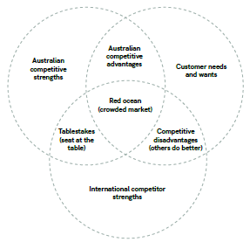

### Roadmap priorities and inclusions

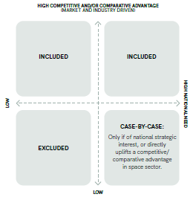

The roadmaps chart capability developments, rather than detailed technology developments, so industry and government researchers can drive innovation and have flexibility in their delivery.

To be included, a capability must:

* Strive towards bold visions and ambitions that align with the Strategy, and
* Have the potential to synergise with other selected capabilities to uplift the sector in an enduring manner, and
* Be based on a comparative or competitive advantage (a domestic government or commercial market opportunity for which Australia has a competitive strength), and/or
* Be an area of national strategic interest, or
* Be a necessary input to realise another included capability.

The roadmaps prioritise capabilities that are essential to the stated vision and ambition for each pathway. Opportunities exist outside the pathways that may still be pursued by the Australian space sector.

The roadmaps also include supporting conditions that would harmonise, support and facilitate the growth of these capabilities. These are prioritised according to their capacity to address challenges and foster opportunity.

## Approach to developing the roadmaps

The Australian Space Agency worked together with industry, researchers and Australian Government agencies to develop each roadmap. Feedback and support to the validation of the assessments of Australia’s state-of-the-art capabilities, technologies and opportunities were provided by peer space agencies and stakeholder organisations.

### Phase 1: Assess opportunity

* State-of-the-art assessments identify and evaluate Australia’s key strengths in the global context. Consideration is made for the ecosystem and value chain, spin-in potential from adjacent sectors, national application needs, strategic value, growth trends and market gaps.
* Australia’s competitive advantages are identified, with capabilities assessed and gaps validated along with their opportunities, risks and barriers.

### Phase 2: Set targets

* A strategic direction is set via the definition of targets for 2030 including: the vision - an aspirational statement about Australia’s future capabilities, and the ambition - a positional statement about Australia’s future role.
* Focus segments are areas of greatest opportunity for the Australian space sector within the Civil Space Priority Area over the next decade. The focus segments interplay strategically to achieve the vision and ambition. Focus segments and related objectives (sub-visions), outcomes (sub-ambitions) and capability targets are defined based on identified opportunities.

### Phase 3: Devise pathways

* Pathways are developed to set the action plan towards achieving the targets and roadmap objectives.
* The roadmap pathways diagram presents an action plan to be led by the space industry, and facilitated by the Australian Space Agency where appropriate, towards achieving the roadmap objectives.
* Capabilities are mapped along the core paths to the targets, together with external drivers that influence the roadmap. These should be captured or mitigated to progress the capability pathways and non-technical facilitating activities (facilitators).

### Phase 4: Enable implementation and monitor progress

* The roadmaps will guide future investment in Australian industry and inform Australian Space Agency activities under the four space pillars in the Strategy.
* Progress against the roadmaps will contribute to the Australian Government’s goals to grow the industry. Their development during Phase 2 of the Strategy ‘Engaging with Opportunity’ (2019 to 2020) will support Phase 3 - ‘Delivering Success’ (2021 to 2028). Progress will be monitored via future State of Space reports and other publications.
* The roadmaps will be updated regularly to allow for refinement as the sector develops.

## Roadmaps audience

The roadmaps are for all Australian space sector stakeholders, including industry, governments, researchers, the future workforce, investors and international partners. The roadmaps can also inform stakeholders in adjacent sectors, including mining and energy, defence and national security, agriculture and natural resources, remote medicine, and environmental and disaster management. These stakeholders could extend their existing capabilities into the space sector, leverage expertise in the space sector or become customers of the sector.

## Seven interconnected roadmaps

The Civil Space Priority Areas are interconnected, reliant on cross-cutting technology areas, facilitated by non-technical enabling activities, and may be applied to many cross-cutting services.

The roadmap for each Civil Space Priority Area details the significance of these factors to its implementation. The roadmaps nexus illustrates the strategic interplay of these important categories.

The roadmaps identify areas of opportunity for industry including investment, as well as identifying areas where government could provide effective investment to deliver on the Strategy. They also link to a range of cross-cutting technology areas, for example there are strong links between these roadmaps and the Modern Manufacturing Strategy where space is a priority sector.

## Roadmaps nexus

### Identifying growth activities

National Civil Space Priority Areas: Communications technologies and services, Earth observation, Robotics and automation on Earth and in space, Leapfrog R&D, Space situational awareness and debris monitoring, Position navigation and timing, Access to space.

Cross-cutting technology areas: Advanced manufacuring, Cybersecurity, Interoperability, Digitised and data driven systems engineering, Platform-based architectures, Artificial intelligence 

Cross-cutting services:
Disaster risk management, Remote industry, environment and resource management, Exploration services, Science services, National security

Facilitators:
Investment and policy, Governance and coordination, Industry resilience, workforce and skills, Regulation and standards, Social licence and sustainability 


### Diagram: NATIONAL CIVIL SPACE PRIORITY AREAS

Communications technologies and services, Earth observation, Robotics and automation on Earth and in space, Leapfrog R&D, Space situational awareness and debris monitoring, Position navigation and timing, Access to space.

### Cross-cutting technology areas

Key technology areas from the broader economy have been identified that should underpin Australia’s future space capability. Leveraging these will foster a more robust development pathway. Government, including the Australian Space Agency, is supporting this through its activities. For example, space has been identified as a national manufacturing priority.

Cross-Cutting Technology Areas boxes: Advanced manufacturing, Artificial intelligence, Cybersecurity, Interoperability, Digitised and data driven systems engineering, Platform-based architectures.

### Cross-cutting services

Cross-cutting services are areas of high opportunity and enduring priority for the application of Australian space capability. They are based on both national need and market considerations. They each draw upon capabilities spanning more than one Civil Space Priority Area. Further service application areas are in scope but are considered within the domain of their relevant Civil Space Priority Area. Sourcing first customers for these applications is critical to capability realisation.

Cross-Cutting Services boxes: Disaster risk management, Remote industry, environment and resource management, Exploration services, Science services, National security.

### Facilitators

Facilitators enable progress towards reaching the targeted capabilities. They provide the supporting conditions to contribute to addressing challenges identified by the Australian space sector and streamline the path to achieving the roadmap visions. Together, the implementation of these facilitators will foster environments conducive to impactful research and development (R&D), and to a dynamic and robust commercially-focused ecosystem favourable to new business ventures.

Facilitators boxes: Investment and policy, governance and coordination, Industry resilience, workforce and skills, Regulation and standards, Social licence and sustainability.

## Opportunities off-Earth are rising

Australia excels in large-scale remote asset management and Earth-based robotics in harsh environments. Future space operations rely on these capabilities. Australia can leverage its experience to support rapidly growing off-Earth activities such as construction, maintenance and repair of lunar infrastructure. This is a unique opportunity for Australian organisations to grow into new markets and, through access to advanced technologies, improve the lives of people on Earth.

### New worlds within reach

As barriers to entry decrease, space exploration is experiencing the greatest market growth of the global space sector, with an estimated 23 percent Compound Annual Growth Rate (CAGR)[4] and a USD2.7 trillion market anticipated by the 2040s.[5] Space exploration offers a new frontier for Australian industry to secure a competitive lead in the construction, operation and maintenance of space assets and infrastructure.

The traditional terrestrial environments of land, sea and air are well-established market domains with long histories of technical development. Space is the next physical domain, and Australia has a narrow window of opportunity to become a trusted manufacturer and responsible key player in the growing long-term market. Australia must make the most of this opportunity by building on its experience and translating its competitive advantages to establish itself as an attractive partner.

### Robotics and automation on Earth and in space enable:

* **Commercial and strategic opportunity.** Australia could become an established Artemis Program partner nation and space industry player, by leveraging competitive strengths and experience in related fields such as planetary science.[6]
* **Leadership in sustainable off-Earth economic development.** Australia is uniquely positioned to deliver responsible and sustainable services to support exploration, and consequently provide strong and sustained economic leadership on Earth and in space.
* **Future workforce**. By inspiring the next generation and attracting global talent, Australia’s contribution to space activities will support the growth of a high-tech STEM-educated workforce and a bright, exciting future.
* **Socioeconomic game changers.** With new, flexible employment opportunitiesto develop and manage systems in space via remote operation, Australians can access skilled jobs from anywhere in Australia.
* **On-Earth development.** By meeting the challenges of activity off-Earth, new skills and methods will be developed for deployment here on Earth, especially in areas such as energy, resources and agriculture.
* **Digital enhancement of the economy**. Keeping at the forefront of artificial intelligence (AI) including machine learning (ML), automation and other technologies that underpin digitalisation and automation.

In the context of this roadmap, robotics and automation (R&A) refers to robotic systems as well as controlling them to conduct activities and deliver services in remote locations.

Key focus segments:

Remote Operations, Interoperability, Analogue facilities and services, Robotics platforms, In-Situ Resource Utilisation (ISRU), Foundation Services

## What is Robotics and Automation?

In the context of this roadmap, robotics and automation (R&A) refers to robotic systems as well as controlling them to conduct activities and deliver services in remote locations.

This includes the full spectrum of automated to autonomous capabilities for controlling a range of robotic assets – such as satellites, infrastructure, facilities and robotic platforms – and ensuring those assets can work together in a safe and trusted system. Australia has terrestrial R&A capabilities that can be exported into space to deliver beneficial outcomes, and the lessons from that process can subsequently be translated back to industries on Earth. Asset operation and service delivery are underpinned by capability across the key R&A elements described below.

### Remote Operations

Remote Operations is the ability to manage, monitor and control an activity where the operator is separated (in most cases) from the activity site.[7] It includes (but is not limited to) scalable operations of multi-asset systems and facilities involving robotic control, enabled by appropriate levels of automation, autonomy and interoperability across all levels of the system architecture.

### Interoperability

Interoperability is a characteristic of a process or system in which the primary interfaces are well defined and all subsystems can be readily and effectively interconnected to achieve a desired systems-level outcome.

### Analogue facilities and services

Terrestrial analogues are field sites and facilities (natural or synthetic) with specific characteristics that simulate properties of a targeted planetary space environment.

### Robotic platforms

Robots are programmable mechanisms designed to operate in known, unstructured or dynamic environments and perform tasks such as assembly, servicing, manipulation or mobility. Robotics is an interdisciplinary field that incorporates engineering and computer science, and involves the design, construction and operation of robots. Platform-based architectures provide flexibility and support innovation by allowing various components to interface together in a standardised manner.

### In-Situ Resource Utilisation (ISRU)

ISRU is the use of local resources available on other planetary bodies to carry out activities on site, minimising the need to bring heavy and expensive resources on space missions. ISRU examples include the use of bulk regolith for shielding, water for drinking and fuel, and oxygen for breathing.

### Foundation Services

Foundation Services are operational services that support exploration missions to build towards (and eventually maintain) a sustained off-Earth presence. They are services for which demand is recurrent, continuous or enduring. The scope of Foundation Services covers monitoring and inspection, planning and logistics, civil construction, materials transport and cargo handling, remote maintenance, salvage, and component manufacture and assembly. Foundation Services are distinctive but complementary to mission critical systems such as power, communications and life support.

Foundation Services utilise and draw together capabilities from the other listed elements.

### NASA Artemis Program

The NASA Artemis Program aims to return to the Moon, establish a sustained human presence on the lunar surface, and subsequently journey on to Mars. Australian R&A capabilities present an area of opportunity for Australia to contribute to this type of mission activity, in a way that is consistent with our international obligations.

### <Call out box>

International law and norms of behaviour provide for a safe, stable and sustainable outer space environment, and a means to address emerging issues, including in outer space. As a State Party to the five international space treaties, and a founding signatory to the Artemis Accords, Australia supports the exploration, exploitation and use of space resources in a manner consistent with international law, in a way that supports the long-term sustainability of outer space, and our aim to grow a globally respected Australian space industry.

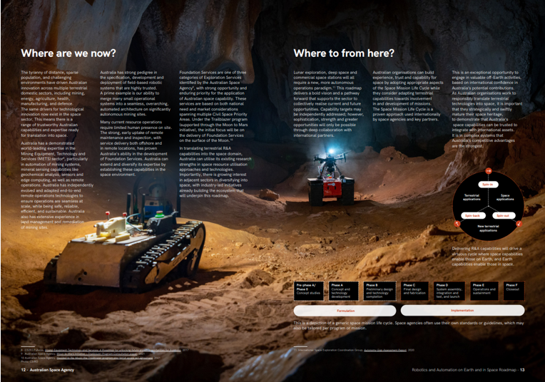

## Where are we now?

The tyranny of distance, sparse population, and challenging environments have driven Australian innovation across multiple terrestrial domestic sectors, including mining, energy, agriculture, health, manufacturing, and defence. The same drivers for technological innovation now exist in the space sector. This means there is a range of trustworthy Australian capabilities and expertise ready for translation into space.

Australia has a demonstrated world-leading expertise in the Mining Equipment, Technology and Services (METS) sector[8], particularly in automation of mining systems, mineral sensing capabilities like geochemical analysis, sensors and edge computing, as well as remote operations. Australia has independently evolved and adapted end-to-end remote operations technologies to ensure operations are seamless at scale, while being safe, reliable, efficient, and sustainable. Australia also has extensive experience in land management and remediation of mining sites.

Australia has strong pedigree in the specification, development and deployment of field-based robotic systems that are highly trusted. A prime example is our ability to merge many small operational systems into a seamless, overarching, automated architecture on significantly autonomous mining sites.

Many current resource operations require limited human presence on site. The strong, early uptake of remote maintenance and inspection, with service delivery both offshore and in remote locations, has proven Australia’s ability in the development of Foundation Services. Australia can extend and diversify its expertise by establishing these capabilities in the space environment.

Foundation Services are one of three categories of Exploration Services identified by the Australian Space Agency[9], with strong opportunity and enduring priority for the application of Australian space capability. These services are based on both national need and market considerations spanning multiple Civil Space Priority Areas. Under the Trailblazer program (supported through the Moon to Mars initiative), the initial focus will be on the delivery of Foundation Services on the surface of the Moon.[10]

In translating terrestrial R&A capabilities into the space domain, Australia can utilise its existing research strengths in space resource utilisation approaches and technologies. Importantly, there is growing interest in adjacent sectors in diversifying into space, with industry-led initiatives already building the ecosystem that will underpin this roadmap.

Graph is descriped in surrounding text.


*<Text next to virtuous cycle diagram>* Delivering R&A capabilities will drive a virtuous cycle where space capabilities enable those on Earth, and Earth capabilities enable those in space.

*<Footnote or text next to the Space Mission Life Cycle Diagram>:* This is a depiction of a generic space mission life cycle. Space agencies often use their own standards or guidelines, which may also be tailored per program or mission.

## Where to from here?

Lunar exploration, deep space and commercial space stations will all require a new, more autonomous operations paradigm.[11] This roadmap delivers a bold vision and a pathway forward that supports the sector to collectively realise current and future opportunities. Capability targets may be independently addressed; however, sophistication, strength and greater opportunities will only be possible through deep collaboration with international partners.

Australian organisations can build experience, trust and capability for space by adopting appropriate aspects of the Space Mission Life Cycle while they consider adapting terrestrial capabilities towards involvement in and development of missions. The Space Mission Life Cycle is a proven approach used internationally by space agencies and key partners.

This is an exceptional opportunity to engage in valuable off-Earth activities, based on international confidence in Australia’s potential contributions. As Australian organisations work to responsibly translate terrestrial technologies into space, it is important that they strategically and swiftly mature their space heritage, to demonstrate that Australia’s space capabilities can be trusted to integrate with international assets. It is in complex systems that Australia’s competitive advantages are the strongest.

## Image of surround text.

## VISION

Australia will build, operate and maintain off-world infrastructure and assets to expand, support and sustain humanity on Earth and in space, in a manner that supports the long-term sustainability of outer space.

## AMBITION

Australia is the leading, trusted and responsible provider of Foundation Services, providing critical solutions into the global marketplace that enable and support the sustained build-up of space assets and infrastructure.

## Focus segments

Australia’s pedigree in adjacent sectors can be leveraged to address emerging space demand in each focus segment.

Six focus segments have been identified as the priorities for Robotics and Automation on Earth and in Space capability development. These are considered to be the areas of greatest opportunity for the Australian space sector, where there is high potential to deliver to the market with competitive and comparative advantage over the next decade. Manufacturing capabilities are also woven into each of the focus segments, such as the manufacturing of robotic systems and tools to deliver Foundation Services.

* Remote Operations
* Interoperability
* Analogue Facilities and Services
* Robotic Platforms
* In-Situ Resource Utilisation
* Foundation Services

## Facilitators

The Australian Government will continue to work across the sector to grow the economy and create jobs by ensuring the facilitating conditions are right.

### Investment and policy:

* The Australian Government has committed more than $800 million to grow the civil space sector, with $255 million allocated through the Australian Space Agency to implement the Strategy. This includes a focus to deliver, create or expand programs and implementation opportunities that will support Australian participation in important Artemis Program functions, and other activities such as the $150 million Moon to Mars initiative and the Modern Manufacturing Initiative.
* There is an opportunity for the Australian Government to help scale the industry by being an initial anchor customer, to support the growth of the industry and position it to lead. Fostering long term investment from across the sector together with a regular cadence of industry-driven missions involving the focus segments will also be key.

### Governance and coordination:

* Foster the Agency’s ongoing role as the coordinator of national civil space activities – supporting it to consult with the domestic and international sector, strengthen relationships, and provide strategic advice on opportunities for further implementation based on global best practice.
* Foster ongoing trusted relationships between industry and the Australian Government, with a commitment to creating near-term market opportunities aligned with roadmap targets.
* The Agency will continue to embrace its values, taking an entrepreneurial approach on bold, shared long-term ambitions to amplify strategic outputs of this roadmap that drive target outcomes for industry.
* The applicability of Robotic and Autonomous Systems spans both civil and military applications, with Defence also identifying Space (in addition to Robotics, Autonomous Systems and Artificial Intelligence) as a Sovereign Industrial Capability Priority. Ongoing collaboration between the Australian Space Agency and Defence in these opportunities has significant potential, particularly with robotics and automated systems present in all Defence domains.

### Industry resilience, workforce and skills:

* Support growth of space heritage and space systems engineering capacity through participation in demonstration missions that are ambitious and highly visible. This will highlight the Australian space sector to international supply chains and generate commercial opportunities.
* Open doors for Australian scientists to participate in international science and research teams and vice versa, affording Australia great access to findings that strengthen the sector.
* Foster the transfer of knowledge from overseas and other industries into the space industry through secondments, exchange programs and access to regular mission opportunities, which will help grow and sustain a robust ecosystem.
* Explore and consider opportunities to incentivise and utilise intellectual property sharing at a national level, to help build an internationally competitive ecosystem.

### Regulation and standards:

* Inform Australian organisations of emerging standards, norms and processes, to realise space readiness and capture supply chain opportunities.
* Support the development of possible frameworks, including common language and terminology with adjacent sectors, and content relevant to space resources, which ensure sustainable activities – for example through the Committee on the Peaceful Uses of Outer Space (COPUOS).

### Social licence and sustainability:

* Reinforce Australia as a responsible spacefaring nation, ensuring the nation’s activities support the long-term sustainability of outer space.
* Support the open sharing of scientific data and results obtained from activities, where appropriate.
* Ensure that technology development can continue to support the global economy here on Earth – including job creation, the transfer of knowledge to other sectors like mining, and industrial automation in Australian regions.
* Support development of norms around ISRU that are consistent with Australia’s international obligations, for example in relation to waste, disturbance, and remediation; and potentially informed by the processes and practices already in place in the resources sector.
* Draw and share lessons from adjacent industries, such as mining site remediation, to support sustainable practices in space.
* Maintain close consultation with, and appropriate considerations for, traditional landowners of terrestrial analogue sites.

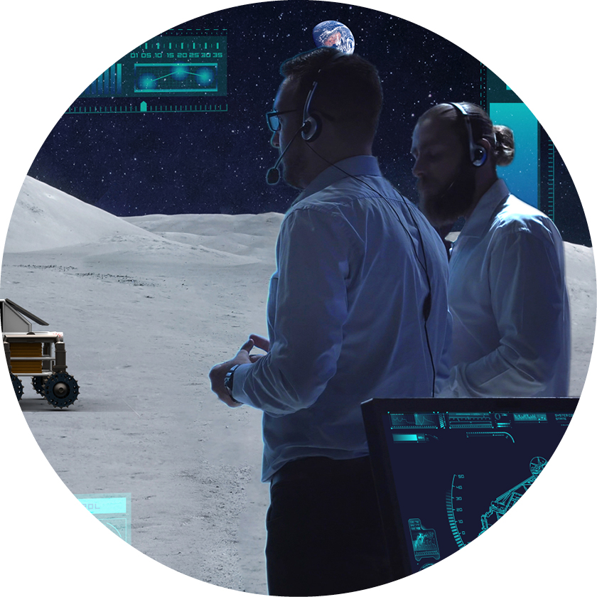

## Remote Operations

Australia is recognised as a world leader in remote operations[12], notably large-scale end-to-end systems. To address challenging environments, Australia has independently evolved and adapted remote management technologies that are safe, reliable, sustainable, productive, and readily scalable.

### Opportunity

Australia has a substantial opportunity to deliver sophisticated remote operations off-Earth by translating its ability to manage mixed multiple assets, mixed fleets, and concurrent operational processes and functions that augment situational awareness and support decision-making.

Communication systems are essential to remote operations. From historic involvement with the NASA Deep Space Network to evolving Internet of Things (IoT) capabilities, Australia has strong foundational infrastructure for fully integrated operations on Earth and in space. These systems are expanding to meet greater needs and are underpinned by the Australian Space Agency’s Communications Technologies and Services Roadmap.[13]

### Objective

Australia will provide remote operation services using state-of-the-art technology to manage space activities, and deliver enduring services through national remote operations facilities linked to distributed operation and control centres across the world. 

### Outcome

Australia is the preferred partner for providing highly complex, integrated and secure remote operation services, with demonstrated world-leading expertise in sustaining surface, sub-surface and multi-asset operations with due care for the operating environment.

### SEGMENT Target Capabilities

* Establish and operate the Australian Space Automation, Artificial Intelligence and Robotics Control Complex (SpAARC)
* Operate and link Australian Remote Operations Centres (ROC)
* Demonstrate use of an end-to-end sovereign chain of control for lunar activities
* Provide logistics and asset management services as part of Foundation Services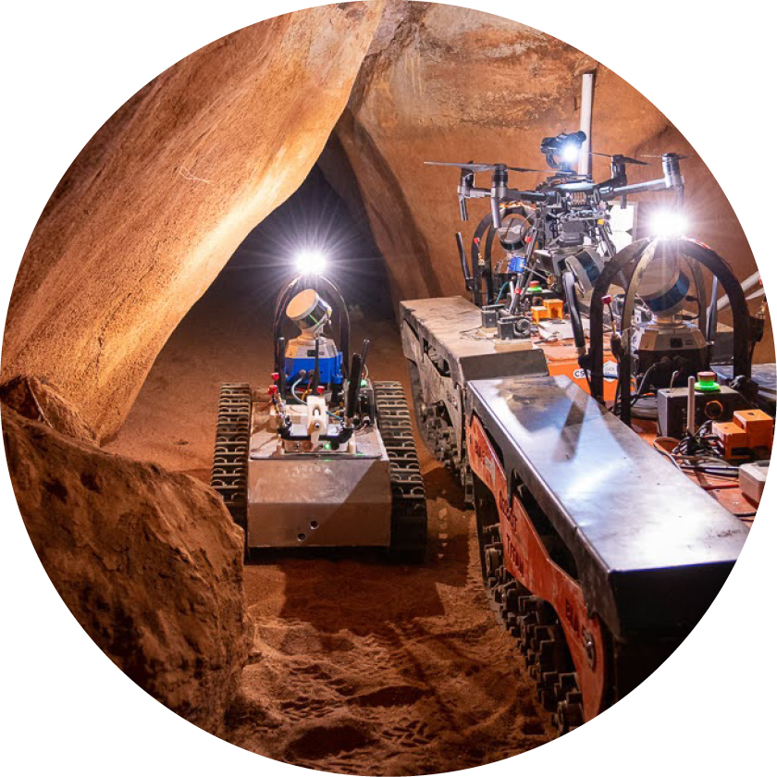

## Interoperability

Interoperability is a critical requirement for successful operations in space environments, and is identified as an essential element of the Artemis Accords.

### OPPORTUNITY

Facilitated by industry experience, such as in the resources sector[14], Australia is growing its presence and expertise within interoperability in off-Earth systems. By bridging mission-critical interoperability gaps with well-defined and effective standards, along with the skills to create them, Australia can offer interoperability support services to the international space community and adjacent sectors as a trusted advisor and supplier.

Australia can enable new interoperability capabilities, targeting the development of specific skills and expertise. This would involve coordinating and creating new standards where appropriate to accelerate Australian research and development efforts together with adjacent industries and international partners (including a common language and terminology), along with methods and facilities to ensure system compliance through formal verification and validation. This will encourage participation and cooperation, as properly designed, reviewed and implemented interfaces and standards will reduce the barriers to entry for new missions with whole-of-system design.

### OBJECTIVE

Australia will create, deploy and support a set of interoperable services that enable rapid development, interconnection and validation of multi-component technologies, systems and data streams.

#### OUTCOME

Australia is recognised within the space community as a key contributor and trusted proponent of applied interoperability to achieve effective integration and operation between robots, infrastructure, humans, payloads and platforms.

### SEGMENT Target Capabilities

* Develop systems, process architecture and reference designs
* Develop and promote interoperable systems interfaces
* Develop well-defined systems behaviour and function
* Establish an Australian facility for co-design and interoperability verification and validation

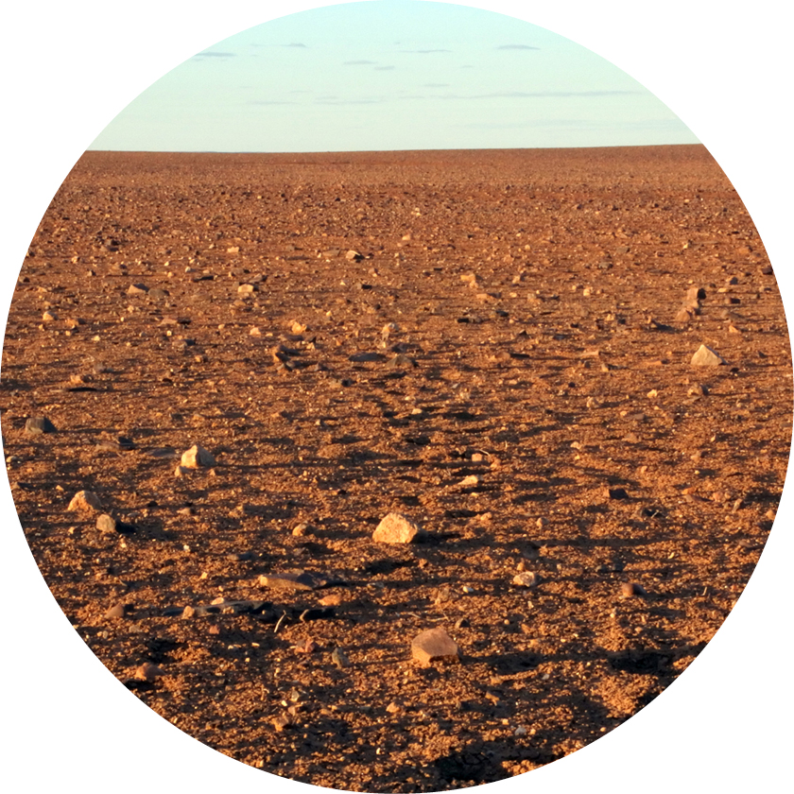

## Analogue facilities and services

Australia's access to unique geological landscapes provides great opportunities to host field-based validation and technology demonstrations of off-Earth mission campaigns.

### OPPORTUNITY

Australia offers a unique network of field sites with varied landscapes and geological histories – such as the Pilbara, Moon Plain and Shark Bay regions, and Antarctic research stations. These environments can be used for research, robotics and ISRU testing, with access via integrated remote operations and testing hubs. Informed by knowledge of planetary materials, these physical and virtual facilities enable practical evaluation in analogous operational environments, heralding a new domestic space service that will accelerate and de-risk space technology and systems development.

Once achieved, Australian facilities will be recognised for hosting international researchers and as a unique set of terrestrial analogue services that provide evaluation environments highly representative of specific locations in lunar and Martian contexts.

#### OBJECTIVE

Australia will offer terrestrial analogue test-bed facilities and services to undertake essential field testing and systems validation for planetary surface operations.

### OUTCOME

Australia’s world-class analogue facilities and services are sought-after by the domestic and international space community to accelerate the development and validation of technologies and systems for international space missions.

### SEGMENT Target Capabilities

* Centralised coordination of multi-location analogue facilities, and services coordination of analogue test-bed facility development and service provision
* Establish a national advisory panel of experts
* Develop field sites in the context of planetary materials and environments
* Construct analogue test-beds
* Develop digital analogues

## Robot on a rocky landscape.

## Robotic platforms

Australia has an unprecedented opportunity to expand its existing field robotic systems capabilities to address known space technology challenges[15]. By implementing robotic platforms, Australia can deliver Foundation Services and ISRU via remote operations.

### OPPORTUNITY

By focusing on the development of robotic systems that are multi-vendor, multi-use and inherently scalable, Australia can activate new opportunities for all segments of the space robotic supply chain. It can also create new and enhanced classes of modular, collaborative robotic platforms, optimised for planetary operations. This builds on the nation’s strong heritage in advanced perception and development of rugged and robust field robotics.

Many small and frequent missions with payload agnostic systems and interoperable standards enable the rapid development and iteration of these systems and capabilities. Robotic systems are a critical tool needed to maximise interoperability and production, and consequently address major challenges in the build-up phase of off-Earth infrastructure.

### OBJECTIVE

Australia will design, manufacture and deploy a range of versatile and robust robotic components, systems and platforms, supporting the development of a self-sustaining domestic space robotics industry.

### OUTCOME

Australia delivers innovative robotic systems and components that are highly utilised and in strong demand, significantly advancing the operational capability in planetary environments.

### SEGMENT Target Capabilities

* Develop autonomous systems that are trusted, robust, persistent and collaborative
* Sense, perceive, and collect in-situ data, as well as model awareness of the system and environment, to support autonomy
* Develop and deploy mobility platforms
* Perform reliable locomotion in complex terrains
* Utilise AI, edge computing, distributed computation and non-traditional computation architectures, and sensing technologies
* Develop practices for resilient mission-critical hardware and software

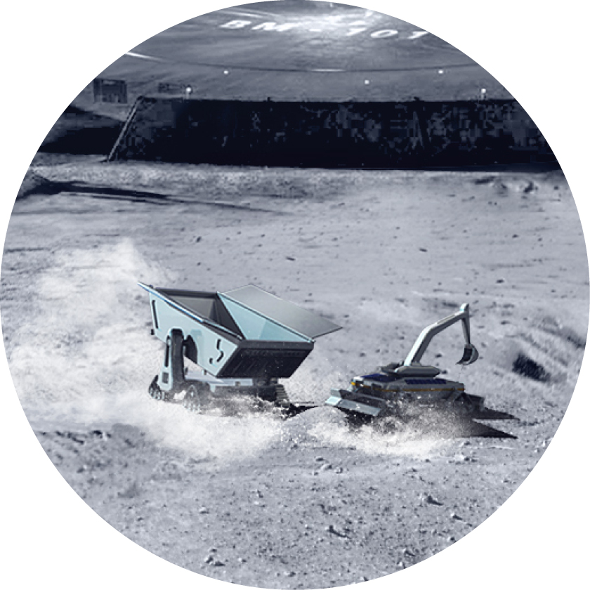

## In-Situ Resource Utilisation

The ability to generate products in-situ minimises the requirement to transport materials from Earth. This can significantly reduce the mass and cost associated with space mission architectures, while expanding scientific knowledge.

### OPPORTUNITY

Significant near-term opportunities exist for Australia to adapt terrestrial approaches to develop ISRU system technologies and components. This includes devising new architectural-level and programmatic approaches adapted to the off-Earth context. Of specific interest are capabilities supporting resource-centric activities that are valuable inputs to science for exploration, technological advancement, and core operations during the build-up phases of off-Earth infrastructure.[16] Ongoing opportunities exist for systems that support creation of the full resource-to-product value chain.

ISRU enhances mission flexibility and scope – a critical need that Australia can help meet. This is vital in supporting an accelerated build-up of responsible services and infrastructure, and therefore represents a long-term risk reduction strategy. The NASA Artemis Program signals a strong near-term demand, with resource provision a major driver in upcoming decades for missions to both the Moon and Mars.

Australia is also in a unique position to support the development of possible frameworks that enable sustainable activities in space with the international community, such as the utilisation of space resources, for example through COPUOS.

### OBJECTIVE

Australia will leverage its world-class expertise in mining processes, resource technology products and associated services to provide critical products that radically improve infrastructure build-up and sustained operations, and support the long-term sustainability of outer space.

### OUTCOME

Australia is recognised as a responsible spacefaring nation – as well as a major contributor to, and enabler of, off-Earth ISRU technologies that support and sustain long-term human and robotic missions.

### SEGMENT Target Capabilities

* Undertake resource prospecting
* Perform site and resource assessment
* Perform resource extraction
* Manage preparation of resources
* Process resources

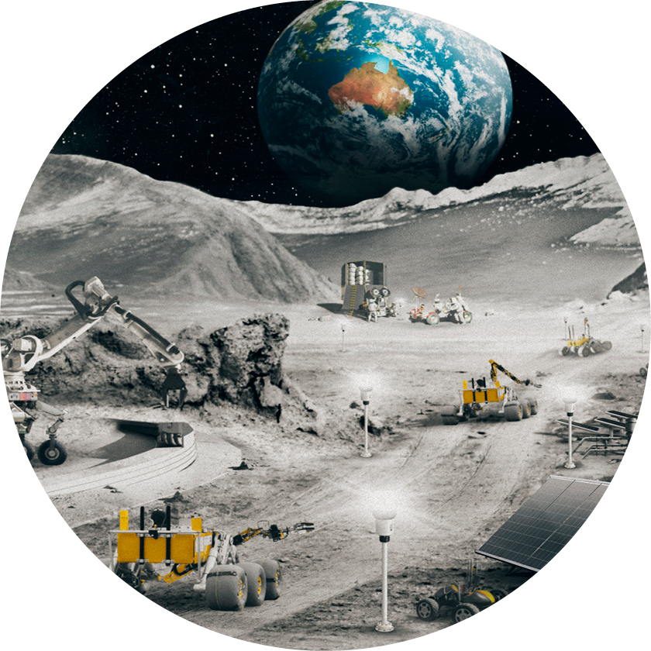

## Foundation Services

Foundation Services fulfil a set of core supportive processes and systems that are necessary in planning, establishing and sustaining planetary activity. These services provide core functions that are required during every stage of off-Earth infrastructure build-up.

### OPPORTUNITY

Australia has significant expertise in remotely managing assets that deliver terrestrial Foundation Services, such as materials handling and transport. By leveraging this experience, substantial opportunities exist for Australia to support the international effort to build up planetary infrastructure and space activity. Australia can use its capabilities to realise a long-term flagship role in Foundation Services, delivering capabilities such as civil works, asset maintenance and component manufacturing. This would add unique value to the global space exploration ecosystem and further its endeavours, while opening up associated market opportunities for Australians.

Targeted near-term opportunities in growing lunar surface markets can be explored in parallel, with smaller immediate opportunities for in-station cargo handling and logistics. This will position Australia well to seize longer-term market possibilities, such as assembly and manufacture in space, and support for surface and subsurface complex multi-asset systems and infrastructure at scale.

### OBJECTIVE

Australia will expand and create a set of sustainable core services that contribute essential operational capability in support of key infrastructure build-up for enduring planetary presence.

### OUTCOME

Australia is an essential contributor to the development and provision of Foundation Services in the international space industry, and is recognised as a responsible spacefaring nation that supports the development and implementation of sustainable practices.

### SEGMENT Target Capabilities

* Monitor, plan and coordinate asset utilisation
* Resource and materials handling logistics
* Conduct primary construction and civil works
* Remote inspection, maintenance and salvage
* Component manufacture and assembly

## Pathways

### Graph of the robotic roadmap explain in surrounding text.

## Setting the conditions for the 2030s

At the end of this decade, the Australian Government aims to see an Australian space sector worth around $12 billion that will sustain around 30,000 jobs. While these jobs are within the space sector, the economic impact will significantly benefit Australians on Earth. Looking into the 2030s and beyond, Australian Government investment in the four space pillars of Inspire, National, International and Responsible will set the conditions for Australia to realise significant social and economic benefits.

While this roadmap has an off-Earth space technology focus, it is only achievable with a diverse and highly skilled STEM workforce. STEM professionals not only enable the space sector, but provide skills transferable to other sectors. As a more digitised nation in a more connected world, Australia can leverage the Civil Space Priority Areas to advance its economy and society back here on Earth. In preparing for the 2030s, Australia’s role as an emerging spacefaring nation can be further enhanced by:

* expanding capability towards more complex, and more commercial space infrastructure
* delivering operational services in preparation for and in support of a human presence for sustained off-Earth activities, and towards in-space assembly and manufacturing activities
* further opportunities for Australian robotic and automation capabilities beyond Artemis, including also commercial Low Earth Orbit (LEO) facilities and On-orbit Servicing, Assembly, and Manufacturing (OSAM) activities
* astronaut support and intervention when robotic systems are not suitable for a task
* development of off-Earth infrastructure and lunar construction programs
* a stronger power supply for sustainable ISRU and Foundation Services pursuing opportunities to extend capabilities outwards towards Mars, asteroids and other celestial bodies
* sustaining a long-term presence on the Moon through the development of infrastructure that contributes to both a human lunar presence and risk reduction for human Mars exploration[17]
* utilising capabilities across the Civil Space Priority Areas, such as quantum technologies for prospecting; Earth observation, space situational awareness and IoT technologies for in-situ environment management and asset monitoring; and translating R&A capabilities to realise greater scalability in satellite and ground systems
* streamlining technology and workforce translation and diversification between space and adjacent sectors
* further attraction and mobilisation of private capital and resources

This roadmap presents a common vision for the sector, as well as dynamic pathways towards seizing opportunities and achieving the sector’s potential. As the roadmap progresses towards the targeted capabilities, new competitive advantages may emerge that call for the development of further capabilities and facilitators.

Australia’s future position in this area depends on strong action within this decade that will ensure the nation and sector is well-positioned for new opportunities.

*The Australian Space Agency will periodically review and update this roadmap in collaboration with the sector.*

## Acknowledgements

The Australian Space Agency is grateful to all those who participated in the roadmap’s development to refine the analysis of Australia’s capabilities and hone in on the best opportunities for our industry’s future.

* CSIRO (Commonwealth Scientific and Industrial Research Organisation)
  + Data61
  + Mineral Resources
* Australian Government, Department of Defence (Defence Science and Technology Group)
* University of New South Wales Sydney
* Curtin University
* Queensland University of Technology (QUT)
* The University of Adelaide
* The University of Western Australia
* The University of Sydney
* Monash University
* Swinburne University of Technology
* Australian Institute for Machine Learning
* Australian Remote Operations for Space and Earth (AROSE)
* METS Ignited
* SmartSat Cooperative Research Centre
* Office of National Intelligence
* Trusted Autonomous Systems Defence Cooperative Research Centre (TAS DCRC)
* Australian Trade and Investment Commission
* Australian Academy of Science
* Robotics Australia Group
* Space Industry Association of Australia

## Quote

"…In land of heat and drought,

We followed where our fortunes led,

With fortune always on ahead

And always further out."

* Banjo Paterson

*Footnote: From ‘The Old Australian Ways’ by A.B. (Banjo) Paterson, Rio Grande’s Last Race, 1902*

1. Industry Growth Centres [METS Ignited](https://metsignited.org/) and NERA, [*Report: Staying ahead of the game*](https://www.nera.org.au/Publications-and-insights/Staying-ahead-of-the-game), 2019
2. Australian Space Agency, [*Australian Civil Space Strategy 2019-2028*](https://publications.industry.gov.au/publications/advancing-space-australian-civil-space-strategy-2019-2028.pdf), 2019
3. Australian Space Agency, [*Moon to Mars initiative*](https://www.industry.gov.au/news/moon-to-mars-initiative-launching-australian-industry-to-space), 2021
4. Northern Sky Research (NSR), *Moon Market Analysis*, 2021
5. Bank of America*, Space Age 2.0*, 2021
6. The term ‘Planetary’ in the context of this roadmap is inclusive of the Moon, planets, and other small bodies of the Solar System
7. AROSE, [*Australian Remote Operations Capability Review*](https://www.arose.org.au/aroc-review-november-2021/), 2021
8. CSIRO Futures, [*Mining Equipment Technology and Services: A Roadmap for unlocking future growth opportunities for Australia*](https://www.csiro.au/-/media/Do-Business/Files/Futures/METSRoadmap.pdf), 2017
9. Australian Space Agency, [*Moon to Mars initiative – Trailblazer Program Consultation paper*](https://storage.googleapis.com/converlens-au-industry/industry/p/prj1a478f5ce6581483b3d86/public_assets/Trailblazer%20Consultation%20Paper.pdf), 2021
10. Australian Space Agency, [*Headed to the Moon: the Trailblazer program and NASA space act agreement*](https://www.industry.gov.au/news/headed-to-the-moon-the-trailblazer-program-and-nasa-space-act-agreement), 2021
11. International Space Exploration Coordination Group, [*Autonomy Gap Assessment Report*](https://www.globalspaceexploration.org/wordpress/wp-content/uploads/2020/08/ISECG-Autonomy-Gap-Assessment-Report-Final.pdf)*,* 2020
12. AROSE, [*Australian Remote Operations Capability Review*](https://www.arose.org.au/aroc-review-november-2021/)*,* 2021
13. Australian Space Agency, [*Advancing Space: Communications Technologies and Services Roadmap 2021-2030*](https://www.industry.gov.au/sites/default/files/2020-12/communications-services-and-technologies-roadmap.pdf), 2021
14. METS Ignited, [*Industry led Interoperability Project enabling rapid wide-spread adoption of technology*](https://metsignited.org/industry-led-interoperability-project-enabling-rapid-wide-spread-adoption-of-technology/), 2021
15. Robotics Australia Network, [*A Robotics Roadmap for Australia 2022*](https://roboausnet.com.au/robotics-roadmap/), 2022
16. International Space Exploration Coordination Group, [*In-Situ Resource Utilization Gap Assessment Report*](https://www.globalspaceexploration.org/wordpress/wp-content/uploads/2021/04/ISECG-ISRU-Technology-Gap-Assessment-Report-Apr-2021.pdf), 2021
17. Tara Ruttley, et al. , *Back to Stay: NASA’s Campaign to Sustainably Return Humans to the Moon*, 2021