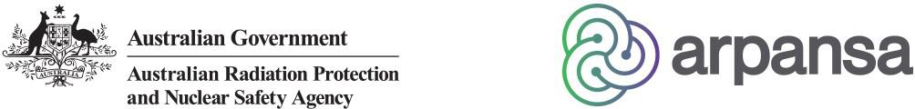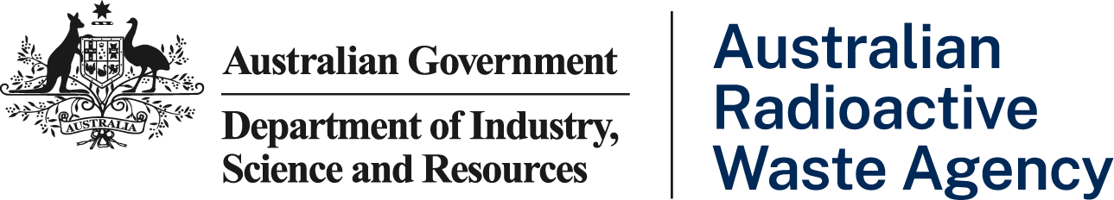

# ARPANSA-ARWA Liaison Forum

Executive Summary of 22 April 2024

## Terms of Reference

* The meeting was held in accordance with the Terms of Reference for the ARWA-ARPANSA Liaison Forum (LFAA), dated 31 August 2022.

## Outcomes of Previous LFAA

* The Executive Summary from the previous LFAA, dated 19 October 2023, was accepted by both parties, with copies to be made available on both the ARPANSA and ARWA websites.

## Strategic Overview from ARWA CEO

* ARWA’s Chief Executive Officer (CEO) spoke about the importance of security of information given the pace of global technological innovation and change.
* ARWA’s key priority is progressing its radioactive waste disposal pathways options assessment work and provision of advice to government about this. ARWA’s findings are continuing to emerge and officers will continue to work with key stakeholders, including regulators and other nuclear agencies, to ensure a wide range of perspectives are considered and inform the assessment work.
* ARWA is preparing for its transition out of Kimba in South Australia. Plans to decommission the site and remediate the land have been finalised and ARWA anticipates this work will be completed towards the end of 2024. Disposal options for the site and disbandment of the Kimba Consultative Committee are also being considered, in line with government policies and processes.
* ARWA’s CEO gave an update on the recruitment of technical staff and outlined that although quality recruits have joined ARWA, the competitive market was impacting recruitment and retention of staff.
* ARWA’s CEO summarised the recent International Atomic Energy Agency (IAEA) ARTEMIS planning visit noting that it was a constructive week-long meeting, with the full mission provisionally scheduled for June 2025. Further details about the visit are provided later in the agenda.

## Strategic Overview from ARPANSA CEO

* ARPANSA’s CEO noted that while recruitment and retention issues and funding uncertainty remain a challenge for ARPANSA, they have been successful recruiting into their regulatory area.
* ARPANSA’s regulatory workload remains high with staff working at capacity on complex ANSTO submissions.
* ARPANSA’s annual Licence Holder Forum takes place in Victoria on 2 to 3 May 2024, with the keynote address to be provided by Associate Professor Gemma Read, Co-Director of the Centre for Human Factors and Sociotechnical Systems at the University of the Sunshine Coast. Members agreed that ARWA would follow up with ARPANSA separately about sending a representative as an observer at the Forum.
* In May 2024 ARPANSA will be attending the International Conference on Nuclear Security. The ARWA CEO noted that ARWA will also be represented at the conference, which will focus on Global Nuclear Security.
* ARPANSA has received a licence application from the Australian Submarine Agency for a low level radioactive waste storage facility at HMAS *Stirling* in Western Australia. ARPANSA plans to undertake online public consultation about the facility in May 2024.
* ARPANSA is progressing the roll out of its new licence holder portal and will be holding a half-day intensive workshop immediately following their Licence Holder Forum in May 2024.
* ARPANSA’s CEO gave an update on the Nuclear Safety Committee. She also noted that until a dedicated Naval Nuclear-Power Safety regulator is established, ARPANSA is the only nuclear safety regulator in Australia.
* Members discussed recent requests for comments relating to ANSTO *Environment Protection and Biodiversity Conservation Act 1999* referral notices.

**Action 22042401: ARWA to follow up with ARPANSA about sending along a representative as an observer at ARPANSA’s Licence Holder Forum.**

## ARPANSA Regulatory Matters

* ARPANSA’s regulatory team’s main focus is on waste and transport-related matters at present. They are currently assessing an application regarding ANSTO’s High Flux Research Reactor’s Phase A decommissioning.
* ARPANSA has undertaken an inspection of ANSTO’s legacy waste operations. The inspection and report are now complete, with the report going through quality assurance and clearance processes.
* ANSTO will be submitting two applications to ARPANSA to modernise their waste operations. These are expected sometime this year and are follow on submissions after the ILWCI siting licence was approved in 2022. One application will be for amending the scope of the siting licence to include storage of intermediate level liquid radioactive waste and the other for construction of a storage facility for intermediate level liquid and solid radioactive waste. These facilities are needed to extend ANSTO’s current waste storage capacity.
* ARPANSA reminded ARWA about the IAEA’s proposed revisions to the *Regulations for the* *Safe Transport of Radioactive Material 2018*. This is a significant revision, with the last major review having occurred 40 years ago. ARPANSA has forwarded the draft updates to ARWA for consideration. Comments are due to ARPANSA by 30 April 2024, after which time ARPANSA will submit feedback to the IAEA.

## ARWA Matters

* ARWA provided an update on their work on the *Australian Radioactive Waste Management Framework April 2018* (the Framework). The Framework’s principles and long-term goals for radioactive waste management in Australia are being reviewed, updated and then re-released in light of significant changes in the nuclear industry since 2018.
* ARPANSA’s importance as a key stakeholder in the Framework update process was noted and members discussed at a high level how ARWA would consult with ARPANSA and across government about it.
* ARPANSA higlighted the importance of a single national radioactive waste management framework for all streams and sources of radioactive waste in Australia to strengthen safety and ensure a nationally uniform and consistent approach.
* Members discussed ARWA engaging with the National Offshore Petroleum Safety and Environmental Management Authority (NOPSEMA) who could have helpful input to ARWA’s Framework review process.
* ARPANSA inquired about the progress on the Recommendation from the IRRS 2018 Mission related to establishing a national policy and strategy for decommissioning of facilities..
* ARWA advised they are looking to provide clarity for the nuclear industry through the revised Framework and will work with ARPANSA to achieve this.

**Action 22042402: following related discussions it was agreed that ARWA would advise on the progress on the decommissioning policy and strategy that may influence HIFAR decommissioning strategy.**

## Mutual Areas of Interest

* Members discussed the recent IAEA ARTEMIS preliminary fact finding visit, and the opportunity the visit presented for learning more about the ARTEMIS peer review service and to agree the scope of their full review mission in 2025. Australian nuclear agency representatives also presented to the IAEA on Australia’s nuclear landscape. ARWA thanked ARPANSA for their valuable contribution to the visit and offered to provide presentations from the visit to ARPANSA, subject to obtaining approvals to do so.
* Meeting attendees discussed the composition of the ARTEMIS 2025 review team. ARPANSA suggested that delegates from the recent IAEA Integrated Regulatory Review Service (IRRS) mission would be able to provide useful Australian context to the ARTEMIS mission. ARPANSA also noted that the ARTEMIS mission will take into account the IRRS review mission findings and recommendations.
* Members discussed plans for the 2025 ARTEMIS full review mission. ARWA committed to consulting with ARPANSA as they progress plans for the mission program.

## Priority meetings for 2024-25

* ARWA gave members an overview of their representation at the recent IAEA Technical Working Group on Radioactive Waste Management and Technologies (WATEC) conference in Vienna and the 50th Anniversary Waste Management Symposia Conference 2024 in Phoenix and their contributions to and learnings from those events. ARWA noted that the WATEC conference was very constructive with extensive discussion on how international members’ waste plans are being affected by advanced and small modular reactors on a range of issues.
* ARWA will be represented at the 54th Annual Scientific Meeting of the Australian and New Zealand Society of Nuclear Medicine in late April 2024. ARWA’s CEO will also be travelling to Busan, Korea to participate in a panel at the Seventh International Conference on Geological Repositories. In May 2024 ARWA will be represented at the IAEA International Conference on Nuclear Security and ARWA is leading a European study tour focusing on Volunteerism and Social Licence with colleagues from other Australian agencies.
* ARWA and ARPANSA will both be represented at the IAEA General Conference in September 2024 in Vienna.

**Action 22042403: ARPANSA requested that ARWA share any reports/information/presentations possible from the Waste Management Symposium in Phoenix as well as following the panel participation in Busan. It was agreed that where appropriate the two agencies would coordinate attendance and support for international meetings and conferences and share information from public conferences and fora they attend.**

* ARPANSA noted that in December 2023 they visited the United States to look at transportation options for radioactive material, including spent fuel. In January 2024 they presented on regulatory implementation at the IAEA Regulators and Implementers in Developing Disposal Solutions for Radioactive Waste (known as RIDD) workshop focused on a Roadmap Towards DGR Licencing in Germany. ARPANSA stated they were happy to share the presentation with ARWA. ARPANSA was also represented at the Radioactive Waste Management Committee (RWMC) Nuclear Energy Agency (NEA) meeting in March 2024 and the NEA’s Committee on Decommissioning of Nuclear Installations and Legacy Management conference in March in Paris. ARPANSA will attend the IAEA’s Transport Safety Standards Committee (known as TRANSSC) meeting in June 2024.
* The IAEA has asked ARPANSA to host a regional workshop on training of transport of radioactive material for the Asia-Pacific region which will provisionally take place in late 2024.
* ARPANSA is preparing the 2024 Australian National Report for the Joint Convention, which is due for submission in August 2024. ARPANSA has sought input from ARWA.

## Updating the Terms of Reference

**Action 22042404: Secretariat to circulate a proposed revised draft for comment and approval.**

## Next Meeting

It is proposed that the next meeting is held in person or online, as appropriate for the agenda, in October 2024.