 

# AI and ESG

An introductory guide   
for ESG practitioners

October 2024

| **industry.**gov.au/NAIC

## Copyright

**© Commonwealth of Australia 2024**

**Ownership of intellectual property rights**

Unless otherwise noted, copyright (and any other intellectual property rights, if any) in this publication is owned by the Commonwealth of Australia.



[**Creative Commons Attribution 4.0 International Licence CC BY 4.0**](http://creativecommons.org/licenses/by/4.0/)

All material in this publication is licensed under a Creative Commons Attribution 4.0 International Licence, with the exception of:

* the Commonwealth Coat of Arms
* content supplied by third parties
* logos
* any material protected by trademark or otherwise noted in this publication.

Creative Commons Attribution 4.0 International Licence is a standard form licence agreement that allows you to copy, distribute, transmit and adapt this publication provided you attribute the work. A summary of the licence terms is available from <https://creativecommons.org/licenses/by/4.0/>. The full licence terms are available from <https://creativecommons.org/licenses/by/4.0/legalcode>.

Content contained herein should be attributed as *AI and ESG: An Introductory Guide for ESG Practitioners, Australian Government Department of Industry, Science and Resources National Artificial Intelligence Centre*.

This notice excludes the Commonwealth Coat of Arms, any logos and any material protected by trademark or otherwise noted in the publication, from the application of the Creative Commons licence. These are all forms of property which the Commonwealth cannot or usually would not licence others to use.

## Disclaimer

The purpose of this publication is to present an introduction to Responsible AI for ESG practitioners by showing how AI can support ESG solutions. It also highlights practical examples of where AI Governance could intersect with ESG governance to support the implementation of the Voluntary AI Safety Standard Guardrail 1: ‘Establish, implement and publish an accountability process including governance, internal capability and a strategy for regulatory compliance.’

The Commonwealth as represented by the Department of Industry, Science and Resources has exercised due care and skill in the preparation and compilation of the information in this publication.

The Commonwealth does not guarantee the accuracy, reliability or completeness of the information contained in this publication. Interested parties should make their own independent inquires and obtain their own independent professional advice prior to relying on, or making any decisions in relation to, the information provided in this publication.

The Commonwealth accepts no responsibility or liability for any damage, loss or expense incurred as a result of the reliance on information contained in this publication. This publication does not indicate commitment by the Commonwealth to a particular course of action.

**Cover image: ChatGPT-generated image.  
Prompt used: ‘Create an image combining the sustainable development goals and AI.’**

Contents

A practical guide for ESG practitioners 2

1. Why you? 2

2. What is AI and Responsible AI? 7

3. How do you assess AI in your sector? 11

4. Ideas to enhance your ESG solutions 12

5. Where to from here? 18

Conclusion: This is just the start 20

Appendix A: Responsible AI deep dive 21

Appendix B: Resources 29

## A practical guide for ESG practitioners

The growing use of AI, in all its forms, is permeating all organisations and all activities.

AI is helping to solve some of our most pressing challenges in areas such as health, climate change, sustainability, accessibility and inclusion. It is also posing significant new risks and challenges.

There is a meaningful overlap between AI and the work you do in ESG. We’ve designed this practical guide to support you in understanding AI as part of your ESG role.

### Why you?

*Why is AI relevant to you, your team and your role in your organisation?*

#### First, the good news.

You and your team have a crucial role to play.

##### AI can help you achieve your ESG outcomes*.*

Using AI can scale and speed up ESG and sustainability outcomes. For example, AI has the power to minimise deforestation. It can provide greater access to services for those who face vulnerability. It can speed up critical insurance, financial and infrastructure responses after natural disasters.

‘We have less than 10 years to solve the United Nations’ Sustainable Development Goals (SDGs). AI holds great promise by capitalizing on the unprecedented quantities of data now being generated on sentiment behaviour, human health, commerce, communications, migration and more.’[1]

##### You have a lot to offer.

You already have what you need to deploy and use AI systems well: your knowledge, skills, mindset and capabilities as an ESG practitioner. The processes you use are valuable. Human-centred design, theories of change, systems thinking, ‘do no harm’ and cross-company problem solving will all help you to implement AI responsibly. Lean into AI on the basis of your existing foundations.

‘AI ESG specializations will become a new career path for many – and I for one will be learning beside them.’[2]

‘The overwhelming weight of accumulated research finds that companies that pay attention to environmental, social and governance concerns do not experience a drag on value creation – in fact, quite the opposite. A strong ESG proposition correlates with higher equity returns …’[3]

##### You know the importance of trust.

Australians are currently the least trusting of AI in the world.[4] Those companies that embed ESG practices when deploying and using AI will earn the trust of their customers, staff, stakeholders and investors. Earning and keeping that trust in an AI-enabled world will become an essential competitive advantage.

‘AI is at a crossroads. Globally, when people see innovation as well-managed, they are 12 points more likely to embrace AI than when it is poorly managed.’[5]

##### You excel at partnerships and coalitions.

You collaborate both within your company and with others outside your company. You excel at working with others so that you can generate system changes needed to achieve ESG outcomes. You will be working across your company with your data scientists, AI developers and procurement teams because AI is increasingly embedded in many processes. Partnerships with the not-for-profit sector, scientists, AI experts and government agencies will allow you to get a handle on the ‘what’ of AI as well as the ‘how’ for best use.

‘28% of Australian organisations need 6 or more partners to succeed with an AI project.’[6]

##### Using AI will save you time.

Significant time. What percentage of your time do you spend on reporting? How about on data gathering or finding alternative data when the data you need doesn’t exist? Or drafting reports and guidance for your organisation? For some, it’s likely to be more than 50% of overall time. The AI ecosystem focuses on how to use AI to reduce this administrative effort and explore data more deeply in particular areas.

Reporting requirements for the Taskforce on Nature Related Financial Disclosures is accelerating. We all know the difficulty in measuring emissions accurately, let alone our overall impact on nature.

**Xylo Systems** is a cloud-based data and AI platform that supports those conserving and impacting biodiversity to measure and manage their nature footprint.*[7]*

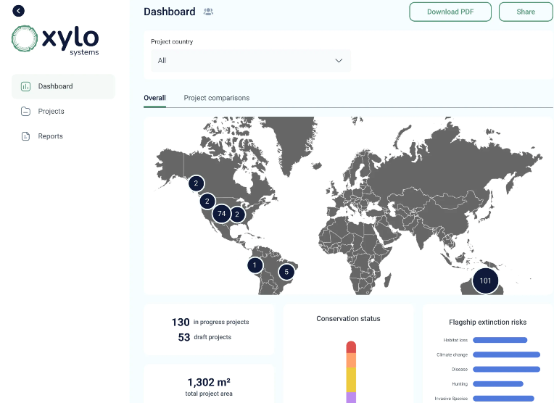

#### Now, the bad news.

##### AI could be high risk.

AI has the ability to scale, move quickly and use masses of data. But this comes with significant risks of bias, privacy infringements, mistakes (hallucinations), surveillance, fraud, human rights abuses, job dislocation, business model disruption and more. There is a long list of risks, and they are material. By increasing your AI capability, you can address complex sustainability issues and keep your company at the forefront of responsible AI use. It’s time for you to upskill, fast! There is also growing regulatory oversight to consider, including Australia’s new [Voluntary AI Safety Standard](https://www.industry.gov.au/publications/voluntary-ai-safety-standard).

Members of the European Parliament have voted to ... ‘ensure AI in Europe is safe, respects fundamental rights and democracy, while businesses can thrive and expand.’ These include human‑centric and human-made AI; safety, transparency and accountability; safeguards against bias and discrimination; right to redress; social and environmental responsibility; and respect for privacy and data protection.[8]

##### You need to keep your eyes open to how others are using AI.

AI systems have unique capabilities – precision, speed, prediction and scale. These can also be used by ‘bad actors’ to undermine some of your ESG issues. This goes beyond cyber threats, disinformation and deep fakes. Think organised crime using AI to accelerate their activities in modern slavery, human rights abuses, illegal trade and other areas. Being aware of how others are using AI will become an important part of your job.

‘Criminals and organized crime groups ... have been swiftly integrating new technologies into their modi operandi ...’[9]

##### AI adds pressure to existing environmental challenges.

Using AI, in particular Generative AI can result in high energy and water use, embedded carbon, electronic waste and other impacts. You will need to build these into your Scope 3 reporting on climate emissions as well as include them in specific initiatives you may have on issues like e-waste.

‘E-waste is the fastest growing solid waste stream in the world. In 2019, an estimated 53.6 million tonnes of e-waste were produced globally, but only 17.4% was documented as formally collected and recycled. ... ILO and WHO estimate that millions of women and child labourers working in the informal recycling sector around the world may be at risk of e‑waste exposure.’[10]

##### Where does the buck stop?

You are already grappling with the need for transparent, ethical and resilient supply chains. You’re uplifting capability of your suppliers on issues such as modern slavery, animal health, climate emissions and more. AI is another consideration on a long list.

‘The AI supply chain is layered, complex, intricate … While the development of foundational [AI] models to fine-tuned models is clear and relatively uncontroversial, that stage splits into the options of in-house, closed source, open-source, or model hubs, before reaching the user. Yet ... We have experience of the allocation and management of complex, globally extended supply chains in other areas which may provide useful precedents ... Modern slavery is managed by encouraging scrutiny and supervision of supply chain, disclosure of steps taken to remove unethical practices, and strategies for dealing with suppliers failing to meet standards.’[11]

##### Your regulatory load will increase, as will your stakeholders’ desire for transparency on your company’s use of AI.

There are many laws that already regulate the use of AI, such as privacy, cyber, anti-discrimination, child protection, work health and safety, and human rights. Being aware of how these laws address AI systems is important. The EU has passed specific AI laws and regulations. Australia now has its own Voluntary AI Safety Standard, and the government is consulting on mandatory guardrails for high-risk AI use. These laws and regulations provide helpful tools and processes to embed in your company.

‘AS ISO/IEC 42001:2023, Information technology – Artificial intelligence – Management system standard. This new standard aims to change the way AI management is approached, providing a clear framework for the ethical and consistent use of AI technologies.’[12]

### What is AI and responsible AI?

#### What is AI?

AI is a set of technologies that use data to perform tasks traditionally done by a human.

The definition from OECD defines an AI system as ‘a machine-based system that ... infers, from the input it receives, how to generate outputs such as predictions, content, recommendations or decisions …’.[13]

While broadly defining AI is important, there are several terms that categorise AI:

* **Narrow AI** systems are designed and trained to perform a specific task. Most AI systems in use today fall into this category. These types of systems can perform well in a narrow range of activities, potentially even better than humans, but they cannot perform any other tasks. Examples include chess engines, product recommender systems, medical diagnostic systems and facial recognition systems.
* **General-purpose AI** systems are designed and trained to handle a broad range of tasks and are therefore flexible. Their use is not limited to a specific function, so they can be more easily used for purposes their designers may not have considered. Examples include Microsoft’s Copilot.
* **Generative AI (Gen AI)** is a subset of general-purpose AI that develops AI models with the capability to produce content such as images, text and other media. Examples include Open AI’s ChatGPT.

For a simple explanation of how AI works, watch the video [AI Explained: It’s maths, not magic (a simple guide)](https://www.youtube.com/watch?v=5mHxO2JpCR0)[14]

#### What is responsible AI?

Responsible AI (RAI) is the practice of developing and using AI systems in a way that benefits individuals, groups and wider society, while minimising the risk of negative consequences.[15]

CSIRO and the Australian Government developed more detail on what this definition means in practice as part of [Australia’s AI Ethics Principles](https://www.industry.gov.au/publications/australias-artificial-intelligence-ethics-framework/australias-ai-ethics-principles).[16]

#### Australia’s AI Ethics Principles at a glance

* **Human, societal and environmental wellbeing**: AI systems should benefit individuals, society and the environment.
* **Human-centred values**: AI systems should respect human rights, diversity, and the autonomy of individuals.
* **Fairness**: AI systems should be inclusive and accessible and should not involve or result in unfair discrimination against individuals, communities or groups.
* **Privacy protection and security**: AI systems should respect and uphold privacy rights and data protection and ensure the security of data.
* **Reliability and safety**: AI systems should reliably operate in accordance with their intended purpose.
* **Transparency and explainability**: There should be transparency and responsible disclosure so people can understand when they are being significantly impacted by AI and can find out when an AI system is engaging with them.
* **Contestability**: When an AI system significantly impacts a person, community, group or environment, there should be a timely process to allow people to challenge the use or outcomes of the AI system.
* **Accountability**: People responsible for the different phases of the AI system lifecycle should be identifiable and accountable for the outcomes of the AI systems, and human oversight of AI systems should be enabled.

#### The intersection between RAI and ESG

Standard ESG approaches are a way to put the AI ethics principles into practice. The illustration below maps 12 ESG topics against the principles. ESG obviously considers both threats and opportunities and this balance is equally important when thinking about the benefits versus harm of AI.[17]

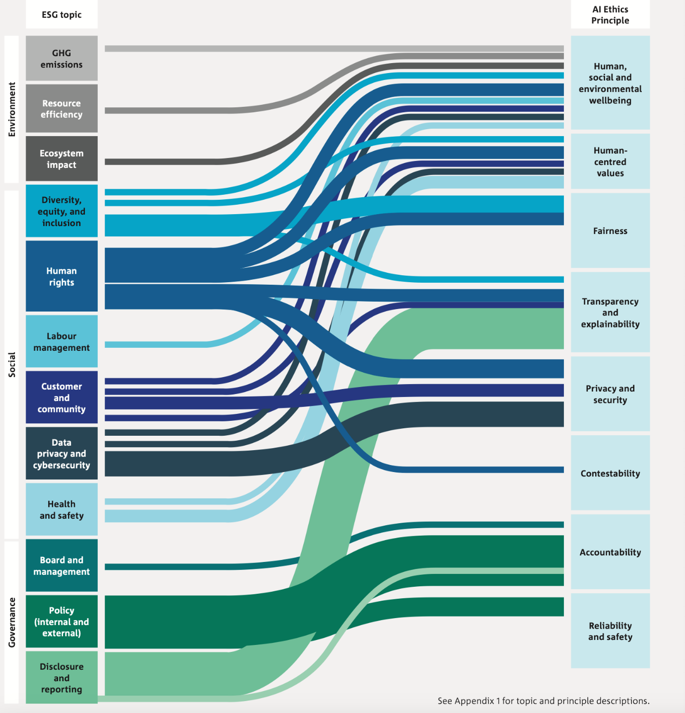

Source: CSIRO & Alphinity Investment Management, *The Intersection of Responsible AI and ESG: A Framework for Investors*, April 2024.

You can explore potential questions, indicators and metrics against each RAI principle at **Appendix A**.

#### Examples of ESG issues related to different AI applications

We’ve mapped ESG sectors alongside potential AI applications to give you a high-level link to the ESG issues you may be responsible for in your role. The governance topic in the table below also shows how AI governance integrates into the governance sector of ESG.

| ESG topic | | Description | Example AI applications |
| --- | --- | --- | --- |
| Environmental | **GHG emissions** | Training and running AI models takes a significant amount of energy. However, AI can also reduce emissions through asset optimisation, automation and operational efficiency. | Digital twins and asset modelling improve operational efficiency and reduce fuel use.  AI algorithms support the energy grid by predicting demand and supply fluctuations. This can optimise energy flow, balance the grid, prevent outages and ensure consistent energy supply. |
| **Resource efficiency** | AI can play a role in optimising resource efficiency in operations and across the supply chain. Depending on the industry this can help reduce energy, land and water consumption. | Predictive maintenance using AI-powered tools can optimise maintenance schedules.  AI can optimise logistics, predict demand and improve quality control |
| **Ecosystem impact** | AI can play a role in tackling environmental challenges. It can bring big data into the picture to monitor and address key ecosystem threats and opportunities across issues such as deforestation, soil health and pollution. | AI-enabled satellite imagery and geospatial mapping can monitor environment impacts and land use change.  AI-enabled early warning systems can detect hazards such as bushfires or pollution events in real-time, allowing for timely intervention. |
| Social | **Diversity, equity and inclusion (DEI)** | AI can perpetuate existing biases or even introduce new forms of discrimination. AI can also support inclusion when trained on up-to-date, high-quality and diverse datasets. | Financial services use AI in application processes and to help make credit decisions.  AI in healthcare allows clinicians to adopt data ‑driven diagnosis and deliver services remotely.  AI can support inclusion, such as hearing and visual aids for people with disability or automated machinery. |
| **Human rights** | Using AI for surveillance, weapons, to spread misinformation, and to reduce access for select groups can breach human rights. AI can also help to address issues such as modern slavery through greater supply chain transparency and information sharing, and increasing the use of robotics to automate low-value and unsafe tasks. | AI-driven surveillance and monitoring such as facial recognition and other image analysis tools.  AI can use supply chain datasets to generate meaningful insights about modern slavery and human rights risks.  Automation is integrated into the production of goods that rely on low-skilled, repetitive and manual human labour. |
| **Labour management** | Using AI to automate repetitive or manual tasks in workforces can boost employee satisfaction, address labour shortages and improve productivity outcomes. However, it could also result in job losses, particularly affecting those in lower-paid roles who already face challenges with financial security. | Automation changes the employment landscape and reduces manual, repetitive and mundane tasks.  Wearable technology can collect employee data, monitor activities and support safety and productivity outcomes.  AI-integrated hiring supports employee selection. |
| **Customer and community** | AI efficacy, security, accuracy, accountability, transparency and reliability pose reputational risks for companies. Companies that safely adopt AI can improve product quality, expand market reach, better service stakeholders such as customers, and benefit from recognised leadership related to AI opportunities. | Product development and innovation from selling AI tools or using AI to power existing processes.  Customer service such as chatbots and virtual assistants can give 24/7 support and manage routine enquiries.  AI insights to model and calculate insurance prices. |
| **Data privacy and cybersecurity** | The use of big data to power AI increases risks related to data privacy, fraud and security, and consent. On the other hand, AI can support fraud detection and help to support cybersecurity by detecting threats and performing predictive analysis. | AI use cases require data and digitalisation, exposing companies to privacy and cybersecurity risks.  AI systems in health research use particularly sensitive and personal datasets.  AI algorithms can detect fraudulent activity in financial or consumer sectors. |
| **Health and Safety** | AI systems can recognise trends and correlations for potential hazards, allowing organisation to minimise high‑severity injuries and fatalities. This also comes with a risk of automated systems failing and causing injury. | AI-enabled sensing devices detect unsafe practices or working conditions that could lead to accidents or fatalities.  Automation can reduce physical strain of manual labour, especially from repetitive tasks. |
| **Governance** | **Board and Management** | Leadership awareness and capability play an important role in an organisation’s success in an AI-enabled world |  |
| **Policy (internal and external)** | An RAI policy can be an early indicator of AI leadership and can build trust by serving as an explicit commitment to ethical AI practices. |  |
| **Disclosure and reporting** | Although ESG disclosures are improving, RAI disclosures remain nascent. Good quality disclosures are important to maintain a strong social licence to operate, prepare for future reporting requirements and ensure transparency with stakeholders. |  |

Source: CSIRO & Alphinity Investment Management, *The Intersection of Responsible AI and ESG: A Framework for Investors*, April 2024.

These are generic summaries. The actual overlap of RAI principles, ESG and AI applications will depend on the nature of your business and your ESG priorities.

#### Spotlight on diversity and inclusion

CSIRO’s Data61 is undertaking detailed research on the importance of focusing on diversity and inclusion in AI system development and deployment. The work highlights the importance for ESG practitioners to understand how AI can harm or improve diversity and inclusion.[18] The team has developed suggested [guidelines and practices](https://research.csiro.au/ss/team/diai/).

‘A review of 47 ethical guidelines that have been developed by governments, inter-governments, the private sector, civil society and multi-stakeholders, has shown that in its current state, AI ethics guidelines are focusing disproportionately on issues of algorithmic decision-making, while the fairness, accountability, sustainability, and transparency of the business decision-making contexts in which AI systems are situated remain seriously undermined by competitive and speculative norms, ethics washing, corporate secrecy, and other harmful business practices. Diversity is mostly considered as a part of showing the intention of fairness, however, we argue that achieving “diversity and inclusion” in the AI ecosystem must be placed as the core intention.’ Professor Didar, Zowghi, Diversity & Inclusion in Artificial Intelligence Lead: CSIRO's Data61 Emeritus Professor: University of Technology Sydney (UTS) Conjoint Professor: University of New South Wales

### How do you assess AI in your sector?

The CSIRO’s Data61 and Alphinity Investment Management released the[*Intersection of Responsible AI and ESG: A Framework for Investors*](https://www.csiro.au/en/research/technology-space/ai/responsible-ai/rai-esg-framework-for-investors) in April 2024.

The framework was developed using interviews with 28 companies from all over the world from 8 different sectors. Each were at different stages of embedding AI initiatives.

Based on this information, the team developed:

* case studies on the implementation of RAI
* 10 key insights related to AI, ESG and RAI
* an ESG-AI assessment framework for investors to assess their investments
* specific guidance for investors by sector and AI application.

The core purpose of the framework is to help investors to:

* identify whether and how companies are implementing AI responsibly
* consider how AI relates to a company’s environmental, social and governance risks
* assess the reality of materials risks and opportunities.

The framework is designed from an investor point of view in assessing the whole company (not just its ESG capability). However, it is a good resource for ESG practitioners as well.

‘We found that a strong track record in ESG performance is an indicator of confidence for investors. Companies that carefully consider how their actions affect people, their reputation, and how they’re seen by society will approach new technologies like AI with the same care. These companies generally have well‑respected Boards, robust disclosures and ESG commitments. They’re also likely to implement AI responsibly and in a measured way. Because AI is evolving so rapidly, good leadership on existing topics like cyber security, diversity and employee engagement suggests that the impact of AI will also be considered thoughtfully.’[19]

Importantly, the work developed 27 use cases by sector to give guidance on:

* most likely AI uses and descriptions
* regulatory flags and guidance
* environmental and social impact guidance
* materiality.

Download the [investor report, framework and toolkit](https://www.csiro.au/en/research/technology-space/ai/Responsible-AI/RAI-ESG-Framework-for-investors).

### Ideas to enhance your ESG solutions

#### Get curious about AI for good.

Only you and your team can work through how best to use AI to improve and accelerate your ESG outcomes specific to your company.

There is no doubt that the use of AI can have a material impact on how you deliver your ESG outcomes. Its ability to accelerate, scale and predict outcomes in the most complex of ESG issues is unmatched. The use of any AI system needs careful oversight. The world needs you and your ESG peers to use all the tools available to accelerate the shift to a sustainable future.

You will likely have your own examples already. Here are a few to encourage curiosity.

##### Example 1: Greater accessibility to products and services

###### AI used to help blind and low vision customers connect to companies



‘In February 2018, we launched Specialized Help – now known as [Accessible Customer Service Suite](https://www.bemyeyes.com/accessible-customer-service) – with Microsoft as our first partner company. This enables blind and low-vision users to connect with official company representatives for accessible and efficient customer support. Be My Eyes now offers a variety of corporate solutions alongside the suite, including [Be My Eyes for Work](https://www.bemyeyes.com/be-my-eyes-for-work), [Corporate Volunteering](https://www.bemyeyes.com/corporate-volunteering), [Be My Eyes Experiences](https://drive.google.com/file/d/1GFHSEkgJIj15h0-1LlxGICnBnyVHnd39/view) and [Be My Eyes Careers](https://drive.google.com/file/d/15G6IoBA2xEdLfYcCmKlF3ZaCr4TP5U8g/view).’[20]

##### Example 2: Better support for those in times of vulnerability

###### Commonwealth Bank protecting vulnerable customers through AI



‘Commonwealth Bank is blocking 400,000 abusive messages each year being sent to vulnerable female customers with tiny payment attached – a form of coercive control by men that can be a precursor to domestic violence.’

This is a powerful example of how a company can use AI to tackle something hidden from view (albeit with appropriate guardrails on considerations such as privacy). This also aligns to the Commonwealth Bank’s values of ‘Care, Courage and Commitment’.

‘This [400,000] alarming number underestimates the extent of the financial abuse taking place in the banking system, as a growing number of perpetrators circumvent the banks’ payment-blocking technology to conduct more nuanced intimidatory behaviour.’[21]

##### Example 3: Reducing carbon emissions in existing energy infrastructure

###### US Energy Grids improved through the use of AI

The United States of America’s Department of Energy states that AI and other improvements to the US existing energy grid could free up as much as 100 gigawatts (GW) in transmission and distribution capacity over the next 3–5 years. This equates to about 13% of current peak demand.

‘The idea underlying these software efforts is to make existing grids more flexible. Users could shift their power needs to quieter periods, when electricity is both more abundant and cheaper. That would lower peak demand ...’[22]

Companies are clearly focusing on how they can achieve their net zero emissions targets. Reducing emissions through greater efficiency and effectiveness is one of the fastest ways to do this. AI systems can support many different companies and sectors in finding ways to reduce carbon emissions. For example, route maximisation in haulage, traffic management, capacity efficiency measures and creating digital twins of remote sites to reduce maintenance visits.

##### Example 4: Restoring nature and reducing emissions

###### AI to preserve Australia’s Giant Kelp Forests.

CSIRO, Google, Institute for Marine and Antarctic Studies, The Nature Conservancy, Great Southern Reef Foundation and Kelp Forest Alliance [are partnering together](https://www.csiro.au/en/news/all/news/2024/february/national-collaboration-to-save-australias-invisible-endangered-forest-of-giant-kelp-using-ai) to preserve and restore Australia’s giant kelp forests using Google’s AI.

One of the most powerful ways to tackle climate change is to sequester carbon. Many carbon sequestration techniques use nature itself.

‘Coastal systems can sequester up to 20 times more carbon per acre than land forests.’[23]

Companies can use carbon ‘insetting’ initiatives like this to contribute towards their net zero targets as well as enhancing readiness for the Taskforce on Nature-related Financial Disclosures.

##### Example 6: Greater inclusion

###### AI has the power to transform inclusion



Get Skilled Access, an Australian company, is a champion for disability employment in Australia. They recognise that AI has the power to be a game-changer for inclusion. Get Skilled Access is focusing on ensuring that the AI tools which benefit disability inclusion are fair, affordable and encourage early adoption. These include tools such as assistive technologies, communication aids, smarter workplaces and smart learning.

Enhancing diversity is a priority for every organisation within its ESG strategy.

Get Skilled Access, led by Founder Dylan Alcott, are expert consultants with ‘real life disability experience to give organisations confidence to make better inclusive decisions’.[24]

#### What can we learn from these examples?

There are common characteristics across these initiatives:

* they all involve partnership
* they can bring scale, accuracy and speed to solving ‘wicked’ ESG issues
* they can help with almost all ESG domains.

Most importantly, the use of AI means you can question previous assumptions about actions which might not have been possible in the past. They are now possible. AI allows you as an ESG practitioner to ask, ‘Imagine if we could?’

### Where to from here?

AI has the potential to accelerate and scale many of your environmental, social and governance initiatives. It also has risks.

Navigating risky potential is one of your strengths as an ESG practitioner. You have the skills, knowledge, techniques and approach to make the most of AI.

You are not alone.

Many in your organisation have embedded or are starting to embed AI and understand how it impacts their roles. Equally, your fellow ESG practitioners, not-for-profit partners and other stakeholders are doing the same.

This is an introductory guide on AI for ESG practitioners.

Start with these 4 steps:

1. Reach out to others in your organisation to talk with them about the links between ESG and AI.
2. Review the resources in **Appendix B**.
3. Sign up for one of the National AI Centre’s free [‘Introduction to AI’ micro-skill courses](https://store.training.tafensw.edu.au/product/introduction-to-artificial-intelligence/?_ga=2.111309956.1073147357.1683769873-1545388492.1657075883&utm_source=NAIC&utm_medium=MR&utm_campaign=AIMicroskills).
4. Review the National AI Centre’s [Voluntary AI Safety Standard](https://www.industry.gov.au/publications/voluntary-ai-safety-standard)

Then, when you are ready, lead your organisation to impactful AI by deploying the **AI Impact Navigator**.

#### The AI Impact Navigator

One of the most important steps you can take within your organisation is to start the conversation to build a broader understanding of:

* the interaction between ESG and AI
* the good and bad impacts AI is having, or could have, from an ESG perspective
* the possible AI measures and metrics for the company to measure from an ESG perspective.

We are developing a toolkit to help you with these. It is called the [AI Impact Navigator](industry.gov.au/AINav). Its purpose is to help you and your peers:

* understand and measure the impact and outcomes of your AI systems on others
* grow cross-organisational team capabilities to maximise good AI outcomes
* build the potential for the use of AI to magnify positive impacts and your ESG aspirations while lessening negative impacts.

The AI Impact Navigator is structured around 4 directions to help you and your team use AI for positive impact:

1. **Social licence and corporate transparency**

Embrace transparency in your AI initiatives, continuously monitor their impact and engage with communities to demonstrate accountability.

1. **Workforce and productivity**

Use AI to enhance productivity and innovation while addressing the challenges of job displacement, regulatory compliance and skills adaptation in an evolving technological landscape.

1. **Effective AI and community impact**

Embrace transparency and accountability in AI to foster trust and enhance community engagement as you navigate its evolving impacts and ethical considerations.

1. **Customer experience and consumer rights**

Improve customer experiences with AI by responsibly using data and ensuring privacy and fairness while balancing competitive advantage and consumer rights.

The [AI Impact Navigator](industry.gov.au/AINav) is designed in non-AI speak so that you can bring your expertise and knowledge into the conversations to help your company focus on the impacts and outcomes of its use of AI.

The AI Impact Navigator has been developed to be cross-cutting for your organisation. As an ESG practitioner, only some of the areas sit within your wheelhouse. But as you know, ESG links closely with other issues, culture and governance, so introducing and using the AI Impact Navigator provides a good opportunity for you to create a culture of impact-led and ESG-aware AI deployment.

### Conclusion: This is just the start

Remember, as an ESG practitioner you are perfectly placed to consider the pros and cons of AI usage in your organisation.

Build your awareness of how AI is already being used – for good and for bad – all over the world. Explore its links to other environmental, social and governance aspects of your organisation. Look at the legislation and regulations that are being used and developed. Talk about AI openly with colleagues and peers.

AI is here to stay. Now is the time to understand its power and its limitations.

## Appendix A: Responsible AI deep dive

Source: CSIRO & Alphinity Investment Management, The Intersection of Responsible AI and ESG: A Framework for Investors, April 2024.

| Principle | Principle Question | Indicator | Example Sub Questions | Example Metrics |
| --- | --- | --- | --- | --- |
| **Human, social, environmental wellbeing:** AI systems should benefit individuals, society and the environment | Are the company's AI systems assessed to have a net positive benefit to human, social and environmental wellbeing? | Environmental impact assessment | Does the company have targets/ strategies in place to reduce environmental impact and/or increase the positive impact over time? | Energy usage Greenhouse gas emissions |
| Social impact assessment | Does the company assess the broader societal impact of the AI system’s use beyond the individual user? | Change in number of employees Cost saving from AI |
| **Human-centred values:** AI systems should respect human rights, diversity, and the autonomy of individuals. AI systems should be designed to augment, complement and empower human cognitive, social and cultural skills. | Are the company's AI systems assessed to respect human rights, diversity and autonomy? | Human protection | Does the company have policies and identify requirements to protect stakeholders, particularly data subjects and individuals affected by the AI systems (decisions/outputs)? | N/A |
| Human rights | Does the company embed AI within its human rights and modern slavery strategy and disclosures? | Number of AI risks (human rights) Number of audits for AI risks (human rights) |
| **Fairness:** AI systems should be inclusive and accessible and should not involve or result in unfair discrimination against individuals, communities or groups. | Has the AI system been designed and deployed to minimise bias and promote inclusion and fairness? | Diverse team | Does the company have a diverse team in place to design, develop, deploy and operate AI systems? | Diversity metrics (e.g., AI teams, diversity in AI risk committee) |
| Bias | Does the company have guardrails in place to mitigate the risks of bias (e.g., racial, gender) in the datasets used for the AI system? | Diversity metrics (e.g., gender diversity, demographic diversity, geographic diversity in data set) |
| Inclusion | Does the company integrate inclusion and accessibility in the design and deployment of AI projects and is this tested throughout the lifecycle? | N/A |
| **Privacy/security:** AI systems should respect and uphold privacy rights and data protection and ensure the security of data. | How do the AI systems elevate the company’s data security risk, has this been assessed and what action has been taken to mitigate this risk? | Cyber security | Does the company have proper measures to prevent and control for attacks? | Number of cybersecurity incidents related to AI systems |
| Copyright protection | Does the company ensure the suitability of the data collection and the sources and document the description of data sources? | Data governance compliance rate |
| **Reliability and safety:** AI systems should reliably operate in accordance with their intended purpose. | How does the company ensure the reliability and safety of its AI system to deliver services in accordance with their intended purposes? | Quality management | Does the company have increased oversight of AI systems which are used in critical operations or assets? | Number of critical systems with AI embedded |
| Does the company involve independent experts for model evaluation, particularly for a foundation model? | Independent expert rate for AI model evaluation |
| **Transparency and explainability:** There should be transparency and responsible disclosure so people can understand when they are being significantly impacted by AI, and can find out when an AI system is engaging with them. | How is the company informing its stakeholders of AI use within different arms of the business, related risks and opportunities? | Explainable system | Does the company evaluate the interpretability of the AI system if it can produce explanations about the model, data and decisions for the users? | AI decision factor (input) importance score |
| User notification | Does the company inform users when they are interacting with an AI system? | Percentage of interactions where users are notified |
| **Contestability:** When an AI system significantly impacts a person, community, group or environment, there should be a timely process to allow people to challenge the use or outcomes of the AI system | What mechanisms are in place for people to challenge the use or outcomes of the AI system to promote healthy contestability? | Internal complaints management | Does the company have complaints process in place where affected internal users can voice concerns? | Number of complaints Completion rate  Time to resolve complaint |
| External complaints management | Does the company have a complaints process with multiple channels in place (e.g., whistle-blower hotline, online complaint form) where affected external users can voice concerns? |
| **Accountability:** People responsible for the different phases of the AI system lifecycle should be identifiable and accountable for the outcomes of the AI systems, and human oversight of AI systems should be enabled. | Does the company have designated responsibility for AI and RAI within the organisation (person, department or committee)? | Risk management | Does the company establish methods and metrics to quantify and measure the risks associated with its AI systems? | Number of AI risk metrics (e.g., risk exposure index, risk severity score, risk monitoring frequency) |
| AI incident management | Does the company have a clear reporting system or process in place for serious AI incidents to inform external stakeholders (e.g., market surveillance authorities, communities) beyond the company? | Number of AI incidents informed to external stakeholders |
| Accountability framework | Does the company have an accountability framework to ensure that AI related roles and responsibilities are clearly defined? | Percentage of defined AI roles and responsibilities |

## Appendix B: Resources

* [AI for social good: unlocking the opportunity for positive impact | Nature Communications](https://www.nature.com/articles/s41467-020-15871-z)
* AI Impact Navigator
* [Australia’s AI Ethical Standards](https://www.industry.gov.au/publications/australias-artificial-intelligence-ethics-framework)
* [Human Technology Institute](https://www.uts.edu.au/human-technology-institute) (UTS)
* [Infoexchange](https://www.infoxchange.org/au)
* [National Artificial Intelligence Centre](https://www.industry.gov.au/NAIC)
* [NetHope](https://nethope.org/)
* [Standards Australia](https://www.standards.org.au/)
* [The Intersection of Responsible AI and ESG: A Framework for Investors – Alphinity Investment Management and CSIRO](https://www.alphinity.com.au/wp-content/uploads/2024/04/ALPH_2404_RAI-Framework.pdf)
* [The UN – AI for Good](https://aiforgood.itu.int/)
* [Voluntary AI Safety Standard](https://www.industry.gov.au/publications/voluntary-ai-safety-standard)
* [World Economic Forum – Global Future Council on the Future of AI](https://www.weforum.org/communities/global-future-council-on-artificial-intelligence/)

1. ITU, [AI For Good website](https://aiforgood.itu.int), accessed June 2024.
2. R Doherty, L Perez, K Siegel and J Zucker, ‘[How do ESG Goals Impact a Company’s Growth Performance?](https://www.mckinsey.com/capabilities/growth-marketing-and-sales/our-insights/next-in-growth/how-do-esg-goals-impact-a-companys-growth-performance)’, McKinsey website, September 2023, accessed June 2024.
3. W Henisz, T Koller and R Nuttall, ‘[Five Ways that ESG Creates Value](https://www.mckinsey.com/~/media/McKinsey/Business%20Functions/Strategy%20and%20Corporate%20Finance/Our%20Insights/Five%20ways%20that%20ESG%20creates%20value/Five-ways-that-ESG-creates-value.ashx)’, *McKinsey Quarterly*, November 2019, accessed June 2024.
4. [BSI,](https://www.bsigroup.com/en-AU/About-BSI/Media-Centre/Press-Releases/2023/october/closing-ai-confidence-gap-key-to-powering-its-benefits-for-society-and-planet/) ‘[Closing ‘AI confidence gap’ key to powering its benefits for society and planet](https://www.bsigroup.com/en-AU/About-BSI/Media-Centre/Press-Releases/2023/october/closing-ai-confidence-gap-key-to-powering-its-benefits-for-society-and-planet/)’, BSI Group website [media release], 17 October 2023, accessed June 2024.
5. Edelman, [2024 Edelman Trust Barometer website](https://www.edelman.com.au/trust/2024/trust-barometer), 2024, accessed June 2024.
6. CSIRO National Artificial Intelligence Centre, [*Australia’s AI Ecosystem Momentum Report*](https://www.csiro.au/AI-Ecosystem-Report), February 2023, accessed June 2024.
7. [Xylo systems website](https://www.xylo.systems/), Accessed June 2024
8. European Parliament, ‘[Artificial Intelligence Act: deal on comprehensive rules for trustworthy AI](https://www.europarl.europa.eu/news/en/press-room/20231206IPR15699/artificial-intelligence-act-deal-on-comprehensive-rules-for-trustworthy-ai)’ [press release], 2023, European Parliament website, accessed June 2024.
9. Trend Micro Research, UN Interregional Crime and Justice Research Institute and Europol’s European Cybercrime Centre, [Malicious Uses and Abuses of Artificial Intelligence](https://www.europol.europa.eu/cms/sites/default/files/documents/malicious_uses_and_abuses_of_artificial_intelligence_europol.pdf), 2020, accessed June 2024.
10. World Health Organization, [Electronic waste (e-waste)](https://www.who.int/news-room/fact-sheets/detail/electronic-waste-%28e-waste%29) [web page], October 2023, accessed June 2024.
11. Gilbert + Tobin, ‘[The AI of the Beholder: risk versus reality](https://www.gtlaw.com.au/knowledge/ai-beholder-risk-versus-reality)’, 24 January 2024, accessed June 2024.
12. [Standards Australia website](https://www.standards.org.au/), accessed June 2024.
13. OECD.AI, [Updates to the OECD’s definition of an AI system explained](https://oecd.ai/en/wonk/ai-system-definition-update) [web page], 29 November 2023, accessed June 2024.
14. CSIRO, [AI Explained: It’s maths, not magic (a simple guide)](https://www.youtube.com/watch?v=5mHxO2JpCR0), Youtube video, accessed June 2024.
15. Q Lu, L Zhu, J Whittle and X Xu, *Responsible AI: Best Practices for Creating Trustworthy AI systems*, Addison-Wesley Professional, December 2023.
16. Department of Industry, Science and Resources, [*Australia’s AI Ethics Principles*](https://www.industry.gov.au/publications/australias-artificial-intelligence-ethics-framework/australias-ai-ethics-principles), DISR website, n.d., Australian Government, accessed June 2024.
17. CSIRO & Alphinity Investment Management, [*The Intersection of Responsible AI and ESG: A Framework for Investors*](https://www.csiro.au/en/research/technology-space/ai/Responsible-AI/RAI-ESG-Framework-for-investors), April 2024, CSIRO, accessed June 2024.
18. CSIRO Data61, [Diversity and Inclusion in Artificial Intelligence](https://research.csiro.au/ss/team/diai/) [web page], n.d., accessed June 2024.
19. CSIRO & Alphinity Investment Management, [*The Intersection of Responsible AI and ESG: A Framework for Investors*](https://www.csiro.au/en/research/technology-space/ai/Responsible-AI/RAI-ESG-Framework-for-investors), April 2024, CSIRO, accessed June 2024.
20. [Be My Eyes website](https://www.bemyeyes.com/), accessed June 2024.
21. James Eyres, ‘How CBA is using AI to shield female customers from financial abuse’, *The Australian Financial Review*, 8 November 2023.
22. ‘AI and other tricks are bringing power lines into the 21st century’, *The Economist*, 5 May 2024.
23. S Hurlimann, ‘[How Kelp Naturally Combats Global Climate Change](https://sitn.hms.harvard.edu/flash/2019/how-kelp-naturally-combats-global-climate-change/)’, *Science in the News*, Harvard Kenneth C Griffin Graduate School of Arts and Sciences, 4 July 2019, accessed June 2024.
24. [Get Skilled Access website](https://getskilledaccess.com.au/), accessed June 2024.