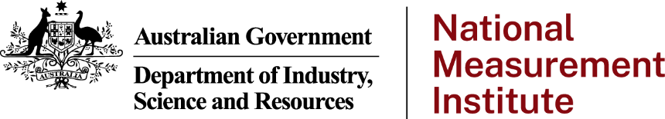

# National Measurement Institute Quality Policy

The National Measurement Institute (NMI) is responsible for Australia’s national infrastructure in biological, chemical and physical measurements and the associated legal and regulatory framework.

Under the *National Measurement Act 1960*, NMI is charged with coordinating Australia’s national measurement system, and for establishing, maintaining, disseminating and regulating Australia's units and standards of measurement.

NMI strives for the highest levels of technical quality in its measurement capabilities and for excellence in the delivery of its measurement services, to ensure a strong and effective measurement system that is trusted and accepted both domestically and internationally.

## NMI’s quality management objectives:

1. To maintain excellence in service delivery and increase customer/stakeholder satisfaction levels by:
2. continually improving customer/stakeholder liaison and communication within NMI
3. meeting agreed turnaround times, and where appropriate, improving them
4. leveraging customer/stakeholder feedback to identify and address problem areas
5. providing the surety, recognition and standing derived from accredited measurement services.
6. To maintain and continually improve the effectiveness of our management systems and technical processes in our laboratories by:
7. ensuring organisational commitment to comply with the principles embodied in relevant ISO Standards (particularly ISO/IEC 17025, ISO 17034, ISO/IEC 17043 and ISO/IEC 17065), and in other quality guidance relevant to our operations (for example the PIC/S Guide to Good Manufacturing Practice for Medicinal Products)
8. ensuring the fitness for purpose and appropriate application of new and existing measurement capabilities
9. achieving excellent performance in both internal and external proficiency testing and intercomparison programs
10. maintaining third party accreditations of NMI’s key services and methodologies
11. acting on the results of monitoring and audit processes in a timely and effective manner.
12. To promote staff excellence by continually encouraging uptake of staff development programs and training.

In adopting these objectives, NMI management and staff undertake to work towards these goals, and to familiarise themselves with, implement and continue to improve the policies and procedures of the quality management system.

Dr Bruce Warrington

Chief Executive Officer and Chief Metrologist

19 November 2024