

Australia’s National  
Science Agency

Exploring regional opportunities and social acceptability for offshore oil and gas decommissioning and resource recovery

Summary Report

Prepared for the Australian Government Department of Industry, Science and Resources

April 2024

Citation

Boxall NJ, Walton A, Okelo W, Kong T, Melbourne- Thomas J, Porter NB, Oude-Egerbrink I, Jeanneret T, Po M, van Putten I, Terhorst A, Emami N, Skidmore M, Thomas D, 2024. Exploring regional opportunities and social acceptability for offshore oil and gas decommissioning and resource recovery: summary report. Prepared by CSIRO for the Australian Government Department of Industry, Science and Resources.

Copyright

© Commonwealth Scientific and Industrial Research Organisation 2024. To the extent permitted by law, all rights are reserved and no part of this publication covered by copyright may be reproduced or copied in any form or by any means except with the written permission of CSIRO.

Important disclaimer

CSIRO advises that the information contained in this publication comprises general statements based on scientific research. The reader is advised and needs to be aware that such information may be incomplete or unable to be used in any specific situation. No reliance or actions must therefore be made on that information without seeking prior expert professional, scientific and technical advice. To the extent permitted by law, CSIRO (including its employees and consultants) excludes all liability to any person for any consequences, including but not limited to all losses, damages, costs, expenses and any other compensation arising directly or indirectly from using this publication (in part or in whole) and any information or material contained in it.

CSIRO is committed to providing web accessible content wherever possible. If you are having difficulties with accessing this document please contact [csiro.au/contact](http://www.csiro.au/contact).

Contents

Overview 2

Introduction 3

Supporting a sustainable decommissioning industry 4

What is offshore oil and gas decommissioning? 6

Why does Australia need to develop an oil and gas decommissioning industry? 7

Australia’s decommissioning and resource recovery value chain 8

Cost reduction is a critical enabler for the industry 10

Expansion and diversification of Australia’s decommissioning workforce is required 11

Availability and capacity of decommissioning infrastructure in regional Australia 12

Opportunities for domestic oil and gas decommissioning 13

Gaining social acceptability for offshore oil and gas decommissioning and resource recovery 16

What we did and further information 19

Resources 20

Overview

CSIRO, Australia's national science agency, has investigated investigated the challenges, regional opportunities and social acceptability for the multi-billion‑dollar decommissioning of obsolete offshore oil and gas infrastructure. The research, describes how Australia can support the sustainable development of the offshore oil and gas decommissioning industry informed by international best practice, a comprehensive review of the literature and extensive stakeholder engagement.

Most decommissioning and resource recovery activities are likely to occur onshore, close to oil and gas infrastructure. As a result, regional Australia will play a key role in developing the industry. Sustainable decommissioning should embed circular economy principles, which include eliminating waste and pollution, whilst aiming to realise a net positive benefit to regional communities where these activities are undertaken. These principles should also underpin planning and approval of new offshore projects.

CSIRO identified five key enablers to support industry development:

1. Consistent, adaptive and co-designed governance frameworks
2. Enhanced and progressive planning and decision-making
3. Technology and innovation
4. Industry collaboration and coordination
5. Social acceptability through authentic and active engagement

CSIRO’s research considers all phases of the decommissioning value chain, including planning, extensive offshore activities and onshore dismantling, transport, material management and supply to markets. Leveraging transferable, highly skilled workers from adjacent industries, diversifying the workforce and training staff, particularly in remote and regional Australia, will be crucial. Gaining social acceptance of decommissioning and resource recovery activities, especially in affected regional communities, will also influence the sustainability and success of the industry.

Decommissioning will likely bring regional and national economic benefits and support thousands of jobs, especially in material management.

Introduction

There is a global shift towards a circular economy that will require a major transformation of Australia’s domestic waste and resource recovery sector, including for oil and gas decommissioning activities.

Much of Australia’s offshore oil and gas infrastructure will require decommissioning within 30 years, with an estimated cost of $40.5 billion. Most of the decommissioning and resource recovery is likely to occur onshore, close to the infrastructure. This will require access to workforces and materials, which may be limited in some regions. These constraints may challenge the development of a safe, cost-effective and environmentally responsible Australian industry.

In 2023, the Australian Government committed $4.5 million to develop a roadmap for establishing a decommissioning industry. The roadmap aims to identify ways Australia can benefit from the projected expenditure, develop repurposing, recycling and waste disposal pathways for decommissioned infrastructure and materials, and create opportunities to re-skill oil and gas workers for an emerging decommissioning industry.

As part of the roadmapping process, the Australian Government Department of Industry, Science and Resources engaged CSIRO to identify the challenges, regional opportunities and social acceptability of the development of domestic offshore oil and gas decommissioning and resource recovery capacity.

Supporting a sustainable decommissioning industry

The development of Australia’s offshore decommissioning industry provides opportunities for regional Australia. These opportunities can be enabled through an adaptive, science-driven, and co-designed regulatory environment that minimises risks and benefits industry, the environment and communities.

Australia has innovative technology, high-quality research and development, established export pathways, infrastructure and assets, and a highly skilled and transferable workforce. However, there are challenges to our ability to service the needs of the future oil and gas decommissioning industry. Challenges include skill shortages; insufficient industry coordination, collaboration and information sharing; a lack of available and suitable infrastructure and ports; technical challenges in removing some structures; insufficient reprocessing and material management capabilities; and a reliance on international vessels.

Five key enablers are proposed to support the sustainable development of the offshore oil and gas decommissioning industry (Figure 1). The enablers are based on circular economy principles, international best practice, industry reports, experience, and insights from research participants.

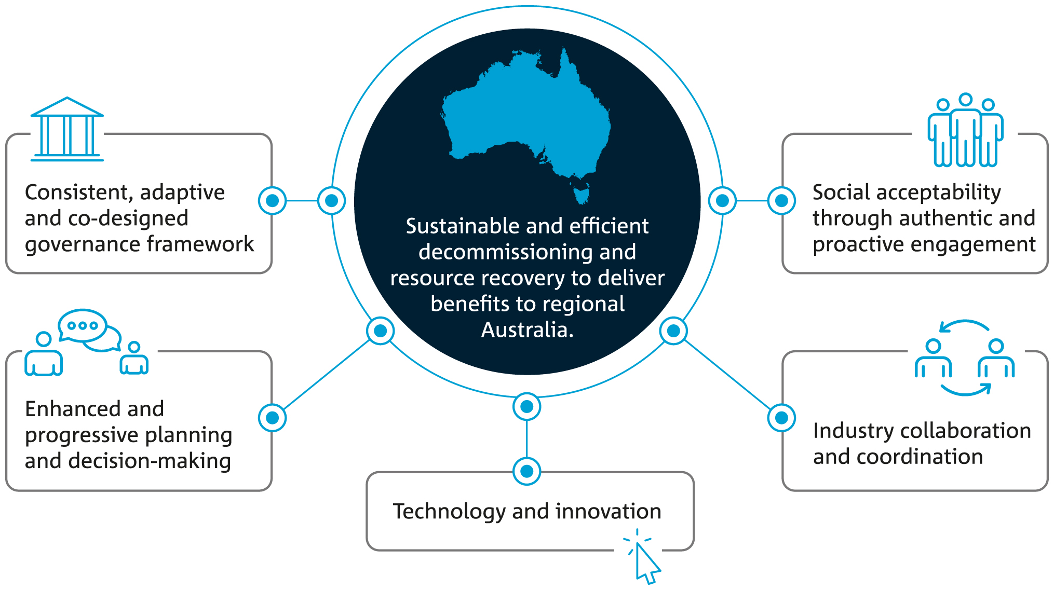

Figure 1. Key enablers to support the development of a sustainable offshore oil and gas decommissioning and resource recovery industry in Australia

**1. Consistent, adaptive and co-designed governance framework**

Harmonised, adaptive and evidence-based national and state regulatory instruments and legal frameworks will help ensure effective project planning and efficiency, reduce costs, and minimise environmental and worker safety risks as the decommissioning industry develops at pace.

A national central authority that operates across jurisdictional boundaries could oversee and coordinate the decommissioning project pipeline. The authority could define requirements for information sharing, maintain accessible data sets for efficient project planning, develop best practice guidelines, and bolster and support innovation to solve regional decommissioning challenges.

**2. Enhanced and progressive planning and decision-making**

Planning is a critical phase of decommissioning and could be improved through information sharing, coordination of activities, and better visibility of the decommissioning project pipeline. Enhanced planning and decision-making underpinned by assessment frameworks, better approval processes, coordinated vessel and infrastructure management, and early workforce planning will improve risk management and promote investment and certainty.

**3. Technology and innovation**

Innovation can produce new technology and methods for decommissioning difficult structures and materials. Innovation funding for domestic cost reduction strategies and regional decommissioning challenges is required. Material flow data, material traceability, and information sharing across supply chains can facilitate the development of new secondary markets.

**4. Industry collaboration and coordination**

Industry collaboration and coordination can be enhanced by co-development of industry guidelines and standards, including a national cost-reduction strategy. Industry peak bodies can strengthen partnerships, relationships with regulatory authorities, and information sharing. Working with research agencies can help develop sound policies, guidance and standards. Sharing aggregated information from operators and contractors can improve project planning, best practices, cost reduction, and innovation, and identify shared efficiencies.

**5. Social acceptability through authentic and proactive engagement**

Authentic, early and inclusive stakeholder engagement, including with communities and First Nations people, will support the social acceptability of decommissioning activities and ensure development meets community expectations. This will require a social acceptability framework and supporting regulatory processes.

What is offshore oil and gas decommissioning?

Offshore oil and gas decommissioning is a standard activity in the offshore oil and gas lifecycle, usually occurring at the final stages of an oil and gas project.

Decommissioning involves removing and dismantling oil and gas infrastructure, permanent and secure well plugging and abandonment (P&A) and rehabilitating the surrounding environment. There is a growing emphasis on managing, reusing and recycling recovered decommissioning materials.

‘The removal of all offshore oil and gas assets once it is no longer in use is the default decommissioning requirement under Australian law’

(The Hon. Madeleine King MP, Minister for Resources and Minister for Northern Australia).

In Australia, oil and gas producers must remove all infrastructure above and below sea level before surrendering a petroleum title. However, achieving full removal of infrastructure remains a technically challenging and costly process for operators. In some cases, there is no industry best practice for removing some types of infrastructure, such as large concrete bases. There are also marine and other environmental issues that need to be managed.

Most of Australia’s oil and gas infrastructure is located at opposite ends of the country, and decommissioning and resource recovery activities are likely to be undertaken close to where the materials are received onshore. As a result, regional Australia will play a key role in the development of the industry. However, the lack of adequate infrastructure, workforces, and materials in some places may increase the risk of decommissioning activities not being conducted in a safe, cost-effective, and environmentally responsible manner. Social acceptability is also likely to influence where offshore oil and gas decommissioning and resource recovery activities occur.

As such, Australia will need to develop a social acceptability framework to help navigate the complex and sensitive nature of the industry's activities.

Why does Australia need to develop an oil and gas decommissioning industry?

Recent resource recovery targets and circular economy transition guidelines provide opportunities for Australia’s offshore oil and gas decommissioning industry.

Australia and the rest of the world are shifting towards a circular economy. As a result, the domestic waste and resource recovery sector is undergoing a transformation that will affect the way material management and supply chain development occur, with a growing emphasis on sustainably managing materials recovered from offshore oil and gas decommissioning.

The three core circular economy principles are to eliminate waste and pollution, develop circular products and materials at their highest value, and regenerate nature (Ellen MacArthur Foundation, 2023). These principles are underpinned by renewable energy and material flow. There are many benefits of incorporating circular economy principles into oil and gas decommissioning. They include improving the life of materials through better project design, reuse and increased recycling and resource recovery rates, and approved processes for planning and approval of new offshore projects and those already requiring decommissioning.

Unlike international examples, Australia’s offshore oil and gas decommissioning and resource recovery industry is unlikely to develop and operate as a discrete industry. Activities will intersect with a range of adjacent activities already established within regions. The networks will be complex and will require industry coordination and collaboration, planning, design, and cost reduction strategies to enable decommissioning and resource recovery projects to be operationally efficient and to mitigate risks.

Understanding the challenges and opportunities for decommissioning activities and framing these in the context of a circular economy will ensure Australia’s decommissioning industry develops in a way that is technically, economically, and environmentally sound.

Australia’s decommissioning and resource recovery value chain

A value chain framework for Australia’s decommissioning sector maps the phases of decommissioning, and the associated activities, stakeholders, infrastructure and skills. The framework underpins the research findings.

CSIRO has developed a value chain conceptual map of Australia’s offshore oil and gas decommissioning sector. The value chain considers major activities, stakeholders, infrastructure, materials and skills across both offshore and onshore activities (Figure 2).

The value chain is based on the UK and Norwegian Decommissioning Work Breakdown Structure (WBS) (SEPA, 2020; Norsk Olje & Gass, 2020), expanded to include additional phases related to the onshore management and recovery of materials. The map provides the content and framing used in this research, including during stakeholder engagement. It considers the default option for decommissioning based on full removal of all infrastructure above and below sea level.

Australia’s decommissioning and resource recovery value chain consists of three phases (Figure 2):

* **Planning**: including managing stakeholder and regulatory interactions, data and project costs, and timelines. Sound project management can minimise costs. Greater collaboration in planning may require incentives.
* **Offshore activities**: characterised by well plug and abandonment and cleaning and flushing of pipelines (preparation); cutting of pipelines, stabilisation of rigs, first-pass decontamination, and removal of non-fixed structures and materials for reuse and recycling (removal); and safe transport of waste and assets to the receiving port for management and disposal (transport to port).
* **Onshore activities**: occur in coastal waters and onshore and include onshore landing, dismantling, materials transport and material management, and secondary markets. Australia’s long domestic supply chains remain a challenge for the industry.

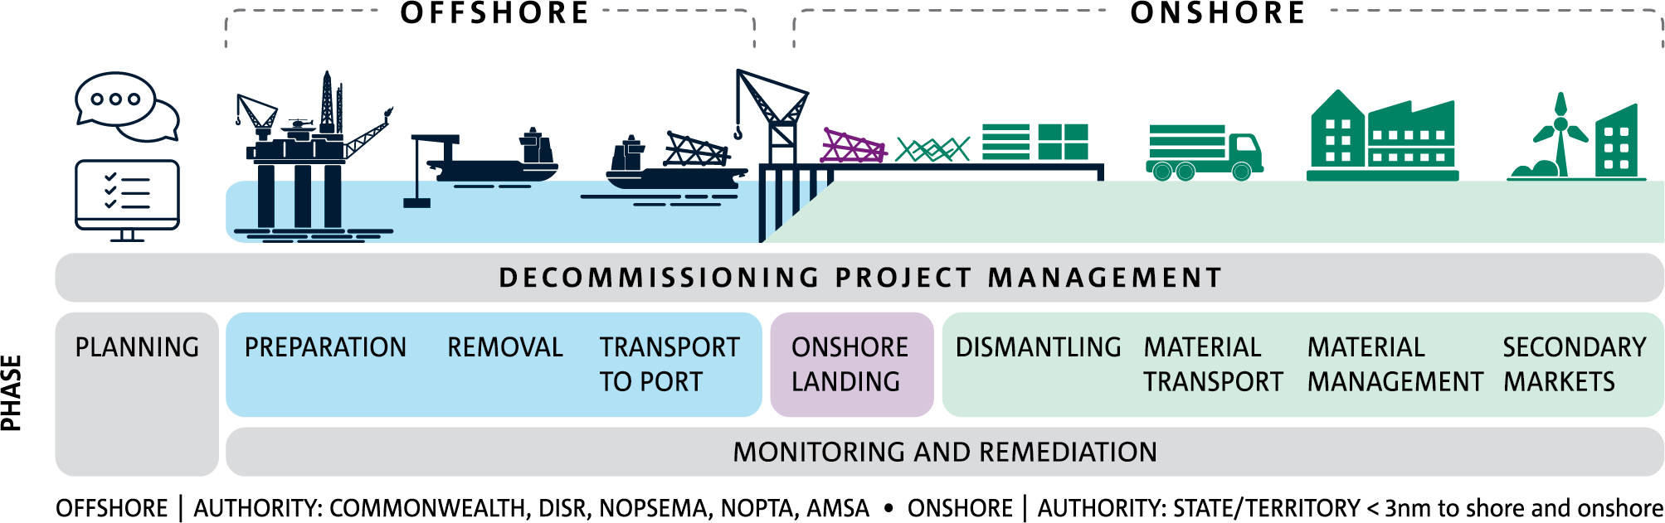

Figure 2. Conceptual map of the offshore and onshore oil and gas decommissioning and resource recovery value chain

Australia’s offshore oil and gas decommissioning and resource recovery value chain is unique and complex. There is a limited but growing amount of information to support industry development and policy direction. To bolster the development of a sustainable domestic industry, Australia can learn from international decommissioning activities, ensuring that our industry is technically, economically, and environmentally sound.

CSIRO determined that sound governance, industry coordination, and enhanced project planning underpin an effective decommissioning value chain.

Governance and regulation

**Australia’s regulatory and legislative arrangements are complex and require coordination and consultation to reduce project costs. A central authority would help address barriers and challenges and leverage opportunities.**

Decommissioning and resource recovery activities cross multiple regulatory levels. The federal government regulates offshore activities. State and territory governments regulate onshore activities. International conventions apply to managing contaminants, the transboundary movement of waste, and sea dumping. These complex regulatory and legal arrangements can create delays and additional costs in planning, approvals, and environmental risk assessments, and may be a disincentive to investment.

There is an opportunity to develop co-designed adaptive governance, underpinned by science and industry lessons, to create a harmonised and improved regulatory and legal framework with increased stakeholder participation, minimised risks and streamlined approval processes.

A central authority, similar to the North Sea Transition Authority (NSTA), would be beneficial. Australia’s National Offshore Petroleum Safety and Environmental Management Authority (NOPSEMA) and other associated regulatory bodies would find it very difficult to mirror the structure and function of the NSTA due to the different governance structures of Australian jurisdictions.

The proposed central authority could oversee offshore and onshore activities related to decommissioning, including state and territory planning and approvals. The authority could address certainty, costs and challenges associated with material accounting, health and safety, and resource recovery. It could set cost reduction targets and strategies, generate and share international and domestic best practice, and support research, development and innovation.

Industry coordination

**Building better industry networks and strengthening industry coordination will improve resource access and minimise costs and delays.**

While some industry coordination is occurring, there is little visibility of project pipelines. This can reduce access to ports and the workforce. Leveraging existing industry networks and improving information sharing could reduce costs and delays.

Project planning

**Enabling better project planning and management through information sharing and incentivising planning and cooperation.**

The industry will gain much from information sharing and greater planning and cooperation between operators, contractors and other stakeholders. This will help manage the complex regulatory environment and stakeholder relationships.

Cost reduction is a critical enabler for the industry

Industry coordination and cost reduction strategies are needed to help constrain the expense of offshore oil and gas decommissioning.

The cost of decommissioning offshore oil and gas projects varies enormously depending on the size of the infrastructure to be removed, the water's depth and the complexity and type of installation.

Australia is a high-cost jurisdiction, bound by a tight labour market and rising infrastructure project costs. Therefore, even small-scale cost efficiencies could provide significant savings for decommissioning projects.

Significant effort has been undertaken to summarise assets and predict the cost of decommissioning expected to occur until 2060.

Decommissioning costs are high and uncertain

Using data from the Wood Mackenzie Lens Portal, the total abandonment cost of the Australian offshore oil and gas industry between 2023–2057 is estimated to be $47 billion. Most of the decommissioning liability (77 per cent) is expected to be incurred off the northwest coast of Western Australia, with the rest focused off the southeast Australian coast.

Predicted costs may not accurately reflect all offshore and onshore activities in the value chain, and may be significantly underestimated, especially those for costs associated with the infrastructure development required to support resource recovery.

Cost reduction strategies

A national cost reduction strategy that considers all cost drivers associated with offshore and onshore decommissioning, is informed by international best practice and our regional context would optimise operational efficiency and improve technical innovation.

Strategies that can increase efficiencies and help to reduce costs in Australia include:

* Fit-for-purpose design and technology
* Intelligent multi-project campaigns
* Excellent project planning and execution
* Standardised approach to more straightforward activities such as well plugging and abandonment, removal of smaller structures and remediation work
* Innovative contracting models
* High-calibre and specialised decommissioning teams
* Consideration of place-based limitations and opportunities

Expansion and diversification of Australia’s decommissioning workforce is required

Australia has a skills shortage that disproportionately affects remote and regional Australia – where most decommissioning activities will occur. Opportunities exist to upskill and transition the workforce, and increase the participation of women and First Nations people.

An increase in decommissioning work will create demand for transferable highly skilled jobs. However, skills shortages, competition for workers and a lack of diversity may affect the ability to service the decommissioning industry.

Developing a skilled workforce through training and development

Australia has a persistent skills shortage, particularly in remote and regional Australia, where most decommissioning activity will occur. The increasing demand for trade skills for the clean energy transition will likely further squeeze the availability of relevant workers.

There is a need for upskilling oil and gas workers, including via on-the-job training. Building decommissioning skills into curricula for education and training in oil and gas and the clean energy sectors will also help develop the skills needed to service the industry.

Workplace safety and environmental management are also important considerations, with robust and consistent measures and transparent regulatory and legal frameworks required to protect workers.

Enabling diversity in the decommissioning workforce

Low participation of women in the domestic oil and gas industry can be improved through flexible work arrangements, generous paid parental leave provisions, and affordable, good quality and accessible childcare. These measures could be incentivised or promoted as best practice and industry-based participation targets could also be established.

First Nations people also face systemic barriers to workforce participation. Regionally targeted training and development, increased access to well-paid positions, mentoring support, and partnering with remote and regional First Nations businesses could help meet national workforce demands. Effective engagement with First Nations people will result in shared benefits and help promote the cultural and social acceptability of the decommissioning industry.

Availability and capacity of decommissioning infrastructure in regional Australia

Australia has a shortfall in access to or capacity of ports, vessels, and infrastructure required to service decommissioning and resource recovery. A coordinated approach to infrastructure management, facilitated by a central authority, would enable the industry to grow sustainably and efficiently.

Port, vessel and infrastructure limitations exist

Existing industries, such as energy and mining, as well as increasing freight tasks predicted for Australia’s port and related infrastructure may compete with the vessel and infrastructure needs of decommissioning projects. A lack of information about available port capacity can also significantly affect the execution and cost of projects.

Access to heavy lift and support marine vessels to perform the offshore components of decommissioning is a critical limitation.

There is also a shortfall in resource recovery and recycling facilities for our waste management sector. Most processing capacity is far from where the materials will be received. However, supply chains for material management are developing in response to decommissioning forecasts in some regions.

Building an integrated decommissioning infrastructure network

Australia has no fit-for-purpose decommissioning facilities. Such facilities may provide greater certainty for industry planning, development, and investment. However, the industry is likely to meet domestic decommissioning demand through existing or upgraded port and quayside infrastructure.

In the absence of a new decommissioning facility, retrofitting ports to accept decommissioned structures is the most likely scenario. Ports and potential decommissioning-related development opportunities have already been identified and are in progress. Incentives may be needed to encourage ports to take on or preference decommissioning activities.

A coordinated approach to vessel and infrastructure management, facilitated by a central authority body, is required.

Opportunities for domestic oil and gas decommissioning

Effective planning, coordination, data generation, national oversight and information sharing will help the decommissioning industry participate in Australia’s circular economy transition, while supporting regional economies and development.

Enabling project completion through enhanced and progressive planning

Incorporating circular economy principles of reuse, repurposing, recycling, and reprocessing into decommissioning projects can extend the lifespan of

assets and promote domestic material management. There are opportunities for reusing decommissioned infrastructure for carbon capture and storage, and renewable energy applications.

However, there are regulatory, technical, safety, transport, and social acceptability challenges associated with reusing infrastructure. The proportion of infrastructure that can be reused is significantly less than the total amount requiring decommissioning and direct reuse of materials is limited by market perceptions that secondary materials are of poorer quality. Due to limited domestic capacity and manufacturing capabilities, most materials are still exported for reprocessing.

Planning for the reuse and repurposing of infrastructure and materials early in projects will allow opportunities to be identified. Incentives for material reuse could be considered to divert quality materials from reprocessing pathways. Mapping the flow of materials would help provide certainty in infrastructure development decisions. Locating waste management capacity in regions where decommissioning is planned would help to manage contamination and biosecurity.

An enhanced planning and assessment framework would help manage materials, identify data gaps and minimise environmental risks, with the view of embedding circular economy into the future state of Australia’s decommissioning industry (Figure 3). The framework should be underpinned by the generation of accessible data, accurate materials reporting, industry collaboration and coordination, and a harmonised legal and regulatory framework.

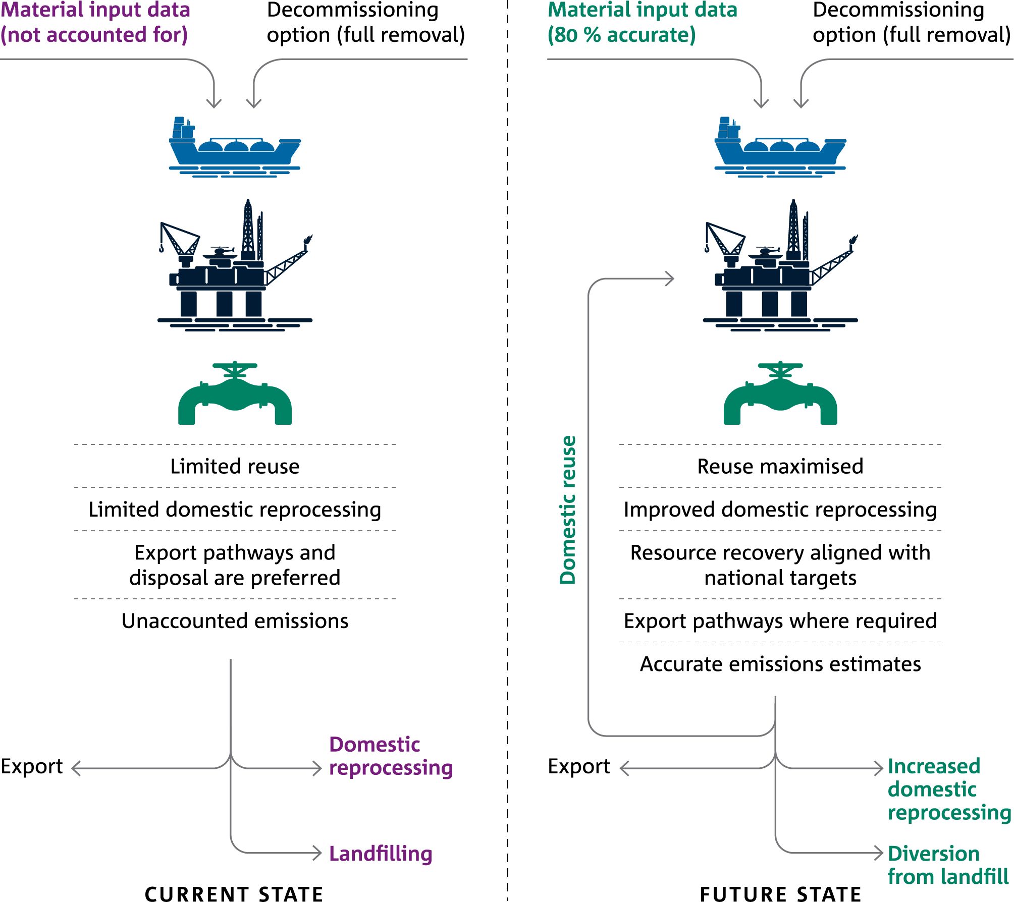

Figure 3. The current (left) and future (right) state of material management from Australian offshore oil and gas decommissioning and resource recovery. More sustainable outcomes could be achieved through enhanced and progressive planning and early adoption of circular economy principles.

Realising regional Australia’s economic potential

Decommissioning activities can help regional and national economies by supporting the engineering industry and its supply chain, enabling trade in decommissioned assets, indirectly enabling other types of trade (such as the export of recycled products), and supporting regional and national supply chains. Regional economies will benefit from increased jobs and industry expenditure.

Data availability and quality are critical for assessing material flows and pathways, economic benefit, jobs creation and emissions accounting. CSIRO researchers undertook an input-output analysis to depict the flow of products and resources and the industry's contribution to local jobs and income.

The assessment estimates that:

* Port construction has a current economic benefit of $239.82 million and will support 211 jobs.
* A 20 per cent increase in Australia’s annual steel processing capacity would have an economic benefit of $29 billion and support 1,149 jobs.
* 3,568 jobs will be supported across the decommissioning and resource recovery value chain, with a high proportion in the material management phase. This figure is likely to be underestimated as it does not include all supporting skills.
* Transporting recovered oil and gas infrastructure by ship, road, and rail significantly contributes to greenhouse emissions. Establishing regional processing hubs for each offshore region can significantly reduce these emissions.

Linking with adjacent regional industry development will be key

CSIRO researchers assessed the current state, barriers, and opportunities for developing regional decommissioning and resource recovery capacity in Western Australia, South Australia, the Northern Territory, Victoria and Tasmania.

The assessment found that decommissioning and resource recovery are likely to be undertaken in a distributed manner through connected regional supply chains and export pathways, with all regions identified as having either material reprocessing or waste management limitations. This distributed approach will require planning, management and oversight, coordinated data management, information sharing, and stakeholder engagement to maximise efficiencies, enable regional workforce and capacity planning, and provide certainty to regional supply chains.

Port upgrades are required to facilitate decommissioning in a sustainable and environmentally responsible manner. This includes improving environmental containment and monitoring and ensuring that depth, berth, and quay length are suitable for service infrastructure. An assessment of port suitability and critical upgrades required to support decommissioning would be beneficial and help identify opportunities to partner internationally.

Long supply chains also present challenges, especially for regions without reprocessing or waste management capacity. Due to the uneven distribution of domestic material management capacity, materials recovered and received in southeast Australia will likely have a greater chance of being recycled domestically than those received in northern Australia, where materials are likely to be managed through existing export pathways or disposed of in regional landfills. A central authority could improve the development of supply chains and infrastructure required to manage materials domestically.

Most regions where decommissioning is planned have limited workforce availability, further constrained by competition with adjacent industries. Building decommissioning into adjacent industry training, diversifying the regional workforce and mapping the demand for jobs and skills may relieve skill shortages.

Environmental management will continue to be a critical issue for decommissioning. Early identification of environmental impacts through enhanced planning can reduce environmental and human health hazards.

Establishing industry best practices for engaging and involving local communities and First Nations peoples in decision-making and developing co-benefit opportunities will support local social acceptability. While a regional case-by-case approach to social acceptability is required, a social acceptability framework would build trust and ensure regional economic benefits are realised.

Gaining social acceptability for offshore oil and gas decommissioning and resource recovery

Social acceptability is critical to oil and gas decommissioning and resource recovery. Despite the sensitive nature, location and potential risks of the activities, no bespoke Australian social acceptability framework exists for this industry.

Most offshore oil and gas decommissioning and resource recovery activities will likely occur in regional Australia. The impact on regional communities and surrounding environments is a significant consideration for industry development. Social acceptance – both broadly among Australian society and locally for host communities – will be an important component for success of any future decommissioning industry. Social acceptance does not depend on one primary driver or factor. There are a range of drivers that are important for social acceptability, and these reflect matters that are important to a host community or society more broadly. Insights can be drawn from international examples and from other contested industries, which demonstrate that addressing these social licence factors along with tailored stakeholder engagement with affected communities is critical.

Understanding social acceptability

Social acceptability or ‘social licence’ is the ongoing acceptance and approval of an industry’s activities by local communities. It reflects how well an industry meets societal expectations and the expectations of its host community in relation to its activities.

Factors that contribute to social acceptability (Figure 4) include:

* **Perceived impacts**: concerns about negative effects or harm to social, economic, and environmental wellbeing of the local community and society more broadly.
* **Perceived benefits**: perceptions of benefits to social, economic, and environmental wellbeing, both locally and wider.
* **Perceived risks**: beliefs and feelings people have about hazards.
* **Procedural fairness, relationship quality and trust in the industry**: expected relations between community and the industry operator including expectations of how fairly communities will be treated, opportunities to have a say, responsiveness of industry, and trust and confidence in industry competence, social responsibility and reliability.
* **Distributional fairness**: expectations of how the benefits of an industry are shared and the costs and risks are borne in a host community.
* **Governance**: expectations and perceptions of compliance activities, planning and engagement with communities to deal with problems and maximise opportunities, and trust and confidence in regulators.
* **The narrative**: perceptions of the rationale for the decisions related to the siting and activities of the industry in relation to the problem (e.g. Why this solution over another option? How effective will this solution be in solving the problem?)

Knowledge confidence: people’s confidence in their knowledge of the industry.

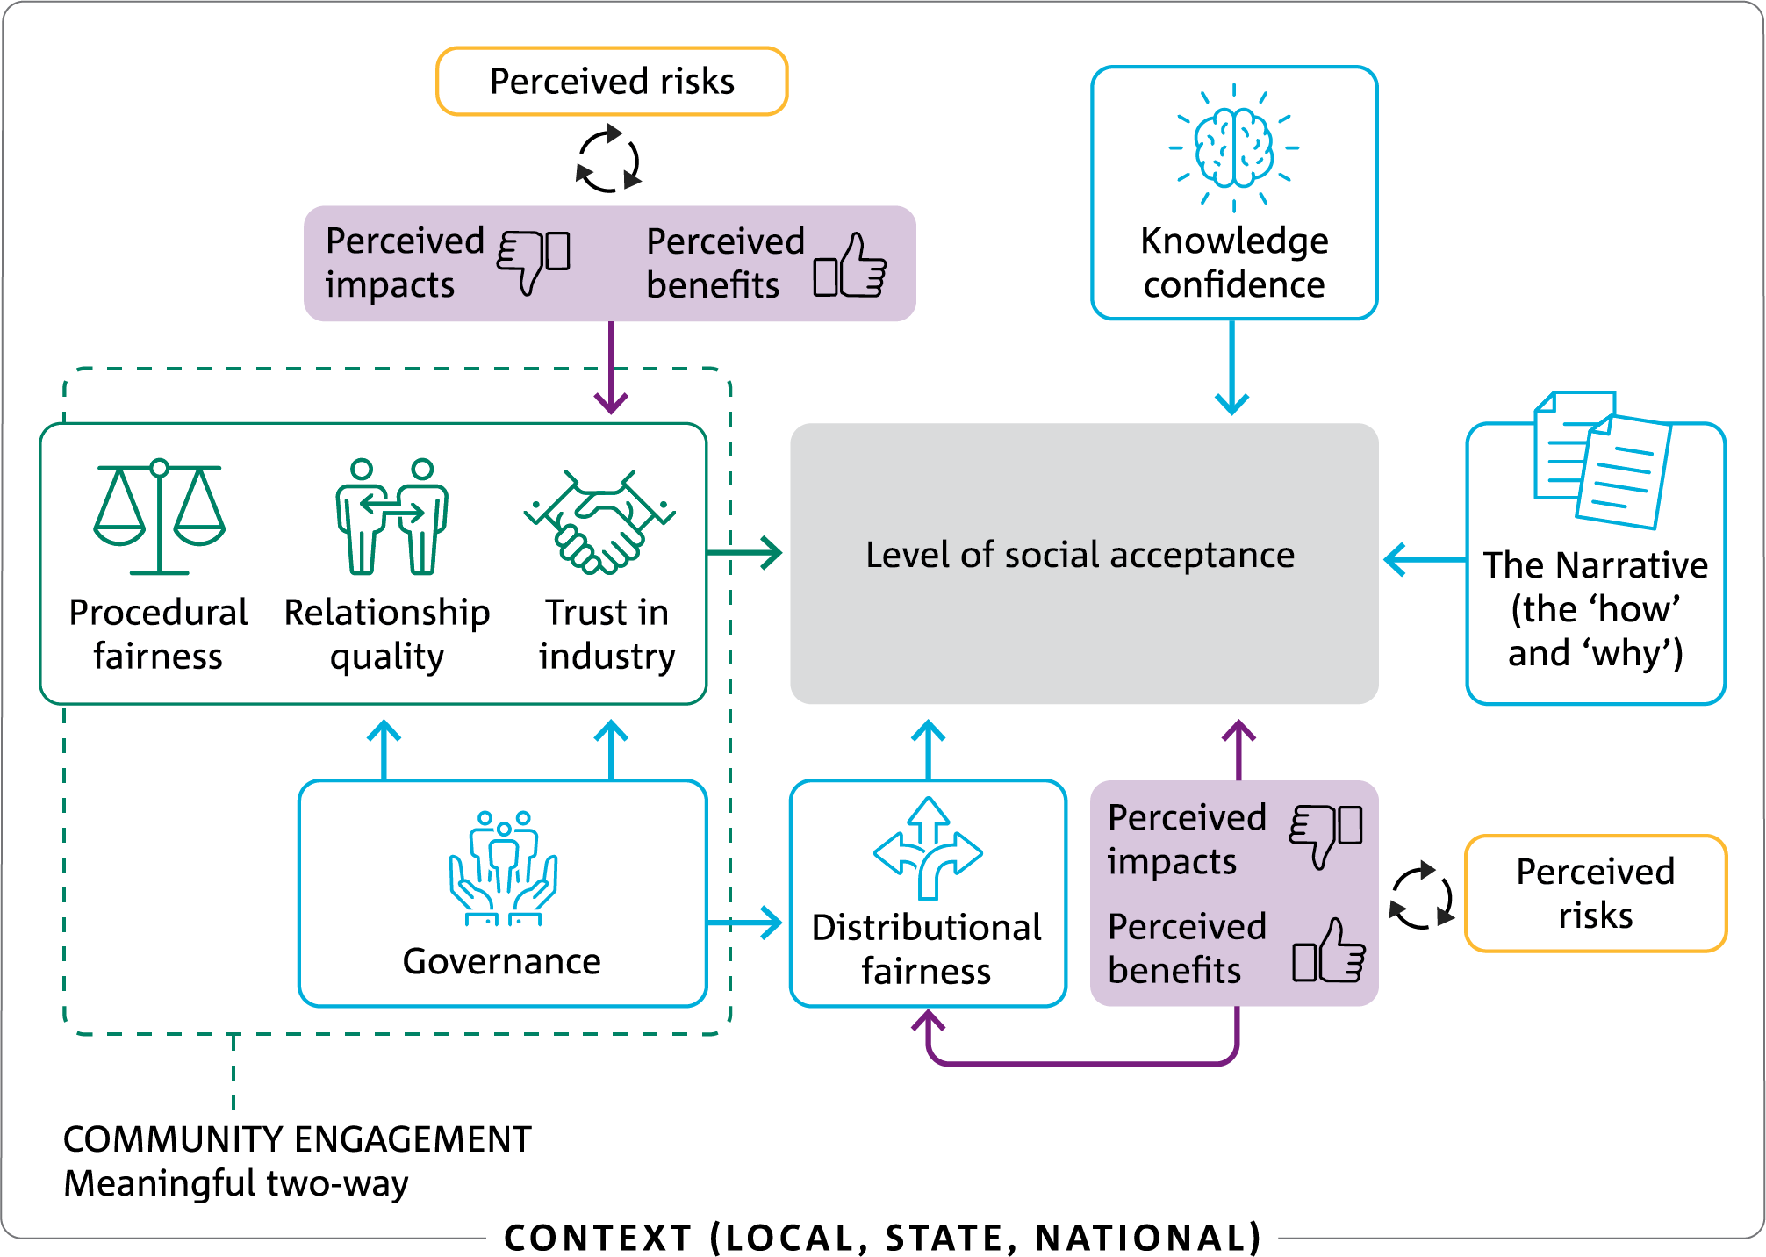

Figure 4. Potential key drivers of social acceptability for the oil and gas decommissioning industry

Perceived adverse impacts and benefits

Decommissioning activities will likely lead to social, economic, and environmental consequences.

Negative perceptions of an activity's impacts result in lower levels of acceptance and trust. However, every community is different. Understanding local values and what is important from a regional perspective can reveal the issues and impacts that matter most to each community.

The offshore decommissioning industry already experiences social acceptability challenges that must be mitigated and managed. There are public health and worker health and safety concerns related to contamination from decommissioning materials. There can be increased traffic, noise, odour and environmental pollution, all needing to be effectively managed. Locating decommissioning infrastructure close to culturally significant sites important for First Nations community health and wellbeing is a challenge. Oil and gas projects in the Northern Territory and Western Australia have encountered strong opposition due to concerns about cultural heritage impacts.

The sudden arrival of workers can affect local housing, rent and property values, causing concerns in the host community. Decommissioning is expensive. The public may have concerns about or a lack of confidence in the industry’s ability to pay for the decommissioning.

Perceived benefits generally relate to positive changes in economic and employment conditions. Increased employment may increase disposable incomes and economic activity for local businesses, including First Nations businesses. Training and development opportunities supported through the decommissioning industry allow up-skilling of workers and access to more diverse and quality jobs. Improved local infrastructure, such as roads and educational facilities, may benefit the host community.

Increasing social acceptability in the decommissioning industry

As no empirical studies have yet been published regarding the social acceptability of offshore oil and gas decommissioning in Australia, lessons come from industry stakeholder insights, international case studies and social licence literature from comparable domestic industries. These lessons could inform the development of an industry-specific social acceptability framework for Australia that can be applied regionally to assess potential social impacts and enablers as the industry develops.

Insights for increasing social acceptability for the decommissioning industry include:

1. Early and effective engagement with stakeholders is critical.
2. Onshore-offshore complexity needs to addressed.
3. Make it doubly safe – technically and in the eyes of the public.
4. Provide the bigger picture through the decommissioning narrative.
5. A strong regulator is vital.
6. The Australian and local context matter.
7. Collaboration and information sharing among industry, government and community can be instrumental to success.
8. Research is required to better understand social acceptability in this industry.

What we did and further information

Australia’s offshore oil and gas decommissioning and resource recovery value chain is unique and complex, and limited information exists to support industry development. To gain expert insights into the industry, CSIRO conducted in-depth stakeholder engagement.

To explore the challenges and opportunities for Australia’s decommissioning industry, CSIRO conducted a comprehensive literature review, which examined international best practices, international and domestic policies, international case studies, industry reports and scientific literature.

Researchers conducted extensive stakeholder engagement with industry experts, including industry and business peak bodies, state and federal government teams and task forces, non-governmental organisation representatives and oil and gas decommissioning researchers. Interviews and engagement with these stakeholders elicited information and expert insights that informed and validated research findings. The information garnered through the desktop review and stakeholder engagement was grounded with international learnings that may be applied to Australia’s decommissioning industry as it develops.

CSIRO’s research is presented in two technical reports:

* *Exploring regional opportunities for offshore oil and gas decommissioning and resource recovery: main report* (Boxall et al., 2024).
* *Exploring regional opportunities for offshore oil and gas decommissioning and resource recovery: social acceptability* (Walton et al., 2024).

The research helps build the evidence to support government decision-making to realise the economic potential of creating connected regional resource recovery supply chains for decommissioning materials.

CSIRO’s research compliments and supports recent research by other organisations and agencies, such as the Centre of Decommissioning Australia, and contributes knowledge on Australia’s decommissioning and resource recovery activities, challenges and opportunities.

This summary report presents the key findings and recommendations from the CSIRO technical reports. The full reports are available at <https://research.csiro.au/circulareconomy/>

CSIRO looks forward to working with industry and government partners to develop a more circular oil and gas decommissioning industry linked to adjacent industries and spanning both onshore and offshore spaces.

Resources

Ellen Macarthur Foundation, 2023a. What is the circular economy?   
Available: https://www.ellenmacarthurfoundation.org/topics/circular-economy-introduction/overview. Accessed November 2023.

Norsk Olje & Gass, 2020. Decommissioning Work Breakdown Structure Handbook.   
Available: https://offshorenorge.no/contentassets/9c8d99d009a04989be2ef32f9fcc0985/wbs-handbook-r1.pdf.

SEPA (Scottish Environment Protection Agency), 2020. UK Oil & Gas Decommissioning Sector Plan.   
Available: https://sectors.sepa.org.uk/media/1148/oil-gas_sector-plan_final_singlepage_360916_sct0619469992.pdf.

As Australia’s national science agency, CSIRO is solving the greatest challenges through innovative science and technology.

CSIRO. Creating a better future for everyone.

Contact us

1300 363 400  
+61 3 9545 2176  
csiro.au/contact   
csiro.au

For further information

CSIRO Environment   
Naomi Boxall  
+61 8 9333 6260  
[Naomi.Boxall@csiro.au](mailto:Naomi.Boxall@csiro.au)

CSIRO Environment   
Andrea Walton  
+61 7 3833 5675  
[Andrea.Walton@csiro.au](mailto:Andrea.Walton@csiro.au)