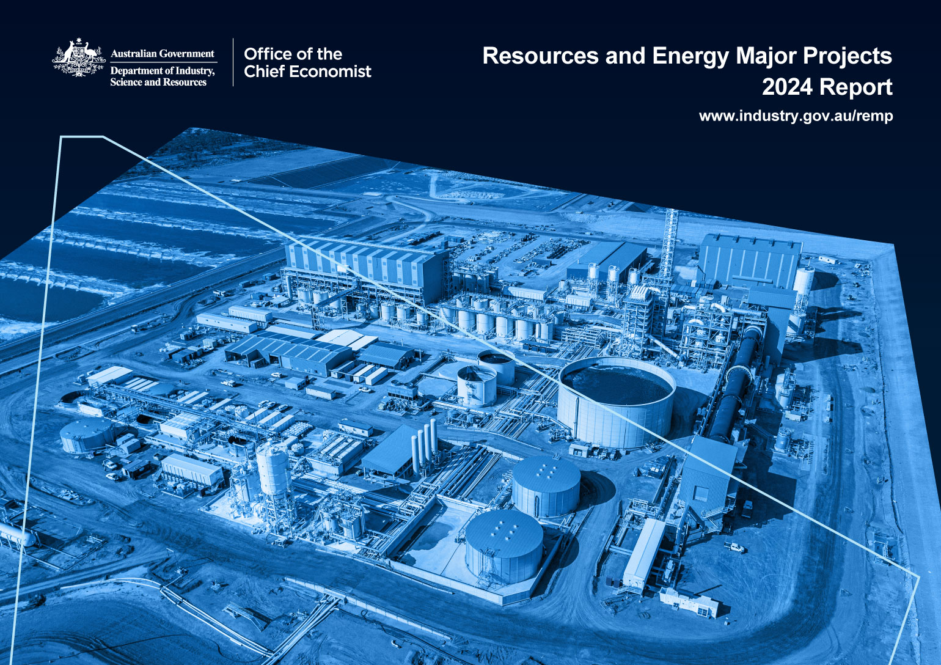000

### **Further information**

For more information on data or government initiatives please access the report from the Department’s website at: [www.industry.gov.au/oce](http://www.industry.gov.au/oce)

### **Project team**

Sufyan Saleem, Mark Gibbons, Andy Lee, Ranjini Palle, Justin Tang, Karol Andrzejewski, Colin Clark, Dan Dwyer, Isacc Farahmand, Timothy Karbanowicz, Bridget Leibold, Chris Mornement, Shuchita Pota, Jacob Rossi, Steve Smith, Riyaz Sayed Sahib, Sabrina Tabassum.

### **Acknowledgements**

The authors would like to acknowledge the contributions of:

Ken Colbert, James Hutson, Andrew Nash and David Thurtell

Cover image source: Lynas Rare Earths

ISSN 1839-5007

© Commonwealth of Australia 2024

### **Ownership of intellectual property rights**

Unless otherwise noted, copyright (and any other intellectual property rights, if any) in this publication is owned by the Commonwealth of Australia.

### **Disclaimer**

The views expressed in this report are those of the author(s) and do not necessarily reflect those of the Australian Government or the Department of Industry, Science and Resources.

This publication is not legal or professional advice. The Commonwealth of Australia does not guarantee the accuracy or reliability of the information and data in the publication. Third parties rely upon this publication entirely at their own risk.

### **Creative Commons licence**

| Image shows Creative Commons licence logo | **Attribution 4.0 International Licence  CC BY 4.0** |
| --- | --- |

All material in this publication is licensed under a Creative Commons Attribution 4.0 International Licence, with the exception of:

* the Commonwealth Coat of Arms;
* content supplied by third parties;
* logos; and
* any material protected by trademark or otherwise noted in this publication.

Creative Commons Attribution 4.0 International Licence is a standard form licence agreement that allows you to copy, distribute, transmit and adapt this publication provided you attribute the work. A summary of the licence terms is available from <https://creativecommons.org/licenses/by/4.0/>.

Wherever a third party holds copyright in material contained in this publication, the copyright remains with that party. Their permission may be required to use the material. Please contact them directly.

### **Attribution**

Content contained herein should be attributed as follows:

Department of Industry, Science and Resources, Commonwealth of Australia Resources and Energy Major Projects 2024. The Commonwealth of Australia does not necessarily endorse the content of this publication. Requests and inquiries concerning reproduction and rights should be addressed to [REQ@industry.gov.au](mailto:REQ@industry.gov.au).

Contents

Summary 4

1. Overview 4

2. Critical minerals 10

3. Oil and gas 15

4. Hydrogen 17

5. Committed and completed projects 19

6. Publicly announced and advanced feasibility projects 23

7. Exploration 24

8. Methodology 25

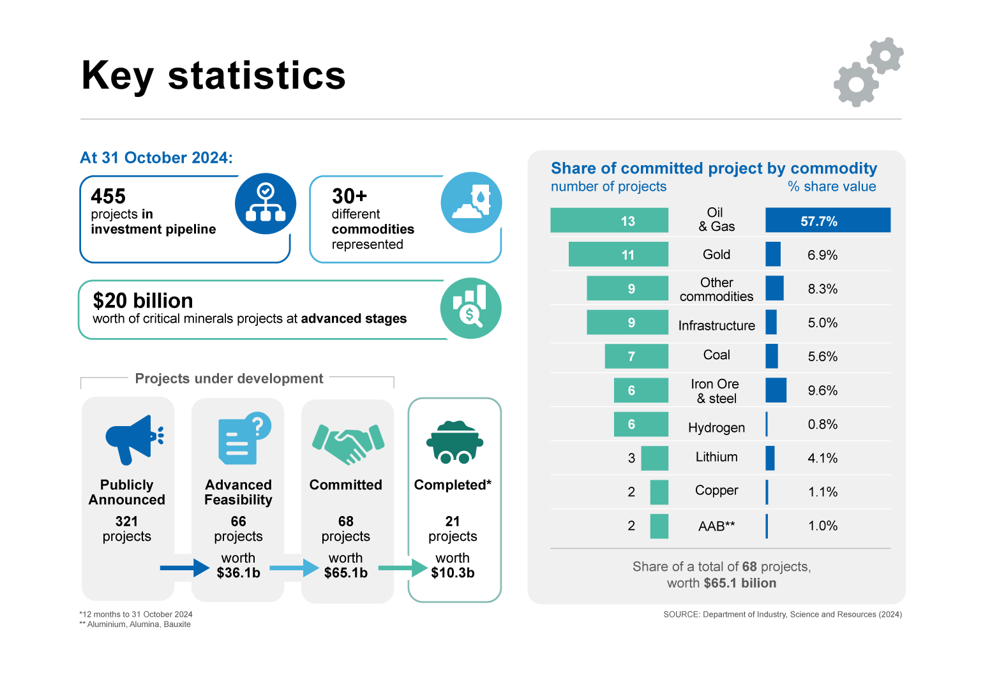//

# Summary

* The 2024 *Resources and Energy Major Projects* (REMP) shows a healthy investment outlook for Australia’s resources and energy sector underpinned by a mix of new energy and traditional commodities.
* There were 455 major resource and energy projects in Australia under development as at 31 October 2024, up from 421 projects a year earlier. This includes 68 committed projects — where a final investment decision (FID) has been taken — and 66 projects at the advanced feasibility stage.
* The value of committed projects fell from $77 billion to $65 billion as projects progressed to completion. Oil and gas projects continue to make up the largest share of committed projects by value.
* Critical minerals projects continue to contribute to Australia’s major projects list, despite challenging conditions and smaller project sizes. Around a quarter of both early-stage and later-stage projects in this year’s list were critical minerals, with $20 billion of proposed investment for later-stage projects.
* Infrastructure projects continue to facilitate Australia's resource and energy industries, totalling $3 billion of committed projects in 2024. These projects cover new and expanded gas pipelines, resource processing, port and rail upgrades, and decarbonisation projects.
* Changes to methodology introduced in the 2023 report have been retained in the 2024 edition.

# Overview

The value of committed and completed projects has declined

The value of committed and completed major projects has decreased following several years of growth. The value of ‘committed’ resources and energy projects fell 16% over the past year to $65 billion, down from $77 billion in 2023 (Figure 1.1), while the number of committed projects fell from 86 to 68 (Figure 1.2).

The decrease reflects 21 projects (worth $10 billion) reaching completion, as well as several projects that were paused (mainly for lithium and nickel-cobalt). The number of projects that reached the FID stage was lower than in the last REMP as project owners manage challenges including an uncertain global environment, falling prices for some commodities, and higher interest rates.

Figure 1.1: Value of committed and completed projects

Source: Department of Industry, Science and Resources (2024)

The post-2022 decline in late-stage projects may be partly driven by the decrease in early-stage announcements which followed the COVID-19 outbreak (Figure 1.2). However, recent growth in early-stage projects may offset this in future years.

Projects may progress without necessarily moving between stages. There are many steps to be completed before a project moves between stages. This can include additional rounds of exploration, multiple feasibility and project scoping/rescoping studies, financing, and contract negotiations with suppliers and service providers. Detail on these steps is not recorded in the report.

A total of 103 projects were added to the project list in 2024, including new projects, expansions and reactivations. A total of 52 projects that appeared on the REMP 2023 project list have been removed. These reflect a combination of cancelled projects and projects that have been rescoped into other projects. A total of 6 projects regressed in stage between the 2023 and 2024 REMP.

Gold, copper, and iron ore projects dominated additions to the REMP

The value of committed and completed projects has remained solid across most commodities. Geographically, most of Australia’s resources and energy major projects are located in Western Australia (Figure 1.4), with the state now holding more than 70% of project value at the committed stage. This trend has been evident for some years, and the growth in early-stage projects in Western Australia suggests it will continue.

**Iron ore** projects remain relatively stable; however, several new green steel and green iron projects (covered in the iron ore category) have been included this year. Four large iron ore projects progressed to the committed stage over the past year and one project was completed. Capital expenditure for advanced projects (those that have reached advanced feasibility or the committed stages) declined to $8.2 billion in 2024 from $8.8 billion in 2023 as some were completed.

The investment pipeline for **gold** remains healthy, propelled by high global gold prices. There are 38 gold projects in the 2024 REMP, up from 27 in 2023. Projects in the publicly announced and advanced feasibility stages rose rapidly (from 15 to 27) but committed project numbers fell as projects reached completion. Capital expenditure for advanced projects grew in 2024 ($9.7 billion, up from $9.6 billion), with Western Australia accounting for 58% of Australia’s total gold capex over the year.

Figure 1.2: Number of projects by stage, 2017-2024

Notes: The 2023 edition replaced the ‘feasibility’ stage with the ‘advanced feasibility’ stage. Projects in the ‘feasibility’ stage are reclassified to either ‘publicly announced’ or ‘advanced feasibility’ stages. Hydrogen was added as a new commodity in the 2021 edition.

Source: Department of Industry, Science and Resources (2024)

Figure 1.3: Value of new commitments by commodity

Source: Department of Industry, Science and Resources (2024)

Figure 1.4: Projects by State/Territory

Source: Department of Industry, Science and Resources (2024)

**Copper** capex for advanced feasibility and committed projects rose to   
$6.1 billion in 2024, from $5.9 billion in 2023, driven by two additional projects reaching advanced feasibility coupled with minor changes in existing projects' capex. The South Australian government announced the Northern Water Supply infrastructure project in 2024, which aims to facilitate copper project expansions in South Australia from 2030 onward. Olympic Dam is expected to more than double its production capacity, potentially improving Australia's refined copper export position in the future. Additionally, Oak Dam – a sizeable exploration project – was announced this year near Olympic Dam. In 2024, only three projects advanced to the next stage, which is fewer than the number that advanced in 2023. Sixteen projects did not change in 2024, compared to 10 in 2023.

The investment pipeline for **other commodities** (non-critical minerals) was largely unchanged in 2024, with 12 out of 18 projects remaining at their existing stage. Market uncertainty and high costs have affected the companies’ decision to invest, but the pipeline remains strong on balance, with the rise in capex reflecting stronger commitments to several existing projects. These include the Mardie Salt and Potash project, where expected capex has been revised up by $649 million to $1.6 billion in 2024. The capex for Taronga Tin project has also been revised up from $114 million in 2023 to $176 million in 2024.

Investment in energy commodities has held up, with little change

Australia’s **coal** projects remain broadly unchanged, with developments mostly limited to brownfield projects. Three projects were completed, all of which were expansions to existing mines. Three additional projects were publicly announced, though these were close to existing Stanmore and Vitrinite projects which points to a potential reluctance to expand coal development in new areas. There were 47 coal projects recorded in 2024, down from 53 in 2023.

Among the 8 **uranium** projects in the list, 7 are publicly announced and one is in the advanced feasibility stage. Uranium projects are generally in a holding pattern, with one project completed during 2024. Uranium projects are highly regulated and typically slow to progress, but if current price strength is sustained it will likely add pressure to progress uranium projects more rapidly.

Table 1.1: Summary of projects as at 31 October 2024

|  | Publicly Announced | Advanced Feasibility | | Committed | |
| --- | --- | --- | --- | --- | --- |
|  | No. of projects | No. of projects | Value A$b | No. of projects | Value A$b |
| Aluminium, Alumina, Bauxite | 2 | 1 | 0.3 | 2 | 0.7 |
| Coal | 39 | 1 | 0.2 | 7 | 3.7 |
| Copper | 18 | 8 | 5.4 | 2 | 0.7 |
| Gold | 12 | 15 | 5.2 | 11 | 4.5 |
| Hydrogen | 63 |  |  | 6 | 0.5 |
| Iron ore | 31 | 4 | 1.9 | 6 | 6.3 |
| Lead, Zinc, Silver | 4 | 4 | 0.7 |  |  |
| Lithium | 8 | 1 | 0.1 | 3 | 2.7 |
| Nickel, Cobalt | 13 | 3 | 3.7 |  |  |
| Oil & Gas | 30 | 1 | 0.8 | 13 | 37.7 |
| Other Commodities b | 60 | 26 | 11.7 | 9 | 5.4 |
| Uranium | 7 | 1 | 0.5 |  |  |
| Infrastructure a | 34 | 1 | 5.6 | 9 | 3.0 |
| **Total** c | 321 | 66 | 36.1 | 68 | 65.1 |

Notes: **a** Infrastructure is limited to resource, energy infrastructure projects including CCS. **b** Other Commodities is limited to resources and energy commodities not elsewhere identified. **c** Totals may not add due to rounding at commodity level.  
Source: Department of Industry, Science and Resources (2024)

Table 1.2: New advanced feasibility studies, commitments to projects and projects completed, between 1 Nov 2023 and 31 Oct 2024

|  | New advanced feasibility studies | | New commitments | | Completed | |
| --- | --- | --- | --- | --- | --- | --- |
|  | No. of projects | Value A$b | No. of projects | Value A$b | No. of projects | Value A$b |
| Aluminium, Alumina, Bauxite | 2 | 0.79 | 1 | 0.553 |  |  |
| Coal | 1 | 0.16 | 1 | 0.15 | 3 | 1.31 |
| Copper | 3 | 1.99 |  |  |  |  |
| Gold | 14 | 5.18 | 9 | 2.46 | 4 | 0.52 |
| Hydrogen |  |  | 3 | 0.29 |  |  |
| Iron ore | 1 | 0.50 | 4 | 2.21 | 1 | 3.00 |
| Lead, Zinc, Silver | 1 | 0.13 |  |  | 2 | 0.69 |
| Lithium |  |  |  |  | 3 | 2.61 |
| Oil & gas |  |  | 1 | 0.25 |  |  |
| Nickel, Cobalt |  |  |  |  |  |  |
| Other Commodities b | 5 | 1.18 | 1 | 0.28 | 3 | 1.23 |
| Uranium |  |  |  |  | 1 | 0.11 |
| Infrastructure a |  |  | 1 | 0.00 | 4 | 0.84 |
| **Total** c | 27 | 9.93 | 21 | 6.18 | 21 | 10.30 |

Notes: **a** Infrastructure is limited to resource, energy infrastructure projects including CCS. Several gas pipelines span across more than one state but have been allocated to one state for reporting purposes. **b** Other Commodities is limited to resources and energy commodities not elsewhere identified. **c** Totals may not add due to rounding at commodity level.

Source: Department of Industry, Science and Resources (2024)

Figure 1.5: Location of projects at the committed stage, as at 31 October 2024

Source: Department of Industry, Science and Resources (2024)

|  |
| --- |

# Critical minerals

### Australia’s growing critical minerals pipeline driven by early-stage projects

Australia’s critical minerals major project list for 2024 includes 117 projects (including 6 completions). This is an increase of 12 projects compared to the 2023 list[1]. Proposed investments for projects at later stages of development as at 31 October 2024 is estimated at $20 billion (Table 2.2).

Two-thirds of critical minerals projects included in this year’s list were in the early stages of development (publicly announced). For later-stage projects, around 21% of projects delivered an advanced feasibility study and a further 8% had been committed. 6 projects were completed in the last 12 months.

Around half of all critical mineral projects (62) are located in Western Australia. Remaining projects were distributed across Queensland (15), the Northern Territory (11), South Australia (10), New South Wales (9), Victoria (9), and Tasmania (1).

### Weak global conditions and project completions contributed to a smaller cohort of later-stage projects

The value of advanced feasibility and committed projects declined to $20 billion, compared to $26 billion in the 2023 report. Despite companies continuing to progress work on critical minerals projects over the year, only a small number of projects published new advanced feasibility studies or reached a final investment decision over the period.

This was particularly evident for lithium and nickel projects, with both commodities experiencing sustained decreases in global prices over the period. No new advanced feasibility studies or final investment decisions were made for lithium and nickel projects over the period. Poor market conditions also resulted in pauses in construction for train 3 of the Kemerton refinery and the Pilgangoora Lithium Phosphate Demonstration

**Figure 2.1: Critical minerals project count by stage**

Source: Department of Industry, Science and Resources (2024)

**Figure 2.2: Critical minerals project count by state or territory**

Source: Department of Industry, Science and Resources (2024)

plant, while plans for train 4 of the Kemerton refinery were cancelled. Similarly, falling nickel prices has seen work on IGO’s Cosmos project and BHP’s West Musgrave copper-nickel project suspended.

Amongst projects that did progress, Alpha HPA’s First Project (Stage 2) and GEMCO Eastern lease South expansion projects reached FID, while Cadoux’s FYI HPA project published a new advanced feasibility study.

This year’s report included the completion of several high-value projects, worth $3.8 billion. Three lithium mine projects were completed in 2024: Liontown’s Kathleen Valley mine ($951 million), Covalent’s Mt Holland ($1.25 billion) and the Pilgangoora P680 expansion ($404 million) reached commercial production. Lynas’ Kalgoorlie rare earths processing facility and the Thunderbird mineral sands project (a joint venture between Sheffield Resources and Yansteel) were also completed over the period.

**Figure 2.3: Investment in later stage critical mineral projects**

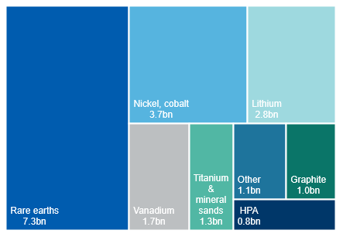

Notes: Later-stage projects includes those that have delivered a Definitive Feasibility Study (or equivalent), and/or have reached a Final Investment Decision (i.e. Committed stage)

Source: Department of Industry, Science and Resources (2024)

### Rare earths, lithium and nickel-cobalt projects account for two-thirds of the value of later-stage projects

Rare earths continue to represent a large share of Australia’s critical mineral major projects, with 15 projects (early- and late-stage projects) in the 2024 project list. Rare earths continue to be Australia’s largest category of critical mineral projects at later stages of development (by value), with $7.3 billion in proposed investment. This is followed by nickel-cobalt ($3.7 billion) and lithium ($2.8 billion) projects. Other major categories of later stage projects include vanadium ($1.7 billion), titanium & mineral sands ($1.3 billion), and graphite ($1.0 billion) (Figure 2.3).

Australia’s first rare earth processing plant — Lynas Rare Earths’ $780 million Kalgoorlie facility — was commissioned this year. The first shipment of mixed rare earth carbonate occurred in the June quarter 2024, with the facility’s official opening occurring in November 2024. Meanwhile, Iluka Resources has indicated its $1.75 billion Eneabba rare earths refinery is expected to be commissioned in 2027. While no projects published advanced feasibility studies or made a FID, both stage 1 and stage 2 of ACDC Metals’ Goschen Central project were added to the project list in 2024.

This year’s report reflects the sector’s continuing efforts to build downstream processing capabilities, with $11 billion in proposed investments. Around half of the value for refinery projects was for rare earths processing plants, while the Sunrise nickel-cobalt project (worth $2.4 billion) and Kwinana lithium refinery (worth $1.25 billion) also contributing to the value of investment in downstream processing.

### Construction and commissioning works underway at a number of HPA, titanium and mineral sands projects

Alpha HPA in Queensland commenced the construction of its Stage 2 high purity alumina (HPA) expansion project in September 2024. With an expected completion date of 2026, the $553 million investment will see the project become the largest HPA producer in the world, with an annual capacity of over 10,000 tonnes. Over the same period, Impact Minerals and Playa One have continued work on their $253 million Lake Hope HPA project, targeting FID in 2025.

Progress is also being made in titanium and mineral sands projects. Thunderbird Stage 1 was successfully commissioned over the reporting period, with shipments of ilmenite and zircon concentrates starting from the June quarter 2024. Iluka’s Balranald project remains on track for commissioning in the second half of 2025. The project — which reached a final investment decision in February 2023 — saw key works completed over the year, including site access and off-site construction of the project’s concentrator.

### Project numbers for graphite, vanadium and active materials are stable

There was no substantial change in the battery active material project pipeline (including vanadium and graphite) in the 12 months to 31 October 2024. Projects in the pipeline remain in early stages, with no new advanced feasibility studies published nor any FIDs made.

Renascor’s Siviour purified spherical graphite (PSG) facility is the most progressed active material project, being at the advanced feasibility stage. Stages 1 and 2 of the project are valued at $772 million collectively, and would add a total 100,000 tonnes of PSG a year. Renascor has recently entered into several non-binding MOUs for the supply of PSG to companies in South Korea, Japan and China.

Australian Vanadium Ltd (AVL) acquired the Murchison Technology Metals Project in February 2024, which is adjacent to the Australian Vanadium Project. In addition to vanadium pentoxide, the Australian Vanadium Project will also produce ferro-titanium, which may further strengthen its position. AVL completed a Bankable Feasibility Study (advanced feasibility study) on the project in April 2022, and expects the project’s output to be 11,200 tonnes of 99.5% vanadium pentoxide high purity flake and 900,000 dry tonnes of ferro-titanium a year once in production. The two products are expected to be exported to Austria, China, Singapore, Spain. AVL has entered into MOUs or letters of intent with companies in these countries.

### Comparing critical minerals projects to last year’s report

This year’s report includes nickel-specific projects, as nickel was classified as a critical mineral in February 2024. Further information on the current list of Australia’s Critical Minerals can be found on the Department of Industry, Science and Resources’ website.

A comparison between projects on the 2023 and 2024 major projects list is included below. The value of proposed investment includes only those projects that have either: (i) delivered a definitive, detailed or bankable feasibility study, or (ii) reached FID.

Table 2.1: Comparing major critical minerals projects to last year

|  |  |  |
| --- | --- | --- |
|  | **2023 report** | **2024 report** |
| Total projects | 105 a | 117 |
| Later-stage projects value b | $26bn | $20bn |
| Projects that progressed **c** | | 8 |
| Projects that regressed **c** | | 9 |

Note: **a** This includes the 100 critical mineral projects listed in the 2023 report, plus an additional 5 nickel-specific projects. This is because nickel was not on the Australian Government’s critical mineral list at the time of the 2023 publication. **b** Value relates to advanced feasibility and committed projects. **c** Progressed or regressed compared with the 2023 list. Progression and regression indicate a movement between categories (such as from advanced feasibility to committed).

Table 2.2: Summary of critical mineral projects as at 31 October 2024

|  | Publicly Announced | Advanced Feasibility | | Committed | Completed | | |
| --- | --- | --- | --- | --- | --- | --- | --- |
|  | No. of projects | No. of projects | Value A$b | No. of projects | Value A$b | No. of projects | Value A$b |
| Active materials & electrolytes | 6 | 2 | 0.8 |  |  |  |  |
| Nickel-cobalt | 13 | 3 | 3.7 |  |  |  |  |
| Graphite | 2 | 4 | 1.0 |  |  |  |  |
| High Purity Alumina | 1 | 1 | 0.3 | 1 | 0.6 |  |  |
| Lithium | 8 | 1 | 0.1 | 3 | 2.7 | 3 | 2.6 |
| Manganese | 3 |  |  | 1 | 0.1 |  |  |
| Magnesium | 6 |  |  |  |  |  |  |
| Rare earths | 7 | 6 | 5.1 | 2 | 2.3 | 1 | 0.8 |
| Silica/Silicon | 1 | 2 | 0.2 |  |  |  |  |
| Titanium & mineral sands | 11 | 3 | 0.8 | 1 | 0.5 | 2 | 0.4 |
| Vanadium | 5 | 3 | 1.3 | 1 | 0.4 |  |  |
| *Other* | *14* |  |  |  |  |  |  |
| **Total** | **77** | **25** | **13.2** | **9** | **6.4** | **6** | **3.8** |

Notes: Other category includes platinum group metals and critical minerals co-located within other metals groups (e.g. copper). Vanadium includes vanadium oxide projects, with outputs including ilmenite, titanium oxide, ferro-vanadium and iron oxides. Heavy mineral sands include zircon, ilmenite, niobium, leucoxene, hafnium, rutile and other heavy mineral concentrates.

Source: Department of Industry, Science and Resources (2024)

Table 2.3: New advanced feasibility studies, commitments to projects and projects completed, between 1 November 2023 and 31 Oct 2024, for critical minerals

|  | New advanced feasibility studies | | New commitments | | Completed | |
| --- | --- | --- | --- | --- | --- | --- |
|  | No. of projects | Value A$b | No. of projects | Value A$b | No. of projects | Value A$b |
| High Purity Alumina | 1 | 0.3 | 1 | 0.6 |  |  |
| Lithium |  |  |  |  | 3 | 2.6 |
| Rare earths |  |  |  |  | 1 | 0.8 |
| Titanium & mineral sands |  |  |  |  | 2 | 0.4 |
| Vanadium |  |  |  |  |  |  |
| Manganese |  |  | 1 | 0.1 |  |  |
| **Total** | **1** | **0.3** | **2** | **0.6** | **6** | **3.8** |

Notes: Other category includes platinum group metals and critical minerals co-located within other metals groups (e.g. copper). Vanadium includes vanadium oxide projects, with outputs including ilmenite, titanium oxide, ferro-vanadium and iron oxides. Heavy mineral sands include zircon, ilmenite, niobium, leucoxene, hafnium, rutile and other heavy mineral concentrates.

Source: Department of Industry, Science and Resources (2024)

# Oil and gas

### Oil and gas projects dominate projects at the committed stage

Oil and gas projects account for a substantial share of overall capital expenditure and a majority of value at the committed stage in the 2024 REMP. Oil and gas projects encompass a range of different project types, including oil and gas extraction, LNG projects which liquify gas for export, and LNG import terminals. The LNG import terminals in the 2024 REMP will be Australia’s first; complementing Australia’s pipeline system and allowing LNG import from other countries for the first time.

The number of oil and gas projects remained relatively steady in 2024 (Figure 3.1). In value terms, committed oil and gas projects rose to   
$38 billion, up from $36 billion in 2023 (Figure 3.2). Newly committed projects include Venice Energy’s South Australian import terminal as well as APA Group's East Coat Grid expansion, which has now progressed to stage 3. This stage includes investments in additional compressor stations, which could increase winter peak capacity on Australia’s east coast.

Two Victorian LNG projects have been recently completed: the Enterprise project, which aims to support higher output from the Otway Basin, and APA Group's Outer Ring Main pipe, which aims to support better connectivity to Western Victoria.

### New project numbers are edging back

The number of oil and gas projects at earlier stages of the project pipeline remains largely unchanged, with a small decline in publicly announced projects in 2024. Although the overall number of publicly announced projects has dropped slightly, more rapid development of LNG has been evident in the Northern Territory where several new projects have been recently announced. Completion of these could add to the Northern Territory’s importance as an energy supplier in the 2030s.

Figure 3.1: Oil and gas project pipeline

Source: Department of Industry, Science and Resources (2024)

Figure 3.2: Oil and gas capex: change since 2022

Source: Department of Industry, Science and Resources (2024)

Table 3.1: Oil and gas projects by state, as at 31 October 2024

|  |  |  |  |  |  |  |  |  |
| --- | --- | --- | --- | --- | --- | --- | --- | --- |
|  |  | **NSW** | **Vic** | **Qld** | **SA** | **WA** | **Tas** | **NT** |
| **Completed** | Number |  | 2 | 1 |  | 8 |  |  |
|  | Value ($m) |  | 106 | 70 |  | 8,654 |  |  |
| **Committed** | Number | 1 | 1 | 2 | 1 | 7 |  | 1 |
|  | Value ($m) | 250 | 400 | 2,500 | 250 | 30,017 |  | 4,300 |
| **Publicly announced & definitive feasibility** | Number | 1 | 7 | 5 | 1 | 13 |  | 4 |

Source: Department of Industry, Science and Resources (2024)

# Hydrogen

### The number of hydrogen projects decreased as expectations mature

The number of projects under development in hydrogen has contracted from 76 in 2023 to 69, as expectations around hydrogen’s place in the energy transition have matured. Of the 69 projects, 64 will use electrolysis to produce green hydrogen, 2 will use a combination of fossil fuels and electrolysis and 3 will use fossil fuel to produce hydrogen.

While the total number of projects under development has decreased, the number of committed projects has increased. The number of committed projects increased from 3 to 6, increasing the reported capex from $234 million to $520 million (figure 4.1). Of the publicly announced projects, 10 projects are undertaking or have completed Front End Engineering Design (FEED) work (Box 4.1).

The increase in committed projects includes Fortescue’s Gladstone PEM50 and Geelong New Energies Service Station reaching FID in the last year. The Geelong New Energies Service Station will have capacity of 365 tonnes and will focus on hydrogen mobility and servicing heavy fuel cell electric vehicles. The Gladstone PEM50 project aims to produce 8,000 tonnes of green hydrogen using PEM (from energy purchased from the grid. Proton exchange membrane (PEM) electrolyser technology can ramp production up and down faster than alkaline electrolysers, potentially allowing for greater grid stability when the project is connected to the grid.

WA and QLD to host majority of hydrogen projects

Around half of the hydrogen projects are located in Western Australia (20) and Queensland (18). The remaining projects are located in South Australia (10), the Northern Territory (7), Victoria (6), New South Wales (6), and Tasmania (2) (figure 3.2).

To maintain consistency across information sources, the Department of Industry, Science and Resources (DISR) draws on HyResource (a joint initiative between Australian industry and government organisations) which lists currently active projects.

### **Figure 4.1 Hydrogen project count by stage**

Source: Department of Industry, Science and Resources (2024)

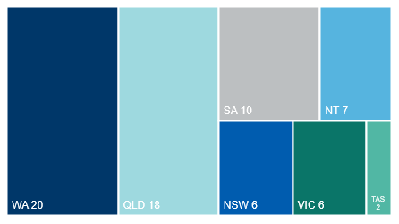Figure 4.2: Number of hydrogen projects by state

Source: Department of Industry, Science and Resources (2024)

|  |  |  |  |  |  |  |  |  |  |  |
| --- | --- | --- | --- | --- | --- | --- | --- | --- | --- | --- |
| **Box 4.1: Hydrogen project stages**  Hydrogen project stages in this report are categorised based on the Methodology section (Chapter 7) of this report. However, like the oil and gas sector, the hydrogen industry uses different categorisations to this report to capture project progressions, including:   |  |  | | --- | --- | | Industry | REMP stage | | Pre-Front End Engineering Design | Publicly announced | | Front End Engineering Design | Publicly announced | | Final Investment Decision | Committed | | Completed | Completed | |

# Committed and completed projects

Project completions have seen committed projects decrease

Over the year to October 2024, 21 projects with a total value of $10 billion were completed: a decrease from 29 projects (valued at $21 billion) in 2023 (Figure 5.1). Most projects that are currently committed are expected to reach completion by the end of 2026.

**Uranium** projects have mostly remained at their current status, however, strong growth in exploration expenditure in 2024 could translate to increased projects in future years. Boss Energy’s Honeymoon Uranium Mine in South Australia completed in 2024.

The **coal** pipeline is the fifth largest in value terms. Three coal projects moved to completed status over the year, with the number of committed projects decreasing from 10 to 7 as a result. One project (Mammoth underground) moved to the committed stage, while another (Dartbrook) moved from advanced feasibility to completed. The Baralaba south project reached the advanced feasibility stage in 2024.

**Iron ore** investment remains relatively stable, with steady progress for most projects. In February 2024, BHP announced approval for its $1.4 billion Western Ridge Crusher project, where first production is expected in 2026-27. Atlas Iron has awarded a mining contract for its $600 million McPhee creek mine in the Pilbara. Mineral Resources’ $3 billion Onslow Iron project reached commercial production, achieving first ore on-ship in May 2024. The net impact of these changes saw the total estimated value of iron ore projects in the committed stage in this year’s report decrease from $7 billion to $6 billion.

Figure 5.1: Expected completion year of projects, for advanced feasibility and committed projects

Notes: Expected completion year of projects are based on either company announcement

Source: Department of Industry, Science and Resources (2024)

Figure 5.2: Number and value of committed projects

Source: Department of Industry, Science and Resources (2024)

Figure 5.3: Value of committed projects by commodity

Notes: Infrastructure is limited to resource, energy infrastructure projects including CCS. Other Commodities is limited to resource and energy commodities not elsewhere identified.

Source: Department of Industry, Science and Resources (2024)

Figure 5.4: Value of completions and new commitments

Notes: Infrastructure is limited to resource, energy infrastructure projects including CCS. Other Commodities is limited to resource and energy commodities not elsewhere identified.

Source: Department of Industry, Science and Resources (2024)

Table 5.1: Summary of projects at the committed stage by state, as at 31 October 2024

|  | NSW | | Vic | | Qld | | SA | | WA | | Tas | | NT | | Total | |
| --- | --- | --- | --- | --- | --- | --- | --- | --- | --- | --- | --- | --- | --- | --- | --- | --- |
|  | No. of projects | Value A$b | No. of projects | Value A$b | No. of projects | Value A$b | No. of projects | Value A$b | No. of projects | Value A$b | No. of projects | Value A$b | No. of projects | Value A$b | No. of projects | Value  A$b |
| Aluminium, Alumina, Bauxite |  |  |  |  | 2 | 0.7 |  |  |  |  |  |  |  |  | 2 | 0.7 |
| Coal | 3 | 1.9 |  |  | 4 | 1.8 |  |  |  |  |  |  |  |  | 7 | 3.7 |
| Copper |  |  |  |  | 1 | 0.1 | 1 | 0.6 |  |  |  |  |  |  | 2 | 0.7 |
| Gold |  |  |  |  | 1 | 0.1 |  |  | 8 | 2.6 |  |  | 2 | 1.8 | 11 | 4.5 |
| Hydrogen | 1 | 0.1 | 2 | 0.1 | 2 | 0.2 |  |  | 1 | 0.1 |  |  |  |  | 6 | 0.5 |
| Infrastructure a | 1 | 0.1 | 1 | 0.1 | 1 | 0.8 | 1 | 0.1 | 5 | 2.0 |  |  |  |  | 9 | 3.0 |
| Iron ore | 1 | 1.2 |  |  |  |  |  |  | 5 | 5.1 |  |  |  |  | 6 | 6.3 |
| Lead, Zinc, Silver |  |  |  |  |  |  |  |  |  |  |  |  |  |  |  |  |
| Lithium |  |  |  |  |  |  |  |  | 3 | 2.7 |  |  |  |  | 3 | 2.7 |
| Nickel, Cobalt |  |  |  |  |  |  |  |  |  |  |  |  |  |  |  |  |
| Oil & Gas | 1 | 0.3 | 1 | 0.4 | 2 | 2.5 | 1 | 0.3 | 7 | 30.0 |  |  | 1 | 4.3 | 13 | 37.7 |
| Other Commodities **b** | 1 | 0.5 |  |  | 2 | 0.7 | 1 | 0.1 | 4 | 4.2 |  |  | 1 | 0.1 | 9 | 5.4 |
| Uranium |  |  |  |  |  |  |  |  |  |  |  |  |  |  |  |  |
| **Total** c | 8 | 3.9 | 4 | 0.6 | 15 | 6.8 | 4 | 1.0 | 33 | 46.6 |  |  | 4 | 6.2 | 68 | 65.1 |

Notes: **a** Infrastructure is limited to resource, energy infrastructure projects including CCS. Several gas pipelines span across more than one state but have been allocated to one state for reporting purposes. **b** Other Commodities is limited to resource and energy commodities not elsewhere identified. **c** Totals may not add due to rounding at commodity level.

Source: Department of Industry, Science and Resources (2024)

Table 5.2: Summary of projects completed by state, between 1 November 2023 and 31 October 2024

|  | NSW | | Vic | | Qld | | SA | | WA | | Tas | | NT | | Total | |
| --- | --- | --- | --- | --- | --- | --- | --- | --- | --- | --- | --- | --- | --- | --- | --- | --- |
|  | No. of projects | Value A$b | No. of projects | Value A$b | No. of projects | Value A$b | No. of projects | Value A$b | No. of projects | Value A$b | No. of projects | Value A$b | No. of projects | Value A$b | No. of projects | Value  A$b |
| Aluminium, Alumina, Bauxite |  |  |  |  |  |  |  |  |  |  |  |  |  |  |  |  |
| Coal | 2 | 1.2 | 1 | 0.1 |  |  |  |  |  |  |  |  |  |  | 3 | 1.3 |
| Copper |  |  |  |  |  |  |  |  |  |  |  |  |  |  |  |  |
| Gold | 1 | 0.1 |  |  |  |  | 1 | 0.1 |  |  |  |  | 2 | 0.4 | 4 | 0.5 |
| Hydrogen |  |  |  |  |  |  |  |  |  |  |  |  |  |  |  |  |
| Infrastructure a |  |  | 2 | 0.4 | 1 | 0.3 |  |  | 1 | 0.1 |  |  |  |  | 4 | 0.8 |
| Iron ore |  |  |  |  |  |  |  |  |  |  |  |  | 1 | 3.0 | 1 | 3.0 |
| Lead, Zinc, Silver |  |  | 1 | 0.5 |  |  |  |  |  |  |  |  | 1 | 0.2 | 2 | 0.7 |
| Lithium |  |  |  |  |  |  |  |  |  |  |  |  | 3 | 2.6 | 3 | 2.6 |
| Nickel, Cobalt |  |  |  |  |  |  |  |  |  |  |  |  |  |  |  |  |
| Oil & Gas |  |  |  |  |  |  |  |  |  |  |  |  |  |  |  |  |
| Other Commodities **b** |  |  |  |  | 1 | 0.1 |  |  |  |  |  |  | 2 | 1.2 | 3 | 1.2 |
| Uranium |  |  |  |  | 1 | 0.1 |  |  |  |  |  |  |  |  | 1 | 0.1 |
| **Total** c | 3 | 1.3 | 4 | 0.9 | 3 | 0.5 | 1 | 0.1 | 1 | 0.1 |  |  | 9 | 7.3 | 21 | 10.3 |

Notes: **a** Infrastructure is limited to resource, energy infrastructure projects including CCS. Several gas pipelines span across more than one state but have been allocated to one state for reporting purposes. **b** Other Commodities is limited to resource and energy commodities not elsewhere identified. **c** Totals may not add due to rounding at commodity level.

Source: Department of Industry, Science and Resources (2024)

# Publicly announced and advanced feasibility projects

Global net zero ambitions drove new critical minerals projects

This year’s report has identified 387 publicly announced and advanced feasibility projects. Of these projects, a total of 66 (with an estimated value of $36 billion) have an advanced feasibility study. The completion of an advanced study is an indicator that the project may be close to reaching the committed stage, with 27 projects (with an estimated value of   
$9.9 billion) progressing to the advanced feasibility stage this year.

**Gold** project numbers in the advanced feasibility stage were much higher than in 2023, suggesting that producers remain optimistic about future gold prices. De Grey Mining has attained feasibility for their new Hemi mine with expected output of 16.5 tonnes per year for the first ten years.

A new **uranium** mine in South Australia is now in prospect. Alligator Energy publicly announced plans for its Samphire Uranium Mine. It is planned to have an annual capacity of 545 tonnes and a capex of $131 million.

There are 35 **iron ore** projects yet to reach the committed stage, including 4 projects which have reached advanced feasibility. Green steel and green iron projects have been added to the list this year. New projects include the POSCO Port Hedland Green Steel project, Green Steel WA’s Mid-West Hydrogen DRI Plant, Quinbrook Infrastructure Partners’ Gladstone Green Iron Project and Element Zero’s Pilbara Iron Super Hub.

**Copper** numbers also continue to increase, with the Oak Dam exploration project publicly announced this year. The Olympic Dam smelter expansion is also expected to more than double copper production capacity at the site.

Many **coal** projects remain at the publicly announced stage. This has been driven in part by deteriorating market conditions for coal as some coal plant constructions were cancelled across parts of Asia and coal firms face growing issues with access to finance.

Figure 6.1: Projects yet to reach the committed stage

Notes: Infrastructure is limited to resource, energy infrastructure projects including CCS. Other Commodities is limited to resource and energy commodities not elsewhere identified. Oil and gas projects are not separated between publicly announced and advanced feasibility stages.

Source: Department of Industry, Science and Resources (2024)

Figure 6.2: Value of projects at the advanced feasibility stage

Source: Department of Industry, Science and Resources (2024)

# Exploration

Exploration expenditure rose, driven by energy

Australian exploration expenditure rose over 2023-24, increasing by 9.2% compared to 2022–23 (Figure 7.1). The increase was mostly due to an increase in petroleum exploration (petroleum data includes gas), as well as coal and uranium expenditure. Petroleum exploration expenditure rose by 39% to $1.3 billion. Non-energy mineral exploration expenditure was stable, increasing by 0.6% to $3.8 billion, while energy mineral exploration expenditure rose by 26% to $0.4 billion.

### Gold continues to draw the largest interest in mineral exploration

For the last nine years, gold has attracted the most mineral exploration expenditure, overtaking iron ore in 2015–16. Gold exploration expenditure continues to decrease from its 2021-22 peak of $1.6 billion, dropping to $1.2 billion in 2023-24. Despite the contraction, gold exploration still contributes 23% towards Australia’s exploration expenditure (Figure 7.2).

Growth in exploration expenditure continued for the ‘other’ minerals category, which includes lithium and uranium. Iron ore exploration expenditure was flat, and base metals exploration expenditure fell slightly to $1 billion, but remain elevated when compared to historical levels. Coal exploration expenditure continued to grow at a similar rate to the prior year, rising by 22% in 2023–24.

Figure 7.1: Mineral and petroleum exploration expenditure

Source: ABS (2024) Mineral and Petroleum Exploration, Australia, 8412.0

Figure 7.2: Annual mineral exploration expenditure by commodity

Notes: Base metals also include silver and cobalt.

Source: ABS (2024) Mineral and Petroleum Exploration, Australia, 8412.0

# Methodology

Each year, information is collected about the investment outlook for major resources and energy projects from publicly available resources. Information is gathered from a range of sources, including company websites and media releases, government departments and agencies, industry associations, and Australian Stock Exchange reports.

The focus of this report is on ‘major’ investments — those that can be confidently valued at over $50 million based on publicly available sources. Smaller scale operations are also an important contributor to the sector and the broader Australian economy. But public information, particularly on early-stage projects, can be scarce or difficult to find, and includes projects undertaken by private companies who have fewer obligations to report project progress. Larger operations also make large, but incremental investments over time replenishing equipment, plant and other property. These investments are unlikely to be characterised as major projects.

For these reasons, this report therefore omits some projects when key parameters cannot be identified. Each year the Department seeks to improve the coverage and data quality of the report, including by incorporating relevant project information that may not have been identified in previous years.

Resources and energy project proponents often use different planning processes and assessment methods to support their FID. There is no standard project development model with clearly defined stages and terminology that can be applied to every resource and energy project.

Projects are grouped into four categories. Earlier stages, such as identifying deposits and exploration activities, are not included in the list. While these activities are important, it is beyond the scope of this report to assess exploration activities on a project-by-project basis. Instead, a summary and analysis of aggregate exploration expenditure is provided.

The four stages projects get classified into are:

1. Projects publicly announced and under consideration
2. Projects that have completed an advanced feasibility study
3. Committed projects — which have taken FID
4. 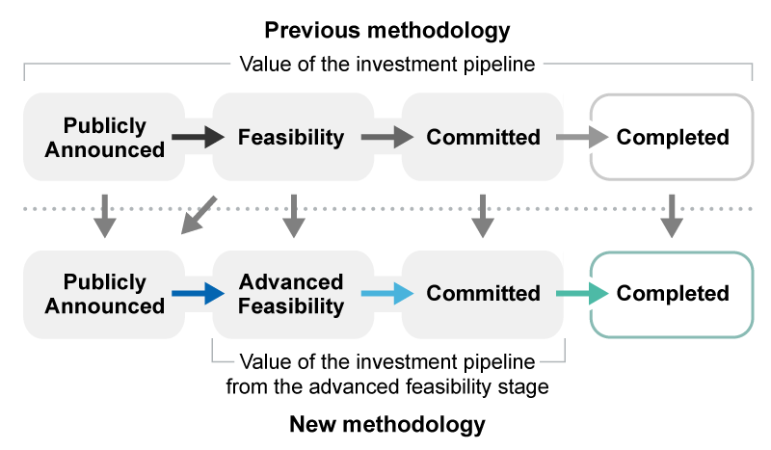Completed projects — which have commenced production

**(1) Publicly announced and under consideration**

Projects at the publicly announced stage are usually early in their development and are typically undergoing feasibility studies to assess the commercial aspects of developing an identified resource. For a project to be listed at this stage, there must be publicly available information on the preliminary project schedule, planned output or cost. As they are still in the early planning stage, projects at the publicly announced stage may not have finalised any engineering designs or construction cost estimates.

Projects at this stage may have provisional or outdated cost estimates and will not have received any formal commitment from companies to proceed. Such projects may have been announced 10 or more years ago with no subsequent progress nor any further studies or updates. The available public information on these projects is collected and presented for use as a reference guide, but data is not modified, aggregated or treated as a formal data source for the purposes of the report. Only the total number of projects at this stage is included.

**(2) Advanced feasibility study completed**

Projects at this stage have completed a definitive, detailed or bankable feasibility study and are considered to have a strong business case for further progression. Definitive feasibility studies will have occurred following detailed Front-End Engineering Design (FEED) studies and full development of the final project scope.

Projects that have progressed through the advanced feasibility stage have a higher likelihood of progressing to the committed stage than earlier stage projects. Figures and data on these projects are considered sound enough to use as a leading indicator for future capital investment by the resources sector. However, capital cost estimates on these projects differ from capital costs for projects at the committed stage, since the latter represents fully committed capital investment.

**(3) Committed stage**

Projects at the committed stage have finished all commercial, engineering and environmental studies, received all necessary government regulatory approvals, and finalised the financing of the project to allow construction. Such projects are considered to have received a positive FID from the owner(s). In most cases, projects at this stage of development have already started construction, as there are typically pre-works undertaken as part of exploration and design activities.

Projects at the committed stage typically have cost estimates, schedules, and mine outputs that are well defined and often published. Most projects that progress to the committed stage are likely to commence production. Nevertheless, post-FID, there are still technical and financial risks that, if realised, can result in delays, scope changes and cost overruns, or even affect the commercial viability of a project and possibly lead to its cancellation.

Data on projects at the committed stage is considered of high quality, and is aggregated, compared, and monitored within the report. Newly committed projects (those which have commenced since the prior report) are included as a distinct category in Table 1.2 of this report.

**(4) Completed stage**

As many projects include multiple stages and scope elements that can be independent of each other, the timing around when a project reaches the completed stage can be difficult to assess. Under our framework, we consider a project reaches the completed stage when all construction and commissioning activities are completed, and the operation has reached commercial production.   
  
**New projects, expansions and reactivations**

Our framework classifies projects as “new”, “expansion” or “reactivation”. New projects are those that were not active at the same location before the first announcement recorded in our research. Expansions correspond to those that are already existing and are taking their operations to neighbouring fields. In many cases, the goal of the “expansion” is merely to maintain output. ‘Expansion’ does not imply output will increase. Reactivation indicates a mine is returning to production after care and maintenance, or projects that were announced, then officially abandoned, but have since been returned to the drawing board.

**Oil and gas projects**

Oil and gas projects are split into three stages — publicly announced, committed, and completed. This is different from the rest of the REMP methodology since it excludes the ‘advanced feasibility’ stage that occurs between publicly announced and committed.

The advanced feasibility stage for non-oil/gas projects is based on projects having completed a ‘definitive feasibility study’ or ‘bankable feasibility study’. These studies are not typically conducted in the oil and gas sector, so the advanced stage has been removed from the oil and gas projects list.

**Estimated start of commercial operation**

Some projects this year have been designated as ‘other’ rather than providing a date. The other category is used in a range of cases, including but not limited to when no date is provided publicly by the project proponent, when recent information on the completion date is not publicly available, or if a project has an expected completion date after 2030.

About this report

The *Resources and Energy Major Projects* publication is an annual review of projects which seek to extend, increase, or improve the quality of mineral commodity output in Australia. These investment projects include greenfield projects, expansions, reactivations, processing facilities, and related infrastructure. Since 1997, the publication has reported the value of current and potential investment in the sector and provided commentary on key development trends.

From 2017 to 2019, *Resources and Energy Major Projects* was published as a chapter in the *Resources and Energy Quarterly*. The 2020, 2021, 2022 and 2023 editions, as well as pre-2017 updates, are standalone publications.

This edition of the report presents an update on project developments over the twelve months from the start of November 2023 to the end of October 2024, and is accompanied by a [detailed project listing](https://www.industry.gov.au/publications/resources-and-energy-major-projects-2022).

Each year, we seek to improve the coverage and quality of the report. Much of the analysis in this edition is directed at projects that have progressed significantly and which have a higher quality of data associated with them. More details on this change are included in Box 1.1.

Terminology

The methodology used in the report is detailed in the *Methodology* section.

This report and project list is the result of our research on major resources and energy projects under development in Australia. For the purposes of this report, ‘major’ projects are those costed at over $50 million and which have the potential to reach a final investment decision (FID) within the next five years.

Projects are classified into four stages: publicly announced, advanced feasibility, committed and completed. Earlier stages of developing mineral projects, such as identifying deposits and exploration activities, are not included in our lists.

1. This includes the 100 critical mineral projects listed in the 2023 report, plus an additional 5 nickel-specific projects. This is because nickel was not on the Australian Government’s critical mineral list at the time of the 2023 publication.