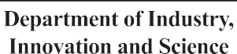

**OPEN GOVERNMENT**

**NATIONAL ACTION PLAN COMMITMENT 5.2:**

**CONCEPTS**

**OPEN GOVERNMENT NATIONAL ACTION PLAN COMMITMENT 5.2: CONCEPTS**

**Introduction**

**This document details the Concepts for Commitment 5.2 of Australia’s first Open**

**Government National Action Plan. The Concepts are initiatives and plans to improve public participation in the Australian Public Service. They were brainstormed and**

**developed during the Ideation phase of the project to implement Commitment 5.2.**

**The concepts are the culmination of feedback generated from workshops and**

**presentations with 324 public servants and members of the public. They also draw on the findings of the project’s Discover Report (see:** [**https://www.industry.gov.au/**](http://www.industry.gov.au/) **innovation/Pages/Open-Government-Partnership-Framework-project.aspx).**

**For more information please email** [**OGP@industry.gov.au**](mailto:OGP@industry.gov.au)

**Purpose of this document and accompanying workshops**

This document is intended to help:

* raise awareness of the concepts;
* quickly gather initial feedback about the concepts in a workshop/focus group environment; and
* serve as a repository for feedback on the concepts, whether from workshops or another medium.

**Overview of accompanying workshops**

The workshops, in which the concepts will be tested and refined, will have a focus group format. Facilitators, with small groups, will rapidly introduce a concept (giving it to participants

as a handout) and then gather quick and initial feedback from participants over a period of around ten minutes. Participants can provide

feedback on anything, but facilitators will also ask targeted questions for feedback on specific

aspects. The process will then be repeated for the next concept, and so on.

Following the workshops, this document will be updated to reflect feedback. Besides iterating the concepts, updates may include shelving some of the concepts, or adding new ones.

The workshops will not be the only opportunity for feedback on the concepts. They will also be tested through other forums and processes.

The workshops are intended to ensure the concepts are robust enough to warrant further scrutiny, and ultimately improve their chances of implementation.

Following this process of iteration, the finalised Concepts will be published in the Create Phase report for Commitment 5.2.

II

DEPARTMENT OF INDUSTRY, INNOVATION AND SCIENCE | **OGP CONCEPTS**

III

**Page Concept title What’s the big idea?**

**Key recommendations: Framework Initiatives**

1

**The Citizen Panel**

Panel of citizens that act like a permanent citizen jury that APS agencies can consult

2

**Engagement Diagnostic Framework**

Conceptual tool that helps public servants diagnose their engagement problem, and how best to solve it.

3

**Exchange programmes**

Develop secondment/exchange, day in the life and exchange programmes to build empathy with stakeholders, creating awareness of the value of, and building capability in, public participation.

4

**Engagement Reporting and Metrics**

The APS establishes, and reports on, agency level engagement metrics; and individual level measures.

5

**Rethinking risk**

Decision tool that helps public servants identify and manage risk involved in engagement.

6

**The Discovery Fund**

Provides risk free funding for ‘discovery’ engagements – both experimental and best practice based.

7

**The Bar: Minimum standards**

Publish APS minimum standards for engagement.

8

**The APS Engagement Practitioner’s Toolkit**

Provides practical help public servants can use to improve their engagement.

9

**Off-the-shelf Models and Methodologies**

Models and methodologies, including ‘how to’ guides, for a variety of different engagements that public servants can take ‘off the shelf’ and apply – including how to modify them depending on time and resource constraints

10

**The Engagement Marketplace**

Establish an Engagement Marketplace, where public servants can go to improve chances of finding people with expertise they can contribute to their work.

11

**The APS Engagement Network**

Establishing an APS wide engagement network: Organises information sharing about engagement and shared initiatives between APS public servants, as well as (potentially) state public servants and the public.

12

**The APS Engagement Snapshot**

Each year, the APS releases an Engagement Snapshot of good practice and successes for that year.

13-14

15

**Partic-hub – the Engagement Hub**

**Revamped Engagement Awards**

Establish a team of engagement experts to manage rollout of the framework; deliver and coordinate associated initiatives; and build APS engagement capacity.

Awards for high quality engagement are established; and included in existing award processes e.g. Australia Day awards; Public Sector Innovation Awards.

IV

**No Concept title What’s the big idea?**

**Other initiatives recommended for APS agencies**

17

**Egg timer**

Software that assists people to estimate the time required to undertake an engagement.

18

**Increase engagement event accessibility**

Changes to events and engagement processes to help reach a wider range of people.



DEPARTMENT OF INDUSTRY, INNOVATION AND SCIENCE | **OGP CONCEPTS**

**FRAMEWORK INITIATIVES**

V



**THE CITIZEN PANEL**

**Recommendation:**

1

**THE IDEA:**

Panel of citizens that act like a permanent citizen jury that APS agencies can consult.

**HOW IT WORKS:**

* Could meet ad-hoc/as summoned
* Or could meet quarterly and have an agenda of items
* Would require secretariat support

**BENEFITS:**

* Helps public servants reach a diverse and accessible audience, bringing community expertise into policy at low risk

**STAFF COMMENTS:**

* How to recruit?
* Do we need to pay panel members?
* Could we do it using Meetups (the online software)?
* Should there be a number of panels?

Do we rotate them? How long are people on a panel for?

* Can we ask New Democracy/others who may have done similar things how they did it?

**INTENSITY:**

Around 10 directly related ideas, but many others that align with the intention behind this idea.

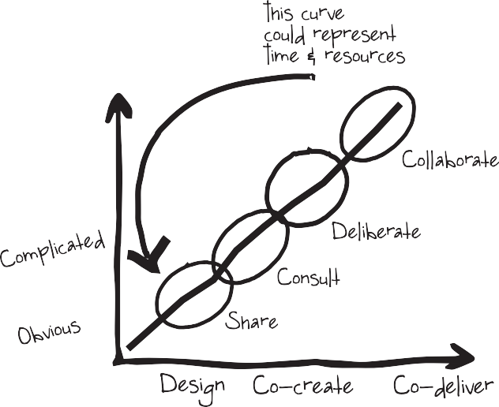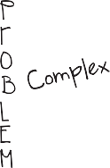

DEPARTMENT OF INDUSTRY, INNOVATION AND SCIENCE | **OGP CONCEPTS**

**ENGAGEMENT DIAGNOSTIC**

**FRAMEWORK**

**Recommendation:**

2

**THE IDEA:**

Conceptual tool that helps public servants diagnose their engagement problem, and how best to solve it.

**HOW IT WORKS:**

* Combines the Ontario engagement framework with the Cynefin conceptual framework
* Vertical access is the Cynefin framework: It outlines four kinds of decisions, simple, complicated, complex and chaos
* Overlaid on its central curve is the Ontario Provincial Government, which outlines four ways in which they engage with citizens – Share – Consult – Deliberate – Collaborate, as well as projected time/resources required
* Horizontal axis is possible approaches for designing a solution – Design, to refine an existing service or process; Co-design (or Co- creation), to create something new and bring people together to develop solutions; Co- delivery, for problems that government cannot solve without the help of the public

**BENEFITS:**

* Provides guidance on how to determine and access the expertise needed to solve public policy issues



**EXCHANGE PROGRAMMES**

**Recommendation:**

3

**THE IDEA:**

Develop secondment/exchange, day in the life and exchange programmes to build empathy with stakeholders, creating awareness of the value of, and building capability in, public participation.

Stakeholders would include: Associations and peak bodies; academia; NGOs; service delivery units of departments; call centres; service desks; government shopfronts.

**HOW IT WORKS:**

People should flow in both directions i.e. public spends time in the APS, public servants spend time with the public

**Three components:**

**1 – Secondments/exchanges**

* Secondments/exchanges: Programmes to second or exchange APS staff to service delivery areas; stakeholders

**2 – Days in the life**

* CEO ‘Sleepouts’ and ‘Days in the life’
* SES staff required to spend at least one day a year answering calls in call centres; or undertaking participation activities

**3 – Secondment to a team undertaking a specialised engagement**

* Allowing staff to experience a more innovative approach in a ‘safe’ environment before adapting or trying it themselves

**BENEFITS:**

* Builds empathy, reducing perceptions or stereotypes that interfere with better engagement
* Builds better understanding of stakeholder perspectives on issues
* Builds awareness of the value of more and better engagement

**INTENSITY:**

Medium – 34 related ‘Reward for effort’ ideas.

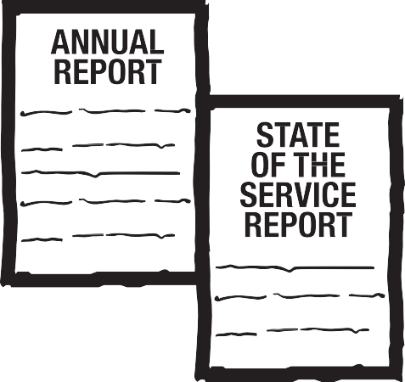

DEPARTMENT OF INDUSTRY, INNOVATION AND SCIENCE | **OGP CONCEPTS**

**ENGAGEMENT REPORTING**

**AND METRICS (FOR INDIVIDUALS**

**AND AGENCIES)**

**Recommendation:**

4

**THE IDEA:**

The APS should establish, and report on:

* Agency level engagement metrics; and
* Individual level measures

**HOW IT WORKS:**

* A central body to run process to develop the metrics (involving all agencies and talking to users who would be affected)

**Once metrics agreed, several ways to embed and establish accountability, for example:**

* Report metrics across government annually (even if kept internal). This could be in the State of Service survey, in Annual Reports, and reporting from Secretaries.
* KPIs in SES contracts.
* BRII platforms could include ‘Trip Advisor’ style rating or badge system where people are rated by their peers on how they are at engagement. These ratings could be reported on in agency annual reports and the State of the Service Report.
* BRII platforms could 1 – collect and report on all engagements conducted on their platforms, and 2 – Include the ‘Trip Advisor’ style rating system

**BENEFITS:**

* Would provide critical feedback that can be the ‘how’ – the basis for improvement
* Normalises engagement as a standard APS behaviour, rather than something that is ‘nice to have’ or in addition to standard process
* Would provide visibility for the engagements that are undertaken and provide the basis for improved performance
* Creates an objective base to assess the quality of engagement
* Ensures high performers get recognition
* Contributes to continuous improvement our engagement
* Creates data to inform engagement strategy

**COMMENTS FROM STAFF:**

* Could provide feedback on meeting the minimum standards
* Transparency and willingness to publish and share research could be something that agencies are reported against.
* Measures need to be actually measurable, involving metrics and perhaps evaluated by other staff and people outside the APS.
* Gerry Stoker and Mark Evans’ CoE Clear tool provides a good model for metrics and measurement
* Measure attitudes before and after engagement
* Could use an APS wide points system to rate
* Include diversity measures to encourage wide-ranging engagement
* Reward departments for publishing
* Could have independent auditing and independently identified measures

**INTENSITY:**

18 KPI related ideas ‘Reward for effort’ platform

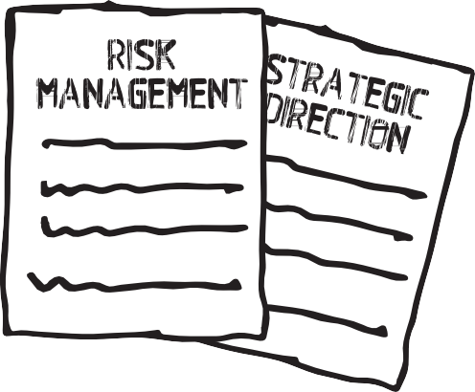

**RETHINKING RISK**

**Recommendation:**

5

**THE IDEA:**

* Develop a decision tool that helps public servants identify and manage risk involved in engagement
* This includes through defining engagement risk and benchmarks and incorporating it into current risk infrastructure

**HOW IT WORKS:**

* Should be aligned with governance and strategic direction of the agency and included in documents/instruments setting these out
* Of course, definitions of risk need to include discussion of the risk of not engaging
* Should be supported with indicators

**BENEFITS:**

* Reduces the degree to which our authorising environment and organisational culture unnecessarily reduces engagement effectiveness

**STAFF COMMENTS:**

* For example, engagement could be seen as a risk reduction exercise, rather than a risky enterprise
* Staff want the language of risk to change from ‘avoiding’ to ‘embracing’ or managed risks
* Engagement could be something that is included in any reviews of risk frameworks
* Should also catalogue or provide advice on implementation risks and challenges
* Concrete way to change behaviours that make public servants ‘catastrophise’ risk – insist that responsibility for engagement gets pushed down the ladder and not only undertaken by SES staff
* Could be represented using a simple flowchart that helps public servants decide what forms of engagement to use and who needs to be engaged
* Online programme to assist public servants to pick the right engagement tool could also include prompts that help ensure questions get answered

**INTENSITY:**

Medium, ~40 directly related ideas, and many others that this aligns



DEPARTMENT OF INDUSTRY, INNOVATION AND SCIENCE | **OGP CONCEPTS**

**THE DISCOVERY FUND**

**Recommendation:**

6

**THE IDEA:**

The APS Modernisation Fund, but for Engagements. Provides risk free funding for ‘discovery’ engagements – whether they are experimental best practice based.

**HOW IT WORKS:**

* Competitive grants: Advertises formal

rounds of funding through APS wide channels and APS agencies can apply for a grant to fund experimental and best practice based collaboration and deliberation engagements

* And/or: more ad hoc – Agencies can apply any time
* Engagement hub assesses applications for funding
* Could be ongoing, or temporary (initial period or limited budget)
* If once off, could be used to fund demonstration engagements

**BENEFITS:**

* Allows ‘safe’ risktaking
* Ensures the necessary resources are there to get the right engagement done

**STAFF COMMENTS:**

* Citizens/the public could potentially propose ideas too
* Should this be for deliberation/collaboration projects only?

**INTENSITY:**

~20 ideas that related to more resources and funding



**MINIMUM STANDARDS**

**(THE BAR)**

**Recommendation:**

7

**THE IDEA:**

* Establish and publish APS minimum standards for engagement

**HOW IT WORKS:**

* A central body runs the process to develop the metrics (involving all agencies and talking to users who would be affected)

**Workshop participants provided the following potential elements for a minimum standard:**

* Openness, transparency and engaging stakeholders more personably:
  + Being as open and transparent as possible in the circumstances + engaging people rather than ‘managing stakeholders’; acknowledging negative or contradictory views; tailoring engagements to the circumstances and stakeholders; use of Plain English; making communication two way when possible;
* Increasing the diversity of stakeholders engaged, engaging them in an ongoing manner, and building better understandings of them:
  + getting end users involved where appropriate; using data to better understand citizens; proactively seeking the views of interested parties and parties that can add expertise; and seeking to build ongoing relationships e.g. through regular meetings (rather than conclude transactions); Better publication of engagement, including events; defining when non-APS or consultants might be best placed to undertake an engagement on behalf of the APS.
* Good habits:
  + being as clear as possible about what is on the table; making it easy for the public to contribute; engaging early; responding to questions quickly; and the final five minutes of an engagement needs to spent explaining to the engage how their input will be used (potentially through a phone prompt);
  + create checklists of issues to be considered at policy review times.
* Briefing should include a ‘citizen voice’ section where problems or opportunities are expressed using their voice (in part to improve our advice, and also as a mechanism to help ensure citizens are consulted in our work)

**BENEFITS:**

* Establishes a benchmark for the quality of APS engagement
* Clarifies expectations of APS engagement and builds awareness
* Helps create conditions that engender trust

**STAFF COMMENTS:**

* Minimum standards would reflect universal basics from project’s Discover phase.
* Needs measures or a way of measuring compliance (for example, surveys, ratings, ANAO audit)
* In particular, needs to ensure that engagement is fit for purpose, starts early and goes end to end, not just piecemeal improvement.
* Requires gov/leadership acknowledging that minimum standards will take time and resources, and permission to innovate and experiment, and committing to providing that air cover i.e. allowing that time and providing some resources
* Also requires a toolkit to explain concrete ways to meet the standards

**PROTOTYPING COMMENTS:**

* Could be combined with the individual ratings to create a Trip Advisor approach to rating engagements – individuals could get ratings; and so could agencies.

**INTENSITY:**

High – 142 related ideas



DEPARTMENT OF INDUSTRY, INNOVATION AND SCIENCE | **OGP CONCEPTS**

**BEST PRACTICE TOOLKIT**

**+ CASE STUDIES**

**Recommendation:**

8

**THE IDEA:**

Provides practical help public servants can use to improve their engagement

**HOW IT WORKS:**

Online platform hosts the toolkit, and is maintained by public servants. Toolkit includes the following resources:

**CASE STUDIES:**

* Case studies of good practice engagement and failures to help learn lessons
* Can include non-APS case studies, including those from overseas (especially leading engagement countries like Canada)

**TOOLS AND TIPS:**

* Survey templates for use in engagement, including to gather feedback on engagements themselves
* Information on costs/resources required to undertake various engagements
* Guidance on how to build evidence that an engagement is working
* Could include: events channel that connects people (similar to NSW Mobilegov)
* Templates for how to run training sessions that can be applied in individual teams
* Provide training for “outrage” management
* Have a decision tree tool that helps select the right type of consultation for the problem at hand
* Guidelines on how to design engagements with your stakeholders, including how to close the loop
* ‘Savings calculator’ that shows you how much time and money you saved in a project through better engagement

**BENEFITS:**

* Builds awareness of what has already been done
* Good engagers get credit for their work through case studies
* Boost APS engagement capability
* Case studies inspire and encourage public servants

**STAFF COMMENTS:**

* Could be included in a BRII challenge platform
* Can employ data to demonstrate benefits of engagements
* Make it interactive and as possible – could be online, a platform to allow constant updating of information and sharing (including on specific consultations and more general topics to peruse)
* Potentially could be open to the public both to read and to edit - Could also be a hub for engagement data
* Could be made into a ‘yoursay.gov.au’ website.
* Case studies could be presented in story formats to make more compelling
* Should we deliver trainings? Should the APSC? Should the APSC recognise engagement as something it needs to train people for?

**INTENSITY:**

Very high – 100 related ideas

**WELCOME**

**TO THE ENGAGEMENT TOOLKIT**

**READY TO USE OFF-THE-SHELF**

**MODELS AND METHODOLOGIES**

**Recommendation:**

9

**THE IDEA:**

Models and methodologies, including ‘how to’ guides, for a variety of different engagements that public servants can take ‘off the shelf’ and apply – including how to modify them depending on time and resource constraints

**HOW IT WORKS:**

Online platform hosts the models and methodologies, and is maintained by public servants. Could include the following resources:

**FOR EXAMPLE:**

* Policy and programme ‘challenges’ to get ideas
* “Big wheel of cheese day” – inspired by the TV show ‘The West Wing’, a day when senior public servants spends several hours with an interest group that does not normally get access to them
* Consult a non-APS body/org you haven’t before
* Have an informal coffee with a stakeholder
* Use a user workshop rather than seminars or lectures
* Go to where people are and ask them: E.g. movies, waiting for trains/buses/planes, coffee shops, shopping centres
* Co-design methodologies
* Include: models for using social media (e.g. make a #shareyouridea hashtag, or using dedicated social media channels for public feedback), and how to use social media analytics and data to get a better sense of community views
* Analyse correspondence to catalogue issues and concerns and use them to design policy and solutions

**BENEFITS:**

* Builds awareness of what has already been done
* Improved engagement, in particular helping public servants pick the right engagement tool for the problem at hand
* Good engagers get credit for their work by their work being made a model

**STAFF COMMENTS:**

* Consider letting a stakeholder lead the engagement (or partner with them)
* Could be made into a ‘yoursay.gov.au’ website.
* Case studies could be presented in story formats to make more compelling

**INTENSITY:**

Medium – 142 related ideas

**READY TO USE OFF-THE-SHELF MODELS AND METHODOLOGIES**



DEPARTMENT OF INDUSTRY, INNOVATION AND SCIENCE | **OGP CONCEPTS**

**ENGAGEMENT MARKETPLACE**

**Recommendation:**

10

**THE IDEA:**

Establish an Engagement Marketplace, where public servants can go to improve chances of finding people with expertise they can contribute to their work.

**HOW IT WORKS:**

Online platform hosts the toolkit, and is maintained by public servants. Includes the following resources:

* Maintains a whole of APS directory of practitioners and skills
* Public servants with niche expertise to share can register themselves (e.g. a public servant who is a beekeeper outside work can create a profile, and public servants looking to gather expertise about bees for their work can search and find them)
* Could include directory of private sector providers or experts
* Helps match mentor and mentees

**BENEFITS:**

* Makes ‘engagers’ feel valued
* Reduces siloed approach to engagement in the APS/agencies
* Gives guidance in real time to employees

**STAFF COMMENTS:**

* Could be part of the Engagement Hub
* Could link to the UC Centre for Deliberatively Democracy and other academic centres that work on engagement

**INTENSITY:**

Medium. ~30 related ideas

**ENGAGEMENT MARKETPLACE**



**CREATE A NEW APS**

**ENGAGEMENT NETWORK**

**Recommendation:**

11

**THE IDEA:**

Establishing an APS wide engagement network, similar to the Public Sector Innovation Network (PSIN): Organises information sharing about engagement and shared initiatives between APS public servants, as well as (potentially) state public servants and the public.

**HOW IT WORKS:**

Network maintained by a small secretariat of public servants.

Public servants from across the APS (and potentially state public services and members of the public) can become

* Members – receiving newsletters and Yammer updates about engagement in the APS
* ‘Agents’ – public servants who take on responsibility to spread and support engagement in their agency
* ‘Champions’ – senior public servants who meet quarterly to support and lead engagement.
* A Secretariat of 1-2 ASL (in the Hub) would support the Network
* (Note: Similar structure and function to the Public Sector Innovation Network (PSIN))
* APS staff can put themselves on a ‘Diversity/ Engagement register’, noting an outside of work interest (e.g. membership of an NGO) or attribute (diverse background) that means they could be contacted to be engaged on something that matters to them, and would benefit the public servants running the engagement
* Could hold events between public stakeholders and academics (e.g., speed dating format)

**BENEFITS:**

* Helps public servants reach a diverse and accessible audience, bringing community expertise into policy at low risk
* Spreads engagement awareness and capability

**INTENSITY:**

Medium ~30 related ideas

**www.your url.com.au**



DEPARTMENT OF INDUSTRY, INNOVATION AND SCIENCE | **OGP CONCEPTS**

**ENGAGEMENT SNAPSHOT**

**Recommendation:**

12

**THE IDEA:**

Like the current APS innovation snapshot, each year the Engagement Hub team releases an Engagement Snapshot of good practice and successes for that year.

**HOW IT WORKS:**

The snapshot would be produced by public servants, to highlight achievements and trends in public sector engagement.

* Once a year publication
* Includes case studies
* Format could include video/interactivity
* Lessons learned
* Interviews/feedback from the public
* Plans for next year

**BENEFITS:**

* Incentivising engagement practices
* Shares useful knowledge about engagement around the APS

**INTENSITY:**

~20 related award ideas ‘Reward for effort’ and ‘Return on Investment’ platforms



**THE ENGAGEMENT HUB**

**“PARTIC-HUB”**

**Recommendation:**

13

**THE IDEA:**

Establish a team of engagement experts to manage rollout of the framework; deliver and coordinate associated initiatives; and build APS engagement capacity.

**HOW IT WORKS:**

To establish a core capacity for the APS to act as a hub to support more meaningful engagement with civil society, develop capability within the APS and to raise awareness of methods and the benefits of tapping expertise outside the APS. The Hub would

act as a resource for agencies to draw upon to assist them to undertake more meaningful engagements. It will scaffold the work of agencies providing technical support.

* Develop the APS’ engagement metrics
* Conducts trainings and build capability: The Hub would have a key role in building capability across the APS to engagement in more effective ways and to select the right way to engage for the challenge. It will provide an immersive experience for agency staff on a learn by doing principle. It will establish a network for APS staff involved in engaging civil society creating opportunities for peer to peer learning.
* Advises public servants on engagement, including picking the right engagement tool for the problem at hand
* In particular, advises on cost of failure to engage – helping compare the cost/time of poor consultation (e.g. measures like FOI requests, QoNs/Estimates questions, ministerials AND/OR impact of publicly unpopular policy, cost blow outs, emotional toll) or case studies of failure, against the value of better engagement
* Includes teams that deliver some of the Framework initiatives
* Teams also deliver pilot engagements/demonstration engagement
* Conducts showcases of good practice engagement
* Develops templates and tools to assist APS engagement, including to ensure that stakeholders have the right information to provide feedback, and get acknowledgement and feedback on their input
* Allows shadowing, so APS staff get opportunities to experience engagement in a safe environment
* Establishes and fosters the APS Engagement Community of Practice
* Includes the Engagement marketplace

**INTENSITY:**

Very high. ~250 ideas to either do the hub or to do initiatives best delivered by a hub.



DEPARTMENT OF INDUSTRY, INNOVATION AND SCIENCE | **OGP CONCEPTS**

**THE ENGAGEMENT HUB**

**“PARTIC-HUB”** (CONTINUED)

14

**HOW IT WORKS:** (CONTINUED)

* Keeps a log of engagements, to help public servants leverage ongoing engagements and not reinvent the wheel/ask stakeholders the same questions twice
* Should include a physical space in capital cities where people can meet and discuss engagement
* Hub can take on the most difficult engagements necessary, ‘containerising’ the risk and ensuring the best APS engagement capability is brought to bear on the biggest challenges
* Oversee rollout of BRII challenge platforms
* Connects policy communications and engagement disciplines

**BENEFITS:**

* Makes ‘engagers’ feel valued
* Empowers and scaffolds innovation
* Reduces siloed approach to engagement in the APS/ agencies
* Gives guidance in real time to employees
* Stakeholders have improved experience of engagement, particularly stakeholders who are less likely to engage using current practices

**STAFF COMMENTS:**

* Most jurisdictions that have been successful in improving engagement have established a central capacity that can be leveraged across the jurisdiction.
* Could base in Parliamentary triangle for accessibility
* Hub can also build a shared language for design and engagement in the APS
* A key risk will be a lack of support from agencies and an under utilisation of the service provided by the hub.
* Could link to the UC Centre for Deliberatively Democracy
* Could extend cost of failure to consult work to advising minister officers
* Could be the subject of a reality TV show
* Needs to be a dominant respected agency like Tax who take on something difficult. Success here (in an area of community conversation not exactly rolling in them) would get noticed and the case study (and operational design) would pair perfectly with your document.

**SPECIFIC QUESTIONS:**

* What would you call it?



**REVAMPED ENGAGEMENT**

**AWARDS**

**Recommendation:**

15

Award

**THE IDEA:**

Awards for high quality engagement are established; and included in existing award processes e.g.

Australia Day awards; Public Sector Innovation Awards, or a new engagement awards process.

**HOW IT WORKS:**

Public servants would identify what existing or new awards process could host engagement awards; or develop a new engagement awards process.

* Australia Day Awards
* Also, Public Sector Innovation Awards could be expanded to include one Engagement award category

**Public servants would establish the kinds of awards and any rewards attached to them, for example:**

* Awards would be for both individuals and teams/projects
* Awards could include one entirely voted for by citizens
* Department performance frameworks could encourage managers to give more autonomy and freedom on next project to staff who perform well at engagement

**BENEFITS:**

* Incentivising engagement practices
* Shares useful knowledge about engagement around the APS

**STAFF COMMENTS:**

* Could be connected to the ‘Trip Advisor’ style rating system idea

**SPECIFIC QUESTIONS**

* Are there other award processes in the APS we could include engagement awards in?

**INTENSITY:**

~20 related award ideas ‘Reward for effort’ and ‘Return on Investment’ platforms



DEPARTMENT OF INDUSTRY, INNOVATION AND SCIENCE | **OGP CONCEPTS**

**OTHER INITIATIVES**

16



**EGG TIMER**

**Recommendation:**

17

**THE IDEA:**

Software that assists people to estimate the time required to undertake an engagement.

**HOW IT WORKS:**

* Users can input what engagement they intend to undertake
* Provides an estimation of time and resources for such an engagement
* During the process, software prompts the user to undertake this or that step e.g. ‘contact stakeholder X now’

**BENEFITS:**

* Helps public servants measure Return on Investment

**STAFF COMMENTS:**

* Could be included in a BRII platform

**INTENSITY:**

Lower, but more of a left field idea so understandable

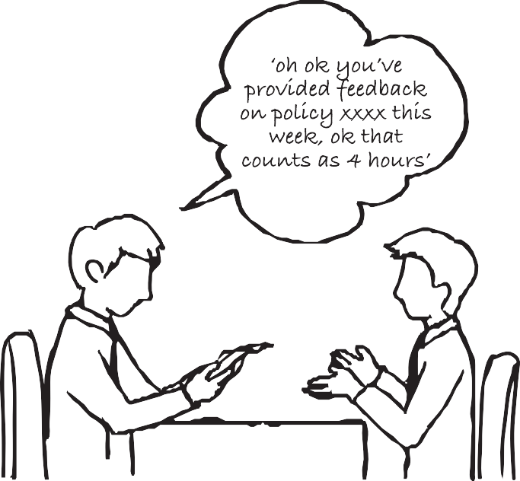

DEPARTMENT OF INDUSTRY, INNOVATION AND SCIENCE | **OGP CONCEPTS**

**INCREASE ENGAGEMENT**

**EVENT ACCESSIBILITY**

**Recommendation:**

18

**THE IDEA:**

Changes to events and engagement processes to help reach a wider range of people.

**HOW IT WORKS:**

**For example:**

* Child care at engagement events
* After hours events
* Wages lost reimbursement for low income earners
* Attending an engagement can count towards Centrelink activity/education/job seeking tests
* Nine to five events, that people can attend at any time during that period
* Hubs for online engagement at Medicare/ Centrelink offices for the 20% who don’t have internet access at home
* Ensure engagement events occur in regional areas
* APS staff can put themselves on a ‘Diversity/ Engagement register’, noting an outside of work interest (e.g. membership of an NGO) or attribute (diverse background) that means they could be contacted to be engaged on something that matters to them, and would benefit the public servants running the engagement

**BENEFITS:**

* Helps public servants reach a diverse and accessible audience, bringing community expertise into policy at low risk
* Spreads engagement awareness and capability

**STAFF COMMENTS:**

* Could include minimum standards and a checklist, as well as what kind of funding/time/ space is needed to execute

**SPECIFIC QUESTIONS:**

* Are there any other accessibility ideas we’re missing?
* How would we implement this? Would it be driven by the APSC? The Hub?

**INTENSITY:**

More a left field idea, but ~15 related ideas.