
OFFSHORE GREENHOUSE GAS STORAGE
ACREAGE RELEASE | AUSTRALIA 2014

Regional Geology
of the Gippsland Basin

Basin outline
The Gippsland Basin is situated in southeastern Australia and is located about 200 km east of the city of Melbourne. Covering about 46 000 km2, two-thirds of the basin is located offshore where several giant oil and gas fields were discovered in the late 1960s (Figure 1). The basin developed into Australia’s premier hydrocarbon province, maintaining that status until large scale hydrocarbon production on the North West Shelf was established in the 1990s. Most of the hydrocarbon accumulations in the Gippsland Basin are hosted by the Upper Cretaceous to Paleogene Latrobe Group, a sedimentary system that is dominated by marginal marine to lower coastal plain depositional environments. Remaining reserves are estimated at 400 MMbbl of liquids and 5 Tcf of gas (Geoscience Australia, 2012).
The Gippsland Basin is bounded to the north by Paleozoic basement of the Eastern Highlands, to the west by uplifted Lower Cretaceous fault-blocks and to the southwest by the Bassian Rise, which separates it from the Bass Basin to the southwest. More than 400 exploration wells have been drilled in the basin and approximately 90 000 line km of 2D seismic data and more than forty 3D seismic surveys have been acquired. Consequently, exploration within the Gippsland Basin is mature in comparison to other Australian basins, though it is actually relatively under-explored in comparison to many other prolific basins around the world. This is particularly true of areas outside the Central Deep (Figure 1).
The Gippsland Basin region (Figure 2) contains a number of significant population centres and it is serviced by an extensive road system. Petroleum infrastructure is well developed, with a network of pipelines transporting hydrocarbons produced offshore to onshore petroleum processing facilities at Longford and Orbost (Figure 2). From there, pipelines deliver the gas across southeastern Australia, to Sydney in New South Wales, to Adelaide in South Australia and to Tasmania. Exploration activity in the Gippsland Basin is expected to continue at the current robust levels, due to a combination of the basin’s inherent untapped potential and the increasing demand for natural gas across southeastern Australia.

Basin evolution
The east-west trending Gippsland Basin formed as a consequence of the break-up of Gondwana in the latest Jurassic/earliest Cretaceous (Rahmanian et al, 1990; Willcox et al, 1992, 2001; Norvick and Smith, 2001; Norvick et al, 2001) and the basin evolution is recorded by dominantly siliciclastic sedimentary sequences from the Upper Cretaceous to Eocene and by carbonate sequences from the lower Oligocene to Holocene. Within the Latrobe Group, four subgroups are discriminated, each of which is bounded by presumed basin-wide unconformities, and each consists of formations that are distinguished by their main depositional facies assemblages (Figure 3 and Figure 4). Other unconformities and disconformities are only recognised biostratigraphically. This is of particular relevance in the context of the upper Latrobe Group, where extensive channel incision and subsequent infill processes resulted in complex sedimentary sequences that developed over slightly different time frames, and which cannot be resolved by seismic mapping alone. The tectonostratigraphic development of the Gippsland Basin is summarised by Wong et al (2001) and Blevin and Cathro (2008).
The Gippsland Basin forms the easternmost part of an Early Cretaceous rift system between Antarctica and Australia. Initial basin architecture consisted of a rift valley complex composed of multiple, overlapping or isolated, approximately east-trending half graben. Continued rifting into the Late Cretaceous generated a broader extensional geometry which consisted of a depocentre (the Central Deep; Figure 1) flanked by fault-bounded platforms and terraces to the north and south. The Rosedale and Lake Wellington fault systems mark the northern margins of the Central Deep and Northern Terrace respectively, with the Darriman and Foster fault systems defining the southern margin of the Central Deep, and the northern boundary of the Southern Platform (Figure 1) respectively. To the east, the Central Deep is characterised by rapidly increasing water depths; these exceed 3000 m in the Bass Canyon (Hill et al, 1998). The eastern boundary of the basin is defined by the Cape Everard Fault System, a prominent north-northeast striking basement high (Moore and Wong, 2001). The western onshore extent of the basin is traditionally placed at the Mornington High. However, the extent of the Latrobe Group is effectively defined by outcrops of the underlying Lower Cretaceous Strzelecki Group (Hocking, 1988).
Initial rifting in the Early Cretaceous resulted in total crustal extension of approximately 30% (Power et al, 2001), producing a complex system of graben and half graben into which the volcaniclastic Strzelecki Group was deposited (Figure 3 and Figure 4). Between 100 and 95 Ma (Cenomanian), a phase of uplift and compression (Duddy and Green, 1992), produced a new basin configuration and provided accommodation space for large volumes of basement-derived sediments. Renewed crustal extension during the Late Cretaceous, perhaps associated with both Turonian extension between Australia and Antarctica evident in the Otway Basin to the west, and opening of the Tasman Sea to the east, established the Central Deep as the main depocentre (Figure 1 and Figure 5). Initial deposition (Emperor Subgroup) into this evolving rift valley was dominated by large volumes of material that were eroded from the uplifted basin margins. A series of large, deep lakes developed, resulting in the deposition of the lacustrine Kipper Shale (Marshall and Partridge, 1986; Marshall, 1989; Lowry and Longley, 1991). The Kersop Arkose represents the earliest erosion of uplifted granites at the southern basin margin, and the alluvial/fluvial Curlip Formation (Partridge, 1999; Bernecker and Partridge, 2001) overlies and interfingers with the Kipper Shale.
The Longtom Unconformity separates the lacustrine dominated Emperor Subgroup from fluvial and marine sediments of the Golden Beach Subgroup (Figure 3 and Figure 4), with the first marine incursion recorded by the upper Santonian sediments of the Anemone Formation (Golden Beach Subgroup) in the eastern part of the basin (Partridge, 1999; Bernecker and Partridge, 2001). Many of the earlier generated faults were reactivated during this tectonic phase, and it is likely that the change in depositional environment was related to the onset of the Tasman Sea rifting.
Rift-related extensional tectonism continued until the early Eocene and produced pervasive northwest-striking normal faults, especially in the Central Deep. A succession of fluvial, deltaic and marine sediments was deposited across the basin forming the Halibut Subgroup (Figure 3). This subgroup comprises upper coastal plain fluvial sediments (Barracouta Formation) and lower coastal plain, coal-rich sediments of the Volador and Kingfish formations. The marine Kate Shale separates the Cretaceous Volador Formation from the Paleocene Kingfish Formation, and has the potential to be a significant intra-Latrobe Group seal. The Mackerel Formation overlies the Kate Shale in the eastern part of the basin (Figure 4) and consists of near-shore marine sandstones with intercalated marine shales.
By the middle Eocene, sea-floor spreading had ceased in the Tasman Sea and there was a period of basin sag, during which the offshore basin deepened but little faulting occurred. The lower coastal plain, coal-rich Burong Formation was deposited during this phase, followed by the transgressive shallow to open marine Gurnard Formation, which is a condensed section characterised by fine- to medium-grained glauconitic siliciclastic sediments (Figure 3 and Figure 4).
In the late Eocene, a compressional period began to affect the Gippsland Basin, initiating the formation of a series of northeast to east-northeast-trending anticlines (Smith, 1988). Compression and structural growth peaked in the middle Miocene and resulted in partial basin inversion. All the major fold structures at the top of the Latrobe Group, which became the hosts for the large oil and gas accumulations, such as Barracouta, Tuna, Kingfish, Snapper and Halibut, are related to this tectonic episode. Tectonism continued to affect the basin during the late Pliocene to Pleistocene, as documented by localised uplift. This uplift affected the Pliocene section on the Barracouta, Snapper and Marlin anticlines, as well as around the township of Lakes Entrance. Ongoing tectonic activity continues in the basin as relatively minor earthquakes along and around major basin bounding faults.
Post-rift sedimentary processes dominated the Gippsland Basin from the early Oligocene, with the deposition of the basal unit of the Seaspray Group, the Lakes Entrance Formation (Figure 3 and Figure 4). These onlapping, marly sediments provide the principal regional seal across the basin. Subsequently, the deposition of the thick Gippsland Limestone, also part of the Seaspray Group, provided the critical loading for the source rocks of the deeper Latrobe and Strzelecki groups, with the majority of hydrocarbon generation (at least the preserved component) occurring in the Neogene. Late loading of the source rocks as a result of the deposition of relatively thick Cenozoic sequences, means that traps developed during the Neogene may be charged with economic quantities of hydrocarbons.

Regional hydrocarbon potential
Despite its relatively small areal extent, the Gippsland Basin is densely populated with economic hydrocarbon accumulations, including a number of oil and gas fields that are considered ‘giants’ by global standards. All currently producing fields are located on the western and northern parts of the present shelf; only four discoveries (Archer/Anemone, Angler, Blackback and Gudgeon) have been made in the eastern, deeper water area (Figure 1 and Figure 2).
It has been a matter of speculation as to why there is a concentration of gas accumulations in the north, whereas oil fields are more common in the southeast. The reasons for this may be due in part to the initial focus on top-Latrobe Group plays, which has resulted in numerous discoveries in sediments from the N. asperus and P. asperopolus biozones. The Latrobe Group is thickest in the Central Deep, where prospective reservoirs are located below 3500 mSS (approximately 2.5 seconds TWT) and it is thus not surprising that less is known about the prospectivity of older sediments.
Another, perhaps more likely, explanation for the distribution of oil and gas in the Gippsland Basin is the nature of the Latrobe Group source systems themselves. The upper coastal plain Latrobe Group depocentres, located between Barracouta and Kingfish, may have produced a mostly gas-prone hydrocarbon inventory, whereas the lower coastal depocentres east of Kingfish would probably be more oil-prone, as originally suggested by Moore et al (1992). The strong spatial compartmentalisation of the hydrocarbon inventory is discussed in detail by O’Brien et al (2008). Analyses of palaeo-charge histories and source rock characteristics, as well as basin modelling indicate that the majority of large fields in the Central Deep received an early oil charge and had significant palaeo-oil columns in the Neogene. These were subsequently displaced by a later gas charge generated by increased maturation and gas expulsion from a gas-prone upper coastal plain source kitchen south of Barracouta (O’Brien et al, 2008; Liu et al, 2010).

Reservoirs and seals
Most of the major hydrocarbon accumulations in the Gippsland Basin are reservoired in high quality, multi-darcy sandstones of the upper Latrobe Group (Cobia and Halibut subgroups), where marine, near-shore barrier and shoreface sandstones are traditionally regarded as the best reservoirs in the basin, and are potential sites for CO2 storage. The most productive of these were drilled either at or near the top of the Latrobe Group and are commonly referred to as the ‘top-Latrobe coarse clastics reservoirs’. This is an unfortunate misnomer, given that similar coarse sandstones are developed throughout the stratigraphic column. All these sandstones are diachronous and developed in response to periodic marine regressive cycles associated with low depositional rates. This provided an ideal environment for high levels of reworking and winnowing of the deltaic and coastal plain sediments. Geographically, this reservoir facies is best developed in the Barracouta, Snapper, Marlin, Bream and Kingfish fields. Reservoir distribution in intra-Latrobe sequences can be complex and frequently involves multiple stacked sandstone/shale alternations characteristic of fluvio-deltaic environments. Submarine channelling, the presence of numerous, thin, condensed sequences and the overall lower net-to-gross ratio contribute to lower reservoir quality. Nevertheless, there are many examples of good quality reservoirs in deltaic sandstones, as well as in fluvial and submarine channels. Latrobe Group reservoir porosities average 15–25% across the basin, with the best primary porosities preserved in fluvial/ deltaic sandstones that are texturally mature and moderately well sorted.
In contrast to the Latrobe Group, the identification of permeable reservoirs within the Strzelecki Group has proven difficult, although primary porosities can be high. Unless an improved model for the prediction of permeability within the Strzelecki Group sands can be developed, such targets are inherently high-risk.
An effective regional seal for the top-Latrobe Group reservoirs is provided by calcareous shales and marls of the lower Oligocene–lower Miocene Lakes Entrance Formation at the base of the Seaspray Group (Bernecker and Partridge, 2001; Partridge et al, 2012). In parts of the basin, the lowermost Seaspray Group is represented by a condensed section of calcareous shales, termed the Early Oligocene Wedge (EOW) by Partridge (1999, 2006). The Oligocene–Miocene marine carbonates which comprise the EOW and the upper Oligocene to Miocene Swordfish Formation (Seaspray Group) are now recognised as lateral equivalents of the Lakes Entrance Formation (Blevin and Cathro, 2008; Goldie Divko et al, 2010; Blevin et al, 2013).
The thickness of this seal varies considerably and ranges from approximately 100 m to over 350 m in deeper water parts of the basin (O’Brien et al, 2008; Goldie Divko et al., 2009, b, 2010; Hoffman et al, 2012). In addition, many potential intraformational sealing units are present within the Latrobe Group. These include floodplain sediments deposited in upper and lower coastal plain environments, as well as lagoonal to offshore marine shales. These seals are commonly thin and mostly occur within stacked sandstone/mudstone successions; the low shale volume in such settings makes the prediction of cross-fault seal problematic. Excellent seals, such as the Turonian lacustrine Kipper Shale, are developed adjacent to the basin-bounding faults. Other effective seals are provided by several distinct volcanic horizons of Campanian to Paleocene age (e.g., as in the Kipper Field). The Kipper Shale exceeds 500 m in thickness, whereas the volcanics are often less than 50 m thick, although they are known to exceed 100 m in the Kipper field.

Timing of generation
From limited published data it is concluded that the main period of hydrocarbon generation and expulsion commenced in the Miocene as a result of increased sedimentary loading of the Cenozoic carbonate sequences (Smith et al, 2000). Some interpretations suggest that hydrocarbon generation and migration is currently at a maximum (Duddy et al, 1997). In the major depocentres of the basin, restricted areas underwent an earlier phase of generation and migration at or around the middle Eocene. It is important to realise that at that time, no regional Lakes Entrance seal was in place and any traps would have involved older intra-Latrobe Group sealing units and earlier formed traps.
Clark and Thomas (1988) proposed that peak generation and primary migration in the Gippsland Basin occurs at depths of 4–5 km for oil and 5–6 km for gas (O’Brien et al, 2008). Peak hydrocarbon generation within the Latrobe Group source rocks is considered to take place with Ro at 0.92–1.0% (Clark and Thomas, 1988), which agrees well with the findings of Burns et al (1987), whose maturity data (Methylphenanthrene Index of Radke and Welte, 1983) indicated that most Gippsland Basin oils were generated with Ro at 0.9–1.16%. The hydrocarbons reservoired in the western Gippsland Basin have undergone some biodegradation and water washing (Burns et al, 1987) as a result of the invasion of the fresh-water wedge in the late Cenozoic (Kuttan et al, 1986).

Play types
During its long exploration history a large variety of play types have been successfully tested in the Gippsland Basin (Figure 5). The giant oil and gas fields discovered early in this history are all related to large anticlinal closures in the Central Deep at top-Latrobe Group level, where coarse-grained coastal plain and shallow marine barrier sands provide excellent reservoirs. Further top-Latrobe discoveries were made in increasingly deeper water, including erosional channel plays in the eastern part of the basin such as Blackback, Marlin and Turrum. In these, channel cut and fill sediments are preserved as complex successions of intraformational reservoir and seal facies.
Other top-Latrobe play types are known to exist on the flanks of the basin. On the Northern and Southern terraces, the Latrobe Group rapidly decreases in thickness and pinches out near the bounding faults of the Northern and Southern platforms. Stratigraphic pinch-out plays have been tested on both the Northern and Southern terraces and platforms. Here the top-Latrobe Group is represented in the west by the coal-bearing lower-middle coastal plain sediments of the Burong Formation and in the east by the marine sandy glauconitic mudstones of the Gurnard Formation (Figure 3 and Figure 4). The Gurnard Formation is characterised by facies changes and acts as a seal as well as a reservoir unit on the northern margin where it hosts the Patricia-Baleen gas accumulation (Bernecker et al, 2002). Structural play types are also developed on the Northern and Southern terraces. The Leatherjacket oil and gas discovery is an example of an inverted normal fault-closure that comprises top- and intra-Latrobe Group reservoir objectives.
Structural plays are dominant within the intra-Halibut Subgroup and Golden Beach Subgroup. They commonly involve down-thrown fault traps that comprise intra-Latrobe fluvial reservoirs and intraformational seals. The Basker/Manta/Gummy oil and gas field in the northeastern Central Deep is an example of such a play type. The Golden Beach Subgroup play is restricted to the Central Deep where the main fairway is represented by the Chimaera Formation comprising fluvial and coastal plain sediments sealed by either Campanian volcanics, upthrown shales of the Emperor Subgroup or intraformational mudstones. The play is proven on lowside fault closures at the Kipper gas field (Bernecker et al, 2002).
A new play was successfully tested by the Longtom 2 and 3 wells which targeted fluvial units within the Emperor Subgroup. This subgroup is dominated by the Kipper Shale, which can be up to 1000 m thick (Bernecker and Partridge, 2001), but it also comprises underlying and overlying coarse-grained fluvial sediments. The stratigraphic position of the Emperor Subgroup has meant that it has been penetrated by drilling only on the Northern and Southern terraces. However, the recent Longtom gas discovery confirms the viability of this new play type along the flanks of the Central Deep.
Exploration plays in the Strzelecki Group have been identified in the onshore Seaspray Depression (Figure 1). The Seaspray and Wombat gas discoveries, assessed as uncommercial, but under review for a possible tight gas stimulation program, are most likely sourced from Lower Cretaceous coaly floodplain deposits and hosted by fluvial sandstones with moderate to good porosities but low permeabilities. As such, this configuration resembles the gas discoveries in the coeval Otway Group in the onshore Otway Basin. It has been suggested that the gas in the Sole field on the offshore Northern Terrace is sourced from the Strzelecki Group. If this is the case, then the shallower areas outside the Central Deep may offer additional exploration opportunities.

Regional carbon storage potential
The offshore Gippsland Basin has been identified as a highly prospective area by numerous previous storage prospectivity studies (Bradshaw et al, 2002; Root et al, 2004; Gibson Poole et al, 20008a,b) for long-term, high capacity CO2 storage, and more recently by the National Carbon Storage Taskforce (2009). The area was also highlighted as a priority for investigation due to its proximity to the Latrobe Valley brown coal power station and natural gas processing facilities infrastructure hub. The petroleum industry has collected extensive 2D/3D seismic and well data in the basin, which provides an excellent basis for assessment of CO2 storage prospectivity.
The Gippsland Basin has been actively explored for hydrocarbons since the 1960s, and contains numerous giant oil and gas fields, including the Kingfish, Snapper, Marlin and Barracouta fields located mainly in the central and northern part of the basin (Figure 1). These producing fields are potential future CO2 storage sites, although they will not be available for storage until ~2025. The Latrobe Group is the major reservoir unit in the basin and the overlying Lakes Entrance Formation is the regional top seal facies.
Potential storage sites within the northern and central parts of the Gippsland Basin are currently unsuitable for CO2 storage due to possible resources conflicts with existing petroleum production (O’Brien et al, 2008) . This has focused attention on the nearshore and southern parts of the basin. The southern margin was selected as the area for the initial Federal Greenhouse Gas Storage Assessment blocks that were gazetted in 2009.
The maximum CO2 storage capacity of existing hydrocarbon fields in the offshore Gippsland Basin has been calculated by Gibson-Poole et al, (2008a) at about 2.1Gt. The recent Carbon Storage Taskforce (2009) has estimated a P50 offshore storage capacity of 49 Gt within the Latrobe Group.
To provide industry quality data to support the technical evaluation of the southern margin of the basin, the Commonwealth Department of Industry (formerly Department of Resources, Energy and Tourism) and the Victorian Government funded the acquisition of ~8,000 line kilometres of regional 2D seismic in an area overlying the 2009 GHG Assessment Areas though the National Low Emission Carbon Initiative and Victorian Geological Carbon Storage (Vic GCS) initiative. This seismic survey (GDPI10) was acquired in early 2010, processed in 2011 and interpreted in 2012 (Blevin et al, 2013), and provides a basis for future storage prospectivity work in the southern margin of the basin. A series of reports on various carbon storage issues including storage capacity and seal integrity were undertaken from 2008 to 2012 the VicGCS program and are available to support future activities in the basin.

Exploration history
The history of oil production in the Gippsland Basin dates back to 1924, when the Lake Bunga 1 well, which was drilled near the town of Lakes Entrance, encountered a 13 m oil column in glauconitic conglomerates overlying the Latrobe Unconformity at a depth of 370 m. Over 60 wells were drilled in the ensuing years, and by 1941, this area had produced more than 8000 bbl of heavy oil (15–20° API). The most productive well was the Lakes Entrance Oil Shaft which produced 4935 bbl (Beddoes, 1972; Boutakoff, 1964).
Significant levels of exploration did not begin in the offshore Gippsland Basin until the mid-1960s, following the acquisition of seismic surveys which allowed the imaging of the Central Deep and the mapping of several large, anticlinal closures. The first successful well, East Gippsland Shelf 1 – later known as Barracouta 1 – was drilled by Esso in 1964/65 and discovered a 102.5 m gas-condensate column at a depth of 1060 mKB. After the subsequent discovery of a large gas-condensate accumulation at Marlin in 1966, the Gippsland Basin was perceived essentially as a gas-prone province. However, when Kingfish 1 was drilled in 1967, it encountered the largest Australian oil field known to date (1.2 Bbbl recoverable) and the Gippsland Basin gained international recognition as both a giant oil and giant gas province.
By the end of 1969, eleven fields had been discovered and the first five (Barracouta, Marlin, Snapper, Kingfish and Halibut) were in production. After the initial exploration phase, which had high success rates, the subsequent discoveries made by the Esso/BHP Petroleum joint venture were more limited through the early 1970s; Cobia 1 (1972), Sunfish 1 (1974) and Hapuku 1 (1975) discovered significant volumes of hydrocarbons, but only Cobia came into production. In 1978, following the boost to exploration resulting from the introduction of Import Parity Pricing (i.e. the removal of artificial government pricing caps on locally produced crude oil), the giant Fortescue oil field was discovered, followed by the Seahorse and West Halibut discoveries.
Stimulated by the OPEC world oil price rise in 1979 and the relinquishment of a significant portion of the original exploration permit by Esso/BHP in October that year, new explorers, including Aquitaine, Shell and Phillips, commenced exploration in 1980. Shell, which had previously discovered the Sole dry gas field in 1973, mapped the Basker-Manta structures and drilled two successful wells, Basker 1 and Manta 1. Discoveries which were then deemed non-commercial were made at West Seahorse, Baleen and Sperm Whale by Hudbay Oil in 1981. West Tuna, drilled in 1984, was the last of the large to giant oil discoveries made by the Esso/BHP Petroleum joint venture. This play was atypical, as the oil was trapped by fault sealing mechanisms rather than having accumulated in a large anticlinal closure. In 1986, the Esso/BHP Petroleum joint venture discovered the Kipper gas field - estimated at 500 Bcf recoverable - a significant find which intersected a 213 m gas column in fluvial sandstones of the Golden Beach Subgroup. Lasmo made a minor, but significant, gas discovery near the northern basin margin at Patricia 1 (adjacent to Baleen) in 1987, with sales gas reserves of the order of 70 Bcf. This field was developed by OMV and later taken over by Santos Limited. Another drilling campaign in 1989/1990, led to the discovery of the Blackback oil and gas field on the shelf edge, in water depths greater than 400 m. In 1989/90, Petrofina drilled the Archer/Anemone discovery in the southern part of the basin. Although the field proved non-commercial, the well encountered substantial quantities of oil and gas and further confirmed the prospectivity of the older part of the Latrobe Group (Golden Beach Subgroup).
Additional exploration wells were drilled in the 1990s, though no new discoveries were made. The principal operator, the Esso/BHP Petroleum joint venture, concentrated their efforts on development and work-over drilling in order to optimise production from the existing fields. Following the privatisation of State Government-owned gas utility companies between 1995 and 1999, a restructured gas market emerged which made it more attractive for explorers to search for gas in the basin. This, together with a sustained recovery in the oil price, sparked a significant resurgence in exploration activity. In 2010, Esso Australia Pty Ltd announced an oil and gas discovery on the northern margin of the Central Deep; South East Remora 1 intersected significant oil and gas columns in the upper Latrobe Group and Golden Beach Subgroup, with traps associated with the Rosedale Fault (ExxonMobil, 2010).
In the last decade, a number of new companies have been granted exploration licences in the basin and have committed to extensive work programs. Apache Energy entered the basin in 2004 after gaining interest in permits VIC/P54, VIC/P58 and VIC/P59. The company drilled a number of wells in 2008/2009, and acquired new 3D seismic data in VIC/P59 in 2007, but relinquished this permit in early 2012. Nexus Energy has also been active in the Gippsland Basin recently, currently exploring within VIC/P54 and producing gas from the Longtom field. This field was discovered by Nexus Energy in 2006, with the successful drilling of Longtom 3, which intersected a suite of gas-bearing sandstones within the Emperor Subgroup. The well was brought into production in 2009 through two horizontal wells tied-back to the Santos operated Orbost gas plant. Larus Energy Ltd entered the Gippsland Basin in 2010, and operates three exploration permits on the southern margin (VIC/P63 and VIC/P64, and T/46P in Tasmanian waters), and is currently assessing these areas with the 2010 vintage Furneaux and Gippsland Basin Southern Flanks 2D seismic surveys.
Other significant players in the Gippsland Basin are Bass Strait Oil Company Ltd, which operates VIC/P41, VIC/P47 and VIC/P66 on the northern basin margin, and VIC/P42, which is along the southern margin, south of the Bream Field. Recent seismic acquisition over VIC/P41 has identified several large volume prospects analogous to the Kipper and Basker/Manta/Gummy fields that lie along strike to the west of this permit. Bass Strait Oil is also working on defining the Judith gas discovery in the southern part of VIC/P47, which has been estimated to be similar in size to the Longtom gas field to the west. 3D Oil has been developing the West Seahorse oil field within VIC/P57. Their recently announced joint venture with Malaysia’s Hibiscus Petroleum is aiming for first oil production in 2014. This joint venture will also target the drilling of an exploration well to evaluate the Sea Lion prospect to the north west of West Seahorse. Santos Limited has also re-establishing itself in the basin having taken over OMV’s interests in the Patricia-Baleen and Sole gas fields, as well as the Orbost gas processing plant. It also holds a non-operating interest in the Kipper gas development project.
On a regional scale, several 3D seismic surveys have been acquired in the last decade, with the result that much of the basin is now covered by 3D seismic data. Esso/BHP Billiton completed two major 3D seismic surveys, including the 4060 km2 Northern Fields survey, between October 2001 and July 2002. This was followed by the 1000 km2 Tuskfish survey which extended over the Blackback-Terakihi area and extended southwards into VIC/P59. In 2001, Encana acquired the Midas 2D seismic/gravity/magnetic survey, which covers ~830 line km across the head of the Bass Canyon, covering some of Release Area V13-2. A further 150 km of 2D seismic was acquired by Eagle Bay Resources NL across the former permit VIC/P65 (now Release Area V12-4).
Sizable 3D seismic surveys have also been acquired by Apache Energy and Bass Strait Oil Company Ltd in the last three to four years. Drillsearch also conducted the Furneaux 2D seismic survey in early 2010, covering their permits in the southwestern part of the Gippsland Basin. A total of 1116.7 line km was acquired in Victorian waters, covering parts of VIC/P63, VIC/P64 (which are now operated by Larus Energy Ltd) and T/46P in Tasmanian waters. This survey was followed by the 8000 line km 2D Gippsland Basin Southern Flanks Marine Survey (GDPI10) acquired over the Southern Terrace and Southern Platform using the same seismic vessel, the M/V Aquila Explorer (SeaBird Exploration). This survey was co-funded by the State and Commonwealth Governments, and covers VIC/P63 and VIC/P64, as wells as parts of VIC/P42, VIC/L17, VIC/L18, T/46P and the southwesternmost portion of the V13-2 Release Area. The seismic stratigraphic interpretation report of this survey (Blevin et al, 2013) evaluates the stratigraphy and seal potential of the basin’s southern margin and provides a basis for future storage prospectivity work in the area.
Recent estimates of the basin’s undiscovered resource potential consider that there is 2–4 Tcf of gas and up to 600 MMbbl of liquids yet to be discovered in the Gippsland Basin (GeoScience Victoria, unpublished data). Despite its long history of extensive exploration, many parts of the basin, especially the southern and eastern regions, are still relatively poorly understood and explored. In the context of high oil prices and a growing demand for gas in south-eastern Australia, the Gippsland Basin should continue to attract investment from both local and international explorers.

Production status
Overall production of crude oil and condensate from the Gippsland Basin has been declining for over three decades, associated with an increased water cut, while gas production has remained steady. In the year 2010–2011, crude oil and condensate production was 3.34 Gl compared to 4.00 Gl the previous year. LPG production was also lower, 1.5 Gl compared to 1.62 Gl, and gas production rose from 5.50 Gl in 2009–2010 to 7.27 G. Hydrocarbon production has remained relatively strong due to infill drilling in the developed fields and work-overs undertaken to renew downhole equipment and to open new zones.

Figures
Figure 1 Structural elements of the Gippsland Basin showing hydrocarbon accumulations and location of the regional cross-section shown in Figure 5.
Figure 2 Petroleum production facilities, hydrocarbon accumulations, and current and proposed pipeline infrastructure in the Gippsland and Bass basins.
Figure 3 Stratigraphy and hydrocarbon discoveries of the western Gippsland Basin and the Central Deep (Partridge et al, 2012). Geologic Time Scale after Gradstein et al (2012).
Figure 4 Stratigraphy and hydrocarbon discoveries of the eastern Gippsland Basin and the Northern and Southern terraces. Geologic Time Scale after Gradstein et al (2012).
Figure 5 Seismic section across offshore Gippsland Basin, providing stratigraphic context and showing rift basin geometry represented by Central Deep, Northern Terrace and Platform, Southern Terrace and Platform. Location of section is shown in Figure 1.

References
BEDDOES, JNR, L.R., 1972—Oil and Gas Fields of Australia, Papua New Guinea and New Zealand. Tracer Petroleum and Mining Publications Pty Ltd.
BERNECKER, T. AND PARTRIDGE, A.D., 2001—Emperor and Golden Beach Subgroups: the onset of Late Cretaceous Sedimentation in the Gippsland Basin, SE Australia. In: Hill, K.C. and Bernecker, T (eds), Eastern Australasian Basins Symposium, A Refocused Energy Perspective for the Future. Petroleum Exploration Society of Australia, Special Publication, 391–402.
BERNECKER, T., WONG, D., DRISCOLL, J. AND LIBERMAN, N., 2002—Hydrocarbon prospectivity of areas V02-2, V02-3 and V02-4, in the Gippsland Basin, Victoria, Australia. Victorian Initiative for Minerals and Petroleum Report 74. Department of Natural Resources and Environment.
BLEVIN, J.E. AND CATHRO, D.L., 2008—Australian Southern Margin Synthesis, Project GA707, Client report to Geoscience Australia by FrOG Tech Pty Ltd. GEOCAT 68892.
BLEVIN, J., CATHRO, D., NELSON, G., VIZY, J. AND LEE, J.D., 2013—Survey GDPI10 Interpretation Project, Southern Flank, Gippsland Basin. VicGCS Report 8, Department of Primary Industries.
BOUTAKOFF, N., 1964—Lakes Entrance oil and the continental shelf. The APEA Journal, 4, 99–110.
BRADSHAW, M.T., 1993—Australian Petroleum Systems. PESA Journal No. 21, 43–53.
BURNS, B.J., BOSTWICK, T. R. AND EMMETT, J. K., 1987—Gippsland terrestrial oils – recognition of compositional variations due to maturity and biodegradation. The APEA Journal, 27, 73–85.
BRADSHAW, J., BRADSHAW, B.E., ALLISON, G., RIGG, A.J., NGUYEN, V. AND SPENCER, L., 2002—The potential for geological sequestration of CO2 in Australia: Preliminary findings and implications for new gas field developments. The APPEA Journal 42, 25–46.
CARBON STORAGE TASKFORCE 2009—National Carbon Mapping and Infrastructure Plan – Australia: Full Report, Department of Resources, Energy and Tourism, Canberra
CLARK, A.B.S. AND THOMAS, B. M., 1988—The Intra-Latrobe Play: a case history from the Basker/Manta block (VIC/P19), Gippsland Basin. The APEA Journal, 28, 100–112.
DUDDY, I.R. AND GREEN, P.F., 1992—Tectonic development of Gippsland Basin and environs: identification of key episodes using Apatite Fission Track Analysis (AFTA). In: Barton, C.M., Hill, K., Abele, C., Foster, J. and Kempton, N. (eds), Energy, Economics and Environment – Gippsland Basin Symposium. Australasian Institute of Mining and Metallurgy, 111–120.
DUDDY, I.R., GREEN, P.F. AND HEGARTY, K.A., 1997—Impact of thermal history on hydrocarbon prospectivity in SE Australia. In: Collins, G. (ed), 1997 Great Southern Basin Symposium, Abstracts. Australian Petroleum Exploration Association, Vic./Tas. Branch, 14–17.
EXXONMOBIL, 2010—[Web page] ExxonMobil Discovers Oil and Gas in South East Remora-1 Well. http://www.exxonmobil.com.au/australia-english/pa/news_releases_20100422.aspx (last accessed 3/1/2013).
GEOSCIENCE AUSTRALIA, 2012—[Web page] Reserves Table 1 – Petroleum Reserves by Basin, as at January 2011. http://www.ga.gov.au/products-services/publications/oil-gas-resources-australia/2010/reserves/table-1.html (last accessed 8/12/2012).
GIBSON-POOLE, C., EDWARDS, S., LANGFORD, R. AND VAKARELOV, B. 2008a—Review of Geological Storage Opportunities for Carbon Capture and Storage (CCS) in Victoria. In: Blevin, J.E., Bradshaw, B.E. and Uruski, C. (eds), Eastern Australasian Basins Symposium III, Petroleum Exploration Society of Australia, Special Publication, 455-473.
GIBSON-POOLE, C.M., SVENDEN, L., UNDERSCHULTZ, J., WATSON, M.N., ENNIS_KING, J.,. van RUTH, P.J.,NELSON, E.J., DANIEL, R.F. AND CINAR, Y. 2008b—Site characterisation of a basin-scale CO2 geological storage system: Gippsland Basin, southeast Australia. Environmental Geology 54, 1583–1606.
GOLDIE DIVKO, L.M., O'BRIEN, G.W., TINGATE, P.R. AND HARRISON, M.L., 2009a—Geological Carbon Storage in the Gippsland Basin, Australia: Containment Potential. GeoScience Victoria VicGCS Report 1. Department of Primary Industries.
GOLDIE DIVKO, L.M., CAMPI, M.J., TINGATE, P.R., O'BRIEN, G.W. AND HARRISON, M.L., 2009b —Geological Carbon Storage Potential of the Onshore Gippsland Basin, Victoria, Australia. GeoScience Victoria VicGCS Report 2. Department of Primary Industries.
GOLDIE DIVKO L.M., O'BRIEN G.W., HARRISON M.L. AND HAMILTON, P.J., 2010—Evaluation of the regional top seal in the Gippsland Basin; implications for geological carbon storage and hydrocarbon prospectivity. The APPEA Journal, 50(1), 463–486.
GRADSTEIN, F.M., OGG, J.G. SCHMITZ, M.D. AND OGG, G.M. (EDITORS), 2012—The Geologic Time Scale 2012; Volumes 1 and 2. Elsevier BV, 1144pp.
HILL, P.J., EXON, N.F., KEENE, J.B. AND SMITH, S.M., 1998—The continental margin off east Tasmania and Gippsland: structure and development using new multibeam sonar data. Exploration Geophysics, 29, 410–419.
HOCKING, J.B., 1988—Gippsland Basin. In: Douglas, J.G. and Ferguson, J.A. (eds), Geology of Victoria. Victorian Division Geological Survey Australia Inc., Melbourne, 322–347.
HOFFMAN, N., ARIAN, N. AND CARMEN, G., 2012—Detailed seal studies for CO2 storage in the Gippsland Basin. In: Mares, T. (ed), Eastern Australasian Basins Symposium IV. Petroleum Exploration Society of Australia, Special Publication, CD-ROM.
KUTTAN, K., KULLA, J.B. AND NEWMAN, R.G., 1986—Freshwater influx in the Gippsland Basin: impact on formation evaluation, hydrocarbon volumes and hydrocarbon migration. The APEA Journal 26, 242–249.
LIU, K., EADINGTON, P., MILLS, D., KEMPTON, R., VOLK, H., O'BRIEN, G., TINGATE, P., GOLDIE DIVKO, L. AND HARRISON, M., 2010—Hydrocarbon charge history of the Gippsland Basin. The APPEA Journal 50 (DVD) – extended abstract.
LOWRY, D.C. AND LONGLEY, I.M., 1991—A new model for the mid-Cretaceous structural history of the northern Gippsland Basin. The APEA Journal, 31(1), 143–153.
MARSHALL, N.G., 1989—An unusual assemblage of algal cysts from the Late Cretaceous, Gippsland Basin, southeastern Australia. Palynology, 13, 21–56.
MARSHALL, N.G. AND PARTRIDGE, A.P., 1986—Palynological analysis of Kipper-1, Gippsland Basin. Esso Australia Ltd. Palynological Report 1986/18, 21p, 3 charts (unpublished).
MOORE, D.H. AND WONG, D., 2001—Down and out in Gippsland: using potential fields to look deeper and wider for new hydrocarbons. In: Hill, K.C. and Bernecker, T (eds), Eastern Australasian Basins Symposium, A Refocused Energy Perspective for the Future. Petroleum Exploration Society of Australia, Special Publication, 363–371.
MOORE, P.S., BURNS, B.J., EMMETT, J.K. AND GUTHRIE, D.A., 1992—Integrated source, maturation and migration analysis, Gippsland Basin, Australia. The APEA Journal, 32(1), 313–324.
NORVICK, M.S. AND SMITH, M.A., 2001—Mapping the plate tectonic reconstructions of southern and southeastern Australia and implications for petroleum systems. The APPEA Journal, 41(1), 15–35.
NORVICK, M.S., SMITH, M.A. AND POWER, M.R., 2001—The plate tectonic evolution of eastern Australasia guided by the stratigraphy of the Gippsland Basin. In: Hill, K.C. and Bernecker, T. (eds), Eastern Australasian Basins Symposium, A Refocused Energy Perspective for the Future. Petroleum Exploration Society of Australia, Special Publication, 15–23.
O’BRIEN, G.W., TINGATE, P.R., GOLDIE DIVKO, L.M., HARRISON, M.L., BOREHAM, C.J., LIU, K., ARIAN, N. AND SKLADZIEN, P., 2008—First order sealing and hydrocarbon migration processes, Gippsland Basin, Australia: implications for CO2 geosequestration. In: Blevin, J.E., Bradshaw, B.E. and Uruski, C. (eds), Eastern Australasian Basins Symposium III. Petroleum Exploration Society of Australia, Special Publication, 1–28.
PARTRIDGE, A.D., 1999—Late Cretaceous to Tertiary geological evolution of the Gippsland Basin, Victoria. PhD thesis, La Trobe University. Bundoora, Victoria, 439 pp (unpublished).
PARTRIDGE, A.D., 2006—New observations on the Cenozoic stratigraphy of the Bassian Rise derived from a palynological study of the Groper-1, Mullet-1 and Bluebone-1 wells, offshore Gippsland Basin, southeast Australia. Biostrata Report 2006/07, 41pp (unpublished).
PARTRIDGE, A.D. KELMAN, A.P., KHIDER, K., LE POIDEVIN, S. AND MANTLE, D.J., 2012—Gippsland Basin, Biozonation and Stratigraphy, 2012, Chart 40. Geoscience Australia. GEOCAT 76687
POWER, M.R., HILL, K.C., HOFFMAN, N., BERNECKER, T. and NORVICK, M., 2001—The structural and tectonic evolution of the Gippsland Basin: results from 2D section balancing and 3D structural modelling. In Hill, K.C. and Bernecker, T. (eds) Eastern Australasian Basins Symposium, A Refocused Energy Perspective for the Future. Petroleum Exploration Society of Australia, Special Publication, pp. 373–384.
RADKE, M. AND WELTE, D.H., 1983—The Methylphenanthrene Index (MPI): a maturity parameter based on aromatic hydrocarbons. In: M. Bjorøy et al (eds) Advances in Organic Geochemistry 1981. John Wiley and Sons, Chichester, pp. 505–512
RAHMANIAN, V.D., MOORE, P.S., MUDGE, W.J. AND SPRING, D.E. 1990—Sequence stratigraphy and the habitat of hydrocarbons, Gippsland Basin. In: Brooks, J. (ed), Classic Petroleum Provinces. Geological Society, London, Special Publications 50, 525–541.
ROOT, R.S., GIBSON-POOLE, C.M., LANG, S., STREIT, J.E., UNDERSCHULTZ, J. AND ENNIS-KING, J., 2004—Opportunities for geological storage of carbon dioxide in the offshore Gippsland Basin, SE Australia: an example from the upper Latrobe Group. In Boult, P.J., Johns, D.R. and Lang, S.C. (eds), Eastern Australasian Basins Symposium II. Petroleum Exploration Society of Australia, Special Publication 367-388.
SMITH, G.C., 1988—Oil and gas. In: Douglas, J.G. and Ferguson, J.A. (eds), Geology of Victoria. Geological Society of Australia Special Publication 5, 514–531.
SMITH, M.A., BERNECKER, T., LIBERMAN, N., MOORE, D.H. AND WONG, D., 2000—Petroleum prospectivity of the deepwater Gazettal Areas V00-3 and V00-4, southeastern Gippsland Basin, Victoria, Australia. Victorian Initiative for Minerals and Petroleum Report 65, Department of Natural Resources and Environment.
WILLCOX, J.B., COLWELL, J.B. AND CONSTANTINE, A.E., 1992—New ideas on Gippsland Basin regional tectonics. In: Barton, C.M. Hill, K., Abele, C., Foster, J. and Kempton, N. (eds), Energy, Economics and Environment, Gippsland Basin Symposium. Australasian Institute of Mining and Metallurgy, Melbourne Branch, 93–110.
WILLCOX, J.B., SAYERS, J., STAGG, H.M.J. AND VAN DE BEUQUE, S., 2001—Geological framework of the Lord Howe Rise and adjacent ocean basins. In: Hill, K.C. and Bernecker, T. (eds), Eastern Australasian Basins Symposium, A Refocused Energy Perspective for the Future. Petroleum Exploration Society of Australia, Special Publication, 211–225.
WONG, D., BERNECKER, T., MOORE, D., 2001. Gippsland Basin. In: Woollands, M.A., Wong, D. (ds.), Petroleum Atlas of Victoria, Australia. Geoscience Victoria, Melbourne, pp. 25–103.

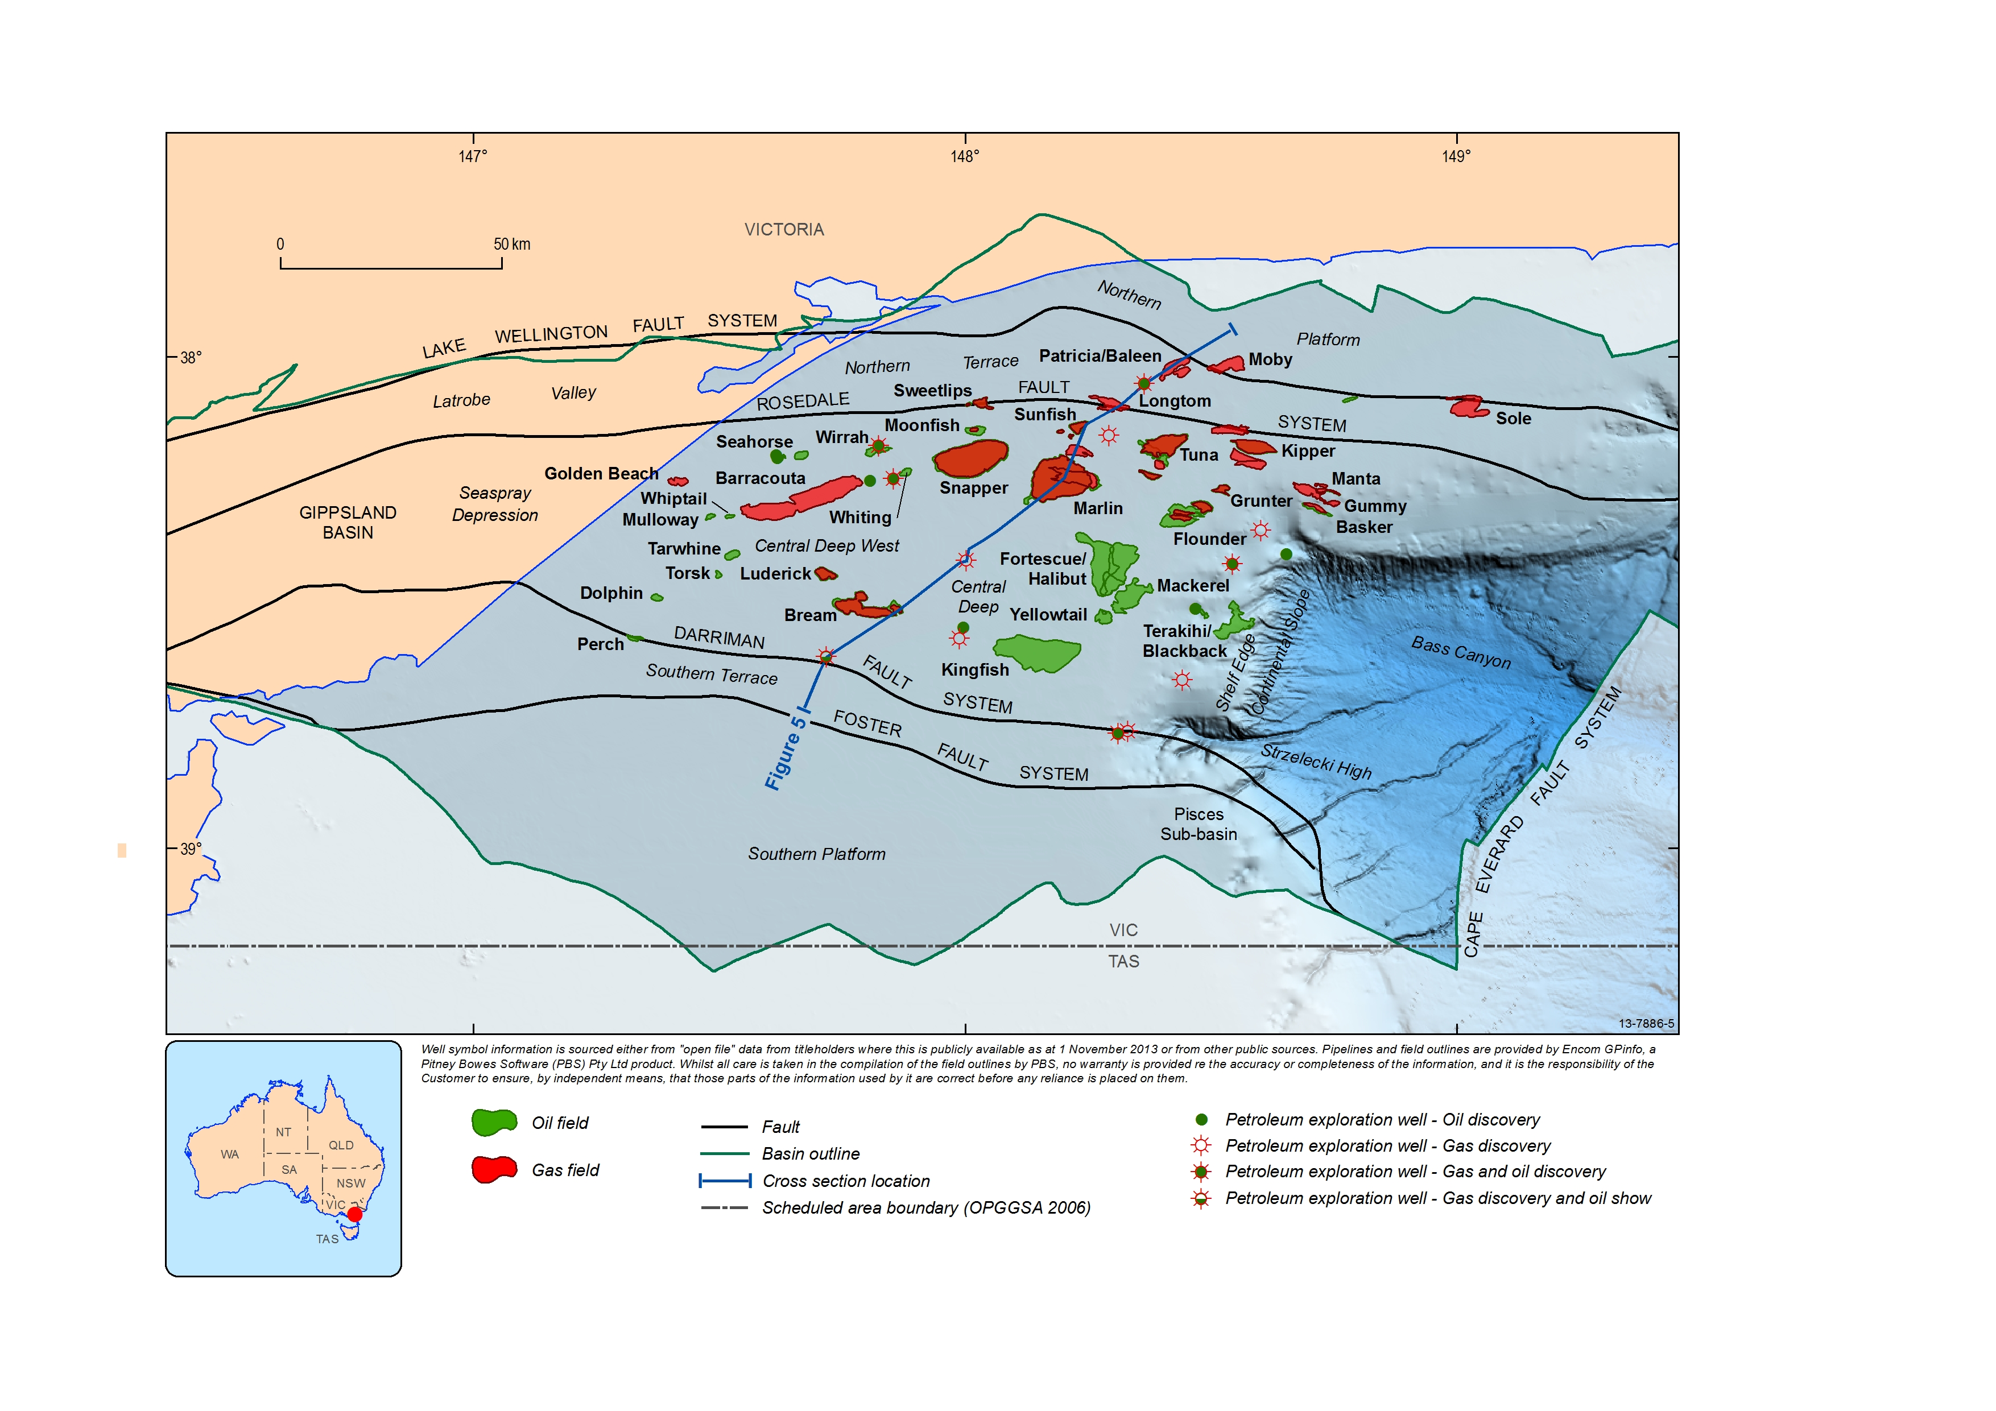
Figure 1 Structural elements of the Gippsland Basin showing hydrocarbon accumulations and location of the regional cross-section shown in Figure 5.

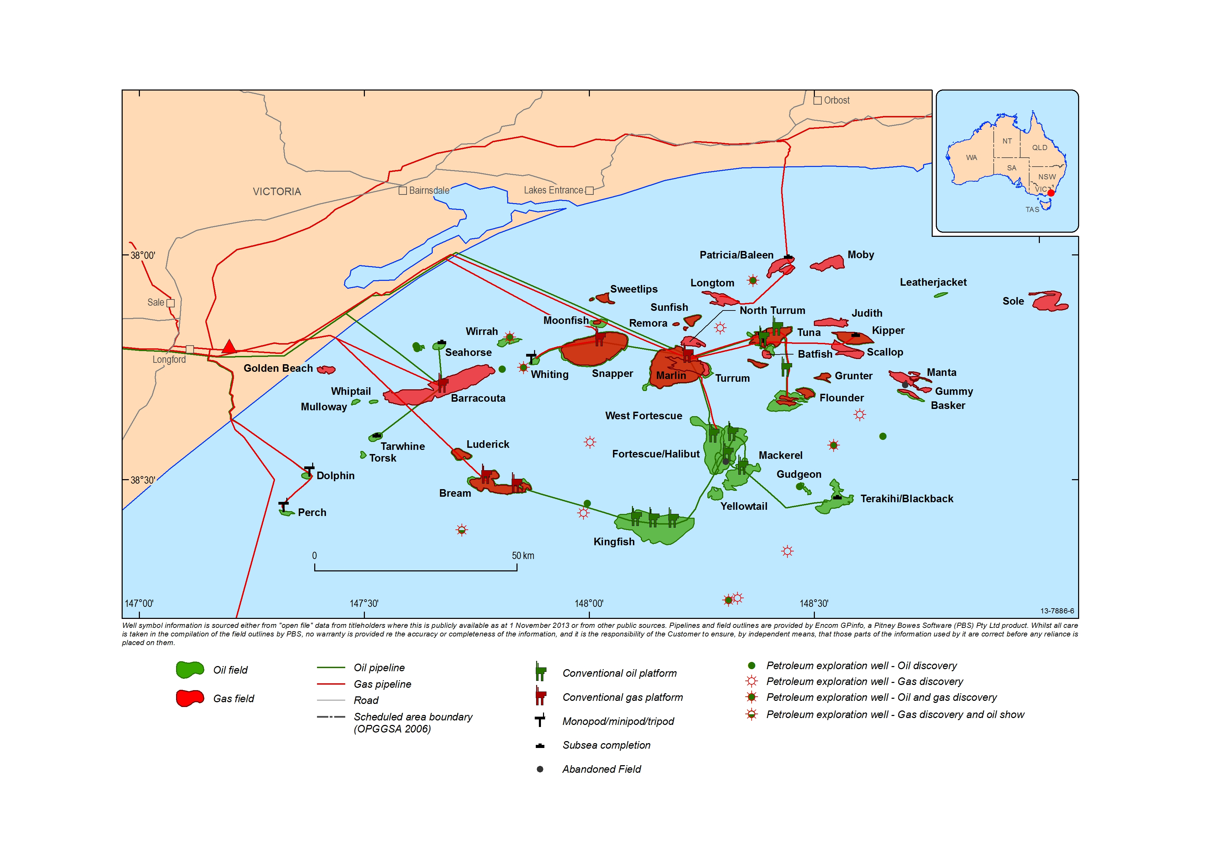
Figure 2 Petroleum production facilities, hydrocarbon accumulations, and current and proposed pipeline infrastructure in the Gippsland and Bass basins.
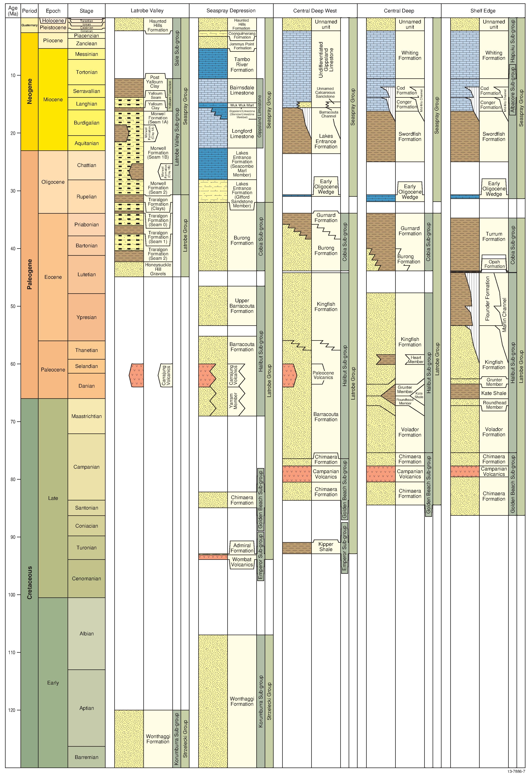
Figure 3 Stratigraphy and hydrocarbon discoveries of the western Gippsland Basin and the Central Deep (Partridge et al, 2012). Geologic Time Scale after Gradstein et al (2012).
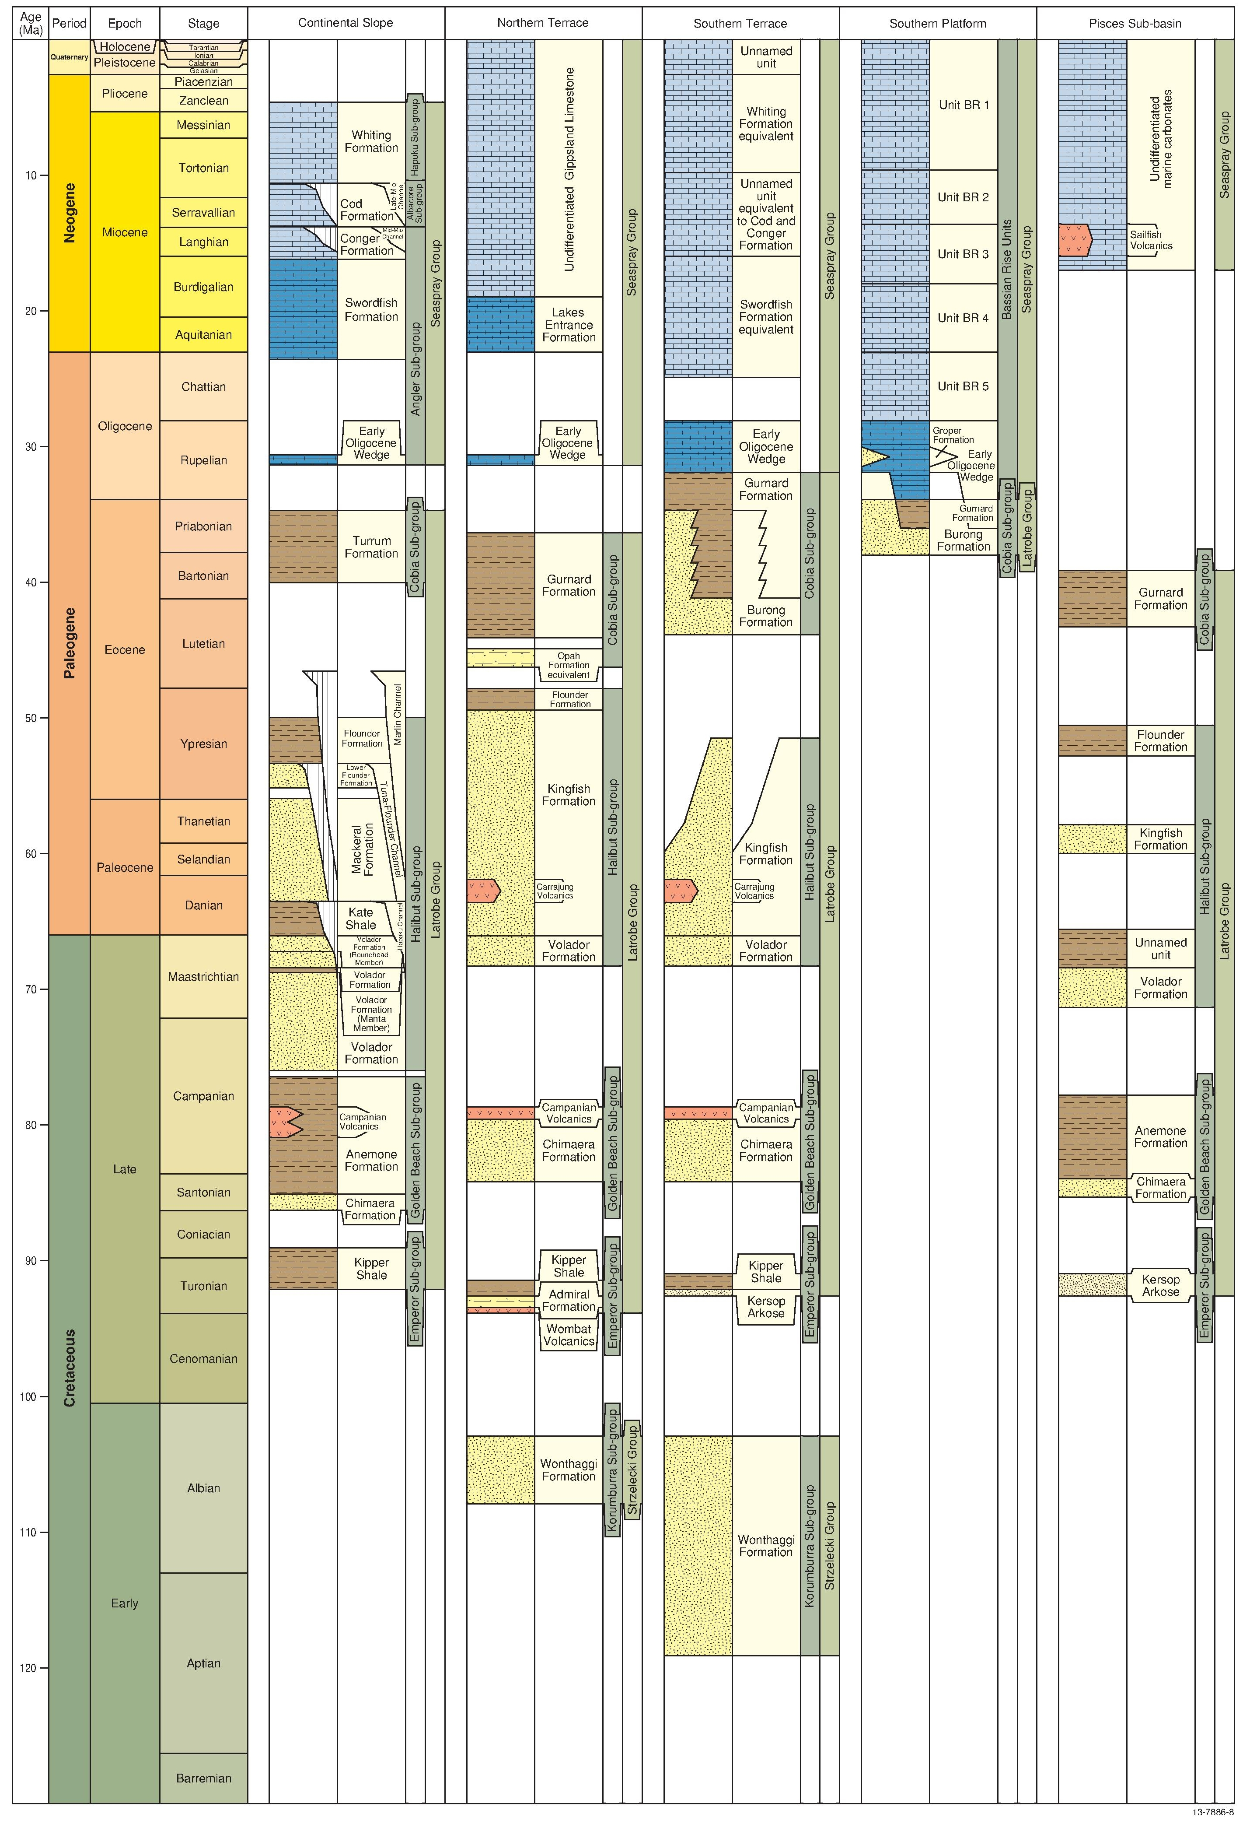
Figure 4 Stratigraphy and hydrocarbon discoveries of the eastern Gippsland Basin and the Northern and Southern terraces. Geologic Time Scale after Gradstein et al (2012).

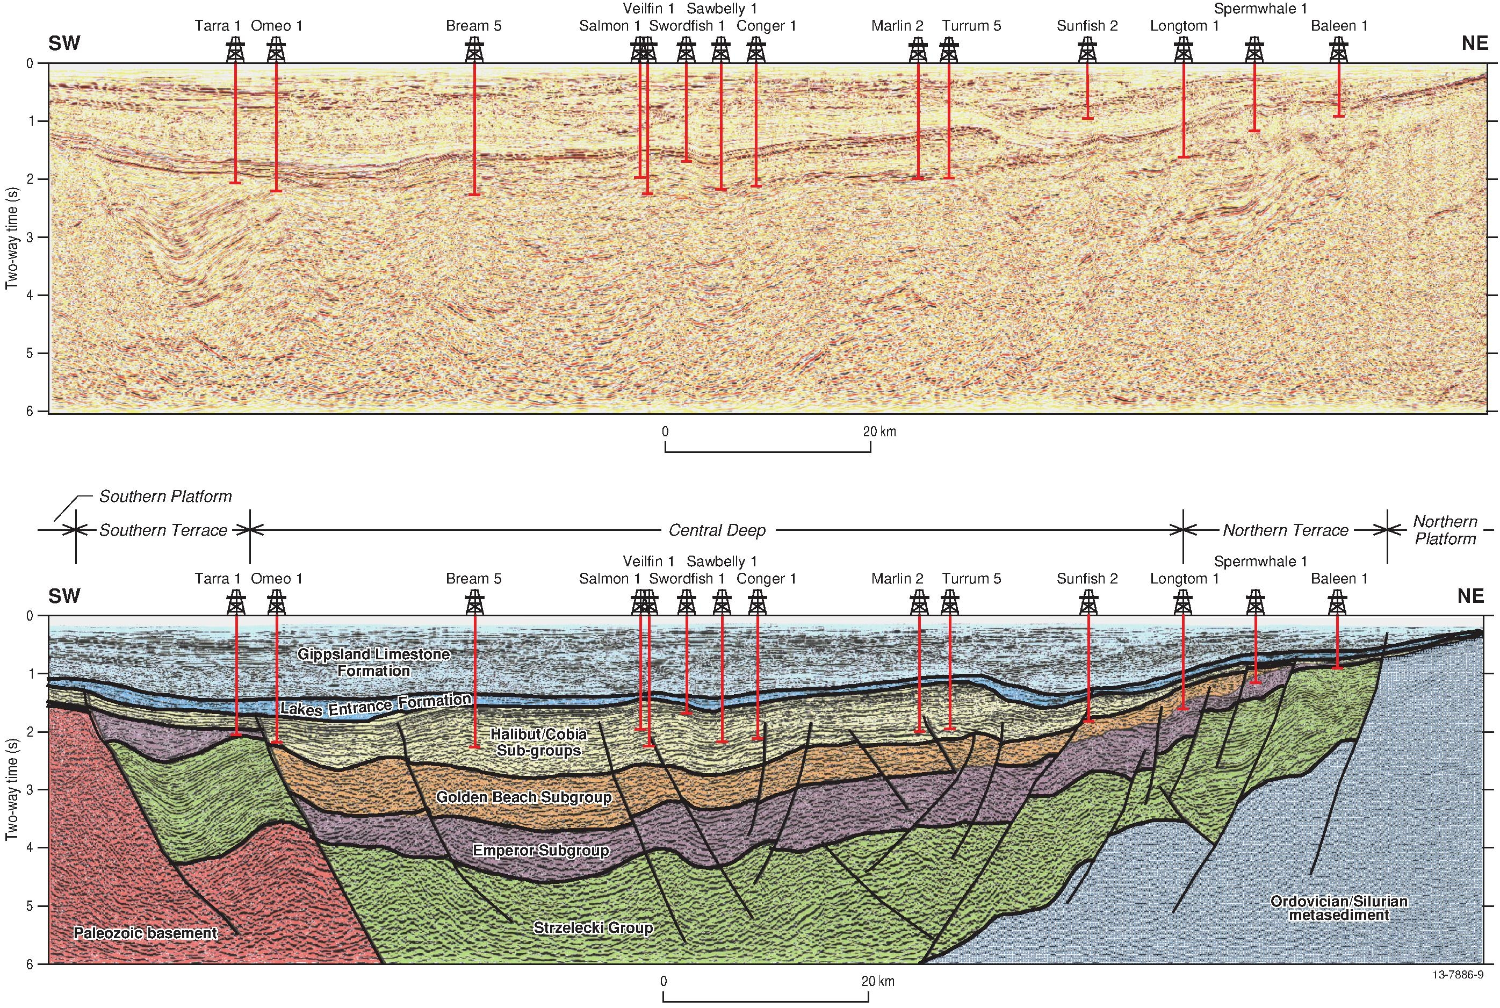
Figure 5 Seismic section across offshore Gippsland Basin, providing stratigraphic context and showing rift basin geometry represented by Central Deep, Northern Terrace and Platform, Southern Terrace and Platform. Location of section is shown in Figure 1.

