

***Inherent Limitations***

*This report has been prepared as outlined in the Introduction section of this report. The services provided in connection with this engagement comprise an advisory engagement, which is not subject to assurance or other standards issued by the Australian Auditing and Assurance Standards Board and, consequently no opinions or conclusions intended to convey assurance have been expressed.*

*No warranty of completeness, accuracy or reliability is given in relation to the statements and representations made by, and the information and documentation provided by stakeholders consulted as part of the process.*

*KPMG have indicated within this report the sources of the information provided. We have not sought to independently verify those sources unless otherwise noted within the report.*

*KPMG is under no obligation in any circumstance to update this report, in either oral or written form, for events occurring after the report has been issued in final form.*

*The findings in this report have been formed on the above basis.*

***Third Party Reliance***

*This report is solely for the purpose set out in the Scope Section and for the Department of Industry, Innovation and Science’s information, and is not to be used for any other purpose or distributed to any other party without KPMG’s prior written consent.*

*This report has been prepared at the request of the Department of Industry, Innovation and Science in accordance with the terms of KPMG’s engagement contract dated 11 July 2016. Other than our responsibility to the Department of Industry, Innovation and Science, neither KPMG nor any member or employee of KPMG undertakes responsibility arising in any way from reliance placed by a third party on this report. Any reliance placed is that party’s sole responsibility.*

***Disclaimer***

*The views expressed in this report are those of the author(s) and do not necessarily reflect those of the Australian Government or the Department of Industry, Innovation and Science.*

***Accessibility***

*To comply with the Commonwealth Government’s accessibility requirements for publishing on the internet, two versions of this Report are available: a KPMG-branded PDF version and an unbranded Microsoft Word version. The KPMG-branded PDF version of this Report remains the definitive version of this Report.*

Table of Contents

Executive Summary i

1. Introduction 1

1.1. Scope 1

1.2. Defining the marine manufacturing industry 1

1.3. Report structure 3

2. The Marine Manufacturing Industry in Australia 4

2.1. Australia's capability in the civil marine industry 4

2.2. Company innovation and investment in research and development 9

2.3. International markets and supply chains 11

2.4. Growth opportunities and barriers 11

Case Study: Incat 13

Case Study: Ocius 14

Case Study: Rivergate Marina & Shipyard 16

3. Economic Profile and Contribution of the Marine Manufacturing Industry 18

3.1. Number of businesses 18

3.2. Direct employment 21

3.3. Value added 24

3.4. Expenditure 25

3.5. Sales 27

3.6. Exports 31

Case Study: Austal 32

Case Study: Echo Yachts 34

Case Study: Steber International 36

Case Study: Arctic Steel 37

4. Conclusion 38

Appendix A: Industry Consultations 39

A.1. Key strengths of the industry 39

A.2. Key challenges for the industry 40

A.3. Industry trends in marine manufacturing sector 41

A.4. Industry trends in research and development 42

A.5. Industry trends in export markets 42

Appendix B: Survey Results 44

B.1. Strengths and challenges for the industry 44

B.2. Broader supply chain responses 45

B.3. Employment 46

B.4. Industry linkages 46

B.5. Capital investment 48

Appendix C: Statistical Classification 49

Appendix D: Survey Questions 50

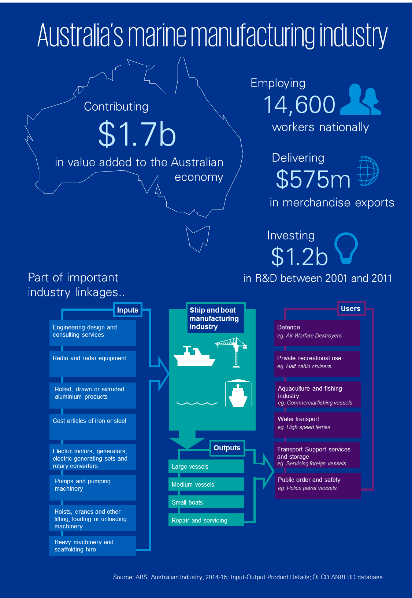

## Executive Summary

The marine manufacturing industry is an important part of the Australian economy. This industry has two distinct and often complimentary parts.

* Recent attention in Australia has focused on naval manufacturing capabilities, as highlighted by the ongoing Senate Economics Reference Committee inquiry into the future of Australia’s naval shipbuilding industry.
* However, with the civil marine manufacturing sector valued at more than one-third of the whole marine manufacturing industry (or at approximately $1.5 billion in sales[1]), it is also important to have a good understanding of this sector – in terms of Australia’s capabilities, current opportunities and challenges, and the contribution of this sector to the broader Australian economy.

While examining the marine manufacturing industry as a whole, the report also focuses on the civil marine part of the industry. Civil marine activities cover multiple market subsets across:

* Shipbuilding and boatbuilding;
* Commercial, private and government users; and
* Services including maintenance, repairs, refits, vessel overhauls and long-term sustainment.

Across these three sub-sectors, the Australian civil marine manufacturing sector has capabilities in the production and maintenance of a variety of vessel types – from runabouts, half-cabin and full‑cabin boats, through to commercial ferries and superyachts.

A number of strengths and challenges within the Australian marine manufacturing industry were highlighted through an industry survey and consultation with stakeholders. In particular, the quality of Australian-made products and the high standards of product safety were identified as two key strengths of the industry. These strengths are important elements of the Australian marine manufacturing industry, as international vessel operators recognise the operational advantages of high quality vessels, and also need to meet international safety standards to operate in many jurisdictions. Three key challenges reported by businesses in the sector were the high cost of labour, competition from cheaper imports, and the availability of skilled labour.



Additional industry feedback has highlighted that Australia has a high quality of marina management, which is an important complimentary aspect to the marine manufacturing industry. Industry stakeholders also identified the ongoing need to ensure opportunities are captured under free trade agreements.

Building on these strengths and, where possible, alleviating the impact of these challenges, can help build a more competitive Australian marine manufacturing industry. A competitive shipbuilding and boatbuilding industry can focus on its comparative advantages and export to new markets, benefiting both the industry and the economy more generally.

Research and development (R&D) in Australia’s marine manufacturing industry has also been an important factor in successfully reaching international markets. While absolute investment in R&D has declined since the early 2000s, Australia ranks above the OECD average in terms of marine manufacturing R&D expense as a share of industry activity. Two specific examples of successful R&D outcomes are:

* Australian commercial vessel manufacturers are pioneers in the design of catamarans for passenger transport. The ability to design vessels that can traverse shallower waters, carry larger numbers of passengers, while not compromising on stability and speed, has brought international market success to Australian ferry exporters.
* The use of computer simulation software and water tank testing has led to Australian exporters achieving advancements in multihull designs and delivering market leading trimarans. The success of the trimaran is evident in its use by Australian companies Austal and Incat in the design and building of high-speed ferries, and use by Echo Yachts in its construction of luxury superyachts.

In aggregate, the marine manufacturing industry contributes $1.7 billion directly in value added to Australia’s Gross Domestic Product. This includes vessel construction and maintenance work across both ships and boats. Nationally, the industry employs approximately 14,600 workers across a variety of occupations such as shipwrights, engineers and naval architects.[2]

***Figure A: Direct contribution of the marine manufacturing industry in 2014-15***



$1.7 billion

14,600 jobs

Source: KPMG estimates

The marine manufacturing industry is an important part of Australian industry. Through its contribution to value added, employment of skilled workers and linkages to other sectors in the economy, the marine manufacturing sector contributes to the Australian economy.

## Introduction

### Scope

KPMG was engaged by the Department of Industry, Innovation and Science to provide a report on the marine manufacturing industry in Australia, with a particular focus on the civil marine manufacturing part of the industry.

The scope of this report covers:

* The contribution of the sector to the Australian economy.
* Capabilities of the civil marine sector in Australia, focusing on larger shipbuilding and superyachts and associated professional and technical services, including repair services.
* Innovative activities, research and development and connections to international markets and supply chains.
* Identified growth opportunities and/or barriers to the development of the marine sector.

To achieve this, KPMG’s research and analysis has included desktop research, surveying companies, consultations with industry bodies and companies, and economic modelling of the ship and boat manufacturing sector[3] in Australia.

### Defining the marine manufacturing industry

According to the Australian New Zealand Standard Industry Classification (ANZSIC),[4] *shipbuilding and repair services* and *boatbuilding and repair services* are both subsets of other transport equipment. Reference in this report to the ship and boat manufacturing sector refers to the two subsets defined by the ABS below.

##### Shipbuilding and repair services

This class consists of units mainly engaged in manufacturing or repairing vessels of 50 tonnes and over displacement, submarines and major components for ships and submarines not classified elsewhere.

Primary activities include:

* Drydock operation
* Hull cleaning
* Ship repairing
* Ship wrecking
* Shipbuilding
* Submarine construction

##### Boatbuilding and repair services

This class consists of units mainly engaged in manufacturing or repairing vessels of under 50 tonnes displacement.

Primary activities include:

* Boat repairing
* Boatbuilding
* Canoe manufacturing
* Dinghy manufacturing
* Inflatable boat manufacturing
* Jet boat building
* Motorboat, inboard and outboard, building
* Powerboat building
* Sailboat manufacturing
* Yacht construction.

Defining the civil marine manufacturing sector according to existing statistical definitions can be challenging, as there is not a distinct civil subsector in the Australian standard industrial classifications. Instead, the sector can best be defined based on the users or consumers of shipbuilding and boatbuilding products and production technology.

For the purpose of this study, the civil marine manufacturing sector has been defined as comprising businesses predominately supplying shipbuilding, boatbuilding, and vessel repair and maintenance services to non-Defence users. That is, products and services provided to commercial and private users.

There are similarities and differences across the defence and the commercial (or civil) marine manufacturing parts of the industry. The table below provides some examples of these comparisons.

Figure 1: Examples of differences and similarities between Defence and commercial sub-sectors

|  |  |
| --- | --- |
| Defence | Commercial |
| New work is dependent on government decisions. | New work is subject to market impacts, such as demand for travel and tourism. |
| Are intensive in electronic systems, engineering and systems integration, requiring relatively more knowledge intensive jobs. | A relatively larger focus on fabrication, and technician and trade jobs. |
| A vessel design is often used for several builds to form a fleet. | Designs are customised for different ferries to meet requirements such as route and passenger numbers. |
| A completed vessel is accompanied with extensive documentation on specifications, training on various aspects of the vessel, and other intellectual property, called the ‘paper boat’. | A completed ferry is delivered with a relatively less complex manual. |
| Maintenance and repair is less predictable, as the use of navy vessels varies greatly at different times and different locations, and can be exposed to harsh conditions. | Ferries are typically used for a repetitive route and can have their maintenance schedules planned out accordingly. |
|  |  |

### Report structure

The remainder of this report is structured as follows:

* Section 2 summarises the features of Australia’s marine industry in terms of capability, innovation, international trade and competition. This section also identifies opportunities for growth in the sector and barriers to future development.
* Section 3 contains a detailed analysis of the marine manufacturing sector’s contribution to the Australian economy.
* The appendices contain a summary of the industry consultations conducted for this research, results from the survey, statistical classifications, and a list of questions included in the KPMG industry survey.
* Finally, case studies have been included at the end of each section to give a deeper understanding and some real life examples of the capabilities, capacities, challenges and opportunities faced by businesses in the marine manufacturing industry.

## The Marine Manufacturing Industry in Australia

This section provides an overview of Australia’s marine manufacturing sector. Australia’s capabilities in the marine manufacturing industry are discussed first, followed by an overview of innovative initiatives currently employed by the industry. Focus then shifts to international trade and the competition present in international markets. In the final subsection, opportunities for growth are identified and barriers to the development of the domestic sector are noted.

### Australia's capability in the civil marine industry

The Australian marine manufacturing industry includes a variety of businesses and specialists that play a role in the life cycles of vessels, from design to hull construction and outfitting to through‑life support including maintenance, repairs and refits.

##### Business capacity

In Australia there are almost 2,000 registered businesses operating in the ship and boat manufacturing sector.[5] Only a few of the major shipbuilding companies are prime suppliers to the naval sector, which means that the majority of these registered businesses form the civil marine manufacturing sector.

Looking at the level of employment in these Australian marine manufacturing businesses, Figure 2 shows that there are a large number of non-employing businesses in shipbuilding and boatbuilding. This indicates that many sub-contractors are used in some sub-sectors of the marine manufacturing industry. At the larger end of the market, there are only nine businesses that employ more than 200 workers. On the revenue side, at the end of the 2015 financial year, there were only 162 businesses that registered annual income greater than $200 million while for the majority of businesses turnover was between $50,000 and $2 million.

Figure 2: Marine manufacturing businesses according to size by employees and revenue (2015)



Source: ABS catalogue number 81650

##### Skills and Training

Maintaining a pool of skilled workers across the ship and boat manufacturing industry is important to sustaining a competitive marine manufacturing industry. Figure 3 shows the number of apprentices and trainees in shipbuilding and boatbuilding and repair services since 2006. There has been a significant decline in the number of boat-related apprenticeships and traineeships, falling from a peak of 1,100 in 2008 to 363 in 2016. There may be a number of factors that have impacted the level of apprentices supported by businesses over this period, such as the global financial crisis and/or structural changes in the industry. The number of shipbuilding apprentices and trainees in training has remained relatively stable at around 300 since 2012, indicating a recovery from the post-GFC decline that dropped to a low of 171 apprentices in 2011.

Figure 3: Number of shipbuilding and boatbuilding apprentices and trainees in training (2006–2016)



Source: NCVER VOCSTATS

The availability of quality training is essential to prepare marine manufacturing workers for the future industry. Figure 4 shows the new enrolments into certificate courses for boatbuilding and boat servicing qualifications.

Industry stakeholders commented on the challenge in recruiting skilled naval architects. Innovation in design and the ability to adapt to client and market needs are qualities in which Australian marine manufacturers excel in. Maintaining these qualities could be at risk if fewer students are able to pursue naval architecture higher qualifications, which is a risk that the recent suspension of the University of New South Wales undergraduate specialisation in naval architecture highlights.[6]

Also noted by industry stakeholders is that many skills in the marine manufacturing industry, such as welding and fabrication, are transferable from other sectors such as construction. This can help the industry meet fluctuations in levels of client demand. However, specialised skills are required in some areas such as aluminium welding, which often requires transferred workers to be up‑skilled in‑house.

Accessibility to training is a major issue as highlighted by the Boating Industry Association.[7] For example, in NSW the only Tertiary and Further Education facility to offer courses in boatbuilding is in the metropolitan area, while much boating building occurs in regional NSW areas. One approach to dealing with this challenge is learning by distance while also learning on the job at a boatbuilding business, as is being trialled by Steber International in Taree, NSW (see the Steber case study).

Figure 4: Number of new enrolments in boatbuilding certificates

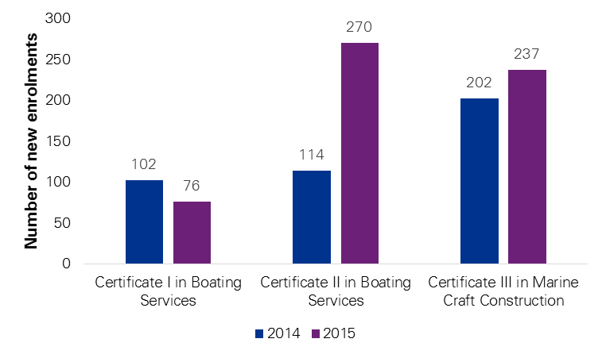

Source: NCVER VOCSTATS

##### Business capability

Australia’s marine manufacturing industry has expertise in working with a range of materials for ship and boat builds – including aluminium, steel and fibreglass. Aluminium vessels have emerged as a particular strength in Australia, with the advanced skills required to weld aluminium currently available within the Australian marine workforce. Australian aluminium built vessels are also recognised for their strength, weight and corrosion resistance.

There is a large range of vessel types and services that the industry supplies and multiple types of customers to which the industry supplies. As a nation surrounded by water, and with established export markets, these users range from small and large ferry operators, commercial fisheries, and government patrol vessels to private recreational users. Users of products and services supplied by the ship and boat manufacturing industry can be categorised into the following three broad categories listed below and then individually described in more detail.

|  |  |  |  |
| --- | --- | --- | --- |
| **Users** | **2015–16 sales** | **Total ship and boat manufacturing industry** | **Civil marine manufacturing industry** |
| Private | $822 million | **$4.2 billion** | **$1.7 billion** |
| Commercial | $817 million |
| Government | $2,561 million |
|

Source: IBIS World, KPMG estimates

###### Private users

The Australian civil marine manufacturing sector contributes around $822 million per annum in sales to private users. These users include boating hobbyists and private fishermen who use runabouts and small cabin vessels. These recreational vessels are typically used on weekends and holidays and endure far less strain to the hull, engine and electronics than commercial or government vessels. At the luxury end of the market, yachts and superyachts are purchased by the very wealthy. The construction and maintenance of these vessels by Australian companies typically requires a premium service that maintains a high quality of performance and amenity for the vessel.

###### Commercial users

The Australian civil marine manufacturing sector contributes around $817 million per annum in sales to commercial users. These are predominately used for fishing charters, ferrying passengers and vehicles, and support vessels for the oil and gas sector.

Australia has a well-established reputation in the design and construction of commercial vessels, particularly high-speed ferries. These are large vessels that are required to carry many passengers and sometimes vehicles. Commercial operators often need these vessels to travel at high speeds across repetitive routes and be reasonably stable across ocean waters.

###### Government users

The Australian marine manufacturing industry contributes a significant $2.56 billion in sales to government users. A major component of government use is by the Royal Australian Navy, which maintains a fleet of frigates, patrol boats, submarines and other craft. In the context of non-military (civil) users, the Australian civil marine manufacturing industry has supplied a range of different local and state government operated vessels, such as marine rescue boats and police boats.

Industry consultation indicated that there are differing views on the interaction of the defence and civil sides of the market. Some believe that these two parts of the market belong to very different industries, while others observe that the defence and civil sides are interlinked with work sourced through a wide range of areas. Further, industry believes that the creation of more interaction around training could be of benefit, while there may be opportunity for further reform or action in the regulatory space for defence procurement to be an additional stimulus to marine sector development.

In addition to a diverse range of customers, Australian businesses in the ship and boat manufacturing industry also have highly diversified output beyond ship and boat products and services. Figure 5 shows that 56 per cent of production by the total ship and boat manufacturing industry is on ship and boat products and services. While is it common for many businesses to diversify their products, it is especially so with ship and boat manufacturing, particularly when compared to other manufacturing industries such as railway rolling stock, aircraft, or iron and steel manufacturing.

Despite this difference, the product coverage ratio is similar to other manufacturing sectors. That is, over 90 per cent of ship and boat products and services are produced by the ship and boat manufacturing industry (as defined by their primary output).

Figure 5: Specialisation and diversification of selected manufacturing sectors



Source: ABS catalogue number 5209.0.55.001 Table 19  
Note: The specialisation ratio indicates how much of an industry's output is made up of that industry's product type.   
The coverage ratio indicates how much production is produced by primary manufacturers.

Looking more closely at the other goods and services produced by the ship and boat manufacturing industry, Figure 6 shows that the industry also provides other transport parts and equipment, property services, technical services, and other fabricated metal products.

Figure 6: Goods and services produced by the marine manufacturing industry

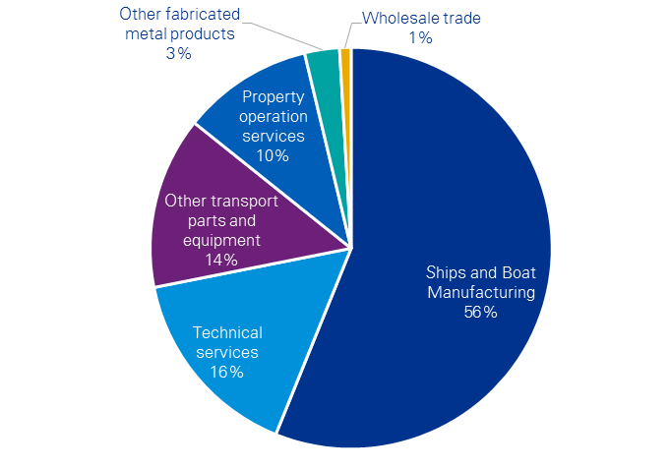

Source: ABS catalogue number 5209.0.55.001 Table 1

These goods and services are described as follows.

* Other transport parts and equipment largely comprise of motorised armoured fighting parts, which would be produced by primes that are engaged in building Defence weapon platforms. A small part of this production also includes boat trailers.
* Technical services includes engineering and design consulting services and research and development services.
* Property operation services includes commercial and industrial leasing, such as operating marinas or leasing space to other business that support shipbuilding and boatbuilding and servicing activities (for example see Rivergate case study).

### Company innovation and investment in research and development

Research and development is critically important for ship and boat builders. This is reflected in the prevalence of specialised research and development (R&D) groups across a spectrum of marine manufacturing companies. Examples are Austal’s in-house R&D and advanced shipbuilding teams, Incat’s sister company Revolution Design, and Steber International’s collaboration with marine technology developer Ocius.

Technological advances can vastly improve the quality and performance of vessels. A recent example is ride control systems developed by Austal, which use enhanced computer controlled motion reduction to create smoother vessel sailing. The world’s first liquefied natural gas (LNG) powered, high-speed ferry developed by Incat is another example of Australia’s ability to create commercial technologies through investment in R&D.

Industry consultation indicates that most targeted R&D in the marine industry is undertaken by larger companies that have the resources to allocate to new innovations. There are many companies in the marine sector accessing the R&D tax incentive; however, industry stakeholders that were consulted stated that for smaller companies the R&D tax incentive was often too complex and required too much additional time to ensure compliance.

However, marine related R&D activities are often required as part of completing a job. Non‑repetitive, customised vessel builds inherently require a considerable amount of research and testing to create a design that can optimise several factors – including meeting a client’s needs, adhering to vessel standards, and controlling costs.

Figure 7 illustrates how new knowledge can be generated in the civil marine manufacturing sector in the early stage of new commercial vessel builds.

Figure 7: Flow chart of innovations from vessel design

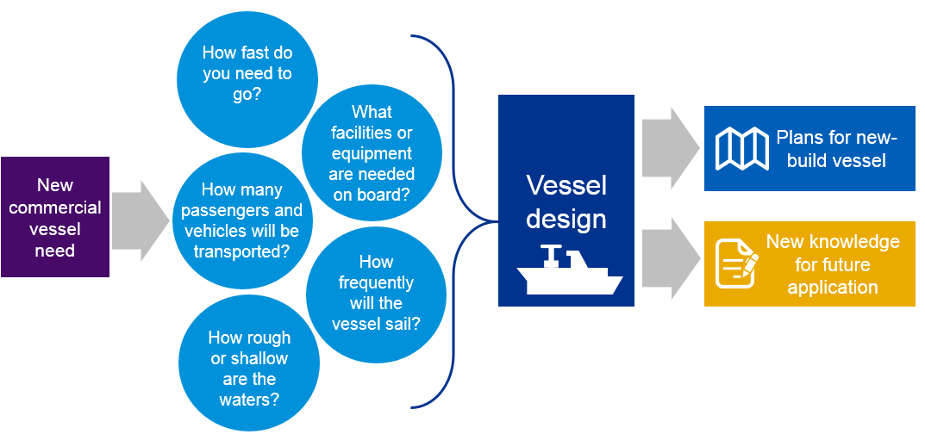

Source: Industry stakeholder feedback

More broadly, the shipbuilding and boatbuilding sector in Australia allocates considerable funds towards R&D, estimated at US$43.5 million in 2011 according to the OECD’s Analytical Business Enterprise Research and Development (ANBERD) database.

Figure 8 shows that the level of ship and boating building R&D spending in Australia has declined since 2003. In contrast, two major global investors in ship and boatbuilding R&D – Korea and the United Kingdom – have been growing their R&D expenditure considerably over the past decade investing in excess of US$200 million in recent years.

The R&D intensity index (also shown on Figure 8) provides an indication of the amount of research and development invested relative to the size of the national ship and boatbuilding industry. By this measure France has the greatest intensity in shipbuilding and boatbuilding R&D, followed by Spain and Germany. Australia performs well in R&D intensity, with an index of 1.45, which is above the OECD weighted mean of 1.10.

Figure 8: Annual expenditure on R&D and R&D intensity in shipbuilding and boatbuilding sector by country



Source: OECD ANBERD database, Galindo-Rueda, F. and F. Verger (2016) [8]  
Note: R&D intensity indices (right-hand side axis) are only reported for 2011. Data for China and the United States was unavailable.

### International markets and supply chains

Integrating into global supply chains is essential for industries to be globally competitive.

Looking first upstream (inputs), it is currently more efficient for businesses to import some of their inputs into the marine manufacturing sector than for these components to be produced domestically. ABS input–output data, supported by a KPMG survey of the industry, indicates that metal products such as steel and aluminium and vessel parts such as engines have a significant amount of imported product. Industry stakeholders have noted that for aluminium components, extrusions can often be manufactured locally, but aluminium sheeting has to be imported from places such as France.

Engines are typically imported for ships and boats manufactured in Australia. The biggest suppliers of marine engines are France and the United States supplying AU$17.4 million and AU$17.2 million respectively worth of engines to Australia in 2015–16.[9] A moderate amount of marine engine imports also come from Germany, Japan and Sweden, representing AU$11.3 million, AU$10.3 million and AU$9.4 million respectively in 2015–16. For large marine engines (over 375 kW), most imports to Australia come from France and Germany.

Turning to downstream (sales), for Australian total ship and boat exports, the two largest markets by far are the United States and New Zealand. According to the ABS international merchandise export data,[10] total ship and boat exports over the past five years to the United States and New Zealand were around AU$190 million and AU$120 million respectively. Other major export destinations are Singapore, Canada, Papua New Guinea and the United Arab Emirates with exports collectively worth AU$110 million between 2011–12 and 2015–16.

Conversations with stakeholders in the civil marine industry have highlighted that connecting to international markets for exports can be challenging, and that a proactive and in-person approach is often necessary for export success. Commercial vessels constructed by Australian shipbuilders reach a range of international markets, such as:

* Australian ferries are servicing the River Thames in London, the Greek Islands and routes in China, Japan, United Arab Emirates and many other routes around the world. This reflects Australia’s strength in designing and building quality high-speed aluminium ferries.
* Luxury boat and yachts manufactured by companies such as Riviera in Queensland are exported to a variety of locations in the United States, South Africa, Europe and Asia.

### Growth opportunities and barriers

There are a number of challenges for the industry. One such challenge for Australian manufacturers is distance to market. The cost of transporting (shipping) a completed vessel, particularly beyond (and within) Asia can be high and a barrier to competing against foreign competitors located closer to international markets

Industry consultations also indicate that competition from imports is regarded as a significant challenge. In addition to the difficulty competing on price (affected by high Australian labour costs and a relatively strong Australian dollar), many Australian boat builders manufacture to voluntary Australian standards, which can increase the cost of the final product in the domestic market.

For much of the past decade, the mining boom and high Australian dollar have meant that exports of Australian ships and boats have been less competitive. With the Australian dollar falling over the past few years, exports can become more competitive, presenting an opportunity for Australian ship and boat builders.

Recent free trade agreements made by the Australian government and governments of important trading partners offer opportunities to expand into foreign markets. For example, the recent China‑Australia Free Trade Agreement has phased out China’s five per cent tariffs on motor vessel exports and the eight per cent tariffs on non-motor vessel exports will be eliminated by January 2019.[11] The Korea-Australia Free Trade Agreement has removed the eight per cent tariffs on sailboats, motor boats and outboard motor boats exported from Australia to Korea.[12] On the import side, Australian tariffs of five per cent on boat and dock fenders, ship and boat propellers, and ship ignition wiring sets from Korea have been phased out and from China will be phased out from January 2019, reducing the cost of parts for vessel construction.

A potential opportunity for businesses in the civil marine manufacturing sector to expand into the defence sector is available through the Royal Australian Navy’s Future Frigate program. Worth $35 billion, the Future Frigates program is currently undergoing a competitive evaluation process between three prime tenderers. The Centre for Defence Industry Capability is working with the Future Frigates program and Australian businesses to overcome some of the barriers that typically limit businesses supplying to Defence or prime contractors.[13]

Another potential opportunity for the industry is on the environmental and efficiency front. Some Australian businesses have invested in developing greener technologies for marine propulsion to create more environmentally sustainable vessels. However, the current low price of oil reduces incentives for ship and boat operators to invest in alternative fuel sources such as LNG, or at least reduce the amount of savings that can be achieved from more efficient vessels. This presents a short to medium-term challenge for Australian businesses with proprietary knowledge in this space. However, it is anticipated by some industry stakeholders that these technologies will receive more investment and application in the future.

**Case Study: Incat

Incat is an Australian ship and boat builder that has operated   
since the 1970s. Along with Austal, they are a leading aluminium shipbuilder, highlighting the strength that Australia has in developing high-speed, aluminium vessels.

Located in Tasmania, Incat has facilities to build vessels up to 150 metres in length. However, the market for commercial ferries of 100 metres or greater is highly volatile. For this reason, Incat also accepts contracts for work to build smaller vessels, such as the recent passenger ferries for Sydney Harbour.[14] This means that there is an under-utilisation of Incat’s capital and labour. However, it is necessary to remain busy during periods of less market demand for large aluminium ferries.

##### Distance to market

Australia already experiences a challenge with distance to market, where accessing European and American markets makes imports of vessel components more costly for Australian producers, adding to the price delivered to customers.

This issue is compounded by the shipping costs from mainland Australia to Tasmania. Incat note that the cost of freight for material shipped from Melbourne to Hobart can exceed the costs for shipping those materials from China to Melbourne. This additional expense decreases the competitiveness of exports.

Despite this, around 90 per cent of Incat’s production are exported, and the quality of products and specialisation in large aluminium vessels has a strong position in the market.

##### Anticipating future markets

Revolution Design is a sister company to Incat, providing designs for current and future Incat vessels. A particular focus of Revolution Design is on the design of non-diesel engines, such as those powered by LNG.

In some parts of the world, LNG is a less costly fuel source and can provide a significant cost saving for operating large, fast moving ferries that consume large amounts of fuel.

Revolution Design works with global engine companies to incorporate alternative engine types into innovative vessel designs to improve the efficiency and performance of vessels.

© 2017 KPMG, an Australian partnership and a member firm of the KPMG network of independent member firms affiliated with KPMG International Cooperative (“KPMG International”), a Swiss entity. All rights reserved. KPMG and the KPMG logo are registered trademarks of KPMG International. Liability limited by a scheme approved under Professional Standards Legislation

Regulation in Europe to reduce carbon emissions is encouraging vessel operators to consider alternative energy mixes. As a result, many ferry operators are expected to shift towards non-diesel engines such as LNG. Incat is forward thinking in this regard, by working with Revolution Design to develop vessels that can meet these future challenges. In 2014, Incat built the world’s first HSC compliant vessel with natural gas powered turbines as a primary energy source.[15]

In addition to regulatory impacts, relative fuel price is another driver for new technologies around engine design. Recent lower oil prices have reduced the current efficiency cost, and hence market momentum, to invest in LNG vessels.[16]

*Figure 9: Francisco – the world’s first LNG high-speed ferry, built by Incat*

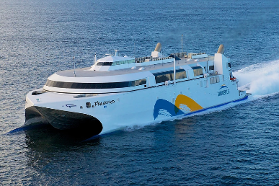 Source: Revolution Design

Case Study: Ocius

Ocius is a small research and development company that focuses on marine technology. In the past, it has developed renewable energy propulsion systems for vessels, which have been used for several commercial ferries.

In 2015, Ocius won a $3 million contract with the Capability Technology Demonstrator (CTD) program to develop an unmanned surface vessel (USV) suitable for anti-submarine warfare surveillance.[17] Developing this technology has now become its core business, with its strategy to become the leading designer of USVs.

Establishing the need for R&D

Earlier technologies by Ocius, then called Solar Sailor, focused on energy-saving technologies to create more efficient propulsion systems. The business was successful in bringing some designs to market, particularly when oil prices peaked at around $140 per barrel in 2008. During this period of high fuel prices, the idea of ‘green ferries’ and other fuel-efficient designs had more incentive for development. However, those incentives became weakened as oil prices plummeted.

For larger commercial shipping applications, another disincentive to pay for alternative energy technologies by industry is that for many cargo ships the charterer pays for fuel. This removes the incentive for the owner to invest in fuel-saving technologies.

Further, technologies for hybrid energy types and alternative fuel sources are often developed in other sectors such as automotive, where consumers are more sensitive to fuel prices and the size of the market is significantly greater.

In response to this, Ocius shifted its focus to the USV market. In contrast to energy saving technologies, the USV market is anticipating significant growth and is being driven by keen interest from defence industries and oil and gas sectors that have the budgets and incentives to develop this technology. The Royal Australian Navy see this as an important capability – with a vast amount of ocean surrounding Australia, it is expensive for manned vessels to patrol the entire area.

Collaborating with industry to lead the market

The recent launch of the new Ocius prototype USV, called the Bluebottle Stinger, illustrates the importance of collaborating across businesses to achieve new innovations. The Bluebottle stinger is 5.6 metres in length and has gone through multiple design phases over the past five years. To build the prototype, Ocius worked with the NSW‑based boat manufacturer, Steber International, leveraging their experience in boat building.

Additionally, for this prototype, Ocius also cooperated with Thales, a prime defence supplier. Thales provided the equipment or ‘payload’ for the Ocius USV to carry. This equipment included a winch, cable and towed array weighing 105 kilograms to detect submarines. Ocius notes that competitor designs do not have the capacity to carry equipment that heavy.

Figure 10: Anti-submarine warfare application of prototype unmanned surface vessel

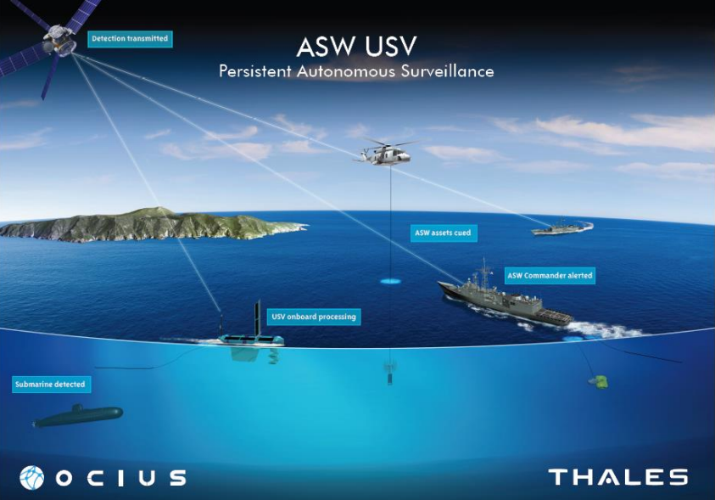

Source: Ocius press release, 24 September 2015[18]

Race to market and beyond

There are competitive technologies in the United States such as Wave Glider by Liquid Robotics,[19] and the Sail Drone – another autonomous vessel developed in the United States. Recent acquisition of Liquid Robotics by the multinational aerospace and systems company, Boeing, highlights the potential that is seen in developing this technology.[20]

There is a race to create a new product that is suitable for scaling up production. The USV market is estimated to be worth US$ 861m by 2021.[21]

Fleet robotic control is a complementary technology that could be developed alongside USVs. While this technology is used for competitions such as the soccer-playing robots, its commercial application is not currently clear.

There is significant potential around coordinating a fleet of USVs to communicate with each other and to be more autonomous.

The Bluebottle Stinger prototype developed for the CTD program responds to a distinct need and opportunity to develop and apply this technology. Success of its development has the potential to flow through to benefit many other applications.

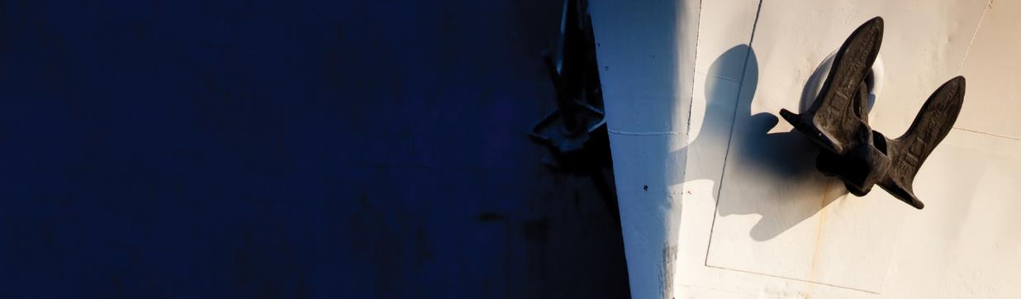Case Study: Rivergate Marina & Shipyard

Rivergate Marina & Shipyard has been operating for approximately 10 years and services around 40 superyachts and numerous other vessels each year.

The shipyard deals primarily with maintenance and refit work for boats. Rivergate is known for providing high quality work, winning the award for 2015 Commercial Marina of the Year presented by the Marina Industries Association. Rising demand at the Marina has allowed Rivergate to operate 24/7 fuelling facilities for vessels.[22]

A Marine Hub

Rivergate Marina and Shipyard contains 106 berths that can be accessed by boats up to 90 metres. The company services boats through its shipyard (1-2 days maintenance through to 3-6 month refits) and also project manages works predominately in the international superyacht market. Thus, the marine hub where Rivergate operates also includes over 20 professional companies that support this type of work – ranging from engineers, carpenters, mechanics and painters. The business model employed by Rivergate and their associated specialists is all about “service”. The success of the companies in this hub is built on brand reputation and client confidence.

Expanding into the build market

Rivergate completed their first new-build of a 24‑metre high-speed aluminium catamaran for the Queensland Police Service in May 2016.[23] The refit space of the shipyard was suitable for this project and Rivergate’s existing group of subcontractors had the relevant skills. Combined with Rivergate’s experience in project management, the vessels were delivered successfully according to specifications.

As evidenced by this project, Rivergate has the ability to leverage the success they have in the refit and maintenance sectors to potentially generate more business in the boat building side of the industry.

Figure 11: Rivergate Marina & Shipyard keeps busy mooring and servicing many vessels

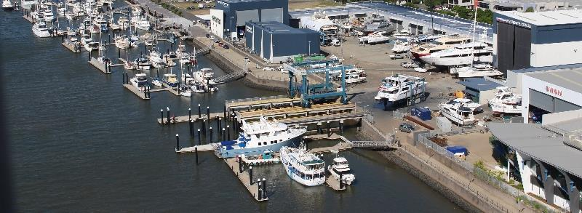

Source: Rivergate[24]

Attracting more global business

Rivergate prides itself on achieving quality outcomes for clients, which in turn is seen to bring more business to South East Queensland. However, there are some barriers that limit the potential market for Australian boat re-fitters, repairers and maintenance workers.

As an official customs and clearing port for Australia and with a large international client base, Rivergate is well placed to observe the perceptions of international boat owners and crew when they visit Australia. Rivergate note that Australia is perceived to be difficult in terms of paperwork. Anecdotal evidence indicates there is a view that it is hard to deal with authorities, and forms requiring a visiting yacht to be a classed as a ‘temporary import’ can be a deterrence for international crews and tourists to visit Australia.

Rivergate believes the Australian fees are seen as another deterrent to vessels visiting the country. For example, the current regulation means that superyachts incur similar fee structures to all other large vessels. For example, regulation requires a 50‑metre vessel to hire a pilot (attracting fees of approximately $1,500 each way) to guide it through the Brisbane River. This is considered unnecessary for a highly manoeuvrable vessel such as a superyacht, which does not need the same assistance as less manoeuvrable vessels such as oil tankers.

Rivergate emphasise that this is an important issue, particularly when considering the potential business that the superyacht industry could bring. The maintenance and refit work on international vessels brought in revenue of approximately $18 million, of which around 90 per cent went to sub-contractors and suppliers. Additionally, crews often accumulated their income while sailing overseas, and are keen to spend it on local entertainment.

Australia’s regulation limiting the ability for superyachts to charter is also seen as a big deterrent to the export market. Nearby countries, for example Tahiti, allow superyachts to undertake chartering under normal business conditions, and the Government receives taxes on any income earned through chartering. Rivergate believes that relaxing this limitation would see a big inflow of international superyacht visits, and drive additional flow-on marine and other tourism industry activity in Australia.

The potential business involved with servicing a single superyacht highlights the importance of reducing deterrence for potential international visitors, and designing processes that are quick and efficient so vessel owners and operators choose to visit Australia for servicing their craft.

Competitiveness in Australia

Being located on the Brisbane River means that Rivergate is close to many domestic customers, and that international visitors are able to visit Brisbane when they dock at Rivergate.

However, Rivergate identifies their location as a disadvantage when tendering for maintenance and refit work that requires the supplier to be located in Cairns. While Rivergate believe they can provide exceptional quality, and that the two day journey to deliver the vessel to their yard is worth the added value that they provide, this locational aspect still often disqualifies them from winning some government contracts and reduces the competitiveness in the refit and maintenance industry.

Rivergate believe that some of these tenders should be more open to a variety of bidders, to increase competitiveness and allow the best value service to be procured from government projects.

## Economic Profile and Contribution of the Marine Manufacturing Industry

The Australian marine manufacturing industry contributes to the Australian economy as both major goods and service provider to other industries, and as a customer for goods and services from supplier industries.

The economic contribution of a sector is generally measured by employment in the sector and the sector’s value added to the final goods and services that it sells (output less inputs from other industries outside the sector).

This section starts by providing a general overview of the full marine manufacturing industry, and as data permits, the civil marine industry in particular. The overview looks first in terms of capacity – the number of shipbuilding, boatbuilding and repair businesses operating across states and territories in Australia, and then in terms of contribution – employment and operational activity by the sector.

This provides an understanding of the direct contribution of the marine manufacturing industry to the Australian economy that is based on the latest available ABS data – in particular, the manufacturing industry statistics (2014–15), the national input–output tables (2013–14), the Labour Force Survey (2015–16) and other public data sources.

While this section discusses the impact of the sector both upstream (suppliers) and downstream (customers), it does not estimate the full flow-on impacts of the sector across the entire economy.

### Number of businesses

The marine manufacturing industry is represented in all Australian states and territories. In 2015, there were almost 2,000 shipbuilding, boatbuilding and repair businesses operating across states and territories in Australia.

Figure 12 (on the following page) shows that a significant portion of shipbuilders and repairers are located in Queensland (32%), New South Wales (28%) and Western Australia (18%), with these states containing major companies such as Austal and BAE Systems, in addition to a large number of small and medium‑sized businesses.

Figure 13 (also on the following page) shows that across most of the states and territories, there is a relatively even split in the number of small and medium shipbuilders. In contrast, there are very few shipbuilding and boatbuilding businesses with more than 200 employees – with these mainly located in Queensland, New South Wales and Western Australia.

Figure 12: State distribution of shipbuilding and boatbuilding businesses (business count, 2015)

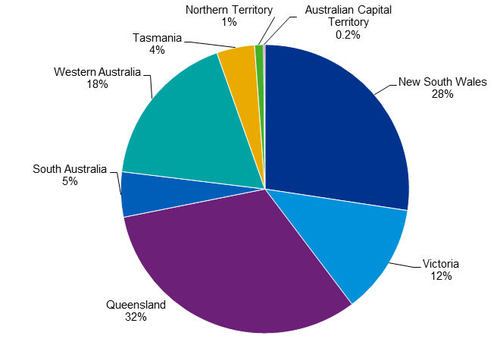

Source: ABS catalogue number 81650

Figure 13: State distribution of employment in shipbuilding and boatbuilding businesses, 2015

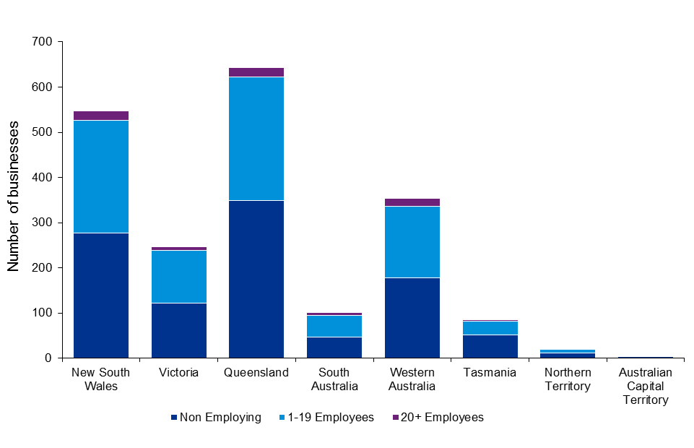

Source: ABS catalogue number 81650

Looking at the regional distribution of ship and boatbuilding activity, Figure 14 shows the industry concentration according to employment. This figure also shows the location of the companies that have been included as case studies in this report.

Figure 14: Regional distribution of marine manufacturing activity and location of case study companies

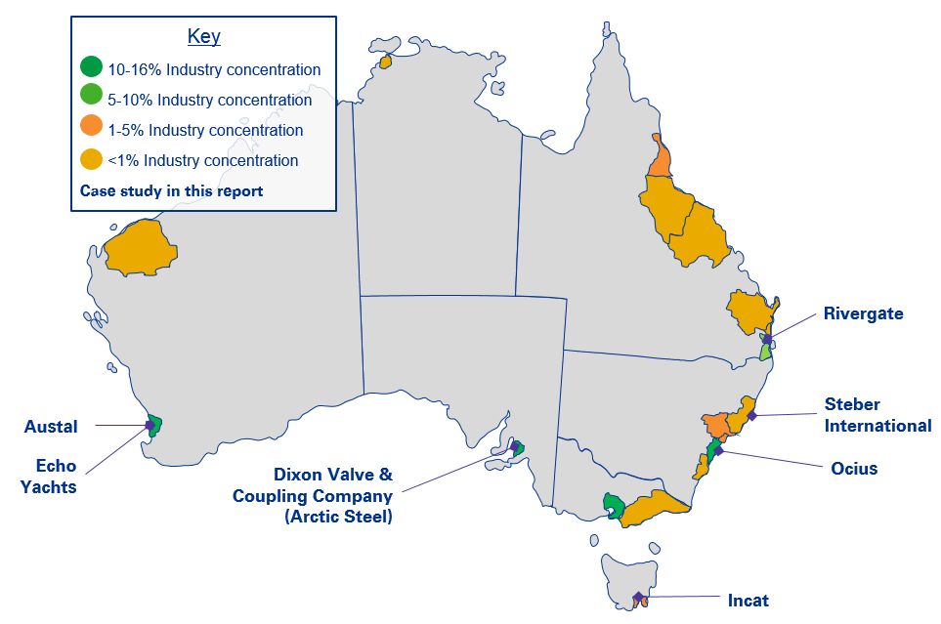

Source: ABS Census (2011)   
Notes: Industry concentration is based on share of regional employment. Regions are mapped at the Greater Capital City boundary and Statistical Area level 4, with the exception of Ashburton in Western Australia (SA3 level).

The Greater Perth, Adelaide, Sydney and Melbourne regions accommodate a significant portion of shipbuilding and boatbuilding activity, collectively representing around 58 per cent of employment in Australia.

* Greater Adelaide focuses predominantly on shipbuilding activity.
* Melbourne is slightly more balanced, with shipbuilding still an important component of this region’s industry.
* Perth and Sydney are more balanced across both shipbuilding and boatbuilding.

The Greater Brisbane and Gold Coast regions are hubs of boatbuilding and serving activity, with a moderate amount also occurring in Cairns. These three areas, together, contribute around 20 per cent of the industry’s employment in Australia.

Looking at the location of the remainder of industry activity:

* Elsewhere in Queensland – some industry activity is located at the Sunshine Coast, Townsville, Mackay and Wide Bay.
* Beyond the Greater Sydney region – in New South Wales, a moderate amount of industry activity is located in Newcastle and the Hunter Valley, and some activity is located in the Mid-North Coast and Illawarra regions.
* A moderate amount of activity is located in Hobart, with smaller amounts of industry activity in Darwin, the Latrobe-Gippsland region of Victoria, and the Ashburton region of Western Australia.

### Direct employment

The latest data on total employment in the marine manufacturing industry across Australia has been sourced from the latest ABS Australian Industry data, which indicates that an estimated 14,561 people were employed directly in the shipbuilding, boatbuilding and repair services sector at the end of financial year 2014–15.

This means that the marine manufacturing industry contributes to almost two per cent of employment across the whole manufacturing sector. This is similar to Iron and Steel Manufacturing’s contribution, and slightly higher than other (non-motor vehicle) transport equipment manufacturing and services such as railway rolling stock and aircraft manufacturing.

Figure 15: Share of total manufacturing employment in 2014–15

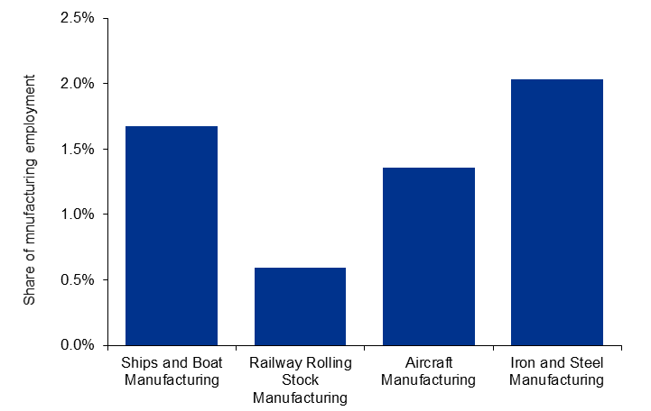

Source: ABS catalogue number 81550 and 6291

Figure 16 shows that, in the 2014–15 financial year, shipbuilding and boatbuilding industries contributed around 9,500 and 5,000 jobs to the Australian economy respectively. There has been very minor growth in employment in the shipbuilding and repair services since the 2012–13 financial year, while employment in the boatbuilding and repair services indicates a very modest decline.

According to a survey conducted by the RAND Corporation, Australian employment across naval shipbuilding, submarine building and ship repair was 7,950 employees in 2013–14.[25] Approximately half of these workers were employed with the ASC Pty Ltd, which is engaged on Defence-related vessels. (This figure is slightly below the ABS shipbuilding employment figures, and is likely due to the focus of the RAND report on employment for naval vessel construction and maintenance.)

Figure 16: Total employment in shipbuilding, boatbuilding and repair services

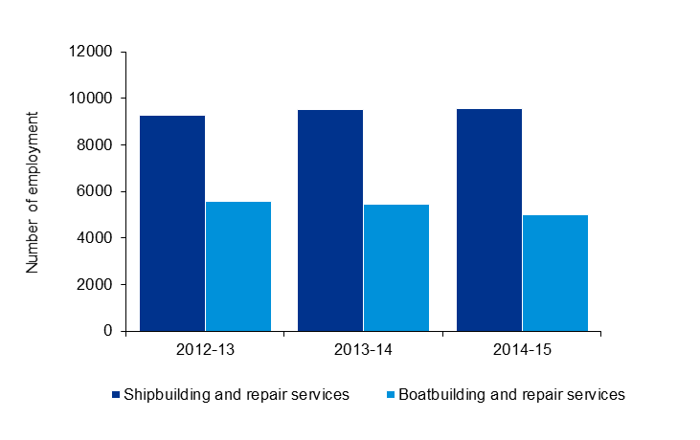

Source: ABS catalogue number 81550

Figure 17 outlines total wages and salaries paid in both shipbuilding and boatbuilding industries in Australia, estimated to be over $1.3 billion at the end of financial year 2014–15. As is evident from the above chart, there has been a slow and steady growth in total wages and salaries paid in both shipbuilding and boatbuilding industries since the 2012–13 financial year.

Figure 17: Total wages and salaries paid in shipbuilding, boatbuilding and repair services ($million)

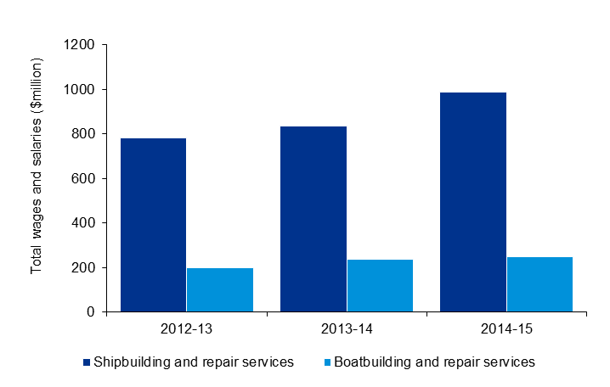

Source: ABS catalogue number 81550

Given the number of people employed by shipbuilding and boatbuilding industries in Australia, average wages and salaries in shipbuilding and repair services industries are estimated to be higher than boatbuilding and repair services industries. This indicates that the shipbuilding industry is a more skilled labour-intensive sector compared to the boatbuilding industry.

Figure 18 summarises the key occupations employed by both the shipbuilding and boatbuilding   
sub-industries. The main occupation for the entire shipbuilding and boatbuilding sector is boat builders and shipwrights, forming 22 per cent of total employment. When looking at the two separate sub-industries, this share is much larger for the boatbuilding sub-sector forming 39 per cent of boatbuilding employees compared to 5 per cent of shipbuilding employees.

This matches industry stakeholder feedback on the broad set of shipwright skills that are required across multiple stages of boat building (see Steber International case study), while construction of large ships require more individual / specialised roles. At the broad occupation categories, shipbuilding and repair employ more professionals (19 per cent) with just 5 per cent of professional occupations making up boatbuilding and repair employment.

Figure 18: Main occupations with ship and boat manufacturing

|  |  |  |  |
| --- | --- | --- | --- |
| Occupation | Shipbuilding and repair services | Boatbuilding and repair services | Total ship and boat manufacturing |
| Boat Builders and Shipwrights | 5% | 39% | 22% |
| Structural Steel and Welding Trades Workers | 14% | 8% | 11% |
| Motor Mechanics | 2% | 7% | 4% |
| Metal Fitters and Machinists | 6% | 2% | 4% |
| Marine Transport Professionals | 3% | 2% | 3% |
| Electricians | 4% | 1% | 3% |
| Vehicle Painters | 1% | 3% | 2% |
| Other Miscellaneous Labourers | 2% | 2% | 2% |
| Contract, Program and Project Administrators | 3% | 0% | 2% |
| Production Managers | 2% | 1% | 1% |
| Office Managers | 1% | 2% | 1% |
| General Clerks | 2% | 1% | 1% |
| Purchasing and Supply Logistics Clerks | 2% | 1% | 1% |
| Industrial, Mechanical and Production Engineers | 2% | 0% | 1% |
| Other Engineering Professionals | 2% | 1% | 1% |
| Engineering Professionals not further defined | 2% | 0% | 1% |
| Storepersons | 2% | 1% | 1% |
| Other Management and Professional occupations | 16% | 7% | 11% |
| Other Technician and Trade occupations | 11% | 7% | 9% |
| Other occupations | 19% | 17% | 18% |
| **Total** | **100%** | **100%** | **100%** |

Source: ABS Census (2011)

Note: Totals may not sum to 100% due to rounding error.

Regarding skill shortages, Industry stakeholders note that recruiting Naval architects is a constant challenge. Some businesses have an on-going recruitment drive, and anticipate needing more naval architects for both designing new vessels, and also to work with design teams from other organisations.

In terms of skill transferability, there are many roles that are performed in other sectors, such as construction and mining, and that can transfer to ship building. One common difference noted is that many welders need further training in working with aluminium, as it is a more difficult and less common metal to work with than steel.

### Value added

The contribution of the ship and boat manufacturing sector in Australia is typically measured in terms of the value of final goods and services produced by the sector. Industry value added is a more direct measure of a sector’s direct contribution to a country’s Gross Domestic Product (GDP).

Value added captures the return to an industry’s labour and capital and other fixed factors. It is calculated as the outputs of the industry less the goods and services from other industries including imports, and is therefore the industry’s direct contribution to GDP (except for indirect tax payments). By excluding goods and services inputs from other industries and imports, ‘value added’ avoids double counting as it does not include the value added from other industries.

The marine manufacturing industry’s economic activity directly adds value to Australia’s economy. As shown in the figure below, the ship and boat manufacturing sector contributed almost $1.45 billion in gross value added to Australia’s GDP in 2013–14, with over $1.3 billion in wage payments to employees and $91 million in Gross Operating Surplus (a return on capital). Australia’s GDP was $1,585 billion in 2013–14, meaning that the ships and boat manufacturing sector contributed approximately 0.1 per cent of Australian GDP in that year. In 2014–15, gross value added of the ship and boat manufacturing sector increased to $1,672 million.[26]

Figure 19: Ship and boat manufacturing sector’s gross value added, 2013–14

|  |  |
| --- | --- |
|  | (2013–14 $million) |
| Expenditure | 4,484 |
| Purchases of Goods and Services | 3,081 |
| Wages | 1,312 |
| Gross Operating Surplus | 91 |
| Taxes Less Subsidies on Products | 24 |
| Other Taxes Less Subsidies on Products | 42 |
| Gross Value Added | 1,445 |

Source: ABS input–output table (2013–14)

### Expenditure

In addition to contributing to the income of Australians through its own value added activities, the ship and boat manufacturing sector also contributes to the economy through its purchase of over $3 billion in goods and services from other industries.

Figure 20: Ships and boat manufacturing sector’s direct expenditure on goods and services, 2013–14

|  |  |  |
| --- | --- | --- |
| Product | (2013–14 $m) | % imported |
| Professional, Scientific and Technical Services | 576 | 6% |
| Ships and Boat Manufacturing | 380 | 1% |
| Iron and Steel Manufacturing | 230 | 49% |
| Professional, Scientific, Computer and Electronic Equipment Manufacturing | 197 | 67% |
| Wholesale Trade | 188 | 0% |
| Specialised and other Machinery and Equipment Manufacturing | 187 | 77% |
| Electrical Equipment Manufacturing | 144 | 81% |
| Basic Non-Ferrous Metal Manufacturing | 141 | 61% |
| Basic Chemical Manufacturing | 98 | 48% |
| Non-Residential Property Operators and Real Estate Services | 83 | 0% |
| Rental and Hiring Services (except Real Estate) | 80 | 13% |
| Petroleum and Coal Product Manufacturing | 62 | 54% |
| Other Wood Product Manufacturing | 60 | 18% |
| Textile Product Manufacturing | 49 | 77% |
| Other Fabricated Metal Product manufacturing | 45 | 37% |
| Other Repair and Maintenance | 41 | 0% |
| Road Transport | 40 | 1% |
| Transport Support services and storage | 31 | 0% |
| Telecommunication Services | 30 | 2% |
| Finance | 27 | 4% |
| Electricity Transmission, Distribution, On Selling and Electricity Market Operation | 25 | 0% |
| Electricity Generation | 23 | 0% |
| Employment, Travel Agency and Other Administrative Services | 22 | 2% |
| Structural Metal Product Manufacturing | 21 | 36% |
| Other | 303 | 29% |
| **Total** | **3081** | **29%** |

Source: ABS input–output table (2013–14)

The main inputs into the sector were purchased from the professional services sector, other ship and boat manufacturing businesses, iron and steel manufacturers, and professional, scientific, computer and electronic equipment manufactures. Most of these inputs are sourced domestically, with less than one third imported. The components with the highest level of imports are electrical equipment, textiles and various metal products.

KPMG has also undertaken a survey of civil marine manufacturers to identify any discrepancies between the latest (2013–14) detailed ABS data and current activity in the sector (see Figure 21). The survey identified a similar mix of marine business expenditure across the different products and domestic/imported sources. This indicates that the input shares identified in the ABS 2013–14 input output data appear current, and there is no indication that any major shifts in the industry structure have occurred (see section B.4 for further details).

Figure 21: Comparison of ship and boat manufacturing industry expenses



Source: ABS input–output table (2013–14), KPMG survey

Note: Employee compensation includes wages, salaries, superannuation and contracted labour. Overheads include transport, electricity, gas, water and fuels. KPMG survey sample size is 31 and is reported as a broad representation and not a statistically significant result.

The KPMG survey also collected information on capital expenditure in which ship and boat manufacturing businesses invested. Figure 22 shows the shares of investment expenses reported by businesses over a five year period. The majority of capital expenses in the reported period are on land and buildings (39 per cent), heavy or specialised machinery (25 per cent), and drydocking and shipbuilding facilities (23 per cent). KPMG notes that the sample size is not statistically significant, and that investment activity can vary significantly over time (more so than intermediate goods for production). However, the survey provides an indication of investment activity by the industry.

Figure 22: Capital Investment (five-year average)

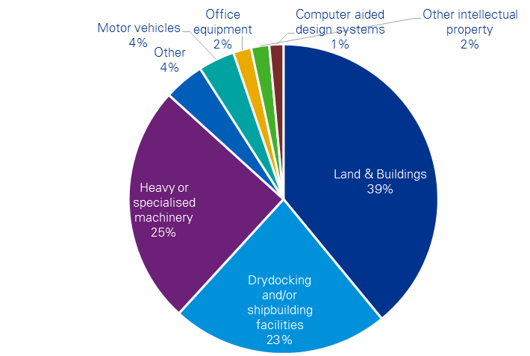

N=29  
Source: KPMG Survey  
Note: Average over 5 years between 2011/12 and 2015/16. KPMG survey sample size is 29 and is reported as a broad representation and not a statistically significant result.

### Sales

The marine manufacturing industry also contributes to the economy by providing products to other industries as inputs into their business activities (intermediate inputs) and providing final products to private, commercial and government users.

The latest ABS input–output table (2013–14) shows that the value of sales by the ships and boat manufacturing sector to other industries (as intermediate goods and services) was over $1.1 billion in the 2013–14 financial year. Of this, $368 million is sales to other ship and boat manufacturing businesses.

Repairs and servicing of vessels were valued at $733 million (see

Figure 23), with the largest users including:

* Water, Pipeline and Other Transport (38 per cent or $277 million)
* Defence repairs and maintenance (29 per cent or $211 million)
* Transport Support Services and Storage (15 per cent or $109 million)
* Fishing, hunting and trapping (7 per cent or $54 million).

Figure 23: Civil and Defence Users of Repairs and servicing of vessels, 2013–14 (Percentage share)



Source: ABS input–output table (2013–14)   
Note: Other industry use includes aquaculture, retail trade, public administration and regulatory services, public order and safety, and sports and recreation.

These repair and maintenance activities provide important support to Australia’s maritime activity. Examples of water transport servicing includes the dry docking and major refit that Sydney Ferries undergo every two to five years[27] to keep the vessels operating safely and efficiently. Maintenance of Royal Australian Navy vessels is important for national defence and regional security, and is undertaken in several locations (such as servicing of the Armidale class patrol boats in Cairns).[28]

In addition to supplying inputs to other industries, the Australian marine manufacturing industry also supplies final products to households, businesses and government. Total sales by the ship and boat manufacturing industry is estimated to be $4.2 billion in 2015–16. Figure 24 shows the revenue breakdown across products and services, and also across customers or users of the industry production.

Figure 24: Products and customers of ship and boat manufacturing (2015–16)



Source: IBIS World Industry Report (2016)   
Note: Medium-sized vessels include those with a displacement between 5 and 50 tonnes.   
Small vessels include those with a displaced under 5 tonnes.   
Total ship and boat manufacturing industry revenue is estimated to be $4.2 billion.

Looking first at the product and services side of the sector, shipbuilding and boatbuilding is by far the largest activity in the Australian marine manufacturing industry, with sales by the civil side of this sector estimated at over $1.3 billion. The major share of products sold by the marine manufacturing industry are Defence related, with military shipbuilding and submarine construction revenue at $2.1 billion – 50 per cent of the total sector’s revenue. In comparison, the maintenance and repair of ships and boats is estimated to have a combined revenue of $755 million or 18 per cent of the total sector.

On the customer side, Defence as a customer represents a larger share than military shipbuilding and submarine construction alone, totalling an approximately $2.7 billion due to their use of ship repair and maintenance services. Removing Defence from the ship and boat manufacturing sector sales estimates the size of the civil marine manufacturing sector (including repairs and maintenance) at $1.5 billion in 2015–16.

Civil marine manufacturing sector supplies are equally spread across commercial and government customers (22%) and wholesalers/retailers and consumers (20%). Commercial users are primarily ferry and water passenger services, but also include the fishing sector and a range of support vessel roles.

Looking at the change in new vessel demands by users over time, Figure 25 presents the demanded value for new vessels by Defence, government (excluding Defence), commercial and private users. The spread across these user groups highlights the diversity of production that exists within the Australian marine manufacturing sector. Of these users groups, Defence demands are particularly lumpy. In 2009–10, the value of new vessel builds by Defence was just over $2 billion. By 2012–13, this fell sharply to $750 million, before increasing to an estimated $2.1 billion in 2015–16. These fluctuations in demand present a challenge for industry to adjust their resources and remain competitive and was an issue highlighted by multiple submissions to the Senate Economics References Committee inquiry into the future of Australia's naval shipbuilding industry.[29] On 4 August 2015, the government announced it would implement a continuous naval surface shipbuilding strategy, with the intention to reform Australia’s naval shipbuilding industry and put it onto a sustainable long-term path. On 16 May 2017, the government released the Naval Shipbuilding Plan[30] confirming its commitment to delivering an enduring national shipbuilding and ship sustainment enterprise.

Figure 25: New vessel demands in Australia



Source: ABS catalogue 5215.0.55.001 (Input–Output Table 2) 2004–05 to 2013–14, IBIS World Industry Report (2016).

These industry linkages discussed in sections 3.4 and 3.5 are summarised in the figure below. The ship and boat manufacturing industry relies on a number of upstream industries to operate including both material inputs such as radar equipment and aluminium sheeting and service inputs such as engineering design and heavy machinery hire. Manufactured vessels and vessel services are provided to market users such as commercial fishing and water transport, and non-market users such as police forces and national defence agencies.

Figure 26: Summary of inputs, outputs and users of the ship and boat manufacturing industry

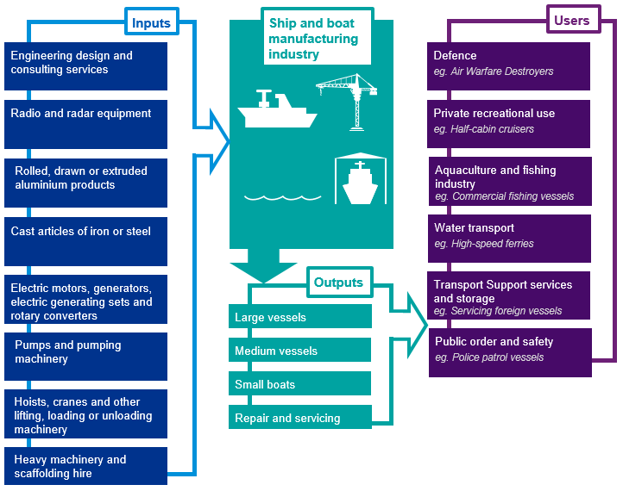

Source: ABS catalogue 5215.0.55.001 (Input-Output Table Product Details)  
Note: Large, medium and small vessels include those with a displacement greater than 50 tonnes, between 50 and 5 tonnes, and less than 5 tonnes respectively.

### Exports

The Australian marine manufacturing industry contributes additional revenue and opportunities to the Australian economy through its connection to export markets. In 2014–15, merchandise exports by the marine manufacturing industry contributed approximately $575 million or approximately 4 per cent of Australia’s total machinery and transport equipment exports.

Many vessel exports are volatile (as shown in the figure below), as they depend on a wide range of factors that drive foreign demand. While exports remain an important market for this industry, aggregate exports of completed vessels have steadily declined since 1996 (see Figure 27). Major factors are the increase of manufacturing facilities in Asia, and also the high Australian dollar during the mining boom.

Figure 27: Australia's ship and boat exports



Source: ABS 5368.0, International merchandise exports

Note: 2015–16 values are preliminary published data. Other vessels includes warships, floating structures and tugboats.

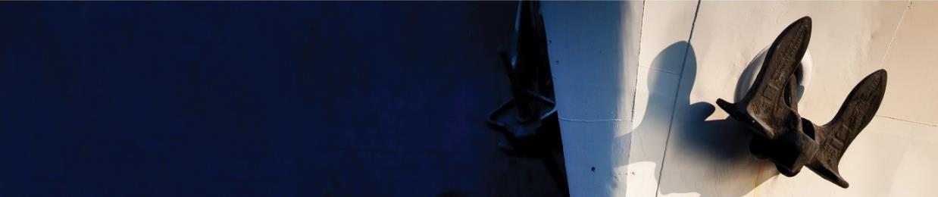Case Study: Austal

Austal is one of Australia’s largest ship and boat manufacturing companies. Headquartered at Henderson, Western Australia, Austal has also expanded to develop shipbuilding capabilities in the United States and the Philippines. Austal supplies shipbuilding and boatbuilding services to both defence users and commercial users.

The shipbuilding yard at Henderson has a mix of both defence and commercial work, which Austal comments is a preferred balance of business. Over the period of the global financial crisis, the demand for new-build commercial ferries declined significantly, leaving the majority of work for defence or government clients.

Austal observe complementarity in working in both the commercial and defence space and in diversifying their client base. While each market has different requirements and a different process of development, both create ideas and on-the-job learning that can benefit both markets.

For example, build requests for commercial ferries require different design elements according to their use, so contracts for these vessels build knowledge of different design options and how to better construct vessels for their intended purpose. In contrast, a Department of Defence project often needs multiple vessels of identical design, such as for the Pacific Patrol Boat Replacement Program for which Austal recently won the 19 vessel contract. Repetitive build allows for the ability to improve building processes and efficiencies in ship and boat building.

Enhancing supply lines to improve competiveness

Austal’s shipyard in the Philippines enhances its capacity and allows it to be more competitive in the global market. The facility can construct vessels up to 80 metres and there are plans to expand facilities to have the capability of constructing up to 130 metre vessels. In addition, the shipyard can be used for ‘hybrid builds’, where part of a vessel is manufactured in the Philippines facility, and then transported to Henderson for integration and completion of the vessel.

This expansion in the Austal supply chain brings new efficiencies to the building process, allowing cost and time savings. Austal continues to expand its naval architecture and design capability, with more than 60 new designers recruited in Australia in the last 12 months. The capacity for design work is also being developed at the Philippines site, with the recruitment of engineers and naval architects in country. New projects can include many hours of design work, so there is the potential for further efficiencies by having engineers and naval architects based in the Philippines, operating as one integrated team with Austal’s Australian-based designers.

Figure 28: Austal shipbuilding facilities

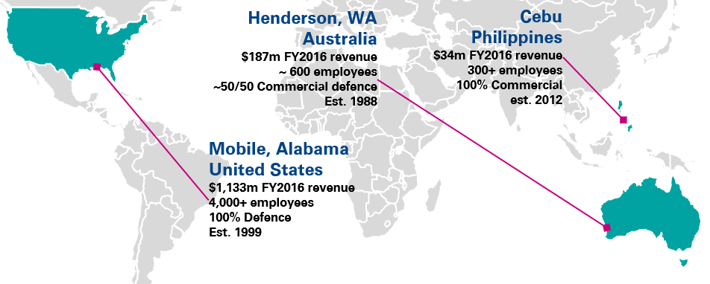

Source: Austal 2016 Annual report, austal,com

© 2017 KPMG, an Australian partnership and a member firm of the KPMG network of independent member firms affiliated with KPMG International Cooperative (“KPMG International”), a Swiss entity. All rights reserved. KPMG and the KPMG logo are registered trademarks of KPMG International. Liability limited by a scheme approved under Professional Standards Legislation

Knowledge transfer across new‑builds and through-life support

While shipbuilding is Austal’s core business, the company is seeking to provide more through-life support for vessels. Accessing the service market has several benefits. Austal noted that if poor maintenance work is undertaken on a vessel and, as a result, a fault occurs during its life, the criticism often still falls on the shipbuilder. Providing maintenance and repair work on their own vessels means that they can ensure that a high standard of work is performed, and that the operability of vessels is maximised.

An additional benefit is that maintaining a vessel through-life provides the shipbuilder with a better understanding of the performance of that vessel and its components. This can often lead to identification of product improvements. Observing first-hand the rate at which different components wear can feedback into the company’s knowledge and improve future ship designs.

Research and development

Defence projects require a high level of detail across many aspects of a build, and this develops knowledge that can be then accessed during a commercial build.

* Naval vessels are typically very intensive in the amount of system and electronics that are installed, creating opportunities for improved use of sensors and data analytics. Austal’s current R&D efforts are focused on making use of such data to improve the operating performance and maintenance of naval vessel to meet the availability demands of Naval customers and reduce the overall cost of sustainment. This “smart ship” development is anticipated to lead to innovations that can be applied for commercial vessels as well.
* Further, improvements in system installation and integration developed through a defence build can bring efficiencies and innovations that are then transferable across to commercial built vessels.

On the other hand, while there is much literature on defence research and development spilling over to the private sectors, spillovers can also occur in the other direction. An example of this is in the Trimaran hull design developed by Austal when building the 127 metre ferry ‘Benchijigua Express’.

Research for this design began in 2000, and the development included using advanced computer software simulations and tank testing facilities to understand how the hull design would perform in the ocean. This development increased efficiency and reduced power requirements and engine exhaust emissions. The resulting ferry was also successful in reducing passenger seasickness when travelling between the Canary Islands.

This same design was then used to win a major US Department of Defence contract for the Littoral Combat Ships in 2005, as the final Trimaran design allows a ship to carry a large amount of weapons and equipment and two helicopters, while still achieving high speed and manoeuvrability at sea.[31]

In summary, there are important dynamics that occur both between defence and commercial work, and also between the building of new vessels and the through-life support of ships and boats.

Figure 29: Austal Trimaran hull design used for both commercial and defence vessels

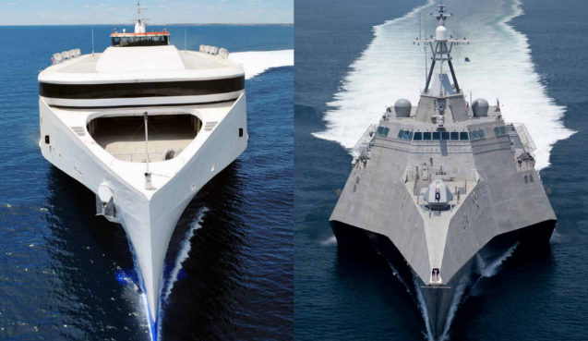

Source: Austal Trimaran Technology brochure[32]

### Case Study: Echo Yachts

Echo Yachts is one of only two companies building superyachts in Australia. The company is part of a larger business group, which also includes Evolution Commercial. The business group has around 250 staff, including approximately 50 apprentices. Their team and facilities are equipped to perform newbuilds, refits, maintenance and repairs with Echo Yachts focused on superyachts and Evolution focused on Commercial Vessels. All design and trades disciplines are available in-house with the company experienced in the production of aluminium, steel and fibreglass hulls. There are some specialised components, such as super high-quality interiors for superyachts, which are occasionally imported from other countries as and when a project requires it from a budget or schedule perspective.

Recent completed works by the group include detailed maintenance and refurbishment of the 51 metre superyacht ‘Aldabra’[33] and refit of ‘True North’.[34] Previous projects also include high speed ferries for Taiwan and wind farm support vessels for Denmark.

Tapping into a growing market

While Australia is an emerging player in the superyacht industry, it can already leverage its expertise in commercial high-speed aluminium vessels to be a competitive global player. The trend for commercial shipyards to play a larger role in construction of large superyachts is growing, as noted in the September 2016 Superyacht Market Report. [35]

The superyacht market is estimated to be worth US $22 billion globally in 2016, across a fleet of almost 4,500 vessels which have an average length of 41 metres. [36] In the larger superyacht market, the number of vessels under construction, with a length of 70 metres and over, has grown from 47 in 2010 to 70 in 2016, with major players in this market including Italy, the Netherlands and Turkey. [37]

Echo Yachts note that many international competitors receive substantial support from their own governments, which distort global competitiveness in the industry and creates an uneven playing field. Despite this, Echo Yachts has demonstrated that Australian shipbuilders have the skill and expertise to tap into this growing market.

Figure 30: Design of the 84 metre trimaran superyacht currently under construction at Echo Yachts

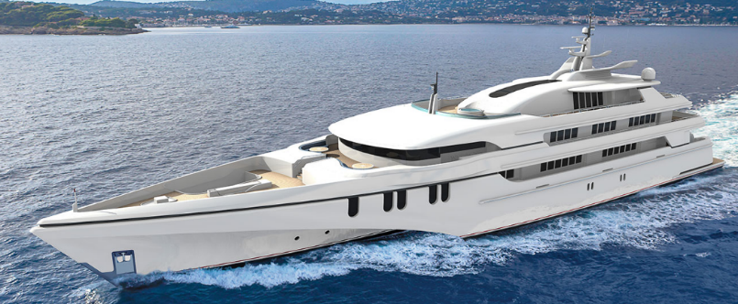

Source: Echo Yachts

© 2017 KPMG, an Australian partnership and a member firm of the KPMG network of independent member firms affiliated with KPMG International Cooperative (“KPMG International”), a Swiss entity. All rights reserved. KPMG and the KPMG logo are registered trademarks of KPMG International. Liability limited by a scheme approved under Professional Standards Legislation

##### Meeting clients’ needs

Echo Yachts is currently constructing an 84 metre trimaran superyacht and has recently completed a 46 metre catamaran shadow vessel. The trimaran superyacht, dubbed the ‘White Rabbit Golf’ is a large 2900 GT aluminium diesel electric vessel expected to be completed in 2018. It will be the world’s largest aluminium superyacht, the world’s largest trimaran superyacht, and Australia’s largest built superyacht.

‘Charley’ is the shadow vessel completed towards the end of 2016, and contains a large number of impressive features. It is the largest composite resin infused vessel to be built in Australia, supporting 18 guests and a crew of 13, and housing a number of watercraft for recreation, including a 12‑metre catamaran with its own custom launch platform. [38] Other features include a helicopter pad, decompression chamber and advanced sonar system to assist with diving trips. In addition to these features, Charley is also required to travel fast enough to keep pace and effectively support the mother ship when completed. [39]

The quality and combination of features demonstrates the ability for Echo Yachts to meet clients’ needs in premium, highly specified and customised vessels, and is a further example of Australia’s strength in high quality and innovative shipbuilding.

In addition to new builds, Echo Yachts have the capability to provide maintenance and refit services for superyachts. Although much of the superyacht build industry is concentrated in Europe, many owners are seeking global travel and unique experiences, and it follows that visiting superyachts in the Asia-Pacific region will require access to quality maintenance and refit services.

Figure 31: Echo Yacht and Evolution Commercial shipyard at Henderson, WA

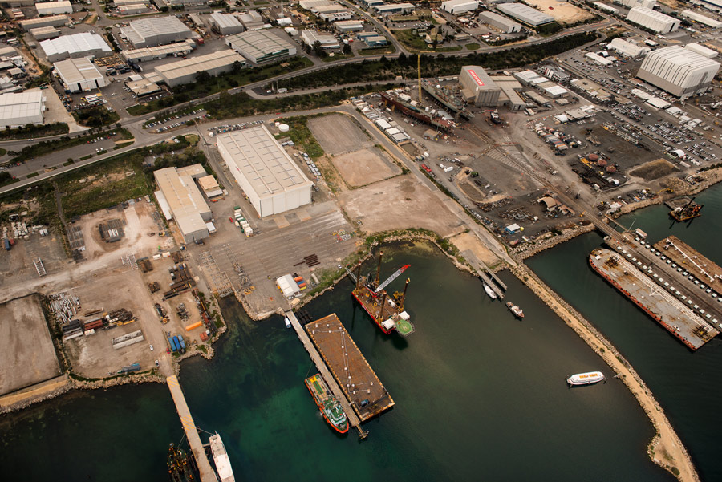

Source: Evolution Commercial[40]

© 2017 KPMG, an Australian partnership and a member firm of the KPMG network of independent member firms affiliated with KPMG International Cooperative (“KPMG International”), a Swiss entity. All rights reserved. KPMG and the KPMG logo are registered trademarks of KPMG International. Liability limited by a scheme approved under Professional Standards Legislation

© 2017 KPMG, an Australian partnership and a member firm of the KPMG network of independent member firms affiliated with KPMG International Cooperative (“KPMG International”), a Swiss entity. All rights reserved. KPMG and the KPMG logo are registered trademarks of KPMG International. Liability limited by a scheme approved under Professional Standards Legislation

Case Study: Steber International

Steber International is a leading manufacturer of fibreglass boats in Australia. The Steber tradition began with timber boats in 1946, moving to fibreglass boat construction in 1961.

The Steber factory is located in Taree, in rural New South Wales. On one hand, this rural location helps reduce costs, which serves as an advantage for production and competitiveness. On the other hand, being removed from major cities or marinas means Steber receives less exposure to clients, impacting their competitiveness.

Steber has worked to overcome this disadvantage by building a solid reputation for quality vessels, and by also participating in boating shows locally and internationally.

Export success with new technologies

Around half of the boats built by Steber are exported. This success in international markets has been recognised by industry through numerous Australian Marine Industry Export and Superyacht awards, including the 2011 highly commended best marine industry export performance for a large exporter and the 2012 Export Champion.

Further, in 2014, their joint work with Ocius in developing an unmanned surface vessel (USV) led them to be awarded the AIMEX award for most innovative export product[41] and the Hunter Manufacturing Award for excellence in innovation.[42]

The USV market is relatively new and has the potential to change the way many marine activities are undertaken by industry, researchers and Defence. Having the first business to commercialise this technology has the potential to bring a major export boost to Australia (see Ocius case study for more information).

Teaching diverse skill sets

To produce their boats, Steber requires a variety of skill sets. These skill sets are provided in-house, with the Steber facilities incorporating a series of separate specialist “shops”- such as the upholstery shop, woodworking shop, paint shop and parts shop. The diverse number of skills required to construct a boat from start to finish means that Steber employees are highly skilled in a number of roles, and flexible to work to many different requirements. Steber employees’ skills are also very transferable, and experienced staff are generally well placed to further their careers in boatbuilding or to work in other sectors such as construction.

While the number of apprenticeships and students studying shipbuilding and design has declined in Australia, Steber is active in trying to encourage skills for the new generation and passing on the Australian boatbuilding expertise. To date, over 150 shipwright-apprentices have been trained with the company. Steber is currently participating in a pilot program that allows an apprentice to receive on-the-job training at Steber while studying online with North Sydney TAFE to become a shipwright.[43]

Figure 32: "Westport Spirit" recent vessel constructed by Steber for the Port Macquarie Marine Rescue

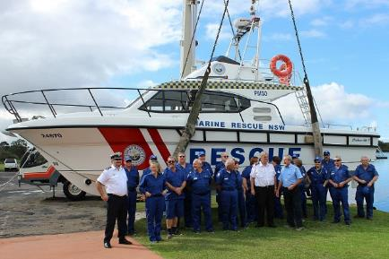Source: Steber International[44]

Case Study: Arctic Steel

Arctic Steel is a brand of high quality stainless steel strainers that are used to strain sea water as it enters engine cooling systems. The products are manufactured by Dixon Valve and Coupling Company (DVCC).[45]

Arctic Steel strainers are made from grade 2205 duplex stainless steel and are cast (not fabricated), which improves the strength, durability and corrosion resistance of the strainers. Arctic Steel is the only brand of strainers with this quality of steel, and is supplied to many boat and shipbuilding businesses, such as Riviera and Austal.

The high quality of these products reflects the company’s focus on commercial clients. DVCC believes that commercial users of vessels typically want something that is durable and reliable, and more frequently opt for high quality products.

The Arctic Steel strainers are cast at a small foundry in China, and then distributed worldwide. There are one or two foundries that could do the casting in Australia. However, the price would be significantly higher and would mean that this premium product would no longer be competitive in the market. Further, the process of casting the strainers also saves on labour requirements compared to the production of fabricated strainers (which require welding). This means that once the moulds are created, the products are fairly economical to produce.

Future growth and accessing new markets

One of the key strategies for accessing markets in Asia is meeting and educating potential buyers. DVCC have found that their most successful strategy for finding new business in this market is to demonstrate a product in-person, allowing them to communicate the benefits of a pricier but higher quality strainer directly to the user.

Figure 33: Arctic Steel strainers installed in an Elandra Yacht

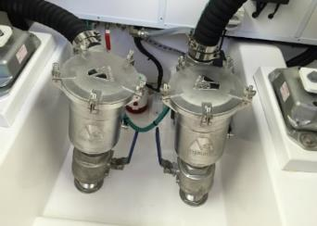

Source: Arctic Steel[46]With the recent acquisition by DVCC, former director of Arctic Steel, Peter Crossley, is now a business development manager for DVCC. This acquisition provides more resources and a greater global network, allowing Arctic Steel strainers to have exposure to new global markets such as France, Germany, Russia and the United States. It is anticipated that distribution of these products in the United States could easily exceed three times the current Australian market value.

Overcoming trade barriers

DVCC highlight the benefit that free trade agreements (FTA), such as the China-Australia FTA, bring for business. The five per cent reduction in duties means that the premium products can be more competitive in the market. However, export duties are still a major barrier for the European market, with duties of around 20 per cent pricing the products out of most markets.

There are also many non-tariff barriers to accessing global markets, including within parts of Asia. These challenges predominately relate to convincing buyers to invest more to access a higher quality product. Communicating the benefits of a better quality product across these markets can be challenging. DVCC note that the only way to access this market is to travel and meet potential buyers in person. This way, the benefits can be better understood by the purchaser, and they can make a better informed decision above simply considering the price. The successful export strategy for Arctic Steel strainers won the AIMEX small exporter of the year award in 2014 and 2015.

## Conclusion

This report has explored the role the Australian marine manufacturing industry in the Australia economy. As a sub-sector of the broader ship and boat manufacturing sector, the economic profile of the civil marine manufacturing industry reveals that there are a large number of businesses that operate across the construction of small and large vessels, and the servicing and repair of various vessel types. Further, Australia’s labour force has skilled workers that give this Australian industry an international advantage, and these skills are repeatedly recognised by industry as a factor in the high quality of vessels manufactured.

Industry consultation and survey responses indicate that there is a declining number of apprenticeships and trainees in the sector, particularly for boat building. Additionally, there is a constant need for skilled naval architects to work in the sector as highlighted by industry stakeholders. Access to these skills is important for Australia to maintain a competitive advantage into the future.

Research and development (R&D) is an important aspect of the industry. Feedback from industry stakeholders has highlighted that the amount investment into R&D has not been as great as previously recorded, and Australia’s level of investment in R&D is well below some major players, such as Korea and the United Kingdom. However, there is some well-targeted R&D that is done by Australian businesses that position Australia as leaders in particular markets, such as high-speed aluminium ferries, and a potential leader in emerging markets such as the unmanned surface vessel market.

Analysis of the ship and boat manufacturing industry supply chain has highlighted that the majority of service inputs into the sector are sourced domestically. In contrast, a large share of intermediate manufactured inputs are foreign sourced, particularly metal components and electronic equipment. The findings are supported by ABS data, industry feedback, and the KPMG survey of the industry.

Australia has good repair and servicing facilities, and Australian businesses have commented on the positive feedback received by owners and operators of foreign vessels that have maintenance or repair work done in Australia.

Free trade agreements were highlighted as a missed opportunity by industry stakeholders in terms of the ongoing need to access and leverage business development activities. However businesses can have challenges with the resources and knowledge to travel to foreign markets and establish a client base for their businesses. There are examples of businesses that have done this successfully, but industry opinion from consultations is that not all of Australia’s strengths and capabilities are being brought to bear in international markets.

The Australian marine manufacturing sector has many strengths to build on to maintain an internationally competitive industry. While a number of challenges are present to the industry, Australian shipbuilding and boatbuilding businesses have shown success in domestic and foreign markets and will continue to play an important role in the Australian economy.

## Appendix A: Industry Consultations

KPMG has consulted with the Australian Shipbuilding & Repair Group (ASRG), the Australian International Marine Export Group (AIMEX), and the Boating Industry Association (BIA) to get their perspective on key issues that face the Australian ship and boat manufacturing industry. This section summarises the key themes that have arisen from these consultations.

### Key strengths of the industry

Australia has a number of key strengths across the marine industry. Our initial consultations with industry representatives have identified Australian key strengths including aluminium built ferries, custom-designed catamarans, quality repair and maintenance services, research and development, and a strong and complimentary marina sector. Each are discussed further below.

A particular strength for the Australian marine manufacturing industry is in **Aluminium built ferries**, which are recognised globally for their high quality. Australian **steel made vessels** are also recognised for their quality, strength and resilience. High levels of research and development, and superior welding techniques contribute to the success of this Australian industry.

Another strength is in the production of **catamarans**, which are also of very high quality and are custom built for purpose. For example, Australian built vessels are often designed to specifically factor in their weight to have an appropriate distance between the waterline and the bottom of the hull. These catamarans can also be specifically designed to traverse rivers in Europe and China that silt up, where many other vessels, such as monohulls, have inadequate draft to travel. Australian‑built catamarans also have superior fuel usage efficiency due to their lighter-weight aluminium construction. Designing these vessels specifically for purpose is important for meeting International Maritime Organization (IMO) and domestic legislative requirements, and the comprehensive instruction provided with each catamaran helps promote safe and efficient operation by the end user.

On the **repair and maintenance** side of the industry, Australia has exceptional repair facilities and a global reputation for delivering quality services to budget and on time. This strength is a combination of good infrastructure and the experience/skills and positive attitudes of Australian workers in the industry.

**Research and Development** is also seen as a strength in the industry. Australian marine businesses have high levels of innovation, creating new products for the market or adapting businesses processes to meet impacts of globalisation (such as better integrating into global value chains).

Australia also has very high standards in the marinas side of the industry, both **in the construction of and in managing marinas** – helping to further promote Australia’s reputation in the industry. It is believed that this industry complements the ship and boat manufacturing industry. If Australian marinas can access a larger proportion of the international market (for example, superyachts and grey nomads), this is likely to also bring additional repair and maintenance activity to the industry.

### Key challenges for the industry

Some general and prominent challenges initially identified by industry representatives have included high labour rates, a high Australian dollar, significant distance to markets, and regulatory burden. These factors typically mean that Australian businesses struggle to compete on price with countries such as Malaysia, Vietnam and China, and instead must rely on their reputation for quality.

**A tight labour market –** a key challenge to the industry has been high labour rates and a tight labour market. The industry lost many workers to the mining sector during the mining boom. However, this trend is gradually reversing as the mining boom subsides. Anecdotally, businesses are now finding it is easier to “tool up or down” as required as a result of this labour market easing.

A potential loss of expertise was highlighted due to the aging of the ship and boat manufacturing workforce. This presents a challenge for maintaining a skilled workforce into the future.

**A high Australian dollar** has been a challenge for most exporting businesses, including those in the shipbuilding and boatbuilding industry. A high Australian dollar can also make imports more affordable, affecting those Australian businesses that supply the domestic market.

**Imported components**, such as aluminium and engines can be a significant share of the total contracted value. Variations in supply and price can significantly affect a business’ profitability.

Industry consultations also indicate that **competition from imports** is regarded as a significant challenge. In addition to the difficulty competing on price (affected by high Australian labour costs and a relatively strong Australian dollar), many Australian boat builders manufacture to voluntary Australian standards, which can increase the cost of the final product in the domestic market.

**Distance to market** is another major challenge for Australian manufacturers. The cost of transporting (shipping) a completed vessel, particularly beyond (and within) Asia is very high and is a barrier to competing against foreign competitors located closer to international markets.

Piracy is also seen as a considerable and real risk to the industry – for example, while it can be more efficient to directly “sail” a completed vessel to the client, the risk of piracy means that it is very difficult (if not impossible) to access insurance for the vessel. It is safer to ship the completed vessel, however this adds considerably to the cost.

There are also number of **regulatory and structural challenges** identified by industry groups. These include rules around foreign-owned charters, lack of industry cohesion, the role of government, the loss of the ‘Shipbuilding Bounty’, and challenges around both International Maritime Organization (IMO) and domestic regulations. Each of these are discussed below.

* Foreign flagged superyachts are unable to charter in Australia, which is seen as a significant deterrent to superyachts visiting Australia. [47] A superyacht typically may travel somewhere and stay for 1-2 years before heading to the next destination. Being unable to generate revenue during this time can be a disincentive to visit – many more superyachts are currently travelling to Fiji, Tahiti or New Zealand (where they can charter and earn revenue) than to Australia. This disincentive is likely to lead to lost revenue across both the marina sector and other parts of the economy, including tourism and marine repair services – it is estimated that a vessel valued at €50 million incurs approximately 10 per cent of its value in maintenance and repair services each year. Further, in contrast to the superyachts, Australia has trialled allowing foreign cruise ships to charter over the past few years, and this is expected to be extended.
* Concern has also been raised by representatives around cohesion across the industry. Specifically, it is believed that the industry should be presenting a united front, particularly when participating in traditional overseas markets. Without this industry cohesion, there is concern that industry messaging is becoming confused, negatively impacting interaction across both the market and with government.
* It has also been suggested that engagement by government agencies could be improved at both the State and Federal levels. One suggestion is that there could be a more consistent approach when dealing with inquiries. Inquiries that come to government could be guided to a central industry contact for distribution to appropriate companies, rather than government directly approaching a particular company. This may help ensure that approaches are more quickly or correctly directed to the appropriate end point.
* Government also provides assistance to the industry on a charge for services basis – through translation, promotional, and other services. It has been suggested that these services be reviewed in terms of both the cost and appropriateness. Concern was raised that, in addition to being costly (an example was given of translation services costing 1.5 per cent of the total contract fees), the government providers were not well-equipped technically to provide some services (e.g. promotional activities) which could cost the industry in terms of lost sales.
* Industry have identified that there are still a number of international competitors whose industries are protected, such as the United States which has the Jones Act. This is despite the OECD shipbuilding agreement which determined that countries should not subsidise their industry, and led to Australia removing the ‘Shipbuilding Bounty’.
* There has also been a move away from a state‑based to a National Regulatory System for commercial vessels. While this move is seen as an improvement – potentially delivering a more efficient and harmonised system – it is still in the process of being implemented (with the second stage scheduled for 1 July 2018). Thus, Industry groups have indicated that, until fully implemented, there is still some uncertainty surrounding the change.

### Industry trends in marine manufacturing sector

A number of initial observations were made by industry representatives in terms of the interaction between Defence commissioned work and the civil (commercial, light commercial and recreational) sectors of the market. These observations are outlined below.

It should be noted at the start that there are differing views on the interaction of the Defence and civil sides of the market. Some believe that these two parts of the market belong to very different industries, while others observe that the Defence and civil sides are inter-linked with work sourced through a wide range of areas.

There are many commercial marine companies that would like to supply to the Royal Australian Navy (RAN), or to the primes who win major RAN contracts. However, there are a number of challenges in this space.

Many smaller businesses are unable to commit resources to pursuing these contracts. Further, while it is believed that many of these businesses can be innovative, and have value‑add that could be up-scaled, these businesses can find it difficult to access opportunities to showcase their work to the right people. As a result, many contracts stay with the incumbent, and there is a general attitude that it is too hard a market to break into.

There were opportunities seen in further developing the market interaction across the two parts. Specifically, the creation of more interaction around training could be of benefit, while more could be done in the regulatory space to allow Defence to further stimulate and help sustain the civil marine industry.

It is believed that companies should not solely depend on Defence work and, most importantly, must be flexible. For example, a business needs to be willing and able to reconfigure its operations if it receives an order for a different size/type of vessel to those it has previously produced (e.g. it may need to reconfigure its yard, apply appropriate security measures, and/or reconfigure vessel specs, such as tide range, draft, speed etc.).

### Industry trends in research and development

It is acknowledged that there is not a lot of industry-wide research and development (R&D). Much of the R&D undertaken in the ship and boat manufacturing industry is internally focused – improving processes, reducing costs and improving efficiency.

Most R&D is undertaken by larger companies that have the resources to allocate to new innovations. These companies are generally already undertaking this activity and thus the R&D Tax Incentives provides little additional incentive. There are many companies in the marine sector accessing the R&D tax incentive; however, industry stakeholders that were consulted stated that for smaller companies the R&D tax incentive was often too complex and required too much additional time to ensure compliance.

Despite this, R&D is seen as important to the industry. Extensive R&D has resulted in Australia being world leaders in the production of high-speed ferries, supplying 45 per cent of the world market.

However, it is believed that the momentum for R&D in Australian shipbuilding and boatbuilding has been negatively affected by the establishment of joint-venture facilities overseas. This has led to an international transfer away from Australia of both skills and commercial advantage.

A key theme in our initial industry consultations was the need for a better understanding of how the industry approaches, implements and benefits from R&D.

### Industry trends in export markets

The Australian marine manufacturing industry has an enviable record for exports, with the export of one Australian built superyacht tipped as switching Australia’s balance of trade from negative to positive in one quarter. International trade promotion over many years has resulted in many enquiries for voyage repairs through to new builds and some major refits.

The Export Market Development Grant (EMDG) scheme, which has been in operation since 1974, is seen as a potential key strategy to help open up export markets for the marine industry. In 2015, the Export Council of Australia stated that the scheme had proven itself to be one of the most effective industry stimulus initiatives introduced by the Federal Government. The scheme is run under a split payment system which ensures that spending under the EMDG scheme is kept within budget, and that all eligible applicants receive a grant.

Industry participants consulted stated that uncertainty over the exact amount to be paid in the second tranche refund of expenses may discourage them from attending certain trade shows. Many stakeholders tend to base export marketing decisions on a more short-term view. Industry stakeholders indicated that the uncertainty over the exact amount of the second tranche refund was a factor in deciding not to attend international trade shows in emerging trade markets such as China and Dubai, as these are generally longer term investments. Attendance at trade shows in more established markets, such as the United States and the European Union, are recognised as providing more immediate (but potentially less overall long-term) returns.

Free trade agreements are also seen as opportunities for ongoing utilisation for the Marine manufacturing industry. Here, favourable tariff cuts have been negotiated by the Australian Government but are not being utilised by businesses. There is complexity to this issue. One is whether the Australian ship and boat manufacturing businesses themselves can understand the tariff changes and how they might benefit their export success. The second is that it can be difficult for an Australian business to invest the resources to communicate this benefit to a foreign company, which can then hinder potential business. A third layer is that a business needs to identify that the gains are significant enough to invest time in accessing a new market. If a tariff cut is a few percentage points, and the exact consumer is not yet identified, then smaller businesses in particular may not see the advantage in pursuing new markets.

The Department of Foreign Affairs and Trade (DFAT) has an information and tariff portal outlining each free trade agreement and relevant tariff information. Austrade in conjunction with DFAT is running an Australia-wide outreach programme engaging with businesses on the opportunities of the North Asia. According the industry stakeholders consulted, the uptake and utilisation of this information by businesses is yet to be determined, and remains and important issue not just for the ship and boat manufacturing industry, but for many exporting industries.

## Appendix B: Survey Results

The industry survey was administered by KPMG, with the assistance of Australian Shipbuilding & Repair Group (ASRG), Australian Marine Export Industry Association (AIMEX) and the Boating Industry Association of Australia (BIAA) to distribute the survey to respondents. The survey was in the field between 16 September and 11 November 2016.

Due to the type of businesses reported, and the quality of information received, the survey responses form three distinct groups.

* There were 92 responses that supplied business opinion on the strengths and weaknesses of the ship and boat manufacturing industry.
* There were 70 responses that provided indication of their business output and had at least some of their output provided towards ship and boat manufacturing. These businesses include the broader supply chain beyond ship and boat manufacturing businesses.
* There were 31 responses which provided financial data and at least 40 per cent of their output was part of the marine manufacturing industry.

As these response levels do not constitute a majority of the industry, care needs to be taken when interpreting the results. With this in mind, financial survey results have been benchmarked against other reported data sources to verify the spending shares.

### Strengths and challenges for the industry

Survey respondents were asked to rank the strengths and challenges identified by the broader industry representatives’ consultation (described in the previous section). Their rankings are as follows.

Figure 34: Ranked strengths for the Australian marine manufacturing industry

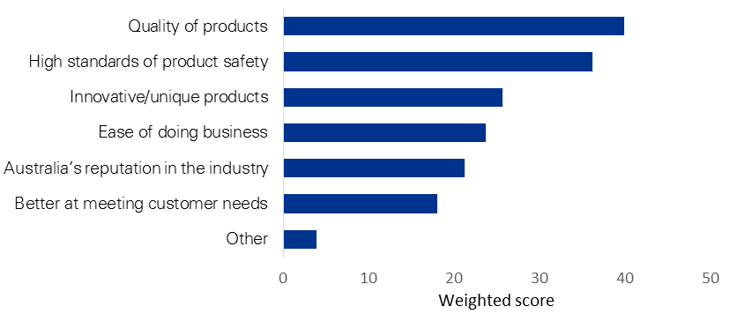

N=92

Source: KPMG survey  
Note: Respondents were asked to rank the top three strengths, these responses were weighted by their strength to calculate the weighted score. No specific strengths were reported for ‘Other’.

Figure 35: Ranked challenges for the Australian marine manufacturing industry

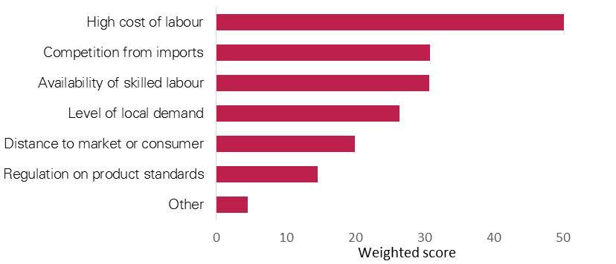

N=92  
Source: KPMG survey  
Note: Respondents were asked to rank the top three challenges,   
these responses were weighted by their relative strength to calculate the weighted score.   
Reported challenges under ‘Other’ included shipyard inefficiencies and freight costs.

### Broader supply chain responses

Figure 36 shows the count of responses that reported some supply of goods or services to the marine manufacturing industry, according to their main product or service. Out of 70 responses in this category, around 20 per cent reported producing non-marine related goods or services as their primary output.[48] Shipbuilding and boatbuilding reflects a relatively small share of the business count, as these companies are fewer in number but typically present a larger share in revenue terms compared to smaller businesses engaged in services or component manufacturing.

Figure 36: Business count of responses according to main product output

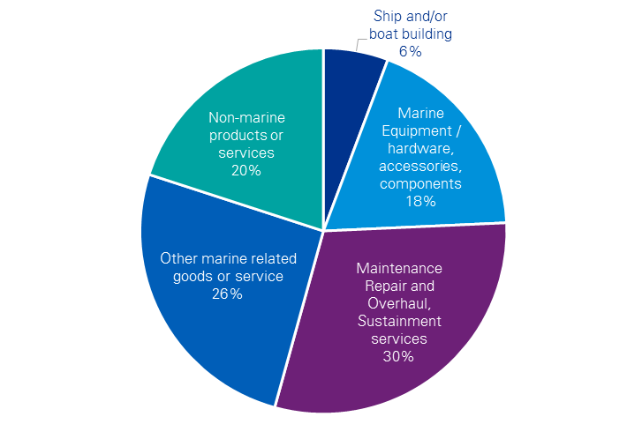

N=70  
Source: KPMG survey  
Note: Nine responses indicated even product shares across non-marine products and another marine‑related product, in these instances the business was counted under its main marine product or service.

### Employment

Figure 37 presents the employment profile of survey respondents included in the analysis of financial data. The majority of responses are small businesses, with between one and 19 employees. Eight businesses had 50 or more employees, of these, three businesses employed over 200 employees.

Figure 37: Survey respondents by employment size

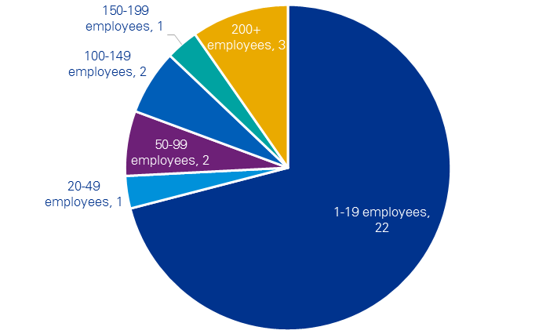

N=31  
Source: KPMG survey  
Note: No respondents were self-employed (i.e. zero employees).

### Industry linkages

Figure 38 and Figure 39 present reported revenue of survey respondents according to their products and services produced, and the market segment to which they supply. These shares have been weighted across businesses according to the value of report revenue. Of the survey sample collected, the majority (51 per cent) of business is from maintenance, repair and sustainment work of ships and boats. Of the customer base, 68 per cent of the sample’s revenue is generated from government and defence work. A further 24 per cent is generated from domestic commercial and private revenue, and eight percent of reported revenue is from exported goods and services.

Figure 38: Industry revenue by activity (2015–16)

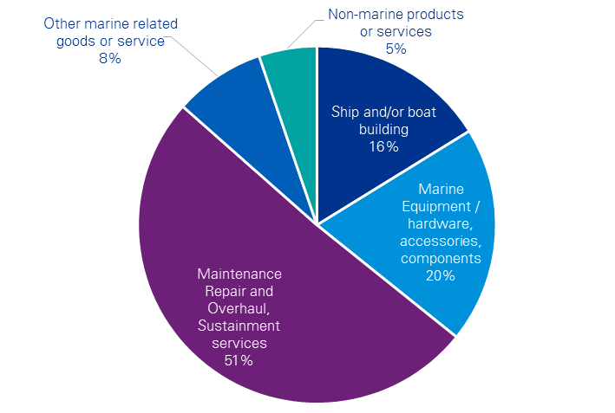

N=27  
Source: KPMG survey  
Note: Calculated by weighing reported revenue against percentage of business production for each area. Four businesses reported all other financial data but omitted revenue.

Figure 39: Industry revenue by purchaser (2015–16)

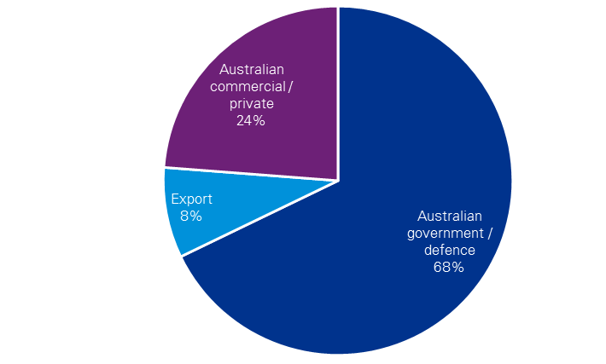

N=27  
Source: KPMG survey  
Note: Calculated by weighing reported revenue against percentage of revenue by purchaser. Four businesses reported all other financial data but omitted revenue.

The composition of industry expenses, and their imported shares, are shown in Figure 40 and   
Figure 41 respectively. The largest expense item for businesses is wages paid to workers. There is a large component of expenses reported as ‘other’, which is likely to be captured subcontracted services that is typical of the shipbuilding and boatbuilding supply chain. The two largest import components to the sector are ship and boat parts and metal products, with a small component of other non-metal products reported as imported. The survey results reflect similar proportions of inputs and the ABS IO data, particularly the shares of labour expense, overheads and metal products.

Figure 40: Industry expenses (2015–16)

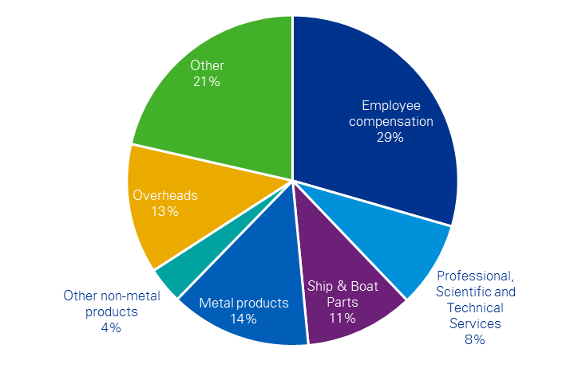

N=31  
Source: KPMG survey  
Note: Calculated by weighing reported expenses against percentage of expense category. ‘Other’ expenses were reported as marketing, freight and other subcontractor services.

Figure 41: Imported Industry expenses (2015–16)

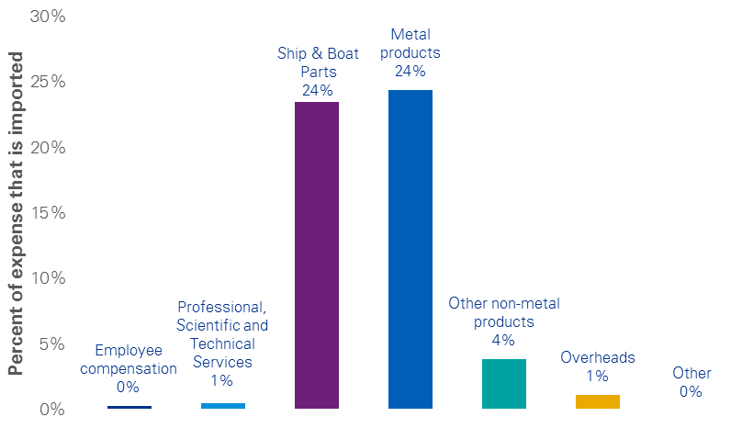

N=31  
Source: KPMG survey

### Capital investment

Survey respondents were asked to report their capital expenditure by category over the past five years (see Figure 42). The largest capital expenditure item is land and buildings, which accounted for 39 per cent of the total reported over the past five years. The other major components are dry-docking and/or shipbuilding facilities (23 per cent) and heavy or specialised machinery (25 per cent). Companies were also asked how much of their capital was imported, but the reported imports were negligible, with the exception of computer aided design systems which reported 19 per cent of value imported.

Figure 42: Capital Investment (five year average)



N=29  
Source: KPMG Survey  
Note: Average over 5 years between 2011/12 and 2015/16. Limited information on ‘Other’ capital investment was provided by respondents, but some examples include specialist heating, ventilation and air conditioning systems and moulds for production. ‘Other intellectual property’ includes patents and non‑CAD IT systems. Total reported investment was $165 billion over the five year period.   
Two respondents omitted capital investment information.

## Appendix C: Statistical Classification

|  |  |  |  |
| --- | --- | --- | --- |
| **Industry (IOIG)** | **Industry (ANZSIC code)** | **Export Product (AHECC)** | |
| Ship and boat manufacturing | Shipbuilding and repair services (2391) | 89012000 | Cruise ships, excursion boats and similar vessels principally designed for the transport of persons; ferry-boats of all kinds |
| 89013000 | Tankers (ships) for the transport of goods |
| 89019001 | Refrigerated vessels (excl. tankers) for the transport of goods |
| 89020000 | Cargo ships, barges and similar vessels for the transport of goods, and vessels for the transport of both people and goods (excl. cruise ships and excursion and similar boats mainly for the transport of people; ferries; tankers; refrigerated vessels) |
| 89031000 | Fishing vessels; factory ships and other vessels for processing or preserving fishery products |
| 89039100 | Inflatable craft for pleasure or sports |
| 89039210 | Sailboats for pleasure or sports |
| 89039220 | Motorboats (excl. outboard motorboats) for pleasure or sports, exported as cargo (loaded on vessel or towed) |
| 89039930 | Motorboats (excl. outboard motorboats) for pleasure or sports, non-cargo (under own power) |
| 89039940 | Yachts and other vessels for pleasure or sport with cargo loaded (excl. inflatables, sailboats, and motor boats) |
| 89040000 | Non-cargo carrying yachts and other vessels for pleasure or sport under own power (excl. inflatables, sailboats, and motor boats) |
| 89051000 | Tugs and pusher craft |
| 89052000 | Dredgers |
| 89059000 | Floating or submersible drilling or production platforms |
| 89061000 | Light-vessels, firefloats, floating cranes and other vessels (excl. dredgers), the navigability of which is subsidiary to their main function; floating docks |
| 89069000 | Warships |
| 89071000 | Vessels (incl. lifeboats but excl. warships and rowing boats) |
| 89079000 | Inflatable rafts |
| 89080000 | Floating structures (e.g. tanks, coffer-dams, landing stages, buoys and beacons but excl. inflatable rafts) |
| 90089000 | Vessels and other floating structures for breaking up |
| Boatbuilding and repair services (2392) | 89031000 | Inflatable craft for pleasure or sports |
| 89039100 | Sailboats for pleasure or sports |
| 89039210 | Motorboats (excl. outboard motorboats) for pleasure or sports, exported as cargo (loaded on vessel or towed) |
| 89039220 | Motorboats (excl. outboard motorboats) for pleasure or sports, non-cargo (under own power) |
| 89039930 | Yachts and other vessels for pleasure or sport with cargo loaded (excl. inflatables, sailboats, and motor boats) |
| 89039940 | Non-cargo carrying yachts and other vessels for pleasure or sport under own power (excl. inflatables, sailboats, and motor boats) |
| 89069000 | Vessels (incl. lifeboats but excl. warships and rowing boats) |
| 89071000 | Inflatable rafts |

Source: ABS catalogues 5209.0.55.001, 1292.0 and 5368.0.55.017

Note: This table maps the broad input out industry group (IOIG) to the Australian New Zealand Standard Industry Classification (ANZSIC) and the Australian Harmonized Export Commodity Classification (AHECC)

## Appendix D: Survey Questions

Below are the questions that were used to collected data for the marine manufacturing industry. These questions were designed by KPMG consultation with the Department and peak industry bodies. The platform used to collect responses was QuestionPro, which was maintained by the KPMG survey team.

Thank you for taking the time to participate in the survey to help increase our understanding of the marine manufacturing and repairs industry.

This survey will take about 30 minutes to complete. If you are not able to complete the survey in one go, please click on the “Save Page & Continue Later” button to come back at another time. Please submit your response by **Friday 4th November 2016.**

All responses are confidential and will be reported in aggregated form to ensure individual responses cannot be identified. *A copy of our Privacy Policy is available* [*here*](https://home.kpmg.com/au/en/home/misc/privacy.html)*, and a statement on our commitment to ethics and integrity is available* [*here*](https://home.kpmg.com/us/en/home/about/corporate-responsibility/integrity.html)*.*

*By clicking on the “Next” button you acknowledge that you have read and understood all of the information detailed in this notification, and agree to undertake the survey.*

**Nature of Your Business**

Q1. Please specify the percentage of your businesses production for each of the following areas.

For example, if you only construct boats for any use – please enter 100% for Ship and/or boat building. If you produce several products, please approximate share of total production value (e.g. 75% Ship and/or boat building, 15% maintenance repair and overhaul, 10% non-marine products for services)

|  |  |
| --- | --- |
|  |  |
| Ship and/or boat building | % |
| Marine Equipment/ hardware, accessories, components | % |
| Maintenance Repair and Overhaul, Sustainment services | % |
| Other marine-related goods or service (please specify below) | % |
| Non-marine products or services | % |
| **(Values must add up to 100%)** | 100% (auto-sum) |

1a. If you purchased “Other marine-related goods or services”, please specify what those goods and/or services are here:

|  |
| --- |
|  |

**Strengths and Challenges facing the Marine Industry**

Q2. Please identify the top 3 strengths of the Australian ship/boat building and repair industry, with *1 being the greatest strength*.

|  |  |  |  |
| --- | --- | --- | --- |
|  | **Strength 1** | **Strength 2** | **Strength 3** |
| Quality of products |  |  |  |
| Ease of doing business |  |  |  |
| Innovative/unique products |  |  |  |
| High standards of product safety |  |  |  |
| Better at meeting customer needs |  |  |  |
| Australia’s reputation in the industry |  |  |  |
| Other (please specify below) |  |  |  |

2a. If you selected “Other” strengths, could you please specify them here:

|  |
| --- |
|  |

Q3. Please identify the top three challenges facing the Australian ship/boat building and repair industry in order of biggest to least challenging.

|  |  |  |  |
| --- | --- | --- | --- |
|  | **Challenge 1** | **Challenge 2** | **Challenge 3** |
| High cost of labour |  |  |  |
| Availability of skilled labour |  |  |  |
| Competition from imported products |  |  |  |
| Distance to market or consumer |  |  |  |
| Level of local demand |  |  |  |
| Regulation on product standards |  |  |  |
| Other (please specify below) |  |  |  |

3a. If you selected “Other” challenges, could you please specify them here:

|  |
| --- |
|  |

**Employment**

**Q4. The Marine industry contributes to economic activity through its employment of staff.**

**How many full time equivalent workers, including contractors, did you employ in the 2015-16 financial year?**

* Non-employing (sole proprietorship or partnership without employees)
* 1-19 employees
* 20-49 employees
* 50-99 employees
* 100-149 employees
* 150-199 employees
* 200+ employees (please specify to the nearest 10)

**Financial Information**

*For each of the below questions, please provide* ***reported dollar values*** *for the* ***total*** *(for example, reported to Australian Tax Office, Australian Stock Exchange, or shareholders). For detailed items, please provide the* ***approximate percentage of expenses*** *according to your financial statements, invoices or best available information.*

*KPMG would like to remind participants that all responses will remain confidential, and only de-identified, aggregated data will be used for the study. A copy of our Privacy Policy is available* [*here*](https://home.kpmg.com/au/en/home/misc/privacy.html)*, and a statement on our commitment to ethics and integrity is available* [*here*](https://home.kpmg.com/us/en/home/about/corporate-responsibility/integrity.html)*.*

**Q5. To develop a better understanding of Marine industry business inputs, can you please complete the following table to provide us with an understanding of your business expenditure for financial year 2015/16 and the share of items that are imported?**

|  |  |
| --- | --- |
| **Expenditure by type, in financial year 2015/16** | **Total expenditure** |
|  |  |
| Total expenses for year (please answer in whole dollars, e.g. $500,000) | $ |
| **Please list the share (percentage of total expenses) for each of the following expense categories.**  *The total value of the column should add to 100%* | |
| Employee compensation (wages, salaries, superannuation), incl. contracted labour | % |
| Purchased goods and services by broad type |  |
| Professional, Scientific and Technical Services | % |
| Ships and Boat parts | % |
| Metal products (e.g., iron and steel, aluminium and other metals) | % |
| Other non-metal products | % |
| Overheads (e.g., transport, electricity, gas and water, fuels) | % |
| Other (please specify below) | % |
| **Total** | **100%** |

**5a. If you selected “Other” expenses, could you please specify them here:**

|  |
| --- |
|  |

**5b. For any expenditures that are imported, please provide an estimate of the share that is imported from overseas. If all of the product or service is purchased from Australian business, leave as 0%.**

|  |  |
| --- | --- |
| **Expenditure by type, in financial year 2015/16** | **imported supplies**  **(% of total)** |
| **Share of total expenses purchased domestically vs imports** |  |
| Employee compensation (wages/salaries/superannuation), incl. contract labour | % |
| Purchased goods and services by broad type |  |
| Professional, Scientific and Technical Services | % |
| Ships and Boat parts | % |
| Metal products (e.g., iron and steel, aluminium and other metals) | % |
| Other non-metal products | % |
| Overheads (e.g., transport, electricity, gas and water, fuels) | % |
| Other (please specify below) | % |

**Q6. Can you please complete the following table indicating how much your business spent on capital investment (buildings, facilities, equipment) over the past 5 years (2011/12 to 2015/16).***Please indicate the total dollar value, and the approximate percentages across types of capital.*

|  |  |
| --- | --- |
| **Capital expenditure (total in the 5 years: 2011/12 to 2015/16)** | **Total** |
|  |  |
| Total capital expenditure (Please answer in whole dollars, e.g. $500,000) | $ |
| **Please list the share (percentage of total capital expenditure) for each of the following types of capital.**  *The total value of the column should add to 100%* | |
| Type of infrastructure |  |
| Marina | % |
| Land & Buildings | % |
| Dry-docking and/or shipbuilding facilities | % |
| Type of equipment |  |
| Heavy or specialised machinery | % |
| Office equipment | % |
| Motor vehicles | % |
| Intangible assets |  |
| Computer aided design systems | % |
| Other intellectual property (e.g. Patents, other IT systems) | % |
| Other (please specify below) | % |
| **Total** | **100%** |

**6a. If you selected “Other” types of capital, could you please specify them here:**

|  |
| --- |
|  |

**6b. Please complete the following table to provide us with an estimate of the share of each item that was purchased from overseas/imported?***If all capital was purchased from Australian businesses, leave as 0%. If, e.g. 20% of specialised machinery was purchased from overseas, enter 20% in row next to Heavy or specialised machinery.*

|  |  |
| --- | --- |
| **Capital expenditure (total in 2011/12 to 2015/16)** | **Imported (% of total)** |
| **Share of total capital expenditure** |  |
| Type of infrastructure |  |
| Marina | % |
| Land & Buildings | % |
| Dry-docking and/or shipbuilding facilities | % |
| Type of equipment |  |
| Heavy or specialised machinery | % |
| Office equipment | % |
| Motor vehicles | % |
| Intangible assets |  |
| Computer aided design systems | % |
| Other intellectual property (e.g. Patents, other IT systems) | % |
| Other | % |
| **Total** | **100%** |

**Q7. Please complete the table below, indicating how much revenue your business raised in 2015/16 from domestic sales, exports, and between civil and defence customers.**

|  |  |
| --- | --- |
| **Revenue item** | **revenue** |
| Total reported revenue (Please answer in whole dollars, e.g. 500,000) | $ |
|  |  |
| Non-marine revenue | % |
| Marine revenue |  |
| Domestic revenue |  |
| - Defence/government revenue | % |
| - Civil/private sector share | % |
| Export sales | % |
| Other income (please specify below) | % |
| **Total** | **100**% |

**7a. If you selected “Other” income, could you please specify it here:**

|  |
| --- |
|  |

**Other Information**

**8. Finally, if there is any additional information about the Marine Industry that you think would be useful to this research project, please provide your comments here:**

|  |
| --- |
|  |

Thank you for participating in this research. Your responses will assist in understanding the marine manufacturing industry’s contribution to the Australian economy.

*We would like to remind participants that all responses will remain confidential, and only de-identified, aggregated data will be used for the study.*

1. IBIS World Industry Report (2016)
2. ABS catalogue number 8155.0
3. Economic modelling has been supplied in a separate document for internal policy consideration.
4. <http://www.abs.gov.au/AUSSTATS/abs@.nsf/DetailsPage/1292.02006%20(Revision%202.0)?OpenDocument>
5. ABS catalogue number 81650
6. <https://www.engineering.unsw.edu.au/suspension-of-naval-architecture-undergraduate-specialisation>
7. <https://www.parliament.nsw.gov.au/committees/DBAssets/InquirySubmission/Body/46022/0248%20Boating%20Industry%20Association%20(BIA).pdf>
8. Galindo-Rueda, F. and F. Verger (2016), "OECD Taxonomy of Economic Activities Based on R&D Intensity", OECD Science, Technology and Industry Working Papers, No. 2016/04, OECD Publishing, Paris. <http://dx.doi.org/10.1787/5jlv73sqqp8r-en>
9. ABS 5439.0, International merchandise imports (2015-16)
10. ABS 5438.0, International merchandise exports (2011-12 to 2015-16)
11. <http://dfat.gov.au/trade/agreements/chafta/official-documents/Pages/official-documents.aspx>
12. <http://dfat.gov.au/trade/agreements/kafta/official-documents/Pages/default.aspx>
13. Services for the Centre for Defence Industry Capability are available at: <https://www.business.gov.au/centre-for-defence-industry-capability>
14. <http://www.abc.net.au/news/2015-09-23/incat-wins-contract-to-build-six-new-sydney-ferries/6797850>
15. <http://www.motorship.com/news101/ships-and-shipyards/lng-fuelled-catamaran-pushes-frontiers-in-ferry-powering>
16. <http://www.opec.org/opec_web/static_files_project/media/downloads/publications/WOO%202015.pdf>
17. <http://ocius.com.au/2016/02/nemo-in-aus-government-defence-industry-policy-statement/>
18. <http://ocius.com.au/wp-content/uploads/2015/09/150914OCIUSCTDPressRelease.pdf>
19. <https://www.liquid-robotics.com/platform/overview/>
20. <http://boeing.mediaroom.com/2016-12-06-Boeing-to-Acquire-Liquid-Robotics-to-Enhance-Autonomous-Seabed-to-Space-Information-Services>
21. <http://www.prnewswire.com/news-releases/unmanned-surface-vehicle-usv-market-worth-86137-million-usd-by-2021-577584251.html>
22. <http://www.marinebusiness.com.au/news/round-the-clock-refuelling-at-rivergate>
23. http://www.aimex.asn.au/news/queensland-water-police-high-speed-catamaran-unveiled-at-rivergate/
24. <http://rivergate.com.au/galleries/>
25. <http://www.rand.org/content/dam/rand/pubs/research_reports/RR1000/RR1093/RAND_RR1093.pdf>
26. ABS catalogue number 8155.0 - Australian Industry, 2014-15
27. <http://www.transport.nsw.gov.au/sites/default/files/b2b/ferry/sydney-ferries-annual-report-201011.pdf>
28. <http://www.cairnspost.com.au/news/cairns/cairns-wins-100m-navy-ship-repair-contract/news-story/3c8a5ff5608c4812f6ff578d4ea41893>
29. <http://www.aph.gov.au/Parliamentary_Business/Committees/Senate/Economics/Navalshipbuilding45th/Submissions>
30. <http://www.defence.gov.au/navalshipbuildingplan/>
31. <http://usa.austal.com/featured-ship/littoral-combat-ship-0>
32. <http://www.austal.com/sites/default/files/related-documents/trimaran-technology-lowres.pdf>
33. <http://evolutioncommercial.com.au/2015/12/03/aldabra-is-all-complete/>
34. <http://evolutioncommercial.com.au/2016/02/24/launch-day/>
35. <http://www.boatinternational.com/yacht-market-intelligence/superyacht-industry-data/superyacht-market-reports/things-you-need-to-know-about-the-superyacht-market-in-september--31465/frame-4>
36. <http://rominabompani.com/wp-content/uploads/2016/04/The-State-of-Wealth-Luxury-and-Yachting.pdf>
37. <http://www.boatinternational.com/yacht-market-intelligence/superyacht-industry-data/superyachts-under-construction>
38. <http://echoyachts.com.au/news/page/2/>
39. <http://www.lomocean.com/projects/pleasure/46m+-+charley>
40. <http://evolutioncommercial.com.au/facilities/>
41. <http://www.steber.com.au/steber-wins-innovation-award/>
42. <http://www.hbrmag.com.au/article/read/excellence-in-innovation-steber-international-1143>
43. <http://www.steber.com.au/steber-leads-the-way-in-pilot-apprenticeship-scheme/>
44. <http://www.steber.com.au/marine-rescue-port-macquarie/>
45. Prior to September 2016, Arctic Steel was a standalone Australian company. It was acquired by Dixon Valve and Coupling Company, which maintains the brand.
46. <http://arcticsteel.com.au/installation-photos/>
47. Superyachts are defined as luxury vessels greater than 24m designed for 12 or fewer passengers.
48. As these businesses are likely more aligned with another sector – albeit a key supplier to this industry – these businesses have not been included when reporting the financial data for the civil marine manufacturing industry (sales, costs and capital) later in this section.