Establishment of the Entrepreneurs’ Infrastructure Programme –

**Discussion Paper**

[www.industry.gov.au](http://www.industry.gov.au)

08

**Fall**

# 1. Introduction

## 1.1 Purpose

In line with the Government’s vision to enable growth and productivity for globally competitive industries, the 2014-15 Budget set a new direction for industry policy with the establishment of the $484.2 million Entrepreneurs’ Infrastructure Programme which will be delivered through the new Single Business Service initiative.

This Programme will support the Government’s National Industry Investment and Competitiveness Agenda which will be finalised in the coming months. It will also complement other Government programmes that provide support to business including the R&D Tax Incentive, Industry Skills Fund, Industry Growth Funds and the Manufacturing Transition Fund.

This consultation paper provides details of the Programme’s proposed services and seeks feedback from stakeholders. It focuses on the overarching service offering, and provides stakeholders with the opportunity to provide input during the consultation period from 5 and continuing throughout June 2014.

To ensure businesses are able to access the support they need to grow, initial services in the business management streams will begin on 1 July 2014. These will be announced in the coming weeks. These services will be refined following the stakeholder consultation and confirmed as part of the final Programme design.

## 1.2 Programme overview

The Entrepreneurs’ Infrastructure Programme, and the Single Business Service, is a new approach to the way Government services are provided to business. It is recognition that Australia’s business landscape is diverse and has different needs.

Some businesses want to get relevant information quickly so that they can get on with the job. Others seek information and help but do not really know what assistance is available and whether it suits their needs. For others, more intensive support can help overcome challenges and assist them to grow and transform.

Therefore, for those seeking it, the Programme will offer easy access and practical support delivered in a simplified, streamlined and above all, complementary way. Some services will be universal and can be accessed by all businesses, while others will provide more direct and ‘hands on’ assistance to businesses that are looking to achieve specific outcomes. See Figure 1 for a graphical representation of the Programme services.

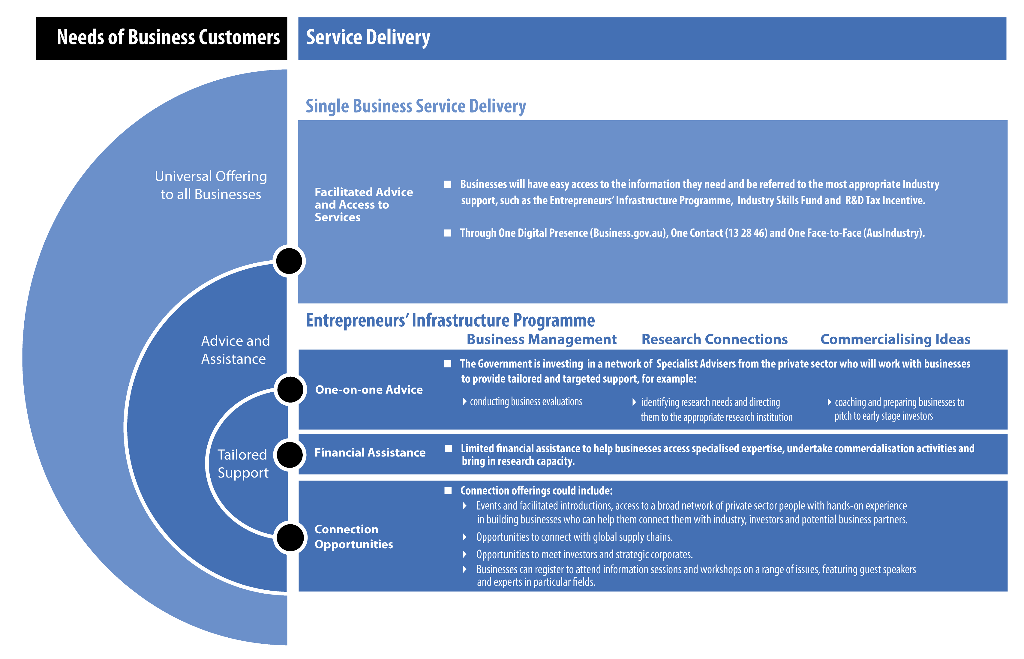

**Figure 1** - Programme Overview Diagram

## 1.3 Single Business Service Initiative

The Entrepreneurs’ Infrastructure Programme will be delivered through a new Single Business Service initiative that will streamline the way businesses access government information and services, putting their needs first and reducing complexity.

The initiative will include a streamlined and consolidated ‘one-stop shop’ web presence, call centre and face-to-face business facilitation network to advise businesses on the most appropriate solutions for their needs. It is a universal offering available to any business in Australia. It will make information simple and easy to find and be available anytime and on any device.

The service will also seamlessly link business with:

* easy to access information on business-relevant topics including: business start-up, banking, finance, accounting and marketing, advertising, small business counselling and information technology,
* other services of the Entrepreneurs’ Infrastructure Programme, through triaging, and a consultation booking service,
* other government services delivered by the Department of Industry (including the Industry Skills Fund);
* other government services including business licensing information and referrals, and
* services provided by third parties to small businesses and state and territory government small business programmes and services.

The Single Business Service will also provide a referral service for businesses who come through to the Programme but who are seeking assistance with regulatory issues such as tax information.

# 2. Proposed Services

The Programme focuses on providing support for businesses. This will occur through three integrated streams, each containing a range of services. Every business needs different support; as such they will be triaged to ensure they get the right support at the right time.

The three proposed streams of the Programme are outlined below:

* Business Management;
* Research Connections; and
* Commercialising Ideas.

Eligibility criteria will apply for one-on-one services (see section 2.4 for further details). The Entrepreneurs’ Infrastructure Programme is also intended to feature a range of “lighter touch” services, designed to support a broader range of businesses to access advice and support. Most of these “lighter touch” services will not have eligibility criteria.

## 2.1 Business Management

The Business Management stream helps CEOs and managers take time out to work on their business rather than in their business. Supported by Advisers drawn from the private sector, businesses will develop explicit plans for improvement and will be able to access limited funding to bring in additional specialists. By focusing on what the business needs, Advisers can also connect businesses to other government programmes.

Services could include:

* Business evaluation - conducted by Advisers with senior private sector management experience, this service provides targeted and tailored advice and connections, and key recommendations for business improvement.
* Matched funding of up to $20,000 to engage external expertise to implement projects recommended in the business evaluation.
* Business capability events - learning events featuring industry specialist guest speakers. Topics are industry driven, with issues identified through engagements across the Entrepreneurs’ Infrastructure Programme, and through private sector feedback.
* Benchmarking for supply chains - Advisers help businesses assess gaps between their capabilities and the requirements of supply chains. For example, assessing their capability against the tendering requirements for major projects, or benchmarking their capabilities against global standards. Initially, this is activity is targeted for the resources sector, but could be extended more widely.
* Regional and remote engagement - dedicated resources deployed to remote and regional areas based on need/opportunity. Facilitation experts will be backed by tested tools to build regional industrial capacity, support the needs and aspirations of Indigenous businesses, and better enable regional and remote businesses to identify and grasp opportunities.
* Business growth - enhanced support for growth oriented businesses, providing additional support for committed and capable businesses to engage with advanced services. This may include accessing the Research Connections or Commercialising Ideas elements.

## 2.2 Research Connections

Australia’s research institutions deliver world class research, conducted by outstanding professionals. Their knowledge and ideas can add substantially to the productivity of businesses. But many businesses may not fully understand the value of research, or how to engage a researcher, where they start, who they talk to, or how to negotiate agreements. It’s generally not as simple as picking up the phone.

Services could include:

* Access to Advisers who can assess a business’ research needs and then direct them to an appropriate research institution; and
* Matched funding of up to $50,000 to support the cost of bringing research capability into the business for projects to be conducted over three to twelve months.

## 2.3 Commercialising Ideas

Whilst Australia makes a significant public investment in science and research, it is well documented that Australian businesses underperform in comparison to their overseas counterparts when it comes to bringing discoveries successfully to market, quickly, and at competitive scale. To address this, the Entrepreneurs’ Infrastructure Programme will include a range of tailored commercialisation services, designed to provide entrepreneurs and innovative businesses access to advice, connections and support, to enhance their prospects of commercial success.

The services in this stream will address key challenges in the commercialisation pathway for businesses by: making new ideas visible to those that have the aspiration and means to identify and help commercialise them, providing critical-mass networking infrastructure and appropriately skilled, experienced and independent Advisers and, funding support for early stage commercialisation activities with commercial potential.

The Entrepreneurs’ Infrastructure Programme recognises the unique challenges associated with building or diversifying a business through commercialising a new product, process or service, are distinct from the challenges that face all businesses.

Services could include:

* Commercialisation evaluation - access to Advisers who can help businesses and entrepreneurs identify and develop the skills and knowledge they need to commercialise their idea, product or service. This may include coaching and preparing businesses to pitch to early stage investors, including venture capital investors.
* Facilitated and qualified introductions - connections to a broader network of private sector people who have hands-on experience in building businesses and who understand the hurdles faced by early stage businesses in trying to commercialise new ideas. These connections will be further complemented by formal and informal networking opportunities that will allow supported businesses to interact with each other, members of the broader network, and Entrepreneurs’ Infrastructure Programme Advisers.
* Linking to markets and investors - access to financial investors, strategic corporate and multinational representatives, both in Australia and overseas, through meetings, workshops, roadshows, or showcase events, to demonstrate the potential of the new product or service. This can play a critical role in building market access and supply chain capacity for innovative businesses who might otherwise lack the capacity to achieve this level of exposure.
* These activities could result in opportunities for direct investments, and partnerships through which Australian businesses can gain rapid penetration of much larger markets and build supply chain or production capacity.
* They will expose these businesses to multinationals and their market imperatives, multinational market opportunities and the needs of the international customer base.
* Multinationals will also learn about the diversity of opportunities offered by Australian businesses and will consequently be more likely to see and pursue Australian businesses as potential opportunities for strategic partnerships.
* Matched funding of up to $250,000 to assist businesses to progress the commercialisation of their new idea. The types of activities that could be funded include: the development of a business or commercialisation plan or an intellectual property protection strategy, or proof of concept work to establish the commercial viability of a new product or service, including prototyping. These activities could be undertaken over a period of up to two years.

## 2.4 Eligibility

It is important that access to the one-on-one support services (see Figure 1) are targeted at businesses that can make the most of the advice and assistance provided. Broadly, the Programme is designed to help established businesses grow and as such they can access any stream. However, it is envisaged that whilst start-up businesses will not be the focus of the business management or research connections streams of the Programme, they will be a focus of the commercialisation stream.

### Business Management

In order to ensure maximum return for businesses receiving facilitation based support, general eligibility requirements for businesses to enter the business management or research connections streams may apply:

* Operating for more than three years;
* Sufficient turnover levels; and
* Operating in an eligible sector which could include: manufacturing, resources, infrastructure related construction, information technology and communications, creative industries, food processing, medical and pharmaceutical, energy and resource management, professional services, freight transport and logistics.

Grant funding for the business management stream will be linked to the application stage, with businesses successfully completing the business evaluation able to access funding.

For businesses to be eligible for access to the growth services part of the business management stream, which provides for a multi-year engagement, they must additionally demonstrate:

* Willingness to engage with change;
* Growth potential; and
* Capacity to benefit from additional services, including commercialisation advice.

### Research Connections

Grant funding for the research connections stream will be allocated up to the limit of funds available in a given year and applicants must be able to demonstrate:

* A need for Government funding;
* That research will support a project of commercial relevance to the business; and
* An ability to at least match the Government funding.

### Commercialising Ideas

General eligibility for the commercialising ideas stream will not be limited to specific sectors, however all projects must involve development of a new product, process or service with a compelling value proposition and a significant market opportunity. This means that it is possible for both established businesses and start-ups to access these services.

Grant funding through this stream will be allocated on a competitive basis and applicants will need to additionally demonstrate:

* A need for Government funding;
* A significant market opportunity for the outcomes of the project;
* A compelling value proposition for a new product, process or service;
* A sound execution plan;
* Appropriate management capability;
* Significant national benefits resulting from the project; and
* An ability to at least match the Government funding.

Governance arrangements for the competitive funding element will be streamlined and conducted by the Department of Industry, relying on the advice of experts in the decision-making process.

The Entrepreneurs’ Infrastructure Programme is also intended to feature a range of “lighter touch” services, designed to support a broader range of businesses to access advice and support. Most of these services will not have eligibility criteria.

## 2.5 Phased implementation

A phased implementation approach is proposed for the Programme. This reflects a desire to balance the provision of services for business on 1 July 2014 with a need to consult appropriately before a final Programme design is settled. A broad timeline for the introduction of services is outlined below.

### **Business Management**

Services under this stream will commence operation from 1 July 2014 under guidelines pending completion of the Programme consultation process. Implementation will focus on those areas for which there is broad support from stakeholders. All services will be settled by 1 January 2015.

### **Research Connections**

Research connection services will commence operations 1 September 2014 under guidelines pending completion of the program consultation process.

### **Commercialising Ideas**

Commercialisation services will commence from 1 November 2014.

## 2.6 Programme complementarity and integration

The Entrepreneurs’ Infrastructure Programme will seek to deliver support for businesses as an integrated product suite. But it does this against a backdrop of other Commonwealth, State and Territory Government programmes.

It is also therefore critical to build strong connections and triage processes with other key programmes across Government including specific small business programmes and services and other programmes within the Industry Department such as the R&D Tax Incentive and the new Industry Skills Fund. Beyond the Department it is particularly important to build links to Austrade’s Adviser network and Export Market Development Grants scheme.

For the Business Management stream it is important to map how this can best operate in remote and regional Australia, and in turn, how best to complement the work of Regional Development Authorities across Australia.

Each of these connections will require time and attention to ensure they operate seamlessly and effectively. This will be explored as part of the Programme consultation process.

# 3. Having your say

## 3.1 Key questions for stakeholders

The Department of Industry is seeking stakeholder input on the proposed Entrepreneurs’ Infrastructure Programme services, in particular the following:

### **General questions**

1. What lessons can be learnt from existing business support programmes that should be incorporated into the Entrepreneurs’ Infrastructure Programme design and implementation arrangements?
2. How can we best work with stakeholders to facilitate access to the Entrepreneurs’ Infrastructure Programme for their networks?
3. How can this Programme best complement similar state and/or territory based activities?
4. How can the Programme best complement other Government activities to maximise opportunities to support businesses to export?
5. What other interconnection points do you believe will be important to deliver a strong Programme?
6. What measures could be used by Entrepreneurs’ Infrastructure Programme to evaluate the programme?
7. Is there value in prioritising support or funding to areas of global growth such as food and agribusiness; mining equipment, technology and services, medical technologies and pharmaceuticals; oil and gas; and advanced manufacturing?
8. Are there any other issues that should be considered in the development of Entrepreneurs’ Infrastructure Programme or Single Business Service delivery?

### **Business Management**

1. Are the proposed eligibility criteria appropriate? Do they achieve the aim of targeting support to those businesses most able to grow?
2. What are the knowledge or capability gaps that prevent individual businesses from accessing supply chains?
3. How can the business management services operate most effectively in remote and regional Australia?
4. What criteria should be used to determine which businesses qualify for more intensive, growth focused support?

### **Research Connections**

1. What are the information barriers to better links between business and research?
2. What should be the balance between facilitation and financial support?
3. How can the Programme best connect with the research sector to match businesses with the right researchers?

## 3.2 How to provide feedback

To ensure that the Entrepreneurs’ Infrastructure Programme is able to start delivering services from 1 July 2014, the industry consultation for the Business management and Research Connections streams will begin 5 June and continuing throughout June 2014. To assist the Department of Industry in compiling and analysing the views of individuals and groups, respondents are encouraged to provide their feedback online by accessing the Department of Industry’s Consultation Hub <https://consult.industry.gov.au/entrepreneurs-infrastructure-programme/entrepreneurs-infrastructure-programme>.

Targeted consultations with key stakeholders will be arranged by the Department of Industry and stakeholders will be advised when these are likely to occur. Comments, as well as any queries or concerns, should be submitted via email to: [Consultation@industry.gov.au](mailto:Consultation@industry.gov.au).