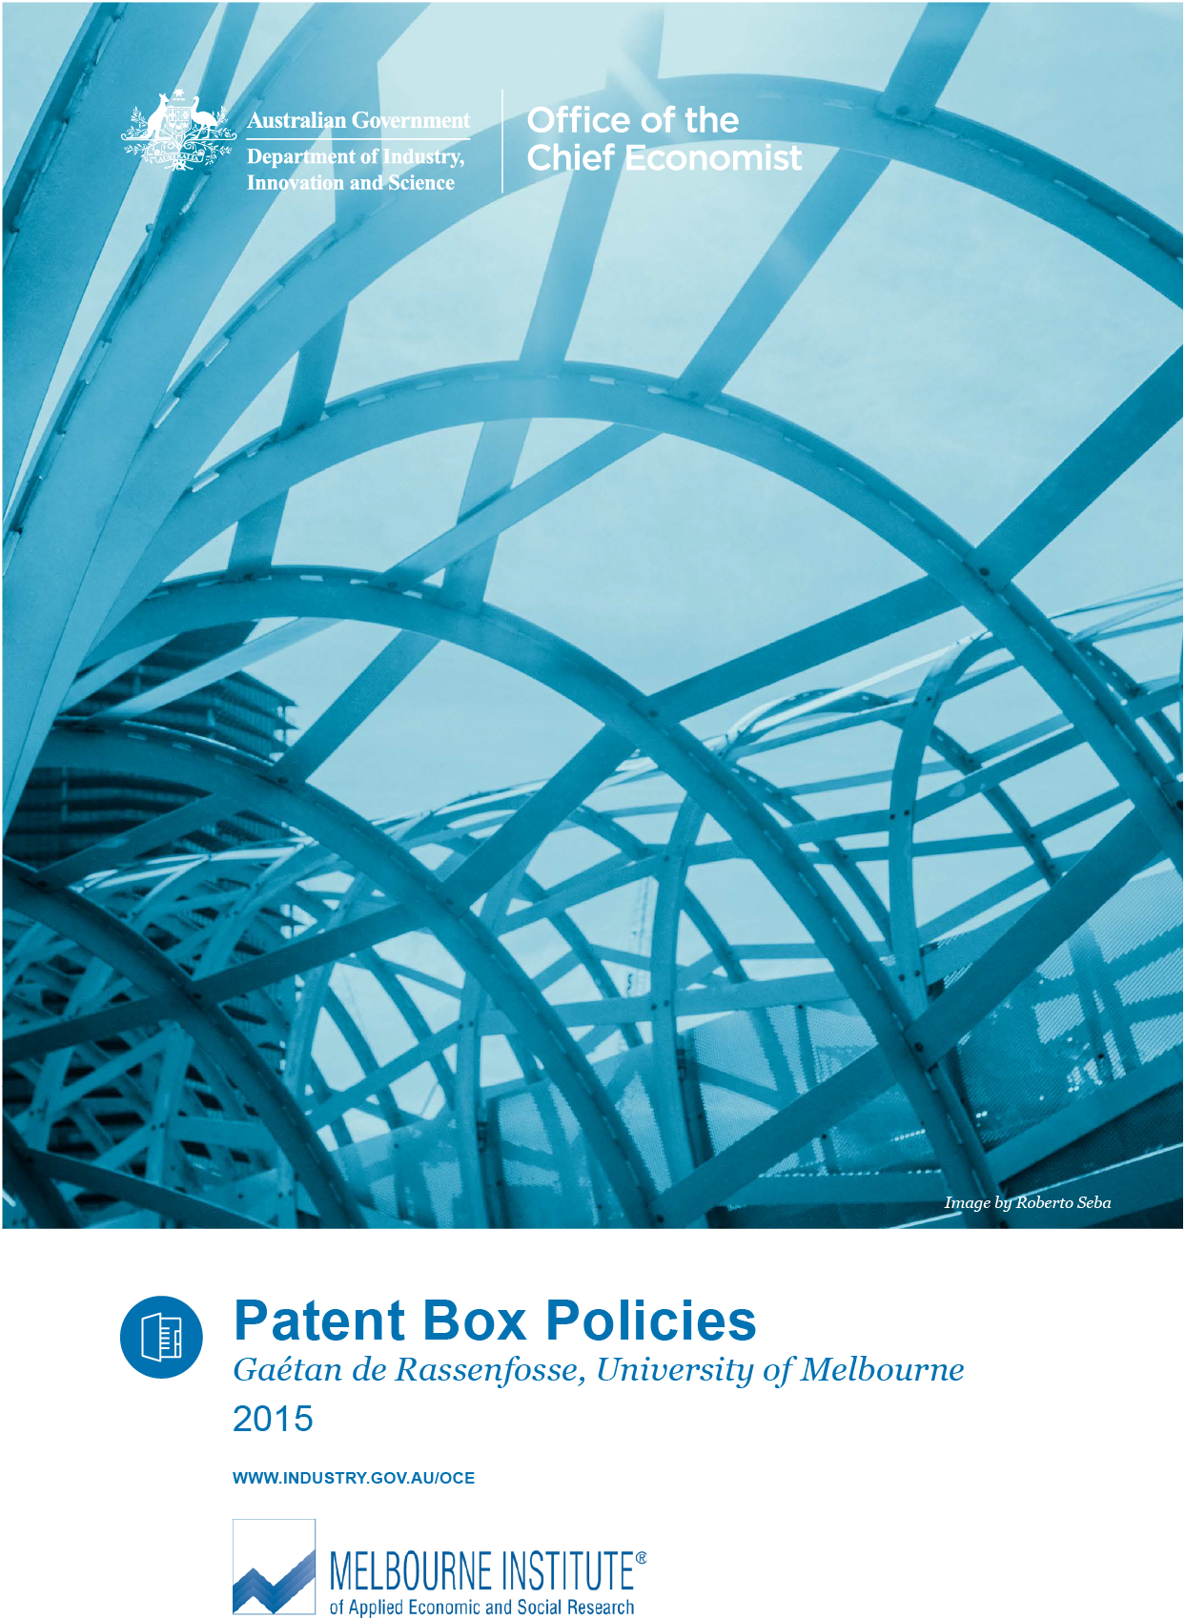

|  |
| --- |
| **Melbourne Institute Logo**Office of the Chief Economist Logo |
| Patent box policies |
| Gaéten de Rassenfosse |
| November 2015 |
|  |

For further information on this research paper please contact:

Chief Economist

Department of Industry, Innovation and Science

GPO Box 9839

Canberra ACT 2601

Email: [chiefeconomist@industry.gov.au](mailto:chiefeconomist@industry.gov.au)

Disclaimer

The views expressed in this report are those of the author(s) and do not necessarily reflect those of the Australian Government or the Department of Industry, Innovation and Science.

© Commonwealth of Australia 2015.

This work is copyright. Apart from use under Copyright Act 1968, no part may be reproduced or altered by any process without prior written permission from the Australian Government. Requests and inquiries concerning reproduction and rights should be addressed to [chiefeconomist@industry.gov.au](mailto:chiefeconomist@industry.gov.au). For more information on Office of the Chief Economist research papers please access the Department’s website at: [www.industry.gov.au/OCE](http://www.industry.gov.au/OCE)

Creative Commons Licence

With the exception of the Coat of Arms, this publication is licensed under a Creative Commons Attribution 3.0 Australia Licence.

Creative Commons Attribution 3.0 Australia Licence is a standard form license agreement that allows you to copy, distribute, transmit and adapt this publication provided that you attribute the work. A summary of the licence terms is available from <http://creativecommons.org/licenses/by/3.0/au/deed.en>. The full licence terms are available from <http://creativecommons.org/licenses/by/3.0/au/legalcode.>

The Commonwealth’s preference is that you attribute this publication (and any material sourced from it) using the following wording:

Source: Licensed from the Commonwealth of Australia under a Creative Commons Attribution 3.0 Australia Licence. The Commonwealth of Australia does not necessarily endorse the content of this publication.

|  |
| --- |
| Key points   * This document reviews the literature on ‘patent box’ policies and discusses the likely impacts of adopting a patent box in Australia. * A patent box is a policy tool that reduces the rate of corporation tax levied on the income generated from certain types of qualifying intellectual property (IP), particularly patents. * It is appropriate to study the adoption of a patent box regime in Australia. According to the OECD, Australia is one of the lowest spenders on direct R&D funding for business: ranking 34th out of 36 among OECD and BRICS nations. Adding indirect support (through the R&D tax incentive) Australia’s rank rises to 18th. * A dozen countries have adopted patent box policies, with two different objectives: attracting mobile IP income (e.g., Hungary); and incentivising innovation (e.g., Belgium).   + **A policy aimed at attracting mobile IP income is a winner-takes-all policy and therefore requires an aggressive lowering of the headline tax rate. In addition, it opens the door to a fiscal race to the bottom as more and more countries seek to offer patent box regimes.**   + **Regarding the latter objective, there are no solid theoretical or empirical grounds for claiming that patent box regimes induce more innovation.** * The implementation of a patent box policy will certainly increase the number of patent applications filed at IP Australia. Indeed the propensity to patent of Australian firms is low by international standards. However, most of these additional patent applications are likely to be opportunistic (i.e., inventions that would previously have been kept secret will be patented) and will not be tied to real economic activity (i.e., the risk is high that R&D leading to these patent applications is performed abroad). * The most important cost associated with the implementation of a patent box regime is a fall in tax revenues collected from innovative companies. Since the fall is likely to exceed revenues collected from (re)allocation of IP income to Australia, the overall return of a patent box regime is likely to be negative. |

# Introduction

This document surveys the academic and grey literatures on ‘patent box’ policies.[1] A patent box is a policy tool that reduces the rate of corporation tax levied on the income generated from certain types of qualifying intellectual property (IP), particularly patents.[2] The term ‘patent box’ refers to the fact that there is a box to tick on the tax form. In contrast with research and development (R&D) tax credits, which target the front end of the innovation lifecycle, a patent box regime targets the last stage of the innovation lifecycle, namely commercialisation. Tax relief can be given either as a reduced tax rate or a tax break for a portion of the patent box income.

A series of (mostly) European countries have adopted patent boxes, the latest being the United Kingdom in 2013. The introduction of a patent box to the United Kingdom has generated heated discussions which are well summarised by the following quotes.

“The EU uses a range of market-based policies such as R&D tax credits and the patent box system. Many of these policies are poorly designed, however. The patent box, which rewards patent holders with a tax credit on the revenues derived from their patent, is badly targeted and wide open to abuse. In an interconnected innovation world, it is almost impossible to decide which particular revenue flow comes from which particular patent; and such patents might be developed abroad and then registered in the particular country giving the tax break.”

Jonathan Haskel (2010:4), Professor of Economics at Imperial College Business School.

“The establishment of the patent box has transformed how we see the UK as a place to invest. As a result, last year we announced we were building our first new factory in the UK for 40 years. The investments announced today are in addition to that and will allow us to harness new technologies that have the potential to deliver a step-change in how we make medicines. These new technologies could significantly reduce costs, improve quality and enable the manufacture of medicines in weeks rather than years and I am delighted that we have been able to bring these investments to the UK.”

Roger Connor, GlaxoSmithKline’s President of Global Manufacturing and Supply, Dec. 2013.[3],[4]

In light of these rather opposite views, this document explains the rationale of patent boxes and discusses their efficacy with a specific focus on Australia. It is appropriate to study the adoption of a patent box policy in Australia. Data recently published by the Organisation for Economic Co-operation and Development (OECD) suggest that Australia’s incentives for research are below the average of other developed economies. Figure 1.1 shows that Australia ranks 18th in terms of government support for R&D expenditures.[5]

Figure 1.1: Direct government funding of business R&D and tax incentives for R&D, 2011

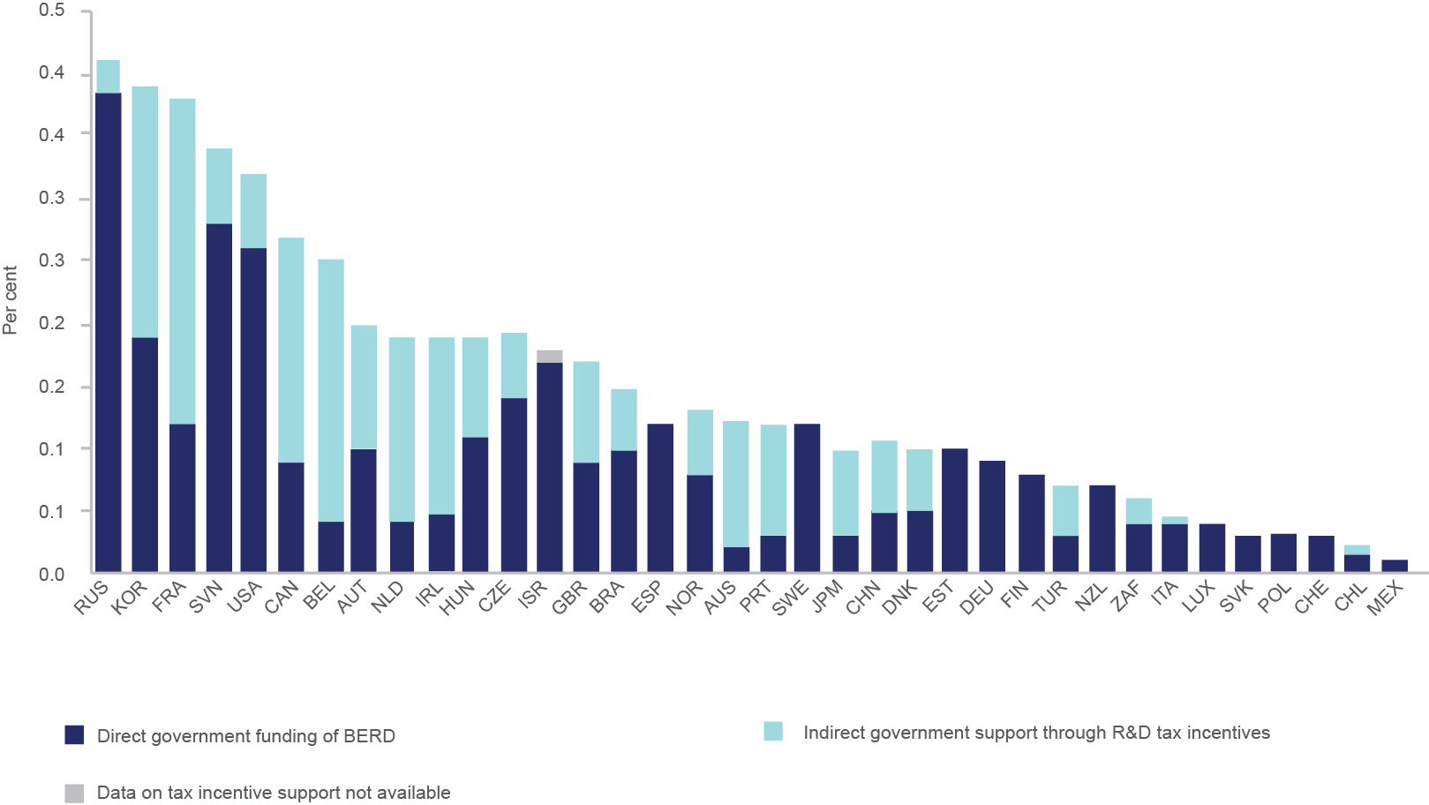

Notes: See endnote 5 for an explanation of the computation of R&D tax incentives.  
Sources: OECD, based on OECD R&D tax incentives questionnaire, publicly available sources, and OECD, Main Science and Technology Indicators Database, <www.oecd.org/sti/msti.htm>, June 2013.

Source: Data available at <http://dx.doi.org/10.1787/888932891112>

The report is structured as follows. Section 2 reviews the main features of overseas patent box policies. Section 3 provides a high-level overview of the benefits and costs of patent box policies. Section 4 draws on arguments from economic theory and empirical studies to discuss the efficacy of patent box policies, and Section 5 offers an overview of IP activity in Australia. Section 6 concludes by assessing the likely impact of adopting a patent box policy in Australia. It is not the objective of this report to provide a detailed estimate of the financial benefits and costs of a patent box regime. This report offers instead a qualitative evaluation of the likely benefits and costs.

# Existing Patent Box Policies

Patent box policies exist in 11 European countries and China and come in various shapes and forms.[6] This section reviews the main features of selected regimes.[7] Briefly, patent box regimes seek to encourage two distinct behaviours (Evers et al. 2013): in countries such as Belgium, the Netherlands and the United Kingdom patent boxes “have elements that are better targeted at incentivising R&D investment and innovation”, whereas in countries such as Cyprus, Hungary, and Malta patent boxes “focus on attracting mobile IP income”. Two features are particularly decisive in drawing a line between the behaviours sought to be encouraged, these are: (i) whether the regime focuses on trade intangibles such as patents or whether it also includes marketing intangibles; and (ii) whether the tax payer is required to conduct original R&D activity.[8] Table 1.1provides an overview of selected regimes.

## Belgium

The Belgian patent box regime takes the form of a patent income deduction (PID). This allows a Belgian company or a Belgian permanent establishment (PE) to deduct from its taxable income an amount equal to 80 per cent of qualifying gross patent income. In other words, 20 per cent of qualifying gross patent income is taxable at the standard corporation tax rate of 33.99 per cent.

*Types of IP included.* The patent box regime is applicable to qualifying patents and supplementary protection certificates (SPC).[9] Know-how closely associated with patents or supplementary protection certificates may also qualify for the PID.

*Ownership conditions.* The PID applies to patents or SPCs which are owned by a Belgian company or a Belgian PE as a direct result of its own patent development activities. The regime also includes patents acquired from related or unrelated parties as well as patents held in joint ownership, and rights obtained by usufruct or through license agreements.

*Development and management conditions*. In order to qualify the patent must have been developed either wholly or partially by the Belgian company or PE. Where a patent has been acquired the Belgian company must have further improved the patented product or process before it can qualify. The improvements do not necessarily have to lead to additional patents over the acquired IP. The patent development work must have been carried out in an R&D centre owned by the Belgian legal entity, although the regime does specifically allow the R&D centre to be located outside of Belgium.

## France

Qualifying IP income and capital gains from qualifying IP are taxed at a reduced corporate tax rate of 15 per cent, compared with the standard rate of 33.33 per cent.

*Types of IP included*. The patent box regime includes patents which have been granted by the French patent office or the European Patent Office (EPO). Other foreign patents are included only if the invention would have been patentable in France (which includes the majority of patents). Improvements made to qualifying patents and industrial manufacturing processes that are a continuation of qualifying patents are also included, as are certificates relating to ‘vegetal inventions’.

*Ownership conditions*. IP rights qualify only if they are classified as an asset in the company’s statutory accounts. The regime applies to existing as well as newly developed IP. However, in addition to fully owned rights the French regime also includes rights obtained under exclusive or non-exclusive licence and sub-licence agreements.

*Development and management conditions*. There are no specific development or management conditions. However, where IP rights are acquired by the company rather than being developed in-house, they must be owned by the company for at least two years before they qualify for the patent box regime.

## Luxembourg

The patent box regime in Luxembourg applies to the net income derived from the use of qualifying intellectual property acquired or developed after 31 December 2007. Tax payers receive an 80 per cent exemption from net income derived from qualifying IP, giving an effective tax rate of 5.84 per cent (the corporate tax rate is 29.22 per cent).

*Types of IP included*. A broad range of IP rights qualify, including patents, trademarks, designs, domain names, models and software copyright.

*Ownership conditions*. In order to qualify for the regime the Luxembourgish company must be the economic owner of the IP rights, and those rights must give the company exclusive exploitation rights in the territory for which a protection is granted.

*Development and management conditions*. There are no specific development or management conditions. The IP can either be developed in-house or acquired. Acquired IP does not need to be further improved by the Luxembourgish company.

Table 2.1: Comparison of Patent Box Regimes

| Tax Factors | Belgium | China | France | Hungary | Luxembourg | Netherlands | Spain | United Kingdom |
| --- | --- | --- | --- | --- | --- | --- | --- | --- |
| Headline tax rate | 6.8% | 0-12.5% | 15% | 9.5% | 5.84% | 5% | 12% | 10% |
| Year Enacted | 2007 | 2008 | 2001, 2005, 2010 | 2012 | 2008 | 2007, 2010 | 2008, 2013 | 2013 |
| Qualified IP | Patents and extended patent certificates | Patents and know how | Patents, extended patent certificates, patentable inventions and industrial fabrication processes | Patent, know-how, trademarks, business names, business secrets, and copyrights | Patents, trademarks, designs, domain names, models, and software copyrights | Patents and IP derived from technological R&D activities | Patents, secret formulas, processes, plans, models, designs, and know-how | Patents, supplementary protection certificates, regulatory data protection, and plant variety rights |
| Applicable to existing IP? | IP granted or first used on or after 01/01/2007 | n.a. | Yes | Yes | IP developed or acquired after 31/12/2007 | IP after 31/12/2006 | Yes | Yes |
| Applicable to acquired IP? | Yes, if further developed | Yes | Yes, subject to specific conditions | Yes | Yes, from non-directly associated companies | Yes, if further self-developed | No | Yes, if further developed and actively managed |
| Includes embedded royalties? | Yes | n.a. | No | No | Yes | Yes | No | Yes |
| Can R&D be performed abroad? | Yes, if qualifying R&D centre | No | Yes | Yes | Yes | Yes, for patented IP; strict conditions for R&D IP | Yes, but must be self-developed by the licensor | Yes |
| Qualifying income | Patent income less cost of acquired IP | Net income from qualifying IP | Royalties net of cost of managing IP | Royalties | Royalties and embedded royalties | Net income from qualifying IP | Net income from qualifying IP | Net income from qualifying IP |
| Includes sale on qualified IP? | No | n.a. | Yes | Yes | Yes | Yes | Yes | Yes |
| Is there a cap on the benefit? | Deduction limited to 100% of pre-tax income | Deduction limited to 5 million RMB, then half the corporate tax rate | No | Deduction limited to 50% of pre-tax income | No | No | No | No |

Source: Adapted from Atkinson and Andes (2011:5) and PWC(2013:13). ‘.a’ stands for ‘not available’.

## The Netherlands

The initial Dutch regime, which became effective on 1 January 2007, applied only to patents and applied a 10 per cent rate of corporate tax to qualifying IP income. On 1 January 2010 the regime was expanded to include income from any IP which arises from technological R&D activities and the headline rate was reduced to 5 per cent (the corporate tax rate is 25 per cent). The regime applies to Dutch resident companies as well as Dutch PE of foreign companies as long as they are paying taxes in the Netherlands.

*Types of IP included*. The ‘innovation box’ regime applies to all worldwide patents taken out by a Dutch taxpayer, as well as any IP which arises from technical innovation activities conducted by or on behalf of a Dutch taxpayer and for which the taxpayer has obtained an R&D declaration from the Dutch government. Therefore, the innovation box can also be used by companies that develop products that are not patentable under EU law, such as software-related intangibles, and trade secrets. Trademarks, non-technical design rights and literary copyrights do not qualify for the regime.

*Ownership conditions*. In order to qualify for the innovation box, the Dutch taxpayer must be the economic owner of the IP and bear the risk associated with the ownership of the IP.

*Development and management conditions*. In order for IP to qualify under the regime, it must be developed through R&D which is paid for and is conducted at the risk of the Dutch taxpayer. For patents, the R&D can be carried out either in the Netherlands or abroad. However, for IP which has an R&D declaration from the Dutch government, generally at least 50 per cent of the R&D must be performed in the Netherlands and the Dutch entity must play a key coordinating role in the development. Acquired IP may qualify in some cases, but only if it is further developed for the risk and account of the Dutch taxpayer.

## United Kingdom

The patent box regime applies to profits of a UK company or UK PE arising on or after 1 April 2013. It applies a 10 per cent rate of corporation tax to worldwide profits arising from patents and certain other forms of associated IP. The IP does not necessarily have to be owned or developed by the UK company, as rights over IP developed elsewhere in the corporate group and exclusively licensed to the UK company are also included.

*Types of IP included*. The regime includes patents granted by the UK IP office, the EPO or a list of European national patent offices. In addition, SPCs, regulatory data protection for pharmaceutical, veterinary and plant protection products, and plant variety rights are all included in the regime. Know-how, trade secrets and some software copyrights that are closely associated with a qualifying patent or other qualifying right are also generally included within the regime. However, other IP such as trademarks and registered designs are specifically excluded.

*Ownership conditions*. Companies can qualify for the UK patent box in four ways. First, through outright legal ownership of the patent or other qualifying IP right. Second, by acquiring an exclusive licence to the IP (the licence may cover only a portion of the IP, and can be limited to a particular field of use and geographical area). Third, through beneficial ownership of all rights relating to the IP. Fourth, by acquiring rights over qualifying IP by participating in a qualifying cost contribution arrangement, where the UK company contributes to the development of the IP.

*Development and management conditions*. Either the IP or the product which incorporates it must have been developed by a company in the worldwide corporate group. The development activities can be carried out in any group company, including a joint venture company, and can take place either before or after the UK company acquires the IP. For acquired IP, the development activities need not give rise to any further patents, but the group must have made a significant contribution to developing a product containing the IP, or the method of applying the IP. Where the development activities have not been carried out by the UK company itself, the UK company must have some responsibility for ongoing decision making concerning either the further development or the exploitation of the IP.

The process leading to the adoption of a patent box policy in the United Kingdom was severely criticised by some British scholars (e.g. Sikka 2013) and columnists. Box 2.1 reports extracts of a 2013 article written by Polly Toynbee, columnist at the Guardian.a

Box .: The patent box controversy in the United Kingdom

| “When the burglar is unscrewing your window locks, would you pay him a fat fee to clean your windows while he's at it? […] That is exactly what has happened in the shocking case of the Patent Box. George Osborne brought in a new tax relief on patents in his last budget, designed to encourage companies to innovate, invest in R&D and entice foreign companies to relocate to Britain. So who did the government invite in as "lead policy adviser" to help frame this tax relief? Jonathan Bridges, senior KPMG corporate tax adviser. This new relief lets any device with a patent be taxed at just 10%, after deductions. […] The Treasury's own estimate is that this will cost £1.1bn a year in lost corporation tax. […] Once he had done his work as a Treasury adviser, Jonathan Bridges returned to KPMG, which promptly advertised his services: "The Patent Box – What's in it for you?" Check it online to see how KPMG boasted about its tax advice to companies: "While on secondment to HMT, Jonathan Bridges also acted as lead policy adviser on tax and innovation, including the Patent Box." This is, as Hodge suggested to KPMG, a case of poacher turned gamekeeper, turned poacher again. The revolving door with government let them set the loophole that they now sell to clients.” |
| --- |

Source: a “Accountancy’s Big Four are laughing all the way to the tax office”, The Guardian, Feb 1 2013. Available at <http://www.theguardian.com/commentisfree/2013/feb/01/accountancy-big-four-laugh-tax-office>.

## Hungary

The ‘property box’ regime in Hungary offers the possibility of excluding 50 per cent of income from IP encompassing licenses, patents, know-how, trademarks, trade secrets, copyrights from the tax base (corporation tax rate is 19 per cent). The maximum deduction must not exceed 50 per cent of the total pre-tax profit determined by the company’s accounts (Koštuříková and Chobotová 2014).

## Spain

Under the Spanish patent box regime tax payers receive a 60 per cent exemption from the net income (after amortization and depreciation) derived from qualifying IP, giving an effective tax rate of 12 per cent (corporation tax rate is 30 per cent). Qualifying IP rights comprise patents, secret formulae or processes, designs or models, plans or information concerning industrial, commercial or scientific equipment. Royalties from any other source (such as trademarks or software) are expressly excluded from this regime. The tax exemption is extended to capital gains deriving from the transfer of IP assets to unrelated parties.

## China

China’s patent box regime allows income from patents and certain types of commercial know-how, such as process innovation, to qualify for a lower rate. China puts a cap on this of five million RMB (approximately AU$875,000) and further taxes that qualify for the patent box are taxed at half the corporate tax rate of 25 per cent. Note that China’s regime also provides a preferential tax treatment to firms that: spend at least 3 to 6 per cent of gross revenue on R&D (depending on firm size); have 60 per cent of firm revenue from core IP (defined as inventions, utility model patents, software, copyrights, proprietary layout designs, and new plant varieties); have 30 per cent of their workforce with a college degree or have 10 per cent of their workforce employed in R&D or high-tech occupations (Atkinson and Andes 2011).

# Benefits and Costs

This section discusses the theoretical benefits and costs associated with the introduction of a patent box policy. It is purposefully high-level. Section 4 provides a critical assessment of these benefits and costs.

## Potential Benefits

### Preventing tax avoidance

The most important reason put forward by nations adopting patent box policies is to prevent firms locating income offshore for the sole purpose of tax avoidance. On the basis of neutrality – the notion that the tax system should not distort investment decisions – economists generally consider it desirable for the tax system to treat the use of physical goods in the same way as intangible goods. However, income from intangible goods is highly mobile and can be easily separated from real activity (Griffith et al. 2010). Therefore the possibility exists that firms may seek to hold intellectual property offshore to avoid tax. A prominent few examples have received wide coverage in the press (see Box 3.1), prompting governments to study possible solutions.

Box .: Tax avoidance by Apple

| Apple recently came into the spotlight for severe tax avoidance. An investigation by the Australian Financial Review shows that while Australian consumers have bought $27 billion worth of Apple products since 2002, the company has paid only $193 million to the Australian Tax Office (ATO) – slightly more than 0.7 per cent of its turnover.a  This situation is due to a global transfer pricing arrangement the Australian operating entity has with an Irish-based shell company. Transfer pricing is the setting of the price for goods and services sold between related legal entities within an enterprise. Out of a typical $600 purchase made in Australia, Apple Australia pays out $550 to Ireland, considerably reducing the revenue base on which it is being taxed in Australia.b  A report by the U.S. Senate Homeland Security Permanent Subcommittee on Investigations provides a detailed analysis of Apple tax avoidance strategy.c |
| --- |

Sources: a “How Ireland got Apple’s $9bn profit”, The Financial Review, Mar. 6 2014. Available at <http://www.afr.com/  
p/technology/how_ireland_got_apple_bn_profit_erlmHONvoHJGixwLUpFckN>  
b “Apple pays $193m tax in Australia on $27b revenue as Federal Government vows to capture lost taxes”, ABC News, Mar. 7 2014. Available at <http://www.abc.net.au/news/2014-03-06/tax-expert-explains-how-apple-pays-193m-tax-on-27b-revenue/5303426>  
c “How Does Apple Avoid Taxes?”, Forbes, May 28, 2013. Available at [http://www.forbes.com/sites/  
leesheppard/2013/05/28/how-does-apple-avoid-taxes](http://www.forbes.com/sites/leesheppard/2013/05/28/how-does-apple-avoid-taxes)

### Inducing investment in innovation activities

An important rationale of innovation policy is to solve the market failure that arises from the non-excludability of research output. Research generates benefits not only to the firms conducting it but also to third parties such as co-located competitors and consumers who do not bear the associated costs. This situation, in which private benefits are lower than social benefits, is known to lead to a level of investment in research activities that is suboptimal from a social point of view. By way of explanation, consider the classic example of a pharmaceutical company which is considering making a $1 billion investment to develop a new drug. Copying of the drug once it is commercialised would considerably lower the firm’s return on investment. If the firm anticipates massive copying it may be rational to not develop the drug in the first place. Although the development of the drug would be desirable from a social point of view it may simply not be worth it from a private (firm’s) point of view. Policies that increase the expected private benefit (e.g., patents) or that reduce the private cost of research (e.g., R&D tax credits) therefore help bring private investments closer to the social optimum. This argument was an important motivation for the adoption of patent box policies by EU countries, as witnessed by explicit references to the 2000 Lisbon Agenda (Hausmann et al. 2012).[10]

### Increase in the incentives to patent

Since patent box regimes usually require the IP to be registered, companies need to patent their inventions in order to claim tax benefits. While some inventions would have been patented anyway, patent box regimes also encourage firms to patent inventions that would otherwise have been kept secret. One direct benefit of an increase in patenting activity is an increase in revenues to the patent office.

Another benefit of more patents is greater disclosure of technical knowledge previously kept secret, which favours the diffusion of knowledge. Indeed patent law stipulates that an inventor is granted a monopoly for a given period of time in exchange for the inventor disclosing to the public how to make his or her invention.

A third benefit of having additional patents is an increased potential for technology transfer. Patents increase the appropriability of inventions for owners by providing a legal title that prevents third-party expropriation. Possession of a valid patent helps assure prospective patent buyers that their future profits will be protected, which facilitates technology transactions (Gans et al. 2008; de Rassenfosse et al. 2013b).

### More profits for firms

The lower tax rate will ultimately increase post-tax profits of innovative firms. Yet only a narrow range of innovative firms are likely to benefit from the patent box regime, namely firms that hold patents and conduct R&D.

## Potential Costs

### Lost tax revenues from the lower tax rate

The most important cost of a patent box regime relates to foregone tax revenues from innovative firms. This cost is greater: when the risk of a company engaging in tax avoidance – or the actual amount of tax avoidance – is small (e.g., companies with no overseas operations are typically not prone to optimising tax using transfer pricing); and when the likelihood of a country attracting multinational enterprises for tax optimisation purposes is small. Nations are thus not all equal in terms of how firms respond to a change in the tax rate. Griffith et al. (2014) have estimated the price elasticities of patent boxes with respect to tax rates for a sample of European countries. They find that the share of patents held in Luxembourg is most sensitive to tax, with a semi-elasticity of 3.9 per cent. In other words, a one per cent decrease in the tax rate in Luxembourg is associated with a 3.9 per cent increase in the share of patents held in Luxembourg. The patent share is least sensitive for Germany, with a semi-elasticity of 0.5 per cent.

### Increase in the incentives to patent

If an increase in the incentive to patent brings benefits, it can also have indirect costs. The first such cost would arise if the patent office was unable to examine patent applications in a reasonable amount of time. If the processing capacity of the patent office does not keep pace with the increased flow of patent applications, the number of patents awaiting examination (backlog) increases. Patent backlog increases uncertainty faced by innovating firms and is harmful to start-ups looking to secure funding. Excessive backlog may ultimately reduce firm incentives to invest in R&D (Rai et al. 2011:5). A second possible indirect cost arises from the fragmentation of IP rights. As more patents are being issued, IP rights become fragmented across a greater number of firms, which could increase coordination costs and ultimately deter innovation (Heller and Eisenberg 1998). This issue, known as the ‘tragedy of the anti-commons’, is particularly relevant in complex product industries (such as telecommunications equipment and semiconductors).

# Empirical evidence on the Efficacy of Patent Box Policies

## Effect on Tax Revenues

There are two aspects which need to be considered in order to evaluate whether a patent box regime is an efficient mechanism for preventing tax avoidance and to estimate the overall effect on tax revenues. On the one hand, there is evidence that the tax rate affects the locating of income from intangible goods. Besides anecdotal evidence such as the Apple case discussed in Box 3.1, empirical studies generally find that business investment decisions respond to tax rate. de Mooij and Ederveen (2003) have reviewed the empirical literature on the impact of company taxes on the allocation of foreign direct investment. They report that the median value of the tax rate elasticity is around –3.3, implying that a 1 per cent reduction in the host-country tax rate raises foreign direct investment in that country by 3.3 per cent.

On the other hand, a patent box may not be the most appropriate mechanism for inducing firms to re-allocate ‘lost revenues’ back into the country of origin (or for preventing revenues from leaving the country in the first place). There are three main reasons for this. First, opponents point out that the patent box system is open to abuse. It is almost impossible for the firm, let alone for the tax authority, to estimate which particular revenue flow comes from which particular patent (Haskel 2014). Second, reductions in the headline tax rate may be of a limited effect if firms are already organising their mobile income streams to achieve lower tax burdens. Third, it may be a short-sighted policy. It is generally conceded that patent boxes are implemented in reaction to other countries’ tax policies. It is therefore reasonable to expect that implementing a patent box policy would trigger further reactions by neighbouring countries. This risk of a fiscal race to the bottom is well explained by Ault (2013:1201): “If one country introduces a patent box and successfully gets or keeps investment, it wins. But if everyone starts doing this, in the end the only result will be that all countries have less revenue, and all are worse off […]” Devereux et al. (2008) provide empirical evidence that countries compete using the corporate tax rate. Drawing on data from 21 OECD countries between 1982 and 1999 the authors show that governments engage in tax competition on two fronts: they compete via their effective marginal tax rates for capital and their statutory tax rates for profit. The issue of tax competition is particularly pressing in Europe, where the ability of companies to operate in one European market and access neighbouring ones without barriers means that tax competition in the bloc is fiercely fought. In fact the fear of a race to the bottom has led Germany’s finance minister to call for a ban on patent boxes.[11]

As far as specific estimates of the overall fiscal effect of patent boxes are concerned, Griffith et al. (2010, 2014) have produced the most robust empirical evidence to date. The authors simulated the effect of patent box regimes on the distribution and revenues from patents throughout Europe. They find that patent box policies do induce firms to patent more in the nations enacting the patent boxes, as shown in Figure 4.1. The figure clearly illustrates the effect of tax competition across countries. The adoption of patent boxes by Benelux countries leads to a reduction in the share of patent applications filed in all the other countries. The modelled effect of the United Kingdom adopting a patent box has the similar effect of increasing the share of patents filed in the United Kingdom and reducing the share of patent applications in all the other countries (including the Benelux countries).

Figure 4.1: Share of new patent applications across countries

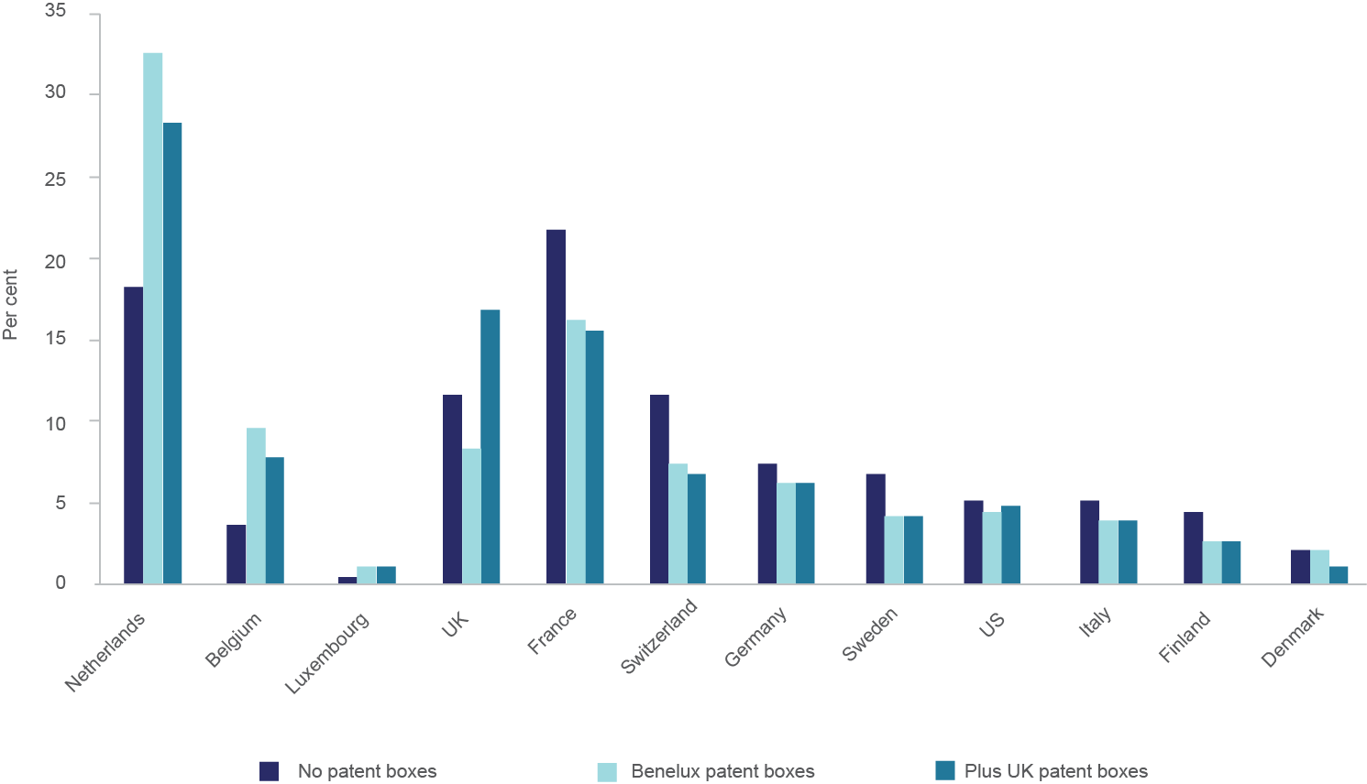

Notes: The first bar for each country shows the predicted shares of patents held in each location before any patent boxes have been introduced. The second bar shows the predicted shares of newly created patents after the Benelux countries have introduced patent boxes (Belgium at 6.8 per cent, Luxembourg at 5.9 per cent and the Netherlands at 10 per cent). The final bar shows predicted shares of newly created patents when the United Kingdom additionally introduces a patent box, at a rate of 10 per cent. Selected countries reported.

Source: figure and notes adapted from Griffith et al. (2010:6)

However, the sheer number of patent applications is not the relevant outcome. What matters in the end is the overall amount of tax revenues collected by nations. Whereas the attraction of foreign patents is associated with an increase in tax revenue (extensive margin), the patent box regime also leads to a decrease of the tax revenues collected from domestic patents (intensive margin). Griffith et al. (2010, 2014) find that the increased tax revenues from the increase in income do not fully offset the lost taxes from the lower tax rates, as shown in Figure 4.2. The UK Treasury comes to a similar conclusion. By its own estimate, the patent box would cost £1.1 billion in steady state (i.e., net of transitory effects).[12]

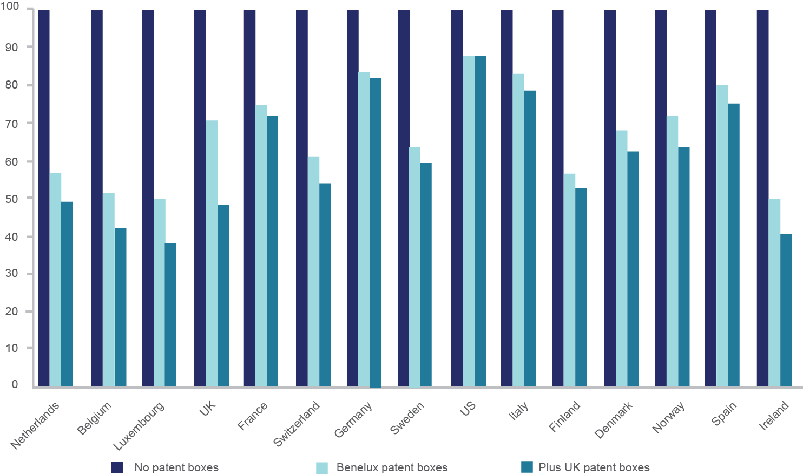Figure 4.2: Government tax revenues from new patent income

Notes: The graph shows government tax revenue from new patents (= tax rate * share of new patents), assuming the 2005 level of patenting. Initial revenue (before any patent box introductions) is indexed to 100 (first bar). The second and third bars show relative revenue when the Benelux countries and also the United Kingdom respectively introduce patent boxes.

Source: figure and notes adapted from Griffith et al. (2010:11)

In other words, even though the number of patents filed in countries adopting patent boxes increases, the total amount of tax revenues collected by these countries decreases. In addition, other nations lose patent tax revenue because firms choose to relocate patent-based activities to countries with patent boxes.

Griffith et al.’s study focuses on the tax-income effect of the reform and leaves aside the indirect effect on R&D. This effect is more difficult to measure because it takes a long time to materialise while patent box policies have only been implemented quite recently. The next section draws on arguments and findings from economic theory and empirical studies to discuss the efficacy of using patent box policies as a tool to encourage innovation.

## Inducing Investments in Innovative Activities

There is anecdotal evidence that patent box policies foster investment in R&D. The GlaxoSmithKline (GSK) story provided in the introduction is a well-known example. The UK patent box reportedly encouraged GSK to build a new pharmaceutical plant in Britain and to bring patents held overseas back into the United Kingdom (see however the discussion in endnote 4).

Yet the GSK case is related to *where* to locate the R&D centre instead of *whether* to create it. GSK was considering opening a new R&D centre, and chose to establish it in the United Kingdom. From the social planner point of view, however, the relevant consideration is whether the policy being considered induces private investments that would not otherwise take place. It is quite clear that GSK would have created its R&D centre anyway, although possibly not in the United Kingdom. Some may argue that the location decision is actually a relevant outcome from a national policy point of view. While there is some truth to this argument, it also opens the door to a race to the bottom in terms of tax revenues, as discussed above.

As far as I can ascertain, there is no systematic evidence that patent box policies foster investment in R&D. One parliamentary exchange at the House of the Oireachtas (Ireland) between Deputy Chris Andrews and Minister for Finance Deputy Brian Lenihan in 2010 provides an insight into the innovation incentives of patent boxes. The Irish decision to end the tax break on patent royalties (one element of the patent box regime in Ireland) was questioned by Deputy Chris Andrews on the ground that it may affect investments and innovation. The answer from the Minister for Finance was unambiguous: “I do not believe that the removal of this relief will have a significant adverse effect on investment and innovation. The decision to abolish the relief was taken on the basis of a recommendation to this effect by the Commission on Taxation. The Commission found that the relief has not had the desired impact on innovation and R&D activity and that, despite various refinements to the scheme over the years, it was not a particularly well-targeted measure providing good value for money.” The Minister further added “The Government agrees with the conclusions of the Commission and believes that scarce resources should be focussed instead on the R&D tax credit scheme. The R&D credit scheme provides a more direct and effective incentive for enterprises to innovate and invest in R&D activities […].”[13]

Obviously one should guard against generalising anecdotal evidence. But the theory would also suggest that the innovation incentive effect of patent boxes is likely to be very limited. To be sure, there is robust empirical evidence that tax incentives induce firms to invest in R&D. Bloom et al. (2002) examined the sensitivity of R&D to changes in fiscal incentives in nine countries over the period 1979–1997. Their analysis suggests that tax changes significantly affect the level of R&D. A 10 per cent fall in the cost of R&D stimulates just over a 1 per cent rise in the level of R&D in the short-run, and just under a 10 per cent rise in R&D in the long-run. But in contrast to R&D tax credits, which come at the front end of the innovation process, patent box policies focus on the back end. Back-end incentives are unlikely to provide an adequate solution to the underinvestment in R&D for two reasons. First, the commercialisation of an innovation may occur several years after the initial R&D investment and discounting reduces the value of the fiscal incentive provided. Second the patent box is targeted at already successfully commercialised products and therefore does not help mitigate the uncertainty cost surrounding R&D investment (over and above the incentive effect provided by patent protection). In addition, nations with patent boxes (with the exception of China) have not made lower tax rates on income from patented products dependent on a requirement that the IP-related R&D was conducted at home. There is thus no genuine guarantee that the research was conducted in the country where the tax benefits are being claimed. While patent boxes may spur the commercialisation of research outcomes, there is no apparent market failure associated with R&D commercialisation, at least not of the type that a patent box policy would solve.[14] The role for government intervention appears difficult to justify on the grounds of market failure.

## Increase in the Incentives to Patent

The implementation of a patent box means that more patents will be applied for, and patents will be presumably maintained for a longer period of time. The cost structure of patent offices is front-loaded, meaning that all the costs occur early in the life of patents. Whereas examining whether a patent application meets the patentability requirement is costly, maintaining a patent in force is inexpensive. If patents are maintained for a longer period of time than currently, then revenues increase more than costs and the patent office makes more profit.[15]

A greater reliance on patents will also increase disclosure of technologies, which is socially valuable because future research builds on previous technical knowledge (Scotchmer and Green 1990). However the question of whether patents are effective in diffusing technical information is still a matter of debate (e.g., Bessen 2005) and little empirical evidence is available to provide a definite answer to this question.

A larger number of patents also increases the potential for technology transfer. However, the very nature of the patent box regime means that the vast majority of transfers will be intra-group transfers. These transfers will be performed for tax reasons and will not necessarily have any real economic impact (such as further development or commercialisation by an external entity).

On the cost side, the risk of increased backlog is real since patent offices worldwide are already unable to keep up with the flow of incoming applications. The increase in costs associated with the ‘tragedy of the anti-commons’ could be expected to be quite small because the incentives to patent such inventions are already quite high (and the patent box will therefore have little additional effect on the decision to patent such inventions).

# Overview of the IP Activity in Australia

This section provides an overview of patent, trademark and design activities in Australia. It first shows that Australian inventors rely to a low extent on the patent system in comparison with overseas inventors. It then presents a list of the largest IP right holders at IP Australia in order to derive three stylised facts. Finally, it provides a list of the largest R&D performers in Australia

## Reliance on Patent Protection by Australian Inventors

Figure 5.1 shows the number of (priority) patent applications by national inventors in the year 2010, per million dollars of R&D expenditures, for countries that have adopted a patent box policy and Germany. Australia produces six times less patents per R&D dollar than Germany, a country with no patent box regime, and the United Kingdom, which did not have a patent box regime at that time. All countries with a patent box regime in place in 2010 produced fewer patents per R&D than Germany and the United Kingdom. The low score obtained for Australia can be explained by two main factors. As discussed in de Rassenfosse and van Pottelsberghe (2009), the patent-to-R&D ratio reflects both a research productivity effect (the number of inventions per R&D) and a patent propensity effect (the proportion of inventions patented). Although the possibility exists that Australian inventors may be less productive than their overseas inventors, most of the difference in the patent-to-R&D ratio can probably be explained by a lower propensity to patent. A variety of reasons can be put forward to explain the low propensity to patent, such as a lack of IP awareness by Australian firms and the specific 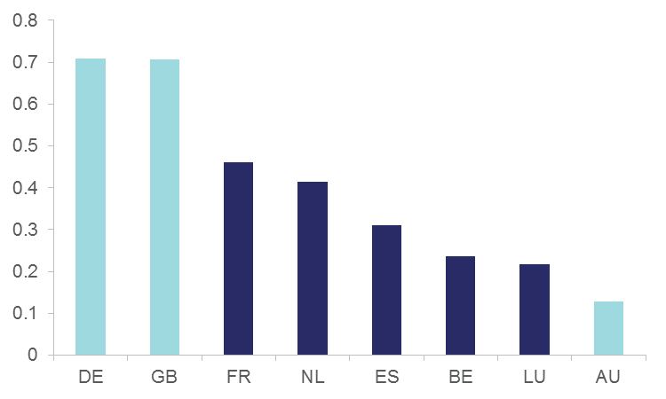industrial structure of the country (low share of manufacturing).

Figure 5.1: Priority patent applications per million R&D expenditures, year 2010

Notes: Priority patent applications by country of residence of the inventor (de Rassenfosse et al. 2013a). Data for application year 2010 available from Google Public Data Explorer at <https://www.google.com/publicdata/  
explore?ds=z1jhj3gpcf2700_&hl=en&dl=en>. Gross expenditures on R&D performed by the business sector in 2010 million US PPPs.

Source: Data available at <http://stats.oecd.org/Index.aspx?DataSetCode=GERD_FUNDS>.

Figure 5.1 suggests that one could expect a noticeable increase of the number of patent applications at IP Australia should a patent box policy be implemented.

## Stylised Facts Related to IP Activity in Australia

The next three tables report the largest IP right holders at IP Australia in relation to patent applications Table 5.1 trademark applications Table 5.2 and designs Table 5.3.

Three stylised facts emerge from the tables. First, the fragmentation of IP right holders is more pronounced in the case of trademark applications. Applications from the 30 largest applicants listed in Table 5.2 account for a mere 3.28 per cent of total applications. On the same definition, patent applications achieve a 12.69 per cent fragmentation rate and designs achieve a 21.35 per cent rate. As a result, allowing a tax benefit for the holding of trademarks (as is the case in Luxembourg and Hungary) would affect the largest group of firms.

Second, there is a predominance of international applicants in the rankings. This is particularly strong in the case of patents and bears witness to the fact that R&D benefiting the Australian economy is primarily conducted overseas. In fact, less than ten per cent of patent applications filed in Australia in 2010 originated from Australian inventors.[16]

The third stylized fact to emerge is the limited overlap between the three tables, which suggests that the choice of IP right to be included in a patent box regime would have strong implications for particular industries. For example, extending the ‘patent’ box regime to design rights would have a particularly marked effect in the clothing design industry (with four applicants in the top 30). Restricting the patent box to patents would affect primarily the manufacturing industry and the professional, scientific and technical services industry, as indicated in Table 5.4.

Table 5.1: Largest patent applicants at IP Australia, 2008–2013

| Rank | N | Name | HQ | Industry |
| --- | --- | --- | --- | --- |
| 1 | 1265 | Novartis AG | CH | Pharmaceuticals |
| 2 | 1246 | Covidien LP | IE | Healthcare |
| 3 | 883 | Qualcomm Inc. | US | Telecommunications equipment |
| 4 | 869 | Nestec S.A. | CH | Food processing |
| 5 | 869 | Aristocrat Technologies Australia Pty Limited | AU | Gaming technology |
| 6 | 827 | BASF SE | DE | Chemicals |
| 7 | 826 | General Electric Company | US | Conglomerate |
| 8 | 746 | F. Hoffmann-La Roche AG | CH | Pharmaceuticals |
| 9 | 696 | Microsoft Corporation | US | Computer software |
| 10 | 692 | Kimberly-Clark Worldwide Inc. | US | Personal care |
| 11 | 687 | Shell Internationale Research Maatschappij B.V. | NL | Oil & gas |
| 12 | 666 | Apple Inc. | US | Consumer electronics |
| 13 | 632 | Halliburton Energy Services Inc. | US | Oilfield services & equipment |
| 14 | 623 | Merck Sharp & Dohme Corp. | US | Pharmaceuticals |
| 15 | 614 | Samsung Electronics Co. Ltd. | KR | Conglomerate (electronics) |
| 16 | 612 | LG Electronics Inc. | KR | Conglomerate (electronics) |
| 17 | 598 | Google Inc. | US | Internet |
| 18 | 585 | E. I. du Pont de Nemours and Company | US | Chemicals |
| 19 | 513 | Colgate-Palmolive Company | US | Personal care |
| 20 | 504 | Daikin Industries Ltd. | JP | Electrical equipment |
| 21 | 474 | Allergan Inc. | US | Pharmaceuticals |
| 22 | 464 | Genentech Inc. | US | Biotechnology |
| 23 | 449 | Baker Hughes Incorporated | US | Oil & gas |
| 24 | 438 | AstraZeneca AB | UK | Pharmaceuticals & biotechnology |
| 25 | 407 | The Regents of the University of California | US | Education |
| 26 | 402 | Chevron U.S.A. Inc. | US | Oil & gas |
| 27 | 391 | The Procter & Gamble Company | US | Consumer goods |
| 28 | 390 | 3M Innovative Properties Company | US | Conglomerate |
| 29 | 382 | Amgen Inc. | US | Biotechnology |
| 30 | 369 | Janssen Pharmaceutica NV | US | Pharmaceuticals |

Notes: ‘N’ stands for number of (standard) patent applications filed. These 30 applicants account for 12.69 per cent of total applications. ‘HQ’ indicates the country hosting of the ultimate owner.

Source: Melbourne Institute - IP Australia Dataset (MIIPA), see Julius and de Rassenfosse (2014).

Table 5.2: Largest trademark applications at IP Australia, 2008–2013

| Rank | N | Name | HQ | Industry |
| --- | --- | --- | --- | --- |
| 1 | 627 | Novartis AG | CH | Pharmaceuticals |
| 2 | 556 | Johnson & Johnson | US | Medical equipment & pharmaceuticals |
| 3 | 491 | Ainsworth Game Technology Limited | AU | Gaming technology |
| 4 | 477 | Aristocrat Technologies Australia Pty Ltd | AU | Gaming technology |
| 5 | 470 | ALDI Foods Pty Ltd | DE | Retail |
| 6 | 462 | LG Electronics Inc | KR | Conglomerate (electronics) |
| 7 | 455 | Glaxo Group Limited | UK | Pharmaceuticals & biotechnology |
| 8 | 425 | Société des Produits Nestlé S.A. | CH | Food processing |
| 9 | 418 | Coles Supermarkets Australia Pty Ltd | AU | Retail |
| 10 | 371 | Telstra Corporation Limited | AU | Telecommunications |
| 11 | 351 | L'OREAL | FR | Personal care |
| 12 | 311 | Woolworths Limited | AU | Retail |
| 13 | 308 | Unilever Plc | NL/UK | Consumer goods |
| 14 | 299 | The Procter & Gamble Company | US | Consumer goods |
| 15 | 296 | Nintendo Co Ltd | JP | Video games & consumer electronics |
| 16 | 288 | Samsung Electronics Co Ltd | KR | Conglomerate (electronics) |
| 17 | 279 | Bristol-Myers Squibb Company | US | Pharmaceuticals |
| 18 | 263 | Philip Morris Brands Sarl | US | Tobacco |
| 19 | 254 | Sanofi SA | FR | Pharmaceuticals |
| 20 | 250 | Commonwealth Bank of Australia | AU | Banking & financial services |
| 21 | 248 | Mars Australia Pty Ltd | US | Food processing |
| 22 | 248 | Boehringer Ingelheim International GmbH | DE | Pharmaceuticals |
| 23 | 233 | BlueScope Steel Limited | AU | Steel |
| 24 | 222 | Z & Y Nominees Pty Ltd | CN* | Conglomerate |
| 25 | 219 | IGT (Australia) Pty Ltd | US | Gaming technology |
| 26 | 219 | DuluxGroup (Australia) Pty Ltd | AU | Chemicals |
| 27 | 213 | Apple Inc | US | Consumer electronics |
| 28 | 206 | Microsoft Corporation | US | Computer software |
| 29 | 202 | Biofarma | FR | Pharmaceuticals |
| 30 | 201 | Eli Lilly and Company | US | Pharmaceuticals |

Notes: ‘N’ stands for number of trademark applications filed. These 30 applicants account for 3.28 per cent of total applications. ‘HQ’ indicates the country hosting of the ultimate owner. ‘*’ indicates best guess.

Source: Melbourne Institute - IP Australia Dataset (MIIPA), see Julius and de Rassenfosse (2014).

Table 5.3: Largest design applicants at IP Australian, 2008–2013

| Rank | N | Name | HQ | Industry |
| --- | --- | --- | --- | --- |
| 1 | 663 | Forever New Clothing Pty Ltd | AU | Clothing |
| 2 | 395 | Samsung Electronics Co. Ltd | KR | Conglomerate (electronics) |
| 3 | 340 | Microsoft Corporation | US | Computer software |
| 4 | 321 | Apple Inc. | US | Consumer electronics |
| 5 | 311 | Colgate-Palmolive Company | US | Personal care |
| 6 | 299 | Koninklijke Philips Electronics N.V. | NL | Electronics |
| 7 | 262 | Toyota Jidosha Kabushiki Kaisha | JP | Automotive |
| 8 | 249 | Honda Motor Co. Ltd | JP | Automotive, aviation & telematics |
| 9 | 249 | The Procter & Gamble Company | US | Consumer goods |
| 10 | 238 | The Decor Corporation Pty Ltd | AU | Homeware |
| 11 | 227 | King Furniture Australia Pty Ltd | AU | Furniture |
| 12 | 196 | JETS Swimwear Pty Ltd | AU | Clothing |
| 13 | 177 | Beba Enterprises Pty Ltd | AU | Clothing |
| 14 | 176 | Dart Industries Inc. | US* | Homeware |
| 15 | 175 | GM Global Technology Operations LLC | US | Automotive |
| 16 | 170 | Spin Master Ltd | CA | Children entertainment |
| 17 | 167 | Nokia Corporation | FI | Telecommunication equipment |
| 18 | 158 | Logue and Co. Pty Ltd | AU | Packaging |
| 19 | 158 | Unilever PLC | NL/UK | Consumer goods |
| 20 | 158 | 3M Innovative Properties Company | US | Conglomerate |
| 21 | 156 | Société des Produits Nestlé S.A. | CH | Food processing |
| 22 | 139 | Fifty-Fourth Rischell Pty Ltd | AU | Clothing |
| 23 | 139 | Eveready Battery Company Inc. | US | Batteries |
| 24 | 134 | Victaulic Company | US | Mechanical engineering |
| 25 | 132 | LG Electronics Inc. | KR | Conglomerate (electronics) |
| 26 | 130 | S.C. Johnson & Son Inc. | US | Consumer goods |
| 27 | 130 | Michelin Recherche et Technique S.A. | FR/US | Auto & truck parts |
| 28 | 127 | Caroma Industries Limited | AU | Bathroom & kitchen products |
| 29 | 124 | Pi-Design AG | CH | Homeware |
| 30 | 112 | Black & Decker Inc. | US | Power tools |

Notes: ‘N’ stands for number of trademark applications filed. These 30 applicants account for 21.35 per cent of total applications. ‘HQ’ indicates the country hosting of the ultimate owner. ‘*’ indicates best guess.

Source: Melbourne Institute - IP Australia Dataset (MIIPA), see Julius and de Rassenfosse (2014).

Table 5.4: Industry allocation (ANZSIC) of patent applications by state

|  |  |  |  |  |  |  |  |  |  |  |  |  |  |  |  |
| --- | --- | --- | --- | --- | --- | --- | --- | --- | --- | --- | --- | --- | --- | --- | --- |
| State | B | C | E | F | G | J | K | L | M | P | Q | R | S | U | X |
| ACT | 8 | 81 | 21 | 22 | 10 | 12 | 19 | 11 | 1252 | 188 | 4 | 10 | 8 | 18 | 53 |
| NSW | 92 | 4773 | 287 | 1117 | 240 | 116 | 606 | 454 | 3055 | 538 | 150 | 56 | 194 | 963 | 815 |
| NT | 2 | 20 | 5 |  | 1 | 1 | 1 | 4 | 12 | 2 |  | 1 | 1 | 3 | 4 |
| QLD | 116 | 1602 | 278 | 355 | 101 | 54 | 284 | 231 | 997 | 133 | 43 | 250 | 80 | 274 | 802 |
| SA | 13 | 848 | 57 | 189 | 34 | 15 | 140 | 82 | 388 | 85 | 38 | 7 | 28 | 77 | 180 |
| TAS |  | 75 | 11 | 16 | 3 | 3 | 6 | 6 | 30 | 7 |  | 3 |  | 3 | 18 |
| VIC | 174 | 3282 | 273 | 949 | 138 | 162 | 805 | 453 | 2281 | 444 | 169 | 66 | 80 | 403 | 1178 |
| WA | 312 | 728 | 154 | 155 | 60 | 16 | 213 | 96 | 686 | 103 | 46 | 3 | 29 | 114 | 434 |

Notes: Patent applications from Australian entities only. ANZSIC B is ‘Mining’, C is ‘Manufacturing’, F is ‘Wholesale Trade’ and M is ‘Professional, Scientific and Technical Services’. See the ABS website for full list.

Source: Melbourne Institute - IP Australia Dataset (MIIPA), see Julius and de Rassenfosse (2014). Industry allocation performed by IP Australia.

## Largest R&D Performers

The next table reports the 30 largest R&D performers in Australia in 2011/12 for which information is available, and helps identify the main likely beneficiaries from the implementation of a patent box regime in Australia. In short, the main beneficiaries are the largest R&D performers and the largest tax payers. Although R&D performers may not all be conducting an aggressive patenting strategy, the implementation of a patent box regime would drastically increase the incentives to apply for patents. Therefore looking at R&D performers provides a view of the ‘latent’ beneficiaries (especially if the patent box regime were to apply to IP rights registered after the implementation of the policy). The data come from the Bureau van Dijk’s Orbis database.

It is striking to see that only two of the 30 largest patent applicants are among the 30 largest R&D performers. This fact suggests that a requirement for R&D to be performed domestically should be an important feature of any Australian patent box policy as a means of limiting opportunistic behaviours.

Table 5.5: Largest R&D performers, 2011/12

| Rank | Name | Patents | Trademarks | Designs |
| --- | --- | --- | --- | --- |
| 1 | CSIRO | - | - | - |
| 2 | CSL | - | - | - |
| 3 | Ford Australia | - | - | - |
| 4 | GM Holden | - | - | - |
| 5 | Oil Search | - | - | - |
| 6 | Arrium Limited | - | - | - |
| 7 | Rio Tinto Group | - | - | - |
| 8 | Cochlear | - | - | - |
| 9 | Aristocrat Leisure | Yes | Yes | - |
| 10 | Fonterra Co-op Group | - | - | - |
| 11 | BHP Billiton | - | - | - |
| 12 | Horticulture Australia | - | - | - |
| 13 | Amcor | - | - | - |
| 14 | Computershare | - | - | - |
| 15 | GlaxoSmithKline | - | Yes | - |
| 16 | Shell Australia | Yes | - | - |
| 17 | ResMed Holdings | - | - | - |
| 18 | Atlassian Corporation | - | - | - |
| 19 | Fisher & Paykel Healthcare | - | - | - |
| 20 | Nufarm | - | - | - |
| 21 | ERA | - | - | - |
| 22 | Technology One | - | - | - |
| 23 | Hospira Holdings | - | - | - |
| 24 | Pfizer Australia | - | - | - |
| 25 | James Hardie Industries | - | - | - |
| 26 | BlueScope Steel | - | Yes | - |
| 27 | SEEK | - | - | - |
| 28 | Mondelez Australia | - | - | - |
| 29 | Ainsworth Game Technology | - | Yes | - |
| 30 | Bristol-Myers Squibb | - | Yes | - |

Notes: the last three columns indicate whether the entity was also in the top 30 largest holders of patents, trademarks and designs.

Source: Orbis database from Bureau van Dijk.

# Conclusion: Likely Impacts of a Patent Box Policy in Australia

This section provides an appraisal of the expected impacts of the implementation of a patent box policy in Australia. Lack of economic models and empirical evidence prevent us from presenting quantitative estimates. In addition, expected impacts depend to a large extent on the design of the patent box regime. The qualitative value judgment provided in this section is based on the assumptions that: i) research has to be conducted in Australia in order to qualify for the patent box exemption; and ii) the patent box would apply only to technologies protected with standard patents (i.e., not to trademarks, industrial secrets, innovation patents, etc.).

This section does not address the possibility that Australia adopts an aggressive tax reform that would make it a potential tax haven. Such a reform would have a drastic – though difficult to quantify – effect on the Australian economy, and may well be welfare enhancing. However, it works best for small countries with a weak innovation base. In addition, it would go against OECD’s ambition of eliminating harmful tax practices in OECD countries.

### Increase in tax revenues from the prevention of tax avoidance and attraction of new IP income

Likely to be very low. A patent box regime is likely to have little effect on large multinational enterprises that are already optimising their tax base (e.g., Apple). Revenues that the country is most likely to attract come from foreign firms that have a research centre in Australia and that have their IP located in a medium-to-high tax jurisdiction. Deeper investigation of the impact on the mining industry is warranted.

### Decrease in tax revenues collected from the population of innovative companies

Likely to be high. Quantitative estimates discussed in Section 4 suggest that government tax revenues systematically fall after the introduction of a patent box (both in the country where the patent box was implemented and in neighbouring countries). In addition, the adoption of a patent box in Australia could push neighbouring countries such as New-Zealand and Singapore to follow suit with the (limited) risk of triggering a fiscal race to the bottom. Patent box policies are winner-takes-all policies and adjustments at the margin are likely to hurt the economy. Note that the decrease in tax revenues is associated with an increase in post-tax profits for firms participating in the scheme.

### Increase in the incentives to invest in research

Likely to be very low. Patent boxes are not a very appropriate innovation policy tool because they target the back end of the innovation process, where market failures are less likely to occur. However, contrary to EU countries, Australia has the possibility of designing a patent box regime that links the incentive to the conduct of R&D and production of patented product in the country.

### Increase in the number of patent applications

Likely to be high. Quantitative estimates discussed in Section 4 suggest that government tax revenues systematically fall after the introduction of a patent box (both in the country where the patent box was implemented and in neighbouring countries). In addition, the adoption of a patent box in Australia could push neighbouring countries such as New-Zealand and Singapore to follow suit with the (limited) risk of triggering a fiscal race to the bottom. Patent box policies are winner-takes-all policies and adjustments at the margin are likely to hurt the economy. Note that the decrease in tax revenues is associated with an increase in post-tax profits for firms participating in the scheme.

### Increase in the incentives to invest in research

Likely to be very low. Patent boxes are not a very appropriate innovation policy tool because they target the back end of the innovation process, where market failures are less likely to occur. However, contrary to EU countries, Australia has the possibility of designing a patent box regime that links the incentive to the conduct of R&D and production of patented product in the country.

### Increase in the number of patent applications

Likely to be high. Australian companies seem to have a low propensity to patent in comparison with overseas companies. A patent box increases the incentive to patent and one could therefore expect an increase in the number of patents applied for. This would increase the revenues collected by IP Australia (the present value of revenues for one patent maintained to full term is about $8,600).[17] However, this outcome should not be an end in itself since the resulting patenting activity would largely be the result of ‘opportunistic’ behaviour, that is, it would not reflect a genuine increase in inventiveness.

References

Atkinson, R. and Andes, S. (2011). “Patent Boxes: Innovation in tax policy and tax policy for innovation”. Report by the Information Technology & Innovation Foundation, October 2011, 22p.

Ault, H. (2013). “Some reflections on the OECD and the sources of international tax principles”. *Tax Notes International*, 70(12), 1195–1201.

Bessen, J. (2005). “Patents and the diffusion of technical information*.*” *Economics Letters*, 86(1), 121–128.

Bloom, N., Griffith, R., and Van Reenen, J. (2002). “Do R&D tax credits work? Evidence from a panel of countries 1979–1997.” *Journal of Public Economics*, 85, 1–31.

de Rassenfosse, G., Dernis, H., Guellec, D., Picci, L., and van Pottelsberghe de la Potterie, B. (2013a). “The worldwide count of priority patents: A new indicator of inventive activity”. *Research Policy*, 42(3), 720–737.

de Rassenfosse, G., Palangkaraya, A., and Webster, E. (2013b). “Do Patents Shield Disclosure or Assure Exclusivity When Transacting Technology?” Melbourne Institute Working Paper 05/13.

de Rassenfosse, G., & van Pottelsberghe de la Potterie, B. (2009). “A policy insight into the R&D–patent relationship”. Research Policy, 38(5), 779–792.

Devereux, M., Lockwood, B., and Redoano, M. (2008). “Do countries compete over corporate tax rates?” Journal of Public Economics, 92(5–6): 1210–1235.

Evers, L., Miller, H., and Spengel, C. (2013). “Intellectual property box regimes: Effective tax rates and tax policy considerations”. *ZEW Discussion Paper* 13-070, Mannheim.

Gans, J., D. Hsu, and Stern, S. (2008). “The impact of uncertain intellectual property rights on the market for ideas: Evidence from patent grant delays.” Management Science 54(5): 982–997.

Griffith, R., Miller, H., and O’Connell, M. (2010). “Corporate taxes and intellectual property: simulating the effect of Patent Boxes”. *IFS Briefing Note 112*.

Griffith, R., Miller, H., and O’Connell, M. (2014). “Ownership of intellectual property and corporate taxation”. *Journal of Public Economics*, 112, 12–23.

Haskel, J. (2010). “Scientific knowledge as a public good and the role of public policy”. Report for Science|Business Innovation Board, available at < http://www.sciencebusiness.net/  
pdfs/innovationboard/Scientific_Knowledge_-_Haskel_Imperial_College.pdf>. Last accessed on August 2014.

Hausmann, R., Roth, P., and Krummenacher, O. (2012). “The license box as an alternative tax model to the mixed company”. *Der Schweizer Treuhänder*, 1–2, 87–94.

Heller, M., and Eisenberg, R. S. (1998). “Can patents deter innovation? The anticommons in biomedical research”. *Science*, 280(5364), 698–701.

IP Australia (2014). “Australian Intellectual Property Report 2014”. Australian Government, IP Australia, Canberra.

Julius, T., de Rassenfosse, G. (2014). “Harmonising and Matching IPR Holders at IP Australia”. *Melbourne Institute Working Paper Series*, Working Paper No. 15/14.

Ketels, C. (2009). “Clusters, Cluster Policy, and Swedish Competitiveness in the Global Economy”. Expert Report 30, The Globalisation Council, Sweden.

Koštuříková, I., and Chobotová, M. (2014). “New Trends in Intellectual Property and Tax Burden of Innovative Corporations”. *Procedia - Social and Behavioral Sciences*, 110, 93–102.

Marcus, A. (1981). “Policy Uncertainty and Technological Innovation”. *Academy of Management Review*, 6(3), 443–448.

PWC (2013). “European patent box regimes”. Report for the Japan External Trade Organisation, available at <https://www.jetro.go.jp/world/europe/ip/pdf/european_  
patent_box_regimes_en.pdf>. Last accessed: August 2014.

Rai, A., Graham, S., and Doms, M. (2011). “Patent Reform: Unleashing Innovation, Promoting Economic Growth & Producing High-Paying Jobs.” White Paper from the U.S. Department of Commerce, Washington, D.C.

Scotchmer, S., and Green, J. (1990). “Novelty and Disclosure in Patent Law.” *The RAND Journal of Economics*, 21(1), 131–146.

Sikka, P. (2013). “Why combatting tax avoidance means curbing corporate power”. *Criminal Justice Matters*, 94(1), 16–17.

Warda, J. (2001). “Measuring the Value of R&D Tax Treatment in OECD Countries”. *STI Review*, 27, 185–211.

# Endnotes

1. The author is grateful to Paul Jensen, Anne Leahy, Benjamin Mitra-Kahn and Elizabeth Webster for valuable comments.
2. This report uses the term ‘patent box’, which is the most commonly-used term in the literature to describe the policy under consideration. Other terms include ‘innovation box’ and ‘IP box’. They are taken as synonyms.
3. “GSK announces £200 million investment in UK advanced manufacturing and science”, press release from GlaxoSmithkline, Dec. 11 2013. Available at <http://www.gsk.com/media/press-releases/2013/gsk-announces-p200-million-investment-in-uk-advanced-manufacturi.html>
4. Note that GSK was prominent in pushing for the patent box policy in the United Kingdom, even sitting on the Treasury group that worked out its implementation. See the composition of the working group available at: <https://www.gov.uk/government/consultations/the-patent-box>. Interestingly, GlaxoSmithKline closed a factory in the United Kingdom at around the same time, with 620 jobs affected. See <http://news.bbc.co.uk/2/  
   hi/uk_news/england/kent/7722326.stm>
5. The OECD calculates the amount of tax subsidy for R&D as 1 minus the B index (Warda, 2001). The B index is defined as the present value of before tax income necessary to cover the initial cost of R&D investment and to pay corporate income tax, so that it is profitable to perform research activities.
6. The eleven countries are: France, Hungary, the Netherlands, Belgium, Luxembourg, Spain, Malta, Liechtenstein, Cyprus and the United Kingdom. A patent box regime also exists in the Swiss Canton of Nidwalden.
7. This section borrows mainly, but not exclusively, from PWC (2013).
8. Trade intangibles are characterised by being the result of R&D activity whereas marketing intangibles aid in the commercial exploitation of products or services.
9. A supplementary protection certificate (SPC) extends the duration of the exclusive right conferred by a patent. It enters into force after expiry of a patent upon which it is based. This type of right is available to medicaments and plant protection products.
10. The Lisbon Agenda was an economic development plan that sought to make the EU “the most competitive and dynamic knowledge-based economy in the world” by 2010.
11. “Germany calls on EU to ban ‘patent box’ tax breaks”, news article from Thomson Reuters, Jul. 9 2013.
12. Table 2.4 of HM Treasury, Budget 2010, June 2010. Available at <http://webarchive.nationalarchives.gov.uk/  
    20130129110402/http://www.hm-treasury.gov.uk/d/junebudget_complete.pdf>
13. Houses of the Oireachtas, parliamentary debate 7 December 2010, written answers. Available at <http://debates.oireachtas.ie/dail/2010/12/07/unrevised2.pdf>
14. One example of a market failure associated with R&D commercialisation is transaction costs arising from the need to coordinate when IP is spread over multiple holders. A patent box regime is not an appropriate tool for addressing such a failure.
15. Because most patent offices have the requirement to balance budget, an increase in profits could lead to a lowering of patent fees. Lower fees may not be desirable from a social point of view since it may further clutter the patent office and encourage the filing of low quality patent applications.
16. The figure is based on 1524 priority filings from Australian inventors in 2010 (see source used in Figure 5.1) and 24,868 applications filed at IP Australia that same year (IP Australia 2014:8).
17. Fees for a standard patent filed using eServices and with no excess claim. The computation of present value assumes a 2 per cent inflation rate.