

**“Are we really committed to becoming a top tier innovation nation?”**

**Bill Ferris AC, Chair of Innovation and Science Australia**

**AFR Innovation Summit 2018**

**30 July 2018**

**\*\*\*Check against delivery\*\*\***

**INTRODUCTION**

Thank you to the *Australian Financial Review* for the invitation to speak here today and for continuing to recognise the centrality of the role that innovation has played, does play and will continue to play in driving our national prosperity, both economic and social. Michael Stutchbury, Editor-in-Chief, Cabinet Minister Michaelia Cash, Opposition spokesman The Honourable Ed Husic, fellow speakers, ladies and gentlemen, it is my pleasure to again address the AFR Innovation Summit. I also acknowledge my fellow ISA Board member and presenter Daniel Petre, and ISA’s CEO, Dr Charlie Day.

**ISA’s 2030 PLAN & GOVERNMENT RESPONSE**

Our 2030 Plan, ‘*Australia 2030: Prosperity through Innovation’*, which we presented to Government last year and publically released in January this year, is fundamentally based on a vision that by 2030 Australia can and should be counted within the top tier of innovative nations. Right now, we are around the middle of the OECD pack, why does that matter? Because innovation drives productivity which drives GDP/head which drives prosperity.

The ISA Board identified five imperatives which would need to be tackled for such a vision to become a reality. In its response to our report, the Government has not agreed with all of our recommendations …not yet anyway. It did however provide some bold and impactful initiatives in response to a number of our high priorities. These I will briefly summarise, before dealing with what I regard as the most serious and unresolved blockage to our 2030 national ambitions. But first the good news…

One of the five imperatives we identified for national attention was the absence of an embedded innovation culture in Australia. *Inter alia*, we called for adoption of large scale national missions to address major challenges and opportunities now faced by the Australian economy and society.

…………. Missions of scale and significance which if achieved would demonstrate to all Australians the excellence of our own science and implementation skills

……….. Missions which if tackled by the collaboration of our BEST and BRIGHTEST scientists, entrepreneurs and innovators, would over time help stimulate a culture of innovation.

As the first of such ambitious missions, we recommended a Government-lead project to expand and integrate a genomics and precision medicine capability into our national healthcare system. Hugely ambitious and requiring “deep pockets”, this mission could play a key role in enabling Australia **to one day become the healthiest nation on earth**.

So we have welcomed the recent announcement by the Government for the Australian Genomics Health Futures Mission with $500 million over ten years funded by the MRFF. And this exciting project comes at the same time as the Australian Digital Health Strategy, the core of which is the $400 million roll-out of MyHealth Record (MHR). This digital replacement of non-integrated paper records has huge potential for reduction in currently high error rates in medications, and for improvement in clinical trials data, prevention and therapies.

The integration of genomics and existing phenotypic medical data will ultimately enable a new and rich repository of data for researchers, clinicians, patients and GPs, and biomedical entrepreneurs, which is essential to improving the quality of care ultimately delivered to patients. We can’t navigate our path to being the healthiest nation on earth without the map that these rich datasets will provide.

In our 2030 Plan we also highlighted a mission to **save the Great Barrier Reef** (GBR), in particular a project to address coral death caused by climate change and bleaching. Let’s hope CO2 emissions worldwide are brought under control. But in the meantime we believe that it may prove possible for our best marine scientists, engineers and innovators to pioneer ways to assist coral reefs adapt and restore growth in an environment of increasing water temperatures. As one of the natural wonders of the world, the Great Barrier Reef is iconically Australian, so where better to demonstrate the power of science and innovation in solving big challenges and providing economic, social and environmental benefits to future generations of Australians, not to mention the rest of the world.

So, we have welcomed the Government’s announcement of a $106 million allocation to the GBR Restoration and Adaption program (RRAP).

Our 2030 report also identified the big opportunities for government in its own activities to adopt innovative approaches to policy development, service delivery, procurement, and the management and curation of their data. We recommended an immediate review of the Australian Public Service (APS) to identify how best to shape and equip it as a fit-for-purpose organisation in our rapidly evolving digital economy. We therefore welcomed the Prime Minister’s announcement on 4 May of an independent reviewof the APSto be conducted by an expert panel chaired by David Thodey and including ISA Board member, Maile Carnegie.

Another welcome response by Government came in the form of its long-term funding of $1.9 billion over 12 years for **national research facilities.** Thisbuilds on the Government’s National Collaborative Research Infrastructure Strategy (NCRIS) to enable collaboration among researchers, government and industry, work otherwise impossible without the requisite capital intensive infrastructure. We supported the case championed by the Chief Scientist and Deputy Chair of ISA, Dr Alan Finkel, given the importance of this infrastructure to the ambitions in our 2030 horizon plan.

We also welcomed the proposed reforms to the **R&D Tax Incentive.** We view these reforms as fundamental to improved integrity and efficacy of the incentive and therefore to its sustainability. This tax-based program is referred to as an “indirect” incentive given that it is sector agnostic and self-assessed. It is an incentive aimed at securing additionality – that is research and development that would otherwise not take place and I will make further comments about what ISA regards as a presently sub-optimal imbalance of “indirect” and “direct” incentives shortly.

This summary of important and positive Government responses to some of ISA’s identified imperatives is encouraging evidence that ongoing investment in innovation remains a national policy priority. While I commend the Government for taking the actions I have just outlined, there remains a yet to be addressed major blockage to our 2030 ambitions. Put simply, I cannot see how these ambitions can be achieved absent a dramatic improvement in business investment in innovation activities.

The key internationally-used measure of innovative business activity is Business Expenditure on R&D (BERD). This is the single largest component of a nation’s total expenditure on R&D (GERD) by Government, Business and other.

In November last year, the RBA[1] pointed out the recent decline in Australia’s GERD down to 1.8% of GDP while the average for all OECD countries has increased – see graph 1.

***Slide 1:*** *Gross R&D Expenditure per cent of GDP*

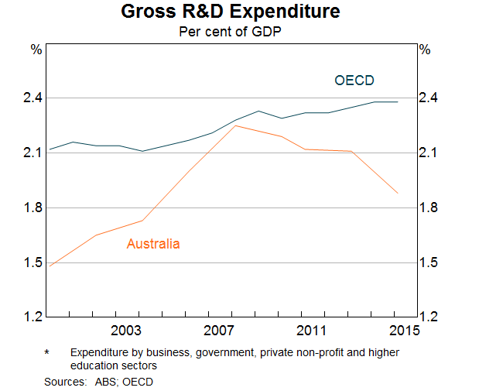

The size of this divergence is even starker when you compare Australia with the top 5 OECD countries now averaging a 3.7% GDP expenditure on R&D……….. double what we are investing!

The major cause of this decline in Australia is BERD which has been steadily in decline since 2008, falling from 1.4% to just 1%[2]. During the same period, BERD in our leading competitor nations has been increasing. **This is a divergence that warrants significant national attention.**

***Slide 2****: Australia’s expenditure on research and development compared with peers, 2015 (Source ISA 2030 Plan)*

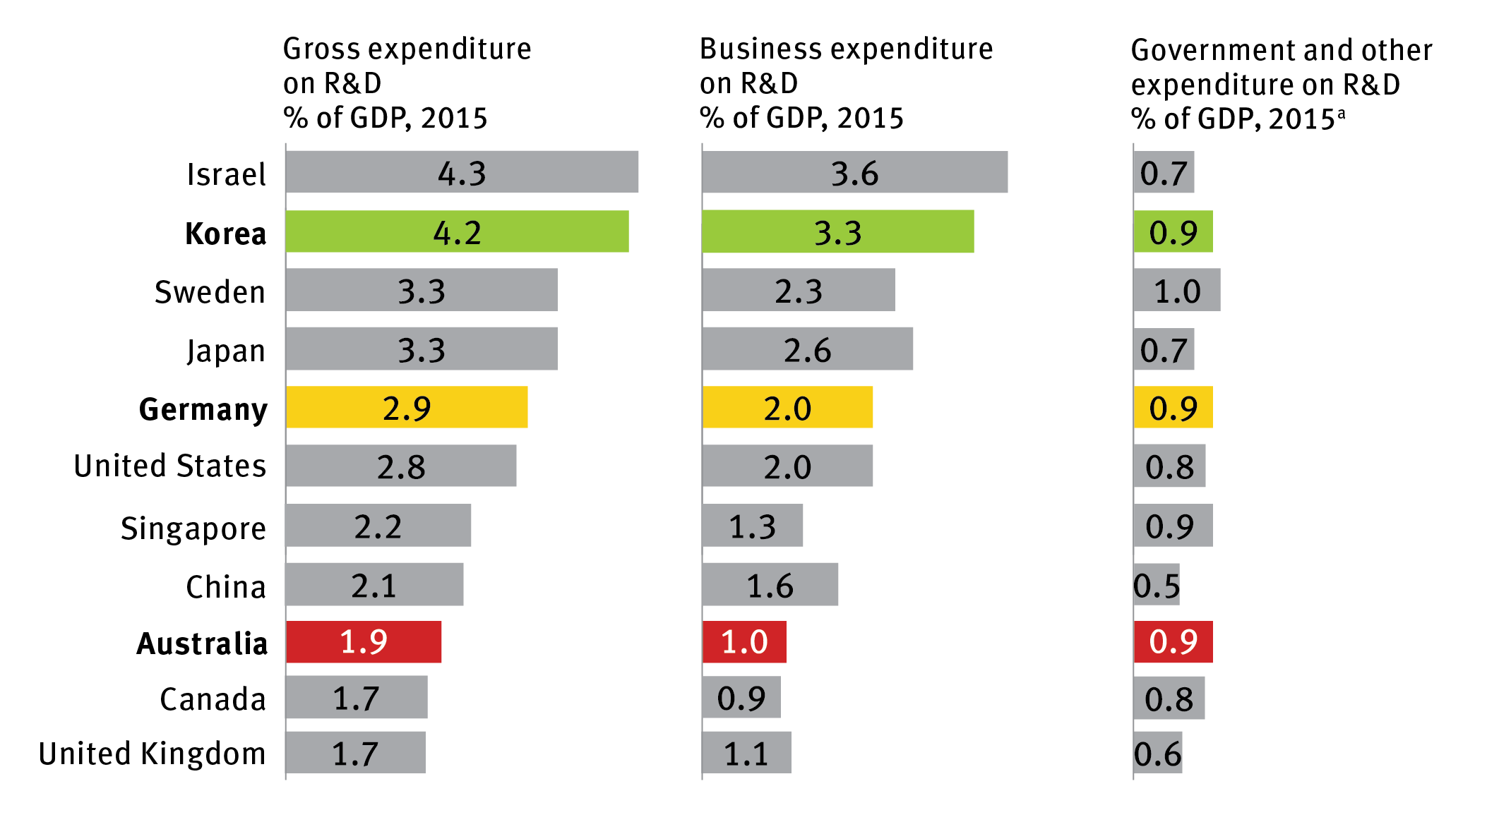

Consider the international comps in slide 2.

Take three countries – Australia, Germany and South Korea. As the third column on slide 2 shows, in all three the expenditures by Government are the same, at 0.9% of GDP. But look at the very different investments by business: 1% in Australia, 2% in Germany and 3.3% of GDP in South Korea. Putting it another way, the leverage on public sector investment is only 1.1 times in Australia, but 2.2 times in Germany, and 3.7 times in South Korea. In Israel the leverage is 5 times.

So why the massive difference? Is it cultural? Is it the quality of currently available government support programs? Our hypothesis is that a key path to address these disparities should be through re-thinking the **form,** andnot just the **amount,** that government support for business R&D takes in Australia compared with the leading innovation nations.

As this next slide shows, in most of our competitor countries, the majority of incentives are direct not indirect ……. Indeed some like Germany, Sweden and Israel have zero indirects and only utilise direct measures to drive their BERDs. We believe a smarter rebalancing of our direct and indirect support mechanisms is overdue and will be essential to reversing Australia’s decreasing levels of business investment in innovation.

***Slide 3****: Percentage of direct vs indirect government funding for business research and development, 2015 (Source OECD 2017 report).*

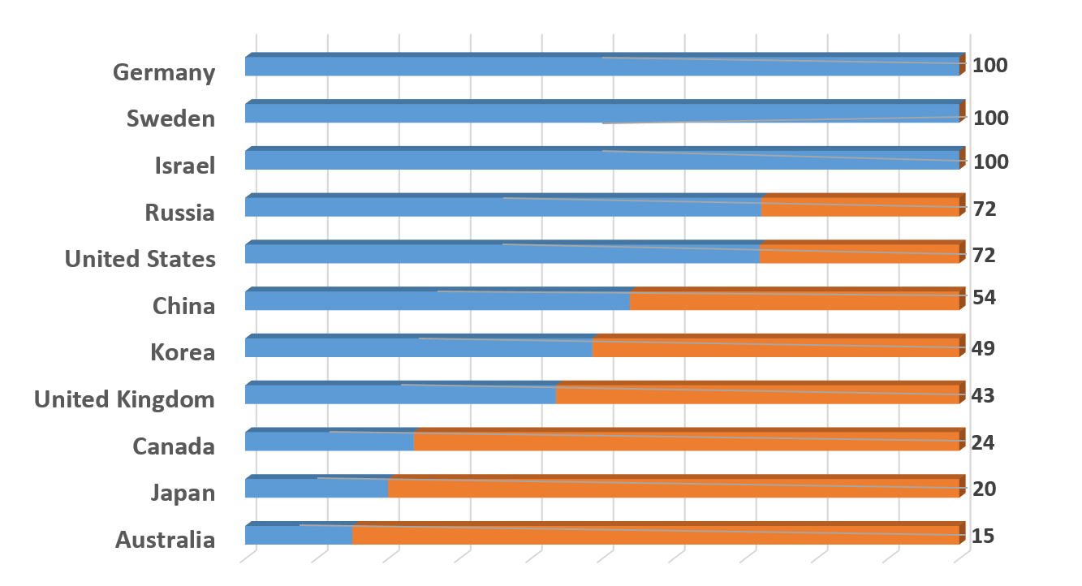

So what do I mean by “Direct” instead of “Indirect” incentives?

Unlike the indirect RDTI, agnostic as to sector, self-assessed and continually available regardless of performance outcomes, direct incentives seek to powerfully leverage Government investment in innovation and have the following characteristics and objectives:

1. Expand availability of risk capital
2. Expand access and size of markets
3. Leverage collaboration for commercialisation
4. **Expansion of Available Risk Capital via Government Co-Investment** Where scale and/or risk otherwise intimidatesand holds back activity in the small domestic market economy of Australia, Government co-investment can leverage private sector action. Think the recently established Biomedical Translation Fund (BTF), a $500 million VC fund, established with ISA’s recommendation and guidance, with 50/50 sharing of equity funding by the Government and private sector investors. The rationale for this fund was to ensure we don’t continue to squander the fantastic health and medical research breakthroughs achieved by our researchers. The $500m of VC, managed by three private life sciences management companies, is now available for development of new drugs and devices through clinical trials into the market place.

Since getting up and running in 2017, the BTF has already provided venture capital of almost $80 million to 12 young companies commercialising a range of exciting innovations including:

* Certa Therapeutics which received $22 million to help commercialise breakthrough kidney disease treatment, and there are currently no effective therapies for this condition worldwide.
* Prota Therapeutics which received $10 million to commercialising novel treatments for peanut allergies in kids. Prota's treatment differs from others in that it allows children to stop ingesting peanut flour, and include regular peanuts in their diet. This will be Australia's first oral treatment for peanut allergies with potential for other common food allergies including allergies to milk, egg, and other nuts.
* Global Kinetics Corporation which received $7.75 million to develop technology that will help Parkinson’s sufferers self-manage their disease. GKC’s wrist-worn medical device, improves the management of and guides therapy in Parkinson’s Disease patients. The device has been used in over 20,000 patients tests and in many cases, it provides a significant and prolonged improvement to a patient’s disease management and quality of life. While still early in the commercialisation the device is currently being sold in 16 countries.

Without the availability of the BTF risk capital and expertise these breakthrough products and IP would continue to drift offshore or simply die in the laboratories. This leverage which Government co-investment delivers is exemplified by the way it has attracted and enabled some of the nation’s leading superfunds to match the Government’s $250 million with the long term and patient risk capital previously eschewed. So there is private sector dollar for dollar skin in the game and the individual projects are selected by experienced private life sciences fund managers.

The BTF demonstrates the power of targeted co-investment by Government.

* 1. **Expansion of market size and access via Government as a large and innovative customer**

Government can choose to foster innovation through its procurement processes. In 2015-16, Australia ranked only 70th out of 144 countries on how government procurement fosters innovation. Leveraging government procurement (federal government spend was $47.3 billion across 64,092 contracts in 2016-17[3]) to drive innovation is a complex challenge. But the success of international initiatives suggest that we should try harder.

Following its NISA announcement in December 2015, the Government launched the Business Research Innovation Initiative (BRII). This was based on other nations’ established procurement experiences with challenge grants in particular the US, Small Business Research Innovation Program (SBIR). ISA assisted the design and roll-out of a pilot BRII program which included two main objectives:

* To solve problems and opportunities identified by government departments by funding SME’s able and willing to create, prototype and test innovative solutions.

* To enable scale up and commercialisation of such solutions to a wider customer base.

I mentioned that this approach had been successful overseas. In the U.S, for example, companies like Intel and Compact have gone through the Small Business Innovation Research Program (SBIR) and successfully commercialised their ideas. The SBIR invests around $2b USD per annum in about 4,000 companies, ranging from $150,000 feasibility studies up to $1m USD for prototype development[4]. The program has generated a significant multiplier effect for the US economy across its lifetime, including attracting around $65b USD in private venture capital[5].

A more contemporary example is Illumina: a global leader in genome sequencing equipment which at the most fundamental level enables the ability to read and understand genetic variation. It received its first SBIR award in 1999. In January 2014, Illumina announced a milestone in life sciences by introducing a system that researchers can use to sequence the genetic code of a human for approximately $1,000. Today the company has grown to over 5,000 employees globally and generated revenues of $2.2 billion in 2015.

**2.2 Expansion of market size and access via export development grants**

This is not about “picking winners” per se; but it is unashamedly about supporting demonstrated high performance sectors.

Our 2030 plan calls for an expansion of Austrade’s EMDG program. Given exports are a strong proxy for innovative and competitive performance, we view this as a very effective direct program[6].

Consumer households in Asia are expected to double from 600 million today to 1.2 billion by 2030. While this will offer fantastic opportunities, our distance from key Asian export markets is an issue, and the distinct cultural, linguistic, business and regulatory environments within these markets are significant barriers to entry. If this does not present a market failure per se it certainly signals a market challenge for Australian SME’s, perhaps a uniquely Australian market challenge that we need to deal with.

We believe there is a very large multiplier opportunity via a significant expansion in targeted EMDG programs.

**3. Grants which leverage Collaboration for Commercialisation**

One such existing direct measure is the successful Co-operative Research Centre Program (CRC). Since 1990 this program has achieved a leverage of 4 times the Government investment by support from academia and industry[7] . Given its success, it is a program that has been largely copied by others offshore (e.g) the Catapault Program in the UK. The success of CRCs is captured in the story of the Capital Markets CRC. Twenty years ago Professor Michael Aitken, CEO of the CRC and 2016 winner of the Prime Minister’s Prize for Innovation, developed software that could define and test fairness and efficiency of financial markets. Capital Markets CRC also spun off SMARTS, a real-time surveillance software that services regulators, exchanges, and brokers in capital markets. In Europe, this surveillance solution has helped to reduce instances of insider trading by 26 per cent. SMARTS has been and adopted by more than 40 national exchanges and regulators and 150 brokers across 50 countries.[8].

The CRC-P program is a recent iteration emphasising a greater role for industry and focusing on shorter terms (up to 3 years) for achieving market tested commercialisation of new products and services. The CRC-P program has backed an incredible range of technologies aiming to make tangible improvements to people’s lives; from driver monitoring systems that help tackle fatigue in truckies, to new technologies for rocket propulsion systems, through to using Artificial Intelligence to improve cancer diagnosis. In just its first five rounds of funding the program has supported 63 Projects with $133m, which has leveraged an additional $320m of partner cash and in-kind support, and I am happy to say that demand remains very strong.

So these are some of the significant direct measures available to correct the imbalance in our business incentives and to reverse the decline in BERD.

ISA looks forward to working with government to develop suitable policy options which would allow all of them to be actively prioritised and expanded.

Importantly, this is not just about Government; to be clear we believe that an appropriate re-allocation by Government of its current “indirect” incentive expenditures of $3 billion per annum can fund most of the “direct” measures referred to above. This would require about $1 billion per annum now and growing to about $3 billion per annum by 2030. But business, big and small, scientists and researchers in institutions, big and small, will also have to step-up to respond with about a 3 x 1 multiplier of activity and funding.

**CONCLUSION**

Are we really committed to becoming a top tier nation? While we commend the Government for taking the actions and responses to our 2030 Plan that I’ve outlined today, it is very clear much more needs to be done.

Unless Government, Business and other key stakeholders take the BERD challenge seriously, our 2030 ambitions will not be achieved.

**Thank you.**

1. Ellis, L. 2017. ‘Where is the Growth Going to Come From?’ *Reserve Bank of Australia*: https://www.rba.gov.au/speeches/2017/sp-ag-2017-11-15.html
2. Innovation and Science Australia. 2016. *Australia 2030: Prosperity through Innovation*. p.40: [www.industry.gov.au/isa](http://www.industry.gov.au/isa)
3. Department of Finance. 2017. ‘Statistics on Australian Government Procurement Contracts’: <https://www.finance.gov.au/procurement/statistics-on-commonwealth-purchasing-contracts/>
4. US Small Business Administration Office of Investment and Innovation. 2016. ‘SBIR/STTR is a Gated Process with Three Phases’: <https://www.sbir.gov/sites/default/files/SBIR%20Overview-%20DEC%202016.pptx>
5. European Investment Bank. 2016. ‘Access-to-finance conditions for KETs companies’. Produced by InnovFin Advisory. p.60: http://www.eib.org/en/infocentre/publications/all/access-to-finance-conditions-for-kets-companies.htm p.60
6. Office of the Chief Economist. 2017. *Australian Innovation System Report*. p. 56.
7. Miles, D. 2015. ‘Growth through Innovation and Collaboration: A Review of the Cooperative Research Centres Programme’: <https://www.google.com.au/url?sa=t&rct=j&q=&esrc=s&source=web&cd=1&cad=rja&uact=8&ved=2ahUKEwjAmOG-i77cAhUO7bwKHWXNBTgQFjAAegQIARAC&url=https%3A%2F%2Fwww.business.gov.au%2F~%2Fmedia%2FBusiness%2FCRC%2FCooperative-Research-Centres-Miles-Review-Growth-through-Innovation-and-Collaboration-WORD.ashx%3Fla%3Den&usg=AOvVaw0Xz2LPO7JU-9ZvmTMtBDC6>
8. Department of Industry, Innovation and Science. 2016. ‘Capital Markets CRC – Fairness underpins efficiency: the profitable innovation saving Australia billions’. p.1.