



Innovation and Science Australia Annual Report 2016-17

**Online version**

The online version of this report can be accessed: [www.industry.gov.au/ISA](http://www.industry.gov.au/ISA)

**Contact**

Department of Industry, Innovation and Science,

GPO Box 2013, Canberra ACT 2601

Email: [office@isa.gov.au](mailto:office@isa.gov.au)

© Commonwealth of Australia 2017

This work is copyright. Apart from any use permitted under the *Copyright Act 1968*, no part may be reproduced by any process without prior written permission from the Commonwealth.

Requests and enquiries concerning reproduction and rights should be addressed to the Department of Industry, Innovation and Science, GPO Box 2013, Canberra, ACT 2601.

Designed and typeset by Digital Design Team, Corporate Network, **Department of Industry, Innovation and Science** Canberra.

This publication is identified as *Innovation and Science Australia Annual Report 2016-17*.

ISSN 2208-7885 (print)

ISSN 2208-7893 (online)

ISBN: 978-1-922125-49-1 (print)

ISBN: 978-1-922125-50-7 (online)

# Letter of Transmittal

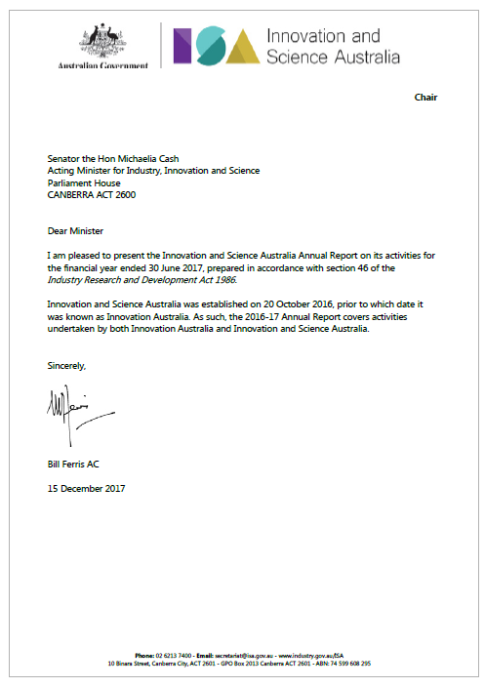

Contents

Letter of Transmittal 3

Innovation and Science Australia’s strategic objectives 5

Chair’s Report 6

CEO’s Report 10

Section One - Activity Overview 13

Introduction to Innovation and Science Australia 14

ISR System Review 2016 16

2030 Strategic Plan 21

Program overview 23

Program overview – Research & Development (R&D) Tax Incentive Program 25

Program overview – Cooperative Research Centres Program (CRC) 31

Program overview – Venture Capital programs 42

Program overview – Biomedical Translation Fund (BTF) 47

Program overview – Entrepreneurs’ Programme 50

Program overview – Business Research Innovation Initiative (BRII) 60

Legacy programs 68

Advocacy overview 69

Section Two – Governance 71

Innovation and Science Australia 72

Legislation 72

*The Industry Research & Development Act 1986* 72

Organisation and management 74

Acronym list 86

Index 89

# Innovation and Science Australia’s strategic objectives

Objective 1: Inform Australian Government policy on Australian innovation, science and research.

Objective 2: Oversee innovation programs to ensure effectiveness and efficiency of delivery.

Objective 3: Advocate and champion for Australia’s innovation, science and research system.

# Chair’s Report

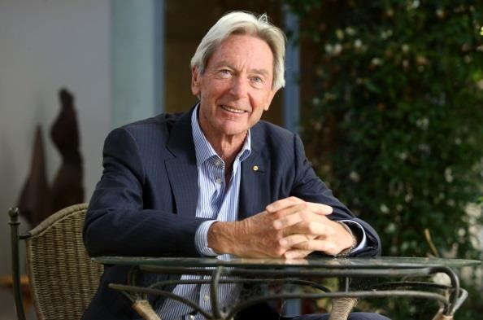

I am pleased to present the *Innovation and Science Australia Annual Report* for 2016-17—my second report as Chair of Innovation and Science Australia (ISA or the Board). ISA, which was formerly Innovation Australia before being re-invigorated as part of the National Innovation and Science Agenda (NISA), has the remit to provide whole-of-government advice on innovation, science and research matters, in addition to its oversight and advocacy roles.

The benefits that innovation have brought to our lives are all around us; Australians now live much longer, healthier, and more fulfilling lives and Australia has one of the highest standards of living in the world thanks to our embrace of technological progress. Through a combination of natural advantages, ingenuity and courage to invest and to make changes, we’ve kept up high standards of health, education, social services and public amenity. We’re not perfect, but we’re a much more equal society than most.

2016-17 has seen a great deal of activity for ISA. In October 2016, ISA was formally established when legislation came into force. The former Innovation Australia board had taken up the additional responsibilities of ISA in December 2015. As part of the transition from Innovation Australia to ISA, I also welcomed Dr Charles Day as the inaugural CEO of the Office of Innovation and Science Australia (OISA). OISA supports the Board in its advice to Government, program oversight and advocacy roles. I would like to again thank Ann Bray for her work as interim CEO of OISA during its establishment phase.

The Board has continued its oversight of key innovation programs in 2016-17. The launch of the Business Research and Innovation Initiative (BRII) in August 2016, and the announcement of fund managers and commencement of investment activity for the Biomedical Translation Fund (BTF) in December 2016, are welcome additions to the suite of measures encouraging research and development, investment and venture capital activities.

The Board has advocated strongly for Australia’s innovation, science and research system. The Board and the CEO of OISA have engaged broadly with stakeholders across the country in research, business and all levels of government. We have presented to, or participated in panel discussions for, a number of forums, including at the AFR Innovation Summit, Westmead Research Hub, Australian Private Equity and Venture Capital Association, American Chamber of Commerce in Australia, Sydney International Women’s Day Breakfast, Business Council of Australia, Women in VC Forum, Young Presidents’ Organization Global Innovation Week, CeBIT Conference, and the CRC Association Collaborate Innovate 2017.

I would like to thank members of the Board and its committees for their contributions in the past year. In particular, I would like to thank Mr Nixon Apple and Ms Susan Wilson, who concluded their time on the Board this past year. I also welcome those new board members appointed during this period: Dr Bronte Adams AM, Dr Rufus Black, Ms Beth Comstock and Professor Bronwyn Harch. I would also like to thank the Board’s international members, Beth Comstock and Saul Singer, for the time they have given in the past year to visit Australia and engage with stakeholders.

When I joined ISA, the Board had two immediate priorities: firstly, to conduct a performance review of the Innovation, Science and Research (ISR) system to find out where Australia stood in relation to our peer competitor nations; and secondly, to develop a strategic plan for the ISR system to set out a path to where we wanted Australia to be in 2030. I am pleased to report that the Board delivered on the first priority, the *Performance Review of the Australian Innovation, Science and Research System 2016* in February 2017, and delivered the 2030 Strategic Plan to Government in November 2017.

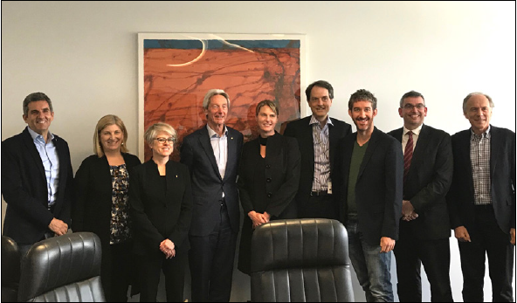

***From left: Daniel Petre AO, Professor Bronwyn Harch, Dr Bronte Adams AM, Bill Ferris AC, Maile Carnegie, Dr Rufus Black, Scott Farquhar, Dr Charles Day, Dr Alan Finkel AO.***

ISA’s vision for Australia in 2030 is for our nation to be counted within the top tier of innovation nations, known and respected for its excellence in science, research and commercialisation. Innovation, underpinning a diversity of internationally competitive industries, will enable current and future generations to have meaningful work, and a great quality of life, in a fair and inclusive society.

Ensuring that Australia improves our innovation performance will be crucial to realising the opportunities and meeting the challenges that the future will bring. Australia is in an intense innovation race with other developed and developing countries. For us to not only maintain our position but to improve it, we need to deepen, and draw down on, our strengths as knowledge producers and our self-belief as innovators.

As an enterprising and ambitious country, standing still is not an option. By putting our energies into creating a world-class Australian innovation system, we are giving our children the best chance at thriving in an Australia successfully navigating the world stage in 2030.

The Board has focused on delivering a bold and actionable 2030 Strategic Plan to Government to position Australia to become a leading innovation nation, and we look forward to working with stakeholders from across the innovation system to bring our vision to reality.

Bill Ferris AC

Chair

# CEO’s Report

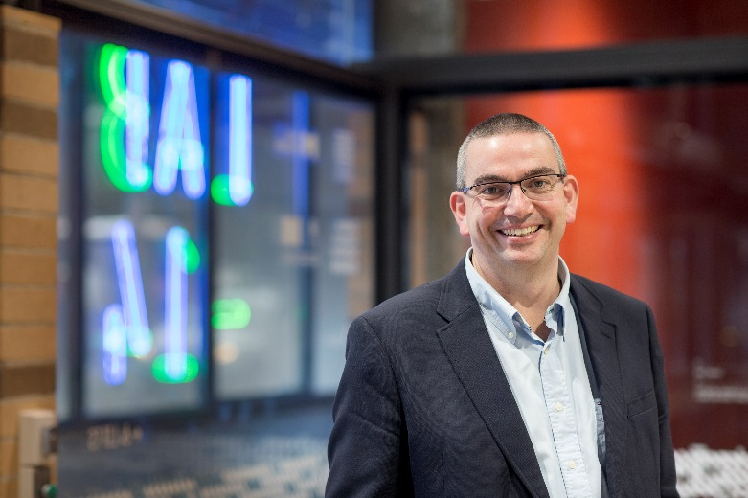

Since joining the Office of Innovation and Science Australia (OISA or the Office) as its inaugural CEO in November 2016 it has been a fast and exciting ride. Innovation and Science Australia (ISA), the independent statutory board that OISA supports, has had a big year in the 2016-17 reporting period, including release of a key deliverable in the *Performance Review of the Australian Innovation, Science and Research System 2016* and commencing development of the 2030 Strategic Plan, including a comprehensive stakeholder consultation.

ISA was established to assist the Australian Government in ensuring that Australia reaches its innovation potential and delivers wellbeing and prosperity for all Australians into the future. This is an ambitious but eminently achievable goal. The Australian innovation, science and research system is complex and dynamic, with a network of many diverse players who interact to produce and spread innovations that have economic, social and environmental value. Part of my role as CEO of the Office that supports the ISA board is to facilitate the Board’s engagement with all levels of government and the broader industry, innovation and research communities and ensure that a productive two-way dialogue is maintained.

To provide structure and direction to achieving the Government’s expectations of ISA, the Board has identified three strategic goals that are based on the functions of the Board as defined by legislation:

1. Inform Australian Government policy on Australian innovation, science and research
2. Oversee innovation programs to ensure effectiveness and efficiency of delivery
3. Advocate and champion for Australia’s innovation, science and research system.

Each of these strategic objectives is important to ensuring that Australia improves the performance of its innovation, science and research system. As noted above, the Australian Government is one of many players in the system, and in order to play its role consistently and constructively it benefits greatly from advice framed by the robust, whole-of-government perspective that ISA brings. As key mechanisms for Government support of the system, the innovation programs that ISA oversees will not deliver quality outcomes for Australia unless those programs are effective and efficient. And finally, our innovation communities are strongly influenced by confidence and cultural factors, and ISA plays a key role in advocating for these communities, and promoting confidence in Australia’s innovators and researchers to drive investment in our economy.

In 2016-17, ISA’s activities have had a strong focus on delivering on the Board’s strategic objective of informing Government policy on Australian innovation, science and research. Following the release of the Performance Review in February 2017, the Board turned its attention to developing a 2030 Strategic Plan. A highlight for our team was the consultation process, which took us to all corners of Australia, from Darwin to Hobart, and Bunbury to Wollongong. The diversity we see in the system is both a strength and a challenge for us as we think about the interaction between national policy and vibrant local innovation communities.

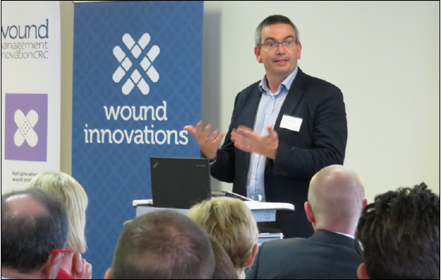

***Dr Charles Day speaking at the opening of Wound Management Innovation CRC in March 2017***

Whilst the Performance Review and the 2030 Strategic Plan have taken a lot of the Board’s time this year, the Board has also been involved in providing input, both in public and privately, on a range of issues that are important to the various communities that make up Australia’s innovation, science and research system.

Whilst the Board’s strategic role in program oversight is often focused on process and governance issues, it has also enabled me to see first-hand some of the great success stories in our system. One such opportunity was the opening of Wound Innovations, a key outcome of the Wound Management Innovation Cooperative Research Centre (WMI CRC) in March 2017. It was a great opportunity to meet with both clinicians and patients who are applying world-leading science to relieve suffering and improve quality of life.

In the year ahead, the Office will work closely with the Department of Industry, Innovation and Science to further enhance our capacity to rigorously capture and evaluate the outcomes of all the programs we oversee, so that we can be as effective in refining and enhancing their impact as the innovators we seek to support.

Through its advocacy activities ISA seeks to raise the profile of Australia as an innovation nation both here and overseas - promoting confidence in its innovation, science and research capability and attracting investment into our innovation system. Led by the Chair, our Board members are regularly asked for comment in the mainstream media, and have given a number of speeches throughout the year. My own activities have included speeches and panel discussions on a range of topics to audiences large and small – a memorable example being the CeBIT conference in Sydney in May where I had the privilege of moderating a panel of entrepreneurs and investors on the topic of “Accelerating and Incubating the next big idea”. The passion in our startup community, and the very real results they are achieving, was certainly on display that day.

Like Bill, I would also thank Ann Bray for her work as interim CEO of OISA. Her work to establish, and staff, the Office smoothed the way for my commencement as CEO and assisted in allowing me to quickly focus on the development of ISA’s 2030 Strategic Plan.

Dr Charles Day

CEO

# Section One - Activity Overview

Introduction to Innovation and Science Australia

Strategic advice overview

Program overview

Advocacy overview

## Introduction to Innovation and Science Australia

Innovation and Science Australia (ISA) was announced as part of the Australian Government’s National Innovation and Science Agenda (NISA) in December 2015, and became an independent statutory board on 20 October 2016. Prior to this the Board was known as Innovation Australia which had been established under the *Industry Research & Development Act 1986* (*IR&D Act*) to assist with the administration and oversight of the Government’s industry innovation and venture capital programs.

ISA’s remit is broader than that of Innovation Australia, and includes the provision of strategic whole-of-government advice to Government on all innovation, science and research matters. ISA’s role and responsibilities are defined by the *IR&D Act*, the Government’s Statement of Expectations issued to ISA and any directions issued by the Minister for Industry, Innovation and Science to ISA. The Government’s Statement of Expectations and ISA’s response, a Statement of Intent, are published on the [www.industry.gov.au](http://www.industry.gov.au) website.

The Board has agreed to three strategic objectives in order to fulfil its role:

1. Inform Australian Government policy on Australian innovation, science and research.
2. Oversee innovation programs to ensure effectiveness and efficiency of delivery.
3. Advocate and champion for Australia’s innovation, science and research system.

The reporting on activities of ISA are structured in this Annual Report according to how they contribute to ISA fulfilling its strategic objectives.

**Strategic advice overview**

ISA’s first strategic objective is to ‘inform Australian Government policy on Australian innovation, science and research’. This objective is derived from the functions of ISA as set out in section 7(aa)-(ad) of the *IR&D Act*, requiring ISA to provide independent strategic advice to the Government on industry, innovation, science and research matters, and listing ways in which ISA may provide this advice including in the form of audits and commissioned research papers.

In March 2016, the Government asked the Board to undertake a comprehensive audit of Australia’s science, research and innovation system and develop a long term, 15 year national innovation and science plan to assist in directing the Government’s investments against the Government’s science and research priorities. ISA prioritised this request of the Government throughout the 2015-16 and 2016-17 reporting periods, resulting in the delivery of the *Performance Review of the Australian Innovation, Science and Research System 2016* and the development of the 2030 Strategic Plan (as outlined below).

ISA advice is intended to complement the work of the Commonwealth Science Council, which advises the Government on high-level science challenges facing Australia. Throughout 2016-17 ISA has engaged with the Growth Centres Advisory Committee, CSIRO, and the Centre for Defence Industry Capability Advisory Board to determine avenues for improving the alignment of innovation programs and maximising potential spill-over benefits to the broader economy from government research and procurement. ISA’s work with these important bodies will continue into the foreseeable future.

ISA has also provided advice, both publicly and privately, on a number of matters that the government has publicly consulted on during 2016-17 including: changes to the immigration program, intellectual property issues such as the copyright safe harbour scheme, the ATO review of scholarships, and crowd-sourced equity funding legislation and guidelines.

### ISR System Review 2016

ISA released the *Performance Review of the Australian Innovation, Science and Research System 2016* (ISR System Review) in February 2017.[1] The ISR System Review used a simple framework to examine the overall strengths and weaknesses of the ISR Systems activities in knowledge creation, knowledge transfer and knowledge application through the lens of innovation enablers.

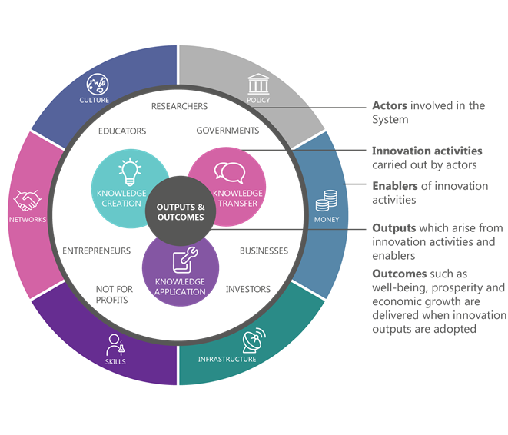

In the ISR System Review, ISA considered a range of performance metrics that characterise the current ISR System, and, where appropriate, compared them to the performance of systems in other OECD+ countries (the 35 OECD member countries in addition to China, Taiwan and Singapore).

The ISR System Review provided, in part, a baseline from which to measure future progress through the adoption of suitable metrics, recognising the limitations of existing frameworks as aids to policy. The ISR System Review introduced a new Australian scorecard, calibrated to the needs of Australian decision-makers through measures of particular relevance to our ISR System, and informed by the global evidence. More than 250 available metrics gathered by domestic and international bodies such as the OECD were assessed and prioritised to identify 20 most pertinent and relevant performance indicators.

**ISR System Review performance scorecard**

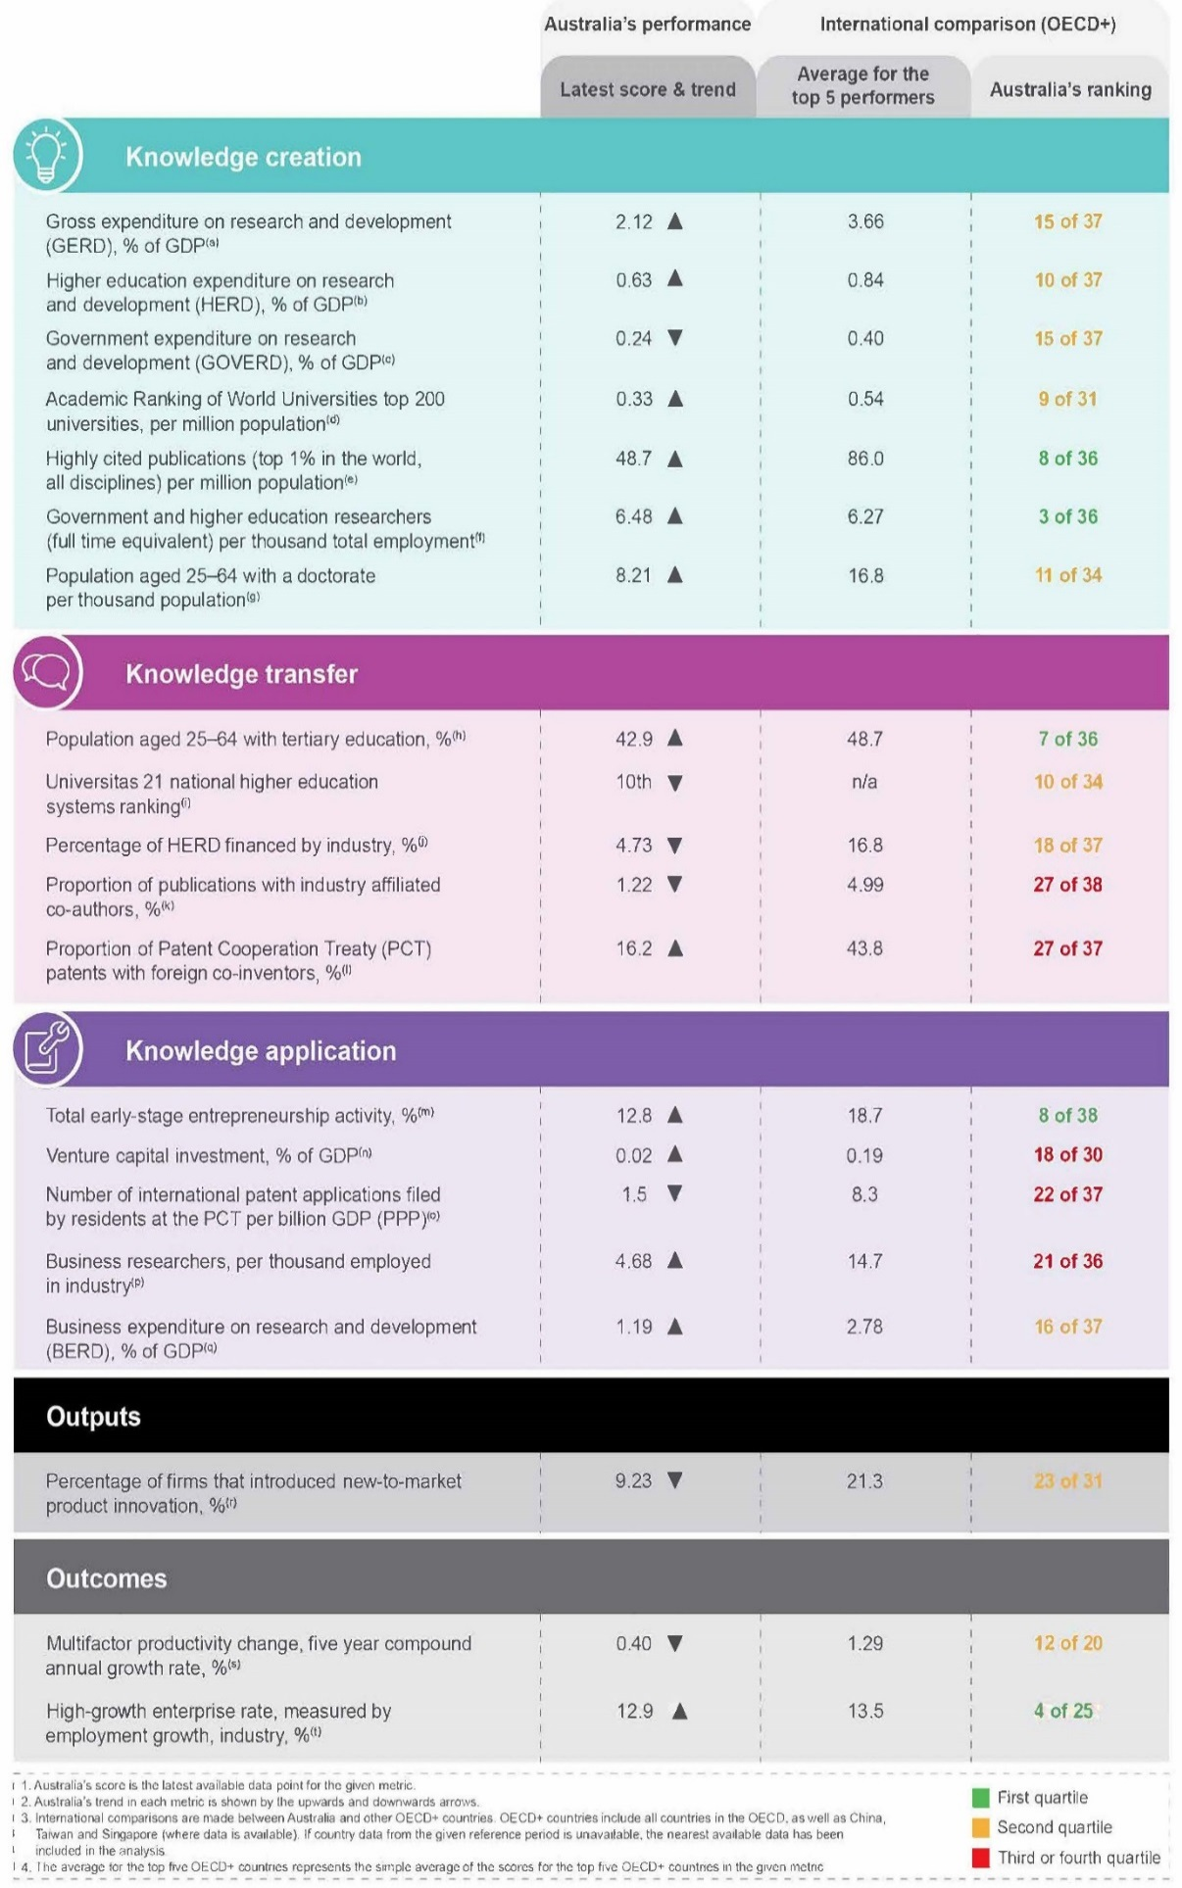

The ISR System Review did not make specific recommendations for future government decisions, but instead provided a baseline from which to develop the 2030 Strategic Plan and measure future progress.

Findings of the ISR System Review are:

|  |
| --- |
| Knowledge creation: Australia is above average |
| * Australia has higher relative levels of funding for R&D activities in higher education and not-for-profit organisations compared to other nations. * Australia has world-class research infrastructure assets although there is a need for overarching governance and ongoing, whole-of-life funding. * Australia’s research workforce is world class in a number of fields. Australia achieves much better research outputs than would be expected from the number of people engaged in research. Australia ranks 8th out of 36 OECD+ countries in its contribution to the top 1 per cent of highly cited research publications per capita. * Australia has good levels of research-to-research collaboration. * Despite a strong and internationally competitive university system, no Australian university is ranked in the global top 20. |
| Knowledge transfer: needs to be improved |
| * Data sharing is improving and there is an increase in the availability of government data sets. * Australia has a highly educated population and sufficient levels of basic skills, however there are some concerning trends. Emerging data on STEM education in particular is a cause for concern. * There is an increasing focus on networks to facilitate relationships and support collaboration across institutions and businesses. * There are few direct mechanisms in Australia to support knowledge transfer and collaboration between researchers and businesses appears limited. * Compared to other countries, Australia under-utilises vocational education and training to build skills for innovation. * Australia’s multicultural society is an important asset, but diaspora could be leveraged more. Australia’s uniquely multicultural society is a strength, and our diverse population, including our diaspora, has the potential to contribute more to innovation. |
| Knowledge application: not yet matching the strength in knowledge creation |
| * Australia has strong regulatory frameworks and sound banking, legal and corporate sectors; however, there are regulatory restrictions in some specific areas. * Financial markets generally function well, although access to risk capital has been a constraint. * Skilled migration contributes significantly to Australia’s skills base. * A number of vibrant start-up ecosystems are flourishing around the country. * Relative to other countries, government procurement could do more to foster innovation. * Australian business expenditure on R&D is low relative to expenditure in other countries. * There are ongoing business, management and leadership skills gaps and the current supply of ICT graduates is not meeting industry needs. * Australian businesses rank poorly on international collaboration. |
| System-wide |
| * New statistical methods will better inform decision-making and allow for the proper evaluation of program impact. * Australia’s multicultural society is an important asset, but Australia’s diaspora could be better leveraged. * Australia’s short-term oriented culture may affect innovation in different ways and Australia remains a gender-unequal society. |
| Outputs |
| * Australia has innovative SMEs and some highly innovative sectors, however Australia’s innovations are not that novel. In many sectors innovations introduced by Australian businesses are new to the business only and reflect a low degree of novelty. |
| Outcomes |
| * Australia’s economic performance has been strong compared to other nations and Australia has performed well on a number of well-known indices of social outcomes, however there has been a slowdown in productivity growth. |

In undertaking the ISR System Review, ISA was supported by a project specific taskforce located within the OISA. During consultations for the Review, ISA met with almost 300 representatives from more than 100 organisations over a seven month period (from April to December 2016) from higher education, research and business sectors, through one-on-one meetings and a series of roundtables held in July and November 2016. ISA engaged with representatives from Commonwealth, State and Territory Governments throughout the course of the review process. ISA also sought input to the ISR System Review from stakeholders using an online survey tool.

### 2030 Strategic Plan

In the second half of the reporting period, ISA commenced development of the 2030 Strategic Plan to respond to the insights of the ISR System Review and to lay out a vision and strategy for Australia’s innovation, science and research system out to 2030. The 2030 Strategic Plan is to provide a single vision, strategy and set of imperatives for government to consider, and policy-makers to act on, that is based on evidence, expertise and experience from every part of Australia’s innovation, science and research system. ISA delivered a 2030 Strategic Plan to Government in the final quarter of 2017 that:

* lays out a long-term vision for how Australia’s innovation, science and research system can help deliver the future Australia aspires to, and the role of different players in achieving it;
* gives policy-makers actionable whole-of-government recommendations to secure this future vision; and
* provides a rigorous performance appraisal mechanism that defines what success looks like, and can be used to hold players in the innovation, science and research system to account to achieve it.

ISA has undertaken an extensive consultation process to support the development of the 2030 Strategic Plan engaging widely with businesses, industry, researchers, teaching institutions, all levels of government and non-government agencies, and the broader community. The consultation process has included:

* establishment of an Expert Reference Group, comprising of almost 40 thought leaders drawn from the innovation community
* stakeholder roundtables held in major cities and regional areas between March and May 2017
* release of an Issues Paper between March and June 2017 for public comment.

ISA also established a Commonwealth reference group, of senior executives from most Commonwealth departments, for information sharing across government.

The Issues Paper released for public consultation on 24 March 2017 identified six strategic challenges that framed ISA’s key areas of focus for developing the 2030 Plan:

* + 1. Moving more firms, in more sectors, closer to the innovation frontier
    2. Moving and keeping Government closer to the innovation frontier
    3. Delivering high-quality and relevant education and skills development for Australians throughout their lives
    4. Maximising the engagement of our world class research system with end users
    5. Maximising advantage from international knowledge, talent and capital
    6. Bold, high-impact initiatives

ISA received 127 submissions in response to this Issues Paper.

Through the consultation process stakeholders have identified both strengths and weaknesses in our current system, and have provided valuable context for the policy issues ISA has been considering. A full report on the consultations will be published alongside the 2030 Strategic Plan.

In developing the 2030 Strategic Plan, ISA has been supported by a project specific taskforce located within the OISA, with secondees from various departments and agencies across the Federal Government. We thank those departments for their generosity and flexibility in providing this support.

## Program overview

ISA’s second strategic objective is to ‘oversee innovation programs to ensure effectiveness and efficiency of delivery’. As at 30 June 2017, the programs and initiatives that the Board administered and provided oversight for included:[2]

**R&D Tax Incentive program**

* Refundable element
* Non-refundable element

**Cooperative Research Centres program**

* Cooperative Research Centres (CRCs)
* Cooperative Research Centres Projects (CRC-Ps)

**Venture Capital programs**

* Early Stage Venture Capital Limited Partnerships (ESVCLPs)
* Venture Capital Limited Partnerships (VCLPs)

**Biomedical Translation Fund (BTF)**

**Entrepreneurs’ Programme (EP)**

* Accelerating Commercialisation (AC)
* Business Management (BM)
* Incubator Support (IS)
* Innovation Connections (IC)

**Business Research Innovation Initiative (BRII)**

A committee structure assisted the Board to oversee these programs. The programs were delivered by AusIndustry, within the Department of Industry, Innovation and Science. The Australian Tax Office assisted the Department of Industry, Innovation and Science with the administration of the R&D Tax Incentive.

### Program overview – Research & Development (R&D) Tax Incentive Program

“*It was pleasing to see, in keeping with the policy objectives of moving from the previous R&D Tax Concession program to the R&D Tax Incentive program, that an increasing number of small and medium enterprises are using the R&D Tax Incentive to support their research, development and commercialisation activities. This is important for Australia as we transform our economy to secure Australia’s future.*

*To help improve program compliance, guidance was issued to support businesses registering R&D activities in the software, agriculture and construction sectors.”* Dr Marlene Kanga AM – Chair, Research & Development Tax Incentives Committee

R&D Tax Incentive program

The *R&D Tax Incentive* *program* is the Government’s principal measure to encourage industry investment in R&D. The program provides generous benefits in the form of tax offsets to eligible entities undertaking eligible R&D activities. To access the incentive companies are required to self-assess the eligibility of their R&D activities and register them with the department, and then claim a tax offset in their company tax return with the Australian Taxation Office (ATO).  
  
During 2016–17, the department continued to promote the *R&D Tax Incentive* and inform stakeholders with the release of customer guidance. This included:

* four specific-issue guidance products, three anonymised case studies of findings and updates to the six sector guidance products
* the department and the ATO releasing four joint taxpayer alerts on key risk areas
* engaging over 10 000 stakeholders through a suite of information products (workshops, bulletins, etc.)
* redesigning the *R&D Tax Incentive* web presence through a user-centric co-design process to enable customers to find the information they are looking for, more easily.

These activities better help customers to correctly self-assess their activities and provide a strong foundation on which to achieve the program’s objectives.

Key outcomes in relation to the *R&D Tax Incentive* at the end of June 2017 include[3]:

* Increased R&D activity with a record 13 567 companies (representing 15 321 R&D-performing entities) registered for the program for the 2015‑16 income year. This is an increase of more than 300 registered R&D-performing entities, up by 3.1 per cent year-on-year.
  + Growth of  5.1 per cent year-on-year in the participation of small and medium businesses (with an aggregated turnover of less than $20 million) in the program
  + An increase of $6.10 billion (up by 5.3 per cent year-on-year) in R&D expenditure by entities with a turnover of less than $20m in 2015‑16
  + The participation of more than 3400 Australian businesses new to the program during the 2015‑16 income year (22.2 per cent of total R&D-performing entities).
* Launching the R&D Tax Incentive e-learning module for Accountants and Tax Agents aimed at introducing the fundamentals of the R&D Tax Incentive to non-R&D specialisation accounting and tax professionals who deal with SME to better assist their clients to lodge eligible R&D Tax Incentive claims, based on a better understanding of the program and its benefits. The e-learning module was accessed 2316 times during 2016‑17.
* a number of decisions made by the Administrative Appeals Tribunal (AAT) on the review of ISA decisions. Each of these decisions aligned with the decisions made by ISA, and affirmed its application of the law.

Further information and details on the performance of the R&D Tax Incentive program is available on the department’s website ([www.industry.gov.au](http://www.industry.gov.ua/)).

On 28 September 2016, the Report of the Review of the R&D Tax Incentive program was released for public consultation. The Review recommended changes to improve the effectiveness and integrity of the program and achieve a stronger focus on encouraging additional research expenditure by business. The department supported the government in its extensive consultations and survey of stakeholders.

The Review report and supporting commissioned work are available on the department’s website ([www.industry.gov.au](http://www.industry.gov.au)).

***Major highlights***

* 3.1% increase in R&D activity. A record 15 321 companies registered for R&D program activities in 2015-16 (JULY-JUNE).
* $15.41 billion of equivalent R&D expenditure in the reporting period
* 3403 Australian business registered for the program for the first time.

Admedus Immunotherapies – Saving lives, improving health and enhancing the quality of life

*Vaccines are said to be one of the most cost-effective and successful health investments available and Admedus Immunotherapies is at the vanguard of delivering life-saving global vaccines against the human papilloma virus and providing relief for those already suffering from it.*

**Why R&D is needed**

Human papillomavirus, or HPV, is a common virus affecting both males and females and up to 80% of people will be infected with at least one type of HPV at some time in their lives. While HPV can be harmless for many, it can lead to cancers of the anogenital area and other HPV-related cancers, including cancer of the head and neck. The aim of Admedus Immunotherapies is to treat cancerous and pre-cancerous conditions caused by HPV infection with their HPV vaccine. Clinical studies will commence shortly.

The company is also developing a HSV-2 vaccine to reduce the transmission of HSV-2 as well as the painful outbreaks HSV-2 sufferers regularly experience. And it is achieving success; to date, the company’s work on their HSV2 vaccine is showing some benefit to those who carry the virus. However, more R&D work is needed so that the company can do more lab research, conduct more clinical trials and demonstrate how its research can be scaled to help more people.

**How the Research and Development Tax Incentive helps**

Admedus Immunotherapies CEO Neil Finlayson says the company’s participation in the Research and Development Tax Incentive (RDTI) program has given $3.37 million to the company over three years. He says RDTI makes the company more resistant to capital pressure – an especially important feature when you are wholly reliant on others to fund ground-breaking research.

As well as supplying much-needed capital to entice investors, the company’s R&D budget is also leading to employment opportunities for others. Indeed, Adelaide’s Trident Clinical Research (now INC Research) and Brisbane’s Clinical Network Services have both had to take on Project Managers, Medical Writers, Clinical Trial Monitors and Statisticians, and Brisbane’s QPharm has put on additional Study Nurses, Pharmacists and Clinicians for Admedus Immunotherapies’ clinical studies.

Looking forward, the company looks poised to achieve its clinical studies, eradicate HPV and relieve sufferers.



In turn, this will not only deliver a return on its investment for its shareholders but provide associated benefits of additional productivity and economic growth for the country.

“Sometimes when we need the money the opportunity isn’t there. If the share market is in the doldrums brokers would say this isn’t the right time to raise money,” he says.

“[For example,] for our HSV second study we were really struggling to do what we wanted to do. If we didn’t have the additional money, it could have been an under powered study. At the time we weren’t able to raise capital so we were between a rock and a hard place at that point. We were fortunate that we knew the [RDTI] return was coming.”

“Having a Government supportive of innovation and research gives confidence to investors to continue to provide funding for this essential research.” CEO Neil Finlayson

**RDTI Impact Facts**

* Australian employment opportunities across the supply chain
* Enabled essential clinical studies
* Intellectual Property secured
* Collaborations with University of Queensland and University of Washington

TrademarkVision – Protecting Australian brands and giving businesses IP confidence

To encourage, reward and protect innovation and creativity, Australian businesses need an IP system that is well-functioning, technologically-advanced and effective. Australian start-up TrademarkVision has used Artificial Intelligence to launch the world’s first visual search for trademarks. It’s not only changing the trademark landscape, but made visual IP searches completely free for the Australian public.

**Why R&D is needed**

Since its inception in 2013, TrademarkVision has been at the forefront of Artificial Intelligence. The founder Sandra Mau came out of an R&D role at National ICT Australia (NICTA) and the technology she has developed as founder of TrademarkVision is already changing the way IP searches are done internationally.

The company’s technology is currently embedded in the back-end of the Australian Government’s IP search system, as well as with the European Union Intellectual Property Office’s systems.

Ms Mau says her company is helping Australian businesses save time doing IP searches; which, prior to their technology was time-consuming and error-prone. And, because the company has worked alongside Government, it is now free for Australian businesses.

“When you come across a logo, it’s easy to compare it with your own, but when you want to compare it to millions, suddenly the task becomes very daunting.

For anyone who has ever wanted to create a unique logo or ensure their IP is safe from possible infringement, they know this process can take hours, days and sometimes weeks. Our technology cuts trademark, brand and logo searches down to seconds. It has the potential to not only improve brand owner’s lives, but completely change the game of brand protection. It is also saving Australian businesses money through related lawyer fees or the associated administration time of searching old-fashioned databases," Ms Mau says.

**How the Research and Development Tax Incentive helps**

TrademarkVision COO Cameron Mitchell believes in the current technology, but says that without continued focus and support into R&D they’ll be left behind.

“Being part of the RDTI program will allow us to concentrate on research that will set us up for continual growth and success. We want to maintain focus on R&D at all times, and without programs like this we wouldn’t be protected from distractions that would take us away from that commitment.

“Though this is the first year we’ve participated in the program we’re already planning to use the money to bring on more R&D staff, explore more Computer Vision projects, and grow our own IP and technology further.

For Australia, the trickle-down benefits are clear because the start-up’s technology has made visual IP searches free in Australia.

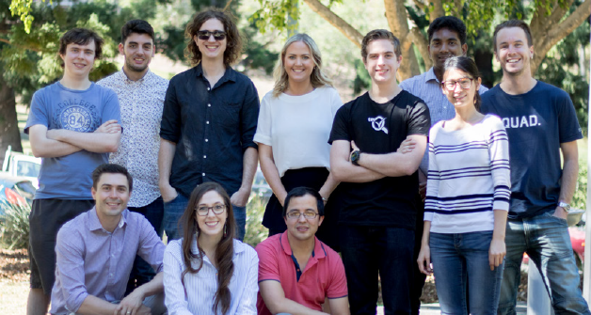

***TradeMarkVision staff from Brisbane office***

“This means we’re empowering all brands, small or otherwise, to have IP confidence. We hope to deliver even greater benefits to Australian businesses as our research progresses. Programs like RDTI will help enable those benefits come to life,” Mr Mitchell says.

“There are tens of thousands of searches done every week on Australian Trade Mark Search, a platform we built with IP Australia. It is a result of our R&D and support from programs like RDTI.” COO Cameron Mitchell

**RDTI Impact Facts**

* Two full-time staff members, four research interns, one research manager
* Talent acquisition from overseas
* Secure intellectual property
* Potential for partnerships with other universities around the world

### Phil Clark AM - Chair, CRC Advisory CommitteeProgram overview – Cooperative Research Centres Program (CRC)

“*The highlight of a busy and productive year for the CRC Advisory Committee has undoubtedly been the very positive response from industry to the CRC-P Program. CRC-Ps involve using research to address a specific industry problem or opportunity. They must be industry led, maximum grant is $3,000,000 and maximum duration is three years. We plan to continue to run two CRC-P Rounds each year, in April and September.*

*Our major challenge during the year has been resourcing, at both department and Committee level, to meet the significant increase in CRC Program activity. We have made some progress but there is more work to be done. Going forward, we also need to do more work to effectively measure and report the commercial outcomes from CRC Program.*” Phil Clark AM – Chair, CRC Advisory Committee

Cooperative Research Centres Program

The CRC Program is a competitive, merit-based grants program that supports industry-driven multi-year research collaborations. The program has supported the development of important new technologies, products and services to solve industry problems and improve the competitiveness, productivity and sustainability of Australian industries.

The CRC Program has two streams:

* CRCs which undertake medium to long term industry-led high quality collaborative research for up to 10 years. There is no set limit on funding for CRCs and they must have at least one Australian industry entity and one Australian research organisation as participants.
* CRC Projects (CRC-Ps) which undertake short term, industry-led collaborative research for up to a maximum of three years. CRC-P grants are capped at $3 million and must have at least two Australian industry entities (at least one must be an SME) and one Australian research organisation as participants.

All grant funding for CRCs and CRC-Ps is required to be matched by participants through cash and in-kind contributions. CRCs and CRC-Ps work with relevant Growth Centres to address the strategic priorities of industry. International engagement and collaboration has been a core element of the program since its inception. CRCs and CRC-Ps are encouraged to collaborate and co-invest with international organisations and businesses to assist industry participants to engage with global supply chains and access new markets.

Since the CRC Program commenced in 1991, the government has committed over $4.3 billion in funding to support the establishment of 216 CRCs and 41 CRC-Ps. Participants have further committed over a $13.7 billion in cash and in-kind contributions. The program is ongoing and government has committed $710 million to it over the next four years.

Program Performance

During the 2016-17 reporting period

* On 7 February 2017 the second CRC-P selection round outcomes were announced, with 17 successful applicants offered grant funding of $34.5 million across a range of industry problems from new biodegradable industrial lubricants to treating sleep apnoea.
* On 7 March 2017 the 18th CRC selection round outcomes were announced, with four successful applicants offered grant funding of $151.5 million across a range of industry problems from food and transport logistics to farming and honey bees.
* On 26 June 2017 the third CRC-P selection round outcomes were announced, with 13 successful applicants offered grant funding of $28.8 million across a range of industry problems from a better test for prostate cancer to a portable 3D metal manufacturing solution that will help build remote housing.
* The total Government commitment for new CRCs and CRC-Ps in 2016-17 was $214.8 million. Participants have further committed over $521 million in cash and in-kind contributions.

***Major highlights***

During the 2016-17 reporting period

* There were 33 CRCs and 25 CRC-Ps operating across a wide variety of sectors of the economy, including manufacturing, mining, healthcare, agriculture, and the environment.
* ASKBILL could change the way that sheep producers cope with the challenges of weather, risks of parasites and changing pasture conditions.

CRC for Cell Therapy Manufacturing - Feel-good work

The Australian Government’s Cell Therapy Manufacturing Cooperative Research Centre (CTM CRC) has created a dressing to deliver adult stem cells to wounds and will, in the first instance, be used for the treatment of chronic foot ulcers in diabetics.

CTM CRC determined that the delivery of stem cells directly to the wound site was a key to producing an economical treatment for chronic ulcers and wounds. The brilliance of this targeted delivery approach is the use of a unique coating to the surface of the dressing, so that it can grow and detach therapeutic adult stem cells, and the dressing can then be applied directly to the ulcer or wound.

Normally, a cell therapy approach would necessitate the injection of a large number of stem cells around a fragile and painful wound. CTM CRC’s dressing presents a kinder alternative to injections and is also more efficient since far fewer cells are required through this targeted approach. This means that the number of cells required for effective treatment can be reduced by hundreds of thousands, if not millions, resulting in significant cost savings.

The dressing developed by CTM CRC biomaterial scientists and cell biologists has been tested in a number of wound models – including small and large animals, with encouraging results. The adult stem cell being used with CTM CRC’s patented dressing has been developed by one of CTM CRC’s industry partners in the United States and is currently in clinical trials for a number of medical conditions.

***“Diabetic foot and leg ulcers are a major problem in Australia and around the world and if untreated, will often lead to amputation. An efficient and cost effective cell therapy for these ulcers will mean more patients can be treated. It is a very exciting development for this type of condition.  
Dr Sherry Kothari, Chief Executive Officer, CTM CRC”***

There are more than 200 million difficult-totreat chronic wounds in individuals suffering from diabetic foot ulcers, pressure ulcers and chronic venous leg ulcers. In Australia, there are more than 400,000 chronic wounds at any given time.

The dressing is in the final phases of pre-clinical testing, which if successful, will lead to a first-in-man clinical trial in Australia in 2017.

CTM CRC’s scientists and researchers are also working on the development of a 3-D scaffold for the safe and consistent production of a sufficient number of immune (T) cells for use in the treatment of a range of immune conditions.

Immunotherapies are one of the fastest growing areas of cell therapy and are being developed for the treatment of a range of conditions, including certain cancers. Cell-based immunotherapies require a patient’s immune cells to be collected and grown in numbers large enough for a therapeutic dose before being administered back to the patient.

CTM CRC’s novel technology aims to improve this process by providing a unique surface that can be integrated with existing commercial systems that are used to produce large numbers of immune cells.



***Stem cell treatment for chronic wounds***

The technology, before being applied to human clinical use, is being tested in a number of commercial systems, through collaborations with public and private organisations in the United Kingdom and United States.

The testing phase of the immunotherapy cell therapies project involves collaborations with commercial and public sector organisations in Australia, the United States and the United Kingdom.

CRC for Low Carbon Living – ambitious sustainability targets can be met

***‘Living laboratory’ to feature clever water and energy saving innovations***

A collaborative four-year project led by innovative property developers, builders and researchers, and backed by the Australian Government, aims to change the way the world lives.

White Gum Valley (WGV) by LandCorp is a modern, innovative, sustainable residential development near Fremantle, Western Australia. It is essentially a ‘living laboratory’ to trial and assess what works for low carbon or carbon neutral housing and community living.

The research and innovation experts from the CRC for Low Carbon Living and their partners, selected the WGV project to participate in a four year ‘Living Laboratory’ type research program. The research will flow from construction through to occupancy to determine how the world can build better energy-saving housing.

WGV will feature cutting edge water and energy-saving initiatives that will reduce resident’s bills by up to $1,200 every year.

The innovation and research behind WGV will focus on how to achieve low carbon outcomes for housing, with a view to making them mainstream.

Solar power is a major energy reduction measure to feature at WGV. Domestic battery storage technology is another.

But the brilliance in the project is not that simple. It is bringing the whole WGV precinct together to work as one, right down to the right trees and plants for the area.

The CRC for Low Carbon Living’s research program will monitor and access energy use and technology performance.

*"The living laboratory concept is a ‘learn-by-doing’ approach to research where innovations are tested in real-life settings with the aim of informing policy and industry outcomes."*

*"WGV is a living laboratory that will answer some very important questions around carbon reductions. It will unlock barriers to cost-effective carbon reduction opportunities, empower communities and facilitate the widespread adoption of renewable energy."*

*MR SANDY HOLLOWAY, DEPUTY CHAIR, CRC FOR LOW CARBON LIVING*

WGV is 2.2 hectares in size with around 100 dwellings to be constructed - comprising detached houses, townhouses and apartments.

Besides the diverse housing types, WGV will feature the latest research and innovation in climate sensitive considerations and creative urban greening and water management strategies.

It is anticipated that there will be a 60 per cent reduction in typical operational greenhouse gas emissions across the WGV dwellings.

Most of the living laboratory initiatives have only modest cost implications. For example, in most cases, a small upgrade on solar panel capacity will enable WGV homes to become operationally carbon neutral.



***An artistic image of WGV which is under construction near Fremantle in Western Australia. A number of buildings are completed and the first residents have moved in.***

Embedding energy efficiency requirements in the design guidelines is expected to show collaboration is highly desirable. Ditto for a precinct layout which ensures all homes are north facing to benefit from a solar passive orientation.

Other features of the thinking behind WGV has been to involve the home owner in the development stage, and estimations are this could save up to 15 per cent on housing prices – i.e. a tailored and higher level of design quality at a cheaper rate. This approach is being tested on a specific apartment site lot using the German Baugruppen, or ‘building group’ model.

Energy saving rebates and subsidies will also be tried and monitored, as will the behaviour and attitude of occupants about their energy use.

This relationship and collaboration between developers, local government, builders and suppliers and home buyers will be studied, with opportunities identified to show how these interactions can align to low carbon targets.

Urban water management is key to the WGV exercise, which aims to reduce a comparative Perth mains water consumption scenario by between 60 and 70 per cent across the various building typologies.

Driving this goal will be a community bore irrigation system, integrated storm water management, rain water harvesting systems, water efficient fixtures and appliances, real time monitoring and low water use landscaping.

A unique solar power and battery storage trial within the unit living development of WGV is an Australian first initiative. The clever idea will mean tenants pay for their power direct to the strata owner rather than a power company – meaning the strata owner is motivated to install and maintain the latest energy saving solar technology.

Autism CRC - new group of skilled workers to bring home the bacon

***Adults on the autism spectrum prove well suited to jobs in livestock husbandry.***

It makes perfect sense yet it took the courage of a leader in Australia’s pork industry and the Cooperative Research Centre for Living with Autism (Autism CRC) to create world-first employment opportunities for autistic adults.

Adults on the autism spectrum are often unemployed, under-employed and socially disadvantaged. Yet, many such adults possess unique empathy for animals, can be very focussed on tasks with great attention to detail, and many thrive on repetitive tasks – of which there are many with pig care.

Autism and Agriculture – Diverse People, Exceptional Care is an initiative by SunPork Farms and Autism CRC to employ people on the spectrum, in fulltime jobs, and create careers for them.

SunPork Farms is a wholly Australian-owned integrated pork production enterprise based on more than 40 years of family farming traditions.

Prof Robert van Barneveld, CEO and Managing Director of the Sunpork Group, has long been involved in autism service provision and research. He knows the diverse skills and attributes of autistic adults and believes this pilot program will prove these individuals are well suited to animalcare industries.

*“Our ultimate goal is to quantify the success of the program, employ more adults on the spectrum in our business, and then offer our insights and experience to other livestock sectors who may also benefit from a more diverse workforce.”*

*"The Autism and Agriculture pilot program has the potential to enhance the human resources capability of the agricultural industry both in Australia and internationally." PROF ROBERT VAN BARNEVELD, CEO & MANAGING DIRECTOR, SUNPORK GROUP*

SunPork Farms has offered fulltime positions to seven autistic adults in their Queensland piggeries. The program’s customised recruitment process is aiming to find four more autistic employees for the company’s South Australian piggeries. All new autistic employees are paid a full, unsubsidised wage by SunPork Farms for the jobs they perform.

The procedure for recruiting people on the spectrum is entirely practical. It’s a hands-on start with a two-day workshop and a two-week paid training program, to see who is suited. There are no interviews or resumes required – which is often a barrier for adults on the spectrum. These cause stress for people who are otherwise well suited to the job.

Autism and Agriculture project leader Dr Kirsty Richards said the project has shifted the paradigm for employee recruitment and selection.

*"We’re providing people with opportunities to show us, rather than tell us, their abilities to care for our livestock, develop new skills and work safely." DR KIRSTY RICHARDS, PROJECT LEADER, AUTISM AND AGRICULTURE*

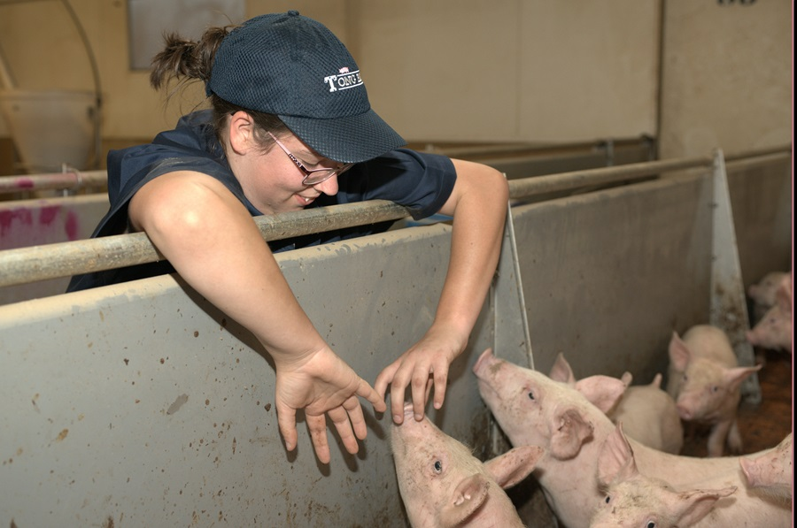

***Adults on the autism spectrum have many skills and traits that make them ideal animal care workers.***

“To see our new employees gain confidence and earn satisfaction from their work is extremely rewarding for the entire SunPork Farms team. Watching them transform as individuals, form their first friendships and become part of our team has been life-changing.”

Dr Richards said the success of this program should challenge business more widely to look at traditional recruitment, training and support to better accommodate a diverse workforce. Prof Robert van Barneveld said skills or traits highly desired in employees, such as great attention to detail, are often inbuilt in autistic people. He sees no reason why the 1000-plus strong workforce of the SunPork Group won’t include many more people on the spectrum.

Trainees of the program at one of SunPork Farms’ Queensland piggeries included David Grose and Daniel Slavin. They are now employees and love their work.

“Tiring, hot but great fun,” David told Channel Ten television, through a beaming smile.

“Opportunities like these are really hard to come by for people with autism,” Daniel added, who at 19 years of age, moved from his Melbourne home to take up the gig with SunPork.

The program was initiated by SunPork Farms and the Autism CRC, and has been supported by the CRC for High Integrity Australian Pork (Pork CRC), the South Australian Government and Specialisterne Australia – which helps with employment.

Pork CRC and the SA Government contributed $150,000 towards the initiative.

*"It's the most exciting project we’ve been involved with and I congratulate Autism CRC and SunPork Farms for coming up with something so innovative." DR ROGER CAMPBELL, CEO, PORK CRC*

Dr Campbell said Pork CRC-supported science and research and development has demonstrated the very real link between good stockmanship and productivity.

Dr Richards said the CRC Program has provided the platform for Autism CRC to collaborate with industry, government and other CRCs.

“This ensures that innovative projects requiring expertise from a range of sectors - such as Autism and Agriculture, are successful and deliver tangible outcomes allowing all individuals to participate fully in society,” Dr Richards said.

CRC Projects - Power Efficient Wastewater Treatment Using Graphene Oxide Technology

***Wonder material to help global energy and water shortages***

An amazing new wonder material called graphene is set to help global energy and water shortage issues and two Australian companies and Monash University are at the cutting edge of its use as a wastewater filtration solution.

Researchers from Monash and two innovative businesses – early‑stage technology company Ionic Industries Pty Ltd, and environmental energy and water business Clean TeQ – have joined forces with support from the Australian Government’s Cooperative Research Centres (CRC) Program.

Specifically, under the CRC Projects initiative, these great minds are working on using graphene oxide to dramatically improve filtration of water, while reducing energy to do so.

They believe the project will produce working products by mid-2018 and it will modernise Australia’s current waste water management from the traditional treatment approach to a low-energy consumption, resource recovery approach.

*“Graphene has special properties which could disrupt current commercial filtration techniques and significantly reduce the energy required to filter wastewater.”Mainak Majumder, Lead Researcher, Monash University*

The commercial market for water and wastewater treatment is estimated to be worth $US 54 billion by 2020.

Freshwater scarcity is a critical barrier to energy and food production and industry in general.

Contaminated freshwater sources, such as ground and surface water and municipal wastewater, are excellent sources provided they can be economically treated.

For the past six years, Ionic Industries and Monash University – supported by a range of Australian Government funding initiatives – have pursued graphene solutions.

Clean TeQ will help them commercialise the great research and development ideas.

*“We plan to be the first to take this breakthrough technology to market in Australia and in developing countries such as China, India, South America and South Africa, where access to clean freshwater is a significant issue.” Peter Voight, Executive Director, Clean TeQ*

Ionic’s first applications will target removal of organic matter for water and wastewater treatment.



***Ground water and municipal wastewater are excellent sources provided they can be economically treated.***

Graphene’s strength, surface area and chemical inertness make it ideal for use in water filtration applications. Ionic has developed two technologies for use in water treatment:

* Patented graphene oxide membranes, that are chemically resistant, much stronger and more tuneable than existing polymer or ceramic membranes meaning safer, lower maintenance, wider applications and increased flow rates.
* Graphene oxide coated SuperSand, a simple, activated carbon substitute, with higher-performance at lower cost than activated carbon products.
* Graphene is 200 times stronger than steel.
* It has the largest volume-to-surface area ratio of any material.
* It is also chemically inert so does not react with other atoms.

*“Our partnership with Associate Professor Majumder has been pivotal in assisting with the transition of graphene manufacturing expertise out of the laboratory and into commercial applications, and the involvement of Clean TeQ, a highly successful Australian Company, is a testament to the strength and commercial prospects of this technology.”*

### Program overview – Venture Capital programs

*“A highlight for the committee has been the continued strong growth in the Venture Capital Programs. There has been a strong increase in the number of registered funds with a corresponding increase in the sources of patient risk capital available for early stage Australian businesses.”*

*“The committee has worked hard to ensure that the programs it administers dovetail with others that funds and investees are also applying for. While this has produced some challenges we have been able to work together with Innovation and Science Australia to increase alignment such as through submissions into relevant policy reviews to ensure greater awareness of program interactions”* Marty Gauvin – Chair, Innovation Investment Committee

Venture Capital Programs

The Australian Government provides a range of tax and co-investment programs to cultivate innovation and to encourage venture capital investment in entrepreneurial start-up and early stage companies.

**Tax Programs: Venture Capital Limited Partnerships (VCLPs) and the Early Stage Venture Capital Limited Partnerships (ESVCLPs)**

The VCLP and ESVCLP programs are designed to stimulate the Australian venture capital sector by attracting both domestic and foreign capital into Australian venture capital markets. Through these programs VCLPs and ESVCLPs (which are venture capital funds structured as limited partnerships) are registered under the *Venture Capital Act 2002* (VC Act). VCLPs and ESVCLPs are required to operate in accordance with the VC Act and the relevant Income Tax Assessment legislation.

The VCLPs program provides incentives to foreign investors. It is also open to domestic investors. The taxation benefits for VCLPs are:

* flow-through taxation treatment for registered venture capital partnerships
* exemption to foreign investors (limited partners) from capital gains tax on their share of profits made by the partnership
* the fund manager can claim their carried interest in the partnership on the capital account, rather than revenue.

Since inception, $5.1 billion has been invested by VCLPs in Australian businesses. This figure represents an increase of $0.8 billion since June 2016, at which time VCLPs had invested $4.3 billion.

* As at 30 June 2017 there were 69 registered VCLPs. Of the 69 total VCLPs, 19 VCLPs were registered during the 2016-17 period, which represents a slight increase over the number of VCLPs (18) that were registered over the same period in 2015-16.
* Committed capital, which is the amount investors have agreed to contribute to a partnership, increased by $0.6 billion to $6.9 billion in 2016-17. This is highest level of committed capital in VCLPs ever achieved.

The ESVCLPs program provides tax concessions for both Australian and foreign residents that invest into funds registered under the program. ESVCLPs encourage investment in start-up enterprises with a view to commercialisation of activity and company growth and by making Australia a more attractive investment destination.

* Since inception, $437.6 million has been invested by ESVCLPs in Australian businesses. This is an increase of $194 million since June 2016, when ESVCLPs had invested a total of $243.6 million.
* As at 30 June 2017 there were 64 registered ESVCLPs. The registration rate had a 27% increase in 2016-17 with 28 ESVCLPs being registered compared to 22 registrations in the previous year.
* The amount of committed capital in ESVCLP partnerships increased from   
  $620 million in 2015-16 to $1.4 billion in 2016-17.

From 1 July 2016, an initiative of the National Innovation and Science Agenda (NISA) to enhance tax arrangements under the ESVCLP program came into effect. These changes include:

* providing an additional tax incentive for limited partners in new ESVCLPs;
* relaxing restrictions on ESVCLP investments and fund size; and
* clarifying the legal framework for venture capital investment in Australia.

These changes are successfully encouraging greater venture capital investment activity as demonstrated by the significant increases to the number of registrations, investment and total committed capital under the venture capital tax programs.

**Other Types of Registration under *the Venture Capital Act 2002***

The VC Act also provides for two other types of registration:

**Australian Venture Capital Fund of Funds (AFOFs)**: for an Australian resident general partner, registration is available for a specific limited partnership investment vehicle as an AFOF under the VC Act. As a fund of funds investment vehicle, AFOFs can only make investments in a VCLP or an ESVCLP. It may also invest in a company in which a VCLP or an ESVCLP that the AFOF invests in is a limited partner. As at 30 June 2017, there are 7 AFOFs with a total of $217 million in capital. At 30 June 2017 the unconditionally registered AFOFs reported investing $17.7 million in 3 ESVCLPs.

**Eligible Venture Capital Investor (ECVI)**: for tax–exempt foreign residents, registration is available as an EVCI under the VC Act. Registration allows the entity to make direct investments and disregard any gain made on disposal of an eligible venture capital investment. To date, one EVCIhas been registered.

***Major highlights***

VCLPs

* $5.1 billion invested by VCLPs in Australian businesses to date.

ESVCLPs

* $437.6 million invested by ESVCLPs in Australian businesses to date.

Right Click Capital–making investment ‘sweeter’

Investment fund manager Benjamin Chong says recent changes to Australia’s venture capital arrangements are encouraging more people to consider investing in high-potential, early stage Australian companies.

Mr Chong, one of three partners at venture capital firm Right Click Capital, says a new 10 per cent tax offset for people investing through early stage venture capital limited partnerships (ESVCLPs) is ‘sweetening’ investment opportunities and attracting new investors.

“Investors can now also receive capital gains tax free status for complying investments made through ESVCLPs, making it a very attractive asset class for investors,” he says. “The tax measures allow new investors to put their toe in the water on a very favourable basis.”

The new venture capital arrangements, introduced as part of the Australian Government’s National Innovation and Science Agenda, also allow venture capital funds to provide more support to innovative companies for longer.

The changes have raised the maximum size of ESVCLP funds, from $100 to $200 million, and mean funds no longer need to divest companies once their value exceeds $250 million.

“Becoming a larger fund, making larger investments, allows us to better support more emerging companies,” Mr Chong says. “And not having to divest companies that reach a value of $250 million means we are not forced to sell our stake in a business prematurely … it’s a very helpful measure.”

Encouraging investment in early stage companies

The National Innovation and Science Agenda changes, have sparked a growth in Australian ESVCLPs, and Mr Chong says the changes spurred the establishment of Right Click Capital’s new fund in 2016.

“We saw these changes as an opportunity as they give us the chance to back more early stage companies and appeal to a wider range of investors,” he says.

Right Click Capital backs Australian internet tech start-ups that have the potential to go global. Its investors include high net wealth individuals, family offices and superannuation funds.

“Our fund not only provides money, we also add value, spending time with founders to help them with their company strategy and operation, helping them work out how to expand or best export to international markets,” Mr Chong says.

Right Click Capital’s backing has nurtured the success of several high-profile Australian companies, including hipages, which connects consumers and tradespeople in an online marketplace.

“We've been the key investor in that business over the last couple of years and have seen it grow to be Australia’s largest home services marketplace,” Mr Chong says.

"We’re also very excited to be an early investor in 8i, a 3D imaging and virtual reality start-up, that allows customers to create 3D images and 3D holograms, and which recently scored a $25 million investment from Time Warner.”

Mr Chong says it is rewarding to be part of the growth of these dynamic Australian companies.

“They not only create direct jobs and revenue, they also have a spill-over effect and create jobs and growth in other parts of our economy,” he says.

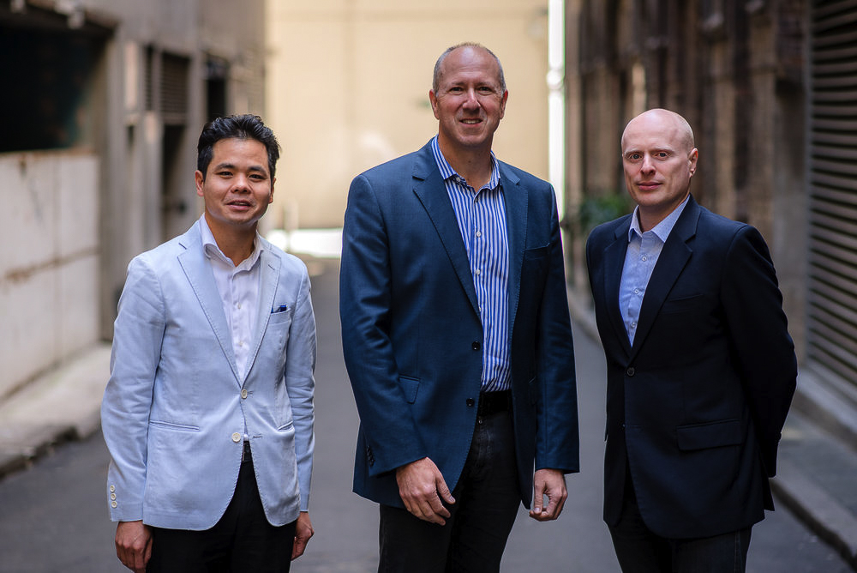

***Right Click Capital partners (left to right): Benjamin Chong, Garry Visontay and Ari Klinger***

### *Peter Willis AC - Chair, BTF Committee*Program overview – Biomedical Translation Fund (BTF)

*“Following the establishment of the Biomedical Translation Fund in early 2016 the Committee was very impressed with the broad range of fund manager applications that were received in response to the public call for expressions of interest. After a very rigorous process of analysing the applications, the Committee appointed three fund managers having the expertise in commercialising health and medical research and the ability to guide innovative Australian companies along the commercialisation process.*

*It is always challenging to appoint fund managers within a very tight timeframe. During the 2016-2017 reporting year, the BTF Committee successfully completed all necessary due diligence processes in order to have all appointments in place by the end of 2016.”* Peter Wills AC – Chair, BTF Committee

Biomedical Translation Fund

The BTF delivers on a major element of the National Innovation and Science Agenda (NISA) to put Australia on the path to becoming a more innovative and entrepreneurial economy.

Australia is a world leader in health and medical research. The BTF addresses the challenge of translating research from the laboratory to commercialisation of products internationally, and achieving better health outcomes for Australians. The BTF is an equity co-investment venture capital program that aims to stimulate innovation and investment in Australia’s biomedical sector by providing finance and mentoring to start-up and early stage companies at critical early phases of development.

Under the BTF, Australian Government funding ($250 million) is being matched by private sector capital commitments ($251.25 million) to provide a total funding commitment of $501.25 million.

Three private sector BTF fund managers were licensed in December 2016 following a competitive, merit-based selection process. This process was conducted by Innovation and Science Australia’s BTF Committee.

Licensed BTF fund managers will:

* invest in promising biomedical discoveries and assist in their commercialisation; and
* encourage the development of companies which are commercialising biomedical discoveries, by addressing capital and management constraints.

All BTF investment decisions are made by the selected fund managers. The Australian Government has no role in selecting investments, technologies or markets, but ensures that all investments are consistent with the requirements of the program guidelines. This approach has been taken to ensure that the venture capital expertise that is required to invest in commercialisation opportunities is provided by those most qualified.

The BTF builds upon the legacy of other Australian Government co-investment programs such as the Innovation Investment Fund, the Pre-Seed Fund, and the Innovation Investment Follow on Fund that have fostered the Australian venture capital industry and helped Australian innovators gain access to the capital and management skills that they need to build the companies, industries and jobs of the future.

The three licensed fund managers announced their first investment commitments into biomedical companies in 2016-17 and began calling for investment capital in 2017-18. The Department of Industry, Innovation and Science has begun collecting information on these investments to illustrate the improvements that they make to the quality of lives and to the economy as they mature.

***Major highlights***

The Biomedical Translation Fund aims to stimulate innovation and investment in Australia’s biomedical sector.

* $250 million – Australian Government funding
* $251.25 million – Private sector capital commitments

The Biomedical Translation Fund will:

* **invest** in promising biomedical discoveries and assist in their **commercialisation**
* **encourage** the development of companies which are commercialising biomedical discoveries, by addressing **capital** the **management constraints**

ProTA Therapeutics – addressing food allergies in children and adults

*Peanut allergy could be a thing of the past for many sufferers, thanks to an innovative treatment in development by ProTA Therapeutics.*

Newly available capital provided through the Australian Government’s Biomedical Translation Fund (BTF) is stimulating investment in innovative health and medical discoveries.

Three new investment funds supported through the BTF are investing in companies in their early stages who are, or will be, developing and commercialising biomedical discoveries. The fund will help strengthen the Australian biomedical industry and create the jobs of the future, benefiting both the economy and the Australian people.

The first company to receive investment, ProTA Therapeutics, received a $10 million commitment from OneVentures Healthcare Fund III.

ProTA’s treatment uses oral immunotherapy technology to allow those with peanut allergies to incorporate peanuts and peanut products into their regular diets—something that will be life-changing for both child and adult sufferers.

The investment commitment delivered by OneVentures will help the company to advance the development of this promising new treatment for food allergies affecting both kids and adults.

The funds will also be critical to advancement of the clinical trial program in Melbourne, Adelaide and Perth. Recruitment is expected to be completed by the fourth quarter of 2018, with the study providing evidence of a longer-lasting tolerance to peanuts and helping to compare the effects of probiotic peanut oral immunotherapy against peanut immunotherapy on its own.

ProTA’s treatment is innovative, in that it’s the first to allow children with peanut allergies to be able to consume peanuts. In a clinical trial, it was found to induce peanut tolerance in more than 80 per cent of children treated. While the treatment currently focuses on this type of allergy, it is expected that it may be applicable to other food allergies like milk, eggs and other nuts in the future, giving it enormous potential.

It is thanks to the BTF that companies like ProTA are able to continue their important work to help improve the health of Australians and assist the industry to fulfil its full potential through innovation.

For further information on the BTF, visit the [business.gov.au website](http://www.business.gov.au/BTF)



### Program overview – Entrepreneurs’ Programme

*"The level of innovation and market potential of companies at the centre of both the AC and BRII programs has been really impressive.  The companies supported are commercialising some of the best emerging technologies coming out of Australia and the close alignment with the Growth Centres has been very positive."*

*"The cooperation between government strategy and policy, departmental staff and the EPC has seen marked improvements in the processes of the three different programs, an improvement in the quality of applications and a sharper focus on the performance metrics of the programs.  This work has helped address some of the key challenges faced by the EPC."* Chris Farquhar – Chair, Entrepreneurs’ Programme Committee

Entrepreneurs’ Programme

The Entrepreneurs’ Programme is an Australian Government initiative to improve business competitiveness and productivity. It forms part of the government’s industry policy outlined in the National Innovation and Science Agenda. The Program uses a national network of more than 130 experienced Advisers and Facilitators, drawn from industry, to ensure businesses get the advice and support they need to improve their capability and to maximise their growth potential. Support may also include funding through matched grants.

The primary focus is on providing access to tailored advice, and connection and networking opportunities to grow their business and capitalise on opportunities. This is done through four elements:

* Accelerating Commercialisation provides access to expert guidance and competitive grants to help businesses to commercialise their novel products, processes and services.
* Business Management helps businesses grow by building management capability and supply chain connections, providing each with a tailored plan to embed change and generate sustainable growth.
* Innovation Connections provides unbiased expert advice and technology solutions on knowledge-related issues, and connection with knowledge providers and Publicly Funded Research Organisations.
* Incubator Support provides grant assistance to develop Australia’s innovation ecosystem and assist Australian start-ups to develop the skills to succeed in international markets.

There is a strong focus on supporting businesses in growth sectors: advanced manufacturing; medical technology and pharmaceuticals; energy oil and gas; food and agribusiness; mining technology and services.

The Entrepreneurs’ Programme Committee plays a key role in advising the department in selection for Accelerating Commercialisation and Incubator Support grants, as well as the Business Research Innovation Initiative (BRII).

***Major highlights***

* 7600 services provided, exceeding its Parliamentary Budget Statement’s Key Performance Indicator target of 6512 for 2016-17
* From the Entrepreneurs’ Programme Customer Satisfaction survey, 91% of respondents believed that the programme has added value to their business, and 86% of respondents would recommend the programme to other businesses
* The Entrepreneurs Programme Provided Services by Element in 2016-17 for the following:
  + Accelerating Commercialisation – 1221 Services
  + Business Management – 5365 Services
  + Innovation Connections – 1074 Services
  + Incubator Support – 14 services

Accelerating Commercialisation - Life Cell Marine Safety – eyeing off $150 million global market

United States distributor on board with Australian water safety device invention

A harrowing sea experience was the catalyst for a couple of mates to create their Life Cell Marine Safety invention.

Known as the Life Cell, the buoyant device designed to save lives, is set to cash in on a $150 million global market after gaining interest from the huge United States marine and boating market.

Safety in all walks of life is big business yet it seems safety at sea had not perfected a package which could help save lives when boats quickly capsize, sink or are swamped by waves.

Rarely is there time in a small-craft emergency to grab, from under seats or from in cupboards, all the safety equipment needed.

Often that equipment is in bags and buckets that become a liability once people are in the water.

The founders of the Life Cell – Scott Smiles and Rick Matthews, found that out when clinging to an esky, with their 11-year-old sons Riley Smiles and Ryan Matthews; after their boat sank, in less than a minute, 10 kilometres off the Sydney coast.

Thankfully Scott could grab and trigger the vessel’s emergency beacon and an esky.

The fathers and their boys held onto that esky for almost two hours before the rescue helicopter reached them to drop a life raft.

They were inspired to redefine how boating safety equipment was stored, so everything needed in an emergency could be taken into the water without delay.

The Life Cell is a high-visibility buoyancy device that stores essential safety equipment and is mounted in a handy position but with the ability to float free of its bracket if submerged.

There are four sizes available, and the equipment which can be placed inside include an EPIRB (emergency beacon), air horn, torch, heliograph, VHF radio, flares and whistles, v-sheet, for example.

The Entrepreneurs’ Programme, through Accelerating Commercialisation assistance and funding, is now helping Life Cell Marine Safety to take its simple yet brilliant idea to the world.

“*The Accelerating Commercialisation grant has assisted us to achieve international product certification and helped us to meet the requirements of our newly-appointed United States-based distributor.*” JENNY AIKEN, CEO, LIFE CELL MARINE SAFETY

“*Attending six trade shows in the US, providing samples, modifying packaging and websites and training sales reps is an incredibly expensive process, but absolutely necessary to successfully commercialise our product.*

*“The $369,919 grant provided us with much needed financial assistance to allow us to gain traction in the US market. I am not sure that we could have achieved this without the grant. We are incredibly grateful for the Government’s support at this critical time for our company,*" Jenny says. They have since appointed Land N Sea as North American distributor.

Life Cell Marine Safety has international product certification for the Life Cell, internationally certified by Lloyds Register for use on SOLAS vessels, and is already being used both commercially and recreationally within Australia.

It was at the time of launching the product in Australia when Life Cell realised they would need funding to survive the commercialisation process.

Jenny Aiken heard about the Accelerating Commercialisation element of the Entrepreneurs’ Programme at a trade show and she realised it could be the key to success.

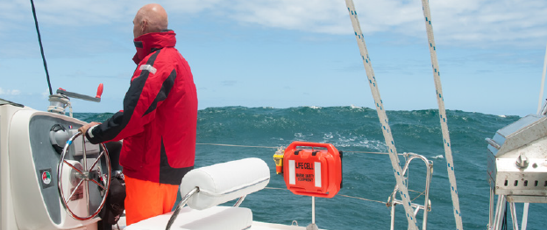

***United States distributor on board with Australian water safety device invention***

“*I was warned from the very beginning that it would be a significant investment of time but it was worth it. The process really forced us to define our business plan, identify our target market and determine the size of this market*,” Jenny says.

“*Although the funds from the grant have been invaluable, so too was the business planning process that was essential as part of the application*.”

Since the grant, Life Cell have raised $300,000 in capital and increased their revenue by 189 per cent.

“*We feel very honoured to be supported by the Government on what is a difficult journey of business development. It is great to see the Government investing in innovation and the future of our country by developing sustainable businesses that will go on to employ staff and potentially export their products to the world*.” JENNY AIKEN, CEO, LIFE CELL MARINE SAFETY

Life Cell’s Commercialisation Adviser is Maureen Murphy and her vast experience and networks has been invaluable to Life Cell.

Jenny says Maureen is a great sounding board and an Adviser’s guidance adds significant value to the program.

Maureen suggested to Jenny that she apply for the 2017 Springboard Enterprises Accelerator/Incubator for Australian Female CEOs, of high-growth start-ups.

Jenny was one of 10 successful applications and started the Springboard Enterprises program in February.

“Without Maureen, I would not have known about the Springboard Enterprises program, and would not have had the confidence to apply. I think the experience will be a real game changer and further increase my ability to pitch the business successfully for further investment,” Jenny says.

Life Cell is approved by Australian Maritime Safety Authority and endorsed by Westpac Life Saver Rescue Helicopter, who rescued the Smiles and Matthews.

The Life Cell is also being used on vessels operated by NSW Roads and Maritime Services and Department of Primary Industries.

Life Cell employs four people at the moment but CEO Jenny Aiken and the two founders hope interest worldwide will see the company grow.

Innovation Connections - Bush tucker has bright future in Northern Territory catering

Karen Sheldon Catering (KSC) has teamed up with researchers from The University of Queensland (UQ) on a project to extend the shelf life of food by using native foods.

Based in Darwin, KSC started in 2006 and evolved from Karen Sheldon’s 30-year-old restaurant business. KSC employs 80 staff and is a Registered Training Organisation Vocational Training and Employment Centre and Transition to Work provider.

KSC and UQ sought to improve the shelf life and nutritional value of frozen food products by using natural additives and plant extracts to replace artificial preservatives and other chemical additives used to prevent the oxidation of frozen food. The project was made possible by Innovation Connections, an element of the Entrepreneurs’ Programmetotr (the Programme).

*“We have gained invaluable knowledge of the nutritional, antimicrobial and antioxidant qualities of Kakadu plum and other native bush foods, and how best to use these amazing ingredients in the cooking process. Without the support of Innovation Connections, and left to our own devices, this is the type of food science and knowledge we would not have gained.” Sarah Hickey, Director, Karen Sheldon Catering*

The KSC project was equally as exciting for UQ staff, who determined the superior antimicrobial and antioxidant properties of native plant extracts would be suitable as a replacement for chemical preservatives and additives.

“*The commercial potential of Australian native plant foods is due to their potent bioactivity, which is a result of their phytochemical composition. The challenge is the retention of these bioactive properties during processing, packaging and storage, when used as functional ingredients.” Yasmina Sultanbawa, Senior Research Fellow, The University of Queensland*

Kakadu plums, in particular, were found to be excellent functional ingredients in frozen food preparations and extended the shelf life by up to 18-24 months, at frozen storage temperatures. Davidson plums have similar qualities. The properties of the Kakadu plum has also been used to improve the shelf life and colour retention of prawns.

David Martin, Innovation Connections Facilitator, said KSC and UQ were a delight to work with. “They had a clear understanding from the start on what they wanted to achieve. As such, my role focused on working behind the scenes to make sure that KSC and UQ could focus on what was really important - the research, and how it could be effectively used in the business.”

KSC’s frozen foods meals are available through independent grocers in Darwin and Alice Springs, as well as KSC’s café at Parliament House in Darwin.



At the moment, raw Kakadu plums need to be sent interstate to be made into a puree and freeze dried. The potential of bush foods as unearthed by the project has KSC directors excited about further opportunities for Northern Territory businesses and communities.

“Processing one ingredient wouldn’t be enough to justify the expense of a processing plant and the equipment required for this, so we need to investigate other native foods and plants for value-adding locally,” Sarah Hickey said.

“We support ethically-harvested or caught wild bush foods and believe that the processing of these foods locally is the next step to communities being able to maximise their return for such products.”

KSC, indigenous businesses, other likeminded local businesses and social enterprise groups, will continue to discuss the possibility of setting up a processing plant in Darwin for Australian bush food.

Business Management – Entrepreneurial spirit turns second grade spuds into ‘paddock-to-glass’ drop

A family potato farm in Tasmania has used Australian Government assistance and funding through the Entrepreneurs’ Programme to transform and diversify their business, and create jobs in regional Australia.

GP & SJ Daly Pty Ltd’s husband and wife team, Gerard and Susie Daly, sought to make use of the perfectly good potatoes that did not meet the shape or size requirements for their A-grade fresh market sales.

Most of their washed and brushed potatoes go to major retailers in Tasmania that have stringent quality control requirements on size and shape, meaning many potatoes are ruled out.

About 20 per cent of each crop fell into this group of ‘second grade’ spuds, and with limited alternative markets, these potatoes had historically been sold for stock feed at very low prices.

The Daly family knew there must be an opportunity to develop new products from these potatoes and in the process, transform their business.

They began investigating options which led to the production of vodka and a range of ready to use potato-based products.

The creation of two new brands, Hellfire Bluff Distillery (named after Hellfire Bluff, a rocky outcrop above Marion Bay in Tasmania where the Dalys are located) and Daly Gourmet Potatoes, have created nine new jobs in the region.

The Dalys are strongly committed to their local community, and the provenance of their products – locally produced – underpins their brand.

To develop and take these new products to market, the Dalys engaged with Growth Services and Innovation Connections, two components of the Entrepreneurs’ Programme.

Their dedicated Business Facilitator, Sarah Jones, is thrilled with their achievements.

*“I am enormously proud of them. They have done a phenomenal amount in a very short period of time. They are quite an inspirational business.” Sarah Jones, Entrepreneurs’ Programme Business Facilitator*

Part of Sarah’s role is to make the right connections to suit the needs of each business. “A lot of my role was connecting the Dalys to the right people. They have taken on advice and support. They have sought out mentors.”

Sarah also provided practical support and guidance. She helped Susie and Gerard plan and prioritise, to access specialist advice on branding and customer awareness, as well as the technical distilling support they needed.

The Dalys now have a distillery onsite housing a local and custom-built copper still.

Innovation Connections provided help and information about various types of technology and research available.

They helped the Daly family understand alternative methods of distilling and what equipment would be required.

Following the success of Hellfire Bluff vodka, the distillery now also produces a Tasmanian London Dry Gin and a Tasmanian Limoncello Liqueur with plans to develop further products and distribute Australia-wide.

To ensure the success of their ready-to-eat potato salads, bakes and mashes, Daly Gourmet Potatoes established a new facility at nearby Sorell and employed a production manager with a strong food development background.

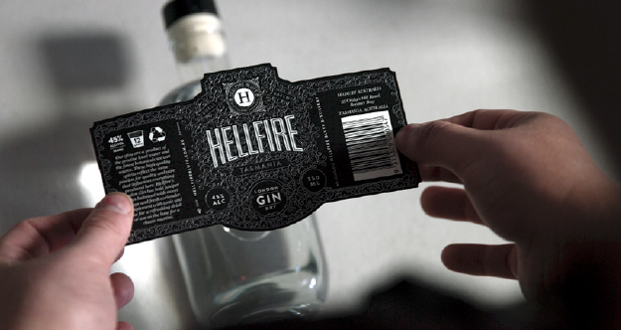

Funding has been used for the engagement of a food scientist to help with new product development, including more alcoholic beverages, and a range of new products are in production.

To develop their skills and capabilities, Growth Services connected the business to a range of technical expertise and advice.

*“The Growth Services engagement was the support we needed to keep moving forward with our plans to expand and grow.” “We knew the right connections would be on hand and they helped us make a detailed and prioritised growth plan, and we have kept that on track.”* Susie Daly, Owner, GP & SJ Daly Pty Ltd

Projects include refining their marketing and brand story through design thinking, creating sustainable costing models and wholesale pricing structures, navigating the licensing requirements for alcohol and defining new sales channels, and developing quality assurance systems.

Susie Daly credits the Entrepreneurs’ Programme with giving them the confidence, knowledge and contacts to diversify into new products in order to maximise the value derived from every potato.

The move into distilling and food production is being followed by tourism, as the Daly clan consider the opportunity for a cellar door for their distillery, to enable them to share their story “from paddock to glass”.

### Program overview – Business Research Innovation Initiative (BRII)

The *Business Research and Innovation Initiative* (BRII) is a $24 million initiative within the ‘Government as an exemplar’ pillar of the National Innovation and Science Agenda (NISA).

Each year the Australian Government spends nearly $57 billion on procurement, but we rank just 63rd out of 138 countries on how well this procurement fosters innovation.

The BRII is a competitive grant program that aims to drive innovation within small to medium enterprises (SMEs) and government. It offers competitive grants to encourage SMEs to develop solutions to public policy and service delivery challenges nominated by Australian Government agencies. The best proposals for each challenge receive grants of up to $100,000 to test the feasibility of their ideas over three months, and they may then apply for up to $1 million to develop a prototype or proof of concept over a period up to 18 months.

The BRII encourages:

* the Australian Government to tap into leading edge thinking and be more open to sourcing innovative solutions to policy and service delivery problems from Australian SMEs; and
* SMEs to develop innovative products and services for which there is a real demand.

The Australian Government agencies consider purchasing solutions developed through the program, but are under no obligation to do so.

The SMEs retain full rights to their solution and any intellectual property and are then able to pursue further sales domestically and worldwide.

The BRII officially launched on 17 August 2016 with the first five challenges from Australian Government agencies:

* The Department of Agriculture and Water Resources would like on-the-spot measurement technology to determine whether pyrethroid residues on interior aircraft surfaces are high enough to kill mosquitoes and other insects that are known vectors of serious human diseases on arriving international flights.
* AUSTRAC, Australia's financial intelligence agency, together with the Australian Criminal Intelligence Commission (ACIC) would like to track the outcomes of the information and intelligence the agencies provide, history of its use, and user feedback through the life of the information.
* The Department of Industry, Innovation and Science and Department of Social Services would like a digital-enabled process to enable business and community organisations to participate in the design of policies and programmes by Australian Government agencies.
* The Department of Agriculture and Water Resources would like to improve transparency and reliability of water market information to increase market participation by water licence holders and enhance consumer confidence in Australia’s water markets.
* Department of Social Services would like a digital solution to ensure adequate information sharing across jurisdictions in child protection cases.

The BRII is administered by the Department of Industry, Innovation and Science and is delivered by AusIndustry. The BRII has three stages as follows:

*Challenge Selection*

1. Australian Government Agencies submit challenges
2. Innovation and Science Australia shortlist challenges through assessment process
3. Minister approves shortlisted challenges
4. Challenges are announced by the Minister

*Feasibility Study*

1. SMEs apply to respond to a challenge
2. Innovation and Science Australia assess applications
3. Minister approves recommenced applications for funding
4. Successful SMEs conduct feasibility studies

*Proof of Concept*

1. Successful SMEs apply for proof of concept grant
2. Innovation and Science Australia assess applications
3. Minister approves recommended applications for funding
4. Successful SMEs conduct proof of concepts

BRII attracted significant interest with more than 190 interested SMEs attending the BRII roadshows and around 6800 (62%) of subscribers to the NISA newsletter registering interest in BRII.

In November 2016, 180 applicants applied for a feasibility study grant and 20 SMEs were awarded grants by the Minister in March 2017. All 20 grant recipients completed feasibility studies and submitted applications for proof of concept grants by 30 June 2017. The list of grant recipients is available at [www.business.gov.au/BRII](http://www.business.gov.au/BRII).

***Highlights/Outcomes***

* 180 feasibility study grant applications received across five challenges
* $1.86 million in feasibility study grants approved for 20 SMEs who all successfully completed their projects

Some examples of the solutions awarded feasibility study grants are outlined below.

Challenge 1:

The Department of Agriculture and Water Resources would like on-the-spot measurement technology to determine whether pyrethroid residues on interior aircraft surfaces are high enough to kill mosquitoes and other insects that are known vectors of serious human diseases on arriving international flights.

Iugotec Pty Ltd proposes harnessing state-of-the-art portable sensor technology which will allow non-technical staff at Australian airports to immediately determine whether aircraft have been adequately treated to prevent the introduction of exotic mosquitos.

Iugotec uses real-time chemical sensor technology to develop in-situ sensing solutions combining cutting edge analytical technologies with advanced data analytics. Its world-class team of engineers and analytical chemists provide support throughout the product development cycle.

“*BRII has enabled us to undertake a feasibility study to test our solution for the challenge – a reliable real-time sensor to measure the insecticide residue on aircraft surfaces. As a start-up, we found BRII particularly helpful in that it has greatly developed our confidence to work with government as a potential customer.*” – Iugotec

Beyond aircraft residual insect treatment in Australia, New Zealand and other countries, Iugotec sees further market opportunities within government in defence, forensics and security, including for drone-deployed chemical sniffers and species verification of imported timber.

*“BRII has enabled the Department of Agriculture and Water Resources to work together with specialist SMEs to find a fast, easy-to-use and cutting edge technical solution to the issue of verification of residual insect treatment of aircraft. All current methodologies are slow, cumbersome, expensive and/or reliant on specialist expertise and therefore restricted by relatively small sample sizes.”* ***–*** Department of Agriculture and Water Resources

Challenge 2:

AUSTRAC, Australia's financial intelligence agency, together with the Australian Criminal Intelligence Commission (ACIC), would like to track the outcomes of the information and intelligence the agencies provide, history of its use, and user feedback through the life of the information.

Atraxium Pty Ltd has expertise in cyber security, threat intelligence and anti-money laundering/counter-terrorist financing, developed across government, international organisations and in the private sector. The BRII feasibility study set out to test whether Blockchain technology would provide the innovative solution required to transform the nature of feedback collection needed by AUSTRAC and ACIC.

There were two key findings in the feasibility study: Blockchain can provide a flexible and secure platform on which to base a feedback mechanism, and a user experience design approach was needed in recognition of the behaviour change required to encourage feedback.



“*The BRII challenge has tackled many of the issues that we, as small business owners, have been looking for action on from government, including putting local knowledge and skills first in the search for innovative solutions, sharing real challenges faced by agencies that are not otherwise accessible to small firms, and providing valuable insight into how government grants programs are managed.*” – Atraxium

The solution Atraxium is developing will provide the basis for secure information exchange between intelligence producers and recipients. It also stands to change the way feedback operates in the criminal intelligence environment by automatically capturing information about what happens to an intelligence product, and motivating recipients to provide feedback (including simplifying the feedback process).

*“The BRII has enabled AUSTRAC to consider how new technologies could address a problem that has existed for many years and refocus on how an activity such as collecting feedback can support strategic decision making. Working with small and medium enterprises has allowed experimentation with these technologies before implementing them in mainstream processes. AUSTRAC and ACIC look forward to continuing to support the BRII program as we progress through the proof of concept.”* – AUSTRAC

Challenge 3:

The Department of Industry, Innovation and Science and the Department of Social Services would like a digitally-enabled process that will provide a faster, lower-cost and broader-based consultation and co-design process to enable business and community organisations to participate in the design of policies and programs by Australian Government agencies.

Likely Theory Pty Ltd’s feasibility study found that a combination of existing technologies and new data processing methods could be used to develop a cost-effective and easy-to-use web-based consultation platform. The platform includes natural language and automated data processing to analyse input and better harness social media to reach more stakeholders.

*“BRII has enabled us to significantly investigate, model and analyse approaches to digitally enabled community policy engagement, specifically within in the context of public service requirements. The BRII further provided an exciting platform for us to engage in dialogue with the agencies, with direct access to staff which provided critical and invaluable guidance during our research into a wide variety of techniques and methodologies related to the challenge. This sense of partnership and level of communication was a highlight of the feasibility study for us.”* – Likely Theory Pty Ltd

Likely Theory has an experienced team of entrepreneurs, engineers, psychologists and policy officers to focus on tackling complex organisational decision making and policy analysis issues in both the public and private sectors. Its proposed solution will allow communities and stakeholders to collaborate on policy and program design, and will include modern information collection and engagement techniques that focus on enabling community building and ongoing participation.

*“Right now, the public service is potentially missing the chance to improve both government decision making and the level of confidence in those decisions, because we have limited means to engage the community and draw on their expertise. Technology will play a part in improving engagement and participation. The BRII has allowed us to investigate technologies that can help public servants develop better solutions to complex public policy problems. It’s also very exciting to work with enthusiastic SMEs as they bring fresh and interesting perspectives to this longstanding challenge.”* – Department of Industry, Innovation and Science and Department of Social Services.

Challenge 4:

The Department of Agriculture and Water Resources is looking for innovative solutions to improve transparency and reliability of water market information.

Marsden Jacob Associates (MJA) has proposed the development of web and mobile applications to improve water market performance and transparency for growers, irrigators, investors and large commercial growers.

For the BRII challenge, MJA used their expertise in water, energy, environment and natural resources to partner with Alliance Software, an agile software development company, to develop the web and mobile applications.

The BRII feasibility study grant has provided MJA with the time and funding to conduct over 30 interviews with water market participants and stakeholders to inform and shape the development of the solution. The completed feasibility report has confirmed there is considerable market interest and support.

*“Many water market participants are finding that they cannot access customised and easily accessible information at low cost in one easy-to-use interface. BRII has enabled us to develop, test and refine prototypes of a water market information platform that would be accessible via mobile and web applications, and confirm that there is a distinct market need for this service.”* – MJA

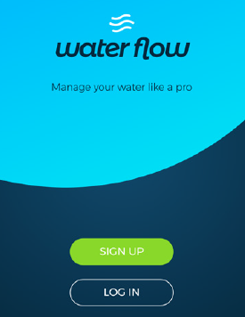

The proposed solution will provide quality, timely water market data and analysis for market analysts and participants, government, investors, financial institutions and large commercial growers. It will be developed in consultation with water users to ensure functional alignment with user needs, including those in remote locations. It will also be developed to be scalable and transferrable to other market applications, as well as supporting the development of environmental and resource markets in Australia and overseas.

*“The BRII has given the Department an opportunity to work with talented SMEs to gain a much deeper insight into the way market participants acquire and use water and market information. It has helped sharpen policy focus.”* – Department of Agriculture, Water and Resources

Challenge 5:

The Department of Social Services would like a digital solution able to interact with existing information systems across Australian jurisdictions that will allow the relevant authorities to identify when there are child protection issues and provide assistance to caseworkers.

Itree develops intelligent software solutions for government agencies, regulators and corporate businesses in Australia and New Zealand. It has proposed a secure, robust, privacy-based integrated solution to assist information sharing between state-based platforms. The interface, coined “REACH”, will help to protect vulnerable children at risk and identify persons of interest who sometimes fall through the cracks when relocating interstate.

The proposed software solution will include advanced search technology and alarm features to enable state and territory child protection agencies to share vital information about children at risk in an effort to accelerate protection activities.

*“BRII has enabled us to apply our talented design and engineering resources towards solving the proposed challenge through innovative technology,” said Ben Hobby, CEO of Itree. “We are thrilled that the feasibility research was a huge success, and even more excited at the prospect of implementing this into live production to increase protection for Australia’s most vulnerable children.”* - Itree



The technology will be able to scale for additional data types and significantly increased traffic from multiple jurisdictions and other organisations.

*“BRII has enabled the agency to work with several enthusiastic SMEs who focussed their innovative ideas on improving information sharing through a digital platform that will support case workers and be able to expand to accommodate other forms of data.”* – Department of Social Services

### Legacy programs

As at 30 June 2017, Innovation and Science Australia continues to monitor the following programs which are closed to applications:

* Clean Technology Food and Foundries Investment Program
* Clean Technology Innovation Program
* Clean Technology Investment Program
* Climate Ready
* Commercial Ready
* Commercialisation Australia
* Green Car Innovation Fund
* Innovation Investment Follow-on Fund
* Innovation Investment Fund
* Pooled Development Funds
* Pre-Seed Fund
* Renewable Energy Development Initiative
* R&D Start

AusIndustry (a division of the Department of Industry, Innovation and Science) will continue to work with legacy program customers.

## Advocacy overview

ISA’s third, and final, strategic objective is to ‘advocate and champion for Australia’s innovation, science and research system’. This objective encompasses a number of activities for ISA, from speeches and presentations by the Chair, board members or CEO at conferences to participation in roundtable forums or one-on-one meetings with individual stakeholder groups and all levels of government on matters of interest. ISA’s broad engagement strategy ensures that ISA can proactively target messages to both the innovation, science and research communities and the wider Australian public, as well as, work directly with stakeholder groups to address issues that impact on Australia becoming a leading innovation nation.

In 2016-17 ISA has worked with professional and peak bodies for the science, research, innovation, and business communities and across all levels of government to build a national dialogue on Australian innovation, science and research. The ISA Chair and Board members have presented at over 50 events, and the CEO of OISA has presented at over 30 events since his recruitment as CEO in November 2016.

Speeches made by Mr Bill Ferris AC, Chair of ISA, in the reporting period include:

* AVCAL Conference 2016 (Transform and Innovate) – opening address - 31 August 2016
* AiiA iAwards – speech: *Nothing Ventured, Nothing Gained. Innovation is for all Australians* – 1 September 2016
* Medical Technology Association Australia (MTAA) National Conference – opening address – 27 September 2016
* Westmead – speech: *Research Excellence and Commercialisation Excellence – can the HMR sector lead the way in Australia?* – 5 October 2016
* NFMRI – speech: *Innovation and Science 2030 – opportunities and challenges for the HMR sector* – 18 October 2016
* NZVCA Conference 2016 – address – 20 October 2016
* AAMRI – speech: *Does the Australian Association of Medical Research Institutes (AAMRI) need to bother with research translation and commercialisation* – 9 November 2016
* American Chamber of Commerce in Australia – speech: *Can Australia become a top tier Innovation Nation* – 16 March 2017
* CRC Association Conference – speech: *CRC Program – A National collaboration exemplar?* – 24 May 2017
* DSTrupt Day – speech: *Innovation, collaboration and industrial linkages* – 6 June 2017

Transcripts of these speeches are published at [www.industry.gov.au/isa](http://www.industry.gov.au/isa).

ISA’s advocacy role also crosses over with its strategic advice role. ISA activities with regards to submissions to public policy consultations, and work with other government and independent bodies is discussed under the strategic advice overview.

# Section Two – Governance

Innovation and Science Australia

Legislation

Organisation and management

Board and committee membership in 2016-17

Structure of Innovation and Science Australia

Meetings of Innovation and Science Australia in 2016-17

Legal matters/Litigation

## Innovation and Science Australia

In 2016-17, Innovation and Science Australia (ISA), an independent statutory board, provided advice to Government on innovation, science and research matters; assisted with the administration of the Government’s industry research and development, innovation and venture capital programs; and engaged with stakeholders across government and the innovation, science and research communities. Through these activities, ISA sought to encourage a more entrepreneurial Australian innovation, science and research system, with an increased level of investment and commercial success in Australian industry.

In 2016-17, ISA reported to the Minister for Industry, Innovation and Science.

## Legislation

## *The Industry Research & Development Act 1986*

ISA operated under the auspices of the *Industry Research and Development Act 1986* (IR&D Act). The aim of the IR&D Act is to facilitate provision of independent strategic advice about investment in industry, innovation, science and research, and promote the development, and improve the efficiency and international competitiveness, of Australian industry by encouraging research and development, innovation and venture capital activities.

To establish ISA, the I*ndustry Research and Development Amendment (Innovation and Science Australia) Bill 2016* was introduced to Parliament in 4 May 2016. Following the 2016 election, the Bill was re-introduced to Parliament on 1 September 2016 and received Royal Assent on 20 October 2016. While awaiting the passage of legislation, the Minister issued Innovation Australia an interim Statement of Expectations, setting out the Government’s priorities for ISA. The Innovation Australia board commenced work on these priorities prior to passage of the legislation and the establishment of ISA.

**Functions and powers of ISA**

ISA’s functions are set out in the IR&D Act and associated Ministerial Directions. The Board’s responsibilities include:

* provision of independent strategic whole-of-government advice to Government in relation to industry, innovation, science and research matters
* promote investment in industry and Australia’s innovation, science and research system
* administration, monitoring and operation of the *R&D Tax Incentive*
* registering, monitoring and revoking the registrations of *Venture Capital Limited Partnerships* and *Early Stage Venture Capital Partnerships*
* administration and oversight of the *Cooperative Research Centres Program*
* strategic oversight of the *Entrepreneurs’ Programme*, which includes administration and monitoring of *Accelerating Commercialisation* and *Incubator Support Initiative*
* monitoring ongoing projects under programs which are now closed to applications (see list of legacy programs on page 57)
* advising the Minister about the operation of the IR&D Act, the *Pooled Development Funds Act 1992* and the *Venture Capital Act 2002*, and the Commonwealth’s income tax laws as they operate in relation to those Acts.

Ministerial directions issued on 2 June 2015 to the former Innovation Australia board provided additional functions. In the 2016-17 reporting period ISA continued to undertake these additional functions as they relate to the Government’s innovation programs.

In December 2016, the Government provided ISA with a Statement of Expectations regarding how ISA would support the Government to transform Australia into a leading innovation nation that is capable of continued economic prosperity and creation of new job opportunities. Aside from the priority tasks of undertaking the ISR System Review and developing the 2030 Strategic Plan, ISA was also asked to:

* provide advice on how ISA may engage with relevant portfolio Ministers regarding the Government’s innovation, science and research programs
* engage across government, and with international, business and community sectors to improve the performance of Australia’s innovation, science and research system
* promote investment in Australia’s innovation, science and research system, including working with the Australian Trade and Investment Commission (Austrade) to encourage international investment in Australia.

**Financial responsibilities of ISA under the IR&D Act**

ISA has no financial responsibility for program-related grant, loan or licence agreements entered into after 10 September 2004. This follows amendments to the IR&D Act which came into effect on 11 September 2004, and removed powers of the former Innovation Australia to commit, approve or recommend expenditure of government funds and further safeguard members from any personal liability stemming from board membership.

## Organisation and management

ISA uses a committee structure to help administer and provide expert advice on innovation and venture capital programs. As at 30 June 2017, five committees report to ISA; each committee has the following specific functions:

* ***R&D Incentives Committee*** - responsible for advising the board about the operations of the *R&D Tax Concession Program* for income years commencing before 1 July 2011 and the *R&D Tax Incentive program* for income years commencing on or after 1 July 2011. In particular, it is responsible for assessing activities registered across all sectors, including providing certificates to the Commissioner for Taxation about the eligibility of activities registered for the concession and the incentive. The committee also advises on operational policy aspects of the *R&D Tax Concession Program* and the *R&D Tax Incentive program*.
* ***Cooperative Research Centres Advisory Committee*** – established to implement the recommendations of the *Growth through Innovation and Collaboration: A review of the Cooperative Research Centres (CRC) Program Report*. The committee’s ongoing role is to provide advice and recommendations on applications for funding, the progress and performance of individual CRCs, and the operation of the CRC Program.
* ***Innovation Investment Committee*** - responsible for activities related to the Australian Government’s venture capital programs. Enhancements to the *Venture Capital Limited Partnerships* (VCLP) regime announced in the National Innovation and Science Agenda will lead to additional program interest. The committee is responsible for meeting the legislated requirements to consider VCLP and *Early Stage Venture Capital Limited Partnerships* (ESVCLP) registrations within 60 days.
* ***Biomedical Translation Fund Committee*** - administers the *Biomedical Translation Fund* (BTF) program and guides the department throughout the lifecycle of the program.
* ***Entrepreneurs’ Programme Committee*** – responsible for providing merit assessments and merit ranking recommendations on applications under the *Accelerating Commercialisation* program and the *Incubator Support Initiative*. These program are elements of the *Entrepreneurs’ Programme*, the Australian Government’s flagship initiative for business competitiveness and productivity at the firm level. The Committee also provides merit assessments for *Business Research Innovation Initiative* which supports Australian businesses to develop innovative solutions that address persistent government challenges.

**Membership**

Members of ISA are appointed by the portfolio Minister in writing. The IR&D Act provides for a maximum of 15 members, including the Chair, Deputy Chair and an ex-officio member. Four members of ISA constitute a quorum.

ISA committee members are appointed by the portfolio Minister and operate under delegation from ISA. Committees comprise a chair and up to six members, with three committee members constituting a quorum.

ISA (board and committee) members are individuals with an appropriate mix of professional and technical expertise across a broad section of industries, technologies and capital markets, as well as experience in commercialisation of industry innovation, corporate governance and business finance.

ISA and its committee members, other than the ex-officio members, are remunerated in accordance with determinations set by the Remuneration Tribunal.

**Conduct of Board**

Innovation and Science Australia has two primary policies setting out requirements for Board and Committee member conduct and the disclosure and management of members pecuniary and non-pecuniary interests—Innovation and Science Australia’s Code of Conduct and Disclosure of Interest Guidelines. As statutory office holders, Board and Committee members are also bound by the Australian Public Service Code as per sections 13 and 14 of the *Public Service Act 1999*.

More details on Disclosure of Interest Framework and Code of Conduct are published on the [www.industry.gov.au](http://www.industry.gov.au) website.

**Office of Innovation and Science Australia**

Whilst ISA is independent of Government by virtue of its founding statute, ISA is supported by the Office of Innovation and Science Australia (OISA), which is located within, and supported by, the Department of Industry, Innovation and Science. OISA supports ISA in providing advice to the Government. As part of the development of its advice to Government ISA, through OISA, undertakes consultation with relevant government portfolios, industry, the innovation community, and the research and science communities.

OISA is headed by Dr Charles Day, Chief Executive Officer, appointment approved by the Board and engaged through the Department of Industry, Innovation and Science. OISA also provides secretariat support, with a dedicated Board Manager, to the Board. Resources in the OISA as at 30 June 2017 were23staff including seconded, temporary and contracted staff.

OISA’s flexible approach to resourcing throughout 2016/17 allowed for the successful delivery of the ISR System Review 2016. The project team that was established for that task included secondees from the Department of the Prime Minister and Cabinet’s Project Office. OISA also gathered a number of secondees from across functions in the Department of Industry, Innovation and Science and other portfolio agencies to assist. A similar approach has been utilised for supporting the Board’s 2030 Strategic Plan project.

**Partners in delivery**

AusIndustry is the principal program delivery division of the Department of Industry, Innovation and Science. AusIndustry staff in the national, state, territory and regional offices provide project reporting services, technical assessment and promotional services to ISA for the programs that ISA oversees. AusIndustry officers also advise customers about the range of government industry support programs.

AusIndustry (on behalf of ISA) and the Australian Tax Office (ATO) jointly administer the R&D Tax Incentive and the R&D Tax Concession. AusIndustry manages the registration of research and development activities and conducts compliance reviews related to the eligibility of these activities. The ATO determines if the expenditure that is claimed in a tax return for research and development activities is eligible.

**Board and committee membership 2016-17**

Board members as at 30 June 2017

|  |  |  |  |
| --- | --- | --- | --- |
| NAME | TITLE |  | TERM OF APPOINTMENT |
| Mr Bill Ferris AC  CHAIR | Co-Founder and Co-Chair CHAMP Private Equity | Mr Bill Ferris AC, Innovation and Science Australia Chair | 12 November 2015 to 11 November 2018 |
| Dr Alan Finkel AO  DEPUTY CHAIR | Australian Chief Scientist | Dr Alan Finkel AO, Innovation and Science Australia Deputy Chair | 10 March 2016 to 24 January 2019 |
| Dr Bronte Adams AM | Managing Director, Dandolo Partners International | Dr Bronte Adams AM, Innovation and Science Australia Board member | 24 October 2016 to 16 August 2019 |
| Dr Michele Allan | Chancellor Charles Stuart University | Dr Michele Allan, Innovation and Science Australia Board member | 10 March 2016 to 27 October 2018 |
| Mr Paul Bassat | Co-Founder Square Peg Capital | Mr Paul Bassat, Innovation and Science Australia Board member | 10 March 2016 to 27 October 2018 |
| Dr Rufus Black | Master Ormond College, President Museum of Victoria, Deputy Chancellor of Victoria University | Dr Rufus Black, Innovation and Science Australia Board member | 24 October 2016 to 16 August 2019 |
| Ms Maile Carnegie | Group Executive, Digital Banking, ANZ Bank | Ms Maile Carnegie, Innovation and Science Australia Board member | 10 March 2016 to 24 January 2019 |
| Ms Elizabeth Comstock | Vice Chair, GE  President and CEO, GE Business Innovations | Ms Elizabeth Comstock, Innovation and Science Australia Board member | 17 August 2016 to 16 August 2019 |
| Mr Scott Farquhar | Co-founder and Co-CEO, Atlassian | Mr Scott Farquhar, Innovation and Science Australia Board member | 10 March 2016 to 27 October 2018 |
| Professor Bronwyn Harch | Executive Director, Institute for Future Environments, QUT | Avatar Image | 24 October 2016 to 16 August 2019 |
| Dr Marlene Kanga AM | Director, iOmniscient Pty Ltd | Dr Marlene Kanga AM, Innovation and Science Australia Board member | 5 August 2013 to 4 August 2016 (inc Acting Chair of Innovation Australia from 19 September 2014 to 18 September 2015)  15 September 2016 to 14 September 2017 |
| Mr Daniel Petre AO | Partner, Air Tree Ventures | Mr Daniel Petre AO, Innovation and Science Australia Board member | 10 March 2016 to 27 October 2018 |
| Dr Christopher Roberts AO | Non-Executive Director, ResMed | Dr Christopher Roberts AO, Innovation and Science Australia Board member | 10 March 2016 to 24 January 2019 |
| Mr Saul Singer | (International member)  Editorial Board member, Times of Israel; Author | [Saul Singer](https://pbs.twimg.com/profile_images/267066690/Saul_author_pic_web3.jpg) | 5 May 2016 to 24 January 2019 |
| Ms Glenys Beauchamp PSM  EX-OFFICIO | Secretary, Department of Industry, Innovation and Science | Glenys Beauchamp PSM | Ex-officio throughout reporting period |

Members whose term finished in 2016-17

|  |  |  |  |
| --- | --- | --- | --- |
| whats | Director | Mr Nixon Apple, Innovation and Science Australia Board member whose term finished in 2016-17 | 14 October 2013 to 13 October 2016 |
| Ms Susan Wilson | Director | Ms Susan Wilson, Innovation and Science Australia Board member whose term finished in 2016-17 | 14 October 2013 to 13 October 2016 |

**Committee members as at 30 June 2017**

**R&D Incentives Committee**

**R&D Incentives Committee Members Term of Appointment**

|  |  |  |
| --- | --- | --- |
| Dr Marlene Kanga AM  CHAIR | Director, iOmniscient Pty Ltd | 5 August 2013 to 4 August 2016,  16 August 2016 to 15 August 2019 |
| Ms Kathryn Adams | Senior Research Fellow, Griffith University | 4 September 2014 to 3 September 2015,  14 September 2015 to 13 September 2018 |
| Mr Marty Gauvin | President and CEO, Virtual Ark Pty Ltd | 14 September 2015 to 13 September 2018 |
| Mr Stevan Green | Principal, GreenEng Consulting | 4 September 2014 to 3 September 2015,  14 September 2015 to 13 September 2018 |
| Ms Julie Phillips | CEO, BioDiem Ltd | 14 September 2015 to 13 September 2018 |
| Dr Bruce Godfrey* | Chief Executive Officer, Australian Scientific Instruments Pty Ltd; Principal, Wyld Group Pty Ltd | 14 September 2015 to 13 September 2018, retired the position on 20 March 2017 |
| Ms Sarah Kosciuk  EX-OFFICIO | Department of Industry, Innovation and Science | N/A |

**Cooperative Research Centres (CRC) Advisory Committee**

**CRC Advisory Committee Members Term of Appointment**

|  |  |  |
| --- | --- | --- |
| Mr Philip Clark AM  CHAIR | Director | 18 June 2015 to 17 June 2018 |
| Dr Michele Allan | Chancellor, Charles Sturt University | 18 June 2015 to 17 June 2018 |
| Professor Ian Chubb AC | Former Australian Chief Scientist | 18 June 2015 to 17 June 2018 |
| Professor Christobel Saunders | Professor of Surgical Oncology, School of Surgery, The University of Western Australia | 20 October 2016 to 19 October 2019 |
| Ms Kylie Sproston | CEO, Bellberry Ltd | 20 October 2016 to 19 October 2019 |
| Mr Douglas Stuart | Chief Marketing Officer, Instaclustr | 20 June 2017 to 19 June 2020 |
| Ms Sue Weston  EX-OFFICIO | Department of Industry, Innovation and Science | N/A |

**Innovation Investment Committee**

**Innovation Investment Committee Members Term of Appointment**

|  |  |  |
| --- | --- | --- |
| Mr Marty Gauvin  CHAIR | President and CEO, Virtual Ark Pty Ltd | 20 April 2016 to 19 April 2019 |
| Professor Stephen Barkoczy | Professor, Faculty of Law, Monash University | 20 April 2016 to 19 April 2019 |
| Ms Jan Bingley | Founder & Principal, UCX Consulting Pty Ltd | 20 April 2016 to 19 November 2018 |
| Ms Amanda Heyworth | Non-executive Director | 20 April 2016 to 19 November 2018 |
| Ms Sarah Kosciuk  EX-OFFICIO | Department of Industry, Innovation and Science | N/A |

**Biomedical Translation Fund Committee**

**Biomedical Translation Fund Committee Members Term of Appointment**

|  |  |  |
| --- | --- | --- |
| Mr Peter Wills AC  CHAIR |  | 2 May 2016 to 1 May 2019 |
| Professor Melissa Little | Professor, NHMRC Senior Principal Research Fellow Murdoch Children’s Research Institute | 2 May 2016 to 1 May 2019 |
| Ms Fiona Pak-Poy | Non-executive Director, Securities Industry Research Centre of Asia | 2 May 2016 to 1 May 2019 |
| Dr Deborah Rathjen | Chief Executive Officer & Managing Director, Bionomics Ltd | 2 May 2016 to 1 May 2019 |
| Dr Leanna Read | Chief Scientist for South Australia | 2 May 2016 to 24 January 2019 |
| Dr Christopher Roberts AO | Non-executive Director, ResMed | 2 May 2016 to 24 January 2019 |
| Mr Jeremy Samuel | Founder & Managing Director, Anacacia Capital | 2 May 2016 to 24 January 2019 |

**Entrepreneurs’ Programme Committee**

**Entrepreneurs’ Programme Committee Members Term of Appointment**

|  |  |  |
| --- | --- | --- |
| Mr Chris Farquhar  CHAIR | CEO and Director, iCetana Ptd Ltd | 1 July 2015 to 30 June 2018 |
| Mr Doron Ben-Meir | Vice-Principal Enterprise, Chancellery, University of Melbourne | 1 July 2015 to 30 June 2017 |
| Ms Teresa Engelhard | Non-executive Director, (GAICD) Origin Energy, Planet Innovation, StartupAus and Redkite Charity | 1 July 2015 to 30 June 2018 |
| Dr Carrie Hillyard | Chair, Fitgenes Australia Ltd  Chair, FizzioFit Pty Ltd  Deputy Chair, Mater Medical Research Institute (MMRI) Pty Ltd  Chair, Hawaii Biotech Australia Pty Ltd | 1 July 2015 to 30 June 2018 |
| Dr Peter Riddles | Director, VicBio Pty Ltd | 1 July 2015 to 30 June 2017 |
| Mr Anthony Surtees | Co-founder and Director of Marketing and Strategy, Zeetings Pty Ltd | 1 July 2015 to 30 June 2017 |
| Mr Steve Telburn | Managing Director, Secret Sauce IP Ventures | 1 July 2015 to 30 June 2018 |

**Structure of Innovation and Science Australia as at 30 June 2017**

Minister for Industry, Innovation & Science

Innovation and Science Australia Board

Chair: Mr Bill Ferris AC

Innovation Investment Committee

Chair: Mr Marty Gauvin

Entrepreneurs’ Programme Committee

Chair: Mr Chris Farquhar

Cooperative Research Centres Advisory Committee

Chair: Mr Philip Marcus Clark AM

Biomedical Translation Fund Committee

Chair: Mr Peter Wills AC

R&D Tax Incentive

Early Stage Venture Capital Limited Partnerships (ESVCLP)

Venture Capital Limited Partnerships (VCLP)

Entrepreneurs’ Programme (EP)

Business Research & Innovation Initiative (BRII)

Cooperative Research Centres (CRC)

Cooperative Research Centres – Projects (CRC-P)

Biomedical Translation Fund (BTF)

**Committees**

**Programs**

R&D Incentives Committee

Chair: Dr Marlene Kanga AM

**Meetings of Innovation and Science Australia in 2016-17**

Innovation and Science Australia held four meetings during 2016-17:

4 August 2016 Canberra

2 December 2016 Sydney

16 February 2017 Canberra

4 May 2017 Sydney

Innovation and Science Australia also considered a number of matters via teleconference and out of session.

**Legal matters/litigation**

During 2016-17, ISA was involved in a total of twenty eight matters before the Administrative Appeals Tribunal (AAT).

Seventeen new applications for external review were received during the year. Four matters initiated in 2014-15 and seven matters initiated in 2015-16 continued in 2016-17.

Five matters were discontinued or withdrawn by the Applicant(s) and three applications were dismissed by the AAT. Two matters were settled by agreement with the applicants. Three matters during 2016-17 proceeded to final hearing, one matter was affirmed by the AAT and two are awaiting the AAT’s decision.

At 30 June 2017, there were 17 current litigation matters in the AAT. Some matters are heard together by the AAT as they involve related matters.  Accordingly, there are 16 separate proceedings before the AAT as at 30 June 2017.

*Current litigation matters*

|  |  |  |
| --- | --- | --- |
| **Current cases as at 30 June 2017** | **Federal Court** | **Administrative Appeals Tribunal** |
| Board as appellant/applicant | 0 | 0 |
| Board as respondent | 0 | 17 |

# Acronym list

**A**

AAT Administrative Appeals Tribunal

AC *Accelerating Commercialisation*

ACIC Australian Criminal Intelligence Commission

AFOF *Australian Venture Capital Fund of Funds*

AFR Australian Financial Review

AiiA Australian Information Industry Association

ASIC Australian Securities and Investment Association

ANZSRC Australian and New Zealand Standard Research Classification

ANZSIC Australian and New Zealand Standard Industrial Classification

ASX Australian Stock Exchange

AVCAL Australian Private Equity and Venture Capital Association Limited

ATO Australian Taxation Office

**B**

BM  *Business Management*

BRII *Business Research Innovation Initiative*

BTF *Biomedical Translation Fund*

**C**

CA *Commercialisation Australia Program*

CAC Act *Commonwealth Authorities and Companies Act 1997*

CEDA Committee for Economic Development of Australia

CRC *Cooperative Research Centres*

CRC-P *Cooperative Research Centres-Projects*

CSIRO Commonwealth Scientific and Industrial Research Organisation

**E**

EP *Entrepreneurs’ Programme*

ESVCLP *Early Stage Venture Capital Limited Partnership*

EVCI Eligible Venture Capital Investor

**G**

GDP Gross Domestic Product

**I**

IA Innovation Australia

IC *Innovation Connections*

ILP Incorporated Limited Partnership

IR&D Industry Research and Development

IR&D Act *Industry Research and Development Act, 1986*

ISA Innovation and Science Australia

ISC Innovation and Science Committee of Cabinet

IS *Incubator Support*

ISR System Review *Performance Review of the Australian Innovation, Science and Research System 2016*

**J**

JAGG Joint Administrative Governance Group

**M**

MoU Memorandum of Understanding

**N**

NFMRI National Foundation for Medical Research and Innovation

NICTA National ICT Australia Limited

NISA National Innovation and Science Agenda

NRG National Reference Group

NZVCA New Zealand Private Equity & Venture Capital Association Inc

**O**

OECD Organisation for Economic Co-operation and Development

OISA Office of Innovation and Science Australia

**P**

PDF Act *Pooled Development Funds Act 1992*

PDF Pooled Development Funds

PGPA Act *Public Governance, Performance and Accountability Act 2013*

**R**

R&D Research and Development

RSP Research Service Provider

**S**

SME Small to Medium Enterprise

SRG State Reference Group

**T**

The Board Innovation and Science Australia

**V**

VC Act *Venture Capital Act 2002*

VCLP *Venture Capital Limited Partnerships*

# Index

**A**

*Accelerating Commercialisation* 17, 42, 43, 44, 60, 61, 67, 70

Acronym List 70

Admedus Immunotherapies – R&D Tax Incentive program Case Study 20

Atraxium Pty Ltd – BRII, Challenge 2 Case Study 53

AusIndustry 17, 50, 57, 62

Australian Tax Office (ATO) 17, 18, 70

*Australian Venture Capital Fund of Funds (AFOF*) 35, 70

*Autism CRC (CRC for Living with Autism) – CRC Program Case Study* 30

**B**

*Biomedical Translation Fund (BTF)* 6, 17, 38, 40, 61, 65, 67, 70

Biomedical Translation Fund (BTF) Case Study

ProTA Therapeutics 40

Biomedical Translation Fund Committee 38, 61, 65, 67

*Business Management* 17, 42, 43, 48, 67, 70

Business Research and Innovation Initiative (BRII) 6, 17, 42, 50, 62, 67, 70

Business Research and Innovation Initiative (BRII) Case Study

*Challenge 1 – Iugotec Ptd Ltd*  52

*Challenge 2 – Atraxium Pty Ltd*  53

*Challenge 3 – Likely Theory Pty Ltd* 54

*Challenge 4 – Marsden Jacob Associates* 55

*Challenge 5 – Itree* 56

**C**

Cell Therapy Manufacturing CRC – CRC Program Case Study 26

CEO’s Report 8

Chair’s Report 6

Code of Conduct 62

Cooperative Research Centres (CRC) 6, 9, 17, 24, 26, 28, 30, 32, 58, 60, 61, 64, 67, 70

Cooperative Research Centres Advisory Committee 61, 64, 67

Cooperative Research Centres Case Study

Cell Therapy Manufacturing CRC 26

CRC for Living with Autism (Autism CRC) 30

CRC for Low Carbon Living 28

CRC-Projects – Power Efficient Wastewater Treatment 32

Cooperative Research Centres – Projects (CRC-P) 17, 67, 70

*CRC for Living with Autism (Autism CRC) – CRC Program Case Study* 30

*CRC for Low Carbon Living – CRC Program Case Study* 28

*CRC-Projects – Power Efficient Wastewater Treatment – CRC Program Case Study* 32

**D**

Department of Industry, Innovation and Science 9, 17, 18, 19, 24, 39, 42, 50, 54, 57, 61, 62, 63, 64, 65,

Disclosure of Interest 62

**E**

Early Stage Venture Capital Limited Partnerships (ESVCLP) 17, 34, 35, 36, 61, 67, 70

Eligible Venture Capital Investor 35, 70

Entrepreneurs’ Programme (EP) 17, 42, 43, 44, 46, 48, 49, 60, 62, 67, 70

Entrepreneurs’ Programme (EP) Case Study

*Accelerating Commercialisation - Life Cell Marine Safety* 44

*Business Management – GP & SJ Daly Pty Ltd* 48

*Innovation Connections – Karen Sheldon Catering* 46

Entrepreneurs’ Programme Committee 42, 61, 66, 67

**G**

*GP & SJ Daly Pty Ltd – EP, Business Management Case Study* 48

Grants 24, 42, 50, 51, 53,

Growth Centres 12, 24, 42,

**I**

Incubator Support 17, 42, 43, 60, 62, 67, 71

*Industry Research and Development Act 1986 (IR&D Act)* 12, 60, 70

Innovation Australia 6, 12, 60, 61, 70

Innovation Connections 17, 42, 43, 46, 48, 67, 70

Innovation and Science Australia

*Conduct* 62

*Functions and powers* 60

*Legislation* 12, 60, 70

*Meetings* 68

*Membership*

*Board* 62, 63

*Committees* 62, 64, 65, 66

*Office of Innovation and Science Australia (OISA)* 6, 8, 15, 16, 58, 62, 71

*Structure* 62, 67

*Strategic Objectives* 5, 8, 12

Innovation Investment Committee 34, 61, 65, 67

Innovation and Science Committee of Cabinet 71

ISR System Review 2016 6, 8, 12, 13, 15, 16, 71

*Itree – BRII, Challenge 5 Case Study* 56

*Iugotec Ptd Ltd – BRII, Challenge 1 Case Study*  52

**K**

*Karen Sheldon Catering – EP, Innovation Connections Case Study* 46

**L**

Legacy Programs 17, 57, 60

Legal Matters/Litigation 68

Letter of Transmittal 1

Life Cell Marine Safety – EP, Accelerating Commercialisation Case Study 44

*Likely Theory Pty Ltd – BRII, Challenge 3 Case Study* 54

**M**

*Marsden Jacob Associates – BRII, Challenge 4 Case Study* 55

**N**

National Innovation and Science Agenda (NISA) 6, 12, 36, 38, 42, 50, 60, 61

**O**

OECD 13, 14, 15, 71

Office of Innovation and Science Australia (OISA) 6, 8, 15, 16, 58, 62, 71

**P**

Performance Review of the Australian Innovation, Science and Research System 2016 (ISR System Review 2016) 6, 8, 12, 13, 15, 16, 71

Pooled Development Funds 57, 60, 71

*ProTA Therapeutics – Biomedical Translation Fund (BTF) Case Study* 40

**R**

R&D Tax Incentives Committee 18, 61, 64, 67

R&D Tax Incentive program 17, 18, 19, 20, 22, 60, 61, 62, 64, 67

R&D Tax Incentive program Case Study

*Admedus Immunotherapies* 20

*TrademarkVision*  22

*Right Click Capital – Venture Capital programs Case Study* 36

**S**

Strategic Objectives 5, 8, 12

Strategic Plan, 2030 6, 7, 8, 9, 12, 14, 16, 61, 62

**T**

*TrademarkVision – R&D Tax Incentive program Case Study* 22

**V**

Venture Capital programs 12, 17, 34, 35, 60, 61, 67

Venture Capital programs Case Study

Right Click Capital 36

1. The *Performance Review of the Australian Innovation, Science and Research System 2016* is published on the [www.industry.gov.au](http://www.industry.gov.au) website.
2. Legacy programs which are no longer open to new applicants and which Innovation and Science Australia maintains oversight are listed at page 57
3. All data as at 30 June 2017. Please note that income period 2015-16 is still incomplete. Companies with a substituted accounting period (SAP), ending after 30 June 2016 (but before 31 December 2016) may continue to register for the R&D Tax Incentive until 30 September 2017. There are around 200 of these R&D-performing entities, which are typically referred to as ‘late balancers’.