

October 2021 edition

**www.industry.gov.au/aismonitor**

**Further information**

Name: Razib Tuhin  
Section: Business Transformation Insights  
Department of Industry, Science, Energy and Resources   
GPO Box 9839 Canberra ACT 2601  
Phone: +61 2 6213 6000  
Email: InnovationReport[@industry.gov.au](mailto:industry@industry.gov.au)

**Project team**

Stan Bucifal (project leader)

Briggs Soria

**Acknowledgements**

The project team wishes to acknowledge the contributions of:

Heike Herald

Alex Stock

Leanne Thompson

Andrew Ford

Monique Shearer

Ben Southall

ISSN 2207-0680 (Print)

ISSN 2207-0699 (Online)

© Commonwealth of Australia 2021

**Creative Commons Licence**

Attribution 4.0 International Licence  
CC BY 4.0

All material in this publication is licensed under a Creative Commons Attribution 4.0 International Licence, with the exception of:

* the Commonwealth Coat of Arms;
* content supplied by third parties;
* logos; and
* any material protected by trademark or otherwise noted in this publication.

Creative Commons Attribution 4.0 International Licence is a standard form licence agreement that allows you to copy, distribute, transmit and adapt this publication provided you attribute the work. A summary of the licence terms is available from <https://creativecommons.org/licenses/by/4.0/>

Wherever a third party holds copyright in material contained in this publication, the copyright remains with that party. Their permission may be required to use the material. Please contact them directly.

**Attribution**

Content contained herein should be attributed as follows: Department of Industry, Science, Energy and Resources, Commonwealth of Australia, Australian Innovation System Monitor. The Commonwealth of Australia does not necessarily endorse the content of this publication.

Requests and inquiries concerning reproduction and rights should be addressed to [chiefeconomist@industry.gov.au](mailto:chiefeconomist@industry.gov.au).

**Disclaimer**

The views expressed in this report are those of the authors and do not necessarily reflect those of the Australian Government or the Department of Industry, Innovation and Science.

This publication is not legal or professional advice. The Commonwealth of Australia does not guarantee the accuracy or reliability of the information and data in the publication. Third parties rely upon this publication entirely at their own risk.

Table of Contents

Executive Summary 5

Introduction 6

Latest Updates 7

COVID-19 9

Revenue impact over time 9

Operating expenses over time 11

Changes in number of employees over time 12

Changes in capital expenditure over time 13

Australian business innovation from the National Australia Bank 14

1 Business Innovation 15

1.1 Innovation Activity 16

1.1.1 Innovation activity overall 16

1.1.2 Innovation activity by innovation stage 17

1.1.3 Innovation activity by business size 18

1.1.4 Innovation activity by industry 19

1.1.5 Businesses that introduced innovations by innovation type 20

1.1.6 Novelty of introduced innovations 21

1.1.7 Barriers to business innovation 22

1.2 Digital Innovation 23

1.2.1 Business internet use 23

1.2.2 Businesses receiving orders via the internet 24

1.2.3 Business use of cloud computing 25

1.2.4 Barriers to business use of paid cloud computing 26

1.2.5 Management practices for business ICT use 27

1.2.6 Digital technologies of major importance 28

1.2.7 Factors impacting business ICT use 29

1.2.8 ICT use in business processes 30

1.2.9 ICT capital investment 31

1.3 Benefits of Innovation 32

1.3.1 Benefits of introduced innovation 32

1.3.2 Business performance by innovation status 33

1.3.3 Employment, productivity and sales outcomes, by innovation status and collaboration 34

1.4 International Comparison 35

1.4.1 Global Innovation Index 35

1.4.2 Global Innovation Index, Innovation input sub-index 36

1.4.3 Global Innovation Index, Innovation output sub-index 37

1.4.4 Innovation-active businesses that are R&D active 38

1.4.5 IMD World Competitiveness Ranking 39

1.4.6 IMD World Digital Competitiveness Ranking 40

2 Entrepreneurship 41

2.1 Business Demography 42

2.1.1 Businesses in operation by industry 42

2.1.2 Business entries and exits by industry 43

2.1.3 Survival of business entries by industry 44

2.1.4 Churn rate by industry 45

2.2 Startup Finance 46

2.2.1 Value of venture capital investments 46

2.2.2 Venture capital investment deals 47

2.3 Business Growth 48

2.3.1 High-growth firms measured by turnover 48

2.3.2 High-growth firms measured by employment 49

2.3.3 Businesses changing turnover range 50

2.3.4 Businesses changing employment range 51

2.4 International Comparison 52

2.4.1 Total early-stage entrepreneurial activity (TEA) 52

2.4.2 Innovative early-stage entrepreneurial activity 53

2.4.3 Adults perceiving start-up opportunities for new businesses 54

2.4.4 Adults prevented from starting a business by fear of failure 55

3 Science and Research 56

3.1 Business R&D 57

3.1.1 Total business expenditure on R&D (BERD) 57

3.1.2 Business expenditure on R&D (BERD) by industry 58

3.1.3 Business expenditure on R&D (BERD) as a share of GDP 59

3.2 Government R&D 60

3.2.1 Government expenditure on R&D (GovERD) by type of activity 60

3.2.2 Government expenditure on R&D (GovERD) by location of expenditure 61

3.2.3 Government expenditure on R&D (GovERD) by level of government 62

3.2.4 Australian Government investment in R&D 63

3.2.5 Australian Government investment in R&D by sector 64

3.2.6 Australian Government investment in R&D by major programs 65

3.2.7 Civil government budget allocations for R&D (GBARD) by selected socio-economic objectives 66

3.3 Higher Education R&D 67

3.3.1 Higher education resources devoted to R&D (HERD) by type of activity 67

3.3.2 Higher education resources devoted to R&D (HERD) by location 69

3.3.3 Higher education resources devoted to R&D (HERD) by source of funds 70

3.4 Research Output 71

3.4.1 Share of world scientific publications 71

3.4.2 Scientific publications per $ million non-business R&D 72

3.4.3 Scientific publications per million population 73

3.4.4 Share of top one and top ten per cent highly-cited publications 74

3.5 International Comparison 75

3.5.1 Gross expenditure on R&D (GERD) as a share of GDP 75

3.5.2 Gross expenditure on R&D (GERD) as a share of GDP by sector 76

3.5.3 Business expenditure on R&D (BERD) performed in service industries 77

4 Networks and Collaboration 78

4.1 Innovation Connections 79

4.1.1 Businesses collaborating for the purpose of innovation 79

4.1.2 Businesses collaborating on innovation 80

4.1.3 Businesses collaborating on R&D 81

4.1.4 Businesses collaborating with publicly funded research organisations 82

4.1.5 Active licences, options and assignments (LOAs) yielding income for research organisations 83

4.1.6 Income from active licences, options and assignments (LOAs) obtained by research organisations 84

4.1.7 Consultancies, contracts and research collaborations with research organisations 85

4.1.8 Total gross value of consultancies, contracts and research collaborations with research organisations 86

4.2 Absorptive Capacity 87

4.2.1 Business human resources devoted to R&D 87

4.2.2 Government human resources devoted to R&D 88

4.2.3 Higher education human resources devoted to R&D 89

4.3 Government Engagement 90

4.3.1 Businesses receiving government financial assistance 90

4.3.2 Innovation-active businesses receiving public support for innovation 91

4.3.3 Innovation-active businesses with public procurement contracts 92

4.4 International Comparison 93

4.4.1 Business funding of higher education R&D (HERD) 93

4.4.2 Businesses collaborating on innovation 94

4.4.3 Businesses collaborating on innovation with higher education or government institutions 95

5 Skills and Capability 96

5.1 Education and Workforce 97

5.1.1 Adults with school and non-school qualifications 97

5.1.2 Adults with non-school qualifications by field of study 98

5.1.3 Adults studying for a non-school qualification by field of study 99

5.1.4 Apprentices and trainees by occupation 100

5.1.5 Apprentices and trainees by employer industry 101

5.2 Innovation Capability 102

5.2.1 R&D personnel by sector 102

5.2.2 Innovation-active businesses that operate in international markets 103

5.2.3 Australian exports with a revealed comparative advantage (RCA) index above two 104

5.2.4 Selected sources of ideas for innovation 105

5.3 Intangible Capital 106

5.3.1 Intangible capital investment 106

5.3.2 Intangible capital stock 108

5.3.3 Business investment in intangible capital 109

5.3.4 Patent family filings involving Australian applicants 110

5.3.5 Patent family filings involving Australian applicants by technology field 111

5.4 International Comparison 112

5.4.1 Total expenditure on educational institutions as a share of GDP 112

5.4.2 Expenditure on tertiary education institutions as a share of GDP 113

5.4.3 Adults attaining a tertiary qualification 114

5.4.4 Adults attaining a vocational qualification 115

5.4.5 Government effectiveness 117

5.4.6 Regulatory quality 118

5.4.7 IMD World Talent Competitiveness Ranking 119

Citations 120

Glossary 129

##### 

## Executive Summary

The AIS Monitor draws on policy-relevant data from a range of sources. Some of this data was collected prior to the COVID-19 pandemic, while some of it is now starting to show the impact of the pandemic on business activity. Pending further updates, the COVID-19 page summarises some of the impacts of COVID-19 on Australian businesses during the first year of the pandemic.

Over the last decade, the proportion of innovation-active businesses has increased to nearly a half of all employing businesses. Increasingly they undertake a range of business operations online, including financial management, information sharing and staff training. Social media is also becoming a widely-adopted channel for marketing, communication and recruitment. However, the majority of Australian businesses opt for adapting existing innovations rather than introducing more novel ones. These businesses report facing barriers such as a lack of relevant skills and restricted access to funds.

Notwithstanding some emerging downside risks in the broader economy, the evidence on entrepreneurial activity is generally positive. Measures such as number of Australian adults starting a business, perceptions of business opportunity and job creation expected from new business ventures are all above OECD average. However, compared to a decade ago, relatively fewer entrepreneurs are now entering the market and those that enter are more likely to exit than those that entered in earlier years. Among the likely contributing factors are fear of failure and limited access to finance and skills.

Aggregate expenditure on R&D as a share of GDP has declined recently, driven primarily by sharp falls in business expenditure on R&D in the mining and manufacturing industries. Government investment in R&D has been relatively flat in recent times, although on a longer timescale the trend in public funding of R&D is increasing. In terms of research output, the science and research sector has increased its share of world-class publications and citations — which is evidence of Australia's strength in knowledge creation.

Compared to other OECD countries, Australia has relatively modest proportions of (product and/or process) innovative businesses receiving public support for innovation or being engaged in public procurement contracts. There remains an opportunity to strengthen collaboration between businesses and the research sector to maximise commercial benefit from Australia's world-class research.

Australia boasts a relatively high aggregate level of expenditure on educational institutions as a share of GDP compared to other OECD countries, and a high proportion of the adult population with tertiary qualifications. In terms of intangible capital stock, R&D and mining exploration continue to dominate, and computer software has seen strong sustained investment growth for more than a decade. Going forward, boosting innovation capability, matching tertiary qualifications to relevant professions, and the uptake of digital, intangible and human capital, will be increasingly important for Australia's economic growth.

##### 

## Introduction

Innovation helps businesses improve their efficiency, solve everyday problems and drive long-term job creation. It is also a key driver of productivity growth and economic renewal. At the national level, an innovation system is an open network of actors clustered in various geographical locations who interact within an institutional, cultural and regulatory environment. These clusters are distributed unevenly across multiple geographical locations, industries and economic niches. Within the innovation system, individuals and organisations are mutually interdependent but not always well-connected. Their activities and interactions within, and between, their immediate clusters are also fundamentally influenced by broader regional, national and international factors.

The many interactions occurring simultaneously and iteratively over different time scales drive the overall performance of the system as a whole. The system's aggregate behaviour is complex, non-linear, and its properties are emergent. These processes are difficult to summarise without sacrificing important detail. The innovation systems approach attempts to map out the key components and linkages between them, using a variety of measures and techniques adopted from multiple disciplines. Despite the lack of a theoretical foundation for which it is sometimes criticised, this approach is tractable for policy because it highlights the key features of the innovation system plainly, as they are empirically observed.

Since 2010, the *Australian Innovation System (AIS) Report* has been tracking Australia's innovation performance and characteristics in an annual, hard copy publication. Since July 2019, the report has been published in a fully digital format. The new digital *AIS Monitor* continues in the tradition of providing high-quality metrics from reputable sources with expert commentary and analysis. It introduces some exciting new features to improve the publication's utility, including interactive charts, downloadable datasets converted to a machine-readable format, and links to complementary analytical work.

The AIS Monitor draws on policy-relevant data from a range of sources. Some of this data was collected prior to the COVID-19 pandemic, while some of it is now starting to show the impact of the pandemic on business activity. Pending further updates, the COVID-19 page summarises some of the impacts of COVID-19 on Australian businesses during the first year of the pandemic.

##### 

## Latest Updates

**October edition**

The *Australian Innovation System Monitor – October 2021 edition* provides updated data on the impact of the COVID-19 pandemic on Australian businesses and the government measures to contain it. It also presents new and updated analyses from the incorporated data releases on this page.

To keep improving the AIS Monitor the project team invites your feedback, which can be submitted via the feedback form link provided on each page or by email to [InnovationReport@industry.gov.au](mailto:InnovationReport@industry.gov.au).

ABS *Business Expenditure on R&D (BERD)* 3.1 & 4.2 >>

* The ABS released its biennial update of Business Expenditures on R&D (BERD) and Gross Expenditures on R&D (GERD) for 2020–21. The estimates suggest that total BERD increased from $16.7 billion in 2015–16 to $17.4 billion in 2017–18.

ABS *Counts of Australian Businesses* 2.1 & 2.3 >>

* Latest business counts data provides insight of the business environment during the COVID-19 pandemic. The counts report a sharp increase in business entries, specifically in the Construction industry in 2020–21.

WIPO *Global Innovation Index 2021* 1.4 >>

* The Global Innovation Index 2021 report was released, ranking Australia against other world economies through innovation measures and outputs.

IMD *World Competitiveness Rankings* 1.4 & 5.4 >>

* Global rankings by the Institute for Management Development which measure competitiveness. Includes an overall ranking, and digital and talent sub-rankings.

Clarivate Analytics *Incites* 3.4 >>

* The latest Clarivate Analytics data has been updated with new world population and country comparison data. Australia continues to perform strongly in terms of highly-cited publications and research excellence.

GEM *Global Entrepreneurship Monitor* 2.4 >>

* Additional insights from the GEM 2019 National Report have been added supplementary to existing global data.

OECD *Education at a Glance 2021* 5.4 >>

* The latest OECD release for 2021 highlights Australia’s performance in educational expenditure, tertiary education and vocational education attainment.

OECD *Main Science and Technology Indicators* 3.2, 3.5, 4.4 & 5.2 >>

* The OECD released its September 2021 update of the Main Science and Technology Indicators (MSTI) database which enables international comparisons on a wide range of measures, including the headline measure of gross expenditure on R&D (GERD).

NCVER VOCSTATS *National VET Provider Collection* 5.1 >>

* The National Centre for Vocational Education Research has released National VET Activity data for 2020.

World Bank *World Governance Indicators* 5.4 >>

* The World Bank has updated World Governance Indicators data for 2021. Australia continues to rate highly across the OECD for government effectiveness and regulatory quality.

**Last updated:** 19 October 2021

##### 

## COVID-19

This page summarises some of the impacts of COVID-19 on Australian businesses during the first year of the pandemic.

### Revenue impact over time

Since July 2020, the share of businesses reporting a negative revenue impact has decreased, from roughly one in two (47 per cent) of all businesses to one in five (20 per cent) in December 2020. Between December 2020 and February 2021, there was an uptick in the share of businesses reporting a decrease in revenue, associated with scheduled closures, renewed restrictions and seasonal factors. Large businesses were 6 percentage points on average less likely to report decreased revenue. Conversely, small businesses were 6 percentage points less likely to report increased revenue. The industries in which businesses were most likely to have reported a decrease in revenue were *Information Media and Telecommunications* (42 per cent), *Construction* (33 per cent) and *Manufacturing* (33 per cent). Businesses were about half as likely to report difficulty in meeting financial commitments in the near term, from about one in three in August 2020 (35 per cent reporting *Difficult* or *Very Difficult*) to about one in six (16 per cent) in June 2021. Small businesses were most likely to report this (16 per cent). The industries having the most difficulty meeting their financial commitments were *Arts and Recreation Services* (37 per cent), *Accommodation and Food Services* (25 per cent), and *Wholesale Trade* (25 per cent).[1]

#### Figure : Change in business revenue, by employment size

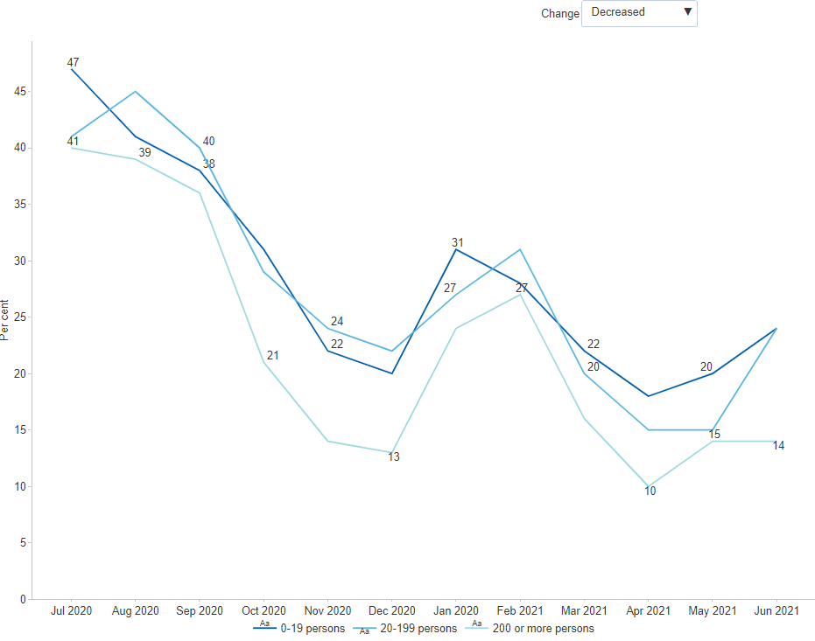

##### 

### Operating expenses over time

Since July 2020, the share of businesses reporting reduced operating expenses has decreased, from roughly one in six (16 per cent) to 6 per cent in June 2021. Large businesses were 4 percentage points more likely, on average, to report increased operating expenses than small businesses. The industries in which businesses were most likely to have reported an increase in operating expenses were *Arts and Recreation Services* (46 per cent), *Manufacturing* (30 per cent) and *Other Services* (29 per cent). Just 8 per cent of businesses sought additional funds over the last three months. The industries most likely to have sought additional funds were *Arts and Recreation Services* (39 per cent), *Education and Training* (20 per cent), and *Electricity, Gas, Water and Waste Services* (19 per cent). One in five businesses (21 per cent) reported accessing support measures in the form of Government wage subsidies, most frequently in *Information Media and Telecommunications* (38 per cent), *Construction* (34 per cent), and *Manufacturing* (33 per cent).[2]

#### Figure : Change in operating expenses, by employment size

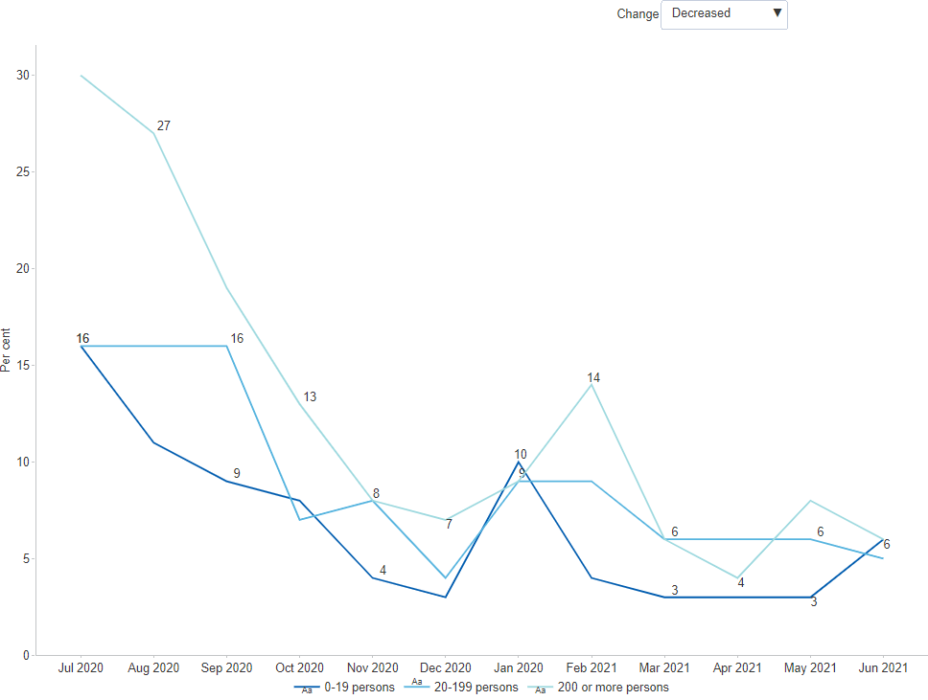

##### 

### Changes in number of employees over time

Since July 2020, the share of businesses reporting a decrease in employment declined from 13 per cent to 5 per cent in June 2021, while those reporting an increase in employment rose slightly from 7 per cent to 8 per cent. Small businesses were generally more stable, with most businesses reporting no change. There was, however, a slight uptick in the share of businesses reporting a decrease in employment in April 2021 due to the cessation of the JobKeeper program.[3] Industries that were on average most likely to report a decrease in the number of employees include *Administrative and Support Services* (15 per cent), *Accommodation and Food Service*s (11 per cent) and *Information Media and Telecommunications* (10 per cent). About one in five businesses (19 per cent) reported staff shortages based on current operations. The most common factors reported by businesses were *Inability to find suitable staff* (57 per cent), *Affordability of additional staff* (48 per cent) and *Uncertainty due to COVID-19* (42 per cent). Workforce actions that businesses plan to take over the next three months are Increase staff numbers (23 per cent), Re-train existing staff (22 per cent) and Increase staff hours (17 per cent).[4]

#### Figure : Change in number of employees, by employment size

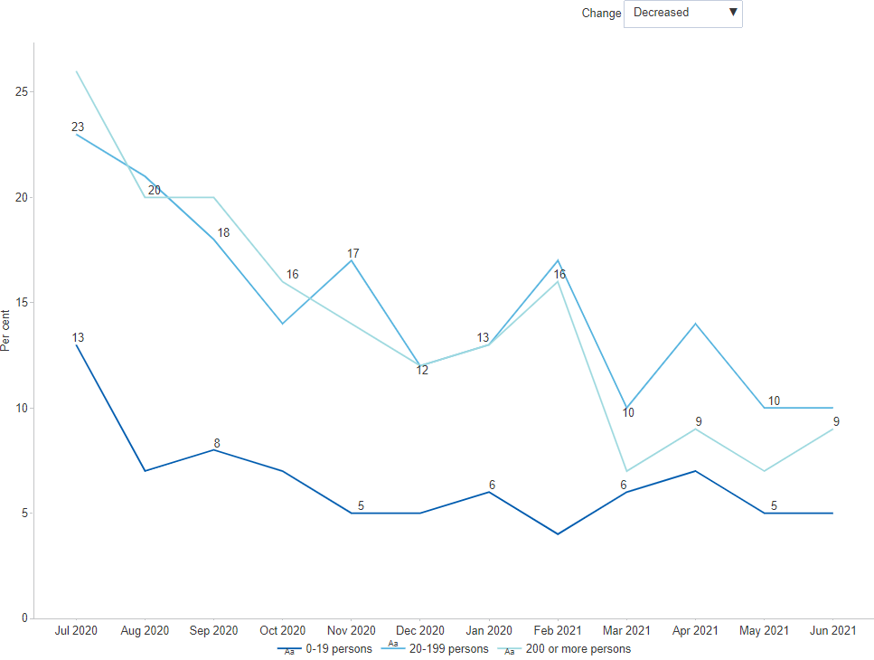

##### 

### Changes in capital expenditure over time

Since August 2020, the share of businesses reporting capital expenditure plans decreased, from about half of all businesses (49 per cent) to just under a fifth (23 per cent). The onset of the pandemic accelerated capital expenditure intentions which led to businesses innovating with new methods and improved ways to do things differently. Large businesses were on average twice as likely to report capital expenditure intentions as small businesses. Industries that were on average likely to report capital expenditure plans within the next three months include *Arts and Recreation Services* (39 per cent), *Mining* (34 per cent) and *Information Media and Telecommunications* (33 per cent). By contrast, industries that on average did not have any actual or planned expenditure were *Administrative and Support Service*s (67 per cent), *Transport, Postal and Warehousing* (67 per cent) and *Construction* (65 per cent). Prior to the pandemic, one out of 5 businesses (20 per cent) had teleworking arrangements. Currently, less than half of all businesses (43 per cent) have employees teleworking. Three in five (60 per cent) businesses expect to have employees continuing teleworking once restrictions are lifted and conditions stabilise.[5]

#### Figure : Businesses with capital expenditure plans, by employment size

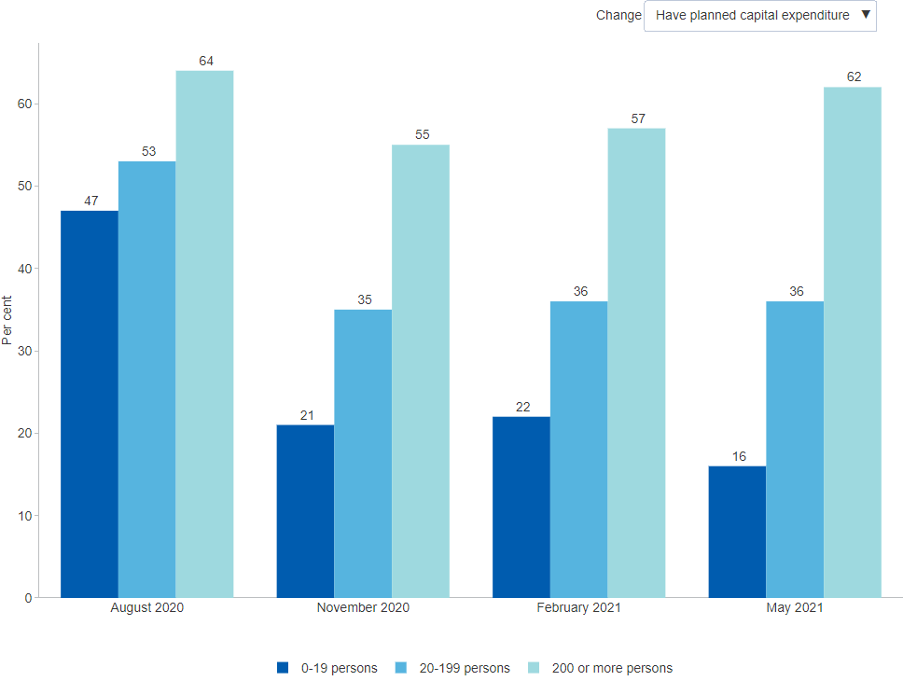

### Australian business innovation from the National Australia Bank

* Business innovation in Australia — as measured by the National Australia Bank’s Business Innovation Index — has recovered in 2021, while still well under pre-pandemic levels. NAB renews the call that innovation needs to be back on the nation’s economic agenda.
* The Business Innovation Index measures innovation by the extent to which a business changes anything that allows it to do things differently, more quickly or more cost efficiently. Business conditions are returning to multi-year highs with ongoing improvements in the economy, where innovation is being driven by doing things more quickly and cost efficiently. Although innovation from the measure of doing things differently has decreased from the COVID-induced spike, it is still the main driver of innovation.
* In 2021, the most innovative sectors were *Mining*, *Utilities & Telecoms*, and *Hospitality*. All industry sectors reported higher innovation.
* Businesses that have made changes in response to COVID-19 have incorporated them to their longer-term business models. The pandemic prompted change and adaptation.[6]

##### 

# 1 Business Innovation

*Some of the data presented in this chapter was collected prior to the COVID-19 pandemic. Pending further updates, the COVID-19 page summarises some of the impacts of COVID-19 on Australian businesses during the first year of the pandemic.*

The Australian economy is in transition. Once a nation that relied heavily on its agricultural exports and manufacturing, Australia is moving towards more digitally-enabled, service-oriented industries, on the back of its strength in mining. As the global economy becomes more integrated, the relative advantages of businesses and regions are changing in terms of trade and investment patterns. And with continuing technological advances, businesses and consumers are also changing their behaviours. Innovation in various forms plays a central role in this process.

Australian businesses have been innovating more than ever and reaping the rewards. The number of innovation-active businesses has steadily increased over the last 10 years, with reported benefits ranging from increased revenue to improved customer service and reduction in costs. Australian businesses generally tend to opt for adapting innovations developed by other parties, rather than introducing more novel kinds. They report barriers to undertaking innovation activity such as lack of skills and access to funds. New technologies continue to re-define what is traded, in turn presenting new export opportunities.

Digital technology is revolutionising business. A growing number of businesses use online services for managing finances, sharing information, staff training and other business activities. Social media usage has grown rapidly with more and more firms using it as a new channel for marketing, communication and recruitment. Access to reliable digital infrastructure, including mobile internet and high-speed broadband, is considered crucial as more Australian businesses introduce formal management practices to complement their substantial ICT investments. Against this backdrop, globalisation has accelerated the spread of new technologies and services, as well as new players with connections to international markets.[7]

##### 

## 1.1 Innovation Activity

### 1.1.1 Innovation activity overall

The proportion of businesses undertaking innovation is a key measure of performance in the innovation system. Based on survey data published by the Australian Bureau of Statistics (ABS), about half (50.7 per cent) of all Australian businesses identified as *Innovation-active businesses* in 2019–20, which is a 0.9 percentage point increase compared to 2017–18 (the most recent comparable estimate). Innovation-active businesses are those that undertook any innovative activity, irrespective of whether the innovation was introduced, still in development or abandoned, during the reference period.[8] The data for this indicator are collected through the *Characteristics of Australian Business* survey, which alternates from year to year between focusing on innovation versus business use of information technology. This results in two slightly different versions of the same data series, both of which are displayed in the chart. When making comparisons over time, it is recommended that estimates from the same version be used.

#### Figure 1.1.1: Innovation-active businesses, share of all businesses, per cent, latest 2019–20

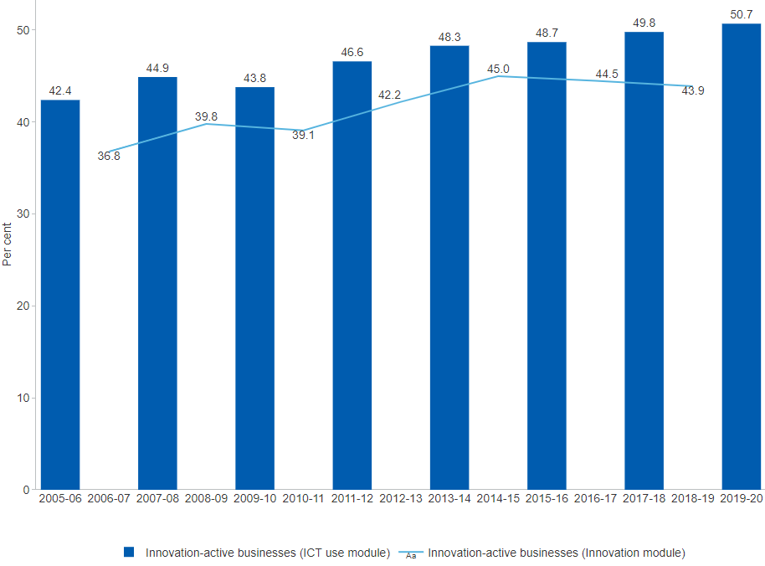

##### 

### 1.1.2 Innovation activity by innovation stage

Survey data published by the Australian Bureau of Statistics (ABS) cover three stages of innovation (introduced, still in development, and abandoned). In 2019–20, 50.7 per cent of Australian businesses were innovation-active, which means they were involved in at least one of these stages of innovation over the last 12 months. As a share of all businesses, two in five (42.6 per cent) had *introduced or implemented their innovation*, 27.9 per cent were *still developing their innovation* and 10.4 per cent had *abandoned some innovative ideas*. These proportions have remained relatively stable since 2011–12, however recent data also shows a rise in *Innovation which is still in development* and *Innovation which has been abandoned*.[9]

#### Figure 1.1.2: Innovation-active businesses, share of all businesses, by innovation stage, per cent, latest 2019–20

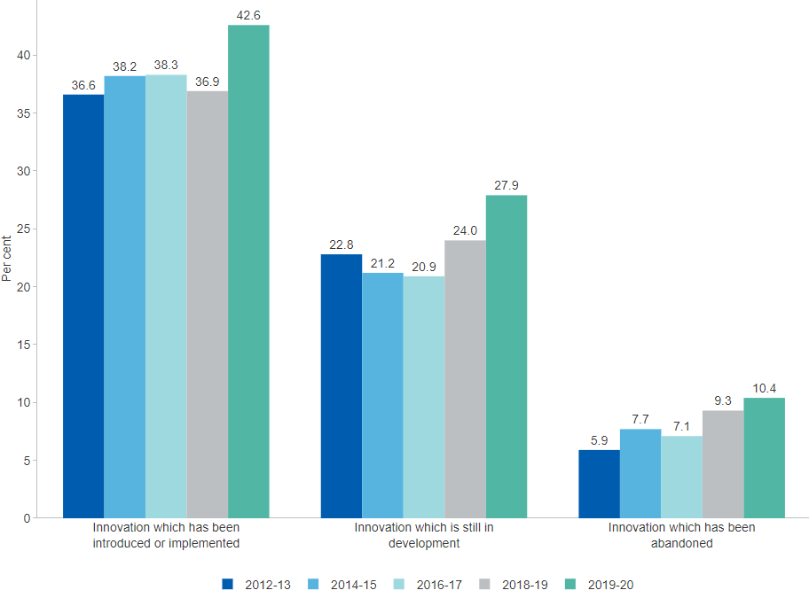

##### 

### 1.1.3 Innovation activity by business size

Innovation activity increases significantly with business size. In 2019–20, 68.0 per cent of large businesses (*200 or more employees*) were innovation active, compared to just 45.8 per cent of micro businesses (*0–4 employees*). In recent years, there has been a gradual decline in the share of large innovation-active businesses from a high of 79.5 per cent in 2013–14 to 68.0 per cent in the latest period. As a group, small and medium sized businesses have maintained relatively stable proportions of businesses with innovation activity.[10]

#### Figure 1.1.3: Innovation-active businesses, share of all businesses, by business size, per cent, latest 2019–20

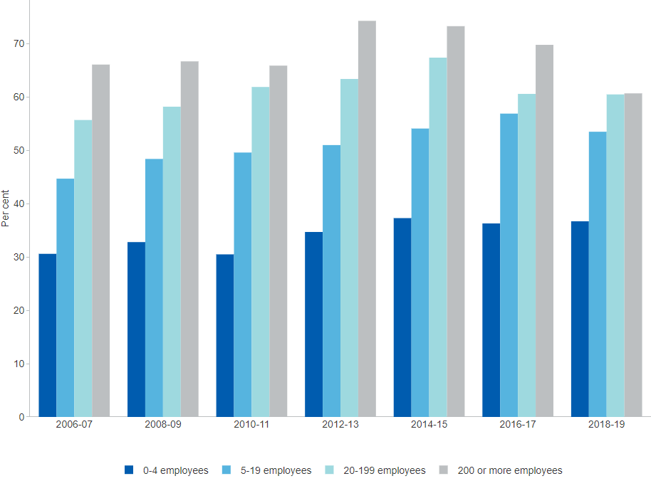

##### 

### 1.1.4 Innovation activity by industry

Innovation activity varies considerably by industry. In 2019–20, the *Professional, scientific and technical services* industry had the highest share of innovation-active business (61.6 per cent), followed by *Information media and telecommunications* (61.3), *Wholesale trade* (60.6 per cent) and *Retail trade* (59.2 per cent). A decade earlier in 2009–10, *Wholesale trade* reported the highest share of innovation-active businesses, followed by *Arts and recreation services*. In the last 10 years, the share of innovation-active businesses increased across the board, except in *Mining* and *Construction* where it declined. The largest relative increases occurred in the *Transport, postal and warehousing* industry.[11]

#### Figure 1.1.4: Innovation-active businesses, share of all businesses, by industry, per cent, latest 2019–20

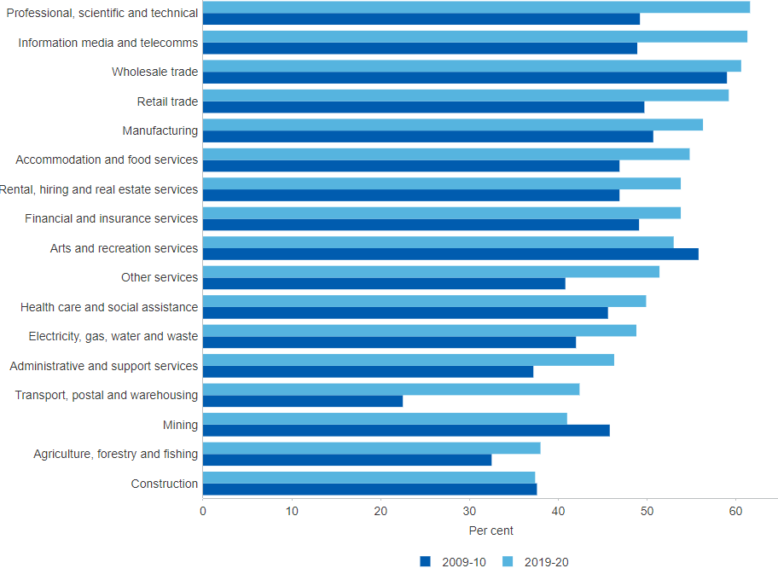

##### 

### 1.1.5 Businesses that introduced innovations by innovation type

Innovating businesses are those that introduced at least one type of innovation during the reference period and are a subset of innovation-active businesses. The introduction of innovations is somewhat correlated with business size. Just over half of all medium (*20–199 employees*) and large (*200 or more employees*) businesses introduced innovations in 2019–20 compared to roughly one third of micro businesses (*0–4 employees*). Similar to the 2018–19 survey, the 2019–20 survey distinguishes between two types of innovation: goods and services innovation, and process innovation. This aligns with the new international innovation standards and concepts, described in the latest Oslo Manual 2018.[12] In 2019–20, more businesses introduced *Process innovations* than *Goods and services innovations*.[13]

#### Figure 1.1.5: Businesses that introduced innovations, share of all businesses, by innovation type, by business size, based on Oslo Manual (4th edition), per cent, latest 2019–20

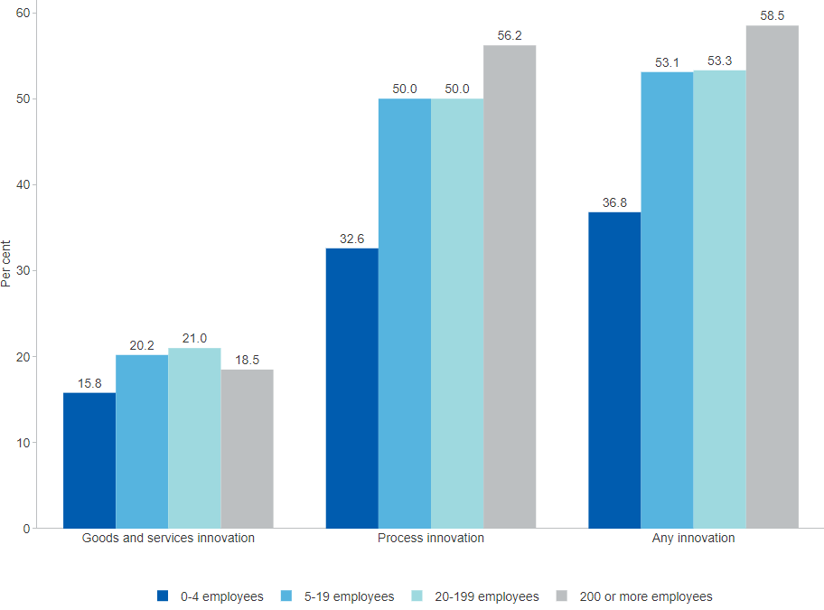

##### 

### 1.1.6 Novelty of introduced innovations

Australian businesses tend to specialise in modifying innovations introduced by other businesses also operating in the domestic market. Roughly three quarters of all innovation in goods and services and almost 90 per cent of all process innovation introduced by Australian businesses is *New to the business only*. Large businesses are generally more likely than SMEs to introduce innovation that is *New to the industry*. In 2018–19, only 9.2 per cent of goods and services innovation was *New to Australia* and 9.1 per cent was *New to the world*. The ability of so many Australian innovating businesses to successfully execute this relatively simple ‘adopt and adapt’ strategy is arguably a strength of Australia’s innovation system. However, excessive focus on domestic modification may adversely affect Australia’s international competitiveness, since innovations with higher degrees of novelty areas generally more valuable, both domestically and internationally.[14]

#### Figure 1.1.6: Novelty of introduced innovations, share of innovating businesses, per cent, latest 2018–19

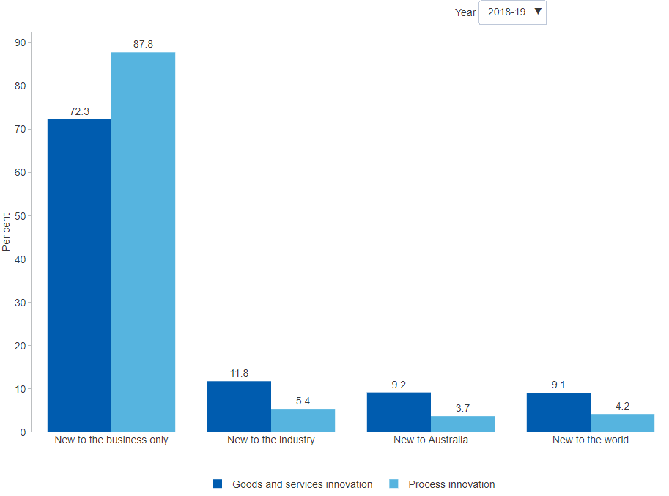

##### 

### 1.1.7 Barriers to business innovation

Recent survey data reflects business perceptions regarding the barriers that are most likely to derail their innovation activities or dissuade them from innovating. The most commonly reported barriers across both innovators and non-innovators include a *Lack of skilled persons*, followed by *Uncertain demand for new products* and *Lack of access to additional funds*. Although there is no clear evidence that access to business finance is a widespread problem in Australia, a 2015 inquiry into business lending found that innovative businesses are more likely to face difficulties than non-innovators.[15] Businesses reported that barriers related to *Government regulations and compliance* were not particularly significant, while *Adherence to standards* and *Lack of access to knowledge or technology* were reported the least.[16]

#### Figure 1.1.7: Barriers to business innovation, by innovation status, per cent, latest 2019–20

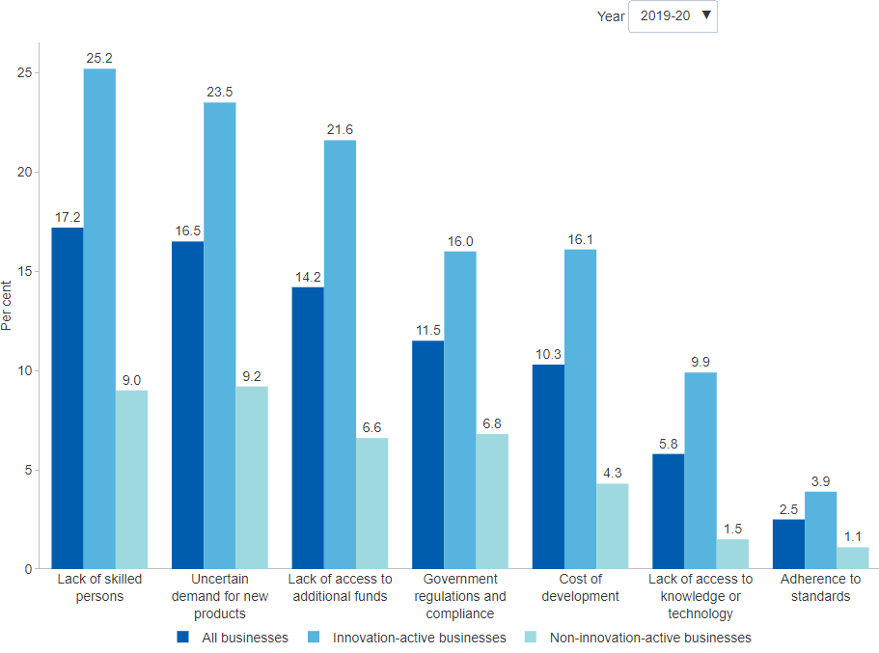

##### 

## 1.2 Digital Innovation

### 1.2.1 Business internet use

Almost all Australian businesses now have internet access (97 per cent in 2018–19) and many are transitioning their broadband connection to a fibre connection, especially large businesses (200 or more employees) (data not shown). For the last 10 years, businesses have steadily integrated internet-enabled services into their business operations. By far the most common use of the internet continues to be to *Manage financial activities* at 90.4 per cent in 2019–20, up from 84.8 per cent in 2009–10. All other uses have also grown considerably and continue to do so. Most notable is that workers have become increasingly mobile with 48.5 per cent being able to *Work from home* in 2019–20. Over a third of businesses also use the internet to *Communicate*, *Receive online training* and *Assess current products*.[17]

#### Figure 1.2.1: Business internet use, per cent, latest 2019–20

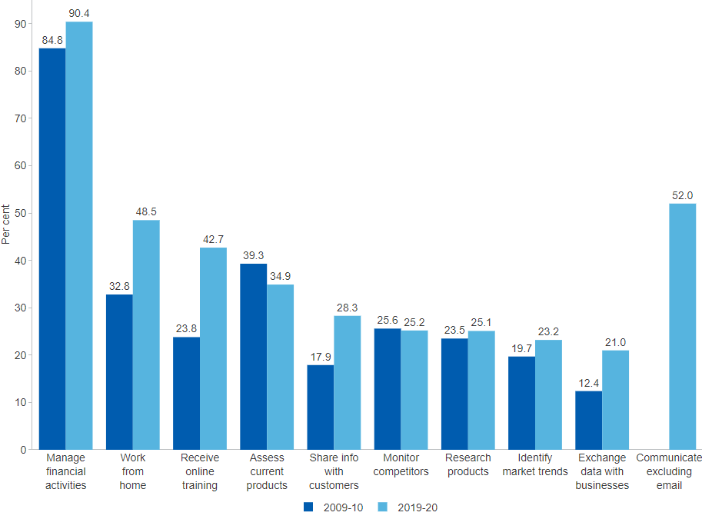

##### 

### 1.2.2 Businesses receiving orders via the internet

The share of businesses receiving orders via the internet indicates the extent of e-commerce as well as the state of business infrastructure necessary to support this. Since 2006–07, there has been a consistent increase in the share of businesses, both innovation-active and non-innovation-active, selling goods and services online. *Innovation-active businesses* are significantly more likely to do so, reaching 58.2 per cent in 2019–20 compared to 40.6 per cent for *Non-innovation-active businesses*. In 2020, the industries with the largest increase of orders received via the Internet were *Accommodation and food services* (13.0 percentage points), *Retail trade* (12.6 percentage points) and *Professional, scientific and technical services* (11.2 percentage points). SMEs also enjoyed increases in orders received via the Internet, with a 9.0 percentage point increase, while large businesses fell by 5.1 percentage points.[18] This shift towards e-commerce was heightened by the COVID-19 pandemic.[19]

#### Figure 1.2.2: Business that reported receiving orders via the internet, by innovation status, per cent, latest 2019–20

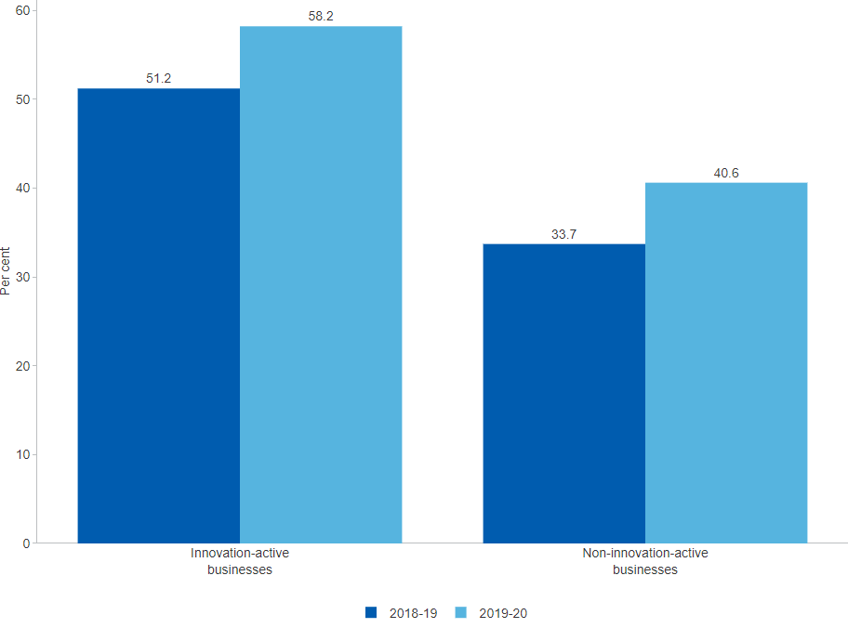

##### 

### 1.2.3 Business use of cloud computing

Cloud computing is a relatively recent technology focused on delivering ICT resources (e.g. software, storage or processing capacity) as a virtualised service over the internet on an on-demand or pay-per-use basis.[20] The share of businesses using cloud computing has rapidly increased from 19.4 per cent in 2013–14 to 55.4 per cent in 2019–20. For those businesses that used cloud computing services in 2019–20, *Software-as-a-service* was the most commonly purchased service (80.4 per cent), followed by *Storage* capacity (55.2 per cent). By business size (data not shown), 48.7 per cent of micro businesses (0–4 employees), 64.8 per cent of other small businesses (5–19 employees), 76.1 per cent of medium-sized businesses (20–199 employees), and 80.6 per cent of large businesses (200+ employees) reported using paid cloud computing services. By industry sector (data not shown), *Professional, scientific and technical services* had the highest proportion of businesses using such services (72.9 per cent), followed by *Information media and telecommunications* (67.1 per cent) and *Mining* (67.1 per cent). Note that survey response options for questions regarding the use of cloud computing have changed since the previous survey period.[21]

#### Figure 1.2.3: Business use of cloud computing, per cent, latest 2019–20

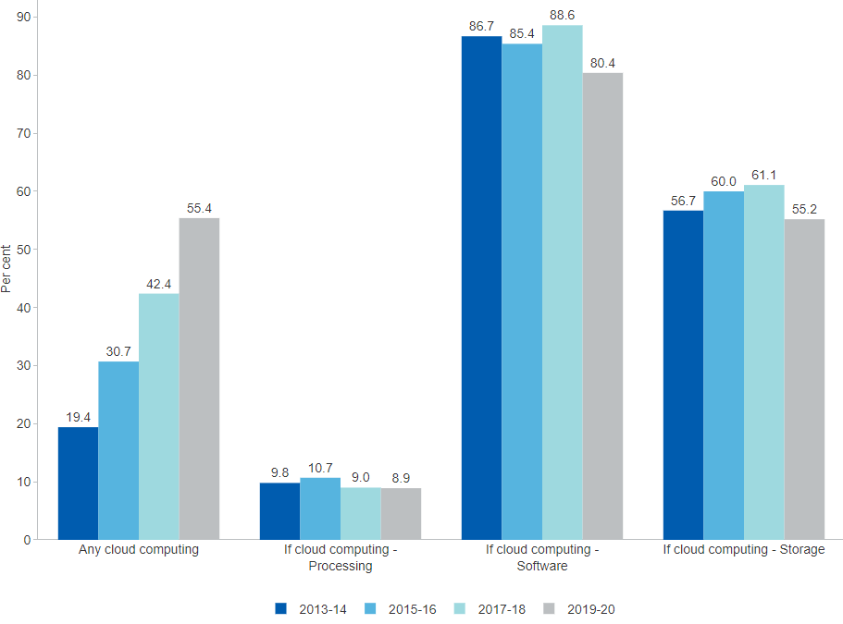

##### 

### 1.2.4 Barriers to business use of paid cloud computing

In the presence of reliable high-speed internet, cloud computing can deliver a number of benefits that amount to a superior ICT service at lower cost compared to traditional models. While the majority of surveyed Australian businesses increasingly report that no factors are limiting their use of paid cloud computing services (70.7 per cent in 2019–20, up from 58.7 per cent in 2013–14), some businesses have identified limitations. In 2019–20, *Insufficient knowledge* of cloud computing services (13.5 per cent) was the most common limiting factor, followed by *High cost* (11.7 per cent) and *Security breach risk* (9.6 per cent). While the perception of barriers fell in general, businesses increasingly reported the high cost of cloud computing services as a barrier.[22] This suggests that there is potential for wider uptake of cloud computing services by Australian businesses, as these factors are addressed.

#### Figure 1.2.4: Barriers to business use of paid cloud computing, per cent, latest 2019–20

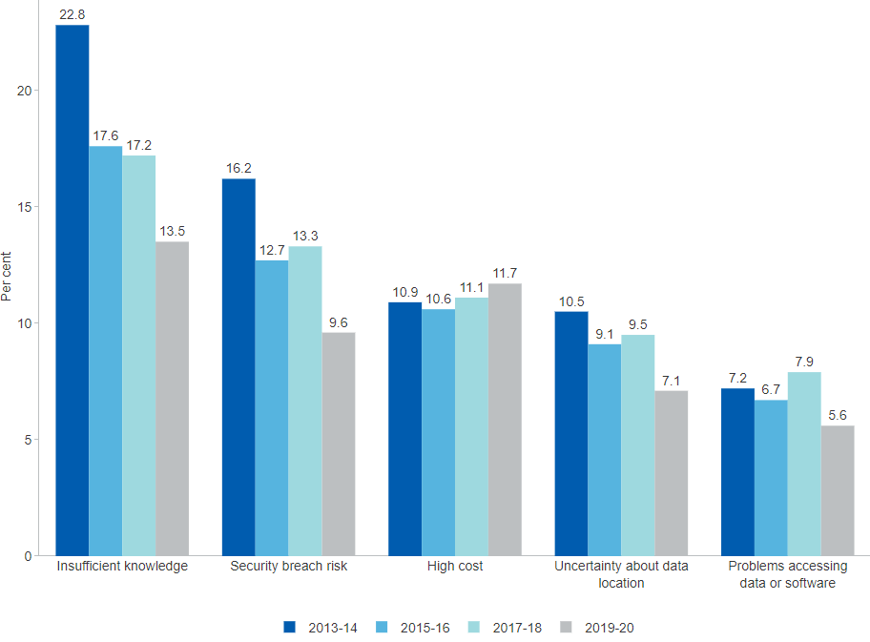

##### 

### 1.2.5 Management practices for business ICT use

Digital technologies offer substantial productivity gains to businesses and their employees, as well as flow-on spillover benefits in terms of skill and capability development. The size of those gains relies in part on the effective management of ICT assets, skills, training, and support services. About half of all Australian businesses implemented at least one management practice for the use of ICT in 2019–20 (43.3 per cent), which is a large increase of 12.1 percentage points from 2017–18. This rapid uptake is led by a 7 percentage point increase in investing in new *Digital technologies* to 16.5 per cent of all businesses in response to the COVID-19 pandemic, driven by the *Rental, hiring and real estate services* and *Administrative and technical services* industries. Other common management practices include *Improved security* through implementing upgrades to cybersecurity software (20.1 per cent) and contracting external *IT consultants* (17.5 per cent).[23]

#### Figure 1.2.5: Management practices for business ICT use, per cent, latest 2019–20

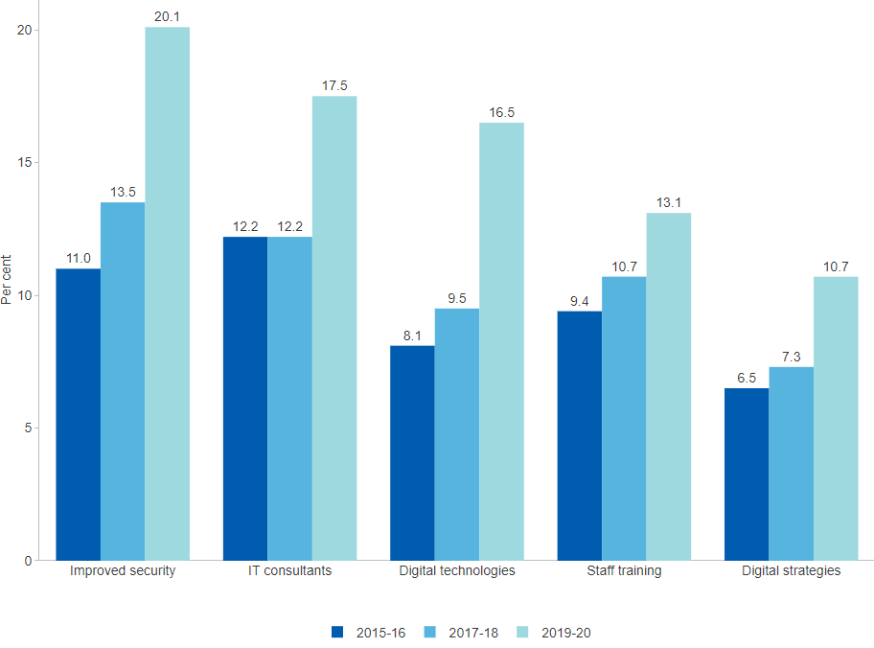

##### 

### 1.2.6 Digital technologies of major importance

Mobility and operational flexibility are increasingly important to business performance. Digital technologies can facilitate this flexibility, for instance, through remote access or convenient service delivery to customers and end users. In 2017–18, more than half of all businesses with internet access reported that *Mobile internet* access was of major importance to their business (57.8 per cent), followed closely by *High-speed broadband* internet access (50.4 per cent). Further, *Cloud technology* (27.0 per cent) is becoming increasingly important. Whilst the importance of each type of digital technology has increased since 2015–16, many technologies continue to not be ranked by businesses as being of major importance, for instance, *Intelligent software systems* (7.2 per cent) and *Data analytics* (5.2 per cent).[24]

#### Figure 1.2.6: Digital technologies of major importance, share of businesses with internet access, per cent, latest 2017–18

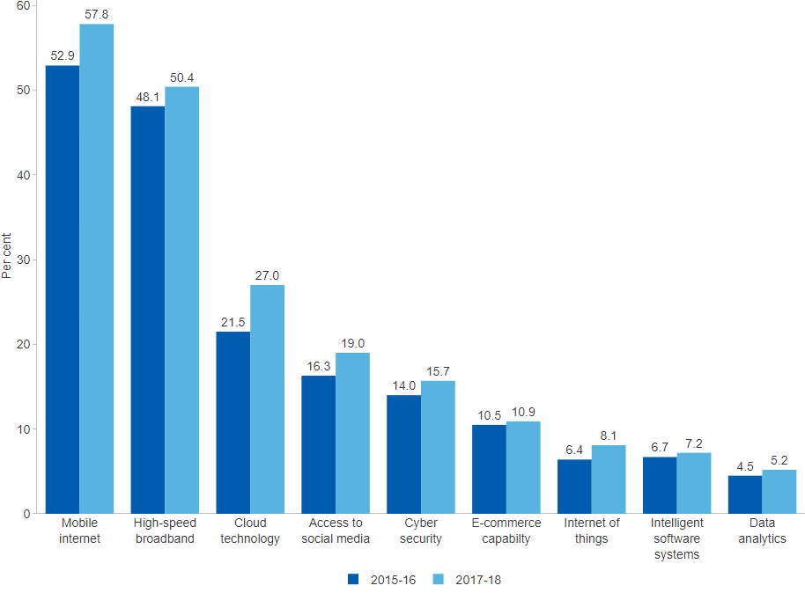

##### 

### 1.2.7 Factors impacting business ICT use

The introduction of new technologies entails not only opportunities but also challenges. In pursuing productivity gains through the uptake of digital technologies, businesses often need to adjust their business practices and resources to complement their ICT assets. The evidence suggests that these factors do not represent substantial obstacles for Australian businesses. The vast majority of businesses surveyed (72.3 per cent in 2017–18 and 74.5 per cent in 2015–16) did not identify any obvious factors as having fundamentally changed their use of ICT. In 2017–18, when they did identify some factors that changed their use of ICT the most commonly reported ones included *Spam* (7.6 per cent), *Lack of access* to digital infrastructure (7.7 per cent), and *Enhanced need for digital skills* and capability (7.7 per cent).[25]

#### Figure 1.2.7: Factors impacting business ICT use, per cent, latest 2017–18

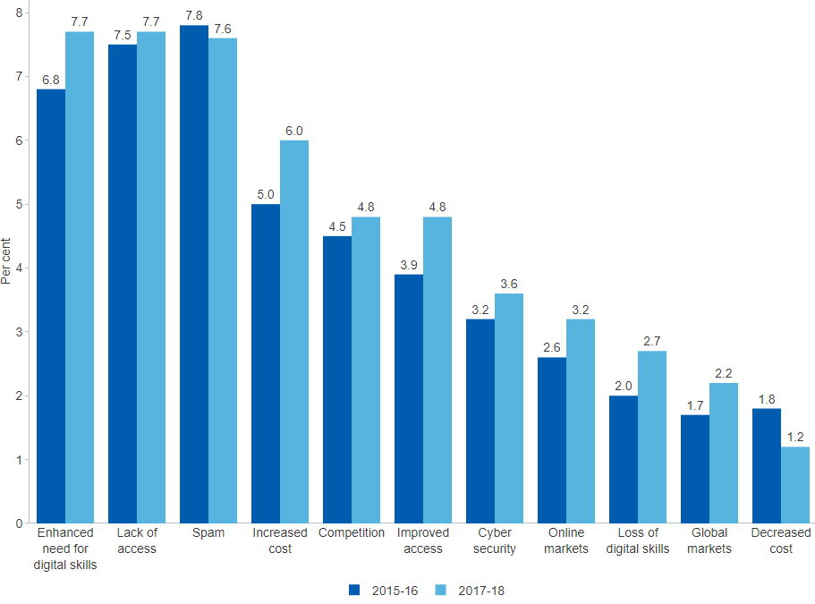

##### 

### 1.2.8 ICT use in business processes

The use of ICT has increased gradually between 2013–14 and 2017–18. In 2017–18, Australian businesses used ICT most extensively for *Accounting* (66.8 per cent), followed by *Invoicing* (60.5 per cent) and *Human resources* (48.1 per cent) purposes. On the other hand, only 17.0 per cent of businesses use ICT in *Stock control*. The share of businesses using ICT extensively tends to increase with business size (data not shown). For example, in 2017–18 in the case of ICT use for *Business planning* (20.4 per cent), business proportions were 16.5 per cent for micro businesses (0–4 employees), 22.0 per cent for small businesses (5–19 employees), 38.1 per cent for medium-sized businesses (20–199 employees) and 61.5 per cent for large businesses (200 or more employees). This pattern may in part reflect differences in business requirements at different scales of operation.[26]

#### Figure 1.2.8: ICT use in business processes, per cent, latest 2017–18

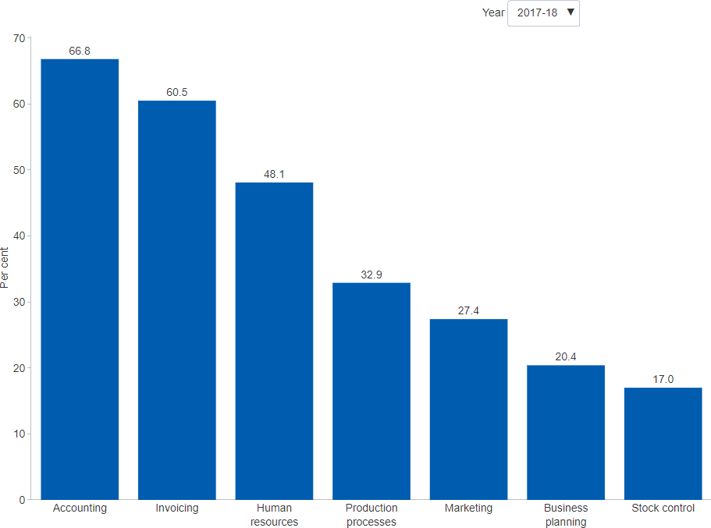

##### 

### 1.2.9 ICT capital investment

The digital economy is underpinned by advances across a range of digital technologies, facilitated by sustained rapid growth of investment in ICT capital goods and services over the past decades. A useful measure for this type of investment is the aggregate spending on *Computer software*, *Computers and peripherals*, and *Electrical and electronic equipment*. The data shows the disproportionate contribution of computer software investment, pointing to the importance of the application of knowledge and the accumulation of intangible capital more broadly. Over the last 20 years, investment in computer software increased more than five-fold in chain volume terms, from $4.3 in 1999–00 to $23.5 billion in 2019–20. At roughly 1.16 per cent of GDP, computer software currently accounts for nearly two-thirds of total investment in ICT across the three assets.[27]

#### Figure 1.2.9: ICT gross capital investment, by asset type, current prices or chain volume, $ billion, latest 2019–20

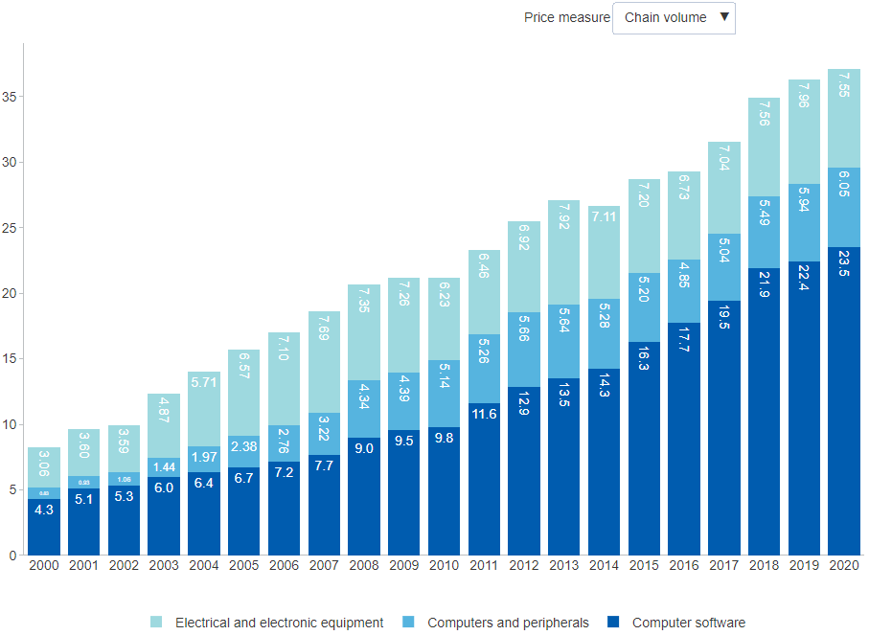

##### 

## 1.3 Benefits of Innovation

### 1.3.1 Benefits of introduced innovation

Most Australian innovation-active businesses (89.4 per cent in 2018–19) report having reaped some kind of benefit from innovation. *Improved customer service* and *Increased revenue* have been the most frequently reported benefits over the period from 2010–11 to 2018–19. In responding to this survey question, innovation-active businesses could identify more than one type of benefit. In each iteration of the survey, roughly a quarter to a third of businesses say that it is *Too early to measure* the benefits of innovation for the given reference period of one financial year. This suggests that at least some are pursuing longer-term investments.[28] In addition to these direct benefits, innovation often provides spillover benefits that accrue to local industries, communities and the rest of society.

#### Figure 1.3.1: Benefits of introduced innovation, share of innovation-active businesses, per cent, latest 2018–19

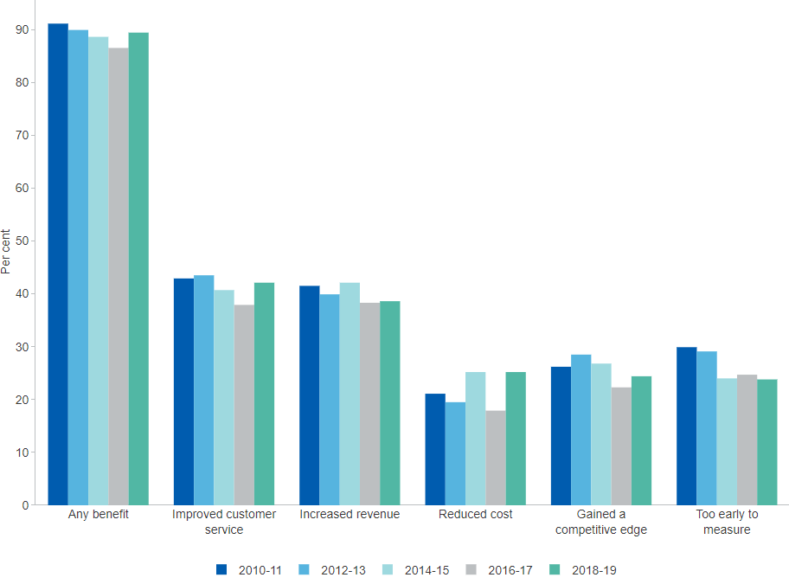

##### 

### 1.3.2 Business performance by innovation status

Compared to Australian businesses that do not innovate, a notably higher proportion of innovation-active businesses consistently report increased sales, profitability, and productivity, as well as other growth-related performance measures. In 2019–20, differences between innovation-active and non-innovation-active were particularly pronounced in terms of increased *IT spending*, *productivity* and *product range*.[29] Furthermore, the positive impact of innovation gets stronger when businesses innovate more frequently. Persistent innovators significantly outperform other businesses in terms of sales, value added, employment and profit growth.[30]

#### Figure 1.3.2: Business performance, by innovation status, per cent, latest 2019–20

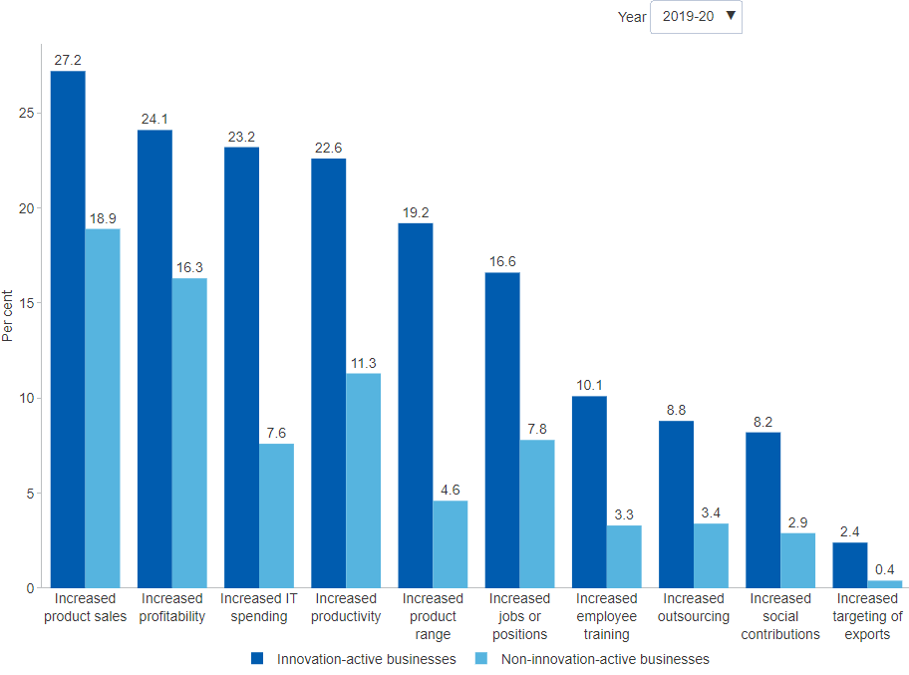

##### 

### 1.3.3 Employment, productivity and sales outcomes, by innovation status and collaboration

Innovation-active businesses are consistently more likely to report increased employment, productivity and sales, compared to businesses that do not innovate. This is even more pronounced for innovation-active businesses that undertake collaboration compared to those that do not. The evidence is less clear about differences in the scope of collaboration in terms of collaboration partners. It appears that once businesses collaborate outside their own sector they gain advantages, irrespective of whether their collaboration partners were from multiple other sectors or just one. Innovation-active businesses that collaborate internationally do, however, tend to report better outcomes more often than other collaborators but the difference is only marginal and may not be statistically significant.[31]

#### Figure 1.3.3: Employment, productivity and sales outcomes, by innovation status and collaboration, per cent, latest 2016–17

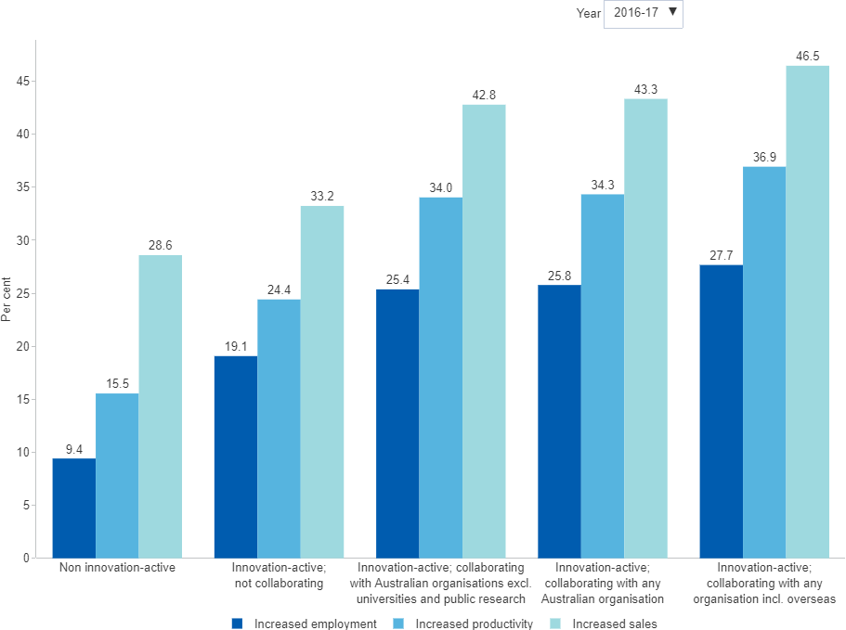

##### 

## 1.4 International Comparison

### 1.4.1 Global Innovation Index

The Global Innovation Index (GII) is a high-profile international index summarising factors affecting innovation outcomes and is often cited in cross-country comparisons. The GII score on which countries are ranked combines seven pillars. Each pillar is a combination of three sub-pillars which are weighted averages of different indicators. *Australia* ranked 25th out of 132 economies on the GII in 2021[32] and as such is classified to be among the innovating leaders — countries with mature innovation systems that perform well on innovation relative to GDP. The GII and other summary indices should be interpreted with caution, due to inherent limitations including the absence of a theoretical foundation to guide the selection of indicators, data availability and low sampling for surveys that provide qualitative data. These limitations may impact Australia's results.

#### Figure 1.4.1: Global Innovation Index, top 30 countries, index points, latest 2021

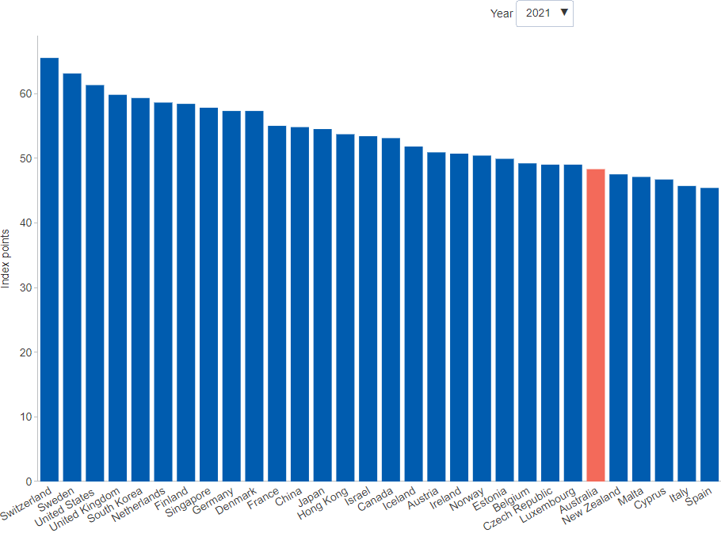

##### 

### 1.4.2 Global Innovation Index, Innovation input sub-index

The GII innovation input sub-index comprises five pillars that capture elements of the national economy generally regarded as innovation enablers — such as *institutions*, *infrastructure*, or *human capital and research*. *Australia* has ranked well on the GII innovation input sub-index since 2011, moving between 10th and 15th among 126 to 143 economies, depending on the year. In 2021, *Australia* ranked 15th out of 132 economies, performing at the OECD average. Australia was strongest in the *market sophistication* (9th) and *institutions* pillars (10th).[33]

#### Figure 1.4.2: Global Innovation Index, Innovation input sub-index, top 30 countries, index points, latest 2021

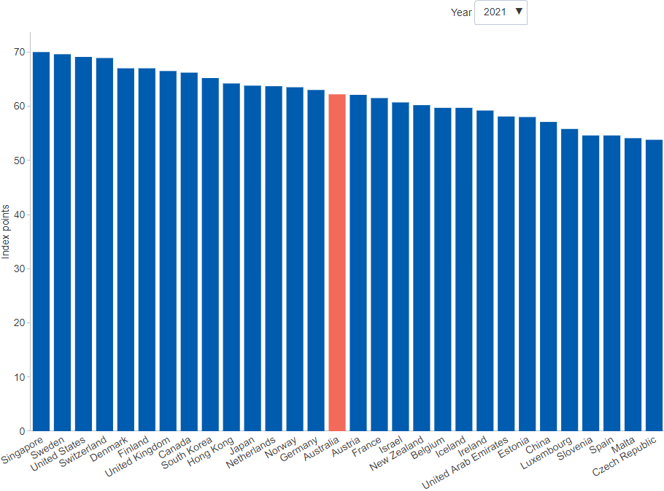

##### 

### 1.4.3 Global Innovation Index, Innovation output sub-index

The GII innovation output sub-index provides information about outputs that are the result of innovative activities occurring in the economy. It comprises two output pillars, namely *knowledge and technology* and *creative*, both of which are weighted by GDP. In 2021, *Australia* ranked 33rd out of 132 economies. This is relatively low compared to Australia's GII innovation input ranking of 15th. Australia’s 2021 performance was weakest in *knowledge and technology outputs*, which measures knowledge creation, knowledge impact and knowledge diffusion. This suggests that Australia produces less innovation outputs relative to its level of innovation investment.[34]

#### Figure 1.4.3: Global Innovation Index, Innovation output sub-index, top 30 countries, index points, latest 2021

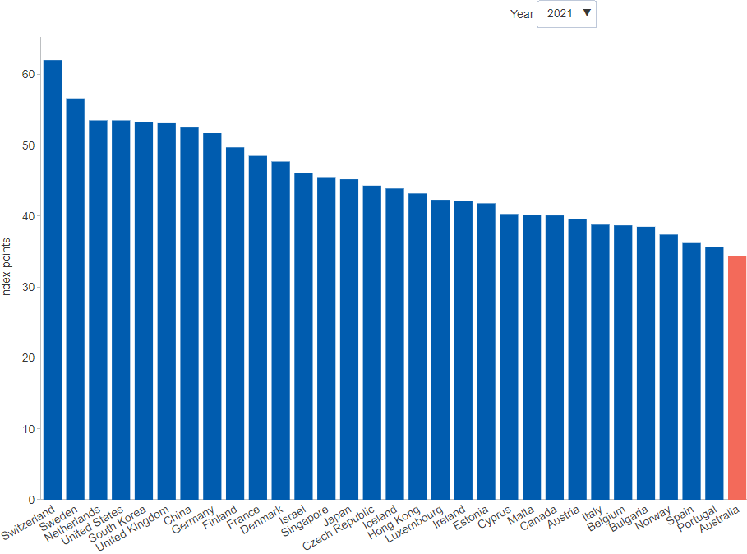

##### 

### 1.4.4 Innovation-active businesses that are R&D active

All businesses engaged in R&D are innovation active but not all innovation-active businesses engage in R&D. R&D is a specific type of innovation activity and it can be costly, requiring specialised expertise and equipment. In the business enterprise sector, R&D activity is industry-specific – important to some industries (e.g. Manufacturing) but not to others (e.g. Accommodation and food). The overlap between innovation and R&D activity provides a proxy measure of the extent to which high-value technological innovation may be occurring. *Australia* has a relatively low proportion of businesses in this category compared to other OECD countries (24.1 per cent in 2016–17 compared to 47.2 per cent for the latest available *OECD average*, respectively).[35] The data only capture businesses pursuing product and/or process innovation, so the estimates partly reflect Australia’s service-oriented industry structure and the diminishing share of manufacturing in output and employment. In 2016–17, *Large businesses* had the lowest share of R&D expenditure (21.9 per cent) and *Manufacturing businesses* continue to have the highest (26.1 per cent).[36]

#### Figure 1.4.4: Innovation-active businesses that are R&D active, only relates to product and/or process innovation, by category, OECD countries, per cent, latest 2019

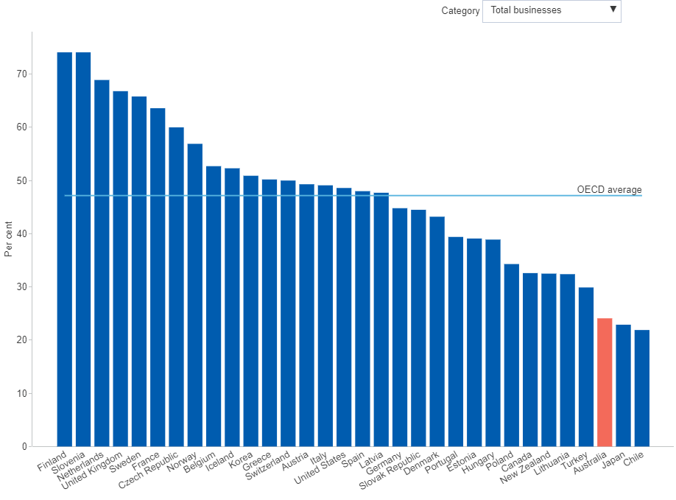

##### 

### 1.4.5 IMD World Competitiveness Ranking

The IMD World Competitiveness Rankings benchmarks economic wellbeing and competitiveness in accordance with criteria obtained through statistical and survey data each year. *Australia* ranked 16th among OECD countries in 2021, a decline from 3rd in 2010.[37] Australia’s competitiveness landscape excelled in benchmark criteria such as efficiency in business legislation and health infrastructure, but cited weaknesses in management practices and international trade, particularly in export sophistication.[38] While the report suggests Australia’s ranking was supported by limiting the economic impact of COVID-19, driving changes such as the digital economy and social outcomes are the key indicators of strong institutional and social frameworks.

#### Figure 1.4.5: IMD World Competitiveness Rankings, OECD countries, index, latest 2021

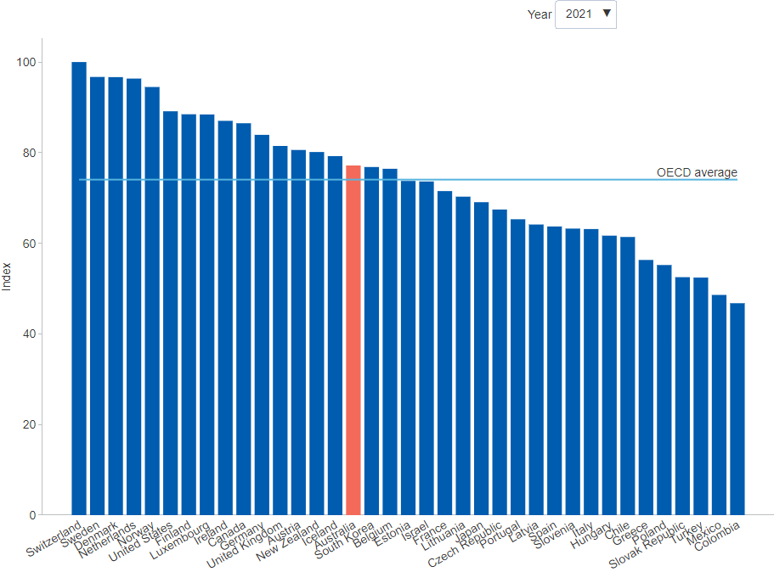

##### 

### 1.4.6 IMD World Digital Competitiveness Ranking

Branching from the IMD World Competitiveness Ranking in 2013, the IMD World Digital Competitiveness Ranking tracks the digital transformation of economies. In particular, the COVID-19 pandemic tested the capacities of economies to use digital technologies and technological infrastructure. Following a decline from 8th place in 2015, *Australia* ranked 15th among OECD countries in 2021, citing weaknesses such as business agility and collaboration.[39] Across sub-factors, Australia was slightly weaker in *digital readiness*, which measures an economy’s capability to sustain its digital competitiveness over time.[40]

#### Figure 1.4.6: IMD World Digital Competitiveness Rankings, OECD countries, index, latest 2021

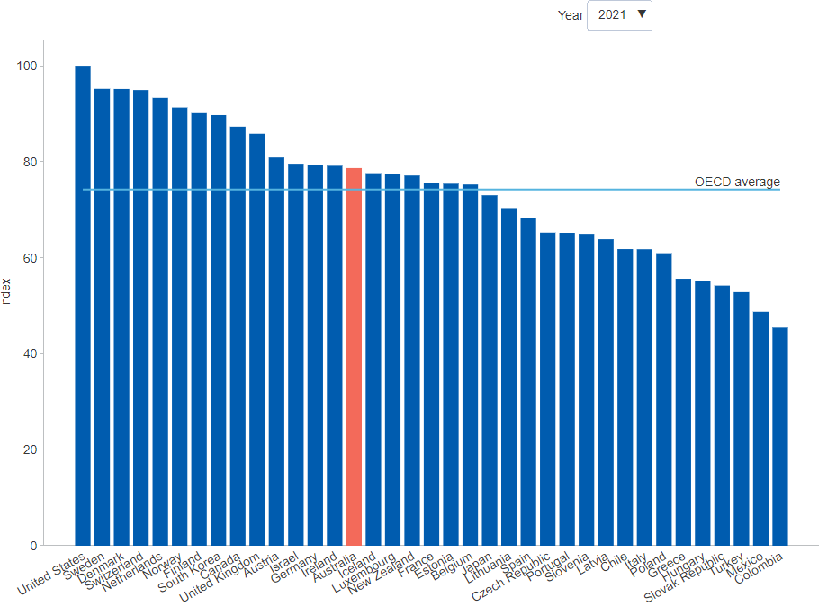

##### 

# 2 Entrepreneurship

*Some of the data presented in this chapter was collected prior to the COVID-19 pandemic. Pending further updates, the COVID-19 page summarises some of the impacts of COVID-19 on Australian businesses during the first year of the pandemic.*

Entrepreneurship is an essential part of business dynamism in market economies. It provides a mechanism for economic renewal through the recycling of talent, capital and other resources displaced by competition and technological progress. The picture of Australia's entrepreneurial activity is mixed. Some evidence suggests that Australia's entrepreneurial landscape may have become less dynamic and more hazardous over the years 2002 to 2015. Relatively fewer entrepreneurs were found to be entering the market, and those that entered were more likely to exit than their counterparts that entered in earlier years. Yet, despite fewer businesses entering, the average number of jobs created per entrepreneur has been steady and even increasing over the most recent years.[41]

Some short-term indicators of Australia's entrepreneurial activity have defied the deterioration in business conditions, including the most recent data on the number of people starting a business, perceptions of business opportunity, and job creation expected from new business ventures. The data show increases in the number of businesses entering the market lifting the number of businesses in operation and the proportion of businesses surviving. There is also tentative evidence of short-term improvement in business growth by employment size, with relatively large increases in the number of micro businesses moving to the small business category, and the number of small businesses moving to the medium-size category.

Only a small fraction of Australian startups drive the majority of net job creation — a pattern that is consistent across OECD economies. These high growth startups show superior sales and profit performance but lower labour productivity, compared to other surviving startups.[42] One factor potentially preventing entrepreneurship is a fear of failure, which is more commonly cited in surveys by Australians than their OECD counterparts. Another factor is access to capital, often identified as one of the main hurdles to innovation and business growth, and evidence suggests that Australia's early-stage venture capital investments are lower than most other OECD countries.[43]

##### 

## 2.1 Business Demography

### 2.1.1 Businesses in operation by industry

The number of businesses operating in a given industry gives an indication of the market structure and level of competition, which in turn determines how businesses might innovate. At the end of June 2021, there were 2,398,926 actively trading businesses in Australia. This represents an increase of 3.8 per cent from 2,310,937 businesses at the end of June 2020. All industries saw positive growth including *Other services* (7.4 per cent) and *Health care and social assistance* (7.2 per cent), with the exception of *Transport, postal and warehousing* (2.8 per cent decrease) and *Public administration and safety* (1.4 per cent decrease). As at 30 June 2021, the highest number of businesses were in *Construction* (410,839 businesses or 17.1 per cent of total) and in *Professional, scientific and technical services* (316,462 businesses or 13.2 per cent of total). (Note: The totals shown in the chart exclude businesses where the industry is *Currently Unknown*, resulting in a small difference from the aggregate totals).[44]

#### Figure 2.1.1: Businesses in operation, by industry, number, latest 2020–21

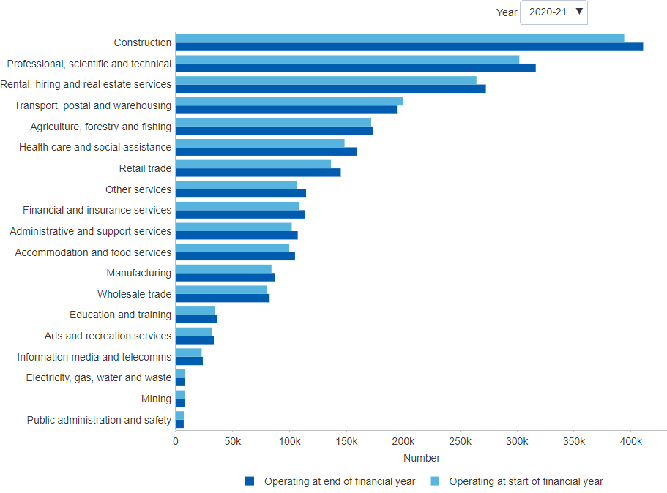

##### 

### 2.1.2 Business entries and exits by industry

Business entries and exits reflect business dynamism, and may be used as proxy indicators for the prevailing conditions for entrepreneurial activity. During 2020–21, the number of new Australian business entries was 364,927 — a sharp increase of 8.6 per cent from 2019–20 (335,931 businesses). The number of business exits in 2020–21 was 276,938 — a decrease of 4.5 per cent from 2019–20 (289,914 businesses). Emergency measures such as subsidies for wages, business cashflows and business insolvency laws appear to have reduced the rate of business failures during the onset of COVID-19. Not surprisingly, business entries have increased over the same period.[45] Industries with the highest number of entries in 2020–21 include *Construction* (67,242 businesses), *Professional, Scientific and Technical Services* (50,032 businesses), and *Transport, Postal and Warehousing* (37,188 businesses). Almost all industries recorded positive growth in business entries over the period, with the exception of *Transport, postal and warehousing* and *Public administration and safety* (Note: The totals shown in the chart exclude businesses where the industry is *Currently Unknown*, resulting in a small difference from the aggregate totals).[46]

#### Figure 2.1.2: Business entries and exits, by industry, number, latest 2020–21

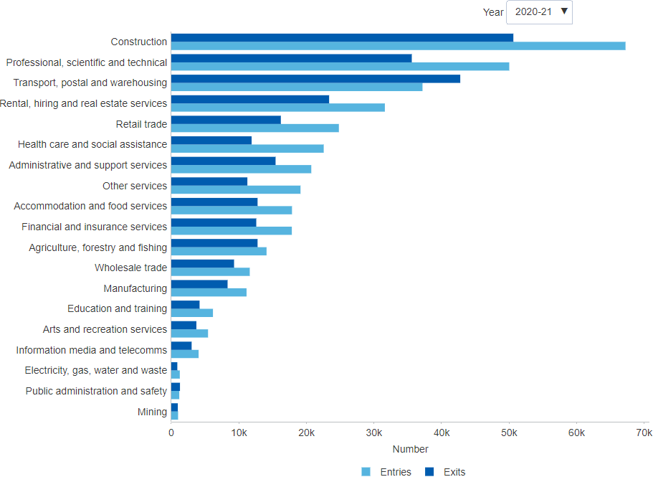

##### 

### 2.1.3 Survival of business entries by industry

The aggregate rate of business survival, while determined by many factors, provides a simple summary measure of the likelihood of entrepreneurial success. Of the 342,462 businesses that entered during 2017–18, some 76.6 per cent (262,338 businesses) survived to June 2019, and 60.4 per cent (206,908 businesses) were still operating two years later in June 2020. The proportion of this cohort that survived the three years to June 2021 was 52.1 per cent (178,338 businesses). Within this cohort, businesses in the *Health care and social assistance* industry had the highest survival rate (65.9 per cent) at the end of 2020–21, closely followed by those in *Agriculture, forestry and fishing* (65.3 per cent), whilst businesses in the *Transport, postal and warehousing* industry had the lowest survival rate (38.5 per cent). (Note: The totals shown in the chart exclude businesses where the industry is *Currently Unknown*, resulting in a small difference from the aggregate totals).[47]

#### Figure 2.1.3: Survival of business entries, by industry, number, latest 2020–21

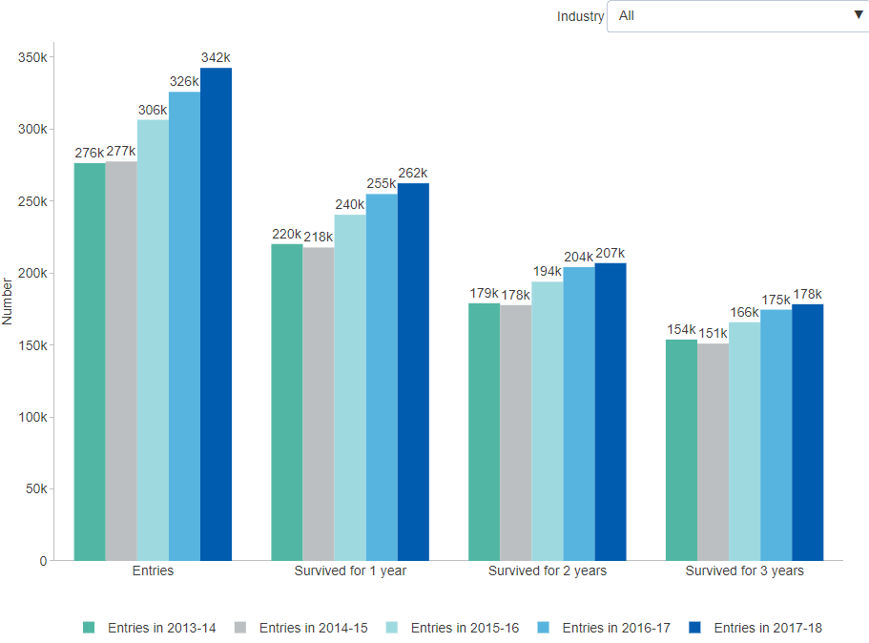

##### 

### 2.1.4 Churn rate by industry

The industry churn rate is the sum of the birth and death rates of businesses in an industry in a financial year. This measure is a proxy for the simultaneous creation of new businesses and the destruction of established ones. New businesses are essential to driving innovation and delivering it to market.[48] The annual churn rate across *All industries* rose from 25.8 per cent in 2014–15 to 27.8 per cent in 2020–21. While churn rates vary across industries, large changes over time are rare. One industry that has seen significant change is *Transport, postal and warehousing*, which rose from 28.2 per cent in 2013–14 to 50.5 per cent in 2017–18 before decreasing back down to 40 per cent in 2020–21.[49] Contributing to the rise were changes introduced in the Victorian taxi market in 2016, which dramatically reduced the cost of purchasing a taxi or hire car license.[50] Also, the strong residential property market has encouraged new businesses to enter the removalists industry.[51]

#### Figure 2.1.4: Industry churn rate, by selected industries, per cent, latest 2020–21

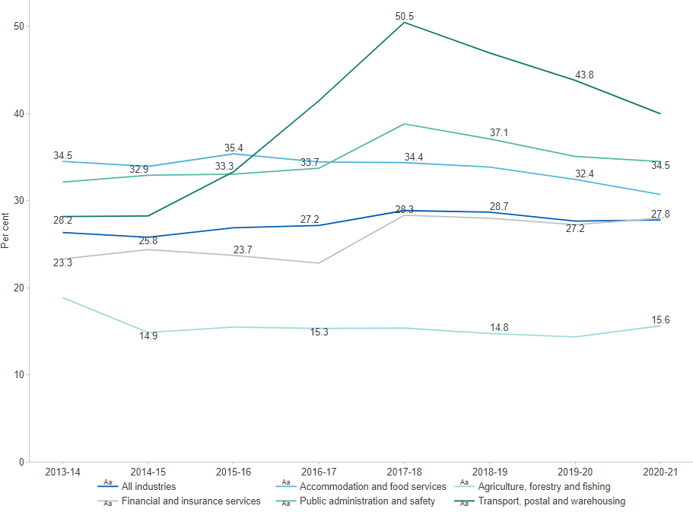

##### 

## 2.2 Startup Finance

### 2.2.1 Value of venture capital investments

Venture capital (VC) plays an important role in financing the launch, early development and expansion of innovative, high-growth-potential companies. These companies may have difficulties accessing traditional sources of capital due to their higher risk profile. In any given year, roughly a quarter of young innovative Australian small and medium enterprises (SMEs) seek some form of external finance. Evidence suggests that the success rate of businesses applying for venture capital investment fell from 3 per cent in 2005–06 to just over 1 per cent in 2013–14.[52] The dollar value of venture capital investment has followed a similar pattern. It peaked in 2007–08 with a total of $901 million invested but subsequently declined to just $266 million in 2012–13. The main contributor to this decline was early expansion funding, which is the largest and most volatile of the three investment types. More recently, Australia’s venture capital investment has been trending back up, reaching $701 million in 2018–19, with around 21 per cent of this going to startups.[53]

#### Figure 2.2.1: Value of venture capital investments, by type, $ million, latest 2018–19

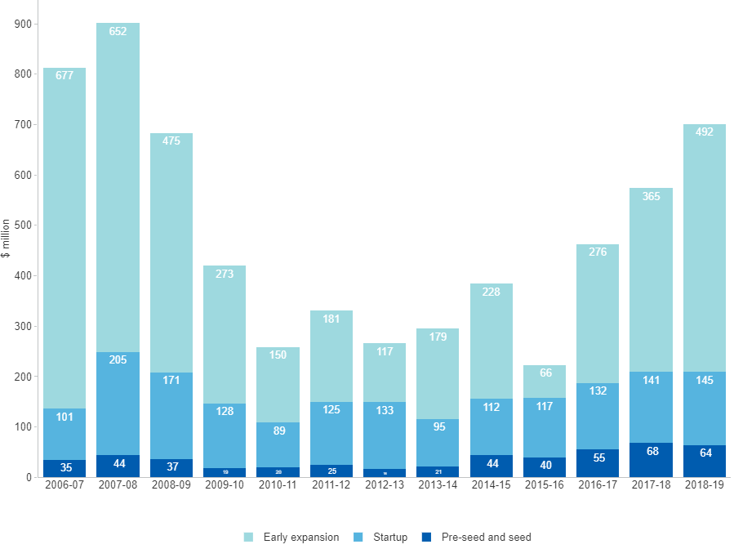

##### 

### 2.2.2 Venture capital investment deals

Surveys in Australia and across the OECD suggest that obtaining adequate access to capital is one of the biggest hurdles to growing innovative businesses. In 2016–17, nearly one in three innovation-active Australian businesses reported the lack of access to funds as a barrier to innovation.[54] Government policy aims to attract more venture capital investment by reducing the associated risks and addressing any information asymmetries, making it easier for investors to find potential matching opportunities.[55] Venture capital is defined as high risk private equity capital for typically new, innovative or fast growing unlisted companies in the pre-seed, seed, start-up or early expansion stage. During the period from 2007–08 to 2012–13, the total number of venture capital deals declined before rising again strongly in more recent years. Since its lowest point of 49 deals in 2012–13, the number of *pre-seed and seed* funding deals increased more than three-fold to 166 deals in 2017–18 before falling to 125 deals in 2018–19. Over the same period, the number of *early expansion* deals nearly tripled from 65 in 2012–13 to 172 in 2018–19, and the number of *start-up* funding deals nearly doubled from 59 in 2012–13 to 114 in 2018–19.[56]

#### Figure 2.2.2: Venture capital investment deals, by type, number, latest 2018–19

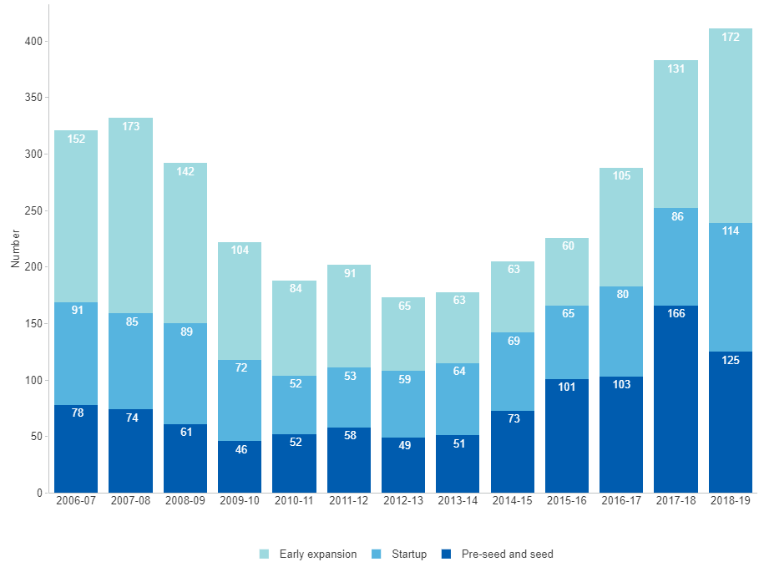

##### 

## 2.3 Business Growth

### 2.3.1 High-growth firms measured by turnover

Evidence suggests that business growth is associated with certain types of innovation.[57] However, exceptional growth is not some innate business characteristic, but rather a phase that some businesses go through during their life cycle. Between 2008 and 2012, *Australia*’s proportion of high-growth firms (HGFs) as measured by turnover was consistently above the median for all countries for which data are available. This was despite the decline of Australia’s HGF proportion since 2008. However, by 2013 the *all-country median* had lifted dramatically to reach 10.5 per cent, while *Australia*’s HGF proportion continued its decline to 9.3 per cent in 2012–13. The most recent available estimate of Australia’s proportion of HGFs is 9.6 per cent for 2016–17, whilst the *all-country median* has now reached 19.6 per cent for 2017. Further investigation may be warranted into the underlying drivers of these trends.[58][59]

#### Figure 2.3.1: High-growth firms measured by turnover, share of all businesses, OECD countries, per cent, latest 2017

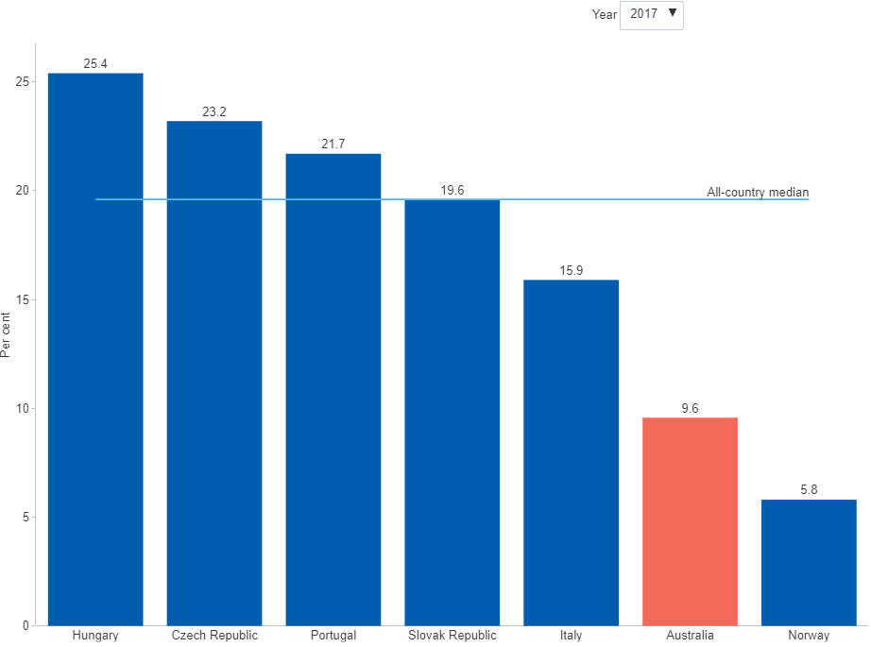

##### 

### 2.3.2 High-growth firms measured by employment

Australian HGFs make a disproportionate economic contribution compared to other businesses. Between 2004–05 and 2011–12, businesses with high-growth in employment represented only 9 per cent of all businesses with five or more employees but they contributed around 46 per cent of net positive employment growth. This means that the effect of job gains outweighed job losses. Further, 23.5 per cent of net positive employment growth came from large HGFs (as measured by employment), which represented only 0.4 per cent of businesses. HGFs are difficult to identify, largely because of their lack of growth persistence and difficulties in predicting which businesses will grow.[60] Since 2007–08, Australia’s proportion of HGFs as measured by employment has steadily fallen from 7.2 per cent to 5.2 per cent in 2016–17.[61]

#### Figure 2.3.2: High-growth firms measured by employment, share of all businesses, Australia, per cent, latest 2016–17

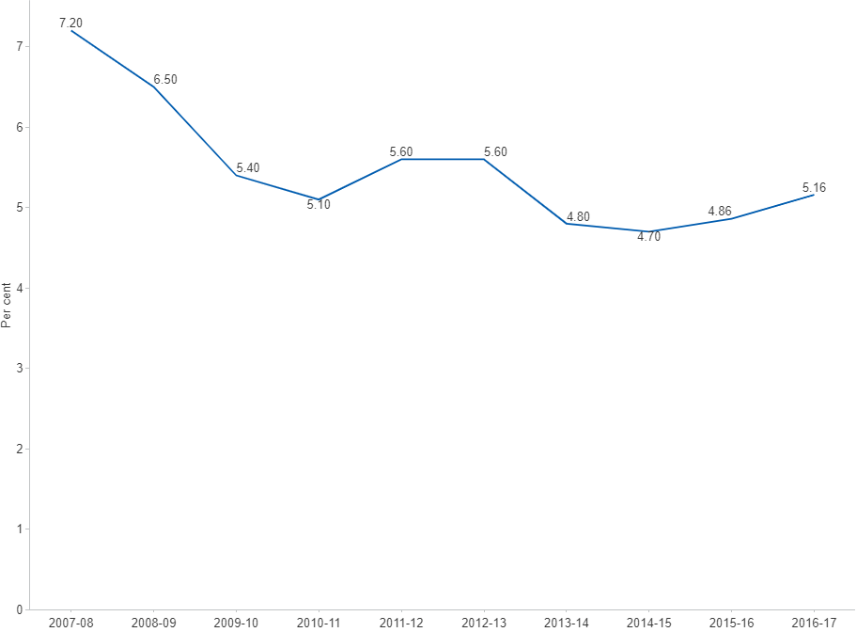

##### 

### 2.3.3 Businesses changing turnover range

Business-growth patterns can be illustrated by the number of businesses moving from smaller turnover ranges to larger ones over a given period. Of the 644,833 businesses that started with an annual turnover in the range *$50k to less than $200k* in the year to June 2020, some 88,065 businesses (13.7 per cent) increased their revenue to a higher range in the following year. Of these, 230 businesses moved into the *$5m to less than $10m* range and a further 165 businesses increased their annual turnover to *$10m or more*.[62] All of these 88,065 businesses could potentially meet the OECD definition of a *high-growth enterprise* — if they remain in their higher turnover range for another two years.[63]

#### Figure 2.3.3: Businesses changing turnover range, as at June, number, latest 2019–20

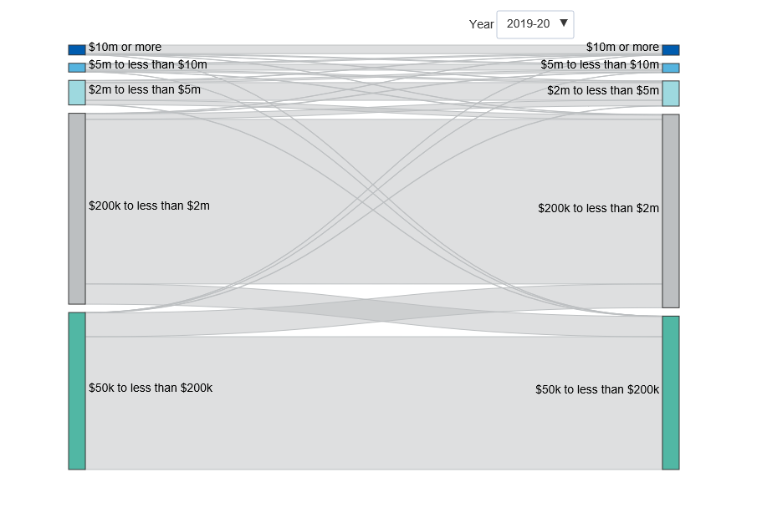

##### 

### 2.3.4 Businesses changing employment range

Business-growth patterns can be illustrated by the number of businesses moving from smaller employment ranges to larger ones over a given period. Of the 558,464 businesses identified as micro businesses (*1–4 employees*) at June 2020, some 36,673 grew to become small businesses (*5–19 employees*) by June 2021. A further 1,665 grew to become medium-sized businesses (*20–199 employees*) and 69 businesses recorded truly exceptional growth by becoming large businesses (*200+ employees*). A total of 38,407 micro-businesses — 6.9 per cent of all employing micro businesses — increased their employment range during the year.[64] All of these businesses could potentially meet the OECD definition of a *high-growth enterprise* — if they remain in their new size range for another two years.[65]

#### Figure 2.3.4: Businesses changing employment range, as at June, number, latest 2020–21

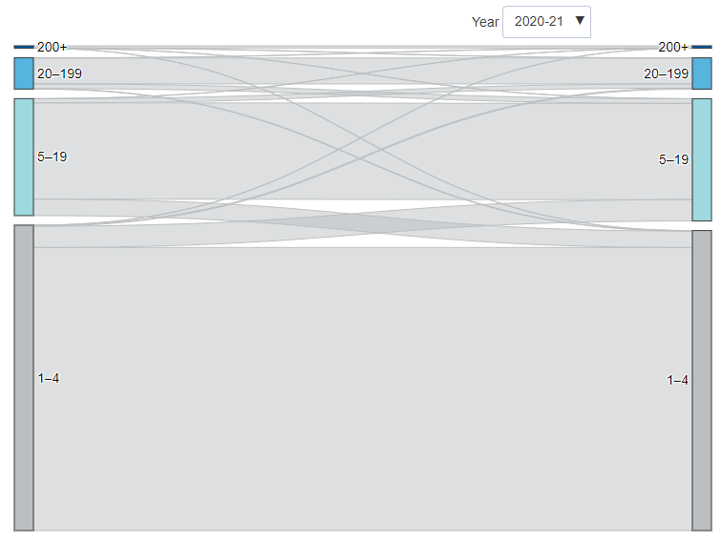

##### 

## 2.4 International Comparison

### 2.4.1 Total early-stage entrepreneurial activity (TEA)

The latest Global Entrepreneurship Monitor (GEM) data paints a relatively positive picture of entrepreneurial activity in Australia. The headline indicator — TEA — estimates the share of working-age adults who are in the process of starting a business (i.e. nascent entrepreneurs) or who started a new business as owner-manager less than 42 months before the GEM survey was conducted. In 2019, around 10.5 per cent of Australia's adult population were early-stage entrepreneurs — a continuing decline from 14.6 per cent in 2016. The survey results would imply that the number of Australian adults who were either a nascent entrepreneur or the owner-manager of a new business contracted from 2.2 million in 2016 to 1.7 million in 2019. *Australia* performed slightly below average in terms of the TEA rate among the 25 OECD economies (11.4 per cent). Australia's performance on this metric was above the *UK* (9.3 per cent), but trailed the *United States* (17.4 per cent) and *Canada* (18.2 per cent) in 2018 by a considerable margin.[66]

#### Figure 2.4.1: Total early-stage entrepreneurial activity (TEA), share of adults as nascent entrepreneur or owner of a new business, OECD countries, per cent, latest 2019

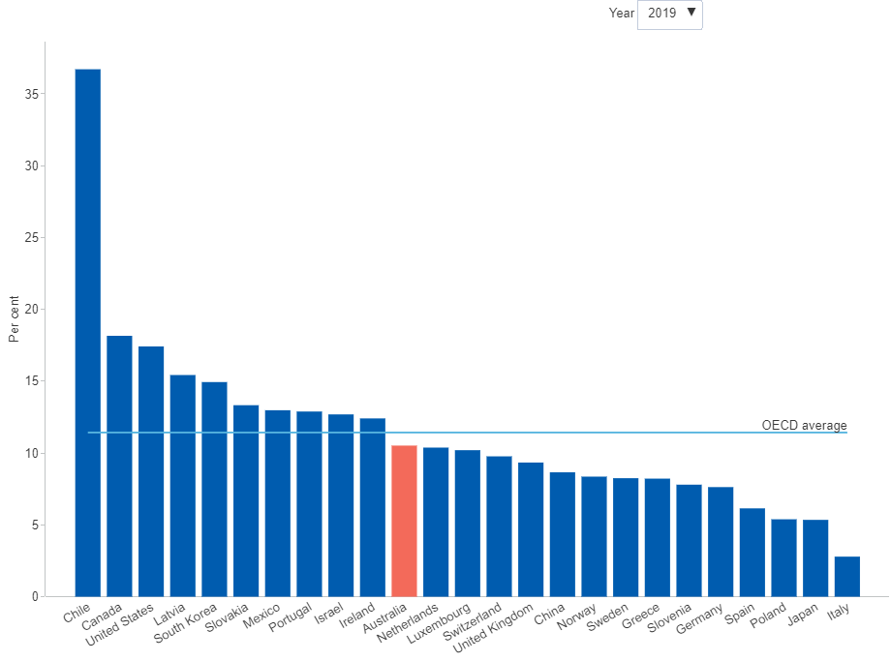

##### 

### 2.4.2 Innovative early-stage entrepreneurial activity

In addition to the headline total early-stage entrepreneurial activity (TEA) metric, the Global Entrepreneurship Monitor publishes information on the fraction of new businesses that offer new or improved products or services to the market. This indicator estimates the extent to which entrepreneurs are introducing products that are new to some or all customers, and that are offered by few or no competitors. In 2017, some 28.5 per cent of Australian adults involved in TEA (more than 513,000 entrepreneurs) indicated that their products or services were innovative, slightly below the OECD average of 31.5 per cent. *Australia*'s estimates lag behind the *United States* and *Canada*, which have comparatively higher rates of innovative startups of 35.9 per cent and 43.2 per cent, respectively.[67] Risks associated with the COVID-19 pandemic suggest that new businesses and technologies may fail to emerge, impacting entrepreneurial activity in the medium to long term.[68]

#### Figure 2.4.2: Early-stage entrepreneurial activity, share of new businesses with new innovative products or services, OECD countries, per cent, latest 2018

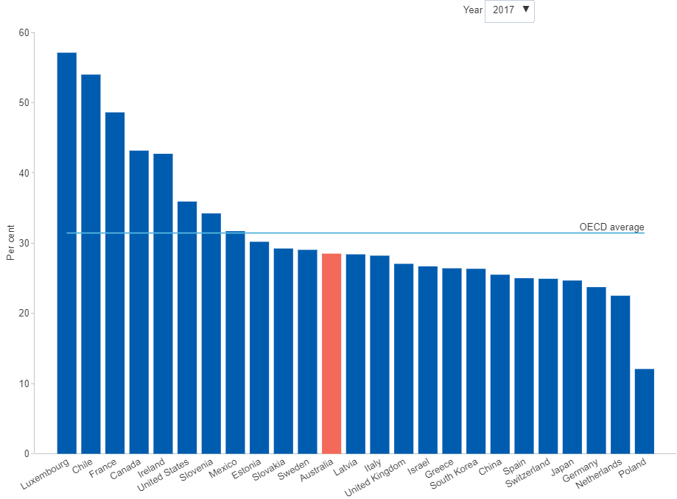

##### 

### 2.4.3 Adults perceiving start-up opportunities for new businesses

Perceptions of the abundance and quality of business opportunities play an important role in deciding whether to be entrepreneurially active. In *Australia*, the share of adults who saw good opportunities to start a business in the area where they lived fell from 51.4 per cent in 2017 to 45.7 per cent in 2019, while the OECD average increased from 44.5 per cent to 52.6 per cent in the same period. *Canada* and the *United States* are significantly above the *OECD average* at 67.1 per cent and 67.2 per cent, respectively.[69] The 2017–18 GEM Australian national report also suggests that in 2017 the share of opportunity-driven Australian entrepreneurs was almost four times higher in that year than the share of entrepreneurs that started a business out of necessity (83.2 per cent and 16.8 per cent, respectively). Similarly, Australia performed relatively well on the metric showing the extent to which new businesses are likely to create jobs. Around 28.2 per cent of new Australian businesses expect to create at least six new jobs in the next five years, performing well above the OECD average (20.6 per cent).[70]

#### Figure 2.4.3: Early-stage entrepreneurial activity, share of adults perceiving start-up opportunities, OECD countries, per cent, latest 2019

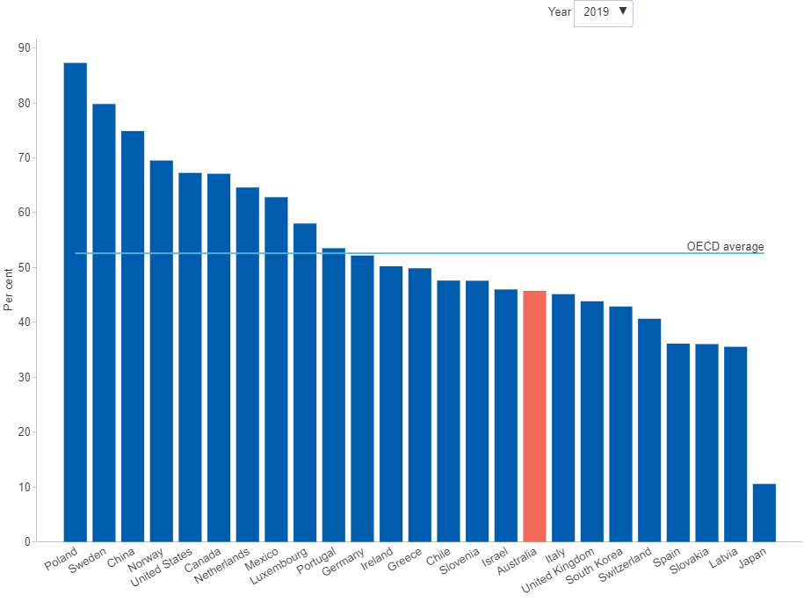

##### 

### 2.4.4 Adults prevented from starting a business by fear of failure

Despite the numerous positive features of Australia's entrepreneurship profile, the Global Entrepreneurship Monitor highlights some areas of concern. Reported fear of failure is at its highest level in *Australia* at 47.4 per cent in 2019 since the metric was first measured, well above the *OECD average* of 40.4 per cent. This metric measures the apprehension preventing prospective entrepreneurs from starting a business despite perceiving good opportunities to do so. *Australia*’s reported fear of failure is well above countries such as *Germany* (29.7 per cent) and the *United States* (35.1 per cent).[71] The 2019 GEM Australian national report suggests that entrepreneurs outside CBDs have a lower fear of failure, but were also less likely to perceive start-up opportunities, citing high entrepreneurial potential in regional communities.[72]

#### Figure 2.4.4: Early-stage entrepreneurial activity, share of adults prevented from starting a business by fear of failure, OECD countries, per cent, latest 2019

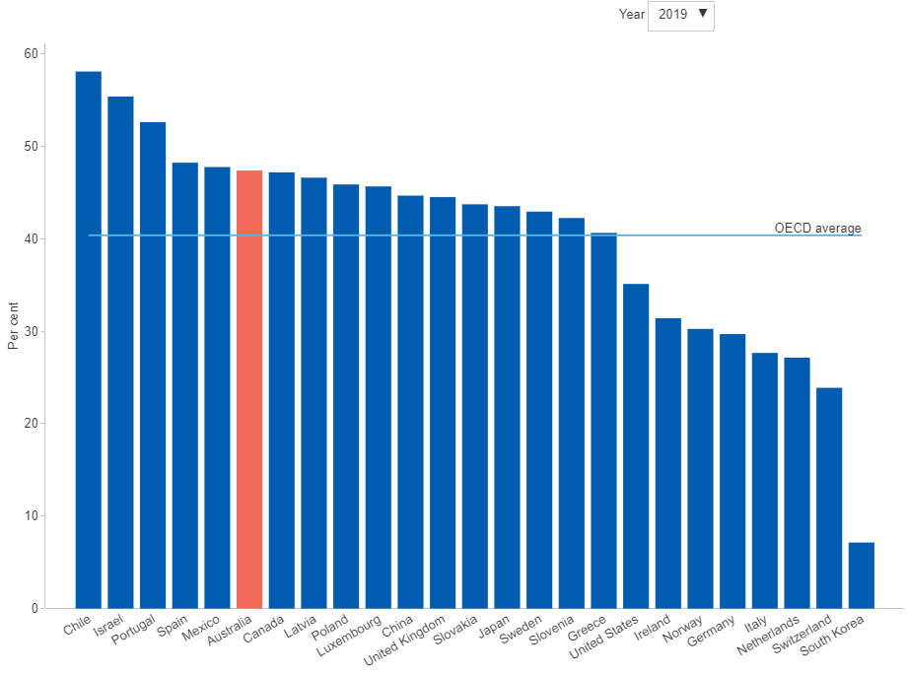

##### 

# 3 Science and Research

*Some of the data presented in this chapter was collected prior to the COVID-19 pandemic. Pending further updates, the COVID-19 page summarises some of the impacts of COVID-19 on Australian businesses during the first year of the pandemic.*

Science and research are major driving forces behind knowledge creation, and play a crucial role in the technological development and competitiveness of an economy. In addition to creating new knowledge, research activity is an important driver of skill development. Research is becoming increasingly data-intensive and multi-disciplinary. For example, the Square Kilometre Array radio telescope research facility will generate huge amounts of scientific data that was previously unavailable. This data can feed into future discoveries that may not yet be conceived, potentially finding new commercial applications either through the incremental improvement of existing services or even by creating entirely new technologies, products and industries.[73]

There is robust and consistent evidence of significant positive spillovers from R&D activity, with some industries generating more spillovers than others.[74] R&D activity has been estimated to explain up to 75 per cent of total factor productivity growth, once externalities are considered. R&D also has high rates of return, estimated at 10–30 per cent for private return and more than 40 per cent for social return.[75] Recent Australian evidence also suggests that an increase in business expenditure on own R&D stock is associated with a significantly larger increase in sales for the average business, and that R&D performed in one business can increase the sales of other businesses nearby.[76]

However, aggregate expenditure on R&D in Australia is falling. Total expenditure on R&D across all sectors (or GERD) has declined in both dollar terms and as a proportion of GDP in recent years. The decline has been driven largely by falls in business expenditure on R&D in the mining and manufacturing industries. Public investment in R&D has followed a long-term upward trend but remained relatively flat in recent years. Compared to the 1980s, there is now considerably more emphasis on indirect R&D tax measures than direct and targeted funding. In terms of research output, Australia's share of the world’s scientific publications has been growing steadily, and its share of the top percentiles of highly cited publications reflects the quality of Australia's science and research output.

##### 

## 3.1 Business R&D

### 3.1.1 Total business expenditure on R&D (BERD)

As experimental development is dedicated to producing new materials, technologies, products or processes, it is closely related to business innovation. It has previously been estimated that R&D-active Australian businesses were three times more likely to introduce new-to-market goods and service innovations than non-R&D-active ones.[77] BERD currently makes up just over half (51.0 per cent) of total Gross expenditure on R&D (GERD). It is particularly relevant to businesses in technology-intensive industries such as *Manufacturing* but also increasingly in *Professional, scientific and technical services*, which now represents the largest contribution to BERD. Following a notable decline in 2015–16, total BERD lifted from $16.7 billion in 2015–16 to $18.2 billion in 2019–20. The largest increase in this period occurred in overseas expenditures (up $1.2 billion), while in Western Australia expenditures continued to fall sharply (down $677 million). In 2019–20 by field of research, the largest contribution to BERD came from *Information and computing sciences* ($7.1 billion) and *Engineering* came in second ($5.3 billion).[78]

#### Figure 3.1.1: Business expenditure on R&D (BERD), $ billion, latest 2019–20

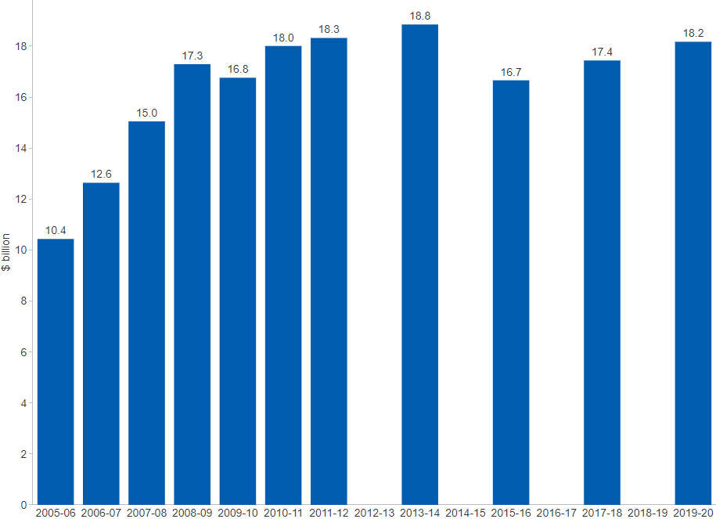

##### 

### 3.1.2 Business expenditure on R&D (BERD) by industry

Australia’s BERD is quite concentrated, with just four industries accounting for nearly eighty per cent of the $18.2 billion in total expenditure. The largest contribution in 2019–20 was reported by *Professional, scientific and technical services* (33.6 per cent), which has overtaken *Manufacturing* (26.2 per cent). The changes in the underlying composition of BERD by industry have been quite dramatic. As recently as 2011–12, *Professional, scientific and technical services* accounted for only 15.5 per cent of total BERD, compared to 24.4 per cent for *Manufacturing* and 22.4 per cent for *Mining*. However, *Mining* R&D expenditure peaked in 2011–12 (at $4.1 billion) and has since fallen to a quarter of that value — $0.9 billion in 2019–20 — accounting now for a modest and shrinking share of total BERD, at 4.9 per cent.[79]

#### Figure 3.1.2: Business expenditure on R&D (BERD), top 4 industries, $ billion, latest 2019–20

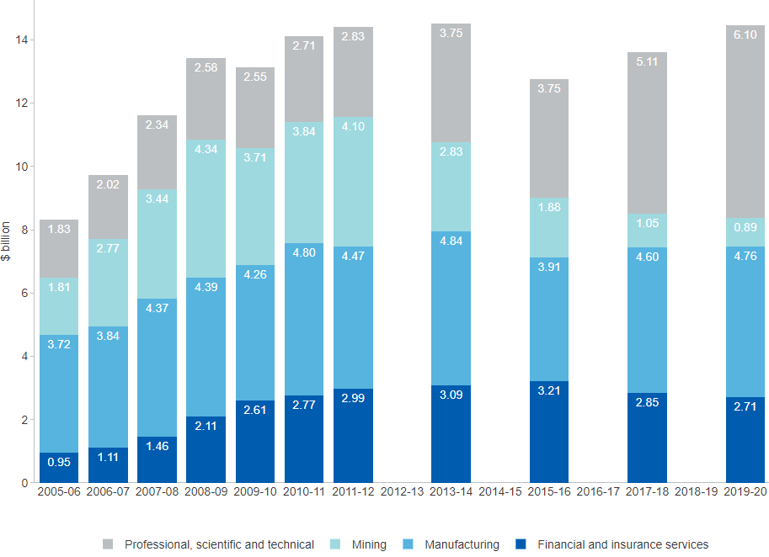

##### 

### 3.1.3 Business expenditure on R&D (BERD) as a share of GDP

In many OECD countries, R&D activity in the business enterprise sector represents the largest contribution to overall R&D activity. The ratio of BERD to GDP provides a convenient measure for making cross-country comparisons. It also gives an indication of the trend of a country’s business R&D intensity over time. Year-to-year changes in the value of BERD to GDP reflect changes in both BERD as well as GDP, so they should be interpreted with caution. Australia’s BERD to GDP declined steadily from 1.37 per cent in 2008–09 to 0.92 per cent in 2019–20. This trend reflects a combination of the stagnating value of BERD (numerator), measured against a growing value of GDP (denominator). A closer look at the data reveals that the bulk of the stagnation is the result of large declines in a handful of industry subdivisions in *Mining* — most notably *Metal ore mining*, *Coal mining*, and *Oil and gas extraction*. The data suggest a large withdrawal of R&D spending from the field of *Engineering*, most evidently by large businesses based in Western Australia and Queensland.[80]

#### Figure 3.1.3: Business expenditure on R&D (BERD), share of GDP, per cent, latest 2019–20

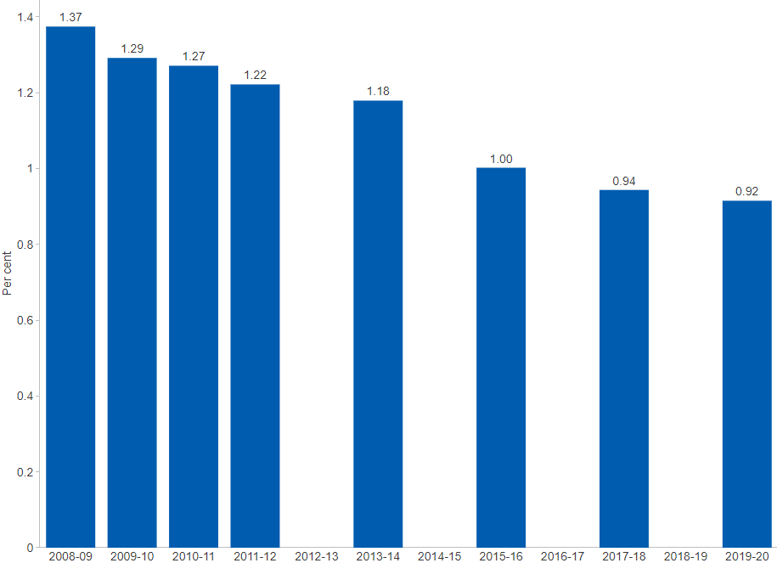

##### 

## 3.2 Government R&D

### 3.2.1 Government expenditure on R&D (GovERD) by type of activity

In addition to providing support for business R&D, governments are major R&D performers through public research agencies, such as the CSIRO. Australian evidence points to significant contributions to productivity from public sector R&D spending.[81] Australia’s GovERD comprises a mix of research activities including *Applied research*, *Strategic basic research*, *Experimental development* and *Pure basic research*. During the 12 years to 2018–19, the majority of GovERD by the Commonwealth was directed towards *Applied research* ($1.17 billion or 55.4 per cent of total in 2018–19). *Pure basic research* has historically received a relatively modest fraction of total GovERD (around $135 million or 4.1 per cent of total in 2018–19).[82]

#### Figure 3.2.1: Government expenditure on R&D (GovERD), by type of activity, $ million, latest 2018–19

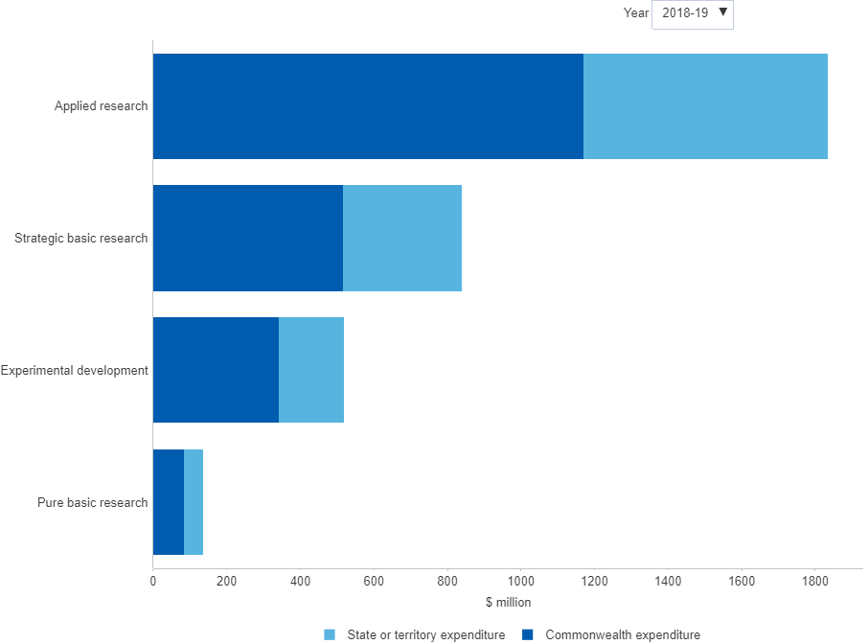

##### 

### 3.2.2 Government expenditure on R&D (GovERD) by location of expenditure

In 2018–19, the *Australian Capital Territory* (ACT) was the third largest jurisdiction of GovERD by the Commonwealth — both in absolute and relative terms ($331 million and 15.7 per cent of total) — behind *Victoria* ($544 million or 25.8 per cent of total) and *South Australia* ($340 million or 16.1 per cent). This pattern of expenditure reflects the significant contribution of the CSIRO, which has its headquarters in the ACT (CSIRO funding is recorded against the ACT, despite having operations nation-wide). Commonwealth GovERD in the ACT peaked in 2011–12 at $492 million (20.3 per cent of total), and has fallen steadily since then. In 2018–19 it fell by $37 million from $367 million in 2016–17, allowing *South Australia* to overtake it for the first time. The ACT was also the second smallest jurisdiction of GovERD by state or territory (under $8.4 million or 0.7 per cent of total), the smallest being *Tasmania* ($4.3 million or 0.4 per cent of total). This general pattern has been broadly consistent over the decade to 2018–19.[83]

#### Figure 3.2.2: Government expenditure on R&D (GovERD), by level of government, by location of expenditure, $ million, latest 2018–19

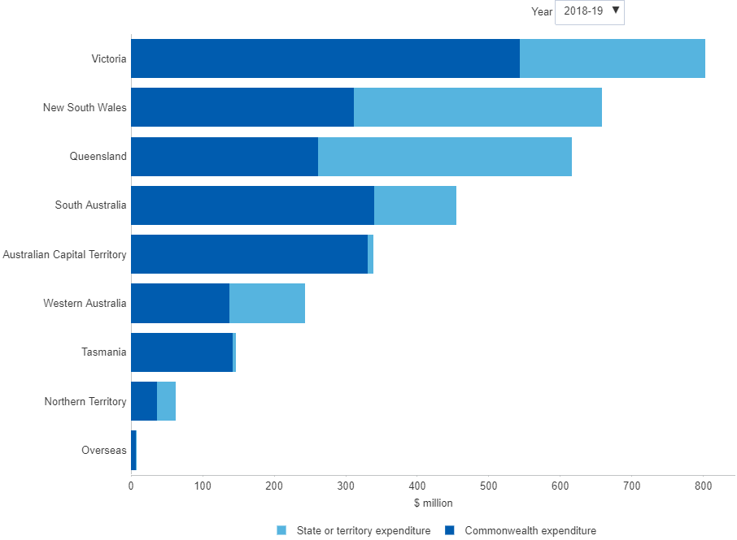

##### 

### 3.2.3 Government expenditure on R&D (GovERD) by level of government

Australia’s total GovERD comprises expenditure by both the Commonwealth, and states and territories. The share of *Commonwealth expenditure* currently makes up around two-thirds of total spending, and this has remained fairly stable over the last 12 years for which data are available. GovERD by the Commonwealth peaked in 2011–12 at $2.43 billion before declining to $2.11 billion in 2016–17. GovERD by states and territories peaked at $1.38 billion in 2012–13, trailing the Commonwealth by approximately one year.[84]

#### Figure 3.2.3: Government expenditure on R&D (GovERD), by level of government, $ billion, latest 2018–19

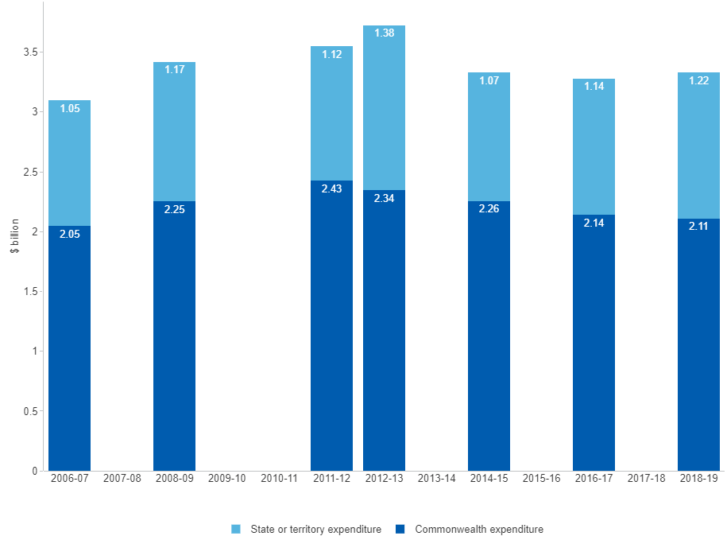

##### 

### 3.2.4 Australian Government investment in R&D

Government investment in R&D aims to cover the difference between the economic value of R&D to society and the private returns received by inventors and businesses that incur the costs and risks of pursuing R&D. Governments also support business R&D by offering tax relief for R&D-related activities and by raising awareness of the technological opportunities available to reduce both the cost and uncertainty of research and innovation.[85] While trending relatively flat in recent years, the latest estimate of Australian Government investment in R&D has jumped to an all-time record of $11.9 billion for 2020–21 (up by 17.1 per cent from the previous year), driven by a sharp increase in research block grants. (Note: The 2020–21 data is a budget estimate and will be revised as actual data becomes available.)[86]

#### Figure 3.2.4: Australian Government investment in R&D, current prices, $ billion, latest 2020–21

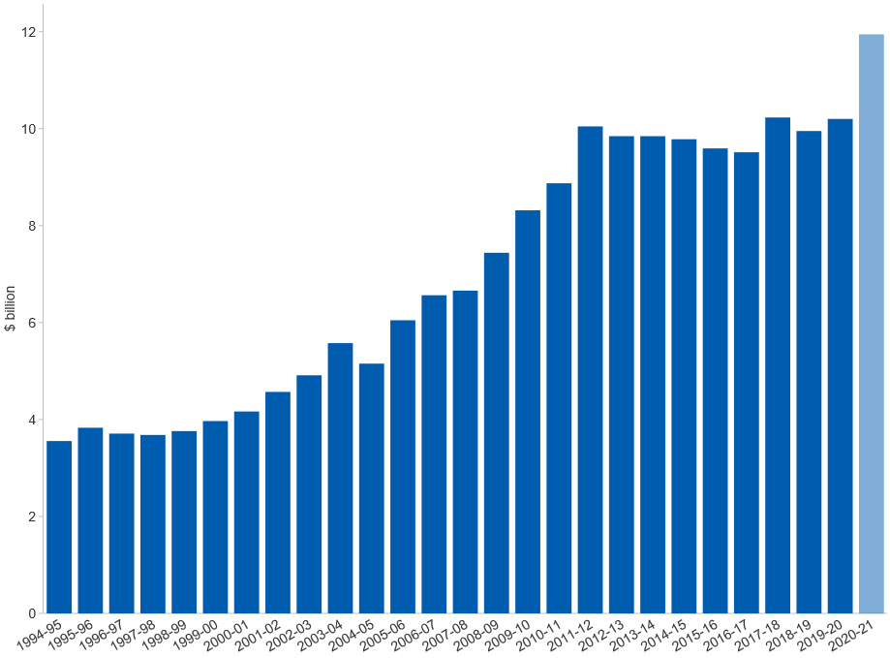

##### 

### 3.2.5 Australian Government investment in R&D by sector

By economic sector, around 39.4 per cent of Australian Government investment in R&D is directed to higher education research for 2020–21. Roughly one fifth (21.8 per cent) is funding for research in business, and some 18.6 per cent is allocated to research activities by the Australian Government and public agencies. *Multisector* funding makes up around 20.1 per cent, and the residual is funding to the rest of the world. The data show that the share of funding for research activities allocated to the *Commonwealth agencies* sector has declined from 51.0 per cent of total in 1981–82 to 18.6 per cent in 2020–21. Over the same period, the share of funding for research in the *Business enterprise* sector has multiplied nearly eight fold (from 2.7 per cent to 21.8 per cent of total) — although the latest estimate is well below the peak of 33.2 per cent in 2011–12. The share of *Higher education* funding peaked at 49.4 per cent in 1998–99 before falling back to between 30 and 40 per cent where it has remained broadly the same over the last decade. (Note: The 2019–20 data is a budget estimate and will be revised as actual data becomes available.)[87]

#### Figure 3.2.5: Australian Government investment in R&D, by sector, per cent, latest 2020–21

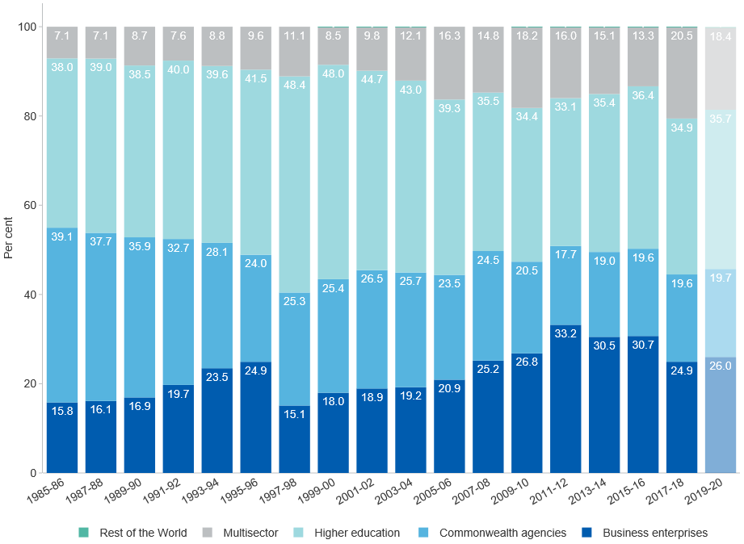

##### 

### 3.2.6 Australian Government investment in R&D by major programs

Seven programs make up roughly three-quarters of total Australian Government investment in R&D. The share of funding for the *Commonwealth Scientific and Industrial Research Organisation (CSIRO)* has declined from 28.8 per cent of total 1981–82 to 8.0 per cent in 2020–21. By contrast, following the introduction of industry *R&D tax measures*, the share of this group of programs expanded from 9.7 per cent in 1985–86 to a peak of 29.9 per cent in 2012–13. At present, these measures represent the second largest component of total Australian Government R&D funding and are estimated to account for 21.5 per cent in 2020–21. *Research block grants* make up the largest share at 24.9 per cent in the same year. (Note: The 2019–20 data is a budget estimate and will be revised as actual data becomes available. From 2000–01 the *Former funding of higher ed. research* was replaced by a new funding regime, introducing new key elements such as competitive *Research block grants* and Australian Research Council (*ARC*) funding.)[88]

#### Figure 3.2.6: Australian Government investment in R&D, by major programmes, per cent, latest 2020–21

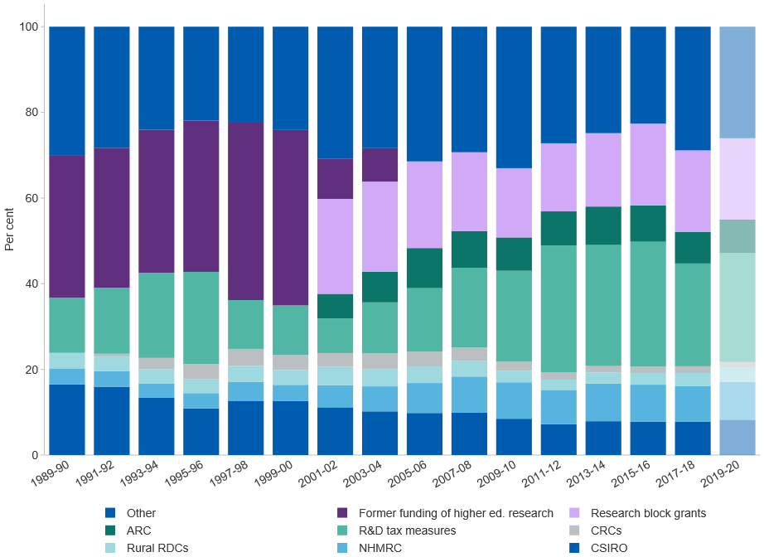

##### 

### 3.2.7 Civil government budget allocations for R&D (GBARD) by selected socio-economic objectives

Governments fund a variety of research effort. Consistent with the OECD Frascati Manual definition of R&D, data on GBARD encompass all allocations from sources of government revenue within the budget and are typically timelier than R&D survey data.[89] Allocations for R&D with specific socio-economic objectives are measured as a share of total civil GBARD, which exclude the allocation of GBARD on defence R&D. In Australia, the share of civil GBARD allocated to *General university funds* showed a notable uptick in 2020 to 36.2 per cent, up from 30.2 per cent the year before. The share of *Health and environment programs* increased from 18.7 per cent in 2000 to 28.9 per cent in 2020. The share of *Economic development programs* has remained relatively steady during this period, starting at 28.9 per cent in 2000 and recently easing to 23.5 per cent in 2020. Compared to other OECD countries, Australia allocates a relatively high share of its civil GBARD to *Health and environment programs*, second only to the United States.[90]

#### Figure 3.2.7: Civil government budget allocations for R&D (Civil GBARD), by selected socio-economic objectives, OECD countries, per cent, latest 2021

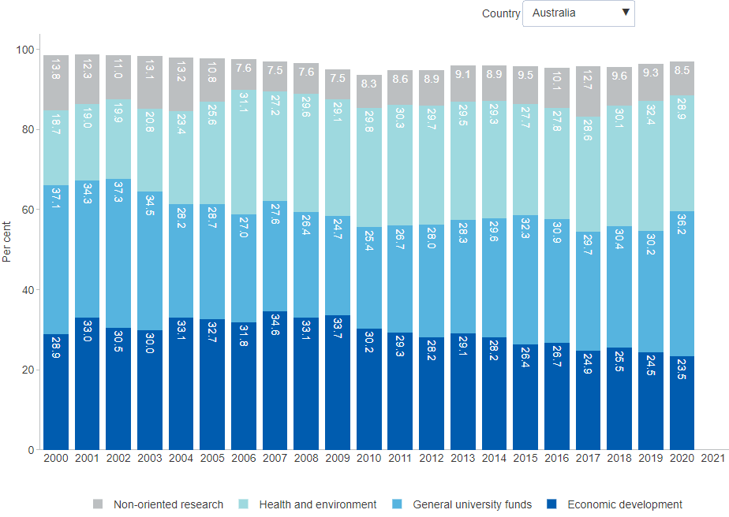

##### 

## 3.3 Higher Education R&D

### 3.3.1 Higher education resources devoted to R&D (HERD) by type of activity

Total HERD, that is spending on R&D performed by Australian higher education organisations, contributed about 34 per cent to Australia's total spending on R&D in 2017–18.[91] As a share of GDP it remained stable at 0.62 per cent over the two year period from 2016 to 2018 (data not shown). *Applied research*, the largest category within HERD, relates to original investigation undertaken in order to acquire new knowledge. It is directed primarily towards a specific practical aim or objective, rather than purely the acquisition of new knowledge which is the goal of basic research.[92] In 2018, nearly half of the research activity in the higher education sector was *Applied research* ($5.9 billion or 48 per cent of total HERD). Its share, as well as its dollar value, has increased steadily since 1992 when it was only $514 million or 30 per cent of total HERD. By contrast, *Pure basic research* recorded $676 million in 1992 and grew to only $2.8 billion in 2018. Its share of total research activity has declined from 34 per cent to 23 per cent over this time period.[93]

#### Figure 3.3.1: Higher education resources devoted to R&D (HERD), by type of activity, $ billion, latest 2018

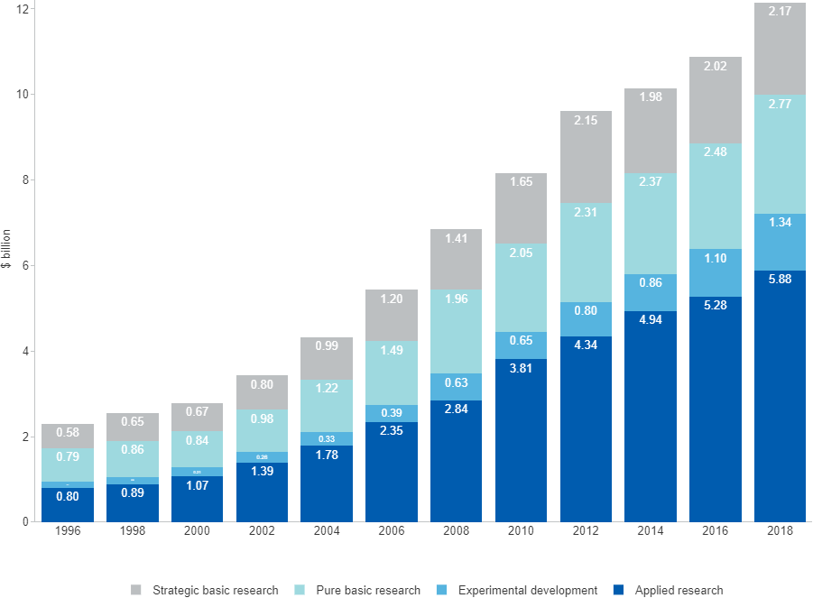

##### 

### 3.3.2 Higher education resources devoted to R&D (HERD) by location

Roughly 60 per cent of total HERD is located in just two states — *New South Wales* and *Victoria* — and this geographical concentration has increased over the last two decades. *Victoria* has increased its share by 5.6 percentage points to 28.2 per cent in 2018 and *New South Wales* increased its share by 1.8 percentage points to 30.9 per cent. Conversely, the *Australian Capital Territory* has almost halved its share of total HERD from 11.0 per cent in 2000 to 6.1 per cent in 2018.[94]

#### Figure 3.3.2: Higher education resources devoted to R&D (HERD), by location, per cent, latest 2018

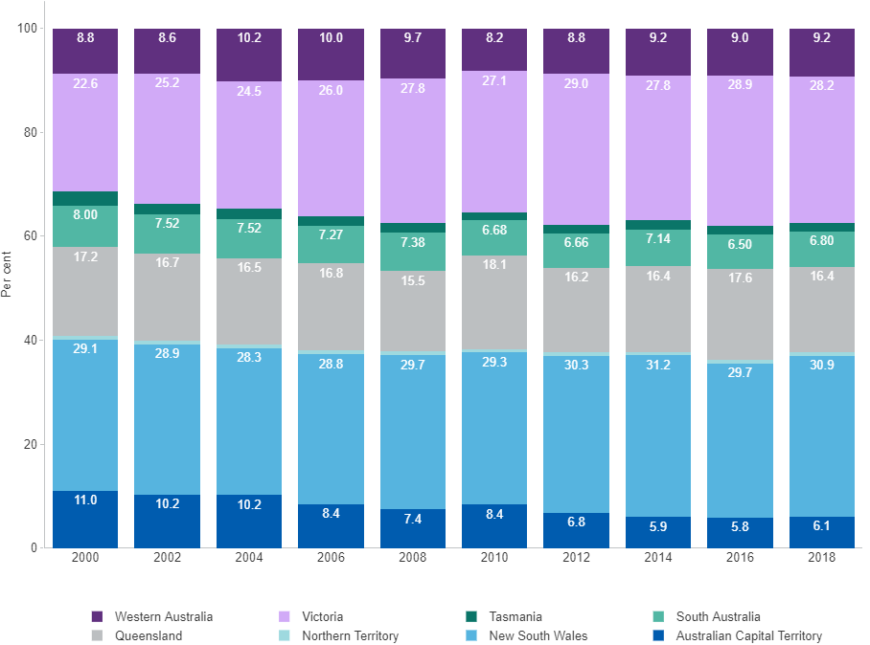

##### 

### 3.3.3 Higher education resources devoted to R&D (HERD) by source of funds

There has been a sustained growth in total HERD over the last two decades. Total HERD was nearly $12.2 billion in 2018 with a significant contribution coming from *General university funds*. Over the last 20 years, this source has increased from $1.8 billion in 2000 to $6.8 billion in 2018, but as a share of total HERD this funding source has decreased from 63 per cent in 2000 to 56 per cent in 2018. Much of this contraction is due to increased *Other Commonwealth government* funding from just under 6 per cent in 2000 to over 15 per cent in 2018. It is now the second largest source of funds.[95]

#### Figure 3.3.3: Higher education resources devoted to R&D (HERD), by source of funds, $ billion, latest 2018

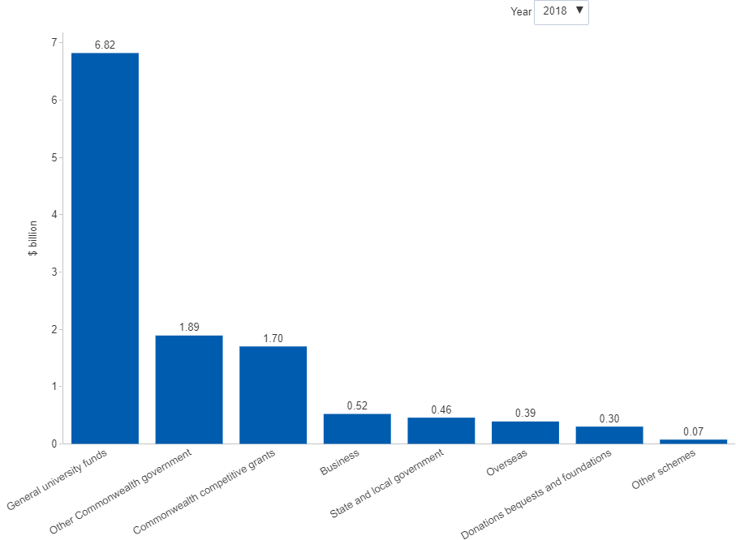

##### 

## 3.4 Research Output

### 3.4.1 Share of world scientific publications

Australia has a considerably higher share of highly-cited publications than its share of world population, suggesting that the quality of Australia's scientific publications is well above the world average. *Australia*'s share of the world's scientific publications has risen from 3.6 per cent in 2011 to 4.1 per cent in 2020, which is an order of magnitude higher than Australia's 0.3 per cent share of world population.[96] While the *United States* still contributes almost a quarter of the world's publications, its share has gradually diminished over time, primarily due to *China*'s increased contribution. *China*'s share of the world's scientific publications has more than doubled since 2011, reaching 25.2 per cent in 2020.[97]

#### Figure 3.4.1: Scientific publications, share of world, top 20 countries, per cent, latest 2020

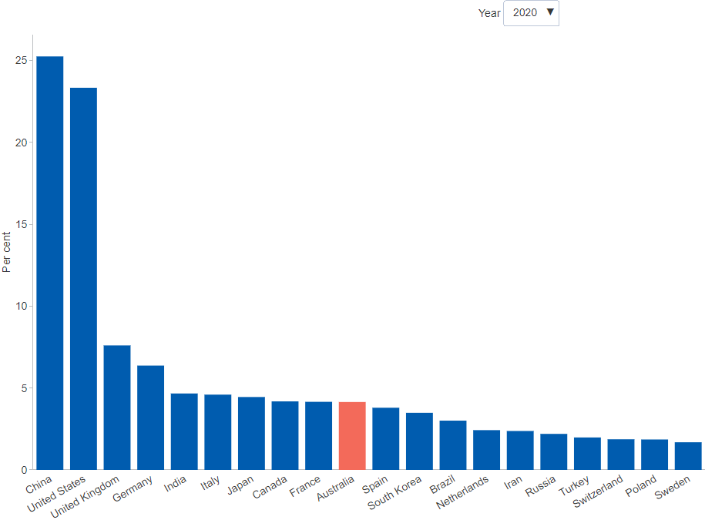

##### 

### 3.4.2 Scientific publications per $ million non-business R&D

Research efficiency can be measured in terms of the number of scientific publications per $ million invested in non-business R&D. *Australia*'s performance on this metric has lifted from 4.9 publications per $ million non-business R&D in 2006 (below the corresponding *OECD average* of 5.2) to 7.2 publications per $ million non-business R&D in 2017 (above the corresponding *OECD average* of 6.2). This indicates that *Australia*'s researchers have become more productive at generating scientific publications per dollar invested and clearly highlights improvements in relation to the *OECD average*. This suggests that *Australia*’s research efficiency has notably improved over the period.[98]

#### Figure 3.4.2: Scientific publications per $ million non-business R&D, OECD countries, number, latest 2020

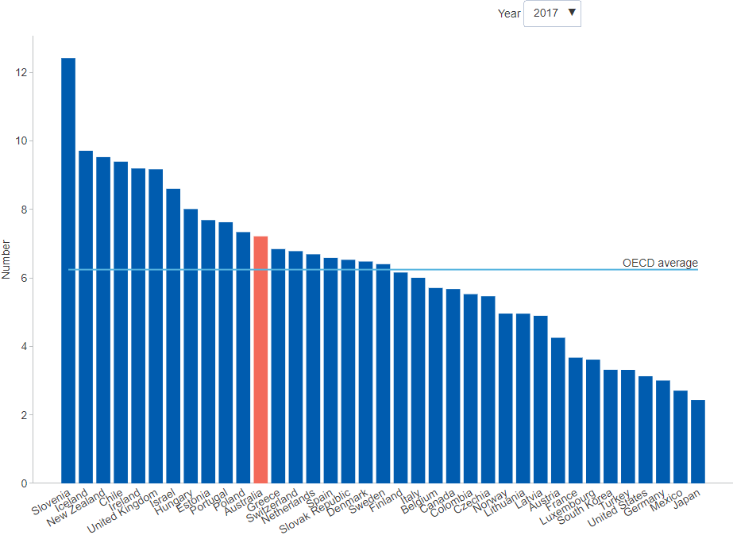

##### 

### 3.4.3 Scientific publications per million population

Research efficiency can be measured not only by the research output per dollar invested but also by the research output relative to the general population. Australia’s scientific research activities draw on talent from a relatively small but well-educated population. In 2020, *Australia* contributed to around 3,533 publications per million population, well above the *OECD average* of 2,090. It ranks 6th in the OECD on this measure. *Switzerland*, *Denmark* and *Iceland* are the three top ranking countries.[99]

#### Figure 3.4.3: Scientific publications per million population, OECD countries, number, latest 2020

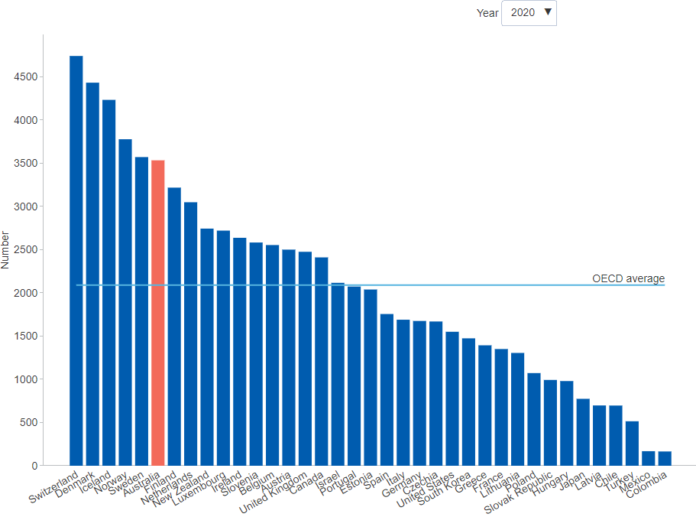

##### 

### 3.4.4 Share of top one and top ten per cent highly-cited publications

*Australia*'s share of both top 1 per cent and top 10 per cent highly-cited publications has risen sharply since 2005, although there are some recent signs of a possible plateau in growth. In 2020, Australian authors were credited in 7.9 per cent of the world's top 1 per cent highly-cited publications and in 6.1 per cent of the world's top 10 per cent highly-cited publications for all disciplines. Further, while rates of international collaboration have risen around the world, *Australia* has experienced a greater increase in its publication citations involving international collaboration compared to the *OECD average*.[100]

#### Figure 3.4.4: Scientific publications, share of highly-cited publications, Australia and OECD average, per cent, latest 2020

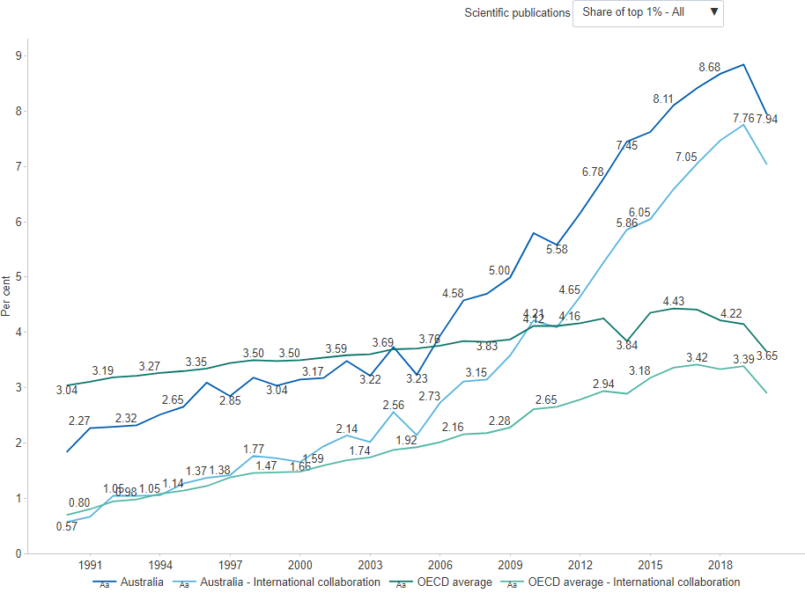

##### 

## 3.5 International Comparison

### 3.5.1 Gross expenditure on R&D (GERD) as a share of GDP

Gross expenditure on R&D (GERD) is a key headline measure of a country’s aggregate R&D activity. It is the sum of expenditures on R&D across all sectors of the economy — business, government, higher education and private non-profit. Australia’s latest GERD estimate published by the ABS is $35.6 billion in 2019–20, which represents an increase of around 7.7 per cent from $33.1 billion in 2017–18.[101] Australia’s national R&D intensity (GERD as a share of GDP) has held steady at 1.79 per cent in across both periods, remaining below the OECD average of 2.48 per cent in 2019. In the same period, *Israel* and *South Korea* had the highest national R&D intensities, 4.93 per cent and 4.64 per cent, respectively. Australia’s overall R&D intensity peaked at 2.25 per cent of GDP in 2008–09 and has been declining ever since.[102]

#### Figure 3.5.1: Gross expenditure on R&D (GERD), share of GDP, OECD countries, per cent, latest 2020

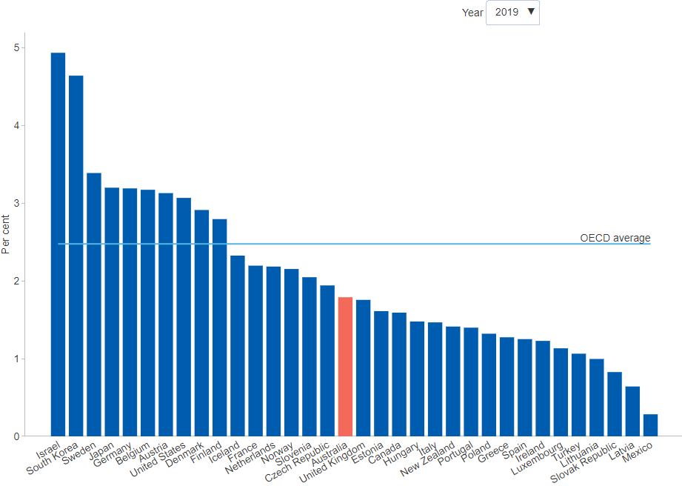

##### 

### 3.5.2 Gross expenditure on R&D (GERD) as a share of GDP by sector

GERD is the aggregate expenditure devoted to R&D by the business, government, higher education and private non-profit sectors. The largest component is business expenditure on R&D (BERD) and its stagnation in recent years has been a major factor driving the decline in Australia’s GERD as a proportion of GDP (or national R&D intensity). The latest *BERD to GDP* estimate is 0.92 per cent in 2017–18, having declined from 1.00 per cent in 2015–16 and 0.94 per cent in 2017–18. Government expenditure on R&D as a share of GDP (*GovERD to GDP*) has also been declining but not nearly to the same extent, with latest estimate at 0.17 per cent in 2018–19. Meanwhile, higher education expenditures on R&D as a share of GDP (*HERD to GDP*) has remained relatively steady over the last five years or so, with the latest estimate at 0.62 per cent for 2018.[103] With BERD being a key driver of Australia’s overall R&D intensity, the GERD to GDP estimate should be interpreted in the context of other relevant information, particularly the role of major R&D industries such as *Manufacturing* or *Mining*.[104]

#### Figure 3.5.2: Gross expenditure on R&D (GERD), share of GDP, by sector, OECD countries, per cent, latest 2020

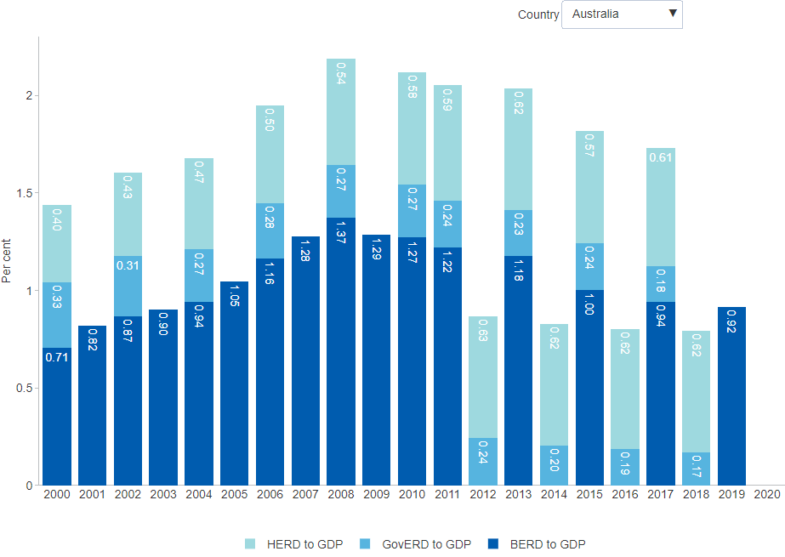

##### 

### 3.5.3 Business expenditure on R&D (BERD) performed in service industries

Across OECD countries, a sizeable and growing share of BERD is performed in service industries. Service industries supply services, as opposed to physical goods. For example, services include accommodation, recreation, health, education, retail, as well as information and communication technologies (ICTs). In *Australia*, the share of BERD performed by service industries in 2018–19 was around 65.5 per cent — well above the *OECD average* of 37.9 per cent. Australia ranks 1st of 8 OECD economies for which data is available on this metric.[105] Only five years earlier, Australian service industries accounted for less than half of total BERD, and a decade ago it was barely above 40 per cent. This broad economic shift towards service industries is occurring across nearly all OECD economies, in part due to the rapid growth in the uptake of new digital technologies. Across OECD economies, ICTs account for a substantial and growing part of BERD, and are disproportionately represented by innovative businesses.[106]

#### Figure 3.5.3: Business expenditure on R&D (BERD) performed in service industries, share of total BERD, OECD countries, per cent, latest 2019

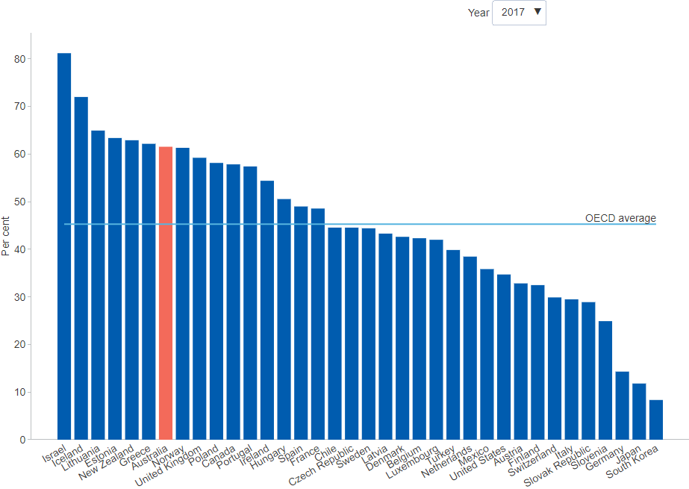

##### 

# 4 Networks and Collaboration

*Some of the data presented in this chapter was collected prior to the COVID-19 pandemic. Pending further updates, the COVID-19 page summarises some of the impacts of COVID-19 on Australian businesses during the first year of the pandemic.*

The systems view of innovation brings into focus the importance of the networks connecting individuals and organisations. Knowledge is often highly specialised and fragmented, and some of the economic benefits are unattainable without its transfer and diffusion. Various measures of collaboration can indicate the system's connectedness. It is a widely accepted principle that market incentives are not conducive to the transfer and diffusion of knowledge, implying a clear role for policy facilitate the flow of knowledge across different parts of the system to maximise the benefits of innovation for society at large.

Roughly one in five innovation-active businesses in Australia collaborate for the purpose of innovation. Businesses collaborate primarily with their customers and suppliers, or with other businesses owned by the same company. Collaboration between businesses and the public research sector is generally weak, and international collaboration is weaker still. Business funding of R&D in the higher education research sector is low. Of the modest number of businesses undertaking joint R&D, large businesses and businesses in the *Mining* or *Professional, scientific and technical services* industries are most active.

A 2017 project by the *Department of Industry, Innovation and Science* identified a number of obstacles to business-research collaboration including misaligned priorities, difficulty finding a collaboration partner, and a lack of skills and management capabilities.[107] The OECD suggests there is a role for governments and publicly funded research organisations to bring together the right partners with the aim of tackling complex inter-disciplinary challenges. Experience across the OECD shows that investments are often essential in applied research centres, pilot production facilities and demonstration facilities, to take new discoveries from the laboratory to production.[108]

##### 

## 4.1 Innovation Connections

### 4.1.1 Businesses collaborating for the purpose of innovation

The extent to which innovation-active businesses collaborate on innovation provides a measure of connectedness between different parts of the innovation system. Collaboration is any arrangement where organisations work together for mutual benefit and share some of the technical and commercial risks. It explicitly excludes fee for service and franchise arrangements. As such, collaboration involves a degree of trust and interdependence. In 2019–20, the *share of innovation-active businesses that collaborated for the purpose of innovation* was 20.8 per cent. This represents a sharp increase from the previous year when only 14.1 per cent of businesses reported collaborating on innovation. Medium-sized businesses (with *20–199 employees*) reported a higher proportion of collaboration on innovation than other businesses. By far the most collaborative industries (data not shown) were *Arts and recreation services* (31.9 per cent) and *Information, media and telecommunications* (29.6 per cent), whilst the lowest level of collaboration was reported for *Agriculture, forestry and fishing* (16.1 per cent).[109]

#### Figure 4.1.1: Businesses collaborating for the purpose of innovation, share of innovation-active businesses, per cent, latest 2019–20

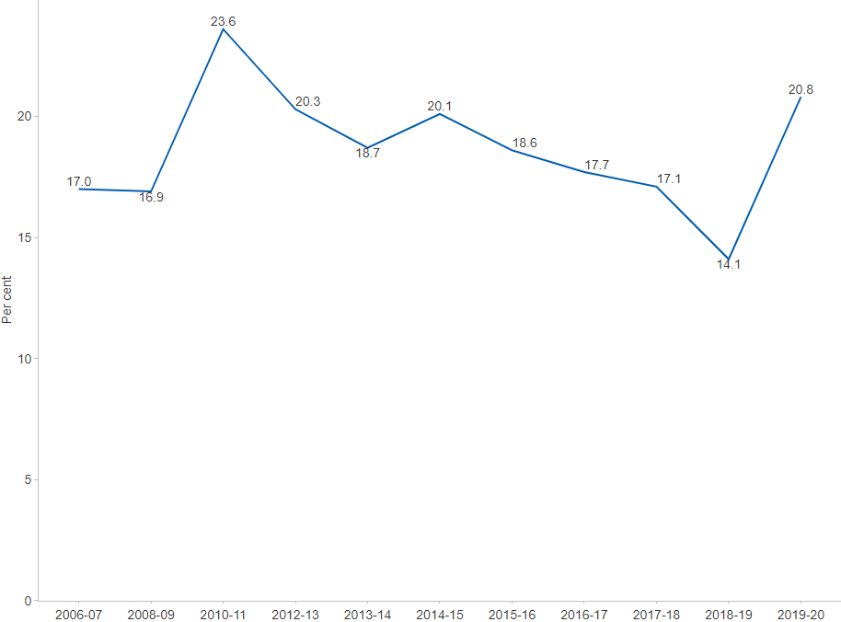

##### 

### 4.1.2 Businesses collaborating on innovation

The majority of collaboration on innovation by Australian businesses occurs *domestically* – most commonly with customers or suppliers (data not shown). Importantly, around a quarter of innovation-active businesses that collaborate on innovation, collaborate with another business owned by the same company and operating in Australia (22.4 per cent in 2018–19). This provides a rough indication of the innovation capability embedded within businesses. In 2018–19 only 9.8 per cent reported collaborating on innovation with Australian universities or other higher education institutions. This though is a sizeable increase from the 4.8 per cent reported in both 2014–15 and 2016–17. Partnership arrangements require trust between the business enterprise sector and higher education researchers. *International collaboration* on innovation occurs at an even lower rate, with just 0.9 per cent of innovation-active businesses collaborating with an overseas higher education institution in 2018–19.[110]

#### Figure 4.1.2: Businesses collaborating on innovation, share of innovation-active businesses, by partner, per cent, latest 2018–19

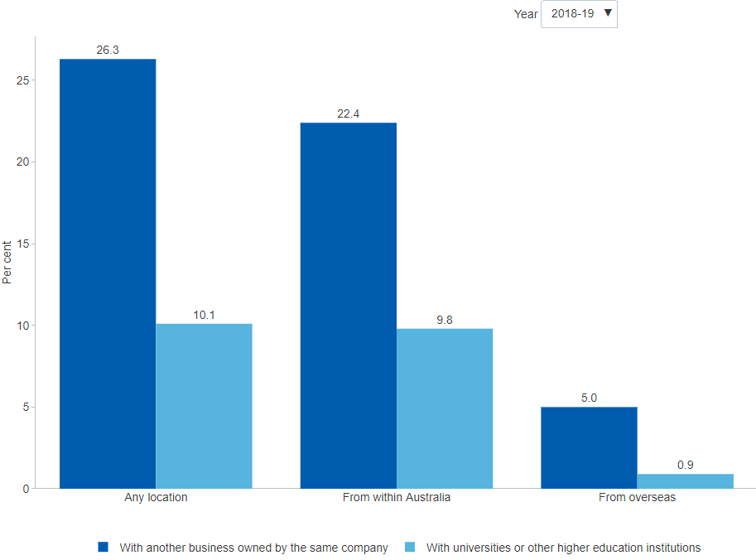

##### 

### 4.1.3 Businesses collaborating on R&D

A modest subset of innovation-active businesses undertake research and development (R&D). Survey evidence suggests that Australian innovation-active businesses report relatively low rates of collaboration on R&D. In 2018–19, only 3.3 per cent of Australia's *innovation-active businesses collaborated on R&D*, which is the lowest proportion since 2005–06. By business size (data not shown), large innovation-active businesses reported the highest rates of joint R&D activity, 6.3 per cent in 2018–19. This compares to only 5.6 per cent of innovation-active medium sized businesses and 2.2 per cent of innovation-active small businesses collaborating on R&D in the same period. By industry (data not shown), the mining industry reported the highest share of innovation-active businesses with joint R&D activities at 8.5 per cent.[111]

#### Figure 4.1.3: Businesses collaborating on R&D, share of innovation-active businesses, per cent, latest 2018–19

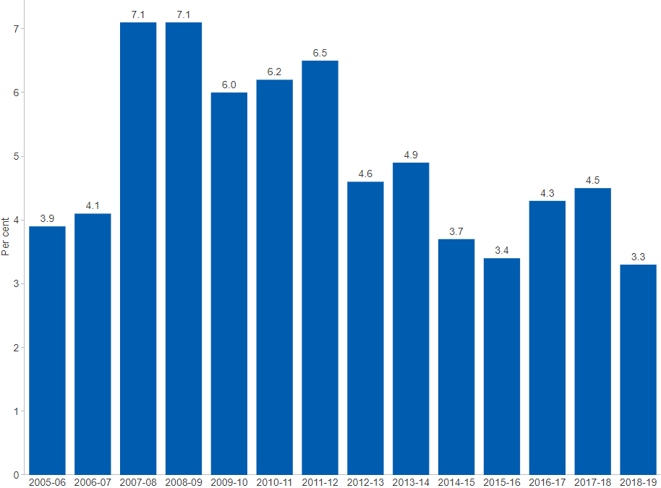

##### 

### 4.1.4 Businesses collaborating with publicly funded research organisations

Collaboration promotes innovation, as collaborators build on other’s knowledge and experience. Patent data on collaboration between businesses and publicly funded research organisations (PFROs) suggests limited interaction between the two sectors in Australia. Among all patent families that include an Australian applicant, just 2 per cent involved collaboration in 2018. That said, collaboration varies substantially across technology fields and years; and it is also not present in all fields. In 2018, the technology fields with the largest share of patents involving business and PFRO collaboration were in *Macromolecular chemistry, polymers* (11.4 per cent), *Biotechnology* (8.2 per cent) and *Optics* (6.3 per cent).[112] A recent report by IP Australia found that collaborative grants have a higher impact on boosting all types of patent applications than non-collaborative ones. Further, a greater impact is seen for Patent Cooperation Treaty (PCT) applications, where PCT applications are submitted to obtain patent protection within multiple countries.[113]

#### Figure 4.1.4: Businesses collaborating with PFROs, share of patent family filings involving Australian applicants, by technology field, per cent, latest 2018

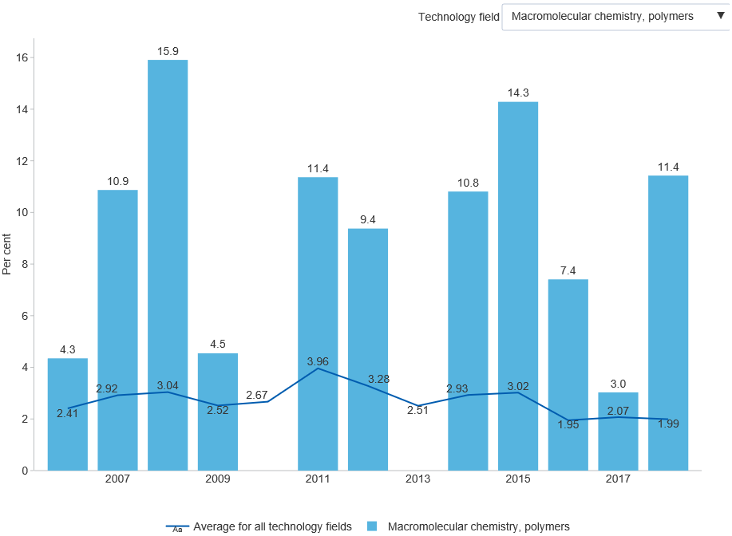

##### 

### 4.1.5 Active licences, options and assignments (LOAs) yielding income for research organisations

Many Australian universities, medical research institutes and public research organisations license intellectual property (IP) to third parties, including businesses. Active LOAs that yield income are a subset of all active LOAs. They reflect high value IP in the research sector, as well as knowledge transfer between sectors. Data from the *National Survey of Research Commercialisation (NSRC)* provides a time series of the number of active LOAs yielding income in the research sector from 2006 to 2016. A peak in the number of active LOAs occurred in 2013 with 950 agreements reported, and an increase of 12.8 per cent can be seen between 2006 and 2016 with 719 and 811 LOAs reported, respectively.[114]

#### Figure 4.1.5: Active LOAs and those yielding income for research organisations, by research organisation, number, latest 2016

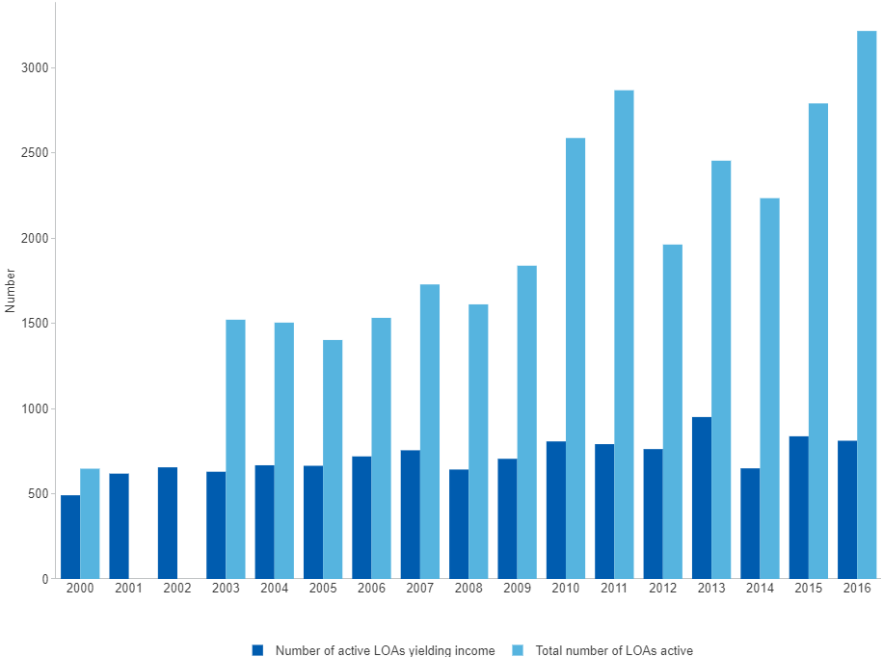

##### 

### 4.1.6 Income from active licences, options and assignments (LOAs) obtained by research organisations

Many Australian universities, medical research institutes and public research organisations license intellectual property (IP) to third parties including businesses. Active LOA deals that yield income provide an indication of IP with high commercial value as well as knowledge transfer between sectors. Survey data shows that total income in the research sector from licensing between 2006 and 2016 was over $2 billion. Over the decade, LOA income varied with spikes seen in 2009 and 2012 which corresponds to large increases in data provided by *Commonwealth Scientific and Industrial Research Organisation (CSIRO)*. This also points to a broader trend — LOA income data often varies from the number of active LOAs executed due to considerable variation at the institutional level in the value of licensing deals.[115]

#### Figure 4.1.6: Income from active licences, options and assignments (LOAs) obtained by research organisations, $ million, latest 2016

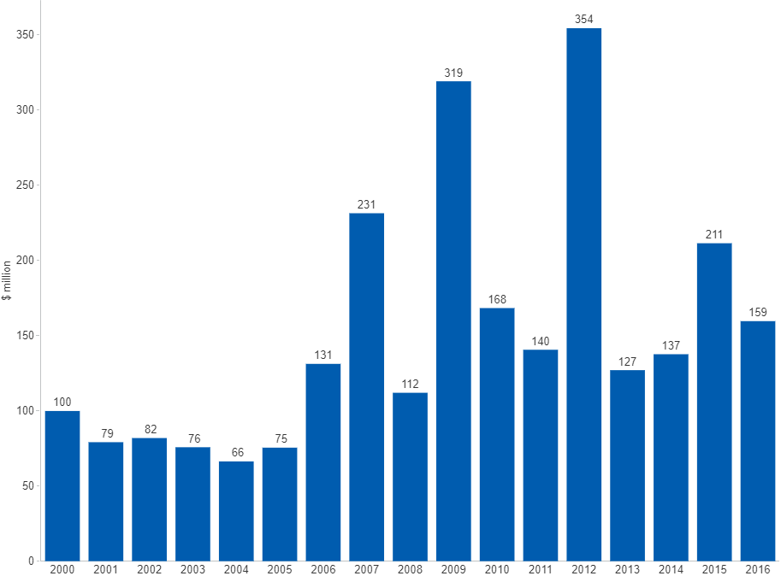

##### 

### 4.1.7 Consultancies, contracts and research collaborations with research organisations

A selection of Australian universities, medical research institutes and public research agencies are surveyed each year on their industry engagement via research-based consultancies, fee-for-service contracts and formal research collaborations. These activities provide an indication of how active the research sector is with respect to knowledge transfer to industry. Data shows that the number of consultancies, contracts and research collaborations undertaken from 2006 to 2016 fluctuated with an overall increase over the period. The largest number of consultancies, contracts and collaborations occurred in the most recent years with 18,076 and 18,279 activities reported in 2015 and 2016, respectively.[116]

#### Figure 4.1.7: Consultancies, contracts and research collaborations with research organisations, number, latest 2016

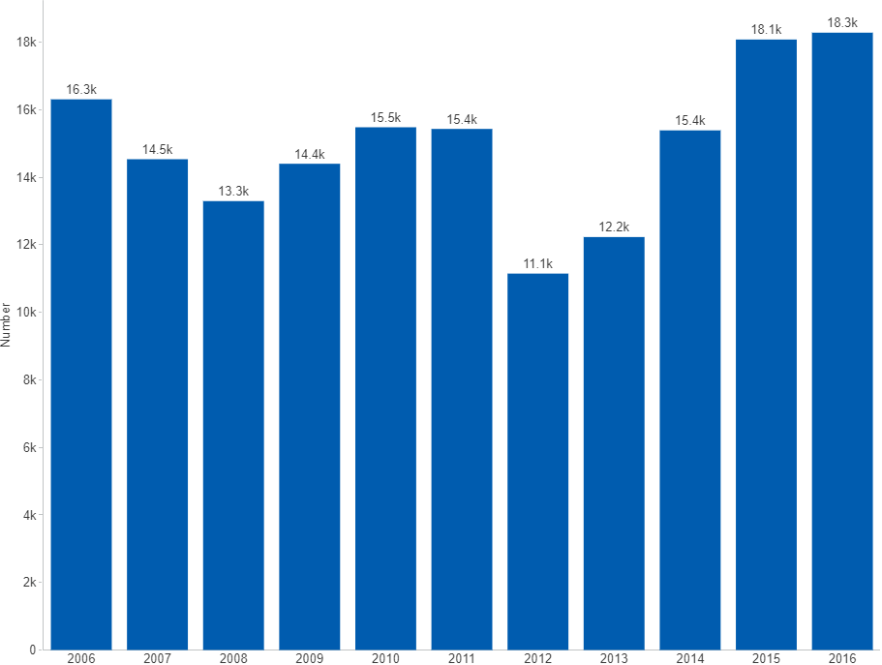

##### 

### 4.1.8 Total gross value of consultancies, contracts and research collaborations with research organisations

A selection of Australian universities, medical research institutes and public research agencies are surveyed each year on industry engagement via research-based consultancies, fee-for-service contracts and formal research collaborations. Data shows that over 2006–2016, the total value of consultancy, contract and collaboration activity in the research sector was $16.1 billion. Compared to income derived from intellectual property (IP) licensing, $2 billion over the same period, this form of knowledge transfer is of significantly greater value. It may suggest consultancies, contracts and collaboration are increasingly the preferred avenue of knowledge transfer to industry over more traditional channels such as IP licensing.[117]

#### Figure 4.1.8: Consultancies, contracts and research collaborations with research organisations, gross value, $ billion, latest 2016

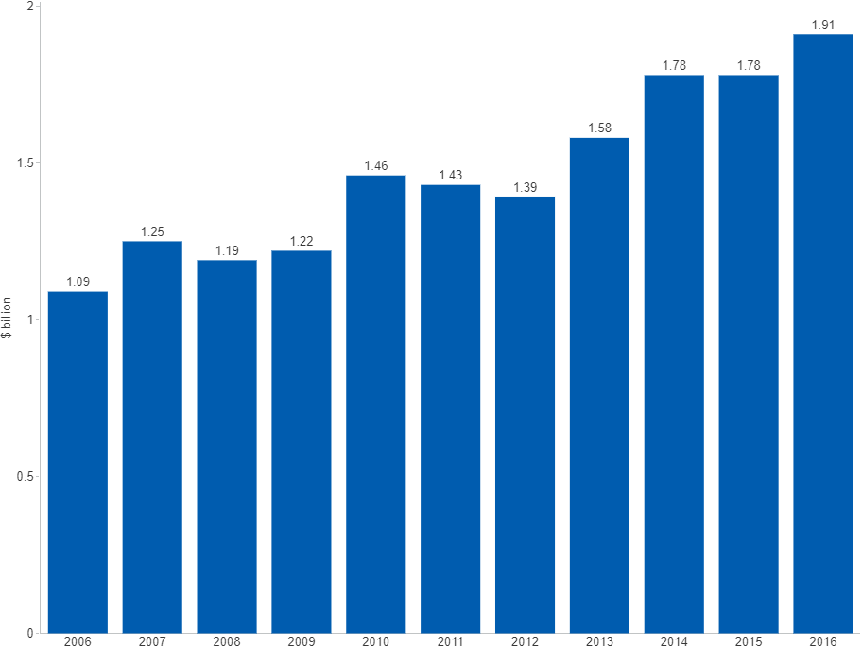

##### 

## 4.2 Absorptive Capacity

### 4.2.1 Business human resources devoted to R&D

One measure of the capacity of businesses to absorb advanced knowledge is the employment of R&D staff. Evidence shows notable across-the-board increases in business resources devoted to R&D between 2010–11 and 2013–14. These were primarily driven by hiring in medium and large businesses (with more than 20 employees). However, between 2013–14 and 2019–20 large businesses (with 200 or more employees) cut roughly 6,800 R&D-related jobs, which was only partly offset by further hiring in small and medium business in the period (up around 2,500 and 3,300 R&D-related jobs, respectively). By resource type, the main impact of these changes has been felt by *Researchers*, whose employment in business declined from around 39,100 person-year equivalent in 2013–14 to roughly 35,000 in 2019–20. The most recent data shows a tentative increase over the four years to 2019–20. It is possible that the longer-term pattern is related to a general shift away from large businesses towards small and medium businesses, accompanied by a shift away from *Engineering* towards *Information and computing sciences*, as seen in the data by field of research.[118]

#### Figure 4.2.1: Business human resources devoted to R&D, by type of resource, person-year equivalent, latest 2019–20

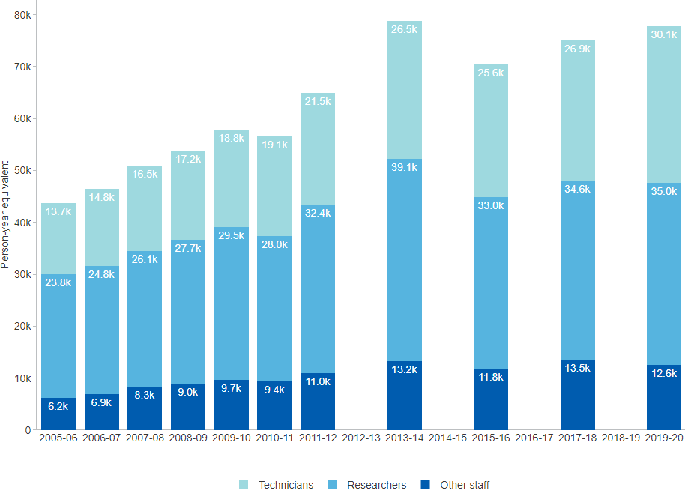

##### 

### 4.2.2 Government human resources devoted to R&D

In any sector, researchers are the main subset of the total human resources devoted to R&D. Important non-research functions related to the conduct of R&D are performed by personnel including *Technicians* and *Support staff*. In the government sector across both Commonwealth, state and territory governments, *Researchers* consistently account for around half of total government human resources devoted to R&D (7,570 person-year equivalent out of 14,521 in 2018–19). Commonwealth human resources devoted to R&D — including not only *Researchers* but also *Technicians* and *Support staff* — peaked in 2012–13 at 9,820 person-year equivalent before declining to 7,763 in 2018–19.[119]

#### Figure 4.2.2: Government human resources devoted to R&D, by level of government, by type of resource, person-year equivalent, latest 2018–19

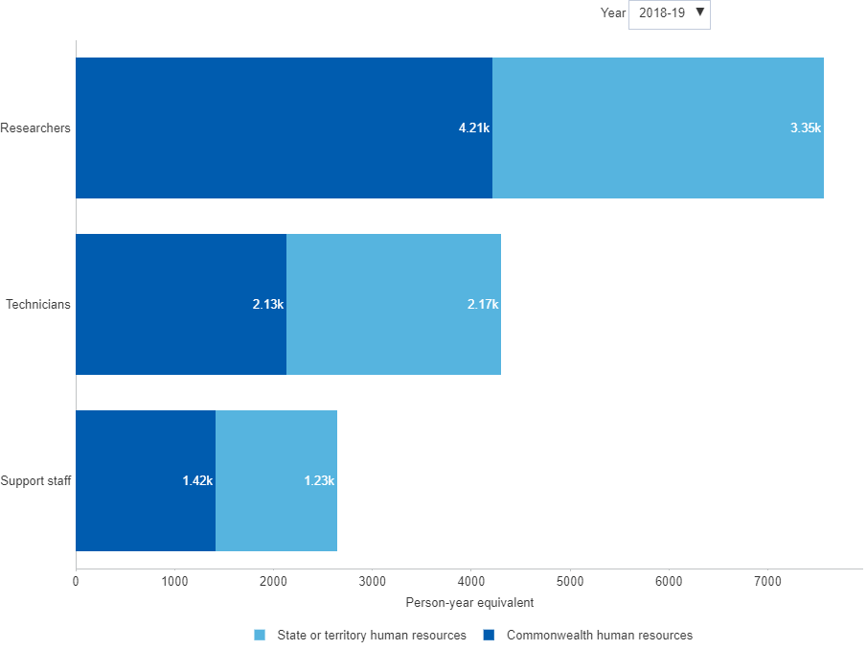

##### 

### 4.2.3 Higher education human resources devoted to R&D

Total human resources devoted to R&D by the higher education sector increased from about 35,400 person-year equivalent in 1992 to more than 81,700 person-year equivalent in 2018. About 56 per cent of these resources are *Postgraduate students*. A further 30 per cent are *Academic staff* and the remainder are *Technical and other staff*. These proportions have remained broadly steady over the last decade. Growth in total human resources devoted to R&D has been positive since 1992 and has averaged 1.8 per cent per year over the last decade.[120] This compares favourably with Australia's average population growth rate of 1.5 per cent over the same period and indicates that Australia's human resources devoted to R&D has been slightly outpacing population growth.[121]

#### Figure 4.2.3: Higher education resources devoted to R&D (HERD), by human resources, person-year equivalent, latest 2018

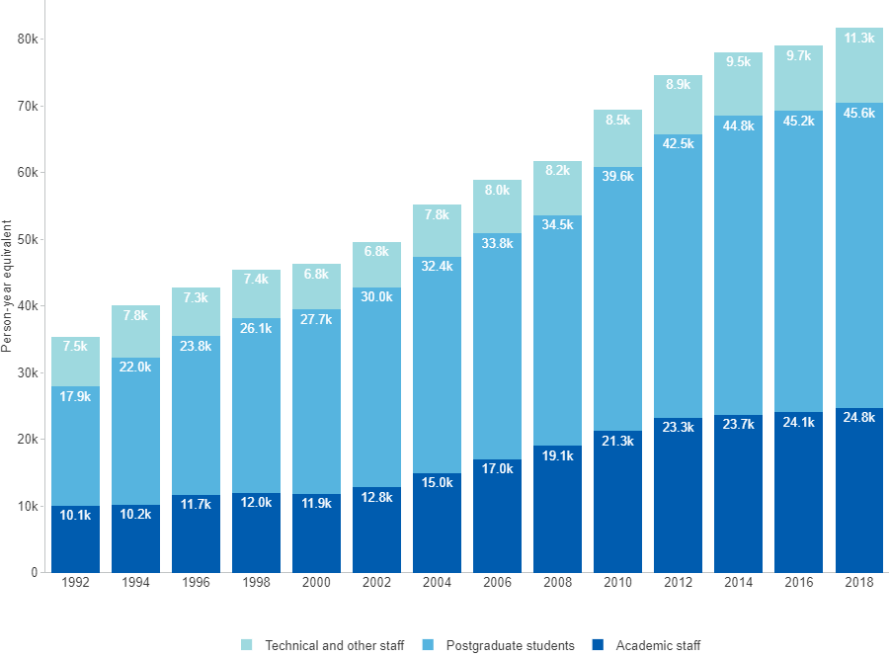

##### 

## 4.3 Government Engagement

### 4.3.1 Businesses receiving government financial assistance

In 2019–20, nearly 8 in 10 Australian business (78.3 per cent) received financial assistance from either Commonwealth, state/territory or local governments. This represents a dramatic increase from the previous year when only 12.8 per cent of businesses received assistance, reflecting the scale of fiscal stimulus deployed during the initial stages of the COVID-19 pandemic. Extensive use of government financial assistance was reported across all business sizes, most notably for small and medium businesses with 5 to 199 employees. All industries have seen sharp increases in the use of government assistance, with large relative increases in *Financial and insurance services* and *Rental, hiring and real estate*. Businesses that relied most heavily on government financial assistance were those operating in *Arts and recreation services* (86.3 per cent) and *Accommodation and food services* (85.0 per cent). Across all businesses, assistance was most commonly dispensed in the form of *Subsidies* followed by *Tax concessions*.[122]

#### Figure 4.3.1: Businesses receiving government financial assistance, by business size, per cent, latest 2019–20

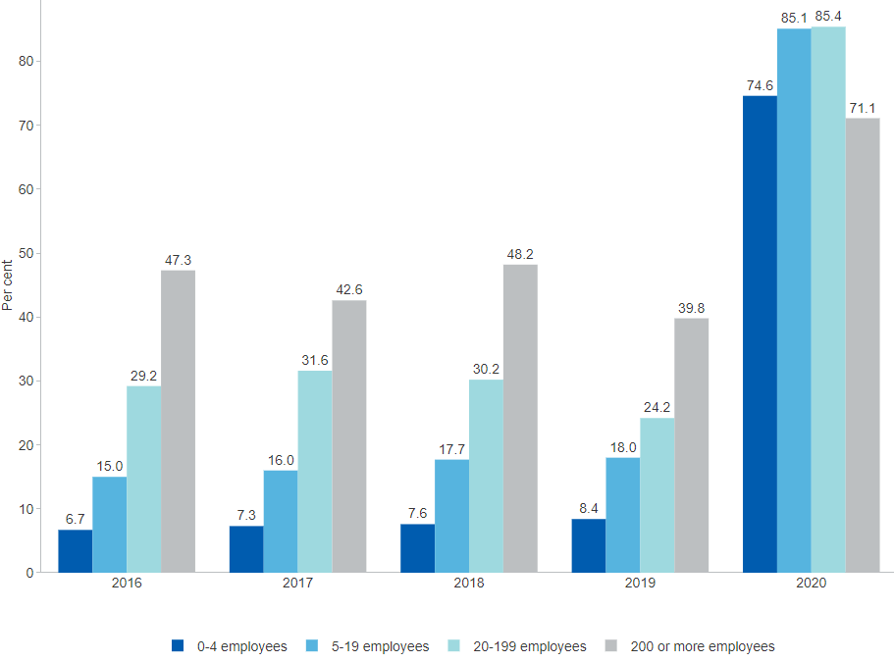

##### 

### 4.3.2 Innovation-active businesses receiving public support for innovation

*Australia* has the third lowest proportion of innovation-active businesses receiving public support for innovation in the OECD (only 10.1 per cent in 2016–17, compared to 25.0 per cent for the latest available *OECD average*). The data only capture businesses pursuing product and/or process innovation.[123] For context, it is important to note that Australia has a large services sector, and that ABS estimates cover a broader range of business innovation activity than product and/or process innovation. For 2017–18, the ABS data show that some 49.8 per cent of all Australian businesses were identified as innovation active.[124] That said, the OECD estimate for *Australia* seems low relative to other countries, so the potential benefits and costs of expanding the take-up of the relevant business innovation initiatives may be worth investigating further.

#### Figure 4.3.2: Innovation-active businesses receiving public support for innovation, only relates to product and/or process innovation, by category, OECD countries, per cent, latest 2019

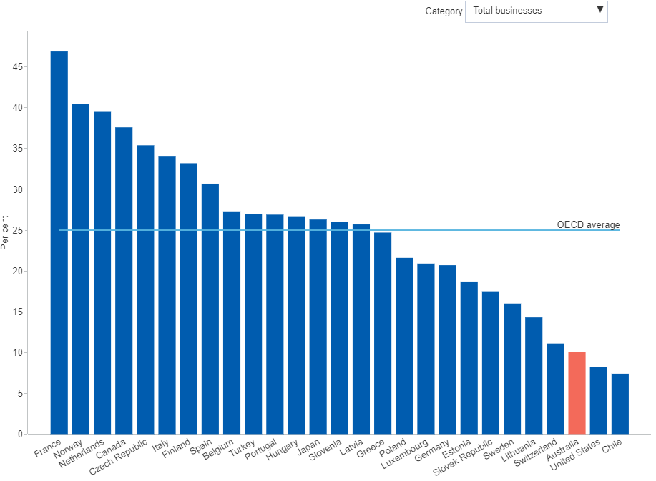

##### 

### 4.3.3 Innovation-active businesses with public procurement contracts

Public procurement affects innovation by influencing the demand conditions in which businesses innovate and compete. The use of public procurement as a tool of innovation has been gaining in popularity in recent years, and there are some notable examples of long-standing successful adoption of such policies. However, the evidence base on the effectiveness and economic value of this type of support is surprisingly sparse. A recent survey of evidence suggests that the barriers encountered by businesses generally correspond to the deficiencies addressed by procurement policies but are not sufficiently addressed by them.[125] In 2014–15, *Australia*’s share of innovation-active businesses with public procurement contracts was estimated at 21.7 per cent, below the latest available *OECD average* estimate of 26.1 per cent. Countries with the highest proportions include *Finland*, *Iceland*, *Austria* and *Norway*.[126] The data only relate to businesses pursuing product and/or process innovation.

#### Figure 4.3.3: Innovation-active businesses with public procurement contracts, only relates to product and/or process innovation, by category, OECD countries, per cent, latest 2017

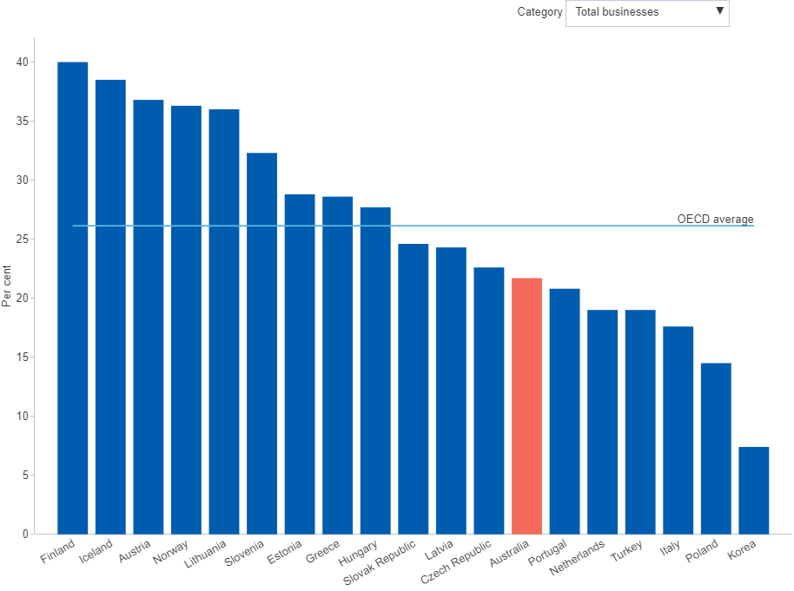

##### 

## 4.4 International Comparison

### 4.4.1 Business funding of higher education R&D (HERD)

Business funding of R&D performed by higher education institutions provides a measure of R&D collaboration between the business and research sectors. Businesses may also support higher education expenditure on R&D (HERD) indirectly by paying to use the R&D facilities of higher education institutions, buying R&D results, or investing in spin-off companies.[127] *Australia’s* performance on this metric is relatively modest compared to other OECD economies with 4.9 per cent of higher education expenditure on R&D financed by the business sector in 2018, which is below the OECD average of 6.2 per cent. Australia’s below-average performance on this metric is persistent over time and consistent with other measures of collaboration. Over the past 15 years the share of HERD financed by the business sector has remained below the 7.0 per cent mark, peaking in 2006 at 6.8 per cent. Among OECD member countries, the share of HERD financed by business in 2018 was highest in *South Korea* (14.3 per cent) and *Germany* (13.5 per cent)[128]

#### Figure 4.4.1: Higher education expenditure on R&D (HERD) funded by businesses, share of total HERD, OECD countries, per cent, latest 2020

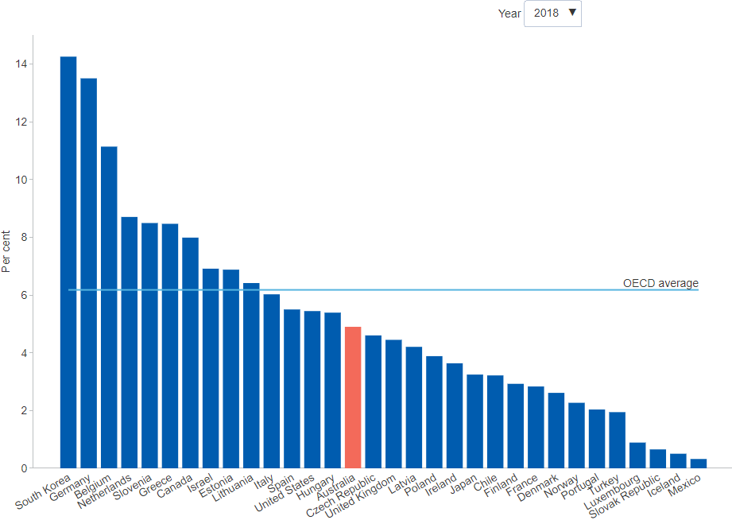

##### 

### 4.4.2 Businesses collaborating on innovation

Australia’s low rates of business collaboration turn up consistently across multiple metrics. One common measure is the share of innovation-active businesses that collaborate on innovation. On this measure, around 21.6 per cent of *Australian* innovation-active businesses are estimated to have engaged in some form of collaboration when developing or introducing innovation in 2016–17. By itself, this estimate may not seem particularly low — especially when compared with some of the other measures of collaboration — and it is certainly not the lowest result across the OECD countries. However, it is still considerably less than the latest available *OECD average* of 34.7 per cent. *Australia* ranks 28th out of 34 countries on this measure – the share of innovation-active businesses collaborating on innovation. Another useful measure is collaborative R&D by *R&D-active businesses*. For 2016–17, 40 per cent of *Australian* businesses collaborating on innovation undertake R&D, which is below the *OECD average* of 47 per cent. *Australia* ranks 23rd on this measure out of 32 countries.[129]

#### Figure 4.4.2: Innovation-active businesses collaborating on innovation, only relates to product and/or process innovation, by category, OECD countries, per cent, latest 2019

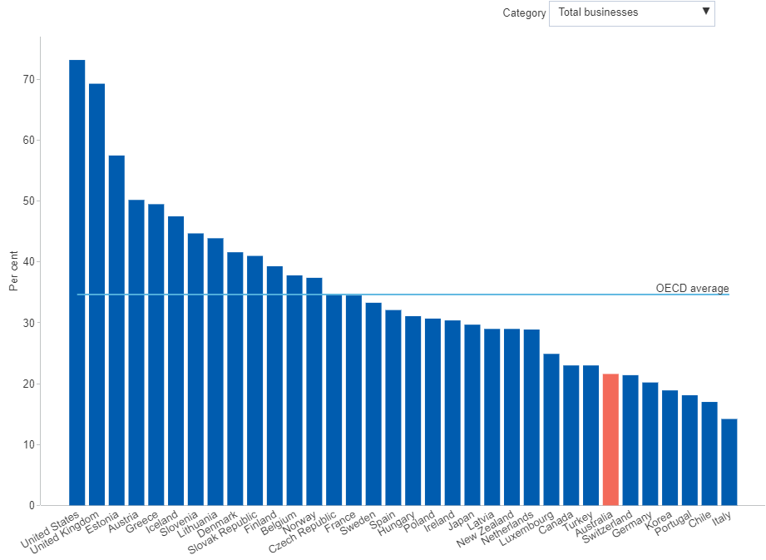

##### 

### 4.4.3 Businesses collaborating on innovation with higher education or government institutions

*Australia* ranks last in the OECD for business collaboration on innovation with higher education or government institutions - at just 1.6 per cent of all product and/or process innovation-active businesses in 2016–17. This compares poorly to the *OECD average* of 14.2 per cent and far below countries such as the *United Kingdom*, *Finland* and *Austria*, where one in four innovating businesses collaborate with either the research or government sectors. It is also arguably the weakest result across a range of similar measures, and reflects unfavourably on the ability of Australian businesses and research institutions to maximise the return on public investment in science and research.[130] Noting the caveats around methodological and scope differences between the different data sources, the result nevertheless stands in stark contrast with both the high quality of Australia’s research outputs and the solid rates of innovation across the business enterprise sector.[131][132]

#### Figure 4.4.3: Innovation-active businesses collaborating with higher ed. or government, only relates to product and/or process innovation, by category, OECD countries, per cent, latest 2019

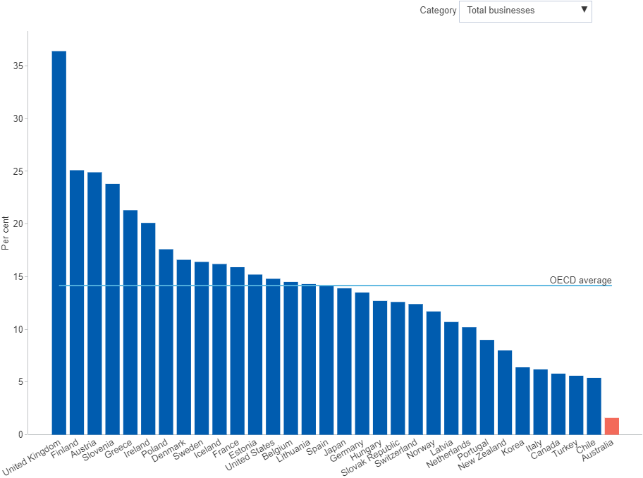

##### 

# 5 Skills and Capability

*Some of the data presented in this chapter was collected prior to the COVID-19 pandemic. Pending further updates, the COVID-19 page summarises some of the impacts of COVID-19 on Australian businesses during the first year of the pandemic.*

Innovation is about the creation, application and diffusion of knowledge — and skills and capability are at the very core of these processes. It is from the interplay of people working, collaborating and competing across the system that innovation and technological progress emerge. Human capital, intellectual property, and a range of other intangibles jointly represent the accumulated stock of knowledge. In the business enterprise sector, knowledge-based (or intangible) capital represents a substantial and growing investment. For example, experimental estimates suggest that Australian businesses invested approximately $21.2 billion on organisational capital in 2012–13 alone.[133]

Computer software is one intangible asset that has seen dramatic investment growth over the last three decades. The transformative potential of Big Data, the Internet of Things and Artificial Intelligence, is starting to be recognised. At the same time, these disruptive technologies have prompted debates around digital privacy and the future of work. Some estimates suggest intelligent technology could be capable of automating the tasks of 44 per cent of Australian jobs in the coming decades.[134] However, historically, technological disruptions have not led to mass unemployment — instead they left the most difficult, dangerous and back-breaking work to machines, and created new and better jobs for people.

Another important intangible asset is the accumulated knowledge generated from research activity. The higher education sector has historically been the largest employer of research personnel in Australia, and in recent years, the higher education research workforce increased substantially. By contrast, Australia's business and government sectors have both cut back dramatically on the number of researchers employed in recent times. Finally, management capability is equally as important. Recent Australian evidence suggests that management capability is positively associated with labour productivity, higher levels of innovation and more engagement in collaboration.[135]

##### 

## 5.1 Education and Workforce

### 5.1.1 Adults with school and non-school qualifications

The progression from secondary education to both tertiary academic studies and vocational qualifications is an important step towards the formation of specialised skills and capabilities in a variety of fields and disciplines. Three in 10 Australian adults have attained a *University degree* in 2020, rising from 23 per cent in 2010. The share of those with a *Certificate or diploma* has remained relatively stable in the same period at 26.6 per cent. Consequently, the share of adults with *Year 12* or *Year 11 or below* qualifications have fallen over this period. All four measures are affected by a change to the age range question that was introduced in the 2014 survey. This change added older people (aged 65–74 years) to the survey population and consequently increased the share of adults with *Year 11 or below* qualifications, whilst decreasing the other categories.[136]

#### Figure 5.1.1: Adults with school and non-school qualifications, by education level, per cent, latest 2020

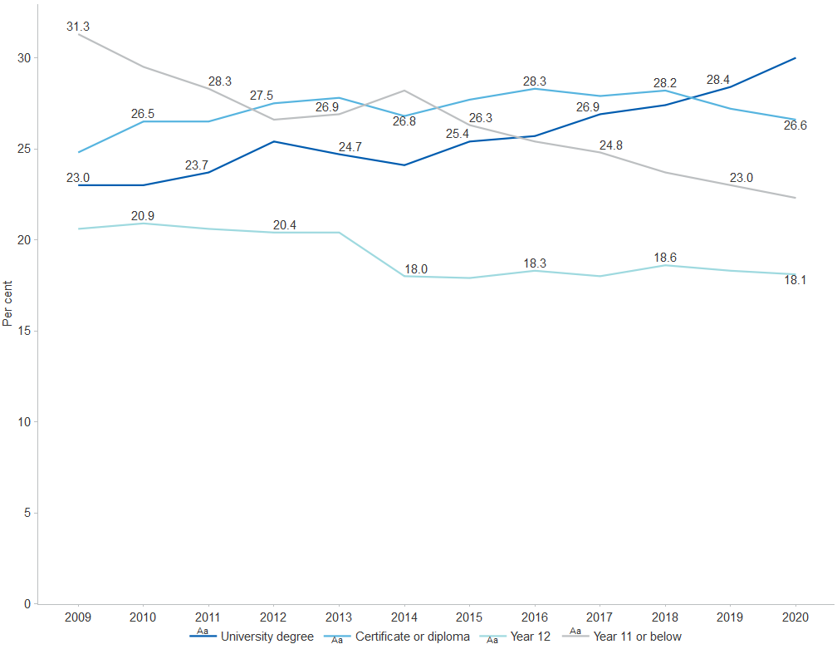

##### 

### 5.1.2 Adults with non-school qualifications by field of study

Students’ choice of field of study is guided by a range of factors, such as personal aspirations, previous experience, education assessment results, or perceptions of future employment prospects. In 2020, the top three successfully attained fields of study represented in the adult population with non-school qualifications in Australia were *Management and commerce* (23.1 per cent), *Engineering* (16.1 per cent) and *Society and culture* (14.2 per cent). The proportions of different fields of study represented in the adult population with non-school qualifications remained broadly unchanged between 2015 and 2020.[137]

#### Figure 5.1.2: Adults with non-school qualifications, by field of study, per cent, latest 2020

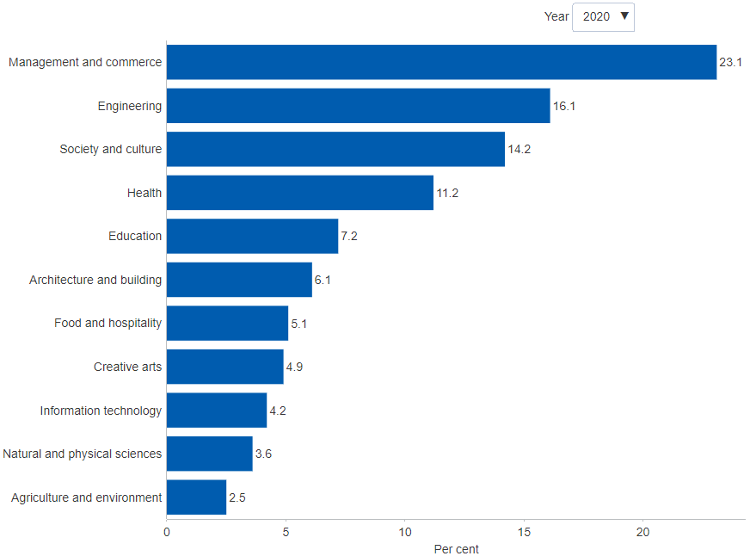

##### 

### 5.1.3 Adults studying for a non-school qualification by field of study

The number of people studying for non-school qualifications represents those who are developing their skills at work, while in the workplace and in preparation to start working. In 2020, there were 1,974,378 students studying for a non-school qualification. This represents a 14.1 per cent decrease from 2,298,735 in 2016. The most popular fields of study were *Management and commerce* (414,401 students or 21 per cent of total), *Society and Culture* (357,874 or 18 per cent of total) and *Engineering* (293,470 students or 15 per cent of total).[138]

#### Figure 5.1.3: Adults studying for a non-school qualification, by field of study, persons, latest 2020

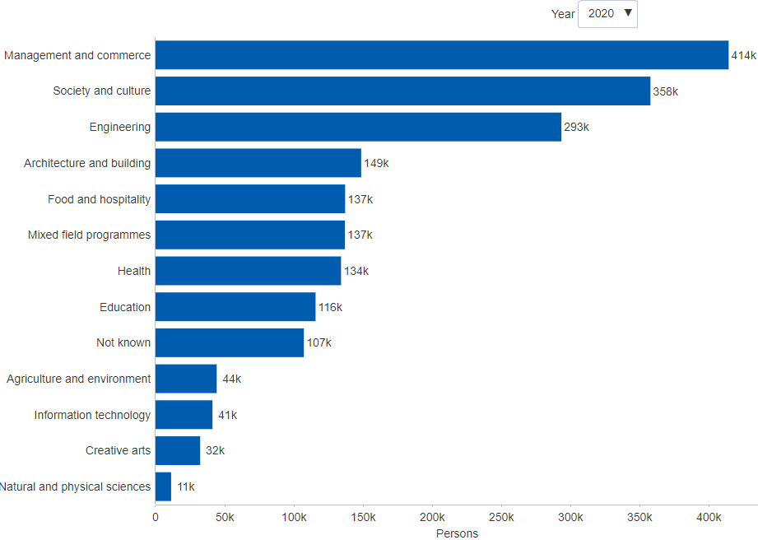

##### 

### 5.1.4 Apprentices and trainees by occupation

The labour force in a modern economy requires diverse skills and qualifications. However, evidence suggests that the occupations of apprentices and trainees (i.e. labour force in the pipeline) have become less diverse in recent years. In 2020, over half of all apprentices and trainees worked in just three fields: *Construction* (57,000 in 2020), *Automotive and engineering* (49,000) and *Electrotechnology and telecommunications* (42,000). *Construction* and *Automotive and engineering* have been very popular since at least 2000, while *Electrotechnology and telecommunications* has gradually gained popularity over time. Other occupations peaked in 2012 and have fallen since then, particularly *Sales assistants* (from 40,000 in 2012 to 11,000 in 2020), *Specialist managers* (from 37,000 in 2012 to 526 in 2020) and *Office managers* (32,000 in 2012 to around 3,200 in 2020). This is partly driven by changes to the financial incentives under the Australian Apprenticeships Incentives Program since 2012. These changes have primarily affected non-National Skills Needs Lists apprenticeships and traineeships.[139]

#### Figure 5.1.4: Apprentices and trainees in training, by occupation, persons, latest 2020

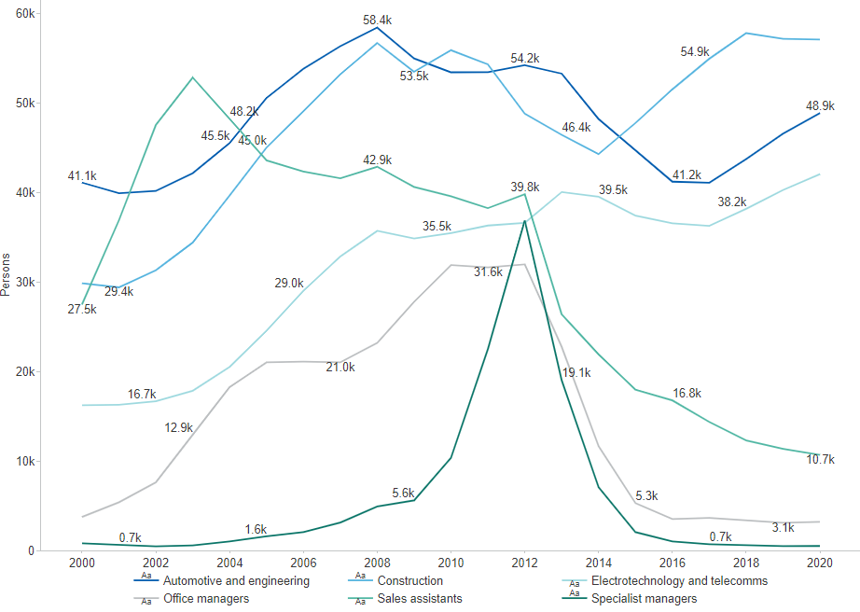

##### 

### 5.1.5 Apprentices and trainees by employer industry

Vocational study is most useful when students can work in the same field as their studies. The great majority of apprentices and trainees (in training) work in the *Construction* industry (93,000 in 2020). This has been the most popular industry of employment since 2007, and the only employer industry not to shrink significantly since 2012. All other major employer industries peaked in 2012 and have declined since then. *Manufacturing* declined by more than 60 per cent (from 61,000 in 2012 to 23,000 in 2020) and *Accommodation and food services* fell by almost 60 per cent (47,000 in 2012 to 20,000 in 2019). The peak in 2012 and subsequent decline were partly driven by changes to the financial incentives under the Australian Apprenticeships Incentives Program since 2012. These changes have primarily affected non-National Skills Needs Lists apprenticeships and traineeships. The *Construction* industry was not affected, and its numbers have continued to climb since 2012.[140]

#### Figure 5.1.5: Apprentices and trainees in training, by employer industry, persons, latest 2020

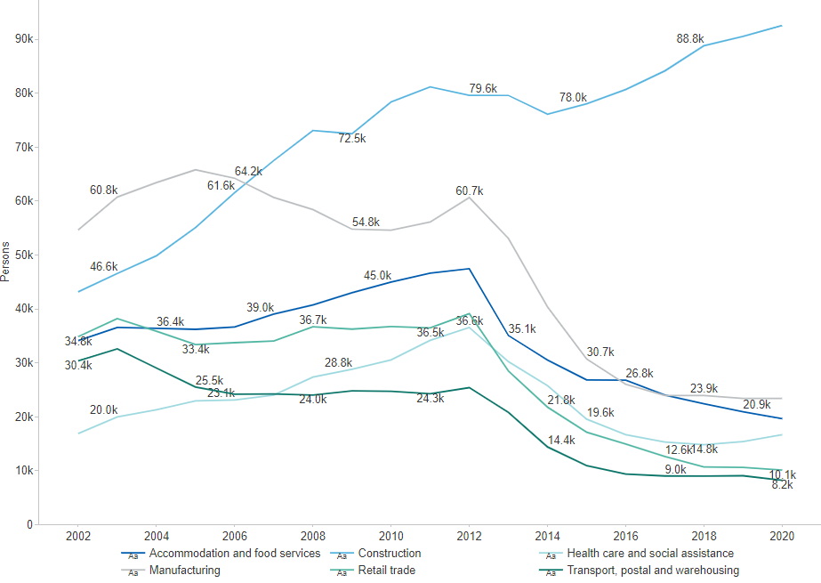

##### 

## 5.2 Innovation Capability

### 5.2.1 R&D personnel by sector

Researchers and other R&D personnel constitute a vital input to R&D activity. In Australia, the number of R&D personnel in the business and higher education sectors increased dramatically since the turn of the century, but declined in the government sector. *Business sector R&D personnel* numbers nearly doubled, from around 35,900 in 2002 to nearly 75,000 in 2017. The rise in *R&D personnel numbers in the higher education sector* was more modest but still significant (from 49,600 in 2002 to 81,700 in 2018). By contrast, the number of *R&D personnel in government* declined in the same period, from 18,500 to 14,500. Based on the OECD definition, R&D personnel include all persons employed directly in R&D activities, and comprises researchers, technicians and support staff. R&D personnel are represented in full-time equivalent units defined as the ratio of working hours actually spent on R&D during a specific reference period divided by the total number of hours worked in the same period by an individual or a group. In *Australia*, just as in many other OECD countries, the business enterprise and higher education sectors are the leading employers of R&D personnel.[141][142]

#### Figure 5.2.1: R&D personnel, by sector, OECD countries, full-time equivalent, latest 2020

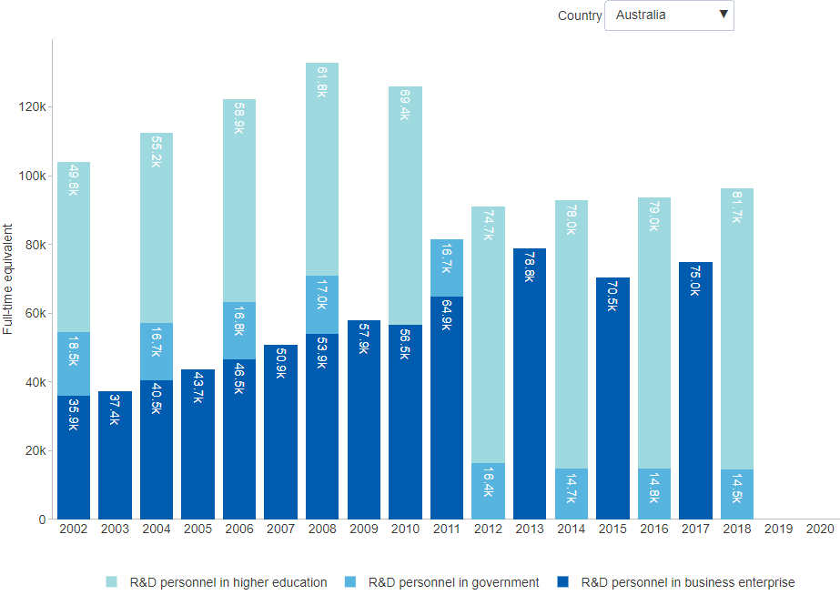

##### 

### 5.2.2 Innovation-active businesses that operate in international markets

Evidence from Australian microdata suggests that innovation-active businesses are 4 to 8 per cent more likely to be exporters compared to businesses that do not innovate, while exporters are 7 to 10 per cent more likely to be innovators.[143] Microdata evidence further suggests that more than one-third of Australian exporters are concentrated in just four industries: Mining; Manufacturing; Wholesale trade; and Information media and telecommunications.[144] In 2016–17, 47.5 per cent of *Australian* businesses operating in international markets were innovative. This compares to the latest available *OECD average* of 58.3 per cent. The leaders in this field were *Canada* (88.1 per cent), *Norway* (82.3 per cent) and *Switzerland* (80.8 per cent).[145] The data only relate to businesses pursuing product and/or process innovation.

#### Figure 5.2.2: Innovation-active businesses that operate in international markets, only relates to product and/or process innovation, by category, OECD countries, per cent, latest 2019

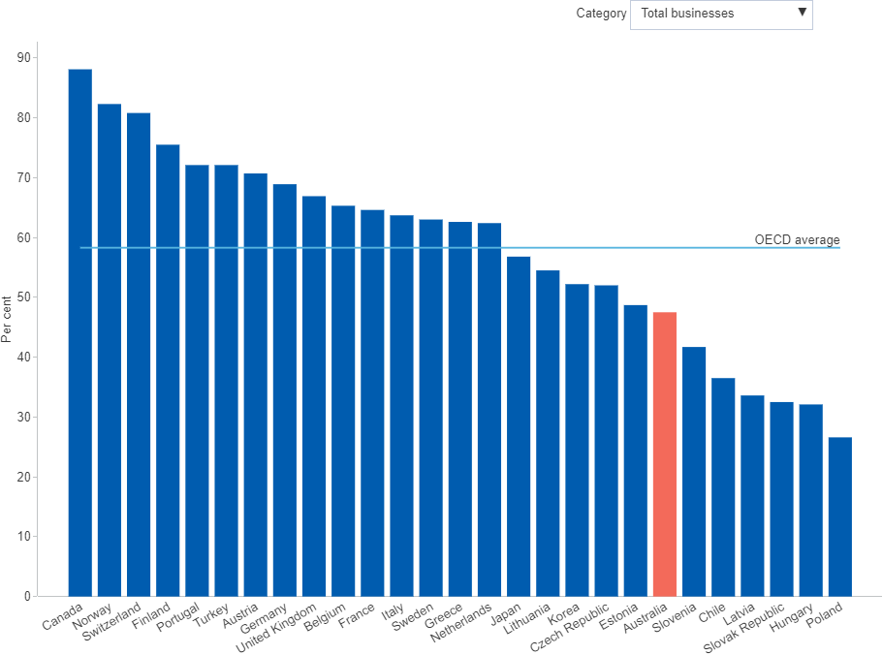

##### 

### 5.2.3 Australian exports with a revealed comparative advantage (RCA) index above two

RCA is an important measure of export competitiveness. It measures a country's relative advantage in a certain class of products as evidenced by export flows. For values above one, a higher RCA index value implies a stronger export competitive advantage.[146] Between 1993 and 2016, the *number of products with an RCA index above two* dropped by 117 (from 336 to 219), while their *export value* increased by $119 billion or 387 per cent. In other words, Australia has become more specialised in exporting fewer product classes at a considerably higher value. This shift has been driven by a very limited number of mineral commodities for which Australia exhibits a super-competitive position in the world. In the export of iron ore, for instance, Australia has an RCA index of around 53 — meaning we are 53 times more competitive at producing and exporting iron ore than the world average. However, an excessive concentration of exports in a handful of mineral commodities is risky, as the prices of those commodities are set by global markets. Australia's lack of export diversity could therefore weigh on growth prospects in the future.[147]

#### Figure 5.2.3: Products with RCA index above 2.0 and export value, number, latest 2016

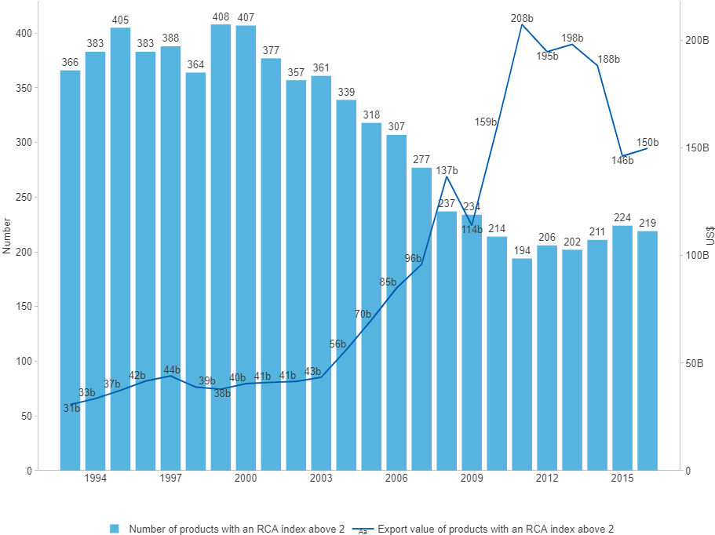

##### 

### 5.2.4 Selected sources of ideas for innovation

Survey evidence suggests that ideas for innovation mostly originate from *Within the business or related company*, with around half of them reporting their own business or another business owned by the same company as the main source of ideas. Large businesses are more likely than small and medium businesses to generate these type of ideas, as they have access to a larger pool of talent and human resources. At the other end of the spectrum are external sources of ideas, such as from *Universities or other higher education institutions*. Although they are much less likely to be identified as the source of ideas, they can provide specialised advice or technical expertise to implement them. Less than 3 per cent of innovation-active businesses reported their ideas or information for innovation originating from these sources and these are most common in the mining, scientific and health care industries (data not shown).[148]

#### Figure 5.2.4: Selected sources of ideas for innovation, share of innovation-active businesses, per cent, latest 2018–19

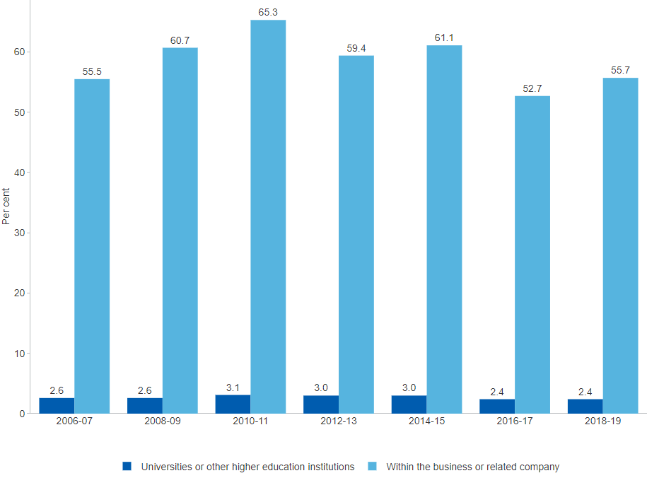

##### 

## 5.3 Intangible Capital

### 5.3.1 Intangible capital investment

The uneven pattern of productivity gains associated with the rise of the so-called knowledge economy — more prevalent in some firms, industries and countries than others — has brought attention to the role of investments in certain intangible assets such as computerised information (e.g. databases) and intellectual property (e.g. patents and designs). Few attempts have been made to date to comprehensively measure all the relevant intangibles identified in literature.[149] For the few intangibles that are currently measured and published in the national accounts, the largest share of Australia’s market sector investment was traditionally directed to *Research and development*. However, this pattern has been changing. Since 2016–17, *Computer software* has been attracting the largest share of investment. Over three decades, this asset has seen dramatic and sustained investment growth, rising from just under $1 billion in 1989–90 to $23.5 billion in 2019–20, in chain volume terms. The other notable trend has been in *Mineral and petroleum exploration*, which led intangible investment prior to the mid-1980s. It peaked in 2012–13 at $8.3 billion before falling back dramatically to $3.2 billion in 2017–18, in chain volume terms. The latest estimate is at $4.1 billion in 2019–20.[150]

#### Figure 5.3.1: Intangible gross capital investment (share of GDP), by asset type, current prices or chain volume, $ billion, latest 2019–20

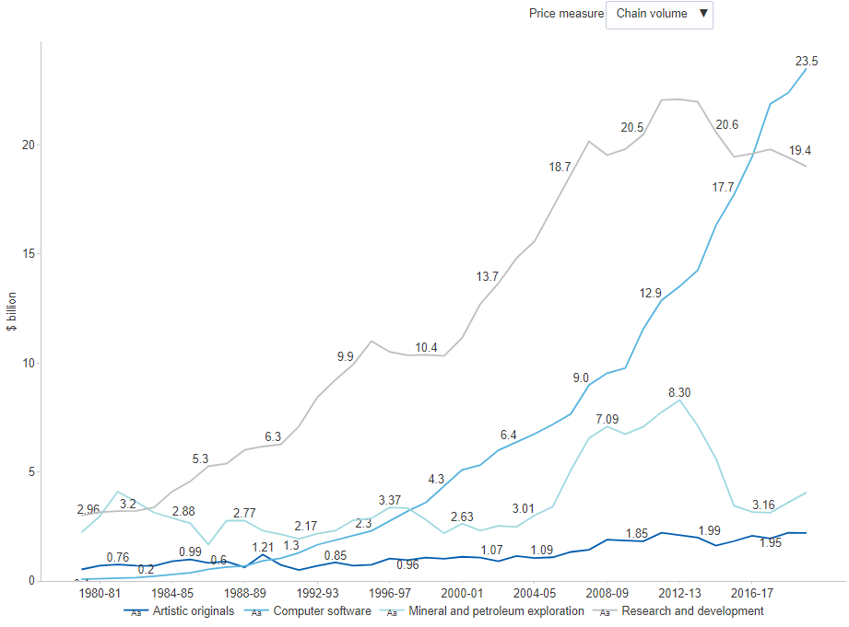

##### 

### 5.3.2 Intangible capital stock

Experimental estimates to date suggest that the aggregate value of Australia’s intangible capital stock is substantial and growing.[151] Until around 2004–05, the largest share was *Mineral and petroleum exploration* but this was subsequently overtaken by *Research and development*. These two assets continue to dominate Australia’s intangible capital stock, accounting for around 78.0 per cent of total measured intangibles, or $193.4 billion as at June 2020.[152] For comparison, Australia’s aggregate stock of physical capital in the form of Machinery and equipment stood at around $668.5 billion at June 2020, roughly 2.7 times the size of total measured intangibles. This comparison underestimates the true size of intangibles since several important assets are currently not being measured, most notably organisational capital and business-specific human capital. Recent experimental estimates of Australia’s organisational capital were published by the Office of the Chief Economist in 2016.[153]

#### Figure 5.3.2: Intangible net capital stock, by asset type, current prices or chain volume, $ billion, latest 2019–20

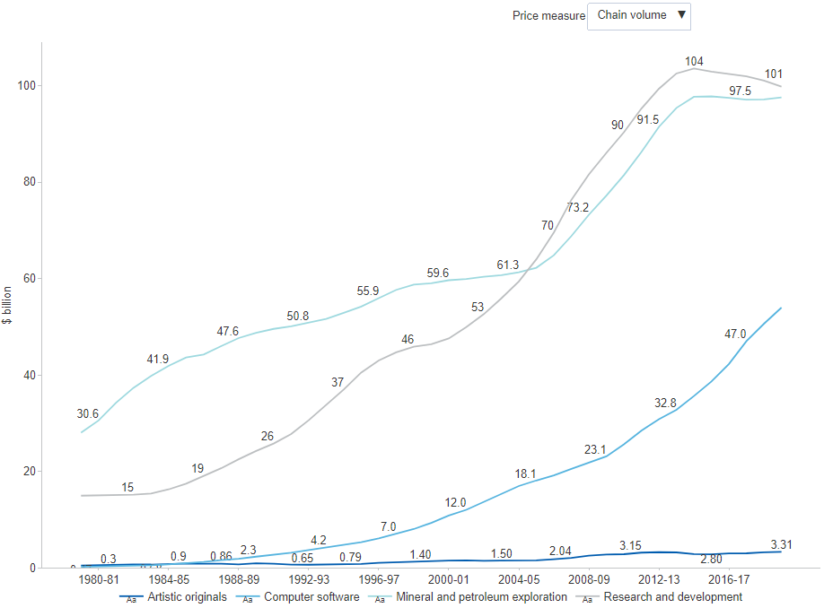

##### 

### 5.3.3 Business investment in intangible capital

Intellectual property rights denote investment in intangible assets, such as branding and design. Spending on intangible capital investments by Australian businesses has seen sustained growth over the past 40 years. In chain volume terms, the data shows the effect from the mining boom, which wound down from 2013.[154] *Business investment in intangible capital* increased until 2012–13 to $36.4 billion and fell to $33.5 billion by 2015–16, before rising to $39.2 billion in 2019–20. As a share of new capital investments, *Business investment in intangible capital* dipped between 2010–11 and 2015–16 before rising to 11.4 per cent in 2019–20.[155]

#### Figure 5.3.3: Private intangible gross capital investment, chain volume, $ billion, latest 2019–20

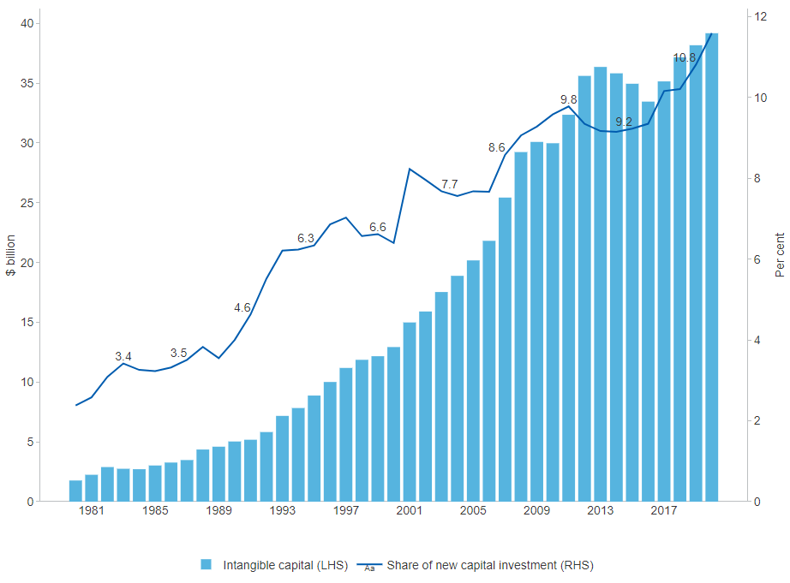

##### 

### 5.3.4 Patent family filings involving Australian applicants

Patent filings are a key indicator of inventive activity. Applications filed in different jurisdictions but claiming the same priority make up a patent family. IP Australia reports that 2,637 resident patent applications were filed in 2019, a slight decrease of 4.3 per cent from 2018 (data not shown).[156] The European Patent Office data shows that, for Australia, the number of patent family filings has remained relatively stable since 2006.[157]

#### Figure 5.3.4: Patent family filings involving Australian applicants, total, number, latest 2018

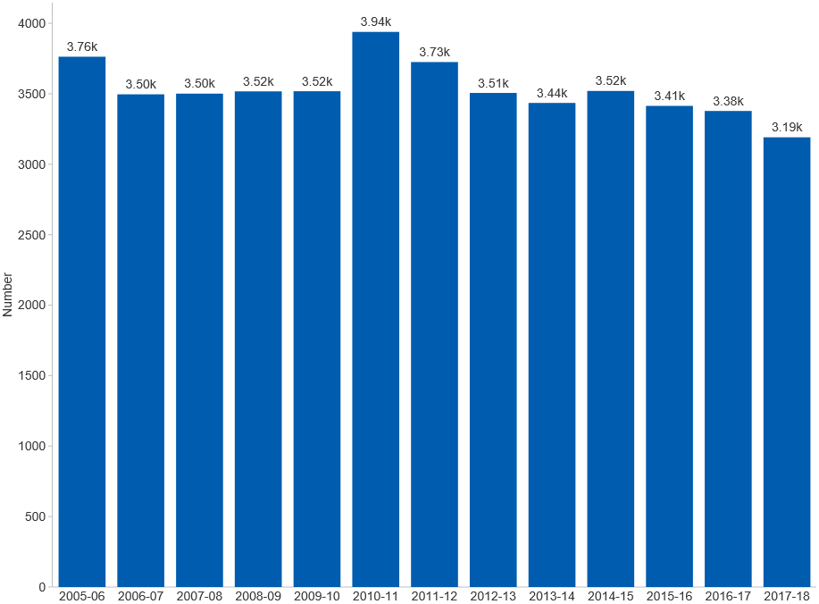

##### 

### 5.3.5 Patent family filings involving Australian applicants by technology field

Applications filed in different jurisdictions but claiming the same priority make up a patent family. The European Patent Office data shows that patent family filings were most concentrated in the *Civil engineering* field with 478 patent families, followed by the *Medical technology* field with 334 patent families filed in 2018. Significant positive growth has occurred in patent families over the last 10 years relating to *Materials, metallurgy* (56 per cent), *Food technology* (48 per cent) and *Computer technology* (16 per cent). A large number of technological fields have also seen significant declines, such as *Textile and paper machines* (63 per cent), *Machine tools* (60 per cent) and *Thermal processes and apparatus* (47 per cent).[158]

#### Figure 5.3.5: Patent family filings involving Australian applicants, by technology field, number, latest 2018

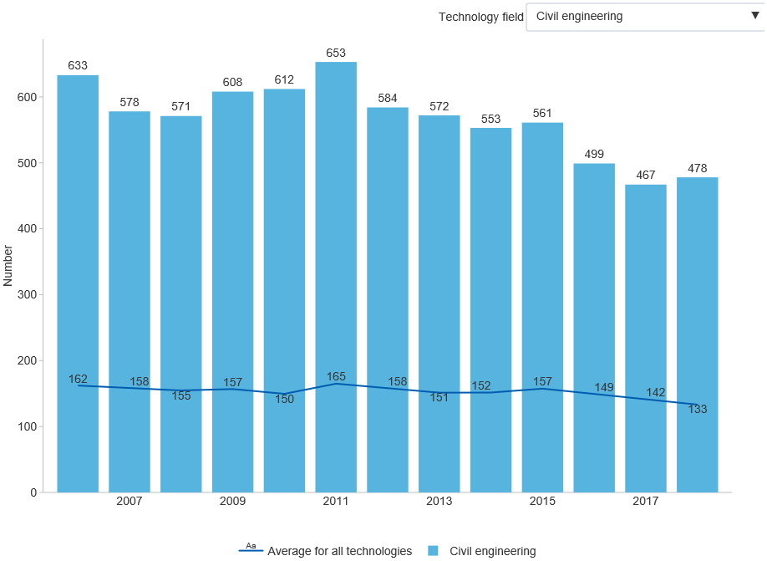

##### 

## 5.4 International Comparison

### 5.4.1 Total expenditure on educational institutions as a share of GDP

Education represents a bedrock investment into personal, national and global development. This is especially true for countries pursuing knowledge-based growth as a means to shoring up prosperity and addressing inequality. Among OECD countries, *Australia* has the 7th highest expenditure on educational institutions as a share of GDP (5.9 per cent in 2018–19) — well above the *OECD average* of 4.9 per cent.[159] While the majority of this expenditure is publicly funded, Australia's reliance on private funding of education is not common in other OECD countries.

#### Figure 5.4.1: Expenditure on educational institutions, share of GDP, OECD countries, per cent, latest 2018

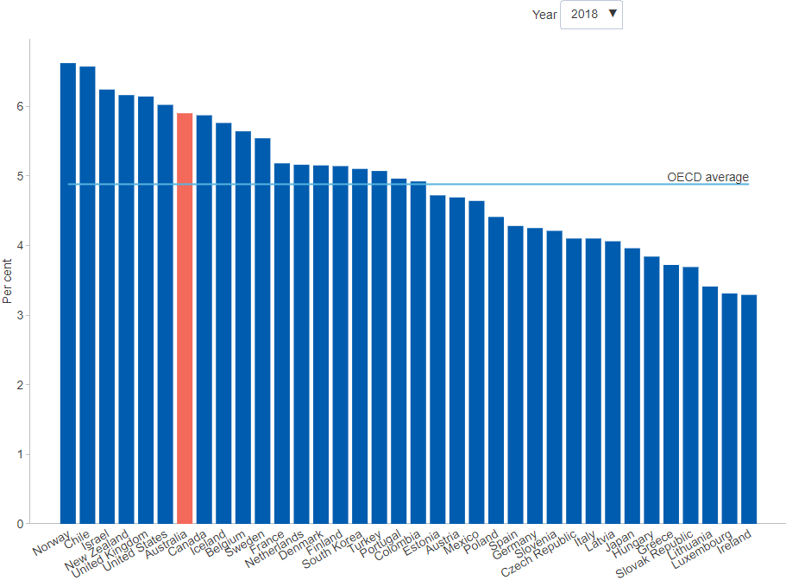

##### 

### 5.4.2 Expenditure on tertiary education institutions as a share of GDP

Higher education provides substantial economic and social benefits. *Australia*'s expenditure on tertiary education institutions relative to GDP is the 6th highest in the OECD, having increased from 1.5 per cent in 2005–06 to 1.9 per cent in 2018–19. R&D activities, which are primarily performed by tertiary education institutions account for 0.7 per cent of GDP in Australia.[160] According to a recent study, education related exports made up 5.7 per cent of Australia's total exports in 2014–15, representing the largest service export and the third largest export category overall with higher education representing roughly two thirds of this. The study estimated the value that university education adds to Australia's productive capacity at $140 billion in GDP in 2014, lifting GDP by around 8.5 per cent. Beyond the economic benefits to labour force outcomes, higher education has been found in other studies to be positively associated with improved health outcomes, quality of life and a range of other social wellbeing measures.[161]

#### Figure 5.4.2: Expenditure on tertiary education institutions, share of GDP, OECD countries, per cent, latest 2018

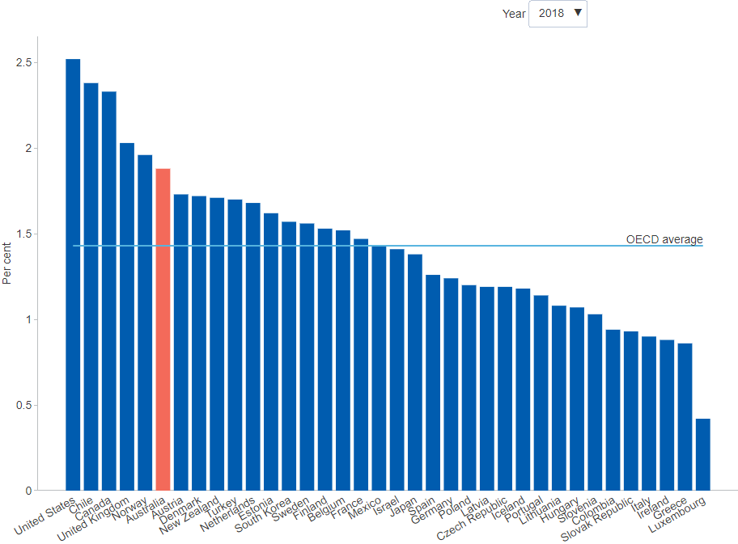

##### 

### 5.4.3 Adults attaining a tertiary qualification

Tertiary qualifications deliver multiple private and public benefits. According to one recent study, disciplines such as health, education, engineering and business tend to have the largest significant positive wage premiums, and around 55 per cent of the benefits associated with tertiary qualifications were estimated to be public.[162] A report for Universities Australia shows that tertiary education creates spillover benefits for jobs, wages and employment growth. A percentage point increase in the share of workers with tertiary education in a city is associated with a 1.1 per cent increase in wages and 120 new jobs per 1,000 university graduates entering the workforce.[163] The overall share of Australians (aged 25 to 64) with tertiary qualifications is the 9th highest in the OECD, having increased substantially by 11.7 percentage points since 2010–11 to 49.3 per cent in 2020–21. This is well above the *OECD average* of 39.4 per cent in 2020.[164]

#### Figure 5.4.3: Adults attaining a tertiary education, share of working-age adults, OECD countries, per cent, latest 2020

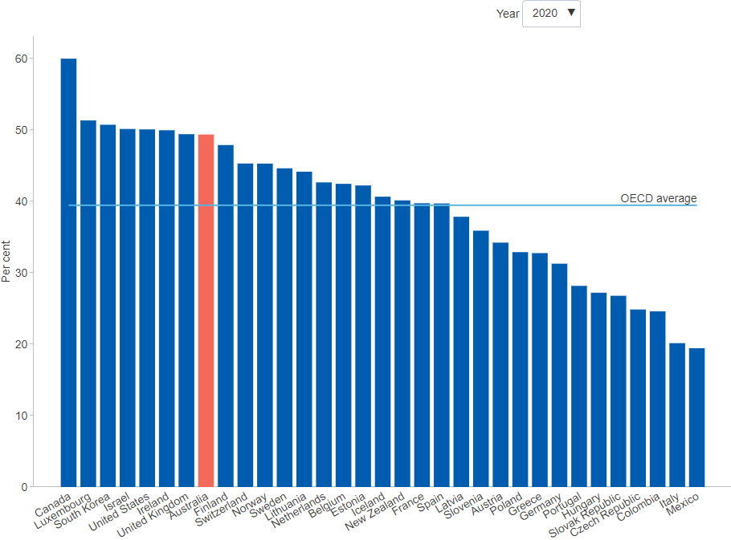

##### 

### 5.4.4 Adults attaining a vocational qualification

Vocational education and training (VET) has important economic benefits that tend to be stronger in certain technological contexts. A recent cross-country study compared the effect on labour productivity of different VET systems using data from six EU member countries. It found multiple patterns of skill complementarity — especially in production-oriented sectors, in the presence of ICTs and in countries with apprenticeship-based VET systems. The complementarity between different skill types was weaker in service-oriented sectors and generally absent for countries with classroom-based VET systems.[165] *Australia* is primarily a service-oriented economy with a relatively modest proportion of adult population with VET qualifications in comparison with the OECD. In 2020–21, 19.4 per cent of Australians (aged 25 to 64 years) had VET qualifications, which is a slight decrease from 21.1 per cent in 2015–16.[166] It is estimated that apprenticeship and traineeship opportunities will be reduced by 30 per cent in the short-term as practice-oriented learning is impacted by the COVID-19 pandemic, further reducing prospects of attaining VET qualifications. Recovery of the labour market through vocational education measures can be achieved by ensuring that programs remain relevant and accessible in the future.[167]

#### Figure 5.4.4: Adults attaining vocational education, share of working-age adults, OECD countries, per cent, latest 2020

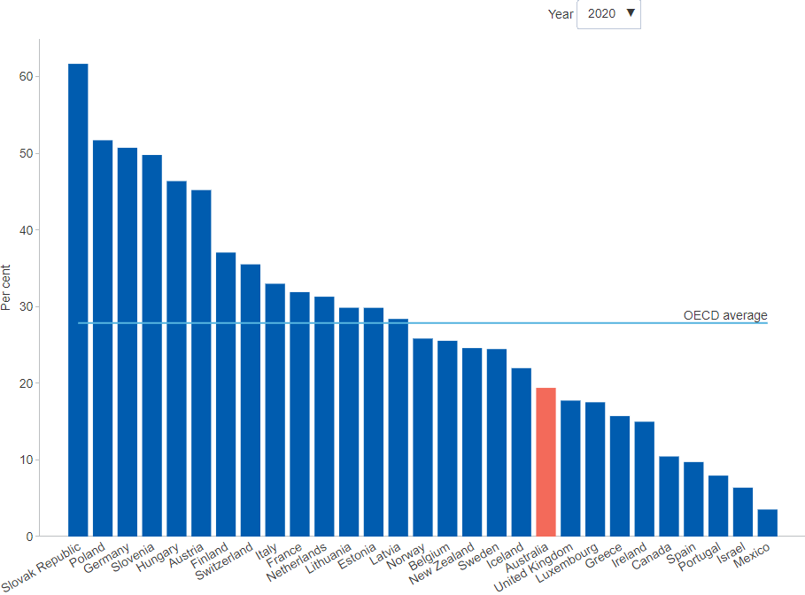

##### 

### 5.4.5 Government effectiveness

The degree of trust in government can be an important determinant of general polity effectiveness. Low levels of trust can reduce compliance with laws and regulations, diminish investor confidence, and increase risk aversion.[168] The World Bank measures the capacity of governments to effectively formulate and implement sound policies in its report on World Government Indicators. This captures perceptions of the quality of public services, the quality of the civil service and the degree of its independence from political pressures, the quality of policy formulation and implementation, and the credibility of the government's commitment to such policies.[169] The World Bank data suggests that *Australia* ranks 10th among the OECD countries on government effectiveness among OECD members - on par with Canada (9th) and New Zealand (12th) and ahead of the United Kingdom (16th) and the United States (19th). *Australia*'s performance on this measure peaked in 2004. This result would suggest that Australia's innovation environment could be supported by a greater focus on increasing government effectiveness.[170]

#### Figure 5.4.5: Worldwide governance indicators, government effectiveness, OECD countries, index points, latest 2020

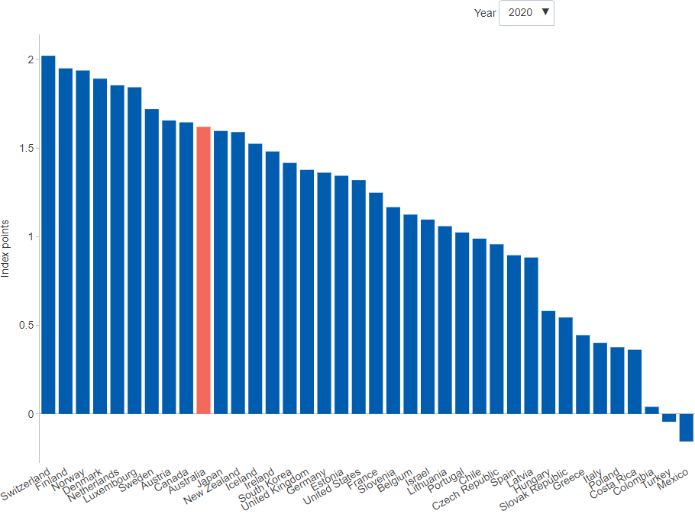

##### 

### 5.4.6 Regulatory quality

An important factor contributing to a government’s capacity to formulate and implement sound policies is the quality of its regulatory environment. The World Bank publishes an indicator that captures perceptions of the ability of governments to formulate and implement sound policies and regulations that promote private sector development. This indicator allows comparison of regulatory quality between countries.[171] World Bank data suggests that *Australia* rates well on regulatory quality, 4th among OECD countries. *Australia*'s regulatory quality has been rising since 2005. This suggests that regulatory quality is unlikely to be a major barrier to business innovation in Australia.[172] This conclusion is consistent with the ABS data showing that government regulations or compliance concerns represent only the fifth most significant barrier to innovation.[173]

#### Figure 5.4.6: Worldwide governance indicators, regulatory quality, OECD countries, index points, latest 2020

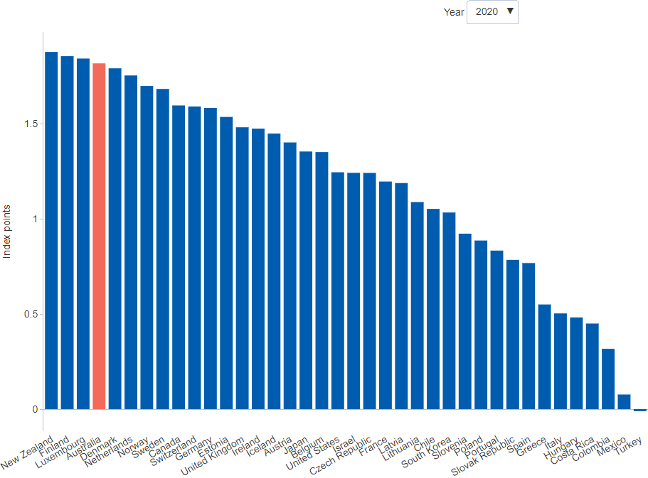

##### 

### 5.4.7 IMD World Talent Competitiveness Ranking

The IMD World Talent Competitiveness Ranking tracks an economy’s ability to grow, attract and retain talent. Talent development efforts are particularly important in transitioning to the future of work, especially with trends towards digitalisation accelerated by COVID-19. The ranking is based on countries’ performance in three main categories: Investment & Development, Appeal, and Readiness. In 2020, *Australia* ranked 12th among the OECD, its highest ranking since 2013. Australia’s performance was strongest in the *Readiness* category, based upon the skills and competencies in the talent pool.[174] While it will take some time before Australia’s net overseas skilled migration returns to pre-pandemic levels, addressing skill gaps can help reduce the impact of the pandemic on local labour markets.[175]

#### Figure 5.4.7: IMD World Talent Rankings, OECD countries, index, latest 2020

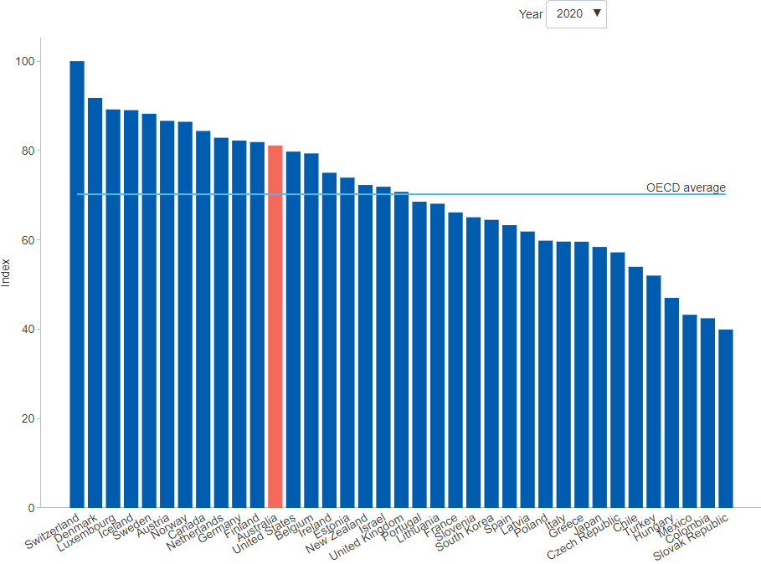

##### 

## Citations

[1]: ABS, *Business Indicators, Business Conditions and Sentiments* (<https://www.abs.gov.au/statistics/economy/business-indicators/business-conditions-and-sentiments/latest-release>)  
[2]: ABS, *Business Indicators, Business Conditions and Sentiments* (<https://www.abs.gov.au/statistics/economy/business-indicators/business-conditions-and-sentiments/latest-release>)  
[3]: ABS, *Labour Force, Australia, March 2021* (<https://www.abs.gov.au/statistics/labour/employment-and-unemployment/labour-force-australia/mar-2021>)  
[4]: ABS, *Business Indicators, Business Conditions and Sentiments* (<https://www.abs.gov.au/statistics/economy/business-indicators/business-conditions-and-sentiments/latest-release>)  
[5]: ABS, *Business Indicators, Business Conditions and Sentiments* (<https://www.abs.gov.au/statistics/economy/business-indicators/business-conditions-and-sentiments/latest-release>)  
[6]: NAB (2021) *Business Innovation Index*, April 2021 (<https://business.nab.com.au/nab-business-innovation-index-2021-45660/>)  
[7]: Department of Industry, Innovation and Science (2018) *Industry Insights: Globalising Australia*, Office of the Chief Economist report 2/2018 (<https://publications.industry.gov.au/publications/industryinsightsjune2018/documents/IndustryInsights_2_2018_ONLINE.pdf>)  
[8]: ABS, *Characteristics of Australian Business*, Cat. No. 8129.0, Cat. No. 8158.0, Cat. No. 8166.0, Cat. No. 8167.0 and ABS.Stat (<https://www.abs.gov.au/>)  
[9]: ABS, *Characteristics of Australian Business*, Cat. No. 8129.0, Cat. No. 8158.0, Cat. No. 8166.0, Cat. No. 8167.0 and ABS.Stat (<https://www.abs.gov.au/>)  
[10]: ABS, *Characteristics of Australian Business*, Cat. No. 8129.0, Cat. No. 8158.0, Cat. No. 8166.0, Cat. No. 8167.0 and ABS.Stat (<https://www.abs.gov.au/>)  
[11]: ABS, *Characteristics of Australian Business*, Cat. No. 8129.0, Cat. No. 8158.0, Cat. No. 8166.0, Cat. No. 8167.0 and ABS.Stat (<https://www.abs.gov.au/>)  
[12]: OECD and Eurostat (2018), *Oslo Manual 2018 – Guidelines for collecting, reporting and using data on innovation (4th Edition)*, OECD Publishing (<https://www.oecd-ilibrary.org/science-and-technology/oslo-manual-2018_9789264304604-en>)  
[13]: ABS, *Characteristics of Australian Business*, Cat. No. 8129.0, Cat. No. 8158.0, Cat. No. 8166.0, Cat. No. 8167.0 and ABS.Stat (<https://www.abs.gov.au/>)  
[14]: ABS, *Characteristics of Australian Business*, Cat. No. 8129.0, Cat. No. 8158.0, Cat. No. 8166.0, Cat. No. 8167.0 and ABS.Stat (<https://www.abs.gov.au/>)  
[15]: Productivity Commission (2015) *Business Set-up, Transfer and Closure*, Productivity Commission inquiry report no 75, December (<https://www.pc.gov.au/inquiries/completed/business/report>)  
[16]: ABS, *Characteristics of Australian Business*, Cat. No. 8129.0, Cat. No. 8158.0, Cat. No. 8166.0, Cat. No. 8167.0 and ABS.Stat (<https://www.abs.gov.au/>)  
[17]: ABS, *Characteristics of Australian Business*, Cat. No. 8129.0, Cat. No. 8158.0, Cat. No. 8166.0, Cat. No. 8167.0 and ABS.Stat (<https://www.abs.gov.au/>)  
[18]: ABS, *Characteristics of Australian Business*, Cat. No. 8129.0, Cat. No. 8158.0, Cat. No. 8166.0, Cat. No. 8167.0 and ABS.Stat (<https://www.abs.gov.au/>)  
[19]: OECD (2020), *E-commerce in the time of COVID-19*, OECD Publishing (<https://www.oecd.org/coronavirus/policy-responses/e-commerce-in-the-time-of-covid-19-3a2b78e8/>)  
[20]: Jadeja, Y & Modi, K (2012) *Cloud computing – concepts, architecture and challenges*, Article (<https://www.researchgate.net/publication/254035330_Cloud_computing_-_concepts_architecture_and_challenges>)  
[21]: ABS, *Characteristics of Australian Business*, Cat. No. 8129.0, Cat. No. 8158.0, Cat. No. 8166.0, Cat. No. 8167.0 and ABS.Stat (<https://www.abs.gov.au/>)  
[22]: ABS, *Characteristics of Australian Business*, Cat. No. 8129.0, Cat. No. 8158.0, Cat. No. 8166.0, Cat. No. 8167.0 and ABS.Stat (<https://www.abs.gov.au/>)  
[23]: ABS, *Characteristics of Australian Business*, Cat. No. 8129.0, Cat. No. 8158.0, Cat. No. 8166.0, Cat. No. 8167.0 and ABS.Stat (<https://www.abs.gov.au/>)  
[24]: ABS, *Characteristics of Australian Business*, Cat. No. 8129.0, Cat. No. 8158.0, Cat. No. 8166.0, Cat. No. 8167.0 and ABS.Stat (<https://www.abs.gov.au/>)  
[25]: ABS, *Characteristics of Australian Business*, Cat. No. 8129.0, Cat. No. 8158.0, Cat. No. 8166.0, Cat. No. 8167.0 and ABS.Stat (<https://www.abs.gov.au/>)  
[26]: ABS, *Characteristics of Australian Business*, Cat. No. 8129.0, Cat. No. 8158.0, Cat. No. 8166.0, Cat. No. 8167.0 and ABS.Stat (<https://www.abs.gov.au/>)  
[27]: ABS, *Australian System of National Accounts*, Cat. No. 5204.0 (<https://www.abs.gov.au/statistics/economy/national-accounts/australian-system-national-accounts/latest-release>)  
[28]: ABS, *Characteristics of Australian Business*, Cat. No. 8129.0, Cat. No. 8158.0, Cat. No. 8166.0, Cat. No. 8167.0 and ABS.Stat (<https://www.abs.gov.au/>)  
[29]: ABS, *Characteristics of Australian Business*, Cat. No. 8129.0, Cat. No. 8158.0, Cat. No. 8166.0, Cat. No. 8167.0 and ABS.Stat (<https://www.abs.gov.au/>)  
[30]: Department of Industry, Innovation and Science (2016) *Australian Innovation System Report 2016*, Office of the Chief Economist (<https://www.industry.gov.au/data-and-publications/australian-innovation-system-report/australian-innovation-system-report-2016>)  
[31]: Customised ABS data commissioned by the Department of Industry, Innovation and Science (<https://www.abs.gov.au/websitedbs/D3310114.nsf/Home/2016%20Customised%20Data%20Services>)  
[32]: Cornell University, INSEAD, and WIPO (2021) *Global Innovation Index 2021: Tracking Innovation through the COVID-19 Crisis* (<https://www.globalinnovationindex.org/analysis-indicator>)  
[33]: Cornell University, INSEAD, and WIPO (2021) *Global Innovation Index 2021: Tracking Innovation through the COVID-19 Crisis* (<https://www.globalinnovationindex.org/analysis-indicator>)  
[34]: Cornell University, INSEAD, and WIPO (2021) *Global Innovation Index 2021: Tracking Innovation through the COVID-19 Crisis* (<https://www.globalinnovationindex.org/analysis-indicator>)  
[35]: ABS, *Research and Experimental Development, Businesses, Australia*, Cat. No. 8104.0 (<https://www.abs.gov.au/ausstats/abs@.nsf/mf/8104.0>)  
[36]: OECD (2019) *Innovation indicators*, OECD Publishing (<http://www.oecd.org/innovation/inno/inno-stats.htm>)  
[37]: IMD International (2021) *IMD World Competitiveness Online*, International Institute for Management Development (<https://worldcompetitiveness.imd.org/>)  
[38]: CEDA (2021) *World Competitiveness Yearbook 2021*, Committee for Economic Development of Australia (<https://www.ceda.com.au/ResearchAndPolicies/Research/International-affairs/World-Competitiveness-Yearbook-2021>)  
[39]: IMD International (2021) *World Digital Competitiveness Rankings*, International Institute for Management Development (<https://www.imd.org/centers/world-competitiveness-center/rankings/world-digital-competitiveness/>)  
[40]: CEDA (2021) *World Competitiveness Yearbook 2021*, Committee for Economic Development of Australia (<https://www.ceda.com.au/ResearchAndPolicies/Research/International-affairs/World-Competitiveness-Yearbook-2021>)  
[41]: Bakhtiari S (2017) *Entrepreneurship Dynamics in Australia: Lessons from Micro-data*, Department of Industry, Innovation and Science, Office of the Chief Economist research paper 4/2015 (<https://www.industry.gov.au/sites/default/files/May%202018/document/pdf/entrepreneurship_dynamics_in_australia_-_lessons_from_micro-data.pdf>)  
[42]: Hendrickson L, Bucifal S, Balaguer A and Hansell D (2015) *The employment dynamics of Australian entrepreneurship*, Department of Industry, Innovation and Science & Australian Bureau of Statistics, Office of the Chief Economist research paper 4/2015 (<https://www.industry.gov.au/sites/default/files/June%202018/document/pdf/the_employment_dynamics_of_australian_entrepreneurship.pdf>)  
[43]: Alinejad M, Balaguer A and Hendrickson L (2015) *Financing innovative entrepreneurship*, Department of Industry, Innovation and Science, Office of the Chief Economist research paper 8/2015 (<https://www.industry.gov.au/sites/default/files/June%202018/document/pdf/financing_innovative_entrepreneurship.pdf>)  
[44]: ABS, *Counts of Australian Businesses, including Entries and Exits*, Cat. No. 8165.0 (<https://www.abs.gov.au/statistics/economy/business-indicators/counts-australian-businesses-including-entries-and-exits/latest-release>)  
[45]: Productivity Commission (2021) *PC Productivity Insights: Recent developments* (<https://www.pc.gov.au/research/ongoing/productivity-insights/recent-developments-2021>)  
[46]: ABS, *Counts of Australian Businesses, including Entries and Exits*, Cat. No. 8165.0 (<https://www.abs.gov.au/statistics/economy/business-indicators/counts-australian-businesses-including-entries-and-exits/latest-release>)  
[47]: ABS, *Counts of Australian Businesses, including Entries and Exits*, Cat. No. 8165.0 (<https://www.abs.gov.au/statistics/economy/business-indicators/counts-australian-businesses-including-entries-and-exits/latest-release>)  
[48]: Economics Innovation Group, *Dynamism in Retreat: Consequences for Regions, Markets and Workers*, February 2017 (<https://eig.org/wp-content/uploads/2017/07/Dynamism-in-Retreat-A.pdf>)  
[49]: ABS, *Counts of Australian Businesses, including Entries and Exits*, Cat. No. 8165.0 (<https://www.abs.gov.au/statistics/economy/business-indicators/counts-australian-businesses-including-entries-and-exits/latest-release>)  
[50]: IBISWorld, *Taxi and Limousine Transport in Australia*, Industry Performance (<https://my.ibisworld.com/au/en/industry/i4626/industry-performance>)  
[51]: IBISWorld, *Removalists in Australia*, Industry Performance (<https://my.ibisworld.com/au/en/industry/i4611/industry-performance>)  
[52]: Alinejad M, Balaguer A and Hendrickson L (2015) *Financing innovative entrepreneurship*, Department of Industry, Innovation and Science, Office of the Chief Economist research paper 8/2015 (<https://www.industry.gov.au/sites/default/files/June%202018/document/pdf/financing_innovative_entrepreneurship.pdf>)  
[53]: ABS, *Venture Capital and Later Stage Private Equity*, Australia, Cat. No. 5678.0 (<https://www.abs.gov.au/statistics/economy/finance/venture-capital-and-later-stage-private-equity-australia/latest-release>)  
[54]: ABS, *Characteristics of Australian Business*, Cat. No. 8129.0, Cat. No. 8158.0, Cat. No. 8166.0, Cat. No. 8167.0 and ABS.Stat (<https://www.abs.gov.au/ausstats/abs@.nsf/mf/8158.0>)  
[55]: Australian Government (2018) *Venture Capital*, Department of Industry, Innovation and Science (<https://www.business.gov.au/Grants-and-Programs/Venture-Capital>)  
[56]: ABS, *Venture Capital and Later Stage Private Equity*, Australia, Cat. No. 5678.0 (<https://www.abs.gov.au/statistics/economy/finance/venture-capital-and-later-stage-private-equity-australia/latest-release>)  
[57]: Department of Industry, Innovation and Science (2017) *Australian Innovation System Report 2017*, Office of the Chief Economist (<https://publications.industry.gov.au/publications/australianinnovationsystemreport2017/index.html>)  
[58]: OECD (2017) *Entrepreneurship at a Glance 2017*, OECD Publishing (<https://www.oecd-ilibrary.org/industry-and-services/entrepreneurship-at-a-glance_22266941>)  
[59]: Customised ABS data commissioned by the Department of Industry, Innovation and Science (<https://www.abs.gov.au/websitedbs/D3310114.nsf/Home/2016%20Customised%20Data%20Services>)  
[60]: Department of Industry, Innovation and Science (2017) *Australian Innovation System Report 2017*, Office of the Chief Economist (<https://publications.industry.gov.au/publications/australianinnovationsystemreport2017/index.html>)  
[61]: Customised ABS data commissioned by the Department of Industry, Innovation and Science (<https://www.abs.gov.au/websitedbs/D3310114.nsf/Home/2016%20Customised%20Data%20Services>)  
[62]: ABS, *Counts of Australian Businesses, including Entries and Exits*, Cat. No. 8165.0 (<https://www.abs.gov.au/statistics/economy/business-indicators/counts-australian-businesses-including-entries-and-exits/latest-release>)  
[63]: Audretsch D B (2012) *Determinants of High-Growth Entrepreneurship*, OECD and Danish Business Authority (<https://www.oecd.org/cfe/leed/Audretsch_determinants%20of%20high-growth%20firms.pdf>)  
[64]: ABS, *Counts of Australian Businesses, including Entries and Exits*, Cat. No. 8165.0 (<https://www.abs.gov.au/statistics/economy/business-indicators/counts-australian-businesses-including-entries-and-exits/latest-release>)  
[65]: Audretsch D B (2012) *Determinants of High-Growth Entrepreneurship*, OECD and Danish Business Authority (<https://www.oecd.org/cfe/leed/Audretsch_determinants%20of%20high-growth%20firms.pdf>)  
[66]: GEM Consortium (2020) *Global Entrepreneurship Monitor 2019/20 Global Report*, Global Entrepreneurship Research Association (<https://www.gemconsortium.org/report>)  
[67]: GEM Consortium (2020) *Global Entrepreneurship Monitor 2019/20 Global Report*, Global Entrepreneurship Research Association (<https://www.gemconsortium.org/report>)  
[68]: Renando C and Moyle C (2021) *Global Entrepreneurship Monitor 2019: Australia Report*, The Australian Centre for Entrepreneurship Research, QUT (<https://eprints.qut.edu.au/211612/>)  
[69]: GEM Consortium (2020) *Global Entrepreneurship Monitor 2019/20 Global Report*, Global Entrepreneurship Research Association (<https://www.gemconsortium.org/report>)  
[70]: Entrepreneurship, Commercialisation and Innovation Centre (2019) *Global Entrepreneurship Monitor 2017/18 Australian National Report*, The University of Adelaide (<https://eprints.qut.edu.au/127058/1/GEM%20AUS%20Report%20CLIENT%20corrected.pdf>)  
[71]: GEM Consortium (2020) *Global Entrepreneurship Monitor 2019/20 Global Report*, Global Entrepreneurship Research Association (<https://www.gemconsortium.org/report>)  
[72]: Renando C and Moyle C (2021) *Global Entrepreneurship Monitor 2019: Australia Report*, The Australian Centre for Entrepreneurship Research, QUT (<https://eprints.qut.edu.au/211612/>)  
[73]: Department of Industry, Innovation and Science (2018) *Co-hosting the Square Kilometre Array*, Project (<https://www.industry.gov.au/policies-and-initiatives/co-hosting-the-square-kilometre-array>)  
[74]: Balaguer A, Talgaswatta T, Palangkaraya A and Webster B (2018) *Evidence of R&D spillovers in Australian business*, Department of Industry, Innovation and Science and Swinburne University Centre for Transformative Innovation (forthcoming) (<https://www.industry.gov.au/data-and-publications/staff-research-papers>)  
[75]: Department of Industry, Innovation and Science (2016) *Australian Innovation System Report 2016*, Office of the Chief Economist (<https://www.industry.gov.au/data-and-publications/australian-innovation-system-report/australian-innovation-system-report-2016>)  
[76]: Bakhtiari S and Breunig R (2017) *The role of spillovers in research and development expenditure in Australian industries*, Department of Industry, Innovation and Science, Office of the Chief Economist research paper 2/2017 (<https://www.industry.gov.au/data-and-publications/staff-research-papers/the-role-of-spillovers-in-research-and-development-expenditure-in-australian-industries>)  
[77]: Department of Industry, Innovation and Science (2016) *Australian Innovation System Report 2016*, Office of the Chief Economist (<https://www.industry.gov.au/data-and-publications/australian-innovation-system-report/australian-innovation-system-report-2016>)  
[78]: ABS, *Research and Experimental Development, Businesses, Australia*, Cat. No. 8104.0 (<https://www.abs.gov.au/statistics/industry/technology-and-innovation/research-and-experimental-development-businesses-australia/latest-release>)  
[79]: ABS, *Research and Experimental Development, Businesses, Australia*, Cat. No. 8104.0 (<https://www.abs.gov.au/statistics/industry/technology-and-innovation/research-and-experimental-development-businesses-australia/latest-release>)  
[80]: ABS, *Research and Experimental Development, Businesses, Australia*, Cat. No. 8104.0 (<https://www.abs.gov.au/statistics/industry/technology-and-innovation/research-and-experimental-development-businesses-australia/latest-release>)  
[81]: Elnasri A and Fox K J (2014) *The Contribution of Research and Innovation to Productivity and Economic Growth*, UNSW Australian School of Business research paper No. 2014–08 (<https://www.business.unsw.edu.au/About-Site/Schools-Site/Economics-Site/Documents/The_Contribution_of_Research_and_Innovation_to_Productivity_Kevin_Fox.pdf>)  
[82]: ABS, *Research and Experimental Development, Government and Private Non-Profit Organisations, Australia*, Cat. No. 8109.0 (<https://www.abs.gov.au/statistics/industry/technology-and-innovation/research-and-experimental-development-government-and-private-non-profit-organisations-australia/latest-release>)  
[83]: ABS, *Research and Experimental Development, Government and Private Non-Profit Organisations, Australia*, Cat. No. 8109.0 (<https://www.abs.gov.au/statistics/industry/technology-and-innovation/research-and-experimental-development-government-and-private-non-profit-organisations-australia/latest-release>)  
[84]: ABS, *Research and Experimental Development, Government and Private Non-Profit Organisations, Australia*, Cat. No. 8109.0 (<https://www.abs.gov.au/statistics/industry/technology-and-innovation/research-and-experimental-development-government-and-private-non-profit-organisations-australia/latest-release>)  
[85]: Elnasri A and Fox K J (2014) *The Contribution of Research and Innovation to Productivity and Economic Growth*, UNSW Australian School of Business research paper No. 2014–08 (<https://www.business.unsw.edu.au/About-Site/Schools-Site/Economics-Site/Documents/The_Contribution_of_Research_and_Innovation_to_Productivity_Kevin_Fox.pdf>)  
[86]: Department of Industry, Innovation and Science, *Science Research and Innovation (SRI) Budget Tables* (<https://www.industry.gov.au/data-and-publications/science-research-and-innovation-sri-budget-tables>)  
[87]: Department of Industry, Innovation and Science, *Science Research and Innovation (SRI) Budget Tables* (<https://www.industry.gov.au/data-and-publications/science-research-and-innovation-sri-budget-tables>)  
[88]: Department of Industry, Innovation and Science, *Science Research and Innovation (SRI) Budget Tables* (<https://www.industry.gov.au/data-and-publications/science-research-and-innovation-sri-budget-tables>)  
[89]: OECD (2015) *Frascati Manual 2015: Guidelines for Collecting and Reporting Data on Research and Experimental Development*, OECD Publishing (<http://www.oecd.org/publications/frascati-manual-2015-9789264239012-en.htm>)  
[90]: OECD (2021) *Main Science and Technology Indicators*, September 2021, OECD Publishing (<http://www.oecd.org/sti/msti.htm>)  
[91]: ABS (2019) *Research and Experimental Development, Businesses, Australia, 2017–18*, Cat. No. 8104.0 (<https://www.abs.gov.au/ausstats/abs@.nsf/mf/8104.0/>)  
[92]: OECD (2015) *Frascati Manual 2015: Guidelines for Collecting and Reporting Data on Research and Experimental Development*, OECD Publishing (<http://www.oecd.org/publications/frascati-manual-2015-9789264239012-en.htm>)  
[93]: ABS, *Research and Experimental Development, Higher Education Organisations, Australia*, Cat. No. 8111.0 (<https://www.abs.gov.au/statistics/industry/technology-and-innovation/research-and-experimental-development-higher-education-organisations-australia/latest-release>)  
[94]: ABS, *Research and Experimental Development, Higher Education Organisations, Australia*, Cat. No. 8111.0 (<https://www.abs.gov.au/statistics/industry/technology-and-innovation/research-and-experimental-development-higher-education-organisations-australia/latest-release>)  
[95]: ABS, *Research and Experimental Development, Higher Education Organisations, Australia*, Cat. No. 8111.0 (<https://www.abs.gov.au/statistics/industry/technology-and-innovation/research-and-experimental-development-higher-education-organisations-australia/latest-release>)  
[96]: World Bank (2021) *World Development Indicators*, The World Bank Group (<http://datatopics.worldbank.org/world-development-indicators/>)  
[97]: Clarivate Analytics (2021) *IncitesTM*, Web of Science Group (<https://clarivate.com/webofsciencegroup/solutions/incites/>)  
[98]: Clarivate Analytics (2021) *IncitesTM*, Web of Science Group (<https://clarivate.com/webofsciencegroup/solutions/incites/>)  
[99]: Clarivate Analytics (2021) *IncitesTM*, Web of Science Group (<https://clarivate.com/webofsciencegroup/solutions/incites/>)  
[100]: Clarivate Analytics (2021) *IncitesTM*, Web of Science Group (<https://clarivate.com/webofsciencegroup/solutions/incites/>)  
[101]: ABS, *Research and Experimental Development, Businesses, Australia*, Cat. No. 8104.0 (<https://www.abs.gov.au/ausstats/abs@.nsf/mf/8104.0>)  
[102]: OECD (2021) *Main Science and Technology Indicators*, September 2021, OECD Publishing (<http://www.oecd.org/sti/msti.htm>)  
[103]: OECD (2021) *Main Science and Technology Indicators*, September 2021, OECD Publishing (<http://www.oecd.org/sti/msti.htm>)  
[104]: ABS, *Research and Experimental Development, Businesses, Australia*, Cat. No. 8104.0 (<https://www.abs.gov.au/ausstats/abs@.nsf/mf/8104.0>)  
[105]: OECD (2021) *Main Science and Technology Indicators*, September 2021, OECD Publishing (<http://www.oecd.org/sti/msti.htm>)  
[106]: OECD (2017) *OECD Science, Technology and Industry Scoreboard 2017: The digital transformation*, OECD Publishing (<https://www.oecd-ilibrary.org/science-and-technology/oecd-science-technology-and-industry-scoreboard-2017_9789264268821-en>)  
[107]: Department of Industry, Innovation and Science (2017) *Business Research Collaboration Discovery Report: User Centred Design*, BizLab report (<https://www.industry.gov.au/data-and-publications/business-research-collaboration-user-centred-design-project>)  
[108]: OECD (2018) *OECD Science, Technology and Innovation Outlook 2018: Adapting to Technological and Societal Disruption*, OECD Publishing (<http://www.oecd.org/sti/oecd-science-technology-and-innovation-outlook-25186167.htm>)  
[109]: ABS, *Characteristics of Australian Business*, Cat. No. 8129.0, Cat. No. 8158.0, Cat. No. 8166.0, Cat. No. 8167.0 and ABS.Stat (<https://www.abs.gov.au/>)  
[110]: ABS, *Characteristics of Australian Business*, Cat. No. 8129.0, Cat. No. 8158.0, Cat. No. 8166.0, Cat. No. 8167.0 and ABS.Stat (<https://www.abs.gov.au/>)  
[111]: ABS, *Characteristics of Australian Business*, Cat. No. 8129.0, Cat. No. 8158.0, Cat. No. 8166.0, Cat. No. 8167.0 and ABS.Stat (<https://www.abs.gov.au/>)  
[112]: European Patent Office (2020) *PATSTAT 2020: Autumn edition* (<https://www.epo.org/searching-for-patents/business/patstat.html>)  
[113]: IP Australia (2018) *IP Report 2018: Collaborative research grants lead to better IP outcomes* (<https://www.ipaustralia.gov.au/ip-report-2018/research-grants>)  
[114]: Department of Industry, Innovation and Science (2019) *National Survey of Research Commercialisation* (<https://www.industry.gov.au/data-and-publications/national-survey-of-research-commercialisation>)  
[115]: Department of Industry, Innovation and Science (2019) *National Survey of Research Commercialisation* (<https://www.industry.gov.au/data-and-publications/national-survey-of-research-commercialisation>)  
[116]: Department of Industry, Innovation and Science (2019) *National Survey of Research Commercialisation* (<https://www.industry.gov.au/data-and-publications/national-survey-of-research-commercialisation>)  
[117]: Department of Industry, Innovation and Science (2019) *National Survey of Research Commercialisation* (<https://www.industry.gov.au/data-and-publications/national-survey-of-research-commercialisation>)  
[118]: ABS, *Research and Experimental Development, Businesses, Australia*, Cat. No. 8104.0 (<https://www.abs.gov.au/statistics/industry/technology-and-innovation/research-and-experimental-development-businesses-australia/latest-release>)  
[119]: ABS, *Research and Experimental Development, Government and Private Non-Profit Organisations, Australia*, Cat. No. 8109.0 (<https://www.abs.gov.au/statistics/industry/technology-and-innovation/research-and-experimental-development-government-and-private-non-profit-organisations-australia/latest-release>)  
[120]: ABS, *Research and Experimental Development, Higher Education Organisations, Australia*, Cat. No. 8111.0 (<https://www.abs.gov.au/statistics/industry/technology-and-innovation/research-and-experimental-development-higher-education-organisations-australia/latest-release>)  
[121]: ABS (2020), *Australian Demographic Statistics, Dec 2019*, Cat. No. 3101.0 (<https://www.abs.gov.au/statistics/people/population/national-state-and-territory-population/latest-release>)  
[122]: ABS, *Characteristics of Australian Business*, Cat. No. 8129.0, Cat. No. 8158.0, Cat. No. 8166.0, Cat. No. 8167.0 and ABS.Stat (<https://www.abs.gov.au/>)  
[123]: OECD (2019) *Innovation indicators*, OECD Publishing (<http://www.oecd.org/innovation/inno/inno-stats.htm>)  
[124]: ABS, *Characteristics of Australian Business*, Cat. No. 8129.0, Cat. No. 8158.0, Cat. No. 8166.0, Cat. No. 8167.0 and ABS.Stat (<https://www.abs.gov.au/>)  
[125]: Georghiou L, Edler J, Uyarra E and Yeow J (2014) *Policy instruments for public procurement of innovation: Choice, design and assessment*, Technological Forecasting and Social Change, Volume 86, July 2014, Pages 1–12 (<https://www.sciencedirect.com/science/article/pii/S0040162513002552>)  
[126]: OECD (2017) *Innovation indicators*, OECD Publishing (<http://www.oecd.org/innovation/inno/inno-stats.htm>)  
[127]: OECD (2017) *OECD Science, Technology and Industry Scoreboard 2017: The digital transformation*, OECD Publishing (<https://www.oecd-ilibrary.org/science-and-technology/oecd-science-technology-and-industry-scoreboard-2017_9789264268821-en>)  
[128]: OECD (2021) *Main Science and Technology Indicators*, September 2021, OECD Publishing (<http://www.oecd.org/sti/msti.htm>)  
[129]: OECD (2019) *Innovation indicators*, OECD Publishing (<http://www.oecd.org/innovation/inno/inno-stats.htm>)  
[130]: OECD (2019) *Innovation indicators*, OECD Publishing (<http://www.oecd.org/innovation/inno/inno-stats.htm>)  
[131]: Clarivate Analytics (2018) *Incites*, Web of Science Group (<https://clarivate.com/webofsciencegroup/solutions/incites/>)  
[132]: ABS, *Characteristics of Australian Business*, Cat. No. 8129.0, Cat. No. 8158.0, Cat. No. 8166.0, Cat. No. 8167.0 and ABS.Stat (<https://www.abs.gov.au>)  
[133]: Bucifal S and Bulic F (2016) *Updating investment estimates for Australia’s organisational capital*, Department of Industry, Innovation and Science, Office of the Chief Economist research paper 2/2016 (<https://www.industry.gov.au/sites/default/files/May%202018/document/pdf/updating_investment_estimates_for_australias_organisational_capital.pdf>)  
[134]: Edmonds D and Bradley T (2016) *Mechanical boon: will automation advance Australia?*, Department of Industry, Innovation and Science; Office of the Chief Economist research paper 7/2015 (<https://www.industry.gov.au/sites/default/files/June%202018/document/pdf/mechanical-boon_-_will_automation_advance_australia.pdf>)  
[135]: Moran I, Balaguer A, Majeed O, Agarwal R, Bajada C and Brown P J (2018) *Strategic management in Australian firms*, Department of Industry, Innovation and Science, Office of the Chief Economist working paper (<https://www.industry.gov.au/sites/default/files/2018-12/oce-strategic-management-in-australian-firms.pdf>)  
[136]: ABS, *Education and Work, Australia*, Cat. No. 6227.0 (<https://www.abs.gov.au/statistics/people/education/education-and-work-australia/latest-release>)  
[137]: ABS, *Education and Work, Australia*, Cat. No. 6227.0 (<https://www.abs.gov.au/statistics/people/education/education-and-work-australia/latest-release>)  
[138]: NCVER VOCSTATS - National VET Provider Collection, extracted on 23/08/2021 (<https://www.ncver.edu.au/research-and-statistics/collections/students-and-courses-collection>)  
[139]: NCVER VOCSTATS – National Apprentice and Trainee Collection, extracted on 08/07/2021 (<https://www.ncver.edu.au/research-and-statistics/collections/apprentices-and-trainees-collection>)  
[140]: NCVER VOCSTATS – National Apprentice and Trainee Collection, extracted on 08/07/2021 (<https://www.ncver.edu.au/research-and-statistics/collections/apprentices-and-trainees-collection>)  
[141]: OECD (2021) *Main Science and Technology Indicators*, September 2021, OECD Publishing (<http://www.oecd.org/sti/msti.htm>)  
[142]: OECD (2017) OECD Science, *Technology and Industry Scoreboard 2017: The digital transformation*, OECD Publishing (<https://www.oecd-ilibrary.org/science-and-technology/oecd-science-technology-and-industry-scoreboard-2017_9789264268821-en>)  
[143]: Tuhin R (2016) *Modelling the relationship between innovation and exporting: Evidence from Australian SMEs*, Department of Industry, Innovation and Science, Office of the Chief Economist research paper 3/2016 (<https://www.industry.gov.au/sites/default/files/May%202018/document/pdf/modelling_the_relationship_between_innovation_and_exporting_-_evidence_from_australian_smes.pdf>)  
[144]: Tuhin R and Swanepoel J A (2017) *Export behaviour and business performance: Evidence from Australian microdata*, Department of Industry, Innovation and Science, Office of the Chief Economist research paper 3/2016 (<https://www.industry.gov.au/sites/default/files/June%202018/document/pdf/export_behaviour_and_business_performance_-_evidence_from_australian_microdata_research.pdf>)  
[145]: OECD (2019) *Innovation indicators*, OECD Publishing (<http://www.oecd.org/innovation/inno/inno-stats.htm>)  
[146]: Department of Industry, Innovation and Science (2014) *Australian Innovation System Report 2014*, Office of the Chief Economist (<https://www.industry.gov.au/sites/default/files/May%202018/document/pdf/australian_innovation_system_report_2014.pdf>)  
[147]: Department of Industry, Innovation and Science (2018) *Economic Insight: Australia’s low complexity – should we be concerned?*, Office of the Chief Economist research paper 2/2016 (<https://mailchi.mp/33fc6728e911/checking-out-a-case-study-in-automation-1165579?e=d0f51f013d>)  
[148]: ABS, *Characteristics of Australian Business*, Cat. No. 8129.0, Cat. No. 8158.0, Cat. No. 8166.0, Cat. No. 8167.0 and ABS.Stat (<https://www.abs.gov.au/>)  
[149]: Barnes P and McClure A (2009) *Investments in Intangible Assets and Australia’s Productivity Growth*, Productivity Commission staff working paper (<https://www.pc.gov.au/research/supporting/intangible-investment/intangible-investment.pdf>)  
[150]: ABS, *Australian System of National Accounts*, Cat. No. 5204.0 (<https://www.abs.gov.au/statistics/economy/national-accounts/australian-system-national-accounts/latest-release>)  
[151]: Barnes P and McClure A (2009) *Investments in Intangible Assets and Australia’s Productivity Growth*, Productivity Commission staff working paper (<https://www.pc.gov.au/research/supporting/intangible-investment/intangible-investment.pdf>)  
[152]: ABS, *Australian System of National Accounts*, Cat. No. 5204.0 (<https://www.abs.gov.au/statistics/economy/national-accounts/australian-system-national-accounts/latest-release>)  
[153]: Bucifal S and Bulic F (2016) *Updating investment estimates for Australia’s organisational capital*, Department of Industry, Innovation and Science, Office of the Chief Economist research paper 2/2016 (<https://www.industry.gov.au/sites/default/files/May%202018/document/pdf/updating_investment_estimates_for_australias_organisational_capital.pdf>)  
[154]: Minifie J (2017) *Stagnation Nation? Australian investment in a low-growth world*, Grattan Institute report (<https://www.ipaustralia.gov.au/ip-report-2020/welcome>)  
[155]: ABS, *Australian System of National Accounts*, Cat. No. 5204.0 (<https://www.abs.gov.au/statistics/economy/national-accounts/australian-system-national-accounts/latest-release>)  
[156]: IP Australia (2020) *Australian Intellectual Property Report 2020* (<https://www.ipaustralia.gov.au/ip-report-2020>)  
[157]: European Patent Office (2020) *PATSTAT 2020: Autumn edition* (<https://www.epo.org/searching-for-patents/business/patstat.html>)  
[158]: European Patent Office (2020) *PATSTAT 2020: Autumn edition* (<https://www.epo.org/searching-for-patents/business/patstat.html>)  
[159]: OECD (20210) *Education at a Glance 2021: OECD Indicators*, OECD Publishing (<http://www.oecd.org/education/education-at-a-glance/>)  
[160]: OECD (2021) *Education at a Glance 2021: OECD Indicators*, OECD Publishing (<http://www.oecd.org/education/education-at-a-glance/>)  
[161]: Deloitte Access Economics (2016) *Estimating the public and private benefits of higher education*, Report for the Department of Education, Skills and Employment (<https://www.dese.gov.au/higher-education-reviews-and-consultations/resources/estimating-public-and-private-benefits-higher-education>)  
[162]: Deloitte Access Economics (2016) *Estimating the public and private benefits of higher education*, Report for the Department of Education, Skills and Employment (<https://www.dese.gov.au/higher-education-reviews-and-consultations/resources/estimating-public-and-private-benefits-higher-education>)  
[163]: Cadence Economics (2016) *The Graduate Effect: Higher Education Spillovers to the Australian Workforce*, Report for Universities Australia (<https://www.universitiesaustralia.edu.au/wp-content/uploads/2021/01/The-graduate-effect-higher-education-spillovers-to-the-Australian-workforce.pdf>)  
[164]: OECD (2021) *Education at a Glance 2021: OECD Indicators*, OECD Publishing (<http://www.oecd.org/education/education-at-a-glance/>)  
[165]: European Centre for the Development of Vocational Training (2014) *Macroeconomic benefits of vocation education and training*, Research paper No. 40 (<https://www.cedefop.europa.eu/files/5540_en.pdf>)  
[166]: OECD (2021) *Education at a Glance 2021: OECD Indicators*, OECD Publishing (<http://www.oecd.org/education/education-at-a-glance/>)  
[167]: OECD (2021) *Implications of the COVID-19 Pandemic for Vocational Education and Training*, OECD Publishing (<https://www.oecd-ilibrary.org/education/implications-of-the-covid-19-pandemic-for-vocational-education-and-training_55afea00-en>)  
[168]: OECD (2015) *The Innovation Imperative: Contributing to Productivity, Growth and Well-Being*, OECD Publishing (<https://www.oecd-ilibrary.org/science-and-technology/the-innovation-imperative_9789264239814-en>)  
[169]: World Bank (2010) *The Worldwide Governance Indicators Methodology and Analytical Issues*, World Bank Policy Research Working Paper No. 5430 (<https://papers.ssrn.com/sol3/papers.cfm?abstract_id=1682130>)  
[170]: World Bank, *Worldwide Governance Indicators* (<https://info.worldbank.org/governance/wgi/>)  
[171]: World Bank (2010) *The Worldwide Governance Indicators Methodology and Analytical Issues*, World Bank Policy Research Working Paper No. 5430 (<https://papers.ssrn.com/sol3/papers.cfm?abstract_id=1682130>)  
[172]: World Bank, *Worldwide Governance Indicators* (<https://info.worldbank.org/governance/wgi/>)  
[173]: ABS, *Characteristics of Australian Business*, Cat. No. 8129.0, Cat. No. 8158.0, Cat. No. 8166.0, Cat. No. 8167.0 and ABS.Stat (<https://www.abs.gov.au/>)  
[174]: IMD International (2021) *World Talent Competitiveness Rankings*, International Institute for Management Development (<https://www.imd.org/centers/world-competitiveness-center/rankings/world-talent-competitiveness/>)  
[175]: OECD (2021) *Preparing for the Future of Work Across Australia*, OECD Reviews on Local Job Creation, OECD Publishing (<https://www.oecd-ilibrary.org/employment/preparing-for-the-future-of-work-across-australia_9e506cad-en>)

##### 

## Glossary

**Absorptive capacity**  
Absorptive capacity is a business’s ability to identify, acquire, transform and exploit knowledge that is external to the business. Measures such as research and development expenditure, number of researchers in the business and survey methods are used to measure absorptive capacity.

**Applied research**  
Original work undertaken primarily to acquire new knowledge with a specific application in view. It is undertaken either to determine possible uses for the findings of basic research or to determine new ways of achieving some specific and predetermined objectives.

**Business demography**  
Business demography statistics describe the characteristics and demography of the business population. A number of business populations are considered for the scope of business demography. These are the population of active enterprises, population of enterprise births, population of enterprise survivals up to five years, and population of enterprise deaths. For each of these populations, variables on number of enterprises, number of employees, and number of persons employed are reported.

**Business expenditure on R&D**  
Business expenditure on R&D (BERD) represents the component of gross expenditure on R&D (GERD) incurred by units belonging to the Business enterprise sector. It is the measure of intramural R&D expenditures within the Business enterprise sector during a specific reference period.

**Cloud computing**  
Cloud computing is a type of computing that relies on shared computing resources rather than having local servers or personal devices to support applications. The services are delivered and used over the Internet and are paid for by the cloud customer on an as-needed or pay-per-use business model.

**Collaboration**  
The Oslo Manual 2018 defines collaboration as requiring co-ordinated activity across different parties to address a jointly defined problem, with all partners contributing. It requires the explicit definition of common objectives and it may include agreement over the distribution of inputs, risks and potential benefits. Collaboration can create new knowledge, but it does not need to result in an innovation. These interactions can consist of informal contacts and information flows, or more formal collaboration on innovation projects. Collaboration relies on openness and knowledge sharing but also some level of focus and accountability on the part of the business organisations.

**Competitive advantage**  
Competitive advantage is the leverage that a business or country has over its competitors. It is an advantage over competitors gained by offering consumers greater value, either by means of lower prices or by providing greater benefits and service that justifies higher prices through differentiation. Competitive advantage can be attributed to a variety of factors including cost structure, branding, the quality of product offerings, the distribution network, intellectual property and/or customer service.

**Competitiveness**  
Ability of a firm or a nation to offer products and services that meet the quality standards of the local and world markets at prices that are competitive and provide adequate returns on the resources employed or consumed in producing them. Competitiveness is gained through a set of institutions, policies and factors that determine the level of productivity of a firm or a country.

**Creative destruction**  
The incessant product and process innovation mechanism by which new production units replace outdated ones.

**Digital innovation**  
Digital innovation, or digital transformation, is the novel use of digital technology to increase the competitiveness of businesses and contribute to society’s total productivity. It is the process of leveraging digital advancements to reimagine how business is done.

**Entrepreneurship**  
Entrepreneurship is the capacity and willingness to develop, organise and manage a new business venture along with risks in order to make a profit. Entrepreneurial spirit is characterised by innovation and risk-taking. Despite definitional differences it is generally agreed that entrepreneurship is both a driving force of and a challenge for young startups that lack funds, human capital and relevant experience.

**Experimental development**  
Systematic work, using existing knowledge gained from research or practical experience, which is directed to producing new materials, products, devices, policies, behaviours or outlooks; to installing new processes, systems and services; or to improving substantially those already produced or installed.

**Framework conditions**  
The efficacy of an innovation system often hinges upon the quality of framework conditions, namely the capacity to ensure an innovation-friendly environment. This is shaped not only by R&D but also by the interplay of factors which enable knowledge to be converted into new products, processes and organisational forms which in turn enhances economic development and growth. Framework conditions encompass the quality and reach of governance in a country, an effective banking and financial system, an honest and functioning judiciary, and working educational and health systems.

**Full-time equivalent**  
Full-time equivalent (FTE) is a measure of the total level of staff resources used by firms. The FTE of a full-time staff member is equal to 1.0. The calculation of FTE for part-time staff is based on the proportion of time worked, compared to that worked by full-time staff performing similar duties. While FTE includes full-time and part-time workers, it does not include contractors.

**Government budget allocations for R&D**  
Government budget allocations for R&D (GBARD) encompass all spending allocations met from sources of government revenue foreseen within the budget. Spending allocations by extra-budgetary government entities are only within the scope to the extent that their funds are allocated through the budgetary process. R&D financing by public corporations based on funds raised within the market and outside the budgetary process, is outside the scope of GBARD statistics.

**Government expenditure on R&D**  
Government expenditure on R&D (GovERD) represents the component of gross expenditure on R&D (GERD) incurred by units belonging to the Government sector. It is the measure of expenditures on intramural R&D within the Government sector during a specific reference period.

**Gross Domestic Product**  
Gross Domestic Product (GDP) is the total market value of goods and services produced in Australia within a given period after deducting the cost of goods and services used up in the process of production but before deducting allowances for the consumption of fixed capital. GDP, as here defined, is at market prices. It is equivalent to gross national expenditure plus exports of goods and services less imports of goods and services.

**Gross expenditure on R&D**  
Gross domestic expenditure on R&D (GERD) is total intramural expenditure on R&D performed in the national territory during a specific reference period. GERD represents the total expenditure devoted to R&D by the business, government, higher education and private non-profit sectors during a specific reference period.

**Government Expenditure in R&D**  
Government Expenditure in R&D (GovERD) represents the component of GERD incurred by units belonging to the Government sector. It is the measure of expenditures on intramural R&D within the Government sector during a specific reference period.

**Higher education expenditure on R&D**  
Higher education expenditure on R&D (HERD) represents the component of gross expenditure on R&D (GERD) incurred by units belonging to the higher education sector. It is the measure of intramural R&D expenditures within the higher education sector during a specific period.

**High-growth firms**  
High-growth firms (HGFs) are defined by OECD as those with more than 20 per cent annualised growth over a three-year period, with at least 10 employees, where growth can be measured by the number of employees or by turnover.

**Human capital**  
Human capital is defined by OECD as the knowledge, skills, competencies and attributes embodied in individuals that facilitate the creation of personal, social and economic well-being.

**Industry sector**  
Industry sector describes firms that operate in the same segment of the economy or share a similar business type. Industries have been defined in accordance with the International Standard Industrial Classification of All Economic Activities (ISIC), Rev.3. For national data, industries are defined according to the 2006 Australian and New Zealand Standard Industrial Classification (ANZSIC).

**Information and Communication Technology**  
Information and Communication Technology (ICT) is the infrastructure and components that enable modern computing. Although there is no single, universal definition of ICT, the term is generally accepted to mean all devices, networking components, applications and systems that combined allow people and organisations (i.e., businesses, non-profit agencies, governments) to interact in the digital world.

**Innovation**  
In this report innovation is defined as the implementation of a new or significantly improved product (good or service), or process, a new marketing method, or a new organisational method in business practices, workplace organisation or external relations. The latest version of Oslo Manual (Oslo Manual 2018) defined innovation as follows a new or improved product or process (or combination thereof) that differs significantly from the unit’s previous products or processes and that has been made available to potential users (product) or brought into use by the unit (process).

**Innovation activities**  
Business innovation activities include all developmental, financial and commercial activities undertaken by a firm that are intended to result in an innovation for the firm. They include

* Research and experimental development activities
* Engineering, design and other creative work activities
* Marketing and brand equity activities
* Intellectual property related activities
* Employee training activities
* Software development and database activities
* Activities related to the acquisition or lease of tangible assets
* Innovation management activities

Innovation activities can result in an innovation, be ongoing, postponed or abandoned.

**Innovation capability**  
Innovation capability is the ability of a firm to support the development of new products, services, processes and systems.

**Innovation-active business**  
An innovation-active business is one that has undertaken any innovative activity, irrespective of whether the innovation was introduced, still in development or abandoned during the reference period.

**Innovation system**  
An innovation system is defined as an open network of organisations interacting with each other and operating within framework conditions that regulate their activities and interactions. Three components of the innovation system networks innovation activities and framework conditions, collectively function to produce and diffuse innovations that have, in aggregate, economic, social and/or environmental value.

**Innovating business**  
An innovative firm is one that has implemented an innovation during the period under review.

**Intangible capital**  
Intangible capital is an asset that is not physical in nature and does not appear on the accounting balance sheet. Intangible capital includes assets such as data, software, designs, new organisational processes, management quality, R&D, patented technology, reputation (brand equity) and business-specific skills.

**Intellectual property rights**  
Clear intellectual property rights are vital for improving incentives to innovate in some industries, particularly in high-technology sectors where R&D plays a central role in innovation. Laws and regulations are part of the framework in which businesses operate. Common methods used for protection of intellectual property include Patents, Registered designs, Trademarks, and copyrights. Other methods include confidentiality agreements and trade secrecy, secrecy that is not covered by legal agreements, complexity of product design, and lead time advantage over competitors. IP rights can be licenced, optioned or assigned to third parties.

**Knowledge economy**  
The knowledge economy is a system of production and consumption that is based on intellectual capital. It is an economy in which growth is dependent on the quantity, quality, and accessibility of data and information, which can be used in various fields to generate economic value.

**Management capability**  
Management capability refers of the capacity of organisations and their managers to effectively plan, organise productive activity, lead staff, and control the actions of the organisations in order to achieve its goals.

**Marketing innovation**  
A marketing innovation is the implementation of a new marketing method involving significant changes in product design or packaging, product placement, product promotion or pricing.

**Nascent entrepreneurs**  
Nascent entrepreneurs are people who are engaged in creating new ventures by committing time and resources.

**New-to-market innovation**  
New to the market innovation includes innovations that are

* New to the world;
* New to Australia but not new to the world; and
* New to the industry within Australia, but not new to Australia or the world.

**Novelty types**  
All innovations must contain a degree of novelty. Three concepts of the degree of novelty of innovations are: new to the business, new to the market and new to the world. New to the business innovation is an innovation that has already been implemented by other businesses. A new to the market innovation is when the business is the first to introduce the innovation on its market (and market is defined as the business and its competitors and can include a geographic region or product line). A New to the world innovation is an innovation that is new to the world when the business is the first to introduce the innovation for all markets and industries, domestic and international. New to the world therefore implies a greater degree of novelty.

**Organisation for Economic Co-operation and Development**  
Organisation for Economic Co-operation and Development (OECD) is a group of countries working towards common problems of increasing economic growth, welfare and social problems. The list is comprised of Australia, Austria, Belgium, Canada, Chile, Czech Republic, Denmark, Estonia, Finland, France, Germany, Greece, Hungary, Iceland, Ireland, Israel, Italy, Japan, Korea, Latvia, Luxembourg, Mexico, Netherlands, New Zealand, Norway, Poland, Portugal, Slovak Republic, Slovenia, Spain, Sweden, Switzerland, Turkey, United Kingdom and United States.

**OECD Frascati Manual**  
The Frascati Manual provides guidelines for collecting and reporting data on Research and Experimental Development.

**OECD Oslo Manual**  
The Oslo Manual provides guidelines for collecting and interpreting innovation data.

**Organisational innovation**  
An organisational innovation is the implementation of a new organisational method in the business’s business practices, workplace organisation or external relations.

**Patent**  
A patent is a form of intellectual property which gives its owner the right to exclude others from making, using, selling, and importing an invention for a limited period of time. It can be granted for any device, substance, method or process that is new, inventive and useful. A patent is a legally enforceable right to commercially exploit the invention for the life of the patent.

**Private non-profit expenditure on R&D**  
Private non-profit expenditure on R&D (PNPERD) represents the component of GERD incurred by units belonging to the Private non-profit sector. It is the measure of intramural R&D expenditures within the Private non-profit sector during a specific reference period.

**Process innovation**  
A process innovation is the implementation of a new or significantly improved production or delivery method. This includes significant changes in techniques, equipment and/or software.

**Product innovation**  
A product innovation is the introduction of a good or service that is new or significantly improved with respect to its characteristics or intended uses. This includes significant improvements in technical specifications, components and materials, incorporated software, user-friendliness or other functional characteristics.

**Productivity**  
Productivity is the ratio of outputs to inputs. It can be measured at the level of the firm, industry or the whole economy. There are a number of ways to measure productivity. Labour productivity is where the only input being considered is labour costs. Multifactor productivity uses labour and capital costs and total factor productivity uses capital, labour, energy, material and services costs as inputs. Productivity growth occurs when growth in industry outputs exceeds growth in inputs.

**Pure basic research**  
Experimental and theoretical work undertaken to acquire new knowledge without looking for long term benefits other than the advancement of knowledge.

**Research and Development**  
Research and experimental development (R&D) comprises creative work undertaken on a systematic basis to increase the stock of knowledge, including knowledge of man, culture and society, and the use of this stock of knowledge to devise new applications. The term R&D covers three activities: basic research, applied research and experimental development. Basic research is experimental or theoretical work undertaken primarily to acquire new knowledge of the underlying foundation of phenomena and observable facts, without any particular application or use in view. Applied research is also original investigation undertaken to acquire new knowledge but directed primarily towards a specific practical aim or objective. Experimental development is systematic work, drawing on existing knowledge gained from research and/or practical experience, which is directed to producing new materials, products or devices, to installing new processes, systems and services, or to improving substantially those already produced or installed.

**R&D intensity**  
At a country level, R&D intensity is defined as R&D expenditure expressed as a percentage of GDP on a national scale, or R&D expenditure expressed as a percentage of sales at the firm level. At a firm level, R&D intensity is defined as R&D expenditure expressed as a percentage of firm turnover.

**Researchers**  
Researchers are defined as professionals engaged in the conception or creation of new knowledge, products, processes, methods and systems, as well as in the management of these projects.

**Revealed comparative advantage**  
Revealed comparative advantage (RCA) is an index calculated using exports, providing a measure of relative specialisation of a country’s export activities in an industry. The RCA is calculated as the proportion of a country’s exports in a product or industry divided by the proportion of world exports in that product or industry. If the RCA is greater than one, a comparative advantage is ‘revealed.’ If the RCA is less than one, the country has a comparative disadvantage in that industry.

**Social media**  
Social media is computer-based technology that facilitates the sharing of ideas, thoughts, and information through the building of virtual networks and communities. By design, social media is internet-based and gives users quick electronic communication of content.

**Spillovers**  
Spillovers refer to unrequited flow of benefits to third parties. In the case of knowledge-based activities like research R&D, spillovers (or externalities) are produced when the knowledge generating activities of one business enhances the knowledge and capabilities of unrelated firms, and subsequently leading the production of better or cheaper goods and services, increased sales, productivity or other benefits.

**Startup**  
Startup is the early stage in the life cycle of an enterprise, where the entrepreneur moves from the idea stage to securing financing, laying down the basis structure of the business, and initiating operations or trading.

**Strategic basic research** Experimental and theoretical work undertaken to acquire new knowledge directed into specified broad areas in the expectation of practical discoveries. It provides the broad base of knowledge necessary for the solution of recognised practical problems.

**Value added**  
The amount by which the value of an article is increased at each stage of its production, exclusive of initial costs. In national accounts, value added is often obtained by deducting intermediate consumption from gross output.

**Venture capital**  
Venture capital (VC) is defined as high-risk private equity capital for typically new, innovative or fast growing unlisted companies. A venture capital investment is usually a short to medium-term investment with the intended return often in the form of capital gains (rather than regular income streams). Early stage VC is often invested in development, testing or pilot production. At this stage the investee company may not be fully operational and may not yet be generating revenue. Expansion VC is invested at a stage when developed products are in the market and the investee company has significant revenue growth and may be approaching, or at, profitable operating levels.

**Vocational education and training**  
Vocational education and training (VET) is a form of tertiary education that provides accredited training in job related and technical skills. It covers a large number of qualifications across industry sectors.

1. ABS, *Business Indicators, Business Conditions and Sentiments* (<https://www.abs.gov.au/statistics/economy/business-indicators/business-conditions-and-sentiments/latest-release>)
2. ABS, *Business Indicators, Business Conditions and Sentiments* (<https://www.abs.gov.au/statistics/economy/business-indicators/business-conditions-and-sentiments/latest-release>)
3. ABS, *Labour Force, Australia, March 2021* (<https://www.abs.gov.au/statistics/labour/employment-and-unemployment/labour-force-australia/mar-2021>)
4. ABS, *Business Indicators, Business Conditions and Sentiments* (<https://www.abs.gov.au/statistics/economy/business-indicators/business-conditions-and-sentiments/latest-release>)
5. ABS, *Business Indicators, Business Conditions and Sentiments* (<https://www.abs.gov.au/statistics/economy/business-indicators/business-conditions-and-sentiments/latest-release>)
6. NAB (2021) *Business Innovation Index*, April 2021 (<https://business.nab.com.au/nab-business-innovation-index-2021-45660/>)
7. Department of Industry, Innovation and Science (2018) *Industry Insights: Globalising Australia*, Office of the Chief Economist report 2/2018 (<https://publications.industry.gov.au/publications/industryinsightsjune2018/documents/IndustryInsights_2_2018_ONLINE.pdf>)
8. ABS, *Characteristics of Australian Business*, Cat. No. 8129.0, Cat. No. 8158.0, Cat. No. 8166.0, Cat. No. 8167.0 and ABS.Stat (<https://www.abs.gov.au/>)
9. ABS, *Characteristics of Australian Business*, Cat. No. 8129.0, Cat. No. 8158.0, Cat. No. 8166.0, Cat. No. 8167.0 and ABS.Stat (<https://www.abs.gov.au/>)
10. ABS, *Characteristics of Australian Business*, Cat. No. 8129.0, Cat. No. 8158.0, Cat. No. 8166.0, Cat. No. 8167.0 and ABS.Stat (<https://www.abs.gov.au/>)
11. ABS, *Characteristics of Australian Business*, Cat. No. 8129.0, Cat. No. 8158.0, Cat. No. 8166.0, Cat. No. 8167.0 and ABS.Stat (<https://www.abs.gov.au/>)
12. OECD and Eurostat (2018), *Oslo Manual 2018 – Guidelines for collecting, reporting and using data on innovation (4th Edition)*, OECD Publishing (<https://www.oecd-ilibrary.org/science-and-technology/oslo-manual-2018_9789264304604-en>)
13. ABS, *Characteristics of Australian Business*, Cat. No. 8129.0, Cat. No. 8158.0, Cat. No. 8166.0, Cat. No. 8167.0 and ABS.Stat (<https://www.abs.gov.au/>)
14. ABS, *Characteristics of Australian Business*, Cat. No. 8129.0, Cat. No. 8158.0, Cat. No. 8166.0, Cat. No. 8167.0 and ABS.Stat (<https://www.abs.gov.au/>)
15. Productivity Commission (2015) *Business Set-up, Transfer and Closure*, Productivity Commission inquiry report no 75, December (<https://www.pc.gov.au/inquiries/completed/business/report>)
16. ABS, *Characteristics of Australian Business*, Cat. No. 8129.0, Cat. No. 8158.0, Cat. No. 8166.0, Cat. No. 8167.0 and ABS.Stat (<https://www.abs.gov.au/>)
17. ABS, *Characteristics of Australian Business*, Cat. No. 8129.0, Cat. No. 8158.0, Cat. No. 8166.0, Cat. No. 8167.0 and ABS.Stat (<https://www.abs.gov.au/>)
18. ABS, *Characteristics of Australian Business*, Cat. No. 8129.0, Cat. No. 8158.0, Cat. No. 8166.0, Cat. No. 8167.0 and ABS.Stat (<https://www.abs.gov.au/>)
19. OECD (2020), *E-commerce in the time of COVID-19*, OECD Publishing (<https://www.oecd.org/coronavirus/policy-responses/e-commerce-in-the-time-of-covid-19-3a2b78e8/>)
20. Jadeja, Y & Modi, K (2012) *Cloud computing – concepts, architecture and challenges*, Article (<https://www.researchgate.net/publication/254035330_Cloud_computing_-_concepts_architecture_and_challenges>)
21. ABS, *Characteristics of Australian Business*, Cat. No. 8129.0, Cat. No. 8158.0, Cat. No. 8166.0, Cat. No. 8167.0 and ABS.Stat (<https://www.abs.gov.au/>)
22. ABS, *Characteristics of Australian Business*, Cat. No. 8129.0, Cat. No. 8158.0, Cat. No. 8166.0, Cat. No. 8167.0 and ABS.Stat (<https://www.abs.gov.au/>)
23. ABS, *Characteristics of Australian Business*, Cat. No. 8129.0, Cat. No. 8158.0, Cat. No. 8166.0, Cat. No. 8167.0 and ABS.Stat (<https://www.abs.gov.au/>)
24. ABS, *Characteristics of Australian Business*, Cat. No. 8129.0, Cat. No. 8158.0, Cat. No. 8166.0, Cat. No. 8167.0 and ABS.Stat (<https://www.abs.gov.au/>)
25. ABS, *Characteristics of Australian Business*, Cat. No. 8129.0, Cat. No. 8158.0, Cat. No. 8166.0, Cat. No. 8167.0 and ABS.Stat (<https://www.abs.gov.au/>)
26. ABS, *Characteristics of Australian Business*, Cat. No. 8129.0, Cat. No. 8158.0, Cat. No. 8166.0, Cat. No. 8167.0 and ABS.Stat (<https://www.abs.gov.au/>)
27. ABS, *Australian System of National Accounts*, Cat. No. 5204.0 (<https://www.abs.gov.au/statistics/economy/national-accounts/australian-system-national-accounts/latest-release>)
28. ABS, *Characteristics of Australian Business*, Cat. No. 8129.0, Cat. No. 8158.0, Cat. No. 8166.0, Cat. No. 8167.0 and ABS.Stat (<https://www.abs.gov.au/>)
29. ABS, *Characteristics of Australian Business*, Cat. No. 8129.0, Cat. No. 8158.0, Cat. No. 8166.0, Cat. No. 8167.0 and ABS.Stat (<https://www.abs.gov.au/>)
30. Department of Industry, Innovation and Science (2016) *Australian Innovation System Report 2016*, Office of the Chief Economist (<https://www.industry.gov.au/data-and-publications/australian-innovation-system-report/australian-innovation-system-report-2016>)
31. Customised ABS data commissioned by the Department of Industry, Innovation and Science (<https://www.abs.gov.au/websitedbs/D3310114.nsf/Home/2016%20Customised%20Data%20Services>)
32. Cornell University, INSEAD, and WIPO (2021) *Global Innovation Index 2021: Tracking Innovation through the COVID-19 Crisis* (<https://www.globalinnovationindex.org/analysis-indicator>)
33. Cornell University, INSEAD, and WIPO (2021) *Global Innovation Index 2021: Tracking Innovation through the COVID-19 Crisis* (<https://www.globalinnovationindex.org/analysis-indicator>)
34. Cornell University, INSEAD, and WIPO (2021) *Global Innovation Index 2021: Tracking Innovation through the COVID-19 Crisis* (<https://www.globalinnovationindex.org/analysis-indicator>)
35. ABS, *Research and Experimental Development, Businesses, Australia*, Cat. No. 8104.0 (<https://www.abs.gov.au/ausstats/abs@.nsf/mf/8104.0>)
36. OECD (2019) *Innovation indicators*, OECD Publishing (<http://www.oecd.org/innovation/inno/inno-stats.htm>)
37. IMD International (2021) *IMD World Competitiveness Online*, International Institute for Management Development (<https://worldcompetitiveness.imd.org/>)
38. CEDA (2021) *World Competitiveness Yearbook 2021*, Committee for Economic Development of Australia (<https://www.ceda.com.au/ResearchAndPolicies/Research/International-affairs/World-Competitiveness-Yearbook-2021>)
39. IMD International (2021) *World Digital Competitiveness Rankings*, International Institute for Management Development (<https://www.imd.org/centers/world-competitiveness-center/rankings/world-digital-competitiveness/>)
40. CEDA (2021) *World Competitiveness Yearbook 2021*, Committee for Economic Development of Australia (<https://www.ceda.com.au/ResearchAndPolicies/Research/International-affairs/World-Competitiveness-Yearbook-2021>)
41. Bakhtiari S (2017) *Entrepreneurship Dynamics in Australia: Lessons from Micro-data*, Department of Industry, Innovation and Science, Office of the Chief Economist research paper 4/2015 (<https://www.industry.gov.au/sites/default/files/May%202018/document/pdf/entrepreneurship_dynamics_in_australia_-_lessons_from_micro-data.pdf>)
42. Hendrickson L, Bucifal S, Balaguer A and Hansell D (2015) *The employment dynamics of Australian entrepreneurship*, Department of Industry, Innovation and Science & Australian Bureau of Statistics, Office of the Chief Economist research paper 4/2015 (<https://www.industry.gov.au/sites/default/files/June%202018/document/pdf/the_employment_dynamics_of_australian_entrepreneurship.pdf>)
43. Alinejad M, Balaguer A and Hendrickson L (2015) *Financing innovative entrepreneurship*, Department of Industry, Innovation and Science, Office of the Chief Economist research paper 8/2015 (<https://www.industry.gov.au/sites/default/files/June%202018/document/pdf/financing_innovative_entrepreneurship.pdf>)
44. ABS, *Counts of Australian Businesses, including Entries and Exits*, Cat. No. 8165.0 (<https://www.abs.gov.au/statistics/economy/business-indicators/counts-australian-businesses-including-entries-and-exits/latest-release>)
45. Productivity Commission (2021) *PC Productivity Insights: Recent developments* (<https://www.pc.gov.au/research/ongoing/productivity-insights/recent-developments-2021>)
46. ABS, *Counts of Australian Businesses, including Entries and Exits*, Cat. No. 8165.0 (<https://www.abs.gov.au/statistics/economy/business-indicators/counts-australian-businesses-including-entries-and-exits/latest-release>)
47. ABS, *Counts of Australian Businesses, including Entries and Exits*, Cat. No. 8165.0 (<https://www.abs.gov.au/statistics/economy/business-indicators/counts-australian-businesses-including-entries-and-exits/latest-release>)
48. Economics Innovation Group, *Dynamism in Retreat: Consequences for Regions, Markets and Workers*, February 2017 (<https://eig.org/wp-content/uploads/2017/07/Dynamism-in-Retreat-A.pdf>)
49. ABS, *Counts of Australian Businesses, including Entries and Exits*, Cat. No. 8165.0 (<https://www.abs.gov.au/statistics/economy/business-indicators/counts-australian-businesses-including-entries-and-exits/latest-release>)
50. IBISWorld, *Taxi and Limousine Transport in Australia*, Industry Performance (<https://my.ibisworld.com/au/en/industry/i4626/industry-performance>)
51. IBISWorld, *Removalists in Australia*, Industry Performance (<https://my.ibisworld.com/au/en/industry/i4611/industry-performance>)
52. Alinejad M, Balaguer A and Hendrickson L (2015) *Financing innovative entrepreneurship*, Department of Industry, Innovation and Science, Office of the Chief Economist research paper 8/2015 (<https://www.industry.gov.au/sites/default/files/June%202018/document/pdf/financing_innovative_entrepreneurship.pdf>)
53. ABS, *Venture Capital and Later Stage Private Equity*, Australia, Cat. No. 5678.0 (<https://www.abs.gov.au/statistics/economy/finance/venture-capital-and-later-stage-private-equity-australia/latest-release>)
54. ABS, *Characteristics of Australian Business*, Cat. No. 8129.0, Cat. No. 8158.0, Cat. No. 8166.0, Cat. No. 8167.0 and ABS.Stat (<https://www.abs.gov.au/ausstats/abs@.nsf/mf/8158.0>)
55. Australian Government (2018) *Venture Capital*, Department of Industry, Innovation and Science (<https://www.business.gov.au/Grants-and-Programs/Venture-Capital>)
56. ABS, *Venture Capital and Later Stage Private Equity*, Australia, Cat. No. 5678.0 (<https://www.abs.gov.au/statistics/economy/finance/venture-capital-and-later-stage-private-equity-australia/latest-release>)
57. Department of Industry, Innovation and Science (2017) *Australian Innovation System Report 2017*, Office of the Chief Economist (<https://publications.industry.gov.au/publications/australianinnovationsystemreport2017/index.html>)
58. OECD (2017) *Entrepreneurship at a Glance 2017*, OECD Publishing (<https://www.oecd-ilibrary.org/industry-and-services/entrepreneurship-at-a-glance_22266941>)
59. Customised ABS data commissioned by the Department of Industry, Innovation and Science (<https://www.abs.gov.au/websitedbs/D3310114.nsf/Home/2016%20Customised%20Data%20Services>)
60. Department of Industry, Innovation and Science (2017) *Australian Innovation System Report 2017*, Office of the Chief Economist (<https://publications.industry.gov.au/publications/australianinnovationsystemreport2017/index.html>)
61. Customised ABS data commissioned by the Department of Industry, Innovation and Science (<https://www.abs.gov.au/websitedbs/D3310114.nsf/Home/2016%20Customised%20Data%20Services>)
62. ABS, *Counts of Australian Businesses, including Entries and Exits*, Cat. No. 8165.0 (<https://www.abs.gov.au/statistics/economy/business-indicators/counts-australian-businesses-including-entries-and-exits/latest-release>)
63. Audretsch D B (2012) *Determinants of High-Growth Entrepreneurship*, OECD and Danish Business Authority (<https://www.oecd.org/cfe/leed/Audretsch_determinants%20of%20high-growth%20firms.pdf>)
64. ABS, *Counts of Australian Businesses, including Entries and Exits*, Cat. No. 8165.0 (<https://www.abs.gov.au/statistics/economy/business-indicators/counts-australian-businesses-including-entries-and-exits/latest-release>)
65. Audretsch D B (2012) *Determinants of High-Growth Entrepreneurship*, OECD and Danish Business Authority (<https://www.oecd.org/cfe/leed/Audretsch_determinants%20of%20high-growth%20firms.pdf>)
66. GEM Consortium (2020) *Global Entrepreneurship Monitor 2019/20 Global Report*, Global Entrepreneurship Research Association (<https://www.gemconsortium.org/report>)
67. GEM Consortium (2020) *Global Entrepreneurship Monitor 2019/20 Global Report*, Global Entrepreneurship Research Association (<https://www.gemconsortium.org/report>)
68. Renando C and Moyle C (2021) *Global Entrepreneurship Monitor 2019: Australia Report*, The Australian Centre for Entrepreneurship Research, QUT (<https://eprints.qut.edu.au/211612/>)
69. GEM Consortium (2020) *Global Entrepreneurship Monitor 2019/20 Global Report*, Global Entrepreneurship Research Association (<https://www.gemconsortium.org/report>)
70. Entrepreneurship, Commercialisation and Innovation Centre (2019) *Global Entrepreneurship Monitor 2017/18 Australian National Report*, The University of Adelaide (<https://eprints.qut.edu.au/127058/1/GEM%20AUS%20Report%20CLIENT%20corrected.pdf>)
71. GEM Consortium (2020) *Global Entrepreneurship Monitor 2019/20 Global Report*, Global Entrepreneurship Research Association (<https://www.gemconsortium.org/report>)
72. Renando C and Moyle C (2021) *Global Entrepreneurship Monitor 2019: Australia Report*, The Australian Centre for Entrepreneurship Research, QUT (<https://eprints.qut.edu.au/211612/>)
73. Department of Industry, Innovation and Science (2018) *Co-hosting the Square Kilometre Array*, Project (<https://www.industry.gov.au/policies-and-initiatives/co-hosting-the-square-kilometre-array>)
74. Balaguer A, Talgaswatta T, Palangkaraya A and Webster B (2018) *Evidence of R&D spillovers in Australian business*, Department of Industry, Innovation and Science and Swinburne University Centre for Transformative Innovation (forthcoming) (<https://www.industry.gov.au/data-and-publications/staff-research-papers>)
75. Department of Industry, Innovation and Science (2016) *Australian Innovation System Report 2016*, Office of the Chief Economist (<https://www.industry.gov.au/data-and-publications/australian-innovation-system-report/australian-innovation-system-report-2016>)
76. Bakhtiari S and Breunig R (2017) *The role of spillovers in research and development expenditure in Australian industries*, Department of Industry, Innovation and Science, Office of the Chief Economist research paper 2/2017 (<https://www.industry.gov.au/data-and-publications/staff-research-papers/the-role-of-spillovers-in-research-and-development-expenditure-in-australian-industries>)
77. Department of Industry, Innovation and Science (2016) *Australian Innovation System Report 2016*, Office of the Chief Economist (<https://www.industry.gov.au/data-and-publications/australian-innovation-system-report/australian-innovation-system-report-2016>)
78. ABS, *Research and Experimental Development, Businesses, Australia*, Cat. No. 8104.0 (<https://www.abs.gov.au/statistics/industry/technology-and-innovation/research-and-experimental-development-businesses-australia/latest-release>)
79. ABS, *Research and Experimental Development, Businesses, Australia*, Cat. No. 8104.0 (<https://www.abs.gov.au/statistics/industry/technology-and-innovation/research-and-experimental-development-businesses-australia/latest-release>)
80. ABS, *Research and Experimental Development, Businesses, Australia*, Cat. No. 8104.0 (<https://www.abs.gov.au/statistics/industry/technology-and-innovation/research-and-experimental-development-businesses-australia/latest-release>)
81. Elnasri A and Fox K J (2014) *The Contribution of Research and Innovation to Productivity and Economic Growth*, UNSW Australian School of Business research paper No. 2014–08 (<https://www.business.unsw.edu.au/About-Site/Schools-Site/Economics-Site/Documents/The_Contribution_of_Research_and_Innovation_to_Productivity_Kevin_Fox.pdf>)
82. ABS, *Research and Experimental Development, Government and Private Non-Profit Organisations, Australia*, Cat. No. 8109.0 (<https://www.abs.gov.au/statistics/industry/technology-and-innovation/research-and-experimental-development-government-and-private-non-profit-organisations-australia/latest-release>)
83. ABS, *Research and Experimental Development, Government and Private Non-Profit Organisations, Australia*, Cat. No. 8109.0 (<https://www.abs.gov.au/statistics/industry/technology-and-innovation/research-and-experimental-development-government-and-private-non-profit-organisations-australia/latest-release>)
84. ABS, *Research and Experimental Development, Government and Private Non-Profit Organisations, Australia*, Cat. No. 8109.0 (<https://www.abs.gov.au/statistics/industry/technology-and-innovation/research-and-experimental-development-government-and-private-non-profit-organisations-australia/latest-release>)
85. Elnasri A and Fox K J (2014) *The Contribution of Research and Innovation to Productivity and Economic Growth*, UNSW Australian School of Business research paper No. 2014–08 (<https://www.business.unsw.edu.au/About-Site/Schools-Site/Economics-Site/Documents/The_Contribution_of_Research_and_Innovation_to_Productivity_Kevin_Fox.pdf>)
86. Department of Industry, Innovation and Science, *Science Research and Innovation (SRI) Budget Tables* (<https://www.industry.gov.au/data-and-publications/science-research-and-innovation-sri-budget-tables>)
87. Department of Industry, Innovation and Science, *Science Research and Innovation (SRI) Budget Tables* (<https://www.industry.gov.au/data-and-publications/science-research-and-innovation-sri-budget-tables>)
88. Department of Industry, Innovation and Science, *Science Research and Innovation (SRI) Budget Tables* (<https://www.industry.gov.au/data-and-publications/science-research-and-innovation-sri-budget-tables>)
89. OECD (2015) *Frascati Manual 2015: Guidelines for Collecting and Reporting Data on Research and Experimental Development*, OECD Publishing (<http://www.oecd.org/publications/frascati-manual-2015-9789264239012-en.htm>)
90. OECD (2021) *Main Science and Technology Indicators*, September 2021, OECD Publishing (<http://www.oecd.org/sti/msti.htm>)
91. ABS (2019) *Research and Experimental Development, Businesses, Australia, 2017–18*, Cat. No. 8104.0 (<https://www.abs.gov.au/ausstats/abs@.nsf/mf/8104.0/>)
92. OECD (2015) *Frascati Manual 2015: Guidelines for Collecting and Reporting Data on Research and Experimental Development*, OECD Publishing (<http://www.oecd.org/publications/frascati-manual-2015-9789264239012-en.htm>)
93. ABS, *Research and Experimental Development, Higher Education Organisations, Australia*, Cat. No. 8111.0 (<https://www.abs.gov.au/statistics/industry/technology-and-innovation/research-and-experimental-development-higher-education-organisations-australia/latest-release>)
94. ABS, *Research and Experimental Development, Higher Education Organisations, Australia*, Cat. No. 8111.0 (<https://www.abs.gov.au/statistics/industry/technology-and-innovation/research-and-experimental-development-higher-education-organisations-australia/latest-release>)
95. ABS, *Research and Experimental Development, Higher Education Organisations, Australia*, Cat. No. 8111.0 (<https://www.abs.gov.au/statistics/industry/technology-and-innovation/research-and-experimental-development-higher-education-organisations-australia/latest-release>)
96. World Bank (2021) *World Development Indicators*, The World Bank Group (<http://datatopics.worldbank.org/world-development-indicators/>)
97. Clarivate Analytics (2021) *IncitesTM*, Web of Science Group (<https://clarivate.com/webofsciencegroup/solutions/incites/>)
98. Clarivate Analytics (2021) *IncitesTM*, Web of Science Group (<https://clarivate.com/webofsciencegroup/solutions/incites/>)
99. Clarivate Analytics (2021) *IncitesTM*, Web of Science Group (<https://clarivate.com/webofsciencegroup/solutions/incites/>)
100. Clarivate Analytics (2021) *IncitesTM*, Web of Science Group (<https://clarivate.com/webofsciencegroup/solutions/incites/>)
101. ABS, *Research and Experimental Development, Businesses, Australia*, Cat. No. 8104.0 (<https://www.abs.gov.au/ausstats/abs@.nsf/mf/8104.0>)
102. OECD (2021) *Main Science and Technology Indicators*, September 2021, OECD Publishing (<http://www.oecd.org/sti/msti.htm>)
103. OECD (2021) *Main Science and Technology Indicators*, September 2021, OECD Publishing (<http://www.oecd.org/sti/msti.htm>)
104. ABS, *Research and Experimental Development, Businesses, Australia*, Cat. No. 8104.0 (<https://www.abs.gov.au/ausstats/abs@.nsf/mf/8104.0>)
105. OECD (2021) *Main Science and Technology Indicators*, September 2021, OECD Publishing (<http://www.oecd.org/sti/msti.htm>)
106. OECD (2017) *OECD Science, Technology and Industry Scoreboard 2017: The digital transformation*, OECD Publishing (<https://www.oecd-ilibrary.org/science-and-technology/oecd-science-technology-and-industry-scoreboard-2017_9789264268821-en>)
107. Department of Industry, Innovation and Science (2017) *Business Research Collaboration Discovery Report: User Centred Design*, BizLab report (<https://www.industry.gov.au/data-and-publications/business-research-collaboration-user-centred-design-project>)
108. OECD (2018) *OECD Science, Technology and Innovation Outlook 2018: Adapting to Technological and Societal Disruption*, OECD Publishing (<http://www.oecd.org/sti/oecd-science-technology-and-innovation-outlook-25186167.htm>)
109. ABS, *Characteristics of Australian Business*, Cat. No. 8129.0, Cat. No. 8158.0, Cat. No. 8166.0, Cat. No. 8167.0 and ABS.Stat (<https://www.abs.gov.au/>)
110. ABS, *Characteristics of Australian Business*, Cat. No. 8129.0, Cat. No. 8158.0, Cat. No. 8166.0, Cat. No. 8167.0 and ABS.Stat (<https://www.abs.gov.au/>)
111. ABS, *Characteristics of Australian Business*, Cat. No. 8129.0, Cat. No. 8158.0, Cat. No. 8166.0, Cat. No. 8167.0 and ABS.Stat (<https://www.abs.gov.au/>)
112. European Patent Office (2020) *PATSTAT 2020: Autumn edition* (<https://www.epo.org/searching-for-patents/business/patstat.html>)
113. IP Australia (2018) *IP Report 2018: Collaborative research grants lead to better IP outcomes* (<https://www.ipaustralia.gov.au/ip-report-2018/research-grants>)
114. Department of Industry, Innovation and Science (2019) *National Survey of Research Commercialisation* (<https://www.industry.gov.au/data-and-publications/national-survey-of-research-commercialisation>)
115. Department of Industry, Innovation and Science (2019) *National Survey of Research Commercialisation* (<https://www.industry.gov.au/data-and-publications/national-survey-of-research-commercialisation>)
116. Department of Industry, Innovation and Science (2019) *National Survey of Research Commercialisation* (<https://www.industry.gov.au/data-and-publications/national-survey-of-research-commercialisation>)
117. Department of Industry, Innovation and Science (2019) *National Survey of Research Commercialisation* (<https://www.industry.gov.au/data-and-publications/national-survey-of-research-commercialisation>)
118. ABS, *Research and Experimental Development, Businesses, Australia*, Cat. No. 8104.0 (<https://www.abs.gov.au/statistics/industry/technology-and-innovation/research-and-experimental-development-businesses-australia/latest-release>)
119. ABS, *Research and Experimental Development, Government and Private Non-Profit Organisations, Australia*, Cat. No. 8109.0 (<https://www.abs.gov.au/statistics/industry/technology-and-innovation/research-and-experimental-development-government-and-private-non-profit-organisations-australia/latest-release>)
120. ABS, *Research and Experimental Development, Higher Education Organisations, Australia*, Cat. No. 8111.0 (<https://www.abs.gov.au/statistics/industry/technology-and-innovation/research-and-experimental-development-higher-education-organisations-australia/latest-release>)
121. ABS (2020), *Australian Demographic Statistics, Dec 2019*, Cat. No. 3101.0 (<https://www.abs.gov.au/statistics/people/population/national-state-and-territory-population/latest-release>)
122. ABS, *Characteristics of Australian Business*, Cat. No. 8129.0, Cat. No. 8158.0, Cat. No. 8166.0, Cat. No. 8167.0 and ABS.Stat (<https://www.abs.gov.au/>)
123. OECD (2019) *Innovation indicators*, OECD Publishing (<http://www.oecd.org/innovation/inno/inno-stats.htm>)
124. ABS, *Characteristics of Australian Business*, Cat. No. 8129.0, Cat. No. 8158.0, Cat. No. 8166.0, Cat. No. 8167.0 and ABS.Stat (<https://www.abs.gov.au/>)
125. Georghiou L, Edler J, Uyarra E and Yeow J (2014) *Policy instruments for public procurement of innovation: Choice, design and assessment*, Technological Forecasting and Social Change, Volume 86, July 2014, Pages 1–12 (<https://www.sciencedirect.com/science/article/pii/S0040162513002552>)
126. OECD (2017) *Innovation indicators*, OECD Publishing (<http://www.oecd.org/innovation/inno/inno-stats.htm>)
127. OECD (2017) *OECD Science, Technology and Industry Scoreboard 2017: The digital transformation*, OECD Publishing (<https://www.oecd-ilibrary.org/science-and-technology/oecd-science-technology-and-industry-scoreboard-2017_9789264268821-en>)
128. OECD (2021) *Main Science and Technology Indicators*, September 2021, OECD Publishing (<http://www.oecd.org/sti/msti.htm>)
129. OECD (2019) *Innovation indicators*, OECD Publishing (<http://www.oecd.org/innovation/inno/inno-stats.htm>)
130. OECD (2019) *Innovation indicators*, OECD Publishing (<http://www.oecd.org/innovation/inno/inno-stats.htm>)
131. Clarivate Analytics (2018) *Incites*, Web of Science Group (<https://clarivate.com/webofsciencegroup/solutions/incites/>)
132. ABS, *Characteristics of Australian Business*, Cat. No. 8129.0, Cat. No. 8158.0, Cat. No. 8166.0, Cat. No. 8167.0 and ABS.Stat (<https://www.abs.gov.au>)
133. Bucifal S and Bulic F (2016) *Updating investment estimates for Australia’s organisational capital*, Department of Industry, Innovation and Science, Office of the Chief Economist research paper 2/2016 (<https://www.industry.gov.au/sites/default/files/May%202018/document/pdf/updating_investment_estimates_for_australias_organisational_capital.pdf>)
134. Edmonds D and Bradley T (2016) *Mechanical boon: will automation advance Australia?*, Department of Industry, Innovation and Science; Office of the Chief Economist research paper 7/2015 (<https://www.industry.gov.au/sites/default/files/June%202018/document/pdf/mechanical-boon_-_will_automation_advance_australia.pdf>)
135. Moran I, Balaguer A, Majeed O, Agarwal R, Bajada C and Brown P J (2018) *Strategic management in Australian firms*, Department of Industry, Innovation and Science, Office of the Chief Economist working paper (<https://www.industry.gov.au/sites/default/files/2018-12/oce-strategic-management-in-australian-firms.pdf>)
136. ABS, *Education and Work, Australia*, Cat. No. 6227.0 (<https://www.abs.gov.au/statistics/people/education/education-and-work-australia/latest-release>)
137. ABS, *Education and Work, Australia*, Cat. No. 6227.0 (<https://www.abs.gov.au/statistics/people/education/education-and-work-australia/latest-release>)
138. NCVER VOCSTATS - National VET Provider Collection, extracted on 23/08/2021 (<https://www.ncver.edu.au/research-and-statistics/collections/students-and-courses-collection>)
139. NCVER VOCSTATS – National Apprentice and Trainee Collection, extracted on 08/07/2021 (<https://www.ncver.edu.au/research-and-statistics/collections/apprentices-and-trainees-collection>)
140. NCVER VOCSTATS – National Apprentice and Trainee Collection, extracted on 08/07/2021 (<https://www.ncver.edu.au/research-and-statistics/collections/apprentices-and-trainees-collection>)
141. OECD (2021) *Main Science and Technology Indicators*, September 2021, OECD Publishing (<http://www.oecd.org/sti/msti.htm>)
142. OECD (2017) OECD Science, *Technology and Industry Scoreboard 2017: The digital transformation*, OECD Publishing (<https://www.oecd-ilibrary.org/science-and-technology/oecd-science-technology-and-industry-scoreboard-2017_9789264268821-en>)
143. Tuhin R (2016) *Modelling the relationship between innovation and exporting: Evidence from Australian SMEs*, Department of Industry, Innovation and Science, Office of the Chief Economist research paper 3/2016 (<https://www.industry.gov.au/sites/default/files/May%202018/document/pdf/modelling_the_relationship_between_innovation_and_exporting_-_evidence_from_australian_smes.pdf>)
144. Tuhin R and Swanepoel J A (2017) *Export behaviour and business performance: Evidence from Australian microdata*, Department of Industry, Innovation and Science, Office of the Chief Economist research paper 3/2016 (<https://www.industry.gov.au/sites/default/files/June%202018/document/pdf/export_behaviour_and_business_performance_-_evidence_from_australian_microdata_research.pdf>)
145. OECD (2019) *Innovation indicators*, OECD Publishing (<http://www.oecd.org/innovation/inno/inno-stats.htm>)
146. Department of Industry, Innovation and Science (2014) *Australian Innovation System Report 2014*, Office of the Chief Economist (<https://www.industry.gov.au/sites/default/files/May%202018/document/pdf/australian_innovation_system_report_2014.pdf>)
147. Department of Industry, Innovation and Science (2018) *Economic Insight: Australia’s low complexity – should we be concerned?*, Office of the Chief Economist research paper 2/2016 (<https://mailchi.mp/33fc6728e911/checking-out-a-case-study-in-automation-1165579?e=d0f51f013d>)
148. ABS, *Characteristics of Australian Business*, Cat. No. 8129.0, Cat. No. 8158.0, Cat. No. 8166.0, Cat. No. 8167.0 and ABS.Stat (<https://www.abs.gov.au/>)
149. Barnes P and McClure A (2009) *Investments in Intangible Assets and Australia’s Productivity Growth*, Productivity Commission staff working paper (<https://www.pc.gov.au/research/supporting/intangible-investment/intangible-investment.pdf>)
150. ABS, *Australian System of National Accounts*, Cat. No. 5204.0 (<https://www.abs.gov.au/statistics/economy/national-accounts/australian-system-national-accounts/latest-release>)
151. Barnes P and McClure A (2009) *Investments in Intangible Assets and Australia’s Productivity Growth*, Productivity Commission staff working paper (<https://www.pc.gov.au/research/supporting/intangible-investment/intangible-investment.pdf>)
152. ABS, *Australian System of National Accounts*, Cat. No. 5204.0 (<https://www.abs.gov.au/statistics/economy/national-accounts/australian-system-national-accounts/latest-release>)
153. Bucifal S and Bulic F (2016) *Updating investment estimates for Australia’s organisational capital*, Department of Industry, Innovation and Science, Office of the Chief Economist research paper 2/2016 (<https://www.industry.gov.au/sites/default/files/May%202018/document/pdf/updating_investment_estimates_for_australias_organisational_capital.pdf>)
154. Minifie J (2017) *Stagnation Nation? Australian investment in a low-growth world*, Grattan Institute report (<https://www.ipaustralia.gov.au/ip-report-2020/welcome>)
155. ABS, *Australian System of National Accounts*, Cat. No. 5204.0 (<https://www.abs.gov.au/statistics/economy/national-accounts/australian-system-national-accounts/latest-release>)
156. IP Australia (2020) *Australian Intellectual Property Report 2020* (<https://www.ipaustralia.gov.au/ip-report-2020>)
157. European Patent Office (2020) *PATSTAT 2020: Autumn edition* (<https://www.epo.org/searching-for-patents/business/patstat.html>)
158. European Patent Office (2020) *PATSTAT 2020: Autumn edition* (<https://www.epo.org/searching-for-patents/business/patstat.html>)
159. OECD (20210) *Education at a Glance 2021: OECD Indicators*, OECD Publishing (<http://www.oecd.org/education/education-at-a-glance/>)
160. OECD (2021) *Education at a Glance 2021: OECD Indicators*, OECD Publishing (<http://www.oecd.org/education/education-at-a-glance/>)
161. Deloitte Access Economics (2016) *Estimating the public and private benefits of higher education*, Report for the Department of Education, Skills and Employment (<https://www.dese.gov.au/higher-education-reviews-and-consultations/resources/estimating-public-and-private-benefits-higher-education>)
162. Deloitte Access Economics (2016) *Estimating the public and private benefits of higher education*, Report for the Department of Education, Skills and Employment (<https://www.dese.gov.au/higher-education-reviews-and-consultations/resources/estimating-public-and-private-benefits-higher-education>)
163. Cadence Economics (2016) *The Graduate Effect: Higher Education Spillovers to the Australian Workforce*, Report for Universities Australia (<https://www.universitiesaustralia.edu.au/wp-content/uploads/2021/01/The-graduate-effect-higher-education-spillovers-to-the-Australian-workforce.pdf>)
164. OECD (2021) *Education at a Glance 2021: OECD Indicators*, OECD Publishing (<http://www.oecd.org/education/education-at-a-glance/>)
165. European Centre for the Development of Vocational Training (2014) *Macroeconomic benefits of vocation education and training*, Research paper No. 40 (<https://www.cedefop.europa.eu/files/5540_en.pdf>)
166. OECD (2021) *Education at a Glance 2021: OECD Indicators*, OECD Publishing (<http://www.oecd.org/education/education-at-a-glance/>)
167. OECD (2021) *Implications of the COVID-19 Pandemic for Vocational Education and Training*, OECD Publishing (<https://www.oecd-ilibrary.org/education/implications-of-the-covid-19-pandemic-for-vocational-education-and-training_55afea00-en>)
168. OECD (2015) *The Innovation Imperative: Contributing to Productivity, Growth and Well-Being*, OECD Publishing (<https://www.oecd-ilibrary.org/science-and-technology/the-innovation-imperative_9789264239814-en>)
169. World Bank (2010) *The Worldwide Governance Indicators Methodology and Analytical Issues*, World Bank Policy Research Working Paper No. 5430 (<https://papers.ssrn.com/sol3/papers.cfm?abstract_id=1682130>)
170. World Bank, *Worldwide Governance Indicators* (<https://info.worldbank.org/governance/wgi/>)
171. World Bank (2010) *The Worldwide Governance Indicators Methodology and Analytical Issues*, World Bank Policy Research Working Paper No. 5430 (<https://papers.ssrn.com/sol3/papers.cfm?abstract_id=1682130>)
172. World Bank, *Worldwide Governance Indicators* (<https://info.worldbank.org/governance/wgi/>)
173. ABS, *Characteristics of Australian Business*, Cat. No. 8129.0, Cat. No. 8158.0, Cat. No. 8166.0, Cat. No. 8167.0 and ABS.Stat (<https://www.abs.gov.au/>)
174. IMD International (2021) *World Talent Competitiveness Rankings*, International Institute for Management Development (<https://www.imd.org/centers/world-competitiveness-center/rankings/world-talent-competitiveness/>)
175. OECD (2021) *Preparing for the Future of Work Across Australia*, OECD Reviews on Local Job Creation, OECD Publishing (<https://www.oecd-ilibrary.org/employment/preparing-for-the-future-of-work-across-australia_9e506cad-en>)